Activity Sheet Name Chapter 5, Lesson 9
Temperature Changes in Dissolving Date

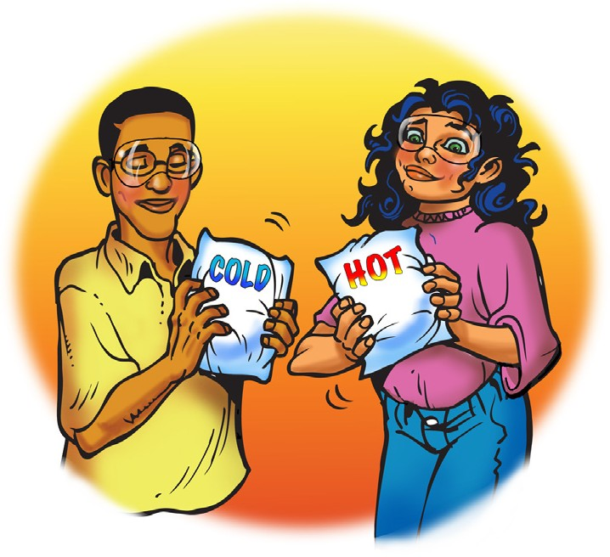
DEMONSTRATION

1. The cold and hot packs you saw each contain a solid substance and water. What is the process that happens inside a cold or hot pack when it is activated?

2. Your teacher opened the cold and hot packs and showed you what was inside each. Then your teacher mixed a small amount of the solid substance from each pack with water.
What happened as each solid substance dissolved in water?
Substance from the ... | Did the temperature of the solution increase or decrease? | Is this process endothermic or exothermic?
Cold pack
Hot pack

3. In this activity, you will place a thermometer in water and then add potassium chloride, calcium chloride, sodium carbonate, and sodium bicarbonate to find out which is most endothermic, and which is most exothermic as it dissolves.

List three variables and how you might control them.

What is the only variable that should be changed?

ACTIVITY

Question to Investigate
Which solute dissolves the most endothermically, and which dissolves the most exothermically in water?

Materials for Each Group
- Potassium chloride
- Calcium chloride
- Sodium carbonate
- Sodium bicarbonate
- Water
- 5 small cups
- Permanent marker or masking tape and pen
- Graduated cylinder
- Thermometer
- Gram balance

Procedure
  - Label the small plastic cups Potassium chloride, Calcium chloride, Sodium carbonate, and Sodium bicarbonate.
  - Weigh 2 g of each solute and place them in their labeled cups.
  - Add 10 mL of water to the small unlabeled cup and place a thermometer in the water. Record this initial temperature in the chart on the activity sheet.
  - Pour the potassium chloride into the water and swirl the cup. Watch the thermometer.
Substance dissolved  in water | Initial temp °C | Final temp °C | Change in temp °C | Endothermic  or exothermic?
potassium chloride
calcium chloride
sodium carbonate
sodium bicarbonate
  - When the temperature stops changing, record the final temperature.
  - Repeat steps 3–5 for each solute.

4. Which solute dissolves the most endothermically in water?

5. Which solute dissolves the most exothermically in water?

EXPLAIN IT WITH ATOM & MOLECULES
6. The two sets of illustrations below and on the next page show the energy changes that may occur during the process of dissolving. Title each either endothermic or exothermic and answer the question beneath each.

Title:

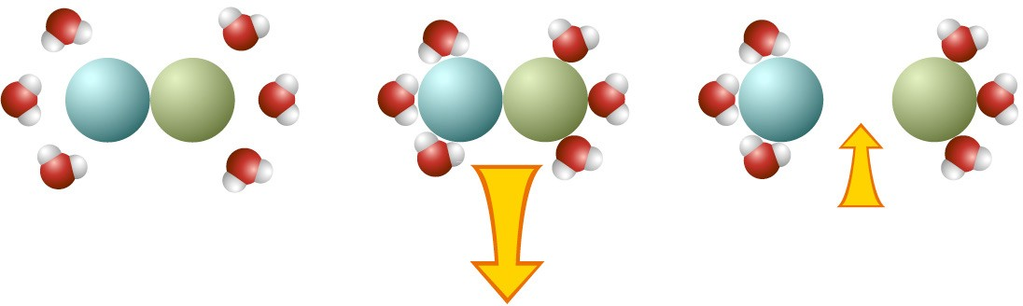
Energy released as water molecules “bond” to the solute.

Energy used when the solute is pulled apart.

How does the size of the arrows relate to the change in temperature of the solution?

Title:

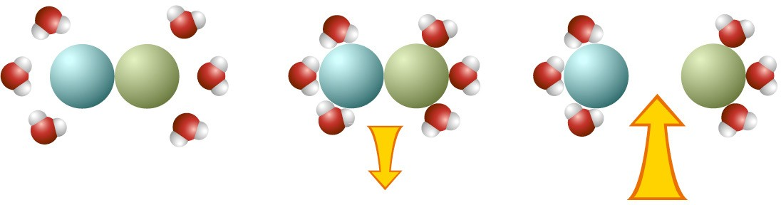
Energy released as water molecules “bond” to the solute.
Energy used when the solute is pulled apart.

How does the size of the arrows relate to the change in temperature of the solution?

TAKE IT FURTHER

7. The hand warmer shown in the video heats up as molecules and ions come together to form a crystal. Does the process of making bonds to form a crystal use or release energy?

8. If you think about the energy of making and breaking “bonds,” why do you think there is an increase in temperature when isopropyl alcohol dissolves in water?

