Activity Sheet Name Chapter 1, Lesson 3
The Ups and Downs of Thermometers Date

ACTIVITY

Question to investigate
What makes the liquid in a thermometer go up and down?

Materials for each group
- Student thermometer
- Magnifier
- Cold water
- Hot water (about 50 °C)

Procedure
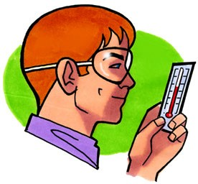
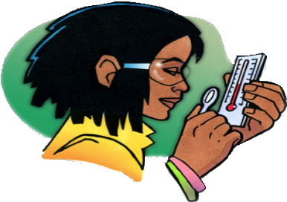
- Look closely at the parts of the thermometer.
  - Look closely at your thermometer. The liquid inside is probably a type of alcohol that’s been dyed red.
  - Read the temperature in °C by having your eye on the same level as the top of the red liquid. What is the temperature?
  - Use a magnifier to look closely at the thermometer from the front and from the side. Look at the bulb and the thin tube that contain the red liquid.
  - Put your thumb or finger on the red bulb and see if the red liquid moves in the thin tube.

- Observe the red liquid in the thermometer when it is heated and cooled.
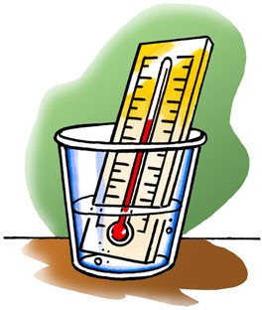

  - Place the thermometer in hot water and watch the red liquid. Keep it in the hot water until the liquid stops moving.

Record the temperature in °C.
  - Now put the thermometer in cold water. Keep it in the cold water until the liquid stops moving.

Record the temperature in °C.

WHAT DID YOU OBSERVE?

- Based on what you know about the way molecules move in hot liquids, explain why the liquid in the thermometer goes up when heated.

- Based on what you know about the way molecules move in cold liquids, explain why the liquid in the thermometer goes down when cooled.

- Why do you think the tube that contains the red liquid is so thin?

- What do you think is the purpose of the larger outer tube?

EXPLAIN IT WITH ATOMS & MOLECULES
You saw an animated molecular model of a thermometer at different temperatures. Now you will draw your own model.

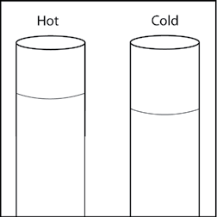
The drawing shows two close-ups of a thin tube in a thermometer like the one you used. One picture represents the thermometer in hot water, while the other is the thermometer in cold water.

- Based on what you know about the motion of molecules in a liquid and what you saw in the animations, draw circles to represent alcohol molecules in the liquid in the thermometer. Try to show the difference in distance between the molecules when the liquid is hot and cold. Use motion lines to represent their movement (fast or slow).

TAKE IT FURTHER

- Imagine that you have two thermometers that are identical in every way, except one has alcohol and the other has mercury inside. Each thermometer is placed in hot water that is 100 °C. The levels of the alcohol and mercury are shown in the picture.
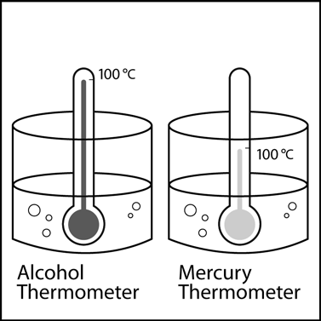

Why do you think the liquids in the thermometers are at different levels even though they are in water that is the same temperature?

Hint: Alcohol and mercury are both liquids but are made of different atoms and molecules. Use what you know about the motion and attractions the particles in a liquid have for one another to explain why the levels of alcohol and mercury in the thermometers are different.

