Activity Sheet Answers
Chapter 1, Lesson 5
Air, It’s Really There

DEMONSTRATION – BASKETBALL AND COMPRESSED GAS

- Think about the demonstration with the deflated and inflated basketball. The basketball weighed more after it was inflated with air than when it was deflated. How does this show that gas is matter?
Since matter is anything that has mass and takes up space, it seems that gas must be matter. It takes up the space in the basketball and it does have some mass even though it is small.

- Think about the demonstration with the can of compressed gas. The can weighed less after some gas was shot out of the can. How does this show that gas is matter?
The gas must have mass since the can had less mass after some gas was released from the can.

EXPLAIN IT WITH ATOMS & MOLECULES

- What did you notice about the molecules of a gas?
  - Do the molecules of a gas have strong or weak attractions?
  - Are the molecules of a gas randomly or orderly arranged?
  - When the molecules of a gas hit each other, do they normally stick together or bounce off?
The molecules of a gas have weak attractions, are randomly arranged, and bounce off each other when they hit together.

WHAT DID YOU OBSERVE?

- What happened to the film of detergent solution when you placed the bottle in hot water?
When the bottle was placed in hot water, the soap film formed a bubble on top of the bottle.

- What happened to the bubble when you placed the bottle in cold water?
When the bottle was placed in cold water, the bubble shrunk and may have gone inside the bottle.

EXPLAIN IT WITH ATOMS & MOLECULES

- What caused the bubble to form when you placed the bottle in hot water? Be sure to write about the speed of the molecules inside the bubble and the force on the bubble from the outside air.
The bubble formed when the bottle was placed in hot water because the molecules that make up the air inside the bottle moved faster. These molecules hit the inside of the bottle and detergent film harder and more often. They pushed against the detergent film hard enough that it was able to overcome the outside air pressure and made the bubble grow.

- Why did the bubble get smaller when you placed the bottle in cold water? Be sure to write about the speed of the molecules inside the bubble and the force on the bubble from the outside air.
The bubble shrinks when the bottle is placed in cold water because the molecules that make up the air inside the bottle moved slower. These molecules hit the inside of the bottle and detergent film less often and with less force. The outside air pressure pushed harder on the outside of the bubble than the molecules pushed from the inside so the bubble got smaller.

- Draw circles to represent the molecules in a solid, liquid, and gas. Because all three different substances are all at the same temperature, draw the same number of motion lines near the circles for each substance. Under each box, write about the arrangement and motion of the molecules and the attractions the molecules have for one another.
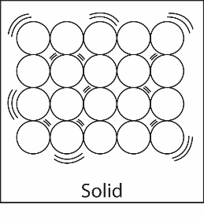
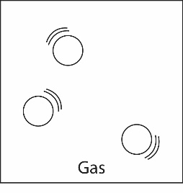
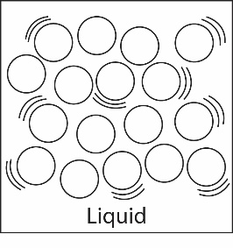
Attractions strong enough to keep atoms in orderly arrangement
Vibrate in fixed positions
Definite shape and volume
Attractions keep particles together, but they can slide past each other
Random arrangement
Definite volume, not definite shape
Attractions too weak to keep particles together
Particles move independently
No definite shape or volume

TAKE IT FURTHER

- Imagine that you work at a party store during the summer. You are going to ride home with the owner of the store whose car has been sitting in the hot sun all day long. The owner tells you that you can take home a big bunch of balloons but advises you not to blow the balloons up all of the way before putting them in the car.

Explain why the owner’s advice is wise. Be sure to discuss how heating affects the motion of the molecules in a gas.
Maybe the owner is afraid that the heat in the car will cause the molecules in the balloons to move faster and push hard enough on the inside of the balloons to make them pop.

