Activity Sheet Name Chapter 2, Lesson 1
Heat, Temperature, and Conduction Date
In this activity, you will place a room-temperature set of washers in hot water and then place a set of hot washers in room-temperature water. Find out what happens to the temperature of each.

ACTIVITY

Question to investigate
Why does the temperature of an object change when it is placed in hot water?

Materials for each group
- 2 sets of large metal washers on a string
- Styrofoam cup filled with hot water
- Room-temperature water
- 2 thermometers
- Graduated cylinder or beaker

Procedure

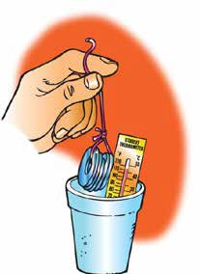
Room-temperature washers placed in hot water
  - Place a thermometer in your cup to measure the initial temperature of the water. Record the temperature of the water in the “Before” column in the chart on the activity sheet. Be sure to also record the initial temperature of the water in the control cup.
  - Use another thermometer to measure the temperature of the washers. Record this in the “Before” column.
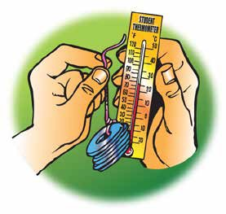
  - With the thermometer still in the water, hold the string and lower the metal washers all the way into the water.
  - Observe any change in the temperature of the water. Leave the washers in the water until the temperature stops changing. Record the temperature of the water in each cup in the “After” column.
  - Remove the washers from the water. Then take and record the temperature of the washers in the “After” column.

  - Empty the cup in a waste container or sink.

Room-temperature washers placed in hot water
Temperature of… | Before | After
Water in your cup
Water in the control cup
Metal washers

1. Why do you think the temperature of the water in your cup changes more than the water in the control cup?

Hot washers placed in room-temperature water
- Pour about 30 milliliters of room-temperature water into your Styrofoam cup.
- Place a thermometer into the water and record the temperature of the water in each cup in the “Before” column in the chart below.
- Get a set of hot washers from your teacher and quickly use a thermometer to measure the temperature of the washers. Record this in the “Before” column.
- With the thermometer still in the water, hold the string and lower the hot metal washers all the way into the water.

- Observe any change in the temperature of the water. Leave the washers in the water until the temperature stops changing. Record the temperature of the water in the “After” column in the chart. Also record the temperature of the water in the control cup.
- Remove the washers from the water. Then take and record the temperature of the washers.

Hot washers placed in room-temperature water
Temperature of… | Before | After
Water in your cup
Water in the control cup
Metal Washers

EXPLAIN IT WITH ATOMS & MOLECULES

Room-temperature spoon placed in hot water
In the first part of the animation, you saw what happens when a spoon is placed in hot water.

2. Explain, on the molecular level, how energy was transferred from the hot water to the room-temperature spoon.

3. Draw motion lines near the atoms and molecules in the “After” illustration to show how the speed of the molecules in the spoon and water changed.

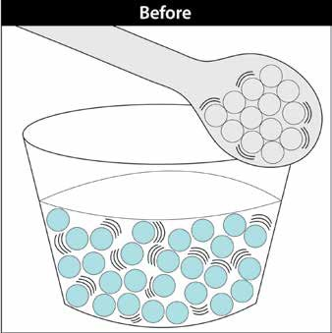
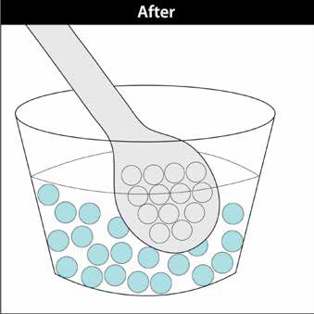

4. Now that you know what happens when a spoon is placed in hot water, explain what happened in the activity:

  - Why did the metal washers get warmer while the water got cooler?

Hot spoon placed in room-temperature water
In the next part of the animation, you saw what happens when a hot spoon is placed in room-temperature water.

5. Explain, on the molecular level, how the heat was conducted from the hot spoon to the room-temperature water.

6. Draw motion lines near the atoms and molecules in the “After” illustration to show how the speed of the atoms in the spoon and molecules in the water changed.
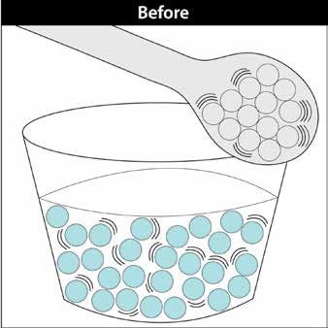
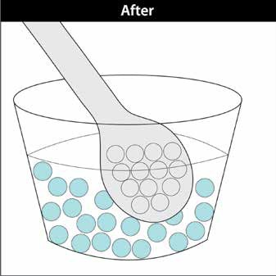

7. Now that you know what happens when a hot spoon is placed in room-temperature water, explain what happened in the activity:

  - Why did the hot metal washers get cooler?

  - Why did the water get warmer?

8. You saw an animation that showed that temperature is a measure of the average kinetic energy of the atoms of molecules of a substance. Does this mean that all the molecules in a cup of water are moving at the same speed or at a variety of speeds? Explain.

TAKE IT FURTHER
9. Touch your metal chair or desk leg and then touch your wooden or plastic desk top or some other wood or plastic.

  - Which feels colder, the metal or the wood/plastic?

  - Explain why the metal feels colder even though it is the same temperature as the wood or plastic.
Hint: Certain materials are better at conducting heat than others.

10. Even though room-temperature water and room-temperature air are about the same temperature, the water feels colder when you put your finger in it. Use what you know about conduction to explain why the water feels colder than the air. Hint: Certain materials are better at conducting heat than others.

11. Let’s say that you put a cup of cold water in one room and a cup of hot water in another room. Both rooms are room-temperature. Why does the cold water get warmer and the hot water get cooler?

