Chapter 5, Lesson 2—Surface Tension
Key Concepts
- The attraction of molecules at the surface of a liquid is called surface tension.
- The polarity of water molecules can help explain why water has a strong surface tension.
Summary
Students will observe several phenomena related to the polarity of water molecules. They will observe a demonstration of a paper clip being placed on the surface of water. Students will place drops of water in an already-filled test tube and on the surface of a penny. They will compare the way water behaves with the less polar liquid isopropyl alcohol and will see how detergent affects water’s surface tension. Students will relate these observations to an explanation of surface tension at the molecular level.
Objective
Students will be able to explain, on the molecular level, the effects of polarity on water’s surface tension.
Evaluation
The activity sheet will serve as the “Evaluate” component of each 5-E lesson plan. The activity sheets are formative assessments of student progress and understanding. A more formal summative assessment is included at the end of each chapter.

Materials for the Demonstration
- 1 clear plastic cup
- Water
- 1 standard size paper clip
- 1 large paper clip
Materials for Each Group
- Water
- Isopropyl alcohol (70% or higher)
- Dish detergent in cup
- Test tube
- 2 pennies
- 2 droppers
- 2 toothpicks
- 2 paper towels
Safety
- Be sure you and the students wear properly fitting goggles. Isopropyl alcohol is flammable. Keep it away from flames or spark sources. Read and follow all warnings on the label. Use in a well-ventilated room.
- Paper towels wet with alcohol should be allowed to evaporate. Dry paper towel can then be placed in the trash.
- Small amounts of isopropyl alcohol can be disposed of down the drain or according to local regulations.
- Have students wash hands after the activity.

ENGAGE

Do a demonstration to show water’s surface tension.
Either do the following demonstration for students or show them the video Water’s surface tension at www.acs.org/middleschoolchemistry/simulations/chapter5/lesson2.html

Materials
  - 1 clear plastic cup
  - Water
  - 1 standard size paper clip
  - 1 large paper clip

Teacher Preparation
Unbend the large paper clip until it is straight. Then bend it into a “U” shape. Bend the bottom of each end out a little bit as shown. This will be your device for picking up and placing the smaller paper clip onto the surface of the water. It works like tweezers, but in reverse: allow it to spread it apart in order to pick up the paper clip and squeeze it to release the paper clip.

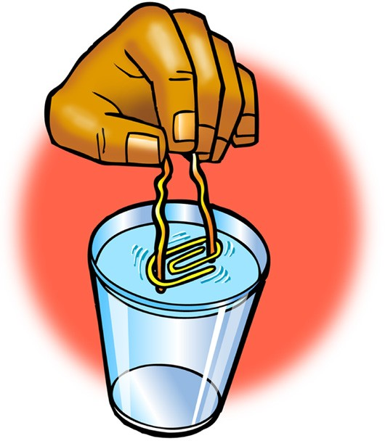
Procedure
- Place water in one cup until it is about 3/4 full.
- Use your device to pick up a paper clip. Do this by squeezing the ends of the device together a bit and placing them inside the paper clip. Then allow the ends to spread apart so that the tension of the ends pushes against the inside of the paper clip and holds it in place.
- Very carefully lower the paper clip so that it lies flat on the surface of the water. Slowly squeeze the device to release the paper clip.

Expected Results
The paper clip should rest on the surface of the water. This may take a couple of tries.

Ask students:

Why do you think a paper clip, which is more dense than water, can stay on the surface of water?
Remind students that paper clips are more dense than water and would normally sink. Help students realize that the paper clip in the demo stayed on the surface of the water because of something having to do with the water molecules at the water’s surface, called surface tension.

Have students relate their observations in the demo to a water strider standing on the surface of water.
Project the image Water Strider and Molecule. www.acs.org/middleschoolchemistry/simulations/chapter5/lesson2.html
Point out how the surface of the water seems to bend but not break under the water strider’s legs. Tell students that what they see is another example of water’s surface tension.

Ask students:

Why do you think water has such a strong surface tension?
Encourage students to think about what they already know about the strong attraction between water molecules. Students should remember that water molecules are very attracted to each other and this attraction is the basis for surface tension. This will be explained in more detail later in this lesson.

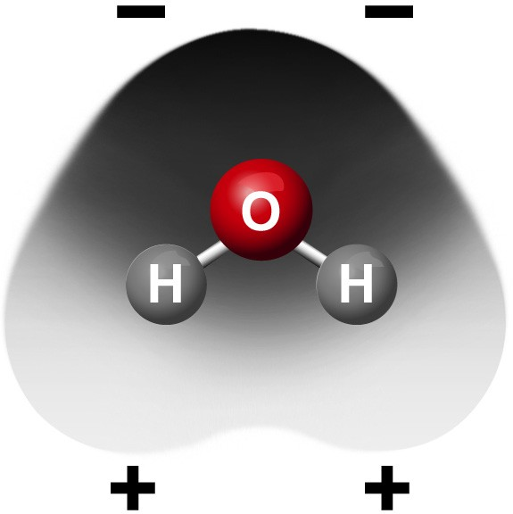

Give each student an activity sheet.
Students will record their observations and answer questions about the activity on the activity sheet. The Explain It with Atoms & Molecules and Take It Further sections of the activity sheet will either be completed as a class, in groups, or individually depending on your instructions. Look at the teacher version of the activity sheet to find the questions and answers.

EXPLORE

Have students carefully add single drops of water to a filled test tube.
Tell students that there is another phenomenon that is caused by water’s surface tension. It is water’s ability to fill beyond the top of a container.

Question to Investigate
How much water can you add to a full test tube?

Materials for Each Group
- Water
- Dropper
- Test tube
- Penny
- 2 paper towels

Procedure
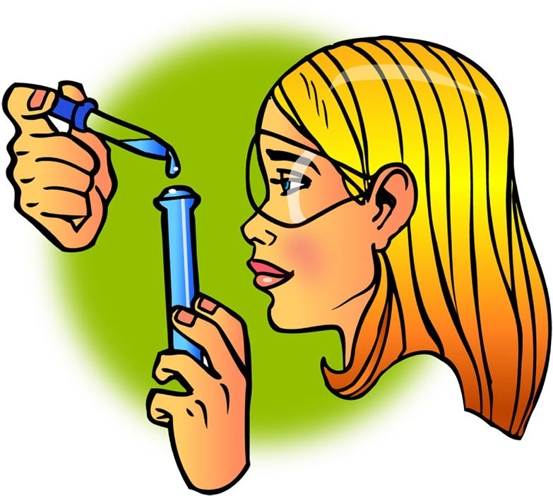
- Pour water into a test tube so that the water is very near the top of the test tube.
- Hold the test tube up to eye level and use a dropper to carefully add drops of water, one at a time, to the test tube.
- Watch the water at the top of the test tube while you add the drops. Continue adding drops until the water spills.
- Place a penny on a paper towel.
- While watching from the side, add single drops of water to the penny. Continue adding drops until the water spills.

Expected Results
While looking from the side, students will see that the water forms a dome on the top of the test tube and on the penny.

Ask students:

What did the water look like as you added it to the top of the test tube and the penny?
The water makes a “dome” or “hill” of water above the top of the test tube and penny.

EXPLAIN

Explain how attractions between water molecules give water its strong surface tension.
Project the image Why Water Beads.
www.acs.org/middleschoolchemistry/simulations/chapter5/lesson2.html

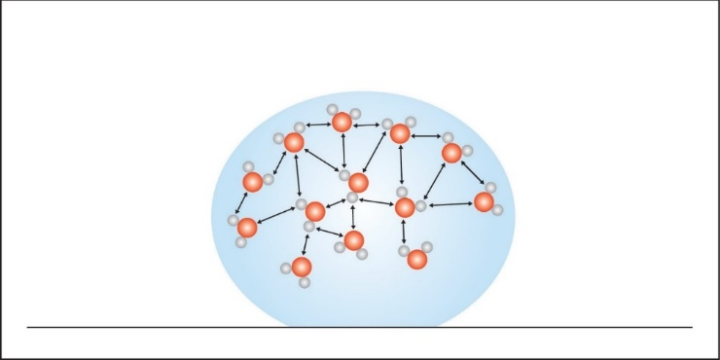

Explain to students that water’s surface tension is based on the attractions between water molecules at the surface and the water molecules in the rest of the water. A water molecule beneath the surface feels attractions from all the molecules around it. But the molecules at the surface only feel attractions from the molecules next to them and beneath them. These surface molecules are pulled together and inward by these attractions. This inward pull has the effect of compressing the surface molecules which form a tight arrangement over the water’s surface. This tight arrangement at the surface is called surface tension.

The inward pull from the attractions of the molecules results in the smallest possible surface for a volume of water, which is a sphere. This is why water forms a round drop or dome at the top of the filled test tube and on the surface of a penny.

EXPLORE

Have students compare the surface tension of water and alcohol.
Ask students:

How could we compare the surface tension of water and alcohol?
Students may suggest placing an equal number of drops of each liquid on wax paper, overfilling a test tube, or comparing the number of drops that can be added to the top of a penny.

Note: Even though there are many ways to compare the surface tension of water and alcohol, the procedure written below compares each liquid on the surface of a penny. In order to make this as fair a test as possible, students should place each liquid on two similar pennies that are either both “heads” or “tails.” They should also be sure to add single drops of each liquid slowly and carefully.

Question to Investigate
Which has a greater surface tension, water, or alcohol?

Materials for Each Group
- 2 pennies
- 2 droppers
- Water
- Isopropyl alcohol (70% or higher)
- Paper towel

Procedure
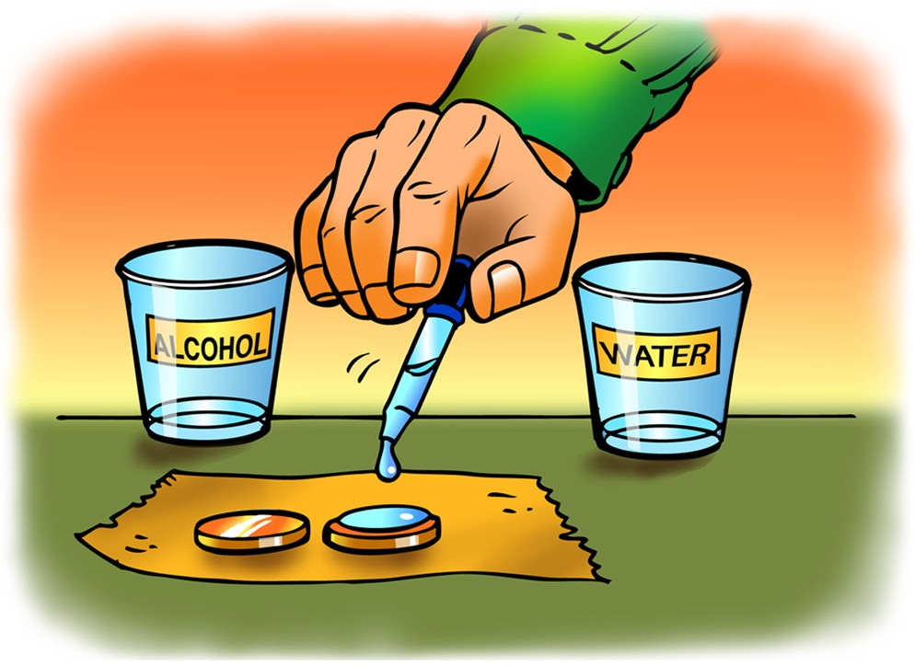
- Place two pennies on a paper towel.
- Use a dropper to add drops of water to the surface of a penny. Count the drops until the water overflows.
- Use a dropper to add drops of alcohol to the surface of the other penny. Count the drops until the alcohol overflows.

Expected Results
The water beads up on the penny and the alcohol spreads out flat. Many more drops of water can be added to the penny than drops of alcohol.

EXPLAIN

Discuss student observations and why students were not able to get as many drops of alcohol on a penny.
Project the image Water and Alcohol.
www.acs.org/middleschoolchemistry/simulations/chapter5/lesson2.html

Review that water molecules are polar and that they are very attracted to each other. Point out that alcohol molecules are polar in only one area, making them somewhat attracted to each other. They are not as attracted to other alcohol molecules as water is to other water molecules.
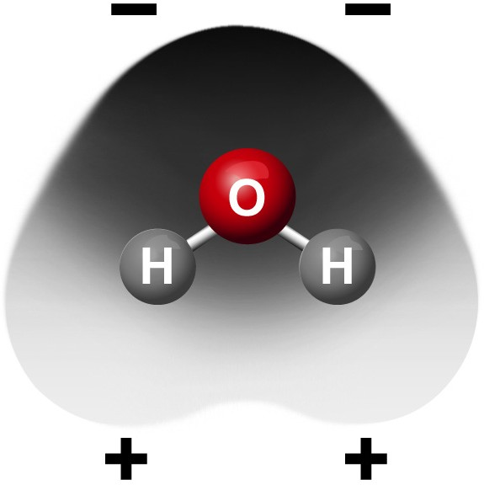
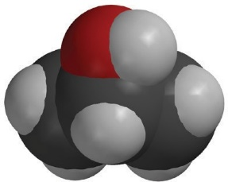
–
+

Water and Alcohol on Pennies
Explain that water’s attraction pulls itself together into a tight arrangement. Explain that alcohol molecules don’t have a structure that is as good as water’s for attraction to itself. Alcohol molecules only have 1 O–H bond and they have some C–H bonds that are pretty nonpolar. There is not as strong an attraction between them as there is between water molecules.

The shape of the water molecule and its polarity at the top and the bottom give water molecules lots of opportunities to attract. Almost anywhere two water molecules meet they can be attracted to each other.

But alcohol has a different size and shape and has its polar part on one end. Alcohol molecules can meet at areas where they would not attract as strongly. The water is more attracted to itself than to the metal of the penny. The alcohol is a bit less attracted to itself, so it spreads more on the penny.

EXPLORE

Have students add detergent to the water on a penny.
Question to Investigate
How does detergent affect water’s surface tension?

Materials
- Dish detergent in cup
- 2 pennies
- Dropper
- 2 toothpicks
- Paper towel

Procedure
- Place 2 clean dry pennies on a flat surface like a table or desk.
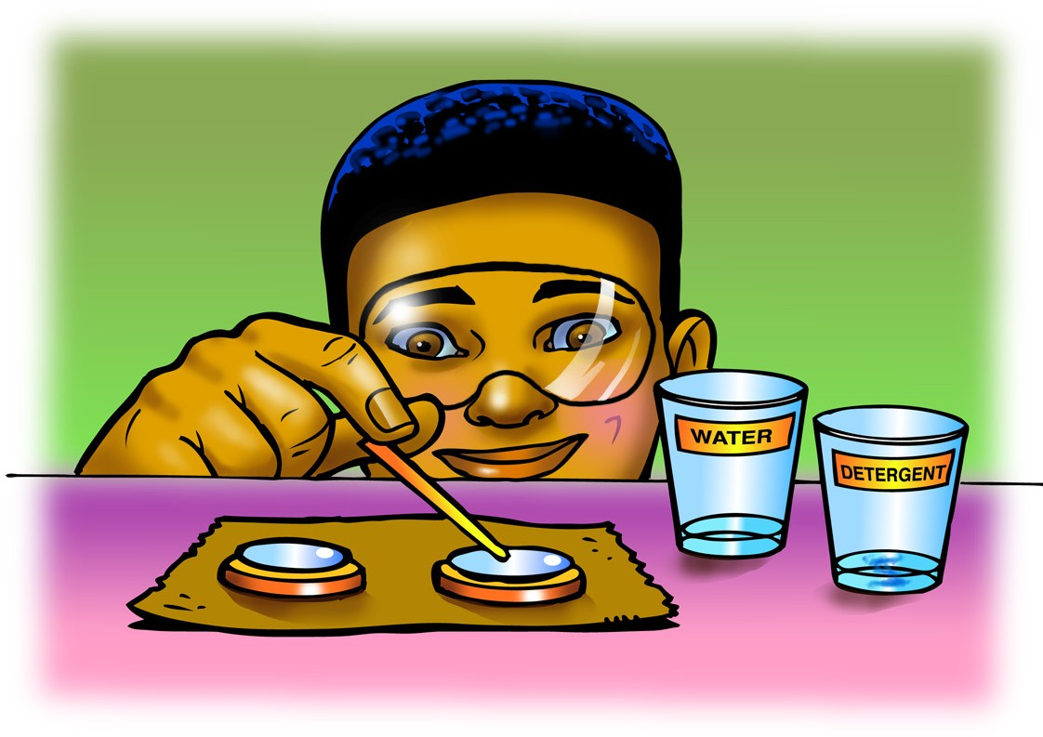
- Use a dropper to add water to both pennies. Add the same number of drops to each penny so that the water stacks up in a dome shape about the same height on both.
- Gently touch the water on one penny with a toothpick. Watch the surface of the water as you touch it.
- Dip the toothpick in liquid detergent and then touch the water on the other penny with the toothpick.
Note: This activity works best if the dome of water on the pennies is pretty high.

Expected Results
Touching the water with the toothpick causes the surface of the water to be pressed down and bend. Touching the water with the toothpick and detergent causes the water to collapse and spill off the penny.

EXPLAIN

Explain how detergent interferes with water’s surface tension.
Project the image Water and Detergent.
www.acs.org/middleschoolchemistry/simulations/chapter5/lesson2.html
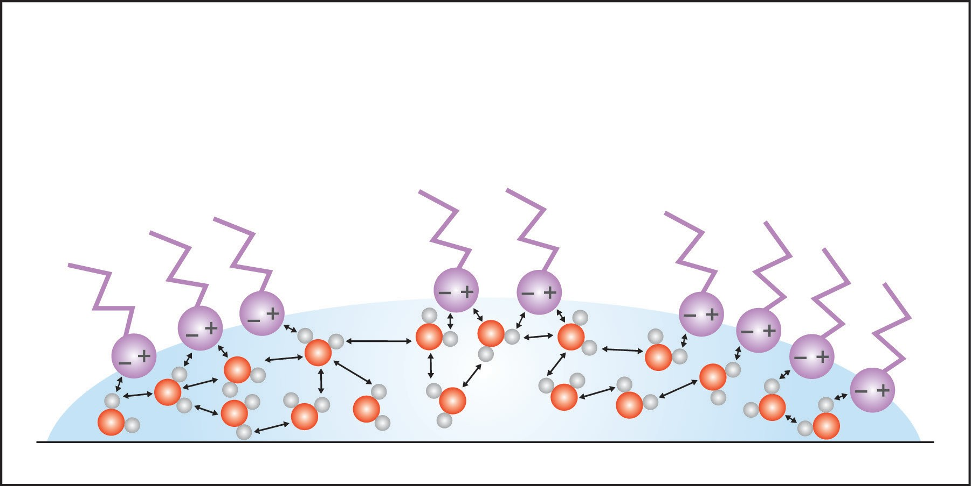

Explain that detergent is made from molecules that have a charged end and a longer uncharged end. The detergent molecules spread out over the surface of the water with the charged end in the water and the uncharged end sticking out. The water molecules at the surface are attracted to the charged end of the detergent molecules. As the surface water molecules are attracted outward, this acts against their inward attraction that was creating the surface tension. This reduces the surface tension, and the water does not hold its round shape and thus spills.

EXTEND

Discuss how the polarity of the material that the water is placed on affects how the water absorbs or beads up.
Ask students:

If water absorbs into a paper towel but does not absorb into wax paper, what does that say about the polarity of paper and wax paper?
The molecules that make up paper are probably polar, and the molecules that make up wax are probably nonpolar.

Project the animation Water on Paper Towel.
www.acs.org/middleschoolchemistry/simulations/chapter5/lesson2.html
Explain that paper towel and other paper is made from cellulose. Cellulose is made from repeating molecules of glucose that are bonded together. The glucose molecule has many O–H bonds, which are polar. Polar water molecules are attracted to polar cellulose.

Project the animation Water on Wax Paper.
www.acs.org/middleschoolchemistry/simulations/chapter5/lesson2.html
Tell students that wax is made from paraffin, which is repeating carbon–hydrogen bonds. The C–H bond is not very polar, so water is more attracted to itself than to the wax. This causes the water to bead up on wax paper.

