**Activity Sheet Name Chapter 6, Lesson 2**

**Controlling the Amount of Date Products in a Chemical Reaction**

DEMONSTRATION

1. 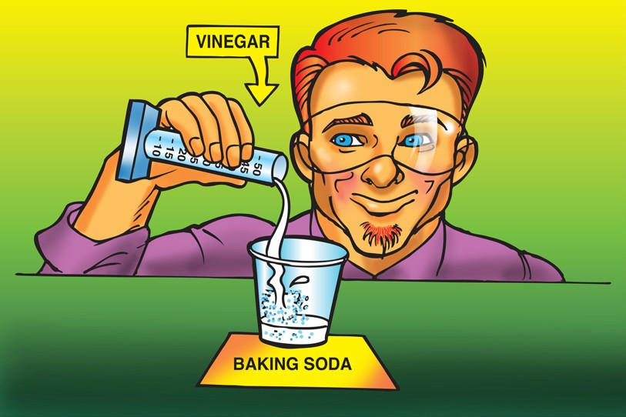**Your teacher combined a liquid (vinegar) and a solid (baking soda). You observed bubbling, which is made from gas. Do you think a chemical reaction occurred?**

**Why?**

1. **Look at the chemical equation for the reaction between vinegar and baking soda to answer the following questions.**

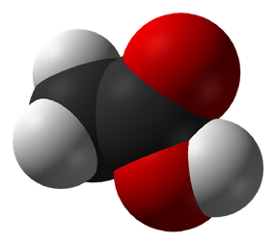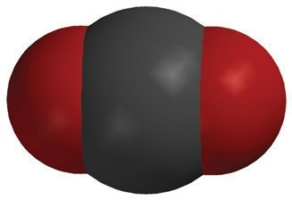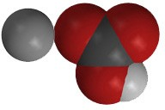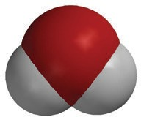

+

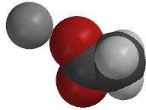

+

+

**C2H4O2**

acetic acid

**NaHCO3**

sodium bicarbonate

**NaC2H3O2**

sodium acetate

**H2O**

water

**CO2**

carbon dioxide

**What are the *reactants* in this chemical reaction?**

**What are the *products* in this chemical reaction?**

1. **How many of each type of atom appears on each side of the chemical equation?**

|  |  |  |
| --- | --- | --- |
| **C2H4O2 + NaHCO3 NaC2H3O2 + H2O + CO2** | | |
| **Atom** | **Reactant side** | **Product side** |
| Carbon |  |  |
| Hydrogen |  |  |
| Oxygen |  |  |
| Sodium |  |  |

1. **What does the statement “*Mass* is conserved during a chemical reaction” mean?**

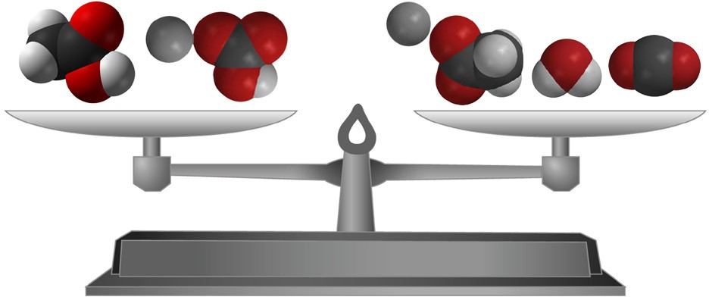

# ACTIVITY

## Question to investigate

How can you make just the right amount of foam that rises to the top of the graduated cylinder without overflowing?

## Materials for each group

* 1. Vinegar in a cup
  2. Baking soda in a cup
  3. Detergent solution in a cup
  4. Dropper
  5. Graduated cylinder (50 mL)
  6. Measuring spoons (⅛, ¼, and ½ teaspoon)
  7. Plastic waste container

## Procedure

1. Decide on how much vinegar and baking soda you will use and write these amounts in the chart on the activity sheet.
2. Use a graduated cylinder to measure the amount of vinegar your group agreed on.
3. 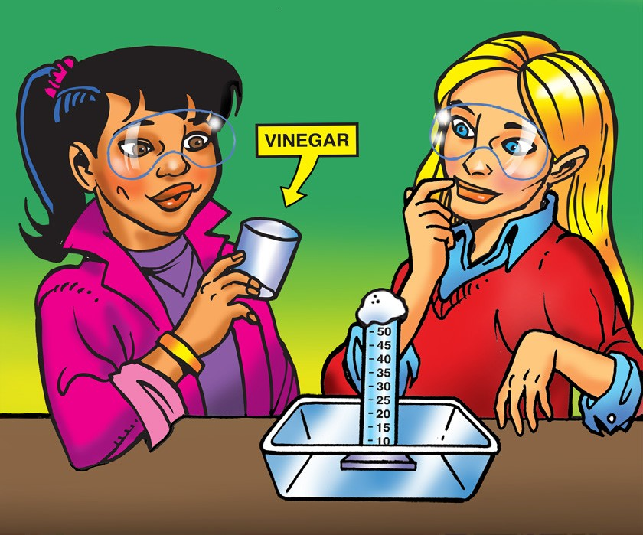Pour the vinegar in a small cup and add 1 drop of detergent. Swirl gently to mix.
4. Add the amount of baking soda your group agreed on to the empty graduated cylinder.
5. Place the graduated cylinder in a plastic waste container.
6. Pour the vinegar and detergent from the cup into the graduated cylinder. Observe the level of foam in the graduated cylinder.
7. Rinse the graduated cylinder over the waste container.

|  |  |  |  |  |
| --- | --- | --- | --- | --- |
| **Adjust the amounts of baking soda and vinegar to create just enough foam to rise to the top of the graduated cylinder without overflowing.** | | | | |
|  | **Demonstration** | **First try** | **Second try** | **Third try** |
| Vinegar | 10 mL |  |  |  |
| Baking soda | 1/2 teaspoon |  |  |  |
| Detergent | 1 drop | 1 drop | 1 drop | 1 drop |
| How close did the foam get to the top of the cylinder? | Overflowed |  |  |  |

# EXPLAIN IT WITH ATOMS & MOLECULES



+



+

+

**C2H4O2**

acetic acid

**NaHCO3**

sodium bicarbonate

**NaC2H3O2**

sodium acetate

**H2O**

water

**CO2**

carbon dioxide

1. **Why, on the molecular level, does changing the amount of baking soda or vinegar affect the amount of carbon dioxide gas produced?**
2. **What would you do if you wanted to make more carbon dioxide?**
3. **Could you just keep adding more and more baking soda to the same amount of vinegar to get more carbon dioxide?**

**Why or why not?**

# TAKE IT FURTHER

1. **An Alka-Seltzer tablet contains aspirin, sodium bicarbonate, and citric acid. Your teacher placed an Alka-Seltzer tablet in water with a drop of detergent. Do you think placing an Alka-Seltzer in water causes a chemical reaction?**

**Why?**