# 

# 2012 ACS Presidential Commission on Graduate Education in the

# Chemical Sciences Members

|  |  |  |
| --- | --- | --- |
|  |  |  |

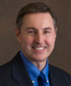**William F. Banholzer**

William F. (Bill) Banholzer is Executive Vice President, Ventures, New Business Development and Licensing, and Chief Technology Officer for The Dow Chemical Company. He is a member of Dow’s Executive Leadership Committee, which is responsible for corporate strategy and financial performance, and also of the Strategy Board, which is responsible for the review and approval of the Company’s strategy and resource allocation decisions. Banholzer earned a bachelor’s degree in chemistry from Marquette University and master’s and doctorate degrees in chemical engineering from the University of Illinois. He is a certified Six Sigma Master Black Belt, holds 16 U.S. patents and has over 80 publications for his work in the field of engineering and chemistry.

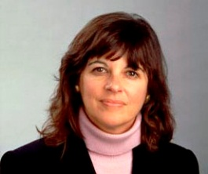**Jacqueline K. Barton**

Jacqueline K. Barton is the Arthur and Marian Hanisch Memorial Professor of Chemistry and Chair of the Division of Chemistry and Chemical Engineering at the California Institute of Technology. She has pioneered the application of transition metal complexes to probe recognition and reactions of double helical DNA. Most recently, her research group has designed bulky metalloinsertors as site-specific probes of DNA base mismatches. Barton was a 2010 National Medal of Science recipient. She was awarded the A.B. *summa cum laude* at Barnard College and a Ph.D. in Inorganic Chemistry at Columbia University. She is a recipient of a prestigious MacArthur Foundation Fellowship and has been elected to the American Academy of Arts and Sciences, the American Philosophical Society, and the National Academy of Sciences.

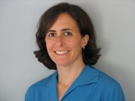**Stacey F. Bent**

Stacey F. Bentis Professor of Chemical Engineering at Stanford University and holds the position of Professor, by courtesy, in the Departments of Materials Science & Engineering, Electrical Engineering, and Chemistry. Bent leads a research group in the areas of semiconductor processing, surface science, and materials chemistry. Her group carries out studies of semiconductor surface modification and functionalization, and has a strong effort in atomic layer deposition. Bent received her B.S. in chemical engineering from the University of California, Berkeley, and her Ph.D. in chemistry from Stanford University. She has received several awards, including the NSF Career award, the Peter Mark Memorial Award, AVS, and the Coblentz Award.

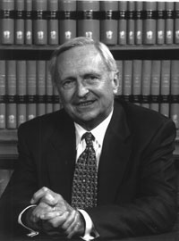**Ronald Breslow**

Ronald Breslow is the S.L. Mitchill Professor of Chemistry and University Professor at Columbia University. Breslow’s recent research interests include the synthesis and study of molecules that imitate enzymatic reactions. He has developed a new group of cyclodifferentiating agents with potential use in cancer chemotherapy. Breslow is the author of more than 400 publications. He received his undergraduate and graduate training at Harvard University, where he did his Ph.D. research with Professor R.B. Woodward. Breslow is a member of the National Academy of Sciences, the American Academy of Arts and Sciences, the European Academy of Science, and the American Philosophical Society. He received the prestigious National Medal of Science in 1991.

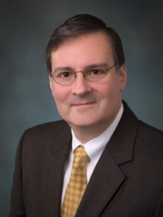**Gary S. Calabrese**

Gary S. Calabrese is Senior Vice President and head of Global Research at Corning Incorporated. Previously he worked at Polaroid, Allied-Signal, and Rohm and Haas where he headed their corporate research laboratory and later became vice president and chief technology officer. Calabrese holds a B.S. degree in chemistry from Lehigh, and a Ph.D. in inorganic chemistry from MIT. A past advisor to the Council for Chemical Research, *Chemical & Engineering News*, and co-chair of the National Academies’ Board on Chemical Sciences and Technology, he currently serves as an advisory board member for Cornell University’s Department of Chemical and Biomolecular Engineering. He is also a member of the National Academy of Engineering, and has over 50 patents and technical publications.

**Pat N. Confalone**

Pat N. Confalone is Vice President, DuPont Crop Protection, Global R&D. After graduating from M.I.T., Confalone received his Ph.D. at Harvard working with Nobel laureate R.B. Woodward. Confalone's Bioorganic Chemistry group at DuPont developed the fluorescent dye-labeled reagents that were used in automated DNA sequencing, and eventually used in the human genome project. He has presented more than 110 invited or plenary lectures worldwide, published over 140 papers, and obtained more than 50 U.S. Patents. Confalone is a member of the ACS Board of Directors, is on the governing boards of the Council for Chemical Research and the United States National Committee for IUPAC, and is an elected Fellow of the American Association for the Advancement of Science.

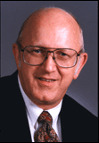**Michael P. Doyle**

Michael P. Doyle isProfessor and Chair of the Department of Chemistry and Biochemistry at the University of Maryland College Park. He held faculty appointments at Hope College, Trinity University in San Antonio, TX, and the University of Arizona before joining the faculty at the University of Maryland. Doyle served as Vice President, then President, of Research Corporation from 1997-2003. He received his B.S. degree from the College of St. Thomas in St. Paul, MN, and obtained his Ph.D. degree from Iowa State University. Doyle has received many honors, including the American Chemical Society Award for Research at Undergraduate Institutions, Doctor Honoris Causa from the Russian Academy of Sciences, and the George C. Pimentel Award for Chemical Education.

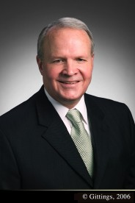**Larry R. Faulkner, Commission Chair**

Larry R. Faulkner is President Emeritus of The University of Texas at Austin. He retired in early 2012 after six years of service as President of Houston Endowment, a private philanthropy established by Jesse H. and Mary Gibbs Jones. Over four decades, Dr. Faulkner served on the chemistry faculties of Harvard University, the University of Illinois, and the University of Texas. At Illinois, he was also department head, dean, and provost. From 1998 into 2006, he served the University of Texas as its 27th president. He is a member of the American Academy of Arts and Sciences and chaired the National Mathematics Advisory Panel. He now serves on the boards of Exxon Mobil Corporation, Southern Methodist University, Houston Grand Opera, Reasoning Mind, the Lyndon Baines Johnson Foundation, and Al Akhawayn University in Ifrane. He was previously on the boards of Temple-Inland, Sandia National Laboratories, and Internet2.

[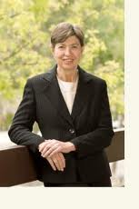](http://www.google.com/imgres?q=marye+anne+fox+cv&um=1&hl=en&sa=N&qscrl=1&nord=1&rlz=1T4GZAB_enUS434US434&biw=1280&bih=754&tbm=isch&tbnid=xMyvXXttVxxG4M:&imgrefurl=http://www.dreyfus.org/news/news.shtml&docid=OBUyKj0k4vDU6M&w=192&h=288&ei=CjBBTqvfAaXo0QG-wNXtAg&zoom=1)**Marye Anne Fox**

Marye Anne Fox is Chancellor Emerita and Distinguished Professor of Chemistry at the University of California San Diego. Previously, she was chancellor and distinguished university professor of chemistry at North Carolina State University, and spent 22 years at the University of Texas. Fox has received honorary degrees from 12 institutions and held over 50 endowed lectureships at universities around the world. She earned a bachelor's degree from Notre Dame College, a master's degree from Cleveland State University, and a Ph.D. from Dartmouth College. She is a member of the National Academy of Sciences and the American Association for the Advancement of Science. In 2010, Fox received the National Medal of Science, the highest honor bestowed by the United States government on scientists, engineers and inventors.

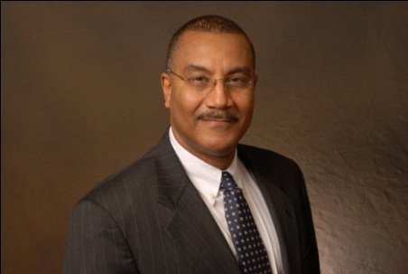**Joseph S. (Joe) Francisco**

Joseph S. Francisco is the William E. Moore Distinguished Professor of Earth and Atmospheric Science and Chemistry at Purdue University. He has published over 400 peer-reviewed publications in the fields of atmospheric chemistry, chemical kinetics, quantum chemistry, laser photochemistry and spectroscopy. Francisco completed his undergraduate studies at the University of Texas at Austin, and received his Ph.D. in Chemical Physics from the Massachusetts Institute of Technology. He served as President of the National Organization for the Professional Advancement of Black Chemists and Chemical Engineers (NOBCChE) from 2005-2007. In 2008 he was elected to the Presidential succession of the American Chemical Society, serving as President in 2010.

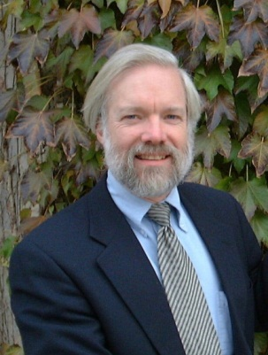**Paul Houston, Commission Executive Director**

Paul Houston is Dean of the College of Sciences and a Professor in the School of Chemistry and Biochemistry at the Georgia Institute of Technology. Prior to these positions he was at Cornell University for 32 years, most recently as the Peter J. W. Debye Professor of Chemistry. Houston has authored or co-authored approximately 150 publications in the field of physical chemistry and a textbook on chemical kinetics. He completed his undergraduate studies at Yale and his doctoral work at MIT. In 2001 Houston shared the Herbert Broida Prize of the American Physical Society with colleague David W. Chandler. He is a fellow of the American Association for the Advancement of Science and the American Academy of Arts and Sciences.

[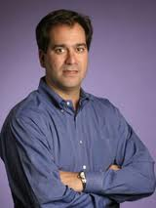](http://www.google.com/imgres?q=chad+mirkin&um=1&hl=en&sa=N&rlz=1T4GZAB_enUS434US434&biw=1280&bih=754&tbm=isch&tbnid=ge_bEoB_ag6xjM:&imgrefurl=http://www.dickinson.edu/news-and-events/news/2008-09/Chad-Mirkin--86-Receives-Lemelson-MIT-Prize/&docid=nbvoiEZF-h3IaM&w=200&h=267&ei=tDFBTtjzLor20gHv0vmoCQ&zoom=1)**Chad A. Mirkin**

Chad A. Mirkin is Director of the International Institute for Nanotechnology at Northwestern University and the George B. Rathmann Professor of Chemistry, Professor of Chemical and Biological Engineering, Professor of Biomedical Engineering, Professor of Materials Science and Engineering, and Professor of Medicine. He is the author of over 430 manuscripts and over 370 patents and applications, and the founder of three companies, Nanosphere, NanoInk, and Aurasense. Mirkin has been recognized for his accomplishments with over 60 national and international awards. He holds a B.S. degree from Dickinson College and a Ph.D. in chemistry from the Pennsylvania State University. Mirkin is a member of the National Academy of Engineering, the National Academy of Sciences, and the Institute of Medicine, and a member of President Obama's Council of Advisors for Science and Technology.

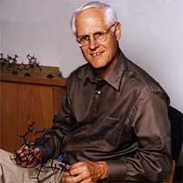**Larry E. Overman**

Larry E. Overman is Distinguished Professor of Chemistry at the University of California, Irvine. His research is focused on the development of new chemical reactions, particularly transition metal catalyzed reactions, and the application of those reactions toward the synthesis of natural products. Overman is best known for the Overman rearrangement, a Claisen rearrangement of allylic alcohols to give allylic trichloroacetamides. He obtained a B.A. degree from Earlham College and a Ph.D. in chemistry from the University of Wisconsin, Madison. Overman is a member of the National Academy of Sciences and the American Academy of Arts and Sciences. He was the recipient of the Arthur C. Cope Award in 2003, and was awarded the Tetrahedron Prize for Creativity in Organic Chemistry for 2008.

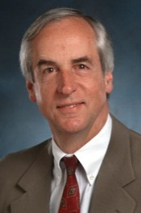**Hunter Ripley Rawlings III**

Hunter Ripley Rawlings III is President of the Association of American Universities. An American classics scholar and academic administrator, Rawlings served as the 17th President of the University of Iowa from 1982 until 1995 and as the 10th President of Cornell University from 1995 until 2003. He also served as Cornell's interim president in 2005-2006. Rawlings received his B.A. with honors in classics from Haverford College and received a Ph.D. in classics from Princeton University. After graduating from Princeton, he joined the faculty at the University of Colorado at Boulder, where he began his career in academic administration, serving as chairman of the classics department and later as associate vice chancellor for instruction.

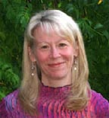**Geraldine Richmond**

Geraldine Richmond is the Richard M. and Patricia H. Noyes Professor in the Department of Chemistry at the University of Oregon. She has distinguished herself in research using nonlinear optical spectroscopy and computational methods applied to understanding the chemistry that occurs at complex surfaces and interfaces that have relevance to important problems in energy production, environmental remediation, atmospheric chemistry and biomolecular surfaces. Over 160 publications have resulted from this research. Richmond was appointed in 2012 by President Obama to the National Science Board. Richmond received her bachelor’s degree in chemistry from Kansas State University and her Ph.D. in chemical physics at the University of California, Berkeley, where she worked under the mentorship of George Pimentel.

**Richard H. Scheller**

Richard H. Scheller is Executive Vice President at Genentech Research & Early Development, where he oversees Genentech's discovery research through clinical proof of concept. He is a member of Genentech's Executive Committee and a member of the Enlarged Executive Committee of Roche. Scheller joined Genentech in 2001 as senior vice president of Research, became executive vice president of Research in September 2003, and was appointed chief scientific officer in 2008. He assumed his current responsibilities following the Roche merger in 2009. Scheller earned his bachelor’s degrees at the University of Wisconsin, Madison, and his Ph.D. in chemistry from the California Institute of Technology. Scheller is the 2010 recipient of the Kavli Prize in Neuroscience.

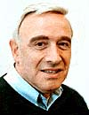**Joel I. Shulman**

Joel Shulman is an Adjunct Professor of Chemistry at the University of Cincinnati. He joined the research staff of the Procter & Gamble Company in 1970, working on the synthesis of biodegradable insecticides. From 1996 to 2001, he was Manager of External Relations and Associate Director of Corporate Research at P&G, with responsibilities for bringing new technical capabilities into the company. Included in his department were doctoral recruiting, university relations, interactions with government laboratories, and technology acquisition from Russia and China. He received a B.S. degree from The George Washington University and a Ph.D. from Harvard University, where he worked with E. J. Corey on development of new synthetic methodology.

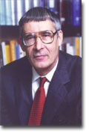**Peter J. Stang**   
Peter J. Stang is Distinguished Professor at The University of Utah and Editor-in-Chief of the *Journal of the American Chemical Society*. His research is focused on molecular architecture and supramolecular chemistry via self-assembly. Stang is the author of more than 450 publications. He earned his B.S. from DePaul University and his Ph.D. from the University of California, Berkeley. He is a fellow of the American Academy of Arts & Sciences and the American Association for the Advancement of Science, and a member of the National Academy of Sciences. Stang received the National Medal of Science in 2011. He will receive the Priestley Medal from the American Chemical Society in 2013.

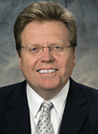**Matthew Tirrell**

Matthew Tirrell is the founding Pritzker Director of the University of Chicago’s Institute for Molecular Engineering. The institute, created in partnership with Argonne National Laboratory, will explore innovative technologies that address fundamental societal problems through modern advances in nanoscale manipulation and the ability to design at a molecular scale. Tirrell’s previous academic appointments include the University of Minnesota, the University of California, Santa Barbara, and the University of California, Berkeley. He received his bachelor’s degree in chemical engineering from Northwestern University and his doctoral degree in polymer science and engineering from the University of Massachusetts. He is a member of both the National Academy of Engineering and the American Academy of Arts and Sciences.

**George M. Whitesides**

George M. Whitesides is the Woodford L. and Ann A. Flowers University Professor at Harvard University. Prior to joining the Harvard faculty in 1982, he was a member of the faculty at the Massachusetts Institute of Technology for almost 20 years. His research encompasses four key areas: biochemistry, materials science, catalysis, and physical organic chemistry. Whitesides received his A.B. degree from Harvard University and a Ph.D. from the California Institute of Technology, with J.D. Roberts. He is the recipient of numerous awards, including the National Medal of Science, the Priestley Medal, the Othmer Gold Medal, and the King Faisal International Prize for Science. Stang is a member of the National Academy of Sciences, National Academy of Engineering, and the American Academy of Arts and Sciences.

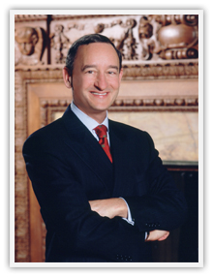**Mark S. Wrighton**  
Mark S. Wrighton is Chancellor and Professor of Chemistry at Washington University in St. Louis. He started his career at the Massachusetts Institute of Technology (MIT) in 1972, becoming Head of the Department of Chemistry and Provost during his tenure at MIT. He is the author or co-author of more than 400 articles published in professional and scholarly journals, and he has 14 patents. He has research interests in the areas of transition metal catalysis, photochemistry, surface chemistry, molecular electronics, and in photoprocesses at electrodes. Wrighton received his B.S. degree with honors in chemistry from Florida State University and did his graduate work at the California Institute of Technology. He is also a member of the Business-Higher Education Forum and past chair of the Association of American Universities.

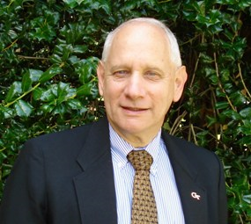**Gary B. Schuster, Special Advisor to the Commission**

Gary Schuster is Regents’ Professor and Vasser Woolley Professor of Chemistry and Biochemistry at Georgia Institute of Technology. He served at Georgia Tech as Dean of Sciences (1994-2006), Provost and Executive Vice President for Academic Affairs (2006-2010) and Interim President (2008-2009). Schuster holds a bachelor of science in chemistry from Clarkson College of Technology and a Ph.D. in chemistry from the University of Rochester. He joined Georgia Institute of Technology in 1994 after twenty years in the Chemistry Department at the University of Illinois, Champaign-Urbana. He was a NIH Post‑Doctoral Fellow at Columbia University, a Fellow of the Sloan Foundation and a Guggenheim Fellow. In 1993 he was recognized by the American Chemical Society with the A.C. Cope Scholar Award, and in 2006 he was awarded the ACS Charles Holmes Herty Medal. Schuster is a nationally known scholar and researcher with an extensive list of published articles on topics ranging from biochemistry through physical chemistry as well as a number of scientific discoveries with commercial applications.

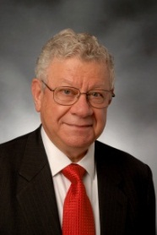 **Bassam Z. Shakhashiri, Special Advisor to the Commission**

**Bassam Z. Shakhashiri** is 2012 president of the American Chemical Society. The William T. Evjue Distinguished Chair for the Wisconsin Idea at the University of Wisconsin-Madison, he is former assistant director of the National Science Foundation for Science and Engineering Education and internationally noted for leadership in promoting excellence in science education. The *Encyclopedia Britannica* cites him as the “dean of lecture demonstrators in America.” Shakhashiri’s scholarly publications include the multi-volume series, *Chemical Demonstrations: A Handbook for Teachers of Chemistry*. He founded the Wisconsin Initiative for Science Literacy and serves as its director. He received his A.B. degree in chemistry from Boston University and M.Sc. and Ph.D. degrees in chemistry from the University of Maryland.