Local Section and Division E-Rosters

Contents
Downloading the Roster 2
Using the Roster Files 2
Adjust Column Widths 4
Sorting the Data 5
Making Labels 6
eRoster File Layout - Explanations 8
eRoster File Layout Activity Roster - Explanations 10
Activity Key 11

Downloading the Roster

This site contains several files:

Full Membership Roster
  - Activity Roster
  - Demographic Report
  - Student Chapters Report
  - Community Associates Report

The roster files can be converted to Excel to create mailing labels, generate email distribution lists, or target a specific population of your local section, technical division, or international chapter membership.

The files are comma-delimited format, which can be imported into many spreadsheet and database tools such as Excel. To import the file, you will have to refer to the software's instructions for opening comma-delimited files. NOTE: if your software identifies the file as Fixed Width, please change the setting to Delimited.

Using the Roster Files

Opening the file using Microsoft Excel

Open Excel

From File, choose open

Change the Files of Type box at the bottom or side of the Open Window to read “Text Files”.
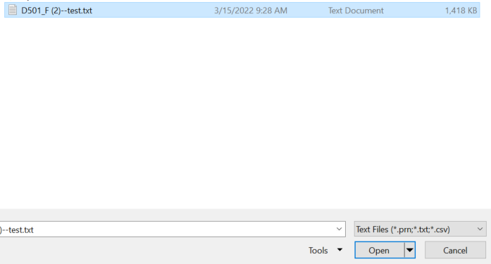

Navigate to the folder where you saved your roster file, select the file and click Open.

After you've opened the file, Excel will launch the Text Import Wizard:

Step 1 Select data type: Delimited Click on next
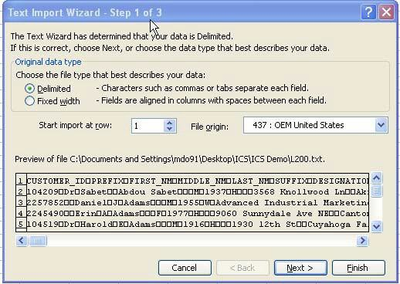

Step 2

Select Tab and Comma as Delimiters Click on Next
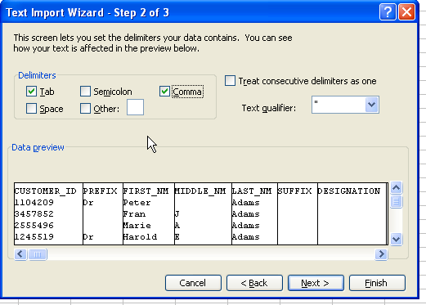

Step 3

Ensure that Customer_ID and Primary_Zipcode fields in the Data Preview is selected. Change Column Data format to Text (this will ensure that leading zeros in Customer_ID are maintained).
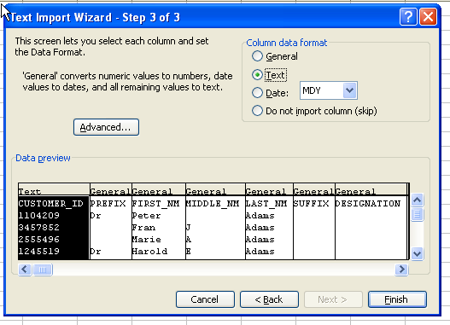

Click on Finish

Save the file as a standard spreadsheet Choose File, Save As, and save the data format to preferred file name.

Adjust Column Widths

Click on the upper left corner of the spreadsheet This will highlight the entire file Position your mouse between columns A&B and double-click.

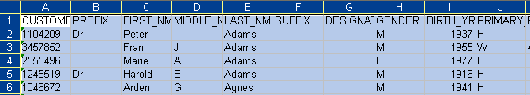
Before:

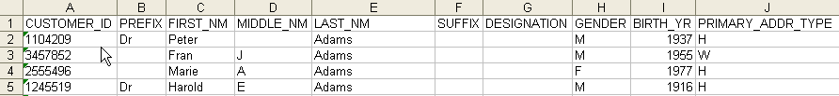
After:

Sorting the Data

Click on the upper left corner of the spreadsheet. This will highlight the entire file.

From the menu, chose Data, Sort.

Select the data field you would like to sort and click OK.

The sort window allows you to select which field you want to sort the data. You can sort up to three categories at one time with sub-sorts.

Making Labels

A mailing label template is designed for use with Avery Labels 5962. This label format will allow you to print 14 labels per page. Please download and save the mailing label template to the same directory as your roster files.

Please note: the template will default to a specific data source that is not on your computer. To change the data source, please follow the below steps:

Open the Mailing Label Template

A Dialog Box will prompt you to run SQL Command. Click Yes

You will receive an error message that says “Operations can not be completed due to database engine failure.

Click OK to find a new Source

Navigate to folder where you saved your converted roster file and select the file.

Click Open. The label merge template will look like this:
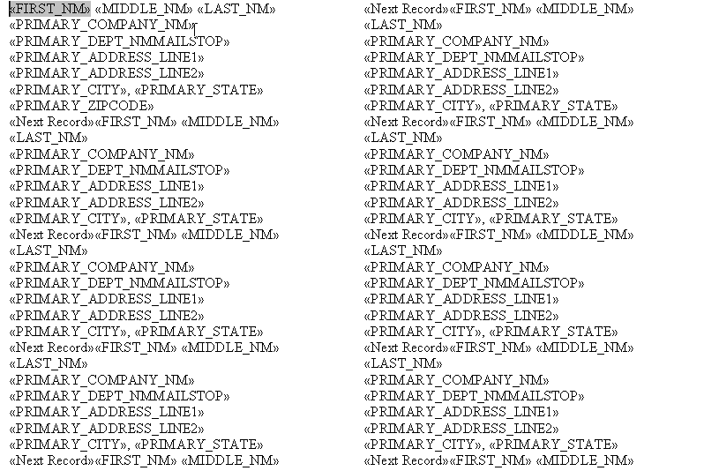

The mail merge toolbar should display at the top of the screen.

If this does not appear, select: Tools, Letters and Mailings, Show Mail Merge Toolbar

Click on one of the following icons to merge the labels to a new document or directly to your printer:

Please email olsa@acs.org for questions or comments.

7

eRoster File Layout - Explanations

Field order Field Name Explanation
  - CUSTOMER_ID ACS Membership Number
  - PREFIX Dr. Mrs. Mr., etc
  - FIRST_NM
  - MIDDLE_NM Middle Name or Middle Initial
  - LAST_NM
  - SUFFIX Jr. Sr., III, etc.
  - DESIGNATION Ph.D, Ed, MD, etc
  - GENDER M, F, (null)
  - BIRTH_YR
  - PRIMARY_ADDR_TYPE H = Home, W = Work
  - PRIMARY_COMPANY_NM
  - PRIMARY_DEPT_NM/MAILSTOP
  - PRIMARY_ADDRESS_LINE#1
  - PRIMARY_ADDRESS_LINE#2
  - PRIMARY_CITY
  - PRIMARY_STATE
  - PRIMARY_ZIPCODE
  - PRIMARY_COUNTRY
  - PRIMARY_ONHOLD_FL Y = Address is "on hold"
  - PRIMARY_ONHOLD_TYPE Reason Address is "on hold"

  - WK_PREF_ADDR_FL

  - WK_COMPANY_NM
Y = Work is Preferred Address N = Work is not Preferred Address

  - WK_DEPT_NM/MAILSTOP Department Name and/or Mailstop
  - WK_ADDRESS_LINE#1
  - WK_ADDRESS_LINE#2
  - WK_CITY
  - WK_STATE
  - WK_ZIPCODE
  - WK_COUNTRY
  - WK_ONHOLD_FL Y = Address is "on hold"
  - WK_ONHOLD_TYPE Reason Address is "on hold"
  - WK_PHONE WITH EXT Phone Number with Extension
  - WK_FAX WITH EXT Fax Number with Extension
  - HM_PREF_ADDR_FL Y= Home is Preferred Address, N = Home is not Preferred Address.

  - HM_ADDRESS_DEPT_NM/MAILSTOP

  - HM_ADDRESS_LINE#1
  - HM_ADDRESS_LINE#2
  - HM_CITY
  - HM_STATE
  - HM_ZIPCODE
  - HM_COUNTRY
(Normally blank field for home address, may exist for students and those in the military)

  - HM_ONHOLD_FL Y = Address is "on hold"
  - HM_ONHOLD_TYPE Reason Address is "on hold"
  - HM_PHONE WITH EXT
  - EMAIL_ADDR
  - EMAIL_CHG_DT Date Present indicates email address has been changed

  - EMAIL_PROMO_OPT_OUT_FL

  - MEMBER_CATEGORY
Y = Do not use email for Promotional Mailings; OK to send regular section mailings (newsletters, meeting notices, etc.)
Regular, Associate, Affiliate, etc

  - NA_MEMBER_TYPE Regular, Student, National Affiliate, Emeritus
  - MEMBER_PACKAGE_CODE
  - CHAP_EFFECTIVE_DT Effective Date of Paid Chapter Membership
  - CHAP_EXPIRE_DT_ACT Expire Date of Paid Chapter Membership
  - LS_ID (Division Roster Only) Local Section ID for Division Member
  - CHAP_ORIG_JOIN_YR Chapter Join Year
  - NA_ORIG_JOIN_YR National Membership Join Year

  - FREE_DIVISION_FL (Division Roster Only)

CHAP_PAY_STATUS_CD*

NA_PAY_STATUS_CD*

CHAP_YRS_SVC*

NA_YRS_SVC*

CHEMISTRY DEGREE*

NON CHEMISTRY DEGREE*
Y= Free Division for 1st year of Membership

  - DIR_SURVEY_OPT_IN_FL Y= May include member information in directory
  - ALPHA_SORT Last Name, First Name, MI
  - AGFD Y = Member of Division
  - ANYL Y = Member of Division
  - BIOL Y = Member of Division
  - CARB Y = Member of Division
  - CELL Y = Member of Division
  - CHED Y = Member of Division
  - CINF Y = Member of Division
  - BMGT Y = Member of Division
  - COLL Y = Member of Division
  - COMP Y = Member of Division
  - ENVR Y = Member of Division
  - FLU0 Y = Member of Division
  - FUEL Y = Member of Division
  - HIST Y = Member of Division
  - I&EC Y = Member of Division
  - INOR Y = Member of Division
  - MEDI Y = Member of Division
  - BIOT Y = Member of Division
  - NUCL Y = Member of Division
  - ORGN Y = Member of Division
  - PMSE Y = Member of Division
  - AGRO Y = Member of Division
  - PETR Y = Member of Division
  - PHYS Y = Member of Division
  - POLY Y = Member of Division
  - PROF Y = Member of Division
  - RUBB Y = Member of Division
  - CHAS Y = Member of Division
  - GEOC Y = Member of Division
  - SCHB Y = Member of Division
  - CHAL Y = Member of Division
  - TECH Y = Member of Division
  - TOXI Y = Member of Division

*Field Not Currently Available

eRoster File Layout Activity Roster - Explanations

CUSTOMER_ID ACS Membership Number
CHANGE_REASON_CD See Description Below
ACTIVITY See Description Below
PREFIX Dr. Mrs. Mr. etc.
FIRST_NM MIDDLE_NM LAST_NM
SUFFIX Jr. Sr. III, etc.
DESIGNATION Ph.D, Ed, MD etc.
PRIMARY_ADDR_TYPE Home, Work PRIMARY_COMPANY_NM PRIMARY_DEPT_NM/MAILSTOP PRIMARY_ADDRESS_LINE#1 PRIMARY_ADDRESS_LINE#2
PRIMARY_CITY PRIMARY_STATE PRIMARY_ZIPCODE PRIMARY_COUNTRY
PRIMARY_ONHOLD_FL Y= Address on hold PRIMARY_ONHOLD_TYPE Reason Address is on hold WK_PRF_ADDR_FL Work is preferred address (Yes or No) WK_COMPANY_NM
WK_DEPT_NM/MAILSTOP WK_ADDRESS_LINE#1 WK_ADDRESS_LINE#2 WK_CITY
WK_STATE WK_ZIPCODE WK_COUNTRY WK_ONHOLD_FL WK_ONHOLD_TYPE
HOME_PRF_ADDR_FL Home is preferred address (Yes or No) HOME_DEPT_NM/MAILSTOP
HM_ADDRESS_LINE#1 HM_ADDRESS_LINE#2 HM_CITY
HM_STATE HM_ZIPCODE HM_COUNTRY HM_ONHOLD_FL HM_ONHOLD_TYPE EMAIL_ADDR
EMAIL_CHG_DT Date of email change EMAIL_PROMO_OPT_OUT_FL Y= Do not use for Promotion Mailings;
OK to send regular mailings (newsletters, meeting notices, etc)

MBR_TERMINATE_DT Date of Termination

Activity Key

Address Change – Address changes that occurred during roster period. DD – (Deceased) Deceased members or affiliates during roster period.

New – Members who have joined the division or local section during the reporting period. Includes members that are new to the Society as well as existing members that joined the division or local section during the reporting month.

RI – (Reinstated) National Members who have reinstated during roster period.

TD – (Terminate Division) Includes division cancellations, free-division expirations and terminations due to non-payment.

TN – (Terminate National) Local Section Roster Only. Member termination of national membership also terminates local section membership.

TO – (Transfer Out) Members that have changed local section due to address change or other request.

Note: Members may be listed multiple times in the activity roster if more than one activity applies.

