October/November 2015 Teacher's Guide for

Light in the Cellar of the Sea

Table of Contents

About the Guide 2
Student Questions 3
Answers to Student Questions 3
Anticipation Guide 5
Reading Strategies 6
Background Information 9
Connections to Chemistry Concepts 19
Possible Student Misconceptions 19
Anticipating Student Questions 19
In-Class Activities 20
Out-of-Class Activities and Projects 21
References 21
Web Sites for Additional Information 23

About the Guide

Teacher’s Guide editors William Bleam, Regis Goode, Donald McKinney, Barbara Sitzman and Ronald Tempest created the Teacher’s Guide article material. E-mail: bbleam@verizon.net

Susan Cooper prepared the anticipation and reading guides.

Patrice Pages, ChemMatters editor, coordinated production and prepared the Teacher’s Guide. E-mail: chemmatters@acs.org

Articles from past issues of ChemMatters can be accessed from a DVD that is available from the American Chemical Society for $42. The DVD contains the entire 30-year publication of ChemMatters issues, from February 1983 to April 2013.

The ChemMatters DVD also includes Article, Title and Keyword Indexes that covers all issues from February 1983 to April 2013.

The ChemMatters DVD can be purchased by calling 1-800-227-5558.

Purchase information can be found online at www.acs.org/chemmatters.

Student Questions
  - List three (3) ways marine organisms emit light.
  - How does the midshipman fish hide from its prey?
  - Explain why so many red and black fish exist in the twilight zone of the ocean?
  - Why is there no red light below 6 meters in the ocean but there is blue light at 35 meters?
  - Based on Figure 1, which wavelengths of light fade fastest underwater?
  - Explain why white objects appear white and black objects appear black.
  - Name the three chemical substances required to produce bioluminescence.
  - What event caused Edith Widder to decide to study bioluminescence?
  - Why did Karen Osborn name the nearly transparent worm Swima bombiviridis?
  - Explain how Dr. Widder uses bioluminescence to detect water pollution.
  - List three (3) characteristics of mantis shrimp’s vision.

Answers to Student Questions
    - List three (3) ways marine organisms emit light.
Marine organisms emit light by
      - flashing or flickering,
      - emitting sparkles (“light bombs”), and
      - glowing.
    - How does the midshipman fish hide from its prey?
The light produced by the midshipman fish helps to hide it from prey. The glow “radiates from its belly and blends in with a hint of moonlight, masking the shadow and silhouette of the fish.”
    - Explain why so many red and black fish exist in the twilight zone of the ocean.
Since red light does not penetrate very far beneath the surface of the ocean there is no red light to reflect off of the red fish so they appear black in the black water as do the black fish. These fish are not visible at depths associated with the twilight zone.
    - Why is there no red light below 6 meters in the ocean but there is blue light at 35 meters?
Red light has the longest wavelength, the least energy of visible light, and is filtered out first. Blue light, with the shortest wavelength, penetrates the ocean water best.
    - Based on Figure 1 which wavelengths of light fade fastest underwater?
Based on Figure 1, Infrared and ultraviolet light fade away first.
    - Explain why white objects appear white and black objects appear black.
“White objects appear white because they reflect all colors of light in the visible spectrum. Black objects appear black because they absorb all colors of light [in the visible spectrum].”
    - Name the three chemical substances required to produce bioluminescence
The three chemical substances required to produce bioluminescence are
      - luciferin,
      - oxygen, and
      - luciferase.
    - What event caused Edith Widder to decide to study bioluminescence?
The event that convinced Edith Widder to study bioluminescence was when she dove in a one-person submersible. During that dive she was so impressed by the bioluminescent light show that she decided to study the phenomenon.
    - Why did Karen Osborn name the nearly transparent worm Swima bombiviridis?
When Karen Osborn gently pinched the nearly transparent worm it shot out tiny bombs that burst into brilliant green light. Swima bombiviridis is Latin for “green bomber.”
    - Explain how Dr. Widder uses bioluminescence to detect water pollution.
To detect water pollution, Dr. Widder mixes glowing bacteria with mud samples from the Indian River Lagoon in Florida. When the water is toxic the glowing solution is dimmer. The toxic substances in the water are killing the bacteria, which is indicated by the dimmer glow.
    - List three (3) characteristics of mantis shrimps’ vision.
The mantis shrimp eyes
      - have four times as many specialized photocells in their retinas as humans,
      - have three pupils, and
      - can see polarized light (which humans cannot see).
    - Based on Figure 1, which wavelengths of light fade fastest underwater?
Infrared and ultraviolet light fade away first.

Anticipation Guide
Anticipation guides help engage students by activating prior knowledge and stimulating student interest before reading. If class time permits, discuss students’ responses to each statement before reading each article. As they read, students should look for evidence supporting or refuting their initial responses.

Directions: Before reading, in the first column, write “A” or “D,” indicating your agreement or disagreement with each statement. As you read, compare your opinions with information from the article. In the space under each statement, cite information from the article that supports or refutes your original ideas.

Me | Text | Statement
 |  | - Very few deep-sea creatures emit light.
 |  | - The sun’s rays penetrate the ocean to a depth of about 100 meters.
 |  | - Red light penetrates water better than blue light.
 |  | - A red fish reflects red light and absorbs all other colors.
 |  | - Bioluminescence is a chemical reaction requiring oxygen.
 |  | - When excited electrons return to their original energy levels they absorblight energy.
 |  | - Students can contribute to keeping track of marine life on citizen science websites.
 |  | - Bioluminescence can be used to detect water pollution.
 |  | - Cancerous tissue reflects light differently than healthy tissue.
 |  | - Mantis shrimp’s eyes are much more complex than those of any other animal.

Reading Strategies
These graphic organizers are provided to help students locate and analyze information from the articles. Students’ understanding will be enhanced when they explore and evaluate the information themselves, with input from the teacher if students are struggling. Encourage students to use their own words and avoid copying entire sentences from the articles. The use of bullets helps them do this. If you use these reading strategies to evaluate student performance, you may want to develop a grading rubric such as the one below.

Score | Description | Evidence
4 | Excellent | Complete; details provided; demonstrates deep understanding.
3 | Good | Complete; few details provided; demonstrates some understanding.
2 | Fair | Incomplete; few details provided; some misconceptions evident.
1 | Poor | Very incomplete; no details provided; many misconceptions evident.
0 | Not acceptable | So incomplete that no judgment can be made about student understanding

Teaching Strategies:

- Links to Common Core Standards for Reading:
  - ELA-Literacy.RST.9-10.5: Analyze the structure of the relationships among concepts in a text, including relationships among key terms (e.g., force, friction, reaction force, energy).
  - ELA-Literacy.RST.11-12.4: Determine the meaning of symbols, key terms, and other domain-specific words and phrases as they are used in a specific scientific or technical context relevant to grades 11-12 texts and topics.

- Links to Common Core Standards for Writing:
  - ELA-Literacy.WHST.9-10.2F: Provide a concluding statement or section that follows from and supports the information or explanation presented (e.g., articulating implications or the significance of the topic).
  - ELA-Literacy.WHST.11-12.1E: Provide a concluding statement or section that follows from or supports the argument presented.

- Vocabulary and concepts that are reinforced in this issue:

  - Solution chemistry
  - Chemical equilibrium
  - Acids and bases
  - pH
  - Buffers
  - Molecular structures

- The infographic about autumn leaves on page 19 will engage students with more information about some of the natural dyes found in “Eating With Your Eyes.”

- To help students engage with the text, ask students which article engaged them most and why, or what questions they still have about the articles. The Background Information in the ChemMatters Teachers Guide has suggestions for further research and activities.
Directions: As you read the article, complete the graphic organizer below using your own words to describe how each sea creature uses light in the deep ocean.

Sea creature | How it uses light
Midshipman fish
Cookiecutter shark
Female anglerfish
Swima bombiviridis
Mantis shrimp
Add a creature not mentioned above

- In the graphic organizer below, tell how two scientists are studying deep-sea organisms to improve human life:

Scientist | Organism studied | How the study helps humans

- Summary: On the back of this paper, write a sentence describing something you learned from the article, and why the information is important to you.

Background Information
(teacher information)
More on Bioluminescence

Bioluminescence is a type of chemiluminescence, which is light produced by a chemical reaction. In Bioluminescence the chemical reaction occurs in a living organism. Chemiluminescence and bioluminescence is considered “cold light” because less than 20% of the light produces heat. This makes it very efficient since energy is not lost as heat. Bioluminescence is found both on land as well as in the sea, however it is far more common in the ocean. It is the result of the chemical reaction between luciferin and luciferase, as reported by National Geographic:

The chemical reaction that results in bioluminescence requires two unique chemicals: luciferin and either luciferase or photoprotein. Luciferin is the compound that actually produces light. In a chemical reaction, luciferin is called the substrate. The bioluminescent color (yellow in fireflies, greenish in lanternfish) is a result of the arrangement of luciferin molecules.

(http://education.nationalgeographic.com/education/encyclopedia/bioluminescence/?ar_a=1)

Although the general method of the bioluminescent reaction is similar, there are more than a dozen different mechanisms used by different organisms. This leads scientists to believe that bioluminescence may have evolved separately among different organisms.

It should be noted that luciferin in not one substance or even a class of compounds. Luciferin is a name given to a compound in a living organism that has the special property of producing light when it loses electrons. Look at the figures below for several different examples of luciferins:

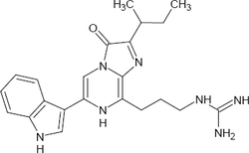

Crustacean luciferin

(http://bioluminescenceintromarinebio.weebly.com/uploads/3/8/6/0/38600933/844757951.png?250)

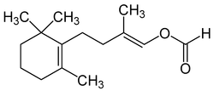

Latia luciferin of a freshwater snail
(http://bioluminescenceintromarinebio.weebly.com/uploads/3/8/6/0/38600933/237999759.png?250)

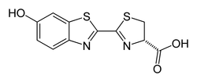

Firefly luciferin

(http://bioluminescenceintromarinebio.weebly.com/uploads/3/8/6/0/38600933/834434594.png?250)

Luciferase is an enzyme/catalyst that reacts with the substrate to oxidize the luciferin and produce light. Most organisms produce light with the luciferin/luciferase chemical reaction system, but some use photoproteins instead of the luciferase. Photoproteins combine with the luciferin, oxygen and generally a cation like calcium to produce light. Photoproteins have just recently been discovered and are still being studied by chemists to understand their properties.

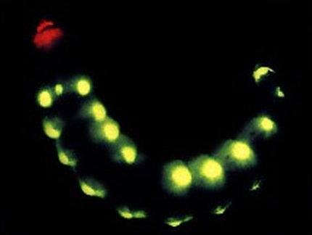
Many living organisms produce their own luciferin while others must absorb it from food or other oragnisms. Not all bioluminescence is the same color and depends on the organism and their habitat. Most marine organisms produce light in the blue- green (475 nm–510 nm) part of the visible spectrum. This light is most readily seen in the deep oceans since it travels well through water without being absorbed. Many land organisms also produce blue-green light, but many also glow in the yellow (570 nm) region of the spectum. Fireflies for example glow in the yellow region. There are a few organizims that produce more than one color of light. The “railroad worm,” which is a larva of a female beetle, produces red light on its head and its body glows green. Diffferent luciferins cause the variety of colors produced by different organisms.
Railroad worm (http://bogleech.com/nature/beetle-glowworm.jpg)

There are many different types of bioluminescence and they serve many different purposes, some of which scientest do not understand and some they can only speculate about. The following table outlines some of the varied functions of bioluminescence.

Purpose/Explanation | Examples
Communication: Used especially when locating a mate | Fireflies, ostracods (small shrimplike crustaceans)
Illumination: In the depths of the ocean some species of fish use bioluminescence to locate their prey | Flashlight fish, dragonfishes
Attracting prey: Some use light to lure their prey. | Anglerfishes, cookie cutter shark
Camouflage or Counter-illumination: Many ocean predators hunt from below. They look for where the sunlight creates a shadow below the prey. The biolumination camouflages the shadow. | Hatchetfish, squid
Self-defense: Some animals release a bioluminescent cloud when threatened. Others flash a bright light to blind their predators. | Dinoflagellates, some jelly fish, vampire squid

(This table was created using information from the following sites: http://animals.howstuffworks.com/animal-facts/bioluminescence2.htm,
http://biolum.eemb.ucsb.edu/functions.html, and
http://education.nationalgeographic.com/education/encyclopedia/bioluminescence/?ar_a=1.)

More on catalysts and enzymes

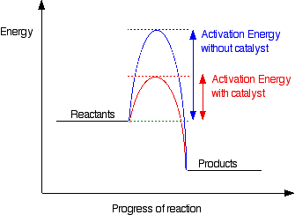
A catalyst is a substance that increases the rate of a chemical reaction but is not consumed in the reaction. An enzyme is a type of catalyst. For a reaction to occur the particles must collide and collide with sufficient energy to break bonds. The minimum energy required to break bonds is known as the activation energy. In order to increase the rate of a reaction the number of successful collisions must be increased. One way to accomplish that is to lower the activation energy. A catalyst provides an alternative mechanism for the reaction which has a new, lower activation energy requirement, thus speeding up the reaction.
(http://chemwiki.ucdavis.edu/@api/deki/files/15862/)

Enzymes are biological catalysts, meaning they are organic substances produced by a living organism. Just like non-enzymatic catalyst, enzymes speed up a reaction by lowering the activation energy but do so more dramatically than do other catalysts. A comparison of properties are given in the table below.

Feature | Non-biological Catalyst | Enzyme
Specificity | Not specific | Highly specific
Molecular weight | Low molecular weight substances | High molecular weight globular proteins.
Rate of reaction | Increases rate by a factor of 10³–10⁶ | Increases the rate only a fraction of that of enzymes
Chemical nature | Metal and nonmetal inorganic substances | Organic substances, generally proteins
Side reactions | Occur | Do not occur
Conditions where effective | High temperatures, high pressures | Mild temperatures and pressures

(This table was created using information from the following sites:
http://www.diffen.com/difference/Catalyst_vs_Enzyme and
http://www.yourarticlelibrary.com/biology/enzyme/comparison-between-enzymes-and-non-biological-catalysts/33694/.)

More on light and the ocean

Light is electromagnetic radiation and is actually properly referred to as visible light. Visible light has wavelengths between 400 and 700 nanometers. Each wavelength produces a different color; the longest wavelength is red and the shortest is violet. The higher the energy the shorter the wavelength and the higher the frequency.

When light strikes a substance it can do one of three things. It can be reflected, refracted or absorbed. In reflection the light bounces off a smooth surface, like a mirror. The reflected ray bounces off at the same angle at which it hit the smooth surface. If the surface is not smooth the light is reflected in a variety of different angles and it is scattered. When light passes from one transparent medium to another, such as from air to water, it is refracted. The light changes speed and the light ray bends when this happens. In opaque objects light is absorbed, either wholly or just certain wavelengths, and the energy is converted into heat.

When sunlight hits the ocean only 2% of it is reflected and most is transmitted into the water. In the water the speed of light is slowed to 2.25×10⁸ m/s (in air light it travels at 3.0 x10⁸ m/s). This sunlight transmitted to the ocean is important because it heats the surface layer of water, provides energy for phytoplankton, and is used for navigation by animals near the surface. Under the right conditions light may travel 1000 meters into the ocean but in reality there is very little light beyond 200 meters.

The ocean is divided into three zones based on depth and light level. The upper 200 meters (656 feet) of the ocean is called the euphotic, or "sunlight," zone. This zone contains the vast majority of commercial fisheries and is home to many protected marine mammals and sea turtles.

Only a small amount of light penetrates beyond this depth.

The zone between 200 meters (656 feet) and 1,000 meters (3,280 feet) is usually referred to as the “twilight” zone, but is officially the dysphotic zone. In this zone, the intensity of light rapidly dissipates as depth increases. Such a miniscule amount of light penetrates beyond a depth of 200 meters that photosynthesis is no longer possible.

The aphotic, or “midnight,” zone exists in depths below 1,000 meters (3,280 feet). Sunlight does not penetrate to these depths and the zone is bathed in darkness.

(http://oceanservice.noaa.gov/facts/light_travel.html)

The white sunlight striking the ocean contains all the color of the visible spectrum, red, orange, yellow, green, blue and violet. Red has the longest wavelength and therefore the least amount of energy. Red light penetrates the water the least. As the wavelength shorten the light is better able to penetrate the water, so blue light penetrates the ocean best. Since all the red light is absorbed by the water oceans appear blue.

More on luminescence, light emitting processes, luminol and light sticks

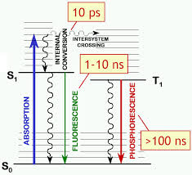
Luminescence is the emission of light that is not the result of high temperatures (e.g., incandescence). It is what is referred to as cold body radiation and occurs after a substance absorbs energy from a source such as electromagnetic radiation, electron beams, chemical reactions, or friction. The absorbed energy lifts an electron from its ground state to a higher energy state, an excited state. Since the excited state is unstable, the electron undergoes other transitions to return to the ground state. Some of the absorbed energy is then released in the form of light.
(http://people.bridgewater.edu/~koverway/courses/CHEM445/ppts/I_Chapt15Fluorescence.pdf)

Light Emitting Processes: The table below provides a list of some common light emitting processes.

Source | Explanation | Example
Bioluminescence/ chemiluminescence | Light produced by a chemical reactions | Fireflies, flashlight fish, light sticks
Fluorescence | An object absorbs electromagnetic radiation of one frequency and immediately reemits light of a different frequency | Fluorescent lights
Phosphorescence | Similar to fluorescence but light is emitted over a longer period of time | “glow in the dark” minerals
Incandescence | An object is heated until it produces electromagnetic radiation including visible light | Incandescent light bulb, candle flames
Triboluminescence | Light caused by the excitation of electrons during the rubbing, crushing, or tearing of a material | Crushing of sugar crystals

Luminol is a common chemiluminescent material. It is used by forensic scientists to detect blood at crime scenes. The iron in the blood serves as the catalyst for the luminol reaction. The production of light from luminol is a fairly complex redox reaction. In an alkaline solution luminol exists in equilibrium with its anion. The anion exists in two forms with the negative charges delocalized on either the oxygen atoms, the enol form, or the nitrogen atoms, the ketol form. Oxygen will react with the enol form and oxidizes it to a cyclic peroxide. The oxygen is produced in the decomposition reaction of hydrogen peroxide in the presence of a catalyst such as an iron compound.
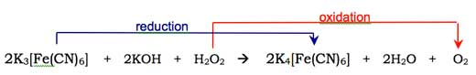
(http://www.scienceinschool.org/2011/issue19/chemiluminescence)

The cyclic peroxide is very unstable and immediately decomposes with the loss of nitrogen to produce 3-aminophthalic acid with electrons in an excited state. Energy is released as blue light when the electrons return to the ground state.

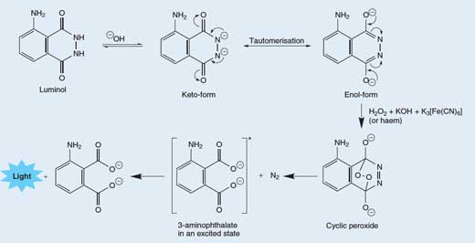

(http://www.scienceinschool.org/2011/issue19/chemiluminescence)

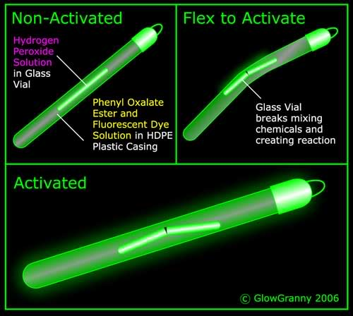
Light sticks, also known as glow sticks, are used as entertainment and as toys but they are also used as light sources and light markers by the military, campers and divers. The chemiluminescent light they produce is also a result of an oxidation/reduction reaction. Light sticks are composed of two separate compartments each containing different chemical solutions.

The inner compartment is made of a thin glass tube containing hydrogen peroxide. The outer plastic tube contains a mixture of diphenyl oxalate and a dye, whose identity varies, depending on the desired color. The separate compartments keep the solutions from mixing and reacting. Bending the light stick breaks the inner glass tube releasing the hydrogen peroxide and starting the redox reaction.
(http://i288.photobucket.com/albums/ll176/cheerleaderchick2856/How-Glow-Sticks-Work-Image-.jpg)

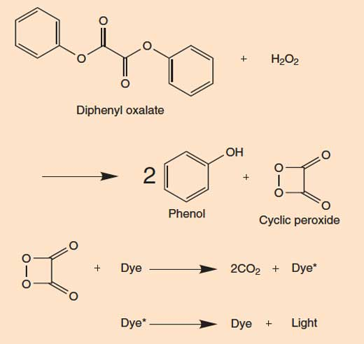
The hydrogen peroxide oxidizes the diphenyl oxalate and produces phenol and a cyclic peroxide (1,2-dioxetanedione). The new, cyclic peroxide is unstable and quickly decomposes into carbon dioxide, releasing energy in the process. The energy is absorbed by the dye molecule causing electrons in the dye molecule to be excited. When the electrons return to the ground state the energy is relased as a photon of visible light.
(http://www.scienceinschool.org/2011/issue19/chemiluminescence)

More on Edith Widder

Edith Widder was born in Arlington, Massachusetts in 1951 to Dr. Vera Widder and Dr. David Widder. Both parents were mathematicians. Her father was a professor at Harvard University. Edith Widder received her Bachelors of Science degree in biology from Tufts University (1973) where she graduated Magna cum laude. She earned her M.S. degree in biochemistry (1977) and her PhD in neurobiology (1982) from the University of California, Santa Barbara.
Dr. Edith Widder

(http://oceanexplorer.noaa.gov/edu/oceanage/04widder/widder1.jpg)

Dr. Widder became certified as a Scientific Research Pilot for Atmospheric Diving Systems. She is qualified to dive the deep diving suit WASP, a self-contained hard suit that incorporates propulsion units. She also became certified to dive in the single-person, untethered submersibles DEEP ROVER and DEEP WORKER. As a result of the dives she took, she became fascinated with bioluminescence.

From 1989–2005, Dr. Widder was a senior scientist and director of the Bioluminescence Department at Harbor Branch Oceanographic Institution in Florida. In 2005 Edith Widder co-founded the Ocean Research & Conservation Action (ORCA). ORCA is a non-profit organization dedicated to the protection and restoration of marine ecosystems and the species found there. According to the ORCA Web site they “have achieved exciting progress in using the latest technologies to develop low-cost solutions for analysis of our polluted waterways.” (http://www.teamorca.org/cfiles/about_orca.cfm)

In 2006 Dr. Widder was awarded the MacArthur Fellowship from the John D. and Catherin T. MacArthur Foundation. “The MacArthur Fellowship is a five-year grant to individuals who show exceptional creativity in their work and the prospect for still more in the future.” (https://www.macfound.org/fellows-faq/)

As a specialist in bioluminescence Dr. Widder has been instrumental in the invention and development of equipment to unobtrusively investigate the deep sea. According to her biography on the ORCA Web site,

Working with engineers, she has conceived of and built several unique devices that enable humans to see beneath the waves in new ways, including HIDEX, a bathyphotometer which is the U.S. Navy standard for measuring bioluminescence in the ocean; important information for keeping submarines hidden from above. Edie also built LoLAR, an ultrasensitive deep-sea light meter that measures light in the deep ocean, both dim down-welling sunlight and bioluminescence – both important determinants of animal distribution patterns. Most recently, Widder created a remotely operated deep-sea camera system, known as ORCA’s Eye-in-the-Sea (EITS), which, when deployed on the sea floor, automatically detects and measures the bioluminescence of nearby organisms. EITS has produced footage of rare sharks, jellyfish, and discovered a new species of large squid (over six feet in length), all in their natural habitats.

(http://www.teamorca.org/cfiles/about_edie.cfm)

More on the green fluorescent protein

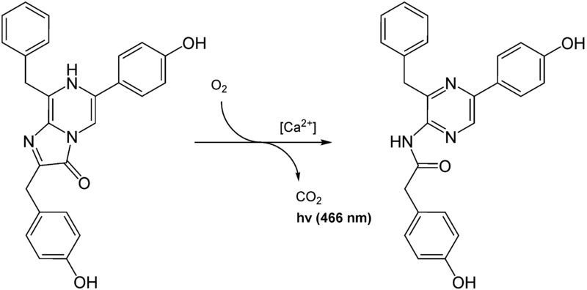
In 2008 Martin Chalfie, Osamu Shimonura and Roger Tsien received the Nobel Prize in chemistry for their discovery and development of the green fluorescent protein. Although this protein has been around for over 150 million years it was not studied until 1961 when Osamu Shirmomura decided to study what made the crystal jellyfish (Aequorea victoria) glow. Working out of the Marine Biological Laboratory in Woods Hole, Mass. he identified a molecule in the emitted blue light when in the presence of calcium ions, Ca²⁺, but the jelly fish emitted green light.
Aequorin in the presence of calcium ions

(https://upload.wikimedia.org/wikipedia/commons/thumb/8/8b/CoelenterazinTOCoelenteramid.png/800px-CoelenterazinTOCoelenteramid.png)

They eventually (1974) found the green fluorescent protein, GFP, in the jelly fish. The GFP absorbed the blue light produced by the aequorin and emitted the green light in response.

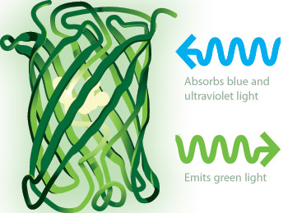

Green Fluorescent Protein

(http://www.nobelprize.org/nobel_prizes/chemistry/laureates/2008/che_illpress_2008_gfp_protein.jpg)

In 1987 Douglas Prasher thought it might be possible to attach the GFP to specific proteins such as virus or cancer cells. By 1992 Prasher cloned the GRP gene, which was the first step in using GFP as a tracer chemical. Unfortunately Prasher lost the funding for his grant and was forced to leave Woods Hole. Before he left he gave the gene to his colleagues Chalfie and Tsien.

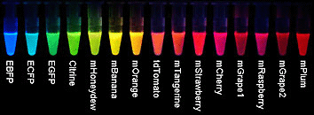
Martin Chalfie inserted the gene into bacteria and within a month saw a green glow under a microscope that demonstrated that the GFP could be inserted into an organism. This became a powerful research tool. Roger Tsien continued the research with the GFP and was responsible for much of the understanding of how the GFP works. He was able to modify the GFP gene and create mutants of GFP. These mutants start fluorescing faster than the natural type. They are also brighter and with different colors. This made it possible for researchers to track more than one protein at a time by attaching different mutant fluorescent proteins to different proteins in a cell.
Tsien’s different fluorescent proteins
(http://www.conncoll.edu/ccacad/zimmer/GFP-ww/images/tsien2.gif)

Applications of GFPs

The discovery of the GFP and its mutations has led to many scientific applications and discoveries. Jeff Lichtman and Josua Sanes, professors at Harvard University in the Brain Center, inserted yellow, cyan and red fluorescent proteins inside the DNA of the brain cells of mice. The cells then produce enough of the protein to glow.

Each cell glowed in a different color based on how many yellow, cyan and red fluorescent proteins were produced in that cell. This way, the scientists were able to produce a mouse brain in which cells glowed in nearly 90 different colors. The scientists called these mice “Brainbow mice”.

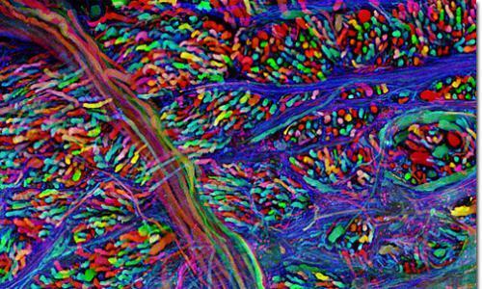
The distinct colors of Brainbow mice can help researchers see individual cells and sort out how they connect with one another. By comparing brain samples from healthy mice with those of mice in which diseases are induced, the scientists hope to better understand what goes wrong in people with debilitating diseases such as Alzheimer’s and Parkinson’s diseases.
Brainstem – Brainbow mouse
(http://cbs.fas.harvard.edu/science/connectome-project/brainbow, picture 11)

(Zajac, L. Glowing Proteins with Promising Biological and Medical Applications. ChemMatters, 2008, 25 (4), pp 12–14)

This technique allows for the mapping of the neural circuits of the brain since individually colored neurons will help define the complex tangle of neurons in the brain and the nervous system.

Using fluorescent proteins researchers at the University of Cambridge have studied the cause of water retentions and constipation during pregnancy. Fruit flies experience the same problems so Dr. Irene Aliaga and her colleagues created genetically modified fruit flies with intestinal neurons that light up when they are used.

According to the fluorescent intestinal neurons and fruit fly poop analysis it's the fruit fly dad who is responsible for that bloated feeling experienced by the pregnant mom. During copulation he passes along his sperm as well as some hormones. One of the hormones switches on a set of intestinal neurons that are responsible for slowing down the gut emptying rate, resulting in constipation, and so even though pregnant fruit flies are eating more food during pregnancy the contents of their intestines become more concentrated. This allows the pregnant mother to absorb the maximum amount of nutrition. The same hormones also result in water retention and bloating

Similar behavior is observed in humans. And the color-coding of the neurons in fruit flies actually helps us understand it. So if you are pregnant, bloated and constipated, it might be good to know that the food you crave isn't responsible for your discomfort, it's a healthy dose of evolution and sex hormones ensuring that the fetus maximizes its nutritional absorption.

(http://www.conncoll.edu/ccacad/zimmer/GFP-ww/cooluses26.html)

The study of cancer has been advanced by the use of fluorescent proteins. Robert Hoffman, professor at the University of California at San Diego, developed imaging techniques using fluorescent proteins that are used in cancer research. Cancers that contain fluorescent proteins can be implanted into mice. The cancer cells can easily be observed and monitored in the live mice. Researchers can observe how the cancer cells grow and migrate in the blood vessels, how they bind to healthy cells and how the cancer cells change DNA. In addition researchers can monitor how drugs affect the cancer cells, allowing for the design of better drugs to fight cancers.

Connections to Chemistry Concepts
- Light and the spectrum—Not only is bioluminescence described as the production of light by a chemical reaction in a living organism, but the absorption and reflection of light is discussed in this article. The article also explains how various colors of light travel through the ocean.
- Organic chemistry—The luciferin and the luciferase are organic structures.
- Enzymes/Catalyst—Luciferase is the enzyme that catalyzes luciferins to produce bioluminescence.
- Oxidation-reduction—Luciferin is oxidized and oxygen is reduced which produces energy in the form of light.
- Technology—The application of bioluminescence to trace disease, detect pollution and detect cancer is described in this article.

Possible Student Misconceptions
(to aid teacher in addressing misconceptions)
- “Bioluminescence is the same as fluorescence.” This is not true. Bioluminescence is the result of a chemical reaction between two or more substances. Fluorescence occurs when an object absorbs light of one frequency and immediately reemits light of a different frequency.
- “Fireflies really are flies.” Fireflies are not flies but beetles. They are nocturnal members of Lampyridae, a family of insects within the beetle order Coleoptera, or winged beetles.
- “Bioluminescence is produced by bacteria.” Some bioluminescence is produced by bacteria and some organisms do have bacteria in their light organs, but the majority of bioluminescent animals produce their light with chemicals stored in their bodies.

Anticipating Student Questions
(answers to questions students might ask in class)
- “What are some other potential uses of bioluminescence?” The potential use of bioluminescence is only limited by the imagination of scientists. In a National Geographic article two such examples are given: “Other uses are more experimental. Bioluminescent trees, for instance, could help light city streets and highways. This would reduce the need for electricity. Bioluminescent crops and other plants could luminesce when they needed water or other nutrients, or when they were ready to be harvested. This would reduce costs for farmers and agribusiness.” (http://education.nationalgeographic.com/encyclopedia/bioluminescence/)
- “Are there any plants that are naturally bioluminescent?” There are no true naturally occurring bioluminescent plants. Dinoflagellates, single-celled marine algae, produce light but they are not true plants. There are researchers that are trying to engineer plants that will glow which today are not “natural”, but may be considered natural one day. (http://inhabitat.com/glowing-plant-project-kickstarter-campaign-creates-bioluminescent-plants-for-natural-lighting/ )
- “Does bioluminescence occur in fresh water?” There are only a few bioluminescence organisms in fresh water and most of these are larvae of creatures that are terrestrial as adults. The most commonly cited luminous creature is a freshwater limpet, which is like a snail, called Latia and found in New Zealand. There are also a few bioluminescent bacteria that live in fresh water.

In-Class Activities
(lesson ideas, including labs & demonstrations)
- A wonderful extension to this article that you might want to use in classes is the TED video (17:19) called Glowing Life in an Underwater World. In the video Edith Widder discusses her exploration of bioluminescence in the deep sea and includes images of her voyages. (http://www.ted.com/talks/edith_widder_glowing_life_in_an_underwater_world?language=en)
- This activity investigates the properties of light and color in ocean waters. Students examine how the wavelength of light determines its ability to penetrate seawater and how deep sea organisms use the properties of light to help them survive.
(https://www.montereybayaquarium.org/-/m/pdf/education/curriculum/light_in_the_deep_sea.pdf)
- The following activities investigate the differences between chemiluminescence, fluorescence, phosphorescence and triboluminescence:
- The first one is a lesson geared to 7th–8th grade life or physical science students. The focus of the lesson is on light-producing processes and organisms in deep-sea environments. It includes complete explanations of the light producing process for teachers and relates it to the bioluminescence organisms in the ocean.
- (http://oceanexplorer.noaa.gov/explorations/09bioluminescence/background/edu/media/ds_09_deeplights.pdf)
This activity was included in the Journal Chemical of Education in 2005. Students investigate the luminescent properties of common items and classify them as fluorescent, phosphorescent or triboluminescent. The site includes both teacher information and a student activity sheet.
(http://www.chem.ufl.edu/~kschanze/outreach/h4.pdf)
- At this Science Friday site, the activity is appropriate for students in 6th–8th grades. It begins with a video of Edith Widder explaining her explorations and bioluminescence. The students then investigate activities involving chemiluminescence, phosphorescence and fluorescence.
(http://www.sciencefriday.com/blogs/09/23/2010/illuminating-luminescence.html)
- A student can further investigate bioluminescence at the following NOAA site. It has a short explanation of bioluminescence, a video of bioluminescent animals and a series of questions relating to the video pictures. (http://oceanexplorer.noaa.gov/edu/learning/6_deepsea_benthos/activities/bioluminescence.html#activity)
- There are numerous activities that use light-sticks to investigate chemiluminescence. The most common experiment is to investigate the temperature effect on the rate of the chemical reaction. These two sites give clear instructions and provide good follow-up questions and information about the reaction.
(http://scifun.chem.wisc.edu/homeexpts/chemilum.html and
http://www.stevespanglerscience.com/lab/experiments/light-sticks-the-science-of-liquid-light)
- Luminol demonstrations provide an excellent example of chemiluminescence and are fun and easy to do. There are many excellent demonstrations available. The following site is an example of one. It not only provides the procedure for several luminol demonstrations but provides good explanations of the chemistry and video references as well.
(http://ncsu.edu/project/chemistrydemos/Light/Luminol.pdf)
- There are many teacher demonstrations using either light-sticks or luminol to demonstrate chemiluminescence at this site: (http://www.acs.org/content/acs/en/education/students/highschool/chemistryclubs/activities/lightsticks-and-luminescence.html)
- Triboluminescence can be observed using simple materials. The following Web sites describe these activities. The first one uses wintergreen lifesavers or sugar cubes. The second one uses duct tape.
(http://www.coolscience.org/CoolScience/Teachers/Activities/TriboLum.htm and
http://chemistry.about.com/od/glowinthedarkprojects/a/duck-tape-triboluminescence.htm)

Out-of-Class Activities and Projects
(student research, class projects)
- Students could obtain and grow dinoflagellates at home. They are as easy to grow as houseplants as reported by The Bioluminescence Web Page. A journal of the process could be kept by the students and then the progress could be reported back to the class. There are several sites that provide information on how to grow the bioluminescence algae. The following are two such sites:
http://biolum.eemb.ucsb.edu/ and
http://www.wikihow.com/Grow-Bioluminescent-Algae-at-Home
Here are several sources to purchase dinoflagellates:
http://seafarms.com/html/products.html#anchor and
http://www.carolina.com/algae/dinoflagellates/FAM_153240.pr
- Students could investigate the properties of light sticks at home as well as in the classroom. They could design their own experiments and report out their findings.
- Students could investigate the unusual uses of bioluminescence, such as in art.
- Edith Widder and others have developed special cameras to observe bioluminescence in the deep ocean. Students could research these technologies and report on them and/or build a model of the cameras.

References
(non-Web-based information sources)
30 Years of ChemMatters

Available Now!

The references below can be found on the ChemMatters 30-year DVD (which includes all articles published during the years 1983 through April 2013 and all available Teacher’s Guides, beginning February 1990). The DVD is available from the American Chemical Society for $42 (or $135 for a site/school license) at this site: http://ww.acs.org/chemmatters. Click on the “Archive” tab in the middle of the screen just under the ChemMatters logo. On this new page click on the “Get 30 Years of ChemMatters on DVD!” tab at the right for more information and to purchase the DVD.

Selected articles and the complete set of Teacher’s Guides for all issues from the past three years are available free online at the same Web site, above. Simply access the link and click on the aforementioned “Archive” tab.

Sweeting, L. Light Your Candy. ChemMatters, 1990, 8 (3), pp 10–12. This is an article on triboluminescence.

Scott, D. Designer Catalyst. ChemMatters, 1994, 12 (2), pp 14–15. This is an excellent article on catalysts and enzymes. It provides an analogy to explain the chemistry involved with catalysis.

Marsella, G. Chemiluminescence, the Cold Light. ChemMatters, 1995, 13 (3), pp 12–15. This is an earlier ChemMatters article on bioluminescence and chemiluminescence. The article explains the production of light in general terms, describes how light sticks work and compares it to the light produced by living organisms. It also explains how bioluminescence is used to diagnose tuberculosis.

Rosenthal, A. Ocean Biolights. ChemMatters, 2004, 22 (4), pp 10–12. Rosenthal describes the bioluminescence of dinoflagellates and explains the process of bioluminescence in this article. He also compares bioluminescence to fluorescence and explains the function of bioluminescence by various living organisms.

The December 2004 ChemMatters Teacher’s Guide for the above article elaborates on bioluminescence. The guide explains “Red Tides” and also provides a list of bioluminescent organisms.

Zajac, L. Glowing Proteins with Promising Biological and Medical Applications. ChemMatters, 2008, 25 (4), 12–14. This article discusses the discovery, the chemistry and the uses of the green fluorescent protein.

The December 2008 ChemMatters Teacher’s Guide for the above article provides additional information on bioluminescence as well as additional ideas for activities and demonstrations.

Web Sites for Additional Information
(Web-based information sources)
More sites on bioluminescence

The Bioluminescence Web Page has a wealth of information on bioluminescence. It includes its chemistry, its functions, myths about bioluminescence, and various organisms that exhibit bioluminescence and their photos. (http://biolum.eemb.ucsb.edu/)

The Scripps Institute of Oceanography site has a section on bioluminescence. It includes, among other things, information on dinoflagellates, a question and answer section, and information on popular accounts citing bioluminescence. (https://scripps.ucsd.edu/labs/mlatz/bioluminescence/)

Extensive information on bioluminescence can be found at this site: http://animals.howstuffworks.com/animal-facts/bioluminescence.htm.

This Smithsonian National Museum of History site not only has good explanations about bioluminescence but also has beautiful pictures of various living creatures. (http://ocean.si.edu/bioluminescence)

This site describes bioluminescence, light production and provides information on luciferins. (http://bioluminescenceintromarinebio.weebly.com/)

The National Geographic site not only has useful information on bioluminescence but also beautiful pictures. (http://education.nationalgeographic.com/encyclopedia/bioluminescence/)

This Science Friday video (4:32) discusses the bioluminescence of fireflies. (http://www.sciencefriday.com/video/07/03/2014/in-a-flash-firefly-communication.html)

More sites on catalyst and enzymes

Catalysts and their relationship to the activation energy are clearly explained at this site: http://www.chemguide.co.uk/physical/basicrates/catalyst.html.

These two sites describe enzymes and their function:
http://chemwiki.ucdavis.edu/Biological_Chemistry/Catalysts and
http://www.microtack.com/html/enzyme1.htm.

A comparison of catalysts and enzymes can be found at these sites: http://www.diffen.com/difference/Catalyst_vs_Enzyme and
http://www.yourarticlelibrary.com/biology/enzyme/comparison-between-enzymes-and-non-biological-catalysts/33694/.

This video (8:50) provides an excellent explanation of enzymes. It is clearly presented, provides good analogies and has easy to understand graphics. (https://www.youtube.com/watch?v=Of1Ix22ytCI)

More sites on luminescence, light emitting processes, luminol and light sticks

The site given below is a great source of information on luminescence and various light emitting processes. It defines luminescence, explains the process, compares luminescence to incandescence and provide some history surrounding these processes. It also explains the various light emitting processes. (http://www.britannica.com/science/luminescence)

A brief explanation of the various light emitting process is given at this site: http://www.scienceclarified.com/Io-Ma/Luminescence.html

This is another site that fully describes luminescence and light emitting processes. (http://www.leica-microsystems.com/science-lab/basic-principles-of-luminescence/)

The Fluorescent Mineral Society site provides a simple explanation of many light emitting processes. (http://uvminerals.org/fms/luminescence)

The Compound Interest site not only describes the chemistry of a light stick but also explains the difference colors of light sticks. At this site there is a great poster that can be downloaded that shows the chemistry of light sticks. (http://www.compoundchem.com/2014/10/14/glowsticks/)

This article describes chemiluminescence, the chemistry and uses of luminol and light sticks in student friendly language. It includes easy to understand graphics as well. (http://www.scienceinschool.org/2011/issue19/chemiluminescence)

“What’s That Stuff?” from Chemical and Engineering News, provides a site describing light sticks: http://pubs.acs.org/cen/whatstuff/stuff/7703scit4.html.

More sites on light and the ocean

Information on visible light, color, absorption, transmission and reflection can be found at the Physics Classroom site. (http://www.pthysicsclassroom.com/class/light)

The wavelength of various colors of light is given at this site: http://science-edu.larc.nasa.gov/EDDOCS/Wavelengths_for_Colors.html.

A technical article on light in the ocean and the absorption of light is given in this article: http://oceanworld.tamu.edu/resources/ocng_textbook/chapter06/chapter06_10.htm.

Edith Widder discusses on this page the absorption of light in the ocean and the effect of the light absorption in the deep ocean. She compares the vision of humans to the deep water fish as well as the ability of these animals to make their own light. (http://oceanexplorer.noaa.gov/explorations/04deepscope/background/deeplight/deeplight.html)

This short NOAA article explains why there are so many red fish: http://oceanexplorer.noaa.gov/facts/red-color.html.

This site provides a nice graphic showing the distance light travels in the ocean: http://oceanservice.noaa.gov/facts/light_travel.html.

A thorough description of light in the ocean can be found at this site: http://www.whoi.edu/oceanus/feature/shedding-light-on-light-in-the-ocean.

More sites on Edith Widder

This site provides a brief biography of Edith Widder. It is the staff biography from the ORCA organization. (http://www.teamorca.org/cfiles/about_edie.cfm)

A series of questions and answers that provide information about Edith Widder can be found at this Web site: http://oceanexplorer.noaa.gov/edu/oceanage/04widder/welcome.html.

This article written by Edith Widder provides information about her explorations and her inventions especially the Eye in the Sea: http://oceanexplorer.noaa.gov/explorations/09bioluminescence/background/eyeinsea/eyeinsea.html.

This article describes Edith Widder when she received the MacArthur Fellowship award: https://www.macfound.org/fellows/794/.

This Wikipedia site provides a brief biography of Dr. Widder: https://en.wikipedia.org/wiki/Edith_Widder.

More sites on the green fluorescent protein (GFP)

A concise description of the history and discovery of the green fluorescent protein can be found at this Nobel Prize site: http://www.nobelprize.org/nobel_prizes/chemistry/laureates/2008/illpres.html.

This article is a brief description of the GFP and its uses. The article contains nice graphics that show the structure of the GFP. (http://www.rcsb.org/pdb/101/motm.do?momID=42)

A description of the discovery of the GFP and how it is used are given in this article: http://www.livescience.com/16752-gfp-protein-fluorescent-nih-nigms.html.

The Green Fluorescent Protein site contains information on its uses, its history including a timeline, the Nobel Prize, and its structure and the research involving GFP. The Web site is loaded with beautiful photos as well. (http://www.conncoll.edu/ccacad/zimmer/GFP-ww/GFP-1.htm)

This video (4:42) describes the use of the GFP to map the neurons in the brain. Analogies and clear explanations make this video very student friendly. (https://www.youtube.com/watch?v=WP4wW4dC30Q)

