



**April 2021**

[Beat the Heat… With Paint!](#_Cow_Power)2

How to Make Fashion Sustainable14

What is Ice Cream?22

Are We Running Out of Helium?32

About the Teacher’s Guide44

[www.asc.org/chemmatters](http://www.asc.org/chemmatters)

**Teacher’s Guide**



**Teacher’s Guide**

#### Beat the Heat… With Paint!

***April 2021***

**Table of Contents**

Anticipation Guide 3

Activate students’ prior knowledge and engage them before they read the article.

Reading Comprehension Questions 4

These questions are designed to help students read the article (and graphics) carefully. They can help the teacher assess how well students understand the content and help direct the need for follow-up discussions and/or activities. You’ll find the questions ordered in increasing difficulty.

Graphic Organizer 7

Thishelps students locate and analyze information from the article. Students should use their own words and not copy entire sentences from the article. Encourage the use of bullet points.

Answers 8

Access the answers to reading comprehension questions and a rubric to assess the graphic organizer.

Additional Resources 11

Here you will find additional labs, simulations, lessons, and project ideas that you can use with your students alongside this article.

Chemistry Concepts, Standards, and Teaching Strategies 12

# Anticipation Guide

Name: ______________________________

**Directions: *Before reading the article*,** in the first column, write “A” or “D,” indicating your **A**greement or **D**isagreement with each statement. Complete the activity in the box.

As you read, compare your opinions with information from the article. In the space under each statement, cite information from the article that supports or refutes your original ideas.

|  |  |  |
| --- | --- | --- |
| **Me** | **Text** | **Statement** |
|  |  | 1. Air conditioning actually makes cities warmer. |
|  |  | 1. Greenery warms up faster and cools down slower than buildings. |
|  |  | 1. AC usage would be significantly reduced by lowering the temperature inside buildings 1 °C. |
|  |  | 1. When a refrigerant condenses from a gas to a liquid, heat is absorbed. |
|  |  | 1. Gases will absorb energy of any wavelength. |
|  |  | 1. Most roofs on commercial buildings in the U.S. today are painted black. |
|  |  | 1. A porous paint with air trapped in the paint layer can help keep buildings cool. |
|  |  | 1. Planting trees helps cool cities. |
|  |  | 1. Reflective pavements are the same temperature as blacktop. |
|  |  | 1. Heat kills more people each year than any other natural disaster. |

# Student Reading Comprehension Questions

Name: ______________________________

**Directions**: Use the article to answer the questions below.

1. Give two reasons why the use of air conditioning systems contributes to warming the planet.
2. Find out about the “urban heat island effect” and briefly describe it.
3. Label the air conditioner schematic below, using different colors for each. Show the path through the air conditioner of:
   1. The air molecules from the warm room.
   2. The air molecules from outside.
   3. The refrigerant molecules.

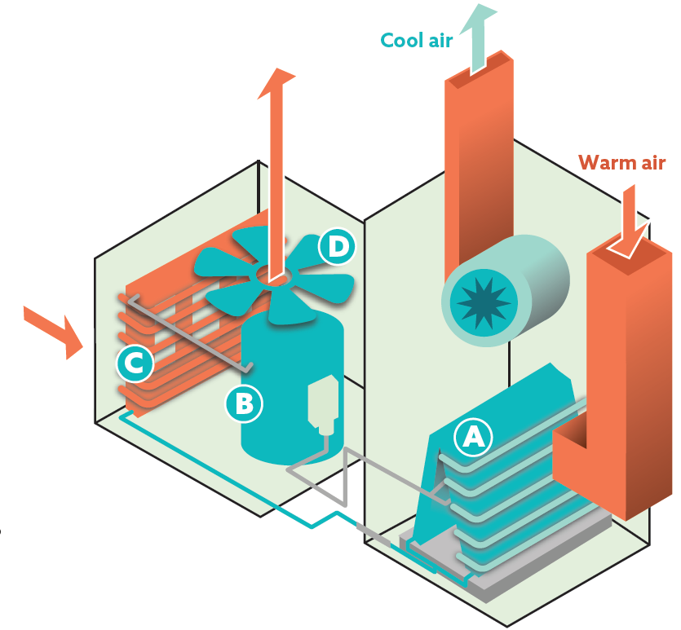

1. Describe all heat transfers that occur at or near each of the components below, as shown in the air conditioner diagram. For each transfer, identify where the heat energy originated and where it was after the transfer.
   1. Evaporator coils (Letter A)
   2. Condenser (Letter C)
2. Describe the relationships between the pressure, volume, and temperature of the refrigerant as it travels through the compressor.

**Student Reading Comprehension Questions, cont.**

1. The temperature of Earth and its atmosphere depend on many interactions between matter and energy. One of these interactions involves the molecules in the atmosphere that are called greenhouse gases. These are the gases that can absorb radiation of certain wavelengths. Use the image at the top of page 7 of the article to answer the following questions about the matter and energy interactions.
   1. Most of the solar radiation that reaches Earth’s surface is in which range(s) of the electromagnetic spectrum?
   2. Most of the energy radiated away from Earth is in which range(s) of the electromagnetic spectrum?
   3. All objects that are not at absolute zero temperature (0 K or -273 oC) emit electromagnetic radiation. Hotter objects radiate higher-energy radiation, which has shorter wavelengths. Why do the sun and Earth give off radiation in different ranges of the spectrum?
   4. Greenhouse gases “recycle” energy given off by Earth by absorbing the energy that corresponds to certain motions (see “Absorbing Energy” graphic on page 6) and re-radiating it.
      1. According to the spectra on page 7, do greenhouse gases in the atmosphere absorb more of the incoming energy or more of the outgoing energy? Explain your answer.
      2. If greenhouse gases didn’t exist, Earth would not be warm enough for humans to live. Why, then, are we trying to reduce the amount of greenhouse gases that we put into the atmosphere?
2. How does light reflection on the Sahara Desert silver ants stop them from overheating even when the sun is shining directly on them?
3. What aspect of the silver ants phenomenon is the inspiration for the “super-cool paint”?
4. How are the solutions described in the article on page 8, for buildings and roads in a city, related to air conditioning?

**Student Reading Comprehension Questions, cont.**

**Questions for Further Learning**

***Write your answers on another piece of paper if needed.***

1. Open the simulation at the following link: <https://acswebcontent.acs.org/ChemistryInContextSuite/applets/ozone/ozone.html>

Drag the black square to various parts of the spectrum to see whether the motions of ozone correspond to absorbing each type of radiation. Summarize the interactions of ozone with electromagnetic radiation by listing the ranges with which it can interact and the overall effect of those interactions.

1. Open the simulation at the following link: <https://acswebcontent.acs.org/ChemistryInContextSuite/applets/IRWindows/IRWindows.html?darkMode=false>

* Click “Display Options” and choose “Black Body Curve.” This shows the range of radiation continually given off by Earth.
* Click “Display Options” again and choose “Scaled Spectra.”
* Note that the *x*-axis is in “wavenumbers,” which is inversely related to wavelength. The atmospheric window show on page 7 of the article corresponds to wavenumbers of 1250 – 770 cm-1.
* Click the molecules to see the ranges of radiation each will absorb (these show as downward peaks). You can click again to remove the spectrum. The scaled spectra accounts for both the radiation range and the amount of absorption based on the relative concentration in the atmosphere.

Using the information you learn from the simulation, explain what an “atmospheric window” is, and why one exists in the range of 8-13 micrometers.

# Graphic Organizer

Name: ______________________________

**Directions**: As you read, complete the graphic organizer below to describe ways to keep building surfaces cool to limit heat transfer to the inside of buildings.

|  |  |  |
| --- | --- | --- |
|  | **Passive radiative cooling** | **Cooling paint** |
| **Power Source needed?** |  |  |
| **Scientific principle(s)** |  |  |
| **Scientists involved** (names and/or location) |  |  |
| **Materials description**  (Drawings OK) |  |  |

**Summary:** Write a short email to a friend describing what you learned about the importance of reducing AC use, and three ways to keep cities cooler.

# Answers to Reading Comprehension Questions & Graphic Organizer Rubric

1. **Give two reasons why the use of air conditioning systems contributes to warming the planet.**

*It takes a lot of electricity. Electricity generation is responsible for a lot of greenhouse gas emissions.*

*It takes the heat from inside and pumps it outside, thus warming the outside air.*

1. **Find out about the “urban heat island effect” and briefly describe it.**

*Basically, the lack of greenery and the prevalence of hard, absorbing surfaces, like roads and buildings, causes the heat to stay around longer. Also, the high buildings and narrow streets limit air flow to move the hot air away. All of these things cause many cities to be significantly warmer than the surrounding suburbs.*

1. **Label the air conditioner schematic below, using different colors for each. Show the path, through the air conditioner, of:**
   1. **the air molecules from the warm room.** (black arrows)
   2. **the air molecules from outside.** (blue arrows)
   3. **the refrigerant molecules.** (red arrows)

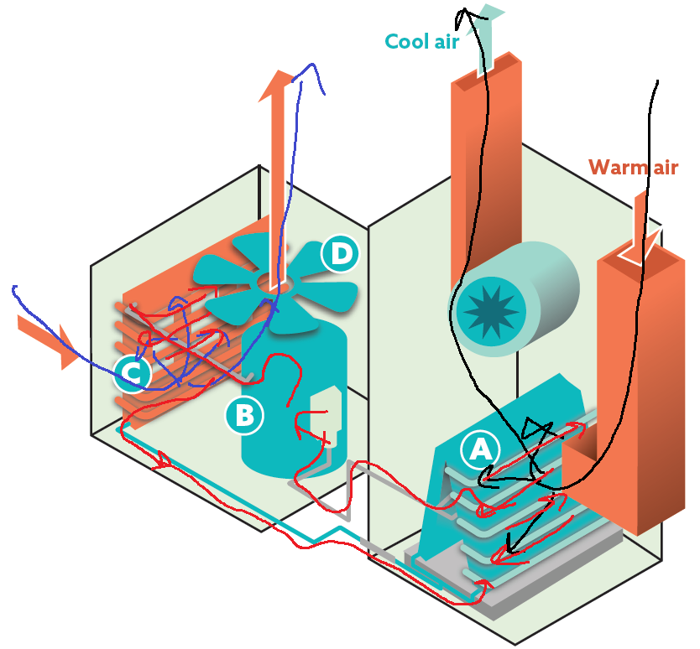

1. **Describe all heat transfers that occur at or near each of the components below, as shown in the air conditioner diagram. For each transfer, identify where the heat energy originated and where it was after the transfer.**
   1. **Evaporator coils (Letter A)**

*Fast-moving air molecules from the room run into the cold metal piping and transfer heat to the piping, thus slowing and cooling the original air. The piping quickly conducts the heat energy to the refrigerant molecules inside, warming them up and vaporizing them.*

* 1. **Condenser (Letter C)**

*The refrigerant molecules are now very fast-moving and vaporized from the compressor, making them hotter than the outside air. The fan pulls the outside air into the unit and, when it contacts the metal piping of the condenser, the heat from the refrigerant molecules is transferred through the metal and into the air, making it even warmer. This warm air is pushed back outside via the fan, and the now-condensed refrigerant molecules travel back to the evaporator.*

1. **Describe the relationships between the pressure, volume, and temperature of the refrigerant as it travels through the compressor.**

*The vaporized refrigerant travels to the compressor, with an original volume that is large. The compressor quickly decreases the volume, which greatly increases the temperature and the pressure. [Note: This is a near-adiabatic change, meaning the volume changes too fast for heat to be transferred, so all of the energy from the pressure-volume work (being done on the gas) becomes part of the internal energy of the gas, thus raising its temperature.]*

1. **The temperature of Earth and its atmosphere depend on many interactions between matter and energy. One of these interactions involves the molecules in the atmosphere that we call greenhouse gases. These are the gases that can absorb radiation of certain wavelengths. Use the image at the top of page 7 of the article to answer the following questions about the matter and energy interactions.**
   1. **Most of the solar radiation that reaches Earth’s surface is in which range(s) of the electromagnetic spectrum?** *Mostly visible range*
   2. **Most of the energy radiated away from Earth is in which range(s) of the electromagnetic spectrum?** *Mostly infrared range*
   3. **All objects that are not at absolute zero temperature (0 K or -273 oC) emit electromagnetic radiation. Hotter objects radiate higher-energy radiation, which has shorter wavelengths. Why do the sun and Earth give off radiation in different ranges of the spectrum?**

*The sun is much hotter than Earth, so it emits a wider range of radiation, with a peak toward shorter wavelengths than the peak of the cooler earth.*

* 1. **Greenhouse gases “recycle” energy given off by Earth by absorbing the energy that corresponds to certain motions (see “Absorbing Energy” graphic on page 6) and re-radiating it.**
     1. **According to the spectra on page 7, do greenhouse gases in the atmosphere absorb more of the incoming energy or more of the outgoing energy? Explain your answer.**

*More of the outgoing energy. The incoming energy has less area darkened, and the dark areas show ranges where the atmosphere absorbs energy.*

* + 1. **If greenhouse gases didn’t exist, Earth would not be warm enough for humans to live. Why, then, are we trying to reduce the amount of greenhouse gases that we put into the atmosphere?**

*Though we do need greenhouse gases to survive, if there are too many, then the amounts of energy going into and out of Earth system become unbalanced. In the case of extra greenhouse gases, this can cause Earth to warm too much.*

1. **How does light reflection on the Sahara Desert silver ants stop them from overheating even when the sun is shining directly on them?**

*If the light energy is reflecting off the ant’s body, then the ant isn’t absorbing the energy. If the ant doesn’t absorb the energy, it will not heat up.*

1. **What aspect of the silver ant phenomenon is the inspiration for the “super-cool paint”?**

*The tiny hairs cause air pockets to interrupt the incoming radiation. Rather than being absorbed, the radiation scatters. This can be very useful if applied to paint because the paint could divert the sun’s energy from getting into the building.*

1. **How are the solutions described on page 8 in the article, for buildings and roads in a city, related to air conditioning?**

*All of these solutions help to reduce the heat going into the buildings or hovering around the city. If the insides of the buildings are cooler and the outside is also cooler, than less air conditioning will be needed. If less air conditioning is used, then less electricity will be needed, thus reducing the need for carbon-emitting electricity generation.*

**Graphic Organizer Rubric**

If you use the Graphic Organizer to evaluate student performance, you may want to develop a grading rubric such as the one below.

|  |  |  |
| --- | --- | --- |
| **Score** | **Description** | **Evidence** |
| 4 | Excellent | Complete; details provided; demonstrates deep understanding. |
| 3 | Good | Complete; few details provided; demonstrates some understanding. |
| 2 | Fair | Incomplete; few details provided; some misconceptions evident. |
| 1 | Poor | Very incomplete; no details provided; many misconceptions evident. |
| 0 | Not acceptable | So incomplete that no judgment can be made about student understanding |

# 

# Additional Resources

**Labs and demos**

**What is Temperature?:** In this demonstration, students will observe food dye mixing with water at different temperatures. <https://teachchemistry.org/classroom-resources/what-is-temperature>

**Lab: Heating and Cooling Curve:** In this lab, students will create a phase change graph by adding and removing heat to observe and record data during actual phase changes. Instead of just memorizing a heating/cooling curve they see in a textbook, students create their own. <https://teachchemistry.org/classroom-resources/heating-cooling-curve>

**Simulations and activities**

**Simulation Activity: Heating Curve of Water:** In this simulation, students will investigate qualitatively and quantitatively what happens as water changes states. This lesson accompanies the simulation from the May 2015 issue of Chemistry Solutions. <https://teachchemistry.org/classroom-resources/simulation-activity-heating-curve-of-water>

**Color Matching Paint Video and Questions:** In this activity, students will watch a video and answer related questions about how technology, specifically focusing on spectrophotometry, can be used for paint matching. <https://teachchemistry.org/classroom-resources/color-matching-paint-video-questions>

**Future of Paint Video and Questions:** In this activity, students will watch a video and answer related questions about the fascinating and innovative scientific advancements of paint. <https://teachchemistry.org/classroom-resources/future-of-paint-video-questions>

**Simulation Activity: Understanding Specific Heat:** In this simulation activity, students will play the role of engineer in deciding which materials are the best candidates for a building project. <https://teachchemistry.org/classroom-resources/simulation-activity-understanding-specific-heat>

**Lessons and lesson plans**

**What Makes Something Feel Warm?:** In this lesson students actively engage in thinking about energy issues in chemistry and the nature of energy (thermal) transfer. <https://teachchemistry.org/classroom-resources/what-makes-something-feel-warm>

**The Ozone Layer:** In this lesson, students will develop an explanation for the consequences of ozone depletion on Earth by planning and carrying out an investigation. <https://teachchemistry.org/classroom-resources/the-ozone-layer>

**Projects and extension activities**

**Heat Flow Process Engineering Optimization:** In this activity, students will use a team-based approach to solve the problem of upscaling a chemical process from lab scale to production scale for a hypothetical reaction. <https://teachchemistry.org/classroom-resources/heat-flow-process-engineering-optimization>

**Sustainable Energy Evaluation Activity:** In this project, students will develop a presentation to compare the pros and cons of a sustainable resource. <https://teachchemistry.org/classroom-resources/sustainable-energy-evaluation>

# Chemistry Concepts, Standards, and Teaching Strategies

**Connections to Chemistry Concepts**

The following chemistry concepts are highlighted in this article:

* Physical properties
* Endothermic and exothermic
* Electromagnetic spectrum

**Correlations to Next Generation Science Standards**

This article relates to the following performance expectations and dimensions of the NGSS:

**HS-PS3-3**

Design, build, and refine a device that works within given constraints to convert one form of energy into another form of energy.

**HS-ETS1-3**

Evaluate a solution to a complex real-world problem based on prioritized criteria and tradeoffs that account for a range of constraint, including cost, safety, reliability, and aesthetics, as well as possible social, cultural, and environmental impacts.

**Disciplinary Core Ideas:**

* PS3.B: Conservation of Energy and Energy Transfer
* ETS1.C: Optimizing the Design Solution

**Crosscutting Concepts:**

* Cause and effect: Mechanism and explanation
* Systems and System Models
* Energy and Matter
* Structure and Function

**Science and Engineering Practices:**

* Developing and using models
* Constructing explanations and designing solutions

**Nature of Science:**

* Science is a human endeavor.

**Correlations to Common Core State Standards**

See how *ChemMatters* correlates to the[**Common Core State Standards**](https://www.acs.org/content/acs/en/education/resources/highschool/chemmatters/teachers-guide.html)  at www.acs.org/chemmatters.

**Teaching Strategies**

Consider the following tips and strategies for incorporating this article into your classroom:

* Before reading the article, consider showing the ACS Reactions Video, “How Air Conditioning Works” at <https://youtu.be/PT38gaGciP4> to review how AC warms the planet.
* **Alternative to Anticipation Guide:** Before reading, ask students how paint could be used to cool buildings and why it is important to keep buildings cool.
  + As they read, students can find information to confirm or refute their original ideas.
  + After they read, ask students what they learned about designing materials to prevent warming the planet.
* This article could be used with energy changes and specific heat, while exploring the different ways that various substances absorb energy.
* Heat transfer is a constant theme throughout the article and students could be challenged to identify places where heat is transferred both usefully and as waste.
* The interaction of electromagnetic radiation and matter is a great way to bring the focus to both the importance of and the dangers of greenhouse gases in the atmosphere.
* This is a great example of bio-inspired design, as the paint was engineered to behave similarly to the silver ant’s reflective surface.



**Teacher’s Guide**

#### How to Make Fashion Sustainable?

***April 2021***

**Table of Contents**

Anticipation Guide  15

Activate students’ prior knowledge and engage them before they read the article.

Reading Comprehension Questions 16

These questions are designed to help students read the article (and graphics) carefully. They can help the teacher assess how well students understand the content and help direct the need for follow-up discussions and/or activities. You’ll find the questions ordered in increasing difficulty.

Graphic Organizer 18

Thishelps students locate and analyze information from the article. Students should use their own words and not copy entire sentences from the article. Encourage the use of bullet points.

Answers 19

Access the answers to reading comprehension questions and a rubric to assess the graphic organizer.

Additional Resources 21

Here you will find additional labs, simulations, lessons, and project ideas that you can use with your students alongside this article.

Chemistry Concepts, Standards, and Teaching Strategies 22

# Anticipation Guide

Name: ______________________________

**Directions: *Before reading the article*,** in the first column, write “A” or “D,” indicating your **A**greement or **D**isagreement with each statement. Complete the activity in the box.

As you read, compare your opinions with information from the article. In the space under each statement, cite information from the article that supports or refutes your original ideas.

|  |  |  |
| --- | --- | --- |
| **Me** | **Text** | **Statement** |
|  |  | 1. Polyester fabrics are made of polymers derived from fossil fuels. |
|  |  | 1. Each year, commercial flights produce more carbon dioxide than the textile industry. |
|  |  | 1. Unwanted clothing made from natural fibers release methane when put in landfills. |
|  |  | 1. Most textiles are made from cotton. |
|  |  | 1. Making one pair of denim jeans requires 20,000 liters of water. |
|  |  | 1. Some natural fibers are made from wood scraps. |
|  |  | 1. As clothing is used, the polymers lengthen. |
|  |  | 1. Ionic liquids have been developed to dissolve cellulose. |
|  |  | 1. The same chemical process that works to recycle cotton works for other fabrics. |
|  |  | 1. Spandex is easy to recycle. |

# Student Reading Comprehension Questions

Name: ______________________________

**Directions**: Use the article to answer the questions below.

1. Which polymer is the most naturally abundant polymer on Earth?
2. Name the greenhouse gas that is produced when the natural fibers in clothing degrade in landfills.
3. What is a polymer?
4. What is lyocell?
5. Describe ionic liquids.
6. How is NuCycl different from other textiles?
7. Explain the impact of the clothing industry on land, air, and water resources.
8. Describe two drawbacks of using cotton for clothing.
9. What are two benefits of using lyocell rather than cotton to make textiles?
10. Describe the process of depolymerization.
11. Why don’t denim jeans dissolve in the washing machine?
12. Create a pie chart to represent the percentage of textiles that are made of polyester, cotton, and other fibers.

**Student Reading Comprehension Questions, cont.**

**Questions for Further Learning**

***Write your answers on another piece of paper if needed.***

1. Explain how solvent-based recycling works.
2. Finding the correct solvent for dissolving specific types of polymers in clothing depends on what type of relationship between the polymer and the solvent?
3. Why is it difficult to use solvent-based recycling on textiles that are made of different types of polymers?
4. Research textile recycling in your area. Where is the closest recycling site? What method do they use to recycle textiles? Use the information you find to create a blog post informing readers about the benefits of recycling textiles and how they can help with recycling efforts.
5. Select one of the options from the “5 Ways to Reduce Your Fashion Footprint” section of the article and create an infographic to help others better understand how they can reduce their fashion footprint.

# Graphic Organizer

Name: ______________________________

**Directions**: As you read, complete the graphic organizer below to describe problems with fabric manufacturing for clothing and possible solutions.

|  |  |  |
| --- | --- | --- |
|  | **Polyester** | **Cellulose** |
| **Raw materials** |  |  |
| **Structural formula** |  |  |
| **Type of clothing** |  |  |
| **Environmental drawbacks** |  |  |
| **Recycling challenges** |  |  |

**Summary:** Write a tweet (280 characters or less) about the importance of recycling clothing.

# Answers to Reading Comprehension Questions & Graphic Organizer Rubric

1. **Which polymer is the most naturally abundant polymer on Earth?**

*Cellulose is the most naturally abundant polymer.*

1. **Name the greenhouse gas that is produced when the natural fibers in clothing degrade in landfills.**

*Methane is produced when natural fibers in clothing degrade in landfills.*

1. **What is a polymer?**

*A polymer is a long chain of chemically linked molecules or monomers.*

1. **What is lyocell?**

*Lyocell is a human made natural fiber produced from wood scraps.*

1. **Describe ionic liquids.**

*Ionic liquids are conductive salts that are composed of a large organic cation and either an organic or an inorganic anion.*

1. **How is NuCycl different from other textiles?**

*NuCycl is a fiber made from 100% post-consumer cotton.*

1. **Explain the impact of the clothing industry on land, air, and water resources.**

*The clothing industry is problematic because it produces 1.2 billion metric tons of carbon dioxide, 90% of clothes end up in landfills, and the process of clothing manufacture uses 93 billion metric tons of water each year.*

1. **Describe two drawbacks of using cotton for clothing.**

*Growing cotton requires a lot of water and the land used to grow cotton could be used to grow food.*

1. **What are two benefits of using lyocell rather than cotton to make textiles?**

*Lyocell does not require as much water and can be grown without pesticides.*

1. **Describe the process of depolymerization.**

*Depolymerization is a process that breaks a polymer down into its constituent monomers.*

1. **Why don’t denim jeans dissolve in the washing machine?**

*Denim does not dissolve in water because the intermolecular forces between polymer strands help keep them together.*

1. **Create a pie chart to represent the percentage of textiles that are made of polyester, cotton, and other fibers.**

*Polyester is found in 55% of textiles. Cotton fibers make up 27% of all textiles. Human-made cellulose fibers, such as lyocell, make up 5%.*

**Questions for Further Learning**

1. **Explain how solvent-based recycling works.**

*Solvent-based recycling is when used textiles are collected, their polymers are dissolved using solvents and then the fibers are turned into yarn.*

1. **Finding the correct solvent for dissolving specific types of polymers in clothing depends on what type of relationship between the polymer and the solvent?**

*The key to finding the best solvent for dissolving polymers is to make sure that the polymer-solvent intermolecular attraction outweighs the polymer-polymer forces.*

1. **Why is it difficult to use solvent-based recycling on textiles that are made of different types of polymers?**

*Solvents that work with one type of polymer may not be effective in dissolving a different polymer.*

1. **Research textile recycling in your area. Where is the closest recycling site? What method do they use to recycle textiles? Use the information you find to create a blog post informing readers about the benefits of recycling textiles and how they can help with recycling efforts.**

*Student responses will vary but should include at least two benefits of recycling textiles and provide information on textile recycling in the region.*

1. **Select one of the options from the “5 Ways to Reduce Your Fashion Footprint” section of the article and create an infographic to help others better understand how they can reduce their fashion footprint.**

*Student responses will vary. Students should select one method for reducing their fashion footprint and include pictures and a meaningful description of the environmental impact of the option.*

**Graphic Organizer Rubric**

If you use the Graphic Organizer to evaluate student performance, you may want to develop a grading rubric such as the one below.

|  |  |  |
| --- | --- | --- |
| **Score** | **Description** | **Evidence** |
| 4 | Excellent | Complete; details provided; demonstrates deep understanding. |
| 3 | Good | Complete; few details provided; demonstrates some understanding. |
| 2 | Fair | Incomplete; few details provided; some misconceptions evident. |
| 1 | Poor | Very incomplete; no details provided; many misconceptions evident. |
| 0 | Not acceptable | So incomplete that no judgment can be made about student understanding |

# Additional Resources

**Labs and demos**

**Focus on Fabrics: Putting Materials to Good Use**: This hands-on lab encourages students to investigate various properties of different natural and synthetic fibers found in textiles. <https://www.teachengineering.org/activities/view/focus_on_fabrics>

**Bond Strength of Ionic Salts**: During this lab students will use models to demonstrate the bonds of ionic salts and will investigate the temperature changes that result when different salts are dissolved. <https://teachchemistry.org/classroom-resources/bond-strength-of-ionic-salts>

**Polymerization of Nylon**: This activity can be conducted as a demonstration or a lab, when following proper safety guidelines, to help students understand the polymerization of nylon. <https://uakron.edu/polymer/agpa-k12outreach/lesson-plans/polymerization-of-nylon>

**Lessons and lesson plans**

**Man and Materials through History:** In this lesson plan students learn identify polymers, learn how they are made, and create a timeline of polymer history. <https://www.acs.org/content/acs/en/education/whatischemistry/landmarks/lesson-plans/man-and-materials-through-history.html>

**Everyday Polymers**: In this lesson plan students will explore the varied uses of polymers and their structures. <https://www.teachengineering.org/lessons/view/csu_polymer_lesson01>

# Chemistry Concepts, Standards, and Teaching Strategies

**Connections to Chemistry Concepts**

The following chemistry concepts are highlighted in this article:

* Molecular structure
* Polymers
* Solutions
* Intermolecular forces

**Correlations to Next Generation Science Standards**

This article relates to the following performance expectations and dimensions of the NGSS:

**HS-PS1-3**

Plan and conduct an investigation to gather evidence to compare the structure of substances at the bulk scale to infer the strength of electrical forces between particles.

**HS-ETS1-3**

Evaluate a solution to a complex real-world problem based on prioritized criteria and tradeoffs that account for a range of constraint, including cost, safety, reliability, and aesthetics, as well as possible social, cultural, and environmental impacts.

**Disciplinary Core Ideas:**

* PS1.A: Structure and Properties of Matter
* ETS1.C: Optimizing the Design Solution

**Crosscutting Concepts:**

* Structure and function
* Scale, proportion, and quantity
* Energy and matter

**Science and Engineering Practices:**

* Planning and carrying out investigations

**Nature of Science:**

* Scientific knowledge assumes an order and consistency in natural systems.

**Correlations to Common Core State Standards**

See how *ChemMatters* correlates to the[**Common Core State Standards**](https://www.acs.org/content/acs/en/education/resources/highschool/chemmatters/teachers-guide.html)  at www.acs.org/chemmatters.

**Teaching Strategies**

Consider the following tips and strategies for incorporating this article into your classroom:

* **Alternative to Anticipation Guide:** Before reading, ask students if clothing can be recycled, and how.
  + As they read, students can find information to confirm or refute their original ideas.
  + After they read, ask students what they learned about energy use in producing textiles, and the problems with recycling clothing.
* The ACS Reactions Video “The dark side of synthetic fleece” (<https://youtu.be/o6qnwV7ep-M>) has information about environmental problems caused from washing synthetic fibers. Consider sharing this video with students after they have discussed how they could reduce their fashion footprint.



**Teacher’s Guide**

#### What is Ice Cream and Why Do We Scream for It?

***April 2021***

**Table of Contents**

Anticipation Guide 24

Activate students’ prior knowledge and engage them before they read the article.

Reading Comprehension Questions 25

These questions are designed to help students read the article (and graphics) carefully. They can help the teacher assess how well students understand the content and help direct the need for follow-up discussions and/or activities. You’ll find the questions ordered in increasing difficulty.

Graphic Organizer 27

Thishelps students locate and analyze information from the article. Students should use their own words and not copy entire sentences from the article. Encourage the use of bullet points.

Answers 28

Access the answers to reading comprehension questions and a rubric to assess the graphic organizer.

Additional Resources 30

Here you will find additional labs, simulations, lessons, and project ideas that you can use with your students alongside this article.

Chemistry Concepts, Standards, and Teaching Strategies 31

# Anticipation Guide

Name: ______________________________

**Directions: *Before reading the article*,** in the first column, write “A” or “D,” indicating your **A**greement or **D**isagreement with each statement. Complete the activity in the box.

As you read, compare your opinions with information from the article. In the space under each statement, cite information from the article that supports or refutes your original ideas.

|  |  |  |
| --- | --- | --- |
| **Me** | **Text** | **Statement** |
|  |  | 1. By definition, ice cream must contain at least 10% milk fat by weight according to the U.S. Food & Drug Administration. |
|  |  | 1. Ice cream is 20-50% air by volume. |
|  |  | 1. Sugars increase the freezing point of ice cream. |
|  |  | 1. Ice cream can be scooped even at -20 °C. |
|  |  | 1. Thawing and refreezing ice cream creates small ice crystals. |
|  |  | 1. Ice cream with small ice crystals has a creamier texture than ice cream with large ice crystals. |
|  |  | 1. Ice cream made with liquid nitrogen has larger ice crystals. |
|  |  | 1. Gelato has a higher fat content than ice cream. |
|  |  | 1. Fat droplets help stabilize the air bubbles formed when ice cream is churned. |
|  |  | 1. Sorbet does not contain any dairy products. |

# Student Reading Comprehension Questions

Name: ______________________________

**Directions**: Use the article to answer the questions below.

1. What is the purpose of adding emulsifiers in the ice cream making process?
2. What components of ice cream help create the creamy, smooth texture? How does varying the amount of these components affect the nature of the ice cream?
3. The article states that 75% of the water in ice cream becomes frozen once the ice cream is made. The remaining 25% combines with other ingredients in the ice cream’s liquid phase. Why is maintaining the liquid phase critical to creating high quality ice cream?
4. Explain the role stabilizing gum plays in improving the shelf life of ice cream.
5. List and explain two natural ingredients that food scientists are experimenting with to develop enhanced ice cream properties in the future.
6. How has low temperature extrusion, or “slow churn,” improved the ice cream making process?
7. Discuss how the ingredients in ice cream can be altered to create a low-calorie version of the famous treat.
8. The article mentions freezing point depression and how the dissolved solutes in the liquid phase of the ice cream help lower the freezing point of water. This helps prevent ice cream from developing a gritty, coarse texture. Explain the freezing point depression on the molecular level and find a real-world application of freezing point depression other than ice cream.
9. Emulsifiers are used to prevent ingredients that normally would not mix from separating in the ice cream making process. Give an example of a polar compound and a non-polar compound and give a brief explanation of why polar and non-polar molecule do not mix.

**Student Reading Comprehension Questions, cont.**

1. The article states that U.S. dairies produce nearly 5.2 billion liters of ice cream each year. Based on that production rate, how many years would it take for the U.S. to produce enough ice cream to fill the moon (if the moon were theoretically hallow)?

Volume of the moon = 2.19 x 1010 km3

1 L = 1 x 103 cm3

1 m3 = 1 x 106 cm3

1 km3 = 1 x 109 m3

**Questions for Further Learning**

***Write your answers on another piece of paper if needed.***

1. An estimated 6.1 million Americans are allergic to milk and other dairy products. Research and discuss alterations that can be made to the ingredients to make ice cream accessible and safe to individuals with a milk or dairy allergy.
2. The number of flavors and varieties of ice cream has increased dramatically over the years. Select your three favorite flavors of ice cream and research and list the ingredients used to make your favorite flavors.

# Graphic Organizer

Name: ______________________________

**Directions**: As you read, complete the graphic organizer below to describe the ingredients in ice cream and why they are needed.

|  |  |  |
| --- | --- | --- |
| **Ingredient** | **Example or source** | **Importance in making ice cream** |
| **Water** |  |  |
| **Fat** |  |  |
| **Emulsifiers** |  |  |
| **Air** |  |  |
| **Stabilizers** |  |  |
| **Sweeteners** |  |  |

**Summary:** Write a one-sentence summary (20 words or less) about what you learned about making ice cream.

# Answers to Reading Comprehension Questions & Graphic Organizer Rubric

1. **What is the purpose of adding emulsifiers in the ice cream making process?**

*Emulsifiers prevent substances that normally do not blend well (such as polar water and non-polar fat) from separating once the ice cream is formed.*

1. **What components of ice cream help create the creamy, smooth texture? How does varying the amount of these components affect the nature of the ice cream?**

*Fat, proteins, emulsifiers, and air bubbles all contribute the texture of ice cream. The quantities of these ingredients can be altered to create different variations of ice cream such as soft served, gelato, and frozen yogurt, which all differ in texture, fat content, melting time, and taste.*

1. **The article states that 75% of the water in ice cream becomes frozen once the ice cream is made. The remaining 25% combines with other ingredients in the ice cream’s liquid phase. Why is maintaining the liquid phase critical to creating high quality ice cream?**

*The liquid phase contains dissolved sugars and other ingredients that help lower the freezing point of the water in the ice cream and keep the ice cream soft and scoopable at very low temperatures.*

1. **Explain the role stabilizing gum plays in improving the shelf life of ice cream.**

*Stabilizers prevent the water molecules from joining together in the liquid phase which would cause larger crystals to form and give the ice cream an undesirable coarse and gritty texture.*

1. **List and explain two natural ingredients that food scientists are experimenting with to develop enhanced ice cream properties in the future.**

*Polyphenol from strawberries helps ice cream keep its shape and prevent dripping during melting.*

*Cellulose nanofibers from banana plants reduce melting, enhance creaminess, and prolong shelf life.*

1. **How has low temperature extrusion, or “slow churn,” improved the ice cream making process?**

*The ice cream freezes more rapidly and uniformly during the process. Therefore, only small ice crystals have a chance to form and stay small. The slow churn kneading motion reduces the air bubbles size and distributes fat more efficiently for enhanced smoothness and texture.*

1. **Discuss how the ingredients in ice cream can be altered to create a low-calorie version of the famous treat.**

*The fat content can be reduced to 2%-3%. The use of non-caloric stabilizer gums can be used to offset the texture loss. Air content can be increased to add volume due to the fat loss. Low-calorie sweeteners can also be used to create a low-calorie version.*

1. **The article mentions freezing point depression and how the dissolved solutes in the liquid phase of the ice cream help lower the freezing point of water. This helps prevent ice cream from developing a gritty, coarse texture. Explain the freezing point depression on the molecular level and find a real-world application of freezing point depression other than ice cream.**

*When a solute is dissolved in a solvent such as water, the particles interfere with the water molecule’s ability to form hydrogen bonds between adjacent molecules and disrupt the freezing process.*

*Another real-world application of freezing point depression adding salt (NaCl) and other compounds to snow and ice covered roads, driveways, and sidewalks. The dissolved Na+ and Cl– ions interact the partial positive and negative charges on the polar water molecule and interfere with the hydrogen bonds and the freezing process.*

1. **Emulsifiers are used to prevent ingredients that normally would not mix from separating in the ice cream making process. Give an example of a polar compound and a non-polar compound and give a brief explanation of why polar and non-polar molecule do not mix.**

*Answers may vary for the compounds. Example: Water-Polar and Oil-Non-polar*

*Non-polar compounds only contain weak London dispersion forces. Therefore, a non-polar solute when placed in a polar solvent the weak dispersion forces of the non-polar solute are not strong enough to disrupt the dipole-dipole or hydrogen bonds present in the polar molecule. Strong intermolecular forces are required to form an attraction, i.e. mix or dissolve, with a polar compound which is simply not present in a non-polar molecule.*

1. **The article states that U.S. dairies produce nearly 5.2 billion liters of ice cream each year. Based on that production rate, how many years would it take for the U.S. to produce enough ice cream to fill the moon (if the moon were theoretically hallow)?**

Volume of the moon = 2.19 x 1010 km3

1 L = 1 x 103 cm3

1 m3 = 1 x 106 cm3

1 km3 = 1 x 109 m3

*2.19 x 1010 km3 x 1 x 109 m3 x 1 x 106 cm3 x _1 L_____ = 2.2 x 1022 L*

*1 km3 1 m3 1 x 103 cm3*

*Liters of ice cream per year: 5.2 x 109 L_*

*1 year*

*Volume of the moon in liters 2.2 x 1022 L x 1 year___ = 4.2 Years*

*5.2 x 109 L*

**Questions for Further Learning**

1. **An estimated 6.1 million Americans are allergic to milk and other dairy products. Research and discuss alterations that can be made to the ingredients to make ice cream accessible and safe to individuals with a milk or dairy allergy.**

*Milk/dairy free ice cream can be created using dairy milk alternatives such as soy milk, coconut milk, and almond milk. Non-dairy emulsifiers and stabilizers also exist to create non-dairy ice cream.*

1. **The number of flavors and varieties of ice cream has increased dramatically over the years. Select your 3 favorite flavors of ice cream and research and list the ingredients used to make your favorite flavors.**

*Answers will vary*

**Graphic Organizer Rubric**

If you use the Graphic Organizer to evaluate student performance, you may want to develop a grading rubric such as the one below.

|  |  |  |
| --- | --- | --- |
| **Score** | **Description** | **Evidence** |
| 4 | Excellent | Complete; details provided; demonstrates deep understanding. |
| 3 | Good | Complete; few details provided; demonstrates some understanding. |
| 2 | Fair | Incomplete; few details provided; some misconceptions evident. |
| 1 | Poor | Very incomplete; no details provided; many misconceptions evident. |
| 0 | Not acceptable | So incomplete that no judgment can be made about student understanding |

# Additional Resources

**Lessons and lesson plans**

**Polarity Activity:** In this activity, the students model the pull of electrons in a bond between two elements, demonstrating covalent bonding. In a second activity, the students apply the information they developed in the first activity to a molecule. <https://teachchemistry.org/periodical/issues/may-2019/modeling-polarity>

**Labs and demos**

**Freezing Ice Cream**: In this lab, students will investigate changing states of matter, chemical reactions, and the properties of ice and salt while creating their own ice cream. <https://teachchemistry.org/classroom-resources/freezing-ice-cream>

**Coffee Creamer Ice Cream:** In this lab, students will investigate how dissolving salt (sodium chloride) in water changes the freezing point of the solution. While investigating this, they will make ice cream from small coffee creamer cups. <https://teachchemistry.org/classroom-resources/coffee-creamer-ice-cream>

**Salad Dressing Science: Emulsions:** In this lab, students mix polar and nonpolar substances and then add various emulsifiers to encourage the mixing of the two substances. They use ingredients in salad dressing to relate science to real life scenarios. <https://teachchemistry.org/classroom-resources/salad-dressing-science-emulsions>

**Homemade Ice Cream:** Use science know-how to create a tasty vanilla treat! Follow along with vides to create your own ice cream. <https://www.stevespanglerscience.com/lab/experiments/homemade-ice-cream-sick-science/>

**Emulsion Experiments:** To illustrate the properties of an emulsion, a well-constructed experiment for students (with notes for teacher support) can be found at <http://www.juliantrubin.com/encyclopedia/chemistry/emulsion_experiments.html>.

**Simulations and animations**

**Salty Roads (Freezing Point Depression):** This simulation from the CK-12 Foundation explores how solutes can keep roads clear of ice in the winter. Students will learn how different types and concentrations of solute affect the freezing point of a solution. <https://interactives.ck12.org/simulations/chemistry/freezing-point/app/index.html>

**Other Resources**

**The Chemistry of Frozen Desserts:** Find the infographic referenced in the article: <https://cen.acs.org/articles/95/i29/Periodic-graphics-chemistry-frozen-desserts.html>

# Chemistry Concepts, Standards, and Teaching Strategies

**Connections to Chemistry Concepts**

The following chemistry concepts are highlighted in this article:

* Solutions
* Freezing point depression
* Mixtures
* Freezing point

**Correlations to Next Generation Science Standards**

This article relates to the following performance expectations and dimensions of the NGSS:

**HS-PS1-3**

Plan and conduct an investigation to gather evidence to compare the structure of substances at the bulk scale to infer the strength of electrical forces between particles.

**HS-ETS1-3**

Evaluate a solution to a complex real-world problem based on prioritized criteria and tradeoffs that account for a range of constraint, including cost, safety, reliability, and aesthetics, as well as possible social, cultural, and environmental impacts.

**Disciplinary Core Ideas:**

* PS1.A: Structure and Properties of Matter
* ETS1.C: Optimizing the Design Solution

**Crosscutting Concepts:**

* Cause and effect: Mechanism and explanation
* Structure and Function

**Science and Engineering Practices:**

* Planning and carrying out investigations

**Nature of Science:**

* Science addresses questions about the natural and material world.

**Correlations to Common Core State Standards**

See how *ChemMatters* correlates to the[**Common Core State Standards**](https://www.acs.org/content/acs/en/education/resources/highschool/chemmatters/teachers-guide.html)  at www.acs.org/chemmatters.

**Teaching Strategies**

Consider the following tips and strategies for incorporating this article into your classroom:

* **Alternative to Anticipation Guide:** Before reading, ask students if they have made ice cream, and what they know about the chemistry involved.
  + As they read, students can find information to confirm or refute their original ideas.
  + After they read, ask students what they learned about making ice cream. Ask what is important to create ice cream with a creamy, smooth texture.
* Students may find this ACS Reactions Video about ice cream interesting to watch after they read the article: “How Science Affects Your Ice Cream” <https://youtu.be/-rlapUkWCSM>   
  The video compares three different ways to make ice cream, including making ice cream in a baggie.



**Teacher’s Guide**

#### Are We Running Out of Helium?

***April 2021***

**Table of Contents**

***Anticipation Guide*** ***33***

Activate students’ prior knowledge and engage them before they read the article.

***Reading Comprehension Questions******34***

These questions are designed to help students read the article (and graphics) carefully. They can help the teacher assess how well students understand the content and help direct the need for follow-up discussions and/or activities. You’ll find the questions ordered in increasing difficulty.

***Graphic Organizer*** ***36***

Thishelps students locate and analyze information from the article. Students should use their own words and not copy entire sentences from the article. Encourage the use of bullet points.

***Answers*** ***37***

Access the answers to reading comprehension questions and a rubric to assess the graphic organizer.

***Additional Resources*** ***40***

Here you will find additional labs, simulations, lessons, and project ideas that you can use with your students alongside this article.

***Chemistry Concepts, Standards, and Teaching Strategies*** ***41***

# Anticipation Guide

Name: ______________________________

**Directions: *Before reading the article*,** in the first column, write “A” or “D,” indicating your **A**greement or **D**isagreement with each statement. Complete the activity in the box.

As you read, compare your opinions with information from the article. In the space under each statement, cite information from the article that supports or refutes your original ideas.

|  |  |  |
| --- | --- | --- |
| **Me** | **Text** | **Statement** |
|  |  | 1. Helium is the most abundant element in the entire universe. |
|  |  | 1. Most of the helium consumed in the U.S. is used for balloons. |
|  |  | 1. Helium on Earth is produced by thermonuclear reactions. |
|  |  | 1. Scientists discovered helium on the sun before it was discovered on Earth. |
|  |  | 1. Helium on the Earth was first found in lava from a volcano that had recently erupted. |
|  |  | 1. Almost all of the helium on Earth is formed by radioactive decay of elements such as uranium or thorium. |
|  |  | 1. Helium and natural gas are often found together in the same types of rock. |
|  |  | 1. At 1 atm of pressure, liquid helium is 4 °C or colder. |
|  |  | 1. Helium does not burn. |
|  |  | 1. Helium is a renewable resource. |

# Student Reading Comprehension Questions

Name: ______________________________

**Directions**: Use the article to answer the questions below.

1. Besides party balloons, list some common uses for helium.
2. How was helium discovered on Earth?
3. How is helium trapped and stored in Earth’s crust?
4. What is meant when an element transmutes into a different element?
5. How does an alpha particle become a helium atom?
6. How do scientists determine what elements are present in stars and planets with spectroscopy?
7. What makes the bright line spectrum of helium different from hydrogen? What causes this difference?
8. Why would the isotope beryllium-6 be unstable? (Hint: what is the main purpose of a neutron?)
9. Why is it so hard to “make” helium through fusion?
10. When two protons combine to form one nucleus, the result is one proton and one neutron. How did the one proton become a neutron?
11. Compare the models of a helium atom and the molecule sulfur hexafluoride. If you had two balloons, one filled with helium and one filled with sulfur hexafluoride, what would the balloons do when you released them? Why?
12. When the periodic table was introduced by Dimitri Mendeleev in 1869, the noble gases were not present on the table. Why did it take so long to discover the noble gases compared to the other elements?

**Student Reading Comprehension Questions, cont.**

**Questions for Further Learning**

***Write your answers on another piece of paper if needed.***

1. Research some bright-line spectra for some elements. Note the simplicity or complexity of these spectra. Why do you think some are more complex than others? What causes these lines to appear?
2. In Bangladesh, people take plastic bottles, cut them in half, and attach them through boards. These were attached to openings in the walls of the homes. The air flowed through the bottles, and entered the house about 5 °C (9 °F) cooler. This is called the Joule-Thompson effect. Explain how this works using basic gas laws. (YouTube video: <https://youtu.be/Fda7mj8ffdY>)

# Graphic Organizer

Name: ______________________________

**Directions**: As you read, complete the graphic organizer below to describe helium.

|  |  |  |
| --- | --- | --- |
|  | **On the sun** | **On Earth** |
| **Discovery** | **Who**  **When**  **Where**  **How** | **Who**  **When**  **Where**  **How** |
| **How produced (equations)** |  |  |
| **How is helium mined and separated from other chemicals?** |  | |
| **Major uses & importance** | **1.**  **2.**  **3.** | |

**Summary:** Write three new things you learned about helium.

# Answers to Reading Comprehension Questions & Graphic Organizer Rubric

1. **Besides party balloons, list some common uses for helium.**

*Cryogenics, welding, heat transfer, pressurization, airships, analysis, and others.*

1. **How was helium discovered on Earth?**

*Helium was first discovered in an eruption at Mt. Vesuvius, which produced the same bright line spectrum that was observed in stars. It was then discovered on in earth radioactive uranium compounds. William Ramsey thought he saw argon, but it was helium.*

1. **How is helium trapped and stored in Earth’s crust?**

*Helium is stored in places with granite, which has the radioactive materials that create helium. The helium is then stored in porous rocks, covered by a solid, nonporous rock that holds the helium underground.*

1. **What is meant when an element transmutes into a different element?**

*When an element transmutes, it emits a particle from its nucleus, which then causes the number of protons to change, thus creating another element.*

1. **How does an alpha particle become a helium atom?**

*An alpha particle is a helium nucleus, meaning it does not have its 2 electrons. The alpha particle is moving so fast, it emits ionizing radiation. This radiation is strong enough to pull off 2 electrons from a neutral atom and attach them to the helium nucleus*

1. **How do scientists determine what elements are present in stars and planets with spectroscopy?**

*Using spectroscopy, scientists can determine the elements present by observing the light emitted through a spectroscope. The scientists match the colored lines with the known emission spectra of the elements. Then they determine hat elements are present.*

1. **What makes the bright line spectrum of helium different from hydrogen? What causes this difference?**

*The difference is caused by the 2nd electron in a helium atom. This 2nd electron produces more colored emissions.*

1. **Why would the isotope beryllium-6 be so unstable? (Hint: what is the main purpose of a neutron?)**

*The nucleus of the beryllium isotope contains 4 protons, and only 2 neutrons. A neutron acts as a “buffer” between the protons and their strong positive charges. There are not enough neutrons in this isotope to buffer the positive charge of 4 protons. This is why the beryllium nucleus emits 2 protons, thus stabilizing the nucleus.*

1. **Why is it so hard to “make” helium through fusion?**

*Fusion requires lots of energy. To make a larger nucleus, we have to combine 2 or more protons into one small nucleus, which means overcoming the repulsion from their very strong positive charges. This is why stars, with their high temperatures and very large gravitational forces, are the only places capable of fusion.*

1. **When 2 protons combine to form one nucleus, the result is one proton and one neutron. How did the one proton become a neutron?**

*One of the 2 protons transmutates into a neutron by releasing a positron. A positron is the opposite of an electron (it is the same mass, but has a positive charge instead of a negative charge). This removes the positive charge of the proton, making it a neutron.*

🡪 *+*

1. **Compare the models of a helium atom and the molecule sulfur hexafluoride. If you had two balloons, one filled with helium and one filled with sulfur hexafluoride, what would the balloons do when you released them? Why?**

*Helium has a molar mass of 4.0 g/mol. Xenon, another noble gas, has a molar mass of 131.29 g/mol. We know that helium, because of its low density (it is “light”), will float up into the air. Xenon, on the other hand, is about 33 times heavier. A balloon filled with xenon will immediately drop to the ground.*

1. **When the periodic table was introduced by Dimitri Mendeleev in 1869, the noble gases were not present on the table. Why did it take so long to discover the noble gases compared to the other elements?***Noble gases are very non-reactive. Since many elements were discovered through chemical reactions that resulted in decomposition of compounds. Because noble gases are rarely (if at all) found in compounds, they were very hard to discover.*

**Questions for Further Learning**

1. **Research some bright-line spectra for selected elements. Note the simplicity or complexity of these spectra. Why do you think some are more complex than others? What causes these lines to appear?**

*Electrons in an atom absorb energy from an outside source, allowing them to “jump” up into a higher energy level. The electrons then release this energy, and then they drop to a new, lower level. The energy that is released is in the form of visible light waves. The light waves create a distinct pattern in a spectroscope, which tells scientist what element they have. Hydrogen is the simplest bright line spectrum, because it has only 1 electron. As the elements increase in size, there are more electrons that jump from energy level to energy level. This creates many different colored lines.*

1. **In Bangladesh, people take plastic bottles, cut them in half, and attach them through boards. These were attached to openings in the walls of the homes. The air flowed through the bottles, and entered the house about 5 °C (9 °F) cooler. This is called the Joule - Thompson effect. Explain how this works using basic gas laws. (YouTube video:** [**https://youtu.be/Fda7mj8ffdY**](https://youtu.be/Fda7mj8ffdY)**)**

*The air goes into the wide end of the bottle. The air is squeezed closer together in a smaller volume. The decrease in volume also decreases the temperature of the air. This follows Charles’ Law that states volume and temperature of a gas is directly proportional.*

$$\frac{V1}{T1}=\frac{V2}{T2}$$

**Graphic Organizer Rubric**

If you use the Graphic Organizer to evaluate student performance, you may want to develop a grading rubric such as the one below.

|  |  |  |
| --- | --- | --- |
| **Score** | **Description** | **Evidence** |
| 4 | Excellent | Complete; details provided; demonstrates deep understanding. |
| 3 | Good | Complete; few details provided; demonstrates some understanding. |
| 2 | Fair | Incomplete; few details provided; some misconceptions evident. |
| 1 | Poor | Very incomplete; no details provided; many misconceptions evident. |
| 0 | Not acceptable | So incomplete that no judgment can be made about student understanding |

# Additional Resources

**Labs and demos**

**Flame Test (Rainbow Demo):** In this demonstration, students will observe the variety of colors produced when different metals or metallic salts are heated in a flame. <https://teachchemistry.org/classroom-resources/flame-test-rainbow-demo>

**Flame Test – Going Further:** In this lab, students will investigate the colors produced when several mixtures of metallic ions are placed in a flame.<https://teachchemistry.org/classroom-resources/flame-test>

**Spectral Detective - Using a Spectroscope:** In this lab, students will use a spectroscope to view the atomic spectra of various unknown elements. Using their collected data in combination with known atomic spectra, they will identify the chemical elements. <https://teachchemistry.org/classroom-resources/spectral-detective>

**Making a Spectroscope:** In this lab, the students will make and use a spectroscope to identify the spectra within various types of light bulbs. The students will then develop an improved design for the spectroscope. <https://teachchemistry.org/classroom-resources/build-a-spectroscope>

**Comparing Gas Density:** In this demonstration, students will observe a reaction between baking soda and vinegar in the presence of a variety of different heights of lit candles. Students will analyze and compare the presence of the gases in the container and make determinations about the densities of each. <https://teachchemistry.org/classroom-resources/comparing-gas-density>

**Lessons and Activities**

**Half-life with Pennies:** Throw one hundred coins, remove all those that come up tails, place them in a pile, repeat—you've got yourself a hands-on model for radioactive decay. The piles graphically show the meaning of the term “half-life.” <https://www.exploratorium.edu/snacks/radioactive-decay-model>

**Fission vs. Fusion Reading:** In this activity, students will annotate an informational text about fission and fusion using the “text-in-the-middle” reading strategy. They will then compare and contrast the two types of nuclear reactions. <https://teachchemistry.org/classroom-resources/fission-vs-fusion-reading>

**Videos & Other Resources**

Sam Keane Helium Video: <https://teachchemistry.org/classroom-resources/helium-video>

Noble Gases in Balloons: <https://youtu.be/QLrofyj6a2s>

How to make your own Eco-Cooler: <https://youtu.be/Oh9LhrLGUc4>

Compound Chemistry Helium Infographic: <https://www.compoundchem.com/2019/02/07/iypt002-helium/>

# Chemistry Concepts, Standards, and Teaching Strategies

**Connections to Chemistry Concepts**

The following chemistry concepts are highlighted in this article:

* Electron configuration
* Separating mixtures
* Density
* Alpha decay
* Half-lives

**Correlations to Next Generation Science Standards**

This article relates to the following performance expectations and dimensions of the NGSS:

**HS-PS1-1**

Use the periodic table as a model to predict the relative properties of elements based on the patterns of elections in the outermost energy level of atoms.

**HS-ETS1-1**

Analyze a major global challenge to specify qualitative and quantitative criteria and constraints for solutions that account for societal needs and wants.

**Disciplinary Core Ideas:**

* PS1.A: Structure and Properties of Matter
* PS1.C: Nuclear Processes
* ETS1.A: Defining and Delimiting Engineering Problems

**Crosscutting Concepts:**

* Patterns
* Stability and Change
* Structure and Function

**Science and Engineering Practices:**

* Asking questions and defining problems

**Nature of Science:**

* Scientific knowledge assumes an order and consistency in natural systems.

**Correlations to Common Core State Standards**

See how *ChemMatters* correlates to the[**Common Core State Standards**](https://www.acs.org/content/acs/en/education/resources/highschool/chemmatters/teachers-guide.html)  at www.acs.org/chemmatters.

**Teaching Strategies**

Consider the following tips and strategies for incorporating this article into your classroom:

* **Alternative to Anticipation Guide:** Before reading, ask students what helium is used for and where it comes from.
  + As they read, students can find information to confirm or refute their original ideas.
  + After they read, ask students what they learned about helium’s uses, where it is found, and why it is not a renewable resource.
* After students read the article, considering showing the ACS Reactions Video “Are We running Out of Helium?” <https://youtu.be/h0Vz_AmKCPw> and challenge students to find information in the video that was not in the article.
* Try the helium puzzle, *Light Elements,* with your students! You can find a on the next page and online at [www.acs.org/chemmatters](http://www.acs.org/chemmatters).

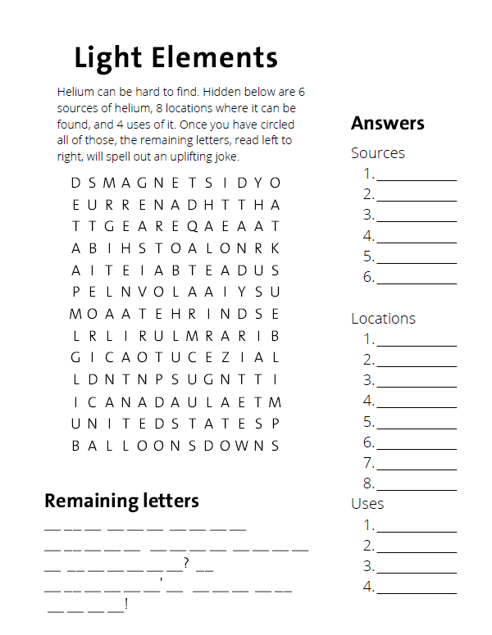

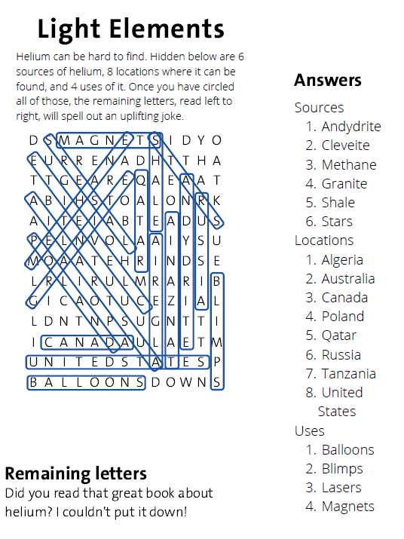

#### About the Teacher’s Guide

Teacher’s Guide team editors Dusty Carroll, Scott Hawkins, Matt Perekupka, and Jennifer Smith created the Teacher’s Guide article material. Susan Cooper prepared the anticipation, reading guides, and connections to standards.

Christine Suh (Managing Editor), Emily Abbott (Administrative Editor), and Lis Gallegos (Production Editor) coordinated the production and development of the Teacher’s Guides.

E-mail: [chemmatters@acs.org](mailto:chemmatters@acs.org)

Subscribe to *ChemMatters* magazine or purchase back-issues of the magazine at [www.acs.org/chemmatters](http://www.acs.org/chemmatters).