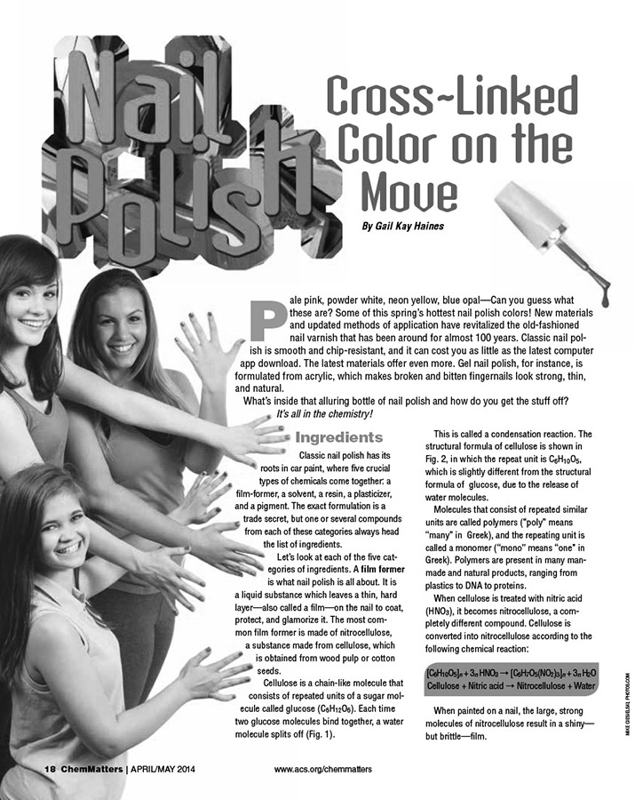


April 2014 Teacher's Guide for
Nail Polish: Cross-Linked Color on the Move

Table of Contents

About the Guide 2
Student Questions 3
Answers to Student Questions 4
Anticipation Guide 5
Reading Strategies 6
Background Information 8
Connections to Chemistry Concepts 16
Possible Student Misconceptions 16
Anticipating Student Questions 16
In-class Activities 17
Out-of-class Activities and Projects 18
References 18
Web Sites for Additional Information 18
General Web References 19

About the Guide

Teacher’s Guide editors William Bleam, Donald McKinney, Ronald Tempest, and Erica K. Jacobsen created the Teacher’s Guide article material. E-mail: bbleam@verizon.net

Susan Cooper prepared the anticipation and reading guides.

Patrice Pages, ChemMatters editor, coordinated production and prepared the Microsoft Word and PDF versions of the Teacher’s Guide. E-mail: chemmatters@acs.org

Articles from past issues of ChemMatters can be accessed from a DVD that is available from the American Chemical Society for $42. The DVD contains 30 years of ChemMatters—all ChemMatters issues from February 1983 to April 2013.

The ChemMatters DVD also includes an Index—by titles, authors and keywords—that covers all issues from February 1983 to April 2013, and all Teacher’s Guides from their inception in 1990 to April 2013.

The ChemMatters DVD can be purchased by calling 1-800-227-5558.

Purchase information can be found online at www.acs.org/chemmatters.

Student Questions
(for “Nail Polish: Cross-Linked Color on the Move”)

  - What is the purpose of a film-former in nail polish? What chemical compound is most commonly used as a film-former?
  - What is the purpose of a solvent in nail polish? What chemical compounds are the most common nail polish solvents?
  - What is the purpose of a resin in nail polish? What type of material are resins?
  - What is the purpose of a plasticizer in nail polish? Describe how its chemical action achieves this purpose.
  - What is the purpose of a pigment in nail polish? List several common pigments used in polish.
  - How is gel nail polish different from regular nail polish?
  - Name some compounds commonly used as nail polish removers.
  - Describe how nail polish remover works to take off nail polish.

Answers to Student Questions
(for “Nail Polish: Cross-Linked Color on the Move”)

    - What is the purpose of a film-former in nail polish? What chemical compound is most commonly used as a film-former?
The purpose of a film-former in nail polish is to leave a thin, hard layer on the nail to coat, protect, and glamourize it. The chemical compound most commonly used as a film-former is nitrocellulose.
    - What is the purpose of a solvent in nail polish? What chemical compounds are the most common nail polish solvents?
The purpose of a solvent in nail polish is to dissolve and help mix the other ingredients together evenly, and then evaporate as the nail polish dries. Butyl acetate and ethyl acetate are the most common nail polish solvents.
    - What is the purpose of a resin in nail polish? What type of material are resins?
The purpose of a resin in nail polish is to help the film-former stick strongly to the nail surface. Resins are natural or synthetic sticky materials that often come from coniferous trees and plants.
    - What is the purpose of a plasticizer in nail polish? Describe how its chemical action achieves this purpose.
A plasticizer helps to make the nail coating flexible so it can shift with moving fingers. Plasticizers are small molecules that can slide between the links in the polymer chain of the polish and keep them farther apart. This reduces the forces of attraction between them and makes the material more flexible.
    - What is the purpose of a pigment in nail polish? List several common pigments used in polish.
The purpose of a pigment in nail polish is to add the desired color. Common pigments used in polish include mica, fish scales, and various colored minerals.
    - How is gel nail polish different from regular nail polish?
Gel nail polish is different from regular nail polish in that it also contains acrylics, and sunlight can begin the drying (curing) process, even while it’s still in the bottle.
    - Name some compounds commonly used as nail polish removers.
Some compounds commonly used as nail polish removers are acetone and ethyl acetate.
    - Describe how nail polish remover works to take off nail polish.
Nail polish remover works to take off nail polish by getting in between the polymer chains in the nail polish and separating them. After the chains are separated, the result is a solution of nail polish dissolved in the remover, which can be wiped off.

Anticipation Guide
Anticipation guides help engage students by activating prior knowledge and stimulating student interest before reading. If class time permits, discuss students’ responses to each statement before reading each article. As they read, students should look for evidence supporting or refuting their initial responses.

Directions: Before reading, in the first column, write “A” or “D,” indicating your agreement or disagreement with each statement. As you read, compare your opinions with information from the article. In the space under each statement, cite information from the article that supports or refutes your original ideas.

Me | Text | Statement
 |  | - Regular nail polish and gel nail polish have similar ingredients.
 |  | - Wood pulp or cotton seeds are used to obtain cellulose used in nail polish.
 |  | - Cellulose is a polymer.
 |  | - Cellulose consists of only carbon, oxygen, and hydrogen.
 |  | - Water is formed in a condensation reaction.
 |  | - Nitrocellulose molecules are small.
 |  | - Sunlight can damage acrylic nail polish when it is in the bottle.
 |  | - Acetone is the most efficient nail polish remover for regular nail polish.
 |  | - Water-based nail polish sets quickly.
 |  | - Water-based nail polish is easy to remove.

Reading Strategies
These graphic organizers are provided to help students locate and analyze information from the articles. Student understanding will be enhanced when they explore and evaluate the information themselves, with input from the teacher if students are struggling. Encourage students to use their own words and avoid copying entire sentences from the articles. The use of bullets helps them do this. If you use these reading strategies to evaluate student performance, you may want to develop a grading rubric such as the one below.

Score | Description | Evidence
4 | Excellent | Complete; details provided; demonstrates deep understanding.
3 | Good | Complete; few details provided; demonstrates some understanding.
2 | Fair | Incomplete; few details provided; some misconceptions evident.
1 | Poor | Very incomplete; no details provided; many misconceptions evident.
0 | Not acceptable | So incomplete that no judgment can be made about student understanding

Teaching Strategies:

- Links to Common Core Standards for writing: Ask students to revise one of the articles in this issue to explain the information to a person who has not taken chemistry. Students should provide evidence from the article or other references to support their position.

- Vocabulary that is reinforced in this issue:

- Solvent
- Amphoteric compounds
- Semiconductor
- Structural formulas
- Polymerization

- To help students engage with the text, ask students which article engaged them most and why, or what questions they still have about the articles.
Directions: As you read, use your own words to describe the main ingredients in nail polish.

 | What it does | Raw materials | Chemicals involved
Film former
Solvent
Resin
Plasticizer
Pigment
Acrylics
(Gel nail polish only)

Background Information
(teacher information)

More on nail polish

History

While modern nail polish has been around for almost 100 years, the process of people using different methods to decorate and beautify their fingernails has been around for thousands of years. At times, users selected specific colors to wear to indicate their social standing, and even their place as royalty. It is said that the act of wearing nail polish in royalty’s colors, without being royalty, was punishable by death. The book Chemical Composition of Everyday Products describes the early history:
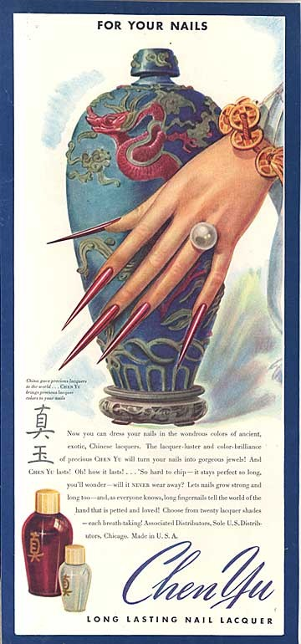
Nail polish can be historically traced back approximately 5,000 years, to at least 3000 BC, when it originated in China. During the Ming Dynasty, Chinese nail varnishes and lacquers were synthesized from a combination of beeswax, egg whites, gelatin, vegetable dyes, and gum arabic. The Egyptians were known to use orange henna to stain their fingernails. In China as well as in Egypt, color symbolized particular social classes. During the Chou Dynasty (600 BC), gold and silver were the royal color choices, and later, royalty preferred black and red and thus applied these colors to their nails to indicate their status.

(Toedt, J.; Koza, D.; Van Cleef-Toedt, K. Chemical Composition of Everyday Products; Greenwood Press: Westport, CT, 2005; p 49: http://books.google.com/books?id=UnjD4aBm9ZcC)

A vintage nail polish advertisement (see right) played on the connection to this past history.

(http://www.beautifully-invisible.com/2011/05/nail-lacquer-blood-red-nails-fingertips-history-nailpolish.html)

The modern formulation of fingernail polish was inspired by glossy car paint, which became available in 1920. The Chemical & Engineering News “What’s That Stuff?” feature included an article on nail polish that briefly outlines the history of car paint and its connection to nail polish.

The key ingredient in nail polish is nitrocellulose, a long-lasting, film-forming agent derived from cellulose. But before nitrocellulose was put into nail polish, it was used as a component of automobile paint by chemists at DuPont. Shortly after the car paint's 1920 debut, nail enamel formulations containing nitrocellulose appeared in patent literature. The patents detail the deposit of a pigment-impregnated film on finger- and toenails just as on car surfaces. The nitrocellulose-containing paint was initially so popular that within four years it covered all of General Motors' cars. The auto industry has long since moved on to other coatings, says DuPont spokesman Rick Straitman. But nitrocellulose, which is also a component in fireworks known as "gun cotton," remains a constituent of many nail polishes today.

Nail polish was not a new idea in the 1920s, although in terms of technology, the period marked a "quantum leap in both formula and production," says history of science expert Gwen Kay at the State University of New York, Oswego. Records from 17th- and 18th-century European royal courts document the appearance of shiny, varnished nails, she says. In addition, 19th-century recipe books from both Britain and the U.S. contain instructions for making nail paints alongside recipes for bread.

(Drahl, C. Chem. Eng. News 2008, 86 (32), p 42. See https://pubs.acs.org/cen/whatstuff/86/8632sci2.html.)

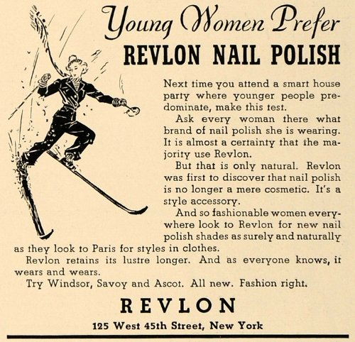
Many locations on the internet credit the original idea to adapt the car paint formula for use on nails to a French make-up artist named Michelle Manard. She worked for The Charles Revson Company. Readers familiar with the names of make-up companies may see “Revson” and wonder if it’s a typo for the company name “Revlon.” Nope—it’s part of the company’s nail polish history, to include the initial of the person who helped produce the polish. The blogger with the pen name “Beautifully Invisible” writes in the blog post “A History of Nail Lacquer: Blood Red Nails on Your Fingertips”: “Owners Charles and Joseph Revson partnered with a man named Charles Lachman and, using Manard’s original idea, created an opaque, non-streaking nail polish based on pigments instead of dyes. In 1932, the company changed its name to Revlon and began selling the very first modern nail polish!” (http://www.beautifully-invisible.com/2011/05/nail-lacquer-blood-red-nails-fingertips-history-nailpolish.html)

An image of a vintage Revlon nail polish advertisement is shown at right.

(http://www.amazon.com/gp/product/B005DH03PM/ref=as_li_ss_tl?ie=UTF8&camp=1789&creative=390957&creativeASIN=B005DH03PM&linkCode=as2&tag=squidoostuff-20)

Polish Components and Chemistry

Fingernail polish may seem like a simple product, but a lot of chemistry is squeezed into those little bottles. As described in the Haines article, each of the typical components—film-former, solvent, resin, plasticizer, and pigment—plays a critical role. The ingredients must all also be deemed safe for use when the polish is used as it is intended. In the United States, the Food and Drug Administration (FDA) regulates nail polishes used in both the home and salons. The FDA site mentions, “Many nail products contain potentially harmful ingredients, but are allowed on the market because they are safe when used as directed. For example, some nail ingredients are harmful only when ingested, which is not their intended use.” (http://www.fda.gov/Cosmetics/ProductandIngredientSafety/ProductInformation/ucm127068.htm) The roles played by each of the polish components, as well as typical examples of the chemicals used, are described in the book Chemical Composition of Everyday Products.

The formulation goal of most manufacturers is to provide as much film as possible in a single application coat while retaining application ease, quick drying time, maximum hardening, chip resistance, and a natural pearl essence. Usually, the application of two coats is necessary to obtain adequate film thickness and sufficient opacity. The three major ingredients in most nail polish brands are organic solvents, resins (thickeners or hardening agents), and color pigments. The most common organic solvents are ethyl acetate and butyl acetate (both also used as solvents in nail polish removers). As volatile solvents, these esters (synthesized by reacting a carboxylic acid with an alcohol; the general formula is R-COO-R’) evaporate quickly, leaving the resin/pigment mixture attached to the nail surface as a thin coating. Other commonly used solvents include acetone, toluene, methyl chloroform, dipropylene, ethyl alcohol, and isopropyl alcohol. Solvents are responsible for the strong odor of nail polishes.

Resins, types of polymers, are the thickening and hardening agents that, without pigments, serve as colorless nail protectors resembling clear furniture lacquer. These agents include nitrocellulose (collodion) and different acrylate and polyester/polyurethane copolymers. Copolymers include chemicals such as methacrylic acid, isobutyl methacrylate, toluenesulfonamide formaldehyde resin, phthalic anhydride/trimellitic anhydride/glycol copolymer, tosylamid/formaldehyde resin, and dimethicone co-polyol.

Nail polish pigmentation (coloring) tends to be the essence of the polish and of paramount importance to the consumer. A variety of D&C laked dyes (drug and cosmetic dyes approved by the FDA) are used in combination to achieve the desired color. Coloring may also be attributable to the presence of chemicals such as chromium oxide greens, chromium hydroxide green, ferric ferrocyanide, ferric ammonium ferrocyanide, stannic oxide, titanium dioxide, iron oxide, carmine, ultramarines, and manganese violet. Sparkling and reflective particles such as mica, bismuth oxychloride, natural pearls (guanine), and aluminum powder are used to make “frost” and “shimmer” polishes appear glittery or pearl-like.

Other ingredients in nail polish include plasticizers (e.g., dibutyl phthalate, camphor, citrates, adipates, and glycol dibenzoate) that serve as molecular lubricants, allowing the resin to remain flexible after drying, and increase resin resistance to oil and water. Dispersants (e.g., organically modified clays such as stearalkonium bentonite and stearalkonium hectorite) are additives that control flow by helping the pigments mix with the resin and solvent, thereby preventing sinking of the color particles. Ultraviolet stabilizers (e.g., benzophenone-1) may be added to prevent the polish from changing color after excessive UV sunlight exposure. In addition, chemicals such as colorant consistency regulators (e.g., palmitic acid) and antioxidant preservatives (e.g., citric acid) may be added.

(Toedt, J.; Koza, D.; Van Cleef-Toedt, K. Chemical Composition of Everyday Products; Greenwood Press: Westport, CT, 2005; pp 49–50. See http://books.google.com/books?id=UnjD4aBm9ZcC)

Chemicals used in nail polish have remained fairly constant over the years. Certain ingredients have been replaced or removed to create more environmental- and consumer-friendly products. Some of these changes are described:

A high-profile change to the recipe came in 2006, when manufacturers eliminated the plasticizer dibutyl phthalate. The change came in response to concerns voiced by environmental groups and European legislators about the ingredient; studies indicate that dibutyl phthalate could interfere with the endocrine system (C&EN, Aug. 4, page 8). Many companies have also eliminated the solvent toluene in response to safety concerns, Bryson [Paul Bryson, director of research and development at professional nail care company OPI Products] says.

Water-based nail polishes represent the biggest departure from the classic formulas. The basic elements are the same: "We need a solvent, a pigment, and something to make a film," says Mark Deason, a spokesman at Acquarella Nail Polish, which specializes in polishes and removers that do not contain petrochemical solvents. But the similarity ends there, he says. Acquarella's polishes replace nitrocellulose with a variant of a styrene-acrylate copolymer. Instead of depending entirely on solvent evaporation to dry the polish, Acquarella's technology relies on the fact that the keratin in nails allows some water to pass through them, Deason explains. The product, he says, appeals to consumers who have sensitivity to old formulas or who are simply looking for more environmentally friendly cosmetics.

(Drahl, C. Chem. Eng. News 2008, 86 (32), p 42: https://pubs.acs.org/cen/whatstuff/86/8632sci2.html)

Some polish formulations may also be tweaked to give them properties that are seen as advantageous by consumers. For example, some polishes are marketed as “quick-drying.” One way manufacturers achieve this is to use the same ingredients, but with additional solvent added. Other products are also available. This type of polish is described:

The solvent evaporates quickly, reducing your drying time.

Faster drying comes at a price. Since there is more solvent than usual, quick-drying formulations tend to run more than regular polish and leave behind a thinner coat of polish. Usually a second film forming ingredient (copolymer) is added to quick drying formulations so that they will form a coat in a short amount of time. Some people feel the quick polishes produce a duller or weaker coat than you would get from regular polish.

Quick drying nail polish isn't the only route to a fast finish. There are other quick-dry products, such as sprays or drops that you apply over the polish to make it dry almost instantly. These products typically contain volatile silicones which evaporate fast, taking the polish solvent along with them. The top film of the polish forms almost immediately, so you're less likely to smudge your nails. Depending on how thick the polish is, you may still need a few minutes to get a good hard 'set' that won't dent under pressure.

(http://chemistry.about.com/od/healthbeauty/a/How-Quick-Dry-Nail-Polish-Works.htm)

Additional Polish Types

The Haines article briefly mentions gel nails. This particular type of nail polish contains the other components already mentioned, plus acrylics. “Acrylics are a special family of monomers and/or oligomers and/or polymers used to create nail enhancement products, including UV gel nails.” (http://www.nailsmag.com/article/91808/the-science-of-gels?page=2) However, there is a difference between the polymers in these gel nail polishes and the polymers present in regular fingernail polish. “… gel is a homogenous product in which the monomers and oligomers (strings of monomers) stay in a semi-liquid/semi-solid state because it hasn’t polymerized.” (http://www.nailsmag.com/article/91808/the-science-of-gels) The gel contains a photo-initiator that can be activated by light of a specific wavelength to start the polymerization process. This polymerization is what the article labels as the curing/drying process. The process is exothermic, which can actually make your fingernails feel warm as they undergo the polymerization. The wavelengths typically needed to activate the photo-initiator fall in the UV-A range, approximately 315 to 400 nanometers. The wavelengths needed for gel polish can vary, depending on the formulation. Salons purchase gel nail lights to work with the specific polishes they use. Gel nail polish may seem as though it came to nail salons somewhat recently, but they actually appeared a bit earlier but had some difficulty becoming widely accepted.

Gel nails first appeared in the U.S. in the early 1980s, but were met with limited success. At the time, the manufacturers of gel lights and the gel itself had not joined forces, not yet recognizing the need to precisely match the intensity of the light to the photo-initiators in the gel. Nail techs and clients soon found out that using the wrong light or applying too much gel caused a burning sensation on the client’s fingertips. Additionally, education on gel application was limited, leaving nail techs in the dark about the product, and home-use systems were introduced around the same time, damaging the reputation of salon-use systems by association. By the end of the ‘80s, many companies had pulled their gel products from the market.

But by the end of the ‘90s, gel nails were back on the U.S. nail scene, now with much-improved formulas that were designed to work with a precise light wavelength and intensity. These new formulations also delivered better clarity and durability.

(http://www.nailsmag.com/article/91808/the-science-of-gels)

Chemistry is behind how ordinary fingernail polishes work, but additional polish types take the science even further, in very interesting ways. One of these polish types is magnetic polish. Magnetic polish and the science behind it are described at a physics Web site:

A common way to visualize a magnetic field, which describes how a magnet affects nearby magnetic materials (and electric currents, but that's another story), is to sprinkle long, thin pieces of iron in the area around a magnet.

When you sprinkle these iron filings around a magnet, each of the filings becomes a small magnet, attracting and repelling the original magnet and all of the other pieces of iron. The filings are pushed and pulled by the forces until they settle into a pattern where the attractive and repulsive force balance. For a bar magnet, this is the result.

If you do the same thing with magnets of different shapes, or use multiple magnets, different patterns emerge.

The designs in magnetic nail polish are formed in the same way. Nail polish manufacturers mix iron powder in with the polish. The color of polish looks uniform when it is painted on, because at that point the iron is evenly distributed within the polish. However, when a magnet is placed near the polish, the bits of iron are attracted and repelled by the magnet and each other, and form a pattern just as the iron filings do in the lab. The pattern that appears on the nail depends entirely on the arrangement of magnets and where you place them above the nail.

(http://www.physicscentral.com/explore/action/nailpolish.cfm)

To allow consumers to easily achieve this effect themselves, manufacturers include a magnet in a two-piece cap for the nail polish bottle. The bottom part of the cap is the usual cap/handle with the brush that is dipped into the polish itself, while the top of the cap can be pulled off and contains a magnet. A thin coat of the nail polish is placed on all nails first. Then, a second thicker coat is placed on each nail, one at a time. Immediately after the coat is placed on a nail, the part of the cap containing the magnet is placed over the nail and held there for several seconds, without touching the nail. The iron filings arrange to form a pattern, which remains in place after the polish dries.

Another polish type is UV color-changing nail polish. These contain photochromic molecules, those that change their appearance when exposed to light of certain wavelengths. They can exist in one of two configurations. When exposed to UV light, such as when they are exposed to the sun outdoors, the molecules are in one configuration; when the UV light is removed, they are in the second configuration. This is explained in more depth:

Classes of molecules that can exhibit photochromism include: spiropyrans, spirooxazines and diarylethenes. An example of a photochromic molecule is shown in Figure 3 [see below]; here, in its leuco, or colorless, form, the spiro bonding prohibits the molecule from exhibiting extended conjugation, which leads to a colored species. When the molecule absorbs UV light, the carbon-oxygen spiro bond breaks, leading to a rearrangement that allows the conjugation [electron shift across the extended double bond structure] to extend across the entire molecule. At this point, the molecule exhibits color when the absorption spectrum shifts to lower energy and into the visible range.

When the UV light is removed, the molecule rearranges back to the leuco or colorless state, which is the more thermodynamically stable of the two configurations. Since the rearrangement is temperature-dependent, it will occur faster at higher temperatures. Commercial examples of photochromic nail polish are available from Ruby Wing and Del Sol. SunChangeNails is another product that goes on clear and changes color when exposed to sunlight. It can also be used as a topcoat over regular nail polish to give combined effects outdoors.

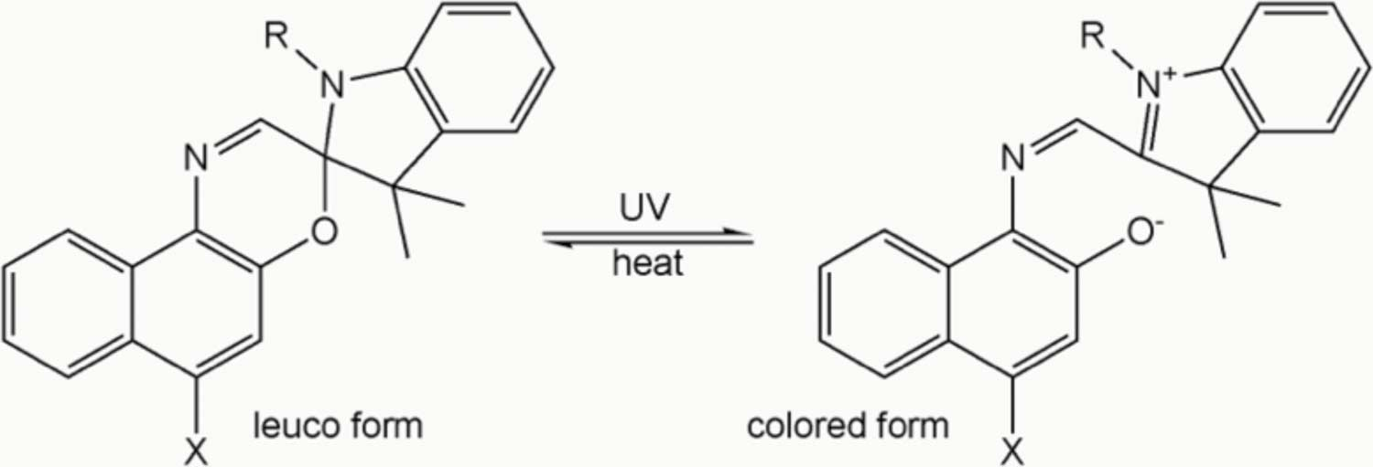

(http://www.cosmeticsandtoiletries.com/formulating/category/color/premiumTechnology-driven-Trends-in-Nail-Polish-Color-and-Texture-239975931.html)

Besides different formulations of nail polish providing different effects, the method of application of polish can also be varied to produce unusual and unique designs. One example of this is water marbling. A material such as petroleum jelly or clear adhesive tape is placed around the edges of each nail to protect the skin from polish. A regular base coat is applied, then a coat or two of a white polish. A cup of room-temperature water is then used to create a thin film of several nail polish colors—a single drop of nail polish is dropped onto the surface of the water, where it spreads into a thin film. Then, a drop of another color is placed in the center of the first color, which then spreads. This can be repeated with additional colors or alternating additional drops of the colors first used. A toothpick is then dragged through different parts of the thin film to create a marbled pattern. A fingernail is then submerged into the water, through the film of nail polish. While keeping the nail submerged, one blows gently onto the remaining polish to dry it. Then, a toothpick is used to drag through the polish and gather it up so the polished nail can be removed from the water without additional polish adhering to it. An online tutorial (http://www.youtube.com/watch?v=D9A_9FH7e-A) for creating this effect is described in the “In-class Activities” section below. Students could investigate the different variables that go into this technique. For example, the tutorial mentions that the technique won’t work unless the water is room temperature. It also recommends the use of newly-purchased nail polish, so the polish is not thickened.

More on nail polish remover

As mentioned in the previous section “More on nail polish,” one of the main components of fingernail polish is a solvent. The solvent helps to dissolve other components and allow them to be mixed together as evenly as possible. After the polish is applied to the fingernail, the solvent evaporates as the polish dries. Fingernail polish remover is also a solvent. In some cases, it may even be the same solvent as in the fingernail polish itself. The solvent in the remover, in a way, reverses the process that occurred when the polish was originally applied and dried. As described in the Gaines article, after application, the film-former present in the polish cross-polymerizes to form a large, molecular mesh. When fingernail polish remover is applied, the solvent in the remover gets into the molecular mesh and separates the cross-connections in the polish. Eventually, enough of these connections are broken, so that the polish becomes dissolved in the solvent of the remover.

One of the most commonly-used types of remover employs acetone as its solvent. Acetone is a very effective polish remover. However, its effectiveness makes it unsuitable for certain uses, such as with nail extensions, which are artificial nails applied to the natural fingernail. If acetone is used on polish that has been applied to nail extensions, it can cause additional problems: “Because of acetone's strength as a solvent, it shouldn't be used on your fake nails. The solvent in the polish remover will weaken your extensions and cause them to separate from your natural nail. One of the reasons non-acetone nail polish removers were created was to be used on nail extensions.” (http://health.howstuffworks.com/skin-care/nail-care/tips/non-acetone-nail-polish-remover.htm) Some alternatives to acetone-based nail polish remover are those that contain ethyl acetate, methyl acetate, or methyl ethyl ketone.

Fingernail polish removers usually include ingredients in addition to the solvent. Certain ingredients are designed to counteract some of the drawbacks associated with the solvent, such as the drying effects of acetone on skin. Some even include an ingredient meant to cut down on accidental poisoning. Some of these additional ingredients are described:

Because acetone contact with the skin may result in irritation and dermal damage, nail polish removers containing acetone usually also contain emollients such as mineral oil, castor oil, or lanolin to prevent the nails and surrounding skin from becoming dry and devoid of natural oils. These oils also decrease the evaporation time [Note: Authors likely intended “decrease the evaporation rate,” since adding oils would likely increase the amount of time before the solvents evaporate] of the volatile paint-removing solvents, thereby allowing more time for the product to work efficiently.

Nail polish removers may also contain ingredients such as general solvents (e.g., propylene carbonate), products found in commercial paint strippers (e.g., dimethyl glutarate, dimethyl succinate, and dimethyl adipate), emollients and moisturizers (e.g., glycerin and panthenol), preservatives (e.g., propylene glycol), vitamins (e.g., dl-a-tocopheryl acetate [vitamin E]), fragrance, and coloring dyes. Some brands also contain a chemical called denatonium benzoate (C₂₈H₃₄N₂O₃), one of the most bitter-tasting substances known. Since most humans have a natural aversion to ingesting highly bitter chemicals, this substance is often added to toxic household liquid products to decrease accidental poisoning via swallowing of substantial amounts.

(Toedt, J.; Koza, D.; Van Cleef-Toedt, K. Chemical Composition of Everyday Products; Greenwood Press: Westport, CT, 2005; p 51. See http://books.google.com/books?id=UnjD4aBm9ZcC.)

No matter the choice of fingernail polish remover, each tends to have potential drawbacks. Fingernail polish removers do have certain concerns connected with them and must be used as directed. For example, they tend to be flammable and must be used away from open flame and with proper ventilation. Specific drawbacks of two other remover solvents are that methyl acetate is more dangerous than acetone if accidentally ingested, while methyl ethyl ketone works more slowly than acetone, so one has to breathe in its fumes for a longer period of time while using. (http://www.besthealthmag.ca/look-great/nails/are-nail-polish-removers-bad-for-your-health)

Since fingernail polish remover solvents are often those used in the fingernail polish itself, some suggest that one can use removers to extend the life of fingernail polishes that have become thickened over time as their original solvents have evaporated. A Ph.D. student in chemistry and self-proclaimed “beauty junkie” answered the question “Is it ok to add nail polish remover to your nail polish?” on her blog “Lab Muffin”:

Unfortunately, there's no easy yes or no - the incredibly unsatisfying answer is: it depends. It depends on 2 things: the type of nail polish remover and the composition of your polish.

Nail polish goes gluggy [moves slowly or with some resistance] over time because the solvent (wet stuff) slowly evaporates. Adding thinner replenishes the lost liquid, usually ethyl acetate or butyl acetate, two very similar non-polar solvents. Adding the first name on the ingredients list is the best bet for restoring the original consistency. But cheap thinners are hard to find.

There are thousands of different removers on the market. They are usually water and either acetone or ethyl acetate, sometimes with small amounts of colour or moisturiser added. So it makes sense that if your remover is pure ethyl acetate (rare, but possible) or the vast majority is ethyl acetate (hard to know if %s aren't listed), there will be no problem using that as a thinner.

However, if your polish remover has lots of water (very common, since water is cheap, and they can claim it's gentle since there will be less solvent to strip oil from your skin), the problem is that water doesn't mix very well with ethyl/butyl acetate. This means that for most polishes, the finish will end up less smooth once water has been added, and depending on how much you add, the incompatible solvents can result in a streaky look. This might not be a concern when it comes to bumpy glitters, or if you plan to use a topcoat, or if the polish had a dodgy formula to begin with.

Adding pure acetone is less likely to lead to incompatible mixtures since it mixes well with ethyl/butyl acetate, but it can still affect the composition of the polish and give a bumpy or dull finish. An additional concern with acetone is that it dissolves more things than ethyl/butyl acetate, so some glitters and shimmers which are solvent stable in the original polish might start leaching after acetone is added.

So there are a lot of factors to consider before you add remover to your polish! The best thing to do is to dump a small amount of goop onto a piece of foil, add a drop or two of remover, stir, and see how it dries.

The bottom line: Adding nail polish remover will generally change the finish of your polish, unless you're using pure ethyl acetate. This might not be a concern if you always use topcoat. The safest thing to do is to test a small amount first, or use a thinner that contains the top few solvents in your polish's ingredients list (usually ethyl acetate or butyl acetate).

(http://www.labmuffin.com/2012/07/is-it-ok-to-add-nail-polish-remover-to.html)

Connections to Chemistry Concepts
(for correlation to course curriculum)

- Polymers—Cross-polymerization is involved when fingernail polish dries and helps to form a more extensive, stronger molecular mesh.
- Solvents—Fingernail polishes and fingernail polish removers both contain solvents. A discussion of solvents could cover the function of a solvent and the selection of a solvent for a particular use.
- Electromagnetic radiation—Gel nail polish requires the use of an ultraviolet (UV) lamp with wavelengths of the appropriate range to properly cure it. This ties in to a discussion of different types of electromagnetic radiation and their associated wavelengths. It can also be related to the idea that UV radiation is of different types (UV-A, UV-B, UV-C); there are different wavelengths, and thus different amounts of energy, associated with each. UV-A and UV-B are often mentioned in connection with sunscreens, since each type has a different effect on the skin.
- Thermodynamics—The curing process of gel fingernail polish is an exothermic process and can release enough energy so that the fingernails feel warm.

Possible Student Misconceptions
(to aid teacher in addressing misconceptions)

- “Fingernail polish is a recent invention.” The modern type of fingernail polish, based on car paint formulations, was developed in the 1920s. Additional types of polishes, such as gel polish, became available in the 1980s. However, the use of substances to coat and decorate fingernails extends back to approximately 3000 BC (see “More on nail polish” section above).
- “There is only one type of fingernail polish.” Different types of fingernail polish are available. The most common is the regular type described in the Gaines article. The article also mentions gel nail polish, which contains acrylics, and water-based nail polish, which uses water as the main solvent. The polishes all serve the same purpose, but differ in properties such as drying time and if an additional step is needed to begin the drying or curing process.

Anticipating Student Questions
(answers to questions students might ask in class)

- “Are nail polish and nail polish removers safe to use?” If the products are used properly as their directions state, they are designed to be safe. For example, certain compounds in the products are harmful if ingested or used near open flame; if one ingests the products or uses them near open flame, they can be harmful, but these do not follow their intended use. Certain ingredients, sometimes called the “toxic trio,” (formaldehyde, toluene, and dibutyl phthalate) are connected with allergies and cancer, but in the small amounts present in the products, they have not been shown to cause harm to users. Many manufacturers are phasing out these chemicals from their products anyway. Those in contact with the products as part of their job have more potential danger, but there are precautions they can take, such as good ventilation.

In-class Activities
(lesson ideas, including labs & demonstrations)

- Students can use clear fingernail polish to explore nanotechnology. A drop of nail polish spreads into a thin film on the surface of water. A piece of black paper can be drawn through this film and then dried. The polish creates an iridescent pattern of rainbow colors. (http://www.nisenet.org/catalog/programs/exploring_materials_-_thin_films_nanodays_11)
- Fingernail polish can be connected to artistic effects as students investigate the idea of creating designs with polish using a water marbling technique. Several drops of nail polish are floated on water and then a toothpick is dragged through it to create patterns. A fingernail can be submerged through the layer of polish, resulting in a marbled design on the nail. Instructions are available online at http://www.youtube.com/watch?v=D9A_9FH7e-A. This could be tied in with various paper marbling activities that discuss more of the science involved, such as the Flinn ChemFax! “Marbling Paper with Oil Paints” (https://www.flinnsci.com/media/395998/91324.pdf) and the Journal of Chemical Education activity “Colorful Lather Printing” (http://pubs.acs.org/stoken/campaign/jce-classroom/abs/10.1021/ed084p608a).
- Experiments involving fingernail polish have been popular science fair projects. For example, one project investigated the durability of different types of nail polish, including a type that contains Teflon. (http://www.all-science-fair-projects.com/project1421_134_1.html) Another tested the durability and drying time of different brands. (https://www.usc.edu/CSSF/Current/Projects/J2120.pdf)
- A past ChemMatters article described a research project by students that was sparked by the question “Is it OK to wear my fake fingernails in lab?” The students tested the flammability of synthetic fingernails. Students could recreate this investigation. (Allin, S. B. Fire at Your Fingertips—The Flammability of Synthetic Nails. ChemMatters 2001, 19 (1), pp 14–15.)
- A popular demonstration uses acetone to dissolve polystyrene cups and packing peanuts. Acetone-based fingernail polish remover is one possible substitute. One demonstration online explores the ability of two different solvents, acetone and water, to dissolve two different types of packing peanuts, polystyrene and starch. (http://sciencegeekgirl.com/activities/Wicked styrofoam activity 2.pdf) A Steve Spangler video shows a twist on the demonstration. He uses a beaker of acetone hidden in a polystyrene mannequin head. Then, strips of polystyrene that have things written on them that you want students to learn are “put into the head.” (http://www.youtube.com/watch?v=H_8Sdpigs0E)

Out-of-class Activities and Projects
(student research, class projects)

- Students could visit a nail salon to talk to nail technicians about the various polishes they use, their application, and any safety procedures they use.
- Students could research the science behind common ideas connected with nail polish and nail care, such as whether eating gelatin makes fingernails stronger, whether or not fingernails need to “breathe” in between manicures, whether it’s better or worse to store nail polish in the refrigerator, etc. Much of the information on the internet related to these topics is contradictory. It could be an exercise in judging whether a source is reliable or not.

References
(non-Web-based information sources)

A two-student team undertook a research project to investigate the flammability of synthetic fingernails (“fake nails”) to evaluate the safety of wearing such nails in a chemistry lab. (Allin, S. B. Fire at Your Fingertips—The Flammability of Synthetic Nails. ChemMatters 2001, 19 (1), pp 14–15)

Web Sites for Additional Information
(Web-based information sources)

Web sites on nail polish

The blog post “A History of Nail Lacquer: Blood Red Nails on Your Fingertips” provides additional details about the history of nail polish, including images of several vintage advertisements. (http://www.beautifully-invisible.com/2011/05/nail-lacquer-blood-red-nails-fingertips-history-nailpolish.html)

Fingernail products for home and salon use in the United States are regulated by the U.S. Food and Drug Administration. An overview of the FDA’s safety and regulatory information is presented online. (http://www.fda.gov/Cosmetics/ProductandIngredientSafety/ProductInformation/ucm127068.htm)

ABC News featured a report by the state of California that multiple nail polishes were mislabeled, including those that claimed to not contain what is known as the “toxic trio,” three chemicals that many companies have been phasing out. (http://abcnews.go.com/Health/Health/nail-polish-safety/story?id=16108721)

A video from a nail polish company shows the application and effects of magnetic nail polish. (http://www.youtube.com/watch?v=xqas6ym_BuU)

A nail polish that allows water and air through to the fingernail is gaining popularity with women wishing to comply with Muslim law. (http://www.dailymail.co.uk/femail/article-2285544/How-new-breathable-nail-polish-Muslim-women-flying-shelves--death-creator-means-live-success.html)

The publication “Stay Healthy and Safe While Giving Manicures and Pedicures: A Guide for Nail Salon Workers,” written by the Occupational Safety and Health Administration (OSHA), is available online. (https://www.osha.gov/Publications/3542nail-salon-workers-guide.pdf)

Nail polish formulations have their roots in automobile paint. One woman took polish back to these roots by painting over the exterior of her car with over 100 bottles of fingernail polish. (http://www.nailsmag.com/article/40373/meet-smiley-the-nail-polish-car)

Web sites on nail polish remover

A U.S. drugstore chain made a decision last year, then quickly rescinded it, requiring consumers to show photo identification when purchasing fingernail polish remover. This was meant to help curb the production of methamphetamine; acetone (often an ingredient in fingernail polish remover) is one of the ingredients used in its production. (http://www.huffingtonpost.com/2013/08/11/cvs-nail-polish-remover-id_n_3739816.html)

Removing certain types of gel nail polish requires a soak-off procedure. An article outlines some of the damage that can be done to the fingernail if done improperly, including microscopic views of the fingernail surface. (http://www.nailsmag.com/article/96323/avoid-nail-damage-with-proper-gel-polish-removal)

Material Safety Data Sheets (MSDS) are available online for fingernail polish removers. (http://www.vijon.com/data/resources/PN679.pdf)

General Web References
(Web information not solely related to article topic)

The post “15 Things You Never Knew About Your Nails” at The Huffington Post Web site shares little-known facts about your fingernails, such as how the time of the year or your gender affects their growth rate and whether you need to let your nails “breathe” between manicures. (http://www.huffingtonpost.com/2013/09/24/nail-facts-fingernails_n_3957467.html)

