logo_chemmatters[1]

**April/May 2015 Teacher's Guide for**

***Left Life? Right Life? Chirality in Action***

**Table of Contents**

[About the Guide 2](#_Toc415151311)

[Student Questions 3](#_Toc415151312)

[Answers to Student Questions 4](#_Toc415151313)

[Anticipation Guide 6](#_Toc415151314)

[Reading Strategies 7](#_Toc415151315)

[Background Information 9](#_Toc415151316)

[Connections to Chemistry Concepts 29](#_Toc415151317)

[Possible Student Misconceptions 30](#_Toc415151318)

[Anticipating Student Questions 30](#_Toc415151319)

[In-Class Activities 31](#_Toc415151320)

[Out-of-class Activities and Projects 33](#_Toc415151321)

[References 34](#_Toc415151322)

[Web Sites for Additional Information 35](#_Toc415151323)

[General Web References 37](#_Toc415151324)

# About the Guide

Teacher’s Guide editors William Bleam, Regis Goode, Donald McKinney, Barbara Sitzman and Ronald Tempest created the Teacher’s Guide article material. E-mail: [bbleam@verizon.net](mailto:bbleam@verizon.net)

Susan Cooper prepared the anticipation and reading guides.

Patrice Pages, *ChemMatters* editor, coordinated production and prepared the Microsoft Word and PDF versions of the Teacher’s Guide. E-mail: [chemmatters@acs.org](mailto:chemmatters@acs.org)

Articles from past issues of *ChemMatters* can be accessed from a DVD that is available from the American Chemical Society for $42. The DVD contains the entire 30-year publication of *ChemMatters* issues, from February 1983 to April 2013.

The *ChemMatters* DVD also includes Article, Title and Keyword Indexes that covers all issues from February 1983 to April 2013.

The *ChemMatters* DVD can be purchased by calling 1-800-227-5558.

Purchase information can be found online at [www.acs.org/chemmatters](http://chemistry.org/chemmatters/cd3.html).

# Student Questions

**(taken from article)**

* 1. Compare the picture of the woman with her mirror image on page 5. Describe two ways that the woman and her image differ.
  2. How does the example in Figure 2 illustrate the meaning of superimpose?
  3. Explain why baseball gloves exhibit chirality, but a toddler’s mittens are not chiral.
  4. Draw the structural formula for molecular hydrogen and explain why this molecule is not chiral.
  5. How can one determine if a carbon atom is asymmetric?
  6. What is the meaning of the term enantiomer? Give an example of enantiomers.
  7. Why do chemists prefer to use the L and D convention rather than left- or right-handed to describe enantiomers?
  8. Why does the human body use only the L form of amino acids? Explain.
  9. What determines whether an amino acid molecule has a D or an L configuration?
  10. What could we learn from a discovery that the cells of extraterrestrial life have enzymes that bind D-amino, rather than L-amino acids, to form proteins?

# Answers to Student Questions

**(from article)**

* + 1. **Compare the picture of the woman with her mirror image on page 5. Describe one way that the woman and her image differ, in addition to the one (“handedness”) mentioned in the article.**

*In the picture, the woman’s hair is parted on her right side. The mirror image shows the part in her hair on the left side. Most student answers will be similar to this one. Also accept other reasonable answers such as ones based on her hands: the backs of her fingers are shown on opposite sides. Or, in the picture her fingers are on the right side of her face and in the mirror image her fingers appear slightly to the left and center of her face.*

* + 1. **How does the example in Figure 2 illustrate the meaning of superimpose?**

*To superimpose means to place one thing on top of the other so that it matches completely. If the mirror image of the right hand is placed palm up on top of the picture of the left hand (outside the mirror), both thumbs will be on the left and the corresponding fingers will exactly match. Thus, the mirror image of the right hand is superimposable on the left hand.*

* + 1. **Explain why baseball gloves exhibit chirality, but a toddler’s mittens are not chiral.**

*Like hands, baseball gloves are left- or right-handed, they are chiral. If a left-handed and a right-handed glove are both placed palm down, when layered they will not superimpose. Just like hands, the thumbs will be on opposite sides. A toddler’s mittens are not chiral because the top and bottom of mittens are exactly the same. They do not exhibit chirality because they can be superimposed by laying one on top of the other with thumbs facing the same way. Toddlers’ mittens can be worn on either hand.*

* + 1. **Draw the structural formula for molecular hydrogen and explain why this molecule is not chiral.**

*The structure formula for H2 is H–H. This formula shows the two hydrogen atoms connected by a single covalent bond. Chirality is not exhibited because the two hydrogens are exactly the same. Two H–H molecules can be superimposed by laying one exactly on top of the other.*

* + 1. **How can one determine if a carbon atom is asymmetric?**

*A carbon atom is asymmetric if it forms the center of a tetrahedral structure that has four different elements at each of the carbon’s four binding sites. These elements can be either single atoms like hydrogen or halogens or they can be groups of atoms such as the amino, carboxyl, or other organic side chains (R groups)*

* + 1. **What is the meaning of the term enantiomer? Give an example of enantiomers.**

*An enantiomer is one of two mirror-image forms. The right and left hands are enantiomers of each other. Students may name left and right feet, shoes, baseball gloves, or any other objects that are mirror images of each other.*

* + 1. **Why do chemists prefer to use the L and D convention rather than left- or right-handed to describe enantiomers?**

*Chemists prefer to use the L and D convention to identify enantiomers because this convention does not convey the idea of “left-handed” and “right-handed”, yet it does convey that L and D are mirror images of each other. Enantiomers were originally called “left-handed” and “right-handed” like our hands or feet.*

* + 1. **Why does the human body use only the L form of amino acids? Explain.**

*Human cells contain enzymes that are specifically shaped to only bind to L-amino acids and link them together to form proteins in our bodies, and do not bind to D-amino acids. Other enzymes shaped to bind to D-sugars, link them together to form large sugar molecules such as carbohydrates. Enzymes that could bind to D-amino acids or L-sugars do not exist in human cells.*

* + 1. **What determines whether an amino acid molecule is considered to have a D or an L configuration?**

*In Figure 5, the left and right locations of the hydrogen and R groups are reversed. They are mirror images of each other. The L-amino acid structure shows the hydrogen atom pointing to the left and toward the back of the sheet of paper and the R group pointing to the left and toward the sheet of paper. The D-amino acid structure shows the hydrogen pointing to the right and toward the back of the paper; the R group points to the right and toward the paper.*

* + 1. **What could we learn from a discovery that the cells of extraterrestrial life have enzymes that bind D-amino, rather than L-amino acids, to form proteins?**

*This would tell us that living creatures on earth probably did not evolve from an ancestor common to that of this extraterrestrial life.*

# Anticipation Guide

Anticipation guides help engage students by activating prior knowledge and stimulating student interest before reading. If class time permits, discuss students’ responses to each statement before reading each article. As they read, students should look for evidence supporting or refuting their initial responses.

**Directions:**  *Before reading*, in the first column, write “A” or “D,” indicating your agreement or disagreement with each statement. As you read, compare your opinions with information from the article. In the space under each statement, cite information from the article that supports or refutes your original ideas.

|  |  |  |
| --- | --- | --- |
| **Me** | **Text** | **Statement** |
|  |  | 1. Right-handed objects (hands, feet, shoes, baseball gloves) cannot be superimposed onto their mirror images. |
|  |  | 1. Many molecules found in living things cannot be superimposed onto their mirror images. |
|  |  | 1. Molecules may exhibit left-(L) or right-handedness (D). |
|  |  | 1. There are more than 50 different amino acids found in life on Earth. |
|  |  | 1. Our bodies use only one type of amino acid (L-amino acids) to form proteins. |
|  |  | 1. Living creatures on Earth use only L-sugars. |
|  |  | 1. We can digest proteins and sugars, regardless of whether they are L or D. |
|  |  | 1. Monosaccharides are building blocks for carbohydrates. |
|  |  | 1. Currently, scientists think that life may be present in only four different places in our solar system. |
|  |  | 1. Scientists use space probes to look for molecular evidence of the relationship of life on Earth to extraterrestrial life. |

# Reading Strategies

These graphic organizers are provided to help students locate and analyze information from the articles. Student understanding will be enhanced when they explore and evaluate the information themselves, with input from the teacher if students are struggling. Encourage students to use their own words and avoid copying entire sentences from the articles. The use of bullets helps them do this. If you use these reading and writing strategies to evaluate student performance, you may want to develop a grading rubric such as the one below.

|  |  |  |
| --- | --- | --- |
| **Score** | **Description** | **Evidence** |
| 4 | Excellent | Complete; details provided; demonstrates deep understanding. |
| 3 | Good | Complete; few details provided; demonstrates some understanding. |
| 2 | Fair | Incomplete; few details provided; some misconceptions evident. |
| 1 | Poor | Very incomplete; no details provided; many misconceptions evident. |
| 0 | Not acceptable | So incomplete that no judgment can be made about student understanding |

***Teaching Strategies:***

1. Links to **Common Core Standards for Reading**:
   1. ELA-Literacy.RST.9-10.5: Analyze the structure of the relationships among concepts in a text, including relationships among key terms (e.g., force, friction, reaction force, energy).
   2. ELA-Literacy.RST.11-12.4: Determine the meaning of symbols, key terms, and other domain-specific words and phrases as they are used in a specific scientific or technical context relevant to grades 11-12 texts and topics.
2. Links to **Common Core Standards for Writing**:
   1. ELA-Literacy.WHST.9-10.2F: Provide a concluding statement or section that follows from and supports the information or explanation presented (e.g., articulating implications or the significance of the topic).
   2. ELA-Literacy.WHST.11-12.1E: Provide a concluding statement or section that follows from or supports the argument presented.
3. **Vocabulary** and **concepts** that are reinforced in this issue: Chirality; Enantiomer; Amino acid; Protein; Enzyme; and Organic molecular structures.
4. To help students engage with the text, ask students which article **engaged** them most and why, or what **questions** they still have about the articles. The Background Information in the *ChemMatters* Teachers Guide has suggestions for further research and activities.

***Directions*:** As you read, complete the graphic organizer below to explain chirality in your own words using information from the article.

|  |  |
| --- | --- |
| **Chirality** | |
| **What is it?** |  |
| **What are some molecular examples?** |  |
| **What are some molecular non-examples?** |  |
| **How can chirality be determined?** |  |
| **How does chirality relate to life on Earth?** |  |
| **How is chirality involved in the search for extraterrestrial life?** |  |

# Background Information

**(teacher information)**

**More on** **the discovery of chirality**

Optical activity was first reported by scientists who described the colors produced by sunlight when it passed through a prism. In 1884 Louis Pasteur recrystallized a water solution of optically inactive tartaric acid and discovered that his sample was composed of two different crystal shapes, mirror images of each other. Using tweezers and a microscope he separated the crystals, dissolved the shapes in individual containers of water, and found that they rotated light in opposite directions. Pasteur’s discoveries led to our understanding of enantiomers and paved the way to recognizing their importance in biological activity. More details are available in the introduction to the Wiley book, *Chirality at the Nanoscale: Nanoparticles, surfaces, Materials and more.* (free access: <http://www.wiley-vch.de/books/sample/352732013X_c01.pdf>)

**More on** **chirality in our lives**

If you can simply lay one spoon on top of the other and the two fit perfectly (superimpose), these two spoons are **achiral** (not chiral). Whether you are left- or right-handed makes no difference when you take notes on a lab table because it is achiral. But, what happens when you work with **chiral** objects? For example, if you are right-handed, try taking notes on a left-handed (chiral) desk!

Checking the chirality of an object is easy if you use a mirror:

* achiral—The mirror image looks exactly the same as the object. This means that the object and its mirror image are superimposable. A few examples include a blank piece of paper, a nail, a plain pencil, and a plain lacrosse ball of “super” ball (with no logo).
* chiral—The mirror image is different from the object. The object is not superimposable on its mirror image. Examples include screw threads, golf clubs, and left-handed scissors.

The shells of animals and flowers may demonstrate chirality. Note the left-styled and right-styled blue flower.

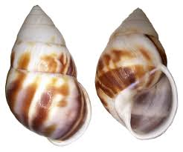 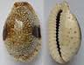 

**snail clam flower**

* The snail exhibits chirality due to spiral coils. Thus, a mirror image will show the shell spirals on the opposite side. ([*http://en.wikipedia.org/wiki/Gastropod\_shell*](http://en.wikipedia.org/wiki/Gastropod_shell))
* The clam’s chirality is shown by the presence of the shell opening on one side and the hinge on the other. ([*http://en.wikipedia.org/wiki/Bivalve\_shell*](http://en.wikipedia.org/wiki/Bivalve_shell))
* The genus Heteranthera contains plants that have asymmetric flowers, a mixture of left and right-handed varieties. The yellow *style* (part of plant reproductive system) can be located on either the left or the right side (or both sides) of the flower, so these flowers show handedness. ([*http://www.zoologi.su.se/ekoklim/z\_SchwanderLeimar2011.pdf*](http://www.zoologi.su.se/ekoklim/z_SchwanderLeimar2011.pdf))

**More on** **chirality at the molecular level**

Chirality is a property of individual molecules. Many organic molecules exhibit chirality, especially biological molecules such as amino acids, enzymes, and sugars. An asymmetric carbon atom usually acts as the chiral center of these molecules. Chirality is also found in coordination compounds where a metal atom (e.g., iron, cobalt) or nitrogen, phosphorus, and sulfur act as chiral centers.

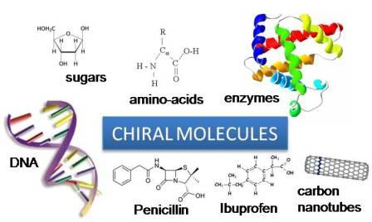

([*http://www.rowland.harvard.edu/rjf/fischer/background.php*](http://www.rowland.harvard.edu/rjf/fischer/background.php))

On page 6 of the Warmflash chirality article, the author describes a chiral molecule as one containing an asymmetric carbon atom. The figures to the right can be used to define and further illustrate symmetry. The illustration shows vertical lines of symmetry bisecting each figure. If you fold the image along the line, both halves will exactly match. Or, if you consider the line a mirror, the symmetric image (on the left) exactly replicates its mirror image. In contrast, the two halves of the asymmetric figure are not superimposable (representing a chiral object).

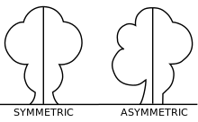

([*http://en.wikipedia.org/wiki/Asymmetry*](http://en.wikipedia.org/wiki/Asymmetry))

**More on** **chiral centers and asymmetric carbons**

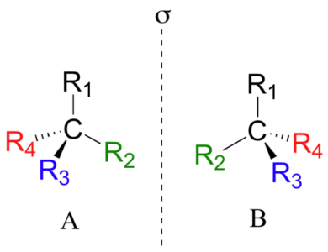 Figure 3 in the Warmflash Chirality article shows the asymmetric carbon (a chiral center) bonded to four different atoms or groups of atoms. This molecule will not superimpose on its mirror image. The molecule and its mirror image are enantiomers. The drawing at right shows the vertical line of symmetry (like a mirror) and the carbon bonded to four different “R” functional groups. Molecule A is chiral with an asymmetric carbon at its center because molecule A is not superimposable on its mirror image, molecule B. Notice that the locations of the R2 and R4 groups have been reversed.

([*http://chemwiki.ucdavis.edu/Textbook\_Maps/Organic\_Chemistry\_Textbook\_Maps/Map%3A\_Bruice\_6ed\_%22Organic\_Chemistry%22/05%3A\_Stereochemistry%3A\_The\_Arrangement\_of\_Atoms\_in\_Space%3B\_The\_Stereochemistry\_of\_Addition\_Reactions/5.03%3A\_An\_Asymmetric\_Center\_Is\_a\_Cause\_of\_Chirality\_in\_a\_Molecule*](http://chemwiki.ucdavis.edu/Textbook_Maps/Organic_Chemistry_Textbook_Maps/Map%3A_Bruice_6ed_%22Organic_Chemistry%22/05%3A_Stereochemistry%3A_The_Arrangement_of_Atoms_in_Space%3B_The_Stereochemistry_of_Addition_Reactions/5.03%3A_An_Asymmetric_Center_Is_a_Cause_of_Chirality_in_a_Molecule))

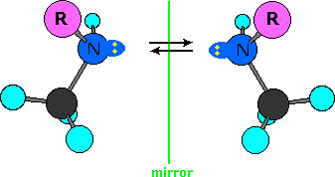 The chiral center of a molecule is not always a carbon atom. Tetravalent phosphorus and trivalent sulfur or nitrogen can also act as the center of a chiral molecule. For example, the molecule at right, non-superimposable on its mirror image, shows nitrogen bonded to three groups, a lone pair of electrons completes the tetrahedron and acts as the fourth group around the central nitrogen atom. Inorganic molecules with a transition metal ion such as iron and cobalt acting as the chiral center can also be chiral. Depending upon the coordination number of the metal ion, the structures can form tetrahedral, square planar, or octahedral complexes that are non-superimposable on their mirror images.

([*source same as above*](http://chemwiki.ucdavis.edu/Textbook_Maps/Organic_Chemistry_Textbook_Maps/Map%3A_Bruice_6ed_%22Organic_Chemistry%22/05%3A_Stereochemistry%3A_The_Arrangement_of_Atoms_in_Space%3B_The_Stereochemistry_of_Addition_Reactions/5.03%3A_An_Asymmetric_Center_Is_a_Cause_of_Chirality_in_a_Molecule))

**More on the nomenclature of enantiomers and the R,S designation**

As described in the Warmflash chirality article, mirror-image isomers are called enantiomers. In biochemical nomenclature CIP, a nomenclature system devised by European Scientists (Cahn, Ingold, and Prelog) using R and S, is the most accepted method for identifying and naming enantiomers. Using this nomenclature and the rotation of light described in the Warmflash chirality article, the enantiomer that rotates plane polarized light in a clockwise direction is designated positive (+); counterclockwise rotation is indicated by a negative sign (–) in the name of the molecule. This nomenclature uses + or – rather than D or L to indicate the directional rotation of plane polarized light. D and L designations still work for amino acids and carbohydrates, but they fall short when naming more complex biochemical molecules.

R or S in the nomenclature refers to the direction followed by prioritizing the four groups that bond to the chiral center of the molecule. The Khan Academy has developed a series of five videos to take students through the process of determining the R and S identities of simple molecules. The first two videos show how to identify the chiral centers of molecules. Khan videos 3–5 provide three examples of prioritizing and numbering to determine the R and S designations.

1. *Stereoisomers, enantiomers, and chirality centers*: This video defines the vocabulary and shows how to use wedge-dash configurations to show the three dimensionality of the tetrahedral structure. (<https://www.khanacademy.org/science/organic-chemistry/stereochemistry-topic/chirality-absolute-configuration/v/stereoisomer-enantiomer-jay>)
2. *Identifying chiral centers*: Students are shown how to identify a chiral carbon by identifying how four different groups bond to it. (<https://www.khanacademy.org/science/organic-chemistry/stereochemistry-topic/chirality-absolute-configuration/v/chirality-center-jay>)

The last three videos provide examples of how to prioritize the four groups attached to the chiral carbon and how to determine the R,S designation. Absolute configurations show the arrangement in space of a chiral molecule leading to its R,S description.

1. *RS system for bromochlorofluoromethane*: Priority numbers are assigned using atomic numbers. Bromine with the highest atomic number (35) is assigned “1”; chlorine (17) is “2”; fluorine (9) is “3”; hydrogen has the lowest atomic number (1) so it is given the lowest value in the “4” priority. Next, the models show how to rotate the molecule so that the hydrogen faces away. Finally the priority numbers assigned are written on each of the four atoms attached to carbon and followed in numerical order to determine if the rotation is clockwise (R) or counterclockwise (S).The pink arrows show a 1–4 clockwise direction of the priority numbers in the R configuration and show a 1–4 counterclockwise direction for the priority numbers in the S configuration. This identifies the enantiomer as R or S. (<https://www.khanacademy.org/science/organic-chemistry/stereochemistry-topic/chirality-absolute-configuration/v/rs-bromochlorofluoro-jay>)

[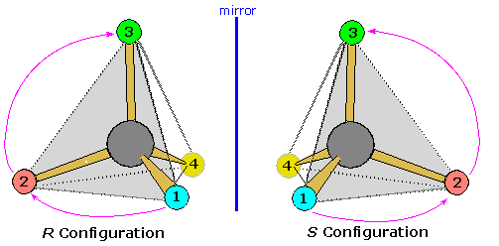](javascript:chng3())

([*https://www2.chemistry.msu.edu/faculty/reusch/virttxtjml/sterism3.htm*](https://www2.chemistry.msu.edu/faculty/reusch/virttxtjml/sterism3.htm))

1. “RS system for 2-butanol”: This video reinforces the method above with 2-butanol. (<https://www.khanacademy.org/science/organic-chemistry/stereochemistry-topic/chirality-absolute-configuration/v/rs-2butanol-jay>)
2. “RS system for cyclic compounds”: RS designation is done for six-carbon rings. (<https://www.khanacademy.org/science/organic-chemistry/stereochemistry-topic/chirality-absolute-configuration/v/r-s-system-for-cyclic-compounds>)

**More on the nomenclature of molecules with more than one chiral center**

Many molecules, especially complex biochemical molecules, contain more than one chiral center. To name the compounds, you first prioritize the chiral carbons and then determine if each is R (clockwise rotation of their priority numbers) or S (counterclockwise rotation). The Michigan State University chemistry department provides a guide for numbering chiral centers. As an example, the numbering of ephedrine, a stimulant, used to treat asthma is discussed on their Web site. Note that the chiral carbon closest to the benzene ring is numbered “1” in each isomer but it may be R or S depending upon the priority numbering of groups around the chiral carbon. (<https://www2.chemistry.msu.edu/faculty/reusch/virttxtjml/sterism3.htm>)

The Chinese shrub Ma Huang (*Ephedra vulgaris*) contains two physiologically active compounds **ephedrine** and **pseudoephedrine**. Both compounds are stereoisomers of 2-methylamino-1-phenyl-1-propanol, and both are optically active, one being levorotatory and the other dextrorotatory. Since these two compounds are optically active, each must have an enantiomer. Although these missing stereoisomers were not present in the natural source, they have been prepared synthetically and have the expected identical physical properties and opposite-sign specific rotations. The structural formula of 2-methylamino-1-phenylpropanol has two stereogenic carbons (#1 & #2). Each may assume an R or S configuration, so there are four stereoisomeric combinations possible.

(<https://www2.chemistry.msu.edu/faculty/reusch/virttxtjml/sterism3.htm>)

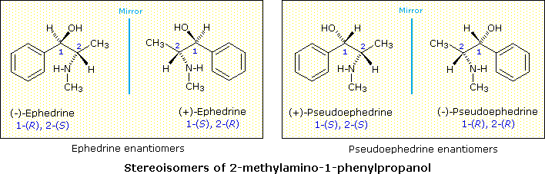

([*https://www2.chemistry.msu.edu/faculty/reusch/virttxtjml/sterism3.htm*](https://www2.chemistry.msu.edu/faculty/reusch/virttxtjml/sterism3.htm))

As seen above, when two or more chiral centers are present in a molecule, more isomers are possible. This illustration boxes each set of enantiomers. The other isomers, such as the ephedrine and pseudoephedrine molecules are diastereoisomers, stereoisomers that are not mirror images of each other and are not superimposable.

**More on** **nomenclature of enantiomers using optical positive (+) and negative (–) or D,L**

The R and S designations refer to clockwise and counterclockwise rotations of the priority numbers (1–4) of the groups attached to the chiral compound. They do not indicate the direction of the optical rotation of plane polarized light.

The D,L designation can be used as in the Warmflash chirality article to show the direction that optical isomers rotate plain polarized light. This is light that vibrates in a single plane or direction. If the enantiomer rotates the light clockwise (to the right), it is designated positive or D (+d); counterclockwise (to the left) is negative or L (–l). If you want to develop this further with your students, check the short “In-class Activity” on plane polarized light located in this Teacher’s Guide.

Some biochemists consider specifying configurations at chiral centers as D or L, “an old, confusing, and often incorrect method”. They contend that biochemistry students should concentrate on the more modern R,S notation coupled + and – to indicate the direction of optical rotation. (<http://chemistry.umeche.maine.edu/CHY251/dlwrong.html>) The use of D and L is strongly discouraged by the International Union of Pure and Applied Chemistry (IUPAC). You will see later in this Teacher’s Guide that more complex chiral molecules are identified by R,S with + or – rotation noted for each chiral center.

**More on** **properties of enantiomers**

While the physical properties of enantiomers are very similar, data from Michigan State University chemistry laboratories show that the two sets of stereoisomers shown above differ considerably. This demonstrates that although they are both stereoisomers, ephedrine and pseudoephedrine are not enantiomers.

|  |  |  |
| --- | --- | --- |
| **Enantiomer from  Ma Huang** | **Ephedrine** | **Pseudoephedrine** |
| Melting point | 35–40 oC | 119 oC |
| Water solubility | moderate | relatively insoluble |
| Rotation of light | [α]D = –41 º | [α]D = +52 º |
| Optical reference | (–)-ephedrine | (+)-pseudoephedrine |

(<https://www2.chemistry.msu.edu/faculty/reusch/virttxtjml/sterism3.htm>)

Boiling and melting points, densities, and almost all characteristic physical properties of enantiomers are identical except their rotational effect on plane polarized light. Even their Rf values in thin layer chromatography and retention time in HPLC are identical.

However, there are some differences in their interactions with other chiral molecules as explained in the Warmflash chirality article. Their effects on biological systems have been discovered. (R)-(–)-lactic acid, a natural product, is found in sour milk and (S)-(+)-lactic acid is the acid that builds up in muscles during exertion. Our olfactory and taste receptors are affected in very different ways by the two enantiomers of carvone, shown below. One enantiomer is detected as spearmint, the other as caraway. Similarly, limonene, located in the rinds of lemons and oranges, has two enantiomers, shown below.

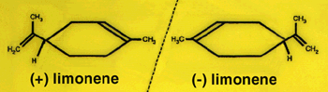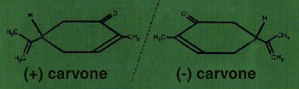

Spearmint Caraway seeds Orange rind Lemon peel

([*http://americanhistory.si.edu/molecule/04exp.htm*](http://americanhistory.si.edu/molecule/04exp.htm))

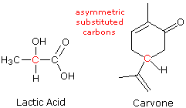 The structural formulas of lactic acid and carvone (to the right) show the chiral carbons in red. Since each contains an asymmetric carbon, they each exist in two enantiomeric forms. Their basic physical properties—melting points, densities, etc.—are the same, but biological differences as described above can be detected.

([*http://chemwiki.ucdavis.edu/Textbook\_Maps/Organic\_Chemistry\_Textbook\_Maps/Map%3A\_Bruice\_6ed\_%22Organic\_Chemistry%22/05%3A\_Stereochemistry%3A\_The\_Arrangement\_of\_Atoms\_in\_Space%3B\_The\_Stereochemistry\_of\_Addition\_Reactions/5.03%3A\_An\_Asymmetric\_Center\_Is\_a\_Cause\_of\_Chirality\_in\_a\_Molecule*](http://chemwiki.ucdavis.edu/Textbook_Maps/Organic_Chemistry_Textbook_Maps/Map%3A_Bruice_6ed_%22Organic_Chemistry%22/05%3A_Stereochemistry%3A_The_Arrangement_of_Atoms_in_Space%3B_The_Stereochemistry_of_Addition_Reactions/5.03%3A_An_Asymmetric_Center_Is_a_Cause_of_Chirality_in_a_Molecule))

**More on** **racemic mixtures**

A racemic mixture contains an equal amount of each enantiomer. Thus, it shows no optical activity; it will not rotate plane polarized light. The racemic D,L mixture displays physical properties such as boiling and melting points and solubilities that differ from those of the individual enantiomers. Chemists can use this difference to test for the purity of an enantiomer.

As seen in the table below, the two enantiomers of tartaric acid have identical physical properties, except for the opposite optical rotation. The meso compound is another isomer of tartaric acid. It has two or more chiral centers but shows no optical rotation because the chiral centers (in effect) cancel each other. The table below shows that the physical characteristics of the meso-tartaric acid differ slightly from those of its stereoisomers, the + and – enantiomers. A Khan video on stereoisomerism provides a clear explanation of the differences and similarities between enantiomers, diastereoisomers, and meso compounds. In addition, the next section in this Teacher’s Guide further explains the meso compound of tartaric acid.

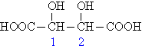

Tartaric acid

(<https://www.khanacademy.org/science/organic-chemistry/stereochemistry-topic/diastereomers-meso-compounds/v/meso-compounds-final>)

**Physical Properties of Tartaric Acid Stereoisomers**

|  |  |  |  |  |  |
| --- | --- | --- | --- | --- | --- |
| **Stereoisomer** | **Configuration** | **Melting point (°C)** | **Optical rotation [α]D (degree)** | **Density (g/ml)** | **Solubility at 20 °C (g/100 ml H2O)** |
| (+)-Tartaric acid | (2*R*,3*R*) | 168 – 170 | + 12 | 1.7598 | 139.0 |
| (–)-Tartaric acid | (2*S*,3*S*) | 168 – 170 | – 12 | 1.7598 | 139.0 |
| meso-Tartaric acid | (2*R*,3*S*) / (2*S*,3*R*) | 146 – 148 | 0 | 1.6660 | 125.0 |
| Racemate of tartaric acid | (2*R*,3*R*) and (2*S*,3*S*) | 206 | 0 | 1.7880 | 20.6 |

([*http://www.chemgapedia.de/vsengine/vlu/vsc/en/ch/12/oc/vlu\_organik/stereochemie/physikalische\_eigenschaften.vlu.html*](http://www.chemgapedia.de/vsengine/vlu/vsc/en/ch/12/oc/vlu_organik/stereochemie/physikalische_eigenschaften.vlu.html))

The racemate of tartaric acid shows no optical activity and differs considerably from its enantiomers in other physical properties.

**More on the meso-compound of tartaric acid**

The meso compound listed in the table of tartaric acid steroisomers (above) is optically inactive, unlike the optically active positive and negative enantiomers shown. Like the other isomers of tartaric acid, meso-tartaric acid contains the same number of each kind of atom and has chiral centers, but the meso-compound is not chiral (not optically active when analyzed by a polarimeter). Unlike the other isomers, the meso compound is superimposable, meaning that one meso molecule exactly fits on top of another.

For example, the *R*,*S* diastereoisomer of tartaric acid is a meso compound. It has an even number of chiral carbons of opposite configuration and it has an internal mirror plane of symmetry bisecting the molecule. Thus, each half of the compound is a mirror image of the other half so it cancels the optical activity of the other half. This makes the molecule an optically inactive meso-compound. See the diagram below showing the plane of symmetry bisecting the R,S stereoisomer of tartaric acid.

**R,S meso-tartaric acid**

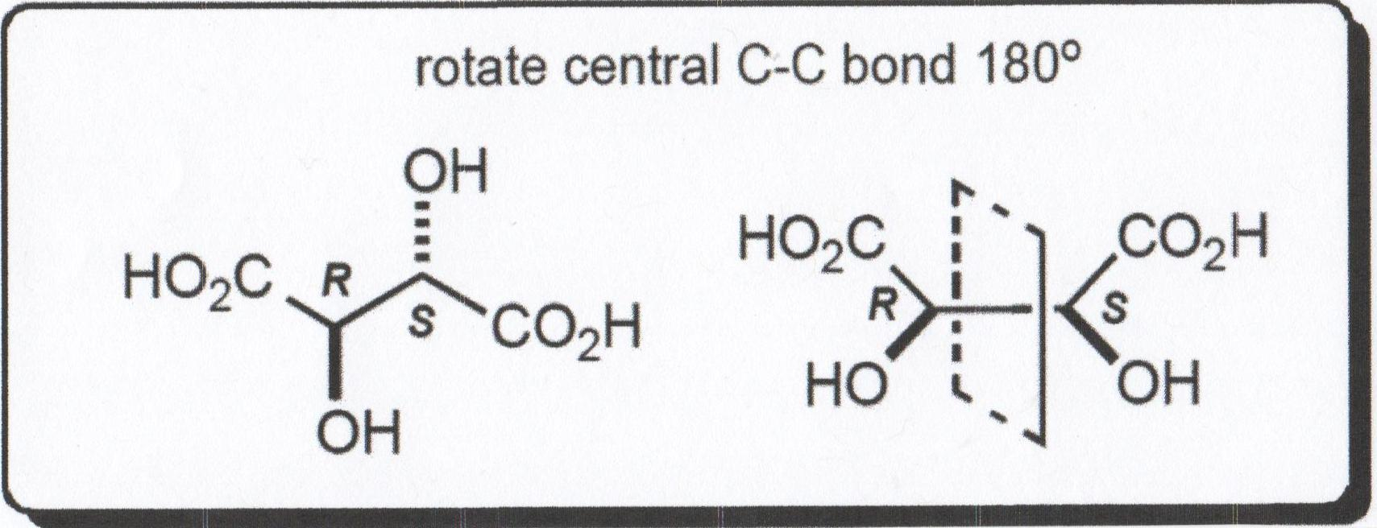

([*https://www.chem.wisc.edu/deptfiles/OrgLab/handouts/CHEM%20344%20stereochemistry%20review.pdf*](https://www.chem.wisc.edu/deptfiles/OrgLab/handouts/CHEM%20344%20stereochemistry%20review.pdf))

**More on** **separating racemic mixtures**

Racemic mixtures do not occur in nature. Statistics show that one of the enantiomers always predominates. But in the laboratory, it is difficult and very expensive to synthesize one enantiomer without producing an equal amount of the other. Not only must the enantiomers be separated, but the purity of the selected isomer must be verified.

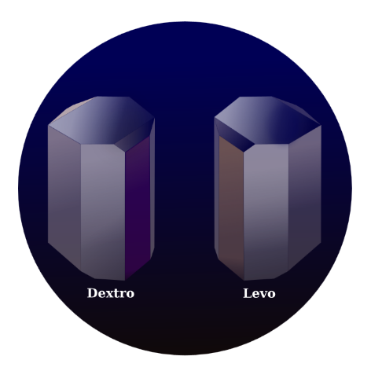

Louis Pasteur proposed that since the crystals of tartaric acid were mirror images of each other, they could be separated into two distinct molecules. In 1849 he used a simple microscope to magnify the crystals of tartaric acid for manual separation. Later in 1832, Jean Baptiste Biot observed their differences in the rotation of plane polarized light. The picture below illustrates the microscopic mirror images of tartaric acid crystals.

*Tartaric acid crystals are drawn here as if seen through an* [*optical microscope*](http://en.wikipedia.org/wiki/Optical_microscope)*.*

([*http://upload.wikimedia.org/wikipedia/commons/2/24/TartrateCrystal.svg*](http://upload.wikimedia.org/wikipedia/commons/2/24/TartrateCrystal.svg))

The structure on the left below represents L-(+)-tartaric acid; D-(–)-tartaric acid is pictured in the middle, and meso-tartaric acid is shown on the right.

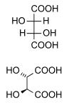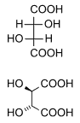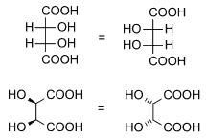

*L-(+)-tartaric acid D-(−)-tartaric acid meso-tartaric acid*

([*http://upload.wikimedia.org/wikipedia/commons/8/89/L-tartaric\_acid.png*](http://upload.wikimedia.org/wikipedia/commons/8/89/L-tartaric_acid.png))

([*http://upload.wikimedia.org/wikipedia/commons/b/b8/D-tartaric\_acid.png*](http://upload.wikimedia.org/wikipedia/commons/b/b8/D-tartaric_acid.png))

([*http://upload.wikimedia.org/wikipedia  
/commons/d/d7/DL-tartaric\_acid.png*](http://upload.wikimedia.org/wikipedia/commons/d/d7/DL-tartaric_acid.png))

To help you (and your students visualize the enantiomers in 3-D, here are two Web sites from *PubChem* that show the rotatable 3-D ball-and-stick models of the D and L stereoisomers:

* D-tartaric acid: <http://pubchem.ncbi.nlm.nih.gov/compound/439655?from=summary#section=CAS>;
* L-tartaric acid: <http://pubchem.ncbi.nlm.nih.gov/compound/444305?from=summary#section=Identification>.

Click on the “3D Conformer” tab on the left of the screen to find the model.

Of course, much has changed from the time of Pasteur and his labor-intensive separation of crystals. And, most chiral molecules do not exist as microscopically distinct crystals. Diastereoisomers can be easily separated due to the difference in their melting points and other characteristic properties. See the table in the section above (“More on racemic mixtures”) that shows the properties of tartaric acid isomers.

**More on** **separation (resolution) of enantiomeric compounds**

Nature usually produces only one enantiomer. Yet, frequently in the lab a racemic mixture is synthesized thus necessitating a procedure to separate the two enantiomers. Since their physical characteristics are identical, enantiomers cannot be separated by simple one-step procedures. Several strategies that are being used currently to separate (resolve) enantiomeric compounds involve the following laboratory processes:

1. React the racemic mixture with a pure compound to form two diastereoisomers. These can be separated by the difference in their physical properties. The resolving agent can then be removed leaving two pure enantiomers. For example, the reaction of an alcohol with tartaric acid can produce two isomeric esters of tartaric acid. Once the esters have been separated, acid hydrolysis can be used to break the bond and separate the acid from the alcohol.
2. Chiral chromatography is one the newer methods of physical separation.
3. Enzymes or other chiral reagents that distinguish between the enantiomers can be used for separations.
4. Asymmetric synthesis: This method uses laboratory procedures that preferentially select the production of one of the enantiomers.

**More on** **the pharmacology of enantiomers**

There is an enormous international market for synthesized drugs. And, more than fifty percent of the drugs that we currently use are chiral compounds. Laboratory synthesis usually produces racemic mixtures. In many cases, particularly in the pharmaceutical industry, the purity of enantiomers is absolutely essential. One of the most disastrous cases involved the sedative thalidomide that was marketed as a racemic (50/50) mixture of its two enantiomers. The (+)(*R*)-thalidomide reduced morning sickness in pregnant women; the other enantiomer   
(–)(*S*)-thalidomide severely damaged the developing fetus. Web sites for additional information on the positive effects of thalidomide in treating cancers and leprosy are located under the “Web Sites for Additional Information” section of this Teacher’s Guide.

In laboratory drug synthesis, the first consideration must be the biochemical effect of each enantiomer. The majority of procedures produce one primary enantiomer, the one which has the desired physiological effect, while the other enantiomer is inactive because it is not receptive to interaction with an enzyme. In some cases however, the other enantiomer may be toxic or may create an undesired effect.

A paper posted on the National Institutes of Health (NIH) site from the *International Journal of Biomedical Science* lists 3 groups of drugs with different implications for the need to separate enantiomers.

**Group 1. Racemic drugs with only one major bioactive enantiomer**

In this group, there are a number of cardiovascular drugs, agents widely used for the treatment of hypertension, heart failure, arrhythmias, and other diseases. Among these are the β-adrenergic blocking agents, calcium channel antagonists and angiotensin-converting enzyme (ACE) inhibitors. …

**Group 2. Racemic drugs with enantiomers that react the same biologically**

There are only a few racemic drugs that could belong to this group such as cyclophosphamide (antineoplastic), flecainide (antiarrhythmic), fluoxetine (antidepressant). …

**Group 3. Racemic drugs with chiral inversion**

There are two types of drug chiral inversion: unidirectional and bidirectional inversion.

Unidirectional enzyme mediated inversion was previously described only with 2-arylpropionate nonsteroidal anti-inflammatory drugs (NSAID), namely ibuprofen, ketoprofen, fenprofen, benoxaprophen, etc. For this group, only S-enantiomer is active i.e. has an analgesic and anti-inflammatory effect. For example, S-ibuprofen is over 100–fold more potent as an inhibitor of cyclooxygenase I than (R)-ibuprofen. In the body, only inactive R-enantiomers can undergo chiral inversion by hepatic enzymes into the active S-enantiomer and not vice-versa.

Bidirectional chiral inversion or racemization should be represented by 3-hydroxy-benzodiazepines (oxazepam, lorazepam, temazepam) and thalidomide in which R and S enantiomer can racemize in vitro by aqueous solution. However, in vivo this phenomenon could occur with thalidomide.

(<http://www.ncbi.nlm.nih.gov/pmc/articles/PMC3614593/> )

Note the serious risk of bidirectional chiral inversion. Thalidomide undergoes a chiral switch by rapidly interconverting in the human body between the R(+)-thalidomide sedative and the S(–)-thalidomide which is toxic to the fetus. This occurs whether it is administered orally or intravenously.

[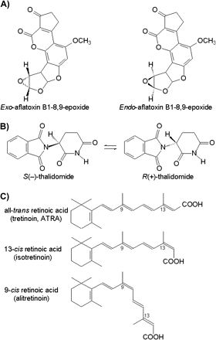](http://toxsci.oxfordjournals.org/content/110/1/4/F7.expansion.html)

([*http://toxsci.oxfordjournals.org/content/110/1/4.full*](http://toxsci.oxfordjournals.org/content/110/1/4.full))

Even if one enantiomer is not toxic, its presence may result in a reduced biological effect of the desired isomer. Bidirectional chiral inversions may cause the beneficial enantiomer to convert in vitro to its inactive isomer thus decreasing the effectiveness of the drug.

**More on the toxicity of and different reactions to drug enantiomers**

In addition to thalidomide, several other pharmaceutical drugs such as those listed in the table below have toxic enantiomers:

|  |  |
| --- | --- |
| **Drug** | **Effect of Enantiomers (beneficial/toxic)** |
| Ethanbutol | Treat tuberculosis/blindness |
| Naproxen | Treat pain/liver poisoning |
| Penicillin | Must mimic D-alanine chains in bacterial cell walls |
| Propranolol anesthetic | L-adrenoceptor antagonist/D-only anesthetic |
| Methorphan | L-opioid analgesic/D-cough suppressant |
| Carvedilol alpha receptor blockers | (s)-(–)-100 times more potent beta blocker than (R)-(+)- |
| Amphetamine & Methamphetamine | D-CNS stimulator/L-peripheral nervous system stimulator\*\* |
| Ketamine dissociative & hallucinogenic properties | Properties differ in both isomers; S-more potent than R |
| Nexium acid reflux, ulcers | Racemic mixture: inactive R converts to active S in vitro |

\*\* L-methamphetamine available over-the-counter as nasal inhaler in some countries; D-highly regulated, banned in many countries.

([*http://en.wikipedia.org/wiki/Enantiopure\_drug*](http://en.wikipedia.org/wiki/Enantiopure_drug))

Separation of the racemic mixture is unnecessary if one of the enantiomers is inactive. For example, the hormone thyroxine has an active S and inactive R enantiomer. Isomers of the multi-chiral cocaine molecule produce different biochemical effects. 1R, 2R, 3S, 5S-cocaine is psychoactive; 1S, 2S, 3S, 5R is inactive.

**More on** **patenting chiral drugs**

The pharmaceutical industry is extremely dependent upon patent protection for its products. Unlike other materials, public disclosure of the benefits and side effects of a medicine may jeopardize the company’s ability to protect its individual property. This leads to issues involving the novelty versus the need for patent protection.

There has been recent litigation pertaining to the laboratory isolation of a pure enantiomer of a chiral drug. A current court ruling supports the ability to patent one enantiomer over a previously patented racemic mixture of this enantiomer. A debate over this issue is suggested in the “In-class Activities” section of this Teacher’s Guide. Additional information is located in the *Berkeley Technology Journal* article: <http://www.btlj.org/data/review/24-129-147.pdf>.

**More on** **chirality in the personal-care, agriculture, and food-flavor industries**

Receptors in the mouth and nose signal the brain when odors and tastes are detected. An article in *Interface*, the journal of the Royal Society of Chemists (published on the National Institutes for Health page) uses an analogy to describe this detection:

We discuss models of receptor selectivity, both those based on shape and those where discrimination is based on other factors, such as electron affinity, proton affinity or vibration frequencies. The differences in scent of these enantiomers appear to be consistent with simple generalizations of a ‘swipe card’ model in which, while the shape must be good enough, critical information for actuation is a separate factor.

(<http://www.ncbi.nlm.nih.gov/pmc/articles/PMC2610320/>)

When it comes to the human perception of smells, there are factors other than the molecular structure that may determine how odors are characterized. There is subjectivity in human descriptions, the smell may be determined by the concentration of the enantiomer or a stronger odor from one enantiomer may mask the odor from the other one. Thus, in the last case the purity of the enantiomer is essential. Also, humans sometimes strongly differ in the interpretation of their reception to odors. For example, some people sense a reversal in the odors of the carvone enantiomer detecting (S)-(+)-carvone as caraway seed and (R)-(–) as mint.

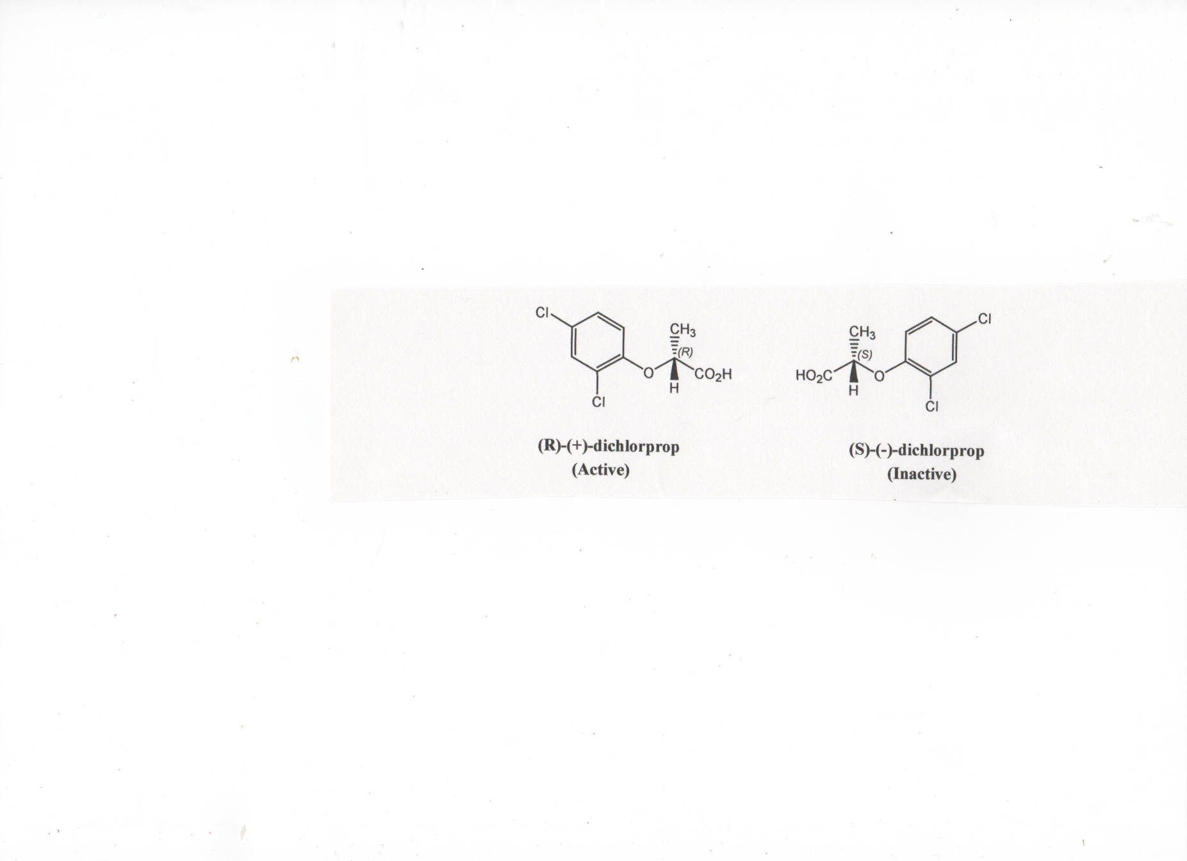 The difference in effects of members of an enantiomeric pair on the human body correctly suggests this is also true for the biological effects of chiral herbicides and pesticides. The herbicide dichlorprop’s active enantiomer kills weeds. Recently some European countries have restricted sales to the pure R-(+)-dichlorprop enantiomer in order to reduce the quantity of herbicide used and any possibility that there might be adverse effects from the inactive form.

(Leffingwell Reports, Vol. 3(No. 1), May 2003; <http://www.leffingwell.com/download/chirality-phamacology.pdf>)

Methyl jasmonate has two sets of enantiomers. The four active enantiomers are valuable as: (1) plant growth regulator, (2) fragrance, (3) insect pheromone activity that defends against herbivores, and (4) recent promising activity against cancer cells. Methyl jasmonate is a component of fine perfumes.

The chiral compound menthol occurs naturally in peppermint and other mint oils. The molecule has 3 chiral centers and eight stereoisomers (4 pairs of enantiomers). A graph of the varied flavors is shown below.

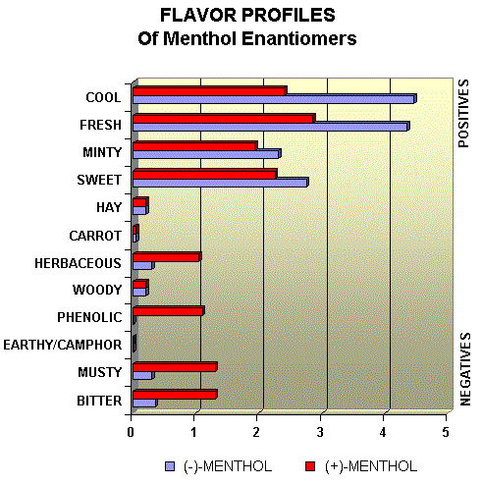

([*http://www.leffingwell.com/menthol1/menthol1.htm*](http://www.leffingwell.com/menthol1/menthol1.htm))

**More on** **sugar substitutes**

Enzymes are molecules (usually proteins) that catalyze the biochemical reactions that break down our foods for use as energy and storage. As discussed in the Warmflash Chirality article, enzymes are highly selective. Human enzymes can only bind to D-sugars. Thus, we cannot digest L-sugars or L-carbohydrates.

The figures below illustrate the process used by an enzyme to break a maltose disaccharide into two monosaccharide molecules of glucose.

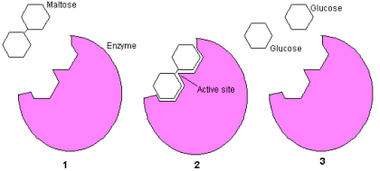

**(**[*http://science.howstuffworks.com/life/cellular-microscopic/cell2.htm*](http://science.howstuffworks.com/life/cellular-microscopic/cell2.htm)**)**

**Maltose is composed of two glucose molecules bonded together**

1. **The maltase enzyme is a protein that is perfectly shaped to accept a maltose molecule and break the bond.**
2. **The two glucose molecules are released.**
3. **A single maltase enzyme can break in excess of 1,000 maltose bonds per second, and its unique shape will only accept maltose molecules.**

The fact that our body can only metabolize D-sugars and carbohydrates has driven research to find sugar substitutes that are L-enantiomers that we cannot metabolize. For example, the L-enantiomer of aspartame tastes sweet. So when used as a sugar substitute (marketed as NutraSweet® and Equal®), it will provide the sweetness of sugar but it will not be absorbed in the body. The other form, D-aspartame is bitter, so this is a case where the chemical synthesis needs to be concerned with selection for the L-enantiomer. This Web site contains a table comparing the relative sweetness of sugar substitutes and sweeteners to sucrose: <http://en.wikipedia.org/wiki/Sugar_substitute>.

**More on** **rare sugars**

Japanese scientists have identified about 50 sweeteners as the future for worldwide soft-drink markets. They dub them “rare sugars” because they do exist naturally in very small amounts. Since commercial harvesting is too expensive, scientists are developing ways to prepare them synthetically assuming that their “naturalness” will appeal to the public.

These molecules are monosaccharides that have also shown potential to prevent spikes in blood sugar and reduce fat buildup in rat studies. One example is allulose, a D-psicose that is approximately 70% as sweet as sucrose with almost zero calories because very little of it is metabolized, most is simply excreted in the urine. Fructose and allulose are stereoisomers, but not enantiomers. A genetically modified bacteria can produce enzymes that convert glucose to allulose. Other rare sugars include xylitol, D-allose, and D-tagatose.

(<http://www.datamonitor.com/store/News/does_rare_sugar_have_the_potential_to_rescue_soft_drink_markets_worldwide?productid=19991313-F210-4E64-BD69-F0765017A9B6>) (<http://www.globalfoodforums.com/new-natural-sweetener-d-psicose-marches-toward-commercialization/>)

Many of the “rare sugars” are six-carbon monosaccharide compounds, each containing a ketone (hence called ketohexoses). The number of enantiomers in a multichiral molecule can be determined by using the formula, 2n, where *n* equals the number of chiral centers. Ketohexoses have three chiral centers. Calculating 23 as 8 means that ketohexoses have eight enantiomers (or four pairs of enantiomers). The structures for the ketohexose enantiomers are pictured below:

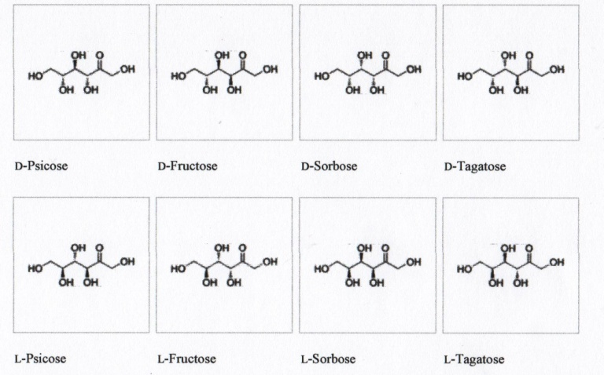

([*http://en.wikipedia.org/wiki/Ketohexose*](http://en.wikipedia.org/wiki/Ketohexose))

**More on** **chirality at work**

The Warmflash chirality article discusses the specificity of enzymes in “Chirality at Work”. In general, both the binding of amino acids to form proteins and the binding of monosaccharides to form carbohydrates are referred to as condensation reactions. A water molecule is released as the two units (amino acids or monosaccharides) are joined. The specificity of these reactions is determined by chiral catalysis.

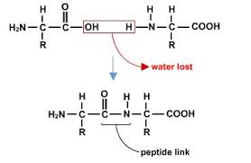 Enzyme molecules that exactly fit the molecular structure of L-amino acids catalyze the reaction to bind them to form proteins. By the loss of a water molecule, a peptide bond forms between the two amino acids that bond to form a protein molecule. Note that an amino acid has both the amino and carboxylic acid groups as described in Figure 5 of the Warmflash article. Also the two amino acids would be enantiomers if their R groups were the same. The peptide link shown in this structure is often referred to as a peptide bond.

([*http://bioap.wikispaces.com/Ch+5+Collaboration*](http://bioap.wikispaces.com/Ch+5+Collaboration))

**Similarly, two D-monosaccharides form a disaccharide in a similar reaction as shown in Figure 6 for the Warmflash article. The enzyme that catalyzes this reaction must be specific for this D-monosaccharide.**

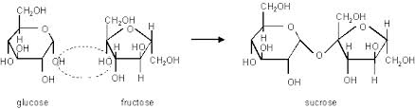

**(**[*http://bioserv.fiu.edu/~walterm/human\_online/chemistry/water\_and\_molecules/water\_and\_organic\_molecules.htm*](http://bioserv.fiu.edu/~walterm/human_online/chemistry/water_and_molecules/water_and_organic_molecules.htm)**)**

**More on** **L-sugars**

In animals, the D-glucose enantiomers are linked by stereospecific enzymes to form polysaccharides and starches. But, in plants L-glucose units are joined to form cellulose, an isomer of sugars and starches. The metabolic breakdown of starch requires the catalytic action of an enzyme that can attack the oxygen atom in the pink area of starch shown below. Starch eating organisms like humans have this stereospecific enzyme. However our enzyme does not recognize the location of the oxygen atom in the blue area of the cellulose molecule so we cannot gain energy by eating toothpicks. If we eat grass or wood, the glucose molecules bonded into cellulose remain as cellulose waste that travels through our systems without being absorbed. Termites on the other hand, have the specific enzymes that catalyze an attack on the cellulose bond releasing the glucose molecules that supply continual energy for munching our wooden houses.

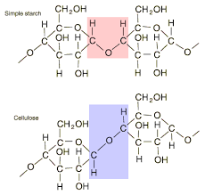

([*hyperphysics.phy-astr.gsu.edu*](http://hyperphysics.phy-astr.gsu.edu/hbase/organic/carb.html))

**More on** **current engineering design of polymer production**

Scientists at the Royal Institute of Technology (KTH) in Stockholm, Sweden are working to modify the active site on the enzyme CALB used in polymer production. They have increased the size of its stereospecific pocket in order to change its enantioselectivity toward   
1‐phenylethanol and its stereospecificity to accommodate the polymerization of *D*,*D*‐lactide. This causes an approximate 90% increase in activity. Additional details are located on the paper at this Web site: (<http://www.diva-portal.org/smash/get/diva2:355255/FULLTEXT01.pdf>)

**More on** **D-amino acids**

Data from the Swiss-Prot database, published in *Scientific Reports*, shows that D-amino acids occur very rarely. The Swiss-Prot and UniProt are European protein data bases. Most of their data comes from genome-sequencing projects. The table shows the abundances of the D-isomers of amino acids in protein sequences containing over 187 million amino acids.

|  |  |
| --- | --- |
| **D-amino acid** | **Number of times experimentally Observed in over 187 million** |
| D-alanine | 664 |
| D-serine | 114 |
| D-methionine | 19 |
| D-phenylalanine | 15 |
| D-valine | 8 |
| D-tryptophan | 7 |
| D-leucine | 6 |
| D-asparagine | 2 |
| D-threonine | 2 |

([*http://en.wikipedia.org/wiki/Chirality\_(chemistry*)](http://en.wikipedia.org/wiki/Chirality_(chemistry))

D-isomers exist as free amino acids in vertebrates; humans can process them with special enzymes. D-aspartic acid has been found during the early stages of life while the brain and peripheral organs are developing. The presence of D-serine or D-alanine in body fluids may indicate renal dysfunction. (<http://www.ncbi.nlm.nih.gov/pubmed/9676266>)

D-amino acids are found in the peptidoglycan cell walls of bacterial cultures. Current theory suggests that they strengthen the walls and help bacteria adjust to environmental changes. Peptidoglycan forms a crystal lattice of alternating sugars attached to a 4–5 sequence of amino acid. In *Escherichia coli* the chain contains the sequence: L-alanine, D-glutamic acid, meso-diaminopimelic acid, D-alanine. Some antibiotics such as penicillin disrupt peptidoglycan formation by attacking the bacterial enzymes that create its amino acid linkages. (<http://www.ncbi.nlm.nih.gov/pmc/articles/PMC2759711/>)

Peptidoglycan

([*http://en.wikipedia.org/wiki/Peptidoglycan*](http://en.wikipedia.org/wiki/Peptidoglycan))

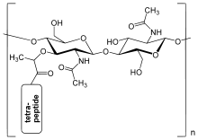

**More on** **D-amino acid peptides**

An article published on the Biochemical Products site LifeTein describes reasons for the presence of D-amino acids in animal peptides (chains of amino acids linked by peptide bonds). The article states,

Proteins and most naturally occurring peptides are composed of amino acids in the L-configuration. However, D-amino acids have been detected in a variety of peptides synthesized in animal cells. Examples include opiate and antimicrobial peptides from frog skin, neuropeptides from snails, hormones from crustaceans, and venom from spiders. These D-amino acids form when L-amino acids undergo posttranslational alterations.

(<http://www.lifetein.com/Peptide-Synthesis-D-Amino-Acid.html>)

In addition this article gives and describes three characteristics of peptides composed of D-amino acids, “Some peptides containing D-amino acids are more biologically potent. D-amino acid peptides are more resistant to proteases. D-amino acids might act as signaling molecules.” Further explanation of the role of D-amino acids in living animals is given on their Web site. (<http://www.lifetein.com/Peptide-Synthesis-D-Amino-Acid.html>)

**More on** **homochirality**

As the subtitle above implies, homochirality means preference for one single optical isomer. The Warmflash Chirality article describes homochirality used in the biochemical reactions. Our cells contain enzymes that will only catalyze L-amino acids to form proteins, and other enzymes that only catalyze the bonding of D-monosaccharides to form polysaccharides.

The reason for homochirality is one of chemistry’s unsolved problems. We know that if we eat only L-sugars, we will starve because the enzymes in our bodies can only breakdown D-saccharides to produce the energy required to maintain body functions. Scientists suggest several theories to explain the use of one enantiomer and not its mirror image in living plants and animals. Although we have no satisfactory explanation, perhaps this preference simply began when life began on earth, and/or perhaps there was strong competition and the most thermodynamically stable enantiomeric form survived, or maybe this was just a chance phenomenon. Some scientists break their explanation into three steps:

* Initial breaking of molecules along their plane of symmetry may have not have been perfectly balanced, creating a preference for one enantiomer.
* The concentration of the preferred enantiomer increased as animals eat other animals or plants containing the same enantiomers.
* The preferred chirality was transferred from one molecule to another.

Whatever the reason, once homochirality was set, all plants and animals used L-amino acids and D-sugars in the same biochemical pathways, just as humans did. Since animals eat plants and other animals, they consume only the enantiomers that fit the requirements for their biochemical reactions. A switch to the mirror images of these amino acids and sugars would be energetically inefficient. For example, using D-amino acids would require construction of an entirely new biochemical pathway.

In terms of carbohydrates, most organisms do not use the monomers that they eat for building. They just oxidize them to release energy. Amino acids that are consumed can be used for building proteins.

**More on** **the search for extraterrestrial life**

The March 12, 2014 issue of the *Smithsonian Magazine* ran an article *“*Where in the Solar System Are We Most Likely to Find Life?” Scientific information about five possible sites was given.

* Europa—Data from the Galileo probe suggests that the surface of Jupiter’s moon is covered with water ice. Also, the Hubble telescope indicates jets of water shooting through small holes on Europa’s surface.
* [Enceladus](http://en.wikipedia.org/wiki/Enceladus)—NASA's Cassini-Huygens probe detected salty water vaporizing from a surface of liquid water under ice on Saturn’s tiny moon.
* Mars—Data from Curiosity Rover showed evidence that Mars once had freshwater lakes and water flowing on its surface. Martian soil contains one to three percent water by mass and suggests the presence of organic compounds.
* Io—The volcanoes on Jupiter’s moon create an atmosphere of sulfur dioxide and some oxygen. But to date, no evidence of organic material or water has been found. Scientists think that there could have been life on Io a long time ago.
* Titan—Saturn’s largest moon has a chemically active atmosphere composed of nitrogen, methane, and oxygen. The Cassini-Huygens probe has shown liquid lakes probably composed of ethane or methane.

(<http://www.smithsonianmag.com/science-nature/where-solar-system-are-we-most-likely-find-life-180949994/?no-ist>)

The Warmflash article also names five possible sites, but omits Io (listed in the *Smithsonian Magazine* article) and includes the dwarf planet Ceres (an asteroid) that displays evidence of icy volcanoes ejecting water vapor.

**More on** **the Viking 1 and 2 space probes**

The Warmflash Chirality article contains a picture of the surface of Mars taken from NASA’s Viking 1 or 2 spacecraft. These two Mars landers performed three experiments designed to search for evidence of life on Mars.

* Labeled Release (LR)—A water solution of radioactive carbon nutrients was mixed with Martian soil.
* Gas Exchange (GEx)—Analysis of any gases produced. If living microorganisms were present, they would release radioactive carbon dioxide or methane as products of metabolizing the nutrients in the LR experiment.
* Pyrolytic Release (PR)—Tests designed to detect the presence of photosynthesis by varying the temperature and light on soil samples. This test also checks the rate of survival of photosynthetic microorganisms.

(<http://news.nationalgeographic.com/news/2012/04/120413-nasa-viking-program-mars-life-space-science/>)

Much controversy surrounds the positive findings in the LR experiment due to the experimental procedures that did not account for the high temperatures and moisture in the samples. The other two experiments did not substantiate the presence of life. Most scientists agree that more data must be collected to conclude that life exists or has existed on Mars. Additional details are available at the *National Geographic* Web site link above.

**More on** **the search for alien life**

The National Institute of Standards and Technology (NIST) published an article by Chad Boutin in April 2009, “Scientists Give a Hand(edness) to the Search for Alien Life”. Boutin explains that instead of looking for specific elements such as oxygen or carbon, scientists should look for chiral substances like amino acids, sugars, and DNA because, “many substances critical to life favor a particular handedness”. He also states that,

Many molecules not associated with life exhibit handedness as well. But when organisms reproduce, their offspring possess chiral molecules that have the same handedness as those in their parents’ bodies. As life spreads, the team theorizes, the landscape will eventually have a large amount of molecules that favor one handedness.

(<http://www.nist.gov/pml/div685/chiral_042109.cfm>)

**More on** **Mars searches**

On March 12, 2014, The European Space Agency (ESA) published the paper “Searching for Signs of Life on Mars”, which suggested that testing for homochirality may be the best indicator that we currently have for extraterrestrial life. ESA does note that high temperatures and wet conditions may invalidate the data during testing. (<http://exploration.esa.int/jump.cfm?oid=43608>)

# Connections to Chemistry Concepts

**(for correlation to course curriculum)**

1. **Properties of Molecules**—Chirality is a property of asymmetry in molecules. The example of a hand showing a nonsuperimposable image in a mirror is an excellent way to demonstrate this property to students. A chiral carbon bonded to four different groups forms the center of a tetrahedral molecule. By exchanging the position of any two of the bonded groups, an isomer is formed that is the mirror image of the original isomer. Chirality can be easily mentioned when your students study molecular geometry and then reinforced in organic chemistry.
2. **Chemical Bonding**—The study of covalent bonding presents the opportunity to focus on molecules that contain a carbon atom that is chiral because it is covalently bonded to four different atoms or groups of atoms. This will provide the basis for later study of covalently bonded biochemical molecules.
3. **Geometry of Molecules**—The study of molecular geometry provides the opportunity to include the possibility of chirality when tetrahedral structures are studied.
4. **Isomerism**—As an extension of simple isomerism, stereoisomerism can be introduced with the conditions necessary to form enantiomers. The “Background Information” section of this Teacher’s Guide contains many details about the characteristics and structural formulas of enantiomers. A student laboratory experiment to produce enantiomers is located in the “In-class Activities” sections of this Teacher’s Guide.
5. **Organic Molecules**—Many organic molecules are chiral including: amino acids, the building blocks of proteins; and simple sugars (monosaccharides), the building blocks of polysaccharides and carbohydrates. In the study of organic chemistry, the importance of chirality and stereospecific enzymes will help students realize the selectivity of the biochemical reactions in our bodies.
6. **Organic Functional Groups**—As the name implies, all amino acids contain an amino group (–NH2) and an organic acid (carboxylic acid) group (–COOH). Organic compounds are categorized and named by the way that they function in chemical reactions.
7. **Chemical Reactions**—Condensation is an important organic/biochemical reaction that synthesizes a new compound by joining two smaller molecules. One of the small molecules loses a hydrogen atom and the other loses an –OH group. Water is released as the by-product. Your biology students may be know this reaction as dehydration synthesis. Esters are formed by condensation from an organic acid and an alcohol.
8. **Nomenclature**—Although your students may be familiar with the names of isomers, they may not have studied optical isomers. Studying chiral molecules provides the opportunity to help students understood the nomenclature used to identify some pharmaceutical drugs. The plus (+) identifies a molecule that rotates plane polarized light in a clockwise direction and the minus (–) identifies a molecule that rotates light counterclockwise.

# Possible Student Misconceptions

**(to aid teacher in addressing misconceptions)**

1. **“I guess I don’t have to worry about whether I eat D- or L-enantiomers, because the enzymes in my body will only work in reactions that use the correct form of the molecule.”** *This misconception may stem from the emphasis of protein synthesis from only L-amino acids. Two enantiomers of many pharmaceutical drugs have different biochemical reactions, one may be beneficial and the other may be harmful to the body.*
2. **“I am certain that there is life on Mars because data from the Viking Lander experiment verified this.”** *Actually only one of the Viking Lander experiments showed positive results, the other experiments were negative. The positive test determined only that there is a* possibility *that life might exist on Mars. Scientific data needs to be verified repeatedly to substantiate a claim.*
3. **“If chiral molecules have both an ‘L’ and a ‘D’ form, there will be an equal number of ‘L’ and ‘D’ amino acids in our bodies.”** *In nature equal amounts of both enantiomers (racemic mixtures) do not occur. Statistics show that one of the enantiomers always predominates such as the L-amino acids in our bodies. We receive many amino acids from protein in the meat that we eat. Just like humans, animals have enzymes that link L-amino acids together to form proteins. Thus, the animal protein that we eat contains only L-   
   (not D-) amino acids.*
4. **“I think that extraterrestrial life will look different from us. Aliens are smaller and look more like lizards.”** *Actually, scientists are looking for evidence to support the existence of microscopic and submicroscopic life rather than for alien creatures.*
5. **“I know that the ozone layer protects us from harmful radiation. Scientists looking for extraterrestrial life should concentrate their study on planets and moons that have protective atmospheric shields.”** *Life has been found that can survive one thousand times the dose of radiation lethal to a human. During trials to find safe methods for canned food preservation, the radiation-resistant bacterium Deinococcus Radiodurans was discovered. D. Radiodurans simply repairs bits of its damaged DNA.*
6. **“Scientists should look on other planets for the presence of light and oxygen, necessary to support life.”** *In the Antarctic living microbes have been found in puddles of sea water trapped in layers of ice with no oxygen and no access to light.*

# Anticipating Student Questions

**(answers to questions students might ask in class)**

1. **“Can I use a mirror to show my left foot superimposed on the image of my right foot?”** *Probably not, unless you are a contortionist; you will find it impossible to turn your left ankle so that the bottom of your left foot will face upward while the bottom of your right foot faces the mirror.*
2. **“Our hands are chiral. I wonder if other animals or plants exhibit chirality.”** *Yes, the shells of snails and clams are often chiral. Consider especially those long spirally shells. The flowers of some plants also exhibit chirality.*
3. **“I don’t understand the methane structures in Figure 3. What do the straight, dashed, and wedged lines mean?”** *Organic chemists use “Wedge-Dash Notation” to show three dimensions in a molecule. Figure 3 shows tetrahedral methane molecules. Straight lines (or sticks) show the hydrogens in the plane of the page, the dashed line hydrogen is going away from you, and the wedged hydrogen is coming toward you.*
4. **“I read that for some chiral molecules, one enantiomer is toxic, but the other is beneficial. Can enantiomers be separated from each other?”** *Yes, they can be separated but this involves laboratory procedures such as using an enzyme that will bind to one enantiomer, but not to the other. See more details in the “Background Information” section of this Teacher’s Guide.*
5. **“When NASA’s Viking spacecraft went to Mars, what experiments were performed to look for life?”** *NASA’s Viking 1 and 2 Landers dug up some Martian soil and added a drop of water containing nutrients and radioactive carbon. Scientists theorized that if microbes were present to metabolize the soil, radioactive carbon dioxide or methane would form and be detected by a radiation detector probe.*
6. **“Did NASA’s Viking spacecraft find evidence of life on Mars?”** *Scientists are still questioning their data because radioactive carbon dioxide and/or methane were detected in only one of the three experiments.*
7. **“I know that the dwarf planet Ceres is an asteroid. Why would scientists predict that life could exist on a rock?”** *Scientists have found evidence of icy volcanoes on Ceres that appear to have water spurting out of them.*
8. **“Is water the primary thing that NASA astronauts look for to determine the possibility of extraterrestrials on a planet or moon?”** *Although they look for water, now scientists consider chirality a better marker for the evidence of life.*

## In-Class Activities

**(lesson ideas, including labs & demonstrations)**

1. This is a high school student lab designed to extract a chiral compound: *Supercritical CO2 and the Comparison of Essential Oil Extraction Methods*. This experiment was prepared for high school teachers to perform at a Green Chemistry workshop during a “High School Day” at an ACS National Meeting. The extracted oil (D-limonene) has the familiar citrus odor used in perfumes and household products. Its enantiomer (L-limonene) smells like turpentine. The high school version of the lab can be downloaded from the Beyond Benign Web site. (<http://www.beyondbenign.org/k12education/highschool.html>)

This site contains a video of this lab process. (<http://www.benchfly.com/video/75/extraction-of-limonene-using-liquid-carbon-di/>)

1. Here are two short lab activities to check the odor of the enantiomers of limonene (orange and lemon rind) and carvone (spearmint and caraway seeds). Structures plus an explanation and illustration of nerve ending receptors can be found at: <http://americanhistory.si.edu/molecule/04exp.htm>.
2. An excellent four-minute homework video produced by an NBC/NSF partnership, “’Mirror’ Molecule: Carvone” will hold student interest. The animation is clever and teachers will appreciate the clarity of the explanations of the enantiomers of carvone and the human receptors that distinguish the difference in odor between these isomers. (<http://www.nbclearn.com/chemistrynow/cuecard/51988/>)
3. This short lesson on plane polarized light can be easily used as a PowerPoint and/or demonstration. (<http://www.chemguide.co.uk/basicorg/isomerism/polarised.html>)
4. This is a classroom demonstration to show how chiral sugars rotate plane polarized light, “Chirality in Sugars”. The directions are published in *Education in Chemistry*, an electronic magazine of the Royal Society of Chemistry (RSC). (<http://www.rsc.org/images/Exhibition%20Chemistry_EiC_January2012_tcm18-212418.pdf>)
5. The activity “What’s Honey Made Of?” is an extension to the optical activity of sugar activity: <http://www.rsc.org/learn-chemistry/resource/res00000579/what-is-honey-made-of-the-optical-rotation-of-sugars?cmpid=CMP00000692#!cmpid=CMP00000692>.
6. This laboratory experiment for Honors or AP level chemistry students uses a polarimeter from Vernier Software and Technology Company. Students study the optical activity of sucrose and tartaric acid first. Then they prepare, isolate, and use a Vernier polarimeter to analyze (+)Co(en)3I3 and its enantiomer (-)Co(en)3I3. Directions for the laboratory activity are found on this website: <http://www.vernier.com/products/sensors/chem-pol/>.
7. These three two-minute YouTube videos by David Whyte provide instructions for constructing and using a simple polarimeter.

* The first video describes construction: <https://www.youtube.com/watch?v=HP14LAEy9BY>;
* The second video demonstrates using the polarimeter to compare three different concentrations of sugar solution and water <https://www.youtube.com/watch?v=CJS6CwL2eQU>; and
* The third video uses the same solutions, but measures the polarization angles. <https://www.youtube.com/watch?v=sexd43iBrRk>

1. Here’s an activity to build a polarimeter: Stary, F., Woldow, N. Build a Simple Polarimeter. *The Journal of Chemical Education* (J Chem Educ) **2001,** *78* (5), p 644. (<http://pubs.acs.org/doi/abs/10.1021/ed078p644>) (abstract—full text for subscribers only)
2. If you prefer using an iPad, this YouTube video (3:34) gives a nice presentation of several demonstrations using polarizing filters: “Demonstrating Polarized Light Using the iPad”. (<https://www.youtube.com/watch?v=SECfm_2e0Mw>)
3. Flinn Scientific sells the Kaleidoscopic Activity kit with polarizing filters and a template for cutting the filters that can be used to show the optical activity of sucrose. The short video on this site demonstrates the use of the polarizers in several different ways: <http://www.flinnsci.com/teacher-resources/teacher-resource-videos/best-practices-for-teaching-chemistry/organic-chemistry/kaleidoscoptical-activity/>.
4. David Katz describes how to make and use your own polarizer like the one in Flinn’s kit. He includes the template for cutting the polarizing filters and suggested activities at <http://www.chymist.com/Overhead%20polarimeter.pdf>.
5. Organize a class discussion or debate based on pending legislation regarding the public’s need for disclosure regarding the side effects of chiral drugs versus the perceived need of drug companies to protect their intellectual property. This involves a drug company’s petition to patent individual enantiomers when the racemate of the drug has been patented. This article from the *Berkeley Technology Journal* details the Federal Court decision based in part on Supreme Court rulings. (<http://www.btlj.org/data/review/24-129-147.pdf>)
6. To demonstrate that a tetrahedron forms when four hydrogen atoms bonded to a central carbon assume positions that create the largest angle between them, give the ends of four long pieces of elastic to one student (the central carbon atom). Four students (hydrogen atoms) take the opposite end of each piece of elastic. Ask hydrogens to create the largest distance between each other as they circle the carbon. Initially, they will probably stand in a square planar arrangement and then they will discover that a tetrahedron increases the bond angles.
7. Here’s a student microscale lab activity dealing with ester formation. “Preparation of Esters” is available on this Web site: <http://www.slideshare.net/walajtys/microscale-preparation-ofsomeesterslab1>.

# Out-of-class Activities and Projects

**(student research, class projects)**

1. The Warmflash article introduces many terms that may be new or confusing to your students. As a review, assign some of the following word list to each student or group of students and ask them to research the definitions and draw pictures to demonstrate their understanding. Suggestion: The research could be done as individual homework. The next day, drawings can be completed and shared by class groups.

mirror image superimpose chiral

exhibit chirality tetrahedral chiral molecules

asymmetric carbon atom enantiomers mirror images

optical isomers L and D convention enzymes

amino group carboxyl group R group

L-amino acids proteins monosaccharides

D-sugars carbohydrate extraterrestrial life

1. This is an excellent four-minute homework video produced by an NBC/NSF partnership, “’Mirror’ molecule: Carvone” that would work well for the “flipped classroom”. Students will enjoy the clever animation and teachers will appreciate the clarity of the explanations of the enantiomers of carvone and the human receptors that distinguish the difference in odor between these isomers. (<http://www.nbclearn.com/chemistrynow/cuecard/51988/>)
2. *Sweet Spot* from Wired.com recounts NASA engineer Gilbert Levin’s efforts to market tagatose, a natural sugar with 40% of the calories of sucrose. Consider assigning parts of the article to read for homework. Or, use it as a springboard for research on the serendipity and development of sugar sweeteners. The article begins: “Atkins. The Zone. Slim-Fast Dark Chocolate Fudge Shakes. For decades, hucksters and scientists alike have offered an endless string of fixes for our oversize appetites and waistlines. But while their wallets may be getting thicker, we aren't getting any thinner. An even more lucrative future awaits the inventor who can give the U.S. what we really want: the ability to eat anything in sight and not get fat.” (<http://archive.wired.com/wired/archive/11.11/newsugar_pr.html>)
3. Chirality is an excellent topic for a science fair project because it is plays an important role in many areas of student interest. Students can build their own polarimeters to investigate the chirality of food flavors, perfumes, sugars, etc. Three two-minute YouTube videos by David Whyte provide instructions for constructing and using a simple polarimeter: <https://www.youtube.com/watch?v=HP14LAEy9BY>, <https://www.youtube.com/watch?v=CJS6CwL2eQU>, and <https://www.youtube.com/watch?v=sexd43iBrRk>. This site from David Whyte contains a sample chirality project, a template for projects, background information on chirality, “Ask an Expert”, and a Blog. (<http://www.sciencebuddies.org/science-fair-projects/project_ideas/Chem_p073.shtml#background>)

# References

**(non-Web-based information sources)**

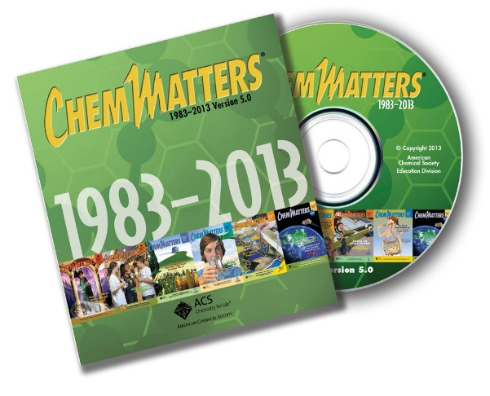

**30 Years of *ChemMatters***

Available Now!

**The references below can be found on the *ChemMatters* 30-year DVD (which includes all articles published during the years 1983 through April 2013 and all available Teacher’s Guides, beginning February 1990). The DVD is available from the American Chemical Society for $42 (or $135 for a site/school license) at this site:** [http://ww.acs.org/chemmatters](http://www.acs.org/chemmatters)**. Scroll about half way down the page and click on the *ChemMatters* DVD image at the right of the screen to order or to get more information.**

**Selected articles and the complete set of Teacher’s Guides for all issues from the past three years are available free online on the same Web site, above. Simply access the link and click on the “Past Issues” button directly below the “M” in the *ChemMatters* logo at the top of the Web page.**

Kirchenbaum, K. Mirror Molecules. *ChemMatters* **1989**, *7* (2), pp 4–7. Shows photos of mirror images of students, discusses the chirality of common objects, and limonene and carvone. Pictures and chemical structures are explained.

Scott, D. Life on Mars? *ChemMatters* **1994**, *12* (4), pp 10–13. The material is based on an interview with the chief designer of the Viking experiments discussed in the Warmflash Chirality article. The experiments are described including the information that both D- and L- enantiomers of carbohydrates and amino acids were used.

Meadows, R. The Horror and Hope of Thalidomide. *ChemMatters* **1997**, *7* (1), pp 13–15. This article discusses the effects of thalidomide on the fetus versus its promise to successfully treat leprosy.

\_\_\_\_\_\_\_\_\_\_\_\_\_\_\_\_\_\_\_\_

Thayer, A. Centering on Chirality. *Chemical and Engineering News* **2007**, *85* (32,) pp 11–19. The FDA policy that enantiomers must be “characterized pharmacologically and toxicologically” has caused a shift in focus for drug companies from preparing racemic mixtures to producing single enantiomeric forms of chiral compounds. (<http://cen.acs.org/articles/85/i32/Centering-Chirality.html>) (available to all)

Rouhi, A. Chiral Roundup. *Chemical and Engineering News* **2002**, *80* (13) pp 47–62. Cost concerns are discussed and new optical probes to separate enantiomers are introduced as the demand increases for enantiopure chiral compounds for pharmaceuticals, flavor and aromas, and agriculture. (<http://pubs.acs.org/cen/coverstory/8023/8023chiral.html>) (available to all)

Isn't it about Time Biochemistry Moved into the 20th Century? *Journal of Chemical Education* **1971**, *48* (9), p 597. This article contains more examples of the “inadequacy and ambiguity” of D- and L- designations for chiral molecules. (subscribers only)

Dedkova, L; Fahmi, N.; Golovine, S.; Hecht, S. Enhanced D-Amino Acid Incorporation into Protein by Modified Ribosomes. *Journal of the American Chemical Society* **2003,** March 13.The article describes how D-amino acid containing peptides and proteins can result from “posttranslational modification” or from “nonribosomal synthesis”. (Subscribers only) However, the research is published by Harvard at <http://arep.med.harvard.edu/pdf/Dedkova03.pdf>. (available to all)

# Web Sites for Additional Information

**(Web-based information sources)**

This section begins with two sources that contain some good basic reference material and explanations of the biochemical concepts of stereoisomerism, chirality, optical isomerism, and more.

**More sites on “chirality 101”**

This is a good basic reference for the concept of chirality: <http://chemed.chem.purdue.edu/genchem/topicreview/bp/1organic/chirality.html>.

**More sites on “Stereochemistry Chapter 05”**

Scroll to the end for the “Peanuts” cartoon. (<http://crab.rutgers.edu/~alroche/Ch05.pdf>)

**More sites on** **the discovery of chirality**

For detailed information regarding the discovery of optical activity leading to the identification of enantiomers, see the introduction by Laurence Barron to *Chirality at the Nanoscale: Nanoparticles, Surfaces, Materials and More.* Barron covers the period from 1811 when Arago observed the colors when sunlight passed through a prism to current work at the nanoscale level. (<http://www.wiley-vch.de/books/sample/352732013X_c01.pdf>) (Access is free to all.)

**More sites on** **thalidomide**

This site provides additional details on the tragic results stemming from the use of thalidomide to reduce morning sickness in pregnant women. This *New York Times* article discusses the history, current research and use to treat cancer and leprosy, and the devastating effects on the developing fetus. (<http://www.nytimes.com/2010/03/16/science/16limb.html?_r=0&pagewanted=print>)

Another article on this subject is published on *Nature.com*. (<http://www.nature.com/nrc/journal/v4/n4/box/nrc1323_BX1.html>)

**More sites on current methods to resolve enantiomers**

This site contains tables showing and describing current laboratory methods for resolution of enantiomers and methods of asymmetric synthesis by both stoichiometric and catalysis procedures. (<http://www.chemgapedia.de/vsengine/vlu/vsc/en/ch/12/oc/vlu_organik/stereochemie/trennung_enantiomere.vlu.html>)

This paper provides flow charts and descriptions of methods to separate enantiomers by crystallization, filtration, supercritical carbon dioxide, and resolving agents. Pertinent chemical reactions with structural formulas are shown. (<http://cdn.intechopen.com/pdfs-wm/36350.pdf>)

**More sites on chiral compounds**

This Web site contains details on chiral compounds and their pharmacology, including information on thalidomide and its chiral switch in the human body. This is a paper published by the *International Journal of Biological Science.* (<http://www.ncbi.nlm.nih.gov/pmc/articles/PMC3614593/> )

**More sites on chiral molecules in perfume, flavor, food and beverages**

The Leffingwell & Associates web site provides primary up-to-date information for the industries that provide the odors and flavors for perfume, food and beverages. The site contains links to articles on topics such as the history of natural chiral medicines. For example, there is an interesting study of the anti-malarial effects of bark from the Peruvian chinchona tree and the discovery of quinine, a chiral molecule. (<http://www.leffingwell.com/>)

**More sites on** **sugar substitutes**

This *Newsweek* article details the exciting and serendipitous search for methods to synthesize allulose, a sugar substitute. (<http://www.newsweek.com/search-perfect-sugar-substitute-308480>)

**More sites on** **origins of homochirality**

Kafri, R.; Markovitch, O.; Lancer, D. Spontaneous Chiral Symmetry Breaking in Early Molecular Networks. *Biology Direct*, May 27, **2010,** 5:38. This paper published on the NIH site uses kinetics to describe the origin of “enantioselection”: <http://www.ncbi.nlm.nih.gov/pmc/articles/PMC2894767/>.

**More sites on** **extraterrestrial life in our solar system**

The *Smithsonian Magazine, March 12, 2014* provides evidence to support that two moons of Jupiter (Europa and Io) and two of Saturn (Enceladus and Titan), plus the planet Mars have conditions that hold the possibility of additional life in our solar system. (<http://www.smithsonianmag.com/science-nature/where-solar-system-are-we-most-likely-find-life-180949994/?no-ist>)

**More sites on** **chirality in outer space**

**“**Star- and Planet-Forming Regions May Hold Key to Life’s Chirality” was published in *Astrobiology Magazine*, April 24, 2013. This article describes an attempt to answer the question of why earth species exhibit homochirality. The research team at the National Observatory in Japan used linear and circular polarimetry techniques on the “Cat’s Paw Nebula” in the Scorpius Constellation to determine if L-amino acids came from outer space. Their data has shown a very high degree of circular polarization to support their hypothesis that the homochirality of life has an extraterrestrial origin. This article is reprinted by *Science Daily*.

(<http://www.sciencedaily.com/releases/2013/04/130423090924.htm>)

**More sites on the problems of using chirality to test for extraterrestrial life**

Russomanno, D.EXPLORING THE NEW FRONTIER: THE SEARCH FOR LIFE ON MARS. University of California, Santa Barbara (UCSB), 2014. A very readable article published by UCSB suggests caution when assuming that life can be predicted by the presence of chirality. Although chirality is an important biomarker, scientists must remember that once an organism dies its biochemicals are released to the atmosphere. The enantiomers may lose their purity and optical activity especially in conditions of severe temperature and humidity. For much more information and extensive, relevant bibliography access the site: <http://www.writing.ucsb.edu/sites/secure.lsit.ucsb.edu.writ.d7/files/sitefiles/publications/2014%20Russomanno.pdf>.

# General Web References

***(Web information not solely related to article topic)***

The University of California, Davis has developed the *Dynamic Chemistry E-Textbook* on their ChemWiki site. This is an excellent reference source. You can easily access information from basic organic chemistry and biochemistry to chirality and optical isomerism. Search options are on the site. For example you can just search for chirality and optical isomerism. (<http://chemwiki.ucdavis.edu/>)