logo_chemmatters[1]

**April/May 2016 Teacher's Guide for**

***Antioxidants: Finding a Balance in Your Diet***

**Table of Contents**

[About the Guide 2](#_Toc446168491)

[Student Questions 3](#_Toc446168492)

[Answers to Student Questions 4](#_Toc446168493)

[Anticipation Guide 5](#_Toc446168494)

[Reading Strategies 6](#_Toc446168495)

[Background Information 9](#_Toc446168496)

[Connections to Chemistry Concepts 44](#_Toc446168497)

[Possible Student Misconceptions 44](#_Toc446168498)

[Anticipating Student Questions 45](#_Toc446168499)

[In-Class Activities 45](#_Toc446168500)

[Out-of-Class Activities and Projects 47](#_Toc446168501)

[References 48](#_Toc446168502)

[Web Sites for Additional Information 49](#_Toc446168503)

# About the Guide

Teacher’s Guide editors William Bleam, Regis Goode, Barbara Sitzman and Ronald Tempest created the Teacher’s Guide article material. E-mail: [bbleam@verizon.net](mailto:bbleam@verizon.net)

Susan Cooper prepared the anticipation and reading guides.

Patrice Pages, *ChemMatters* editor, coordinated production and prepared the Microsoft Word and PDF versions of the Teacher’s Guide. E-mail: [chemmatters@acs.org](mailto:chemmatters@acs.org)

Articles from past issues of *ChemMatters* can be accessed from a DVD that is available from the American Chemical Society for $42. The DVD contains the entire 30-year publication of *ChemMatters* issues, from February 1983 to April 2013.

The *ChemMatters* DVD also includes Article, Title and Keyword Indexes that covers all issues from February 1983 to April 2013.

The *ChemMatters* DVD can be purchased by calling 1-800-227-5558.

Purchase information can be found online at [www.acs.org/chemmatters](http://chemistry.org/chemmatters/cd3.html).

# Student Questions

**(taken from the article)**

**Antioxidants: Finding a Balance in Your Diet**

* + 1. According to studies, how do the dietary vitamin needs of teenage girls differ from the needs of teenage boys?
  1. How do antioxidants provide protection for berries, tomatoes and peppers?
  2. What important role do antioxidants play in photosynthesis?
  3. Why is a free radical unstable and highly reactive?
  4. What can be done to reduce the harmful effects of reactive oxygen species?
  5. What is a redox reaction?
  6. How do antioxidants reduce cell damage?
  7. In what part of the cell does each of the two main species of antioxidants (water soluble and fat soluble) prevent damage?
  8. What chemical change occurs when beta-carotene enters the body? Why is this important?
  9. What is the probable value of dietary turmeric?
  10. According to health experts, in what ways should we change our diets?

# Answers to Student Questions

**(taken from the article)**

**Antioxidants: Finding a Balance in Your Diet**

* + 1. **According to studies, how do the dietary vitamin needs of teenage girls differ from the needs of teenage boys?**

*According to studies, teenage girls often require more vitamins A and E, while boys do not get enough vitamin E in their diets.*

* + 1. **How do antioxidants provide protection for berries, tomatoes and peppers?** *Antioxidants provide protection for berries, tomatoes and peppers by:*

1. *causing bright colors in their fruits that insects and birds avoid.*
2. *producing aromas that are unpleasant to insects and birds.*
   * 1. **What important role do antioxidants play in photosynthesis?**

*Antioxidants play an important role in photosynthesis by regulating the production of reactive oxygen species that can damage plants.*

* + 1. **Why is a free radical unstable and highly reactive?**

*A free radical is unstable and highly reactive because it has an unpaired electron.*

* + 1. **What can be done to reduce the harmful effects of reactive oxygen species?**

*The harmful effects of reactive oxygen species can be reduced by eating foods that contain antioxidants.*

* + 1. **What is a redox reaction?**

*A redox reaction occurs when there is an exchange of electrons from one atom or molecule to another.*

* + 1. **How do antioxidants reduce cell damage?**

*Antioxidants reduce cell damage by preventing reactive oxygen species from capturing electrons from surrounding atoms and molecules.*

* + 1. **In what part of the cell does each of the two main species of antioxidants (water soluble and fat soluble) prevent damage?**

1. *Water soluble antioxidants (like vitamin C) prevent damage within the cell.*
2. *Fat soluble antioxidants prevent damage in the fatty cell membrane.*
   * 1. **What chemical change occurs when beta-carotene enters the body? Why is this important?**

*When beta-carotene enters the body, it is chemically converted to vitamin A. The vitamin A is a critical component of rhodopsin that absorbs light and helps promote vision at nighttime and in low light.*

* + 1. **What is the probable value of dietary turmeric?**

*The probable value of dietary turmeric is that it contains curcumin, which may block some cancers and help reduce inflammation.*

* + 1. **According to health experts, in what ways should we change our diets?**

*Health experts say that we should change our diets by:*

1. *eating more whole foods containing vitamins and antioxidants.*
2. *reducing the amount of foods high in salts, carbohydrates and fats.*

# Anticipation Guide

Anticipation guides help engage students by activating prior knowledge and stimulating student interest before reading. If class time permits, discuss students’ responses to each statement before reading each article. As they read, students should look for evidence supporting or refuting their initial responses.

**Directions:**  ***Before reading,*** in the first column, write “A” or “D,” indicating your agreement or disagreement with each statement. As you read, compare your opinions with information from the article. In the space under each statement, cite information from the article that supports or refutes your original ideas.

|  |  |  |
| --- | --- | --- |
| **Me** | **Text** | **Statement** |
|  |  | 1. Studies have shown that most teenagers get all the vitamins they need in the food they eat. |
|  |  | 1. Antioxidants are important in photosynthesis. |
|  |  | 1. Only plants produce reactive oxygen species. |
|  |  | 1. Electrons are exchanged in an oxidation-reduction (redox) reaction. |
|  |  | 1. Antioxidants receive electrons from reactive oxygen species. |
|  |  | 1. Many antioxidants have aromatic ring structures, making them relatively stable. |
|  |  | 1. All antioxidants are water soluble. |
|  |  | 1. Beta-carotene is an antioxidant found in tomatoes, carrots, and red peppers. |
|  |  | 1. Spices are very good sources of antioxidants. |
|  |  | 1. Eating a variety of foods is an excellent way to get the antioxidants you need to stay healthy. |

# Reading Strategies

These graphic organizers are provided to help students locate and analyze information from the articles. Student understanding will be enhanced when they explore and evaluate the information themselves, with input from the teacher if students are struggling. Encourage students to use their own words and avoid copying entire sentences from the articles. The use of bullets helps them do this. If you use these reading and writing strategies to evaluate student performance, you may want to develop a grading rubric such as the one below.

|  |  |  |
| --- | --- | --- |
| **Score** | **Description** | **Evidence** |
| 4 | Excellent | Complete; details provided; demonstrates deep understanding. |
| 3 | Good | Complete; few details provided; demonstrates some understanding. |
| 2 | Fair | Incomplete; few details provided; some misconceptions evident. |
| 1 | Poor | Very incomplete; no details provided; many misconceptions evident. |
| 0 | Not acceptable | So incomplete that no judgment can be made about student understanding |

***Teaching Strategies:***

1. Links to **Common Core Standards for Reading**:

ELA-Literacy.RST.9-10.1:Cite specific textual evidence to support analysis of science and technical texts, attending to the precise details of explanations or descriptions.

ELA-Literacy.RST.9-10.5: Analyze the structure of the relationships among concepts in a text, including relationships among key terms (e.g., force, friction, reaction force, energy).

ELA-Literacy.RST.11-12.1:Cite specific textual evidence to support analysis of science and technical texts, attending to important distinctions the author makes and to any gaps or inconsistencies in the account.

ELA-Literacy.RST.11-12.4: Determine the meaning of symbols, key terms, and other domain-specific words and phrases as they are used in a specific scientific or technical context relevant to grades 11-12 texts and topics.

1. Links to **Common Core Standards for Writing**:

ELA-Literacy.WHST.9-10.2F: Provide a concluding statement or section that follows from and supports the information or explanation presented (e.g., articulating implications or the significance of the topic).

ELA-Literacy.WHST.11-12.1E: Provide a concluding statement or section that follows from or supports the argument presented.

1. **Vocabulary** and **concepts** that are reinforced in this issue:

Personal and community health

Reactive oxygen species

Fuel production and use

Molecular structures

Polymers

1. Some of the articles in this issue provide opportunities, references, and suggestions for students to do further research on their own about topics that interest them.
2. To help students engage with the text, ask students which article **engaged** them most and why, or what **questions** they still have about the articles. The Background Information in the *ChemMatters* Teachers Guide has suggestions for further research and activities.
3. In addition to the writing standards above, consider asking students to debate issues addressed in some of the articles. Standards addressed:

**WHST.9-10.1B** Develop claim(s) and counterclaims fairly, supplying data and evidence for each while pointing out the strengths and limitations of both claim(s) and **counterclaims** in a discipline-appropriate form and in a manner that anticipates the audience’s knowledge level and concerns.

**WHST.11-12.1.A** Introduce precise, knowledgeable claim(s), establish the significance of the claim(s), distinguish the claim(s) from alternate or opposing claims, and create an organization that logically sequences the claim(s), counterclaims, reasons, and evidence.

**Directions:** As you read the article, complete the graphic organizer below to describe antioxidants.

|  |  |
| --- | --- |
| **Why are they important?**  **Antioxidants** | **Where can they be found in nature?** |
| **Examples** | **Nonexamples** |

**Summary:** On the back of this paper, write a sentence describing one thing you learned about antioxidants from reading the article, and how you might use the information in the future.

# Background Information

**(teacher information)**

**More on energy production in cells**

Mitochondria are one type of organelle located in cellular cytoplasm. A cell may contain one or several mitochondria whose function is to break down nutrients in the cell and use them to create energy-rich molecules of adenosine triphosphate (ATP). The structural model pictured below was reproduced from an exhibit in the Indian Museum in Kolkata, India.

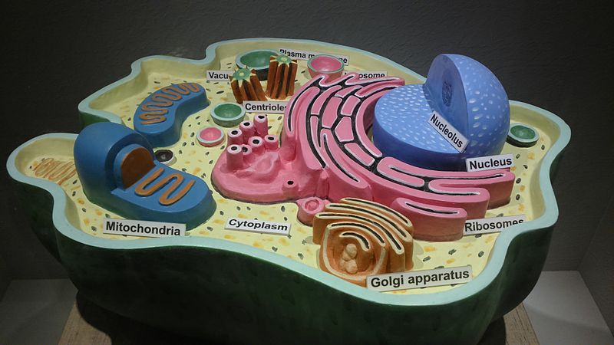

Structure of animal cell

*(*[*https://commons.wikimedia.org/wiki/File:Structure\_of\_animal\_cell.JPG*](https://commons.wikimedia.org/wiki/File:Structure_of_animal_cell.JPG)*)*

The electron transfer chain in the mitochondria is the only metabolic process that directly uses atmospheric oxygen to produce energy. Sunlight provides the energy for photosynthesis. Within the mitochondria a chain of redox reactions rapidly transfers electrons between a series of peptides, proteins and complex proteins. The proteins serve as enzymes to expedite this process and drive the synthesis of ATP. Ultimately, glucose is oxidized to release the energy required to produce ATP for energy storage. For example, in complex I (pictured below), when the mitochondrial electrons from the electron donor NADH are accepted, NAD+ + H+ form; the final electron acceptor is molecular oxygen, O2. The diagram illustrates this process as explained in the textbook, *Boundless Biology* from Boundless.com:

* + There are four [protein](https://www.boundless.com/biology/definition/protein/) [complexes](https://www.boundless.com/biology/definition/complex/) (labeled complex I-IV) in the electron transport chain, which are involved in moving electrons from [NADH](https://www.boundless.com/biology/definition/nadh/) and FADH2 to molecular oxygen.
  + Complex I establishes the hydrogen [ion](https://www.boundless.com/biology/definition/ion/) gradient by pumping four hydrogen ions across the membrane from the matrix into the intermembrane space.
  + Complex II receives FADH2, which bypasses complex I, and delivers electrons directly to the electron transport chain.
  + [Ubiquinone](https://www.boundless.com/biology/definition/ubiquinone/) (Q) accepts the electrons from both complex I and complex II and delivers them to complex III.
  + Complex III pumps protons through the membrane and passes its electrons to cytochrome c for transport to the fourth complex of proteins and [enzymes](https://www.boundless.com/biology/definition/enzyme/).
  + Complex IV reduces oxygen; the reduced oxygen then picks up two hydrogen ions from the surrounding medium to make water.

(<https://www.boundless.com/biology/textbooks/boundless-biology-textbook/cellular-respiration-7/oxidative-phosphorylation-76/electron-transport-chain-362-11588/>)

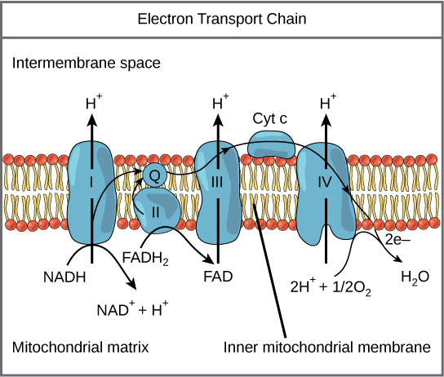

The Electron Transport Chain

*(*[*https://www.boundless.com/biology/textbooks/boundless-biology-textbook/cellular-respiration-7/oxidative-phosphorylation-76/electron-transport-chain-362-11588/*](https://www.boundless.com/biology/textbooks/boundless-biology-textbook/cellular-respiration-7/oxidative-phosphorylation-76/electron-transport-chain-362-11588/)*)*

**More on the formation of free radicals—internal sources—reactive oxygen species (ROS)**

The body’s internal electron transfer chain does not always work exactly as explained above. Since there is a great deal of rapid donating and accepting of electrons within the mitochondria, there is plenty of opportunity for free radical formation. In a 1995 symposium for the *Biochemical Society*, Kelvin Davies, who chairs the University of Southern California’s School of Gerontology, describes the formation of free radicals: “The paradox of aerobic life, or the 'Oxygen Paradox', is that higher eukaryotic aerobic organisms cannot exist without oxygen, yet oxygen is inherently dangerous to their existence. This 'dark side' of oxygen relates directly to the fact that each oxygen atom has one unpaired electron in its outer valence shell, and molecular oxygen has two unpaired electrons.” Note that eukaryotic aerobic organisms are oxygen-using organisms that contain cells with defined walls and a nucleus, along with various organelles located within their cytoplasm.

Davies explains that in safe mitochondrial situations, the electron transfer chain reduces molecular oxygen (O2) to water. The redox reactions below show O2 accepting electrons as it is reduced to water. The enzymes catalyzing these reactions are shown in red. The “ase” suffix is attached to the name of the substrate to establish the name of the enzyme. When a single electron is transferred as shown in these reactions, potentially dangerous reactive oxygen species (ROS) are produced as intermediates during the reduction of O2 to H2O. ROS, referred to as free radicals, are reactive atoms or molecules that have non-paired electrons in their valence shells. The high reactivity of free radicals is attributed to their non-paired electrons. This site provides access to the content of Davies’ *Biochemical* Society symposium: “Oxygen Paradox”: <http://symposia.biochemistry.org/content/ppbioss/61/1.full.pdf>.

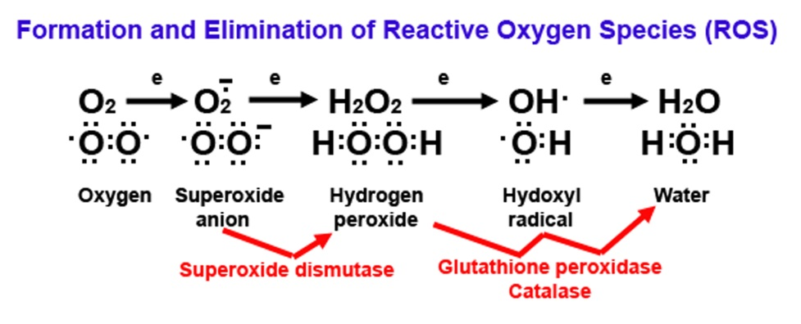

*(*[*http://www.impactaging.com/papers/v1/n8/full/100082.html*](http://www.impactaging.com/papers/v1/n8/full/100082.html)*)*

In most cases as the chain reactions proceed, the catalysts protect the cell by making certain that the electrons are quickly passed on to the next step in the process, thus expediting the elimination of ROS by-products. But one to three percent of all atmospheric O2 used by the mitochondria fail to follow a perfect exchange of electrons during these chain reactions, thus releasing some ROS into the cells.

Electron structures of common reactive oxygen species

*(*[*http://www.biotek.com/resources/articles/reactive-oxygen-species.html*](http://www.biotek.com/resources/articles/reactive-oxygen-species.html)*)*

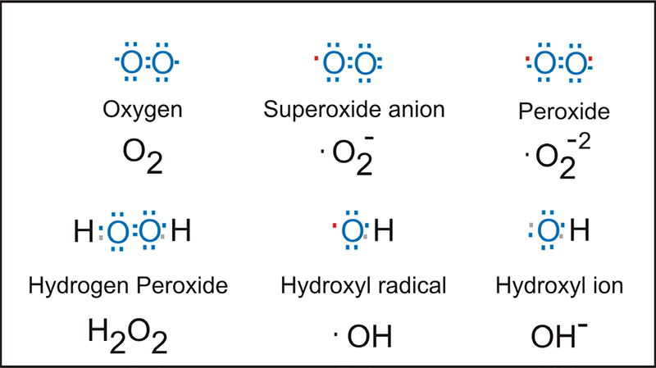

Each oxygen atom contains six electrons, so there are two unpaired electrons in its valence shell. When a covalent bond joins two atoms to form the atmospheric O2 molecule, the resulting molecule contains an unpaired electron on each oxygen atom leaving it prone to free radical formation. The Lewis structures of major ROS are seen above, right. The red • represents an unpaired electron.

Some anti-inflammatory and cancer drugs oxidize cells, forming ROS. The following table provides additional descriptions and actions of the primary ROS found in cells.

|  |  |  |  |  |
| --- | --- | --- | --- | --- |
| **Main reactive oxygen species and its performance** | | | | |
| **Species** | **Chemical Structure** | **Description** | **Occurrence** | **Action** |
| Superoxide radical | O2– | Most potent radical in the induction of cellular damage | Almost all aerobic cells | Majority of reactions as a reducing agent |
| Hydroxyl radical | OH• | O2– acid conjugate, highly reactive | Formed through water radiolysis | DNA, proteins, carbohydrates and lipids |
| Hydroperoxyl radical | HO2• | Protonated form of the O2 – | From hydrogen peroxide | Biological Membranes |
| Hydrogen peroxide | H2O2 | It’s not a free radical because it did not submit electrons paired in the last layer | Reactions for the production of OH• | Proteins and lipids |
| Singlet oxygen | 1O2 | Excited form of molecular oxygen. It’s not a free radical because it did not submit electrons paired in the last layer | Generated by phagocytes, luminous induction and catalyzed reactions by peroxidases | DNA Changes |

*(adapted from* [*http://www.scielo.br/scielo.php?script=sci\_arttext&pid=S1516-89132010000600009*](http://www.scielo.br/scielo.php?script=sci_arttext&pid=S1516-89132010000600009)*)*

**More on the formation of free radicals—internal sources—reactive nitrogen species (RNS)**

Nitrogen can also be involved in the formation of reactive species within the body. Nitric oxide (NO) serves an important function in cellular communication. It regulates responses between cells through redox signaling pathways similar to those in the mitochondrial electron transfer chain. Although NO does not directly kill pathogens, in its signaling role it is important in cellular defense mechanisms.

Reactive nitrogen species (RNS) are formed when RNS reacts with ROS. For example, when nitric oxide reacts with superoxide, peroxynitrite (ONOO−), a very reactive RNS, forms:

•O2− + •NO → ONOO−

Peroxynitrite can react with lipids, DNA and proteins to initiate cell death and lead to serious illnesses, including cancer, diabetes and those involving neurons and heart function. (<https://www.ncbi.nlm.nih.gov/pmc/articles/PMC2248324/>)

The structural formula below shows nicotinamide adenine dinucleotide phosphate (NADP+) a coenzyme involved in lipid and nucleic acid synthesis. NADPH is a reducing agent that both reduces dangerous ROS and generates free radicals in white blood cells for the destruction of pathogens.

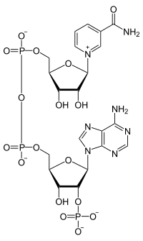

Nicotinamide adenine dinucleotide phosphate (NADP+)

*(*[*https://en.wikipedia.org/wiki/Nicotinamide\_adenine\_dinucleotide\_phosphate*](https://en.wikipedia.org/wiki/Nicotinamide_adenine_dinucleotide_phosphate)*)*

The illustration below depicting the mitochondrial pathway shows the role of NADP+ in the chain of redox reactions that lead to the formation of RNS. A complete explanation of the reactions is given by the author below.

**Formation of reactive nitrogen species in biological systems**

Through the rapid reaction of NO and O−2, peroxynitrite (ONOOH) [actually peroxynitrous acid] is formed and leads to oxidation, nitrosation (addition of NO) or nitration (addition of NO2). Nitric oxide is formed from the enzymatic action of the nitric oxide synthases (NOS) which under some circumstances can also produce O−2. There are further potential sources of O−2 in the cell including xanthine oxidase (XOD), NAD(P)H oxidases (NAD(P)H ox and respiratory complexes within the mitochondria (Mito). Recently it has also been shown that the enzyme myeloperoxidase (MPO) can cause nitration reactions using nitrite (NO−2) and its product hypochlorite (HOCl) as a substrate. The oxidation reactions (e.g. oxidation of glutathione) occur at the highest chemical yield but the nitration  
(e.g. formation of nitrotyrosine) or nitrosation (e.g. formation of *S*-nitrosoglutathione) reactions are also biologically significant since they can alter cell signalling and generate NO donors.

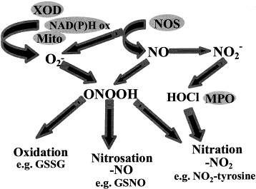

Nitric oxide-dependent reactions that lead to the formation of RNS

(<http://www.sciencedirect.com/science/article/pii/S0005272899000286>)

Below is a diagram of the RNS path to the destruction of unsaturated fats that compose the walls of cells, lipid peroxidation. This is similar to the damage caused by ROS.

**Reactive nitrogen species in membranes and lipoproteins**

Higher concentrations of NO within hydrophobic compartments may result in its reaction with oxygen forming a variety of intermediates (e.g. NO2) capable of initiating lipid peroxidation reactions which are propagated by lipid peroxyl radicals (LOO). Oxidative damage to lipids mediated by NO2 or other oxidant species may be prevented, however, by termination of propagating peroxyl radicals (LOO) by NO.

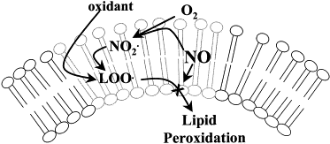

Reactions of NO within hydrophobic compartments.

*(*[*http://www.sciencedirect.com/science/article/pii/S0005272899000286*](http://www.sciencedirect.com/science/article/pii/S0005272899000286)*)*

Both ROS and RNS can be generated by ultraviolet light (UV), X-rays and gamma rays—in other words, ionizing radiation. When metal ions such as those of iron and copper are released into air polluted by cigarette smoke and other airborne particles, they are free to catalyze reactions that form dangerous ROS and RNS. These metals are usually harmless in the body where they are tightly bonded within protein structures. (<http://www.ncbi.nlm.nih.gov/pmc/articles/PMC2763257/>)

ROS and RNS are often referred to collectively as the highly chemically reactive ROS/RNS since their formation involving electron transfer and much of their reactivity involving cellular signaling are similar. The following table covers nomenclature for ROS and RNS species.

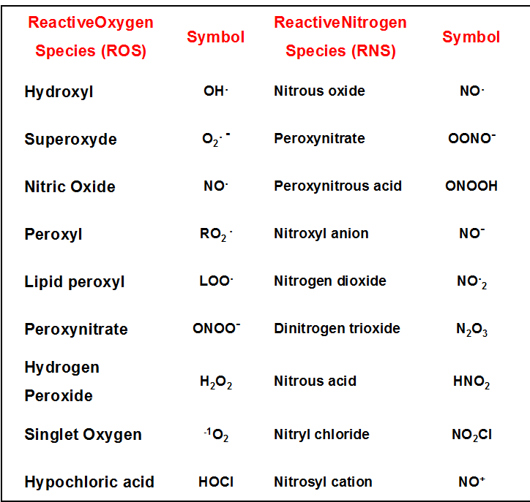

List of oxygen (ROS) and nitrogen (RNS) reactive species commonly found in normal and pathological tissues

*(*[*http://www.intechopen.com/books/research-directions-in-tumor-angiogenesis/manipulating-redox-signaling-to-block-tumor-angiogenesis*](http://www.intechopen.com/books/research-directions-in-tumor-angiogenesis/manipulating-redox-signaling-to-block-tumor-angiogenesis)*)*

The following figure indicates how the superoxide anion (O2−) triggers the formation of various reactive species. (Note: the Fenton reaction will be discussed in this Teacher’s Guide under the “More on damaging effects of free radicals” section.)

[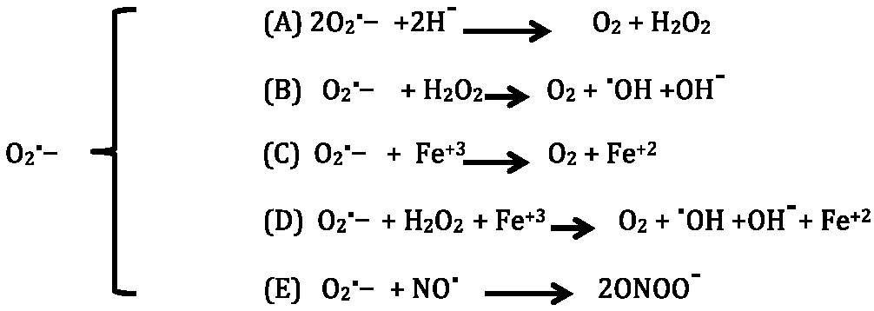](http://www.intechopen.com/source/html/49314/media/image1_w.jpg)

1. O2⋅– dismutation, which can be formed spontaneously or can be catalyzed by superoxide dismutase (SOD).
2. Haber-Weiss reaction generates hydroxyl radicals from hydrogen peroxide and superoxide.
3. Fe+3 to Fe+2 reduction.
4. Fenton reaction.
5. peroxynitrite (ONOO-) formation.

*(*[*http://www.intechopen.com/books/basic-principles-and-clinical-significance-of-oxidative-stress/regulation-of-the-redox-environment*](http://www.intechopen.com/books/basic-principles-and-clinical-significance-of-oxidative-stress/regulation-of-the-redox-environment)*)*

**More on the formation of free radicals—external sources**

In addition to generating free radicals during mitochondrial electron transfer, they are also formed when the diet lacks fresh fruits and vegetables and/or includes excess alcohol that can also promote the generation of ROS.

Free radicals form during cigarette smoking. The tar contains ROS in a fairly stable state. Yet, they are capable of reducing O2 to superoxide. It is speculated that these free radicals may be able to covalently bond to DNA. The cigarette smoke produces very active free radicals such as NO that can be oxidized to NO2. The RNS react with organic molecules such as isoprene in the smoke, forming oxidizing radicals that contribute to DNA damage. In addition, tobacco smoke often contains oxidizing metal atoms. (<http://www.ncbi.nlm.nih.gov/pmc/articles/PMC1568603/>)

Ozone can also form free radicals when it adds across the double bond of an unsaturated fat. As seen in the diagram below, the first compound formed is a cyclic ozonide. Next the oxygens are rearranged to form the secondary compound that splits to form a carbonyl and the final biradical (note the two unpaired electrons, one on the oxygen and the other on the carbon). This free radical was first postulated by the German chemist, Rudolf Criegee in the 1950s.

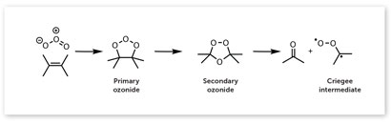

Ozone reacts with alkenes to produce a carbonyl and a biradical carbonyl oxide, known as a   
Criegee intermediate.

*(*[*http://www.rsc.org/Education/EiC/issues/2013september/criegee-biradical-atmosphere-free-radical.asp*](http://www.rsc.org/Education/EiC/issues/2013september/criegee-biradical-atmosphere-free-radical.asp)*)*

Ionizing radiation provides the energy required to move an electron from a stable orbital to an empty, higher energy orbital where it is now unpaired, thus forming a free radical. The effects of ionizing radiation are exacerbated when the tissue environment is highly oxygenated. Certain prescription drugs and some chemicals from the fertilizers and pesticides used on our foods can generate reactive species as we digest them. (<http://www.ncbi.nlm.nih.gov/pmc/articles/PMC3249911/>)

**More on the beneficial effects of free radicals**

Although many advertisements portray ROS and oxidants as extremely damaging substances that must be treated immediately by antioxidants, they actually serve important roles in healthy metabolism. Phagocytes, a type of white blood cells, generate ROS as needed to aid in bodily defense against pathogens. Since ROS have the ability to breakdown lipids and proteins (as described in the next section), they assist the white blood cells in digesting cell debris, bacteria, foreign proteins, cancer cells and other waste that needs to be eliminated from the body. The efficacy of some prescription drugs used to treat tissue inflammation and cancer depends upon their oxidizing ability to produce ROS as they are digested by the body.

Research suggests that ROS may play a role in both intracellular and intercellular cell signaling processes by triggering a series of redox reactions that create responses involving gene expression and apoptosis (cell death).

(<http://www.biotek.com/resources/articles/reactive-oxygen-species.html>)

**More on the damaging effects of free radicals**

Along with their beneficial attack on harmful microorganisms and cellular debris, excess ROS can damage the nuclei and cell walls of healthy DNA, proteins, lipids and carbohydrates. Significant cell damage occurs when a free radical attacks a fatty cellular membrane as pictured below. The hydroxyl radical cleaves the double bond in the hydrocarbon chain of an unsaturated fatty acid by removing a hydrogen atom to form water (HOH). This leaves a piece of the carbon chain as a radical that reacts with oxygen to form the peroxyl radical. This radical is now available to attack another fatty acid, a protein and the cross links between these molecules.

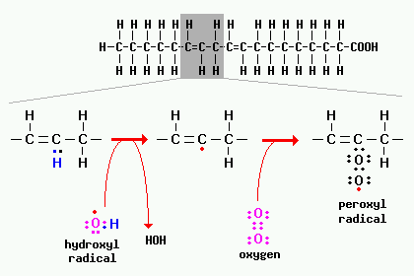

Reactions involving radicals occur in chain reactions.

*(*[*http://www.vivo.colostate.edu/hbooks/pathphys/misc\_topics/radicals.html*](http://www.vivo.colostate.edu/hbooks/pathphys/misc_topics/radicals.html)*)*

The extent of the effect of this process (lipid peroxidation) on cellular membranes is determined by the strength, duration and exposure to ROS. Damage includes:

* increased membrane rigidity
* decreased activity of membrane-bound enzymes (e.g. sodium-potassium pumps across the cell membrane)
* altered activity of membrane receptors
* altered permeability

(<http://www.vivo.colostate.edu/hbooks/pathphys/misc_topics/radicals.html>)

Pro-oxidant foods, such as those high in sucrose, and pro-oxidant drugs, including some cancer drugs, can initiate or increase the production of ROS and/or inhibit the function of antioxidants. Iron and copper can both donate and accept free electrons and act as catalysts in free radical formation. Most of the free iron in cells is in the oxidized Fe+3 state. For the Fenton reaction to occur (below), the iron must first be reduced (often by vitamin C) to Fe2+; then, it will be oxidized by hydrogen peroxide to form Fe+3 and yield the hydroxyl radical. A similar reaction occurs with copper. Both reactions produce ROS by-products. (Note that although vitamin C is a potent antioxidant, it also reduces metal ions.)

**The Fenton reaction**

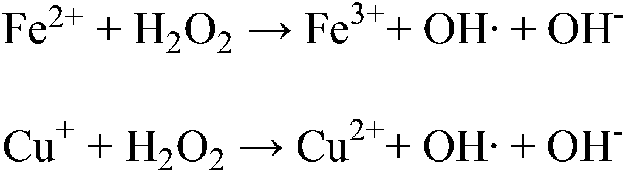

(<http://www.ncbi.nlm.nih.gov/pmc/articles/PMC4425619/>)

A paper published in the *British Journal of Nutrition* cites research on rats and describes the effects of a short-term, high-sucrose diet. An increased production of ROS reduced the rats’ metabolic defenses against lipid peroxidation.

(<http://www.ncbi.nlm.nih.gov/pubmed/12064343>)

Since reactive oxygen and nitrogen species can interfere with mitosis, where cells rapidly divide, they can also trigger the replication of viruses. Antioxidants may play a role in treating viral diseases such as the flu or HIV, as well as reducing oxidative stress. (<http://www.ncbi.nlm.nih.gov/pubmed/9164274>)

To summarize, here are three major ways that free radicals damage cells:

1. lipid peroxidation – ROS attack and cleave the double bonds of unsaturated cell wall lipids.
2. oxidative modification of proteins – ROS oxidize side chains of amino acid residues and form cross-links between proteins denaturing enzymes.
3. DNA lesions – ROS break amino acid strands in nuclear and mitochondrial DNA.

(<http://www.scielo.br/scielo.php?script=sci_arttext&pid=S1516-89132010000600009>)

**More on oxidative stress**

Free radicals can be both beneficial and damaging to the body. To maintain redox homeostasis, the healthy body must maintain a balance between ROS/RNS and antioxidants. In cells, free radical formation occurs continuously, producing enough ROS to reduce inflammation and to aid the immune system. Sufficient antioxidants are required to reduce free radicals, eliminating their ability to damage cells and tissues. If the amount of the free radicals exceeds the body’s ability to use, eliminate or destroy them, oxidative stress occurs. The Haber-Weiss reaction shown in the section “More on formation of free radicals—internal sources” located in this Teacher’s Guide suggests that since this reaction occurs in cells, it may be a source of oxidative stress. Chronic oxidative stress occurs when the body can no longer keep a balance between the free radicals that it needs and its ability to neutralize them with antioxidants as shown in the diagram below.

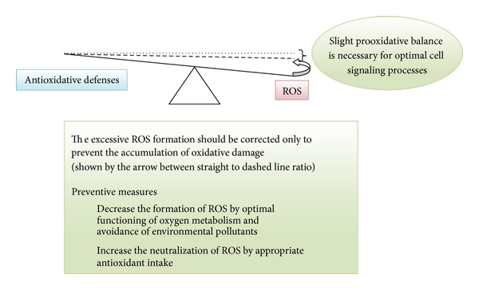

Figure 1: Model antioxidative/oxidative balance of an adult person—the balance is slightly moved towards the increased ROS production (dashed line). The physiological balance is represented by the dashed line and not the dotted line (geometrical balance), since slight pro-oxidative balance is necessary for optimal immune system and cell signaling processes.

*(*[*http://www.hindawi.com/journals/omcl/2013/956792/*](http://www.hindawi.com/journals/omcl/2013/956792/)*)*

When a person experiences physical, emotional or biological stress such as inflammation or cancer, the body senses the need for additional energy. This may trigger the mitochondrial electron transfer chain to accelerate the rate of energy production in the body. This leads to the release of additional ROS that may disrupt homeostasis. The damage from oxidative stress is thought to initiate and contribute to health problems such as heart diseases, neurodegenerative diseases and cancer, as well as contribute to the aging process.

A primary key to indicate oxidative stress is the amount of lipid peroxidation that occurs. This biochemical process can be measured because an end-product is a reactive aldehyde (malondialdehyde) that is sufficiently stable for measurement. The sample is reacted with thiobarbituric acid and the product is analyzed both calorimetrically and fluorometrically. Descriptions of commercial malondialdehyde assay kits can be found at these URLs: <http://www.biovision.com/lipid-peroxidation-mda-colorimetric-fluorometric-assay-kit-4953.html>, <http://www.abcam.com/lipid-peroxidation-mda-assay-kit-colorimetricfluorometric-ab118970.html>, and

<http://www.ncbi.nlm.nih.gov/pubmed/23296666>.

**More on theories of aging**

As animals age, their ability to maintain homeostasis decreases. They lose the ability to resist external stresses such as changes in temperature, trauma and infections. They become more susceptible to cancer and diseases such as Alzheimer’s, Parkinson’s and arteriosclerosis.

Scientists have proposed more than 300 theories of aging. Free radical generation is seen as a critical factor. Studies have shown that the rate of ROS generation increases in mitochondria during the process of mammalian aging. This increase in ROS leads to the oxidation of cells, including disruption of their membranes, DNA mutations, and dysfunction of organelles, often leading to cellular death. In addition, the older the animal, the greater the number of accumulated waste products, such as oxidized proteins, DNA and lipids that are detected. As shown in the figure below, major theories of aging can be lumped into three major categories: Genetic Mutation, Cellular Waste Accumulation and Wear and Tear. For the reasons above, the Free Radical Theory falls into both the Genetic Mutation and Waste Accumulation categories. (<http://www.scielo.br/pdf/babt/v53n6/a09v53n6.pdf>)

**Theories of ageing. Classification.**

(Viña, J., Borrás, C. and Miquel, J. (2007), Theories of ageing. IUBMB Life, 59: 249–254. Doi: 10.1080/152165406011780)

*(*[*http://onlinelibrary.wiley.com/doi/10.1080/15216540601178067/pdf*](http://onlinelibrary.wiley.com/doi/10.1080/15216540601178067/pdf)*)*

Some studies show that overexpression of antioxidant enzymes increases longevity. Yet supplements of antioxidants have not been shown to be effective against age-related diseases and, in some cases, they have decreased life expectancy. In other cases, increased generation of ROS has increased life-span. Additional research is needed to clarify these seemingly contradictory findings. (<http://www.ncbi.nlm.nih.gov/pubmed/8660387>)

**More on** **the discovery of an antioxidant**

Although the potential for oxidative damage is built into the mitochondrial reactions of aerobic animals in general, humans, in particular, have mechanisms to protect their cells from damage caused by free radicals. Antioxidant molecules can accept or donate an electron to a free radical, erasing its unpaired electron situation. This may leave the antioxidant as a free radical but these less reactive substances, often large molecules, may be easily neutralized by other antioxidants. Molecules with releasable hydrogen atoms can also act as antioxidants to reduce free radicals.

Henry Albright Mattill (1883–1953) is credited with the discovery of the antioxidant function of vitamin E. During his career as a university professor, Mattill had appointments at the Universities of Utah, Iowa, California and Rochester. A paper from the University of Iowa archives, “The Discovery of the Antioxidant Function of Vitamin E: the Contribution of Henry A. Mattill”, describes Dr. Mattill’s background and details his research on rats that led to the recognition of Vitamin E as an antioxidant. The research of others also working on this problem often received the credit. But in 1980 Karl E. Mason, a leader in vitamin E studies wrote, “The pioneer studies of Mattill and his colleagues deserved more recognition than they received.”

When Mattill kept male and female rats on basic diets of milk and cornstarch, they became sterile. Manipulating the percentage of butterfat and other ingredients did not change their inability to reproduce. So he modified these diets by adding vitamins. The addition of vitamins A, B or C had no effect, but when he added wheat germ or fresh spinach, their fertility returned. Mattill hypothesized that these foods must contain an anti-sterility factor.

At the same time, Barnett Sure at the University of Arkansas came to the same conclusions, namely that something was missing from the milk diets. Since vitamins A, B, C and D were already discovered; he decided to call this new substance, vitamin E. (<http://jn.nutrition.org/content/135/3/363.short>)

According to the U.S. Department of Agriculture (USDA), “A dietary antioxidant is a substance in foods that significantly decreases the adverse effects of reactive oxygen species, reactive nitrogen species or both on normal physiological function in humans.” (<https://fnic.nal.usda.gov/sites/fnic.nal.usda.gov/files/uploads/3-5_150.pdf>)

**More on the chemistry of antioxidants—phytochemicals**

The energy from sunlight drives photosynthesis and exposes plants to much potentially damaging ultraviolet (UV) radiation which can generate free radicals. To protect against free radical damage to their cells, plants internally generate phytochemicals. These powerful antioxidants such as flavonoids, allyl sulfides, polyphenols and carotenoids can donate electrons to neutralize ROS. Each of these is covered in a separate section of this Teacher’s Guide, below.

**Flavonoids**

Flavonoids are a water soluble type of phytochemical that are responsible for the bright colors in berries, tomatoes and peppers as well as the taste and odor that deter insects and birds as introduced in the Porterfield antioxidants article. Plants produce flavonoids and store them in their leaves. Thus, a diet of whole grains and fresh fruits and vegetables is usually rich in antioxidants that can reduce free radicals. This protects human cells against the damaging effects of ROS on macromolecules such as lipids, carbohydrates, proteins and DNA. Note that foods that have been processed and/or refined do not contain phytochemicals.

Flavonoids are broken down in the digestive tract. Their chemical structure determines their ability to chelate and reduce harmful free metal ions such as those of iron and copper and thus reduce lipid peroxidation. Their hydroxyl groups (see the formulas below) provide the structural ability to reduce antioxidants by acting as chelating agents.

(<http://www.ncbi.nlm.nih.gov/pubmed/12550068>)

Flavonoids are a type of phenolic compound. The structure of plant phenolics comes from basic phenol, a benzene ring with a hydroxyl group attached (shown below on the left). The basic structure of a flavonoid (a type of phenolic compound) is shown on the right. Note, this is C6-C3-C6, arranged in two benzene rings (A and B) and a central heterocyclic ring (C) with an oxygen atom.

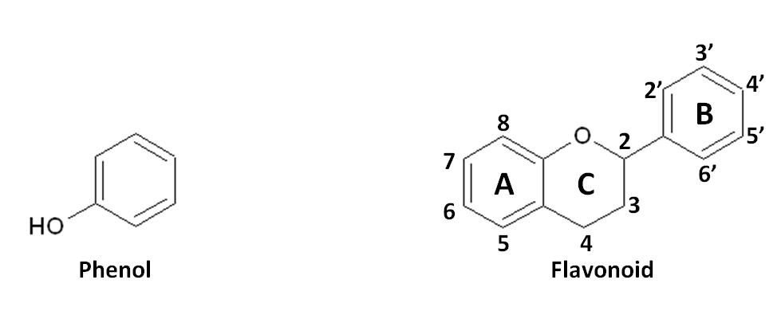

*(*[*http://www.academicjournals.org/article/article1380724896\_Ghasemzadeh%20and%20Ghasemzadeh.pdf*](http://www.academicjournals.org/article/article1380724896_Ghasemzadeh%20and%20Ghasemzadeh.pdf))

Below are structural formulas for the six flavonoid subclasses. Note the similarity in their basic hydrocarbon structures.

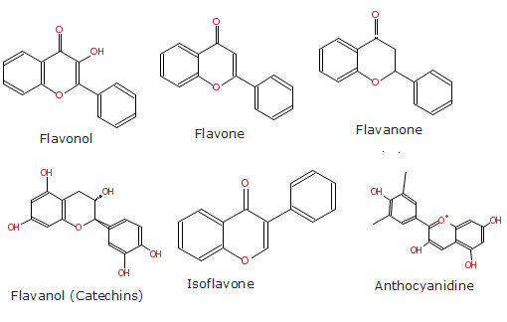

Structures of the major classes of flavonoids

*(*[*http://www.akspublication.com/paper05\_jul-dec2007.htm*](http://www.akspublication.com/paper05_jul-dec2007.htm)*)*

Many plant foods are very rich in flavonoids. To date, chemical research has not verified their ability to prevent cancer and other serious diseases and conditions. The table below shows the six subclasses of flavonoids (structures are pictured above), their dietary compounds and some of their food sources.

|  |  |  |
| --- | --- | --- |
| **Table 1. Common Dietary Flavonoids  (Select the highlighted text to view chemical structures.)** | | |
| **Flavonoid Subclass** | **Dietary Flavonoids** | **Some Common Food Sources** |
| [**Anthocyanidins**](http://lpi.oregonstate.edu/mic/dietary-factors/phytochemicals/flavonoids#figure-2) | Cyanidin, Delphinidin, Malvidin, Pelargonidin, Peonidin, Petunidin | Red, blue, and purple berries; red and purple grapes; red wine |
| [**Flavanols**](http://lpi.oregonstate.edu/mic/dietary-factors/phytochemicals/flavonoids#figure-3) | **Monomers (Catechins)**:  [Catechin, Epicatechin, Epigallocatechin Epicatechin gallate, Epigallocatechin gallate](http://lpi.oregonstate.edu/mic/dietary-factors/phytochemicals/flavonoids#figure-3)  **Dimers and Polymers**:  [Theaflavins](http://lpi.oregonstate.edu/mic/dietary-factors/phytochemicals/flavonoids#figure-4), Thearubigins, [Proanthocyanidins](http://lpi.oregonstate.edu/mic/dietary-factors/phytochemicals/flavonoids#figure-5) | **Catechins**: Teas (particularly green and white), chocolate, grapes, berries, apples  **Theaflavins, Thearubigins**: Teas (particularly black and oolong)  **Proanthocyanidins**: Chocolate, apples, berries, red grapes, red wine |
| [**Flavanones**](http://lpi.oregonstate.edu/mic/dietary-factors/phytochemicals/flavonoids#figure-6) | Hesperetin, Naringenin, Eriodictyol | Citrus fruit and juices, e.g., oranges, grapefruit, lemons |
| [**Flavonols**](http://lpi.oregonstate.edu/mic/dietary-factors/phytochemicals/flavonoids#figure-7) | Quercetin, Kaempferol, Myricetin, Isorhamnetin | Widely distributed: yellow onions, scallions, kale, broccoli, apples, berries, teas |
| [**Flavones**](http://lpi.oregonstate.edu/mic/dietary-factors/phytochemicals/flavonoids#figure-8) | Apigenin, Luteolin | Parsley, thyme, celery, hot peppers, |
| [**Isoflavones**](http://lpi.oregonstate.edu/mic/dietary-factors/phytochemicals/flavonoids#figure-9) | Daidzein, Genistein, Glycitein | Soybeans, soy foods, legumes |

*(*[*http://lpi.oregonstate.edu/mic/dietary-factors/phytochemicals/flavonoids#food-sources*](http://lpi.oregonstate.edu/mic/dietary-factors/phytochemicals/flavonoids#food-sources)*)*

Flavonoids form stable complexes with the metal cations, Fe3+, Al3+, Cu2+ and Zn2+. Only the flavon and flavanol structures have the ability to chelate and reduce copper (Cu2+) and iron (Fe3+) ions. They can also produce a “shield effect”: When attached to DNA, they shield it from ROS attacks.

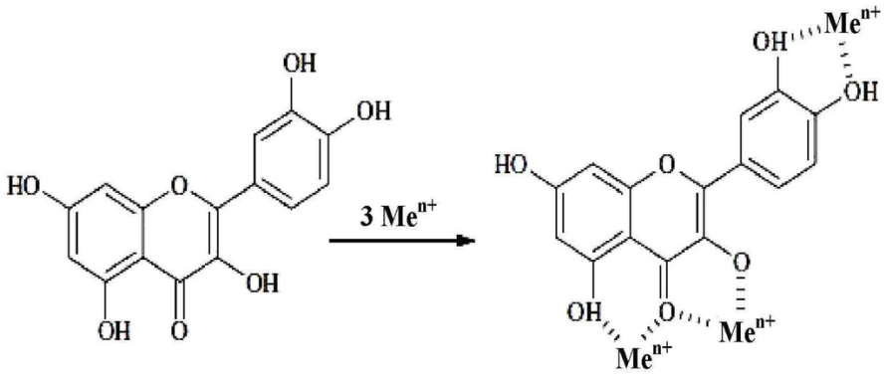

Metal-binding sites for flavonoids

*(*[*http://www.mdpi.com/1420-3049/19/1/78/htm*](http://www.mdpi.com/1420-3049/19/1/78/htm)*)*

See the numbered diagram on the right (below): There are three metal binding sites: (1) the hydroxyl, #5 of A ring; (2) the carbonyl, #4 and oxygen, #3 of the C ring; and (3) the two hydroxyls at #3’ and #4’ on the B ring. Studies indicate that all flavones have a higher capacity for Cu2+ than for Fe3+. The best flavonols are the catechins, amines that are neurotransmitters such as epinephrine and dopamine. They all chelate Cu2+ probably between the hydroxyl groups at junction #5 and the carbonyl at #4. Flavonols, quercetin and myricetin, probably react with Fe3+ at site between #5 and #4. These reactions are pH dependent. Continuing research is needed to specify both the binding sites and the required pH for each complexion.

(<https://www.researchgate.net/publication/10894458_Interactions_of_Flavonoids_with_Iron_and_Copper_Ions_A_Mechanism_for_their_Antioxidant_Activity>)



*(*[*http://www.academicjournals.org/article/article1380724896\_Ghasemzadeh%20and%20Ghasemzadeh.pdf*](http://www.academicjournals.org/article/article1380724896_Ghasemzadeh%20and%20Ghasemzadeh.pdf)*)*

**Allyl sulfides**

As the name implies allyl sulfides contain sulfur. These phytochemicals that have both water soluble S-allyl cysteine (SAC) and the oil soluble diallyl disulfide (DADS) forms are responsible for the odor and taste of garlic. SAC, a colorless liquid, is present in fresh garlic and DADS, a yellow tinted oil, is found in garlic oil.

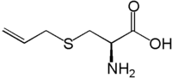

Water-soluble SAC Oil-soluble DADS

*(*[*https://en.wikipedia.org/wiki/S-Allyl\_cysteine*](https://en.wikipedia.org/wiki/S-Allyl_cysteine)*) (*[*https://en.wikipedia.org/wiki/Diallyl\_disulfide*](https://en.wikipedia.org/wiki/Diallyl_disulfide)*)*

Research suggests that allyl sulfides (particularly DADS) reduce cancer risk by retarding tumor cell division. Studies on rat livers show that these antioxidants damage DNA by attacking cells at the point of mitosis (G2/M phase). (<http://www.ncbi.nlm.nih.gov/pubmed/11201305>) When rat diets are supplemented with powdered garlic, mammary tumors are shrunk. (<http://www.ncbi.nlm.nih.gov/pubmed/8603370>)

Research suggests that SAC may be effective in treating and preventing the dementia caused by Alzheimer’s disease. During the formation of nitrosamines, RNS radicals are generated as intermediates. Allyl sulfides may restrict free radical formation that can destroy neuropathways. (<http://www.ncbi.nlm.nih.gov/pubmed/21728972>)

**Polyphenols**

A phenol is a molecule with a hydroxyl group attached to its benzene ring. These phytochemicals are strong antioxidants found in many plants such as grapes, apple skin, green tea, and even in chocolate. In plants, polyphenols act as a primary defense against UV radiation and pathogens. Their ability to donate a hydrogen atom damages the reaction chain of free radicals. This can interrupt cellular signally thus causing inflammation and DNA damage. (<http://www.ncbi.nlm.nih.gov/pmc/articles/PMC3493419/>)

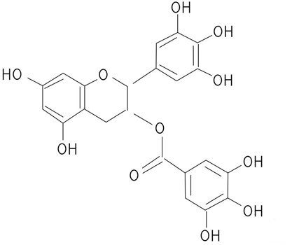

A polyphenol

*(*[*http://www.ti-tonics.com/Whats+special/Polyphenols.html*](http://www.ti-tonics.com/Whats+special/Polyphenols.html)*)*

Curcumin, mentioned in the Porterfield antioxidant article and considered a polyphenol is one of three curcuminoids of turmeric. It chelates heavy metals such as cadmium and lead and it acts as an antioxidant to reduce reactive species involved in inflammation. (<http://www.phytochemicals.info/phytochemicals/curcumin.php>)

The diagram below attributes the antioxidant activity of polyphenols to defense against many human diseases. (Note: C.V.Ds is the acronym for cardiovascular diseases.)

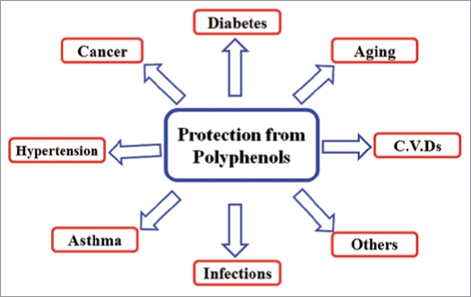

*(*[*http://www.ncbi.nlm.nih.gov/pmc/articles/PMC2835915/*](http://www.ncbi.nlm.nih.gov/pmc/articles/PMC2835915/)*)*

**Carotenoids**

Carotenoids are another type of phytochemical. There are two forms that can be categorized by their difference in structure: carotenes are hydrocarbons; xanthophylls contain oxygen as well as hydrogen and carbon. Both are fat soluble antioxidants that absorb light between 450-550 nanometers, the violet to green range. Their primary functions are to absorb the sun’s energy for photosynthesis and, in their role as antioxidants, to protect plants from the damage of UV radiation. They are responsible for the yellow, orange and many red plant pigments found in tree leaves, fruits and vegetables.

Beta-carotenes (C40H56) give carrots, pumpkins, peaches and sweet potatoes their colors and tastes. Each carotene shows a different range of colors:

* Alpha Carotene (yellow-orange, dark green)
* Beta Carotene (red-orange)
* Lutein (yellow)
* Lycopene (red)
* Zeaxanthin (yellow)
* Crocetin (yellow)

(<http://www.simplyantioxidant.com/carotenoids.html>)

Lycopene in the list above and mentioned in the Porterfield antioxidant article, is a beta-carotene found in tomatoes and other red fruits. The molecule has seven double bonds whose delocalized electrons are held in p-orbitals where the energy required for transition to higher states is low enough to allow electron donation to ROS.

Beta-carotene is a precursor to vitamin A. The structural formula for beta-carotene is shown below:

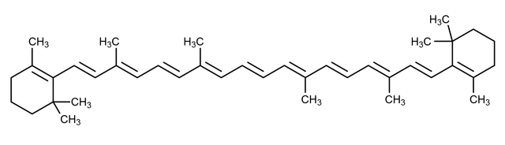

The chemical structure of beta-carotene

*(*[*http://chemistry.about.com/od/factsstructures/ig/Chemical-Structures---C/Carotene.htm*](http://chemistry.about.com/od/factsstructures/ig/Chemical-Structures---C/Carotene.htm)*)*

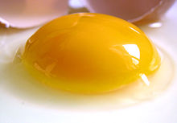Xanthophylls produce yellow pigments. The egg yolk shown is colored by xanthophyll carotenoids lutein and zeaxanthin:

Note how the basic structure of beta-carotene, above, differs from the structure of a xanthophyll ([cryptoxanthin](https://en.wikipedia.org/wiki/Cryptoxanthin)), below. While both carotenoids are fat soluble, carotenes are hydrocarbons while xanthophylls contain oxygen as well as hydrogen and carbon. Note the hydroxyl group on the structure below:

Egg yolk

*(*[*https://en.wikipedia.org/wiki/Xanthophyll*](https://en.wikipedia.org/wiki/Xanthophyll)*)*

The chemical structure of [cryptoxanthin](https://en.wikipedia.org/wiki/Cryptoxanthin)

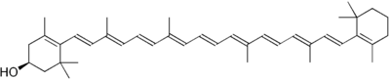*(*[*https://en.wikipedia.org/wiki/Xanthophyll*](https://en.wikipedia.org/wiki/Xanthophyll)*)*

**More on the chemistry of antioxidants—vitamins**

Antioxidant vitamins are not manufactured in the human body so they must be included in a diet of fresh fruits and vegetables or added as dietary supplements. They are essential to the body’s defensive system and often act as the primary responders in free radical reduction. Although vitamins are antioxidants, at high doses they may exhibit pro-oxidant activities. Most are not enzymes, but some vitamins can act as cofactors (or coenzymes) providing the assistance required for proper enzymatic function.

**Vitamin A**

Vitamin A is one half of a beta-carotene molecule. Within the intestine, the enzyme beta-carotene dioxygenase splits a molecule of beta-carotene at the double bond situated at its mid-point forming two molecules of vitamin A. Note how the structure below is a beta-carotene molecule (described in the prior section of this Teacher’s Guide) split at the middle to form two molecules of vitamin A.



The chemical structure of beta-carotene

*(*[*http://chemistry.about.com/od/factsstructures/ig/Chemical-Structures---C/Carotene.htm*](http://chemistry.about.com/od/factsstructures/ig/Chemical-Structures---C/Carotene.htm)*)*

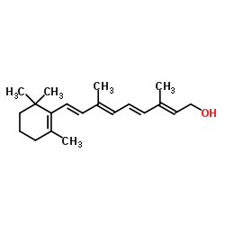

The structure of vitamin A

*(*[*http://www.chemspider.com/Chemical-Structure.393012.html?rid=4b2174b9-ebe5-43e1-9660-6ca0937ba8ba*](http://www.chemspider.com/Chemical-Structure.393012.html?rid=4b2174b9-ebe5-43e1-9660-6ca0937ba8ba)*)*

As seen by the long hydrocarbon tail in the structure above, vitamin A is a fat soluble molecule. When beta-carotene is consumed from plants, the body’s enzymes break the molecule into vitamin A only as needed, keeping sufficient quantity safely stored for as long as necessary in body lipids. There is danger in over supplementation of the diet since it can be stored in body fats at toxic levels. Toxic levels of vitamin A may enlarge the liver or spleen, cause birth defects and even result in death.

Studies show that vitamin A protects against copper stimulated oxidation. It is also a very effective molecular oxygen (O2) reducer that protects against skin aging from the sunlight’s UVA radiation. Energy from the sun’s radiation (Δg) stimulates O2 forming ROS shown on the right in the diagram below. Studies show that when the diet of rats is rich in beta-carotene, it accumulates in the skin where it protects the tissues.

An external file that holds a picture, illustration, etc.
Object name is jcbn11-008FRf03.jpg

Structures of primary oxidation n products of β-carotene with reactive oxygen species. 1O2: O2 (1Δg).

*(*[*http://www.ncbi.nlm.nih.gov/pmc/articles/PMC3022065/*](http://www.ncbi.nlm.nih.gov/pmc/articles/PMC3022065/)*)*

A deficiency of vitamin A may affect the eyes resulting in night blindness, harm bone growth and increase susceptibility to respiratory infections. The best source of vitamin A is beta carotene because it can be safely stored in the body and only converted to vitamin A as needed. There is a dark side of beta-carotene. For those who smoke and/or drink excessively beta-carotene may increase the risk of lung cancer.

**Vitamin C**

Vitamin C (ascorbic acid) is essential for the maintenance of protein structure in connective tissue. A deficiency causes scurvy, a major problem during early ocean voyages. The author, Jonathan Lamb wrote: "In 1499, Vasco da Gama lost 116 of his crew of 170; in 1520, Magellan lost 208 out of 230; all mainly to scurvy." As many as 2 million sailors died of scurvy between the years 1500 and 1800. It was found that fresh produce was essential to prevent scurvy and lemons best survived the long trips. Some tried lime juice but found it ineffective. Now we know that the vitamin C in pre-squeezed juice exposed to air and light, quickly degrades. (<https://en.wikipedia.org/wiki/Scurvy>)

Vitamin C is also a major antioxidant. The structures below show the L-form and the ion that can reduce free radicals.

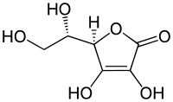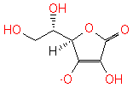

L-Ascorbic acid (vitamin C) Anion of ascorbic acid (ascorbate)

*(*[*https://en.wikipedia.org/wiki/Ascorbic\_acid*](https://en.wikipedia.org/wiki/Ascorbic_acid)*)* (URL for figure on the right:

[*http://biocyc.org/META/NEW-IMAGE?type=COMPOUND&object=ASCORBATE*](http://biocyc.org/META/NEW-IMAGE?type=COMPOUND&object=ASCORBATE))

Ascorbic acid has two forms pictured below. The L isomer is found in living plants and animals; the D form is not found in nature. When D-ascorbic acid is synthesized in the lab for use in animal studies, it appears to be less active than the L form. Both isomers pictured below are capable of losing hydrogen ions to form: first the ascorbyl radical, then dehydroascorbic acid (DHA). Within the body, DHA is transported within cells and in the small intestine.

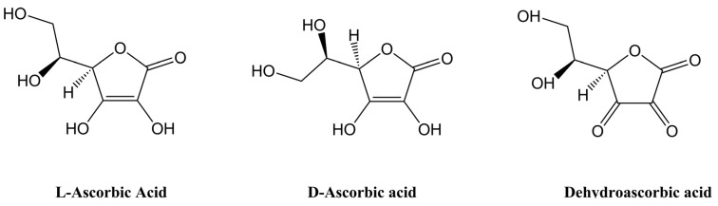

Vitamin C in its reduced form (ascorbic acid), shown as both its l- and d-isomers, and its two electron oxidation form (dehydroascorbic acid, DHA). DHA can be readily reduced back to ascorbic acid *in vivo* via both chemical and enzymatic pathways.

*(*[*http://www.ncbi.nlm.nih.gov/pmc/articles/PMC3847730/*](http://www.ncbi.nlm.nih.gov/pmc/articles/PMC3847730/)*)*

The sequence below shows the two oxidation steps as ascorbate (the anion) undergoes oxidation to form DHA. Dotted lines are used on the ascorbyl radical with the intention of showing the delocalization of electrons. This resonance forms a fairly stable structure for the ascorbyl radical.

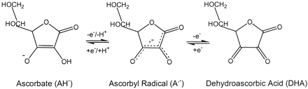

Figure 1.

Oxidation of ascorbate (AH−) by two successive one electron oxidation steps to give the ascorbyl radical (A•-) and dehydroascorbic acid (DHA), respectively.

*(*[*http://www.fasebj.org/content/13/9/1007.full*](http://www.fasebj.org/content/13/9/1007.full)*)*

The University of California, Davis’ CHEMWIKI site presents an excellent lesson describing and illustrating the chain of electron transfers involved as the ascorbate anion acts as an antioxidant by reducing free radicals:

Here is how ascorbate (the deprotonated form of ascorbic acid) acts as a free radical scavenger: when it encounters a free radical (denoted X• in the figure below), ascorbate donates a single electron to become ascorbyl radical.

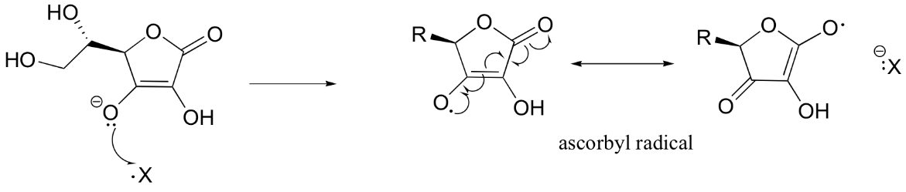

Ascorbyl radical is significantly more stable than most other radical species due to resonance delocalization. The end result of this first step is that a very reactive, potentially harmful radical (X•) has been 'quenched', and replaced by a much less reactive (and thus less harmful) ascorbyl radical.

Next, the ascorbyl radical can donate a second electron to another potentially harmful radical species, resulting in the formation of dehydroascorbate, the oxidized form of ascorbate (it is actually the cyclic hemiacetal, hydrated form of dehydroascorbic acid that is thought to be prevalent in physiological conditions).

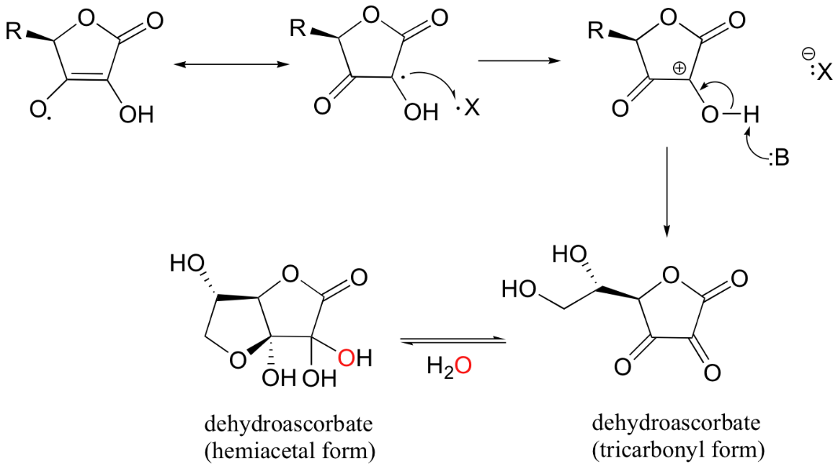

One ascorbate molecule is thus potentially able to scavenge two harmful radical species. Dehydroascorbate is subsequently either broken down and excreted, or else recycled (reduced) back to ascorbate. This can happen either in a direct, enzyme-free reaction with glutathione, or through the action of a specific glutathione/NADH-dependent reductase enzyme.

(<http://chemwiki.ucdavis.edu/Core/Organic_Chemistry/Organic_Chemistry_With_a_Biological_Emphasis/Chapter_17%3A_Radical_reactions/Section_17.2%3A_Radical_chain_reactions>)

The antioxidant mechanism explained above can be represented by a net reaction: (Note that RO • represents the reactive oxygen species.)

RO • + C6H7O6− → RO- + C6H7O6• → ROH + C6H6O6

(<https://en.wikipedia.org/wiki/Ascorbic_acid>)

Since vitamin C is a water soluble antioxidant, it reduces ROS and RNS found in the aqueous parts of the cell and fluids outside cell walls. The table below shows some of the reactive species that can be neutralized by vitamin C along with the rate of each reaction.

Table 1.

Reactive oxygen and nitrogen species which are scavenged by ascorbate

| **Chemical species scavenged by ascorbate** | **Reaction rate  (M−1 s−1)*a*** |
| --- | --- |
| Reactive oxygen species |  |
| Hydroxyl radical (•OH) | 1.1× 1010 |
| Alkoxyl radicals (RO•) | 1.6× 109 |
| Peroxyl radicals (RO2•) | 1-2× 106 |
| Superoxide anion/hydroperoxyl radical (O2•−/HO2•) | 1 × 105 |
| Hypochlorous acid (HOCl) |  |
| Ozone (O3) |  |
| Single oxygen (1O2) |  |
| Reactive nitrogen species |  |
| Nitrogen dioxide (NO2•) |  |
| Dinitrogen trioxide/dinitrogen tetroxide (N2O3/N2O4) | 1.2× 109 |
| Nitroxide (NO) |  |
| Peroxynitrite/peroxynitrous acid (ONOO−/ONOOH) | 235 |
| Antioxidant-derived radicals*b* |  |
| α-Tocopheroxyl radical (α-TO•) | 2× 105 |
| Thiyl/sulphenyl radicals (RS•/RSO•) | 6× 108 |
| Urate radical (UH•) | 1× 106 |
| β-Carotene radical cation (β-C•+) |  |

*a* The approximate rates of reaction (at pH 7.4) are given if known.

*b* A number of other small molecule antioxidants can be regenerated from their respective radical species by ascorbate.

*(*[*http://www.fasebj.org/content/13/9/1007.full*](http://www.fasebj.org/content/13/9/1007.full)*)*

Although vitamin C is primarily an antioxidant, in the presence of active metals such as iron, it can also act as a pro-oxidant. In the body, metals are usually tightly bound in protein structures, but when they are inhaled from environmental sources such as polluted air, UV radiation, X-rays and tobacco smoke, they can enter the bloodstream as free ions. The ascorbate ion can reduce Fe3+ to Fe2+ as seen in reaction 2 below. When the reduced iron is formed, it is available to react with hydrogen peroxide to form the free radical seen in reaction 1. So vitamin C is sometimes called a “double-edged sword” because it has both antioxidant and pro-oxidant properties. Further, the iron ion is involved in a redox recycling situation where it can be oxidized, reduced and then reoxidized. This is the Fenton Reaction described earlier in this Teacher’s Guide: “More on the formation of free radicals—internal sources—ROS” section.

1. 2 Fe2+ + 2 H2O2 → 2 Fe3+ + 2 OH• + 2 OH−
2. 2 Fe3+ + Ascorbate → 2 Fe2+ + Dehydroascorbate

(<http://flipper.diff.org/app/pathways/6861>)

**Vitamin E**

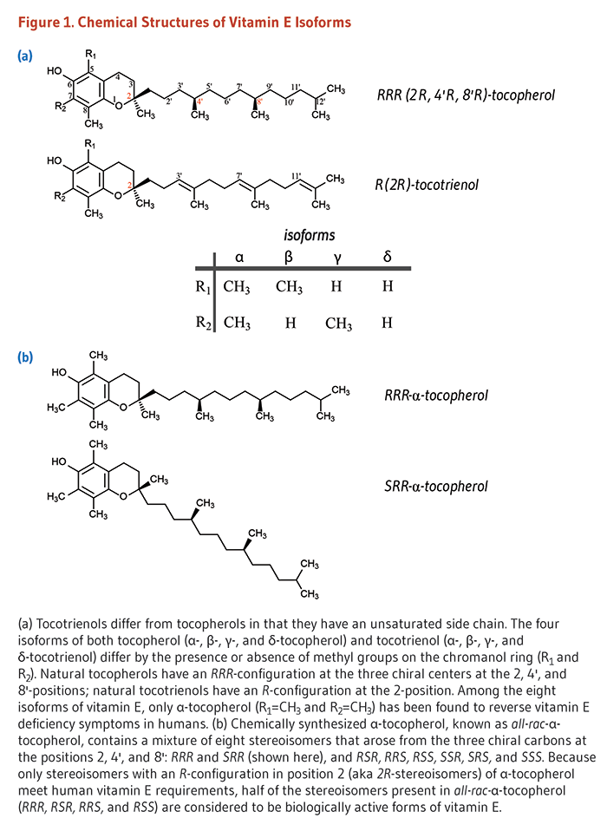 Vitamin E is a fat-soluble molecule with two basic forms as seen below. Tocotrienols have unsaturated side chains; tocopherol side chains are saturated. Much of the early research produced contradictory data on the anti-inflammatory functions of vitamin E. This led to the discovery that each form of vitamin E has four “isoforms” (α, β, γ, and δ). Isoforms are molecules with similar chemical function but their structures vary slightly. They differ by the placement and number of their methyl groups.

The two forms of vitamin E

*(*[*http://lpi.oregonstate.edu/mic/vitamins/vitamin-E*](http://lpi.oregonstate.edu/mic/vitamins/vitamin-E)*)*

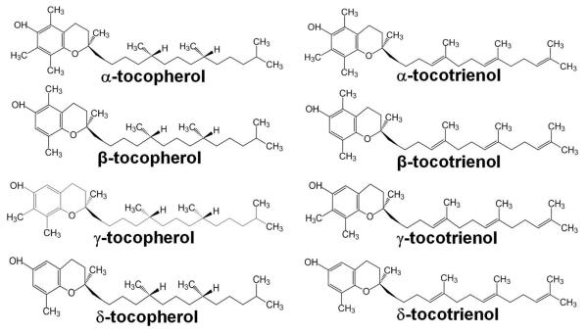

Isoforms of vitamin E

*(*[*http://www.ncbi.nlm.nih.gov/pmc/articles/PMC3271790/*](http://www.ncbi.nlm.nih.gov/pmc/articles/PMC3271790/)*)*

The primary antioxidant function of α-tocopherol is breaking the chain reactions involved in lipid peroxidation. Excessive use of vitamin E supplements can interfere with vitamin K’s ability to clot blood and may lead to severe bleeding for anyone taking anticoagulant medication. In addition α-tocopherol prevents oxidation of low-density lipoproteins (LDLs). Oxidized LDLs are considered “bad cholesterol” because they collect on the walls of blood vessels, thus blocking blood flow and possibly causing heart attacks. (<http://lpi.oregonstate.edu/mic/vitamins/vitamin-E>)

In general, the human body uses both α-tocopherol and the tocotrienols. The diagram below illustrates the antioxidant activity of vitamin E. Note the interactions with vitamin C. The caption below the diagram explains the chain of redox reactions.

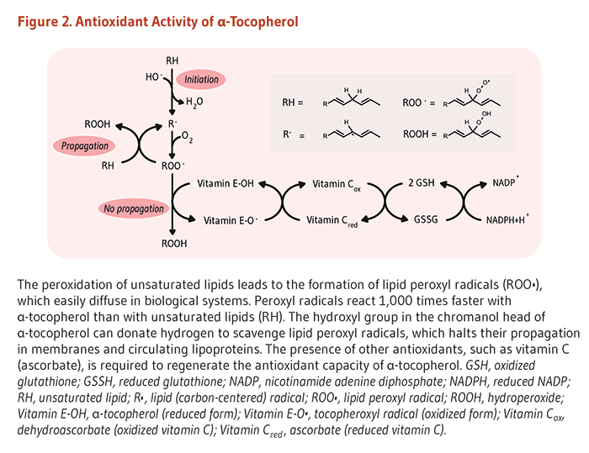

*(*[*http://www.ncbi.nlm.nih.gov/pmc/articles/PMC3847730/*](http://www.ncbi.nlm.nih.gov/pmc/articles/PMC3847730/)*)*

The following table published by Harvard University lists fresh food sources and other pertinent information for the antioxidant vitamins A (beta-carotene), C and E. Note this table has been reduced to emphasize only the antioxidant vitamins. The URL (below the table) contains a complete list of other vitamins and dietary metals.

**Listing of Vitamins**

|  |  |  |  |  |  |
| --- | --- | --- | --- | --- | --- |
| **Vitamin (common names)** | **Benefits** | **Recommended amount (daily RDA\* or daily AI\*\*)** | **Upper limit (UL) per day** | **Good food sources** | **Did you know?** |
| **VITAMIN A** (Retinol, retinal, and retinoic acid — three active forms of vitamin A in the body — are retinoids, “preformed” vitamin A. Beta carotene can easily be converted to vitamin A as needed.) | Essential for vision Lycopene may lower prostate cancer risk. Keeps tissues and skin healthy. Plays an important role in bone growth. Diets rich in the carotenoids alpha carotene and lycopene seem to lower lung cancer risk. Carotenoids act as antioxidants. Foods rich in the carotenoids lutein and zeaxanthin may protect against cataracts | M: 900 mcg (3,000 IU), W: 700 mcg (2,333 IU) Some supplements report vitamin A in international units (IU’s). | 3,000 mcg (about 10,000 IU) | **Sources of retinoids:** beef, liver, eggs, shrimp, fish, fortified milk, cheddar cheese, Swiss cheese  **Sources of beta carotene:** sweet potatoes, carrots, pumpkins, squash, spinach, mangoes, turnip greens | Many people get too much preformed vitamin A from food and supplements. Large amounts of supplemental vitamin A (but not beta carotene) can be harmful to bones. |
| **VITAMIN C** (ascorbic acid) | Foods rich in vitamin C may lower the risk for some cancers, including those of the mouth, esophagus, stomach, and breast. Long-term use of supplemental vitamin C may protect against cataracts. Helps make collagen, a connective tissue that knits together wounds and supports blood vessel walls. Helps make the neurotransmitters serotonin and norepinephrine Acts as an antioxidant, neutralizing unstable molecules that can damage cells. Bolsters the immune system | M: 90 mg, W: 75 mg **Smokers:** Add 35 mg | 2,000 mg | Fruits and fruit juices (especially citrus), potatoes, broccoli, bell peppers, spinach, strawberries, tomatoes, Brussels sprouts | Evidence that vitamin C helps reduce colds has not been convincing. |
| **VITAMIN E** (alpha-tocopherol) | Acts as an antioxidant, neutralizing unstable molecules that can damage cells. Protects vitamin A and certain lipids from damage. Diets rich in vitamin E may help prevent Alzheimer’s disease. Supplements may protect against prostate cancer | M: 15 mg, W: 15 mg (15 mg equals about 22 IU from natural sources of vitamin E and 33 IU from synthetic vitamin E) | 1,000 mg (nearly 1,500 IU natural vitamin E; 2,200 IU synthetic) | Wide variety of foods, including vegetable oils, salad dressings and margarines made with vegetable oils, wheat germ, leafy green vegetables, whole grains, nuts | Vitamin E does not prevent wrinkles or slow other aging processes. |
| \*Recommended dietary allowance \*\*Adequate intake | | | | | |

June 9, 2009 *(*[*http://www.health.harvard.edu/staying-healthy/listing\_of\_vitamins*](http://www.health.harvard.edu/staying-healthy/listing_of_vitamins)*)*

**More on the chemistry of antioxidants—enzymes**

When enzymes function as antioxidants, they work differently from the phytochemicals and vitamins described in the last two sections, which primarily interrupt electron transport chain reactions. Through a series of reactions, enzymes break down reactive species and remove them by chemically converting them into hydrogen peroxide and water.

Unlike vitamins that are ingested, antioxidant enzymes are synthesized by the body from proteins and trace amounts of minerals that are included in the diet. They cannot be purchased as supplements or acquired by eating certain foods. Enzymes inactivate ROS by converting them to hydrogen peroxide and then assisting their decomposition into water. Trace metal cofactors such as copper, selenium, zinc, manganese or iron help enzymes catalyze these chemical reactions.

A chain of three primary reactions are involved in the destruction of ROS by antioxidant enzymes:

1. **Superoxide dismutase (SOD)**: The enzyme SOD along with a metal cofactor reduces superoxide to prevent lipid peroxidation:

2 O2– + 2 H → H2O2 + O2

1. **Catalase (CAT): The catalase enzyme and cofactors iron and manganese accelerate the decomposition of** hydrogen peroxide to water and oxygen:

2H2O2 → 2 H2O + O2

1. **Glutathione peroxidase (GSHpx)** and **glutathione reductase:** Simultaneously these two selenium-containing enzymes work with CAT to decompose H2O2 into water and oxidize glutathione.

H2O2 + 2 glutathione → oxidized glutathione + H2O

Finally, the oxidized glutathione is reduced by the antioxidant enzyme glutathione reductase. These enzymes restore oxidized DNA and proteins as well as eliminate oxidized lipids. (<http://articles.mercola.com/sites/articles/archive/2011/05/16/all-about-antioxidants.aspx>) (<http://health.howstuffworks.com/wellness/food-nutrition/facts/antioxidant3.htm>)

**More on the chemistry of antioxidants—other antioxidants**

In addition to phytochemicals, vitamins and enzymes, there are some other molecules and atoms that have antioxidant functions in the body. Metal ions such as iron, selenium, magnesium and zinc have been discussed as coenzymes to assist in the reduction of ROS.

Coenzyme 10 also known as ubiquinone (CoQ10) is a lipid-soluble antioxidant. It is involved in energy (ATP) production through the electron transport chain and it reduces lipid peroxidation in the circulation system, particularly in the heart. While CoQ10 is present in all body tissues and organs, it is most concentrated in the heart. In addition, studies show that higher CoQ10 concentrations are associated with less severe cases of congestive heart failure. Many CoQ10 supplements are available on supermarket shelves.

“Effect of coenzyme Q10 supplementation on heart failure: a meta-analysis” was published in 2012 by the *American Journal of Clinical Nutrition.* This paper reviews current literature and finds “inconclusive results” as to whether CoQ10 supplements improve heart function. Ejective fraction (EF) is a measure of the strength of heart muscle contraction, indicating its ability to send oxygen-rich blood into the body. This paper suggests that if there are any benefits from CoQ10 supplements, these would be limited to people in “less severe stages” of congestive heart failure. In conclusion, the review suggests that future studies need to be more inclusive with respect to the diversity of their populations. (<http://ajcn.nutrition.org/content/97/2/268.full>)

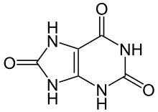 Uric acid is a water-soluble compound; a product of DNA metabolism. It is derived from the breakdown of purines in the body. A rise in uric acid concentration in the blood plasma indicates oxidative stress. It can act as an oxidant to help prevent lipid peroxidation. Note the nitrogens in its structure (below) indicating its amino acid derivation:

Like ascorbic acid, uric acid can also act as a pro-oxidant. When found in cells, its presence may be indicative of a response to oxidative stress and thus suggests cardiovascular disease. (<http://www.ncbi.nlm.nih.gov/pmc/articles/PMC2895915/>)

Uric acid

*(*[*https://en.wikipedia.org/wiki/Uric\_acid*](https://en.wikipedia.org/wiki/Uric_acid)*)*

**More on antioxidants—supplements**

Enzymes are better antioxidants than vitamins but they can only be produced within the body. These protein molecules are unable to pass through intestinal walls and enter the bloodstream due to their large size. While in the intestine, they are quickly broken down into amino acids. Yet, the body cannot synthesize all the essential compounds needed, so we must depend on a good, varied diet to meet our needs. Oxidative stress is suspected to cause many diseases, so a healthy diet containing foods with antioxidants is particularly important for health maintenance.

Superoxide dismutase (SOD) was introduced earlier in this Teacher’s Guide. Researchers found that when superoxide dismutase (SOD) was injected directly into inflamed joints, its effect was minimal because 50% was broken down within five minutes and only 0.1% was still present after an hour. Tatsuya Oda, a Japanese researcher, has found that SOD bound to artificial polymers will last five hours in the bloodstream. An excerpt from a 1998 medical textbook notes that, “As promising as this finding is, it raises questions about the long-term effects of adding an enzyme to the body in large quantities. These effects are not known as yet, and the question is far from trivial.” (<http://bsherman.net/freeradicals.htm>) In a 2011 paper, Oda reported successful results against a serious viral infection in mice. His polymer-conjugated SOD was injected within five to eight days following the infection. (<https://utmb.influuent.utsystem.edu/en/publications/oxygen-radicals-in-influenzainduced-pathogenesis-and-treatment-with-pyran-polymerconjugated-sod(f2f30c96-b9b6-40b2-8290-ae8faa56408f).html>)

A healthy diet is the best source of antioxidants. Dietary supplements should not replace a good diet unless, due to extenuating circumstances, a specific one is recommended by a physician. Vitamin A (retinol) is converted in enzymatic reactions within the body. One molecule of beta-carotene is split into two molecules of vitamin A. The chart below shows that from two units of supplemental beta-carotene only one is absorbed as retinol. When beta-carotene is taken in the form of a dietary supplement, the body can only convert 1/2 of it (a 2:1 ratio) into vitamin A. Further, the body is unable to store any of the non-converted supplement.

Yet, when dietary beta-carotene from plants is absorbed, the body only converts 1/12th of it to vitamin A (a 12:1 ratio). This seems to indicate that dietary consumption is a poor way to gain retinol. But, it is important to remember that the human body is equipped to handle excess dietary source beta-carotene by simply storing it in fatty tissue and converting the amount needed to vitamin A, as required. In addition, the body can easily eliminate excess dietary beta-carotene.

Once in the body, synthetic vitamins do not retain all of their ability to reduce reactive species: vitamin E supplements lose approximately 50% of their biological activity because the human body can only absorb the d-form of alpha-tocopherol from dietary sources such as olive and sunflower oils. When synthesized in a lab, a racemic mixture of the d and dl forms is produced. Dl-alpha-tocopherol is useless in the body. Water soluble, light sensitive vitamin C loses about 30% of its activity. (<http://www.home-remedies-for-you.com/vitamins/natural-vitamin/synthetic.html>)

The chart below shows that all vitamin A in supplemental form is absorbed as retinol. A dangerous situation may occur because the body cannot store or eliminate excess amounts of lipid-soluble vitamin A supplements. Effects of excess vitamin A include nausea, headache, fatigue and loss of appetite—as well as long term bone loss, eye damage and brain swelling. It is best to obtain needed vitamin A through the beta-carotene in fresh fruits and vegetables and non-fat dairy products. (<http://www.mayoclinic.org/drugs-supplements/vitamin-a/safety/hrb-20060201>)

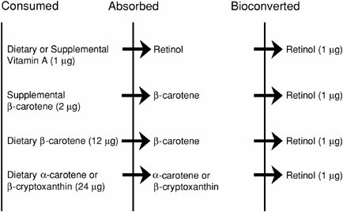

Absorption and bioconversion of ingested provitamin A carotenoids to retinol based on new equivalency factors (retinol activity equivalency ratio).

*(*[*http://www.nap.edu/read/10026/chapter/6#92*](http://www.nap.edu/read/10026/chapter/6#92)*)*

This table contains a list of vitamins (micronutrients) with the RDA for teenagers. Note: A complete table showing amounts and guidelines for other micronutrients can be found at the website below.

|  |  |  |
| --- | --- | --- |
| **Table 1. Dietary Reference Intakes Set by the FNB: RDA for Micronutrients During Adolescence, Ages 14 to 18 Years, Per Day** | | |
| **Micronutrient** | **Males** | **Females** |
| Vitamin A | **900 μg (3,000 IU)c** | **700 μg (2,333 IU)c** |
| Vitamin B6 | **1.3 mg** | **1.2 mg** |
| Vitamin B12 | 2.4 μg | 2.4 μg |
| Vitamin C | **75 mg** | **65 mg** |
| Vitamin D | 15 μg (600 IU) | 15 μg (600 IU) |
| Vitamin E | 15 mg (22.5 IU)d | 15 mg (22.5 IU)d |
| Vitamin K | 75 μg (AI) | 75 μg (AI) |

RDA, recommended dietary allowance; AI, adequate intake   
cRetinol Activity Equivalents   
dα-Tocopherol

*(*[*http://health.gov/dietaryguidelines/2015/guidelines/appendix-7/*](http://health.gov/dietaryguidelines/2015/guidelines/appendix-7/)*)*

**More on the use of dietary supplements in the U.S.**

In 2013, the *Journal of the American Medical Association* (JAMA) published an investigation, “Why U.S. Adults use Dietary Supplements”. This is an analysis of the data from self-reported surveys of adults 20 years or older. The survey of 11,956 people was done by the National Health and Nutrition Examination Survey 2007-11.

Although most Americans have no problem obtaining the needed antioxidants from a normal diet, almost one-third of American adults take dietary supplements. The supplement users reported that their health was good to excellent; they had health insurance; used alcohol modestly; did not smoke; and exercised more than nonusers. Thus, it was difficult to tell if supplements had any effect on those with already healthy lifestyles and diets.

They took supplements for their health, but not to specifically supplement their food intake. The most common motivation for taking dietary supplements was to improve or maintain a healthy life style. Women reported using calcium supplements to improve the health of their bones; men took supplements for their heart health and to lower cholesterol.

(<http://archinte.jamanetwork.com/article.aspx?articleid=1568520>)

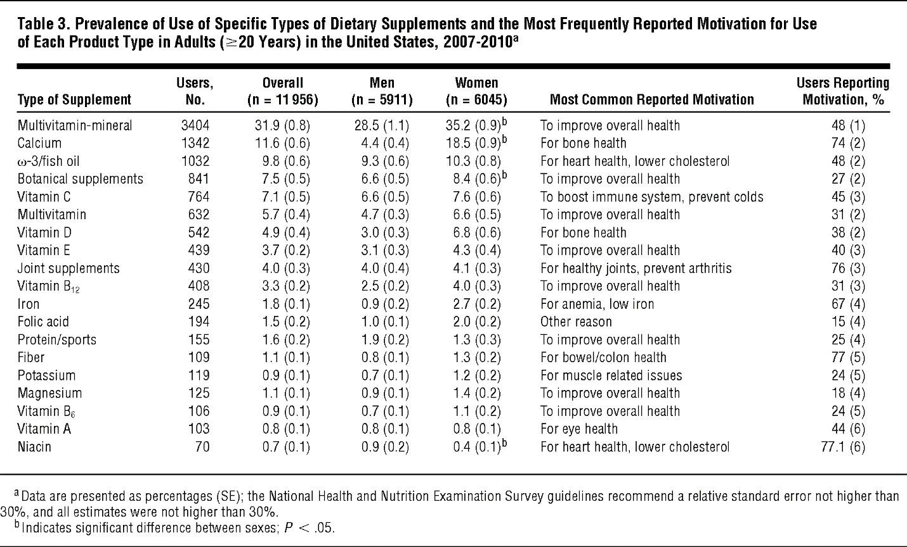

Note: The percentages in each column are followed (in parenthesis) by the standard deviation.

*(*[*http://archinte.jamanetwork.com/article.aspx?articleid=1568520*](http://archinte.jamanetwork.com/article.aspx?articleid=1568520)*)*

Only 23% reported that they took the supplements on a recommendation from their health care provider. Doctors most commonly suggested multivitamin-mineral supplements; also suggested were calcium and fish oil.

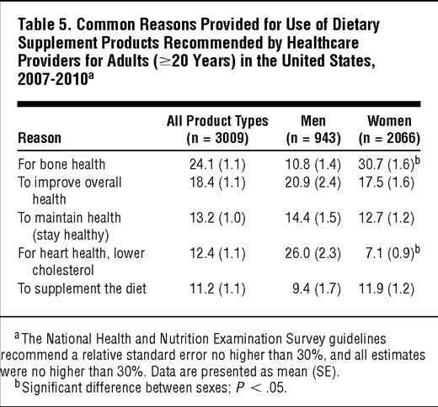

*(*[*http://archinte.jamanetwork.com/article.aspx?articleid=1568520*](http://archinte.jamanetwork.com/article.aspx?articleid=1568520)*)*

This chart graphs the JAMA study participants’ major goals: to improve, prevent or maintain their current health status; to provide additional immunity and energy; and to promote various aspects of their health.

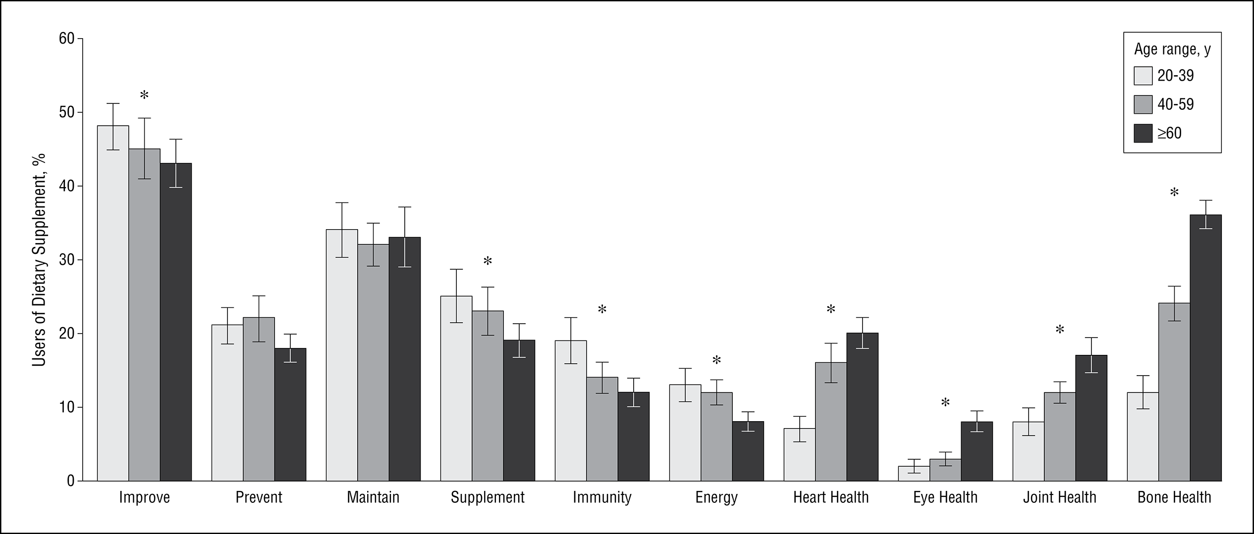

*(*[*http://archinte.jamanetwork.com/article.aspx?articleid=1568520*](http://archinte.jamanetwork.com/article.aspx?articleid=1568520)*)*

**More on herb (also known as botanical) supplements**

Data from national surveys shows that those who use herbs such as the leaves, flowers or seeds of plants as botanical supplements frequently do not inform their physicians. They also tend to be under-insured and looking for cheap fixes, rely on over-the-counter medications and over use prescription medications. Some of these supplements may be harmful when used in conjunction with other medications, supplements or prescription drugs.

These products may contain a single herb such as those used to flavor cooking or they may be a mixture. Laws require that all ingredients be listed, but some herbal supplements contain many compounds along with some small amounts of unknown ingredients. (<http://archinte.jamanetwork.com/article.aspx?articleid=1568520>)

**More on clinical trials—meta-analysis**

Meta-analysis is a method used to statistically evaluate combined data from independent trials. A study of 53 randomized trials investigating the use of beta-carotene, Vitamin A and Vitamin B supplements was first published on an open access/peer reviewed site, PLOS One. Following, it was published by the U.S. National Library of Medicine of the National Institutes of Health (NIH) on September 6, 2013. These trials assessed the value and risks of using these supplements individually or taken together or combined with other vitamins and trace elements.

Supplement doses used in the studies were greater than the Recommended Dietary Allowance (RDA) requirements for each substance: beta-carotene >9.6 mg, vitamin A >800 mg and vitamin E >15 mg. Studies showed a significant increase in mortality when doses of β-carotene and/or Vitamin E exceeded the RDA; but scientists lacked sufficient evidence on the risk of vitamin A. Data regarding doses below RDA were not available for analysis. See the experimental doses in the table below:

Table 2. Recommended dietary allowances, tolerable upper intake levels, and experimental doses used of antioxidant supplement.

|  |  |  |  |  |  |
| --- | --- | --- | --- | --- | --- |
| **Antioxidant supplements** | **RDA\*\*** | | **TUIL\*\*\*** | **Experimental doses** | **Median doses** |
|  | **Men** | **Women** |  |  |  |
| **Beta-carotene** | 9.6 mg\* | | 36 mg\* | 1.2 to 50 mg | 19.5 mg |
| **Vitamin A** | 900 µg | 700 µg | 3000 µg | 400 to 60000 µg | 800 µg |
| **Vitamin E** | 15 mg | 15 mg | 1000 mg\*\*\*\* | 10 to 5000 mg | 350 mg |

\*Calculated based on retinol equivalents.

\*\***RDA The recommended dietary allowance** is the average daily dietary intake level that is sufficient to meet the nutrient requirement of nearly all (97 to 98 per cent) healthy individuals in a particular life stage and gender group.

**\*\*\*TUIL Tolerable upper intake level** is the highest level of nutrient intake that is likely to pose no risk of adverse health effects for almost all individuals.

\*\*\*\*The European Commission Scientific Committee on Food published its opinion on the tolerable upper intake level of vitamin E. The TUIL was established as 270 mg for adults, rounded to 300 mg.

*(*[*http://journals.plos.org/plosone/article?id=10.1371/journal.pone.0074558*](http://journals.plos.org/plosone/article?id=10.1371/journal.pone.0074558)*)*

This statistical meta-analysis concludes:

The current evidence calls for a shift in attitude towards antioxidant supplements, with beta-carotene, vitamin A, and vitamin E in specific. The current evidence on the effects of these antioxidants on all-cause mortality, disease occurrence, and quality of life does not support the use of these antioxidant supplements in a generally well-nourished population. Beta-carotene, vitamin A, and vitamin E in lower doses may have neutral or beneficial effects on mortality, but according to our accumulated evidence we cannot exclude harmful effects either. We simply lack such knowledge.

(<http://journals.plos.org/plosone/article?id=10.1371/journal.pone.0074558>)

The NIH site where the material is also published can be found at this URL: <https://www.ncbi.nlm.nih.gov/pmc/articles/PMC3765487/>.

**More on the safety and regulation of dietary supplements**

Sometimes large doses of antioxidant supplements may be very harmful. Studies have shown that high doses of beta-carotene may increase the risk of lung cancer in smokers. Excessive amounts of vitamin E may also lead to prostate cancer or brain hemorrhaging, particularly if the patient is taking a blood thinner. The U.S. National Cancer Institute suggests that cancer patients should talk to their physician before taking any supplements. (<https://nccih.nih.gov/health/antioxidants/introduction.htm>)

A web page published by the U.S. National Institutes of Health (NIH) cautions,

Many supplements contain active ingredients that have strong biological effects in the body. This could make them unsafe in some situations and hurt or complicate your health. For example, the following actions could lead to harmful – even life-threatening – consequences.

* Combining supplements
* Using supplements with medicines (whether prescription or over-the-counter)
* Substituting supplements for prescription medicines
* Taking too much of some supplements, such as vitamin A, vitamin D, or iron

Some supplements can also have unwanted effects **before, during, and after** surgery. So, be sure to inform your healthcare provider, including your pharmacist about any supplements you are taking.

(<https://nccih.nih.gov/health/antioxidants/introduction.htm>)

The U.S. Food and Drug Administration (FDA) law defines supplements simply as dietary supplements for “health maintenance” such as increasing energy or muscle tone. They are not medicines for “disease claims” that are designed to "prevent, diagnose, treat, mitigate or cure diseases”. Suppliers are not permitted to advertise that their products will alleviate pain or treat diseases. (<http://www.berkeleywellness.com/supplements/other-supplements/article/supplement-claims-whats-allowed>)

Dietary supplements are regulated by the U.S. Federal Government through the FDA. Although manufacturers and distributors of dietary supplements are not required to obtain FDA approval for products before marketing, they must adhere to FDA regulations by taking responsibility for ensuring that:

* the products it manufactures or distributes are safe
* any claims made about the products are not false or misleading
* the products comply with the Federal Food, Drug, and Cosmetic Act and FDA regulations in all other respects

(<http://www.fda.gov/AboutFDA/Transparency/Basics/ucm194344.htm>)

In addition, the label information must be “truthful and not misleading”. These regulations differ from the strict laws governing over-the-counter medications. Note that the responsibility is on the manufacturers to deem that their products meet the bulleted items above. The FDA does not test dietary supplements. Manufacturers will also need to provide evidence that products are safe and effective.(<https://nccih.nih.gov/health/supplements/wiseuse.htm>)

# Connections to Chemistry Concepts

**(for correlation to course curriculum)**

1. **Reduction-oxidation (redox) reactions**—This article provides the opportunity to introduce real world examples into the study of oxidation and reduction, including an emphasis on the role that antioxidants play in keeping us healthy.
2. **Free radicals**—Atoms or molecules that contain at least one unpaired electron. This topic usually gets short shrift in most first year chemistry curricula. This might be the place to discuss the paramagnetic property of molecular oxygen (perhaps at AP or IB level).
3. **Lewis dot diagrams**—Use the dot diagrams of ascorbic acid from the article to show the electron distribution in organic molecules.
4. **Unpaired electrons**—Figure 1 in the article provides a good extension to a classroom discussion of the instability (and paramagnetism) of molecular oxygen due to its unpaired electrons. Your students may be unaware that metabolic processes in their bodies constantly produce species that are highly reactive due to unpaired electrons. Fortunately, the body can use antioxidants to reduce the potential for oxidative damage.
5. **Organic molecules**—The compounds and molecules discussed and pictured in this article can provide a valuable link between the basic study of molecules and the organic molecules that are involved in metabolic functions.
6. **Dissociation constants of weak acids**—During a study of weak acids, introduce vitamin C. The antioxidant ascorbic acid, H2C6H6O6, is a weak diprotic acid. The first dissociation has a Ka of 7.9x10–5 and the second’s is 1.6x10–12. The formation of free radicals during dissociation of ascorbic acid is shown in the Porterfield antioxidant article.
7. **Covalent bonding**—This article provides a good place to discuss covalent bonding and how it adds to the stability of molecules in living organisms.
8. **Solubility**—When your students study solubility, emphasize the importance of knowing the solubility of vitamin supplements. Excess of water-soluble vitamins such as vitamin C can be eliminated in body waste, but excess of fat-soluble vitamins like vitamin E are stored in body fat and have the potential to reach dangerous concentrations in the body.
9. **Catalysis**—Students may not have made the connection between inorganic catalysts that may rapidly speed reactions and vitamins, enzymes and coenzymes that are essential catalysts in organic reactions within the human body.

# Possible Student Misconceptions

**(to aid teacher in addressing misconceptions)**

1. **“Since I am a teenage girl, I am going to buy additional vitamin A and E supplements from our local health food store to make certain that I stay healthy.”** *This can be dangerous. Excess intake of vitamin A can lead to liver and skin damage; vitamin E may cause excessive bleeding, even in the brain. It is best to only take supplements that are recommended by your doctor.*
2. **“I really don’t need to worry about taking too many supplemental vitamins because what my body doesn’t need will just pass through.”** *Although some water-soluble vitamins can pass out of your body, about 10% of the vitamins will be absorbed through the intestinal walls and if they are fat-soluble, they will be stored in your cell membranes and could build up to toxic amounts.*
3. **“Since our bodies make plenty of antioxidants, we don’t really need to worry about our diet.”** *The body makes antioxidant enzymes, but other essential antioxidants must come from the foods we eat.*
4. **“I have heard that vitamin C will cure a cold and I am sneezing now. Since vitamin C is water-soluble and will not be stored in fatty body tissues, I’ll begin taking megadoses right now!”** *Although vitamin C is not stored in the body tissues, excessive amounts are dangerous and may lead to headaches, insomnia and kidney stones.*
5. **“I suppose that any antioxidant will improve my health.”** *Every antioxidant is unique. For example, water-soluble antioxidants work within the cell protoplasm; fat-soluble antioxidants prevent damage to the lipid cell walls.*
6. **“My doctor says that I need a vitamin supplement, but natural antioxidants must be much better for me.”** *Vitamins C and E that are chemically synthesized in a laboratory are exactly the same molecule and will produce the same chemical reactions, including the antioxidant effect in your body.*

# Anticipating Student Questions

**(answers to questions students might ask in class)**

1. **“Can our bodies make all the antioxidants that we need?”** *Our bodies can make antioxidant enzymes, but other essential antioxidants must come from our diet.*
2. **“What is the difference between an unshared electron and an unpaired electron?”** *Students frequently confuse these two terms. Unshared electrons are nonbonding electrons, usually present in pairs, but not shared in a covalent bond; an unpaired electron is a single electron such as one in reactive oxygen or reactive nitrogen species.*
3. **“Is it important to keep careful track of everything that I eat to be certain that I get all the antioxidants that I need?”** *If you eat a varied diet including plenty of fresh fruits and vegetables, you will receive the antioxidants that your body needs.*
4. **“How do reactive oxygen species damage DNA?”** *As one example, hydroxyl radicals such as the one shown in the article can attach to the backbone and bases of DNA causing lesions that mutate the DNA.*
5. **“Are the reactive oxygen species produced in plants the same as those produced in our body?”** *Yes, both plants and humans receive their energy from chemical reactions that involve oxygen where reactive oxygen species are produced.*
6. **“Most supplementary antioxidants just pass out of our bodies, so why should we take them?”** *Actually the intestines absorb about 10% of most antioxidants that we take.*

# In-Class Activities

**(lesson ideas, including labs & demonstrations)**

1. These are several versions of the iodine titration lab to determine the amount of vitamin C in various juices. (<http://chemistry.about.com/od/demonstrationsexperiments/ss/vitctitration.htm#step1>)
2. *ChemCom* publishes this “Investigating Matter” lab activity, in both the traditional and microscale versions:

* The microscale activity can easily be completed in a 50 minute lab period: Heikkinen, H., Ed. *ChemCom: Chemistry in the Community*, 5th ed. A project of the American Chemical Society; W.H. Freeman and Company/BFW: New York, New York, 2006; unit 7, section D.3.
* Macroscale works better if students calibrate the standard on one day and titrate the vitamin C beverages on the second: Powers, A., Ed. *ChemCom: Chemistry in the Community*, 6th ed. A project of the American Chemical Society; W.H. Freeman and Company/BFW: New York, New York, 2012; unit 7, section D.3.
* This website gives complete directions (including pictures) and uses supermarket materials to determine the amount of vitamin C in fruit juices. Students could easily use this material for a class experiment. (<http://www.scienceprojectlab.com/vitamin-C-science-project.html>)

1. Consider watching this video in-class and follow with a discussion that includes the scientists’ suggestions for the future of this new technology. Although this 7:09 YouTube video may be more applicable to an Honors or AP Chemistry course, general chemistry students may appreciate seeing cutting-edge technology. Using atomic force microscopy, IBM scientists have developed methods to trigger and observe bonds breaking and new bonds forming within an individual brominated hydrocarbon molecule. Intermediates formed during the process are free radicals. In the video, researchers take students into their laboratories as they show and describe their equipment and procedures. (<https://www.youtube.com/watch?v=OOkbt16M3Mg>)

The February 1, 2016 *Chemical and Engineering News* article describing the process (above) and showing formulas for the molecule and the intermediates includes a 2:05 summary video. (<http://cen.acs.org/articles/94/i5/Chemists-Nudge-Molecule-React-Watch.html>)

1. You and your students will probably find this February 2016 *Chemical and Engineering News* article interesting. “Fueling for Performance, competitive athletes drive a diverse and growing market for products that may give them an edge” describes the clinical studies designed to test the effectiveness of “power foods and supplements” for athletes. The article could be cut into sections for a jigsaw activity. (<http://cen.acs.org/articles/94/i6/Athletes-Look-Sports-Nutrition-Products.html>) If you are not familiar with the jigsaw teaching strategy, this works well with a long article, large class size and a focus on peer learning. The task is divided into small parts to be read individually and then shared as groups within the entire class. This website provides directions: (<https://www.jigsaw.org/>)
2. “Looking for antioxidant food” is an appropriate lab for high school chemistry. Students use the pretty Briggs-Rauscher reaction. This reaction oscillates between the amber radical and blue non-radical steps. Students use malonic acid, manganese sulphate, potassium iodate and hydrogen peroxide to quantitatively determine the antioxidants present in various foods. A graph of high school student data is included with the complete experimental procedure at: <http://www.scienceinschool.org/2009/issue13/antioxidants>.
3. “A Study of the Oxidation of Foods” can be done as a class demonstration on apple browning using vitamin C as an antioxidant that can retard the oxidative browning process (the Maillard reaction). Or, students can complete the short laboratory exercise as written here: <http://www.chymist.com/Apple%20browning.pdf>.
4. Soak two small slices of apple or other fruit, one in distilled water (control) and the other in a dilute sodium sulfite solution. During a class period students will see how the sulfite acts as an antioxidant to retard oxidation (browning) of the apple. Discuss the use of sulfites on salad bars to keep lettuce and fruits looking fresh. Tell students that some people have serious sulfite allergies so, recently, this process has been frequently banned in restaurants.
5. This YouTube video is probably too long to assign as a homework assignment due to its length and complexity. However, “ELearning Antioxidants Video 1” (45:07 minutes) uses a slide show to show the reactions that form ROS including illustrations to demonstrate how this works in the mitochondria. Oxidative damage is explained as well as the function of antioxidants to reduce these effects. Sections (slides and explanation) could be used as valuable pre-lab information for an antioxidants-in-foods laboratory activity. (<https://www.youtube.com/watch?v=GduTIAMDQ5M>)

# Out-of-Class Activities and Projects

**(student research, class projects)**

1. You may choose to assign the Khan Academy video (11:32) “Mitochondria, apoptosis, and oxidative stress” after students read the Porterfield antioxidant article. Thismaterial will carry students a step forward in their understanding of the function of the mitochondria. Ask students to identify the positive nature of some programmed cell death (apoptosis). For example, the importance of the death of embryonic cells that web together fetal fingers. (<https://www.khanacademy.org/test-prep/mcat/cells/cellular-development/v/mitochondria-apoptosis-and-oxidative-stress>)
2. The following are two Khan Academy videos on oxidation and reduction that may be assigned before students read the Porterfield antioxidant article to refresh their understanding of the concepts discussed in the article:
   1. If students have not studied redox recently, you can assign, “Oxidation and Reduction” (11:03) to refresh their understanding. This is a basic, beginning introduction to the concept. (<https://www.khanacademy.org/science/chemistry/oxidation-reduction/redox-oxidation-reduction/v/introduction-to-oxidation-and-reduction>)
   2. This video assumes that students understand the basics, “Oxidizing and reducing agents” (8:29). (<https://www.khanacademy.org/science/chemistry/oxidation-reduction/redox-oxidation-reduction/v/oxidizing-and-reducing-agents-1>)
3. Ask your students to do a homework web search for information about foods that contain antioxidants. Ask them to construct a table to organize their data (such as columns for name of antioxidant, benefits, dietary food sources, etc.), for classroom comparison the next day.
4. Students can use Internet sources to research U.S. FDA supplement advertisement regulations, invent a supplement and design an advertisement for it. Suggest that they use a media of their choice to design a poster, PowerPoint, TV/video with disclaimers crawling across the bottom of the screen, or spoken quietly while the screen holds the action, etc. The Berkeley Wellness Letter (<http://www.berkeleywellness.com/supplements/other-supplements/article/supplement-claims-whats-allowed>) is a site that provides examples of “Health Maintenance Claims” that are permitted and “Disease Claims” that are illegal.

This URL for the Federal Trade Commission (FTC) takes you to a detailed explanation, “II. Application of FTC Law to Dietary Supplement Advertising”. This government page is designed for the advertising industry. (<https://www.ftc.gov/tips-advice/business-center/guidance/dietary-supplements-advertising-guide-industry>)

1. This Khan Academy video, “Free Radical Reactions” (13:45) contains excellent animated diagrams to show how free radicals are formed. You may decide to assign this as preparation for an in-class antioxidant laboratory activity. (<https://www.khanacademy.org/science/organic-chemistry/substitution-elimination-reactions/free-radical-reaction-alkanes/v/free-radical-reactions>)

# References

**(non-Web-based information sources)**

**The references below can be found on the   
*ChemMatters* 30-year DVD, which includes all articles   
published from the magazine’s inception in October 1983 through April 2013, all available Teacher’s Guides, beginning February 1990, and 12 *ChemMatters* videos. The DVD is available from the American Chemical Society for $42 (or $135 for a site/school license) at this site:** [**http://ww.acs.org/chemmatters**](http://www.acs.org/chemmatters)**. Scroll all the way down to the bottom of the page and click on the icon at the right, “Get the past 30 Years of *ChemMatters* on DVD!”**

**Selected articles and the complete set of   
Teacher’s Guides for all issues from the past three   
years are available free online at the same Web site, above. Click on the “Issues” tab just below the logo, *“ChemMattersonline”*.**

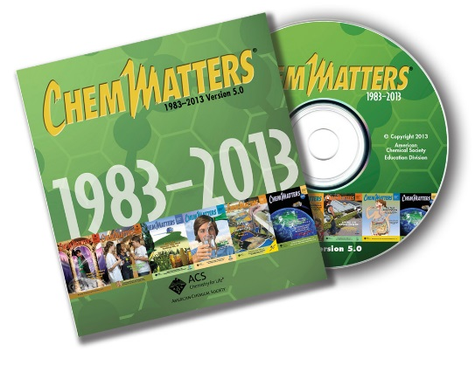

***30* Years of *ChemMatters!***

Available Now!

Haines, G. K. Honey: Bee Food Extraordinaire! *ChemMatters*, 2005, *23* (4), pp 13–16. This article discusses the history of the use of honey, the biochemistry of the honey bee and varied commercial uses of honey. Students may be interested to learn that honey contains antioxidants including vitamins and flavonoids.

Haines, G. K. Coffee: Brain Buster to Go. *ChemMatters*, 2008, *26* (4), pp 7–9. The suggestion that coffee is good for you because it contains antioxidants will be very appealing to high school students who depend on a cup to wake up for early morning chemistry class. The article addresses possible damage caused by free radicals and the benefits of antioxidant protection. Research on chlorogenic acid (an antioxidant) indicates that light to medium roast coffees contain the most antioxidants.

Haines, G. K. Chocolate: The New Health Food. Or Is It? *ChemMatters*, 2009, *27* (2), pp 13–9. This is another article by Haines that will appeal to students interested in maintaining their health. They may find (to their delight) that chocolate is a good source of antioxidants. The article discusses antioxidant protection from free radicals and includes structural diagrams for two flavonols.

Emilsson, G. M. What’s in Sunscreens? *ChemMatters*, 2010, *28* (2), pp 13–15. This article on sunscreens contains illustrations showing UVA hitting a cell and creating reactive oxygen species. The author says that green tea contains vitamins C and E that may reduce the harmful effects of UVA exposure. She suggests that future sun screens may add antioxidants to their formulas.

Haines, G. K. Sugar in the Blood Boosts Energy. *ChemMatters*, 2011, *29* (3), pp 6–7. In this article, Haines points out that although it produces energy, glucose is not a complete food because it lacks other chemicals needed by the body, including antioxidants.

Warner, J. Sniffing Out Cancer. *ChemMatters*, 2013, *31* (1), pp 11–13. A dog’s acute sense of smell can detect oxidative stress due to a low concentration of antioxidants at a level insufficient to balance an excessive concentration of reactive molecules. When reactive oxygen species oxidize the lipid membranes of cells, dogs can detect the subsequent release of volatile organic compounds such as aldehydes and ketones. These chemicals may indicate the presence of cancer. This article is well written and the health topic may be well received by students.

# Web Sites for Additional Information

**(Web-based information sources)**

**More sites on energy production in cells**

“Chapter 14: Energy Conversion: Mitochondria and Chloroplasts” of the textbook *Molecular Biology of the Cell* has been made accessible by the publisher through a search feature for this chapter only. The process of the synthesis of energy-rich ATP is well explained here. (<http://www.ncbi.nlm.nih.gov/books/NBK21063/>)

**More sites on the formation of free radicals—internal sources—ROS**

This Rice University site provides more detailed information about the series of steps involved in the electron transport system in mitochondria. Additional details regarding the redox reactions that drive the synthesis of ATP are explained on this page. (<http://www.ruf.rice.edu/~bioslabs/studies/mitochondria/mitets.html>)

This 2003 paper on the Texas A & M University site shows structural formulas for the complexes in the electron transfer chain, as well as providing the redox reactions involved and the standard free energy for each reaction. (<https://www.tamu.edu/faculty/bmiles/lectures/electrontrans.pdf>)

This article provides an additional description of the work by the IBM scientists who developed the process of using atomic force microscopy to watch bonds break and reform within a single molecule. The single and double free radicals pictured are intermediates in this reaction. A YouTube video of the process is suggested as In-Class Activity number 1 in this Teacher’s Guide. (<http://www.rsc.org/chemistryworld/2016/01/bergman-cyclisation-electron-tunnelling-microscope>)

This page from Robbins and Cotran's *Pathologic Basis of Disease* is found on Google Books. It provides additional details about the Fenton reaction. (<https://books.google.com/books?id=5NbsAwAAQBAJ&pg=PA48&lpg=PA48&dq=Robbins+and+Cotran's+Pathologic+Basis+of+Disease++Fenton+Reaction&source=bl&ots=A4bGsVm0Ac&sig=cZJfzBciq1PTW0IHqsoilO_vGz8&hl=en&sa=X&ved=0ahUKEwirjKDttITLAhXIRSYKHSsPATsQ6AEIHzAA#v=onepage&q=Robbins%20and%20Cotran's%20Pathologic%20Basis%20of%20Disease%20%20Fenton%20Reaction&f=false>)

This Colorado State University website provides an additional description of free radicals and ROS, their biological effects and mechanisms. (<http://www.vivo.colostate.edu/hbooks/pathphys/misc_topics/radicals.html>)

This source discusses the paradox of aerobic life, or the “Oxygen Paradox”—that higher aerobic organisms cannot exist without oxygen, yet oxygen is inherently dangerous to their existence: <http://symposia.biochemistry.org/content/ppbioss/61/1.full.pdf>.

**More sites on the formation of free radicals—internal sources—RNS**

This site provides a review of the literature on RNS, “Biological aspects of reactive nitrogen species”. Included is a nice diagram including descriptions that shows the reactions with ROS and other reactive species to form RNS. (<http://www.sciencedirect.com/science/article/pii/S0005272899000286>)

**More sites on the formation of free radicals—external sources**

As the title implies, “Free-radical chemistry of cigarette smoke and its toxicological implications”, this paper thoroughly details the experimental process and data of studies on the generation of free radicals and their damage to health during cigarette smoking. The entire report is located at this URL: <http://www.ncbi.nlm.nih.gov/pmc/articles/PMC1568603/>.

This paper discusses the metabolism of alcohol. An excellent figure shows the biochemical process and the ultimate release of ROS as a product of the chemical reactions. (<http://pubs.niaaa.nih.gov/publications/arh294/245-255.htm>)

**More sites on the beneficial effects of free radicals**

This very readable excerpt from a Scottish medical journal was ghost written for the public. It covers the basics of the sources of free radicals and their positive effects on the human body. (<http://bsherman.net/freeradicals.htm>)

**More sites on the damaging effects of free radicals**

This *Journal of Nutrition* article discusses the role of oxidants and antioxidants in exacerbating and reducing the effects of viral diseases such as influenza, hepatitis and human immunodeficiency virus (HIV). (<http://jn.nutrition.org/content/127/5/962S.long>)

**More sites on oxidative stress**

“What is Oxidative Stress?” is a very readable guide that defines oxidative stress, free radicals, antioxidants and provides a table showing the damage caused by various free radicals. (<http://www.news-medical.net/health/What-is-Oxidative-Stress.aspx>)

**More sites on theories of aging**

This paper published September 2015 describes mouse research on the Schwann cells which wrap around the neural-muscular junction of cells in the peripheral nervous system. When the mitochondria do not function correctly, the resultant oxidative stress has been linked to the death of the neurons leading to Amyotrophic Lateral Sclerosis (ALS). ALS can lead to paralysis including respiratory paralysis and death. (<http://www.ncbi.nlm.nih.gov/pmc/articles/PMC4555015/>)

**More sites on** **the discovery of antioxidants**

Burnett Sure published, “Dietary Requirements: The existence of a Specific Vitamin for Reproduction” in the *Journal of Biological Chemistry*. This paper describes the laboratory studies that led to the discovery of vitamin E and describes experimental details that include graphical representations of the scientific data. (<http://www.jbc.org/content/58/3/693.full.pdf+html?ijkey=f31ce8926428d1a029d0143668057e901aa6acd9&keytype2=tf_ipsecsha>)

“The discovery of the antioxidant function of Vitamin E: The contribution of Henry A. Mattill”, published in the *Journal of Nutrition* discusses Mattill’s work in an interesting, readable paper. The focus is on “how a new idea can arise from a change in the interpretation of preexisting experimental results”. (<http://jn.nutrition.org/content/135/3/363.short>)

Recent imaging techniques that use small molecule fluorescence and genetically encoded sensors provide both the location and quantity of ROS. Many diagrams and images are used to illustrate the technical biochemistry explanations. This material is dated January 2014. (<http://www.biotek.com/resources/articles/reactive-oxygen-species.html>)

“Definition and Review of Dietary Antioxidants and Related Compounds” is a comprehensive government review. The 23 page document is nicely organized so that one can quickly “browse by subject” from the left hand margin list. This document is from the U.S. Department of Agriculture dated 1998.

(<https://fnic.nal.usda.gov/dietary-guidance/dri-nutrient-reports/definition-and-review-dietary-antioxidants-and-related>)

As the title implies, this article from the Linus Pauling Institute at the University of Oregon, “Micronutrient Requirements of Adolescents Ages 14 to 18 Years” contains a thorough description including rationale for special dietary needs of during teenage years. (<http://lpi.oregonstate.edu/mic/life-stages/adolescents#reference59>)

**More sites on the chemistry of antioxidants—phytochemicals**

The Oregon State University Linus Pauling site contains much information about the possible health benefits of antioxidant flavonoids. This website contains many tables that list the foods that contain various flavonoids. (<http://lpi.oregonstate.edu/mic/dietary-factors/phytochemicals/flavonoids#food-sources>)

Whole Food Market has a website with a nice table of food sources of flavonoids. In addition they list and describe the suggested health benefits of these compounds. (<http://www.whfoods.com/genpage.php?tname=nutrient&dbid=119>)

This article in the *Journal of Nutrition* discusses research findings on the effects of allyl sulfides in reducing uncontrolled cell division that leads to tumor formation. (<http://jn.nutrition.org/content/131/3/1061S.full>)

This article provides an intensive review of the research on the effect of allyl sulfides as antioxidants in cancer tumor reduction and prevention. (<http://www.ncbi.nlm.nih.gov/pmc/articles/PMC3915757/>)

**More sites on the chemistry of antioxidants—vitamins**

**Vitamin A**

In addition to its important role as an antioxidant, vitamin A plays a major role in the functioning of the immune (infectious disease resistance) and visual systems (preventing night blindness) and metabolism (production of red blood cells). This study of people in low-income South Asian countries describes the health problems exacerbated by the lack sufficient vitamin A in their diets. (<http://www.ncbi.nlm.nih.gov/pmc/articles/PMC3905635/>)

Elmhurst College has a nice presentation on “Beta-carotene and Vitamin A”. The explanations of the relationship between and the function of beta-carotene and vitamin A are clear and the visuals would make good PowerPoint slides for your class. (<http://chemistry.elmhurst.edu/vchembook/532vitaminA.html>)

**Vitamin C**

This *Journal of Food and Nutrition Research* paper contains a description of the research methods and data obtained from the study of guava juice at various temperatures over time. Extensive graphical analysis of the data is shown. A free full download of the pdf file for “Kinetics of Ascorbic Acid Degradation and Quality Changes in Guava Juice during Refrigerated Storage” can be found at this URL: <http://pubs.sciepub.com/jfnr/3/8/10/index.html>.

The University of California, Davis’ CHEMWIKI site presents an excellent lesson describing and illustrating the chain of electron transfers involved as the ascorbate anion acts as an antioxidant by reducing free radicals. (<http://chemwiki.ucdavis.edu/Core/Organic_Chemistry/Organic_Chemistry_With_a_Biological_Emphasis/Chapter_17%3A_Radical_reactions/Section_17.2%3A_Radical_chain_reactions>)

**Vitamin E**

This study discusses tests on the anti-inflammatory regulatory function of vitamin E. It also contains a nice picture of the eight isoforms of the molecule. (<http://www.ncbi.nlm.nih.gov/pmc/articles/PMC3271790/>)

**More sites on** **the chemistry of antioxidants—enzymes**

This December 2012 paper published in *Advances in Bioresearch* contains a well-organized description of “Reactive Oxygen Species and Natural Antioxidants: A Review”. The “Natural Antioxidants in the Body” section on pages 167-8 presents a full description of the mechanisms of enzymes. (<http://soeagra.com/abr/abrdec_2012/24.pdf>)

**More sites on** **the chemistry of antioxidants—other**

This “How Stuff Works” site provides a brief summary of each of the various types of antioxidants. Included are basic redox reactions showing the reduction of ROS. You may find this a clear, simply summary for classroom study of antioxidants. This site also provides additional information on uric acid including a description of its role as an iron chelator to protect the ascorbate ion.

(<http://health.howstuffworks.com/wellness/food-nutrition/facts/antioxidant3.htm>)

“Structural, chemical and biological aspects of antioxidants for strategies against metal and metalloid exposure” discusses and provides explanatory chemical reactions to explain how that various antioxidants provide protection by chelating metal ions. This paper provides much information about each vitamin and its interaction with free metals.

(<http://www.ncbi.nlm.nih.gov/pmc/articles/PMC2763257/>)

**More sites on use of dietary supplements in the U.S.**

This page from the U.S. Food and Drug Administration (FDA) is titled, “Dietary Supplements: What You Need to Know”. It is designed for those who plan to purchase supplements. Included are definitions, risks, a list of common dietary supplements and contact information to report problems. (<http://www.fda.gov/Food/DietarySupplements/UsingDietarySupplements/ucm109760.htm>)

**More sites on safety and the regulation of dietary supplements**

This FDA site contains links for consumers and industry to obtain information regarding over-the-counter dietary supplements as well as a link to report a concern or problem. (<http://www.fda.gov/Food/DietarySupplements/>)