logo_chemmatters[1]

**April/May 2016 Teacher's Guide for**

***Cellulosic Ethanol: A Fuel of the Future?***

**Table of Contents**

[About the Guide 2](#_Toc446168607)

[Student Questions 3](#_Toc446168608)

[Answers to Student Questions 4](#_Toc446168609)

[Anticipation Guide 6](#_Toc446168610)

[Reading Strategies 7](#_Toc446168611)

[Background Information 10](#_Toc446168612)

[Connections to Chemistry Concepts 26](#_Toc446168613)

[Possible Student Misconceptions 26](#_Toc446168614)

[Anticipating Student Questions 27](#_Toc446168615)

[In-Class Activities 27](#_Toc446168616)

[Out-of-Class Activities and Projects 28](#_Toc446168617)

[References 29](#_Toc446168618)

[Web Sites for Additional Information 30](#_Toc446168619)

# About the Guide

Teacher’s Guide editors William Bleam, Regis Goode, Barbara Sitzman and Ronald Tempest created the Teacher’s Guide article material. E-mail: [bbleam@verizon.net](mailto:bbleam@verizon.net)

Susan Cooper prepared the anticipation and reading guides.

Patrice Pages, *ChemMatters* editor, coordinated production and prepared the Microsoft Word and PDF versions of the Teacher’s Guide. E-mail: [chemmatters@acs.org](mailto:chemmatters@acs.org)

Articles from past issues of *ChemMatters* can be accessed from a DVD that is available from the American Chemical Society for $42. The DVD contains the entire 30-year publication of *ChemMatters* issues, from February 1983 to April 2013.

The *ChemMatters* DVD also includes Article, Title and Keyword Indexes that covers all issues from February 1983 to April 2013.

The *ChemMatters* DVD can be purchased by calling 1-800-227-5558.

Purchase information can be found online at [www.acs.org/chemmatters](http://chemistry.org/chemmatters/cd3.html).

# Student Questions

**(taken from the article)**

**Cellulosic Ethanol: A Fuel of the Future?**

* 1. What is the connection between “burning” petroleum and climate change?
  2. What is the difference between hydrocarbons and ethanol in terms of their origins?
  3. Why does burning ethanol have less effect on atmospheric carbon dioxide than burning petroleum, even though both fuels produce carbon dioxide when they burn?
  4. How much of the greenhouse gas emissions come from the burning of gasoline and diesel fuels in the USA?
  5. From what chemical is ethanol produced?
  6. If corn is the source of the sugar glucose, used to make ethanol, how does the conversion from sugar to ethanol take place?
  7. What is the fate of the carbon dioxide gas that is produced in the yeast fermentation process?
  8. List three concerns, mentioned in the article, that people have about producing ethanol from the fermentation of corn sugars rather than from using plant cellulose to make the ethanol.
  9. List two major sources of waste material that can be used to make cellulosic ethanol.
  10. What is the biggest problem to be solved if trying to use plant cellulose for making ethanol?
  11. Describe the two techniques used to extract glucose from plant waste material.

# Answers to Student Questions

**(taken from the article)**

**Cellulosic Ethanol: A Fuel of the Future?**

* + 1. **What is the connection between “burning” petroleum and climate change?**

*Burning petroleum produces carbon dioxide, a so-called greenhouse gas, meaning that the gas traps heat in the atmosphere, causing climate change on a global scale.*

* + 1. **What is the difference between hydrocarbons and ethanol in terms of their origins?**

*Petroleum is (was) produced from ancient decomposed organic matter, that has been mixed with other sediments and subjected to high pressure and temperature for millions of years. Ethanol is often produced through the yeast fermentation of sugars from plants grown today.*

* + 1. **Why does burning ethanol have less effect on atmospheric carbon dioxide than burning petroleum, even though both fuels produce carbon dioxide when they burn?**

*Plants absorb carbon dioxide from the atmosphere to make chemical compounds for growth. By using the plants to produce ethanol which is then burned, the amount of carbon dioxide generated in the burning process is the same amount of carbon dioxide that was initially taken up by the plants. So there’s no net gain in the atmosphere. By contrast, burning petroleum releases carbon dioxide that is not part of the natural carbon cycle because it is added to the atmosphere and not recycled by its ancient plant source. This makes for a net increase of atmospheric carbon dioxide.*

* + 1. **How much of the greenhouse gas emissions come from the burning of gasoline and diesel fuels in the USA?**

*This burning of gasoline and diesel fuels is calculated to account for 32% of greenhouse emissions.*

* + 1. **From what chemical is ethanol produced?**

*Ethanol is made from the sugar glucose, in corn.*

* + 1. **If corn is the source of the sugar glucose used to make ethanol, how does the conversion from glucose to ethanol take place?**

*Corn, which is soaked in water and crushed, is chemically acted upon by yeast, converting sugar molecules into carbon dioxide and ethanol.*

* + 1. **What is the fate of the carbon dioxide that is produced in the yeast fermentation process?**

*Carbon dioxide that is captured can be used for carbonating soft drinks and making dry ice.*

* + 1. **List three concerns, mentioned in the article, that people have about producing ethanol from the fermentation of corn sugars rather than from using plant cellulose to make the ethanol.**

*Three concerns about making ethanol from corn sugars are:*

1. *One-third of the corn produced in the U.S. is being diverted to make fuel rather than serving as a food source. Many people consider the demands for corn-based food supplies to be more important than using that crop for corn ethanol.*
2. *Producing ethanol requires equipment that needs fossil fuel to operate, which adds to the amount of greenhouse gases released into the atmosphere.*
3. *Farmers in other parts of the world are enticed into transforming rainforests into farmland to grow corn, eliminating trees that capture carbon dioxide, a greenhouse gas. With fewer trees, more carbon dioxide builds up in the atmosphere, defeating the original purpose of using ethanol instead of fossil fuels.*
   * 1. **List two major sources of waste material that can be used to make cellulosic ethanol.**

*Sources of waste material include:*

1. *residue from the lumber industry and*
2. *huge amounts from agriculture such as leftover plant debris such as stalks and husks of corn plants.*
   * 1. **What is the biggest problem to be solved if trying to use plant cellulose for making ethanol?**

*Cellulose is a polymer constructed from glucose molecules, but there needs to be an economical way to free up the glucose from the cellulose polymer, since the yeast used to digest glucose in corn cannot break the cellulose apart to get to the glucose.*

* + 1. **Describe the two techniques used to extract glucose from plant waste material.**

*The two techniques for separation are*

1. *Biochemical—The biochemically-based separation involves drying and grinding up the plant material, which is then soaked in sulfuric acid which removes the lignin, releasing the cellulose. Enzymes then break down the cellulose and the glucose is fermented into ethanol.*
2. *Thermochemical—This method relies on treating the plant material with hot steam to break it down into a mixture of two gases—carbon monoxide (CO) and hydrogen gas (H2). The hot gases run are subjected to a metal catalyst and combine to form ethanol and other alcohols.*

# Anticipation Guide

Anticipation guides help engage students by activating prior knowledge and stimulating student interest before reading. If class time permits, discuss students’ responses to each statement before reading each article. As they read, students should look for evidence supporting or refuting their initial responses.

**Directions:**  ***Before reading,*** in the first column, write “A” or “D,” indicating your agreement or disagreement with each statement. As you read, compare your opinions with information from the article. In the space under each statement, cite information from the article that supports or refutes your original ideas.

|  |  |  |
| --- | --- | --- |
| **Me** | **Text** | **Statement** |
|  |  | 1. Many plastics and medicines are made using petroleum as a raw material. |
|  |  | 1. Burning petroleum and ethanol both produce carbon dioxide. |
|  |  | 1. Burning petroleum and ethanol have the same effect on the environment. |
|  |  | 1. The Environmental Protection Agency states that burning gasoline and diesel in the U. S. accounts for more than half of greenhouse gas emissions. |
|  |  | 1. Most ethanol in the United States comes from the glucose in sugar cane. |
|  |  | 1. Yeast is used to ferment glucose into ethanol. |
|  |  | 1. Most ethanol producers sell the carbon dioxide produced during fermentation for use in carbonating soft drinks and manufacturing dry ice. |
|  |  | 1. Cellulose is a polymer of sucrose. |
|  |  | 1. Cellulosic ethanol can be made from waste agricultural materials. |
|  |  | 1. Cellulosic ethanol is produced commercially. |

# Reading Strategies

These graphic organizers are provided to help students locate and analyze information from the articles. Student understanding will be enhanced when they explore and evaluate the information themselves, with input from the teacher if students are struggling. Encourage students to use their own words and avoid copying entire sentences from the articles. The use of bullets helps them do this. If you use these reading and writing strategies to evaluate student performance, you may want to develop a grading rubric such as the one below.

|  |  |  |
| --- | --- | --- |
| **Score** | **Description** | **Evidence** |
| 4 | Excellent | Complete; details provided; demonstrates deep understanding. |
| 3 | Good | Complete; few details provided; demonstrates some understanding. |
| 2 | Fair | Incomplete; few details provided; some misconceptions evident. |
| 1 | Poor | Very incomplete; no details provided; many misconceptions evident. |
| 0 | Not acceptable | So incomplete that no judgment can be made about student understanding |

***Teaching Strategies:***

1. Links to **Common Core Standards for Reading**:

ELA-Literacy.RST.9-10.1:Cite specific textual evidence to support analysis of science and technical texts, attending to the precise details of explanations or descriptions.

ELA-Literacy.RST.9-10.5: Analyze the structure of the relationships among concepts in a text, including relationships among key terms (e.g., force, friction, reaction force, energy).

ELA-Literacy.RST.11-12.1:Cite specific textual evidence to support analysis of science and technical texts, attending to important distinctions the author makes and to any gaps or inconsistencies in the account.

ELA-Literacy.RST.11-12.4: Determine the meaning of symbols, key terms, and other domain-specific words and phrases as they are used in a specific scientific or technical context relevant to grades 11-12 texts and topics.

1. Links to **Common Core Standards for Writing**:

ELA-Literacy.WHST.9-10.2F: Provide a concluding statement or section that follows from and supports the information or explanation presented (e.g., articulating implications or the significance of the topic).

ELA-Literacy.WHST.11-12.1E: Provide a concluding statement or section that follows from or supports the argument presented.

1. **Vocabulary** and **concepts** that are reinforced in this issue:

Personal and community health

Reactive oxygen species

Fuel production and use

Molecular structures

Polymers

1. Some of the articles in this issue provide opportunities, references, and suggestions for students to do further research on their own about topics that interest them.
2. To help students engage with the text, ask students which article **engaged** them most and why, or what **questions** they still have about the articles. The Background Information in the *ChemMatters* Teachers Guide has suggestions for further research and activities.
3. In addition to the writing standards above, consider asking students to debate issues addressed in some of the articles. Standards addressed:

**WHST.9-10.1B** Develop claim(s) and counterclaims fairly, supplying data and evidence for each while pointing out the strengths and limitations of both claim(s) and **counterclaims** in a discipline-appropriate form and in a manner that anticipates the audience’s knowledge level and concerns.

**WHST.11-12.1.A** Introduce precise, knowledgeable claim(s), establish the significance of the claim(s), distinguish the claim(s) from alternate or opposing claims, and create an organization that logically sequences the claim(s), counterclaims, reasons, and evidence.

**Directions**: As you read the article, complete the graphic organizer below to explain the similarities and differences of ethanol and cellulosic ethanol, including how they are produced.

|  |  |  |
| --- | --- | --- |
|  | **Ethanol** | **Cellulosic Ethanol** |
| **Advantages** | **1.**  **2.**  **3.** | **1.**  **2.**  **3.** |
| **Disadvantages** | **1.**  **2.**  **3.** | **1.**  **2.**  **3.** |
| **How it is produced** |  |  |

**Summary:** Write a one-sentence summary (20 words or less) explaining what you learned about cellulosic ethanol from reading the article.

# Background Information

**(teacher information)**

**More on** **cellulose and plant material**

The Sherwood ethanol article discusses in some detail the requirements for producing ethanol from cellulose. The production of ethanol from plant material other than from corn is in its early research phase, focusing on the need to develop a cost-effective process. The government has been primarily funding research efforts at various universities rather than supporting industry, which is in contrast to the case where the government made a big push to use corn as the source of sugars for fermentation into ethanol. Any number of studies showed then that the use of corn for ethanol production required more energy related to all aspects of corn utilization (production, processing) than available in the final product. Government subsidies for the manufacturing process were meant to erase losses in production expenses. So there is the push to find alternative sources of sugars for fermentation that are cost effective. Or, in the case of diesel fuel, research has focused on extracting useful oils from various plant materials. Both government and private industry are focused on the search. Related to the keen interest in finding sources other than corn for fermentable sugars is the necessity to avoid using important food crops such as corn and soybeans, for example. As noted in the article, there are many non-food sources of cellulose, the majority of which are waste plant materials.

This quote provides a succinct rationale for the use of cellulose:

Only a small part of most plants is sugar or starch, the part that can be digested by humans and fermented by yeast into ethanol. Most of the rest is cellulose. Naturally, using the bulk of the plant is more efficient. Better yet, we need not use our food plants. Some grasses store more energy in cellulose than does corn, and require far less nitrogen fertilizer, far fewer pesticides, and less process heat (energy).

(<http://zfacts.com/p/85.html>)

The following table from a 2007 report by the United States Department of Agriculture provides some projected cost data, comparing corn with cellulose-based material, pointing to a cellulosic future. As you can see, although the costs as of 2007 for making ethanol from a cellulose source was 60% higher ($2.65 vs. $1.65) than those from corn, by 2012 the costs for making ethanol from a cellulose source were projected to be 60% lower ($1.10 vs. $1.65) than those from corn.

|  |  |  |  |  |  |  |  |  |  |  |  |  |  |  |  |  |  |  |  |  |  |  |  |  |  |  |  |  |  |  |  |  |
| --- | --- | --- | --- | --- | --- | --- | --- | --- | --- | --- | --- | --- | --- | --- | --- | --- | --- | --- | --- | --- | --- | --- | --- | --- | --- | --- | --- | --- | --- | --- | --- | --- |
| |  |  |  |  | | --- | --- | --- | --- | |  | **Corn Based** | **Cellulosic Today?– Illustrative** | **Cellulosic 2010-12— DOE target** | | Feedstock | $1.17 @$3.22/bu 2.75g/bu | $1.00 @$60/dt 60g/dt | $0.33 @$30/dt 90g/dt | | By-Product | –$0.38 | –$0.10 | –$0.09 | | Enzymes | $0.04 | $0.40 | $0.10 | | Other Costs\*\* | $0.62 | $0.80 | $0.22 | | Capital Cost | $0.20 | $0.55 | $0.54 | | Total | $1.65 | $2.65 | $1.10 | | g = gallon, dt = dry ton. \*\* (includes preprocessing, fermentation, labor) | | | |   *(*[*http://zfacts.com/p/85.html*](http://zfacts.com/p/85.html)*)* |

Deconstruction is the process by which the major components found in lignocellulosic feedstocks (i.e., cellulose, hemicellulose, and lignin) are converted into fermentable sugars and other desirable intermediate products suitable for upgrading into finished products that can be sold in the marketplace. Through the biochemical routes proposed today, there is no doubt that the deconstruction process represents the biggest cost in lignocellulosic biofuels production. Plant cell wall recalcitrance (resistance to deconstruction) continues to be the major impediment to efficient and economic conversion of lignocellulosic feedstocks into sugars, fuels, and value-added products, such as the plant residue (biomass) that can be used for fuel. The key to overcoming recalcitrance is to find economical methods for pretreatment of the cellulose source, which in turn facilitates the efficient hydrolysis of the cellulose into sugars through specialized enzymes.

The three important chemical components in lignocellulosic biomass are cellulose, hemicellulose and lignin.

**Cellulose**

As the most common organic compound on Earth, cellulose comprises 38%–50% of cellulosic biomass (Rowell 2005). Cellulose is a polymer of 6-carbon sugar molecules (glucose) linked together in a crystal structure that strengthens plants and is similar in function to skeletons of animals. Cellulose is the major constituent of paper, paperboard, card stock, and textiles, all of which are made from woody or herbaceous biomass such as pine, eucalyptus, sugarcane bagasse, cotton, or linen. In a bioethanol process, cellulose must first be transformed into easily-fermentable monosaccharides (simple sugars, such as glucoses) by physical, chemical, and biological treatments, and then used as a fermentation substrate to produce ethanol through a fermentation process.

*(*[*http://edis.ifas.ufl.edu/LyraEDISServlet?command=getImageDetail&image\_soid=FIGURE%201&document\_soid=AE493&document\_version=48749*](http://edis.ifas.ufl.edu/LyraEDISServlet?command=getImageDetail&image_soid=FIGURE%201&document_soid=AE493&document_version=48749)*)*

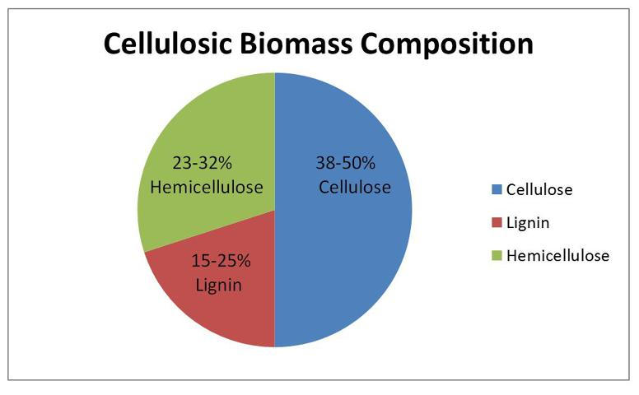

**Hemicellulose**

Hemicellulose forms 23%–32% of cellulosic biomass (Rowell 2005), and is present, along with cellulose, in almost all plant cell walls. It consists of complex polysaccharides from a variety of five- and six-carbon sugars. While cellulose is crystalline, strong, and resistant to hydrolysis, hemicellulose has a random, amorphous structure with little strength. Hemicellulose is easily hydrolyzed by dilute acid or base, as well as a myriad of hemicellulase enzymes. However, five-carbon sugars released from hemicelluloses have more difficulty fermenting than 6-carbon sugars.

**Lignin**

Lignin forms 15%–25% of cellulosic biomass. It is a complex network polymer with phenyl propane basic units. Lignin has a variety of chemical structures, depending on different purification approaches. It fills the spaces in the cell wall between cellulose, hemicellulose, and pectin components. It is covalently linked to hemicellulose and thereby cross-linked with different plant polysaccharides. As a rigid material, lignin provides mechanical strength to the cell wall, and also plays a crucial part in conducting water through the plant stems (Rowell 2005). During a bioethanol process, lignin is left as a residue. However, it still has some energy value and can be used to make a variety of value-added products.

(<http://edis.ifas.ufl.edu/ae493>)

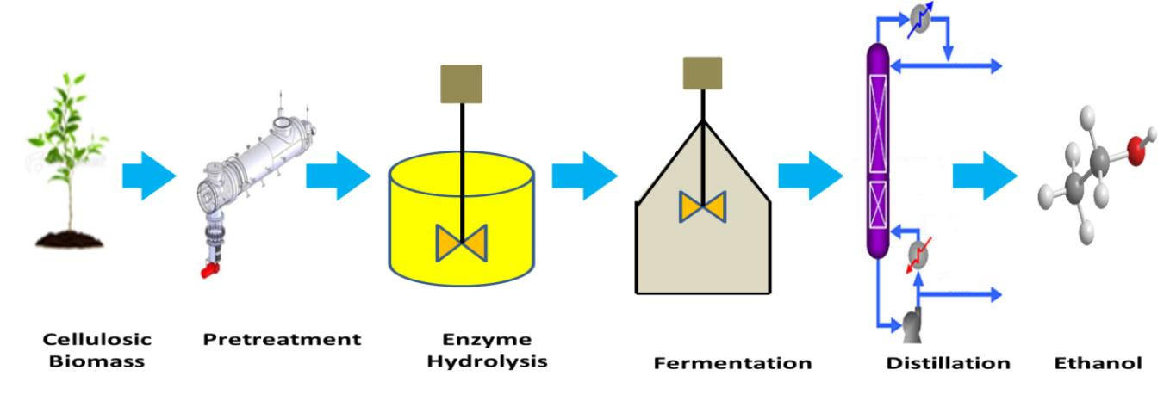A schematic of the overall process for converting cellulosic material into ethanol.

*(*[*http://edis.ifas.ufl.edu/ae493*](http://edis.ifas.ufl.edu/ae493)*)*

The details for the different stages of converting cellulosic material into ethanol as shown in the scheme above follow:

**Pretreatment**

Pretreatment is the first step of the cellulosic bioethanol process. The purpose of pretreatment is to make the cellulose more susceptible to being broken down so that it is ready for the enzyme hydrolysis step. Pretreatment does this by partially removing the lignin and hemicellulose, which block the cellulose inside the cell wall (Geddes et al. 2010). Currently, there are a number of challenges to efficiently and effectively completing the pretreatment process, including the following (Chandra et al. 2007; Mosier et al. 2005):

* Reducing the cost (capital and operating) of the process;
* Ensuring that the particle size is reduced enough in order to increase surface area-to-mass ratio for maximum exposure to contact surfaces;
* Minimizing the accumulation of inhibitory products that could interfere with the subsequent fermentation step;
* Enhancing the sugar yield and allowing efficient hydrolysis at a lower concentration of enzyme.

The pretreatment step can be done by using acid, alkali, organic solvents, heat treatments, etc. Some options for pretreatment are steam explosion, liquid hot water, lime-ammonia and acid treatment (Wyman 2010).

**Enzyme Hydrolysis**

Enzyme hydrolysis usually occurs immediately after the pretreatment step. Enzyme hydrolysis is the process used to convert polysaccharides (cellulose and hemicelluloses) and their oligomers (molecules with a few single sugar units) into simple sugars, which can be fermented by bacteria or yeast. The high cost of enzymes is currently the greatest challenge in this processing step. Although current world-leading enzyme suppliers have reduced the price of enzymes about 20- to 30-fold, the cost for enzymes is still the most expensive part of the entire bioethanol process. An important approach to reduce the cost for enzyme hydrolysis is to develop an efficient pretreatment method to reduce the enzyme dosage and enhance the yield of simple sugars. Sugar yield is typically less than 20% without pretreatment, whereas yield after pretreatment often exceeds 90% (Chandra et al. 2007).

**Fermentation**

Conventional fermentation is the process that converts the sugars from sugar-rich feedstocks (fruit juices, pomace and grains, such as corn and sweet sorghum) into alcohol in the brewing and beverage alcohol industries. In a cellulosic bioethanol process, fermentation is used to convert the single sugars obtained from the enzyme hydrolysis step (glucose from cellulose and xylose from hemicellulose) to fuel ethanol. Organisms such as yeast (Saccharomyces cerevisiae) or bacteria (Escherichia coli) are used to convert these simple sugars to ethanol. In order to keep distillation costs low, the appropriate microorganism is selected based on the need to achieve high ethanol yield while also withstanding inhibition from accumulating toxic substances and autointoxication from increasing ethanol concentration.

The fermentation step usually follows enzymatic hydrolysis, as a separate step. This procedure is known as separate hydrolysis and fermentation (SHF). However, the most commonly used technique is called the simultaneous saccharification and fermentation (SSF) process, which is carried out by combining fermentation and enzyme hydrolysis in the same step. Normally, higher ethanol yield can be achieved with SSF, which can be attributed to the reduction of inhibitory end-products (glucose and cellubiose) (Olofsson, Bertilsson, and Lidén 2008).

**Distillation**

Ethanol is recovered from the fermentation broth by the process called distillation. Distillation works by boiling the liquid mixture of water and ethanol. Ethanol vapors are separated from the liquid portion because ethanol has a lower boiling point (78.3°C) at atmospheric pressure compared to water (100°C). The lignin residues, along with unreacted cellulose, hemicellulose, ash, enzymes, and remaining microorganisms, end up in the bottom of the distillation column during the bioethanol process. This solid waste (still bottoms) has high energy content, which can be burned as fuel for power or may be converted to various value-added products.

(<http://edis.ifas.ufl.edu/ae493> )

**More on** **the sources of cellulose**

As mentioned previously, cellulose is found in both its original plant source (plant residue like corn stalks [stover], sawdust, and tree detritus), as well as products derived from the cellulose, such as finished lumber, and paper products. An example of the harvesting of plant residue specifically for use in producing the final product, ethanol, is found in agricultural practices. The DuPont company has developed a complete commercial processing plant near one of the big agricultural areas of the USA, Iowa, where a lot of corn is grown!

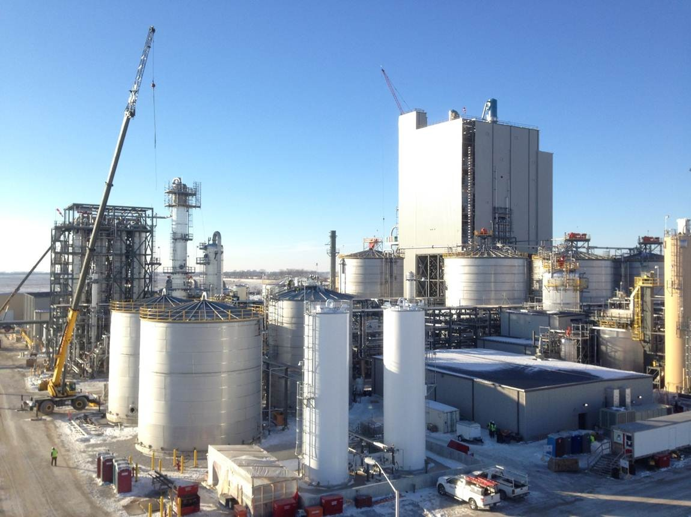

DuPont Nevada Iowa Cellulosic Ethanol Facility—Jan 13, 2015

([*http://www.dupont.com/products-and-services/industrial-biotechnology/advanced-biofuels/uses-applications/corn-stover.html*](http://www.dupont.com/products-and-services/industrial-biotechnology/advanced-biofuels/uses-applications/corn-stover.html)*;*

A time-lapse video of the building of this facility is shown at [*https://www.youtube.com/watch?v=eYid02qL-0g&feature=youtu.be*](https://www.youtube.com/watch?v=eYid02qL-0g&feature=youtu.be)*)*

This excellent video by DuPont shows the entire operation in this plant facility for processing corn stover into ethanol: <https://www.youtube.com/watch?v=77Mu-0fGJ2s&feature=youtu.be>.

A pictorial outline of the DuPont-like process (in the above video), is shown below.

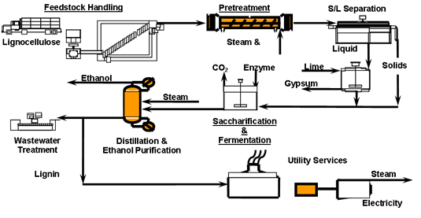

*(*[*http://www.ibri.ncsu.edu/facilities/cellulosic-ethanol-pilot-plant.php*](http://www.ibri.ncsu.edu/facilities/cellulosic-ethanol-pilot-plant.php)*)*

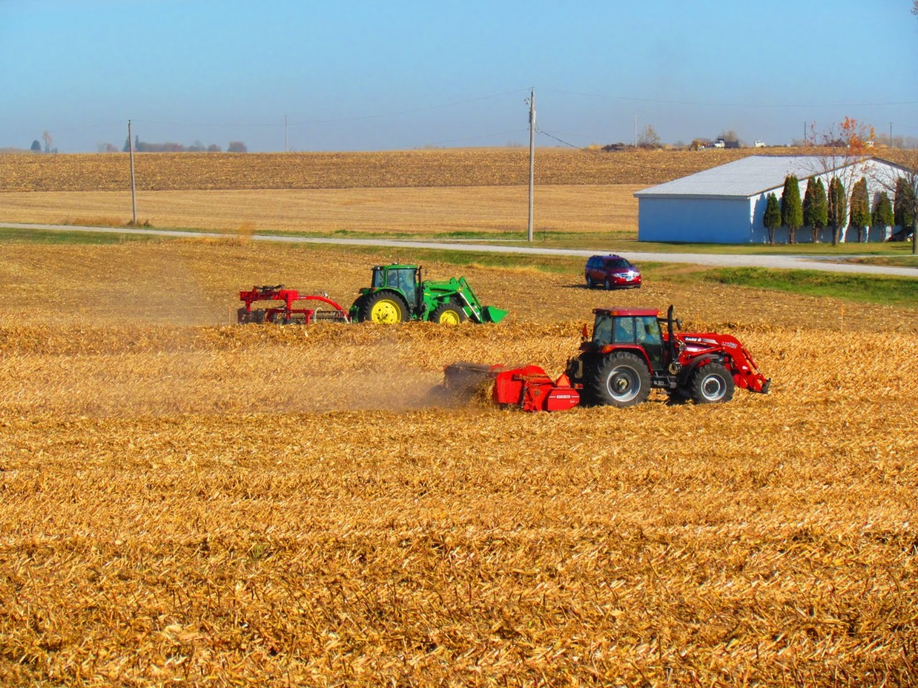

Harvesting corn stalks (stover) for making cellulosic ethanol

*(*[*http://www.dupont.com/products-and-services/industrial-biotechnology/advanced-biofuels/uses-applications/corn-stover.html*](http://www.dupont.com/products-and-services/industrial-biotechnology/advanced-biofuels/uses-applications/corn-stover.html)*)*

DuPont is collaborating with corn crop producers to establish a high-quality, cost-effective, and sustainable supply of corn stover for commercial production of cellulosic ethanol.

The rationale for actually NOT plowing under the corn plant remnants to serve as fertilizer (the usual practice), but harvesting them instead for cellulosic ethanol production is discussed here:

DuPont says, amidst the focus on renewable fuels, cellulosic ethanol’s potential contribution to sustainable agriculture can get overlooked.

“The secret to soil health,” says DuPont’s John Pieper simply, in speaking with the Digest, “is that all the things above the ground should really stay above the ground, and all the things below the ground should stay below the ground. That’s Nature’s way, how it was intended.

Pieper should know, after more than 20 years with Pioneer Hi-Bred working with growers, and after years as a grower himself. “The negative is tillage, it can kill the soil structure, as all the microbes and the ecosystem that build up in the ground are tossed around and the soil structure is disturbed. What you have is basically an agricultural equivalent to residential landfill. Things are not where they are supposed to be.”

As Marion Owen, author of Chicken Soup for the Gardener’s Soul observed, “Healthy soil is chock-a-block FULL of living things such as plant roots, animals, insects, bacteria, fungi and other organisms. It’s a jungle down there…Roto-tilling destroys the network of fungal hyphae that gives soil structure. This includes the mychorrhizal network that is so important to plants.”

(<http://www.biofuelsdigest.com/bdigest/2014/10/16/breaking-the-cycle-of-agricultural-landfill-can-cellulosic-ethanol-offer-a-path-to-more-no-till-farming/>)

Cellulose can be found in a variety of plants other than corn; the map below shows not only the different types of plants that can be used for cellulose extraction but also where they are found in the U.S.

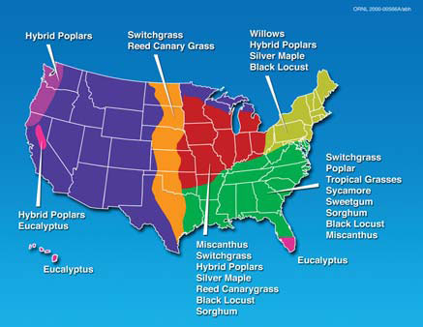

*(*[*https://web.extension.illinois.edu/ethanol/cellulosic.cfm*](https://web.extension.illinois.edu/ethanol/cellulosic.cfm)*)*

The production value from using such cellulosic sources as switchgrass, as compared with corn (using the food—corn kernels) is shown here:

1 acre of corn = 150–300 bushels of corn = 420–840 gallons of ethanol

vs.

1 acre of grass = 5–15 tons of plant material = 150–1200 gallons of ethanol

And of course, switchgrass is a plant not in competition with a food crop such as corn. Further, switchgrass does not require the expense of both fertilizer and irrigation, as is true with cultivated corn, because switchgrass grows naturally “in the wild” throughout the Midwest and west.

**More on the chemistry of biodiesel**

A second biofuel that is becoming more important as a fossil fuel replacement is biodiesel, produced primarily from the oils removed from a variety of photosynthesizers, including algae (some species affectionately referred to as “pond scum”) and traditional oil plants such as palm, canola and soybean.

Green diesel is a very interesting product derived from biomass. It is made from renewable feedstock and is combined with regular diesel fuel. It is produced from oils which, in turn, are derived from plants, hence back to the biomass. In Europe, this is the preferred fuel for vehicles that use diesel fuel and is much less expensive. While it can be mixed with regular diesel, it is recommended that it only be 15% of the mixture.

(<http://www.biomass.net/>)

Overall, the oils removed from the plant source are converted to biodiesel through several chemical reactions.

Biodiesel from plant-derived oils is based on the standard chemical process of esterification. Essentially, one combines an oil with an alcohol in the presence of some alkali such as sodium or potassium hydroxide. Heating the mixture converts the oil into an ester (the biodiesel) and glycerol. As will be referenced later, students can easily perform this experiment in the laboratory. [Reaction of vegetable oil with alkali is shown below.]

Vegetable oil, like biodiesel, belongs to a category of compounds called *esters*.

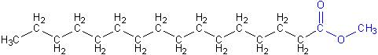

Molecule of biodiesel (with ester group in blue):

diesel-molecule

Molecule of regular diesel, a hydrocarbon

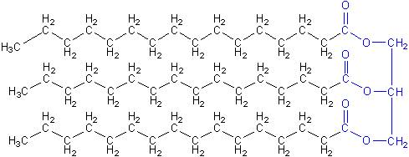

Molecule of vegetable oil

Therefore, converting vegetable oil into biodiesel is called a *trans-esterification reaction*. Doing this reaction requires using methanol (shown in green [in the diagram below]), which causes the red bonds in the structure below to break. This breaks off the blue section, like a backbone on the molecule, which becomes glycerol. The red bonds that did go to the glycerol backbone are [re]placed with bonds to methoxy groups (shown in green in the final structure) that came from the methanol:”

(Teacher’s Guide accompanying the April 2011 ChemMatters article: Nolte, B. Tanking up with Cooking Oil. *ChemMatters,* 2011, *29* (2), pp 5–7)

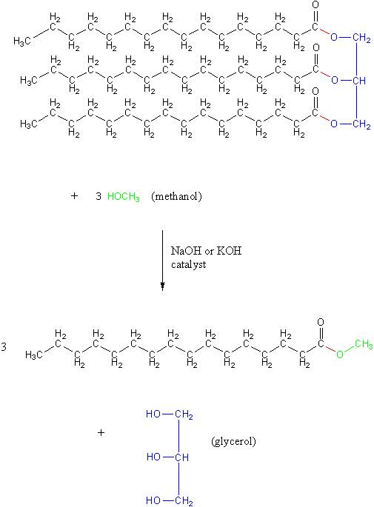

(Goshen College Department of Chemistry Web site, [*http://www.goshen.edu/chemistry/biodiesel/chemistry-of/*](http://www.goshen.edu/chemistry/biodiesel/chemistry-of/)*)*

**More on biodiesel using algae**

As with the production of ethanol from non-food crops, there is a focus on using raw materials that are not food substances to make biodiesel. Therefore, in comparing a food crop such as soybeans with algae, production figures give an added incentive to use algae rather than soybeans.

|  |  |  |  |  |
| --- | --- | --- | --- | --- |
|  | **Soybeans** | **Algae** | | |
| **Productivity** |  | Low | Medium | High |
|  |  | 10 g/m2/day | 25 g/m2/day | 50 g/m2/day |
|  |  | 15% TAG | 25% TAG | 50% TAG |
| **Gal/acre** | 48 | 633 | 2637 | 10,549 |
| **Total Acres** | 63.6 million | 63.6 million | 25 million | 6.26 million |
| **Gal/Year** | 3 billion | 40 billion | 66 billion | 66 billion |
| **%Petrodiesel** | 4.5% | 61% | 100% | 100% |

NOTE: TAG is Triacylglycerols

*(*[*http:/****/w****ww.afdc.energy.gov/afdc/pdfs/microalgal\_biofuels\_darzins.pdf*](http://www.afdc.energy.gov/afdc/pdfs/microalgal_biofuels_darzins.pdf)*, p.434)*

There are many benefits from using algae as the source of plant lipids for conversion to biodiesel. Cultivation of algae is done in water rather than growing on land, obviously. The cultivation is done in closed-loop structures to eliminate contamination from other air-borne algae. With these closed loop set-ups, cultivation is under controlled conditions of temperature, light intensity, carbon dioxide concentrations (higher than from the normal atmosphere), pH, and nutrient levels. Certain physical arrangements also increase the surface area exposed to light using transparent vertical growing tubes. (See video, <http://www.5min.com/Video/Algae-as-a-Green-Solution-to-the-Worlds-Energy-Problem-255719725>.)

Another comparison between growing algae for oil rather than using land crops in terms of productivity is shown here. Algae (and other photosynthetic microbes) produce as much as 200 times the amount of oil compared with soybean.

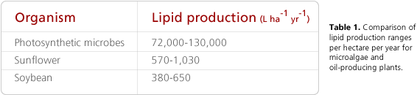

*(*[*http://biofuels.asu.edu/tubes.shtml*](http://biofuels.asu.edu/tubes.shtml)*)*

In the USA, the primary feedstock for making biodiesel has been soybean. There was a total of 803 million pounds of feedstocks used to produce biodiesel in November 2015. Soybean oil remained the largest biodiesel feedstock during November 2015, with 464 million pounds consumed for that purpose. (<http://www.eia.gov/biofuels/biodiesel/production/>)

Currently, the search is on for the most economical methods for both producing the oil and converting it to biodiesel. …there is currently keen interest in the use of algae rather than food crops such as soybean and canola seed. Further there is a good argument to locate these algae-culturing units close to a source of carbon dioxide such as a power-generating plant that burns coal, oil, or natural gas. The algae cultures become a carbon sink for the emissions of the electricity generating plant, therefore adding a second dimension to developing oils for fuel. One of the current U.S. government policies concerning the production and use of biofuels is that these fuels must achieve at least a 50% reduction in life-cycle greenhouse gas emissions. This is not possible using fossil fuels since these fuels, although plant derived, are not currently utilizing carbon dioxide in their production! They simply produce carbon dioxide in their combustion. Presently living plants that eventually become biofuels absorb as much if not more carbon dioxide than they eventually produce if “burned” or “biologically decomposed.”

(Teacher’s Guide accompanying the April, 2011 *ChemMatters* article: Nolte, B. Tanking up with Cooking Oil. *ChemMatters*, 2011, *29* (2), pp 5– 7)

According to Sapphire Energy, a producer of algae-derived biodiesel, another major benefit of algae as a fuel feedstock is its massive consumption of carbon dioxide. In the Sapphire process, 1 kilogram of algae biomass uses (consumers) 1.8 kilograms of CO2. About 50 percent of that algal biomass is oil, so the production of each gallon of oil consumes 13 to 14 kilograms of the greenhouse gas.

The Energy Independence and Security Act of 2007, a Federal energy law, requires that 36 billion gallons of renewable biofuels be produced. The law also caps corn ethanol production at 15 billion gallons a year by 2015 and requires the remaining 21 billion gallons of renewable fuels to come from advanced biofuels, including 17 billion gallons from cellulosic biofuels and biodiesel (which could include algae). And there are several companies, including Sapphire Energy, that are ramping up algae-based biodiesel production. The Sapphire company (backed by groups such as the Rockefeller Foundation and the Bill & Melinda Gates Foundation), expects that it will be producing more than 100 million gallons a year by 2018 and 1 billion gallons a year by 2020—enough to meet almost three percent of the U.S. renewable fuel standard (RFS) of 36 billion gallons. And more importantly, Sapphire says its technology is unique because it produces a fuel that can be used with existing U.S. pipelines, refineries, cars, trucks and airplanes. (<http://www.scientificamerican.com/article/algae-biofuel-of-future/>)

Here is a list of pros and cons for algae-based biofuels.

**Pros**

* Bio-based fuel with essentially carbon neutral combustion
* Drop in replacement for petroleum-based liquid fuels
* Inherently renewable
* Absorbs carbon dioxide as it grows
* Both waste CO2 and wastewater can be used as nutrients
* Higher energy per-acre than other bio-fuels
* Can be grown on land unsuitable for other types of agriculture
* Scalable: Study found that 17 percent of U.S. oil imports could be met with algae
* Investments are being made
* Production is presently scaling up (Navy buying 100,000 gallons this year)
* Research has been underway for 50 years

**Cons**

* Need to be grown under controlled temperature conditions
* Requires a considerable amount of land and water
* Cold flow issues with algal biofuel
* Some researchers using genetic engineering to develop optimal algae strains
* Requires phosphorus as a fertilizer which is becoming scarce
* Fertilizer production is carbon dependent
* Relatively high upfront capital costs
* Not clear yet what the ultimate cost per gallon will be. Presently too high.

In summary, algae-based bio-fuel is a promising energy source that is in the latter stages of development. A number of issues related to the ultimate cost of the product need to be resolved, but there is a good deal of research money going into this as production is beginning to scale up. Land issues can be addressed using marginal land. Water can be recycled in reactors. Cold flow issues might result in the fuels being blended with other fuels or possibly additives. Fertilizer issues could be addressed using waste streams, thereby recycling the critical nutrients.”

(<http://www.triplepundit.com/special/energy-options-pros-and-cons/algae-based-biofuel-pros-cons/>)

**More on** **extracting oil from algae**

Extraction of oil from algae can be done by one of three ways—use of an oil press, use of supercritical fluids, and use of the solvent hexane. The use of an oil press is the most direct way to extract the oil from algae, with a yield of some 75%. The supercritical fluids extraction technique involves both multiple steps and more expense in terms of equipment. Although this method can extract 100% of the oil, it is not as popular a process because of the equipment involved. Using hexane as the extractor is a two-step process. First is the use of the press, then residual oil in the algae residue is removed using the solvent hexane. The liquid mixture is then filtered. This extraction process has a yield of about 95%, though it is more expensive compared with just pressing alone and easier to use than the supercritical fluids extraction method.

**More on** **methane as a biofuel**

Another biofuel from biologically degradable substrate is methane. It is also found in association with underground oil and coal. But producing methane without a fossil fuel source is possible through anaerobic decay of organic matter. The two primary sources of the organic material used in anaerobic decay are from landfill refuse (“garbage”) and animal waste (manure). The production of the methane is done through reliable methods that have been in place for several decades at a minimum. The map below shows landfill operations in the U.S., both active and projected.

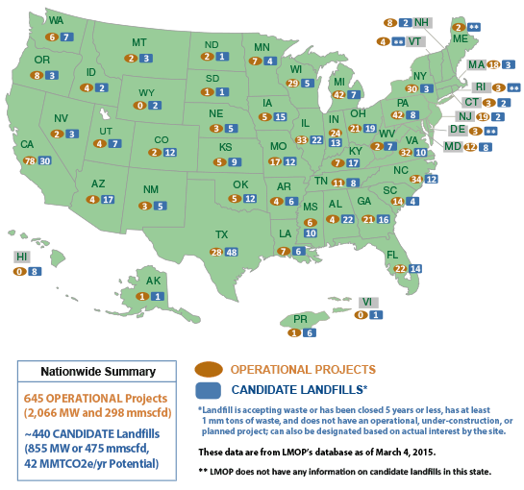

Production of methane from landfills in the USA; (As of March 2015, there are 645 operational

LFG [landfill gas] energy projects in the United States and approximately 440 landfills that are good candidates for projects.)

*(*[*http://www3.epa.gov/lmop/projects-candidates/index.html*](http://www3.epa.gov/lmop/projects-candidates/index.html)*)*

Capturing methane from both landfills and dedicated methane generators using animal manure means that this greenhouse gas (GHG), which is considered more deleterious than carbon dioxide, is not released into the atmosphere. Obviously the methane gas is a useful fuel, primarily for producing heat.

Manure is easily collected on dairy farms where cows are routinely confined. Biogas is most efficient when used directly for heating, and dairy farms have a year-round demand for hot water. A very complete and interesting paper about cow manure methane generators from Penn State can be accessed from <http://extension.psu.edu/natural-resources/energy/waste-to-energy/resources/biogas/projects/biogas-from-manure> . Among other things is the inclusion of a number of interesting historical facts about public use of methane generators in different European countries, starting in the latter part of the 19th century.

The chemistry involved in the anaerobic digestion of manure is described as follows:

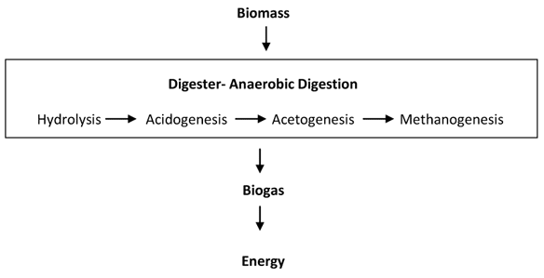

*(*[*http://www.e-inst.com/biomass-to-biogas/*](http://www.e-inst.com/biomass-to-biogas/)*)*

The details of the outline are as follows:

The anaerobic digestion process occurs in two stages. The volatile solids in manure are initially broken down to a series of fatty acids. This step is called the acid-forming stage and is carried out by a particular group of bacteria, called acid formers. In the second stage, a highly specialized group of bacteria, called methane formers, convert the acids to methane gas and carbon dioxide.

(<http://extension.missouri.edu/publications/DisplayPub.aspx?P=G1881>)

Methanogenesis constitutes the final stage of anaerobic digestion in which methanogens create methane from the final products of acetogenesis as well as from some of the intermediate products from hydrolysis and acidogenesis. There are two general pathways involving the use of acetic acid and carbon dioxide, the two main products of the first three steps of anaerobic digestion, to create methane in methanogenesis:

CO2 + 4 H2 → CH4 + 2 H2O

CH3COOH → CH4 + CO2

While CO2 can be converted into methane and water through the reaction, the main mechanism to create methane in methanogenesis is the path involving acetic acid. This path creates methane and CO2, the two main products of anaerobic digestion.

(<http://www.e-inst.com/biomass-to-biogas/>)

The anaerobic process depends on methane formers because they are more environmentally sensitive than acid formers. Methane bacteria are strict anaerobes and cannot tolerate oxygen in their environment. They function best at 95 degrees Fahrenheit; therefore to obtain maximum gas production, heat usually must be added to a digester.

Methane bacteria are slower growing than acid-forming bacteria and are extremely pH-sensitive (pH 6.8-7.4 optimum). The acid formers will grow rapidly if an excess of organic material is fed to a digester, producing an excess of volatile acids. The accumulated acids will lower the pH, inhibiting the methane bacteria and stopping gas production. To help buffer the system against increases in acids, high alkalinity must be maintained. Lime has been added to digesters during start-up or periods of slug loading to maintain pH control.

A variety of materials can become toxic to anaerobic bacteria — salts, heavy metals, ammonia and antibiotics. Bacteria require minimum amounts of salts for optimum growth. However, if salts are allowed to accumulate beyond bacterial requirements, they can become toxic and inhibit digestion.

Soluble heavy metals (copper, zinc, nickel) may be toxic to digester bacteria. Most heavy metals can be precipitated out with sulfides and will cause no problems in the sludge. Livestock feeds containing significant amounts of heavy metals may require special attention.

Most livestock manure (particularly swine and poultry) contain appreciable amounts of nitrogen, which will be converted to ammonia in the digester. Most of the ammonia will accumulate in the digester material and will become toxic if not controlled. Ammonia toxicity is a major concern in the anaerobic digestion of livestock manure. To avoid the problem, loading rates must be carefully controlled.”

(<http://extension.missouri.edu/publications/DisplayPub.aspx?P=G1881>)

[NOTE: Humphrey Davey conducted the first laboratory experiments on the anaerobic digestion of manure to produce methane in 1808.]

Methane gas generators using animal manure have been in use for individual households in any number of developing countries, but in particular in India and China, as well as some countries in Africa. The design of the generator includes a floating “lid” that both seals the decaying matter from the atmosphere as well as allowing for expansion of the accumulating gas volume. The key to successful production of gas is to keep the carbon-to-nitrogen ratio at the optimum, determined by a slowdown of gas generation. At that point an “operator” adds a carbon source, usually just some plant material rather than more animal manure which is higher in nitrogen than carbon. An added benefit from using a manure-fueled methane generator is that the residual organic matter is a high quality material for returning to the fields as a fertilizer.

**More on water usage in agriculture**

Although the idea of producing ethanol often has a focus on the energy cost of the production process, from cultivation and harvest of the plant materials (corn, soybean, switchgrass) to the fermentation process, there is also the consideration of how much water is involved other than what is provided by the natural water cycle (i.e., rain!). In the cultivation of algae for biodiesel and ethanol production, the water is recycled, which is a decided advantage compared with soil cultivation of crops used for the same energy products. For growing corn and soybeans in the Midwest U.S., irrigation is often used. So the water usage costs have to be calculated into the expense of producing ethanol.

How much of that irrigation water is recaptured in underground storage (aquifer recharge) is an issue that has become paramount in the agriculture sector—look at the situation in California. In the Midwest, many aquifers are being pumped dry. Again, the argument for using switchgrass and algae as biofuel material, rather than corn or soybeans, can be made from the standpoint of water usage as well as other cultivation costs (fertilizer and fuel for cultivation devices; i.e., machinery).

# Connections to Chemistry Concepts

**(for correlation to course curriculum)**

1. **Properties of materials**—Carbon Dioxide’s ability to absorb and re-emit infrared radiation, increasing and decreasing, respectively, its vibrational frequencies, is why CO2 is a greenhouse gas. That’s why we need to use biofuels, rather than fossil fuels, to effectively eliminate new CO2 from the atmosphere. Combustion of biofuels approaches a zero-sum game, using as much CO2 to grow them as they produce when burned.
2. **Rates of reactions**—Since there is a series of biochemical reactions involved in producing biofuels, the rates of these reactions are dependent upon such factors as temperature, pH, and the presence of certain catalysts (enzymes).
3. **Enzymes (catalysts)**—Many biochemical reactions involved with producing biofuels such as ethanol are dependent on enzymes. The success in freeing up the sugars in cellulose for fermentation is dependent on specific enzymes that are inexpensive to produce. (There is a DuPont video on the basics of enzymes at <https://www.youtube.com/watch?v=XRbd1IWRW4I>.
4. **Alcohols**—This category of organic compound is a desirable biofuel if it can be produced economically, making it competitive with fossil fuels.
5. **Organic molecules**—These carbon-containing molecules are the primary category of biofuel chemicals including ethanol, methane, and the oils of biodiesel.
6. **Hydrocarbons**—This particular category of carbon-based molecules is the primary component of fossil fuels. These types of molecules are good fuels because of the carbon-hydrogen content that leads to production of water and carbon dioxide with a net delta H that is negative. (Coal, which is essentially pure carbon and not a hydrocarbon, produces less energy per mole because of the lack of hydrogen for producing water.)
7. **Distillation**—The fuel-producing industry is dependent upon the distillation process to separate the distinctive fuel products from both each other and sometimes from the starting reactant materials.
8. **Esterification**—Because lipids (plant oils) contain triacylglycerols or triglycerides, these molecules can be broken apart using an alcohol in a basic reacting environment (the esterification process) to form a molecule dubbed biodiesel (the ester), and glycerin which can be used in the soap-making industry as well as an additive to animal feed.

# Possible Student Misconceptions

**(to aid teacher in addressing misconceptions)**

1. **“Alcohol for drinking is produced by the distillation process.”** *Alcohol for drinking is produced by the fermentation process which utilizes yeast for the conversion of plant sugars into ethanol and carbon dioxide. The distillation process is used to separate the alcohol from water, producing a concentrated ethanol.*

# Anticipating Student Questions

**(answers to questions students might ask in class)**

1. **“Why can some animals like cows and sheep eat and digest cellulose-containing plants, but humans cannot?”** *The difference between these two situations is that humans lack the enzyme cellulase needed to digest the cellulose (i.e., to chemically break the bonds between the sugars of the cellulose polymer). The enzyme cellulase is provided in cows and sheep by certain protozoans and bacteria that dwell in their digestive system.*
2. **“How does the octane rating of alcohol compare with that of gasoline?”** *E85, a gasoline mixture of 53–83% alcohol with the rest as gasoline, has higher octane than unleaded gasoline (94–96 octane, compared to 87 for unleaded or 91–93 for premium), which results in a power increase of**approximately five horsepower. So performance could actually improve, although gas mileage would decrease. An interesting fact about pure alcohol as a fuel is that ethanol has been recognized as a high-octane fuel for over 100 years. And in the 1920s and 1930s it was commonplace to find “corn alcohol” fuel pumps alongside gasoline pumps, to fuel Detroit’s new high-compression engines. In addition, ethanol is considered an oxygenated fuel which means the gasoline-alcohol blend produces less polluting tailpipe emissions. Note that E85 (or pure ethanol, for that matter) cannot be used in today’s standard automobile engines.*
3. **“Does using a gasoline-alcohol blend such as E85 affect a car’s miles-per-gallon (MPG)?”** *Using a blended gasoline does reduce MPG in a car. However, less pollution results and the cost per gallon is less than pure gasoline. So in terms of cost, it is a wash, so to speak.*
4. **“Does making ethanol require more energy than found in the fuel itself?”**

*Ethanol production results in a net energy gain—according to some authoritative life-cycle analyses—producing about 67 percent more energy than it takes to grow and process the corn into ethanol. The "energy balance” often quoted can be misleading, since the ethanol industry is changing rapidly to capture further efficiencies and produce more value-added products from the grain feedstocks. One of the ways to increase this efficiency is to create cellulosic ethanol from the co-product DDGS (distiller's dried grains with solubles). DDGS is the nutrient rich co-product of dry-milled ethanol production, which is already at the ethanol plant and use the corn cobs and corn stover (leaves and stems) as fuel instead of natural gas*. (<http://web.extension.illinois.edu/ethanol/>)

1. **“What is the basic chemistry behind detecting alcohol on exhaled breath?”** *There are several methods to detect if a person has been drinking alcohol (ethanol). The older way is to react orange dichromate with a sample of exhaled air. If ethanol is present, it will reduce the chromate from the orange color to green. The newer method uses a device containing a fuel cell which is able to generate a current when hydrogen is removed from the alcohol molecules as protons (oxidation by one of two platinum electrodes), creating acetic acid and free electrons. The electrons flow in the device’s circuit creating a current. The size of the current is directly related to the amount of alcohol oxidized; a microprocessor in the device calculates the amount of alcohol in the breath sample.*

# In-Class Activities

**(lesson ideas, including labs & demonstrations)**

1. A fermentation lab activity that is set up as an investigation for students is found at <https://biology.mit.edu/sites/default/files/fermentation_challenge.pdf>. This Web site also includes a teacher’s guide (with lab prep notes) and questions for students.
2. When discussing Hess’s Law, you can have students calculate and compare energies from the combustion of ethanol vs. straight gasoline (as pure octane). Using equations for combustion, convert energy per mole to energy per gram of fuel for comparing the two fuels. What would be the energy potentially available in one gallon of each of the two fuels?
3. Students can do calorimeter measurements in the lab of three fuels—butanol, ethanol, and kerosene (consider it to be a mixture of hydrocarbons with a collective formula of C10H22). Use fuel containers with wicks for burning the fuel to heat the water calorimeters (aluminum soda cans). These wick burners are used in bacteriology labs for flame sterilization of inoculating needles. (An example of the fuel burner is found at <http://www.carolina.com/laboratory-burners/alcohol-lamp-with-metal-cap/FAM_706604.pr>.)
4. Illustrate the basic ideas behind distillation (used in the fuel-producing industry) as a separation process, based on differences in boiling points of different liquids.
5. A mixture of different alcohols such as methanol, ethanol, butanol, and glycerol (along with some blue dye) can be used. Commercial distillation glassware with a cooling column is the best equipment. Prior to doing the distillation, have students test each alcohol for its boiling point, using a side arm flask with a rubber-stoppered thermometer inserted into the top opening of the flask.
6. A distillation lab for separating salt water is found at <http://facweb.northseattle.edu/amohamed/CHEM%20102N/Labs/Lab%202_Purification%20of%20water.pdf>.
7. And a third lab for distilling out some of the contents of Cherry Coke (requiring less sophisticated lab equipment) is found at <http://wayback.archive-it.org/2118/20100925031545/http://64.251.202.97//EducationalServices/pharm/chemo/activity/sep.htm> (contains student and teacher version) and <https://www.learner.org/workshops/chemistry/support/act5_b1.pdf>.
8. A fairly simple lab procedure that produces biodiesel from vegetable oil is found at <http://coloradocast.org/userfiles/Making%20Biodiesel%20in%20the%20Chemistry%20Classroom.pdf>. This lab exercise involves a number of different analytical activities which can be optional to the actual biodiesel synthesis activity, listed as Activity Two. A similar biodiesel lab activity is found at <http://diesel.btc.edu/Biodiesel/Biodiesel%20Lab%20Experiment%202.doc>.

# Out-of-Class Activities and Projects

**(student research, class projects)**

1. Students can research the issue of food vs. fuel from farm crops. What safeguards are in place to keep the commercial exploitation of crops for biofuels from creating both shortages of food crops and resultant price increases for that food?

# References

**(non-Web-based information sources)**

**The references below can be found on the   
*ChemMatters* 30-year DVD, which includes all articles   
published from the magazine’s inception in October 1983 through April 2013, all available Teacher’s Guides, beginning February 1990, and 12 *ChemMatters* videos. The DVD is available from the American Chemical Society for $42 (or $135 for a site/school license) at this site:** [**http://ww.acs.org/chemmatters**](http://www.acs.org/chemmatters)**. Scroll all the way down to the bottom of the page and click on the icon at the right, “Get the past 30 Years of *ChemMatters* on DVD!”**

**Selected articles and the complete set of   
Teacher’s Guides for all issues from the past three   
years are available free online at the same Web site, above. Click on the “Issues” tab just below the logo, *“ChemMattersonline”*.**



***30* Years of *ChemMatters!***

Available Now!

In the April 2005 issue, there is a very detailed article on biodiesel—its chemistry, synthesis, and the rationale for this particular biofuel. (Kirchhoff, M. Do You Want Biodiesel With That? *ChemMatters*, 2005, *23* (2), pp 7–9.

The April 2005 Teacher’s Guide accompanying the above article is useful for additional teaching resources, including background information on biodiesel, some in-class activities including labs, and a number of video sources to illustrate the production of algae as a source of oil to be converted to diesel fuel.

A different approach to creating gasoline, rather than ethanol from plant sugars, is found in this reference: Schirber, M. Green Gasoline—Fuel from Plants. *ChemMatters****,*** 2010, *28* (1), pp 13–15.

The Sherwood article mentions the concern about global warming and the need for reducing the amount of carbon dioxide in the atmosphere. This article details the sequestering of carbon dioxide in underground rock formations. (West, K. Clean Coal: Cleaning Up Its Act. *ChemMatters*, 2010, *28* (2), pp 8–9)

Another article on biodiesels details the use of cooking oil (which is derived from corn or soybeans, usually) for making biodiesel, which is still considered a useful biofuel. (Nolte, B. Tanking Up With Cooking Oil. *ChemMatters,* 2011, *29* (2), pp 5–7.

The Teacher’s Guide for the April 2011 article above contains additional resources related to biodiesel. Besides the background material concerning the conversion of corn oil into biodiesel, there are a number of in-class activities including lab activities, one of which details how students can make biodiesel fuel. Another activity described is the making of ethanol through fermentation.

For the production of both ethanol and biodiesel, the up-and-coming source for these two categories of fuel is algae. (Hill, M. From Fish Tank to Fuel Tank. *ChemMatters*, 2012, *30* (2), pp 12–14)

The April 2012 Teacher’s Guide that accompanies the article above provides additional background material on the broader subject of biofuels.

# Web Sites for Additional Information

**(Web-based information sources)**

**More sites on the** **rationale for corn stover cellulose**

This site from DuPont is an important source of data and rationale for using corn stover as a cellulose source for producing ethanol: <http://www.dupont.com/content/dam/dupont/products-and-services/industrial-biotechnology/documents/IB-PDF-01_Pioneer_Crop_Insights.pdf>.

A video (5:24 minutes) on harvesting and processing corn stover can be accessed at <https://www.youtube.com/watch?v=qiSt9CghPeQ>.

Another video (6:02) on how corn residue is harvested is found at <https://www.youtube.com/watch?v=7-xICmMTDiA>.

Several videos from DuPont on the program for harvesting corn stover are found at <http://www.dupont.com/products-and-services/industrial-biotechnology/videos/collaborating-for-cellulosic-ethanol-reality.html>.

**More sites on** **operating a cellulosic ethanol facility**

A (4:38) video found at <https://www.youtube.com/watch?v=77Mu-0fGJ2s&feature=youtu.be> will be very useful for in-class instruction on how a commercial company (DuPont) converts corn stover into ethanol.

Purdue University provides a descriptive outline of the total process for producing cellulosic ethanol at <https://ag.purdue.edu/extension/renewable-energy/Documents/Bioenergy/ID-335.pdf>.

A 30-second video that illustrates the total process of converting cellulose to sugars and subsequent fermenting and distilling is found at <http://www.nrel.gov/biomass/biochemical_conversion.html>.

A reference on ethanol and various cellulose sources other than corn plants is found at

<https://web.extension.illinois.edu/ethanol/cellulosic.cfm>. Some of the topics at this university Web site, with references, include:

* “What is it (ethanol)?”
* “Ethanol Use in Motor Vehicles”
* “Biofuels and the Consumer”
* “Food and Fuel Issues”
* “Water Use for Ethanol Production” – an issue under reported
* “The Future of Ethanol: Cellulosic”

An interactive world map shows the different types of crops that can be used for cellulosic ethanol. (<http://www.dupont.com/products-and-services/industrial-biotechnology/advanced-biofuels/articles/global-sources-of-biomass.html>)

Another Web site that provides many details on all aspects of cellulosic ethanol including the costs, analysis of the issues and problems, and projected future needs for this particular fuel is found at <http://www.c2es.org/technology/factsheet/CellulosicEthanol>.

A “super-duper” Web site from the government on all aspects of cellulosic ethanol is found at <http://www.nrel.gov/biomass/pdfs/40742.pdf>. The source is filled with many useful facts and figures.

A government report on a 2015 workshop/conference concerning the current and future status of lignocellulosic biomass for advanced biofuels and bioproducts is found at <http://genomicscience.energy.gov/biofuels/lignocellulose/BioenergyReport-February-20-2015LR.pdf>.

A good two-page, illustrative schematic of DuPont’s harvest program can be found at <http://www.dupont.com/content/dam/dupont/products-and-services/industrial-biotechnology/documents/IB-PDF-04-Feedstock_Collection_Program_2015.pdf>.

DuPont also provides this infographic of data on the harvesting of corn stover at <http://www.dupont.com/content/dam/dupont/products-and-services/industrial-biotechnology/documents/IB-PDF-02_Commercializing_CE_Iowa.pdf>.

**More sites on** **biofuels.**

A long video (43:42) on the state of matter with regard to alternative energy, including biofuels, is found at <https://www.youtube.com/watch?v=2tEtgBRoUbg>. The first 15 minutes is probably the most useful part of the video. This video could be used in class as an introduction biofuels.

A short (0:48) video on the conversion of microalgae to biodiesel is available at <http://www.nrel.gov/biomass/microalgal_biofuels.html>. It is part of an informative Web site about biomass for fuel.

**More sites on the chemical details of methane generation**

A good site for the details on the chemistry of anaerobic generation of methane gas is found at <http://www.e-inst.com/biomass-to-biogas/>.

**More sites on commercial algae production**

A 3:46 video clip showing the setup for commercial algae-growing is found at <https://www.youtube.com/watch?v=k4z7p8-4oGo>. This is a useful visual presentation for the classroom.

An important 2016 commercial algal biofuel company is described at <http://www.sapphireenergy.com/sapphire-renewable-energy/>. Their news and media section contains the parameters for efficient algae production under the guise of looking for a new “home” to purchase for algae production, not human habitation.

A good short (2:34) video clip on the basics of making biofuel from algae is found at the government Web site, <http://energy.gov/articles/energy-101-algae-fuel>.

A short (1:58) video showing a scale model for converting algae to petrol is found at <https://www.youtube.com/watch?v=Qs0QZJ0rea0>.

Another related video (3:12) can be accessed at <https://www.youtube.com/watch?v=QP_HbQ5cWSk>. This video from a commercial company, Algae.tec shows a different physical setup for growing algae.

**More sites on** **the issue of greenhouse gases in agriculture**

Agriculture as one of the principle sources of biofuels is also the locus for controlling production of greenhouse gases. Both plants and soil are primary chemical sinks for carbon dioxide. But the agriculture sector can also be a source of carbon dioxide. The following reference details the many ways in which agricultural practices are central to the control of carbon dioxide in the atmosphere: <http://www.c2es.org/technology/overview/agriculture>.