logo_chemmatters[1]

**April/May 2016 Teacher's Guide for**

***A Close-Up Look at the Quality of Indoor Air***

**Table of Contents**

[About the Guide 2](#_Toc446168199)

[Student Questions 3](#_Toc446168200)

[Answers to Student Questions 4](#_Toc446168201)

[Anticipation Guide 5](#_Toc446168202)

[Reading Strategies 6](#_Toc446168203)

[Background Information 9](#_Toc446168204)

[Connections to Chemistry Concepts 34](#_Toc446168205)

[Possible Student Misconceptions 34](#_Toc446168206)

[Anticipating Student Questions 35](#_Toc446168207)

[In-Class Activities 36](#_Toc446168208)

[Out-of-Class Activities and Projects 37](#_Toc446168209)

[References 38](#_Toc446168210)

[Web Sites for Additional Information 39](#_Toc446168211)

[More Web Sites on Teacher Information and Lesson Plans 42](#_Toc446168212)

# About the Guide

Teacher’s Guide editors William Bleam, Regis Goode, Barbara Sitzman and Ronald Tempest created the Teacher’s Guide article material. E-mail: [bbleam@verizon.net](mailto:bbleam@verizon.net)

Susan Cooper prepared the anticipation and reading guides.

Patrice Pages, *ChemMatters* editor, coordinated production and prepared the Microsoft Word and PDF versions of the Teacher’s Guide. E-mail: [chemmatters@acs.org](mailto:chemmatters@acs.org)

Articles from past issues of *ChemMatters* can be accessed from a DVD that is available from the American Chemical Society for $42. The DVD contains the entire 30-year publication of *ChemMatters* issues, from February 1983 to April 2013.

The *ChemMatters* DVD also includes Article, Title and Keyword Indexes that covers all issues from February 1983 to April 2013.

The *ChemMatters* DVD can be purchased by calling 1-800-227-5558.

Purchase information can be found online at [www.acs.org/chemmatters](http://chemistry.org/chemmatters/cd3.html).

# Student Questions

**(taken from the article)**

**A Close-Up Look at the Quality of Indoor Air**

* + 1. How does indoor air become polluted?
  1. Why is it difficult to detect radon in your home?
  2. How does radon enter the soil?
  3. What is a “daughter product”?
  4. How do polonium-218 and polonium-214 cause cancer?
  5. Why are some substances volatile?
  6. List two reasons that new homes have higher levels of VOCs than older homes.
  7. Cite two reasons why formaldehyde is considered dangerous?
  8. Under what conditions does burning natural gas produce carbon monoxide?
  9. Provide two reasons for obtaining a blue flame in your Bunsen burner in the lab.
  10. Why is carbon monoxide toxic?
  11. What is the best way to eliminate VOCs from your home?

# Answers to Student Questions

**(taken from the article)**

**A Close-Up Look at the Quality of Indoor Air**

* + 1. **How does indoor air become polluted?**

*Indoor air becomes polluted by toxic gases and airborne irritants that originate from within a building or structure.*

* + 1. **Why is it difficult to detect radon in your home?**

*It is difficult to detect radon in your home because it is a colorless and odorless gas.*

* + 1. **How does radon enter the soil?**

*Radon enters the soil as a decay product of the uranium present in rocks and soil.*

* + 1. **What is a “daughter product”?**

*A “daughter product” is the element produced when a radioactive substance decays into other elements.*

* + 1. **How do polonium-218 and polonium-214 cause cancer?**

*Polonium-218 and polonium-214 cause cancer because when they are inhaled into the lungs, they decay, emitting alpha particles that damage the DNA of cells inside the lungs and cause mutations that can lead to cancer.*

* + 1. **Why are some substances volatile?**

*Some substances are volatile because the intermolecular forces between their molecules are weak. This means that even room temperature “… is enough to overcome these forces and release gaseous compounds into the air.”*

* + 1. **List two reasons that new homes have higher levels of VOCs than older homes.**

*Newer homes have higher levels of VOCs than older homes because*

1. *any component used to build a home can release harmful VOCs (e.g., particle board, insulation, paints); newer homes are likely to have more of these components than an older home, and*
2. *levels of VOCs dissipate in a home over time, so an older home will have fewer of them.*
   * 1. **Cite two reasons why formaldehyde is considered dangerous.**

*Two reasons that formaldehyde is considered dangerous are:*

1. *it is known to be a human carcinogen and*
2. *it is toxic if ingested.*
   * 1. **Under what conditions does burning natural gas produce carbon monoxide?**

*Carbon monoxide forms when the combustion of methane is incomplete (due to insufficient oxygen).*

* + 1. **Provide two reasons for obtaining a blue flame in your Bunsen burner in the lab.**

*We try to obtain a blue flame in our Bunsen burner because it ensures:*

* + - 1. *the hottest flame, and*
      2. *complete combustion.*
    1. **Why is carbon monoxide toxic?**

*Carbon monoxide is toxic because it binds readily to hemoglobin, displacing oxygen and, thus, causing suffocation.*

* + 1. **What is the best way to eliminate noxious chemicals from your home?**

*The best way to eliminate noxious chemicals from your home is to open the windows to displace the stale air.*

# Anticipation Guide

Anticipation guides help engage students by activating prior knowledge and stimulating student interest before reading. If class time permits, discuss students’ responses to each statement before reading each article. As they read, students should look for evidence supporting or refuting their initial responses.

**Directions:**  ***Before reading*,** in the first column, write “A” or “D,” indicating your agreement or disagreement with each statement. As you read, compare your opinions with information from the article. In the space under each statement, cite information from the article that supports or refutes your original ideas.

|  |  |  |
| --- | --- | --- |
| **Me** | **Text** | **Statement** |
|  |  | 1. Most indoor air pollutants come from the outside environment. |
|  |  | 1. Radon, the heaviest noble gas, is colorless and odorless. |
|  |  | 1. Radon is the leading cause of lung cancer in the United States. |
|  |  | 1. Alpha particles released in nuclear decay can damage the lungs. |
|  |  | 1. Volatile organic compounds (VOCs) can come from sublimation of chemicals used to manufacture products found in the home. |
|  |  | 1. Volatile compounds stay together through strong intermolecular forces. |
|  |  | 1. The concentration of VOCs is higher in older homes than in newer ones. |
|  |  | 1. Carbon monoxide is produced during incomplete combustion of compounds containing carbon. |
|  |  | 1. Blue flames indicate incomplete combustion. |
|  |  | 1. Carbon monoxide causes death by suffocation because it displaces the oxygen from hemoglobin. |
|  |  | 1. Scented candles and wood smoke cause similar health problems. |

# Reading Strategies

These graphic organizers are provided to help students locate and analyze information from the articles. Student understanding will be enhanced when they explore and evaluate the information themselves, with input from the teacher if students are struggling. Encourage students to use their own words and avoid copying entire sentences from the articles. The use of bullets helps them do this. If you use these reading and writing strategies to evaluate student performance, you may want to develop a grading rubric such as the one below.

|  |  |  |
| --- | --- | --- |
| **Score** | **Description** | **Evidence** |
| 4 | Excellent | Complete; details provided; demonstrates deep understanding. |
| 3 | Good | Complete; few details provided; demonstrates some understanding. |
| 2 | Fair | Incomplete; few details provided; some misconceptions evident. |
| 1 | Poor | Very incomplete; no details provided; many misconceptions evident. |
| 0 | Not acceptable | So incomplete that no judgment can be made about student understanding |

***Teaching Strategies:***

1. Links to **Common Core Standards for Reading**:

ELA-Literacy.RST.9-10.1:Cite specific textual evidence to support analysis of science and technical texts, attending to the precise details of explanations or descriptions.

ELA-Literacy.RST.9-10.5: Analyze the structure of the relationships among concepts in a text, including relationships among key terms (e.g., force, friction, reaction force, energy).

ELA-Literacy.RST.11-12.1:Cite specific textual evidence to support analysis of science and technical texts, attending to important distinctions the author makes and to any gaps or inconsistencies in the account.

ELA-Literacy.RST.11-12.4: Determine the meaning of symbols, key terms, and other domain-specific words and phrases as they are used in a specific scientific or technical context relevant to grades 11-12 texts and topics.

1. Links to **Common Core Standards for Writing**:

ELA-Literacy.WHST.9-10.2F: Provide a concluding statement or section that follows from and supports the information or explanation presented (e.g., articulating implications or the significance of the topic).

ELA-Literacy.WHST.11-12.1E: Provide a concluding statement or section that follows from or supports the argument presented.

1. **Vocabulary** and **concepts** that are reinforced in this issue:

Personal and community health

Reactive oxygen species

Fuel production and use

Molecular structures

Polymers

1. Some of the articles in this issue provide opportunities, references, and suggestions for students to do further research on their own about topics that interest them.
2. To help students engage with the text, ask students which article **engaged** them most and why, or what **questions** they still have about the articles. The Background Information in the *ChemMatters* Teachers Guide has suggestions for further research and activities.
3. In addition to the writing standards above, consider asking students to debate issues addressed in some of the articles. Standards addressed:

**WHST.9-10.1B** Develop claim(s) and counterclaims fairly, supplying data and evidence for each while pointing out the strengths and limitations of both claim(s) and **counterclaims** in a discipline-appropriate form and in a manner that anticipates the audience’s knowledge level and concerns.

**WHST.11-12.1.A** Introduce precise, knowledgeable claim(s), establish the significance of the claim(s), distinguish the claim(s) from alternate or opposing claims, and create an organization that logically sequences the claim(s), counterclaims, reasons, and evidence.

**Directions**: As you read, complete the graphic organizer below to compare different air pollutants.

|  |  |  |  |
| --- | --- | --- | --- |
|  | **Radon** | **Volatile organic compounds (VOCs)** | **Carbon monoxide** |
| **Source(s)** |  |  |  |
| **What health problems does it cause?** |  |  |  |
| **How can it be detected?** |  |  |  |
| **How can it be avoided?** |  |  |  |

**Summary:** On the bottom or back of this paper, write a short email to a friend explaining how to avoid indoor air pollution.

# Background Information

**(teacher information)**

**More on** **indoor air pollution─global concerns**

The adverse health effects from indoor air pollution extend well beyond those studied in the United States. Scientists are concerned about global health, particularly the health of people in third world countries. Approximately 50% of the world’s homes depend primarily on coal and biomass such as wood, animal dung and residue from crops to provide energy for indoor heating and cooking. The table below shows major indoor pollutants that cause global concerns and the sources of each of these fuels.

(<http://bmb.oxfordjournals.org/content/68/1/209.full>)

**Indoor air pollution: a global health concern**

**Table 1**

Major health-damaging pollutants generated from indoor sources

|  |  |
| --- | --- |
| **Pollutant** | **Major Indoor Sources** |
| Fine particles | Fuel/tobacco combustion, cleaning, cooking |
| Carbon monoxide | Fuel/tobacco combustion |
| Polycyclic aromatic hydrocarbons | Fuel/tobacco combustion, cooking |
| Nitrogen oxides | Fuel combustion |
| Sulphur oxides | Coal combustion |
| Arsenic and fluorine | Coal combustion |
| Volatile and semi-volatile organic compounds | Fuel/tobacco combustion, consumer products, furnishings, construction materials, cooking |
| Aldehydes | Furnishing, construction materials, cooking |
| Pesticides | Consumer products, dust from outside |
| Asbestos | Remodelling/demolition of construction materials |
| Lead\* | Remodelling/demolition of painted surfaces |
| Biological pollutants | Moist areas, ventilation systems, furnishings |
| Radon | Soil under building, construction materials |
| Free radicals and other short-lived, highly reactive compounds | Indoor chemistry |

\*Pb-containing dust from deteriorating paint is an important indoor pollutant for occupants in many households, but the most critical exposure pathways are not usually through air.

*(*[*http://bmb.oxfordjournals.org/content/68/1/209/T1.expansion.html*](http://bmb.oxfordjournals.org/content/68/1/209/T1.expansion.html)*)*

In the 1990s the term “disability-adjusted life year” (DALY) was developed as a measure for comparing overall health worldwide. One DALY represents one year of healthy life that has been lost to death or disability. When looking at populations, the perfect situation would be zero DALYs. This would mean that everyone lived to the age of their life expectancy and lost no healthy time due to suffering from a disease or disability. In other words, DALYs represent the distance between this perfect situation and the reality of premature deaths and disabilities within a population.

Public health officials measure DALYs using the population’s life-expectancy data and the level of disability. DALYs are calculated by combining the total number of Years of Life Lost (LLY) and the Years of Life Lost to Disability (YLD) using the formula:

DALY = YLL + YLD

(<http://www.who.int/healthinfo/global_burden_disease/metrics_daly/en/>)

[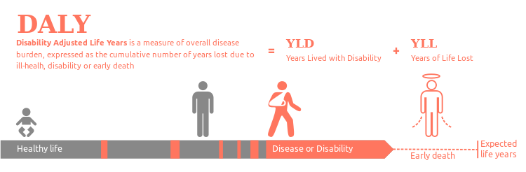](https://en.wikipedia.org/wiki/File:DALY_disability_affected_life_year_infographic.svg)

*(*[*https://en.wikipedia.org/wiki/Disability-adjusted\_life\_year*](https://en.wikipedia.org/wiki/Disability-adjusted_life_year)*)*

DALYs are considered a measure of the “burden of disease” expressed as the number of healthy years that a population has lost due to death or to disease or disability. The burden of disease is used by the World Health Organization (WHO) to measure the years of life lost to premature death and years of healthy life lost while health is impaired. (<http://www.who.int/topics/global_burden_of_disease/en/>)

The two graphs below show estimates in DALYs of the risk of indoor air pollution globally (1) and in India (2). The first graph estimates indoor smoke from the use of solid fuels in the home as the tenth risk factor globally. Note this data excludes risk associated with tobacco smoke.

1. **Global Burden of Disease**

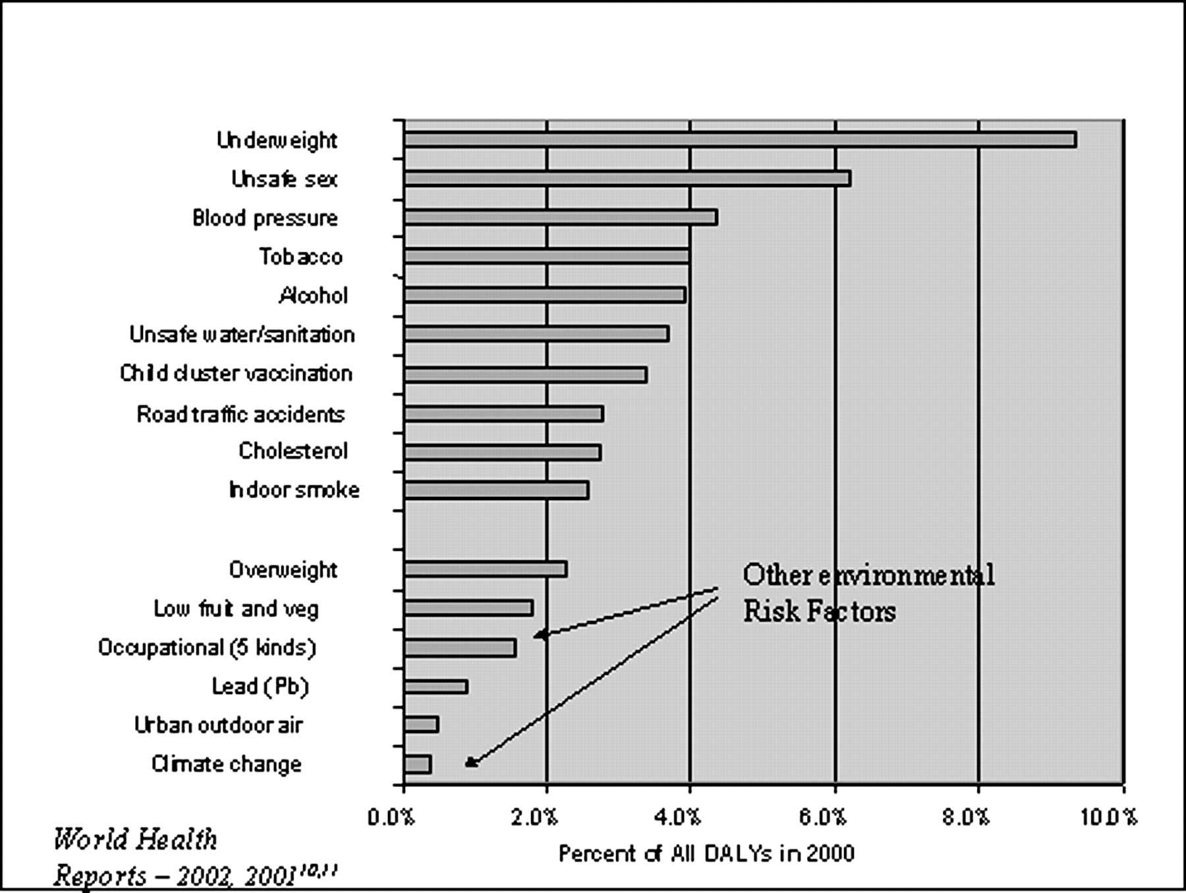

Global burden of disease from the top 10 risk factors plus selected other risk factors. Note: Indoor smoke category here includes only solid fuel use in households and not smoke from other fuels or tobacco.

*(*[*http://bmb.oxfordjournals.org/content/68/1/209/F1.large.jpg*](http://bmb.oxfordjournals.org/content/68/1/209/F1.large.jpg)*)*

In another study published in the November 2000 issue of the *Proceedings of the National Academy of Sciences*, the prior decade of work by epidemiologists was evaluated to compile the “National Burden of Disease in India from Indoor Air Pollution”. Seventy-five percent (75%) of the households used solid fuels for cooking and heating their homes. Scientists chose to study women and children under five years because they spend most of their time indoors exposed to polluted air.

The following figure estimates the total Indian national burden attributed to various disease risk factors. And, it highlights the substantial risk associated with indoor air pollution.

1. **Estimated Disease Severities for Women and Children in India**

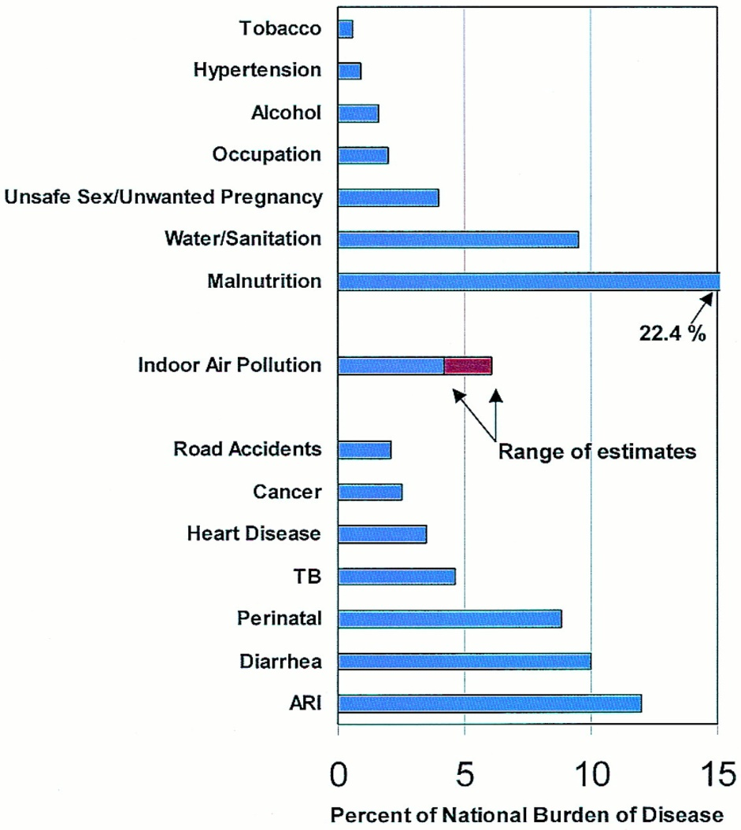

Estimated burden of disease (DALYs) in India for selected major risk factors and diseases compared with that from indoor air pollution.

*(*[*http://www.pnas.org/content/97/24/13286.long*](http://www.pnas.org/content/97/24/13286.long)*)*

WHO is an agency that was established by the United Nations (U.N.) in 1948. WHO works to improve international public health as well as to control or prevent the spread of communicable diseases throughout the world. In 2012, WHO estimated that almost three billion people who live in low- to middle-income countries lacked access to clean energy sources. They estimate that this resulted in about 4.3 million premature deaths worldwide from indoor air pollution. (<https://sustainabledevelopment.un.org/content/documents/1969Indoor%20Air%20Quality.pdf>)

**More on** **deadly London fog**

Analysis by researchers published in *Environmental Health Perspectives* and by the U.S. National Institutes of Health (NIH) describes the London fog of 1952 as, “one of history’s most important air pollution episodes in terms of its impact on science, public perception of air pollution, and government regulation.” In early December 1952, a temperature inversion trapped cold air near the earth’s surface. Polluted indoor air composed of emissions from coal-burning household stoves was trapped, along with the ground level air, to form a thick, deadly fog. As the weather became colder, people shoveled more coal on their fires, exacerbating the problem.

Up to this time little attention had been paid to a correlation between indoor air pollution and health. London’s mortality rate from December 1952 to March 1953 was 80% higher than for the same time in the prior year. The death rate for this time period was 13,500 deaths higher than what would have been considered normal for a similar period. At first the extremely high death rate was simply attributed to influenza, but further analysis showed this was not the cause. And although some of the outdoor air pollution was due to industrial emissions, the major contributor to the deadly fog was the polluted indoor air caused by burning coal in stoves, both for home heating and cooking.

Triggered by the Great London Fog, many cities in developed countries began banning the use of solid fuels for indoor use. This meant that households began switching from traditional solid fuels to modern electricity, liquids, petroleum gas, natural gas and heating oil to meet their energy needs, because fossil fuel gases and liquids emit less indoor pollutants than solid fuels. (<http://www.ncbi.nlm.nih.gov/pmc/articles/PMC1241789/pdf/ehp0112-000006.pdf>)

As these laws went into effect, “traditional” use of indoor solid fuels for heating and cooking was replaced by more efficient and cleaner fossil fuels. As a result, the indoor pollution risk decreased as shown on the graph below. At the same time in many countries, “modern” risks from the use of new materials, synthetic chemicals and climate-efficient dwellings increased indoor pollution as described in the Rohrig indoor air pollution article. VOCs from these newer materials appear to increase the risk of health problems such as asthma, autism, childhood cancer, and low sperm counts. The graph shows question marks at the end of each trend as the outcomes are unknown. To a certain extent the graph line path will depend upon how well building designers recognize and employ methods to reduce the risks of indoor air pollution. (<https://bmb.oxfordjournals.org/content/68/1/209.full>)

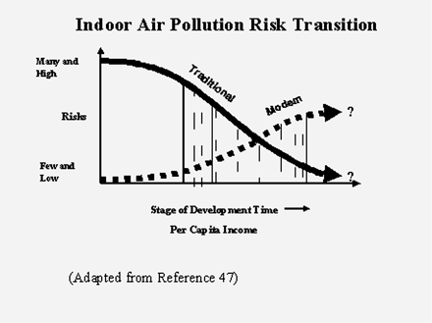

**Figure 2** Conceptualized indoor air pollution risk transition

*(*[*http://bmb.oxfordjournals.org/content/68/1/209/F1.large.jpg*](http://bmb.oxfordjournals.org/content/68/1/209/F1.large.jpg)*)*

The United Kingdom’s *Clean Air Act of 1956* created areas composed of some small towns and cities where only “smokeless” fuel could be used. In the 1990s Ireland prohibited the sale of bituminous (black, tarlike, smoky) coal in certain parts of the country. China’s ban of coal use and sales in 2000 targeted 113 large “key” cities. Today in Ulaanbaatar, the capital city of Mongolia, the condition is still a serious problem due to cold, calm weather coupled with indoor coal dependence.

*Environment and Climate Change in Bolivia* was written as a February 2013 policy brief by the University of Gothenburg and the Swedish University for Agricultural Sciences. Sweden’s Non-governmental Organizations (NGOs) have long been involved in addressing the challenges presented by extreme poverty and government instability in Bolivia.

Although Bolivia has developed the new “Bolivian National Development Plan”, it does not specifically address environmental problems. Almost 80% of the rural population still cook and heat their households with firewood and other solid fuel energy sources in poorly ventilated dwellings. The emissions from these fires are the key cause of respiratory infections that primarily affect those most exposed, women and young children. Note the blackened walls from open fires in the picture below. Swedish NGO volunteers see cleaner stoves, a switch from solid to gas energy sources and improved ventilation in homes as the best measures to reduce indoor air pollution. (<http://sidaenvironmenthelpdesk.se/wordpress3/wp-content/uploads/2013/06/Bolivia-Environmental-Policy-Brief-Final-May-2013.pdf>)

**Figure 1 A rural home in the highlands of Bolivia**

****

*(*[*http://www.who.int/bulletin/archives/78(9)1078.pdf*](http://www.who.int/bulletin/archives/78(9)1078.pdf)*)*

In contrast, government regulations in the United States are issued by the Environmental Protection Agency (EPA). In February 2015, the U.S. EPA revised its existing laws on the manufacture of wood burning heaters. The new guidelines are based on the use of advanced technology to manufacture wood-burning furnaces with cleaner emissions.

The new rules ensure that consumer options will be among cleaner-burning models. New models must be labeled to indicate that they have passed emission standards including testing for the presence of carbon monoxide. Since this legislation will not apply to older woodstoves, some cities, states and local districts have enacted their own, stronger regulations. To address this, the U.S. EPA states that federal standards will not replace stronger state or local regulations.

State and local requirements are frequently more stringent and involve banning the household use of wood- and coal-burning furnaces. Requirements issued by air quality management districts (AQMDs) often ban the use of indoor (and outdoor) wood-burning fireplaces on certain days or specific hours during the day, especially during poor air quality alert seasons. (<http://www.epa.gov/residential-wood-heaters/final-new-source-performance-standards-residential-wood-heaters>)

**More on the health impact of air pollution**

The 2012 WHO Report released in March 2014 reported that approximately seven million people died of exposure to polluted air in 2012. This number doubles previous estimates, and WHO considers air pollution to be the world’s largest single environmental health risk. WHO concludes that millions of lives can be saved by a reduction in air pollution. The WHO Report breaks down percentages of deaths by specific disease categories and separates them into those caused by indoor and those by outdoor exposure to polluted air. Note in the table below that while the diseases are the same, the percentages differ.

These 2012 data were used to estimate the mortality values in this table for both indoor and outdoor air quality. The following is a basic explanation of the diseases listed in the table: In a stroke, brain tissue is deprived of oxygen carrying blood by a clot or other obstruction. Ischemic heart disease occurs when blood flow to the heart muscle is restricted by a narrowing of heart arteries. COPD is a combination of chronic bronchitis (swollen airways) and emphysema (damaged air sacs in lungs). Both conditions make it difficult for the patient to breathe. (<http://www.who.int/mediacentre/news/releases/2014/air-pollution/en/>)

|  |  |  |
| --- | --- | --- |
| **2012 WHO Data: Air Pollution-caused Deaths Worldwide** | | |
| **Disease** | **From Indoor Air** | **From Outdoor Air** |
| Stroke | 34% | 40% |
| Ischemic Heart Disease | 26% | 40% |
| Chronic Obstructive Pulmonary Disease (COPD) | 22% | 11% |
| Children’s Acute Lower Respiratory Infections | 12% | 3% |
| Lung Cancer | 6% | 6% |

(adapted from [*http://www.who.int/mediacentre/news/releases/2014/air-pollution/en/*](http://www.who.int/mediacentre/news/releases/2014/air-pollution/en/)*)*

The picture below was produced by new global mapping tools that help visualize global data in a manner designed to facilitate understanding and communication concerning areas of greatest risk. The map uses a color chart to show data from the “WHO World Health Report, 2002”. The level of risk of death from indoor air pollution (IAP) generated by solid fuel combustion is shown throughout the world. Note that the levels are extremely high in underdeveloped nations.

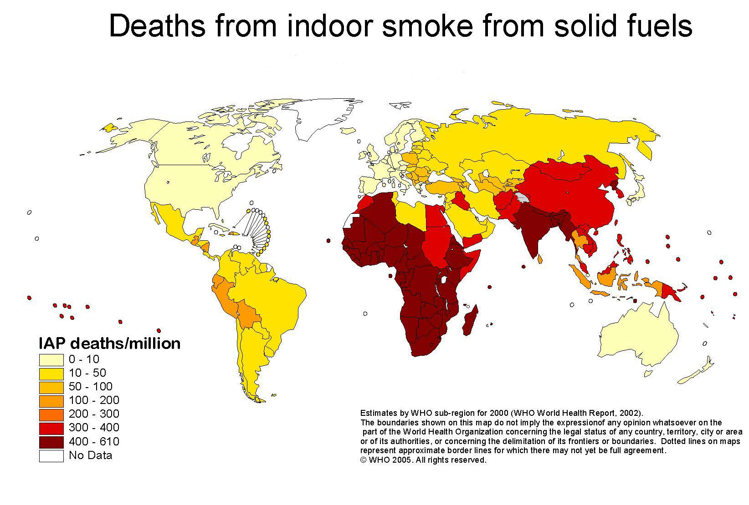

*(*[*http://www.who.int/heli/risks/risksmaps/en/index3.html*](http://www.who.int/heli/risks/risksmaps/en/index3.html)*)*

**More on “sick building syndrome”**

The “sick building syndrome” (SBS) is a term used to describe non-specific health problems linked to the time people spend in a building or certain areas/rooms of their working environment. People may experience a wide range of symptoms including headaches, dizziness, nausea, fatigue, skin rashes and respiratory irritations. They may also detect irritating odors and find it difficult to concentrate. Relief is usually experienced once they leave the sick building, but in some cases long term problems such as asthma develop.

As a response to the 1973 oil embargo, energy conservation was a major concern. So, U.S. building codes were modified to reduce the amount of outdoor air required for ventilation in new or remodeled buildings. In addition, buildings were designed to be more energy efficient by reducing or eliminating windows and tightening designs to eliminate loss of energy from heating or air conditioning systems. When ventilation, heating or air conditioning systems malfunction, indoor air pollution increases. WHO reported that in 1984 as many as 30% of new or remodeled buildings worldwide received multiple illness complaints from the occupants. (<http://www.epa.gov/sites/production/files/2014-08/documents/sick_building_factsheet.pdf>)

Studies conclude that SBS is a major occupational hazard contributing to employee illness, absenteeism and decreased productivity. The U.S. EPA defines four circumstances that imply SBS as the cause of illness:

* Symptoms are temporally related to time spent in a particular building or part of a building
* Symptoms resolve when the individual is not in the building
* Symptoms recur seasonally (heating, cooling)
* Co-workers, peers have noted similar complaints

(<http://www.ei-resource.org/illness-information/related-conditions/sick-building-syndrome/>)

When a building is poorly designed, so that cubicles are placed where they interfere with the air conditioning/heating system, and/or the building is crammed with an unreasonable number of offices, inadequate ventilation often results. This is particularly true in new buildings where the volatile organic compounds (VOCs) are readily emitted from new furniture, wall and floor coverings and from office equipment, especially photocopy machines. A buildup of VOCs can reach a point where the indoor concentration is so high that the quality of air is even worse indoors than outside the building. Exacerbating the problem is the failure to maintain regular maintenance and cleaning of air ventilation systems.

The U.S. EPA distinguishes between illnesses related directly to the building and SBS. When a specific building is involved, identification and treatment is much easier. For example, Legionnaires ’ disease is a type of pneumonia caused by the *legionella* bacterium that resides in a building’s water systems, such as air conditioning and drinking fountains. However, it is frequently difficult to diagnose the cause of SBS because it may involve several triggers acting individually, in combination, or synergistically. The result is multiple symptoms. (<http://www.ncbi.nlm.nih.gov/pmc/articles/PMC2796751/>)

Most studies attribute SBS to exposure to illnesses related to airborne building contaminants trapped in an area with poor indoor ventilation. But the exact cause of these symptoms is often not known. The Rohrig article addresses three airborne chemical pollutant contaminants found in homes: radon gas, VOCs and carbon monoxide.

**More on radon gas**

The U.S. Centers for Disease Control and Prevention (CDC) “Radon Fact Sheet” provides basic information about radon: facts, dangers and personal protection. Radon gas is the second leading cause of lung cancer in the United States; for nonsmokers it ranks first. The U.S. EPA estimates that, every year, 20,000 lung cancer deaths are caused by radon.

Radioactive concentrations are measured in picocuries per liter (pCi/L). The unit, named after Pierre Curie, is the standard that is based on one gram of radium. The rate that radium decays is approximately 2.2 trillion (2.2 x 1012) disintegrations per minute. One picocurie is one trillionth of a curie so it represents 2.2 disintegrations per minute. According to the U.S. EPA, almost one third of U.S. homes screened for radon exceed permissible indoor exposure limits of 0.4 pCi/L. This is the natural level expected in outdoor air.

The U.S. EPA safety standards for carcinogens are based on one in 100,000 people at risk of death. The risk of death for radon is 4 pCi/L and most scientists say that at this exposure level, one in 100 people may die. Thus, the risk of death from radon at 4 pCi/L is 1,000 times greater than for any other U.S. EPA designated carcinogen. The U.S. EPA stipulates, “There are no safe levels of radon gas.”

The Rohrig indoor air pollution article calls radon a “silent killer” because you can’t see, smell or taste it. Cigarette smokers face a radon exposure risk of lung cancer about 20 times greater than nonsmokers. And children, due to their high respiration rates and rapidly dividing cells, may be more susceptible than adults to radon damage. (<http://www.radon.com/radon/radon_facts.html>)

The density of radon is 9.72 grams per liter, 7½ times that of air so it moves horizontally through the soil, particularly igneous (volcanic) rocks and soils. This noble gas is composed of single atoms that can easily penetrate low density plastic bags, concrete basements, wood paneling and most insulation materials, thus it enters homes (particularly basements) easily.

Radon has a melting point of –71 oC and boiling point of –61.8 oC. It dissolves in water to form a clear, colorless solution that contaminates well water and enters homes through the water pipes. A small amount may be directly ingested from the tap. However since the gas quickly leaves water, particularly hot water where it is less soluble, most enters the lungs by inhalation, especially during warm water dish washing and showering. As the temperature is lowered, the gas solidifies as a yellow to orange-red solid that exhibits brilliant phosphorescence due to the intensity of its radioactivity.

This extremely radioactive gas is difficult to study chemically because it is very unreactive and has a short half-life of only 3.8 days. However, in the 1960s chemists began using extreme laboratory conditions to combine noble gases with highly electronegative elements. Radon difluoride (RnF2) is stable as a solid, but disintegrates when heated to the gaseous phase.

In the past, radon was used in medicine to reduce cancerous tumors; now, better methods are usually employed. It is used to detect liquid leaks in pipes because of its solubility in both water and organic solvents. When radon is dissolved in liquid or mixed with a gas, a Geiger counter can be used to trace the flow and indicate the location of a leak in the tube or pipe. Radon concentrations are greater above geological faults, leading to its use in the study of geothermal gradients and in earthquake prediction. (<http://www.encyclopedia.com/topic/radon.aspx>)

The schematic below shows the decay series as radon (Rn-222) alpha-decays (α) to polonium (Po-218) and another α-decay yields Po-214. The decay path between Po-218 and Po-214 also includes two beta (β) emitters. Po-218 α-decays to form lead (Pb-214) that β-decays to form bismuth (Bi-214), that then β-decays to form   
Po-214. During each single α-decay the isotope loses 4 atomic mass units (amus), a helium nucleus, as described in the Rohrig article.

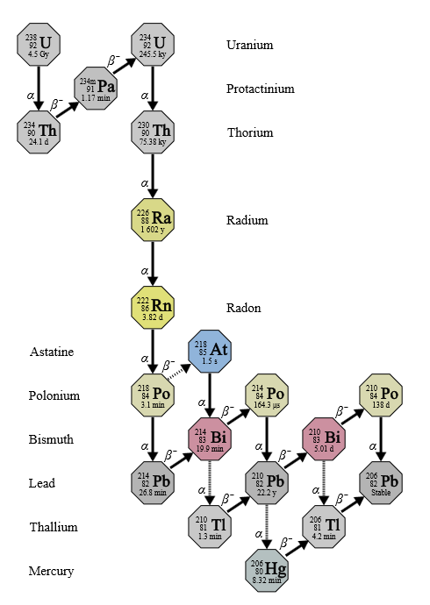

*(*[*https://upload.wikimedia.org/wikipedia/commons/6/65/Decay\_chain%284n%2B2%2C\_Uranium\_series%29.svg*](https://upload.wikimedia.org/wikipedia/commons/6/65/Decay_chain%284n%2B2%2C_Uranium_series%29.svg)*)*

As described in the Rohrig indoor air pollution article, most lung damage is not caused by radon, but by its daughter products. Both Po-218 and Po-214 are α-emitters with short half-lives, 3 minutes and 0.164 milliseconds, respectively. Although there are other decay products as seen in the diagram, the Po-218, Po-214 and Bi-214 (a beta- (β) emitter with a 19.9 minute half-life) emit the most damaging radiation. As the half-life decreases, the rate of decays and emissions increases resulting in more concentrated doses of radiation (greater intensity). Each step in the diagram above shows the release of α- or β-particles that bombard lung cells causing genetic mutations and cancer during decay processes.

(<http://www.radonseal.com/radon-health.htm>)

**More on Volatile Organic Compounds (VOCs) and sense of smell**

The primary danger from outdoor VOCs is the formation of photochemical fog or smog. The deadly London Fog of 1952 described in an earlier section of this Teacher’s Guide was a photochemical smog. When a temperature inversion occurs, VOCs from motor vehicle exhausts serve as the precursors of smog: hydrocarbons, carbon monoxide and **oxides of nitrogen**. These emissions, energized by sunlight, combine with oxygen to produce photochemical smog.

The most common indoor contaminants are defined as organic compounds with boiling points in the range from 50–250 oC. In homes, these compounds evaporate or sublimate from upholstery and carpet adhesives; new furniture; manufactured wood products, such as cabinets and laminated floors; pesticides; cleaning supplies and deodorants. SBS is probably due to exposure to indoor VOCs.

Smell is our only sense that connects directly to the brain. Olfactory sensory receptor cells line the nasal mucous membrane. These receptors are G-protein coupled receptors (GPCRs) that sense the foreign odor molecules from VOCs. They are not specific for one odor molecule; each can accept a wide range of molecules. When the odor molecule binds to the G-protein, it breaks away and activates an enzyme that serves as a transmitter to open ion channels. These create electrical potentials to form synapses that are transferred along the olfactory nerve to the mitral cells. The mitral cell neurons transfer the information to various parts of the brain. Energy for this process comes from the enzyme-catalyzed conversion of guanine triphosphate to guanine diphosphate. The illustration at right above shows the enlarged olfactory bulb.

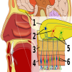

1: [Olfactory bulb](https://en.wikipedia.org/wiki/Olfactory_bulb) 2: [Mitral cells](https://en.wikipedia.org/wiki/Mitral_cell) 3: Bone 4: Nasal [Epithelium](https://en.wikipedia.org/wiki/Epithelium)   
5: [Glomerulus](https://en.wikipedia.org/wiki/Glomerulus_(olfaction)) 6: [Olfactory receptor cells](https://en.wikipedia.org/wiki/Olfactory_receptor)

"Olfactory system" by Chabacano - from Image: Brain human sagittal section.svg Image: Head lateral mouth anatomy.jpg by Patrick J. Lynch, medical illustrator. Licensed under CC BY-SA 2.5 via Commons

*(*[*https://en.wikipedia.org/wiki/Olfactory\_system*](https://en.wikipedia.org/wiki/Olfactory_system)*)*

**More on VOCs─indoors**

Initially air fresheners were available only as a bottle of fragrant solution with a large wick. Now, they can be purchased as solids, gels, liquids or in spray cans. These products contain odor molecules strong enough to mask an offensive odor. The desired scent diffuses through the air from a perfumed candle, a solid hanging from a car’s rearview mirror, or the mist from an aerosol can. The air freshener in your car mentioned in the Rohrig indoor air pollution article is probably a piece of paper coated with fragrant substances. (<http://www.ehow.com/how-does_4566554_air-fresheners-work.html>)

In addition to masking odors, other methods can be employed to manage offensive odors, such as:

* [**Adsorption**](https://en.wikipedia.org/wiki/Adsorption): Adsorbents like [zeolite](https://en.wikipedia.org/wiki/Zeolite), [activated charcoal](https://en.wikipedia.org/wiki/Activated_charcoal), or [silica gel](https://en.wikipedia.org/wiki/Silica_gel) may be used to remove odors.
  + [**Oxidation**](https://en.wikipedia.org/wiki/Oxidation): [ozone](https://en.wikipedia.org/wiki/Ozone), [hydrogen peroxide](https://en.wikipedia.org/wiki/Hydrogen_peroxide), [peroxide](https://en.wikipedia.org/wiki/Peroxide); [chlorine](https://en.wikipedia.org/wiki/Chlorine), [chlorate](https://en.wikipedia.org/wiki/Chlorate) [sic] other [oxidizing agent](https://en.wikipedia.org/wiki/Oxidizing_agent) can be used to oxidize and remove organic sources of odors from surfaces and, in the case of ozone, from the air as well.
* [**Air sanitizer**](https://en.wikipedia.org/wiki/Air_sanitizer): Odors caused by airborne bacterial activity can be removed by [air sanitizer](https://en.wikipedia.org/wiki/Air_sanitizer) that inactivate[s] bacteria.
* **Surfactants and soaps**
* **Masking**: Overwhelming an odor with another odor by any of the means described above.

(<https://en.wikipedia.org/wiki/Air_freshener>)

The Connecticut Department of Public Health has issued a stern warning regarding the use of air fresheners. This state’s “Fact Sheet” also suggests ways to mask odors with safe chemicals such as baking soda. They urge residents to limit their use of air fresheners and keep them away from children. They provide advice in the format of “What You Need to Know”:

* Air fresheners don’t freshen or clean the air – they add fragrance and in some cases chemicals that could be harmful to one’s health.
* People with allergies, asthma or other breathing disorders may be sensitive to air fresheners
* Natural ways to decrease odors include opening windows or using common household items (e.g., lemons, vinegar, baking soda) to absorb odors
* Decreasing use of air fresheners will decrease chemical exposure in the home

(<http://www.ct.gov/dph/lib/dph/environmental_health/eoha/pdf/air_freshener_fs.pdf>)

**More on VOCs─formaldehyde**

Formaldehyde is probably the best known and the most toxic VOC emission from building materials and household products. Formaldehyde also enters the air naturally; we exhale as a by-product of the oxidation of organic molecules in our bodies. This molecule plays an important role in human metabolism. In fact, it serves as a major building block for organic synthesis in all living organisms. Human blood contains approximately 2.5 ppm formaldehyde. Like alcohol, formaldehyde evaporates from our blood stream and enters the environment through our breath. Formaldehyde also has many industrial uses. (<http://www.reuters.com/article/idUS188340+04-Apr-2008+BW20080404>)

**Formaldehyde**

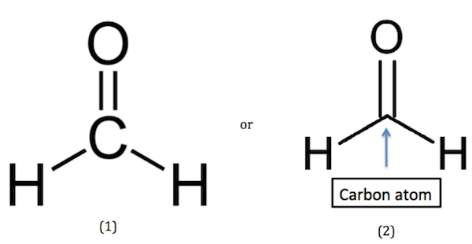

structural formula organic chemist’s “shorthand”

*(*[*http://study.com/academy/lesson/what-is-formaldehyde-definition-uses-structures.html*](http://study.com/academy/lesson/what-is-formaldehyde-definition-uses-structures.html)*)*

The American Chemistry Council (ACC) represents leading companies in the chemical industry. This group challenges the proposal by the U.S. EPA to set what they contend is an “unreasonably” low permissible limit on formaldehyde emissions. ACC asserts that the U.S. EPA assessments are of “poor quality” and “overly conservative”. The U.S. EPA proposes a 0.008 ppb limit which ACC considers within background levels since human breath emits from 0.008 to 0.8 ppb formaldehyde and the World Health Organization (WHO) recommends an 81 ppb limit as seen on the graph below. The most recent update on formaldehyde assessment listed on the U.S. EPA Web page is dated 1989 for cancer assessment and 1990 for oral exposure. (<http://cfpub.epa.gov/ncea/iris2/chemicalLanding.cfm?substance_nmbr=419>)

Finally, at the insistence of the ACC and the U.S. National Academy of Sciences (NAS), the U.S. EPA released: “Toxicological Review of Formaldehyde-Inhalation Assessment” in June 2010. The next April, the U.S. NAS issued a press release on the U.S. EPA draft assessment with a rather scathing comment, “not prepared in a logically consistent fashion, lacks clear links to an underlying conceptual framework, and does not sufficiently document methods and criteria used to identify evidence for selecting and evaluation studies.” [(http://www.americanchemistry.com/ProductsTechnology/Formaldehyde/New-Graphic-Illustrates-Problems-with-EPAs-Formaldehyde-Risk-Assessment.pdf](file:///C:\Users\sitzman\AppData\Local\Microsoft\Windows\Temporary%20Internet%20Files\Content.IE5\2SNM07M1\(http:\www.americanchemistry.com\ProductsTechnology\Formaldehyde\New-Graphic-Illustrates-Problems-with-EPAs-Formaldehyde-Risk-Assessment.pdf))

The *New York Times* reports that the action of the U.S. NAS, “is likely to further delay EPA efforts to finalize a 12-year-old effort to assess risks posed by formaldehyde, a widely used residential construction material.” (<http://www.nytimes.com/gwire/2011/04/08/08greenwire-nas-reviewers-slam-epas-formaldehyde-assessmen-83879.html>)

In February 2015, the U.S. EPA submitted a report to the U.S. Congress, “EPA’s Integrated Risk Information System (IRIS)”. The report is an overhaul of risk assessment processes. Pending approval, hopefully updated information on formaldehyde will be placed on their Web site soon. (<http://www.epa.gov/sites/production/files/2015-06/documents/iris_report_to_congress_2015.pdf>)

**Range of Formaldehyde Concentration in Different Environments**

An external file that holds a picture, illustration, etc.
Object name is cr-2008-00399g_0026.jpg

*(*[*http://www.ncbi.nlm.nih.gov/pmc/articles/PMC2855181/*](http://www.ncbi.nlm.nih.gov/pmc/articles/PMC2855181/)*)*

A much better graph of this data, which includes the lower limit and the range of formaldehyde in human breath, can be found in a paper from the American Chemical Council, “Risky Business: Overview of Integrated Risk Information System Assessment of Formaldehyde”: <http://www.americanchemistry.com/ProductsTechnology/Formaldehyde/New-Graphic-Illustrates-Problems-with-EPAs-Formaldehyde-Risk-Assessment.pdf>.

**More on VOCs─formaldehyde sources**

Formaldehyde is emitted from materials and products throughout the home. One of these sources is limonene. The citrus smell in scented candles, plug-ins, air fresheners and cleaning products comes from limonene. While limonene is considered safe for food, it is easily oxidized by ozone, producing formaldehyde and formic acid among the reaction products. Indoor air contains small amounts of ozone (approximately 4 ppm) that either seep into the home from outdoor air or are produced indoors by machines such as photocopiers. (<http://www.sciencedirect.com/science/article/pii/S0160412001000356>)

Limonene has two enantiomers. Their chemical properties are identical but the citrus odors differ. The odor of the positive isomer is orange and found naturally in oranges. The negative isomer smells like turpentine or pine but it is often described as a lemon scent.

**Enantiomers of Limonene**

[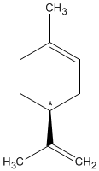](http://www.chm.bris.ac.uk/motm/limonene/(s)-(-)-limonene.mol)

[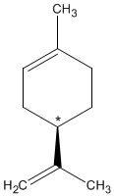](http://www.chm.bris.ac.uk/motm/limonene/(r)-(+)-limonene.mol)

(+)-Limonene (–)-Limonene

*(*[*http://www.chm.bris.ac.uk/motm/limonene/limoneneh.htm*](http://www.chm.bris.ac.uk/motm/limonene/limoneneh.htm)*)*

Formaldehyde is also released into the home from burning incense, fire wood, or cigarette smoke. Although formaldehyde also has minor uses as a preservative in personal care products and a color stabilizer in photography, its primary role is as a chemical intermediate for the manufacture of adhesive resins.

Urea-formaldehyde is a thermosetting resin. Heat changes the shape of thermoset polymers irreversibly; a very high temperature would be needed to distort them. Urea-formaldehyde has low water-absorption and a high surface hardness making it suitable for decorative laminates, paints and paper. The most common use of formaldehyde is in the manufacture of urea-formaldehyde resins where it serves as a strong, low cost adhesive to glue wood together in composites such as particle board and plywood. It can also be blended with textiles to produce fabrics with fewer tendencies to wrinkle or shrink.

(<http://www.formaldehydetesting.com/whatisformaldehyde.html>)

The formation of urea-formaldehyde resin is a two-step process. Urea and formaldehyde combine in an approximately 1:1 ratio. As seen below, urea first reacts with excess formaldehyde to form urea-formaldehyde (C2H6N2O2). In the second step of the reaction, the condensation polymer is formed by the removal of H2O as two monomers bond to form the resin.

[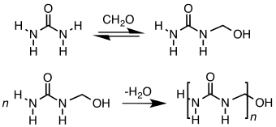](https://en.wikipedia.org/wiki/File:UFresinSyn.svg)

*(*[*https://en.wikipedia.org/wiki/Urea-formaldehyde*](https://en.wikipedia.org/wiki/Urea-formaldehyde)*)*

**More on VOCs─formaldehyde toxicity**

As with other VOCs, some people are more sensitive than others to formaldehyde emissions. Reactions range from no effect to potentially life-threatening responses. Some may experience respiratory irritations, headaches and/or fatigue. High concentrations may cause cancerous nasal and upper respiratory tumors. Formaldehyde can also trigger acute allergic reactions, including asthma. Formaldehyde concentrations are highest in new construction. Yet, over time, emissions from new building materials decrease.

(<https://www.builddirect.com/learning-center/home-improvement-info/formaldehyde-emissions/>)

The American Cancer Society cites studies of exposure to high concentrations of formaldehyde in the workplace of morticians, lab technicians and health care professionals who face a higher risk of leukemia and cancer of nasal sinuses. (<http://www.cancer.org/cancer/cancercauses/othercarcinogens/intheworkplace/formaldehyde>)

The U.S. CDC finds that formaldehyde at high concentrations is linked to the risk of nose and throat cancer. The following table compares the effects of breathing formaldehyde at various levels of concentration. Note that MRL is the acronym for Minimal Risk Levels, the acronym used by the U.S. Agency for Toxicology and Environmental Medicine of the U.S. Department of Health and Human Services.

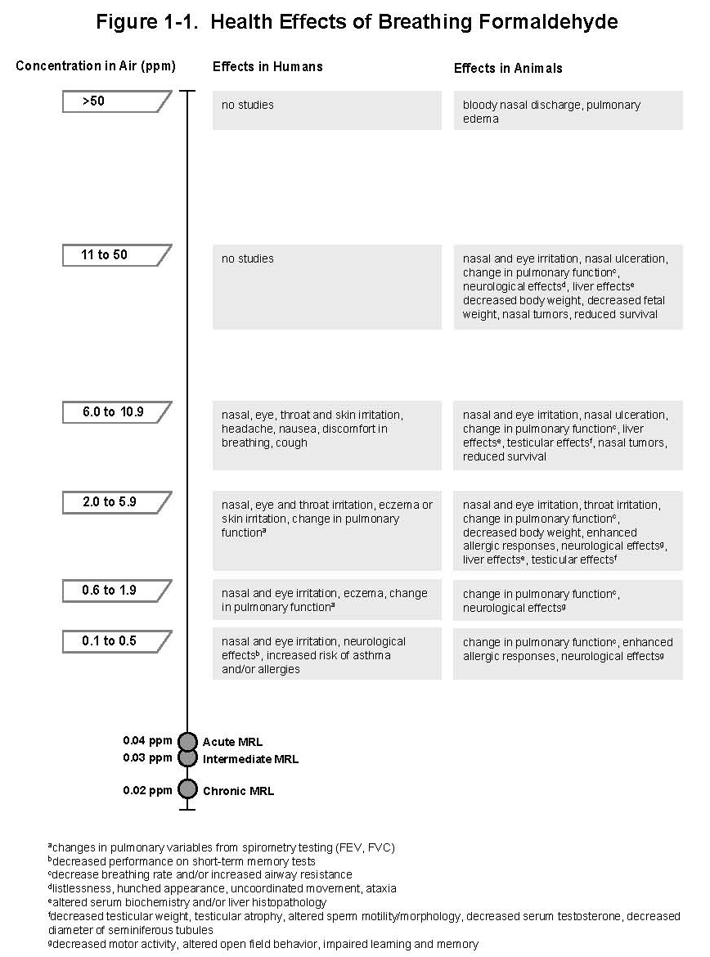

*(*[*http://www.atsdr.cdc.gov/toxprofiles/formaldehyde\_fig\_1-2.jpg*](http://www.atsdr.cdc.gov/toxprofiles/formaldehyde_fig_1-2.jpg)*)*

The U.S. Federal Emergency Management Agency (FEMA) provides temporary manufactured housing following natural disasters. Following the Katrina disaster in 2005, FEMA sold trailers for $1,100 each to displaced families. These were designed to provide up to 18 months of temporary housing. In July 2006, people started to report health issues (difficulty breathing, flu-like symptoms, eye irritation, nose bleeds). A class action lawsuit was filed by 55,000 residents of southern states who attributed their illness to toxic levels of formaldehyde due to poor construction and substandard building materials used for the “Katrina Trailers”. In 2012 the U.S. District Judge of New Orleans approved a $42.6 million settlement against the manufacturers and contractors of the mobile homes. U.S. FEMA has since modified its specifications. New housing will be larger and have better ventilation. (<http://investigations.nbcnews.com/_news/2012/09/28/14140222-class-action-suit-against-fema-trailer-manufacturers-settled-for-426-million>)

In 2009 public trailer auctions were held, trailers were sold and some were discarded as scrap but somehow many have reappeared as living quarters minus the “NOT TO BE USED FOR HOUSING” stickers placed on back windows by U.S. FEMA. Once the stickers were removed, Katrina Trailers sold for almost four times their original price.

The Manufactured Housing Association for Regulatory Reform (MHARR), a national trade association, contends that media reports on formaldehyde vapor levels in Katrina Trailers have omitted important scientific facts about formaldehyde and its impact on health:

The fact that formaldehyde is a normal component of human metabolism has continually been ignored in congressional proceedings, press reports and even in communications by the Centers for Disease Control (CDC) and other federal agencies. Because formaldehyde, like alcohol, has a tendency to evaporate from the bloodstream into exhaled breath, there are measurable amounts of formaldehyde in human breath at all times. These levels are the result of the normal amounts of formaldehyde present in the blood rather than external exposure. In the same way, then, that alcohol contained in the breath is a reliable indicator of blood alcohol levels (i.e., the basis for the commonly used "breathalyzer" test), the same is the case with formaldehyde. In a 2005 study (Berthold Moser, et al., published in Respiratory Physiology & Neurobiology, Vol. 145, Issues 2-3, February 2005), researchers measured the amount of formaldehyde in the breath of 344 healthy men and women. The results of this study are significant since it is now being claimed that formaldehyde concentrations equivalent to normal levels emitted in human breath are capable of producing adverse effects. In the Moser study, the median level of formaldehyde in human breath was 4.3 parts per billion (ppb) with levels of 6.3 ppb, 40 ppb and 73 ppb of the 75th, 97.5th and maximum percentiles, respectively. Given this data, it is troubling that CDC has recently advocated quickly relocating residents from FEMA emergency manufactured homes that have tested formaldehyde levels below that which many people naturally exhale as a result of their own metabolism.

(<http://www.reuters.com/article/idUS188340+04-Apr-2008+BW20080404>)

**More on carbon monoxide (CO)**

CO has ten valence electrons. A Lewis structure below shows the covalent triple bond between carbon and oxygen and a lone pair of electrons on each of these atoms. The bond length is measured in picometer (pm) units. One pm equals 1 x 10–12 meters. In formaldehyde the carbon is double bonded to oxygen by a longer, weaker bond length of 120.8 pm. Although the triple covalent bond in CO forms a stable molecule, it is highly flammable.

*(*[*https://en.wikipedia.org/wiki/Carbon\_monoxide*](https://en.wikipedia.org/wiki/Carbon_monoxide)*)*

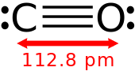

A small amount of CO is produced as a by-product of animal metabolism. Humans exhale this. Current research shows that trace amounts of CO act as signaling molecules in the neural systems that involve learning and memory. It has also been shown that CO protects the cardiac vascular system and may hold important roles in the immune, respiratory, reproductive, gastrointestinal, kidney and liver systems. (<http://pharmrev.aspetjournals.org/content/57/4/585>)

The largest source of natural CO production comes from the oxidation of hydrocarbons (VOCs) in the troposphere. The atmospheric oxidation cycle for formaldehyde is shown below. This series of reactions produces CO, CO2 and H2O. Note that CO is produced in equation (8).

The simplest VOC molecule that contains the carbonyl bond is formaldehyde (HCHO). Because formaldehyde enters into several types of reactions of importance for understanding ozone formation and removal, we will use it to help illustrate these reactions. The oxidation cycle for formaldehyde can be written in the following sequence of reactions.

OH + HCHO 🡪 H2O + HCO (7)

HCO + O2 🡪 HO2 + CO (8)

HO2 + NO 🡪 NO2 + OH (9)

Hydroperoxyl radical (HO2) is generated by reaction 8, and the hydroxyl radical (consumed in reaction 7) returns in reaction 9 to complete the cycle. In addition, reaction 9 produces the NO2 required for ozone formation … Also, the carbon monoxide (CO) generated by reaction 8 can react like an organic molecule to yield another hydroperoxyl radical.

(<http://www.fraqmd.org/ozonechemistry.htm>)

The photochemical equations above produce about 5 x 1012 kilograms of CO per year. CO also enters the atmosphere from volcanic eruptions, forest fires and human activities. (<https://en.wikipedia.org/wiki/Carbon_monoxide>)

**More on CO─poisoning**

The graph below shows the relationship between the symptoms of CO poisoning related to the time and concentration of exposure. NAAQS on the graph is the acronym for National Ambient Air Quality Standards for outdoor air quality that are established by the U.S. EPA.

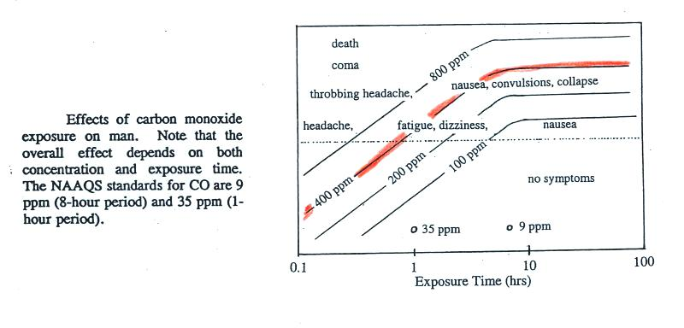

*(*[*http://www.atmo.arizona.edu/students/courselinks/spring13/atmo170a1s1/online\_course/week\_1/lect2\_pollutants\_pt1.html*](http://www.atmo.arizona.edu/students/courselinks/spring13/atmo170a1s1/online_course/week_1/lect2_pollutants_pt1.html)*)*

According to the U.S. Consumer Products Safety Commission, each year approximately 170 people in the United States die from non-automotive-consumer product produced CO poisoning. These deaths are caused by CO emitted in the home from gas burning appliances, gas fueled generators, and burning wood and charcoal. (<http://www.cpsc.gov/en/Safety-Education/Safety-Education-Centers/Carbon-Monoxide-Information-Center/Carbon-Monoxide-Questions-and-Answers-/>) The U.S. CDC reports a total of 430 non-intentional CO deaths per year. This value represents deaths inside and outside the home. (<http://www.cdc.gov/mmwr/preview/mmwrhtml/mm6303a6.htm>)

In the normal situation where the body is healthy and breathing oxygen (not carbon monoxide) the hemoglobin (Hb), an ion-containing metallic protein in the blood, transports oxygen to the cells according to this equilibrium expression:

**Hb (aq) + 4 O2 (g) ⇋ Hb(O2)4 (aq)**

Carbon monoxide has an affinity for Hb that is 200 times greater than that of oxygen. When carbon monoxide is present, it displaces oxygen, thus the cells receive insufficient oxygen and death can occur. The equilibrium below strongly favors the product:

**Hb (aq) + 4CO (g) ⇋ Hb(CO)4 (aq)**

The hemoglobin molecule contains four heme (iron containing) groups. Bonding of the iron(II) (Fe2+) ion to CO seen in the equation above is an ion-induced dipole reaction resulting in the formation of HbFe(ll)CO within the Hb molecule.

(<http://chemistry.stackexchange.com/questions/33780/why-does-carbon-monoxide-have-a-greater-affinity-for-hemoglobin-than-oxygen>)

This traditional explanation of CO poisoning was challenged by 1997 studies at the University of Pennsylvania Medical Center. This work indicates that only a “small fraction” of people exposed to CO die due to suffocation when inhaled CO preferentially bonds to hemoglobin molecules in the blood, thus blocking the oxygen receptors and stopping oxygen transport throughout the body.

The senior author of this project, Stephen R. Thom, MD, PhD, Associate Professor of Emergency Medicine, and chief of hyperbaric medicine at Penn's Institute for Environmental Medicine states: "The vast number of patients we see clearly don't fit this traditional explanation. Science falls down in terms of what we see in day-to-day practice."

The new research investigates a mechanism involving the role of nitrogen monoxide (NO) in this process. Hemoglobin is a globular protein with an embedded iron (Fe) atom. Normally each Fe atom binds to one oxygen atom by ion-induced dipole forces. Both CO and NO readily form coordination complexes with the iron (Fe) in Fe-containing proteins such as hemoglobin. The structure below shows CO ligands complexed with Fe.

[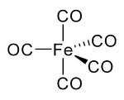](https://en.wikipedia.org/wiki/File:IronPentacarbonylStructure.png)

iron pentacarbonyl, Fe(CO)5

*(*[*https://en.wikipedia.org/wiki/Carbon\_monoxide*](https://en.wikipedia.org/wiki/Carbon_monoxide)*)*

When CO preferentially binds to Fe displacing NO, excess NO is released into the body. While NO at normal levels plays an important role in blood flow and neurotransmission, excess amounts produce damaging oxidants and free radicals that have a destructive effect on tissues and cause cell death. Thom said, "This is the first time this mechanism of carbon monoxide toxicity has been demonstrated.”

(<http://www.sciencedaily.com/releases/1997/09/970927111303.htm>)

Although this is an interesting hypothesis, the current research literature has not addressed Dr. Thom’s mechanism. In a 2001 publication he referenced the O2-CO-Nitric Oxide balance as one of five contributing processes to carbon monoxide poisoning:

* Impaired delivery and use of oxygen
* Disrupted O2-CO-Nitric Oxide balance
* Damage to blood vessels
* Damage to the nervous system
* Immune system responses during recovery

(<http://www.thedoctorwillseeyounow.com/content/public_health/art2100.html>)

However, studies are continuing to address the role of NO in the body. A 2002 paper published in the *Proceedings of the National Academy of Sciences of the U.S.* describes research findings that the Hb protein reacts with NO much faster to form HbFe(II)NO when Hb is free (not in cells) than when it is in red blood cells. (<http://www.pnas.org/content/99/11/7763.full>)

Victims of CO poisoning can be placed in a hyperbaric (high pressure) chamber filled with pure oxygen. The high pressure forces oxygen into the blood displacing carbon monoxide. Treatment must begin immediately or at least within six hours of poisoning to avoid irreversible brain damage. (<http://www.divingmedicine.info/Ch%2023%20SM10c.pdf>)

**More on** **detection of indoor pollutants**

**Radon**

The only way to know the radon levels in your home is by testing. Normal home levels are approximately 1.25 pCi/L. Since there may be years of exposure before symptoms surface, the U.S. EPA recommends radon testing as the only way to alert you when levels are dangerous (at or above 4 pCi/L). (<http://www.radon.com/radon/radon_facts.html>)

There are three basic types of radon detection devices: short term, long term and digital readout. Both short- and long-term kits must be sent to a lab for reading the radon level. Some are sold with the lab cost built into the kit cost; others require a separate fee for testing. While a short-term kit (2 to 7 days) will provide a quick measurement, radon values vary considerably over time, so a long-term kit (more than 8 days) will give the best assessment of the radon level. Digital read-out models are more expensive, but are not sent to a lab for reading. The values are constantly available to the reader. (<http://www.livestrong.com/article/125327-radon-test-kits/>)

Radon detection involves two basic steps, collection and counting the alpha particles released by radon and its daughters. Following exposure to indoor air, the detector is sent to a lab for analysis. Counting of alpha particles can be done by a Geiger counter or by spectra analyzing equipment where peaks show the concentration of alpha emitters such as Po-218. A new technique for assessing radon concentration was introduced in a 2012 paper published by the NIH. The alpha tracks collected on foil are etched electrochemically and then measured by a computer-aided image analysis process. (<http://www.ncbi.nlm.nih.gov/pubmed/22908348>)

Approximately 95% of all radon testing is done by a short-term charcoal test kit (see photo below). To improve the accuracy, windows and doors should be kept closed as much as possible during the short testing time. A canister contains activated charcoal that absorbs airborne atoms of radon gas; when the test period is over the canister is sealed and sent in a mailer to the lab, where a sodium iodide counter or a scintillation detector can be used to count the atoms. (<http://home.howstuffworks.com/home-improvement/household-safety/tips/radon3.htm>)

Long-term radon detectors are designed to be used while leading a normal life style with no special ventilation procedures or restrictions. Alpha tracker devices (see photo below) contain pieces of plastic that are marked when alpha particles from radon and its daughter products hit them. These tracks are chemically treated in the lab to make them visible for counting. (<http://home.howstuffworks.com/home-improvement/household-safety/tips/radon3.htm>) The long term alpha detector (shown below) has been newly designed. While it still looks like the 1986 version, the current model contains filters to eliminate dust and radon daughters. The electrochemical etching technique is used in the analysis lab.

Electrets (photo below), used by professional radon inspectors, require high cost, expert analysis and specialized equipment. They contain an electrically charged plastic disc. As ions (He2+) are produced during alpha decay, the surface voltage is reduced. Laboratory analysis measures the concentration by the amount of voltage reduction. (<http://www.rtca.com/product.asp?prodID=12&catID=5>)

(<http://www.ehow.com/how-does_5229372_do-radon-test-kits-work_.html>)

A continuous radon monitor (photo below) is another type of long-term radon detector that detects radon and daughter products. This equipment shows hourly radon concentrations and temperature readings. Thus it is valuable for professionals such as those selling real estate. ([*http://home.howstuffworks.com/home-improvement/household-safety/tips/radon3.htm*](http://home.howstuffworks.com/home-improvement/household-safety/tips/radon3.htm))

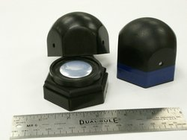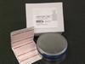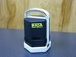

Short-term Long-term Electrets Continuous radon

charcoal test alpha tracker monitor

*(*[*http://www.rtca.com/shop.asp?catID=1*](http://www.rtca.com/shop.asp?catID=1)*)* All photos came from this site except the alpha tracker which came from the site below.

*(*[*http://www.accustarlabs.com/radon-testing-product-specifications/alpha-track.aspx*](http://www.accustarlabs.com/radon-testing-product-specifications/alpha-track.aspx)*)*

**Formaldehyde**

Chemistry is used to determine the amount of formaldehyde present in a product. This is done by a gas sampling apparatus, where formaldehyde is washed by absorption from a definite volume of air, then determined quantitatively. In the detection method shown below, sodium sulfite reacts in a 1:1 ratio with formaldehyde. When excess sodium sulfite is used to ensure complete reaction with formaldehyde, titration with an acid can be used to measure the amount of sodium hydroxide formed. This is the chemical reaction:

CH2O + Na2SO3 + H2O **→**  HOCH2SO3Na + NaOH

(<http://www.academia.edu/6244446/iii_MANUFACTURE_OF_FORMALDEHYDE_FROM_METHANOL_A_PROJECT_REPORT>)

**Carbon Monoxide**

BestReviews.com provides a review of the “Best” carbon monoxide detectors in a chart format showing the Good, Bad and Bottom line for each. There are battery powered models and plug-in types with or without a battery backup. The life of the battery and the sound of the alarm are reviewed. Portable types can be taken on trips to check your tent or hotel room. All detectors have been reviewed in BestReviews’ independent laboratories.

(<http://bestreviews.com/5-best-carbon-monoxide-detectors>)

The picture below shows the inside of a typical CO detector. The basic parts include:

* The base of the unit is an integrated electronic circuit panel.

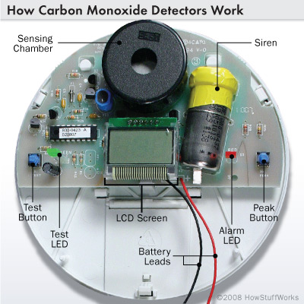

The interior of a carbon monoxide detector: When pressed, the peak button causes the LCD screen to display the highest level of CO recorded since the last reset.

*(*[*http://home.howstuffworks.com/home-improvement/household-safety/tips/carbon-monoxide-detector1.htm*](http://home.howstuffworks.com/home-improvement/household-safety/tips/carbon-monoxide-detector1.htm)*)*

* A silicon microchip that sends an electronic charge is fused to the copper-wired base.
* There are two light-emitting diodes (LEDs): “test” shows if the battery is weak; “alarm” sounds the alarm.
* Battery leads connect to the energy source, a nine volt battery or electric plug.
* Sensing chamber contains a detector that measures CO concentration in ppm.

(<http://home.howstuffworks.com/home-improvement/household-safety/tips/carbon-monoxide-detector1.htm>)

The sensing chambers can hold various devices such as:

* biomimetic sensor─mimics CO’s effect on Hb by changing the color of a gel to activate the alarm as CO is detected
* metal oxide semiconductor─CO lowers electrical resistance on circuits fused to a silicon chip to activate the alarm (This type is usually “plug-in” due to need for much electricity.)
* electrochemical sensors─similar to metal oxide type but a change in current is detected by electrodes immersed in a chemical solution
* electrochemical instant detection and response─used by professionals for instant detection of high CO concentration

(<http://home.howstuffworks.com/home-improvement/household-safety/tips/carbon-monoxide-detector1.htm>)

# Connections to Chemistry Concepts

**(for correlation to course curriculum)**

1. **Volatility**—Molecules of VOCs are very volatile. They are held together by weak intermolecular forces so they separate easily entering the gaseous phase by evaporation or at their boiling points.
2. **Volatile Organic Compounds**—Abbreviated VOCs, these organic molecules have high vapor pressure at room temperature, indicating weak intermolecular forces, so their boiling points are low and they readily enter the air by evaporation or sublimation. When your students study phase changes and vapor pressure, consider introducing some volatile organic compounds.
3. **Sublimation**—VOCs present in upholstery fabric sublimate from solid to gaseous phases without liquefying.
4. **Phase changes**—This article provides a good opportunity to discuss phase changes, including sublimation and the difference between evaporation and boiling.
5. **Intermolecular forces (IMFs)**—Add volatile organics to the study of IMFs. Since the molecules of VOCs are held together by weak intermolecular forces, they sublimate easily.
6. **Energy**—The phase changes from solid to liquid to gas require energy. Energy is required to change the state of VOCs from solid to gaseous forms during sublimation, but this energy requirement is rather small and enough energy is readily available from the environment.
7. **Radioactive decay**—Tie the dangers of radon pollution to study of the decay chain of U-238 that yields radon, a daughter product which is dangerous because it decays into Po-218 and Po-214. The polonium isotopes decay, releasing alpha particles that bombard human lung tissue, damaging cellular DNA to produce cancer causing mutations.
8. **Density**—Due to the density of radon gas, it settles under the foundations of homes and seeps into basements through cracks in the cement.
9. **Solubility**—Radon is water-soluble so it dissolves in surface water and well water sources. Thus, well water is often polluted by radon.
10. **Inverse Relationships**—During the study of direct and inverse relationships, add the real world example of the danger of gaseous radon. The solubility of gases in water is inversely proportional to the temperature. This explains radon’s rapid escape from water during a hot shower.
11. **Concentration units**—This article provides a good place to study very low concentrations such as parts per million (ppm) and parts per billion (ppb) used to measure environmental pollutants. VOC concentration is usually measured in ppm in air.

# Possible Student Misconceptions

**(to aid teacher in addressing misconceptions)**

1. **“I understand that all indoor VOCs are harmful.”** *While many indoor VOCs are harmful, their toxicities vary and this often depends upon concentration. For example, breathing in the aroma of coffee and the scent from a flower bouquet is not harmful for most people and trace amounts of carbon monoxide are essential to body metabolism.*
2. **“I will tell my parents to buy products with “Zero-VOC” or “VOC-free” labels to make certain that no more VOCs are added to our indoor air.”** *According to the U.S. Federal Trade Commission, zero-VOC or VOC-free products can legally contain trace amounts (not more than background levels) of VOCs.*
3. **“I don’t pay much attention to indoor pollution detectors because I am certain that if I don’t feel it or smell it, it can’t hurt me.”** *This is a very dangerous misconception because deadly gaseous indoor pollutants such as radon and carbon monoxide are odorless and colorless.*
4. **“Improving the indoor air quality in my home is just too expensive.”** *Actually there are many inexpensive ways to reduce indoor pollutants such as moving a painting or gluing project to an outside area, opening the windows when you paint a room and eliminating the use of highly scented cleaning products.*
5. **“I am an asthmatic runner so I watch the smog alerts and adjust my schedule so that I won’t have an asthma attack.”** *To avoid asthma attacks, it is wise to consider outdoor air quality but you should also consider ways to reduce indoor pollution. Polluted indoor air can also cause asthma attacks.*
6. **“When winter camping, I always close the tent flaps to keep my camping stove heat in and the animals out.”** *Always keep the tent flaps open to provide sufficient oxygen for complete combustion of your camping stove fuel so that poisonous carbon monoxide will not form. When you have finished cooking, turn off the stove.*
7. **“At least we don’t have to worry about radon exposure, because my home doesn’t have a basement or a sump pump.”** *All types of houses even those without basements or sump pumps can have radon problems. Since radon comes from the ground, the only way that you can determine if it is in your house is by using a radon test kit.*
8. **“Everyone should test their water for radon.”** *If your water comes from a well, you should test it but if you use a public water system, call the water department first, because they test radon levels regularly.*
9. **“We have an all-electric house with no fireplace, so there isn’t any carbon monoxide in our home.”** *Although the levels in your home may be low and safe, there is always some carbon monoxide that enters from outdoor air and some from our breath as we exhale the by-products of the body’s metabolic processes.*

# Anticipating Student Questions

**(answers to questions students might ask in class)**

1. **“I know that breathing radon causes lung problems, but why should I be concerned if the radon is only in our well water?”** *When your well water enters the home the radon gas escapes as the water is agitated as it leaves the faucet and as it is warmed for a shower, dishwasher and washing machine.*
2. **“If radon is detected in our home, does this mean that my well water will also be polluted with radon?”** *Not necessarily, radon can be in both places or in only one or the other. This depends upon whether the radon comes from the soil as a gas directly into your home or is dissolved in your water supply.*
3. **“Do water districts test for radon?”** *Yes, the water district regularly tests for contaminants including radon.*
4. **“What is a sump pump?”** *A sump pump is used to remove water from a sump, a low-lying, water-collecting area near a basement. The pump draws water out to prevent damage from flooding.*
5. **“My family has a new car and the new car smell is strong, do we need to keep the windows open while driving to avoid getting cancer?”** *After initial airing, pollutant concentration will decrease. While driving the air conditioning/heating system in your car always brings in some outside air even with the windows closed.*
6. **“The company claims that their carpets contain no formaldehyde. Does this mean that we won’t need to be concerned?”** *Although the carpet doesn’t contain formaldehyde, the adhesive used to seal strips together and attach it to the floor will probably contain formaldehyde.*
7. **“Our next-door neighbor’s radon level is fine, do we really need to check our home?”** *Every home and the ground below it is a bit different, so you should check your own level.*
8. **“Can’t we simply stop using man-made products to eliminate all indoor VOCs?”** *Not all VOCs come from man-made products. Some natural sources produce VOCs, for example, the scents of indoor plants, flowers, onions, and garlic. Also, it would be extremely difficult to eliminate all man-made products from the home.*

# In-Class Activities

**(lesson ideas, including labs & demonstrations)**

1. A debate or design project: The World Health Organization (WHO) presents four Scoping Questions (page 27 of the document cited below) that could serve to introduce a debate or as the basis for a project to design methods to reduce worldwide indoor air pollution. This document provides suggested solutions to the Scoping Questions on pages 52–73. The publication contains many excellent photographs of risky situations in both third world and industrial nations. (<https://sustainabledevelopment.un.org/content/documents/1969Indoor%20Air%20Quality.pdf>)
2. Risk analysis: This URL provides a process for risk analysis. A two by two matrix shows labels on each of the four sides. From top clock wise: “unknown risk”, “high dread risk”, “known risk” and “low dread risk”. The descriptions are thorough and clear; the hazards are arranged in the quadrants. Remove the hazards from the matrix and list them for students (or ask students make their own list). Ask students to place each hazard in the area of the quadrant that they feel best represents the risk. Discussion or written analysis of student’s rational for hazard placement can follow. Matrix is located on page 35 at this URL: (<http://www.who.int/whr/2002/en/whr02_en.pdf?ua=1>)
3. Here are two short lab activities. Check the odor of the enantiomers of limonene (orange and lemon rind) used in household candles, deodorizers and cleaning products. The comparison of enantiomers of carvone (spearmint and caraway seeds) is also on the Web site. Structures plus an explanation and illustration of nasal receptors for odor can be found at: <http://americanhistory.si.edu/molecule/04exp.htm>.
4. These student activities are two ways to study the half-life of radioactive substances. The labs include data collection and graphing. This resource is from the American Association of Chemistry Teachers (AACT). (<https://www.teachchemistry.org/content/aact/en/classroom-resources/high-school/nuclear-chemistry/half-lives/Twizzler-Half--Life.html>)

This activity uses M&M candies. (<http://serc.carleton.edu/sp/mnstep/activities/34884.html>)

1. Demonstrate the complete combustion of a hydrocarbon by lighting a Bunsen burner and adjusting the flame to blue by adding sufficient oxygen. Then close off the air intake to show the yellow flame of incomplete combustion. A candle will also burn yellow indicating incomplete combustion of a hydrocarbon fuel. This might be a good place to discuss the difference between a solid fuel (actually liquid, once wax is melted) and a gaseous fuel in terms of air pollutants, as discussed in the “More on indoor air pollution—global concerns” at the beginning of this Teacher’s Guide.
2. This lesson plan uses the 5E instructional model to investigate indoor pollution. Included are background information on airborne pollutants; an observational laboratory activity; instructions for calculating the amount (moles, particles and mass) of the lowest safety limit of each gaseous pollutant in the classroom; and a paper and pencil trace of the decay chain from U-238 to Pb-206. The lesson plan provides questions for students and answers for teachers. (<https://www.uni.edu/storm/downloads/highschool/Indoor%20air%20pollution.pdf>)

# Out-of-Class Activities and Projects

**(student research, class projects)**

1. Students can research their local water quality and check for radon gas. The U.S. EPA site provides *Consumer Confidence Reports* (CCRs) that give the level of contaminants present in water from U.S. suppliers. Much information is on this Web site. Under “Customers” click on “Find your local CCR” for a U.S. map. Click on your state for a list of water suppliers. (<http://www.epa.gov/ccr>) Or, “search” online for the CCR from your local water district.
2. The Khan Academy video (12:45) *Olfactory Structure and Function* can be assigned as homework to explain the olfactory pathway. This YouTube video will help students understand the chemistry involved in the connections between nasal receptors and the brain. The pathway is shown step by step from receptors picking up VOC odors from a “new home smell” to the final connection where odor is detected by the brain. (<https://www.youtube.com/watch?v=5-McqAO8_Qw>)
3. These two YouTube videos can be assigned as homework to prepare for class discussions on the dangers, detection and ethics of indoor air pollution in the U.S. and in a poor, rural area in India.
4. the 2:37 minute YouTube video of a *CBS News* “60 Minutes” program discussion of the “sick building syndrome” with a focus on the U.S. EPA building in Washington D.C. (<https://www.youtube.com/watch?v=adzMcfHr1q8>)
5. the 10:04 YouTube video: “Indoor Air Pollution: The Silent Killer”, where young research scholars interview villagers in rural India. (<https://www.youtube.com/watch?v=V4x1I03LZFc>)
6. The YouTube video (6:18 minutes) “Warning: Silent Killers in your Home” can be assigned as the basis for a research project explained below. This video was produced by Air-Cleaner-System.com. This firm sells residential and commercial air cleaning systems. The video begins with a series of “Scary Statistics” from the U.S. EPA including numbers of deaths and illnesses caused by indoor air pollution. Ask students to research the validity of these claims and search for verification by the U.S. EPA. (<https://www.youtube.com/watch?v=GrwbVBKEqZg>)
7. While studying nuclear chemistry equations, ask students to write the series described in the Rohrig indoor pollution article showing the decay from U-238 to Po-214.
8. As homework, ask students to watch the monthly progress across the world of carbon monoxide poisoning in the NASA QuickTime video on this Web site. This will set the stage for classroom analysis of this data. The data covers the 15½ year period from March 2000 to October 2015. Note that the month and year located in the upper right corner of the map continuously changes. Students can be asked to construct a data table and describe changes as the video progresses. This map is set for CO, a panel on the right allows a change to maps of different variables. For example, they might compare “land surface temperature” with their CO data. (<http://earthobservatory.nasa.gov/GlobalMaps/view.php?d1=MOP_CO_M>)

# References

**(non-Web-based information sources)**

**The references below can be found on the   
*ChemMatters* 30-year DVD, which includes all articles   
published from the magazine’s inception in October 1983 through April 2013, all available Teacher’s Guides, beginning February 1990, and 12 *ChemMatters* videos. The DVD is available from the American Chemical Society for $42 (or $135 for a site/school license) at this site:** [**http://ww.acs.org/chemmatters**](http://www.acs.org/chemmatters)**. Scroll all the way down to the bottom of the page and click on the icon at the right, “Get the past 30 Years of *ChemMatters* on DVD!”**

**Selected articles and the complete set of   
Teacher’s Guides for all issues from the past three   
years are available free online at the same Web site, above. Click on the “Issues” tab just below the logo, *“ChemMattersonline”*.**

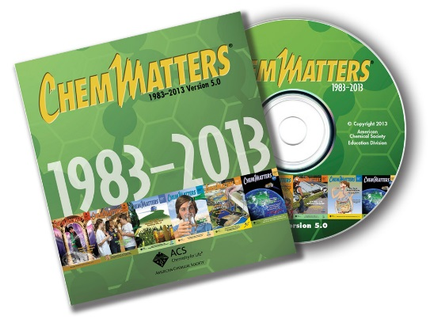

***30* Years of *ChemMatters!***

Available Now!

Wood, C. Dissolving Plastic. *ChemMatters*,1987, *15* (3), pp 12–14. Formaldehyde is used to cross link the polymer chains in polyvinyl alcohol (PVA). Thus, PVA used in fabrics, plastic films and many other household products contributes formaldehyde fumes to indoor air pollution.

Goldfarb, B. CO Control. *ChemMatters*, 1997, *15* (3),pp 10–12. This article begins with a story about carbon monoxide poisoning and includes the chemical equation for incomplete methane combustion plus symptoms of CO poisoning and suggestions for reduction in the home.

Goldfarb, B. Color in a Capsule. *ChemMatters*, 1998, *16* (1), pp 10–11. When dyes, pigments, hospital indicators and carbonless paper contain formaldehyde, indoor air pollution increases.

Curtis, B. The Radium Girls─Dialing up Trouble. *ChemMatters*,1998, *16* (3), pp 13–15. This is the story of the women who used radium salts to paint glowing watch dials. This includes a discussion of radioactive decay, including the alpha-decay of radium to form radon.

McKone, H. Embalming─Chemistry for Eternity. *ChemMatters*,1999, *17* (3), pp 12–13. The properties, history and use of formaldehyde for embalming are discussed in this article. People working in professions where formaldehyde is used need to wear proper personal protection from the fumes.

Goldfarb, B. Liquid Bandages. *ChemMatters*, 2000, *18* (1), pp 9–10. The adhesives used in liquid bandages may emit formaldehyde as they cure.

Rohrig, B. Radioactivity. *ChemMatters*, 2000, *18* (2), pp 6–8. The article covers the discovery of radioactivity and “radioactivity at home” including radon and polonium-210 inhaled by cigarette smokers.

Graham, T. The Silent Killer. *ChemMatters*, 2005*, 23* (1),pp. 12–15.Carbon monoxide is “The Silent Killer”. The article begins with a story and continues to use illustrations to describe why CO is toxic, the use of a hyperbaric oxygen chamber to flush out CO, and CO detectors.

Laliberte, M. Air Pollution Comes Home─Sick Buildings. *ChemMatters*, 2006, *24* (3), pp 12–14. This article provides additional information on indoor pollutants, including radon, formaldehyde, molds, biological pollutants and carbon monoxide.

Rohrig, B. Serendipitous Chemistry. *ChemMatters*, 2007, *25* (3), pp 4–6. When the body metabolizes the sugar substitute aspartame, methanol is produced and further oxidation releases formaldehyde.

Brownlee, C. The Swoosh Goes Green. *ChemMatters*, 2008, *26* (3), pp 18–19 This is an interview with a Nike chemist who is working on reducing VOCs emissions from adhesives used in manufacturing footwear.

Becker, B. Question from the Classroom. If radon is a noble gas, which means it is not supposed to react with anything, how can it be poisonous? *ChemMatters*,2009, *27* (1), p. 2*.* This article presents a discussion of the physical characteristics of radon, its decay series and danger levels.

Warner, J. Sniffing Out Cancer. *ChemMatters*,2013, *31* (1), pp 11–13. Warner describes how dogs can be trained to identify odors from VOCs released via human breath or stool that indicate the presence of human cancer.Although the focus is not on indoor-polluting VOCs, it might be a good, high interest addition to lessons.

# Web Sites for Additional Information

**(Web-based information sources)**

**More sites on indoor air pollution─global concerns**

This National Geographic article summarizes some of the data collected by the World Health Organization (WHO) on indoor air pollution in an easy readable format. (<http://news.nationalgeographic.com/news/2014/03/140325-world-health-organization-indoor-fuel-pollution-death/>)

The “Impact of Environmental Pollution on Health: Balancing Risk”, published by *Oxford Journals,* provides data on the “global burden of environmental diseases”. Percentages for specific types of disease caused by environmental factors are given.(<http://bmb.oxfordjournals.org/content/68/1/1.full>)

**More sites on the deadly London fog**

This article describes how people tried to cope with the killer fog that shrouded London in December 1952. (<http://www.history.com/news/the-killer-fog-that-blanketed-london-60-years-ago>)

A list of references to additional sources of information about the London fog, plus a description of the conditions by a funeral director, can be found at this URL: <http://www.npr.org/templates/story/story.php?storyId=873954>.

Here is an explanation of the effect of temperature on the formation of the deadly London fog: <http://www.eoearth.org/view/article/154281/>.

**More sites on the health impact of air pollution**

This article was published in 2000 as a “Bulletin of the World Health Organization”. The study explores indoor air pollution in developing countries and concludes that this is a major environmental health challenge. The conclusion is written in English, French and Spanish so you may want to share this with your students who are fluent in French and/or Spanish (or your foreign language teachers). (<http://www.who.int/bulletin/archives/78(9)1078.pdf>)

The complete version of 2002 “The World Health Report” prepared by WHO contains additional specific information about the effects of environmental pollution and poverty on the world’s populations. This is a very comprehensive document covering global health risk factors and how much they reduce life expectancies. (<http://www.who.int/whr/2002/en/whr02_en.pdf?ua=1>)

This Fact Sheet provides an overview of updates to the U.S. EPA February 2015 rules for air emissions standards for new household wood heaters. (<http://www.epa.gov/residential-wood-heaters/fact-sheet-overview-final-updates-air-emissions-requirements-new>)

U.S. wood burning stoves and fireplace regulations by state and local governments are given on this site. Note that local laws follow the state regulations. (<http://www.epa.gov/burnwise/ordinances-and-regulations-wood-burning-appliances#state>)

**More sites on** “**sick building syndrome”**

The Lawrence Berkeley labs in California provide a discussion of research into the link between ventilation rates and reports of building-related disease. Ventilation rates are measured in cubic feet per minute per person (cfm/p) of outside air that is introduced into a building. Research methods are described in this paper. (<https://www.iaqscience.lbl.gov/vent-syndrome>)

**More sites on radon gas**

The U.S. NIH “Tox Town” focuses on environmental health concerns. In addition to basic information about radon, this site includes many links to additional material. Students can see where individual toxins, including radon, might lurk in cities, towns, farms, homes, etc. The site is also available in Spanish. (<http://toxtown.nlm.nih.gov/text_version/chemicals.php?id=27>)

Extensive work at the University of Tokyo on the Geological Survey of Japan uses radon concentrations to predict earthquakes. Section 2.1 of this paper covers the use of radon in these studies. (<https://www.jstage.jst.go.jp/article/jpe1952/43/5/43_5_585/_pdf>)

This American Cancer Society site describes home and worksite exposure to radon and lists toll-free numbers and Web sites of national organizations for more information and how to report possible radon exposure. (<http://www.cancer.org/cancer/cancercauses/othercarcinogens/pollution/radon>)

**More sites on VOCs─indoors**

These Stanford University lecture notes on taste, smell and touch contain excellent illustrations of parts of the olfactory pathway. Scroll down to the Section II “Smell”, then scroll down to the bullet on “Anatomy of Smell” and click on each figure following its description. (<http://www-psych.stanford.edu/~lera/psych115s/notes/lecture11/>)

*Scientific American* magazine reported on “harsh chemicals” used to deodorize air including VOCs such as benzene and formaldehyde.

(<http://www.scientificamerican.com/article/nontoxic-air-fresheners/>)

The Minnesota Department of Health bulletin, “Volatile Organic Compounds in your Home” provides public information about indoor VOCs, including a list of compounds, sources (building materials, personal care products, human behaviors such as smoking, painting and reading newspapers), health effects and how to reduce VOCs in your home. (<http://www.health.state.mn.us/divs/eh/indoorair/voc/>)

**More sites on VOCs─formaldehyde**

The PubChem site lists physical and chemical properties, uses, safety, toxicity and much more about chemical compounds. This is the result of a “search” for formaldehyde. (<https://pubchem.ncbi.nlm.nih.gov/compound/formaldehyde>)

This site shows structural formulas for chemical reactions yielding two trade-name formaldehyde products: Bakelite (the first synthetic plastic), from formaldehyde and phenol; and Formica (fire and water repellent; used on countertops and in glues), from formaldehyde and urea. (<http://www.chm.bris.ac.uk/webprojects2002/robson/uses_of_formaldehyde.htm>)

**More sites on VOCs─formaldehyde sources**

This review of the literature on formaldehyde provides history, characteristic properties, toxicology, industrial use, outdoor and indoor sources and methods of detection, including structural formulas showing the chemical reactions. (<http://www.ncbi.nlm.nih.gov/pmc/articles/PMC2855181/>)

This site describes two industrial processes used for the production of formaldehyde. (<http://www.icis.com/resources/news/2007/11/05/9076014/formaldehyde-production-and-manufacturing-process/>)

**More sites on VOCs─formaldehyde toxicity**

This paper from the American Chemistry Council provides their position on the allowable-levels-of-formaldehyde controversy. Keep in mind that this may be somewhat biased. (<http://www.americanchemistry.com/ProductsTechnology/Formaldehyde/New-Graphic-Illustrates-Problems-with-EPAs-Formaldehyde-Risk-Assessment.pdf>)

A January 19, 2016 article published in the *Daily Mail* (United Kingdom) addresses “How your scented candles can kill you”. The danger of formaldehyde as a product of limonene oxidation is presented in general terms. (<http://www.dailymail.co.uk/health/article-3401454/How-scented-candle-KILL-Perfume-release-dangerous-cocktails-cancerous-chemicals.html>)

This paper: “Ozone and Limonene in Indoor Air: A Source of Submicron Particle Exposure”, describes the research methods used to study the impact of ozone on indoor limonene aerosol particles. Much of the quantitative data from these studies is displayed in graphical form. The full text is available free at this URL: <http://www.ncbi.nlm.nih.gov/pmc/articles/PMC1240194/pdf/ehp0108-001139.pdf>.

**More sites on CO─poisoning**

This site describes additional research on the biochemical interaction and effects of CO and NO in bonding with the Fe in the hemoglobin protein. (<http://www.ncbi.nlm.nih.gov/pmc/articles/PMC1223127/pdf/12423201.pdf>)

**More sites on detection of indoor pollutants**

Some states provide free short-term radon test kits. For example, a limited number are available for certain counties in California. (<http://www.cdph.ca.gov/healthinfo/environhealth/Pages/Radon.aspx>)

Use this URL from the U.S. EPA to find a radon test kit or mitigation specialist in your area: <http://www.epa.gov/radon/find-radon-test-kit-or-measurement-and-mitigation-professional>.

The U.S. CDC has published a paper titled: “What you should know about formaldehyde”. This includes a description of short and long term effects, a table of effects due to various concentration levels, and ways to improve the air quality in your home.

(<http://www.cdc.gov/nceh/drywall/docs/whatyoushouldknowaboutformaldehyde.pdf>)

The U.S. Consumer Product Safety Commission (CPSC) works with the government to develop safe standards for CO alarms and to promote public awareness of the hazards posed by CO. This site answers frequently asked questions and provides a list of safety precautions and ways to prevent CO poisoning in the home. (<http://www.cpsc.gov/en/Safety-Education/Safety-Education-Centers/Carbon-Monoxide-Information-Center/Carbon-Monoxide-Questions-and-Answers-/>)

# More Web Sites on Teacher Information and Lesson Plans

**(sites geared specifically to teachers)**

“Chemistry and Environmental Sciences: Indoor Air Pollution” from the University of Iowa provides complete lesson plans and activities for the study of indoor air pollution. The 5 E Instructional Model (Engage, Explore, Explain, Extend (or Elaborate), and Evaluate) is used to format lessons. There are activities for research and suggestions for measuring indoor pollution as well as questions to evaluate student learning. (<https://www.uni.edu/storm/downloads/highschool/Indoor%20air%20pollution.pdf>)

iLab Central is a place to share data from remote online laboratories. The National Science Foundation (NSF) has sponsored a lab curriculum using real data for radioactivity. The lesson plans can be found at this URL: <http://ilabcentral.org/radioactivity/>.

This resource contains lesson plans, experiments and science fair projects for testing air pollution. (<http://www.juliantrubin.com/encyclopedia/environment/airpollution.html>)

This teacher designed unit, “Atmosphere, Pollution, Green House Effect and Climate Change for A.P. Environmental Science” contains lesson plans, labs and videos including information on the “sick building syndrome” and other indoor pollution. (<http://ogoapes.weebly.com/unit-9-atmosphere-air-pollution-and-greenhouse-effect.html>)