April/May 2016 Teacher's Guide for

Chemistry Helps Athlete Keep Moving

Table of Contents

About the Guide 2
Student Questions 3
Answers to Student Questions 4
Anticipation Guide 6
Reading Strategies 7
Background Information 9
Connections to Chemistry Concepts 30
Possible Student Misconceptions 31
Anticipating Student Questions 31
In-Class Activities 33
Out-of-Class Activities and Projects 35
References 36
Web Sites for Additional Information 37

About the Guide

Teacher’s Guide editors William Bleam, Regis Goode, Barbara Sitzman and Ronald Tempest created the Teacher’s Guide article material. E-mail: bbleam@verizon.net

Susan Cooper prepared the anticipation and reading guides.

Patrice Pages, ChemMatters editor, coordinated production and prepared the Microsoft Word and PDF versions of the Teacher’s Guide. E-mail: chemmatters@acs.org

Articles from past issues of ChemMatters can be accessed from a DVD that is available from the American Chemical Society for $42. The DVD contains the entire 30-year publication of ChemMatters issues, from February 1983 to April 2013.

The ChemMatters DVD also includes Article, Title and Keyword Indexes that covers all issues from February 1983 to April 2013.

The ChemMatters DVD can be purchased by calling 1-800-227-5558.

Purchase information can be found online at www.acs.org/chemmatters.

Student Questions
(taken from the article)
Chemistry Helps Athlete Keep Moving

  - Why did Chandler’s parents agree to have his leg amputated when he was just 18 months old?
  - Why are a prosthetic leg and foot separate, instead of making one prosthetic leg/foot combination?
  - Who paid/pays for Chandler’s prosthetic legs?
  - List three requirements for a prosthetic leg, to ensure it will last.
  - List the properties of silicone elastomers that make them suitable for use as the liner for a prosthetic limb.
  - What are these silicone polymers made of?
  - What property makes titanium biocompatible?
  - What are the properties of carbon fibers, and what effect do these properties have on Chandler’s prosthetic foot?
  - Describe the results of the two heating processes, the first at 300 ºC and the second at 400–600 ºC, using polyacrylonitrile to make carbon fibers.
  - What is done to the carbon fibers manufactured according to the above process to make them a strong material?
  - Describe osseointegration.
  - Considering all the benefits of an implant mentioned in the article, was this type of prosthetic leg the best option for Chandler’s situation? Why or why not?

Answers to Student Questions
(taken from the article)
Chemistry Helps Athlete Keep Moving

    - Why did Chandler’s parents agree to have his leg amputated when he was just 18 months old?
Chandler’s parents decided that having his leg amputated and replaced with a prosthetic leg and foot would help him “avoid lifelong deformity and give him the best possible quality of life.”
    - Why are a prosthetic leg and foot separate, instead of making one prosthetic leg/foot combination?
The two parts of the prosthetic are kept separate so that different feet that are designed for specific purposes (e.g., running versus hiking) can be attached to the prosthetic leg.
    - Who paid/pays for Chandler’s prosthetic legs?
Shriners (Hospitals for Children) paid for annual prosthetic limb replacements until Chandler turned 18; after that, a crowdfunding Web site helps to raise funds for new prosthetics.
    - List three requirements for a prosthetic leg, to ensure it will last.
To ensure that a prosthetic leg lasts,
- it needs to fit the shape of the leg comfortably,
- not irritate the skin, and
- be sturdy enough to be worn all day in a rigid socket and be washed every night.
    - List three properties of silicone elastomers that make them suitable for use as the liner for a prosthetic limb.
Three properties of silicone elastomers making them suitable for use as liners for prosthetics:
- they’re resistant to chemical attack,
- they’re unaffected by temperature changes, and
- they can exist as liquid, gel, rubber and hard plastic.
    - What are these silicone polymers made of?
Silicone polymers are made of repeating units consisting of one silicon atom, two carbon atoms and one oxygen atom see Fig. 2 in article).
    - What property make titanium biocompatible?
The property that makes titanium biocompatible is its corrosion resistance to bodily fluids due to the protective TiO₂ film cover that forms naturally in the presence of oxygen and that protects its surface from those fluids.
    - What are the three properties of carbon fibers, and what effect do these properties have on Chandler’s prosthetic foot?
The three properties of carbon fibers are:
- they are very light,
- they’re ten times stronger than titanium, and
- they do not expand much with changes in temperature.
As a result, Chandler’s prosthetic foot feels light yet stiff, and it does not stretch when he runs or when it is hot or cold outside.
    - Describe the results of the two heating processes, the first at 200–300 ºC and the second at 400–600 ºC, using polyacrylonitrile to make carbon fibers.
The first heating of polyacrylonitrile at 300 ºC makes the cyano groups (–CN) form cyclic rings with each other; the second heating to 400–600 ºC results in adjacent polymers binding together to form sheets of graphite.
    - What is done to the carbon fibers manufactured according to the above process to make them a strong material?
Several thousand carbon fibers produced in this way are twisted together to form a yarn and then combined with epoxy and wound or molded into shape, to form light yet strong carbon fiber-reinforced composite.
    - Describe osseointegration.
Osseointegration is the biological process whereby living bone integrates with the surface of a man-made implant. (The bone actually grows around the implant.)
    - Considering all the benefits of an implant mentioned in the article, was this type of prosthetic leg the best option for Chandler’s situation? Why or why not?
Despite all the benefits of an implanted prosthesis, this type of prosthetic leg is NOT the best option for Chandler because the titanium is more rigid than bone, so the bone around the implant could fracture from the high (impact) forces of an athletic activity. Also, sports activities can result in the bolt loosening in the bone.

Anticipation Guide
Anticipation guides help engage students by activating prior knowledge and stimulating student interest before reading. If class time permits, discuss students’ responses to each statement before reading each article. As they read, students should look for evidence supporting or refuting their initial responses.

Directions: Before reading, in the first column, write “A” or “D,” indicating your agreement or disagreement with each statement. As you read, compare your opinions with information from the article. In the space under each statement, cite information from the article that supports or refutes your original ideas.

Me | Text | Statement
 |  | - Children who need prosthetics have to be refitted every year.
 |  | - Running using a prosthetic leg without a knee is similar to using a prosthetic leg with a knee.
 |  | - Prosthetic legs with knees have the same structure as those without knees, except for the knee joint and rotator.
 |  | - The gel liner in a prosthetic leg consists of long molecules containing silicon, oxygen, and carbon.
 |  | - Materials used in prosthetic legs must be compatible with living tissue.
 |  | - Carbon fibers are stronger than titanium.
 |  | - Adding heat can cause polymers to rearrange their bonding pattern.
 |  | - A carbon fiber-reinforced composite contains only carbon.
 |  | - When titanium bolts are integrated to bone, the growth of new bone and blood vessels is encouraged.
 |  | - Titanium bolts are preferred for people who participate in sports activities.

Reading Strategies
These graphic organizers are provided to help students locate and analyze information from the articles. Student understanding will be enhanced when they explore and evaluate the information themselves, with input from the teacher if students are struggling. Encourage students to use their own words and avoid copying entire sentences from the articles. The use of bullets helps them do this. If you use these reading and writing strategies to evaluate student performance, you may want to develop a grading rubric such as the one below.

Score | Description | Evidence
4 | Excellent | Complete; details provided; demonstrates deep understanding.
3 | Good | Complete; few details provided; demonstrates some understanding.
2 | Fair | Incomplete; few details provided; some misconceptions evident.
1 | Poor | Very incomplete; no details provided; many misconceptions evident.
0 | Not acceptable | So incomplete that no judgment can be made about student understanding

Teaching Strategies:

- Links to Common Core Standards for Reading:

ELA-Literacy.RST.9-10.1: Cite specific textual evidence to support analysis of science and technical texts, attending to the precise details of explanations or descriptions.

ELA-Literacy.RST.9-10.5: Analyze the structure of the relationships among concepts in a text, including relationships among key terms (e.g., force, friction, reaction force, energy).

ELA-Literacy.RST.11-12.1: Cite specific textual evidence to support analysis of science and technical texts, attending to important distinctions the author makes and to any gaps or inconsistencies in the account.

ELA-Literacy.RST.11-12.4: Determine the meaning of symbols, key terms, and other domain-specific words and phrases as they are used in a specific scientific or technical context relevant to grades 11-12 texts and topics.

- Links to Common Core Standards for Writing:
ELA-Literacy.WHST.9-10.2F: Provide a concluding statement or section that follows from and supports the information or explanation presented (e.g., articulating implications or the significance of the topic).

ELA-Literacy.WHST.11-12.1E: Provide a concluding statement or section that follows from or supports the argument presented.

- Vocabulary and concepts that are reinforced in this issue:

Personal and community health
Reactive oxygen species
Fuel production and use
Molecular structures
Polymers

- Some of the articles in this issue provide opportunities, references, and suggestions for students to do further research on their own about topics that interest them.

- To help students engage with the text, ask students which article engaged them most and why, or what questions they still have about the articles. The Background Information in the ChemMatters Teachers Guide has suggestions for further research and activities.

- In addition to the writing standards above, consider asking students to debate issues addressed in some of the articles. Standards addressed:

WHST.9-10.1B Develop claim(s) and counterclaims fairly, supplying data and evidence for each while pointing out the strengths and limitations of both claim(s) and counterclaims in a discipline-appropriate form and in a manner that anticipates the audience’s knowledge level and concerns.

WHST.11-12.1.A Introduce precise, knowledgeable claim(s), establish the significance of the claim(s), distinguish the claim(s) from alternate or opposing claims, and create an organization that logically sequences the claim(s), counterclaims, reasons, and evidence.
Directions: As you read the article, complete the graphic organizer below to explain the chemistry of prosthetics..

 | Where is it used in the prosthesis? | Chemical Structure or Description | Properties
Silicone elastomer
Titanium
Carbon fibers

Summary: Write a one-sentence summary (18 word limit) explaining the importance of chemistry in designing prosthetics.

Background Information
(teacher information)
More on the history of prosthetics

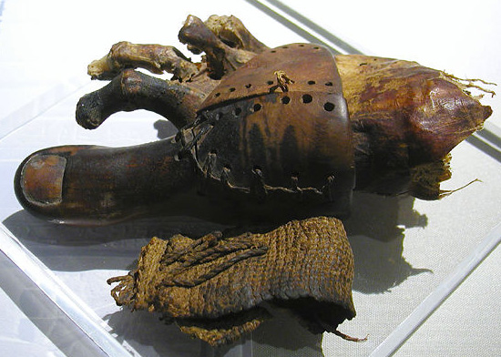
The first prosthetics known to man were made to be esthetically pleasing—to look like the missing body part. Often, these prosthetics were found on mummies, dressed to make them appear “whole”, to help them in their afterlife. These prosthetics were typically poorly made and crudely constructed; they were generally not used as functional prostheses during the life of the person; rather, they were crafted to make the person appear “whole”, to prepare them for the afterlife, a perfect version of life on Earth.
Cropped version of image of a prosthetic toe from ancient Egypt, now in the Egyptian Museum in Cairo. The big toe is carved from wood and is attached to the foot by a sewn leather wrapping.

(By Jon Bodsworth - http://www.egyptarchive.co.uk/html/hidden_treasures/hidden_treasures_31.html, copyrighted free use, https://commons.wikimedia.org/w/index.php?curid=3155729)
(from Wikipedia, https://en.wikipedia.org/wiki/Prosthesis)

But several prostheses found on mummies recently are very life-like and detailed, and they seem to show signs of wear and tear, indicating they might actually have been worn and used in life, before mummification. For example, the toe shown at right, found on the Egyptian mummy of Tabaketenmut, a priest's daughter found buried near the city of Luxor, possibly from as early as 950 B.C., looks very much like a normal toe, one that may even have helped this woman walk more naturally.

For the most part, however, the functionality of these ancient prosthetic devices was almost non-existent. (This Egyptian toe, dubbed the “Cairo toe”, may well be an exception to this idea, though, as scientists think it was functional—and they’re asking patients with amputated big toes to test models fashioned after this one to see if it actually was functional.)

If indeed this prosthetic (and another big toe found on a mummy dated around 600 B.C.) was functional, it pre-dates the previously oldest known functional prosthetic, a prosthetic leg (the Roman “Capua” leg) dated around 300 B.C.

There are references to prosthetic devices in poems and stories of ancient literature, but the Greeks and Romans gave us the earliest recorded accounts of actual use of prosthetic limbs. An artificial arm was designed to help a general who had lost a limb in battle. The prosthetic arm was used to hold his shield so that he could continue doing battle. The arm was made of metal and attached to the general’s shoulders by leather straps. The device served only one purpose—to hold his shield.

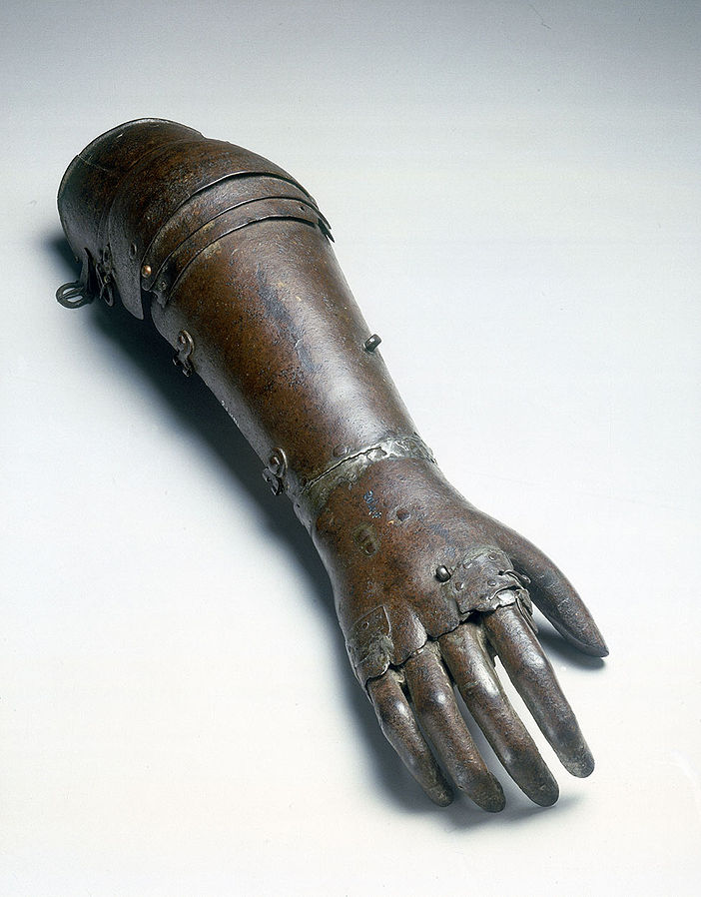
Almost 2,000 years later, little had changed in prosthetics. During the Dark Ages, knights losing a limb in battle depended on prosthetic limbs, and these were made by their armorers, men who crafted their swords and shields. The main function of these limbs was to hide the disfigurement of the lost limb. They were still made of metal and secured by leather straps.
Artificial iron arm, once thought to have been owned by Gotz von Berlichingen (1480-1562), the German knight and adventurer who served with the Holy Roman Emperor Charles V against the Turks. Artificial limbs such as these were expensive items made by armourers, and they allowed wearers, who had lost a limb in combat, to continue with their fighting career. This example is believed to date from 1560-1600, but other examples of these arms have been recognised as later copies. Full view (palm down).

(By Science Museum London / Science and Society Picture Library [CC BY-SA 2.0 (http://creativecommons.org/licenses/by-sa/2.0)], via Wikimedia Commons)
(https://upload.wikimedia.org/wikipedia/commons/e/eb/Iron_artificial_arm%2C_1560-1600._%289663806794%29.jpg)

The “peg legs” of pirate fame actually existed, although they were probably not as common as movies would have us believe. Sailors with limbs requiring amputation were probably reliant on their ship’s cook to do the amputation, since few doctors would be available at sea. And the success rate of these procedures must have been rather poor.

In the 1500s and 1600s, some progress was made with medical techniques for amputation, and this greater success rate also resulted in wider use and improved functioning of prosthetic devices. Ambroise Paré, a French military doctor advanced the amputation procedure and designed a hinged mechanical hand and prosthetic legs that featured a locking knee. These designs are still widely used even today.

Anesthesia, developed in the 1840s, and the development of germ theory with John Snow and Louis Pasteur in the l850s and ‘60s, along with Lister’s work on antiseptic in the 1870s, all contributed to vast improvements in the surgical techniques and duration of amputation, the outcomes of amputations and the development of prostheses to replace the amputated limbs.

The effects of war

As noted above, one of the first uses of prosthetics was to replace an arm lost in war. It turns out that war has always been accompanied by enhanced interest and progress in prosthetic limb development—primarily because soldiers are wounded and that often requires amputation of limbs and the subsequent need for prosthetics to “replace” the amputated limb. “You hate to think that war is what drives technology, but it does,” says Kevin Carroll, the Vice President of Prosthetics for Hanger, a major artificial-limb producer founded just after the Civil War.

The United States Civil War proved to be no exception to the above observation. The Civil War was a brutal war (Is there any other kind?), due in part to the development of new firearms technology. The barrels of old rifles to that time (muskets, actually) had a smooth bore, while the barrel of the newer rifles of the time had a “rifled” bore, grooves in the barrel that resulted in imparting a spin on the bullet as it left the barrel, ensuring greater distance and accuracy, resulting in more injuries to soldiers.

In addition, a new type of bullet—the Minié ball—that replaced the old round ball used by muskets was made of soft lead with a hollow center, which expanded upon firing and flattened upon impact, creating a crater-like, slow-healing wound. Doctors of that era didn’t know to deal with such wounds and usually wound up amputating the affected limb.

Both these developments made the Civil War the bloodiest battle in history to that point. It also resulted in large numbers of soldiers returning home from war missing one or more limbs and in need of prosthetic devices. Public funds provided for the development and purchase of these devices. The U.S. government began the “Great Civil War Benefaction”, a plan to provide prosthetics for all disabled soldiers.

"It is not two years since the sight of a person who had lost one of his lower limbs was an infrequent occurrence. Now, alas! There are few of us who have not a cripple among our friends, if not in our own families."
~ Physician Oliver Wendell Holmes, 1863
(https://www.nlm.nih.gov/exhibition/lifeandlimb/honorablescars.html)

More than three million soldiers fought in the war from 1861-1865. More than half a million died, and almost as many were wounded but survived. Hundreds of thousands were permanently disabled by battlefield injuries or surgery, which saved lives by sacrificing limbs. These men served as a symbol of the fractured nation and remained a stark reminder of the costs of the conflict for long after the war.
.
(“Life and Limb: The Toll of the American Civil War”, an online and traveling exhibition from the U.S. National Library of Medicine, National Institutes of Health; https://www.nlm.nih.gov/exhibition/lifeandlimb/exhibition.html)

But even with all the renewed interest in prosthetics and the development of more advanced devices, like those which included hinged fingers and knees, the average person could not afford the new devices. Nevertheless, advances were being made, such as the use of rubber to make fingers and hands seem more life-like.

World War I saw an even bigger boom in prosthetics, as advanced warfare brought machine guns and larger armament that resulted in more egregious wounds. Advances in medical attention that prevented soldiers from dying from infection resulted in more soldiers who were wounded surviving their injuries. That meant more veterans returning home as amputees, in need of prosthetics. Great Britain had decreed after the Napoleonic Wars that returning amputee soldiers were entitled to free prosthetics, so much of the research and many of the patents on prosthetics occurred there.

The sheer numbers of amputees were staggering—estimated at 41,000 in Britain alone. This soon overwhelmed the prosthetics industry, resulting in shoddy craftsmanship (to produce as many prosthetics as possible in the shortest time), which caused many of the veterans to forsake their prosthetic limbs due to bad fit and poor instructions on their use. As the need for prosthetics began to be met by the industry, designers began to focus on quality, rather than quantity, and improvements began to be seen. Hands were developed to allow the limb user to grip objects, especially for workers in industry. This shift to less affluent people and their need to be productive led developers to design limbs using lighter metals and even plastics, rather than the old wood or iron and leather.

Amputee veterans returning from the wars in Iraq and Afghanistan continue to push prosthetic limb development. Limbs are now developed for specific purposes (e.g., the spring-like feet used by Oscar Pistorius in the 2008 Olympics), and new technology that makes wearing and using the limbs more natural and less painful (e.g., silicone socket layers mentioned in the article and limbs using microprocessor technology that anticipate movement or that help the wearer control the limb with just their brains). The focus today is on making a prosthetic that will make the person whole again, functioning normally—rather than, as in the past, just making a device that made them appear whole.
(http://www.collectorsweekly.com/articles/war-and-prosthetics/)

More on current research in prosthetics

Today, 3-D printing technology is even making it possible to custom-print a working artificial hand, complete with moving, gripping fingers. A group called e-Nable is printing artificial hands using 3-D printers and providing them free to people in need in third-world countries. The plastic pieces of the hands are printed and then require assembly to create the final product. At Shady Side Academy in Pittsburgh, senior Connor Columbo has engaged the school’s service club to do the assembly after he prints the parts. They have sent a dozen hands to recipients overseas so far. It is important to note that these are not actually fully prosthetic limbs, but they should instead be viewed as tools. They require a working wrist or elbow to make them work. The hands open and close, but the fingers do not move individually. (reported February 12, 2016; http://www.post-gazette.com/news/education/2016/02/12/Shady-Side-Academy-senior-Connor-Columbo-uses-3-D-printer-to-make-artificial-hands/stories/201602120023)

One of the latest developments in prosthetics is a limb that can “feel” objects. One of the biggest drawbacks in prosthetic limbs has always been the inability to get direct feedback from the limb, to be able to sense pressure and tactile information (e.g., to know how hard to press on an object to just grip it, without breaking it by holding it too tight, or letting it drop by not holding it tight enough). Up to now, the only way an amputee could get feedback from his/her limb was to see it in action.

But now, researchers at Northwestern University in Chicago have succeeded in transplanting nerves from a severed hand onto the chest of the amputee that allows the person to feel hand sensation in that location. This will allow doctors to send electrical signals from sensors on the prosthetic hand to those nerves on the patient’s chest that will send signals of feeling in the artificial hand to the brain.

This research was based on recent work that showed that motor nerves from a severed arm and transplanted to the chest of the amputee could be controlled by the person thinking about moving his arm. The transplanted nerves associated with moving the hand twitched on the chest when the person thought about moving his hand. The next logical step was then to attach those nerves to the motors of the artificial limb, allowing him to control its movement by his thoughts.

Limited success has been met with two different patients involving the sense of touch. Much more research needs to be done to make this process a “standard operating procedure” to give the sense of touch to people with prosthetics. (https://www.technologyreview.com/s/409100/prosthetic-limbs-that-can-feel/)

And the latest report from Johns Hopkins University (February 17, 2016) says that they have succeeded in having a person control individual fingers on a prosthetic hand by mind-control alone. The person was not an amputee, but a victim of epileptic seizures whose brain had been thoroughly mapped. This allowed the physicians to observe exactly which parts of the brain were responsible for individual finger movements and construct and program the prosthetic using that information. The scientists in the study caution that applying the technology to an actual amputee is likely years away, however. (http://www.oandp.com/articles/NEWS_2016-02-17_01.asp)

More on the properties of titanium

Here is a table listing some of the physical and chemical properties of titanium:

Atomic number 22
Atomic mass 47.90 g.mol ⁻¹
Electronegativity
according to Pauling 1.5
Density 4.51 g.cm⁻³ at 20°C
Melting point 1660 °C
Boiling point 3287 °C
Van der Waals radius 0.147 nm
Ionic radius 0.09 nm (+2) ; 0.068 nm (+4)
Isotopes 8
Electronic shell [ Ar ] 3d¹ 4s²
Energy of first ionization 658 kJ.mol ⁻¹
Energy of second ionization 1310 kJ.mol ⁻¹
Energy of third ionization 2652 kJ.mol ⁻¹
Energy of fourth ionization 4175 kJ.mol ⁻¹
Discovered by William Gregor in 1791

(http://www.lenntech.com/periodic/elements/ti.htm#ixzz429fob3jY)

From Supra Alloys.com, “The Titanium Specialists…”, comes this list of the beneficial properties of medical titanium:

- Strong
- Lightweight
- Corrosion Resistant
- Cost-efficient
- Non-toxic
- Biocompatible (non-toxic AND not rejected by the body)
- Long-lasting
- Non-ferromagnetic
- Osseointegrated (the joining of bone with artificial implant)
- Long range availability
- Flexibility and elasticity rivals that of human bone

Two of the greatest benefits of titanium are its high strength-to-weight ratio and its corrosion resistance. Couple this with its non-toxic state and its ability to fight all corrosion from bodily fluids and it’s no wonder titanium has become the metal of choice within the field of medicine.

(http://supraalloys.com/medical-titanium.php)

More on silicone polymers/elastomers

Structure

Silicone, like its cousin on the periodic table, carbon, can form small individual molecules, or continue its bonding to form very long and convoluted polymer chains.

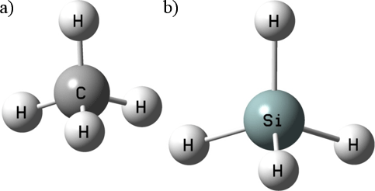

Ball and stick models of methane (left) and silane (right)

(http://www.godandscience.org/images/weird_life_fig4.gif)

Space-filling models of methane (left) and silane (right)

(http://www.treknews.net/wp-content/uploads/2011/09/methane-silicane.jpg)

Both methane and silane are highly flammable gases. But there are few similarities between the two elements in terms of other similar compounds. Carbon dioxide and silicon dioxide, for example have similar formulas, with very different properties. CO₂ is an individual-molecule gas at room temperature, while SiO₂ is a complex network solid. Individual molecules of SiO₂ do not exist at normal conditions.

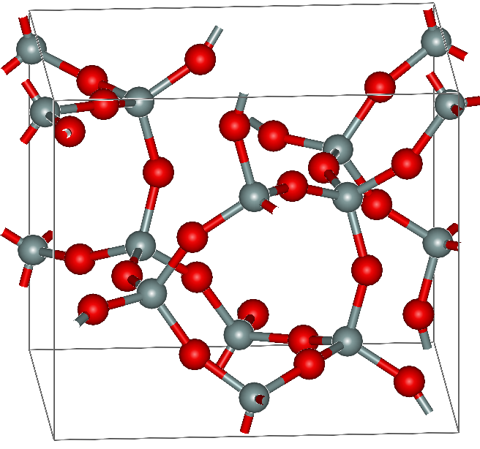
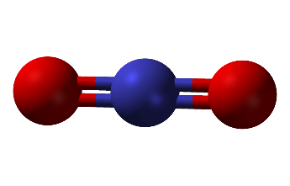
Carbon dioxide, CO₂

(https://upload.wikimedia.org/wikipedia/commons/5/59/Carbon-dioxide.png)
Silicon dioxide, SiO₂
(red = oxygen, gray = silicon)

(https://upload.wikimedia.org/wikipedia/en/d/d1/Keatite.png)
Note that carbon is double-bonded to two oxygen atoms, completing its octet of electrons; the oxygen atoms also achieve their complete octet in this manner. This is in stark contrast to silicon, where each silicon atom completes its octet by single-bonding to four oxygen atoms (except those silicon atoms that extend beyond the edges and faces of the unit cell cube, which continue the bonding in other cubes), and each oxygen is bonded to two silicon atoms (again, except those extending outside the cube). So this network solid could, in theory, extend infinitely in all directions. The huge number of inter-linking bonds involved explain why SiO₂ is a solid at room temperature.

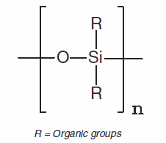
The bonds in the above structure essentially alternate between silicon and oxygen atoms. The basic building block of silicone polymers is this same type of …–Si–O–Si–… linkage. This basic repeating structure is referred to as a siloxane. The end silicon atoms in the structure continue bonding with new oxygen atoms, which bond with new silicon atoms, etc. to continue a growing chain. This arrangement completes the bonding capacity of the oxygen atoms, and each silicon atom continues to bond linearly with other oxygen atoms, but each silicon atom still needs to form two more bonds. Instead of bonding with other silicon and oxygen atoms, as in the case of silicon dioxide, the siloxane structure bonds with hydrogen or other alkyl groups, the simplest of which are methyl groups. Siloxanes form the main chain “backbone” of silicone polymers.
Siloxane repeat unit
http://www.eeweb.com/blog/avago_technologies/silicone-encapsulation-for-led

The basic siloxane structure with methyl groups attached produces the roughly linear, but 3-dimensional structure poly(dimethylsiloxane), the quintessential silicone polymer.

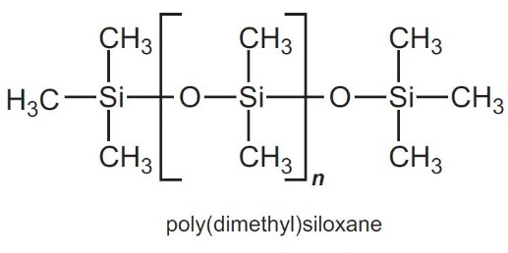
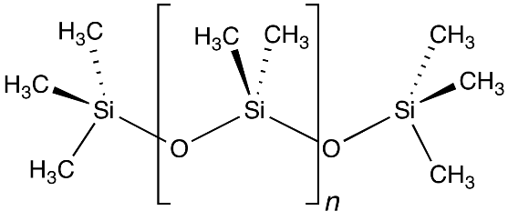
Poly(dimethylsiloxane), 3-D view
(https://upload.wikimedia.org/wikipedia/commons/a/ac/PmdsStructure.png)
(http://essentialchemicalindustry.com/images/stories/680_Silicones/Silicones_07.JPG)
The bracketed structure in the diagrams above is the dimethylsiloxane repeating unit for this poly(dimethylsiloxane) polymer, noted in the Dambrot article; the “n” subscript signifies a very large number of these repeating units.

Properties

Poly(dimethylsiloxane), known as PDMS, is the simplest and most widely used of the group of silicone-based polymers referred to as silicones. Wikipedia describes its properties:

PDMS is viscoelastic, meaning that at long flow times (or high temperatures), it acts like a viscous liquid, similar to honey. However, at short flow times (or low temperatures), it acts like an elastic solid, similar to rubber. In other words, if some PDMS is left on a surface overnight (long flow time), it will flow to cover the surface and mold to any surface imperfections. However, if the same PDMS is rolled into a sphere and thrown onto the same surface (short flow time), it will bounce like a rubber ball.

(https://en.wikipedia.org/wiki/Polydimethylsiloxane)

If these properties sound familiar, it may be because they are the very properties that made Silly Putty™ a household name back in the 1950s and 60s. Silly Putty is primarily dimethylsiloxane and crosslinked PDMS, with other additives.

Here is more information about silicones.

High-molecular-mass polymers called silicones contain an (Si–O–)_{n} backbone with organic groups attached to Si… The properties of silicones are determined by the chain length, the type of organic group, and the extent of cross-linking between the chains. Without cross-linking, silicones are waxes or oils, but cross-linking can produce flexible materials used in sealants, gaskets, car polishes, lubricants, and even elastic materials, such as the plastic substance known as Silly Putty.

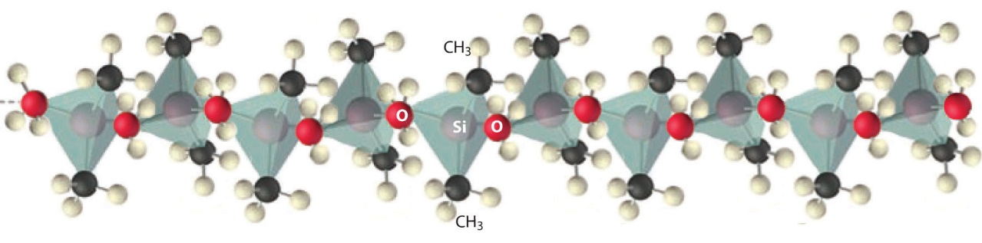

Figure 22.9 Silicones Are Polymers with Long Chains of Alternating Silicon and Oxygen Atoms

The structure of a linear silicone polymer is similar to that of quartz, but two of the oxygen atoms attached to each silicon atom are replaced by the carbon atoms of organic groups, such as the methyl groups (–CH₃) shown here. The terminal silicon atoms are bonded to three methyl groups. Silicones can be oily, waxy, flexible, or elastic, depending on the chain length, the extent of cross-linking between the chains, and the type of organic group.

(http://catalog.flatworldknowledge.com/bookhub/4309?e=averill_1.0-ch22_s02#averill_1.0-ch22_s02_s03_f03)

The elasticity of the crosslinked silicones is responsible for its usefulness in preparing silicone liners for prosthetic limbs.

Dow Corning provides this list of properties of silicones that help to explain their usefulness in so many different applications in modern society.

- Outstanding weathering and aging resistance
- Thermostability
- High water repellency
- Extremely strong adhesion qualities
- Can withstand long-term exposure to the atmosphere
- Resistance to UV and IR radiation
- Extremely low volatility
- Inert (non-reactive with most materials)
- Chemical resistance
- Long-term elasticity, pliability and flexibility
- Excellent electrical insulation
- Tensile strength
- Anti-foaming properties
- Microbial resistance

(http://www.dowcorning.com/content/publishedlit/silicones_overview2.pdf)

The company also lists these as benefits of silicone polymers, compared to organic, carbon-based polymers:

Compared to carbon-based polymers, polydimethylsiloxane (PDMS) polymers:
- Have more open, more flexible molecular chains – are less rigid.
- Have the ability to form much longer chains without solidifying.
- Have stronger, more stable bonds and are more resistant to harsh environmental, processing, and operating conditions.
- Are more flexible and flowable at low temperatures, and do not break down under high temperatures.
- Are able to align their organic substituents more effectively at interfaces; can more easily “connect” with other materials and formulation ingredients.
http://www.dowcorning.com/content/discover/discoverchem/si-vs-organic.aspx

More on carbon fibers and their preparation

Polyacrylonitrile (PAN) is the source of choice for making carbon fibers. Before polyacrylonitrile can be drawn or spun into fibers to process into carbon fibers, its monomer, acrylonitrile, must first be polymerized. This is done by free radical initiation. Step 1 in Figure 5 from the Dambrot article shows the polymerization, but without explanation of how the process works. Let’s investigate further.

Polymerization of acrylonitrile to create polyacrylonitrile (PAN)

In the initiation step, the individual acrylonitrile monomers react with a free radical catalyst—a material that contains an unpaired electron. Because it will attract another electron or be drawn to another atom’s nucleus, this catalyst is extremely reactive and is able to break double bonds in the acrylonitrile monomers and combine with the monomer, resulting in another very reactive free radical, the repeating unit.
N N
||| |||
C C
| |
HC + Cat• Cat⁺ + HC
// //
H₂C H₂C•

Initiation step

Next, in the process known as the propagation step, this new free radical, with the carbon atom on the acrylonitrile repeating unit as the active site, reacts with another acrylonitrile monomer as shown at left. The product is yet another free radical that continues reacting with acrylonitrile monomers. This continues to add to the length of the polymer chain (hence, propagation) as the number of acrylonitrile repeating units attached to the growing chain increases, as shown in the Wikipedia illustration on the next page. The actively growing polymer is referred to as a living polymer.
N N N N
||| ||| ||| |||
C C C C
| | | |
HC + CH HC — CH etc.
// / \ / \
H₂C H₂C• H₂C •CH₂

Propagation step

Eventually, the reaction will run out of reactant acrylonitrile monomers. This will stop the reaction. Or, chemists can stop the reaction, thereby controlling the polymer chain length, by adding another reactant that will react with the free radical active site at the end of the growing polymer, thereby terminating the reaction. This is called the termination step. Two living polymers can also react with each other to terminate the reaction. Even the original unreacted catalyst can act as a terminator, with its unpaired electron entering the reaction with the living polymer’s unpaired electron, resulting in a bond that stops the reaction.
N N N N N N N N
||| ||| ||| III III III III |||
C C C C C C C C
| | | | | | | |
HC — CH + C — C HC — C — C — C
\ / \ \ / \ \ / \ / \ / \
H₂C •CH₂ •H₂C CH₂ H₂C H₂C H₂C CH₂

Possible Termination step

PAN processing

So step 1 in the diagram below, right, virtually the same as the one from the Dambrot article, actually reflects the polymerization of the acrylonitrile molecules, discussed above.
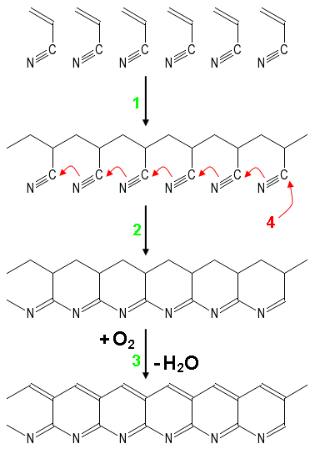
Synthesis of carbon fiber from polyacrylonitrile (PAN): 1) Polymerization of acrylonitrile to PAN, 2) Cyclization during low temperature process, 3) High temperature oxidative treatment of carbonization (hydrogen is removed). After this, process of graphitization starts where nitrogen is removed and chains are joined into graphite planes.

(https://en.wikipedia.org/wiki/Carbon_fibers)
The next step in the process involves heating the polyacrylonitrile from step 1 to 200–300 ºC. This results in breaking one of the bonds in the nitrogen-carbon triple bond, causing new bonds to form between adjacent repeating units on the polymer and producing the ring-like structures shown in step 2, at right. This process is referred to as cyclization.

Continued heating at these temperatures in the presence of oxygen causes oxidation of the polymer, resulting in the elimination of hydrogen atoms from adjacent carbon atoms on the cyclic structures. This produces a new double bond and removes the hydrogen atoms, reacting with the oxygen to form water molecules. (Chemically speaking, the structure becomes aromatic, with a double bond on each hexagon.) This process is referred to as carbonization, increasing the proportion of carbon atoms and removal of non-carbon atoms from the structure.

Finally, at higher temperatures of 400–600 ºC the polyacrylonitrile linear polymers lose most of their nitrogen atoms, increasing the carbon content, a process known as carbonization. These chains fuse together, linking up to form a sheet of hexagonal carbon structures, the beginning of the formation of graphene sheets (single layers of hexagonal graphite). Actually, these ARE graphene sheets, carbon fibers, but of only medium quality and strength. This may be the final stage for some carbon fibers, but others may go on in another step.

To increase the purity, strength and modulus of elasticity of the carbon fibers produced from polyacrylonitrile, further heating is needed, beyond the steps shown in the Dambrot article. This continued heat-treatment step requires taking the PAN fibers (the product of the 400–600 ºC heating step) and heating them in an inert atmosphere such as argon to temperatures of approximately 2,000 ºC. (The PAN fiber, composed primarily of carbon, would burn at these temperatures if allowed to come in contact with oxygen; hence, the inert gas atmosphere.) At these temperatures, the graphitization continues, resulting in the improvement of the alignment of the crystals in the direction of the fiber axis and making a higher quality fiber.

Temperatures at the lower range (graphitization at 1,500–2,000 ºC) result in about 92–95% carbon fibers, with greatest tensile strength, while temperatures at the higher end (graphitization at 2,000–2,800 ºC) produce more than 99% carbon fibers, with greatest modulus of elasticity.

Although this section of the Teacher’s Guide has explained in some detail how PAN becomes carbon fibers, note that there are many variables in the process of polymerizing acrylonitrile into polyacrylonitrile, e.g., reaction conditions (temperature, pressure, etc.) and actual catalysts used, that are considered proprietary by companies in the industry.

Other sources used to make carbon fibers

As mentioned in the article, polyacrylonitrile (PAN) is the present-day component-of-choice to prepare carbon fibers; however, according to CompositesWorld.com, they are not the only source of these reinforcing fibers.

Carbon fibers produced from high-quality polyacrylonitrile (PAN) precursor are typically the highest in quality, find use in structural composite parts (for example, commercial aircraft airframes) and thus have earned the descriptor aerospace-grade, and make up 95% of the current carbon fiber market. But carbon fibers made from other precursors are in use, commercially, and many more precursor alternatives have been investigated.

The best-known commercial alternatives are pitch and rayon. Pitch-based carbon fibers, first produced in the early 1960s by Union Carbide, now GrafTech (Independence, OH, US), are derived from the remnants of crude oil or coal distillation that are rich in aromatic hydrocarbons. The fibers can be formed without mechanical stretching, making them easier to process than PAN, but the result is finished carbon fibers with high modulus and excellent thermal conductivity, depending on the degree of processing and graphitization, but tensile strength lower than that found in PAN-based carbon fiber. Pitch fibers are used in applications that range from aircraft brakes to space satellite structures, where heat management is critical.

Rayon precursor, based on cellulose, dates to Thomas Edison’s first electric light bulbs, where fibers were used as the bulb filaments. Rayon-based carbon fibers, in a phenolic matrix, are still used to make ablative insulating material in solid rocket motors (SRMs), where they perform better than any other carbon fiber.

Currently in the spotlight, lignin was first considered a viable candidate for carbon fibers decades ago. One example is Kayacarbon carbon fibers, produced by Nippon Kayaku Co. in the early 1970s. But, the patent literature reveals many more potential precursors, among them polyethylene (high density and low density), polyolefin, Saran (polyvinylidene chloride]-polyvinyl chloride copolymer), polystyrene, polybutadiene, polyimide, phenol/hexamine and phenol/formaldehyde/ammonia, phenolic, aromatic polyamide 6/6, varieties of polyphenylene-benzothiazoles (PBZTs), and poly(p-phenylenebenzobisoxazole (PBO). All of these have been investigated at lab or pilot scale, with varying degrees of success and at projected lower costs than aerospace-grade PAN.

(Black, S. Alternative Precursor R&D: What are the Alternatives to PAN? Composites World, January 29. 2016; http://www.compositesworld.com/articles/alternative-precursor-rd-what-are-the-alternatives-to-pan)

Research into lignin as a source for manufacturing carbon fibers is gaining momentum for several reasons:
- it has a high carbon content (obviously needed, after all, to make carbon fibers), since it is organic material;
- it is low-cost, since it is a by-product of paper-making and biorefining;
- techniques for processing it already exist;
- it is readily available in scaled-up quantities (the second most abundant organic polymer [after cellulose] on the planet); and
- it is renewable (coming from trees and almost all other plants).
(adapted from http://www.compositesworld.com/articles/alternative-precursor-rd-lignin-in-the-lightweighting-limelight)

Most researchers working to use lignin as their source for carbon fibers agree that they are not trying to compete with PAN as the source, because the PAN-created fibers are very pure and therefore expensive and are used primarily in the aerospace industry. Rather, they see their methods as ways to make cheaper fibers that will be an alternative to glass fibers and low-cost PAN fibers, for higher volume and more widespread use.

Why carbon fibers?

The comparison chart below provides information that shows why carbon fiber is the preferred fiber type by many industries. Note its superior elastic modulus (more than twice that of Kevlar), its exceptional tensile strength (as good as or better than Kevlar), and its extremely small coefficient of thermal expansion. The single most useful property of carbon fibers, though, is the extreme temperatures at which it is useful. This makes it especially valuable in the aerospace industry and in the military. The primary drawback to the use of carbon fibers is its cost.

MATERIAL | DENSITY  (kg/m3) | ELASTIC MODULUS  (Mpa) | TENSILE STRENGTH  (Mpa) | COEFFICIENT OF THERMAL EXPANSION  (ºC-1) | USEFUL  TEMP LIMIT, TMAX (ºc)
Steel | 7800 | 205,000 | 400-1500 | 1.3 x 10-5 | 800
Aluminum | 2800 | 75,000 | 450 | 2.2 x 10-5 | 350
Titanium | 4400 | 40,300 | 1200 | 0.8 x 10-5 | 700
"R" Glass | 2500 | 86,000 | 3200 | 0.3 x 10-5 | 700
"E" Glass | 2600 | 74,000 | 2500 | 0.5 x 10-5 | 700
Kevlar 49 | 1450 | 130,000 | 2900 | -0.2 x 10-5
Carbon  (Pre-Ox, 62% Carbon) | 1360 | 4,000 | 300 | NA | >1500
Carbon  (Intermediate Modulus) | 1750 | 300,000 | 3200 | 0.02 x 10-5 | >1500
Carbon  (High Modulus) | 1800 | 325,000 | 2500 | 0.08 x 10-5 | >1500

(http://carbonfiberremanufacturing.com/pages/reclaimedCarbonFiber/download2b.php)

So, just what is a carbon fiber?

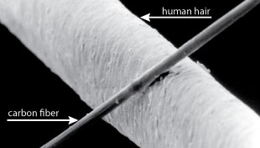
A carbon fiber is a long, thin strand of material about 0.0002-0.0004 in (0.005-0.010 mm) in diameter and composed mostly of carbon atoms. The carbon atoms are bonded together in microscopic crystals that are more or less aligned parallel to the long axis of the fiber. The crystal alignment makes the fiber incredibly strong for its size. Several thousand carbon fibers are twisted together to form a yarn, [also called a tow] which may be used by itself or woven into a fabric. The yarn or fabric is combined with epoxy and wound or molded into shape to form various composite materials. Carbon fiber-reinforced composite materials are used to make aircraft and spacecraft parts, racing car bodies, golf club shafts, bicycle frames, fishing rods, automobile springs, sailboat masts, and many other components where light weight and high strength are needed.
Comparison of the diameter of a carbon fiber filament to that of a human hair

(http://zoltek.com/carbonfiber/)

(http://zoltek.com/carbonfiber/)

A photo gallery of carbon fiber and fabric
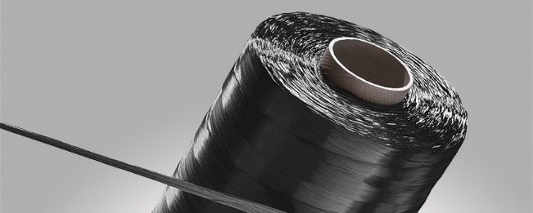
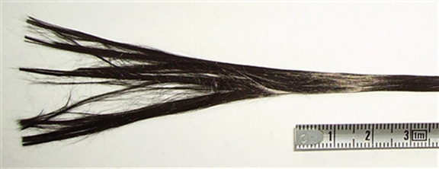
A bobbin of carbon fiber tow

(http://www.sglgroup.com/cms/_common/images/products/product-groups/cf/carbon-fiber-continuous-tow/SIGRAFIL_C-P_4627_07_G_v1.jpg)
Carbon fiber "tow" made up of thousands of filaments

(http://www.build-on-prince.com/carbon-fiber.html#gallery[pageGallery]/3/)

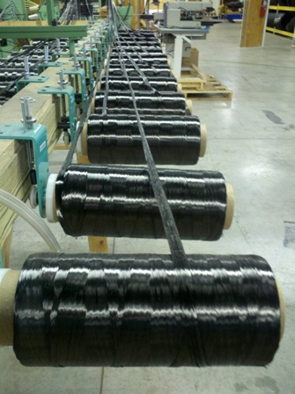
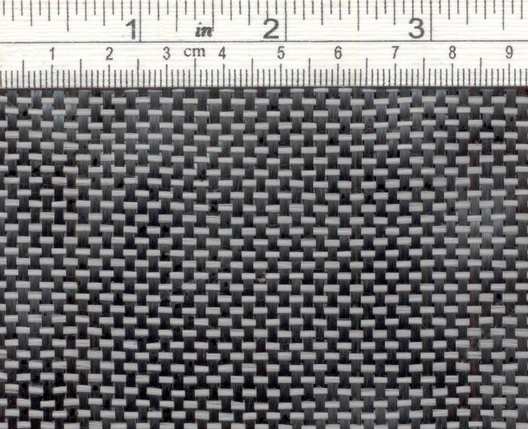
Spools of carbon fiber tows loaded onto a weaving machine

(http://www.build-on-prince.com/carbon-fiber.html#gallery[pageGallery]/0/)
A swatch of carbon fiber reinforced composite fabric: warp (black, running vertically—long, continuous threads), carbon fiber; weft (gray, running horizontally), glass fiber

(http://www.fibermaxcomposites.com/shop/carbon-fiber-fabric-br-c125u-p-100078.html?cPath=36)
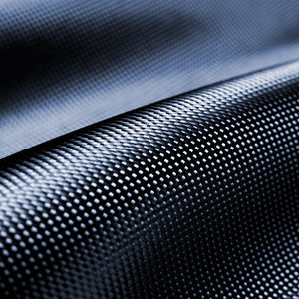
A larger piece of a similar-weave fabric

(http://creationwiki.org/pool/images/thumb/3/3b/Carbon_fiber4.jpg/300px-Carbon_fiber4.jpg)
More on allotropes

Carbon has many allotropes—different structural arrangements of its atoms. The following is a depiction of the structures of eight of them:
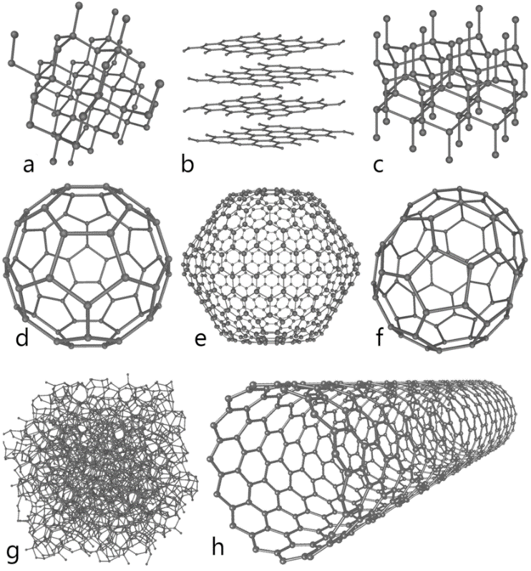
This illustration depicts eight of the allotropes (different molecular configurations) that pure carbon can take:
- a) Diamond
- b) Graphite
- c) Lonsdaleite
- d) C60 (Buckminsterfullerene)
- e) C540 (see Fullerene)
- f) C70 (see Fullerene)
- g) Amorphous carbon
- h) single-walled carbon nanotube

(https://en.wikipedia.org/wiki/Allotropes_of_carbon)

The physical properties of each of these is different from those of the others (e.g., graphite is one of the softest substances on the Mohs scale of hardness, while diamond is the hardest naturally occurring substance; graphite conducts electricity, diamond does not; graphite is black, diamond is clear).

As mentioned in the Dambrot article, graphite is the allotrope of choice for making carbon fibers. Sheets of graphite can be wound and combined with epoxy to strengthen the final product, they can be woven together to make a fabric, they can be fused onto matrices of other substances to add strength, etc.

More on composites

A composite is a material that is a mixture of two or more substances with properties that are better than those of any of the components individually. The two main components are the matrix and the filler or reinforcing material. The matrix holds the reinforcing material together and is usually the component providing flexibility and tensile strength, while the filler provides the reinforcement—the structural strength.

The reinforcing phase usually exists in one of three forms: particles, fibers or flat sheets. Concrete and asphalt or “blacktop” are examples of composites with the reinforcing phase in particle form. Rock or aggregate is the reinforcing material for both concrete and asphalt. Cement is the matrix for concrete, while asphalt or bitumen, a viscous mixture derived from petroleum, is the matrix for what we commonly call asphalt, but which is actually asphalt concrete. Fiberglas™ is a composite made of a polymer resin (the matrix) reinforced with spun glass—long filamentous threads of glass. And plywood is an example of the flat sheets reinforcing material. Thin layers of wood (the sheets) are oriented so that the grains of the wood run in different directions. Epoxy glue is the matrix for plywood, spread between the thin wood sheets. All these composites are man-made.

But man isn’t the only—or the original—manufacturer of composite materials; Nature makes composites, too. For example, trees use cellulosic fibrous components to reinforce lignin’s matrix, aligning the fibers in exactly the best way to have the composite structure maintain its form to great heights and to withstand strong winds (see figure below). And bone is a natural composite, made of flexible collagen and strong, but rigid hydroxyapatite [Ca₁₀(PO₄)₆(OH)₂]. These two complement and improve on each other’s properties; the overall effect is synergistic.

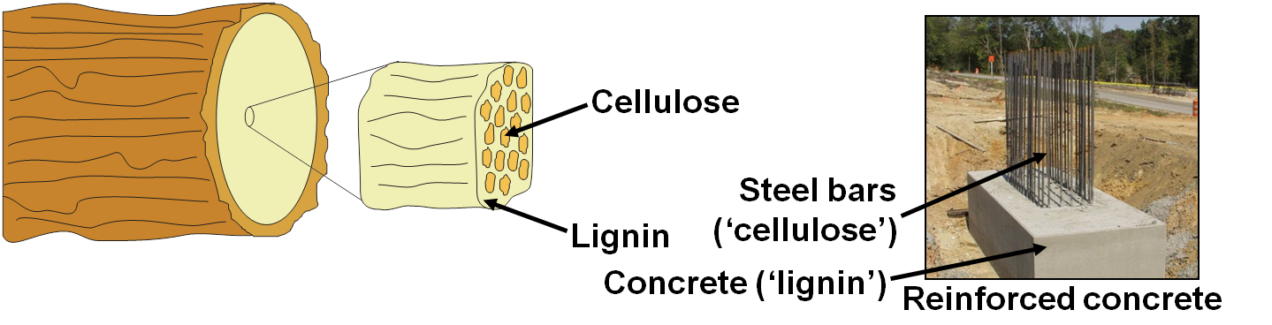

Comparing the matrices and reinforcing materials in wood (natural)
and reinforced concrete (man-made)
(http://4.bp.blogspot.com/-WfTS3hwUSEQ/UTi4gU1lkfI/AAAAAAAAJdM/IrWSdwIoJ1I/s1600/Picture3.png)

Underwater natural composites exist also, and man is trying to imitate them.

The abalone, a marine mollusk, builds its strong shell from just calcium carbonate and protein. The layers of carbonate are connected by protein to make a very strong laminate. Compared to a brick walls, the calcium carbonate forms the bricks and the protein is the mortar. Such laminates can be used for lightweight armor and … ceramic-metal composites. A team of researchers at Princeton University, led by Ilhan Aksay developed the composites in the late 1990s. Says Aksay, "When people ask me if I needed to study biological systems to invent laminated ceramic-metal composites," he says, "I tell them, no, I might have come up with the idea anyway, but studying biological systems helped get me there faster." More recent developments mimicking the hardness of the abalone shell have been done at the University of California at San Diego. The laminated composites will find potential uses in tooth repair and in the manufacture of cutting surfaces that will not dull.

(Teacher’s Guide for the April 2006 ChemMatters article “Biomimicry”: Parent, K. and Young, J. Biomimicry—Where Chemistry Lessons Come Naturally. ChemMatters, 2006, 24 (2), pp 15–17)

Composites are a rapidly-growing area of chemistry because they serve several direct societal needs: the need for better materials (with enhanced properties) that can keep up with ever-expanding technology, and the need for materials that do not rely solely on fossil fuels for their manufacture. The main advantage of composites is that they can be manufactured for specific purposes using individual components that can be blended to provide the best properties of each of these components, or properties between the individual components. An example of this is plastic lumber

A homebuilding material that is often made of recycled plastic is composite lumber. Used for decks and window and door frames, this material is a 50/50 mixture of wood fibers from sawdust and recycled plastic. The wood fibers reinforce the plastic lumber, so that it is stronger than 100% recycled plastic. Furthermore, the plastic protects the wood from rotting. So the combination of natural and synthetic materials brings out the positive characteristics of both wood and plastic.

A huge advantage for the homeowner is that plastic lumber does not have to be painted. Color can be added during the manufacturing process. As a further blessing to the environment, composite lumber is made of plastic and sawdust that would otherwise end up in a landfill.
(Baxter, R. Green Chemistry: Chemistry Builds a Green Home. ChemMatters, 2006, 24 (3), pp 9–11)

Composite use in prosthetics

The Orthotics and Prosthetics Digital Library provides this 1987 article from that journal: “Composite Materials for Orthotics and Prosthetics”. It discusses the types of composites being used at that time (and still today, for the most part) in these fields.

The three composites tested and presently being used in the orthopedic industry are: 1) fiberglass; 2) Kevlar® (Aramid®); and 3) carbon (Graphite). The advantages of one composite over another is [sic] due to each material having completely different properties and characteristics.

Fiberglass is by far the most common and economical composite. Although the heaviest material of the three, it is easy to saturate with resin and very easy to obtain in many forms and qualities. The principal properties of fiberglass are its durability and flexibility, due to the fibers being twice as strong under compression as compared to the fiber strength under tension.

Kevlar® is the lightest and most expensive composite. It provides an excellent resistance to fracture under impact and can absorb high loads of torque and stress. These desirable properties are, however, compromised, as Kevlar® is very poor in maintaining structure or form under load; it is five times weaker under tension than it is under compression. In addition, Kevlar® is extremely resistant to chemicals and very difficult to saturate with resin.

Perhaps the most valuable composite to orthopedic appliances is carbon. Almost as light as Kevlar®, it is very stiff and able to hold its shape under stress due to its impressive strength under both tension and compression. The structural compromise of the carbon fibers is that the stiffness creates brittleness and a poor resistance to impact.

(http://www.oandplibrary.org/op/1986_04_035.asp)

To overcome these structural weaknesses, the carbon fiber is used to reinforce plastics used in prosthetics. This decreases its brittleness and increases its impact resistance, without causing it to lose any of its beneficial properties.

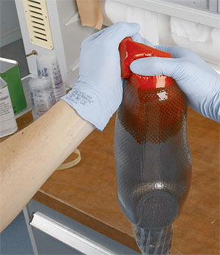
Carbon is used in orthoses and prostheses as a durable, fiber-reinforced composite… Carbon fabric looks flimsy until it physically and chemically bonds with a resin system to create carbon fiber reinforced plastic (CFRP).
The technician positions the pliable carbon fiber-reinforced composite into the prosthetic mold.
(http://www.oandp.com/articles/2013-07_10.asp)

The resin fixes the carbon fibers in a geometric arrangement, transmits force to the fibers, and stabilizes the fibers as pressure builds. The embedded fibers strengthen and stiffen the composite and absorb forces throughout the length of the fibers. The chemical bond created by carbon atoms in the resin matrix produces strength superior to most metals and other fiber-reinforced composites…
(http://www.oandp.com/articles/2013-07_10.asp)

In many other medical devices, Kevlar and polyether ether ketone (PEEK) are used as the matrix in the carbon fiber-reinforced composite, but in prosthetic limbs, the rigidity of these polymers makes them less suitable. A new, actually old, polymer seems better suited for lower body prosthetics—nylon 6,6. It is a less rigid polymer that still exhibits the other properties needed to serve as the matrix for these artificial limbs.

More on implants and abutments

In terms of the technology involved, it’s useful to distinguish body implants from transplants, and from synthetic organs. Transplants are indeed “implants”, but these are “natural” biological body parts, actual duplicates of the organ or tissue being replaced, albeit from another person. Synthetic organs are things like artificial heart valves or pacemakers, and these, too, are “implanted”, but these usually involve entire organs and very complex mechanisms. Implants for this discussion mean much simpler objects place in the body (e.g., hip replacements or tooth implants, or posts placed in bone to which are anchored prosthetic devices.

There are lots of types of medical implants. These include pins, rods, screws and plates to anchor broken bones while they heal; hip replacement joints; spine rods and replacement vertebrae disks; breast implants; knee replacement joints; coronary stents and replacement heart valves; cochlear implants for people who can’t hear; and artificial lenses for eyes after cataract surgery.

Dental implants may be the most common form of implant. When a tooth is extracted, the dentist may do a root canal, which removes the nerve from the tooth socket. Then a metal screw is inserted into the root of the tooth and an abutment is screwed onto the implant. Finally, a tooth crown is affixed to the abutment to complete the project.

A 2008 issue of Science Daily discussed new technological developments related to implants.

Half a century ago, Swedish scientists invented the first implantable heart pacemaker, demonstrating the potential of treating medical conditions by placing electronic devices within the human body. Now a consortium of 27 universities, research centres, hospitals, technology companies and manufacturers is developing new micro-technologies for implantable medical devices of the future.

The EU’s Healthy Aims project includes partners from seven EU countries, Switzerland and Israel, all of whom were already members of a medical devices industry association. “We started with a very strong group of people,” recalls Diana Hodgins of European Technology for Business Ltd, the project coordinator. “We looked at the clinical needs and the end manufacturers’ requirements and married those up to the technologies that we had available.”
In its four years, the project has pioneered three powered implants and three diagnostic devices.

Six products

A common consequence of a stroke is that patients lose control of an arm and are unable to release their grip. In functional electrical stimulation (FES), muscles are activated by signals from an implant. “Our stimulator extends the wrist, so the hand is in the right position, and then opens the fingers and thumb ready for an object to be grasped,” Hodgins explains.

“The first ones have been implanted and we’ve had some excellent results.” The technology is now being extended to tackle incontinence by helping patients control their bladder and bowel sphincter muscles.

A second product restores limited vision in certain types of blindness. A camera chip integrated into a pair of glasses transmits data to an array of electrodes inside the eyeball which stimulate retinal nerve cells. The image has 231 points which is a major achievement for patients with no sight at all. Clinical trials are already underway.

Similar technologies are being used in a cochlear implant to restore hearing. Compared to existing devices, the implant will improve voice recognition in noisy environments by having more stimulation sites and placing them in the inner cochlea, sending electrical impulses directly to the brain.

Yet another implant will measure the pressure inside the brain cavity, a crucial diagnostic for sufferers of hydrocephalus where an excess of fluid can damage the brain.

Three diagnostic tools are also emerging from the Healthy Aims project. The glaucoma sensor, a contact lens incorporating a ‘strain gauge’ to monitor the pressure within the eyeball, is already being trialled with patients. A catheter for measuring the pressure inside the bladder will help diagnose cases of incontinence. And an activity monitor, spun-off from the FES work, will keep track of a person’s physical activity over a period of time, in sport as well as in medicine.

All these products share a small number of core micro-technologies, developed within the project, that will give the European medical devices industry a toolkit of techniques for the future.

Healthy results

The first is wireless communication. All the implants and sensors transmit and receive data without any connecting wires. Although a single solution for all the devices has not proved practicable, the project has developed a technology (based on the ‘medical implants communications service’, or MICS, standard) that can transmit radio waves from an implant to a receiver worn on the body.

“While it wasn’t suitable for all the applications, it’s the ideal solution for FES,” says Hodgins. “We now have a working MICS system that can be sold anywhere in the world.”

The partners have developed arrays of tiny microelectrodes to stimulate nerves or muscles and the connectors to join them to supporting electronics. “Platinum electrodes are the most common for implantable devices and the most difficult to make and join to in an automated process. We’ve learned a great deal and we are now sharing that with other projects,” says Hodgins.

Implants have to last for the life of the patient. That means that they must be completely enclosed by materials that will not degrade by long exposure to body fluids. The team has come up with two new materials, a modified silicone and diamond-like coating (DLC), both of which look very promising.

Finally, implants need a source of power. At present, the only makers of implantable batteries are in the USA and they do not sell their technology to competitors. Now, thanks to Healthy Aims, two new European prototypes are moving towards clinical trials: a rechargeable battery, suitable for powering the FES and cochlear implants, and a fuel cell powered by the body’s own glucose which could run a heart pacemaker for ten years.

(https://www.sciencedaily.com/releases/2008/01/080116170100.htm)

Connections to Chemistry Concepts
(for correlation to course curriculum)
- Chemical/Physical properties—The properties of various materials in the article determine their use in the manufacture of prosthetic limbs. (e.g., rigidity, strength and biocompatibility are properties of titanium that make it useful in the main structure of prosthetics.
- Composites—These substances greatly expand the repertoire of technology. Where a specific substance may have only some of the properties it needs for use in a specific application, by combining it with other substances, its properties can be enhanced to the point where it can now be used for that application.
- Polymers/repeat units—The polymerization of polyacrylonitrile (PAN) to ultimately form graphene sheets and carbon fibers can be used as an example of polymer formation.
- Elastomers—The elastomeric properties of silicone polymers make them ultimately suitable for their specific roles in prosthetics (e.g., they provide a flexible surface between the residual limb and the prosthetic leg that reduces pain at the juncture.
- Chemical reactivity—The oxide coating of titanium, similar to that of aluminum, makes it relatively unreactive and prevents titanium atoms from reacting with body fluids, thus making titanium biocompatible for prosthetics. It has long been used for hip replacement joints.
- The usefulness of the graphite allotrope of carbon in prosthetics can be attributed to its 3-dimensional structure that gives it strength in one direction and flexibility in another
- Allotrope structure— The usefulness of the graphite allotrope of carbon in prosthetics can be attributed to its 3-dimensional structure that gives it strength in one direction and flexibility in another. Its strength and flexibility can be altered by “weaving” it into composite structures with epoxies.
- Chemical synthesis—This topic probably gets short shrift in most courses, but the chemical industry relies on chemical syntheses to produce substances needed by society. Many of these may seem unorthodox at first, but the criterion of success is if they work.

Possible Student Misconceptions
(to aid teacher in addressing misconceptions)
- “People with prosthetic legs can’t swim, bike, run or dance.”
Obviously, Chandler shows that this is not true, as does Amy Purdy (Dancing with the Stars, 2014; https://youtu.be/ZiEIKy1elMk). Sometimes, disability seems to be more in the mind than the body.
- “People who wear prosthetics must have been involved in horrific accidents that caused them to lose a limb.” Actually, most amputees had limbs removed as a result of diseases like cancer or diabetes.

Anticipating Student Questions
(answers to questions students might ask in class)
- “Can a person outgrow a prosthetic?” Yes, they can and do. As mentioned in the Dambrot article, Chandler needed to have a new prosthetic limb annually as he grew through childhood and his teen years.
- “Are prosthetic limbs the only type of implant?” There are lots of other types of medical implants. These include pins, rods, screws and plates to anchor broken bones while they heal; hip replacement joints; spine rods and replacement vertebrae disks; knee replacement joints; artificial hearts, pacemakers, defibrillators, coronary stents and replacement heart valves; cochlear implants for people who can’t hear; and artificial lenses for eyes after cataract surgery. Cosmetic implements include breast implants, nose and face implants.
Dental implants may be the most common form of implant. When a tooth is extracted, the dentist may do a root canal, which removes the nerve from the tooth socket. Then a metal screw is inserted into the root of the tooth and an abutment is screwed onto the implant. Finally, a tooth crown is affixed to the abutment to complete the project.
- “What other uses do silicone polymers have?” Silicone polymers are used: in automobiles for adhesives, lubricants, sealants, paints, polishes and gaskets; in fabrics for water-proofing, stain-proofing, wrinkle-proofing; in personal care products to provide a silky-smooth feel; in health care for dialysis tubing, lubrication of syringe needles (and prosthetic sleeves); in construction for roofing materials, pavement sealants and caulking; in the paper industry for pressure-sensitive adhesives and the label-backing paper; in aerospace for sealants ,elastomers and resins; in the food industry for defoaming various materials and as release agents in cake pans. (http://www.dowcorning.com/content/about/aboutmedia/Everyday_Uses_of_Silicone.pdf)
- “Is titanium the only metal that has this ‘oxide coating’ thing?” No, other metals besides titanium also exhibit the spontaneous formation of an oxide coating. Aluminum, for instance, forms a coating with oxygen from the air. This results in aluminum not “rusting” or corroding in air, unlike iron that does not form an oxide coating. Instead in iron, oxygen reacts with iron atoms on the surface, forming iron oxide, which then flakes off, exposing another iron “surface” that can then react with more oxygen from air, resulting in constant flaking off of iron atoms; i.e., rusting.
- “Are there other metals, besides titanium, that can be used for prosthetics?” Aluminum, cobalt-chrome alloys, stainless steel, and tantalum are also used in prosthetics. Aluminum is light-weight, but it is not as strong as steel or titanium. Nevertheless, it can be used where its strength meets the criteria for that application. It can also be alloyed with titanium and vanadium. Cobalt-chrome alloys may still be used, but they are dense, so they are used primarily as covers for other materials in joints. Stainless steel is very strong, but it is also denser, so its added weight is a disadvantage. It is typically used in smaller parts, where its slight additional weight will not be prohibitive. Tantalum is used, primarily in hip replacement joints and skull plates, due to its high biocompatibility.
- “What other uses are there for composites?” Composites are used for lots of other purposes. Examples include: fiber-reinforced polymers and, especially, carbon-fiber reinforced polymers are used in sports venues for items like golf clubs and tennis rackets, to increase performance; in aircraft materials, to reduce weight; in the auto industry to decrease weight and enhance design; in the energy industry for solar panels and wind turbines; in building and construction for flooring, furniture and building materials; in military uses such as stealth airplanes to minimize detection by absorption of radar waves and for ballistic protection (think body armor and Kevlar); in dentistry for fillings and adhesives; and in the medical profession for surgical equipment and, of course, prosthetics.
- “What else is graphite good for?” Graphite has many other uses. It is the writing material in pencils (not “lead”); it is used as a dry lubricant; it is the anode rod in dry cell batteries, including lithium-ion batteries, and, on a much larger scale, in electric-arc furnaces that produce steel; it is used in refractory materials (requiring high heat-resistance) like automobile brake linings and brake shoes (replacing asbestos) and crucibles to contain high-temperature molten metals; it is used in electrical applications for motor brushes; and it is a neutron absorber in nuclear reactors.
- “Is osseointegration useful anywhere else in the body?” Dental implants depend on osseointegration to mesh the metal of the screw implant with the jawbone to ensure that the implanted tooth will stay in position.
- “What other composites are ‘out there’, besides carbon-fiber composites?” Concrete is one of the oldest composites, consisting of cement, water and aggregate, a mixture of rock chips. Since concrete is brittle, steel rods called rebar are added to make it more flexible and crack-resistant; this is called reinforced concrete. Fiber-reinforced polymers and glass-reinforced polymers (think Fiberglas®) also are in widespread use. Ceramic-matrix and metal-matrix composites use metal fibers to reinforce the base material. Laminates like plywood, wood layers bonded together with glue, are composites used in home construction. Newer dental fillings (not amalgam or “silver” fillings) are composites consisting of resin polymers reinforced with fillers to resist wear and tear. (“Silver” fillings contain mercury and are alloys, not composites.)

In-Class Activities
(lesson ideas, including labs & demonstrations)
- You can easily show the crosslinking of silicone rubber polymer. Silicone caulk is an elastomer (already a polymer) that has been chemically designed to crosslink when it comes in contact with air. Simply squeeze out some silicone caulk onto a flat surface, and students can observe the caulk change from a flowing material to a material that holds its shape as the crosslinking takes place within minutes. The chemical reaction releases acetic acid and will produce a noticeable vinegar odor.
- This site provides a pdf of a series of slides describing the eight allotropes of carbon, with a student assignment at the end. Students are divided into eight groups to complete the assignment. Note that the assignment as written requires that you supply a large number of either K’Nex pieces or marshmallows to construct models of these allotropes. The other part of the assignment involves internet research on that specific allotrope. (http://www.egr.msu.edu/~alocilja/Teaching/High%20School%20materials/NSF%20High%20School%20Jennifer's%20Work%20-%20Final%202008/11-LESSON%20PLAN%203c.pdf)
- This site from Boundless Teaching contains information about carbon allotropes, and it includes teacher/student features: “Assign Concept Reading, “View Quiz” and “View PowerPoint Template”. Note that, to assess these features, you must register, and it apparently is NOT free (but it is advertised as “affordable”). (https://www.boundless.com/chemistry/textbooks/boundless-chemistry-textbook/nonmetallic-elements-21/carbon-150/allotropes-of-carbon-582-3569/)
- Using molecular models, students can construct diamond, graphite, and graphene (using an individual layer of graphite to show graphene). There are instructions at this site for producing buckyballs (another allotrope of carbon) from paper. (http://www.nisenet.org/sites/default/files/catalog/uploads/2008/11/3066/strucbucky_diecut_1of8_dec09.pdf)
- Students can also make a model of a buckyball (another allotrope of carbon, related to graphene and graphite) using this insert page from the December 1992 issue of ChemMatters in an article on, strangely enough, buckyballs.
(Wood, C. Buckyballs. ChemMatters, 1992, 10 (4), following pp 7–9)
- You can use the idea of the conductivity of graphite and graphene when you discuss metallic vs. non-metallic properties in class. This can be done in conjunction with the periodic table. Actual explanation of why these two conduct may have to wait until later in the course, when you discuss valence electrons and bonding.
- You may want to have students try to obtain single layers of graphene in the lab. Here is a site that describes the process: http://science.wonderhowto.com/how-to/make-graphene-sheets-from-graphite-flakes-and-cellophane-tape-402113/. This site includes a video that shows the technique. It uses refined graphite, but pencil “lead” graphite will work also, providing students with crude single-to-multilayers of graphene. You can’t really prove you’re obtain graphene, but it IS the technique used by scientists who won the Nobel Prize for the method.
And this site shows how people do it in a “real” lab: http://www.scientificamerican.com/slideshow/diy-graphene-how-to-make-carbon-layers-with-sticky-tape/#1. Note that the nine slides appear NOT to be in proper order.
- Alternatively, students might want to simulate the process of the sticky tape removal of a single layer of graphene from graphite by applying a similar forensic technique for lifting fingerprints. The procedure can be found at http://www.ehow.com/how_6523624_lift-fingerprints-home.html.
- For a complete unit on the allotropes of carbon, including molecular modeling, wet lab and student research/reporting activities, see “Carbon Allotropes: The Same and Not the Same”, at http://www.nsec.northwestern.edu/Curriculum%20Projects/Carbon%20Allotropes.pdf. Note that this a 2005 project, and the wet lab requires the use of some chemicals that may no longer be in your chemical inventory.
- This brief (1-1/4 page pdf) document from the Royal Society of Chemistry provides a quick overview for students of composite materials. It also provides a separate page of seven questions to review their grasp of the topic. (http://www.rsc.org/Education/Teachers/Resources/Inspirational/resources/4.3.1.pdf)
- This 73-slide presentation (in a Word document) from the U.S. Naval Academy is a very detailed overview of fibers in general. Carbon fibers are covered in slides 22–41, and these could be used in class (selectively) to discuss PAN processing into carbon fibers.
- Students could “kill two birds with one stone” by doing the old tried-and-true “making “gluep” and varying its properties” lab activity. a) They can create a composite of the gluep, and discover the effects on its properties by changing the percentages of the ingredients, including extra additives. b) They could adapt the goal of the activity from making a ball with specific properties to that of making a silicone lining for a prosthetic. They would need to establish as a class the properties such a lining would need, and then proceed to experiment with the ingredients you provide to prepare an “ideal” composite polymer mix that meets these properties; this would include a report to the class to support their claims/findings. This site offers ideas about such a series of lessons, but their topic is designing athletic shoes: http://www.polymerambassadors.org/AkronStudentShort.pdf. (That’s the student version; here’s the teacher version: http://www.polymerambassadors.org/AkronTeacherShort.pdf.
- And this site does the same thing with gluep as #12 above, except the goal is to design products with properties suitable for various snowmobile-related items (e.g., snowmobile body, snowmobile suit and snowmobile storage): http://www.hofstra.edu/pdf/tec_nyscate_polymers.pdf.

Out-of-Class Activities and Projects
(student research, class projects)
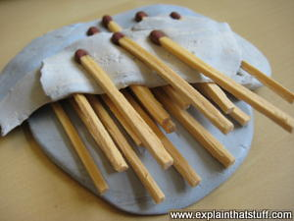
- You could ask students to create their own version of a composite (matrix and reinforcement) from materials found around the home, and then prepare a presentation explaining/demonstrating why their product is a composite and how its properties improve upon the properties of the individual components, and perhaps some uses for the composite. You might or might not want to show them this (at right) as a sample to get them started:
Photo: A simple model of a composite. I've used layers of sticky plastic fastener (Blu-Tack) as the matrix and matchsticks as the fibers, so this is (loosely speaking) a kind of polymer matrix composite. It would be easy to turn this into a science fair experiment: build yourself a large sample of composite like this and then compare its properties to those of the materials from which you've made it.

(http://www.explainthatstuff.com/composites.html)
- You could give your students the task of researching individual composites, providing a list of criteria for their search (e.g., components; type of composite; uses; properties; benefits; drawbacks, if any; why the composite is better than the individual components’ why the composite is better than the other, “natural” materials used for the same purposes; others items you might think of). A list of composites could include: concrete, reinforced concrete, fiber-reinforced concrete, Fiberglas, adobe (as in brick), plywood, clothes with Spandex, clothing with Gore-Tex, particleboard, laminate flooring, drywall or sheetrock, epoxy granite, Masonite, and fiberboard. This Wikipedia site provides a long list of composite materials: https://en.wikipedia.org/wiki/Category:Composite_materials.

References
(non-Web-based information sources)
The references below can be found on the
ChemMatters 30-year DVD, which includes all articles
published from the magazine’s inception in October 1983 through April 2013, all available Teacher’s Guides, beginning February 1990, and 12 ChemMatters videos. The DVD is available from the American Chemical Society for $42 (or $135 for a site/school license) at this site: http://ww.acs.org/chemmatters. Scroll all the way down to the bottom of the page and click on the icon at the right, “Get the past 30 Years of ChemMatters on DVD!”

Selected articles and the complete set of
Teacher’s Guides for all issues from the past three
years are available free online at the same Web site, above. Click on the “Issues” tab just below the logo, “ChemMattersonline”.
30 Years of ChemMatters!
Available Now!

One of the fun uses of silicone is in Silly Putty™, a silicone polymer/elastomer. A complete article on Silly Putty with some useful molecular structures and references can be found in the 1986 article “Silly Putty”. (Marsella, G. Silly Putty. ChemMatters, 1986, 4 (2), pp 15–17)

This insert page from the December 1992 issue in an article on Buckyballs (another allotrope of carbon) provides a template for making a model of C₆₀. (Wood, C. Buckyballs. ChemMatters, 1992, 10 (4), following pp 7–9)

One major use of titanium is in Nitinol, the “memory metal”, composed of nickel and tin. This article in the October 1993 issue of ChemMatters discusses how it works and some uses for the metal alloy, including as a prosthetic of sorts in shoulder joint repair. (Kauffman, G. and Mayo, I. Memory Metal. ChemMatters, 1993, 11 (3), pp 4–7)

The December 2004 Teacher’s Guide that accompanies “The Science of Slime” (Rohrig, B. The Science of Slime. ChemMatters, 2004, 22 (4), pp 13–16) provides information about the history and development of Silly Putty™, a polymer based on silicone.

“Serendipitous Chemistry” discusses a bit of the history and chemistry behind Silly Putty™. (Rohrig, B. Serendipitous Chemistry. ChemMatters, 2007, 25 (3), p 5)

This article is a reprint from “What’s That Stuff?” published in Chemistry & Engineering News, from the American Chemical Society. This is one of a series of articles that discusses the chemistry behind a common, ordinary, everyday item—like the pencil. Graphite is a topic of the discussion. (Ritter, S. What’s That Stuff? Pencils & Pencil Lead. ChemMatters, 2007, 25 (3), pp 11–12)

The Teacher’s Guide to the October 2007 article on the pencil above provides much background information on allotropes and graphite,

This article discusses the differences between graphite and diamond, two allotropes of carbon, and how diamonds are formed—naturally and synthetically. (Sicree, A. Graphite versus Diamond: Same Element but Different Properties. ChemMatters, 2009, 27 (3), pp 13–14)

The 2009 article “Hollywood’s Special Effects” presents a bit more whimsical tone to the use of prosthetics in movies. The difference here is that Hollywood’s definition of prosthetics is a bit more wide-ranging than the current Dambrot prosthetics article (where the term prosthetics means limbs). Prosthetics in Hollywood include fake jowls and pointy ears, many made with silicone. (Lutz, D. Hollywood’s Special Effects. ChemMatters, 2009, 27 (4), pp 5–8)

The December 2009 Teacher’s Guide for the special effects article above has a series of activities that deal with artificial skin and prosthetics, although, again, these deal with the cosmetic or special effects types, rather than the more serious types in the Dambrot article. The Teacher’s Guide also contains much information about the chemistry of silicone.

In this short, half-page article author Baxter provides information about a flexible polymer fiber-reinforced concrete composite. (Baxter, R. Did You Know…? Polymers: Bendable Concrete. ChemMatters, 2012, 30 (2), p 4)

Author Tinnesand discusses possible future uses of graphene, individual thin sheets of graphite. The article includes photos of a foldable cell phone and a prosthetic hand, both made in part of carbon fibers. (Tinnesand, M. Graphene: The Next Wonder Material? ChemMatters, 2012, 30 (3), pp 5–8)

The October 2012 Teacher’s Guide that accompanies the graphene article above contains extensive material about even more uses of graphene in electronics. It includes two sources that describe how students can use sticky tape to obtain their own layers of graphene from pencil markings.

Web Sites for Additional Information
(Web-based information sources)
More sites on the history of prosthetics

An article in the November/December 2007 issue of inMotion, a publication of the Amputee Coalition, discusses briefly the history of prosthetics: http://amputee-coalition.org/inmotion/nov_dec_07/history_prosthetics.html.

The article “The History of Prosthetics Reveals a Long Tradition of Human Cyborgs”, from io9: We come from the Future and Gizmodo.com, provides an array of photographs showing prosthetic limbs through history: http://io9.gizmodo.com/the-history-of-prosthetics-reveals-a-long-tradition-of-1552921361. (Be careful if you just give this site to students, as a comment at the end of the article contains profanity.)

This online exhibition, “Life and Limb: The Toll of the Civil War” from the U.S. National Library of Medicine, National Institutes of Health, describes, through original documents and photographs, the effects of war on soldiers: https://www.nlm.nih.gov/exhibition/lifeandlimb/index.html.

Here is another pictorial (37 photos) of the status of medical equipment/treatment during the Civil War: http://www.cbsnews.com/pictures/civil-war-medicine-37-pieces-of-history/.

Gizmodo.com presents “The Fascinating Untold History of War and Prosthetics” at: http://gizmodo.com/the-fascinating-untold-history-of-war-and-prosthetics-1570009850.

This site, “In Pictures: Prosthetics through Time” from the BBC, shows 10 detailed pictures of prosthetics, with captions, through man’s history: http://www.bbc.com/news/health-16599006#4.

This site from the National Museum of Health and Medicine shows 125 photos of prosthetics through U.S. history. Note that, although many of these are photos are “normal” arm and leg prostheses, many others are before-and-after photos of facial prosthetics for soldiers injured during the world wars, which may be disturbing. (https://www.flickr.com/photos/medicalmuseum/albums/72157614213959355/page1/)

Collectors’ Weekly provides this site, with many photographs, on the history of prosthetics: “War and Prosthetics: How Veterans Fought for the Perfect Artificial Limb”: http://www.collectorsweekly.com/articles/war-and-prosthetics/.

More sites on prosthetics organizations

The American Orthotic Prosthetic Association, a trade and business organization, works “…for favorable treatment of the O&P business in laws, regulation and services”, at http://www.aopanet.org/.

The Web site of the same group as above, The American Orthotic Prosthetic Association, contains this list of sites that provide information for patients: http://www.aopanet.org/resources/patient-information/.

The Open Prosthetics Project is a non-profit organization with its Web site that provides open information (in the public domain) to anyone desiring help with prosthetics problems. (http://openprosthetics.org/) Their aim is to provide ways for people to obtain better, cheaper prosthetic devices than those presently on the commercial market. A sample page from the project shows several designs for a hook for a prosthetic arm; a prototype is made of Legos. (http://openprosthetics.org/body-powered)

The National Association for the Advancement of Orthotics and Prosthetics, a national non-profit—“Your Government Affairs Advocate for Quality Orthotic & Prosthetic Patient Care”, is a trade organization that advocates for patients and practitioners of orthotics and prosthetics through lobbying and public policy, at http://www.naaop.org/.

The Amputee Coalition of America, a group that more directly supports individuals suffering limb loss, Web site is here: http://www.amputee-coalition.org/.

Limbs International, an international non-profit, enlists the help of entire schools in projects to raise funds for limbs for amputees in third world countries, at https://limbsinternational.org/.

O&P.com, “Your Resource for Orthotics and Prosthetics Information”, is a clearinghouse for all things prosthetic, at http://www.oandp.com/.

More sites on the properties of titanium

This is the University of Nottingham video (8:30) on the properties of titanium, from the Periodic Table of Videos elemental video series: http://www.rsc.org/periodic-table/video/22/Titanium?videoid=MpFTQYynrc4. The video includes a description of titanium’s use in prosthetics.

And here’s the old stand-by Wikipedia’s page on titanium: https://en.wikipedia.org/wiki/Titanium.

More sites on silicone polymers/elastomers

Dow Corning’s Web site provides a wealth of information about silicone. The site includes a Web page for each of 13 major areas where silicone polymers are used (e.g., the automotive industry, healthcare and the paint industry), and illustrations on each page allow you to highlight specific uses for silicone within that industry. It also includes some science of silicone polymers. (http://www.dowcorning.com/content/discover/)

These pdf links, also from Dow Corning (but rather difficult to find on the Web site), deal with silicone polymers:
- “Silicones: Overview I, Meeting the Demands of Modern Society” (3 pp): http://www.dowcorning.com/content/publishedlit/silicones_overview.pdf
- “Silicones: Overview II, Sophisticated Chemical Building Block” (2 pp): http://www.dowcorning.com/content/publishedlit/silicones_overview2.pdf
- “Everyday Uses of Silicon-Based Products” (2 pp): http://www.dowcorning.com/content/about/aboutmedia/Everyday_Uses_of_Silicone.pdf
- “The Advantage of Silicon-Based Materials” (1 p): http://www.dowcorning.com/content/about/aboutmedia/Silicon_Advantage.pdf
- This one is more appropriate for teachers: “Silicones: Preparation, Properties and Performance” (14 pp): http://www.dowcorning.com/content/publishedlit/01-3077.pdf
- “Silicones: Rubber, Bringing Color and Performance to Life” (3 pp): http://www.dowcorning.com/content/publishedlit/ces_rubber.pdf
- “Silicones: Sealants and Adhesives: The Art of Bonding”: http://www.dowcorning.com/content/publishedlit/Sealants_and_Adhesives_factsheet.pdf

This page from the Essential Chemical Industry.org Web site provides basic background information on silicones: http://essentialchemicalindustry.org/polymers/silicones.html

Another Dow Corning site provides this 12-page (+2 pages of references) pdf document, the abstract of which says it all: “The objective of this article is to give the curious reader a short but scientific overview about the ways silicones are prepared, their key properties and how these properties allow silicones to perform in many different applications.” (http://www.dowcorning.com/content/publishedlit/01-3077.pdf)

The American Chemical Society’s ongoing series of articles “What’s That Stuff?” in their Chemical and Engineering News weekly publication contains this article on the silicone polymer Silly Putty™: http://pubs.acs.org/cen/whatstuff/stuff/7848scit3.html.

This 25-page pdf contains all the detailed chemical and physical information about the properties of poly(dimethylsiloxane) that you could ever want to know. It comes from the Polymer Data Handbook, copyright 1999. (http://www.rubloffgroup.umd.edu/teaching/enma490fall03/resources/current/publications_etc/pdh-735(pdms).pdf)

More sites on silicone liners for prosthetic limbs

This site from Smooth-On.com provides several videos showing the fabrication of silicone liners for a prosthetic leg, as well as actual silicone prosthetic feet. The videos are rather long (50-minutes for one), but the first three or four minutes shows examples of a progression of silicone liners for a prosthetic leg. (http://www.smooth-on.com/Prosthetics-%26-Or/c1293/index.html) (Note: the process is actually rather complex [but interesting]; hence the 50-minute clip. Also note that this large company is primarily a supplier of polymer materials for many industries, including hobbies and special effects.)

More sites on carbon fibers

The somewhat dated paper on this site (2000), “The Structure of Carbon Fibers”, provides some very nice illustrations of the structure of carbon fibers, as well as scanning electron microscope photos of carbon fibers: http://www.arrhenius.ucsd.edu/miakel/Miakel_B.html.

An online copy of the book “Extreme Textiles: Designing for High Performance” mixes stunning photography with information about structure and function of fibers and fabrics. It shows an amazing array of uses of textile products, such as parachutes, buildings, spacesuits, and carbon fiber prosthetics similar to that worn by recent 2012 Olympian Oscar Pistorius. (http://www.scribd.com/doc/7437440/Extreme-textiles)

Section two of the 2009 edition of Mary Humphries’ book, Fabric Reference, is available at http://wps.pearsoncustom.com/wps/media/objects/7608/7791478/FA110_Ch02.pdf. This section covers basic information related to fibers, their properties, and identification. Note: This is a great basic reference to fibers and fabrics in general, but carbon fibers are only listed in several charts.

In this 20-minute TED archive video from 1998, Paralympic, double below-the-knee amputee sprinter Aimee Mullins talks about her record-setting career as a runner, and about the amazing carbon-fiber prosthetic legs (then a prototype) that helped her cross the finish line. It shows her changing from her “pretty legs” to her sprinter legs and discusses the role of silicone in their production and use.
(http://www.ted.com/talks/lang/eng/aimee_mullins_on_running.html)

The January 2009 article “The making of carbon fiber” from Composites World.com presents a very detailed discussion about the various qualities of carbon fibers and about the industrial processes that use PAN to make carbon fibers. (http://www.compositesworld.com/articles/the-making-of-carbon-fiber)

More sites on carbon allotropes

This Wikipedia site provides much background information on the allotropes of carbon: https://en.wikipedia.org/wiki/Allotropes_of_carbon.

This site provides rotatable models of diamond, graphite and buckminsterfullerene (buckyballs). Note that it requires Java to run, and Windows 10 blocked the site for this editor, not allowing him to override the security block.) (http://www.creative-chemistry.org.uk/molecules/carbon.htm)

This page from Boundless.com provides information about the allotropes of carbon: https://www.boundless.com/chemistry/textbooks/boundless-chemistry-textbook/nonmetallic-elements-21/carbon-150/allotropes-of-carbon-582-3569/.

The April 2008 Scientific American article “Carbon Wonderland” describes the discovery of the technique to isolate single layers of graphite, called graphene, and its weird properties (including “perfect quantum tunneling”) and its potential uses in technology. (http://www.nature.com/scientificamerican/journal/v298/n4/pdf/scientificamerican0408-90.pdf)

This site from Scientific American, D.I.Y. Graphene: How to Make One-Atom-Thick Carbon Layers with Sticky Tape”, shows how chemists extracted layers of graphene from graphite using sticky tape: http://www.scientificamerican.com/slideshow/diy-graphene-how-to-make-carbon-layers-with-sticky-tape/#1.

This site from nanotechwb.org provides a video clip (8:50) that shows an interviewer visiting a scientist who performs the in-the-lab separation of layers of graphite by sticky tape into layers of graphene, with discussion of what’s happening in the process. It then shows another scientist doing an optical microscope analysis of those graphene layer samples; he then discusses the potential uses for graphene layers in technology. (http://nanotechweb.org/cws/article/tech/47684)

This commercial site provides much information on graphene, including links to other sources. Click on “Graphene Properties” and “Basics and DIY” tabs at top. (http://graphene-battery.net/index.htm) The site provides methods to make graphene “at home”.

More sites on composites

This site from the American Composites Manufacturers Association, “Composites Lab”, provides basic information about what composites are and their composition and processing: http://compositeslab.com/.

This site from the NonDestructive Testing Resource Center provides a wealth of information about materials and materials fabrication processing (materials engineering) in general, and about composites in particular. Although the material was developed for the community college level and there are a few more difficult equations, most of the material is understandable at the high school level. (https://www.nde-ed.org/EducationResources/CommunityCollege/Materials/Introduction/introduction.htm)

This article from the Dibner Institute for the History of Science and Technology at Caltech provides the recent history of composites through four generations, from glass-reinforced composites in the 1940s, to high-performance composites in the Sputnik Era (1960s), to the search for new markets and the synergy of properties (1970s and ‘80s) and, finally, to nanocomposites and biomimetic strategies (1990s). The last update to the site was 2007, so by now there may be another generation (or more). (http://authors.library.caltech.edu/5456/1/hrst.mit.edu/hrs/materials/public/composites/Composites_Overview.htm)

Home Made Composites, a site that helps you learn how to make your own products like using composites, provides this link that describes and shows photos of many, many uses of composites in and around the home: http://www.composites.ugent.be/home_made_composites/composites_in_daily_life.html.

This site from the Occupational Safety and Health Administration, U.S. Department of Labor, provides information about composites. Although it focuses on the safety and health concerns involved with the matrices and reinforcing materials, it first gives a very thorough introduction to composite materials. It also has an extensive glossary of terms involved in the composite industry. (https://www.osha.gov/dts/osta/otm/otm_iii/otm_iii_1.html)

This site provides considerable background information about composites,
(http://fog.ccsf.cc.ca.us/~wkaufmyn/ENGN45/Course%20Handouts/14_CompositeMaterials/01_CompositesOverview.html), as well as several individual pages about specific composites.
- Concrete: http://fog.ccsf.cc.ca.us/~wkaufmyn/ENGN45/Course%20Handouts/14_CompositeMaterials/06_Concrete.html
- Wood: http://fog.ccsf.cc.ca.us/~wkaufmyn/ENGN45/Course%20Handouts/14_CompositeMaterials/04_Wood.html

This site shows how a carbon composite is used to construct a laminated sail for sailboats: http://www.se.northsails.com/tabid/20695/Default.aspx.

More sites on the latest research into different types of prosthetics

This 1:22 YouTube video clip shows a 3-finger prosthetic hand that has impressive manual dexterity: https://www.youtube.com/watch?v=sv_X7MQJCN0.

Another YouTube video is a Ted^{X} talk (13:14), “When Life Gives You Lemons”, that shows the use of OPRA and osseointegration to allow a person to control a prosthesis by brain-arm electrical connections—an integration of biology and mechatronics. (https://www.youtube.com/watch?v=V4UQU4392wM&feature=youtu.be)

This 6:34 video on YouTube shows the actual 3-D printing of a prosthetic foot with a flexible ankle and the subsequent use of that prosthetic foot and ankle—for Buttercup, a duck! (https://youtu.be/DyD2m9gFTIE)

This 18:44 TED Talk with Dr. Todd Kuiken shows recent research into bionics—prosthetic limbs that are controlled exclusively by the brain—and prosthetic limbs that can “feel”. Dr. Kuiken brings along a woman with a full prosthetic arm to show how his research has worked out in the real world. (http://www.ted.com/talks/todd_kuiken_a_prosthetic_arm_that_feels)

Here is another TED^{X} talk (13:14), “When Life Gives You Lemons”, about the process of integrating prosthetic (bionic) limbs to bone, muscle and nerves: http://tedxtalks.ted.com/video/Bionic-limbs-integrated-to-bone;search%3Abionic%20limbs%20integrated.

More sites on the 3-D printed artificial hand

This 10:24 Ted^{X} talk on YouTube discusses the use of 3-D printing and open-source design to experiment with design of prosthetic fingers around the world. (https://youtu.be/peoZJRtnPiA)

This February 22, 2016 article from Carnegie Mellon’s The Tartan student newsletter discusses further the 3-D printing of artificial hands and e-Nable’s role in distributing the around the globe: http://thetartan.org/2016/2/22/scitech/proshand.

Here is a 1:06 video clip from WISTV of a 13-year-old who was born without a right hand and is now using a 3-D printed artificial hand. (http://www.wistv.com/story/31253822/turbeville-teen-gets-3d-printed-prosthetic-hand)

This site from the February 16, 2015 New York Times contains more information and several video clips dealing with the 3-D-printed artificial hand, including one showing the printing and assembly of the parts for the “Cyborg Beast” artificial hand: http://www.nytimes.com/2015/02/17/science/hand-of-a-superhero.html?_r=0.

This 10:03 YouTube video shows the development, by Ivan Owen of Washington State, a special effects artist, and Richard Van As, a carpenter from South Africa who had lost 4 fingers in an accident, of the original 3-D printed artificial hand developed using a MakerBot 3-D printer: https://youtu.be/rDD8SSIPrP0.

