

December 2014 Teacher's Guide for

A Measure of Confusion

Table of Contents

About the Guide 2
Student Questions 3
Answers to Student Questions 4
Anticipation Guide 6
Reading Strategies 7
Background Information 9
Connections to Chemistry Concepts 21
Possible Student Misconceptions 21
Anticipating Student Questions 22
In-Class Activities 22
Out-of-class Activities and Projects 26
References 26
Web Sites for Additional Information 27
General Web References 32
More Web Sites on Teacher Information and Lesson Plans 32

About the Guide

Teacher’s Guide editors William Bleam, Regis Goode, Donald McKinney, Barbara Sitzman and Ronald Tempest created the Teacher’s Guide article material. E-mail: bbleam@verizon.net

Susan Cooper prepared the anticipation and reading guides.

Patrice Pages, ChemMatters editor, coordinated production and prepared the Microsoft Word and PDF versions of the Teacher’s Guide. E-mail: chemmatters@acs.org

Articles from past issues of ChemMatters can be accessed from a DVD that is available from the American Chemical Society for $42. The DVD contains the entire 30-year publication of ChemMatters issues, from February 1983 to April 2013.

The ChemMatters DVD also includes Article, Title and Keyword Indexes that covers all issues from February 1983 to April 2013.

The ChemMatters DVD can be purchased by calling 1-800-227-5558.

Purchase information can be found online at www.acs.org/chemmatters.

Student Questions
  - What was the first indication NASA had that the Mars Climate Orbiter was in trouble?
  - And what WAS the problem?
  - Why do societies even have and use units?
  - Over man’s history, why were there so many different systems of units for measurement?
  - What factor is responsible for developing the need for international standardization in measurement systems?
  - Name two measurement units that were based on varying or variable “standards”.
  - What was the goal of the metric system when it was first developed?
  - Discuss one major advantage of the metric (or SI) system over all the other conventional systems in existence at the time (1799).
  - Cite two examples of units of measure used by countries that have adopted the metric system that are not metric-based.
  - Internationally, how widespread is the adoption of the metric system?
  - What has prevented the U.S. from adopting the metric system wholesale?
  - What one consideration is pushing the U.S. to adopt the metric system wholesale?
  - In the U.S., industries frequently use both U.S. Customary units and metric system units to measure their consumer products. List two examples of this.

Answers to Student Questions
    - What was the first indication NASA had that the Mars Climate Orbiter was in trouble?
The first indication NASA had that there was a problem was when flight controllers couldn’t detect a signal from the Orbiter when it was expected to come out from behind the planet.
    - And what WAS the problem?
The problem with the orbiter was that engineers had made an error when converting between metric and English units. Pound-force-seconds, a unit of impulse and momentum in the English system of measurement, was used instead of Newton-seconds—the unit of impulse and momentum in the metric system.
    - Why do societies even have and use units?
Units are used by societies in “… trade and commerce, land division, taxation, and scientific research…”
    - Over man’s history, why were there so many different systems of units for measurement?
Different systems of measurement units were developed by individual societies for their own purposes, usually involving local trade—long before there was international trade or widespread inter-societal communication.
    - What factor is responsible for developing the need for international standardization in measurement systems?
According to the article, development of international trade spurred the need for an internationally standardized system of measurement.
    - Name and describe two measurement units that were based on varying or variable “standards”.
Two units of measurement (and more) that were based on varying “standards” are:
      - The cubit, which was based on the length of the forearm from the elbow to the tip of the middle finger.
      - The yard, which was the distance from the tip of King Henry I of England’s nose to the end of his outstretched thumb.
      - The grain was the mass of one grain of a grain type (very variable).
      - A span was three palms.
      - A palm was four digits.
    - What was the goal of the metric system when it was first developed?
According to the article, “The basic concept of the metric system was to adopt a system of uniform base units that serve as the foundation for decimal-based derived units. The derived units were identified by a standard set of prefixes for larger or smaller divisions of the base unit.”
    - Discuss one major advantage of the metric (or International System of Units—SI) system over all the other conventional systems in existence at that time (1799).
A primary advantage of the metric system over all other systems in use at the time was that its units reflected all distances, from astronomical distances (e.g., between planets) to sub-microscopic distances (e.g., between atoms. (Most other systems were based solely on measurements on a “human-size scale”.)
    - Cite two examples of units of measure used by countries that have adopted the metric system that are not metric-based.
Two non-metric-based units (and then some) used by countries that have adopted the metric system are:
- In the United Kingdom, distance is still measured in miles, height in feet and inches (instead of kilometers, meters and centimeters), and units of weight used are stones and pounds (instead of Newtons).
- In Argentina, Chile and Australia, tire pressure is still measured in pounds per square inch (psi), the British Imperial System unit for pressure, instead of Pascals (Pa), the SI unit for pressure.
- Some countries in northern Europe still use inches and feet (and hence, “2 by 4s” for construction), instead of meters and centimeters.
- Worldwide, automobile wheel diameters are measured in inches while tire tread depth is measured in millimeters.
- Worldwide, racing bike frames are measured in centimeters, while mountain bike frames are measured in inches.
    - Internationally, how widespread is the adoption of the metric system?
The metric system has been adopted by all countries worldwide except Burma, Liberia and the United States.
    - What has prevented the U.S. from adopting the metric system wholesale?
The author says that the reason the metric system hasn’t been adopted in the U.S. is that the federal government hasn’t mandated its use, including the ban of the old U.S. Customary system. Of course, inertia also plays a role; we keep using what we are familiar with—few of us embrace change!
    - What one consideration is pushing the U.S. to adopt the metric system wholesale?
The one factor that might push the U.S. into adopting the metric system is international trade. If every other country uses metric measurements, the U.S. will be (and is being) forced to use metric measurements in its products if it wants to continue trading with other countries.
    - In the U.S., industries frequently use both U.S. Customary units and metric system units to measure the same consumer product. List two examples of this.
Two examples (plus one more—all shown somewhere in the article) of using both types of units for the same consumer product are:
      - Teaspoons and milliliters for dispensing medicine
      - Liters and quarts to measure volume of liquids (e.g., milk or other drinks).
      - Speedometers show speed in both miles per hour (m/hr) and kilometers per hour (km/hr).
      - Others the student might be familiar with could include:
- Liquids like soups and soaps, juices and energy drinks, all measured both in fluid ounces and milliliters
- Dry goods (e.g., cereals, cake mixes or potato chips) measured both in ounces and grams
- String, rope, dental floss or ribbon measured both in yards or feet and meters

Anticipation Guide
Anticipation guides help engage students by activating prior knowledge and stimulating student interest before reading. If class time permits, discuss students’ responses to each statement before reading each article. As they read, students should look for evidence supporting or refuting their initial responses.

Directions: Before reading, in the first column, write “A” or “D,” indicating your agreement or disagreement with each statement. As you read, compare your opinions with information from the article. In the space under each statement, cite information from the article that supports or refutes your original ideas.

Me | Text | Statement
 |  | - In 1999, a $193-million spacecraft crashed into the surface of Mars because the wrong units were used in the computer program calculations.
 |  | - Some older cars need wrenches to measure in both old English and metric units in the same car.
 |  | - King Henry I of England based the length of a yard on his courtyard.
 |  | - Measurement systems are only a few hundred years old.
 |  | - The International System of units (SI) was introduced in France in 1799.
 |  | - Some countries that have officially adopted the metric system have made exceptions to it.
 |  | - Racing bicycle frames and mountain bike frames are measured in inches.
 |  | - The metric system is much more convenient than other systems for measuring both huge and very small distances.
 |  | - By the late 19th century, half the world’s population lived in countries that had officially adopted the metric system.
 |  | - It was not legal to use the metric system in the United States before 1960.

Reading Strategies
These graphic organizers are provided to help students locate and analyze information from the articles. Student understanding will be enhanced when they explore and evaluate the information themselves, with input from the teacher if students are struggling. Encourage students to use their own words and avoid copying entire sentences from the articles. The use of bullets helps them do this. If you use these reading strategies to evaluate student performance, you may want to develop a grading rubric such as the one below.

Score | Description | Evidence
4 | Excellent | Complete; details provided; demonstrates deep understanding.
3 | Good | Complete; few details provided; demonstrates some understanding.
2 | Fair | Incomplete; few details provided; some misconceptions evident.
1 | Poor | Very incomplete; no details provided; many misconceptions evident.
0 | Not acceptable | So incomplete that no judgment can be made about student understanding

Teaching Strategies:

- Links to Common Core Standards for writing:
  - ELA-Literacy.WHST.9-10.2F: Provide a concluding statement or section that follows from and supports the information or explanation presented (e.g., articulating implications or the significance of the topic).
  - ELA-Literacy.WHST.11-12.1E: Provide a concluding statement or section that follows from or supports the argument presented.

- Vocabulary and concepts that are reinforced in this issue:

  - Lethal dose (LD)
  - Amino acid
  - Enzyme
  - Organic molecular structure
  - Metric system
  - Electromagnetic radiation
  - Redox reaction
  - Pheromones
  - Volatility

- To help students engage with the text, ask students which article engaged them most and why, or what questions they still have about the articles.
Directions: As you read the article, complete the graphic organizer using information from the article to answer the question: Should the United States have a law to mandate conversion to the metric system?

Find reasons to support both sides in the article and then state your conclusion in the space below.
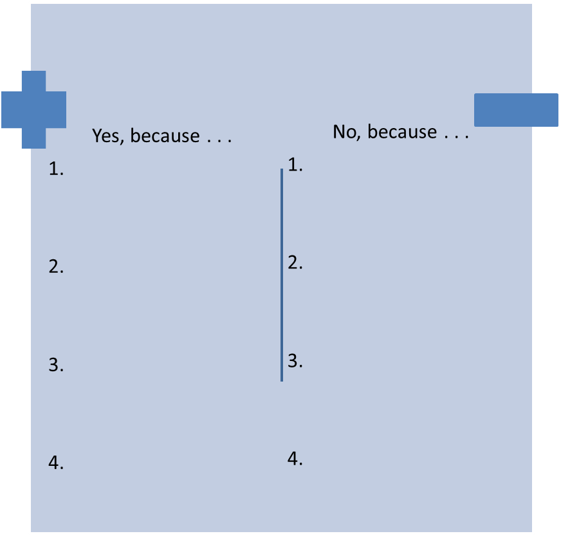
State your conclusion, with an explanation based on information in the article:

Background Information
(teacher information)
To truly understand the problems NASA had with the Mars Climate Orbiter (we’ll come back to that later), one needs to understand the two different systems of measurement in effect at the time of the mishap (and still in effect today).

More on the history of SI and the metric system

ChemMatters Teacher’s Guides frequently begin with “More on the history of…” the topic. In the case of measurement, SI and the metric system, the history is interwoven in their development, as well as in their “final”, or present status. You will find much history on SI throughout this “Background Information” section.

More on metrology (no, not meteorology—that’s weather)

Maybe some of your students will choose to become metrologists. Scientists who study units and measurement work with the science of metrology.

Metrologists are scientists who work to define and refine the units and techniques of measurement. Nearly every nation in the world has an institute or national laboratory devoted to metrology. Governments are committed to metrology because it is important for trade, as well as for science, to have a consistent set of units for measurement. In the United States, metrology is part of the mission of the National Institute for Standards and Technology (NIST), formerly known as the National Bureau of Standards, a division of the U.S. Department of Commerce.

The goal of metrologists has been to develop units that are based only on atomic properties or universal constants. So far, this goal has been achieved for length, time, electric current, temperature, amount of substance, and light intensity—six of the seven base units in the System Internationale (SI). The only unit that is still based on a “prototype”, or physical example of the quantity, is the standard for mass, the kilogram.

(ChemMatters Teacher’s Guide, Oct 1999, p 14; accompanies the article “The Weighty Matter of the Kilogram Standard”; Powers, A. The Weighty Matter of the Kilogram Standard. ChemMatters 1999, 17 (3), pp 14–15)

More on Le Système International d’Unités

The goals of Le Système International d'Unités (SI), or The International System of Units, are to:

- Have units of measurement be neutral and (therefore) universal. This would avoid any political or national bias or dependency (e.g., base unit of length [foot] changing with revolution or death of local king), with the result that all nations would be more likely to adopt it.
- Allow any laboratory to replicate the units by making copies of prototypes of the base units (that all nations could duplicate). (While this goal might seem to conflict with the first goal because adopting countries would be dependent on the original prototype base units, these units were also established using common quantities or materials (e.g., volume of water of specific mass and cubic units of length, or distance along a meridian of the Earth) that most laboratories could use to produce their own “copies” of the unit, thereby ensuring consistency of the unit worldwide.
- Provide decimal multiples and submultiples to make computations easier (based on man’s possessing 10 fingers).
- Use common prefixes across the various base and derived units, thus making the entire system more universal and more “user-friendly”.
- Be practical, in the sense that the base units should be close in size to customary units (again, more “user-friendly”), making adoption by nations and individuals more likely to succeed.

(adapted from http://www.sciencemadesimple.com/metric_system.html)

More on SI base units

The SI system has only seven base units to measure length, mass, time, electric current, temperature, amount and luminous intensity. All other measurable quantities are derived from these seven base units. Because of this minimalist approach, SI is a much simpler system of measurement than any that has preceded it.

The table below lists the seven SI base units, the quantity they measure, their symbol, and the original (historical) and most recent (scientific) basis for the size of that unit:

Quantity Measured | Unit | Symbol | Original Basis | Newest Basis
Length | meter | m | (1793) 1/10,000,000 of length of a quadrant of Earth (North Pole to Equator);  Later (1960), length of platinum-iridium alloy prototype meter | (interim) Various measurements involving wave-lengths of visible emission of light from various elements (first, 1960, Kr-86);  Now (1983), distance light travels in a vacuum in  1 / 299,792,458  of a second
Mass | kilogram | kg | (1793) Unit of “grave” (now obsolete), mass of 1 decimeter³ of water | (1901) Mass of  platinum-iridium alloy prototype kilogram
Time | second | s | (ancient) 1/86,400  of one day;  Later (1956) 1/31,556,925.9747 of tropical year for January 1900 | (1997) Duration of  9,192,631,770 periods of radiation corresponding to transition between two hyperfine levels of ground state of the Cs-133 atom
Electric Current | ampere | A | (1881) One-tenth of current flowing in an arc 1 cm long of a circle 1 cm in radius that creates a field of one oersted at the center | (1948) Current which, if maintained in two straight parallel conductors of infinite length, of negligible circular cross-section, and placed  1 m apart in vacuum, would produce between these conductors a force equal to  2×10⁻⁷ newtons per meter of length
Temperature | kelvin | K | (1743) Centigrade scale, based on water freezing at 0 ºC and boiling at 100 ºC (later changed to Celsius) | (1967) (now Kelvin)  1 / 273.16 of temperature of triple point of water (0.01 ºC)
Amount | mole | mol | (1900) Molecular weight of substance in grams | (1971) Amount of material in a substance that contains as many particles as are contained in 0.012 kg of carbon-12
Luminous Intensity | candela | cd | (1948) Value of new candle is such that brightness of full radiator at temperature of solidification of platinum is 60 new candles per square centimeter | (1979) Luminous intensity, in a given direction, of a source that emits monochromatic radiation of frequency 540×10¹² hertz and that has a radiant intensity in that direction of 1/683 watt  per steradian.

(This table was crafted from various sources; primary source is the National Institute of Standards and Technology, NIST, at http://physics.nist.gov/cuu/Units/current.html).

More on SI derived units

The SI system of units was established so that all measurable quantities could be expressed in the seven base units or in units derived from the seven base units (or in units derived from units derived from the base units). Derived units are created by mathematical relationships ​ (multiplication or division) among other base units and are expressed in a combination of fundamental and base quantities. The base units and derived units together comprise the “coherent system of SI units”. The SI also includes the prefixes to form decimal multiples and submultiples of SI units. (http://physics.nist.gov/cuu/pdf/sp811.pdf)

According to NIST (URL above, p 3, footnote 2), “A system of units is coherent with respect to a system of quantities and equations if the system of units is chosen in such a way that the equations between numerical values have exactly the same form (including the numerical factors) as the corresponding equations between the quantities…. In such a coherent system, of which the SI is an example, no numerical factor other than the number 1 ever occurs in the expressions for the derived units in terms of the base units.” Thus, a unit with a prefix (e.g., a milliliter) cannot be a coherent unit in the SI system because it requires the use of a number other than one (one thousand) to convert it to an SI base unit (the liter). Note that the milliliter is still an accepted SI unit, but it is not a coherent unit, because it uses a prefix.

This table shows a few simple, coherent derived units in SI. Note that in these units, there are no special names—the name is expressed in the SI unit symbols appropriate for that measurement.

DERIVED QUANTITY | NAME | SYMBOL
Area | Square Meter | m²
Volume | Cubic Meter | m³
Mass Density | Kilogram Per Cubic Meter | kg / m³
Specific Volume | Cubic Meter Per Kilogram | m³ / kg
Speed, Velocity | Meter Per Second | m / s
Acceleration | Meter Per Second Squared | m / s²
Wavenumber | Reciprocal Meter | m^{–1} or 1 / m
Amount concentration | Mole Per Cubic Meter | mol / m³

(http://physics.nist.gov/cuu/pdf/sp811.pdf)

The unit’s name does not always match its symbol, however; many SI derived units, even though they are derived from the base units, are given special names, often for their discoverer(s), as indicated in the examples in this table.

DERIVED QUANTITY | NAME | SYMBOL  (and Non-SI Expression) | EXPRESSION IN TERMS OF BASE UNITS
Force | Newton | N | m • kg / s²
Pressure | Pascal | Pa (N / m²) | kg / m / s²
Energy | Joule | J (N • m) | kg • m² / s²
Power | Watt | W (J / s) | kg • m² / s³
Electric Charge | Coulomb | C | A • s
Electric Potential | Volt | V (W / A) | kg • m² / s³ / A
Celsius Temperature | Degree Celsius | ºC | K

(http://physics.nist.gov/cuu/pdf/sp811.pdf)

And the table below shows examples of slightly more complex, coherent derived units expressed with the aid of other SI derived units that themselves have special names and symbols.

DERIVED QUANTITY | NAME | SYMBOL | EXPRESSION IN TERMS OF BASE UNITS
Moment of Force | Newton Meter | N • m | kg • m² / s²
Surface Tension | Newton Per Meter | N / m | kg / s²
Heat Capacity, Entropy | Joule Per Kelvin | J / K | kg • m² / s² / K
Specific Heat, Specific Energy | Joule Per Kilogram | J / kg | m² / s²
Specific Heat Capacity,  Specific Entropy | Joule Per Kilogram Kelvin | J / (kg • K) | m² / s² / K
Thermal Conductivity | Watt Per Meter Kelvin | W / (m • K) | kg • m / s³ / K
Energy Density | Joule Per Cubic Meter | J / m³ | kg / m / s²
Electric Charge Density | Coulomb Per Cubic Meter | C / m³ | A • s / m³
Molar Energy | Joule Per Mole | J / mol | kg • m² / s² / mol
Molar Entropy | Joule Per Mole Kelvin | J / (mol • K) | kg • m² / s² / mol / K

(http://physics.nist.gov/cuu/pdf/sp811.pdf)

This table shows the accepted prefixes that precede the base- or derived units in the SI system, their names, symbols and number.

Power  of Ten | Unit  Name | Symbol | Actual  Number
10²⁴ | yotta | Y | 1,000,000,000,000,000,000,000,000
10²¹ | zetta | Z | 1,000,000,000,000,000,000,000
10¹⁸ | exa | E | 1,000,000,000,000,000,000
10¹⁵ | peta | P | 1,000,000,000,000,000
10¹² | tera | T | 1,000,000,000,000
10⁹ | giga | G | 1,000,000,000
10⁶ | mega | M | 1,000,000
10³ | kilo | k | 1,000
10² | hecto | h | 100
10¹ | deka | da | 10
10⁰ |  |  | 1
10^{–1} | deci | d | .1
10^{–2} | centi | c | .01
10^{–3} | milli | m | .001
10^{–6} | micro | μ | .000 001
10^{–9} | nano | n | .000 000 001
10^{–12} | pico | p | .000 000 000 001
10^{–15} | femto | f | .000 000 000 000 001
10^{–18} | atto | a | .000 000 000 000 000 001
10^{–21} | zepto | z | .000 000 000 000 000 000 001
10^{–24} | yocto | y | .000 000 000 000 000 000 000 001

(ChemMatters Teacher’s Guide [October 2009, pp 84–5] to accompany: Halim, N. Nanotechnology’s Big Impact, ChemMatters 2009, 27 (3), pp 14–17.

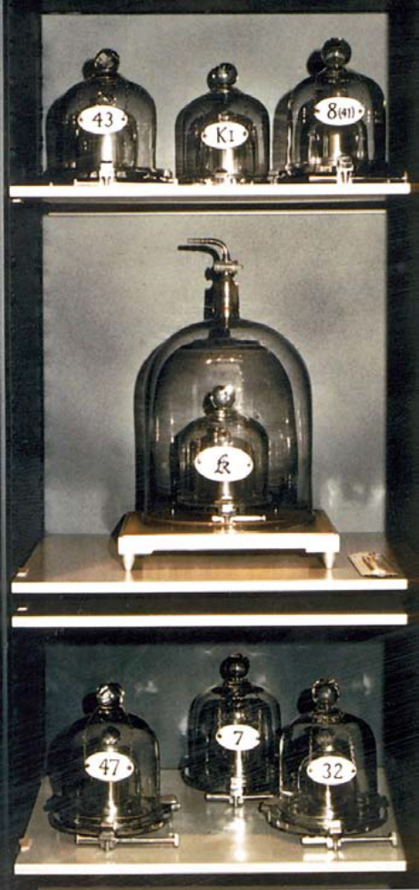
More on the SI base unit for mass—the kilogram
Housed in Sèvres, France, at the Bureau International des Poids et Mesures (BIPM), under three vacuum-sealed bell jars, inside a vault two stories below the ground, there is a carefully tended metal cylinder, and six copies—each one about the size of a film canister. To the French, this is “le grand K”. We know it as the kilogram.

As mentioned previously, the standard unit of mass, the kilogram, unlike all other base units in the International System of Units (Le Système International d'Unités, or SI), is still an actual object—a cylinder of a platinum-iridium alloy, polished to a mirror-like finish, that is housed in Sèvres, France. It has resided there since 1889.

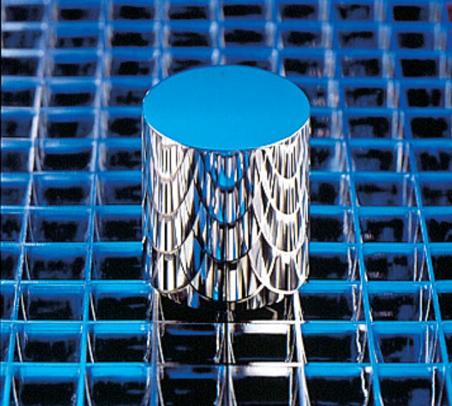
It is protected from oxidation by the atmosphere under a triple vacuum system using three bell jars. It is only rarely brought out from under that vacuum system, usually for comparison to other standard prototypes that have been distributed in various countries around the world. Those prototypes are themselves protected under a vacuum system to protect them from atmospheric oxidation.
The United States stores its copy of the kilogram prototype at the National Institute for Standards and Technology (NIST).
(both images above from Powers, A. The Weighty Matter of the Kilogram Standard. ChemMatters 1999, 17 (3), pp 14–15)

More on teaching the metric system

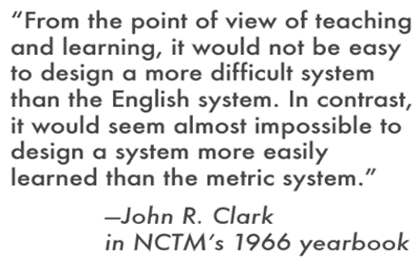
(http://lamar.colostate.edu/~hillger/whyteach.htm)

The National Science Teachers Association publishes position statements on many topics specific to science and science education. In 1999, the organization published their position statement on teaching the metric system:

NSTA Position Statement: Use of the Metric System

Rationale

The efficiency and effectiveness of the metric system has long been evident to scientists, engineers, and educators. Because the metric system is used in all industrial nations except the United States, it is the position of the National Science Teachers Association that the International System of Units (SI) and its language be incorporated as an integral part of the education of children at all levels of their schooling. Therefore, we recommend that the following actions be taken:

Declarations

- We assume responsibility for leadership in teaching the metric system.
- We urge that use of the metric system be integrated into all curriculum subjects and at every grade level.
- We recognize that the use of the customary units will persist for some time, especially in the early grades, but will encourage the use of the metric system whenever possible.
- We urge the re-establishment of the U.S. Metric Board to support and encourage the use of the metric system nationwide.

—Adopted by the Board of Directors, January 1999

(http://www.nsta.org/about/positions/metric.aspx)

The National Council of Teachers of Mathematics (NCTM) also issued a position statement, in 2011, on the teaching of the metric system, as well as learning goals for students:

NCTM Position

Because the metric system is an effective, efficient base-ten measurement system used throughout the world, students need to develop an understanding of its units and their relationships, as well as fluency in applying it to real-world situations. At the same time, since some non-metric units of measure are still widely used in day-to-day life in the United States, American students also need to develop familiarity with these units of measure.

The learning goals for students include—
- knowledge of and ability to use referents, or benchmarks, in estimation;
- ability to make a reasonably accurate measurements of an attribute by using standard tools;
- ability to assess and select an appropriate unit for the type and size of the attribute being measured;
- ability to convert flexibly and fluently among commonly used units within a measurement system;
- knowledge of the role and implications of accuracy and precision in measurement; and
- ability to apply and operate on units of measure flexibly and fluently in the solution to problems.

(http://www.nctm.org/uploadedFiles/About_NCTM/Position_Statements/Metric_System_Positions_Statement_20113.pdf)

This probably is not a problem for chemistry teachers or science teachers in general, but just in case you aren’t sure why you should teach metric units, visit this U.S. Metric Association page “Why Teach the Metric System?” at http://lamar.colostate.edu/~hillger/whyteach.htm.

And if you need a graphic to show your students how “Metric” the world is, or why the U.S. should “go metric”, show them this illustration.

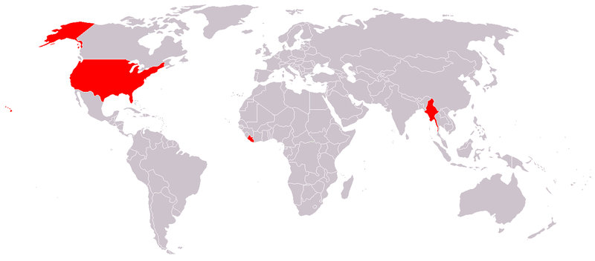
Map of the world where red represents countries that do not use the metric system (Liberia, Myanmar, and the USA (including Alaska (the big red block to the northwest of Canada) and the Hawaiian Islands (that tiny red blur in the Pacific Ocean)
(http://commons.wikimedia.org/wiki/File:Metric_system.png)

More on Mars Climate Orbiter

Engineers at Lockheed Martin in Denver, Colorado helped to build and operate the Orbiter spacecraft and provided data and navigation commands for the thrusters aboard the craft. Unfortunately, they used U.S. Customary or “English” units, while NASA had been using metric units for almost a decade.

As mentioned in the article, the English unit for thrust is pound-force-seconds, while the metric or SI unit is Newton-seconds. To convert the two, consider the following:

1 N = 1 kg-m / s²

and

1 lb = 453.59237 g

The pound is already a unit of force, while the kilogram is a unit of mass, so to convert from pound-force in the English system to newtons, the SI unit of force,

F = mass x gravitational attraction

1 lb = 453.59237 g x (1 kg/1000 g) x 9.80665 m/s²

Therefore

1 lb = 4.4482216152605 kg-m/s² (exactly) or ~ 4.448 N

Thus a pound-force-second = 4.448 Newton-seconds

So, any calculations involving the wrong unit here would be off by a factor of almost 4.5!

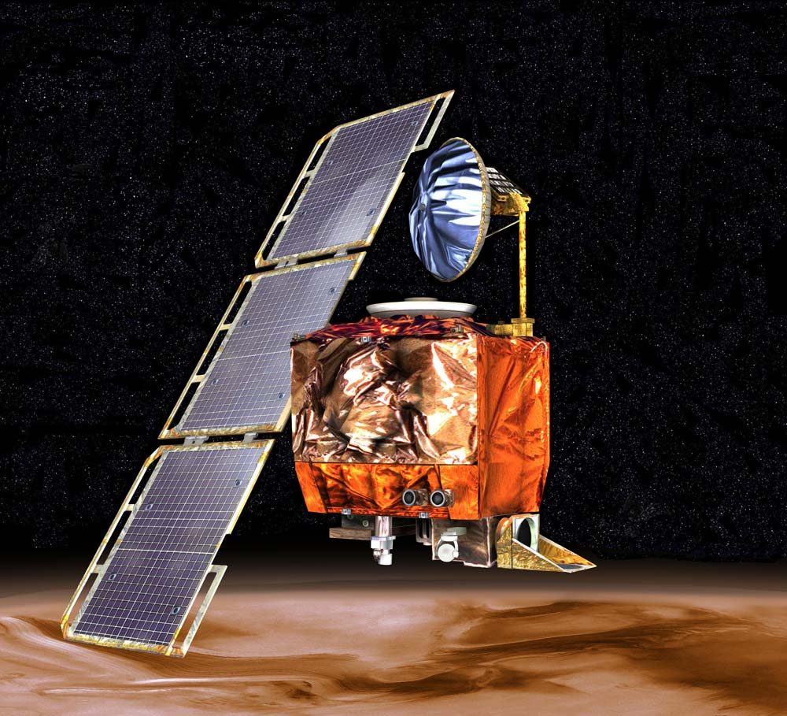
If Lockheed Martin was supplying information to NASA about amounts of thrust to use to bring the Orbiter into orbit around Mars, their calculated value would be in pound-force-seconds and therefore too large by that factor of 4.5, providing too much thrust and sending the craft much too close to Mars.
Mars Climate Orbiter, 1998

(http://www.jpl.nasa.gov/missions/web/mars_climate_orbiter.jpg)

After tracking the flight of the Mars Climate Orbiter for almost 10 months, a planned trajectory correction maneuver (the fourth during the long flight) made on September 8, 1999 was supposed to bring the spacecraft to an insertion point that would bring it around Mars at an altitude of 226 km—the desired altitude for final orbital insertion—on September 23.

But calculations made in the week after that maneuver and before the crash indicated the craft could be lower than that, around 150–170 km from the planet’s surface. And later calculations, made the day before insertion showed the actual altitude to be only 110 km. (Original calculations had established an absolute safe minimum altitude of 80 km.) And calculations made after the crash indicated the orbiter approached at an altitude of only 57 km, which put it well within the Martian atmosphere, where atmospheric stresses likely caused disintegration of the spacecraft.

According to Wikipedia, several software operators had recognized the problem with the calculations involving U.S. Customary units instead of SI units, but their concerns were never recognized (or admitted?) by other scientists and engineers.

The primary cause of this discrepancy [in calculated insertion altitudes] was that one piece of ground software produced results in a United States customary unit ("English"), while a second system that used those results expected them to be in metric units. Software that calculated the total impulse produced by thruster firings calculated results in pound-seconds. The trajectory calculation used these results to correct the predicted position of the spacecraft for the effects of thruster firings. This software expected its inputs to be in newton-seconds.

The discrepancy between calculated and measured position, resulting in the discrepancy between desired and actual orbit insertion altitude, had been noticed earlier by at least two navigators, whose concerns were dismissed. A meeting of trajectory software engineers, trajectory software operators (navigators), propulsion engineers, and managers, was convened to consider the possibility of executing Trajectory Correction Maneuver-5, which was in the schedule. Attendees of the meeting recall an agreement to conduct TCM-5, but it was ultimately not done.

(http://en.wikipedia.org/wiki/Mars_Climate_Orbiter)

The initial report of the NASA Jet Propulsion Lab investigation board issued these findings and recommendations in their official report:

A summary of the findings, contributing causes and MPL recommendations are listed below. These are described in more detail in the body of this report along with the MCO [Mars Climate Orbiter] and MPL [Mars Polar Lander] observations and recommendations.

Root Cause: Failure to use metric units in the coding of a ground software file,
“Small Forces,” used in trajectory models
[text bolded by Teacher’s Guide editor]

Contributing Causes:
- Undetected mismodeling of spacecraft velocity changes
- Navigation Team unfamiliar with spacecraft
- Trajectory correction maneuver number 5 not performed
- System engineering process did not adequately address transition from development to operations
- Inadequate communications between project elements
- Inadequate operations Navigation Team staffing
- Inadequate training
- Verification and validation process did not adequately address ground software

MPL Recommendations:
- Verify the consistent use of units throughout the MPL spacecraft design and operations
[text bolded by Teacher’s Guide editor]
- Conduct software audit for specification compliance on all data transferred between JPL and Lockheed Martin Astronautics
- Verify Small Forces models used for MPL
- Compare prime MPL navigation projections with projections by alternate navigation methods
- Train Navigation Team in spacecraft design and operations
- Prepare for possibility of executing trajectory correction maneuver number 5
- Establish MPL systems organization to concentrate on trajectory correction maneuver number 5 and entry, descent and landing operations
- Take steps to improve communications
- Augment Operations Team staff with experienced people to support entry, descent and landing
- Train entire MPL Team and encourage use of Incident, Surprise, Anomaly process
- Develop and execute systems verification matrix for all requirements
- Conduct independent reviews on all mission critical events
- Construct a fault tree analysis for remainder of MPL mission
- Assign overall Mission Manager
- Perform thermal analysis of thrusters feedline heaters and consider use of pre-conditioning pulses
- Reexamine propulsion subsystem operations during entry, descent, and landing

(ftp://ftp.hq.nasa.gov/pub/pao/reports/1999/MCO_report.pdf)

More on other mixed-system measurement problems

In the past there have been other problems with unit conversions between metric (SI) and U.S. Customary systems (English), besides the Mars Orbiter.

Canada Flight 143

Here’s the story of Canadian Air Flight 143, as told by Wikipedia:

On July 23, 1983, flight 143 was cruising at 41,000 feet (12,000 m) over Red Lake, Ontario. The aircraft's cockpit warning system sounded, indicating a fuel pressure problem on the aircraft's left side. Assuming a fuel pump had failed the pilots turned it off, since gravity should feed fuel to the aircraft's two engines. The aircraft's fuel gauges were inoperative because of an electronic fault which was indicated on the instrument panel and airplane logs (the pilots believed the flight was legal with this malfunction). The flight management computer indicated that there was still sufficient fuel for the flight; but the initial fuel load had been measured in pounds instead of kilograms. A few moments later, a second fuel pressure alarm sounded for the right engine, prompting the pilots to divert to Winnipeg. Within seconds, the left engine failed and they began preparing for a single-engine landing.

As they communicated their intentions to controllers in Winnipeg and tried to restart the left engine, the cockpit warning system sounded again with the "all engines out" sound, a long "bong" that no one in the cockpit could recall having heard before and that was not covered in flight simulator training. Flying with all engines out was something that was never expected to occur and had therefore never been covered in training. Seconds later, with the right-side engine also stopped, the 767 lost all power, and most of the instrument panels in the cockpit went blank.

(http://en.wikipedia.org/wiki/Gimli_Glider)

Without engines, electrical power (produced by the engines) was almost non-existent, save for a few battery-powered emergency flight instruments. Also with no engines, the hydraulic control systems also went out. A backup “ram” system driven by air under the plane only helps when the plane maintains cruising speed, and with both engines out, and speed decreasing as a landing was attempted, that backup system became almost useless.

The pilot, having had much glider experience, was finally able to bring down the plane (itself now essentially a 156-ton glider) safely at close-by Gimli Airport—with no loss of life, and only a few slightly bruised passengers who were injured when they slid down the escape slides. (You can show to your classes one of two videos, either a 7-minute condensed version or a 47-minute full TV version from the “MayDay: Air Crash Investigation” series. See “More sites on other mixed-system measurement problems” near the end of this Teacher’s Guide.)

So, what caused the engines to stop? It turns out it was due to a mix-up of “Canadian” and metric units.

How? How does a modern jetliner—equipped with the latest technology and piloted by skilled people—run out of fuel at 26,000 feet? As with most air disasters, there was no single cause. Flight 143 was brought down by a string of errors in technology, communication, and training, but at the heart of the crisis was a simple mistake in calculating the amount of fuel needed for the flight.

The plane’s instruments should have quickly detected the error. The 767 boasts an advanced fuel quantity processor that accurately gauges fuel on board. But, on this particular plane, the fuel computer had never worked properly, and maintenance workers lacked a spare computer.

Because the 767 was new addition to Air Canada’s fleet, the written maintenance standards were still being revised. When the ground crew was preparing the plane for departure from Montreal, they found that the fuel gauge did not work. A maintenance worker assured Pearson—incorrectly—that the plane was certified to fly without a functioning fuel gauge if the crew manually checked the quantity of fuel in the tanks.

(Marsella, G. The Crash of Flight 143. ChemMatters 1996, 14 (3), pp 12–15)

The ground crew measured how much fuel was left in the two main tanks and planned to subtract that amount from the amount they knew the plane would need to make the trip. That would tell them the amount needed to add to the tanks to complete the trip. Unfortunately, the amounts established for flights were given in kilograms (mass), not liters (volume). And, in keeping with to the Canadian government’s desire to change to the metric (SI) system, the mass was specifically noted in kilograms, whereas the flight crews had for years used pounds as the normal unit for measuring weight.

An incorrect conversion factor was used by the ground crew for the calculation of volume from weight. The number 1.77 was the conversion factor used, but that was for the density of jet fuel in pounds per liter, not kilograms per liter. Their calculations were off! They only filled the tanks with about 5,000 liters, instead of the required 20,000 liters. “At the time of takeoff Flight 143 had about 10,000 kg of fuel—less than half the amount needed to reach Edmonton.” To see the calculations involved, go to the source, above. For more information about this near-catastrophe, see “More sites on other mixed-system measurement problems” near the end of this Teacher’s Guide.)

Space Mountain, Disneyland, in Tokyo

At Tokyo Disneyland's Space Mountain, an axle broke on a roller coaster train, causing it to derail.

On December 5, 2003, a roller coaster train derailed as it was returning to the station. No riders were injured, and the ride was closed pending an investigation. A January 2004 investigation completed by Oriental Land Company, the park's owner/operator, determined that an axle on the train had failed because its diameter was smaller than the specifications for the part required. The attraction re-opened in February 2004, after 17 park officials were reprimanded for the accident

(http://en.wikipedia.org/wiki/Incidents_at_Tokyo_Disney_Resort#cite_note-8)

The cause was a part (the axle) being the wrong size due to a conversion in 1995 of the master plans for construction from English units to metric units. In 2002, new axles were mistakenly ordered using the pre-1995 English specifications instead of the current Metric specifications.

Connections to Chemistry Concepts
(for correlation to course curriculum)
- Measurement—This is at the heart of any science, and especially a lab-based science. Our understanding of chemistry (historically) comes from the results of experiments conducted over centuries.
- Precision/Accuracy—Although this is not a focus of the article (since the measurements made for the Orbiter were accurate; they were just made in the wrong measuring system), students must be made to understand the need for their measurements to be accurate.
- Uncertainty/Error—Similarly, each measurement made inherently contains uncertainty, and analysis of possible errors can lead to a better understanding of the results of experiments.
- Unit conversions—Unit conversions between units in the SI system are relatively easy, since they primarily involve powers of ten. Understanding this type of conversion will help students with their “eternal” struggle with unit conversions throughout the chemistry course.

Possible Student Misconceptions
(to aid teacher in addressing misconceptions)
- “Maybe the rest of the world will come around to our system of measurement; after all, we ARE the United States!” Unfortunately, the rest of the world has recognized that SI is a much more desirable measurement system than the U.S. Customary System and is NOT backtracking to a less desirable system. Our (U.S. Customary) system offers none of the advantages of SI, and since the rest of the world uses SI for their commerce, the U.S. will fall further and further behind and we will have difficulty exporting our goods because they won’t match what the rest of the world is doing/using.
- “If the U.S. system of measurement was good enough for our grandparents, it should be good enough for us now.” In our grandparents’ times, commerce was much less globalized than it is now. In the mid-20th century, the U.S. was producing goods primarily for local consumption, and only beginning widespread export to countries worldwide. That is no longer true today, hence the answer to statement #1.
- “I guess we’ve gone as far as we can with establishing standard units for the SI; those standards are ‘set in stone’.” As the chart shows in the “More on Le Système International d’Unités” section, the standards used in the seven base units in SI continue to change even today. As science and technology progress allowing scientists to make more accurate measurements, those standards thought to be “exact” are sometimes determined to be rather inexact (e.g., the distance from Earth’s North Pole to the Equator was discovered to vary with longitude), and adjustments need to be made.
- “So, all Congress has to do to get us to adopt SI is to pass a law that says SI is our national system of units. That doesn’t sound so difficult.” It’s not quite that easy. Even if Congress DID pass such a law stating that we adopt SI—and we came a bit close to that in 1975 when Congress passed the Metric Conversion Act with the goal of increasing use of metric measurements in our daily lives—that alone wouldn’t prevent us from continuing to use the U.S. Customary units of measure. Change is difficult, and people would probably just continue using units they are familiar with, which would not move the country forward commercially or economically in the global marketplace. The only effective way for us to adopt SI completely would be for Congress to enact a law that forced everyone to use metric—by outlawing the use of conventional units. And many countries that have adopted SI still use non-SI units.

Anticipating Student Questions
(answers to questions students might ask in class)
- “Why DON’T we (the U.S.) switch to SI?” It’s not as easy as it sounds; see “Possible Student Misconception” #4 above for answer.
- “Does America HAVE to go completely SI? Is it all-SI or nothing?” Many countries have adopted SI while still maintaining a few of their own standard units of measurement, but those units often cause confusion for international trade or travel; the U.S. could do the same.
- “Why do we use SI (or metric) units in the chemistry lab?” Chemistry, often called the “central science”, utilizes the tools of science, and the metric system is the measuring system of the sciences. Since chemistry was a well-established science in Europe, practitioners (scientists) used the measurement units of the land—the metric system—and they’ve stuck with metric ever since.
- “Did Peter Piper really pick a peck of pickled peppers? And how many is that in SI?” This is an age-old question with no definitive answer, because the number of peppers depends on their size. And the number of peppers in SI would be the same as in this measurement system. The difference would be that the unit wouldn’t be 1 peck, but it would be 7.6 liters. (According to Wikipedia, a peck is “equivalent to 2 gallons or 8 dry quarts or 16 dry pints [all U.S. Customary units] (7.6 liters [SI units])”. (http://en.wikipedia.org/wiki/Peck)

In-Class Activities
(lesson ideas, including labs & demonstrations)
- To get students used to measuring in metric, have students complete a normal recipe using only SI units. You might start with this one from Reader’s Digest, via NIST: http://www.nist.gov/pml/wmd/metric/upload/Metric_Chocolate_Chip_Cookies_May2011.pdf.
Or try this experiment, “Partial Thermal Degradation of Mixed Saccharides with Protein Inclusions” (making peanut brittle) from Dave Katz. Although the amounts are given in metric measurements, the U.S. Standard amounts and units are also provided in parentheses. (You might want to delete those from the experiment.) (http://www.chymist.com/peanut%20brittle.pdf)
- This activity has students simulate a space mission, like one involving a space satellite, in which the space flight or satellite team must create their own standard measuring device, measure various objects with their device and communicate their findings back to the “ground crew” or validation team, all within a specified time frame. A class discussion follows to discuss findings and accuracy and precision. (McCue, K. Your Mission: Validate a Stick! ChemMatters 2005, 23 (Special Issue 1), p 10) Also see the reference to Anne Douglass, a NASA scientist in the “References” section below.
- This two-page table provides conversions involving a series of nonsensical scientific units, utilizing SI prefixes. Students must be familiar with (or have access to a list of) the SI prefixes to understand the conversions. (Golomb,S. MegaMeanings. ChemMatters 1984, 2 (4), pp 14–15)
- These two questions involve students in calculations that require them to use units and conversion factors to calculate gas pressure of a near-vacuum in space, and mass of Earth’s atmosphere. (Calculating Chemistry: Gases; and The Mass of the Earth’s Atmosphere. ChemMatters 1983 1 (1), p 7)
- This question provides some basic information (acidic, actually), along with some conversion factors and asks students to calculate the volume of H₂SO₄ produced by a volcano eruption (Calculating Chemistry: Acid Rain. ChemMatters 1983 1 (2), p 13)
- This one-page pdf document from NASA’s “spacemath” site provides a one paragraph introduction to each of three famous unit conversion problems: The Mars Climate Orbiter, the Tokyo Disneyland roller coaster accident, and Canadian Flight 143 (the Gimli Glider). It then asks one question for each story that requires students to do conversion calculations from U.S. customary to SI or vie versa.
- This is a group of (independent) activities centered on the Canadian Flight 143 (the “Gimli Glider”), discussed in the “More on other mixed-system measurement problems” above.
- Here is a worksheet of questions about the Air Canada Flight 143, the “Gimli Glider”, crash: http://mrsj.exofire.net/chem/docs/meas_ec.pdf. This could be used in class as a follow-up to the video clips referenced in “More sites on other mixed- system measurement problems” toward the end of this Teacher’s Guide.
- Here’s more background on the numbers involved and how the accident involving Flight 143 happened, “Passengers of Flight 143 Learn the Importance of Units”: http://www.cheresources.com/flightzz.shtml.
- Chemistry professor Jerry Bell suggests you have students determine the validity of the data on the “Crash of Flight 143”, the article in the October 1996 issue of ChemMatters. (Bell, J. Letter to the Editor. ChemMatters 1996, 14 (4), p 2)
- Assign your classes to debate the statement: “Resolved that the U.S. should immediately adopt the International System of Units.” Investigation could include: effects (pro and con) on worldwide trade, scientific research, everyday life, our economy, your chemistry class, etc. Here are two opposing views on this topic, from Popular Mechanics, September 1996:
“No, Let’s Keep America American” and Yes, America Needs to Be Metrified” offer the pros and cons of the U.S.’s going metric.
(http://www.gk12.ilstu.edu/chemistry/PowerPoint%202006/Intro%20Word/Yes%20Metric.doc)
You could stage this debate during National Metric Week (the week in October that contains October 10, 10/10—it was October 5–11 in 2014), but holding it then might tip the scales (pun intended) toward the pro-metric team.
- The pdf document “Measurement: Uncertainty and Error in Lab Measurements” is a “30-page illustrated guide to fundamentals of measurement. This is intended to be a clear, comprehensive overview of effective measurement technique. Intended for advanced high school or introductory college level students. Includes worked examples and problems.”
(http://d32ogoqmya1dw8.cloudfront.net/files/sp/library/uncertainty/introduction_measurement_advan.v3.pdf)
- For chemistry teachers who also teach physics, Carleton University has a Web site, “Introduction to Measurement (advanced high school/intro college level)” that is a curriculum unit to teach measurement, uncertainty and error to physics students. (http://serc.carleton.edu/sp/library/uncertainty/examples/example1.html
- Commercial vendors have kits to help students learn about measurement, uncertainty and error: (e.g., http://www.pasco.com/physhigh/measurement/significant-figures.cfm).
- Flinn Scientific suggests a measurement competition. See their one-minute video (not much detail provided, but you can get creative): http://www.flinnsci.com/measurement.
- Flinn also has a series of activities and experiments (for sale) involving measurement, including these activities: “Metric Match Game”, “The Metric Measurement Puzzle” and “Metric-ominoes”.
- Before a discussion of units in class, ask students to bring in:
  - Packages with units listing the amount of content (mass, volume). Challenge them to find packages that contain only SI units or only U.S. Customary units. (U.S. only units should be hard to find because Congress passed the Metric Conversion Act of 1975 to encourage use of metric units in the U.S.)
  - Pictures of measuring instruments used in the world around them (e.g., ruler, bathroom scale, etc.)—at home, at the store, on TV, etc. Then discuss what quantities and what units the instrument measures (or have students do this in an activity).
- This is a series of 11 “blackline masters” (only “experienced” teachers will even know what these are—says a lot about the pdf’s pedigree [age]!). The first four are about the scientific method (but do involve measurement), while the last seven provide many independent, easy activities for students to do to help them learn about measurement. Many are simple paper-and-pencil activities, while a few of them are actual experiments—all are geared primarily to middle school. http://www.unitedstreaming.com/videos/Scientific%20Method%20and%20Measurement/108_BM.pdf
- The U.S. Metric Association Web site contains a page, “Tips to Educators for Teaching the Metric System, and Ideas for Schools Celebrating National Metric Week”. It offers lots of ideas about how to teach students the metric system, first among them is “Stop teaching (and using) the inch-pound system completely. Teach only the metric system.” http://lamar.colostate.edu/~hillger/ideas.html
- This very simple set of paper-and-pencil activities entitled “How Do Scientists Measure Things?” takes students through the basics of measuring. It discusses basics of measuring and the metric system, then has students do activities using that information. This set could be used as a lesson for a substitute teacher on a sick day (early in the year, probably). http://www.schenectady.k12.ny.us/TechResources/EETT/measurement/Measurement/measurement%20packet.pdf)
- The bottom of this sheet provides a short series of questions to ask students to assess their understanding of metric units (e.g., “If Mr. Jones is to travel 4,000 kilometers, should he walk, bike, or take a plane?”). You can construct more of these for your own students.
(http://www.pkwy.k12.mo.us/west/teachers/anderson/pack1/WS12.pdf)
- This is a “Measurements in Chemistry” lab activity, but it also contains questions about uncertainty, precision, % error, significant figures and conversions. You might want to use this as a lab assessment or review activity for the topic of measurement. (http://www.collinsville.k12.ok.us/webpages/documents/HS-FrameR/Chemistry/Lab%201%20Measurment%20in%20chemistry.doc)
- This lab activity involves multiple weighings on multiple balances and then filtering and recrystallizing a solid from solution. The goal is to show experimental uncertainty.
(http://chemmovies.unl.edu/chemistry/labs/LABS03.html)
- Flinn Scientific has a package of three short videos on measurement: a measurement challenge, graphing mass and volume of salt, and calibrating an unmarked thermometer. (http://elearning.flinnsci.com/ViewProduct.aspx?product=EL9008) The videos are free, but you must register to view them.
- This page from sciencegeek.net provides a series of PowerPoint presentations on a whole curriculum of chemistry. Relevant shows are “Scientific Measurement”, “The SI System”, and “Metric Conversion Practice”. (http://www.sciencegeek.net/Chemistry/Powerpoints2.shtml
- While uncertainty in measurement is not the focus of this article, measurements inherently contain uncertainty. One way to drive this home to students might be to ask the entire class independently to make the same measurement, and then compare class results. A suggested quantity to measure is the time it takes to drop a pen, to the nearest minute. While you would expect that everyone would get the same measurement, it appears that is not the case. If you subscribe to the Journal of Chemical Education, you can access a very simple, brief description of just such an experiment. (Sen, B. Simple Classroom Experiment on Uncertainty of Measurement. J. Chem. Educ. 1977, 54 (8), p 468; http://pubs.acs.org/doi/pdf/10.1021/ed054p468)
- This experiment combines measurement with a real science scenario—measuring and modeling atoms. The activity has students simulating an atomic force microscope and using their measurements to construct a model of the hidden surface. As written, the activity is geared to middle school, but it could easily be adapted for high school.
(Goss, V., Brandt, S., Lieberman, M. The Analog Atomic Force Microscope: Measuring, Modeling and Graphing for Middle School. J. Chem. Educ. 2013, 90 (3), pp 358–60) (available to JCE subscribers at http://pubs.acs.org/doi/pdf/10.1021/ed200704j)
- A measurement experiment is described (here, for college general chemistry students, but easily adapted to high school students) that asks each student to measure an egg’s mass, dimensions and volume (a different egg for each student). They also have to measure shell, white and yolk, separately—and devise a procedure for the experiment and bring or arrange with the teacher to have their needed equipment to do the separations and measurements. The experiment is from 1990, but it essentially provides teachers with an inquiry-based, “5E” experiment. You can then collect data and do a class analysis, including uncertainty in the discussion. (Newton, T. Measurement of Eggs: A General Chemistry Experiment. J. Chem. Educ. 1990, 67 (7), pp 604–605; available to JCE subscribers at http://pubs.acs.org/doi/pdf/10.1021/ed067p604.
- This J. Chem. Educ. article is an analysis of an experiment done to evaluate drop-counting as a means of measuring volume. (Ealy, J., Pickering, M. The Microscale Laboratory: An Evaluation of Drop Counting as a Volume Measurement. J. Chem. Educ. 1991, 68 (5), pp A120–A122; available to JCE subscribers at http://pubs.acs.org/doi/pdf/10.1021/ed068pA120)
- This J. Chem. Educ. Publication reports on an alternative method of converting SI units (different from dimensional or unit analysis). It also discusses how to teach the method to your students. (Ford, E., Gilbert, Y. Displacement between Orders of Magnitude Method for SI Unit Conversion. J. Chem. Educ. 2013, 90 (5), pp 134–136; available to JCE subscribers at http://pubs.acs.org/doi/ipdf/10.1021/ed300006e)
- This might be too “young” for your classes (geared for middle school), but here’s a site from the AIMS Education Foundation showing you how to run a “Mini-Metric Olympics” competition: http://cmase.uark.edu/teacher/workshops/AIMS-lessons/mini-metrics.pdf. Maybe you could devise some chemistry-based events for the competition.
- This Web site from the U.S. Metric Association provides 24 different puzzles and quizzes for students (most for middle school): http://lamar.colostate.edu/~hillger/puzzles/. It includes crossword puzzles, word searches, word scrambles, and a few unusual puzzles.

Out-of-class Activities and Projects
(student research, class projects)
- Students who are interested in promoting the metric system (SI) in the U.S. could put together a promotional flyer (or even a school-sponsored Web site?) to be distributed to students in the school (or more widely distributed throughout the environs of the school). This could be particularly useful if done in time for National Metric Week (held each year in October, the week containing October 10 (10/10—metric, get it?), held in 2014 during the week of 10/5–10/11. The U.S. Metric Association Web site would be a good place to start.
- If you want students to be active in National Metric Week, you can get ideas from the National Council on Teaching Mathematics (NCTM). NCTM sponsors National Metric Week: http://www.nctm.org/news/content.aspx?id=10248. U.S. Metric Association also has information for teachers about metric activities, as well as a brief history of National Metric Week: http://lamar.colostate.edu/~hillger/ideas.html.
- You could assign students to be “Metric Patrol” members, with the task of finding and reporting on consumer products on the market that have incorrectly stated SI units, and writing a letter to the producer of that product (tactfully) explaining the error. Barring that, students could be asked to find and report on a specific number of consumer products with correct SI units. See “Metric Patrol” at http://lamar.colostate.edu/~hillger/patrol.htm.

References
(non-Web-based information sources)
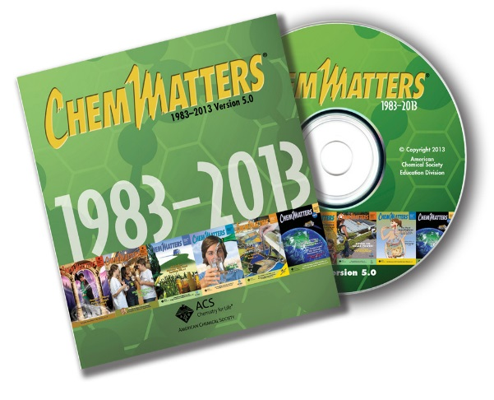
30 Years of ChemMatters

Available Now!

The references below can be found on the ChemMatters 30-year DVD (which includes all articles published during the years 1983 through April 2013 and all available Teacher’s Guides, beginning February 1990). The DVD is available from the American Chemical Society for $42 (or $135 for a site/school license) at this site: http://ww.acs.org/chemmatters. Scroll about half way down the page and click on the ChemMatters DVD image at the right of the screen to order or to get more information.

Selected articles and the complete set of Teacher’s Guides for all issues from the past three years are available free online on the same Web site, above. Simply access the link and click on the “Past Issues” button directly below the “M” in the ChemMatters logo at the top of the Web page.

Powers, A. The Weighty Matter of the Kilogram Standard. ChemMatters 1999, 17 (3), pp 14–15. This article provides a great deal of information about the kilogram standard, and some history of SI.

The ChemMatters Teacher’s Guide for the October 1999 article on the kilogram, above, provides a brief timeline of the metric system, extra background information and ideas for class activities and student projects.

Rohrig, B. Thermometers. ChemMatters 2006, 24 (4), pp 45–49. This article provides information about the three most widely used temperature scales and a brief history of their origins.

The December 2006 Teacher’s Guide article dealing with the article above on thermometers provides background information on seven different temperature scales that have existed over the ages and a brief history of SI.

Anne Douglass: Making the World Safe for Blondes. ChemMatters 2002, 20 (Special Issue No. 1), pp 14–15. This article discusses the job of Anne Douglass, the scientist in charge of validating the chemistry instruments for Aura, a NASA space satellite. The Aura satellite’s four instruments measure the chemical composition of the atmosphere, and Douglass has to make sure that those measurements agree with measurements made from ground observations and those made from weather balloons. Validating measurements ensures correct readings. Lack of validation is one reason that old measuring units, like the cubit or the span didn’t work out—there is too much variation in the size of people’s bodies to be able to make any part of the body be a measuring instrument. (In case you’re wondering about the title of the article, about blondes, one of the measurements AURA takes is levels of UV radiation and, while blondes may have more fun, they are also more susceptible to sunburn and skin cancer.)

Banks, P. The Crash of Flight 143. ChemMatters 1996, 14 (3), pp 12–15. The author takes the reader step-by-step through the July 23, 1983 flight of Canada Air Flight 143. The near disaster was caused by a wrong conversion of units from U.S. Customary (also used by Canada for years) to SI. This article was the source for some of the discussion of Flight 143 in the “More on mixed-system measurement problems” section above.

Web Sites for Additional Information
(Web-based information sources)
More sites on measurement

World Metrology Day celebrates the role of metrology in our daily lives. Posters from the past 10 or more years are available here at this site. Each one focuses on one area of life that requires measurement (e.g., the home, sports, business/industry, health, environment, and science). (http://www.worldmetrologyday.org/past_posters.html)

The National Institute of Standards and Technology (NIST) Web site on units at http://physics.nist.gov/cuu/Units/ provides a wealth of information on the history of measurement, base SI units, derived SI units, and non-SI units, and unit conversions.

More sites on history of measurement

The video clip “The Metre and Time” (7:22) shows a bit of the history of the development of a unified system of measurement, specifically dealing only with length and time; it shows how these two quantities are integrally related in establishing base units: http://www.youtube.com/watch?v=dvVCNhWJvvo.

A Web page about the metric system from Science Made Simple focuses primarily on the development of the metric system from the late 18th century to modern-day SI, providing a brief history of metric measurement. It also includes the goals of SI, as well as very brief discussions of other metric measuring systems that are not SI. (http://www.sciencemadesimple.com/metric_system.html)

Here is a timeline of the definition of the meter, from the birth of the International System in 1791 to the present, from NIST: http://www.nist.gov/pml/div683/museum-timeline.cfm.

NIST provides another very detailed document, “The International System of Units (SI),” that includes a comprehensive discussion of the base and derived units of SI, and how to use these units in writing. Two appendices are included: one provides a history of the decisions made by the General Congress of Weights and Measures (Congress General des Poids et Mesures or CGPM), which oversees the International Bureau of Weights and Measures (Bureau International des Poids et Mesures or BIPM). The first appendix is an historical timeline of the decisions made by the CGPM from 1889 to 2005 in the development of the SI international system of units. The second appendix (available online only at http://www.bipm.org/en/publications/mises-en-pratique/) includes very detailed up-to-date information about the SI base units and how they are measured and standardized. The 97-page document from NIST is the U.S. version of the definitive reference booklet known simply as the ”BIPM SI Brochure” published by BIPM. The U.S. document is available at http://physics.nist.gov/Pubs/SP330/sp330.pdf.

For an extensive timeline on the history of measurement (from “15000000000 BCE” to the present), visit the “Metrication Matters” Web site: http://www.metricationmatters.com/docs/MetricationTimeline.pdf.

More sites on the English (non-metric) system of measurement

Students (and teachers) may be interested in seeing this Excel spreadsheet list of more than 300 non-SI measurement units from the U.S. Metric Association. You can find it on this page: http://lamar.colostate.edu/~hillger/traditional.htm, or you can go directly to the list: http://lamar.colostate.edu/~hillger/non-SI_units_alphabetically.xls.

More sites on the metric system

The Molecular Expressions web site has an interactive page showing orders of magnitude (powers of ten), on which the metric system is based, at http://micro.magnet.fsu.edu/primer/java/scienceopticsu/powersof10/.

This Vimeo video shows the one of the original “Powers of Ten” videos (1977): http://vimeo.com/1066547.

From the U.S. National Institute of Standards and Technology (NIST), the organization charged with maintaining our system of calibrating unit masses and other measuring units, comes this article, “The Kilogram and Measurements of Mass and Force”. It deals with methods used by NIST to maintain our standard kilogram masses, calibrated to the international kilogram standard, made of a platinum-iridium alloy, dubbed BIPM IPK, the International Prototype Kilogram (IPK) from the “Bureau International des Poids et Mesures” (International Bureau of Weights and Measures, BIPM). This is a rather technical document. (http://www.nist.gov/calibrations/upload/j61jab.pdf)
NIST also provides this pdf document: “The Dissemination of Mass in the United States …” It deals with the use of the U.S. standard kilogram, dubbed K20 to ensure that all users of kilogram standards in the U.S. are measuring equal kilogram masses. (http://nvlpubs.nist.gov/nistpubs/jres/119/jres.119.001.pdf)

Here are more recipes using metric system units and a chart of metric/U.S. Customary unit equivalents from NIST: http://www.nist.gov/pml/wmd/metric/cooking.cfm.

More sites on SI

In 2008, the National Institute of Standards and Technology, NIST, published a very in-depth resource, “Guide for the Use of the International System of Units (SI)”. The purpose of the guide is “to assist members of the NIST staff, as well as others who may have need of such assistance, in the use of the SI in their work, including the reporting of results of measurements.” The 78-page pdf document primarily deals with the way units should be expressed in publications, but it still contains a lot of information useful to teachers. (http://physics.nist.gov/cuu/pdf/sp811.pdf) The NIST Web site also contains this document as a separate set of Web pages: http://www.nist.gov/pml/pubs/sp811/index.cfm.

This page from the NIST Web site contains links to detailed discussions of each of the seven base units of the SI system: http://www.nist.gov/pml/wmd/metric/si-units.cfm.

Not directly related to this article but still dealing with SI at its very small levels, this is a really nice poster showing photos or drawings of various objects or phenomena at the nano- and micro-levels, with a “yardstick” continuum of the relative sizes of each: http://www.nist.gov/pml/wmd/metric/upload/doe-scale-of-things-18-jan-05.pdf.

This site from Purdue University gives a succinct overview of English vs. metric vs. SI, with conversion practice problems for each section. (http://chemed.chem.purdue.edu/genchem/topicreview/bp/ch1/unitframe.html)

NIST provides this colorful chart of the 7 base units of the SI, along with coherent derived units (those that use only combinations of the 7 base units), along with their names and symbols. (http://www.nist.gov/pml/wmd/metric/upload/si-color-diagram-apr-08.pdf)

The one-page explanation of the arrangement of units on the colorful chart above can be found here: http://physics.nist.gov/cuu/pdf/sp811.pdf. Scroll all the way down to the end (page 78) and you’ll see the chart; move up one page and you’ll find the explanation.

This is a pdf of an 8-1/2 x 11 (inch, not centimeter) 2-color poster of “Base Units and Derived Units with Special Names” in the SI system, from Metrication Matters, part of the U.S. Metric Association: http://lamar.colostate.edu/~hillger/pdf/SI-units-named.pdf.

And this is a pdf of an 8-1/2 x 11 (inch, not centimeter) 2-color poster of “Base Units and Examples of Derived Units” in the SI system, from the same organization: http://lamar.colostate.edu/~hillger/pdf/SI-units-derived.pdf.

The SI Navigator site provides links to many other sites dealing with SI measurement: http://www.metric1.org/. It offers SI sites from other countries (using their flag icons), so it helps show that SI is indeed international in scope.

More sites on the U.S. switch to metric measurement

This site provides the pdf of the actual Metric Conversion Act of 1975, the law that promotes the use of metric nationwide (but doesn’t outlaw the the use of U.S. Customary units): http://www.gpo.gov/fdsys/pkg/STATUTE-89/pdf/STATUTE-89-Pg1007.pdf.

This NIST site provides the pdf of the OmibusTrade and Competitiveness Act of 1988 that amended the Metric Conversion Act of 1975: http://gsi.nist.gov/global/docs/Omnibus.pdf.

A Washington Post video answers the question, “When will the U.S. switch fully to metric?” It includes a brief discussion on why we need a unified system (3:20). (http://www.youtube.com/watch?v=xXK-QJ_9SLs)

This video explains “Why we need the metric system”: YouTube (9:34).
http://www.youtube.com/watch?v=XI9w8g4UT2I

The U.S. Metric Association Web site (http://lamar.colostate.edu/~hillger/#usma) contains many useful pages for teachers and students, including:
- Consumer products sold in metric sizes: http://lamar.colostate.edu/~hillger/products/, including descriptions and photos of products
- Puzzles and quizzes for students (most for middle school): http://lamar.colostate.edu/~hillger/puzzles/. It includes crossword puzzles, word searches, word scrambles, and a few unusual puzzles.
- A clickable map of the United States: Clicking on a state will show examples of metric signage (mostly road signs) in that state. (http://lamar.colostate.edu/~hillger/signs/)
- Tips for teachers teaching the metric system: http://lamar.colostate.edu/~hillger/ideas.html
- A set of flash cards (>60, print back-to-back) for practice on SI units—the “Basic” set: http://lamar.colostate.edu/~hillger/pdf/flash-cards-basic.pdf. This set includes conversion problems.
- A second set of flash cards (>120, print back-to-back) for practice on SI units—the “Advanced” set: http://lamar.colostate.edu/~hillger/pdf/flash-cards-advanced.pdf. There are no conversions in this set.
- A set of posters, some for sale, some downloadable free: http://lamar.colostate.edu/~hillger/posters.html

“Measurement in Sports”, a page from NIST lists SI measurement quantities used in sports settings: http://www.nist.gov/pml/wmd/metric/sports.cfm.

And here is a blog from Scientific American that explains why the U.S. should “gometric”: http://blogs.scientificamerican.com/plugged-in/2013/08/20/you-know-what-the-rest-of-the-world-has-figured-out-the-metric-system-its-time-the-us-got-on-board/.

More sites on the Mars Climate Orbiter

This video clip (7:20) provides a very detailed analysis, called process mapping, of the entire Mars Climate Orbiter disaster, from launch to accident, from plan to reality: http://www.youtube.com/watch?feature=player_embedded&v=UV3dNiR13CQ.

This September 23, 1999 CNN.com news story reports that NASA lost contact with the Mars Orbiter “today”, with lots of speculation about what may have happened to it.

And this CNN.com news story from September 30, 1999 presents a preliminary report on the Orbiter mishap, subject to change when more data was investigated: http://www.cnn.com/TECH/space/9909/30/mars.metric.02/.

And here is another news report from the Washington Post from October 1, 1999: http://www.washingtonpost.com/wp-srv/national/longterm/space/stories/orbiter100199.htm.

These four sites below describe the official NASA position from their own reports:

- September 23, 1999, the day of the loss (http://mars.jpl.nasa.gov/msp98/news/mco990923.html)
- September 24, 1999, the next day, when they abandon the search (http://mars.jpl.nasa.gov/msp98/news/mco990924.html)
- September 30, 1999, one week later when a preliminary report is issued (http://mars.jpl.nasa.gov/msp98/news/mco990930.html)
- November 10, 1999, when NASA’s Jet Propulsion Laboratory (JPL) issues the investigation board’s report (http://mars.jpl.nasa.gov/msp98/news/mco991110.html)

And finally, this site is the pdf of the actual NASA JPL “Mars Climate Orbital Mishap Investigation Board Phase 1 Report” from the group that did the official investigation: ftp://ftp.hq.nasa.gov/pub/pao/reports/1999/MCO_report.pdf.

More sites on other mixed- system measurement problems

The Gimli Glider

This site provides a both detailed and personal account of the crash: http://hawaii.hawaii.edu/math/Courses/Math100/Chapter1/Extra/CanFlt143.htm.

This site provides audio of the entire ChemMatters article, “The Crash of Flight 143”: http://my.brainshark.com/Guided-Reading-The-Crash-of-Flight-143-536326575. It is an audio-video series of slides that plays a narrator’s voice reading the actual text that is displayed on the screen, paragraph by paragraph (slide by slide), as well as showing many photos of the crew, the airplane, the crash site, etc., to keep a student’s interest. This would be great for students reading below grade level, or low-vision students.

This site provides the mathematical explanation (with conversion factors) of what happened with Flight 143—why the calculations of the ground crew were wrong, and what they should have done to fix the problem (before it happened): http://www.cheresources.com/flightzz.shtml.

A video (47:26) shows a simulated Canada Flight 143, recounting the episode, including the landing, in great detail: http://www.dailymotion.com/video/x18um8z_mayday-s05e02-gimli-glider-deadly-glide-miracle-flight_shortfilms.

Here’s a condensed-version video clip (7:25) of the Flight 143 incident. It involves a simulation of the cockpit, rather than actual people in a real cockpit. (http://wn.com/air_crash_investigation_air_canada_flight_143_gimli_glider_part_3)

A made-for-TV movie, “Falling from the Sky: Flight 174”, also known as “Freefall: Flight 174” is based loosely on Flight 143. Here’s a trailer (1:30) for the movie, available on DVD on Amazon or elsewhere: http://www.youtube.com/watch?v=FnSHnqyXqmg.

Other incidents

This ChemWiki page from the University of California–Davis discusses briefly the three major metric/English conversion mishaps discussed above, possibly as a way to motivate students to learn how to do conversions, of which they provide simple example problems: http://chemwiki.ucdavis.edu/Analytical_Chemistry/Quantifying_Nature/Case_Studies%3a_Metric%2f%2fEnglish_Conversion_Errors.

The U.S. Metric Association has published a Web page that contains 9 major incidents (some more major than others) that involved incorrect unit conversions. The page includes the Gimli Glider and Mars Orbiter. Other topics range from rice selling at 39 cents a pound (or 39 cents per kilogram[?], depending on whether you’re buying or selling the rice), to amusement park rides measuring the diameter of a roller coaster axle in inches or millimeters, to an escaping 250-kg (or 250 lb?) tortoise. (http://lamar.colostate.edu/~hillger/unit-mixups.html#spacemountain)

General Web References
(Web information not solely related to article topic)
PRISM, Partnerships for Research in Science & Math Education hosts a Web site that contains teacher materials for an entire first year and for an AP curriculum. The site includes labs, PowerPoints, worksheets, an outline of each topic, questions, etc. (http://www.gk12.ilstu.edu/chemistry/index.asp)

More Web Sites on Teacher Information and Lesson Plans
(sites geared specifically to teachers)
Sciencegeek.net’s Web site contains a series of PowerPoint presentations covering most of the entire first year high school chemistry curriculum. These files are also available in Flash and html5 formats. The html5 allows you to view them on tablets or smartphones. (http://www.sciencegeek.net/Chemistry/Powerpoints2.shtml)

The National Institute of Standards and Technology (NIST) provides a free SI Teacher’s Kit. The kit contains a class set of metric rulers and conversion cards, hard copies of activities, an educational CD and other educational resources. “The SI Education CD contains a wide variety of K-12 resources and activities (many for the middle school audience), with several also included as hardcopy prints. These kit resources have been assembled to help students become familiar with the metric system (e.g., developing reference points or that innate understanding of how much a quantity is) and learn more about SI basics.”

Several examples of the content of the SI Educational CD follow:
- “Guide for the Use of the International System of Units (SI)”
- “Color Diagram” of Base Units and Derived Units
- “SI Conversion Factors for General Use”
- “Metric Pyramid” study aid
- “Macro, Micro, Nano: The Scale of Things” poster

According to Elizabeth Gentry at NIST, “Each educator may directly request their set of publications [the SI Educators Kit] by providing their basic contact information to TheSI@nist.gov (name, school, subject, grade level, phone number, and mailing address; flier URL: http://www.nist.gov/pml/wmd/metric/si-teacher-kit-for-educators.cfm.... It’s important that each educator contact us directly because we will follow-up with each of them via email for their feedback to learn how the materials were used in their classroom and seek ideas on how we can improve the kit resources. Parents may also request a set of metric materials for use at home with their children.”

