

December 2014 Teacher's Guide for

Pheromones: The Chemical Language of Animals

Table of Contents

About the Guide 2
Student Questions 3
Answers to Student Questions 4
Anticipation Guide 5
Reading Strategies 6
Background Information 8
Connections to Chemistry Concepts 16
Possible Student Misconceptions 17
Anticipating Student Questions 18
In-Class Activities 18
Out-of-class Activities and Projects 19
References 20
Web Sites for Additional Information 21

About the Guide

Teacher’s Guide editors William Bleam, Regis Goode, Donald McKinney, Barbara Sitzman and Ronald Tempest created the Teacher’s Guide article material. E-mail: bbleam@verizon.net

Susan Cooper prepared the anticipation and reading guides.

Patrice Pages, ChemMatters editor, coordinated production and prepared the Microsoft Word and PDF versions of the Teacher’s Guide. E-mail: chemmatters@acs.org

Articles from past issues of ChemMatters can be accessed from a DVD that is available from the American Chemical Society for $42. The DVD contains the entire 30-year publication of ChemMatters issues, from February 1983 to April 2013.

The ChemMatters DVD also includes Article, Title and Keyword Indexes that covers all issues from February 1983 to April 2013.

The ChemMatters DVD can be purchased by calling 1-800-227-5558.

Purchase information can be found online at www.acs.org/chemmatters.

Student Questions
  - What is the basic chemical composition of pheromones?
  - List the three types of intermolecular forces that attract molecules to each other.
  - How is volatility of a compound related to its intermolecular forces?
  - What is a primary function of pheromones in the animal world?
  - For insects living in colonies, such as ants and bees, what use do they make of pheromones?
  - Since many pheromones are volatile and travel by gaseous diffusion, how does the queen bee’s “queen mandibular pheromone”, QMP, travel through the hive when it is not a very volatile substance?
  - Why is QMP needed in a hive—what purpose does it serve?
  - How are pheromones used by ants in food searches?
  - Can different ant colonies use the same ant trail to find food? Why or why not?
  - What synthetic cat pheromones are available for cat owners and for what are they used?

Answers to Student Questions
    - What is the basic chemical composition of pheromones?
Pheromones are hydrocarbons—a carbon backbone to which hydrogen is attached; sometimes oxygen juts off the sides of the carbon backbone as well.
    - According to the article, what are the two types of intermolecular forces that attract molecules to each other?
The two types of intermolecular forces are:
- dipole-dipole interactions of polar molecules and
- dispersion forces of attraction between non-polar molecules
    - How is volatility of a compound related to its intermolecular forces? Explain your answer.
The stronger the intermolecular forces, the lower the volatility of a substance. Stronger intermolecular forces (e.g., dipole-dipole interactions) stick molecules together for longer periods of time, so it’s harder to separate them, so they’re not as likely to evaporate.
    - What is a primary function of pheromones in the animal world?
A primary function of pheromones is to help animals recognize each other and other animals.
    - For insects living in colonies, such as ants and bees, what use do they make of pheromones?
Their pheromones help them to recognize each other, to detect foreign invaders, and to identify their role in the colony.
    - Since many pheromones are volatile and travel by gaseous diffusion, how does the queen bee’s “queen mandibular pheromone”, QMP, travel through the hive when it is not a very volatile substance?
The QMP produced by the queen is carried by bees attending the queen, as they move around the hive.
    - Why is QMP needed in a hive—what purpose does it serve?
The QMP is used to inform the hive residents that the queen bee is alive and continues to reign. It helps maintain reproductive exclusivity for the queen.
    - How are pheromones used by ants in food searches?
When ants go out in search of food, they leave a chemical pheromone trail. When a desirable food source is located, the ant returns to the colony, reinforcing that particular trail through the deposition of more pheromone which other ants can then follow to the food.
    - Can different ant colonies use the same ant trail to find food? Why or why not?
Members of one colony cannot detect another colony’s chemical marker. The markers left by the ants of one colony are very specific in chemical structure so that only the ants of that colony can detect them. Even though the molecules might only differ by one methyl (CH₃–) group, that is enough difference to prevent a second colony from detecting that colony’s “scent”.
    - What synthetic cat pheromones are available for cat owners and for what are they used?
Synthetic feline facial pheromones (FFPs) are now available for cat owners. These synthetic pheromones are used to make cats in a new home feel or sense that the environment is familiar.

Anticipation Guide
Anticipation guides help engage students by activating prior knowledge and stimulating student interest before reading. If class time permits, discuss students’ responses to each statement before reading each article. As they read, students should look for evidence supporting or refuting their initial responses.

Directions: Before reading, in the first column, write “A” or “D,” indicating your agreement or disagreement with each statement. As you read, compare your opinions with information from the article. In the space under each statement, cite information from the article that supports or refutes your original ideas.
Me | Text | Statement
 |  | - Pheromones are used by animals to communicate.
 |  | - All pheromones are organic compounds.
 |  | - Volatility depends on intermolecular forces.
 |  | - Polar molecules evaporate more readily than nonpolar molecules.
 |  | - Water molecules evaporate more readily than most pheromone molecules.
 |  | - Each individual in a colony of bees has pheromones to specifically identify itself, including its job.
 |  | - The shape of a molecule can change the pheromone signal.
 |  | - Pheromones are used to locate food.
 |  | - All species of ants respond to the same pheromones.
 |  | - Scientists have synthesized human pheromones.

Reading Strategies
These graphic organizers are provided to help students locate and analyze information from the articles. Student understanding will be enhanced when they explore and evaluate the information themselves, with input from the teacher if students are struggling. Encourage students to use their own words and avoid copying entire sentences from the articles. The use of bullets helps them do this. If you use these reading strategies to evaluate student performance, you may want to develop a grading rubric such as the one below.

Score | Description | Evidence
4 | Excellent | Complete; details provided; demonstrates deep understanding.
3 | Good | Complete; few details provided; demonstrates some understanding.
2 | Fair | Incomplete; few details provided; some misconceptions evident.
1 | Poor | Very incomplete; no details provided; many misconceptions evident.
0 | Not acceptable | So incomplete that no judgment can be made about student understanding

Teaching Strategies:

- Links to Common Core Standards for writing:
  - ELA-Literacy.WHST.9-10.2F: Provide a concluding statement or section that follows from and supports the information or explanation presented (e.g., articulating implications or the significance of the topic).
  - ELA-Literacy.WHST.11-12.1E: Provide a concluding statement or section that follows from or supports the argument presented.

- Vocabulary and concepts that are reinforced in this issue:

  - Lethal dose (LD)
  - Amino acid
  - Enzyme
  - Organic molecular structure
  - Metric system
  - Electromagnetic radiation
  - Redox reaction
  - Pheromones
  - Volatility

- To help students engage with the text, ask students which article engaged them most and why, or what questions they still have about the articles.
Directions: As you read the article, complete the graphic organizer below describing your learning about pheromones.

3 | Write three new things you learned about pheromones from reading this article that you would like to share with your friends.  1.  2.  3.
2 | Share two things you learned about chemistry from the reading the article.  1.  2.
1 | Did this article change your views about the importance of pheromones? Explain in one sentence.
Contact! | Describe a personal experience about pheromones that connects to something you read in the article—something that your personal experience validates.

Background Information
(teacher information)
More on the discovery of pheromones

The initial awareness of pheromones in the insect world came from the observations and early experimentation by the French naturalist Jean-Henri Fabre. Fabre is considered one of the great entomologists—a keen observer and writer, the author of “Souvenirs Entomologiques”, which documented all his experiments and discoveries in the world of insects. Fabre discovered the power of the insect sex pheromones quite by accident in the 1870s. Male peacock moths came flitting in the open windows of his laboratory, landing on the mesh cage of a female. He tried to fool the males by moving her cage to different locations, but the males always found their way back to her. Actual identification of pheromones did not occur until the 1950s with the purification of only 5.3 mg of the male silk moth attractant bombykol, from the scent glands of 313,000 male silk moths! (Some short biographical references about Fabre can be found at http://www.efabre.net/, http://www.efabre.net/biography/fe/biography.htm and http://www.e-fabre.com/en/biography/bio.htm.)

More on the basics of pheromones

Pheromones are chemicals produced as messengers that affect the behavior of other individuals of insects or other animals. They are usually wind borne but may be placed on soil, vegetation or various items. One authority on the topic of the science of chemical use by insects claims that each species of insect relies on some one hundred chemicals in its life, to engage in such routine activities as finding food and mates, aggregating to take advantage of food resources, protecting sites of oviposition, and escaping predation. It has been found that pheromones may convey different signals when presented in different combinations or concentrations. Pheromones differ from sight or sound signals in a number of ways. They travel slowly, do not fade quickly, and are effective over long distances. Sound and sight receptors are not needed for pheromone detection, and pheromone direction is not limited to straight lines. (reference: http://www.si.edu/Encyclopedia_SI/nmnh/buginfo/pheromones.htm)

In mammals, there are two general categories of pheromones—releaser pheromones and primer pheromones. Releaser pheromones act quickly. One such releaser pheromone is used by animals such as dogs, wolves and cats to mark their territory. As these compounds vaporize, they signal to other members of the same species that the marker animal is the occupant of the territory. Domestic lactating rabbits release a mammary pheromone that triggers immediate nursing behavior by the baby rabbits (pups). Some mammals also possess an alarm pheromone which, when released, causes other members of their species to either take flight or stand and fight. The chemical nature of the alarm pheromone has not been deciphered nor where within the animal it is produced. But there is a special cluster of ciliated cells located at the very tip of an animal’s nose that detects airborne molecules even before the vomeronasal region of the nose or nasal epithelium are able to do so.

Primer pheromones, on the other hand, induce delayed behavioral or psychological responses. They basically activate other systems (priming), such as the endocrine system when it is involved in reproductive physiology.

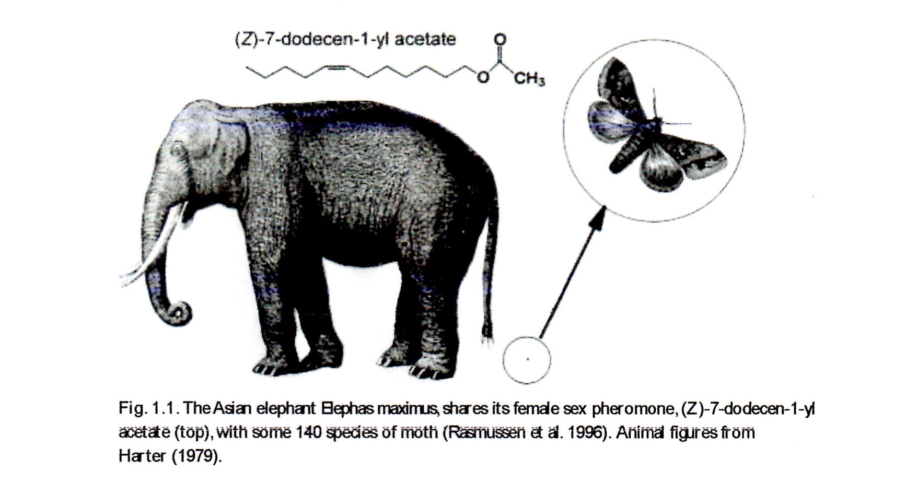
There are many documented examples of how pheromones play into the lives of various animals, in particular, insects. And because of the fact that insects can be destructive to plants useful to humankind, such as food crops, both natural and synthetic pheromones have been developed to attract and capture these undesirable insects. An interesting bit of trivia is that the molecular structure of an elephant pheromone is the same as that of some 140 species of moth!

(http://catdir.loc.gov/catdir/samples/cam033/2002024628.pdf )

Pheromones have long been known to be instrumental in the mating behavior of insects. Examples include male silkworm moths traveling up to 30 miles to a source of attractant from the female of the species. The male Cecropia moth is thought to be able to detect a few hundred molecules of the attractant in a cubic centimeter of air. In the honeybee, the particular pheromone secreted by the queen and picked up by the workers in the hive actually suppresses the development of the ovaries of the female worker bees so that they do not develop into a competing queen bee. Another twist in the effect of a pheromone in the behavior of insects is found with the male mealworm beetle. After a male mates with a female, the male spreads a pheromone over the female that acts as an anti-aphrodisiac, discouraging other males from trying to mate with the same female. This may conserve some of the energy of the female. Parasitic wasps use other scale insects to harbor the eggs they lay. The wasp is able to find this specific scale insect host because the wasp can detect an identifying sex attractant pheromone given off by the potential host! The wasp lays its eggs in the body of the scale host in which the wasp larvae feed and develop into new wasps. Some male cockroaches and crickets produce a pheromone called seducin from their bodies, on which the females nibble during copulation. This pheromone is an aphrodisiac. Another clever development in the insect world has to do with certain spiders producing a pheromone that is identical to the sex attractant of a female moth. This attracts night flying male moths which, when they navigate to the source of the pheromone, are captured by the spider.

Some molecular formulas for insect pheromones include:

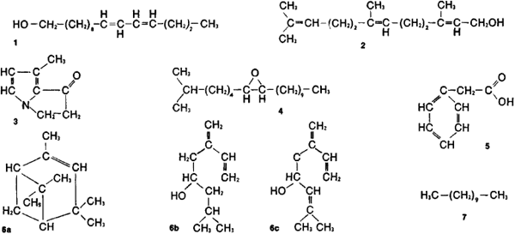

Chemical composition of certain pheromones: (1) sex attractant of female of Asiatic silkworm, (2) marking substance of certain bumblebees, (3) aphrodisiac of male of Danaidae butterfly, (4) attractant of female of gypsy moth, (5) component of marking secretion of a rodent (clawed jird), (6a, 6b, 6c) three components of clustering pheromone of Scolytus bark beetle, (7) anxiety pheromone of Lasius ant

(http://encyclopedia2.thefreedictionary.com/Pheromone)

More on the use of pheromones for insect control

The fact that pheromones are involved so much in the reproductive cycle of insects, including the undesirable ones, has been a motivating force for chemists to decipher the molecular structure of some of these pheromones. Over the last 50 years, chemists have identified pheromones from well over 1500 different insect species. Insects detect these pheromones with their antennae, their “nose”, so to speak. Long lasting pheromones allow insects to mark territorial boundaries or sources of food. Other signals are short lived and provide some kind of warning or an indicator of readiness for mating. The chemical makeup of these compounds can range from some kind of small hydrophobic molecules to water soluble peptides.

There are three main uses of pheromones in the integrated pest management of insects. The most important application is to determine the presence or absence of a particular insect in an area and also to determine their concentration for making a decision as to whether or not a control program needs to be implemented. Examples of monitoring include urban pest control of cockroaches, the management of stored grain pests, and tracking the spread of major pets such as the gypsy moth, the Japanese beetle, and the Medfly.

Pheromone traps have many applications. At the port of entry for shipping containers from other countries, traps are used to monitor the movement of exotic insect pests into most major North American ports. Another major use of pheromones is to “mass trap” insects in order to remove them from a feeding and breeding population. Mass trapping has been used to control the destructive bark beetle, the coddling moth (a serious pest of apples and pears), and certain moth pests that are destructive to some crops. In this case, a synthetic pheromone is dispersed onto crops. The false odor attracts males away from females waiting to mate, reducing the rate of mating. This false odor masks the insect’s own attractant and thus may prevent the sexes from getting together, which results in the reduction of the population density. In some cases, the effect has been so great that the pests have been eliminated in a particular locale.

An example is the use of a synthetic pheromone to control the beet army-worm. A field is flooded with the pheromone (which vaporizes), luring males to the area, away from females. The chemical is effective for a hundred days, way past the window of opportunity for mating. The beet army-worm has a wide host range, occurring as a serious pest of vegetable, field, and flower crops. Among susceptible vegetable crops are asparagus, bean, beet, broccoli, cabbage, cauliflower, celery, chickpea, corn, cowpea, eggplant, lettuce, onion, pea, pepper, potato, radish, spinach, sweet potato, tomato, and turnip. Field crops damaged include alfalfa, corn, cotton, peanut, safflower, sorghum, soybean, sugar beet, and tobacco.

A somewhat different approach to using pheromones is to attract insects in large numbers by utilizing synthetic trail pheromones. As an example, ant trail pheromones direct the insects to insecticidal bait, eliminating the pests directly rather than trying to interrupt the reproductive process. Of course, if the ant is eliminated, so is its reproductive mode!

A long list of insects for which there are pheromones is available at https://en.wikipedia.org/wiki/Pheromone_trap.

More on controlling animal behavior through hormones

There is interest in the use of pheromones to control the behavior of domestic animals (pets). In particular, dogs and cats can get stressed. Changes like a new home, a new family member or an annoying dog or cat next door can precipitate unwanted behaviors like marking or urinating in the house, excessive barking or meowing, or simply going on a rampage of destruction around the house. Evidently there are some pheromones that are calming or appeasing. They may relieve stressed animals. These pheromones are said to mimic natural cat or dog pheromones. They come in various forms including sprays, plug-in diffusers, wipes and collars. While these pheromones can be used with cats and dogs, they are not effective for treating aggression in dogs.

What does the research say about the effectiveness of these products? Research, funded by the products’ makers, claim that they help soothe stressed pets in some circumstances. One cat pheromone called Fellway mimics a cat’s facial pheromones which it deposits when rubbing its cheeks against a surface, marking the area as being safe, supposedly. This chemical may reduce scratching and some types of cat spraying. But it does not address the underlying problems that cause spraying on horizontal surfaces, such as beds or couches.
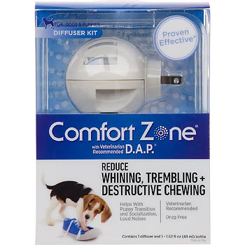
http://www.petcomfortzone.com/dogs/behavior-advice/puppy-whining-and-howling
Another pheromone product called Comfort Zone mimics the pheromone released by nursing dogs to comfort their puppies. The product may help with general anxiety as well as stress caused by loud noises such as thunder or fireworks. It may also help to mollify separation anxiety or to calm dogs in shelters. But owners should also do behavior modification with the animal.

Further research suggests that the dog appeasing pheromone (D.A.P., above) might reduce anxiety in puppies during training. Other than that, scientific studies did not find convincing evidence of benefit for anxiety associated with veterinary care, anxiety in shelter dogs, or barking and elimination (urination or defecation) indoors by recently adopted dogs.

In a limited number of cat studies, none provided convincing evidence of a benefit. Some decrease in urine spraying happened with some cats. Pheromone therapy was also not clearly beneficial for calming cats in hospitals or facilitating the stressful process of placing IV catheters in hospitalized cats. It seems as if these products are providing some sense of calm to the owners rather than their pets. Certainly, veterinarians have little basis for recommending these pheromone-based products to the owners of their pet patients.

In contrast to the inconclusive studies on the effectiveness of commercial products such as D.A.P. (dog appeasing pheromone), recent work at Texas Tech University points to a better product with scientific validation of its effectiveness. The product is the result of research by Dr. John McGlone into the use of a pig pheromone for calming dogs, more specifically for silencing dogs that bark too much. Dr. McGlone actually came across the effectiveness of the pig pheromone, known as an androstenone, by accident. The androstenone is normally produced by male pigs (boars) and sets female pigs into a breeding mode. Dr. McGlone had some of this pheromone in a bottle which he sprayed on his barking dog one day out of frustration. The dog immediately went quiet! Further testing of the pheromone on a whole variety of dogs stopped their barking also. A new product was born, called Boar Mate. And the pheromone is a synthetic rather than the natural derivative. Dr. McGlone evaluated the product in a series of experiments which included a placebo, of course. Refer to http://www.sciencedaily.com/releases/2014/08/140824213155.htm for a complete description of the testing program by Dr. McGlone. And as a result of this work, Dr. McGlone introduced a new term to the pheromone literature. Because the pheromone from one animal affected the behavior of another animal, the chemical was classified as an interomone.

More on the murky state of research into human odors associated with priming the endocrine system

This is a field of research where the opinions of experts range from animated support and even promotion to healthy scientific skepticism. Within the research ranks are accusations of all kinds about the veracity of data and how the experiments have been conducted, particularly when it involves all the variables of human behavior.

On one side of the debate are the pheromone boosters, some of whom have founded companies that sell pheromone-based perfumes and pharmaceuticals. On the other side are skeptics who argue that the phrase "human pheromone" is a contradiction in terms. Between the two extremes lies a middle ground of researchers who are doubtful of the strongest claims but unwilling to ignore the possibility that humans, like many other animals, use chemicals to communicate.

Among them is Martha McClintock, PhD, who can be credited with starting the human pheromone phenomenon. In 1971, the University of Chicago psychologist, then an undergraduate at Wellesley College, published a study showing that the menstrual periods of women who lived together tended to converge on the same time every month, an effect thought to be mediated by pheromones.

Now, more than 30 years later, McClintock and others in the middle ground are finally making progress in understanding the effects of human pheromones. Many aspects of the field remain unclear--including the definition of the term "pheromone" itself --but at least one conclusion can be drawn from the research conducted so far: Their effects are far more dependent on social and psychological context than originally suspected.

(http://www.apa.org/monitor/oct02/pheromones.aspx)

Scientists now suggest there are four kinds of human pheromones—primers, releasers, modulators and “signalers”—that provide information to the recipient without directly altering behavior. There is the opinion among some researchers that the term pheromone should be used only in the narrowest sense—in part because those who use looser definitions can label and sell almost anything as a pheromone. Two of the human secretions that have attracted attention and debate about their effects and about their classification as pheromones are the hormone-like chemicals, androstadienone and estratetraenol, which are found in human sweat. Some researchers claim there is evidence to support the idea that these two sweat products are pheromones and induce sexual responsiveness in males and females. But Charles Wysocki, PhD, of the Monell Chemical Senses Center in Philadelphia, PA, disagrees.

“There's no good evidence in the biomedical literature that these are human pheromones," he says. According to his analysis of McCoy's data (another researcher), the additive appeared to work only because women who received the placebo and the "pheromone" started out with different levels of sexual activity, then regressed toward the mean--a statistical flaw disguised by the study's data analysis methods.

Martha McClintock PhD, too remains skeptical. Social and psychological conditions are important mediators of pheromonal effects, she says, and any claims that a particular product will increase the user's opportunities for sexual intercourse regardless of context are, in her opinion, misleading.

‘It's like saying that if you see a red light, you cannot control yourself from stopping no matter the circumstance," says McClintock. "Human behavior just isn't like that in any domain.”

(http://www.apa.org/monitor/oct02/pheromones.aspx )

McClintock was one of the earliest researchers investigating potential human pheromones. In the 1970s she collected women’s underarm fluids and showed that when applied to the upper lip of a female recipient, the fluid could either hasten or delay a recipient’s menstrual period. But they were not able to identify the exact chemicals responsible for the effect. These substances were considered primers, substances that can influence long-term changes in hormone levels. What they were really hoping to find were so-called “releasers”, fast acting pheromones that are found in other non-human animals that trigger stereotypical behavioral responses related to sexual reproduction activity. Later research activities claimed to have found and isolated such releaser hormones that were then manufactured and sold by companies started by some of the researchers! But the scientific community has been reluctant to support claims of specific releaser pheromones that have been identified, as mentioned above. (For more details about the work of McClintock, refer to the reference immediately above.)

More on how odors are detected by insects

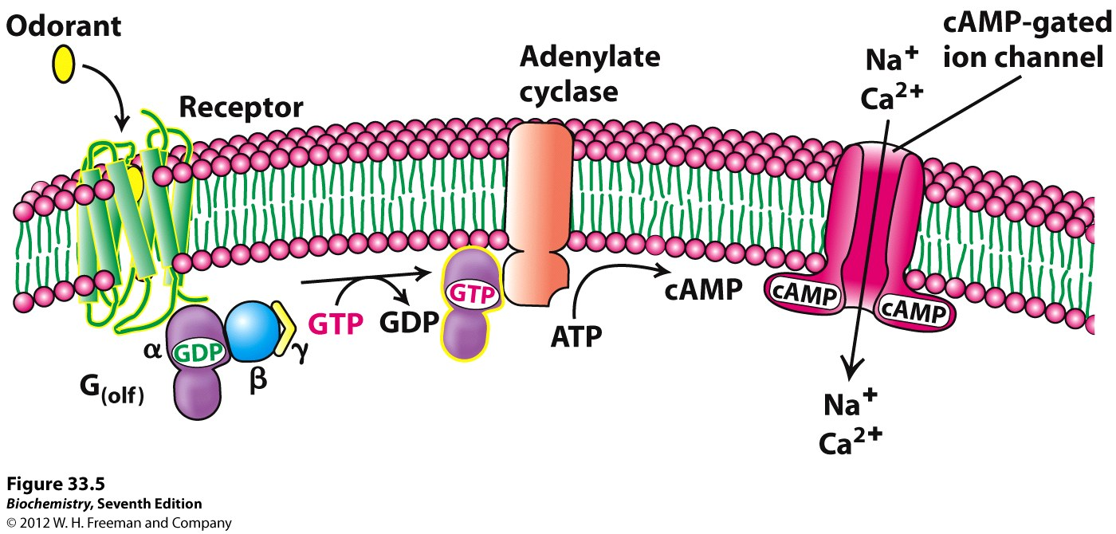
The chemistry behind detecting odors in insect antennae involves specialized proteins that change physical shape which, in turn, change neural cell membrane structure, allowing for certain ions (Ca²⁺, K⁺, Na⁺, and Cl–) to flow in or out of the cell, which sets off a nerve impulse.

(http://oregonstate.edu/instruct/bb451/summer14/stryer7/CH33/figure_33_05.jpg)

The description that follows relates to the illustration above.

Rather than binding specific ligands, olfactory receptors display affinity for a range of odor molecules, and conversely a single odorant molecule may bind to a number of olfactory receptors with varying affinities. Once the odorant has bound to the odor receptor, the receptor undergoes structural changes and it binds and activates the olfactory-type G protein on the inside of the olfactory receptor neuron. The G protein (Golf and/or Gs) in turn activates the lyase - adenylate cyclase - which converts ATP into cyclic AMP (cAMP). The cAMP opens cyclic nucleotide-gated ion channels which allow calcium and sodium ions to enter into the cell, depolarizing the olfactory receptor neuron and beginning an action potential which carries the information to the brain.

(http://en.wikipedia.org/wiki/Olfactory_receptor)

The following series of drawings provides the structural details of a moth antenna, which includes the physical interactions of the sensory neuron membrane proteins, pheromone-binding proteins, and the phospholipid bilayer portion of the neuronal membrane. Essentially, what you have are the important structural components that provide the chemical interaction between pheromone molecules and the insect’s neural network for “sensing” the presence of specific chemicals. This “sensing” in the insect’s brain then leads to specific behavior that the pheromone is meant to provoke.

(A) A close-up view of the hairy branches of moth antenna.
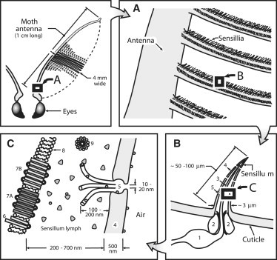
(B) Diagram of the olfactory sensillum ([1] olfactory receptor neuron; [2] auxillary supporting cells; [3] dendrite of an olfactory receptor neuron projecting into the hollow space of the sensillum; [4] cuticle wall of the hair; [5] cuticular pores).
(http://ac.els-cdn.com/S1074552109000295/1-s2.0-S1074552109000295-main.pdf?_tid=37aa1d7a-62b6-11e4-be1e-00000aab0f26&acdnat=1414949728_24bffeccad4594299e411807624b6d87)
(C) The peripheral components of the sensillum trichodeum ([6] sensory neuron membrane protein [SNMP]; [7] olfactory receptor and coreceptor; [8] phospholipid bilayer of the neuronal membrane; [9] micelles formed by fatty acids; shaded triangles, pheromone-binding proteins (PBPs); open circles, pheromone molecules). The pheromone molecules adsorbed on the cuticle wall of the sensillum migrate along the surface into the pore canal penetrating the cuticle and diffuse through the pore tubules into the sensillum lymph. PBPs come to interact with the ligands. The pheromone molecule may diffuse by itself through the barrier to associate with the membrane protein and then activate the receptor (Benton et al., 2007). Alternatively, ligand can either activate the PBP (Laughlin et al., 2008) or be delivered by the micelles (Honson, 2006).

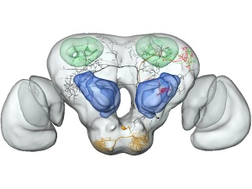
The brain of a moth, which is smaller than a pinhead, is shown at right. The blue areas are the primary smell center. Learning and memory take place in areas that are colored green. The protrusions on the sides are the visual areas, otherwise known as eyes.

(Norwegian University of Science & Technology (NTNU) Dept. of Biology: (http://earthsky.org/earth/inside-a-moths-brain)

The basic operational mechanism for detection of odors (and, of course, pheromones) is that there are olfactory receptor cells that contain specific proteins that interact with an odorant’s molecular structure when they meet within some kind of olfactory structure (an antennae in insects, ciliated epithelium within a mammal’s nose). An insect’s olfactory receptor cell is called an olfactory sensilia and is found in the antennae. Each cell has only one kind of protein for each type of odorant molecule. In a mouse there are more than 1000 different kinds of receptor proteins. In a human, we are talking about some 350 different kinds of receptor proteins. Each of these different receptor proteins is genetically coded for its synthesis. The receptor proteins are linked to receptor neurons. A nerve impulse is generated when an odorant molecule links to the receptor protein within the receptor neuron’s cell membrane, causing a deformation of the membrane protein which in turn sets off a cascade of chemical changes within the neuron cell that generates an impulse (see the illustration of moth antennae, above).

Connections to Chemistry Concepts
(for correlation to course curriculum)
- Organic compounds—In the biological/chemical world, organic compounds are fundamental to structure and function of living organisms. Because of a carbon backbone in the molecule’s structure, bonding that results can produce an almost infinite number of configurations with important functional groups attached. This allows for a variety of different pheromones for example helping one colony of ants to distinguish its members from those of another colony.
- Hydrogen bonding—As mentioned in the article, the type, hence strength, of bonding between pheromone molecules determines the ease with which the molecules can dissociate from each other in the phase change from a liquid to a gas.
- Polar molecules (dipoles)—Dipole moments found in a pheromone’s molecular structure are responsible for the molecule’s intermolecular bonding and the molecules’ phase—liquid versus gas, depending on temperature.
- (London) dispersion forces (temporary dipoles)—The weakest of the types of intermolecular bonding between pheromone molecules, these forces are produced from temporary dipoles within the molecule shifting from moment to moment because of the molecule’s temperature-dependent vibrations.
- Phase changes—When a pheromone is produced within an organism (most likely as a liquid), it usually depends upon a phase change to a gas in order to be transmitted over a distance to another recipient organism.
- Kinetic molecular theory of gases—Because gas molecules are constantly in motion, volatile substances such as pheromones can reach an animal’s detection apparatus at some distance from the source.
- Pheromone—For pheromones to function as a gaseous substance, these organic compounds must contain between 5 and 20 carbon atoms, with a molecular weight between 80 and 300. The size and weight limits are related to molecular diversity and olfactory efficiency.

Possible Student Misconceptions
(to aid teacher in addressing misconceptions)
- “Human pheromones have been identified, since they are sold for enhancing sexual attraction.” Although “pheromones” are purportedly available as human pheromones and sold for enhancing sexual attraction in various perfumes, there is no evidence that human pheromones exist or that they enhance sexual attraction as in other animals. Some studies have tried to link odor of men’s sweaty underwear to women’s sexual responses, but most scientific studies do not find a link. Underarm sweat from male or female when placed on the upper lip of females is found to affect the timing of the menstrual cycle. There are plenty of odors that females respond to, but they are not specific responses as in the case of other animals and insects related to pheromone emissions. A specific human pheromone has yet to be isolated chemically.
- “If we synthesize a molecule that occurs in nature (as in the gypsy moth lure), then it is natural.” For a chemical to be natural, it has to be produced in nature by a living plant or animal or from a non-living source such as that which is extracted from the earth. But to put together (synthesize) a molecule that has the exact same structure as that extracted from natural sources is still synthetic.
- “Liquids evaporate or vaporize only at high temperatures, as in the boiling of water.” First, remember that water does evaporate at almost all temperatures; it doesn’t need to boil to form vapor. The temperature at which a liquid evaporates, whether at the boiling point or not, is dependent on the molecular structure of the molecule, which in turn determines the type of intermolecular force. If you compare the rate at which water evaporates at room temperature with that of an organic compound such as carbon tetrachloride (CCl₄), you find that carbon tetrachloride will evaporate much more quickly than water because the intermolecular bonds between the carbon tetrachloride molecules are much weaker than those between water molecules.
The type of intermolecular bond results from the bonding within the molecules. The water molecule ends up being a polar molecule which means it possesses slight positive and negative electrical charges on opposite ends of the structure (dipoles). This allows for attractive forces between water molecules (dipole-dipole interactions—hydrogen bonding). The carbon tetrachloride molecules are the exact opposite, or non-polar. Their intermolecular forces are much weaker than those of water. So it takes less kinetic energy for separation of carbon tetrachloride molecules in the evaporative process.
Liquid molecules do not have to reach the boiling point in order to evaporate because some of the molecules have enough kinetic energy to break intermolecular bonds and become gaseous. Non-polar molecules create a higher vapor pressure (from more gaseous molecules) at a given temperature than polar molecules because of their weaker intermolecular forces. NOTE: Vapor pressure relies on the existence of three distinct types of intermolecular forces—London forces (temporary dipoles), present in all molecules; dipole-dipole interactions, which are the result of a molecule’s polarized structure; and hydrogen bonds, which are the result of a hydrogen atom covalently bonded to a highly electronegative atom (such as oxygen) in a polarized structure being attracted to another highly electronegative atom in another neighboring molecule.

Anticipating Student Questions
(answers to questions students might ask in class)
- “Why are dogs more sensitive to smell than humans?” It all has to do with the brain. If you look at a dog’s brain, you will find 20 to 40 times as many nerve receptors for interpreting odors than in our brains. Testing a dog’s sensitivity of smell for a particular chemical, hydrogen sulfide, we find that the lowest concentration of hydrogen sulfide in air that a dog can detect is 10⁻¹³ %. (1 part per quadrillion). The lowest concentration of hydrogen sulfide detected by humans is 10⁻⁶ % (10 ppb). (from ChemMatters Teacher’s Guide for December 2012, to accompany ChemMatters article “What’s That Smell?”) Note that the MSDS for hydrogen sulfide lists the short term exposure limit (10 minutes) at 15 ppm, a level so low we cannot even detect it at its toxic level—but dogs can.
- “Can we smell human pheromones and what are the particular functions of those we can smell?” There have not been any human pheromones isolated and analyzed to date. There is some anecdotal evidence to suggest that certain responses can be elicited in females when underarm sweat from either males or females is placed on the upper lip of a female, can affect the timing of the menstrual cycle. But sweat is not a pheromone. (Refer to the details of misconception #1 in the previous section (“Possible Student Misconceptions”).
- “At what concentration and at what distance can a male moth detect a female moth’s sexual pheromone attractant?” As an example, the male silkworm moth can detect a female as far away as one mile. The pheromone secreted by a female gypsy moth can be detected by the male species at concentrations as low as ONE molecule in 1 x 10¹⁷ molecules of air!
- “Are pheromones required for sexual reproduction to occur in insects?” What we are really talking about is the techniques used by insects to attract a mate for reproduction. Naturally, the release of a pheromone is one such device. But insects also use a number of other “attractants” including visual clues, auditory clues, and flashes of light as in the case of the firefly. Visual clues simply mean that a male will detect a female by sight, will inspect, and, if truly a female of his species, will engage in reproduction. In the case of butterflies, color and the pattern of flight by the female provide the identification cues for the male. Female fireflies use a specific light-signaling code to attract a male. Crickets and cicadas use sound to attract mates. The “singing” is usually produced by the male species.
- “If a pheromone-based trap for Japanese beetles attracts the insect to a garden area, wouldn’t that simply lure the beetles to the plants rather than to the trap?” In reality, there is the possibility that some of the beetles lured in the direction of the garden might find plants to eat. But the pheromone lure is strong enough (think sex!) to attract the majority of beetles away from the plants.

In-Class Activities
(lesson ideas, including labs & demonstrations)
- Olfactory fatigue is the temporary, normal inability to distinguish a particular odor after a prolonged exposure to particular airborne compound. Some animals such as dogs do not suffer from this fatigue because of their special nasal architecture. Humans do experience olfactory fatigue. Several experiments on this topic can be found at the following Web sites—http://www.sciencebuddies.org/science-fair-projects/project_ideas/HumBio_p031.shtml#materials: and http://academic.evergreen.edu/curricular/perception/Lab1006.htm. This latter Web site has very good questions for the students to think about with regard to the topic of olfactory fatigue.
- Another Web site on olfactory fatigue activity is found at http://faculty.washington.edu/chudler/chems.html. ). The teacher guide for this activity is found at http://faculty.washington.edu/chudler/pdf/chemstg.pdf .
- Students could synthesize esters which are normally used as flavoring in foods, but for this exercise would simply be the production of pleasantly smelling compounds that they can recognize. Ester synthesis involves the use of concentrated sulfuric acid. But if done in small quantities it presents less of a lab safety issue. Or the teacher can add the acid for the students at the correct step in the procedure. Refer to the following Web site for a complete lab exercise in ester synthesis: http://www.nuffieldfoundation.org/practical-chemistry/making-esters-alcohols-and-acids
- Although this ChemMatters article deals with smell in the insect world, students could map their tongue for the locations of the principle tastes of salt, bitter, sweet and sour (acidic). Smell is often involved with a particular taste. And for insects, while using smell for locating both mates as well for locating food sources, also use taste for evaluating the type and quality of a food source. This exercise would also point out to students the specificity of neural receptors. Most biology lab manuals contain the exercise procedure. A printable outline of the tongue with the locations on the tongue for the different categories of taste is found at http://www.teachervision.fen.com/tv/printables/orange/SL-27.pdf . A Web site for the lab procedure can be found at http://faculty.washington.edu/chudler/chtaste.html. You can also actually see the taste buds on the tongue and compare the number for different people. See the following Web site for the simple instructions: http://www.bbc.co.uk/science/humanbody/body/articles/senses/tongue_experiment.shtml Additional background information and discussion about the integral role of smell with taste and touch for the sensations of what some people call the flavor of foods is found at http://www.tastescience.com/default.html . Smell is often involved with a particular taste.

Out-of-class Activities and Projects
(student research, class projects)
- Student activities involving insects provide learning on how to design an experiment. A list of research ideas with ants but no particular set of procedures (i.e., students design the experiment) can be found at http://www.science-projects.com/behavior.htm.
Here is another list of experiments with ants: http://www.all-science-fair-projects.com/science_fair_projects/78/3/47e9f497402253a67d9ef19e5e99d17d.html
- Two specific experiments with ants dealing with concentrations of sugar (solutions) and type of sugars are found at http://www.crystal-clear-science-fair-projects.com/ant-behavioral-science-projects.html and http://www.crystal-clear-science-fair-projects.com/ant-behavioral-science-project.html. This reference includes where to obtain the ants.
- Another experiment with ants tests both ant attractants as well as ant repellents. To do this particular study, ants can be obtained from biological supply companies that the biology teachers are familiar with. For all aspects of this activity, consult http://www.sciencebuddies.org/science-fair-projects/project_ideas/Zoo_p025.shtml#materials.
- An experiment dealing with ant trails and their chemical signals (pheromones) is found at http://www.sciencebuddies.org/science-fair-projects/project_ideas/Zoo_p016.shtml .
- Students could investigate the use of pheromone-based insect traps for such destructive insect pests as the Gypsy moth and Japanese beetle. What other devices are used either separately or in conjunction with the traps?
- An experiment to determine the chemical basis for ant behavior involves extracting and testing chemicals from ants to test their effect on a group of nest mates’ behavior. The second part to the experiment is to modify the extracted ant scent using several organic solvents to see what effect this has on the ants’ behavior. The procedure for extracting the scent chemicals is documented. Refer to http://www.sciencefairexperiments.org/Zoology/Chemical-Basis-for-Ant-Behavior.php.
- A large collection of experiments done by students (as science projects) is found at http://www.juliantrubin.com/fairprojects/zoology/ant.html. Each experiment is described completely by a student who actually did the experiment. This particular Web site has a collection of experiments on both ants and termites.
- Another Web site with a collection of investigations into ant behavior suggests topics to investigate but does not give specific procedural details; however, is does point out what variables need to be tested and makes suggestions about experimental setups. This site would be useful for providing students with an investigation of a topic without resorting to the cookbook style of class experiment. These topics for investigation are closer to open-ended research. Refer to http://www.all-science-fair-projects.com/science_fair_projects/78/3/47e9f497402253a67d9ef19e5e99d17d.html%2056.

References
(non-Web-based information sources)

30 Years of ChemMatters

Available Now!

The references below can be found on the ChemMatters 30-year DVD (which includes all articles published during the years 1983 through April 2013 and all available Teacher’s Guides, beginning February 1990). The DVD is available from the American Chemical Society for $42 (or $135 for a site/school license) at this site: http://ww.acs.org/chemmatters. Scroll about half way down the page and click on the ChemMatters DVD image at the right of the screen to order or to get more information.

Selected articles and the complete set of Teacher’s Guides for all issues from the past three years are available free online on the same Web site, above. Simply access the link and click on the “Past Issues” button directly below the “M” in the ChemMatters logo at the top of the Web page.

Kimball, A. Human Pheromones: The Nose Knows. ChemMatters 1997, 15 (2), pp. 6–8. This ChemMatters article deals specifically with the search for human pheromones and the difficulties that entails. Several molecular formulas of several human odorants (as opposed to pheromones) are described. These male odorants may induce or prime the female endocrine system to begin the menstrual cycle.

Eboch, C. What’s That Smell? ChemMatters 2012, 30 (4), pp 12–14. This ChemMatters article deals extensively with the sense of smell, including that of humans, fish, and also dogs whose keen sense of smell is used for detecting bombs, cancer, and of course the pheromones of a canine reproductive partner. There is also a very useful Teacher’s Guide.

Web Sites for Additional Information
(Web-based information sources)
More sites on the work of two great entomologists—Jean-Henri Fabre (19th C) and EO Wilson (20th C)

An extensive biography about the work in entomology of Jean-Henri Fabre is found at http://www.e-fabre.com/en/biography/bio.htm.

A very good PBS video program about the work of EO Wilson is found at http://www.pbs.org/wgbh/nova/nature/lord-ants.html.

More sites on the basics of pheromones

A twenty-eight page treatise on all aspects of pheromones that is clearly written and useful as a primary reference on pheromones is found at http://catdir.loc.gov/catdir/samples/cam033/2002024628.pdf.

A second Web site from the animal science research labs at the Texas Tech University provides a good amount of information on pheromones related to dogs, cats, pigs, horses, rats, and mice. It also provides the details of their research into the use of pig pheromones to control dog behavior. This is in contrast to some of the poorly done research into the use of the commercial products sold for controlling undesirable behavior in dogs and cats. A video shows the use of one commercial pheromone product to control the behavior of a dog. There is also a PowerPoint program at this same Web site that presents the science of pheromones. It could be useful for class. Refer to the following Web site: http://www.depts.ttu.edu/animalwelfare/Research/Pheromones/index.php.

More sites on commercial insect lures and traps

A short and readable essay on the current state of pheromone use in controlling insects is found at http://mypestprevention.com/2013/09/pheromones-insect-control/. A complementary article from a state agriculture service is found at http://www.unce.unr.edu/publications/files/ag/other/fs9841.pdf.

A commercial Web site, http://www.pestcontrolindia.com/pheromone-lures-and-traps.aspx, shows examples of various types of pheromone-based insect traps.

The Web site http://www.insectslimited.com/pheromones-home provides detailed information about the various pheromone traps that can be used to control insect pests that eat food as well as clothing!

An extensive reference on the use insect traps of all kinds for a large variety of applications is found at http://www.insectslimited.com/history-of-pheromones.php. It also includes a history of pheromones.

More sites on the life of ants

In case students have not seen the life activities of colonies of different ants, their exceptional physical strength and energy reserves, refer to the hour-long program from National Geographic, http://www.youtube.com/watch?v=55tXhnlZoOg.

A second, short (3 minute), but very informative video shows the behavior of ants concerning laying and following scent trails under lab conditions where the evidence is clearly documented. Refer to the Web site http://blog.wildaboutants.com/2010/06/27/questions-about-ant-pheromones/. There is also printed information about various aspects of an ant’s anatomy and the function of its various appendages.

A third article about determining the specificity of odor detection in desert ants is found at http://blogs.scientificamerican.com/thoughtful-animal/2011/06/23/nosejobs_for_ants/. This might be a useful article for students to read because of how the experiment was set up, what data was collected and, most importantly, what questions were answered from the data.

More sites on biological control of insects using pheromones and bacteria

This site provides the story behind the gypsy moth invasion and control methods, including the Bacillus thuringiensis as well as pheromone-based traps. This is a commercial site but provides useful information about various methods to control a variety of insects, as well as the gypsy moth. (http://bugspray.com/article/gypsymoths.html#gypsy-moth-control-traps)

More sites on the chemical basis for detecting odors

For basic information on how an odor detected by an insect becomes neural information, refer to this Web site: http://insects.about.com/od/behaviorcommunication/f/how_insects_smell.htm.

A related Web site concerning the different ways by which insects either attract or find a mate is found at http://insects.about.com/od/matingreproduction/p/findamate.htmb.

Finally, for a discussion about how insects taste their food or their prey, (which, neurologically, is related to smell), consult the final Web site in this series, from About.com, at http://insects.about.com/od/behaviorcommunication/f/how-insects-taste.htm.

More sites on current thinking about the existence of human pheromones

This site from the highly respected and world famous Monell Chemical Senses Center (Philadelphia, PA) for basic research into taste and smell details the proceedings of a 2003 seminar on the state of human pheromone research. View this comprehensive study at http://www.monell.org/images/uploads/Monell_Spring03.pdf.

A balanced review of both the history of the search for human pheromones and the present debate about the very existence of human pheromones from several scientific quarters is found at http://www.apa.org/monitor/oct02/pheromones.aspx. A related reference from the same professional organization, the American Psychological Association, lays out a newer definition of a human pheromone that delineates four subcategories under the term pheromone. (http://www.apa.org/monitor/oct02/othername.aspx)

A second article on the current state of affairs about human pheromones from Scientific American is found at http://www.scientificamerican.com/article/are-human-pheromones-real/. The article tries to present a balanced and non-anecdotal basis for accepting or rejecting claims about the existence of human pheromones and their actions.

A Web site from Macalester University looks at pheromones in a comprehensive way, including the issue of the existence of human pheromones. It can be found at http://www.macalester.edu/psychology/whathap/UBNRP/pheromone10/pheromones%20intro.html. An interesting section of this reference includes the evolutionary reasons for pheromones—what are the benefits for possessing pheromones, biologically speaking.

More sites on moth behavior related to finding food, mates and avoiding predators—it’s not just pheromones

The American Museum of Natural History provides a blog that describes a number of interesting tools, including sight, used by moths to find food and mates, as well as to avoid becoming food for other predators, such as bats! The design and coloration of moth wings are integral to communication as well as protection. Refer to http://www.amnh.org/explore/news-blogs/news-posts/happy-national-moth-week.

