logo_chemmatters[1]

**December 2015/January 2016 Teacher's Guide for**

***Geothermal Energy: Hot Stuff***

**Table of Contents**

[About the Guide 2](#_Toc436734339)

[Student Questions 3](#_Toc436734340)

[Answers to Student Questions 4](#_Toc436734341)

[Anticipation Guide 6](#_Toc436734342)

[Reading Strategies 7](#_Toc436734343)

[Background Information 10](#_Toc436734344)

[Connections to Chemistry Concepts 34](#_Toc436734345)

[Possible Student Misconceptions 34](#_Toc436734346)

[Anticipating Student Questions 35](#_Toc436734347)

[In-Class Activities 36](#_Toc436734348)

[Out-of-Class Activities and Projects 39](#_Toc436734349)

[References 40](#_Toc436734350)

[Web Sites for Additional Information 40](#_Toc436734351)

# About the Guide

Teacher’s Guide editors William Bleam, Regis Goode, Donald McKinney, Barbara Sitzman and Ronald Tempest created the Teacher’s Guide article material. E-mail: [bbleam@verizon.net](mailto:bbleam@verizon.net)

Susan Cooper prepared the anticipation and reading guides.

Patrice Pages, *ChemMatters* editor, coordinated production and prepared the Microsoft Word and PDF versions of the Teacher’s Guide. E-mail: [chemmatters@acs.org](mailto:chemmatters@acs.org)

Articles from past issues of *ChemMatters* can be accessed from a DVD that is available from the American Chemical Society for $42. The DVD contains the entire 30-year publication of *ChemMatters* issues, from February 1983 to April 2013.

The *ChemMatters* DVD also includes Article, Title and Keyword Indexes that covers all issues from February 1983 to April 2013.

The *ChemMatters* DVD can be purchased by calling 1-800-227-5558.

Purchase information can be found online at [www.acs.org/chemmatters](http://chemistry.org/chemmatters/cd3.html).

# Student Questions

* 1. List four (4) advantages of geothermal energy over other energy sources.
  2. What are the three requirements for geothermal energy?
  3. How is underground geothermal energy used to produce electricity?
  4. List the similarities and differences between the generation of electricity by geothermal energy and generation of electricity by burning fossil fuels.
  5. What is a binary-cycle system?
  6. What is the advantage of using a binary-cycle system?
  7. How does a heat pump work?
  8. Is geothermal energy likely to be “the answer” to all our energy needs in the future? Why/Why not?
  9. Currently, what percentage of the electricity in the United States is produced from geothermal energy?
  10. List the energy transfers that happen when electricity is generated from burning fossil fuels.

# Answers to Student Questions

* + 1. **List four (4) advantages of geothermal energy over other energy sources.**

*The four (actually, 5) advantages for geothermal energy mentioned in the article are*

*It will not run out, as the Earth’s core will remain hot for the next 5 billion years*

*Power plants using geothermal energy can work 24/7, regardless of the weather*

*Geothermal energy is better for the environment than fossil fuels because it releases practically no greenhouse gases*

*Geothermal energy can be cheaper than energy from fossil fuels (it requires no fuel,   
per se)*

*Geothermal energy can be tapped locally, decreasing our dependence on foreign oil.*

* + 1. **What are the three requirements for geothermal energy?**

*Three requirements for geothermal energy are*

*A source of heat,*

*Rock permeability and*

*Water.*

* + 1. **How is underground geothermal energy used to produce electricity?**

*A well is dug into the earth to extract the hot water which turns into steam. The steam goes through the turbine, which turns due to the kinetic energy imparted to it by the hot steam. The turbine drives a generator that uses electromagnets to convert the kinetic energy to electrical energy. The “used” water, which has lost much of its heat to the turbine, is pumped back into the ground to be reheated geothermally and then it can be used again in the power plant.*

* + 1. **List the differences between the generation of electricity by geothermal energy and generation of electricity by burning fossil fuels.**

*Differences between fossil fuel-produced electricity and geothermal-produced energy include:*

*fossil fuel-generated electricity*

*requires that the fossil fuel be burned, which requires the depletion of the fuel (a natural resource) and*

*produces pollution;*

*geothermal energy*

*extracts already-heated boiling water from the ground, requiring no external fuel and, as a result*

*produces no greenhouse gases.*

* + 1. **What is a binary-cycle system?**

*A binary-cycle system sends heated water (that is not hot enough to boil), from underground, through a heat exchanger to heat a second liquid. Note that the two liquids do not mix or come in direct contact with each other; only heat is exchanged between the two. The boiling point of the second liquid is lower than that of water, so the heat from the water transferring to the second liquid is sufficient to cause the second liquid to boil. This produces gaseous vapor, like steam. This vapor then turns the turbines that power the generators to produce electricity.*

* + 1. **What is the advantage of using a binary-cycle system?**

*A binary-cycle system can be used in more places than a typical geothermal system.*

* + 1. **How does a heat pump work?**

*In the winter, heat pumps absorb heat from underground and transfer it through a heat exchanger to a building; in the summer, heat pumps absorb heat from the building and transfer it underground.*

* + 1. **Is geothermal energy likely to be “the answer” to all our energy needs in the future? Why/Why not?**

*Geothermal energy is not likely to be the answer to all our energy needs because it doesn’t work everywhere. Many places in the U.S. don’t have all three requirements for geothermal energy: high temperature, underground water and permeable rock. These areas will require wind or solar energy as alternative sources of energy.*

* + 1. **What percentage of the electricity in the United States is produced from geothermal energy currently?**

*The article states that only about 1% of the electricity generated in the U.S. comes from geothermal energy.*

* + 1. **List the energy conversions that happen when electricity is generated from burning fossil fuels.**

*The energy conversions happening in a fossil fuel electricity power plant include the following:*

*Coal or oil is burned to produce heat to warm water. This converts chemical stored energy to thermal or heat energy.*

*Heat energy makes the water boil. Boiling water makes steam, water molecules moving quickly through air. This conversion is thermal energy changing to kinetic energy.*

*Energetic steam turns the turbine, a conversion of kinetic energy to mechanical energy.*

*The moving turbine turns the generator, forcing electrons to move through a wire, a conversion of mechanical energy into electrical energy.*

# Anticipation Guide

Anticipation guides help engage students by activating prior knowledge and stimulating student interest before reading. If class time permits, discuss students’ responses to each statement before reading each article. As they read, students should look for evidence supporting or refuting their initial responses.

**Directions:**  *Before reading*, in the first column, write “A” or “D,” indicating your agreement or disagreement with each statement. As you read, compare your opinions with information from the article. In the space under each statement, cite information from the article that supports or refutes your original ideas.

|  |  |  |
| --- | --- | --- |
| **Me** | **Text** | **Statement** |
|  |  | 1. Geothermal power plants must shut down at night. |
|  |  | 1. Geothermal power plants release about 50% as much carbon dioxide as fossil-fuel power plants. |
|  |  | 1. The largest geothermal power plant development in the world is in Iceland. |
|  |  | 1. Most geothermal power plants work by using steam from hot springs or geysers. |
|  |  | 1. Currently, most geothermal power plants in the United States are in western states. |
|  |  | 1. The upper 10 feet of Earth’s surface remain at fairly constant temperatures. |
|  |  | 1. Currently, families in almost every state in the United States have geothermal heat pumps in their homes. |
|  |  | 1. Moving molecules can transfer kinetic energy to a turbine fan. |
|  |  | 1. When a gas is compressed, its temperature increases. |
|  |  | 1. Currently, geothermal power plants produce almost 10% of the electricity in the United States. |

# Reading Strategies

These graphic organizers are provided to help students locate and analyze information from the articles. Student understanding will be enhanced when they explore and evaluate the information themselves, with input from the teacher if students are struggling. Encourage students to use their own words and avoid copying entire sentences from the articles. The use of bullets helps them do this. If you use these reading and writing strategies to evaluate student performance, you may want to develop a grading rubric such as the one below.

|  |  |  |
| --- | --- | --- |
| **Score** | **Description** | **Evidence** |
| 4 | Excellent | Complete; details provided; demonstrates deep understanding. |
| 3 | Good | Complete; few details provided; demonstrates some understanding. |
| 2 | Fair | Incomplete; few details provided; some misconceptions evident. |
| 1 | Poor | Very incomplete; no details provided; many misconceptions evident. |
| 0 | Not acceptable | So incomplete that no judgment can be made about student understanding |

***Teaching Strategies:***

1. Links to **Common Core Standards for Reading**:

* ELA-Literacy.RST.9-10.1:Cite specific textual evidence to support analysis of science and technical texts, attending to the precise details of explanations or descriptions.
* ELA-Literacy.RST.9-10.5: Analyze the structure of the relationships among concepts in a text, including relationships among key terms (e.g., force, friction, reaction force, energy).
* ELA-Literacy.RST.11-12.1:Cite specific textual evidence to support analysis of science and technical texts, attending to important distinctions the author makes and to any gaps or inconsistencies in the account.
* ELA-Literacy.RST.11-12.4: Determine the meaning of symbols, key terms, and other domain-specific words and phrases as they are used in a specific scientific or technical context relevant to grades 11-12 texts and topics.

1. Links to **Common Core Standards for Writing**:

* ELA-Literacy.WHST.9-10.2F: Provide a concluding statement or section that follows from and supports the information or explanation presented (e.g., articulating implications or the significance of the topic).
* ELA-Literacy.WHST.11-12.1E: Provide a concluding statement or section that follows from or supports the argument presented.

1. **Vocabulary** and **concepts** that are reinforced in this issue:

* Chemical safety
* Molecular structures
* Energy conservation
* Lipids
* Hydrophobic and hydrophilic structures
* Enzymes
* Evaluating scientific claims

1. Some of the articles in this issue provide opportunities, references, and suggestions for students to do further research on their own about topics that interest them.
2. To help students engage with the text, ask students which article **engaged** them most and why, or what **questions** they still have about the articles. The Background Information in the *ChemMatters* Teachers Guide has suggestions for further research and activities.

**Directions:** As you read the article, complete the graphic organizer below to compare geothermal power plants, binary-cycle power plants, and geothermal heat pumps.

|  |  |  |  |
| --- | --- | --- | --- |
|  | **How do they work?** | **Advantages** | **Disadvantages** |
| **Geothermal power plants** |  |  |  |
| **Binary-cycle power plants** |  |  |  |
| **Geothermal heat pumps** |  |  |  |

**Summary:** On the back of this sheet, write a 20-word summary sentence explaining the energy conversions in producing power from geothermal energy.

# Background Information

**(teacher information)**

**More on the history of geothermal energy**

The first human uses of geothermal energy probably occurred more than 10,000 years ago, when Paleolithic American Indians settled near and used hot springs for bathing and heating. Evidence also indicates that the springs were seen as a source of healing.

Spas and public baths were built around hot springs. The oldest known spa was built on China’s Mount Li in the Qin dynasty in the 3rd Century BC. In the 1st Century AD, Romans used hot springs in the newly conquered territory of Aquae Sulis to supply public baths. The required admission fees for these baths constitute the first commercial use of geothermal energy. Another ancient hot tub, about a thousand years old, is located in Iceland, built by one of the original settlers there.

The first use of district heating to heat an entire community occurred in Chaudes-Aigues, France. Put into use in the 14th century, it is still in operation today. In 1892, Boise, Idaho was the first community in the U.S. to use district heating with geothermal energy as its source, followed a few years later by Klamath Falls, Oregon.

The first use of geothermal energy for industrial purposes occurred in the 19th century (1827), when Francesco Larderel & sons used steam from the geothermal vents in Larderello, Italy to process boric acid from the volcanic mud and rock in that area. Later, in 1904, Prince Piero Conti used the same steam vents in the Larderello Fields near Pisa, Italy to produce electricity. The first geothermal power plant produced enough electricity to illuminate only five 5-watt lights. By 1913 a commercial plant using pure steam produced 250 kW of electricity, and by 1916 two plants were running that produced 3.5 MW each.

Lord Kelvin had invented the concept of the heat pump in 1852. Three years later Peter von Rittinger created the first working heat pump. The first commercial heat pump was used in the Commonwealth Building in Portland, Oregon in 1946. The first heat pump to be used in an individual’s home occurred in 1948. The 1973 oil crisis caused people in Sweden to use heat pumps in many of their homes and commercial buildings, leading to worldwide acceptance of the concept. It’s estimated that today well over a million geothermal heat pumps are installed worldwide.

The first use of geothermal energy to produce electricity in the U.S. occurred in 1922 at The Geysers, California, when a geothermal power plant was constructed that produced 150 kilowatts (KW) of electricity to light street lights and buildings in The Geysers area Resort. This plant didn’t last long, as other sources of fuel to power electric power plants became available and cheap. Also, the steam used in this plant was very corrosive due to the minerals dissolved in the hot water, and this caused pipes to “rust out” very quickly.

The first large-scale industrial power plant to produce electricity that relied on geothermal energy was constructed and operated by Pacific Gas and Electric at The Geysers, California, in 1960 and produced 11 megawatts (MW) of electricity. The plant operated successfully for 30 years, and many more plants cropped up in the same area.

As more power plants were built at The Geysers, they eventually overused the steam pocket underlying the region that supplied the energy to run the turbines that generated the electricity, using steam faster than it could be regenerated underground. This resulted in several of the power plants being shut down and the remaining steam rerouted to the remaining plants. The owners then initiated the process of pumping back down into the wells processed wastewater from several cities in the vicinity. The wastewater restocked the underground reservoirs, was reheated and became steam that they could use in the plants.

The restocking process guaranteed the sustainability of the region’s geothermal heat source to provide power for the plants well into the foreseeable future. Today there are more than 60 geothermal power plants working in the U.S., with many more around the world.

But the story of geothermal energy as a heat source for energy production on Earth’s surface doesn’t stop there. Research on other types of geothermal energy systems, utilizing heat contained in bedrock, at far greater depths than hot springs or geysers, has been ongoing since the 1970s. You can find more on this topic in “More on Enhanced Geothermal Systems” later in this Teacher’s Guide.

**More on the source(s) of geothermal energy**

OK, the article talks about all the heat available from geothermal energy for our use, but where does that energy come from? It turns out that it was—and is—a long time in the making.

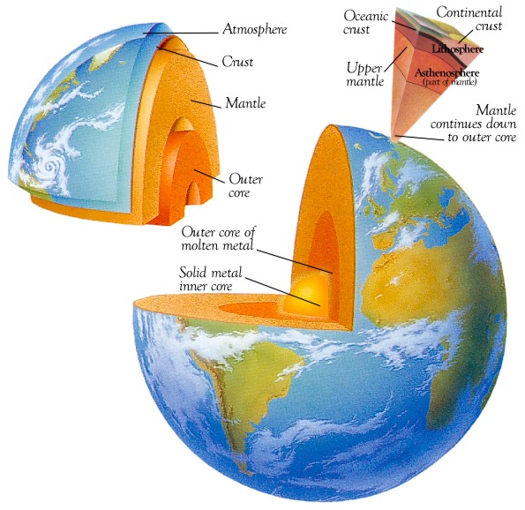

*(*[*http://www.zmescience.com/space/when-inner-core-formed-0432432/*](http://www.zmescience.com/space/when-inner-core-formed-0432432/)*)*

(image credited to Wikipedia, but this editor was unable to find the original illustration on the Wikipedia site)

The earth's **core** lies almost 4,000 miles (6,400 kilometers) beneath the earth's surface. The double-layered core is made up of very hot **molten** iron surrounding a solid iron center. Estimates of the temperature of the core range from 5,000 to 11,000 degrees Fahrenheit (F) [3,000–6,000 oC]. Heat is continuously produced within the earth by the slow decay of radioactive particles that is natural in all rocks.

Surrounding the earth's core is the **mantle,** thought to be partly rock and partly magma. The mantle is about 1,800 miles thick. The outermost layer of the earth, the insulating crust, is not one continuous sheet of rock, like the shell of an egg, but is broken into pieces called **plates.** These slabs of continents and ocean floor drift apart and push against each other at the rate of about one inch per year in a process called **continental drift.**

**Magma** (molten rock) may come quite close to the surface where the crust has been thinned, faulted, or fractured by plate tectonics. When this near-surface heat is transferred to water, a usable form of geother[mal]- energy is created.

(<http://lsa.colorado.edu/essence/texts/geothermal.html>)

Scientists know that the center of the earth is extremely hot—on the order of 4,000–6,000 oC. The rate of conductivity of that heat from the core through the mantle and out through the crust is excruciatingly slow. It occurs both by convection, heat passed through circulating fluids, as in the molten outer core conveying heat to the solid mantle, and by conduction, heat passed through non-circulating solid boundary layers, as the crustal plates. Conduction is, by far, the slower of the two processes. Since both these processes are slow, the earth has maintained much of its primordial heat, from when it was first formed.

But, you may ask, where did the heat come from in the first place? There are several sources. First, when smaller astronomical bodies came together to form the “proto-Earth”, the process of accretion of these bodies produced enormous amounts of heat. Of course, some of that heat was likely lost as it was re-radiated into space, but a huge amount must have remained in the larger, coalesced body. In addition, the presently-accepted idea of how the moon was created involves the later collision of a relatively large body, perhaps the size of Mars, with the early earth. This collision would also have produced enormous amounts of energy—heat that mostly was trapped inside both bodies, thus increasing the temperature of Earth once again.

The next source of heat was actually generated within the planet itself as the denser material of the early molten (hot) earth began to sink toward the center to form the core. This descent of the more dense material (and concomitant rise of the less dense material) generated large amounts of heat via friction as the differing masses “slipped” by one another. This process is still happening today as the crustal plates pass one another.

The solid inner core of the earth is enlarging ever-so-slightly each year as the earth cools a bit and melted material from the molten outer core solidifies. Crystallization of the material of the molten core also plays a role in generating heat within the earth, as crystallization, changing from liquid to solid, is an exothermic process.

The final source of heat came from (and continues to come from) the nuclear decay processes believed to have occurred deep within the core, occurring in the mantle and primarily in the crust. Potassium-40, uranium-235, uranium-238, and thorium-232 are all radioactive isotopes and are all known to decay and generate heat in the process of radioactive decay. Their half-lives, listed in the table at the right, provide insight into why they are still today providing heat to the earth’s interior; they’ve been around for a long time.

|  |  |
| --- | --- |
| Isotope | Half-Life (years) |
| K-40 | 1.2 x 109 |
| U-235 | 7.0 x 108 |
| U-238 | 4.5 x 109 |
| Th-232 | 1.4 x 1010 |

The actual abundances of these materials in the core and mantle at great depth is not known with any certainty, so precise calculations of the heat generated by their decay are impossible, and thus the amounts/percentages of heat emanating from Earth’s center attributed to nuclear decay vary among scientists, from very small percentages to as much as 90% of Earth’s heat. (The source article here provides more in-depth coverage of the calculated range of temperatures of the earth and how scientists arrived at those temperatures.)

(<http://www.scientificamerican.com/article/why-is-the-earths-core-so/>)

The following is a table showing the nuclear decay series for U-238, U-235 and Th-232:

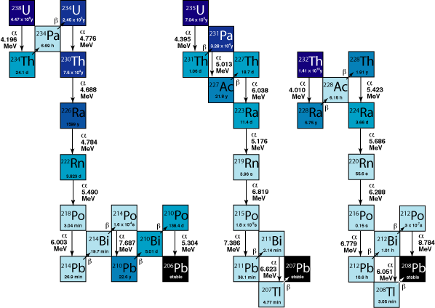

*(*[*http://markusphotoblog.blogspot.com/2010/04/roman-lead-for-neutrino-physics.html*](http://markusphotoblog.blogspot.com/2010/04/roman-lead-for-neutrino-physics.html)*)*

(The citation above is for a blog containing this table; the editor can’t find the original source of this table.)

The other major source of terrestrial naturally-occurring radioactive material is potassium-40 (K-40). The long half-life of K-40 (1.25 billion years) means that it still exists in measurable quantities today. It beta decays, mostly to calcium-40, and forms 0.012% of natural potassium which is otherwise made up of stable K-39 and K-41. Potassium is the seventh most abundant element in the Earth’s crust; hence, there is a lot of K-40 there slowly decaying.

Potassium-40 decays into two different daughter isotopes, as follows:

${}_{19}^{40}{ K+ {}_{-1}^{0}{ e} → {}_{18}^{40}{ Ar} }$ and ${}_{19}^{40}{K→ {}_{20}^{40}{Ca + {}_{-1}^{0}{ e}} }$

Electron capture Beta decay

These two decay processes are shown in more detail in the diagrams below. At left is information regarding the two processes and their relative amounts; the right diagram shows the energy emitted when K-40 decays to Ar-40. The K-40 nucleus emits a large amount of energy (gamma radiation [**γ**]) as it decays to Ar-40. The K-40 to Ca-40 decay process is a β-emission, with much less energy emitted. This **γ-**emission from K-40 to Ar-40 is useful in determining when the K-40 isotope actually disintegrates into Ar-40.

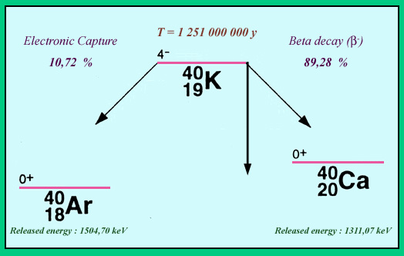 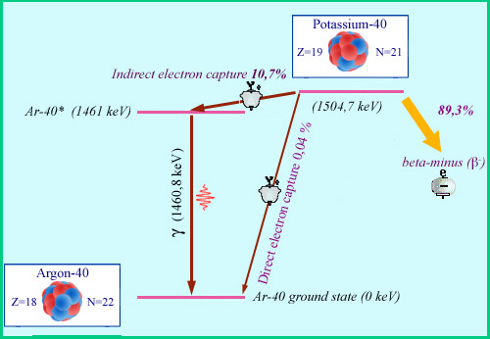

*(*[*http://www.radioactivity.eu.com/en/site/pages/Potassium\_40.htm*](http://www.radioactivity.eu.com/en/site/pages/Potassium_40.htm)*)*

**More on natural geothermal (hydrothermal) systems**

The western part of the United States contains a vast region of hydrothermal vents and features, including The Geysers, Lassen National Volcanic Park, Yellowstone National Park, etc. These areas are locations where volcanic activity is prevalent, providing hot water heated by underground magma.

Although temperatures in these [magma-heated underground chambers] reach 300 °C or more, the water does not vaporize but remains liquid because it is under great pressure from the rocks and water lying above. (Note that under high pressures, the boiling temperature of water changes. For example, water at twice the atmospheric pressure boils at 121 °C—instead of 100 °C—and water at 10 times the atmospheric pressure boils at 180 °C!) The superheated water pushes its way up through openings, and, as the water rises, the pressure is reduced and the water begins to boil.

If the pressure decreases rapidly, the boiling water is released as steam, triggering a geyser eruption. But if the pressure is released more slowly or the opening on the surface is wide, the water bubbles to the surface into a pool of hot water, creating a hot spring (Fig. 1). The underground plumbing system for geysers is different from that of hot springs. In the case of a hot spring, the plumbing system is usually open enough to allow water to flow freely to the top (Fig. 1).

In a geyser, the plumbing system contains at least one narrowing, usually close to the surface. Water above the narrowing acts like a lid, helping to maintain the pressure on the boiling water below. So, when the geyser erupts, it blows off this lid and shoots upward, its size being determined by the width of the narrowing. The narrower the constriction, the higher the plume of steam. After a geyser erupts, the underground chamber is emptied, so surrounding cooler water starts moving downward to replace the erupted water, and the cycle of water accumulating underground and erupting begins again. The entire trip from the surface and back probably takes at least 500 years. The water erupting today fell as rain or snow about the time that Christopher Columbus was exploring the New World!

(Ruth, C. Letting off Steam. *ChemMatters,* 2009, *27* (2), pp 4–7)

**More on locations of geothermal resources**

The Eboch article mentions that The Geysers in California was the site of one of the first U.S. geothermal power plant. Most geothermal activity in the U.S. is located in the western part of the country, hence it is logical that most geothermal power plants—present or future—would be located there. The map below shows where the geothermal systems are located in the U.S.

*(*[*http://www.nrel.gov/gis/images/geothermal\_resource2009-final.jpg*](http://www.nrel.gov/gis/images/geothermal_resource2009-final.jpg)*)*

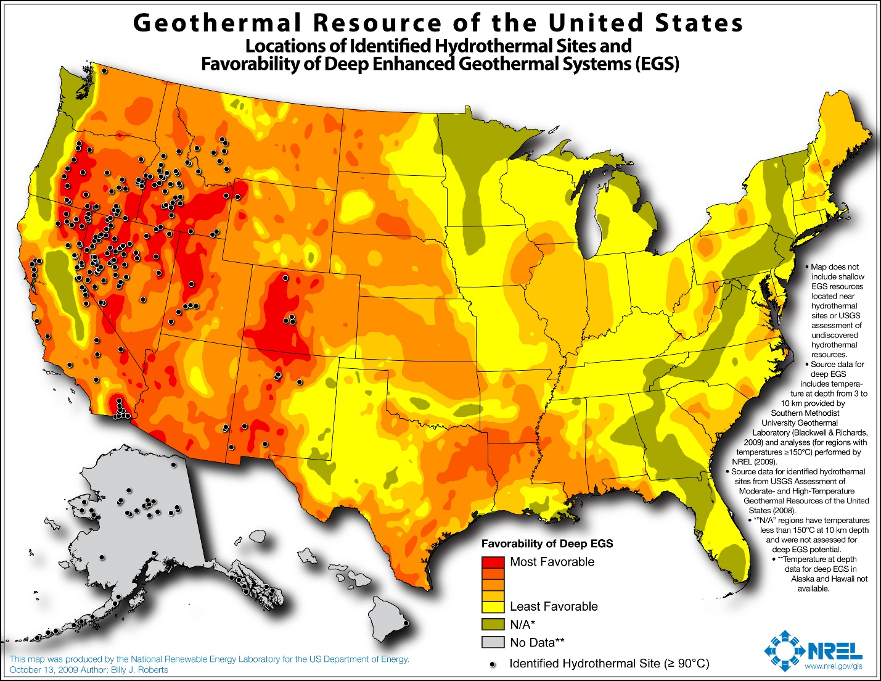

This map shows why the west is the logical place to site geothermal power plants (high underground temperatures at depth), and why the eastern half of the U.S.—if it is ever to have geothermal energy as a significant power source for plants generating electricity—will probably need to employ binary cycle systems, that use another, lower-boiling point liquid to act as the heat exchanger, rather than water. This minimizes the temperature differential needed between heat source and heat sink.



*(“Geothermal—The Energy Underneath Our Feet”, 2006, National Renewable Energy Laboratory;* [*http://www1.eere.energy.gov/geothermal/pdfs/40665.pdf*](http://www1.eere.energy.gov/geothermal/pdfs/40665.pdf)*)*

To avoid the inference that the United States is the only country using and developing geothermal energy sources to produce electricity, the pie chart below shows the relative amounts of electricity that individual countries produce using geothermal energy.

***Source:*** *Marin Katusa, Chief Investment Strategist, Casey Research Group, 2009;   
Wired.com,* [*http://www.wired.com/2009/03/devworldgreen/*](http://www.wired.com/2009/03/devworldgreen/)*)*

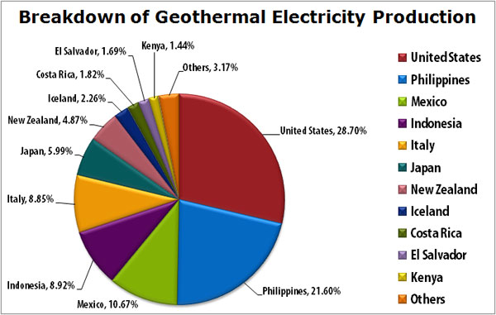

As with real estate, on a global basis, the key to geothermal sources of energy is “location, location, location”.

An important issue in creating geothermal power plants is finding areas that have practical access to underground heat supplies, such as where the earth’s tectonic plates meet and provide large amounts of heat close to the surface (see below image).

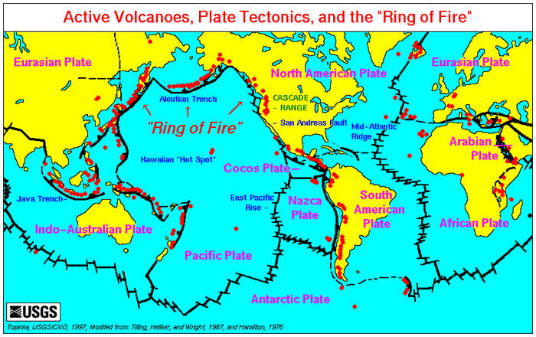

Geothermal electric plants have until recently been built exclusively on the edges of tectonic plates where high temperature geothermal resources are available near the surface. The development of [binary cycle power plants](http://en.wikipedia.org/wiki/Binary_cycle_power_plant) and improvements in drilling and extraction technology may enable [enhanced geothermal systems](http://en.wikipedia.org/wiki/Enhanced_geothermal_systems) over a much greater geographical range.

(EnergyGroove.net; <http://www.energygroove.net/technologies/geothermal-energy/>)

**More on superheated water**

Iceland is a prime example of a country that utilizes geothermal energy. It has a large supply of geothermal, coming from hot springs that are heated by underground volcanic magma. It uses this geothermal energy primarily for home and commercial heating by piping the hot water throughout its cities, but it proposes to develop more electrical generating power from geothermal energy (and from water power from rivers and waterfalls, which are fed by glaciers), so that it can use the electricity to electrolyze water. This will provide hydrogen gas, which it plans to use as a fuel to power its cars and buses—and boats for its fishing industry. The country has already transformed most of its commercial urban bus fleet to burn hydrogen.

It desperately needs this fuel as it has almost no coal, oil or natural gas deposits of its own and imports petroleum for fuel. And if the electrolysis process succeeds large-scale, Iceland may wind up exporting hydrogen to other countries, thus becoming an energy exporter, rather than an energy importer.

As mentioned in the article, the hot, trapped water at great depths underground reaches temperatures that far exceed its *normal* boiling point of 100 oC  
(at 1 atmosphere pressure). This is because the boiling point of water varies with pressure; the greater the pressure, the greater the temperature. The graph at right illustrates this phenomenon.

*(*[*http://www.delvin.co.nz/CatOnLine/Pix/Steam%20pressure-Temperature.gif*](http://www.delvin.co.nz/CatOnLine/Pix/Steam%20pressure-Temperature.gif)*)*

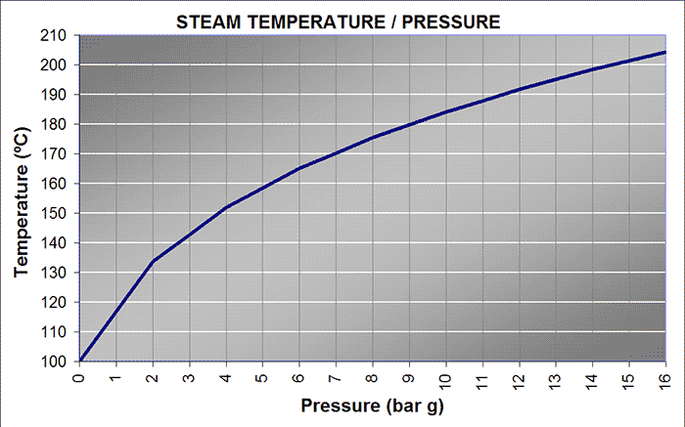

Scientists and engineers have known and made good use of this relationship by heating water under greater-than-atmospheric pressures in order to get it to higher temperatures. This superheated water contains more thermal energy than the same amount of water at 100 oC, so it can do more work. Steam plants that use superheated water can be more efficient than a plant using water at normal atmospheric pressure because, when the pressure is released from the superheated water, the water will “flash” boil, releasing its heat of vaporization and then, with the water still above   
100 oC, it still contains more heat than water that boiled at 100 oC, so it has a larger heat differential and can do still more work.

That’s why some engineering firms provide online calculators that show the “saturation temperature” (boiling temperature), as well as numerous other properties of water and steam, at selected pressures (and vice versa, pressure at selected saturation temperatures). Here’s one link, for example: <http://www2.spiraxsarco.com/esc/SS_Properties.aspx?lang_id=ENG&country_id=US>. Information for the table below was taken from this link:

|  |  |  |  |
| --- | --- | --- | --- |
| **Property** | **At Pressure of 1.0 atm  (101.3 kPa)** | **At Pressure of  2.0 atm (202.6 kPa)** | **At Pressure of  3.0 atm  (303.9 kPa)** |
| Saturation Temperature (Boiling Point) (oC) | 100.0 | 120.7 | 134.0 |
| Specific Enthalpy of Water  (kJ/kg) | 419.1 | 506.6 | 563.6 |
| Specific Enthalpy of Evaporation  (kJ/kg) | 2256.7 | 2200.6 | 2162.4 |
| Specific Enthalpy of Steam (kJ/kg) | 2675.8 | 2707.2 | 2725.9 |

This table shows that water’s enthalpy increases with temperature, as does that of steam. Both of these will increase the energy content of superheated water when it goes through a steam power plant.

Water that has been heated under pressure beyond its normal boiling temperature is stable as long as it remains under pressure, but if the pressure is reduced or released entirely (back to 1 atmosphere), the water will flash boil. This means that steam will form as bubbles and rapidly escape from the superhot liquid water. This is essentially what happens in geysers and fumaroles, when water from deep underground near magma has become superheated and rises through fissures in the rock. As it approaches the surface, the superheated water flash boils, pushing lots of very hot water with it and ahead of it as it erupts from the ground into a geyser.

The effect of flash boiling is similar in effect, but not in origin or cause, to what happens when you open a soda can that’s been shaken up. The soda contains lots of carbon dioxide that was injected into the liquid under pressure. Shaking the can moves some of the carbon dioxide gas that was at the top of the can into the soda, where tiny bubbles lodge. When the tab on the soda can is pulled, those bubbles erupt from the can, taking liquid soda with them, just as the geyser spews both gas (steam) and liquid (water). Again, effect (spewing gas and liquid) is the same, not cause (boiling of superheated water due to release of pressure for geysers, release of supersaturated gas in the solution once pressure is released by opening the can for sodas).

**More on types of geothermal power plants**

There are three main types of geothermal power plants in operation. Dry Steam is the simplest and oldest type of geothermal plant; Flash Steam is the most common type in operation; and the Binary Cycle plant is the latest version.

**Dry Steam**

The dry steam power plant design makes direct use of geothermal steam at 150°C or more. Cold water is pumped down the injection well deep into the earth. As the water meets hot rocks it turns to steam which is then extracted through the production well. This steam will then be fed directly to a steam turbine which will rotate a generator to produce electricity. The main problem with this design is that you must not pump too much cold water into the earth as this could cool the rocks too much resulting in the geothermal hot spot becoming depleted.

**Flash Steam Geothermal Power Plants**

The flash steam power plant design works in a similar way to that of a dry steam power plant only steam isn’t extracted through the production well. Instead, high pressure water that has been superheated to at least 180°C is extracted from deep within the earth through the production well. As the liquid flows toward the surface, the pressure decreases which causes some of the fluid in the well to separate or “flash” into steam. Once at the surface, the liquid is fed through a variety of systems that further reduce its pressure. This allows more of the fluid to “flash” into high-pressure steam which can then be fed into the steam turbine to produce electricity.

In modern flash steam power plants, any remaining liquid can be returned to the reservoir deep beneath the earth’s surface through the injection well. In addition, the steam that is used by the turbine can be passed through a condenser turning it back to a liquid which can then also be returned to the reservoir. All this careful management helps to reduce the possibility that a geothermal hotspot becomes depleted.

**Binary Cycle Geothermal Power Plants**

The binary cycle power plant design works in a similar way to that of the flash steam power plant although it can make use of water with a temperature as low as 57°C. It does this by passing the water by a secondary fluid that has a much lower boiling point than water. This process causes the secondary fluid to flash into steam and the steam is then fed to the turbine to produce electricity.

(<http://www.clean-energy-ideas.com/geothermal/geothermal-power/geothermal-power-plant>)

**More on enhanced geothermal systems**

The Eboch article says three things are needed for geothermal systems: a heat source, permeability, and water. If we interpret the term “requirements” as being those needs supplied by nature, it turns out that the statement is not quite true. Research done since the 1970s by the U.S. Department of Energy (DOE) and the geothermal industry has shown that the only true requirement of nature is the heat source; science and technology can do the rest.

**Hot Dry Rock (HDR) geothermal systems**

After the power plants that were built using steam from geysers and other volcanic structures, the DOE began research on extracting heat from deeper underground, at depths between 9,000 and 12,000 feet—extracting heat that did not come from already-existing reservoirs of superheated water. These projects used injection wells to inject high-pressure water (and other materials) into bedrock to lubricate existing rock fractures so that they slide and open, or to create new pores or fissures in the rock—in effect, hydraulic fracturing, very similar to the “fracking” done today to extract natural gas or to glean more oil from already-existing oil wells. The fluids used to fracture the rock resided in these fractures or pores temporarily, gaining heat from the rock at those depths. Then another well, the production well, was dug to retrieve those fluids that had been injected into the rock, fluids which were now, themselves, super-heated. This liquid, mostly water, became the heat source for new geothermal power plants. When the plants extracted the available heat from the fluid, it was re-injected back into the injection well to be reheated in the next cycle, thus providing a closed-loop energy system.

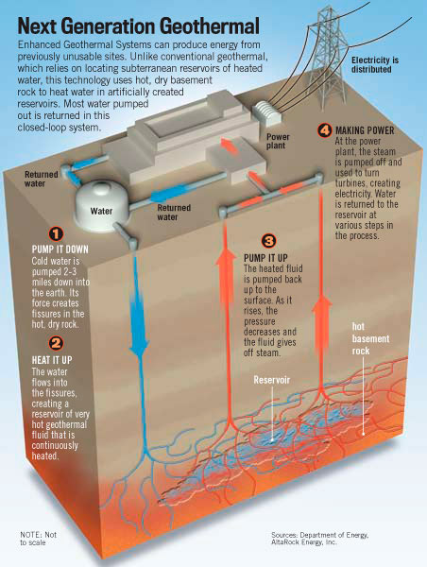

*(*[*http://altarockenergy.com/wp-content/uploads/2013/06/misc\_1.jpg*](http://altarockenergy.com/wp-content/uploads/2013/06/misc_1.jpg)*)*

Notice that this heat source—from deep within the earth’s crust—is NOT the same as the surface sources found only in *hydro*thermal systems—those using existing hot water close to the surface as, for instance, in The Geysers. That type, the *hydro*thermal system, is very limited geographically; very few of these geological features exist on Earth, so developing these types of systems will never become widespread, and therefore there is little commercial impetus to continue research in those systems.

Instead, the type of system being researched by the DOE, then called the Hot Dry Rock system, could theoretically be developed practically anywhere on Earth, since temperatures a few thousand feet underground are relatively the same around the planet. Thus the success of such a system could result in dramatic changes in the way electricity is generated globally. This means that there is much greater industry support (and funding) for research into this method of extracting heat from the earth.

**Hot Dry Rock**

The US DOE completed the first ever Hot Dry Rock (HDR) project at Fenton Hill, New Mexico in the 1970s and 80s. Scientists developed and flow-tested two separate fully engineered HDR reservoirs between 1974 and 1995. These reservoirs are unique in that they were totally confined, with only very small levels of water loss (5-10 gal/min) at their pressurized boundaries. Over the years, these two reservoirs demonstrated electricity generation from hot dry rock with associated and expected microseismicity, having magnitude < 1 on the Richter Scale.

These two test wells extracted hot water sufficient to drive turbines to generate electricity. The development and operation of the Fenton Hill reservoirs and power plants were not without their problems, but the projects proved the concept of the hot dry well as a source of hot water for electricity generation almost anywhere in the world. The problems eventually led to the shutdown of these wells, but the study proved invaluable in obtaining information that would be used to enhance technology in later deep well production of geothermal energy.

For very thorough coverage of the two Fenton Hill reservoir research projects, visit this site from OpenEI.org: <http://en.openei.org/wiki/Fenton_Hill_HDR_Geothermal_Area#Fenton_Hill_HDR_Timeline>.

**Enhanced Geothermal Systems (EGS)**

After the limited success with the hot rock geothermal system at Fenton Hill, New Mexico, the DOE decided to suspend their support of that project. Due to the enormity of the heat source potentially available from geothermal energy, they did, however, realize the importance of continued research in geothermal energy. This time they invited industry to work with them in their research.

The methods employed in the new research still involved tapping deep-earth heat, but they chose this time to call all their research efforts in this area as “enhanced geothermal” research.

According to the Office of Energy Efficiency & Renewable Energy (EERE) of the U.S. DOE, their research on enhanced geothermal systems, done jointly with cooperating interested industries, realized the following accomplishment: “[EGS [p]rovided impetus and funding to the industry for collaborative feasibility studies to evaluate EGS as an energy source and to develop improved technologies for its use.”

The significance of that accomplishment is as follows:

A significant portion of worldwide energy demand would be met by EGS if technology could be improved to allow its widespread development.

Existing hydrothermal resources could potentially be extended by using EGS technology to utilize heat in low permeability rocks on the margins of fields.

EGS development could eventually allow geothermal utilization in areas where the thermal gradient is much lower than it is in known hydrothermal areas.

And the industries involved in the research also reaped some rewards:

A new energy industry would be the result of successful EGS technology.

Current geothermal power producers would be able to turn some unproductive wells into injection or production wells.

(<http://energy.gov/sites/prod/files/2014/02/f7/geothermal_history_3_engineering.pdf>, p 6)

**More on environmental concerns for geothermal power plants**

But geothermal is not without its risks. Several enhanced geothermal power plants have been shut down, or at least paused, due to concerns about earthquakes generated by the hydrofracturing of underground rock. The December 14, 2009 issue of *Popular Science* reports that two major geothermal projects, one in Switzerland and one in The Geysers in California, were shut down due to induced earthquakes. The Swiss project is reported to have been closed down after the area experienced more than 3500 after-quakes following a 3.4-magnitude quake that occurred in December 2006. (<http://www.popsci.com/technology/article/2009-12/two-major-geothermal-projects-terminated-amid-quake-risk-questions>) References in reports of seismic activity in The Geysers found online usually mention “micro-earthquakes”. (e.g., [www.osti.gov/servlets/purl/1048267/](http://www.osti.gov/servlets/purl/1048267/))

The New York Times published a lengthy article on June 23, 2009 titled, “Deep in Bedrock, Clean Energy and Quake Fears”, about both the Basel, Switzerland earthquake and the AltaRock Energy project in The Geysers region of California. Author James Glanz discusses the similarities between the methods used by both companies to obtain the heat from the earth. He also discusses the process of using high-pressure water to fracture rock deep down in the earth, and what the effects might be.

This information comes from the California Public Utilities Commission, 1999, in an environmental review done for the divestiture of four electrical generating companies by Pacific Gas & Electric, to come into compliance with a new state energy law:

The northern portion of the Geysers area (Unocal lease area) is extremely active seismically with earthquakes of relatively small magnitude (see [Figure 4.3-2](http://www.cpuc.ca.gov/Environment/info/esa/divest-pge-two/eir/figures/fig_4_3-2.gif)). Earthquakes occur at apparently random intervals rather than in related groups or swarms and generally have epicenters less than 20,000 feet deep. Seismic monitoring has demonstrated that the rate of earthquake occurrence increased as steam development increased from the 1960s to 1970s. Studies have revealed a correspondence between production wells, episodes of water injection, and earthquakes. Both steam production and injection of water to restore production may induce seismic activity (Parsons, 1996).

Baseline seismicity at the Geysers, before geothermal development began, is not well documented. It appears that the currently high rate of seismicity in the vicinity of the Geysers Geothermal Area began in the early 1960s, shortly after initiation of commercial steam power generation. Studies of induced seismicity in the Geysers area began in 1971, and by 1972 regional seismographic monitoring capabilities were established. At this time, numerous small earthquakes with epicenters in the Geysers area began to be routinely reported. Since 1975, more than 20,000 earthquakes with magnitudes ranging from 0.7 to 3.0 (Richter magnitude) and about 300 larger earthquakes (magnitudes ranging from 3.0 to 4.6) have been reported to originate at the Geysers.

(<http://www.cpuc.ca.gov/Environment/info/esa/divest-pge-two/eir/chapters/04-03geo.htm>)

**More on other generating plants that use heat exchange technology**

Although the focus in most of this Teacher’s Guide is on the source of energy to generate electricity, another facet of the process is the heat exchange technology. It might be interesting to note that nuclear reactors use heat exchange technology very similar to that used in geothermal power plants (or almost all electric power plants). There are two main types of nuclear reactors, boiling water reactors (BWRs) and pressurized water reactors (PWRs).

The design of boiling water reactors is simpler than that of pressurized water reactors. In boiling water reactors, water is circulated in a closed loop around the reactor core (where fission occurs). Refer to the diagram at right. Steam is produced in the reactor and is piped outside the reactor building to a turbine, which is used to produce alternating current for use in factories, offices and homes. The steam is cooled by water circulating in a second, separate loop from a nearby river, lake or ocean, and the resulting water is cycled back to the reactor core where it absorbs heat produced by the nuclear reaction. The tall cooling towers that most people associate with nuclear power plants serve to remove waste heat from the river water in the second loop so that the water can be sent back into the river without causing thermal pollution of the river. The water that flows through the reactor is under a pressure of about 7100 kPa (70 atm). This water is also radioactive. Boiling water reactors have an operating efficiency of about 30%.

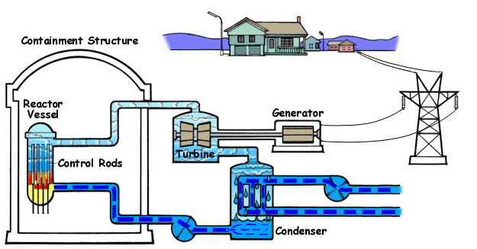

*Boiling Water Reactor,* *Nuclear Regulatory Commission*

*(*[*http://www.nrc.gov/reading-rm/basic-ref/students/animated-bwr.html*](http://www.nrc.gov/reading-rm/basic-ref/students/animated-bwr.html)*)*

Pressurized water reactors have three cooling loops (see diagram below). The first loop is similar to the one in boiling water reactors—water circulates around the fuel rods in the reactor core. The water in this loop is under a pressure of about 15,500 kPa (153 atm) and so does not boil—hence, pressurized water. This superheated (and radioactive) water flows into a heat exchanger where its heat is transferred to a second loop of water which is converted to steam to drive the turbine. As the steam is cooled it is condensed back to water by the external loop of water from an outside source (river, etc.) and cycled back, not to the reactor, but to the heat exchanger. Pressurized water reactors operate at a higher efficiency (about 32%) but are more costly to build. They are, however, considered safer.

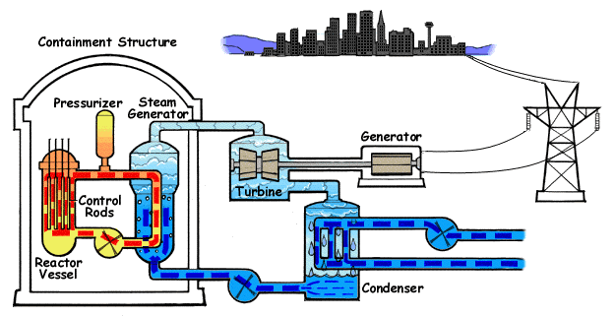

*Pressurized Water Reactor, Nuclear Regulatory Commission*

*(*[*http://www.nrc.gov/reading-rm/basic-ref/students/animated-pwr.html*](http://www.nrc.gov/reading-rm/basic-ref/students/animated-pwr.html)*)*

(April 2010 *ChemMatters* Teacher’s Guide, pp 67– 68, to accompany the *ChemMatters* article: Shearer. D. Nuclear Reactors: A Safe and Clean Source of Energy? *ChemMatters*, 2010, *28*, 2, pp 16–17)

**More on the laws of thermodynamics**

The common interpretation of the first law of thermodynamics is that energy cannot be created or destroyed. It actually says that, the total energy in an isolated system is constant; energy can change form, but it cannot be created or destroyed. Another way of saying this is that the change in internal energy of the closed system equals the amount of heat supplied to the system by the surroundings, minus the amount of work done by the system on its surroundings.

ΔU = q - w

where ΔU = change in internal energy,

q = heat added *to* the system from the surroundings, and

w = work done *by* the system on the surroundings

[Note: you probably learned this equation as ΔU = q + w. This is the equation preferred by IUPAC. The difference is in the interpretation of work. Physicists typically deal with work done *by* the system *on* its surroundings (making it –w), while typically in chemistry, positive work is work done *on* the system *by* its surroundings (making it – (–w), double-negative, or +w.]

The second law of thermodynamics states that the entropy of a system and its surroundings will always increase. The definition of entropy has been a stumbling block to a deeper understanding of the second law for years. Here’s another way to define the second law that includes a definition of entropy: “Energy of all types changes from being localized to becoming dispersed or spread out, if it is not hindered from doing so. Entropy change is the quantitative measure of that kind of a spontaneous process: how much energy has flowed or how widely it has become spread out at a specific temperature." (<http://www.entropysite.com/entropy_isnot_disorder.html>; note, the link does not connect)

Professor Emeritus Frank Lambert, of Occidental College, was a pioneer in changing the views of other chemists and chemistry textbook authors, to redefine entropy, from the disorder of particles in a system and its surroundings to the dispersal/distribution of energy in that system and its surroundings. He describes entropy this way: “Entropy measures the spontaneous dispersal of energy: how *much* energy is spread out in a process, or how *widely* spread out it becomes—at a specific temperature.” The article by Dr. Lambert, “Entropy is simple—If We Avoid the Briar Patches!” (<http://entropysimple.oxy.edu/content.htm#top>), provides teachers with a detailed discussion of the newer understanding of entropy, as a form of energy distribution/dispersal, rather than disorder of particles.

Professor Steve Lower’s (Simon Fraser University) online textbook *chem 1 virtual textbook*, at <http://www.chem1.com/acad/webtext/thermeq/TE1.html>, provides a detailed discussion of thermodynamics and the first and second laws of thermodynamics, geared to college students. He also uses the newer energy dissemination version of entropy.

**The Carnot cycle**

The Carnot cycle provides an absolute upper limit on the efficiency of any thermodynamic cycle. If a cycle proceeds clockwise around the Carnot cycle shown below, taken from Wikipedia, it is acting as a heat engine that produces useful work, removing heat from a warmer source, doing useful work, and delivering waste heat to a cooler heat sink. This is sometimes referred to as a *power cycle*. If, on the other hand, the cycle operates with the addition of energy from an outside source, it will cycle counterclockwise around the cycle below. This reversed Carnot cycle is sometimes referred to as a *heat pump and refrigerator cycle*. The heat pump represents one such reversed-Carnot cycle, where outside energy is used to do work on the system, allowing the system (the heat pump) to take heat from the lower temperature heat source and transfer it to the higher temperature heat sink.

Wikipedia provides this discussion of the Carnot cycle:

The Carnot cycle when acting as a heat engine consists of the following steps:

1. \Delta S=Q_1/T_1**Reversible** [**isothermal**](https://en.wikipedia.org/wiki/Isothermal) **expansion of the gas at the "hot" temperature, *T1* (isothermal heat addition or absorption).** During this step (1 to 2 on Figure 1, A to B in Figure 2) the gas is allowed to expand and it does work on the surroundings. The temperature of the gas does not change during the process, and thus the expansion is isothermal. The gas expansion is propelled by absorption of heat energy Q1 and of entropy from the high temperature reservoir.
2. [**Isentropic**](https://en.wikipedia.org/wiki/Isentropic_process) **(**[**reversible adiabatic**](https://en.wikipedia.org/wiki/Reversible_adiabatic_process)**) expansion of the gas (isentropic work output).** For this step (2 to 3 on Figure 1, B to C in Figure 2) the mechanisms of the engine are assumed to be thermally insulated, thus they neither gain nor lose heat. The gas continues to expand, doing work on the surroundings, and losing an equivalent amount of internal energy. The gas expansion causes it to cool to the "cold" temperature, *T2*. The entropy remains unchanged.
3. \Delta S=Q_2/T_2**Reversible isothermal compression of the gas at the "cold" temperature, *T2*. (isothermal heat rejection)** (3 to 4 on Figure 1, C to D on Figure 2) Now the surroundings do work on the gas, causing an amount of heat energy Q2 and of entropy   
   to flow out of the gas to the low temperature reservoir. (This is the same amount of entropy absorbed in step 1, as can be seen from the [**Clausius inequality**](https://en.wikipedia.org/wiki/Clausius_inequality).)
4. **Isentropic compression of the gas (isentropic work input).** (4 to 1 on Figure 1, D to A on Figure 2) Once again the mechanisms of the engine are assumed to be thermally insulated. During this step, the surroundings do work on the gas, increasing its internal energy and compressing it, causing the temperature to rise to *T1*. The entropy remains unchanged. At this point the gas is in the same state as at the start of step 1.

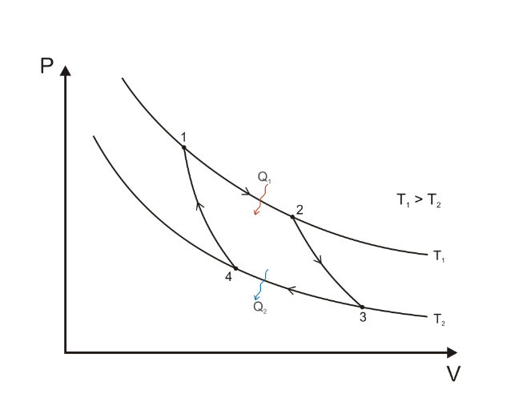[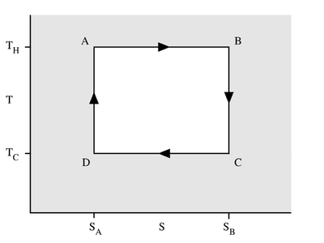](https://en.wikipedia.org/wiki/File:CarnotCycle1.png)

*Figure 2: A Carnot cycle acting as a heat engine, illustrated on a temperature-entropy diagram. The cycle takes place between a hot reservoir at temperature TH and a cold reservoir at temperature TC. The vertical axis is temperature, the horizontal axis is entropy.*

*Figure 1: A Carnot cycle illustrated on a* [*PV diagram*](https://en.wikipedia.org/wiki/PV_diagram) *to illustrate the work done.*

(<https://en.wikipedia.org/wiki/Carnot_cycle>)

**More on Gay-Lussac’s law (Amontons’ law, actually) related to the heat pump**

Your students may wonder, “Why does compressing a gas increase its temperature?” (e.g., in the condenser of the heat pump, and the inverse effect in the evaporator)

When one compresses a gas, one does work on the system containing the gas molecules. That means that energy is transferred from the surroundings to the system, which will increase the kinetic energy of the molecules, resulting in their faster motion. Temperature represents the average kinetic energy of the molecules, so temperature will rise.

A demonstration you could do in your classes to show the relationship between temperature of a gas and its pressure is the old “egg-in-the-bottle” trick. One description of this relationship is “Gay-Lussac’s Law”, which can be stated as: “The pressure of a given volume of gas increases when its temperature increases.” In the demonstration, on a molecular level, we can visualize gas molecules both inside and outside of the bottle, before it is sealed with the hard-boiled egg. The molecules travel around, colliding with other gas molecules, with the sides of the bottle, and any other objects around them. The molecules of air inside and outside the bottle are moving (collectively) at the same average speed.

Once the burning slip of paper is dropped into the bottle and the mouth of the bottle sealed with the peeled egg (you push it in snugly), the volume of the gas in the bottle is now a constant, as long as the bottle remains sealed with the egg. The energy from the burning paper increases the temperature of the gas molecules trapped inside the bottle. Those molecules now have increased kinetic energy, which causes them to move faster, resulting in more collisions both between molecules and with the sides of the container. This increases the pressure in the container. This increase pushes up the bottom of the egg and opens the bottle slightly, allowing some of the gas molecules to escape. This equalizes the pressure inside and outside the bottle. The egg drops back down into the mouth of the bottle, once again sealing it from the outside air.

After the flame is extinguished within the now re-sealed bottle, the temperature of the gas molecules in the bottle decreases, slowing their travel and decreasing the number of their collisions with each other and the sides of the bottle. This results in a decreased pressure within the bottle. The pressure outside of the bottle is now higher than the pressure of the gas molecules inside of the bottle, which allows the egg to be pushed all the way into the bottle.

The term “Gay-Lussac’s Law” brings up a historical point that may be interesting to share with students. Guillaume Amontons is rarely mentioned in connection with the law, although he was the one to first discover the described relationship between pressure and temperature in 1699. The *Physics Hypertextbook* (<http://physics.info/gas-laws/>) states “The experiment was repeated later by Jacques Alexander Cèsare Charles (1746-1823) in 1787 and much, much later by Joseph Louis Gay-Lussac (1778-1850) in 1802. Charles did not publish his findings, but Gay-Lussac did. It is most frequently called Charles’ law in the British sphere of influence and Gay-Lussac’s law in the French, but never Amonton’s law.”

Oct 2010 CM TG

An apparatus that more closely demonstrates the relationship between pressure and temperature (and not the other way around) is the fire syringe. This apparatus consists of a clear cylinder, closed at one end, and tight-fitting piston. A small bit of cotton or frayed paper is placed in the bottom of the cylinder, the piston inserted at the top, and very rapidly pushed to the bottom of the cylinder. The piston compresses the air in the cylinder to such an extent that its temperature rises to a sufficient temperature to actually ignite the cloth or paper. This is analogous to what happens in the compressor of the heat pump.

**More on heat pumps**

A heat pump is a device that takes heat from one place and transfers that heat to another destination. In that respect, it works much like a refrigerator. Both heat pumps and refrigerators are considered to be “heat engines”—they operate to move heat from a cooler area (the heat source) to a warmer area (the heat “sink”). This transfer of energy from a cooler place to a warmer place runs counter to the second Law of Thermodynamics, which basically says that heat ALWAYS flows from a warmer location to a cooler location—spontaneous heat flow from warmer to cooler. So, in order to run the system “backwards”, both heat pumps and refrigerators must do work (in the physics sense) and expend energy. If they are running efficiently, they will extract more energy than they expend.

It may seem counter-intuitive that a heat pump can extract heat from a cooler source, like soil and rock at a temperature of 55 oF (13 oC) to heat a house to 75 oF (24 oC), but that’s exactly what a heat pump does. Likewise, a refrigerator takes heat from inside the refrigerator at a temperature of 40 oF (4 oC) and expels it into the kitchen at a temperature of, perhaps, 75 oF. It’s important to note that, while the rock is at a lower temperature than the house, it still has heat; 13 oC is NOT absolute zero (-273 oC)! That means its heat is still available to heat something else. The heat pump extracts that heat and sends it into the house.

It is the heat exchange mechanism, as described in the article, which actually makes the extraction of heat possible. The heat exchangers consist of the evaporator and the condenser, connected by the reversing valve and the expansion valve, all of which make the heat pump work. The heat pump uses a fluid (the refrigerant) with a low boiling temperature that can change phases with little temperature differential (the heat pump itself is more efficient if there is a small temperature differential between the heat source and the heat sink).

In the evaporator, the liquid refrigerant is cooled and extracts heat from another liquid, flowing through the underground pipes. This heat increases the temperature of the refrigerant which, having a low boiling point, begins to boil, absorbing even more heat as it changes phase (heat of vaporization). The heated gas then goes through the reversing valve to a compressor, which increases its pressure, causing another temperature rise. Now it flows to the condenser, where it cools, lowering its temperature and releasing heat, until it condenses. And as it condenses, it releases even more heat—its heat of vaporization. The released heat from all three processes (cooling, depressurizing and condensing) is transferred either directly to air that circulates in the home, or to a radiator with liquid in that heats the home. Once the cooled refrigerant has condensed, it is returned to the evaporator to begin the cycle anew.

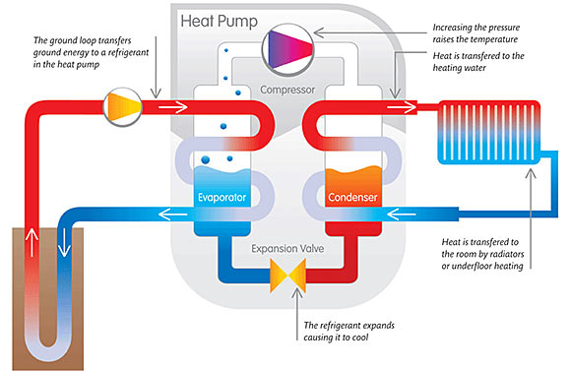

*(*[*http://www.energygroove.net/technologies/heat-pumps/*](http://www.energygroove.net/technologies/heat-pumps/)*)*

The process for cooling in the summer reverses the flow in the heat pump. The reversing valve is simply turned 90o, allowing the refrigerant to flow in the opposite direction through the compressor. The cooling process begins by the warm air inside the building heating the refrigerant inside the condenser. This cools down the air, and this cool air is circulated throughout the building. The now-warmed refrigerant evaporates (boils, absorbing even more heat from the air) in the condenser, sending the gas through the (now-reversed) reversing valve. This sends the warmed gas into the compressor, where its temperature increases even more. The hot gas now flows through the evaporator (backwards) and is cooled by the relatively cooler liquid flowing through the external underground pipe loop. The heat picked up by the heat pump then transfers into the earth. The cooled refrigerant then re-enters the condenser to begin the cooling cycle again.

The type of heat pump described in the article is the geothermal heat pump. It extracts heat from the earth to heat a home and, with the system reversed, it dumps heat back into the earth to cool a home. This type of heat pump requires a liquid (the refrigerant) with a relatively low boiling point that, when it absorbs heat, can vaporize or boil. The now-vaporized liquid flows into a heat exchanger and cools and condenses, transferring that previously absorbed heat to another location to heat a home or business building. To cool the same home, the heat pump is reversed and uses the heat inside the home to boil the liquid. The gas then travels back through the heat exchanger, and cools and condenses, providing heat which is then transferred back into the earth.

That heat may be derived from anywhere from 10 feet to hundreds of feet underground. And it can come from rock and other solid matter, or from water, either in wells, or lakes or ponds.

The article only mentions one type of heat pump, the geothermal or ground-source heat pump. But there are other types of heat pumps:

* Solar
* Absorption
* Air-source
* Ground-source
* Water-source
* Dual or Hybrid

**Solar**

A solar heat pump is a bit of a misnomer, because it is still a normal heat pump. But the source of the energy to drive the compressor and other pumps is solar energy. This type of heat pump requires photovoltaic solar panels on the roof that convert the sun’s energy into electricity. Instead of taking (and paying for) electricity off the power grid, you can use the solar-generated electricity to power the heat pump. But the heat pump is still a typical heat pump. And solar is only really useful as a stand-alone heat pump in areas where temperatures are warmer. It is not as effective in areas where temperatures go down to and below freezing for long periods.

**Absorption**

Absorption heat pumps are basically air-source heat pumps that use a heat source: burning a fuel, like natural gas or propane, or using solar-heated water or geothermal-heated water. Natural gas is the most common heat source. These are particularly useful where there is no access to electricity because they use alternate fuels, not electricity. They are usually used in commercial buildings, although improved technology has made them useful in larger homes.

Absorption heat pumps use an absorption cycle that utilizes as the refrigerant an ammonia and water solution. The system goes through the same cycle as other heat pumps. Outside air passes over the tubes containing the ammonia water refrigerant. Heat from the air causes the ammonia to boil out of the ammonia-water solution. This process absorbs the heat from the outside air. The ammonia is then pumped through the heat exchanger, where the heat from the ammonia gas transfers to the inside air, cooling the ammonia down until it condenses and dissolves back into the water to reform the ammonia-water solution. And the cycle continues.

To cool the building, the cycle is reversed. The ammonia-water solution is run through the building, absorbing heat from the inside air. The ammonia boils and carries the extra heat through the heat exchanger to the coils outside, where it transfers its heat to the outside air, condenses and dissolves, and the cycle is ready to start over.

The advantage of the ammonia-water system is that it doesn’t require high pressures to compress the gas because the gas dissolves in the water. So a low-power pump can be used, reducing energy requirements and cost of operation.

**Air-Source**

Air-source heat pumps are much more prevalent than geothermal or ground-source systems. This is because they don’t require any excavation to lay down underground pipes and are therefore much less costly to install. They are much simpler in concept and much simpler to operate.

Air-source heat pumps use an outdoor fan to pass outside air over coils filled with a refrigerant. The refrigerant in the evaporator absorbs the heat from the air (even if it is cold air). This causes the fluid to boil. The gas then moves to the compressor and is compressed to an even higher temperature. Then the gaseous refrigerant goes to the heat exchanger where it gives up its energy to the inside air. A fan then blows this warmed air through the home to heat it.

When the refrigerant gives up its heat, it cools and condenses back to liquid and is returned to the outside evaporator coil to absorb heat from the outside air and begin the cycle again.

Despite their popularity, air-source heat pumps are limited because they use outside air as their heat source. When the temperature differential between inside and outside air becomes too great, heat pump efficiency (coefficient of performance, or COP) suffers. In really cold climates, supplemental heat sources, such as a small furnace may be needed to maintain comfortable temperatures. (See Hybrid below.)

Air-source heat pumps are also known as air-air or air-water heat pumps, depending on whether the home heating system is blown hot air (air flows and transfers heat throughout the building) or radiator (water flows and transfers the heat throughout the building).

**Ground-source**

Ground-source heat pumps use heat from the earth, but not the deep heat from magma. They use the heat of the ground, from 10 to 20 feet beneath the surface. The heat in the ground does not, however, come from sources within the earth; rather, it comes from latent heat the ground absorbed from the sun. These are still known as geothermal heat pumps because the heat is coming from the ground, but there is a distinction between this shallow-depth (solar-retained) heat and the deep-well heat generated from within the earth.

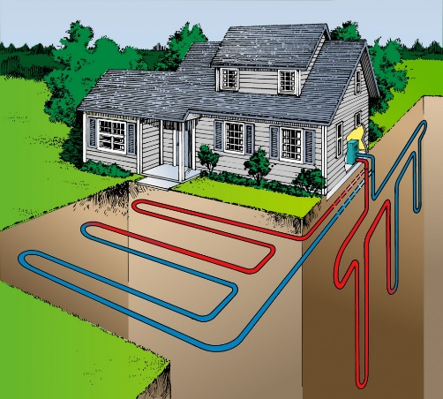

*pipe laid for a ground-source heat pump*

*(*[*http://geothermalinnovation.org/*](http://geothermalinnovation.org/)*)*

The actual source of heat could either be the solid ground itself, or it could be the water in an underground aquifer. Both work the same way, and both are considered “ground”-source systems.

The ground-source system requires pipes underground to absorb heat from or transfer heat to the earth, depending on whether the heat pump is heating or cooling, respectively. Trenches are dug and pipes are laid underground. These can be done horizontally or vertically, depending on how much land surface is available (see diagram at right). Of course, this makes the cost of the ground-source system greater than the air-source system because of the extra construction involved with installation; however, the efficiency rating of a ground-source system is also greater, so that operating costs are less for this type of heat pump than for the air-source system.

The ground-source heat pump itself runs exactly like air-source or geothermal heat pumps, with the typical compression-expansion cycle of a refrigerant.

**Water-source**

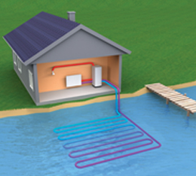

*pipe laid in a lake for a water-source heat pump*

*(*[*http://www.ag-energy.co.uk/products/water-source-heat-pumps*](http://www.ag-energy.co.uk/products/water-source-heat-pumps)*)*

A water-source heat pump works exactly the same as a ground-source heat pump, except that the heat source is an actual body of surface water, say, a lake or pond. Water in these bodies of water also maintain a relatively constant temperature at or near the bottom of the reservoir. Pipes are run from the heat pump evaporator (usually outside the building, except in the case of a single unit heat pump, right down to the bottom of the reservoir. There the liquid, in the pipes, usually a water and anti-freeze mixture, absorbs heat from the water and flows to the evaporator, where the refrigerant absorbs its heat. And begins the heat pump cycle.

**Hybrid**

The typical hybrid heat pump systems consist of a dual heating system—usually an air-source heat pump for mild temperatures, say, 40 oF and above, and a small fuel-based (non-renewable energy source) furnace that kicks in at lower outside air temperatures. The fuel is usually natural gas or propane but can be oil as well. The system also frequently has a dual speed fan so that, when the temperature is milder, the lower speed is sufficient to warm the building, but when colder weather hits, the higher speed fan keeps the temperatures comfortable. Efficiency in the system is optimized by switching back and forth between the two systems as needs warrant.

Yet another type of hybrid heat pump system consists of two different source heat pumps. For example, one hybrid system could include both an air-source and a ground-source heat pump, both in one system. This would be even more efficient than a hybrid system using either air-source or ground-source with a small furnace, because this dual system uses no non-renewable resources.

In all heat pump scenarios, regardless of the heat source, the heat extracted from the source can be used both for heating the home and for heating water in a hot water heater.

**Another classification scheme for heat pumps**

There is yet another way to classify heat pump systems, and that is by the piping involved in extraction of heat from the ground or water heat source.

**Closed-loop systems**

The illustrations above showing the piping for ground-source and water-source heat pumps both show what is known as closed-loop systems. These systems use the same liquid, usually water, to absorb heat from or radiate heat to the surroundings. These are closed systems, and the same liquid is used over and over through the external piping. Closed-loop systems are the most common type of heat pump system.

**Open-loop systems**

Another type of piping system is the open-loop system. This system only works for water-source heat pump systems. In this system, two wells in near proximity, tapping into the same aquifer, are usually involved. Pipe is laid into one well (the source well), through which water that is extracted flows to the heat exchanger. Once it has given up its heat, this water flows through another pipe into a second well (the disposal well), where it replenishes the aquifer. That water resides in the aquifer, warming and waiting for extraction through the source well. In this way, new water is constantly being used as the heat source. The open-loop system is encountered much less frequently than closed loop systems.

Other open-loop systems in lakes or ponds might simply use two different pipes at a distance from one another, one for extraction of water from the lake going to the heat pump, and another that expels the used water back into the lake.

# Connections to Chemistry Concepts

**(for correlation to course curriculum)**

1. **Thermodynamics**—The laws of thermodynamics control the workings and limitations of heat pumps and power plants.
2. **Phase changes**—Liquids must undergo phase changes in heat pumps and turbine-driven generators to extract heat from underground sources. Evaporation or boiling of the refrigerant requires energy and extracts heat from the source; while condensation produces energy and releases heat to the building.
3. **Gay-Lussac’s (Amonton’s) Law**—The relationship between temperature and pressure (or, rather, pressure and temperature) of a gas is evidenced in the compressor and evaporator in a heat pump.
4. **Boiling temperature affected by atmospheric pressure**—Water underground is heated way above its boiling temperature, but it cannot boil due to the pressure surrounding it. Thus it becomes superheated. But when it reaches the surface and atmospheric is greatly reduced, it flash boils.
5. **Potential and kinetic energy**—Changes in these energies occur in the transfer of energy from one source to another as in heat pumps, solar heating, and geoexchange of heat from the ground to a heat pump. Fluids like water and those used in pipes in heat pumps change phase in the process of removing heat from or adding heat to the earth, both for heating homes directly (heat pumps) and generating electricity (turbine-driven generators).
6. **Specific heat and heat capacity**—These properties of matter at least in part explain why the earth has maintained much of its primordial heat. They also help scientists and engineers to determine which fluids are best to use in heat transfer devices such as heat pumps.
7. **Alternative (“green”) energy sources**—Geothermal energy is a prime source of energy for future generations as it emits almost zero pollution.
8. **Radioactivity and nuclear decay**—Radioactive isotopes of specific elements underground undergoing spontaneous nuclear decay into stable isotopes of other elements are a major and ongoing heat source for geothermal energy.

# Possible Student Misconceptions

**(to aid teacher in addressing misconceptions)**

1. **“But if everybody uses all this geothermal energy to replace oil and coal, we’ll run out of that, too, just like those other fuels!”** *This is highly unlikely, unless the student is thinking of running out millions of years into the future. It’s really difficult to comprehend how large the earth is, or how much heat is stored—and being produced—underground. Earth is huge, and so are its heat reserves.*
2. **“Cold comes into the house from the outside in the winter time.”** *When dealing with the idea of energy transfer, students need to understand the basic laws of thermodynamics, that heat energy moves from an environment with a higher temperature to that of a lower temperature. Insulation does not act to keep out cold from a house in the winter, but rather it prevents heat transfer from the warmer house to the colder environment. Likewise, thermal transfer by some “heating” device such as a heat pump, in which outside air of 55 oF is to be used to heat a room at 65 oF would occur by the cooling of that outside air (to an even lower temperature) by the heat pump, giving up its heat to the room (refrigeration cycle, air conditioner with heat expelled). (October 2006 ChemMatters Teacher’s Guide)*
3. **“A heat pump can’t work to heat a house when it’s colder outside than it is inside.”**

*While the air temperature outside may be lower than the temperature inside, the heat that the geothermal heat pump extracts doesn’t come from the air outside, but from rock, soil and water 10 to a few hundred feet underground, which maintain an even 50–60 oF. While that temperature is cooler than the temperature inside the house, it is warmer than the liquid in the pipes passing through the rock. So, heat flows into the liquid and the heat pump extracts that heat and sends it into the house. Remember that a low temperature doesn’t mean no heat. There is still heat in a substance at low temperatures because its molecules are still moving. That heat can be extracted by the liquid in the heat pump pipes and moved to another area (e.g., inside the house) by the heat pump. Note that the colder it gets outside, the lower the efficiency of the heat pump. Eventually, if it gets too cold, it takes more energy (electricity) to drive the heat pump than is extracted from the ground to heat the home. This is why heat pumps in colder climates also contain a small burner/furnace to supplement the heat from the heat pump.*

1. **“Water *always* boils at 100 oC,” or “Water’s boiling point is 100 oC, *period*.”** *The boiling temperature of a liquid is determined by atmospheric pressure, meaning the pressure of the liquid’s surrounding gases. So, on the top of a mountain, where there is less overhead air and therefore a lower atmospheric pressure, the boiling point of water is lower (71 oC, 160 oF) than its “normal” boiling point (100 oC), and underground, where there is a much greater pressure, water will boil at a much higher temperature (e.g., 250 oC at 10 km, 480 oF at 8 mi. below ground). The temperature of 100 oC is water’s normal boiling point, at one atmosphere (101.3 kPa) pressure. Here the word “normal” means “standard” (IPUAC), not “typical”. See “In-Class Activities” section for ways to demonstrate this to students.*
2. **”Potential energy and kinetic energy are really the same thing.”** *Students need to understand the difference between potential energy and kinetic energy and their relationship to thermal energy and temperature. Phase changes in which temperature does not change but thermal energy is either absorbed or lost can be difficult to understand if students do not have a model for atomic/molecular behavior when a substance is undergoing a temperature change vs. a phase change.*

# Anticipating Student Questions

**(answers to questions students might ask in class)**

1. **“How can a heat pump use the cooler temperature of underground rock to heat a house to a warmer temperature?”** *See “Possible Student Misconceptions” #3 above.*
2. **“How is it possible for air at 35 oF, which is drawn into a heat pump outside a house, to heat the interior of the house that is at a temperature of 75 oF?”**

*The heat pump operates like a refrigerator or air conditioner. Since the air at a temperature of 35 oF has to contain some heat energy (because it’s not at absolute zero), it is a matter of removing some of that heat energy. This is done as in a refrigerator, which means that the refrigerator’s compressor mechanism that compresses a gas into a liquid causes heating due to both an increase in kinetic as well as a decrease in potential energy. When this pressurized liquid is allowed to expand in another part of the refrigerator or heat pump, the gas cools the environment because the change in physical state from liquid to gas requires thermal energy from the environment. The cooled gas circulates and heat from the 35 oF air moves to the cold gas.*

*When this gas returns to the compressor, the gas becomes a liquid, with subsequent heating again. But this time the heat energy is greater because of the addition of thermal energy from the air to the cold refrigerant gas. As the recycling of the refrigerant repeats itself, some of the heat of the hot liquid is transferred into the interior of the house (there is always heat loss from the hot liquid refrigerant through coils that are exposed to the house interior, as with a refrigerator).*

## In-Class Activities

**(lesson ideas, including labs & demonstrations)**

1. This 9:28 video clip from the University of Nottingham *Periodic Table of Videos* shows mountain climbers boiling water and measuring its temperature at various altitudes (noted) as they climb mountains in the Himalayas, right up to Mt. Everest: <https://www.youtube.com/watch?v=JTL4dj3Gx1o>. You could have students view the video, record the elevations and boiling points and graph the results and follow that with a discussion of the effects of *increased* pressure on boiling temperature.
2. There are several ways to demonstrate to students that water can boil at temperatures other than 100 oC, depending on its “atmospheric” pressure:
   1. A way to demonstrate the variation of boiling temperature with pressure in your classroom is to use a large syringe (without a needle), say 100-140 mL size. (Smaller syringes work, but they’re harder for students to see.) Heat water to about 80 oC in a beaker. Using the syringe, draw about 20 or so mL of the hot water into the syringe. Turn the syringe upright, open end up, and squeeze all the air out, as doctors do on television. Stopper the syringe (or you could just use your finger) and pull back on the piston. This increases the volume of space inside the syringe, thus decreasing “atmospheric” pressure (Boyle’s law). Lowering atmospheric pressure inside the syringe reduces the boiling temperature of water, and the water begins to boil inside the syringe. You can extrapolate this information to higher pressures, resulting in higher boiling temperatures. Relate this to superheated water in underground reservoirs. You might also want to discuss the underwater hydrothermal vents found in deep water areas around volcanic activity. The water in these vents is extremely hot (perhaps 400 oC as it erupts out of the holes in the ocean floor), yet it does not boil.
   2. This Flinn Scientific video clip (4:11) shows an experienced teacher demonstrating the phenomenon of boiling water in a syringe to a class of novice teachers: <https://www.youtube.com/watch?v=I5mkf066p-U>.
   3. Flinn also offers this Flinn ChemFax, a pdf document describing the experiment, but note that this description requires a syringe with a stopcock. You can replace that with the apparatus described above.
   4. The Exploratorium Web site offers another version of this demonstration that uses tap water at room temperature, with no extra heating. It’s contained within a Mars theme, which could be a way to motivate students, following the successful movie debut of *The Martian*. (<http://www.exploratorium.edu/mars/coldboiling.php>)
   5. You can also allow students to experience this phenomenon for themselves, hands-on, in a “microscale vacuum apparatus”, sold by Educational Innovations. This kit contains a large syringe, like in the above demonstration, and a small bell jar to contain a beaker of warm water. The difference is that students can do this experiment themselves, instead of just watching you do a demonstration. The apparatus may be inexpensive enough that you can purchase enough for a class lab set. See the kit at <http://www.teachersource.com/AirPressure/MicroscaleScience/MicroscaleVacuumApparatus.aspx>.
   6. You can use a saturated steam table to show students that water boils at different temperatures dependent upon atmospheric pressure. (e.g.,
3. Water is superheated when exposed to magma deep underground, due to the extreme pressure of its surroundings. To demonstrate superheated water (from a microwave),
4. Here is a 9-second video clip showing superheated water when a foreign substance (instant coffee) is added (minor explosion—rapid boiling only): <https://youtu.be/2FcwRYfUBLM>.
5. And here’s another 7-second video clip on superheated water from the microwave. It offers no audio, except for the “explosion” as the salt/sugar (?) is added to the superhot water. (<https://youtu.be/ZAqqpDF4bVw>).
6. Geysers contain superheated water that can “flash” boil when it rises to earth’s surface and the pressure is released. Steam can also be superheated, as is the case in many geothermal power plants. You can view this demonstration in the following video clips:
   1. Jamie and Adam of the TV show “Mythbusters” investigate superheated water in the microwave oven in a short (1:40) YouTube video clip at <https://www.youtube.com/watch?v=1_OXM4mr_i0>.
   2. If you would like to do the demonstration yourself in your classes, Flinn Scientific provides this 8:40 video clip that shows teachers how to prepare the superheated steam in their classrooms and discuss this phenomenon with their students: <https://youtu.be/sJfV_Hip6WA>.
   3. This 4:41 YouTube video clip shows a close-up of a teacher doing the superheated steam demonstration in his class, with his explanation. He shows details that the Flinn video clip does not. (<https://youtu.be/14RvYbYIImY>)
   4. And this one from a scientist at Imagination Station demonstrating superheated steam with a weatherman from television station WTOL 11 discusses whether or not we can see steam: <https://www.youtube.com/watch?v=8InpXBbjtPU>.
7. This pdf from Vernier Software shows a draft copy of a student experiment using Vernier software to determine the relationship between temperature of a gas and its pressure: <http://www2.vernier.com/sample_labs/CWV-07-COMP-pressure_temperature.pdf>. The experiment sets temperature as the independent variable, by heating a flask full of air, at constant volume, and measuring its pressure at various temperatures. The argument can be made that if increased temperature increases gas pressure, then the inverse should be true, increased gas pressure will cause an increase in the gas temperature. This is analogous to what happens in the compressor of the heat pump.
8. The fire syringe is a great apparatus to demonstrate the effect of pressure of a gas on its temperature. A small bit of cotton or “frayed” paper is placed in a clear syringe sealed at one end, and a tight-fitting piston is rapidly pushed down the barrel of the syringe. The cotton or paper will ignite from the increased temperature of the air in the syringe as the work being done on the system increases the kinetic energy of the air inside. Although there is obviously a decrease in the volume of the air and a corresponding decrease in the energy of the air molecules, this energy change is not the main contributor to the ignition of the paper or cotton.

Many science supply stores sell this apparatus, including

Educational Innovations: <http://www.teachersource.com/product/fire-syringe-demo/chemistry> and Arbor Scientific: <http://www.arborsci.com/fire-syringe>

Arbor also provides this 2:06 video clip on TeacherTube showing how and explaining why the fire syringe works: [http://www.teachertube.com/video/fire-syringe-thermodynamics-55314#](http://www.teachertube.com/video/fire-syringe-thermodynamics-55314).

The company also has a whole Web page devoted to short descriptions of thermodynamics demonstrations (some involving apparatus they sell, of course—but some, not), including the fire syringe: <http://www.arborsci.com/cool/thermodynamics-the-heat-is-on>.

1. You could demonstrate the “egg-in-the-bottle” trick to show the relationship between gas temperature and pressure, somewhat akin to the condenser/evaporator cycles in the heat pump. View a 3:57 video clip from Steve Spangler Science here: <https://youtu.be/Fhz4xsJ1LUo>. Steve shows how it’s done, although his explanation is “dumbed down” for a television audience. (See the “More on Gay-Lussac’s law (Amonton’s law, actually) related to the heat pump” section above for an explanation of the “trick”.) Steve does show you how to extract the egg after you’ve finished the experiment. (You might ask students to propose a method to do the extraction, but don’t let them search online—the answer’s out there and too easy to find.)

A 1:42 video clip from “Full-Time Kid with Mya” is the same demonstration done by a female elementary student, complete with a gasp as the egg is pushed in is equally cool (although I infer from the surprise on her face that she did NOT practice this demonstration before she videotaped it. Of course, chemistry teachers would NEVER do a demonstration in front of their classes without trying it first!) (<https://youtu.be/tmc9U_mK3v4>) See the “More on Gay-Lussac’s law (Amonton’s law, actually) related to the heat pump” section above for an explanation of the “trick”.

1. The “Science Projects” web site contains a suggested activity for middle school students to construct a model power plant run by steam. You could use this as a classroom demonstration to show how steam from the hydrothermal features of Yellowstone could be harnessed to produce electricity. View the activity at <http://www.energyquest.ca.gov/projects/geothermal-pp.html>.

A page from NASA provides a set of teacher instructions on how to build a simple Hero’s Engine, the earliest version of this type of steam engine. View it at <http://er.jsc.nasa.gov/seh/Pop_Can_Hero_Engine.pdf>.

1. This middle school pdf document, “Geothermal Energy”, from the U.S. DOE office of Energy Efficiency & Renewable Energy, provides background information for teachers on geothermal energy and electricity production, as well as heat pumps, and it describes 5 student lab activities that will help students understand how geothermal energy works. These can be adapted for introductory chemistry classes. It includes National Science Education Standards, and ideas for follow-up projects. (<http://energy.gov/sites/prod/files/2014/06/f16/geothermal_energy.pdf>)
2. If your budget is overflowing, you may want to purchase a demonstration model of a heat pump, from 3B Scientific, only $2487.00: [https://www.a3bs.com/heat+pump/q/?SearchText=heat pump](https://www.a3bs.com/heat+pump/q/?SearchText=heat%20pump) (also on Amazon), or the same one from Fisher Scientific for only $4499.00(!): <https://www.fishersci.com/shop/products/3b-scientific-heat-pump-d/s05533>.
3. The University of Waikato in New Zealand provides this Word document online: “Interpreting Representations: The Heat Pump Cycle”. This student lesson/activity asks students to interpret diagrams in order to learn about phase changes and how heat pumps work. The document provides links to information on the Web. The goal is to have students write a report on their understanding of the diagrams and explain how those helped them learn about heat pumps. (<http://sciencelearn.org.nz/content/download/59633/1249353/version/3/file/Interpreting+representations+%E2%80%93+heat+pump+cycle.docx>)
4. If you want to include information about geothermal energy in your classroom presentation, you might want to access this 122-slide presentation by the Geothermal Education Office. Unfortunately, it is not a PowerPoint and doesn’t seem to allow full-screen viewing. (<http://geothermaleducation.org/GEOpresentation/sld001.htm>) This is the index to the slide show, where you can view the titles of the individual slides: <http://geothermaleducation.org/GEOpresentation/>>

# Out-of-Class Activities and Projects

**(student research, class projects)**

1. Students could research how geothermal features have been used by individuals and by governments to provide energy for heating and electricity. A follow-up study could be done on the effects of these efforts to harness nature. (Many geysers and hot springs have ceased to erupt or have disappeared as a result.) Perhaps a debate could ensue between two class groups: one, *for* the private use of hydrothermal features, and one *against*. Students could begin here: <http://www.clean-energy-ideas.com/geothermal/geothermal-energy/disadvantages-of-geothermal-energy> and <http://www.clean-energy-ideas.com/geothermal/geothermal-energy/advantages-of-geothermal-energy>. This is another site that provides a list of advantages and disadvantages of geothermal: <http://earthsheat.blogspot.com/2012/12/geothermal-energy-main-advantages-and.html>.
2. This document from the U.S. Department of Energy, geared for middle school teachers and students, provides much background information on geothermal energy and descriptions of five student experiments/research projects, as well as a series of potential further research ideas for student projects. It also contains references and a rubric for evaluating the student projects. (<http://www1.eere.energy.gov/education/pdfs/geothermal_energy.pdf>)
3. Students could research and explain to the rest of their class how pressure cookers work, how an automobile cooling system works, and why packaging for commercial products like cake and cookie mixes frequently contain special baking directions for people living at high altitudes. All of these are based on the pressure-dependent boiling temperature of water.
4. The “Science Projects” web site contains a suggested activity for middle school students to construct a model power plant run by steam. You could have them develop the plant and then use this as a classroom demonstration to show how steam from the hydrothermal features of Yellowstone could be harnessed to produce electricity. View the activity at <http://www.energyquest.ca.gov/projects/geothermal-pp.html>.

# References

**(non-Web-based information sources)**

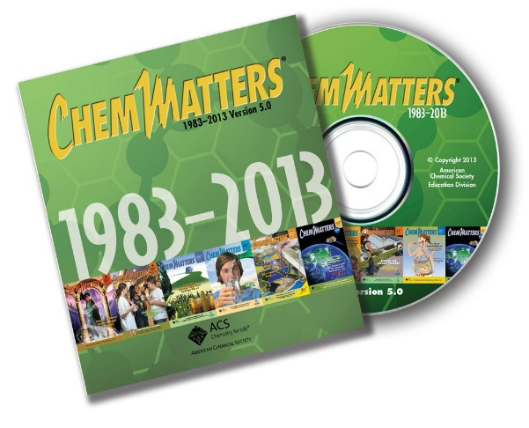

**30 Years of *ChemMatters***

Available Now!

**The references below can be found on the *ChemMatters* 30-year DVD (which includes all articles published during the years 1983 through April 2013 and all available Teacher’s Guides, beginning February 1990). The DVD is available from the American Chemical Society for $42 (or $135 for a site/school license) at this site:** [http://ww.acs.org/chemmatters](http://www.acs.org/chemmatters)**. Click on the “Archive” tab in the middle of the screen just under the *ChemMatters* logo. On this new page click on the “Get 30 Years of ChemMatters on DVD!” tab at the right for more information and to purchase the DVD.**

**Selected articles and the complete set of Teacher’s Guides for all issues from the past three years are available free online at the same Web site, above. Simply access the link and click on the aforementioned “Archive” tab.**

Teacher Bob Becker explains in detail to students how a heat pump works. (Becker, R. Question from the Classroom: How Do Heat Pumps Work? *ChemMatters,* 2006, *24* (3), pp 2–3)

In this article, author Baxter explains how geothermal energy extracted from the ground by a hear pump helps heat an environmentally-friendly, award-winning home. (Baxter, R. *Chemsumer:* Chemistry Builds a Green Home. *ChemMatters,* 2006, *24* (3), pp 9–11)

This article focuses on hydrothermal energy in Yellowstone National Park. The author discusses the various features of Yellowstone, as well as their energy source, geothermal. (Ruth, C. Letting off Steam. *ChemMatters,* 2009, *27* (2), pp 4–7)

# Web Sites for Additional Information

**(Web-based information sources)**

**More sites on the history of geothermal energy**

This site from the Office of Energy Efficiency & Renewable Energy (EERE), energy.gov, provides a timeline of the uses and development of geothermal energy in the U.S.: <http://energy.gov/eere/geothermal/history-geothermal-energy-america#2011>.

The USGS free, downloadable pdf 36-page booklet *Geothermal Energy—Clean Power from the Earth’s Heat* provides information showing how geothermal energy can serve as one of the several alternative, sustainable energy sources the government is researching to replace oil as our major source of energy. The book contains maps of the areas where geothermal energy is available and being used, and it discusses the past, present and future uses of geothermal energy. (<http://pubs.usgs.gov/circ/2004/c1249/c1249.pdf>)

**More sites on Earth’s interior**

This page from Annenberg Learner provides an interactive screen allowing the viewer to scroll across the various parts of the earth’s interior to view more (basic) information about that section: <http://www.learner.org/interactives/dynamicearth/structure.html>. A tab at the top of the screen takes the viewer to an interactive section on “Plate Tectonics”, which explains briefly how the crustal plates have shifted (and are still shifting today), and gives a quiz afterward.

**More sites on nuclear processes related to Earth’s interior**

This site from *Virtual Chemistry* from the University of Oxford, U.K., provides an animated sequence for the nuclear decay series for both U-235 and U-238. The viewer can control the progress of the steps in the process. (<http://www.chem.ox.ac.uk/vrchemistry/Conservation/page31.htm>)

The World Nuclear Association provides information on “Naturally Occurring Radioactive Materials (NORM) at <http://www.world-nuclear.org/info/Safety-and-Security/Radiation-and-Health/Naturally-Occurring-Radioactive-Materials-NORM/>. The site includes information on uranium, thorium and potassium isotopes.

Here is another site that shows the decay series for the major nuclear decay reactions in the earth: <http://images2.wikia.nocookie.net/__cb20100419124443/thorea/images/7/74/Nuclear_Decay_Chains_Th_cycle.jpg>.

This site also shows the three nuclear decay processes, for U-2389, U-235 and Th-232: <https://www.euronuclear.org/info/encyclopedia/d/decaybasinnatural.htm>.

For more information on where uranium came from (before it was deposited in the earth), and what’s happening to the Earth now as a result of having this uranium, see this page from the World Nuclear Association: <http://www.world-nuclear.org/info/Nuclear-Fuel-Cycle/Uranium-Resources/The-Cosmic-Origins-of-Uranium/>.

This paper suggests that the abundance of radioactive isotopes in the crust relative to those in the mantle may indicate a much younger earth than most scientists believe: <http://www.sentex.net/~tcc/radearth.html>.

This brief page from Science on NBCnews.com provides information to explain how scientists know that nuclear radiation that is heating the earth comes primarily from the crust, and just how much is there: <http://www.nbcnews.com/id/43786480/ns/technology_and_science-science/t/radioactive-decay-fuels-earths-inner-fires/#.Vif-jjZdFOR>.

**More sites on geothermal energy**

This “Energy 101: Geothermal Energy” video (3:47) from U.S. Dept. of Energy describes much that is in the Eboch article: <https://youtu.be/mCRDf7QxjDk>.

This 10-page document from the book, *Energy for Keeps: Electricity from Renewable Energy*, from the Energy Education Group provides general-audience information about geothermal energy. (<http://geothermaleducation.org/geo_fmat/geo_excerpt_4_07.pdf>)

This 18-page pdf document from EERE the Office of Energy Efficiency and Renewable Energy, “Geothermal—The Energy Under Our Feet”, discusses geothermal resource estimates for the U.S., as of 2006. (<http://www1.eere.energy.gov/geothermal/pdfs/40665.pdf>)

This site from EERE briefly discusses each of the three main types of geothermal power systems. It includes illustrations of each. (<http://energyalmanac.ca.gov/renewables/geothermal/types.html>)

This site provides very basic information about various alternative energy sources, including geothermal: <http://www.clean-energy-ideas.com/>. The “Geothermal” tab contains information on geothermal energy, geothermal heating, and geothermal power.

The *National Geographic* provides a site that has a good overview of geothermal energy and geothermal systems: <http://education.nationalgeographic.com/encyclopedia/geothermal-energy/>.

**More sites on natural (hydrothermal) energy systems**

“The Total Yellowstone Page” is a web site that contains the usual tourist-y stuff, but it also has detailed information about the science behind the hydrothermal features. Check it out at <http://www.nps.gov/yell/learn/nature/hydrothermalsystems.htm>.

The United States Geological Survey (USGS) provides this 4-page pdf document “Tracking Changes in Yellowstone’s Restless Volcanic System” that discusses the goals and findings of the Yellowstone National Observatory that tracks geological changes in Yellowstone’s volcanic system: <http://pubs.usgs.gov/fs/fs100-03/fs100-03.pdf>.

The 6-page USGS publication “Steam Explosions, Earthquakes, and Volcanic Eruptions—What’s in Yellowstone’s Future?” discusses the role of geothermal energy in Yellowstone National Park’s active volcanic system. (<http://pubs.usgs.gov/fs/2005/3024/fs2005-3024.pdf>)

This page from the National Park Service provides descriptions and images of the various hydrothermal features evident in Yellowstone National Park: <http://www.nps.gov/yell/learn/nature/hydrothermal-features.htm>.

**More sites on locations of geothermal energy**

This site from the International Geothermal Association provides a lot of information about geothermal energy worldwide: <http://www.geothermal-energy.org/what_is_geothermal_energy.html>.

The Calpine (electrical company) Geysers Web site has an 8-minute video that covers the history of The Geysers, from warming people 10,000 years ago, to electricity-production today. It includes their problem-solving to reverse declines in steam-production. View the video at <http://www.geysers.com/>

**More sites on Iceland’s geothermal development of a hydrogen economy**

A 2008 PBS NOVA video, “Car of the Future”, features Tom & Ray Magliozzi (“Click” & “Clack”), the NPR radio car-talk guys, as they travel to various sites to investigate alternative fuels for cars. The first 16 minutes of the 53-minute video focuses on the need for reducing fuel consumption and how we’re doing that. Part of the video (10:20-16:35) focuses on the hydrogen shift in Iceland and that country’s fuel cell-powered transit buses. (Other parts of the video feature corn-ethanol fuel, friction-reduction inside the internal combustion engine, the hyper-car—more aerodynamic, higher efficiency car, hybrid cars, and electric cars.) (<http://video.pbs.org/video/980048834/?starttime=623000>)

A brief 3-minute excerpt from a PBS show, starring Alan Alda describes the hydrogen economy: http://www.youtube.com/watch?v=bgGlE97rJl4.

An 18-minute interview with the president of Iceland and scientists researching hydrogen fuel in Iceland can be found at <http://www.youtube.com/watch?v=U79CWDtdZOA&NR>.

The October 20, 2008 issue of Scientific American discusses the geothermal features of Iceland in this article: “One Hot Island: Iceland’s Renewable Geothermal Power”. (<http://www.scientificamerican.com/article/iceland-geothermal-power/>)

“Hydrogen Hopes”, the complete PBS show from which the 3-minute excerpt above was taken: http://www.youtube.com/watch?v=THGarJkZJgk&feature=related. (26 minutes)

**More sites on superheated water**

This site from TLV, the “Steam Specialist Company”, provides a saturated steam pressure calculator that allows you to choose a pressure (you can choose from many units) and it will show you the corresponding boiling temperature (you can also choose oF, oC or K units) for water: <http://www.tlv.com/global/TI/calculator/steam-table-pressure.html>.

**More sites on enhanced geothermal systems**

CalEnergy provides this 4:45 video clip showing animated sequences describing their enhanced geothermal system for generating electricity: <https://www.youtube.com/watch?feature=player_embedded&v=kjpp2MQffnw>. The video discusses several phase change sequences from the deep underground superheated water resource as it is brought to the surface; these may be useful in your classes to discuss how pressure affects boiling temperature.

Wikipedia provides a good discussion of hot dry rock (HDR) technology for enhanced geothermal systems at <https://en.wikipedia.org/wiki/Hot_dry_rock_geothermal_energy>.

A 1993 37-page pdf document from the USGS reports on the “Potential of Hot-Dry-Rock Geothermal Energy in the Eastern United States”: <http://rglsun1.geol.vt.edu/NGDS/Other/Potential%20of%20Hot%20Dry%20Rock%20Geothermal%20Energy%20in%20the%20Eastern%20US.pdf>.

Another document from the USGS, Geothermal Direct Use: Technology and Marketplace” reports on a workshop held in the summer of 2015. “The aim of the workshop was to explore the potential for geothermal direct use applications in the eastern United States.” (<http://energy.gov/sites/prod/files/2015/09/f26/Geothermal%20Direct%20Use%20Workshop%20Summary%20Report%20-%20No%20List%20%2809-23-2015%29.pdf>)

A 2:38 animated video clip from Baker Hughes describes and shows the Enhanced Geothermal System process of injecting water into bedrock to open fractures in the rock and the extraction of that heated water back to the surface to produce steam to drive turbines to create electricity. (<http://www1.eere.energy.gov/geothermal/media/geothermal_egs_calpine-lbnl.wmv>)

This 2008 pdf from US DOE EERE, “An Evaluation of Enhanced Geothermal Systems Technology”, reports on the process of developing EGS power, and its promise for the future.

(<http://energy.gov/sites/prod/files/2014/05/f15/evaluation_egs_tech_2008.pdf>)

This 200-page document from the U.S. Department of Energy (DOE), “A History of Geothermal Energy Research and Development in the United States: Reservoir Engineering 1976–2006”, presents a detailed discussion of the work of the DOE in the area of geothermal energy as an alternative form of renewable energy, directly after the energy crisis of the early 1970s: <http://energy.gov/sites/prod/files/2014/02/f7/geothermal_history_3_engineering.pdf>.

Two other books from the DOE reflect other aspects of the history of research in geothermal energy:

* 160-page “A History of Geothermal Energy Research and Development in the United States: Exploration 1976–2006”: <http://energy.gov/sites/prod/files/2014/02/f7/geothermal_history_1_exploration.pdf>,
* 150-page “A History of Geothermal Energy Research and Development in the United States: Drilling 1976–2006”: <http://energy.gov/sites/prod/files/2014/02/f7/geothermal_history_2_drilling_0.pdf>.

The 18-page document “Annual Report 2012: Year in Review” from EERE discusses the development of hydrothermal and enhanced geothermal systems, past, present and future: <http://energy.gov/sites/prod/files/2014/02/f7/geothermalannualreport2012.pdf>.

**More sites on the laws of thermodynamics**

Here is the link to Dr. Frank Lambert’s Web site on entropy. It lists almost 40 chemistry textbooks that have deleted “disorder” as an explanation for entropy in favor of his distributed energy definition, and the site contains links to his myriad articles in journals (most in ACS’s *The Journal of Chemical Education*) that “turned the tide” on the definition of entropy: <http://entropysite.oxy.edu/>.

The link “Chapter 23: Thermodynamics of Chemical Equilibrium”, from *chem1 virtual textbook*, an online chemistry textbook, provides a detailed discussion of entropy and the second law of thermodynamics: <http://www.chem1.com/acad/webtext/thermeq/index.html>.

This site from physics professor Richard Piccard of Ohio University provides another page that discusses Carnot cycles and heat pumps: <http://www.ohio.edu/people/piccard/phys202/carnot/carnot.html>.

The UC-Davis ChemWiki provides a thorough discussion of the first and second laws of thermodynamics at

<http://chemwiki.ucdavis.edu/Physical_Chemistry/Thermodynamics/Laws_of_Thermodynamics/First_Law_of_Thermodynamics>, and

<http://chemwiki.ucdavis.edu/Physical_Chemistry/Thermodynamics/Laws_of_Thermodynamics/Second_Law_of_Thermodynamics>.

This site discusses heat engines and the Carnot cycle, and the first and second laws of thermodynamics: <http://www.taftan.com/thermodynamics/HENGINE.HTM>, as does this *Hyperphysics* page: <http://hyperphysics.phy-astr.gsu.edu/hbase/thermo/heatpump.html#c1>.

**More sites on heat pumps**

This 2:31 video clip, “Energy 101: Geothermal Heat Pumps”, from energy.gov shows an animated explanation of how a heat pump works: <http://energy.gov/eere/videos/energy-101-geothermal-heat-pumps>.

This HowStuffWorks.com Web page provides a nice, simple thought experiment and analogy to the Carnot cycle to explain to readers how a refrigerator (and therefore a heat pump) works: <http://home.howstuffworks.com/refrigerator3.htm>. The entire article can be found at <http://home.howstuffworks.com/refrigerator.htm>.

This page from the HowStuffWorks.com Web site on heat pumps contains a nice animated sequence that explains simply the parts of a heat pump and how it works: <http://home.howstuffworks.com/home-improvement/heating-and-cooling/heat-pump1.htm>. This entire article on the heat pump can be found at <http://home.howstuffworks.com/home-improvement/heating-and-cooling/heat-pump.htm>.

The Geothermal Exchange Organization (GEOExchange), “the Voice of the Geothermal Heat Pump Industry in the U.S.”, provides a very short, concise coverage of the various types of heat pumps, with nice illustrations, at <https://www.geoexchange.org/geothermal-101/>.

GEOExchange also provides this 4:26 video clip that describes how a heat pump works, and the types of heat pumps: <https://www.youtube.com/watch?v=oLKB9vk3n0A>.

This site from Ground Source Heating Exchange, a commercial heat pump company, provides graphs that compare the cost efficiencies of natural gas, oil, and liquid propane (LP) gas to that of ground source heating by use of a heat pump to heat a typical home. Their not-so-surprising conclusion is that geothermal is cheaper. (<http://geoexchange.sustainablesources.com/>)