February 2015 Teacher's Guide for

3D Printers: The Next Print Revolution

Table of Contents

About the Guide 2
Student Questions 3
Answers to Student Questions 4
Anticipation Guide 6
Reading Strategies 7
Background Information 9
Connections to Chemistry Concepts 30
Possible Student Misconceptions 31
Anticipating Student Questions 31
In-Class Activities 32
Out-of-class Activities and Projects 33
References 34
Web Sites for Additional Information 36

About the Guide

Teacher’s Guide editors William Bleam, Regis Goode, Donald McKinney, Barbara Sitzman and Ronald Tempest created the Teacher’s Guide article material. E-mail: bbleam@verizon.net

Susan Cooper prepared the anticipation and reading guides.

Patrice Pages, ChemMatters editor, coordinated production and prepared the Microsoft Word and PDF versions of the Teacher’s Guide. E-mail: chemmatters@acs.org

Articles from past issues of ChemMatters can be accessed from a DVD that is available from the American Chemical Society for $42. The DVD contains the entire 30-year publication of ChemMatters issues, from February 1983 to April 2013.

The ChemMatters DVD also includes Article, Title and Keyword Indexes that covers all issues from February 1983 to April 2013.

The ChemMatters DVD can be purchased by calling 1-800-227-5558.

Purchase information can be found online at www.acs.org/chemmatters.

Student Questions
- Why did Mario consider his smartphone case essential during cross-country training?
- Since Mario was unable to repair his smartphone case, why didn’t he just order a new clip?
- How does some of the motion of a 3D printer resemble that of an elevator?
- Explain the horizontal motion of a 3D printer.
- What is the difference in printing done by a 2D printer and a 3D printer?
- What directs a 3D printer to produce the layers required to form a 3D image?
- How does material come to be extruded from the printer heads of a 3D printer? Explain how this works.
- Describe the physical characteristics of common plastics used by 3D printers.
- Explain how the plastic materials that feed the 3D printer heads help conserve petroleum resources.
- What are monomers?
- What is the meaning of the subscript “n” in the chemical formula, (C₈H₈·C₄H₆·C₃H₃N)_{n}, for the ABS polymer?
- What role do 3D printers play in the engineering design process?

Answers to Student Questions
- Why did Mario consider his smartphone case essential during cross-country training?
Mario needs his smartphone case clipped to the strap on his arm so that he can listen to his favorite music while training for long cross-country races.
- Since Mario was unable to repair his smartphone case, why didn’t he just order a new clip?
Mario didn’t want to wait weeks for a new smartphone case clip to arrive from the manufacturer because, without the new clip, he couldn’t listen to music during his cross-country training runs.
- How does some of the motion of a 3D printer resemble that of an elevator?
A flat plate inside the 3D printer moves up and down vertically resembling a small elevator platform.
- Explain the horizontal motion of a 3D printer.
Above the plate, the 3D printer heads move horizontally back-and-forth along a rod while the rod slides back-and-forth in the opposite direction.
- What is the difference in printing done by a 2D printer and a 3D printer?
A 2D printer produces single one-dimensional lines and places one right after the other to make two dimensions; a 3D printer produces two-dimensional layers and stacks them into a three dimensional object.
- What directs a 3D printer to produce the layers required to form a 3D image?
A 3D printer contains a computer file that describes a 3D object by virtually slicing it into thin layers; relays the slices to the printer; and directs the printer to recreate the object by printing and stacking the layers.
- How does material come to be extruded from the printer heads of a 3D printer? Explain how this works.
Strips of plastic are fed into each printer head where they are heated to melting temperature, and then squeezed onto the printing surface. As the plastic from the printer head cools it joins other pieces of plastic and solidifies to form a layer of the object.
- Describe the physical characteristics of common plastics used by 3D printers.
Plastics commonly used in 3D printers are thermoplastics, meaning they are solids but, upon heating, soften to become moldable and then harden again upon cooling. These printer materials must also be fairly impact-resistant. Two of these plastics are acrylonitrile butadiene styrene (ABS), a hard rigid plastic that comes in many colors, and polylactic acid (PLA), objects made from this can be made in solid colors, as well as translucent and glow-in-the-dark forms. ABS and PLA are excellent materials for 3D printing because they are thermoplastics that can be heated and molded over and over again, and they are resistant to impact.
- Explain how the plastic materials that feed the 3D printer heads help conserve petroleum resources.
PLA is not a petroleum product; it is not made from crude oil. PLA, made from plant products such as corn starch, is considered a renewable resource because plants can be grown again, so we don’t need to extract petroleum from the ground to produce PLA.
- What are monomers?
Monomers are the repeating units of large chain molecules called polymers.
- What is the meaning of the subscript “n” in the chemical formula, (C₈H₈·C₄H₆·C₃H₃N)_{n}, for the ABS polymer?
The ABS polymer is formed by “n” number of repetitions of the three monomers (styrene, 1,3-butadiene, and acrylonitrile) shown in figure 1.
- What role do 3D printers play in the engineering design process?
3D printers are used by engineers to quickly build and test their prototype designs to be certain that they function well before building a permanent structure.

Anticipation Guide
Anticipation guides help engage students by activating prior knowledge and stimulating student interest before reading. If class time permits, discuss students’ responses to each statement before reading each article. As they read, students should look for evidence supporting or refuting their initial responses.

Directions: Before reading, in the first column, write “A” or “D,” indicating your agreement or disagreement with each statement. As you read, compare your opinions with information from the article. In the space under each statement, cite information from the article that supports or refutes your original ideas.

Me | Text | Statement
 |  | - Typical home workshop 3D printers are the size of a large refrigerator.
 |  | - A 3D printer prints one-dimensional lines one at a time.
 |  | - Typical 3D printers use plastics.
 |  | - All plastics come from compounds obtained from petroleum.
 |  | - Polymers are large chain-like molecules composed of many repeating subunits of monomers.
 |  | - All of the monomers in a given polymer must be the same compound.
 |  | - Polylactic acid (PLA) is a polymer containing only carbon, hydrogen, and oxygen.
 |  | - 3D printers require thermoplastic because it is soft and malleable when heated.
 |  | - Most plastics we use every day are thermoplastics.
 |  | - 3D printers are often used by engineers to produce prototypes.

Reading Strategies
These graphic organizers are provided to help students locate and analyze information from the articles. Student understanding will be enhanced when they explore and evaluate the information themselves, with input from the teacher if students are struggling. Encourage students to use their own words and avoid copying entire sentences from the articles. The use of bullets helps them do this. If you use these reading and writing strategies to evaluate student performance, you may want to develop a grading rubric such as the one below.

Score | Description | Evidence
4 | Excellent | Complete; details provided; demonstrates deep understanding.
3 | Good | Complete; few details provided; demonstrates some understanding.
2 | Fair | Incomplete; few details provided; some misconceptions evident.
1 | Poor | Very incomplete; no details provided; many misconceptions evident.
0 | Not acceptable | So incomplete that no judgment can be made about student understanding

Teaching Strategies:

- Links to Common Core Standards for Reading:\
  - ELA-Literacy.RST.9-10.5: Analyze the structure of the relationships among concepts in a text, including relationships among key terms (e.g., force, friction, reaction force, energy).
  - ELA-Literacy.RST.11-12.4: Determine the meaning of symbols, key terms, and other domain-specific words and phrases as they are used in a specific scientific or technical context relevant to grades 11-12 texts and topics.

- Links to Common Core Standards for Writing:
  - ELA-Literacy.WHST.9-10.2F: Provide a concluding statement or section that follows from and supports the information or explanation presented (e.g., articulating implications or the significance of the topic).
  - ELA-Literacy.WHST.11-12.1E: Provide a concluding statement or section that follows from or supports the argument presented.

- Vocabulary and concepts that are reinforced in this issue:

  - Skepticism
  - Amino acid
  - Protein
  - Enzyme
  - Organic molecular structures
  - Polymer

- To help students engage with the text, ask students which article engaged them most and why, or what questions they still have about the articles. The Background Information in the ChemMatters Teacher’s Guide has suggestions for further research.

Directions: As you read the article, complete the graphic organizer below to describe your understanding of 3D printers.

3 | New things you learned about 3D printers | 1.  2.  3.
2 | Describe 2 types of plastic polymers used in 3D printing
1 | Name one use for 3D printers not mentioned in the article
Contact! | What would you use a 3D printer for if you had one?

Background Information
(teacher information)
3Ders, those who print in 3D, say, “If you can draw it, you can make it.” Your students may ask how this is possible. First, we’ll look at the history of 3D printing, then the process, the products, and some future ideas. Remind your students that complicated models may require professional 3D files and printing machines.

The beginning of 3D printing can be traced back to 19th century attempts to create three dimensional models with cameras. Later, layering was used to produce topographical maps. In 1981, Hideo Kodama used a photopolymer liquid that turns to solid when exposed to UV light to produce an object by layering the polymer. Chuck Hull, considered the “Father of 3D Printing”, produced the first working 3D printer in 1984. 3D printing was not well known beyond the fields of engineering, architecture, and manufacturing until the 1990s.

More on the history of 3D printing

The British firm AV Plastics prepared a timeline of “3D Printing History”:

1860 - The photosculpture method of François Willème captures an object in 3 dimensions using cameras surrounding the subject.
1892 - Blanther proposes a layering method of producing topographical maps.
1972 - Mastubara of Mitsbushi motors proposes that photo-hardened materials (photopolymers) are used to produce layered parts.
1981 - Hideo Kodama of Nagoya Municipal Industrial Research Institute publishes the first account of a working photopolymer rapid prototyping system.
1984 - Charles Hull (founder of 3D systems) invents stereolithography (SLA) – which is patented in 1987. The technology allows you to take a 3D model and use a laser to etch it into a special liquid (photopolymer).
1991 - Stratasys produces the world’s first FDM (fused deposition modeling) machine. This technology uses plastic and an extruder to deposit layers on a print bed.
1992 - 3D systems produce the first SLA 3D Printer machine.
1992 - DTM produces first SLS (selective laser sintering) machine. This machine is similar to SLA technology but uses a powder (and laser) instead of a liquid.
1994 - Model Maker’s wax printer is released.
1997 - Aeromet invents laser additive manufacturing.
1999 - Scientists manage to grow organs from patient’s cells and use a 3D printed scaffold to support them.
2000 - The first 3D inkjet printer produced by Object Geometries.
2000 - The first multicolor 3D printer made by Z Corp.
2001 - The first desktop 3D printer made by Solidimension.
2002 - A 3D printed miniature kidney is manufactured. Scientists aim to produce full-sized, working organs.
2005 - The Reprap project is founded by Dr Adrian Bowyer at the University of Bath. The project was intended as a democratization of 3D printing technology.
2008 - The Reprap Darwin is the first 3D printer to be able to produce many of its own parts.
2008 - The first biocompatible FDM material produced by Stratasys.
2008 - The first 3D prosthetic leg is produced.
2008 - Shapeways – a website market for 3D models – launches.
2008 - Makerbot’s Thingiverse launches – a website for free 3D (and other models) file sharing.
2009 - Makerbot produces a Reprap evolved kit for a wider audience.
2009 - The first 3D printed blood vessel is produced by Organovo.
2011 - The first 3D printed car (Urbee by Kor Ecologic).
2012 - The first 3D printed jaw is produced in Holland by LayerWise.
2013 - Cody Wilson of Defense Distributed is asked to remove designs for the world’s first 3D printed gun and the domain is seized.

(http://www.avplastics.co.uk/3d-printing-history)

More on Charles Hull, “the father of 3D printing”

In 1982 Charles (Chuck) Hull made the first 3D printed object, a small, blue eye cup. 3D Printer & 3D Printing News (June 11, 2014) published a brief biography of his work where they cited the case of twins conjoined at the leg. A 3D model of the twins’ upper leg bone showed that it was large enough to split forming two legs. As recounted by 3D Printer & 3D Printing News following an interview with Chuck Hull:

“I think the first one that impacted me was surgical planning”, declared Hull. Talking about the recent uses of 3D printing in health care, he said that the fact that doctors are now able to scan patients’ bodies and use the scan in order to replicate the insides of the patient, and basically create a model of the part of the body that needs surgery, has been “amazing” to him. This allows surgeons to practice before the real surgery. “The first one that struck me was on conjoined twins”, added Hull. “That’s a very successful surgery now, with detailed planning. There are people walking around today who were born as conjoined twins, but now have normal lives.”

(http://3dprint.com/5827/charles-hull-3d-printing-advancements/)

The Guardian, June 22, 2014, published a nice biography of “Chuck Hull, the father of 3D printing who shaped technology”:
(http://www.theguardian.com/business/2014/jun/22/chuck-hull-father-3d-printing-shaped-technology).

More on how 3D printers work: additive manufacturing

3D printing is an additive process. Additive processes build products composed of stacked (or added) layers. In 3D printing, the bottom layer is formed first; a second layer is then stacked (“added”) on top of the first. Stacking continues until the top of the object has been created. Finally, the support material around the object is removed by brushing or washing it away. Three major additive techniques are used to solidify the material that forms the object: stereolithography (STL) uses a photo-reactive liquid resin that is hardened by a laser as it traces the product’s pattern layer after layer; fused deposition modeling (FDM) (the type described in the ChemMatters article) heats thermoplastics fed by spools which solidify as they cool; and selective laser sintering (SLS) uses a laser to fuse powdered materials such as metals, nylon, and ceramics. An excellent video shows and describes each of these manufacturing processes and the types of products produced. At this Web site (http://www.solidconcepts.com/technologies), click on a labeled box and watch from beginning to final product production as the relevant process is described.

The types of additive process (described below) differ in terms of the type of materials used and the method of fusing these materials together to produce the desired product. More information on additive processes can be found at http://taktikz.com/products-services/industrial-manufacturing/manufacturing-technology/additive-processes/.

- stereolithography (SLA) or (STL)

Both acronyms (SLA and STL) are often used to describe the same process. Actually, SLA is the rapid prototyping process. The .STL file, consisting of x, y, z coordinates, is an industry standard interface that forms a bridge between computer aided design (CAD) designs and the 3D printer hardware. This is described as a rapid prototyping system, a technique used to quickly fabricate a scale model of the product using 3D CAD data.

Starting from a 3D image, a part is built slice by slice from bottom to top in a vessel of liquid polymer that hardens when struck by a laser beam. The .STL file provides the 3D printing machine with the precise design data needed to divide the object into horizontal slices to create production paths. The file programs this information into the stereolithography 3D printing machine. A computer-controlled laser draws the bottom cross section onto the surface of a liquid polymer composed of photo-reactive resin that hardens where struck by the laser. The next cross section is then drawn and hardened directly on top of the previous one. The process is repeated by stacking the layers until the part is finished.
(http://computer.howstuffworks.com/stereolith.htm)

- fused deposition modeling (FDM)

FDM is the process described in the Wetterschneider article. Spools of polymer threads are fed into the dual printer heads, heated to melting, and extruded onto the surface of the machine where they cool and harden. Successive layers are added according to directions from the computer program.
(http://www.livescience.com/39810-fused-deposition-modeling.html)

- selective laser sintering (SLS)

In this process, a laser is used to fuse together finely powdered solids. This process works with plastics such as nylon, metals, ceramic, or glass powders. So, it can be used to form metal machinery parts. Since a very high-powered pulsed laser is required, SLS is too dangerous and expensive for home use. This process is generally reserved for industry or university research. (http://www.livescience.com/38862-selective-laser-sintering.html)

SLS technology is used in the medical field for bone tissue engineering, and bone and cartilage repair. Polycaprolactone, a bioresorbable polymer, can serve as the powdered material for the SLS 3D printer. (http://www.sciencedirect.com/science/article/pii/S0142961204011068)

The following URL contains a well prepared, very short, 19 second video showing the SLS process: (http://www.buy3dprinter.org/3dprintingtechnologies/selective-laser-sintering-sls/).

More on the skeletal structures used in the Wetterschneider article

The structures shown in Figures 1, 2, and 3 of the Wetterschneider 3D printer article are skeletal structures. Students may be unfamiliar with this shorthand method used to represent organic molecules. Skeletal structuring provides a quick way to draw large structures by omitting the carbon and hydrogen atoms. In addition, this type of representation is less messy so the organic chemist finds it quicker and easier to read.

Students may require help picturing that line bonds are connected by implied carbons. First, they must determine where the bonds are joined by a carbon. For example in Figure 1(a) acrylonitrile, carbon 1 (at left) joins the triple bond with nitrogen; carbon 2 (at the peak, ᴧ) single bonds to carbon 1 and double bonds to carbon 3. Once the carbons are placed, the number of implied hydrogens needed to complete the four bonds to each carbon can be counted. A good, 14-minute YouTube video shows students how to draw and interpret these structures: (https://www.youtube.com/watch?v=RP6AS7XVIC8).

More on the preparation of the ABS and PLA monomers

The dual extrusion (two nozzle) printer described in the Wetterschneider 3D printer article used ABS polymer in one feeder and PLA in the other. The three monomers that compose ABS are made from petroleum products:

- Acrylonitrile is a monomer produced from a catalyzed reaction between propylene and ammonia. The Sohio process combines propylene, ammonia, and air as the oxidizer:

2CH₃-CH=CH₂ + 2NH₃ + 3O₂ → 2CH₂=CH-C≡N + 6H₂O

- 1,3-Butadiene is usually isolated from other four-carbon hydrocarbons produced in steam cracking and fractional distillation from crude oil.

- The styrene monomer is the product of dehydrogenation (removal of hydrogen atoms) from ethyl benzene, a hydrocarbon obtained from the reaction of ethylene and benzene. This reaction may be catalyzed by iron(III) oxide that is promoted by potassium oxide or potassium carbonate.

C₆H₅CH₂CH₃ → C₆H₅CH=CH₂ + H₂

More on preparation of the ABS polymer

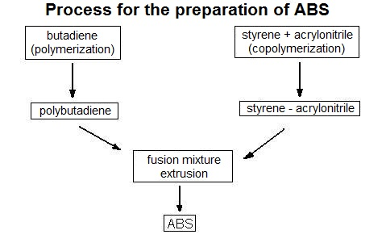
As explained in the Wetterschneider 3D printer article, ABS is formed by copolymerization of monomers of acrylonitrile, styrene, and 1,3-butadiene. First, butadiene is polymerized into polybutadiene (left reaction in flow chart at right); next, acrylonitrile is co-polymerized with styrene (first reaction on right in flow chart) to form the polymer styrene-acrylonitrile (SAN); then SAN combines with polybutadiene to form ABS, the fusion mixture that is extruded from the 3D printer nozzle (center of flow chart).
(http://www.tudosobreplasticos.com/en/materiais/abs.asp)

More on preparation of the PLA polymer
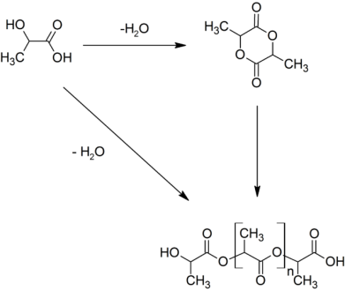
Lactic acid is a product of bacterial fermentation of crops such as sugar cane and corn. Polylactic acid, PLA, can be produced by the direct condensation of lactic acid monomers. The reaction to the right shows the condensation (removal of water) to form intermediate products (right arrow) and the final PLA polymer (down arrow). Note that the final product in the reaction is the same one shown in the Wetterschneider article, Figure 3.

(http://commons.wikimedia.org/wiki/ File:PLA_from_lactic_acid_%26_lactide.png)

More on the physical and chemical properties of ABS

ABS is a rubber-like material that is soluble in acetone and methylethylketone (2-butanone). As its name implies, 2-butanone is similar to butadiene, the linkage that holds ABS polymers together. Ketones and esters are polar protic solvents, molecules that do not have acidic hydrogen centers but which can accept hydrogen bonds. So, they are good solvents for many polymers. Nozzles clogged with ABS can be cleared with acetone and the pieces of ABS left-over from printing can be recycled by dissolving in acetone. Also, as long as there is sufficient surface area, a dilute ABS solute can bond a plastic polymer to glass. The intermolecular forces that hold ABS to glass are similar to those used by a gecko to run on glass and other surfaces.

The solubility of ABS in acetone was used to produce the attractive figure on the left (below). The newly 3D-printed owl (at right) was sanded and then wiped with acetone to dissolve and smooth the outer layer, giving a glassy look. Actually, this is best done with acetone vapor rather than liquid acetone. See the directions, safety precautions, and “don’t try this at home” precautions on this Web site: http://nicklievendag.com/filament-guide/.

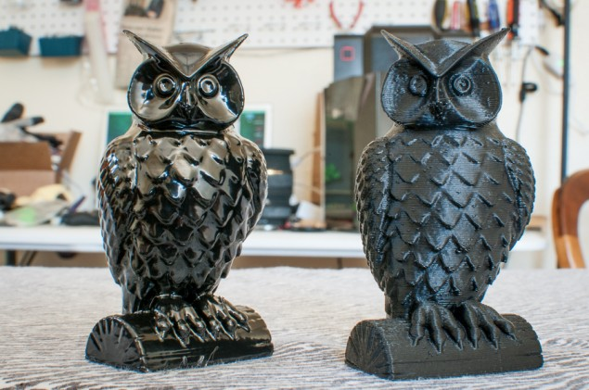
ABS owls: Treated (Left) and untreated with acetone (by Sinkhacks)

(http://sinkhacks.com/building-acetone-vapor-bath-smoothing-3d-printed-parts/)

The properties of ABS can be varied slightly by changing the concentration of the three monomers to produce the desired characteristics for the product. For example, if the product needs to be more heat resistant, slightly increase the percentage of acrylonitrile in the mixture. See the table below for the physical characteristics of the three monomers.

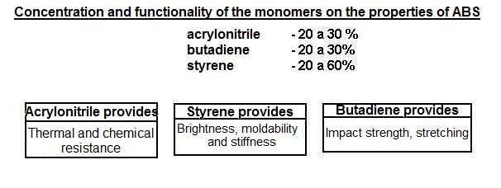
(http://www.tudosobreplasticos.com/en/materiais/abs.asp)

More on the physical and chemical properties of PLA

PLA has a lower melting point and is not as strong and hard as ABS. Unlike ABS, PLA is not soluble in acetone; it dissolves in a strong base such as sodium hydroxide. In dual extrusion printers such as the one described in the Wetterschneider 3D printer article, PLA can serve as a dissolvable support for ABS 3D prints.

The melting point of PLA is 180–220 °C, a lower temperature than ABS, which melts at approximately 230 °C. It flows better than ABS so it can be printed more quickly. Quick printing produces prints with a shinier surface. PLA’s flammability is the key to “Lost PLA casting”. This is a process where a PLA printed solid is encased in a plaster-like molding. The entire structure is placed in a furnace where the PLA object is burned out leaving a hollow center. Thus, a mold for a molten metal casting of the object has been formed.

PLA filament comes in more colors than ABS. There are even sparkle and glow-in-the-dark colorings. The pictures below are shown in both white and UV light colors on the Web site.
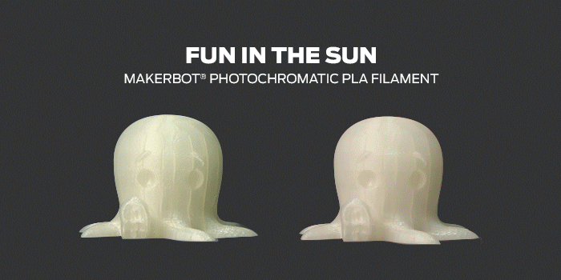
(http://nicklievendag.com/filament-guide/.)

PLA breaks down into lactic acid, so it can safely be used for 3D printed medical implants. It is absorbed inside the body gradually, within six months to two years. Another note, PLA can be used to make biodegradable, disposable clothing.

More on a comparison of the properties of PLA and ABS

Although both PLA and ABS are thermoplastic polymers, their properties differ considerably. PLA is made from renewable resources such as corn starch or sugar cane, so it is biodegradable and considered more “green” than ABS, whose monomers are derived from crude oil.

The table below provides some basic information to help decide which material is best for use in a single nozzle 3D printer. Of course the choice will depend upon the characteristics needed for the desired product. Although there are drawbacks to either choice, basically ABS is the best plastic to use for machine parts due to its strength, resistance to impact, higher melting point and length of usable life. For an artist working at home, PLA will produce nicer, more pliable models and be easier and safer to use.

PLA |  | ABS
Pro | Con | Pro | Con
+ Can be printed on a cold surface | - Can deform because of heat (like a cassette in a car) | + Very sturdy and hard | - Made out of oil, so more damaging to the environment
+ More environmental-friendly | - Less sturdy (than ABS) | + Suitable for machine or car parts | - Deforms when not being print on a heated surface
+ Shinier and smoother appearance |  | + Higher melting point | - Hot plastic fumes when printing
+ Smells sweet when being printed |  | + Longer lifespan | - Therefore, you need ventilation
+ No harmful fumes during printing |  |  | - More difficult to print
+ Higher 3d printer speed |  |  | - Not suitable for using with food
+ More detail

(http://www.absplastic.eu/pla-vs-abs-plastic-pros-cons/)

More on blended filaments

PLA can be combined with many different materials to form creative 3D printed products. The Web site http://nicklievendag.com/filament-guide/ gives blending percentages and provides descriptions and pictures of many products composed of PLA blended with wood fibers (bamboo, pine, cherry, and coconut), brick, bronze, and copper.

Nick Lievendag is the co-founder of an animation & video marketing studio, Captain Motion, in The Netherlands. He writes about 3D printing for creative professionals. The following are just two of many examples posted on Lievendag’s Web site:

- PLA + PHA
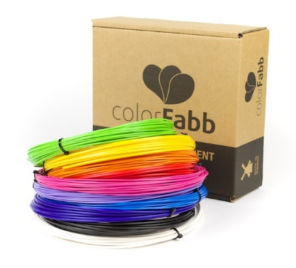
Earlier I mentioned that while PLA is the easiest material for 3D Printing, it’s also very brittle. Dutch Filament manufacturer Colorfabb improved on this and developed its own unique blend of PLA/PHA which results in a tougher and less brittle PLA 3d printing filament. PHA (polyhydroxyalkanoate) is like PLA a bio-polyester, so the blend is still 100% biodegradable.

(http://nicklievendag.com/filament-guide/)

(Manufactured by: http://colorfabb.com/pla-pha)

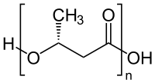
PHA is a thermoplastic like PLA and ABS. It is produced by the bacterial fermentation of sugar or lipids. Note that its structure (below) contains carbon, oxygen, and hydrogen bonded to form a polymer similar other thermoplastics.

This is the structure of PHA.
(http://en.wikipedia.org/wiki/Polyhydroxyalkanoates)

While printing in 3D is excellent for building and tweaking models, one of the major drawbacks of using this technology for mass production is the slow print speed. Now that FDM printers with multiple extruder heads are available, the process is expedited. These machines can print in multiple colors, with different polymers, and make multiple prints simultaneously. Only one machine and controller are required so speed is increased. Thus, industrial cost is reduced. (e.g., http://3dprint.com/13310/theta-3d-printer/)

Lievendag continues on his site:

- PLA + Bronze

Because this contains metal, the spool is a lot heavier than usual, but the effect is stunning!
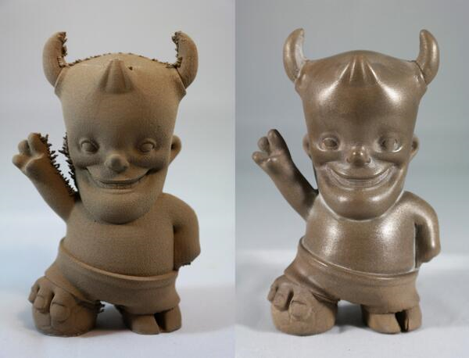
(Design by: (http://bauermaker.tumblr.com/)

bronzeFill by ColorFabb can be sanded and polished to get an actual bronze look like this beautiful print by Bauermaker.

(http://nicklievendag.com/filament-guide/)

More on the toxicity of the polymers used in the Wetterschneider article

The Soft Landing, a team that specializes in safe, natural childproofing assessment, is particularly concerned about toxic chemicals in products for children. They found few health risks associated with ABS used in toys such as Lego building blocks.

Solid ABS resin is stable and will not leach into soil or water. But, the individual components of ABS may cause health problems. Butadiene is a known carcinogen; styrene and acrylonitrile are suspected carcinogens. While the solid polymer is not a problem, overheating ABS during 3D printing can release acrylonitrile vapors that have an unpleasant odor and carry possible health risks. In contrast, some people detect pleasant vapors released as biodegradable PLA is heated. There are no known health concerns associated with PLA fumes.
(http://thesoftlanding.com/is-acrylonitrile-butadiene-styrene-abs-plastic-toxic/)

More on recycling the polymers used in 3D printing in the Wetterschneider 3D printer article

It is possible to recycle ABS from another product to use in a 3D printer, but currently this is not very practical. An industrial strength grinder is needed to pulverize an ABS product, such as an old telephone. Then, the fine powder from the grinder is fed into an extruder to produce strands for the feeder spools. When this equipment is available at a reasonable price for home use, the cost of 3D printing will be greatly reduced. Yet, there are other concerns such as:

- Dioxins and toxic fumes being released should the consumer recycle the wrong type of plastic.
- Possible release of fumes when recycling the correct plastic.
- Maintaining uniform or near uniform filament diameter.
- Slow filament extrusion speeds.

(http://www.quora.com/Is-it-possible-to-recycle-ABS-plastic-for-a-home-3D-printer)

ABS products are accepted by most recycling centers. They are labeled either ABS or 07, see below:
(http://commons.wikimedia.org/wiki/File:Plastic-recyc-abs.svg)
(http://www.sustainableokc.org/category/compost/)

More on the 3Ders news site

In 2011, a group in the Netherlands launched the 3Ders news site (http://www.crunchbase.com/organization/3ders) to serve as a source of the latest in 3D printing technology. This site covers just about anything you need and want to know about 3D printing. The home page shows the latest news in 3D printing as well as a list of the basic categories. The site covers: data storage, design, scanning, software, printing (printers, accessories, and printing materials), price comparisons, and videos on 3D printing basics.

There is also a “forums” section for news discussions, questions, and an area for 3D communities to collaborate. This would be a good, comprehensive place to direct students who want to know more about 3D printing. You will see 3Ders referenced in several places in this background information section. (http://www.3ders.org/)

More on purchasing a 3D printer

When choosing a 3D printer, consider the speed, type of material to be printed, color capabilities; also research the cost of the printer, CAD program, files, and filament. In 2010–2013, commercial computer prices began at $20,000. Prices have since dropped to a level that is reasonable for some home use. Tom’s Hardware Guide is advertised as the “Largest independent source of cutting edge hardware information and reviews”. The London firm, founded in 1996, publishes reviews and price comparisons for 3D printers. The ““Best 3D Printers 2014” lists prices, pictures, and reviews for: “Best Budget”, $349; “Best for Beginners”, $1000. (http://www.tomsguide.com/us/best-3d-printers,review-2236.html)

SLS 3D printers are designed for industrial use and considered too dangerous to be used in the home. They require temperatures high enough to melt metals (over 2000 ºC) and use high powered lasers. Prices range from $3,000 to $20,000 for these machines.

More on 3D printing software

A beginner needs to choose user-friendly software like Mario’s file, used in the Wetterschneider 3D printer article, so that the product can be printed with as little tweaking as necessary. Many files can be freely downloaded from the Internet, but these may be quite generic and require some engineering expertise for modification to personal specifications.

Non-profit MakerBot Industries was created to support early research in 3D computers. They sell kits to build your own computer. MakerBot supports Thingiverse, an on-line community for design trading and sharing of 3D printer files. (http://www.thingiverse.com/about)

According to their Web site: “3Ders.org provides the latest news about 3D printing technology and 3D printers.” This site lists both free and expensive commercial 3D files.
(http://www.3ders.org/3d-software/3d-software-list.htm)

More on scanning for 3D printer files

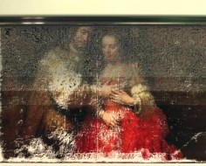
The Rijks Museum in Amsterdam’s closure for renovation provided the opportunity to scan paintings by Van Gogh and Rembrandt. During this time Tim Zaman, a Dutch researcher, used the museum collection to work on his master’s degree in biomechanical engineering. Zaman scanned slices of original paintings, then layered them with a 3D printer to produce exact replicas of the paintings such as the one shown here. This site contains three short videos showing the 3D layering process as the paintings are printed: http://www.psfk.com/2013/09/3d-printer-paintings.html.

This picture shows Zaman’s 3D printing of the “Jewish Bride”

Zaman wrote his master’s thesis on his work in 3D scanning and printing at Delft University of Technology, Netherlands: “Development of a topographical imaging device for the near-planar surfaces of paintings”. (http://repository.tudelft.nl/search/ir/?q=zaman) Using Zaman’s scanning procedures, researchers can study paintings at depth and propose ways to best restore, authenticate, and conserve them.

Below is an illustration of his work published in the 27 October, 2013 issue of the U.K. publication The Sunday Times. (http://www.thesundaytimes.co.uk/sto/news/uk_news/Arts/article1332581.ece?CMP=OTH-gnws-standard-2013_10_26)

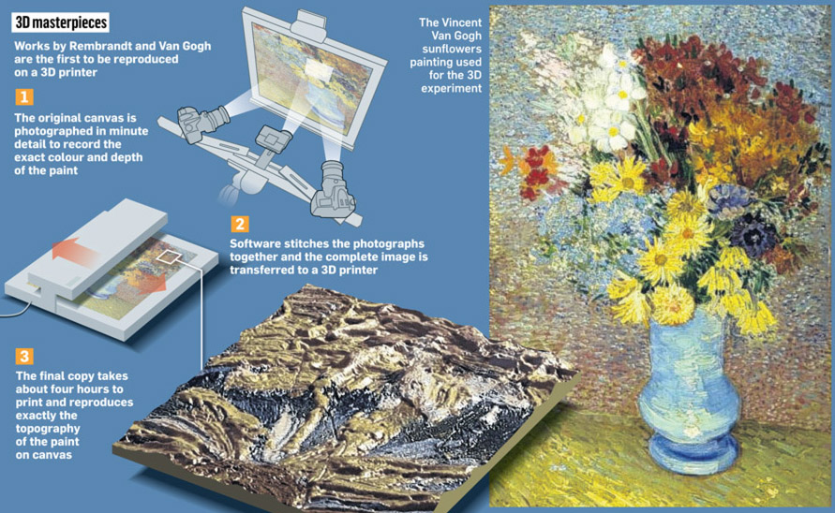

(http://www.thesundaytimes.co.uk/sto/news/uk_news/Arts/article1332581.ece?CMP=OTH-gnws-standard-2013_10_26)

More on scanners for home use

The MakerBot® Digitizer™ Desktop 3D Scanner is designed for home use. Also, it eliminates the need for CAD files. The video shows how to calibrate and use the machine to scan up to an eight inch model. Once scanned, the file is ready to print with a 3D printer. The cost of this scanner is approximately $800. (https://www.youtube.com/watch?v=AYq5n7jwe40)

More on Disney 3D printing research products

Disney Research (www.disneyresearch.com) is using 3D printing techniques “to advance the company’s broad media and entertainment efforts”. From the use of 3D printing techniques to produce Disney characters, the research group moves to more innovative projects such as those described below.

- Disney characters

Disney Researchers at ETH Zurich and MIT have developed software tools that allow a designer to load an animated Disney character model into the software. First, the points where movable joints should be placed are identified. Then, the software calculates where parts should be rigid or soft enough to allow for movement while keeping the overall appearance the same. Another type of 3D software is designed to create wobbly elastic characters that lack definite form.
(http://www.gizmag.com/disney-research-mechanical-characters/28428/)

- Fluffy stuff

Carnegie Mellon-Disney researchers have developed a 3D printer that resembles a sewing machine and extrudes a wool felt material. The machine uses an additive printing process: the first layer is a firm, flexible nylon mesh fabric designed to keep the yarn in place; flexible inner layers have embedded stiffeners; and the outer layers are soft and fluffy. The process is similar to FDM discussed above and in the Wetterschneider 3D printer article except that the printer heads feed out loose felt yarn instead of melted plastic. Each layer of yarn tangles with the layer below to form the solid, fluffy object. 3D printing also provides the opportunity to insert hardware into an inner layer to produce an articulated arm or bendable head.

Scott Hudson, who developed the 3D wool felt printer for Disney, predicts that in the future a 3D computer can be designed to produce both fabric and plastic in the same application. There are two short, excellent videos showing the process on the Web site:
http://www.disneyresearch.com/project/printed-teddy-bears/.

- Printed optics

Disney recognizes that, “Face-to-phase communication begins with the eyes, a crucial factor in the design of interactive physical characters.” So, the Disney Papillon research team used 3D printing to create interactive eyes on the characters. In response to the wave of a child’s hand, the character’s eyes will use hearts to express affection or question marks to suggest confusion. Also, with printed optics, the shapes and locations of eyes can be changed. An informative video and additional information about the Papillon project is located on the Web site. (http://www.disneyresearch.com/project/papillon/)

- 3D printing produces interactive speakers

With 3D printing techniques, Disney Research Pittsburgh scientists are able to insert electrostatic loudspeakers into printed objects. In addition to adding sound to toys, embedded, inaudible ultrasound can be integrated into games and other interactive systems. Additional information is provided on their Web page. (http://www.disneyresearch.com/wp-content/uploads/Project_3DSpeakers_CHI14_release.pdf)

More on 3D printing and medical applications

- 3D printing of body parts

WebMD asks, “Will 3-D Printing Revolutionize Medicine?” This site describes five pages of medical uses for 3D printing. The WebMD page begins with an initial five minute video featuring an art teacher who lost her fingers. The process of producing body parts is shown and described during this video.

In another, Sydney Kendall is featured. The 13 year old, who lost her arm in a boating accident, finds her pink, plastic, 3D printed arm much superior to her former prosthetic arms. With an opposable thumb, she can grip a baseball and pick up a paper cup. “It took about 7 minutes to do each finger,” says Sydney’s mother, Beth Kendall. “We were all blown away.”

Additional advancements in 3D medical printing are shown on this site. In addition, the cost of prosthetics is included. For example Sydney’s 3D printed arm cost $200 compared to the cost of traditional robotic limbs, $50,000 to $70,000. (http://www.webmd.com/news/breaking-news/20140723/3d-printing)

- 3D printing of knee replacements

Traditionally knee implants were entirely generic; a recent improvement was to manufacture them gender-specific. But even more recently, they are being 3D printed! Yet, this is still the case where the surgeon adjusts the replacement to fit the patient.

For the past year, Dr. Wallace Huff, Bluegrass Orthopaedics in Lexington, Kentucky, has been using 3D technology to print the knee replacement to fit his patient. "So rather than taking different sizes off the shelf and picking the best fit then you have the exact fit," said Dr. Huff. The 3D printed implant is the exact shape and mimics the complex forward, backward, and swivel movement of the patient’s natural knee joint. Hospital recovery time drops from three or four days to one night following surgery; pain is decreased by the perfect fit; and Dr. Huff notes that the 3D printed knee implants last longer than traditional ones. A video on this site features one of Dr. Huff’s patients. (http://www.wkyt.com/betterliving/headlines/New-knee-replacement-surgery-in-Lexington-using-3D-printing-255540191.html)

- 3D printing to promote tissue growth

Recognizing the pain and possible arthritis associated with torn menisci, researchers under the direction of Dr. Jeremy Mao, department of chemistry, Columbia University Medical Center, use the 3D printing machine pictured below to print biodegradable knee scaffolds that promote tissue regeneration. The body will continue the additive process to grow new knee tissue. “We envision that personalized meniscus scaffolds, from initial MRI to 3D printing, could be completed within days,” said Dr. Mao. “The personalized scaffolds would then be shipped to clinics and hospitals within a week, to be surgically implanted in the patient’s knee.” The Columbia University Web site shows an animation of the scaffold for a knee meniscus being 3D printed. (http://3dprintingindustry.com/2014/12/15/knee-tissue-3d-printing/)

In the YouTube video Dr. Mao explains the process as you watch a knee meniscus scaffold being printed by the machine pictured below.
(https://www.youtube.com/watch?v=yTDK88G2ed0#t=74)

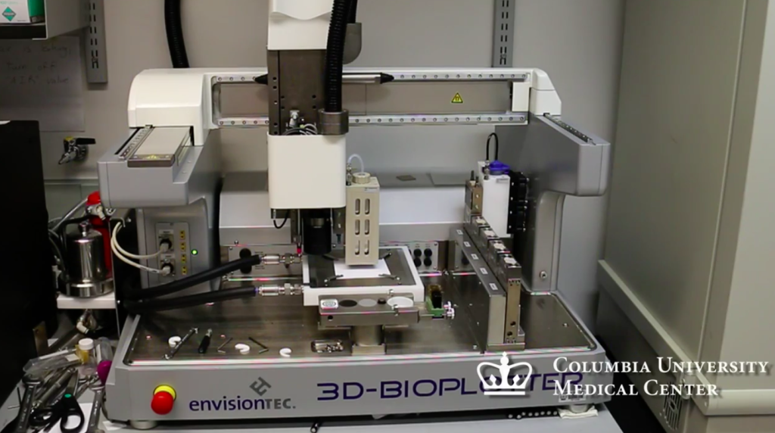

- 3D printing of orthopedic implants

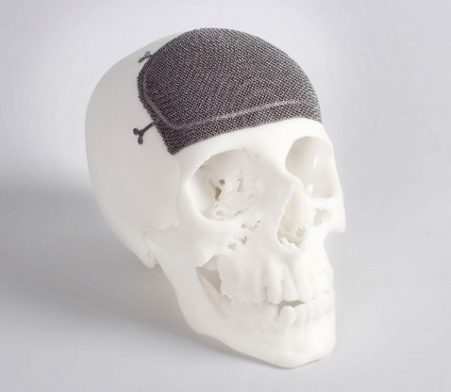
3D prints of biodegradable fibrous tissue can be used to promote osseointegration, by encouraging new bone growth as the printed tissue becomes integrated with the bone. Frequently, they may also have a mechanical function. For example, they may be used in a knee joint.
Custom Cranio-Maxillofacial implant
(http://www.arcam.com/wp-content/uploads/CMF_custom_made_implant.jpg)

The electron beam melting (EBM) technology (http://www.arcam.com/technology/electron-beam-melting/) can be used to produce patient-specific implants. Computer Technology (CT) scan data is used to create a Computer Assisted Design (CAD) file of the desired implant such as the “Custom Cranio-Maxillofacial implant” pictured at right.

EBM is also used to produce the trabecular structures used in reconstructive hip surgery. These structures need to be porous to provide biological ingrowth surfaces. Trabecular structures are described in an abstract posted by National Institutes of Health (NIH):

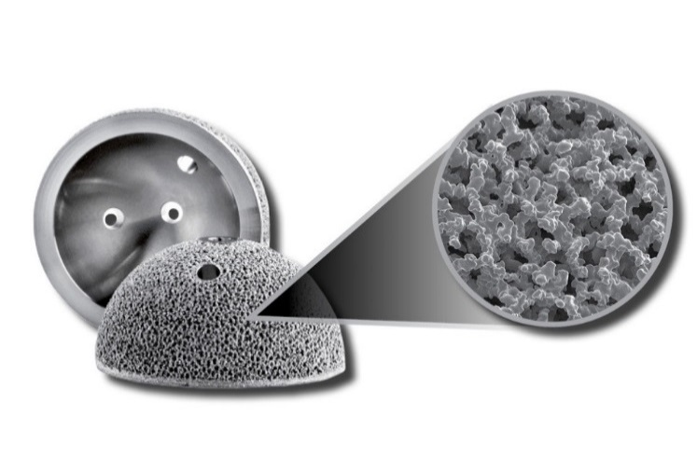
Trabecular metal in hip reconstructive surgery by JB Stiehl,
Abstract: Biological ingrowth surfaces have become a standard prosthetic element in reconstructive hip surgery. A material's properties, three-dimensional architecture, and surface texture all play integral parts in its biological performance. Trabecular metal is an important new biomaterial that has been introduced to enhance the potential of biological ingrowth as well as provide a structural scaffold in cases of severe bone deficit. Initial clinical applications have focused on bone restoration in tumor and salvage cases and in primary and revision reconstructive cases where the increased biological fixation would be of clinical benefit. The bone ingrowth potential and mechanical integrity of this material offer exciting options for orthopedic reconstructive surgeons.
Acetabular cups with integrated Trabecular Structures™ for improved osseointegration

(http://www.arcam.com/solutions/orthopedic-implants/)

(http://www.ncbi.nlm.nih.gov/pubmed/16119281)

More on 3D printed dog legs

Derby, the dog shown in the video cited below, was born with completely deformed front legs. With his new 3D printed legs, he is able to run faster than his owners. This three minute video will appeal to most students. It provides an excellent way for them to see the 3D printing process in action, along with an explanation. They will watch the new legs being formed and used by Derby. (https://www.youtube.com/watch?v=uRmoowIN8aY)

More on 3D printed foods

The Ford motor company uses 3D printing technology to develop four by two inch detailed plastic models of all its new vehicles. In 2014, 3D Systems worked with The Sugar Lab and partnered with Ford to produce a 3D printed edible 2015 Ford mustang in white chocolate. This well prepared, short classroom video (https://www.youtube.com/watch?v=TSAdjGGhfwo) shows and explains the process as both the plastic and the chocolate mustangs are printed.
(http://3dprintingindustry.com/2014/02/16/3d-printing-ford-mustang-sugar/)

NASA is funding a Texas company to study the feasibility of using 3D printing to prepare food for astronauts during long space missions. Current space food is the shelf ready, freeze dried variety because refrigeration and/or freezing is too energy intensive. “NASA’s Advanced Food Technology program is interested in developing methods that will provide food to meet safety, acceptability, variety, and nutritional stability requirements for long exploration missions, while using the least amount of spacecraft resources and crew time.” 3D printed food could provide the opportunity for personal preferences. (http://www.nasa.gov/directorates/spacetech/home/feature_3d_food_prt.htm)

“A Guide to All the Food That’s Fit to 3D Print (So Far)”, Bloomberg Business Week, January 18, 2014, describes: the Hershey candy maker, NASA’s pizza printer, Natural Machine’s Foodini’s ravioli maker (after printing, ravioli must be baked) and vegetarian nuggets, Cornell Creative Machines Lab’s flower-shaped corn chips and hamburger patties complete with layers of ketchup and mustard, and Chefjet Pro’s custom edible cake toppers. In the article, pictures are shown and prices are provided for the 3D printers used to make these printed foods. (http://www.businessweek.com/printer/articles/188115-a-guide-to-all-the-food-thats-fit-to-3d-print-so-far) A video showing Chefjet’s 3D printer at work preparing decorations is located at https://www.youtube.com/watch?v=8WWHpWgaq7I).

More on 3D printing for wearable jewels and clothes

3D design software for custom jewelry saves designers the time and expense of making actual models to show and sell custom jewelry. The Gemvision site contains a video (Create Seductive Renders) that shows how the CAD (computer assisted design) software, Matrix 7, can be used to generate a realistic image of jewelry. This process, “rendering”, enables a computer program to make a virtual design. (http://gemvision.com/matrix/)

Although the primary use of 3D printing in the jewelry business has been limited to using software to generate virtual 3D images of designs, Jenny Wu is using her experience in working on 3D architectural projects to develop her own line of jewelry. She markets her 3D printed rings and necklaces under LACE. The 3Ders news site announces a show of her artwork:

Internationally celebrated architect, Jenny Wu, announced this week [November 22, 2014] the official public launch of her first 3D printed wearable designs, LACE. The collection will make its debut at Aqua Art Miami this December as a pop-up exhibition/shop in the main courtyard space.

Prompted by her success as an architect, designer and partner at the award-winning design and architecture firm, Oyler Wu Collaborative, Jenny launched her line, taking her artistic eye to the jewelry industry. The LACE by Jenny Wu collection reflects Wu's architectural aesthetic, marrying line-based geometry with intricate organic movement to create avant-garde designs that make a statement.

(http://www.3ders.org/articles/20141122-jenny-wu-launches-lace-3d-printed-jewelry-collection.html)

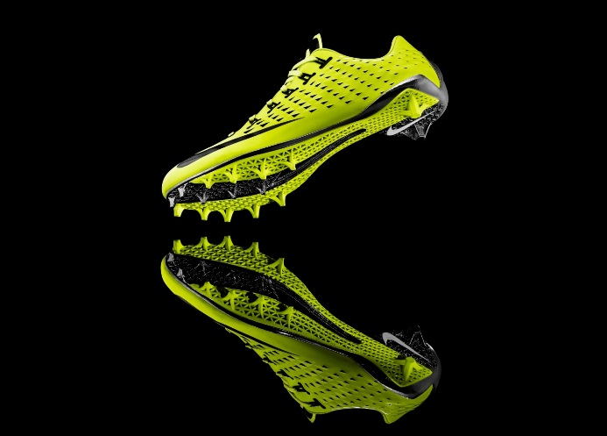
In February 2013, gold metal sprinter Michael Johnson worked with Nike designers to produce the first 3D printed football cleat. “Nike’s new 3D printed plate is contoured to allow football athletes to maintain their drive position longer and more efficiently, helping them accelerate faster through the critical first 10 yards of the 40,” said Johnson. “Translated to the game of football, mastering the Zero Step can mean the difference between a defensive lineman sacking the quarterback or getting blocked.” The cleat pictured below was printed using selective laser sintering (SLS) technology.
(http://news.nike.com/news/nike-debuts-first-ever-football-cleat-built-using-3d-printing-technology)

Fashion designers are experimenting with 3D printed wearable women’s shoes and dresses. Dutch designer, Iris van Herpen’s new clothing line, Magnetic Motion, was shown at Paris Fashion Week. The inspiration for the clothing came from the magnetic fields used by the Swiss Large Hadron Collider at CERN. She uses magnets to help 3D print her garments.

3D printed fashion. Credit: Iris Van Herpen

(http://www.inside3dp.com/iris-van-herpen-reveals-3d-printed-clothes-paris-fashion-week/)

More on printing molecular models for your classroom

The article, 3-D Models, Without a Kit, suggests that if you have access to a 3-D printer, you can print inexpensive custom made molecular models for your classroom.

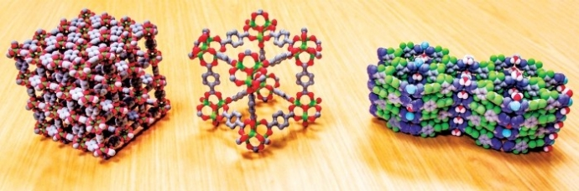

Credit: Ognjen Miljanic, University of Houston

If you don’t have access to a printer, Shapeways 3D Printing Service and Market Place (http://www.shapeways.com/) will print and send your model to you. The Shapesways YouTube video (2 minutes) shows the 3-D printing of many other objects that people have created in addition to molecular models. (https://www.youtube.com/watch?v=qJuTM0Y7U1k)

(http://cen.acs.org/articles/92/i20/3-D-Models-Without-Kit.html?h=-1610457888)

More on the challenges and the dark side of 3D printing technology

Making exact copies can be very useful. With 3D printing technology, a painting that duplicates the original can be copied down to fine brush strokes thus producing an almost perfect replicate of the original. 3D printing can provide the detail needed to authenticate and/or restore a work of art as well as to produce a copy of a famous painting or statue for home enjoyment at a reasonable price. Unfortunately, this also provides the opportunity for a 3D printed copy to be counterfeited and sold as “an original”.

3D Printing Industry lists six ways that counterfeiting may impact the 3D printed world:

- Professional and semi-professional pirates selling knockoffs that appear genuine
- 3D design files sold or shared peer-to-peer on the Internet, pretending to be genuine
- Genuine 3D design files sold or shared peer-to-peer on the Internet and printed not according to the specifications for the “genuine” products; the products look real but are modified or deficient, possibly dangerously so
- Consumers and prosumers printing and using products that appear genuine
- Consumers and prosumers printing and selling products that appear genuine on Craig’s List, ebay, at flea markets, etc.
- Companies, print shops, prosumers, and consumers scanning and printing replacement parts that do not satisfy OEM specs.

(http://3dprintingindustry.com/2014/02/05/tell-whats-real-whats-fake-3d-printed-world/)

NASA has even more serious concerns about counterfeiting, listed as one of their “biggest challenges”. 3D printed counterfeit parts that are permeating the market place can “threaten the success of its missions, the safety of its personnel and the security of the country.” Automakers and tool manufacturers face similar threats. The following graph shows the spike (blue line) of counterfeit reports in the semiconductor business during the second quarter of 2011.
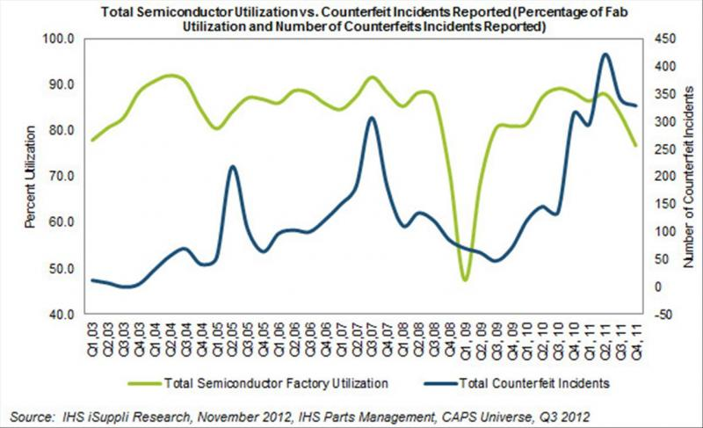

(http://www.pcbdesign007.com/pages/zone.cgi?a=87719&artpg=1)

In addition, problems involving intellectual property theft occur when people using 3D printers ignore copyrights to print and sell everything from toys to kitchen ware. Is there legal recourse when someone is injured because their 3D printed, counterfeit bicycle helmet falls apart? How will the victim and the company know if it is genuine?
(http://3dprintingindustry.com/2014/02/05/tell-whats-real-whats-fake-3d-printed-world/)

More on anti-counterfeiting measures

Quantum Materials Corporation (QMC) embeds unique quantum dots in products for authentication. David Doderer, Vice President for Research and Development at QMC explains,

The remarkable number of variations of semiconductor nanomaterials properties QMC can manufacture, coupled with Virginia Tech’s anticounterfeiting process design, combine to offer corporations extreme flexibility in designing physical cryptography systems to thwart counterfeiters. As 3D printing and additive manufacturing technology advances, its ubiquity allows for the easy pirating of protected designs. We are pleased to work with Virginia Tech to develop this technology’s security potential in a way that minimizes threats and maximizes 3D printing’s future impact on product design and delivery by protecting and insuring the integrity of manufactured products.

(http://3dprintingindustry.com/2014/07/01/quantum-dots-hinder-3d-printed-counterfeits/)

Applied DNA Sciences (ADNAS), Stony Brook, New York, marks products as genuine with plant DNA. One gram of DNA can protect 100 billion DVDs. For national security, the U.S. Defense Logistics Agency has mandated that certain electronic parts be DNA marked. The company has marked the Swedish national rail system, burglary-prone London neighborhoods, and cotton and wool fiber used by high-end carpet and textile makers. ADNAS says,

Our scientists have developed a precision-engineered mark based on botanical (plant) DNA. The engineered mark has not and cannot be broken. The conventional process used to sequence (“decode”) native DNA is not possible with the engineered mark. Additional layers of protection and complexity are added to the mark in a proprietary manner. This engineering “secret sauce” is shielded by a portfolio of 21 patents and other intellectual property protection.

(http://3dprintingindustry.com/2014/02/05/tell-whats-real-whats-fake-3d-printed-world/)

More on the future of 3D printed guns

Cody Wilson, a Texas law student, founded the non-profit organization, Defense Distributed. In May, 2013, he posted 3D printer designs for a plastic gun. The U.S. Government asked that the designs be removed. During the 2 days that the blueprints were available, there were more than 100,000 downloads. Plastic guns are not detectable by current airport screening methods.

In Japan at least eight personal computers downloaded the files. A university employee, Yoshitomo Imura, was arrested in Japan for possessing and owning five 3D printed firearms, 3D printed from files posted on the Defense Distributed Web site.
(http://www.3ders.org/articles/20140924-new-3d-printed-revolver-dedicated-to-yoshitomo-imura-in-development.html)

More on the future of 3D-Printing in Medicine

- 3D printed micro-robotic drug delivery systems

Swiss professors, Bradley Nelson and Christofer Hierold at the department of Mechanical and Process Engineering at the Swiss Federal Institute of Technology, Zurich (ETH), have developed 3D printed helical shaped micro-robots that can carry medications or chemical sensors to specific locations in the body. They are formed with a microscopic 3D printer that incorporates magnetic nanoparticles within a light-sensitive, bio-compatible epoxy resin.

The computer program controls a laser beam that moves repeatedly in a 3D manner throughout the resin to cure it in a desired pattern. The uncured portion of the resin is washed away. By tweaking the computer program, scientists have been able to produce structures with large surface areas to enable the tiny robots to carry maximum loads. 3D Printer & 3D Printing News quotes a student from the ETH Zurich lab:

“It is not just about swimming micro-robots,” says doctoral student Christian Peters from the group led by Professor Hierold. “The new technology can also be used when other micro-objects have to be manufactured with specific magnetic properties. Previously, these elements wobbled as they moved forward, and they were less efficient because their magnetic properties were not ideal. We have now developed a material and a fabrication technique with which we can adjust the magnetic properties independent of the object’s geometry,” said Peters.

(http://3dprint.com/25786/micro-robots-eth-zurich/)

- 3D printed medical-quality filaments for targeted drug delivery

Louisiana Tech University researchers have developed methods to use 3D printers to extrude medical-quality filaments containing antibacterial and chemotherapeutic compounds to implant for targeted drug delivery. Current antibiotic implants are made of Plexiglas™ and must be removed surgically. 3D printed filaments can be made from biodegradable materials that are absorbed by the body.

“After identifying the usefulness of the 3D printers, we realized there was an opportunity for rapid prototyping using this fabrication method," said Jeffery Weisman, a doctoral student in Louisiana Tech's biomedical engineering program. "Through the addition of nanoparticles and/or other additives, this technology becomes much more viable using a common 3D printing material that is already biocompatible. The material can be loaded with antibiotics or other medicinal compounds, and the implant can be naturally broken down by the body over time.

According to Weisman, personalized medicine and patient specific medication regiments is a current trend in healthcare. He says this new method of creating medically compatible 3D printing filaments will offer hospital pharmacists and physicians a novel way to deliver drugs and treat illness. "One of the greatest benefits of this technology is that it can be done using any consumer printer and can be used anywhere in the world," Weisman said.

(http://www.sciencedaily.com/releases/2014/08/140821090659.htm)

More on “How 3D Printing is changing everything”

Bre Pettis, founding member and CEO of the 3D printer firm, MakerBot Industries describes the prototype Digitizer Desktop 3D Scanner in the Consumer Electronics Association (CE). (http://www.ce.org/i3/Features/2013/May-June/How-3D-Printing-is-Changing-Everything.aspx) A YouTube video (referenced and described above in the “More on scanners for home use” section) is located at (https://www.youtube.com/watch?v=AYq5n7jwe40). “This is something you would envision being science fiction, but in fact, it is real—and it is so cool,” Pettis says. “If something gets broken, you can just scan it and print it again.” (http://blogs.redorbit.com/makerbot-takes-us-even-further-into-the-future-with-3d-scanning/)

The CE.org site lists these future trends in 3D printing:

3D Printing Trends to Watch

It’s all in the parts: Expect to drive more cars and fly in more planes that are built using 3D printing. Parts that are created from this additive process will become more common, not only in heavy machinery, but also in household appliances and other devices. Lose your iPhone case? Can’t find your wrench? More households will implement 3D printers into their homes to make these smaller items.

Let’s go shopping: Expect to see 3D printing kiosks at the mall alongside the phone accessories hut. Not only will these destinations make 3D printing more of a household word, but they will also introduce a new generation of consumers to the technology, a lot like custom printed t-shirts and coffee mugs did a decade ago (before everyone had their own photo printers). Expect to order and pick up a 3D print the same way you order your digital photos.

It does the body good: The future of 3D printing isn’t just for inanimate objects anymore. It’s being used to develop products that can assist in the medical industry, including prosthetic limbs and orthodontic devices. Scientists are even experimenting with soft tissue printing that could change the way patients are treated for a variety of health needs. And 3D printing is also being used to take living cells to produce a transplantable kidney. Surgeon Anthony Atala recently demonstrated an early-stage experiment.

The kids are all right: Forget the construction paper and clay, tomorrow’s students will bring home 3D prints that they make right in the classroom. Progressive schools around the country are already starting to introduce the technology in the classroom, but as the price points come down on 3D printers, a new generation of innovators will have the opportunity to experiment with the endless possibilities.

(http://www.ce.org/i3/Features/2013/May-June/How-3D-Printing-is-Changing-Everything.aspx)

More on 3D printing a kidney

To watch surgeon Anthony Atala use living cells to 3D print a kidney, see the video (with interpretation in 27 languages) located on this site.
(https://www.ted.com/talks/anthony_atala_printing_a_human_kidney#)

Connections to Chemistry Concepts
(for correlation to course curriculum)
- Organic Chemistry: nomenclature, structure—The Wetterschneider 3D Printer article gives the names, chemical formulas, and the structures of monomers and the polymers. This provides the opportunity to discuss: functional groups, multiple bonds between atoms, and the omission of carbon and hydrogen in organic structural formulas.
- Organic Chemistry: polymerization—The structures shown in the Wetterschneider 3D Printer article provide the opportunity to discuss how monomers, acrylonitrile, 1-3 butadiene, and styrene in Figure 1, join to form the polymer, acrylonitrile butadiene styrene (ABS), Figure 2.
- Reaction Mechanisms: multi-step reactions—Step 1: butadiene monomers polymerize to form polybutadiene; Step 2: Acrylonitrile is copolymerized with styrene; Step 3: the two polymers (polybutadiene and acrylonitrile-styrene) are extruded together from the 3D printer heads to form ABS. See the background information of this teacher’s guide for additional information on this reaction.
- Physical Properties—Each of the three monomers forming ABS contributes to the overall physical properties of the product. By varying the amounts of each polymer, the properties of the resulting ABS can be adjusted to form the optimal physical characteristics for the product.
- Physical Properties: thermoplastics—The Wetterschneider 3D Printer article provides the opportunity to discuss how the physical properties of some thermoplastics make them suitable for smartphone cases. These materials are impact resistant and can be molded and remolded, changing from solid to liquid and back to solid again by heating or cooling. Thus, they can be reused by softening and remolding into a different shape.
- Chemical Bonding: intermolecular forces—The polymer chains of thermoplastics are attracted by intermolecular forces which weaken to form viscous liquids as the temperature increases. As the polymers cool, the intermolecular forces increase to form the solid product.
- Green Chemistry: renewable resources, biodegradable—Poly(lactic acid) (PLA) is a polymer composed of a renewable resource, lactic acid monomers. Lactic acid, formed from cornstarch or sugar cane, is biodegradable.

Possible Student Misconceptions
(to aid teacher in addressing misconceptions)
- “What fun it will be to print a custom smartphone case with our school logo, I’ll ask my parents to buy a 3D printer today so that I can design and print like Mario.” Although the price of 3D printers is decreasing, they are still too expensive for most family uses. Mario’s mother is an engineer who uses the 3D printer for her business.
- “My sister’s boyfriend says that pretty soon you’ll be able to print an iPhone. This will be cheaper than buying one.” Maybe your sister needs a smarter boyfriend! At present, home computers are not capable of printing objects with internal wiring like telephones. It will probably be a long time before you can print a personal iPhone.
- “3D printing is neat but it only makes plastic objects.” The spools that feed a 3D printing machine can be loaded with many materials other than plastic, for example: clay, cement, silicone, and even chocolate and sugar.
- “3D printing is just a fad that will soon disappear.” In addition to producing things for fun, in the engineering field 3D printing is becoming such a valuable asset to manufacturing that it will become a permanent part of the process. Computer designing is often less expensive than hand crafting prototypes; and tweaking the design file is simple compared to making another model by hand.
- “I understand that soon human hearts can be 3D printed.” A replica of the human heart can be printed, but this does not mean that it will function in the human body.
- “Printing in 3D is easy; Mario just tweaked his mother’s program to make the part he needed.” Mario was able to easily print the part he needed because the file in his mother’s 3D printer was designed to make models similar to his smartphone clip. Learning to write computer files for a 3D printer is a difficult and time consuming process. Commercial files frequently contain glitches that need to be corrected by someone with engineering skills.
- “Computer assisted design (CAD) programs make 3D printing simple.” While 3D Printers are easy to use, CAD software is not user-friendly. To successfully run these programs you must be well trained and have engineering expertise.
- “The 3D printer in the article uses plastics, another name for polymers.” While all plastics are polymers, NOT ALL polymers are plastic. Polymers are long chains of molecules. The chains may be composed of monomers that form plastics, but many biomolecules also polymerize to form starches (polymers of sugars), proteins (polymers of amino acids), and DNA (polymers of nucleotides). Additionally, films, paints, elastomers, fibers, gels, and adhesives are ALL polymers.

Anticipating Student Questions
(answers to questions students might ask in class)
- “What is the cost of a home 3D printer?” Prices for home 3D printers have gradually decreased from $20,000 in 2010 for a commercial 3D printer to $400 to $1,000 now for a home version.
- “If I don’t know how to design, can I get files to 3D print?” Yes, many files that are ready for printing are available on-line and many of these are free. One community of designers willing to share files is located on the 3Ders Web site: http://3ders.org.
- “Can I design a file to make a 3D surfboard?” Creating an entire surfboard using a 3D printer is possible, but not yet practical. You would need a very large, very expensive printer. Now, surfers do 3D print small things like custom designed fins.
- “With a single nozzle system, should I print with ABS or PLA?” ABS requires a higher temperature, which means that your printer will run hotter during printing. If you overheat it, unpleasant fumes may escape. PLA cools more quickly and sticks together better so you can usually print more quickly. If you are making a part for a dishwasher for example, ABS will withstand the higher temperature better.
- “Since ABS is plastic, can it be recycled?” Yes, most recycling centers can handle the ABS polymer. Products of ABS are labeled with the recycling code triangle containing the number seven or ABS.
- “Will everything soon be printed rather than manufactured in the traditional manner?” Although many things can be printed by 3D printers, current home models are not capable of printing with materials such as metals that require very high-powered, pulsed lasers and temperatures high enough to melt metals. Currently, it is usually not economically feasible to replace most industrial processes with 3D printing, a relatively slow process. In industry, 3D printing is mainly used to make prototypes and custom designed products.
- “What do the formulas in Figures 1, 2, and 3 mean? I don’t understand them.” The diagrams in the Wetterschneider 3D Printer article are organic shortcuts called skeletal structures. They are quicker to draw and less messy than structural formulas because the carbons and hydrogens are assumed. Each intersection between lines contains a C (carbon) and the H (hydrogen) is determined by the number needed to give carbon four bonds. For example, the condensed formula for acrylonitrile is NCCHCH₂.
- “What is a thermoplastic polymer?” Thermoplastic polymers like ABS can be heated and formed over and over again. Thermoplastic monomers are often linear and have few branches and cross links so they flow under pressure when heated above their melting points. In contrast, as the name implies, a thermoset polymer forms a “set” three dimensional network when heated that cannot be reformed.

In-Class Activities
(lesson ideas, including labs & demonstrations)
- Show the 14 minute YouTube video that teaches students how to write skeletal structures. Ask students to translate the three skeletal structures in Figure 1 of the Wetterschneider 3D printer article to structural formulas. Then, challenge students to identify the location of the three monomers, acrylonitrile, 1,3-butadience, and styrene shown polymerized in Figure 2. (https://www.youtube.com/watch?v=RP6AS7XVIC8)
- Two suggestions for holding a class debate:
- Watch the 36-second video that shows how to fake a master painting with a 3D printer that replicates down to fine details like brush strokes: (https://www.youtube.com/watch?v=EXRt64HEBrk&hd=1). and
Should museums keep original works of art hidden in light and air controlled environments? And show replicas to the public, thus reducing the cost of insurance and the possibility of theft? Student debate information is located on this site: http://gizmodo.com/3d-printing-fine-art-fakes-is-here-to-stay-1383456733.
- Present a scenario about a child choking on a counterfeit toy part. The toy was sold by a major manufacturer and the part came from one of their suppliers. Who should be responsible? Who should pay for the child’s medical expenses?
- Make a corn-based bioplastic (like PLA) in the lab. A recipe is given on page 12 of the April, 2010 ChemMatters article by Cynthia Washam, Plastics Go Green. See the section: “References (non-Web-based information sources)” for this article. The reference for this lab comes from the Field Guide to Utah Agriculture in the Classroom, Volume 1: The URL for the original lab activity, Corn Starch Plastic, can be found at: https://utah.agclassroom.org/files/uploads/fieldguide1/plastic.pdf.
- Thermoplastics lab: In this chemistry lab activity, students use a hot glue gun, to investigate the properties of thermoplastics, including viscosity and the effect of heating and cooling. (http://www.terrificscience.org/lessonpdfs/PolymerLab25.pdf)
- The chemistry lab activity “Bridging to Polymers” is designed for students to investigate the difference between thermoplastics and thermosets. As described in the introduction: “Students act as engineers to learn about the strengths of various epoxy-amine mixtures and observe the unique characteristics of different mixtures of epoxies and hardeners. Student groups make and optimize thermosets by combining two chemicals in exacting ratios to fabricate the strongest and/or most flexible thermoset possible.” Complete lab instructions and materials lists are located on the site. (https://www.teachengineering.org/view_activity.php?url=collection/uoh_/activities/uoh_polymer/uoh_polymer_lesson01_activity1.xml)
- “Conflicts in Chemistry: The Case of Plastics, a Role-Playing Game for High School Chemistry Student” was written by Deborah Cook. This activity was developed by the Chemical Heritage Foundation to “promote increased public understanding of chemistry”. As stated in the abstract, “The activity allows students to engage in debate regarding current science policy issues linked to competing values and interests.” The complete directions and student information is located on the Chemical Heritage Web site.
(http://www.chemheritage.org/discover/online-resources/conflicts-in-chemistry/the-case-of-plastics/index.aspx) For JCE subscribers only: This activity was also published in the Journal of Chemical Education, October, 2014.

Out-of-class Activities and Projects
(student research, class projects)
- If English is not the first language of your students, this activity about the process of solving an environmental pollution problem may be especially valuable. The accompanying interactive transcript is available in 31 languages. Ask students to select their preferred language and watch the 10-minute video, “Two young scientists break down plastics with bacteria”. Some plastics contain phthalates, as plasticizers, that easily escape to pollute the environment. In the video the scientists decide to tackle a problem in their local area. Note: ABS described in the Wetterschneider 3D printer article does not contain plasticizers.
After watching the video, ask students to take notes for a class discussion or write a report. They can be asked to focus on topics such as:
- The problem of phthalates in the environment.
- How mistakes may lead to discoveries (serendipity).
- The chemistry involved in solving this problem.
(http://www.ted.com/talks/two_young_scientists_break_down_plastics_with_bacteria)
- Preparation for the Chemical Heritage “Conflicts in Chemistry” role-playing activity can be done at home. Information for this activity is located under number 6 in the In-class activity section.
- In 2013, one of my chemistry students attended a summer program at the University of Illinois in Materials Science. The Women in Engineering Camp for high school girls was a wonderful experience that reinforced her interest in a career in engineering. Professors lectured and graduate students ran the labs. She wrote that, “The 3D printing was really cool! We actually got to scan ourselves into a computer and then 3D print ourselves.” She returned with small 3D printed objects to show her classmates. I would highly recommend this program for female students interested in science and engineering. (http://engineering.illinois.edu/academics/undergraduate/communities/WIE/games.html)

References
(non-Web-based information sources)
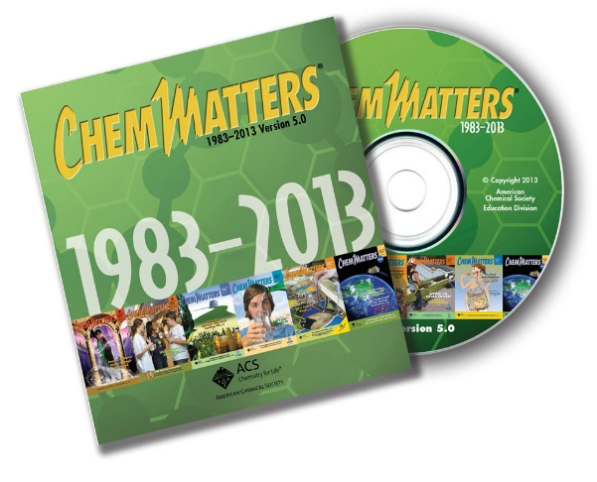
30 Years of ChemMatters

Available Now!

The references below can be found on the ChemMatters 30-year DVD (which includes all articles published during the years 1983 through April 2013 and all available Teacher’s Guides, beginning February 1990). The DVD is available from the American Chemical Society for $42 (or $135 for a site/school license) at this site: http://ww.acs.org/chemmatters. Scroll about half way down the page and click on the ChemMatters DVD image at the right of the screen to order or to get more information.

Selected articles and the complete set of Teacher’s Guides for all issues from the past three years are available free online on the same Web site, above. Simply access the link and click on the “Past Issues” button directly below the “M” in the ChemMatters logo at the top of the Web page.

The ChemMatters references cited below are related to the polymers used in the Wetterschneider 3D printer article.

Wood, C. Detergents. ChemMatters 1985, 3 (2), pp 4–7. Surfactants such as ABS are discussed and identified as environmental pollutants, resistant to bacterial decomposition. ABS contributes to the suds found in polluted rivers.

Wood, C. Dissolving Plastic. ChemMatters 1987, 5 (3), pp 12–15. This article is about another bioplastic, poly(vinyl alcohol), PVA. Hospitals put laundry in water-soluble laundry bags (made of PVA) to reduce the chance of exposure to infection. The PVA bag is tossed into the washer and as the laundry is cleaned, the bag dissolves completely in the hot water. The article discusses basic polymer chemistry including the formation of PVC. Student laboratory suggestions for solubility testing are given in the article. An envelope containing a PVA sample was included in the original magazine.

Downey, C. Biodegradable Bags. ChemMatters 1991, 9 (3), pp 4–6. This article describes making polylactic acid (PLA) bags from lactic acid formed by the fermentation of potato peelings. An experiment designed to examine the biodegradable properties of these bags is included in the article.

Black. H. Putting a High Grade on Degradables. ChemMatters 1999, 17 (2), pp 14–15. The process of making PLA for use as disposable garbage bags is described. These environmentally friendly bags can be decomposed by bacteria in compost heaps.

Washam, C. Plastics Go Green. ChemMatters 2010, 28 (2), pp 10–12. As the title implies, this article discusses ways to “green” our lives by replacing petrochemicals with bioplastics such as PLA (used in the Wetterschneider 3D printer article) and PHA (polyhydroxyalkanoate, a biodegradable bioplastic produced by the bacterial fermentation of sugars or lipids). On page 12, there is an in-class chemistry activity: “Make Your Own Compostable Bioplastic”, using corn starch. The reference for this lab comes from the Field Guide to Utah Agriculture in the Classroom, Volume 1: The URL given in the ChemMatters article is no longer available online, but the original lab activity, Corn Starch Plastic, can be found at https://utah.agclassroom.org/files/uploads/fieldguide1/plastic.pdf.
____________________

Selected Chemical and Engineering News (C&EN) articles address the topic of 3D printing. Some of these are available only to ACS members.

- Virginia Tech scientists have developed a process to 3D print with ionic liquids. Thus, they can print ion-conducting membranes for batteries and fuel cells, or grow tissues for bone and skin grafts. (http://cen.acs.org/articles/92/web/2014/11/Printing-3-D-Conductive-Materials.html) (available to all)

- A more recent article on the same research, in the December 1, 2014 issue of C&EN, is available to ACS members. (http://cen.acs.org/magazine/92/09248.html) (subscribers only)

- At Princeton University, researchers have 3D printed LEDs by stacking a layer of quantum dots on top of printed conductive polymers and between metallic contacts. This article is available to ACS members. (http://cen.acs.org/articles/92/i45/Extending-Reach-3-D-Printing.html) (subscribers only)

- This article addresses the business end of 3-D printing. Many people still consider the technology merely as a creative way to print and play. At the ACS National Meeting (San Francisco, August, 2014), Daniel Daly, chair of the ACS Division of Business Development & Management, spoke of the job opportunities in 3-D manufacturing such as GE’s use of 3-D printing for generating jet engine parts. http://cen.acs.org/articles/92/i37/3-D-Printing-Steps-Toward.html (available to all)

The MIT Technology Review reports that Harvard University is using 3-D technology to make objects that “sense and respond” to their environment. Princeton University researchers see the challenge to print 3-D artificial organs for drug testing or human replacement parts. They have printed eye tissue. This Web site contains a short, repeating video clip of the 3-D printing of the polymer layers to form a bionic ear. (http://www.technologyreview.com/featuredstory/526521/microscale-3-d-printing/)

Web Sites for Additional Information
(Web-based information sources)
More sites on obtaining or creating files to control 3D printers

This site sells 3D printers, but it also provides a very nice description of the types of printers and how they work: https://bootsindustries.com/portfolio-item/3d-printers-technology-rundown/.

More sites on 3D printed things

This site lists 30 things that are currently made by 3D printers. Note that they chose to omit any that referred to 3D printing of weapons. The objects printed range from “jet parts to unborn babies, icebergs to crime scenes, dolls to houses”.
(http://www.theguardian.com/technology/2014/jan/29/3d-printing-limbs-cars-selfies)

More sites on putting the finishing touches on 3D printed things

This site is for teachers to use with students to discuss solubility in depth. This will help in explaining the smoothing off of ABS plastic-3D printed objects by use of acetone. (http://www.masterorganicchemistry.com/2012/04/27/polar-protic-polar-aprotic-nonpolar-all-about-solvents/)

More sites on 3D bioprinting of tissues and organs

The ability to use biocompatible and biodegradable materials in 3D printers has opened the field of 3D printing to cells and supportive components of living systems. This research, published in Nature Biotechnology, December 05, 2013, provides detailed descriptions of these technologies including designing of files, types of bioprinters (inkjet, microextrusion, laser assisted), materials, scaffolds, and cell sources.
(http://www.nature.com/nbt/journal/v32/n8/full/nbt.2958.html)

More sites on Disney research on tactile surfaces

Disney Research Pittsburgh has produced 3D geometric features on touch screen surfaces. This allows a hiker to “feel” the ridges and bumps on a topography map or a blind person to detect the 3D shape of an apple. The energy produced by fingers sliding across or tapping the screen surface is sufficient to create the illusion of surface variations. The site contains an informative video and details regarding the algorithm and the calculation of the voltage requirement. (http://www.disneyresearch.com/project/3d-touch-surfaces/)

