logo_chemmatters[1]

**February/March 2016 Teacher's Guide for**

***Biomimicry: Taking Inspiration from Nature***

**Table of Contents**

[About the Guide 2](#_Toc441570231)

[Student Questions 3](#_Toc441570232)

[Answers to Student Questions 4](#_Toc441570233)

[Anticipation Guide 5](#_Toc441570234)

[Reading Strategies 6](#_Toc441570235)

[Background Information 9](#_Toc441570236)

[Connections to Chemistry Concepts 32](#_Toc441570237)

[Possible Student Misconceptions 32](#_Toc441570238)

[Anticipating Student Questions 33](#_Toc441570239)

[In-Class Activities 33](#_Toc441570240)

[Out-of-Class Activities and Projects 35](#_Toc441570241)

[References 36](#_Toc441570242)

[Web Sites for Additional Information 37](#_Toc441570243)

[More Web Sites on Teacher Information and Lesson Plans 41](#_Toc441570244)

# About the Guide

Teacher’s Guide editors William Bleam, Regis Goode, Donald McKinney, Barbara Sitzman and Ronald Tempest created the Teacher’s Guide article material. E-mail: [bbleam@verizon.net](mailto:bbleam@verizon.net)

Susan Cooper prepared the anticipation and reading guides.

Patrice Pages, *ChemMatters* editor, coordinated production and prepared the Microsoft Word and PDF versions of the Teacher’s Guide. E-mail: [chemmatters@acs.org](mailto:chemmatters@acs.org)

Articles from past issues of *ChemMatters* can be accessed from a DVD that is available from the American Chemical Society for $42. The DVD contains the entire 30-year publication of *ChemMatters* issues, from February 1983 to April 2013.

The *ChemMatters* DVD also includes Article, Title and Keyword Indexes that covers all issues from February 1983 to April 2013.

The *ChemMatters* DVD can be purchased by calling 1-800-227-5558.

Purchase information can be found online at [www.acs.org/chemmatters](http://chemistry.org/chemmatters/cd3.html).

# Student Questions

**(taken from the article)**

**Biomimicry: Taking Inspiration from Nature**

* 1. What is biomimicry?
  2. Under what circumstances are the glues mentioned in the article not effective?
  3. What kind of forces are involved when a glue sticks to a surface?
  4. List at least three uses for a good underwater glue.
  5. Identify two organisms that make their own underwater glue.
  6. Describe the blue mussel’s glue.
  7. How does the shell of the Namib Desert beetle help it collect water?
  8. How does the self-filling bottle apply the idea of the Namib beetle?
  9. What is the “lotus effect”?
  10. Based on the article, predict whether a water droplet on a water-repellent surface will have a greater or smaller contact angle than one on a non-repellent surface?
  11. List three uses of the lotus effect.

# Answers to Student Questions

**(taken from the article)**

**Biomimicry: Taking Inspiration from Nature**

* + 1. **What is biomimicry?**

*According to the article, biomimicry is a “… discipline devoted to using the designs of nature to create helpful products and solve problems.”*

* + 1. **Under what circumstances are the glues mentioned in the article not effective?**

*These otherwise strong glues do not work well under water.*

* + 1. **What kind of forces are involved when a glue sticks to a surface?**

*The forces involved are intermolecular forces of attraction.*

* + 1. **List at least three uses for a good underwater glue.**

*The article mentions five:*

1. *stopping the flow of blood in an injury,*
2. *dentists cementing false teeth or a crown,*
3. *repairing boats under water,*
4. *stopping a water pipe leak, and*
5. *making outdoor repairs in the rain.*
   * 1. **Identify two organisms that make their own underwater glue.**

*Barnacles and blue mussels are two organisms that make their own underwater glue.*

* + 1. **Describe the blue mussel’s glue.**

*The blue mussel produces a natural epoxy-type adhesive that is made in two separate compartments in the mussel. Secreted simultaneously, they form a tough glue that hardens in minutes. Chemically the components are made of several polymers.*

* + 1. **How does the shell of the Namib Desert beetle help it collect water?**

*The shell is covered in tiny bumps, the points of which are hydrophilic (attracting water) and the sides of the bumps are hydrophobic. Fog is the main water source, and tiny amounts of fog are attracted to the points of the bumps. Water accumulates there and, when enough accumulates, a drop forms, which then rolls down the bump onto the beetle’s back into a trough that leads to the mouth of the beetle.*

* + 1. **How does the self-filling bottle apply the idea of the Namib beetle?**

*The lid of the bottle is covered in tiny bumps made of hydrophilic aluminum oxide and hydrophobic polypropylene. Fog collects on the bumps as in the beetle and runs into a channel that fills the bottle.*

* + 1. **What is the “lotus effect”?**

*The lotus effect is the ability of a substance to repel water.*

* + 1. **Based on the article, predict whether a water droplet on a water-repellent surface will have a greater or smaller contact angle than one on a non-repellent surface?**

*Since a water droplet on a lotus leaf has a contact angle of 130o and a droplet on a piece of glass has a contact angle of 30o, it is likely that the water-repellent substance will have a greater contact angle, making the droplet more spherical and therefore more likely to roll off.*

* + 1. **List three uses of the lotus effect.**

*Three uses (the article provides four) of the lotus effect are:*

* + - 1. *the non-stick honey spoon,*
      2. *stain-repellent fabrics using nanotechnology,*
      3. *Lotusan self-cleaning paints, and*
      4. *super-hydrophobic coatings on the surfaces of windows, mirrors, airplanes and boats.*

# Anticipation Guide

Anticipation guides help engage students by activating prior knowledge and stimulating student interest before reading. If class time permits, discuss students’ responses to each statement before reading each article. As they read, students should look for evidence supporting or refuting their initial responses.

**Directions:**  ***Before reading*,** in the first column, write “A” or “D,” indicating your agreement or disagreement with each statement. As you read, compare your opinions with information from the article. In the space under each statement, cite information from the article that supports or refutes your original ideas.

|  |  |  |
| --- | --- | --- |
| **Me** | **Text** | **Statement** |
|  |  | 1. Engineers often look to nature for solutions to problems. |
|  |  | 1. Glue bonds with the surface of molecules through intermolecular attraction. |
|  |  | 1. Glue that works under water would be very helpful to surgeons and dentists. |
|  |  | 1. Blue mollusks produce underwater glue in two separate compartments in their bodies. |
|  |  | 1. Underwater glue has been developed for commercial use. |
|  |  | 1. Cross-linked polymers make a very strong adhesive. |
|  |  | 1. Hydrophilic substances repel water. |
|  |  | 1. The desert beetle that collects water has very smooth wings. |
|  |  | 1. Water condensed from fog or mist in desert areas is salty. |
|  |  | 1. Fabrics that repel water and stains use nanotechnology. |

# Reading Strategies

These graphic organizers are provided to help students locate and analyze information from the articles. Student understanding will be enhanced when they explore and evaluate the information themselves, with input from the teacher if students are struggling. Encourage students to use their own words and avoid copying entire sentences from the articles. The use of bullets helps them do this. If you use these reading and writing strategies to evaluate student performance, you may want to develop a grading rubric such as the one below.

|  |  |  |
| --- | --- | --- |
| **Score** | **Description** | **Evidence** |
| 4 | Excellent | Complete; details provided; demonstrates deep understanding. |
| 3 | Good | Complete; few details provided; demonstrates some understanding. |
| 2 | Fair | Incomplete; few details provided; some misconceptions evident. |
| 1 | Poor | Very incomplete; no details provided; many misconceptions evident. |
| 0 | Not acceptable | So incomplete that no judgment can be made about student understanding |

***Teaching Strategies:***

1. Links to **Common Core Standards for Reading**:
   1. ELA-Literacy.RST.9-10.1:Cite specific textual evidence to support analysis of science and technical texts, attending to the precise details of explanations or descriptions.
   2. ELA-Literacy.RST.9-10.5: Analyze the structure of the relationships among concepts in a text, including relationships among key terms (e.g., force, friction, reaction force, energy).
   3. ELA-Literacy.RST.11-12.1:Cite specific textual evidence to support analysis of science and technical texts, attending to important distinctions the author makes and to any gaps or inconsistencies in the account.
   4. ELA-Literacy.RST.11-12.4: Determine the meaning of symbols, key terms, and other domain-specific words and phrases as they are used in a specific scientific or technical context relevant to grades 11-12 texts and topics.
2. Links to **Common Core Standards for Writing**:
   1. ELA-Literacy.WHST.9-10.2F: Provide a concluding statement or section that follows from and supports the information or explanation presented (e.g., articulating implications or the significance of the topic).
   2. ELA-Literacy.WHST.11-12.1E: Provide a concluding statement or section that follows from or supports the argument presented.
3. **Vocabulary** and **concepts** that are reinforced in this issue:
   1. Chemistry and Health
   2. Evaluating scientific claims
   3. Hydrophobic and hydrophilic substances
   4. Structural formulas
   5. Chemical engineering
   6. Intermolecular forces
4. **“Open for Discussion”** on page 4 of this issue provides excellent information about why different scientific studies might yield different results. You might consider relating this information to the articles in this issue about salt in food, kombucha, and e-cigarettes. Students can compare the different types of studies (randomized controlled trials and observational studies) to help them decide what information they need to make informed choices.
5. To help students engage with the text, ask students which article **engaged** them most and why, or what **questions** they still have about the articles. The Background Information in the *ChemMatters* Teachers Guide has suggestions for further research and activities.

**Directions**: As you read, complete the graphic organizer below to describe products inspired by nature.

|  |  |  |
| --- | --- | --- |
| **Object from Nature** | **Product** | **How it works (scientific principles)** |
| **Burs from burdock plant** |  |  |
| **Geckos** |  |  |
| **Blue mussels** |  |  |
| **Namib Desert beetle** |  |  |
| **Lotus plant** |  |  |

**Summary:** On the back of this sheet, write a brief summary (3-5 sentences) explaining what you learned about the work of chemical engineers from reading this article.

# Background Information

**(teacher information)**

Life can be thought of as a long-running research and development program that has yielded invaluable design ideas. Long before human beings began tinkering in labs, organisms had developed carbon capture and sequestration systems, water harvesting techniques, water transport systems, adhesives, colorfast materials, electronic circuits, distributed energy conversion systems, color displays, light absorbers, insulation, thermal dissipators, and information storage, along with countless other designs. All of these are blueprints for technologies that are not only useful to society but are also integral to the global economy. Companies that learn from nature are increasing revenues, mitigating risk, reducing costs, and supporting the development of a sustainable society.

(<http://www.terrapinbrightgreen.com/wp-content/uploads/2015/03/Tapping-into-Nature-2015p1.pdf>)

The Rohrig article focuses on a brief explanation of biomimicry and a few interesting examples. If we broaden the lens through which we look at biomimicry we find multiple questions, concepts and ideas that can be of real interest in a high school chemistry class. As a simple example, the quote above refers to life as a “long-running research and development” program.” Teachers often talk to students about the importance of being life-long learners, but using the term “long-running research and development program” casts life-long learning in new terms.

From an even broader perspective it is worth noting that biomimicry does not, in and of itself, concern itself solely with chemistry. The text below suggests that the biomimicry framework was derived from many disciplines, including chemistry. Chemistry occupies a place in biomimetic thinking since chemical processes occur naturally and chemistry is, therefore, part of the natural world from which biomimicry is derived.

**More on** **the history of** **biomimicry**

The term “biomimicry” is derived from *bios* meaning life and *mimensis*, to imitate. The idea is not new. Both Leonard de Vinci’s flying machine (right), designed in 1485, and the Wright brother’s first airplane were both inspired by the wings of birds.

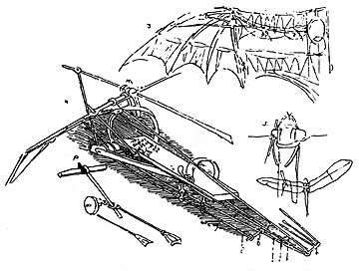

*(*[*http://www.flyingmachines.org/davi.html*](http://www.flyingmachines.org/davi.html)*)*

People over the centuries have tried to copy nature in various ways. The earliest attempts may have been a rather simplistic approach: prehistoric man using the skins or fur hides of the large animals they killed for food to wrap around the humans’ bodies to keep them warm in cold climates.

Spinning wool hair into yarn and cotton fibers to make threads mimicked what people saw in spider webs and silk from silkworms. And then along came new synthetic fibers produced by chemists to replicate the properties of these and other natural fibers. Rayon was the first on the market in the 1890s. Derived from natural cellulose, it is not a true synthetic, but the cellulose requires significant chemical treatment to make rayon. And this discovery led to other, truly synthetic fibers, their feedstocks typically being petroleum derivatives. Acrylic, nylon and polyester are just three of the myriad synthetic fibers that the chemical industry now produces.

Even the idea of the switchover from man as hunter-gatherer to domesticator of animals and cultivator of crops—growing food crops and raising livestock under controlled conditions—can be seen as attempts at biomimicry, attempts to mimic (and improve upon) nature in growing and raising food staples.

**More on biomimicry**

But the modern term “biomimicry” originated with Janine Benyus in her 1997 book *Biomimicry: Innovation Inspired by Nature*, and the approach is slightly different. While the idea of copying nature is still front-and-center, the concept now focuses on making the new product/invention sustainable and beneficial to the earth.

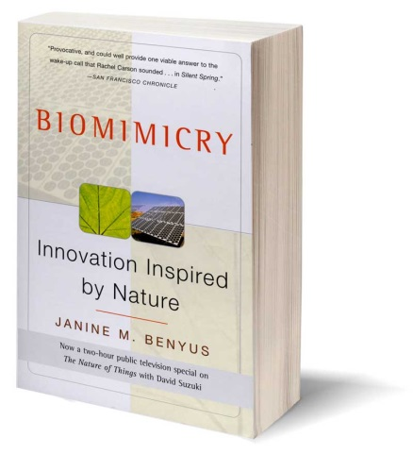

*(*[*http://biomimicry.org/janine-benyus/#.VlH4x3arSM8*](http://biomimicry.org/janine-benyus/#.VlH4x3arSM8))

In her *Biomimicry Primer*, Benyus offers a definition: “Biomimicry is learning from and then emulating natural forms, processes, and ecosystems to create more sustainable designs.” Benyus has assembled ideas from a number of scientific disciplines and constructed a framework of thinking about the ways in which natural processes and organisms produce materials and process energy.

According to “Conversation with Janine”, from Benyus’ Web site, Biomimicry 3.8 (the “3.8” for the 3.8 billion years of life’s evolution on Earth) (<http://biomimicry.net/about/biomimicry/conversation-with-janine/>), three major tenets of biomimicry are to:

* **Use nature as a model** – study the processes in nature and imitate them or adapt them to solve human problems,
* **See nature as a mentor** – since nature has learned “what works, what is appropriate and what lasts” use nature as a guide, and
* **Use nature as a measuring stick** – look at human behavior and modern society in terms of what nature values and what humans can learn from nature.

Biomimicry thinking helps create products and processes that:

**Are sustainable** | Biomimicry follows [Life’s Principles](http://biomimicry.net/about/biomimicry/biomimicry-designlens/lifes-principles/). Life’s Principles instruct us to build from the bottom up, self-assemble, optimize rather than maximize, use free energy, cross-pollinate, embrace diversity, adapt and evolve, and use life-friendly materials and processes, engage in symbiotic relationships, and enhance the bio-sphere. By following the principles life uses, you can create products and processes that are well adapted to life on earth.

**Perform well** | In nature, if a design strategy is not effective, its carrier dies. Nature has been vetting strategies for 3.8 billion years. Biomimicry helps you study the successful strategies of the survivors, so you can thrive in your marketplace, just as these strategies have thrived in their habitat.

**Save energy** | Energy in the natural world is even more expensive than in the human world. Plants have to trap and convert it from sunlight and predators have to hunt and catch it. As a result of the scarcity of energy, life tends to organize extremely energy efficient designs and systems, optimizing energy use at every turn. Emulating these efficiency strategies can dramatically reduce the energy use of your company. Greater efficiency translates to energy cost savings and greater profitability.

**Cut material costs** | Nature builds to shape, because shape is cheap and material is expensive. By studying the shapes of nature’s strategies and how they are built, biomimicry can help you minimize the amount your company spends on materials while maximizing the effectiveness of your products patterns and forms to achieve their desired functions.

**Redefine and eliminate “waste”** | By mimicking how nature transitions materials and nutrients within a habitat, your company can set up its various units and systems to optimally use resources and eliminate unnecessary redundancies. Organizing your company’s habitat flows more similarly to nature’s, will drive profitability through cost savings and/or the creation of new profit centers focused on selling your waste to companies who desire your “waste” as a feedstock.

**Heighten existing product categories** | Biomimicry helps you see stale product categories in a radically different light. This new sight creates an opportunity for innovation.

**Define new product categories and industries** | Biomimicry can help you create disruptive technologies, that transform your industry or help you build entirely new industries.

**Drive revenue** | Biomimicry can help you create whole new growth areas, reignite stale product categories and attract both customers who care about innovation and sustainability.

**Build your brand** | Creating biomimetic products and processes will help your company become known as both innovative and proactive about the environment.

(<http://biomimicry.net/about/biomimicry/>)

The foundation for these principles is Benyus’ Life Principles, which are actually design principles. On the biomimicry web site these are described this way:

Life’s Principles are design lessons from nature. Based on the recognition that Life on Earth is interconnected and interdependent, and subject to the same set of operating conditions, Life has evolved a set of strategies that have sustained over 3.8 billion years. Life’s Principles represent these overarching patterns found amongst the species surviving and thriving on Earth. Life integrates and optimizes these strategies to create conditions conducive to life. By learning from these deep design lessons, we can model innovative strategies, measure our designs against these sustainable benchmarks, and allow ourselves to be mentored by nature’s genius using Life’s Principles as our aspirational ideals.

(<http://biomimicry.net/about/biomimicry/biomimicry-designlens/lifes-principles/>)

You can compare this version of design principles with those often used in engineering design processes and you will see similarities, most notably in the iterative nature of the process—design, test, repeat.

Also, if the language in the above quote seems familiar, it is, in fact, evolution that Benyus is talking about when she refers to “these overarching patterns found amongst the species surviving and thriving on Earth.”

Three of the biomimicry principles seem to be especially relevant to chemical changes. They are the ones that stress cutting material costs, saving energy and eliminating waste products. Many traditional chemical processes used industrially use increasingly expensive petroleum-based reactants, require high temperatures and pressures and produce what have been considered useless waste products or by-products. More and more chemists are striving to mimic nature in that most natural chemical processes are water-based, occur at ambient temperatures, and the products are all useful in some way. This is the arena of green chemistry, described more fully in the next section of the Teacher’s Guide.

Note that, early in these principles, one of the purposes is to create products, and these may be chemicals like the adhesives, self-filling bottle and self-cleaning plant described in the Rohrig article.

In current practice biomimicry can also be thought of as a part of bionics, which also includes bioengineering, biomechanics, and integrated design systems. Bionic designs fall into one of two categories: analogic and composition synthetic design systems. Analogic systems are technical systems based on biological principles, and these are what most people think about as biomimicry. Examples are radar based on bat echolocation, the strength of spider webs and other examples described in the article. Composition systems are a mix of both technical and biological components. Examples include computer network systems that require human maintenance, chemical syntheses that use biological catalysts and humans wearing prosthetic devices or pacemakers.

Another system of organizing biomimetic engineering is:

1. Mimicking the way in which nature manufactures chemical compounds. This is the strongest link between biomimicry and green chemistry.
2. Imitating mechanisms (like Velcro or echolocation) found in nature.
3. Imitating organizational principles found in nature, like the behavior of bees or ants.

**More on** **green chemistry**

Biomimicry and Green Chemistry offer a new way of valuing nature and designing in sustainable ways. Biomimicry is the practice of emulating life's time-tested strategies and deep patterns to generate sustainable designs and practices. The Green Chemistry movement is based on the designing of chemical products and processes that reduce or eliminate toxic or hazardous materials.

The American Chemical Society’s Green Chemistry Institute (GCI) Web site describes green chemistry as “the design of chemical products and processes that reduce or eliminate the use and generation of hazardous substances.” Further, it states that “Chemists and engineers are designers who have the unique ability to affect molecules, materials, products, processes, and systems at the earliest possible stages of their development.”

The 12 principles of green chemistry were developed by Paul Anastas and John Warner\*. The following list outlines an early conception of what would make a greener chemical, process, or product. (Clicking on any of the titles will take you to more information on that topic by a green chemistry expert.)

[**Prevention**](http://www.acs.org/content/acs/en/greenchemistry/what-is-green-chemistry/principles/gc-principle-of-the-month-1.html)  
It is better to prevent waste than to treat or clean up waste after it has been created.

[**Atom Economy**](http://www.acs.org/content/acs/en/greenchemistry/what-is-green-chemistry/principles/gc-principle-of-the-month-2.html)  
Synthetic methods should be designed to maximize the incorporation of all materials used in the process into the final product.

[**Less Hazardous Chemical Syntheses**](http://www.acs.org/content/acs/en/greenchemistry/what-is-green-chemistry/principles/green-chemistry-principle-3.html)  
Wherever practicable, synthetic methods should be designed to use and generate substances that possess little or no toxicity to human health and the environment.

[**Designing Safer Chemicals**](http://www.acs.org/content/acs/en/greenchemistry/what-is-green-chemistry/principles/gc-principle-of-the-month-4.html#articleContent_headingtext_2)  
Chemical products should be designed to affect their desired function while minimizing their toxicity.

[**Safer Solvents and Auxiliaries**](http://www.acs.org/content/acs/en/greenchemistry/what-is-green-chemistry/principles/green-chemistry-principle--5.html)  
The use of auxiliary substances (e.g., solvents, separation agents, etc.) should be made unnecessary wherever possible and innocuous when used.

[**Design for Energy Efficiency**](http://www.acs.org/content/acs/en/greenchemistry/what-is-green-chemistry/principles/green-chemistry-principle--6.html)  
Energy requirements of chemical processes should be recognized for their environmental and economic impacts and should be minimized. If possible, synthetic methods should be conducted at ambient temperature and pressure.

[**Use of Renewable Feedstocks**](http://www.acs.org/content/acs/en/greenchemistry/what-is-green-chemistry/principles/green-chemistry-principle--7.html)  
A raw material or feedstock should be renewable rather than depleting whenever technically and economically practicable.

[**Reduce Derivatives**](http://www.acs.org/content/acs/en/greenchemistry/what-is-green-chemistry/principles/green-chemistry-principle--8.html#articleContent_headingtext)  
Unnecessary derivatization (use of blocking groups, protection/ deprotection, temporary modification of physical/chemical processes) should be minimized or avoided if possible, because such steps require additional reagents and can generate waste.

[**Catalysis**](http://www.acs.org/content/acs/en/greenchemistry/what-is-green-chemistry/principles/green-chemistry-principle--9.html#articleContent_headingtext)  
Catalytic reagents (as selective as possible) are superior to stoichiometric reagents.

[**Design for Degradation**](http://www.acs.org/content/acs/en/greenchemistry/what-is-green-chemistry/principles/green-chemistry-principle--10.html#articleContent_headingtext)  
Chemical products should be designed so that at the end of their function they break down into innocuous degradation products and do not persist in the environment.

[**Real-time analysis for Pollution Prevention**](http://www.acs.org/content/acs/en/greenchemistry/what-is-green-chemistry/principles/green-chemistry-principle--11.html)  
Analytical methodologies need to be further developed to allow for real-time, in-process monitoring and control prior to the formation of hazardous substances.

[**Inherently Safer Chemistry for Accident Prevention**](http://www.acs.org/content/acs/en/greenchemistry/what-is-green-chemistry/principles/green-chemistry-principle--12.html)  
Substances and the form of a substance used in a chemical process should be chosen to minimize the potential for chemical accidents, including releases, explosions, and fires.

\*Anastas, P. T.; Warner, J. C. Green Chemistry: Theory and Practice, Oxford University Press: New York, 1998, p.30. By permission of Oxford University Press

(<http://www.acs.org/content/acs/en/greenchemistry/what-is-green-chemistry/principles/12-principles-of-green-chemistry.html>)

The GCI Web site says this about the principles: “The principles of green chemistry and green engineering provide a framework for scientists and engineers to use when designing new materials, products, processes and systems. The principles focus one's thinking in terms of sustainable design criteria and have proven time and again to be the source of innovative solutions to a wide range of problems. Systematic integration of these principles is key to achieving genuine sustainability for the simultaneous benefit of the environment, economy, and society.”

The intent of providing both the biomimicry and the green chemistry sets of principles is to allow you and your students to make the connection between the larger set of principles (biomimicry) and the subset of principles (GCI) and to recognize that not all examples of biomimicry are related to chemistry. The article provides three examples—natural adhesives, water collecting methods and self-cleaning surfaces—which do, in fact, apply to concepts and studies in chemistry.

Both green chemistry and biomimicry are part of a growing interest in chemistry for sustainability, which means using processes and resources that are less damaging to the environment. Dr. Terry Collins, professor of chemistry at Carnegie Mellon University and a leading expert on sustainability, says:

“When chemists teach their students about the compositions, outcomes, mechanisms, controlling forces, and economic value of chemical processes, the attendant dangers to human health and to the ecosphere must be emphasized across all courses. In dedicated advanced courses, we must challenge students to conceive of sustainable processes and orient them by emphasizing through concept and example how safe processes can be developed that are also profitable.

“Green or sustainable chemistry can contribute to achieving sustainability in three key areas. First, renewable energy technologies will be the central pillar of a sustainable high-technology civilization. Chemists can contribute to the development of the economically feasible conversion of solar into chemical energy and the improvement of solar to electrical energy conversion. Second, the reagents used by the chemical industry, today mostly derived from oil, must increasingly be obtained from renewable sources to reduce our dependence on fossilized carbon. This important area is beginning to flourish … Third, polluting technologies must be replaced by benign alternatives.”

(<http://www.sciencemag.org/cgi/content/full/291/5501/48>)

(above quote from the Teacher’s Guide for the following article from *ChemMatters*: Parent, K. and Young, J. Biomimicry—Where Chemistry Lessons Come Naturally. *ChemMatters*, 2006, *24* (2), pp 15–17)

And at the crossroads of biomimicry and green chemistry, Janine Benyus, at the forefront of the biomimicry movement, and John Warner, recognized as the father of green chemistry, have begun working together to solve some problems facing big business. Covering a 2010 forum panel at which both spoke, Scott Cooney, Principal of GreenBusinessOwner.com, reports that

Together with Benyus, the two [Warner and Benyus] have helped several California-based startups solve complex biochemical issues. Benyus’s group found a way that bacteria were able to solidify their cell walls by producing a certain protein. Turning that over to Warner’s group, they were able to help make a vaccine that didn’t need refrigeration. The implications? Medical facilities across the world no longer need freezers.

Chilling? I know when she mentioned this, it sent shivers down my spine. Similarly, they’ve managed to find out the process by which coral fixes carbon in the ocean, and use that to fix carbon coming out of smokestacks. Cool, right? It gets better–this product can replace Portland Concrete, which, because it has to be superheated for so long, accounts for 6-8% of ALL CARBON EMISSIONS GLOBALLY.

(<http://www.triplepundit.com/2010/10/biomimicry-green-chemistry-collide/>)

**More on quotes abut biomimicry**

Here are several quotes about biomimicry.

“We know that green chemistry works. We know that biomimicry works. Is there a possibility that the two crossing will create good things? The more appropriate question may be: is there a possibility it won’t?”

~ Scott Cooney, Principal of GreenBusinessOwner.com

“You could look at nature as being like a catalog of products, and all of those have benefited from a 3.8 billion year research and development period. And given that level of investment, it makes sense to use it.”

~ Michael Pawlyn, biomimicry proponent, quoted from a TED talk

(<http://www.ted.com/talks/michael_pawlyn_using_nature_s_genius_in_architecture/transcript>)

And, in Dr. Janine Benyus’s own words,

We're basically this very young species, only 200,000 years old. We're one of the newcomers, and we're going through the same process that other species go through, which is, how do I keep myself alive while taking care of the place that's going to keep my offspring alive? And if you don't learn how to do both of those things in the natural world, you essentially go extinct.

We're trying to figure out how to keep the place in shape, to take care of the place that's going to take care of our offspring. And the way you do that is you figure out a way to do chemistry without persistent toxins. You figure out a way to use the minimum amount of materials, and the minimum amount of energy, and you figure out a way to get your needs met locally. I feel like [organisms] are sitting there sort of waving their arms saying, "Look over here! For god's sake, don't do it like that!"

(<http://www.bloomberg.com/news/articles/2013-08-16/whose-intellectual-property-can-i-rip-off-without-worry-dumb-question>)

“Life creates conditions conducive to life.”

~ Janine Benyus

**More on blue mussels and barnacles**

Blue mussels and barnacles both have amazing properties relative to creating underwater adhesives. Their methods of producing their individual adhesive, however, are very different. We’ll talk about each individually.

**Blue mussels**

Blue mussels (Mytilus edulis) are bivalves that attach to rocks in intertidal seashores. They produce adhesives comparable in strength to human-made glues but without carcinogens such as formaldehyde and which can cure under water.

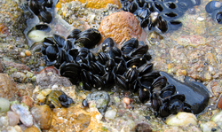

*(*[*http://www.asknature.org/strategy/1052eed7fd56c4933871c04b65b1cafb*](http://www.asknature.org/strategy/1052eed7fd56c4933871c04b65b1cafb)*)*

A key feature of the blue mussel’s unique adhesive chemistry is the presence of the amino acid 3,4-dihydroxyphenylalanine, with a functional group (two hydroxyl groups sticking out from a benzene ring) that forms strong bonds on adjacent molecules and with metal atoms present in the surface of most natural solid substrates. Another key feature is the ability of the molecules to overcome a solid surface's otherwise strong preference for water molecules (which is why conventional adhesives fail on wet surfaces)

(<http://www.asknature.org/strategy/1052eed7fd56c4933871c04b65b1cafb>)

The glue produced by the blue mussel, *Mytilus edulis*, according to Dr. Herbert Waite, who is now at the University of California at Santa Barbara, is actually “a bundle of threads collectively referred to as the byssus. Byssal threads are permanent holdfasts and extraordinary biomolecular materials; they are strong, rapidly made, durable and adhere to a wide variety of surfaces including glass, metal, paraffin and bone.

Mussels (*mytilus trossulus*) attach to substratum with byssal threads.   
Photo: Emily Carrington.

*(*[*http://depts.washington.edu/nucella/mussel-byssal-threads/*](http://depts.washington.edu/nucella/mussel-byssal-threads/)*)*

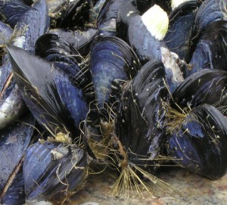

A careful morphological examination of byssus reveals it to be a complex composite material with at least four functional domains: load-bearing fibers, microcellular solids, sealants and adhesion promoters. … We are using protein chemistry, molecular biology and a variety of physical methods including laser mass spectrometry, solid-state NMR and atomic force microscopy to reveal sequence, structure and solution behavior. Our aim is ultimately to process the appropriate protein(s) into useful applications that mimic their adapted functions in the mussels.”

(<http://www.chem.ucsb.edu/people/j-herbert-waite>)

Applications of this “superglue” might include plywood manufacture, wood veneers, particle board and other wood products. Other uses might include biological glue for surgery and dentistry.

In January, 2004, Jonathan Wilker, Mary Sever and their colleagues at Purdue University announced their discovery that iron in seawater is the key binding agent in the glue. In trying to make the glue synthetically, the researchers discovered that mussels and other bivalves extract the metal iron from the surrounding seawater and use it to join proteins together, linking the fibrous molecules into a strong, adhesive mesh. Wilker says, "We are curious as to whether or not this newly discovered, metal-mediated protein cross-linking mechanism of material formation is a prevalent theme in biology. We will be exploring systems such as barnacle cement, kelp glue and oyster cement to see how other biomaterials are produced." (<http://www.eurekalert.org/pub_releases/2004-01/nsf-ccs010704.php>)

According to research chemist Mike Clarke, "Proteins often rely on metal ions to tie them together and provide stability, but this is the first time that a transition metal ion [iron] has been determined to be an integral part of a biological material. The research wonderfully illustrates the potential for metal ions to strengthen materials by cross-linking polymer chains.”

For more information on blue mussels, see “Stuck on You” in this same issue of *ChemMatters* (Agner, M. Stuck on You. *ChemMatters*, 2016, *34* (1), pp 8–10), and this same Teacher’s Guide that accompanies that article.

**Barnacles**

Barnacles, like mussels, secrete an underwater glue. They use the glue they secrete to stick to objects, where they live out their life. They are a drag—literally—on ocean-going vessels. They accumulate and weigh down ships, slowing them down and wasting fuel. They have to be scraped off ships and buoys and other objects remaining in the ocean for long periods (see photo at right).

Barnacles that grew on the bottom of an ocean buoy

*(*[*http://www.learner.org/jnorth/images/graphics/a-b/barnacle\_a.jpg*](http://www.learner.org/jnorth/images/graphics/a-b/barnacle_a.jpg)*)*

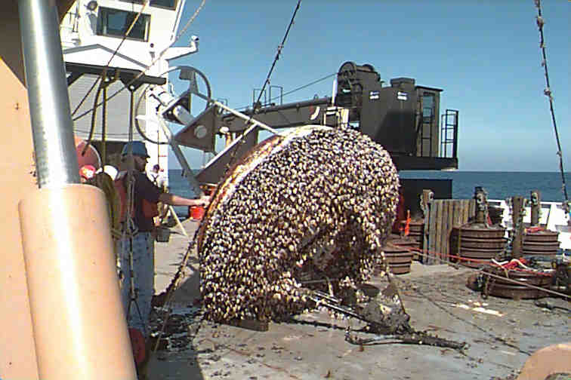

Darwin was the first to study them in depth. He undertook an 8-year project to learn all he could about barnacles in order to correct their then-flawed biological classification scheme and to better prepare him for the unveiling of his research in, and new theory on, evolution. Barnacles had been classified as mollusks by the early 1800s, since they had hard shells. But several researchers in the 1830s and 40s saw evidence that they were really crustaceans, based on changes in the larval stages.

Darwin’s close observation of myriad species of barnacles sent to him from friends and colleagues around the world showed him that barnacles had segmentation, making them more closely related to crustaceans. And his extensive research on barnacles resulted in the scientific world changing their minds about the way barnacles had been classified, making them crustaceans, part of the phylum *arthropoda*, rather than being part of the phylum *mollusca*.

Part of Darwin’s keen observations dealt with the ability of barnacles to attach to underwater objects. He described “cement glands” in the barnacle larva that ejected the glue that allowed the barnacle to attach to objects, although he had no idea about the composition of the glue, or how this whole process was accomplished.

Despite the intense scrutiny barnacles have received in the 150-plus years since Darwin’s research, it is only since 2014 that scientists have understood how barnacles are able to attach themselves to underwater objects—inorganic or organic. In July 2014, Dr. Dick Aldred, head of an international research team, published in the prestigious academic journal *Nature Communications* the findings of their research into the mechanism of barnacle attachment.

The glue from the barnacle appears to be significantly different from that of the blue mussel. Although there are two components of the barnacle glue, as in the mussel glue, the similarity ends there. The barnacle has essentially three forms in its life cycle, the naupliar larva stage, the cypris (cyprid) larva stage, and the adult barnacle.

The life cycle of a barnacle

*(*[*http://www.asnailsodyssey.com/IMAGES/BARNACLE/PechenikEtAl1998Fig3.gif*](http://www.asnailsodyssey.com/IMAGES/BARNACLE/PechenikEtAl1998Fig3.gif)*)*

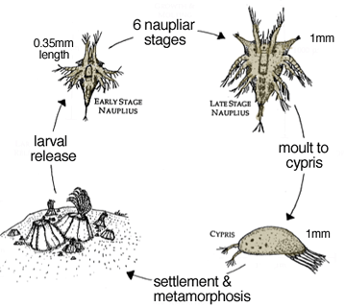

In the barnacle larva, the two components don’t combine to form the glue. Instead, the first component is an oily secretion that simply moves water away from the site of fixation. With the water removed from the site, the second component of the secretion, which IS the adhesive, simply attaches the barnacle larva to the substrate, resulting in a very secure attachment that will in all likelihood last for the life of the barnacle, and perhaps beyond.

It is the cypris (cyprid) form of the larva, the final larval stage, which determines the future abode of the adult barnacle (see diagram at right). The cyprid lays down the oil layer that pushes the water away so that the secretion of the actual phosphoprotein glue can take hold. Once the cyprid has secreted the glue, the barnacle is essentially stationery at that location for the remainder of its life, unless it is somehow rubbed off the surface of the medium.

The barnacle is apparently the only crustacean that has the second larval stage, the cyprid. The nauplius, is typical of crustaceans. It is a free-swimming stage that ingests plankton for nourishment. The cyprid has no gut and cannot eat; thus it is imperative that it finds something to latch onto quickly so that the next stage of metamorphosis can occur before the cyprid dies.

Once again nature has found a solution to an adhesive that works underwater—a problem with which man is still grappling, despite decades of research. According to Dr. Aldred, “It’s an incredibly clever natural solution to this problem of how to deal with a water barrier on a surface. It will change the way we think about developing bio-inspired adhesives that are safe and already optimised to work in conditions similar to those in the human body, as well as marine paints that stop barnacles from sticking.” In other words, nature has shown us how.

Like for the discovery involving blue mussel glue, scientists have great expectations for the development and application of man-made glues using similar approaches to glue for wet environments. An added bonus here is that the research techniques this team used may allow researchers may to study organisms in order to produce materials that will prevent biofouling—the accumulation of barnacles and other organisms on ship bottoms that waste fuel and make the ship engines work harder due to increased drag. (<http://phys.org/news/2014-07-nature-strongest-unstuck.html>)

One more little tidbit of information about barnacles and mussels: Barnacles habitually attach themselves to mussels and many spend their lives on the back of a mussel. The term for this relationship is epibiotic, “living on top”. The attached barnacle benefits in a number of ways by this relationship: there is an increased surface area on which to settle, reducing competition; and, being close to the intake and outflow siphons which the mussel uses to process seawater for food, it gets food carried by currents past the two creatures. The mussel would seem to be bearing more than its share of the load (pun intended), since it must compete for food with the barnacle, and the barnacle’s extra surface area on the back of the mussel increases drag from seawater flowing over its normally streamlined shell, forcing it to anchor itself more securely with an enhanced byssus than it would normally. Whether the mussel also benefits from the situation is presently under study. (<http://www.thenakedscientists.com/HTML/articles/article/barnacles-mussel-in/>)

**More on intermolecular forces**

The Rohrig biomimicry article references intermolecular forces that are responsible for the adhesive properties of the glue. There are three types of intermolecular forces. In order of increasing strength, they are: London dispersion forces, dipole-dipole interactions, and hydrogen bonds. These forces collectively are called van der Waals forces.

London dispersion forces (one of the three forces that are, in aggregate, known as van der Waals forces) arise from temporary charges … in non-polar molecules involving atoms with larger number of electrons. Dipole-dipole interactions (the second type of van der Waals forces) are electrostatic forces created by the partial positive and negative charges within neighboring molecules that exhibit some degree of polarity. Hydrogen bonds (the last of van der Waals forces) are the best known of the three and are the attractions between a polar covalently bonded hydrogen atom in one molecule and an electronegative atom with one (or more) nonbonding pair(s) of valence electrons in a neighboring molecule. Hydrogen bonding occurs most often in covalently bonded molecules involving nitrogen, oxygen, fluorine and chlorine.

(Teacher’s Guide for the October 2005 issue of *ChemMatters* to accompany this article: Rohrig, B. The Amazing Drinking Bird. *ChemMatters,* 2005, *23* (3), pp 10–11)

For more information on intermolecular forces and their application to adhesives, see “More on adhesion, cohesion and intermolecular forces” in the Teacher’s Guide for “Stuck on You”, also found within this document.

**More on the Namib** **Desert beetle**

The beetle mentioned in the Rohrig article, the Namib Desert beetle, *Stenocara gracilipes*, is also known as the Fogstand Beetle (see below to discover why).

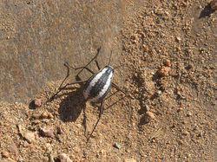

Namib Desert beetle *Stenocara gracilipes*

(aka Racing Stripe Darkling Beetle)

*(*[*http://www.asknature.org/strategy/dc2127c6d0008a6c7748e4e4474e7aa1*](http://www.asknature.org/strategy/dc2127c6d0008a6c7748e4e4474e7aa1)*)*

Darkling beetles (family Tenebrionidae) of the Namib Desert, located on the southwest coast of Africa, live in one of the driest habitats in the world. But some species of Darkling beetle can get the water they need from dew and ocean fog, using their very own body surfaces. Several researchers are studying the beetles, as well as synthetic surfaces inspired by the beetle’s body, to uncover the roles that structure, chemistry, and behavior play in capturing water from the air.

Micro-sized grooves or bumps on the beetle’s hardened forewings can help condense and direct water toward the beetle’s awaiting mouth, while a combination of hydrophilic (water attracting) and hydrophobic (water repelling) areas on these structures may increase fog- and dew-harvesting efficiency. For certain species of Darkling beetle, the act of facing into the foggy wind and sticking its rear end up in the air (known as fog-basking behavior) is thought to be just as important as body surface structure for successfully harvesting water from the air.

(<http://www.asknature.org/strategy/dc2127c6d0008a6c7748e4e4474e7aa1>)

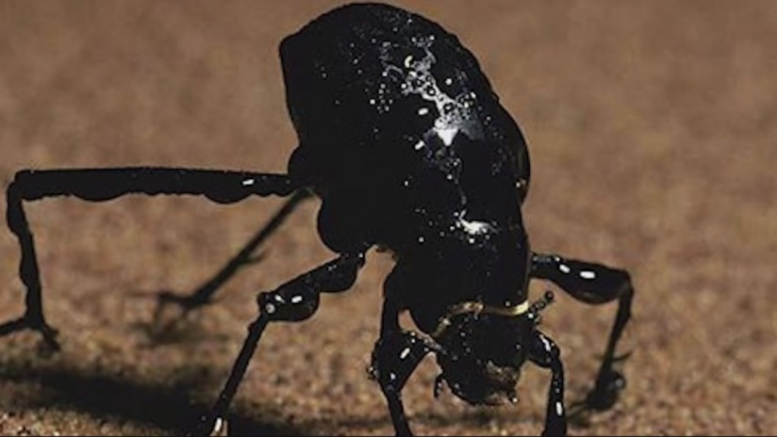To drink water, the *S. gracilipes* stands on a small ridge of sand using its long, spindly legs. Facing into the breeze, the beetle catches fog droplets on its hardened wings. Minute water droplets (15-20 µm in diameter) from the fog gather on its wings; there the droplets stick to hydrophilic (water-loving) bumps, which are surrounded by waxy, hydrophobic troughs. Droplets flatten as they make contact with the hydrophilic surfaces, preventing them from being blown by wind and providing a surface for other droplets to attach.

The Namib Desert beetle in position to “drink” fog

*(*[*http://www.wcvb.com/news/beetles-being-used-solve-waterloving-waterhating-issues/29677374*](http://www.wcvb.com/news/beetles-being-used-solve-waterloving-waterhating-issues/29677374)*)*

Accumulation continues until the combined droplet weight overcomes the water's electrostatic attraction to the bumps as well as any opposing force of the wind; in a 30 km/h breeze, such a droplet would stick to the wing until it grows to roughly 5 mm in diameter; at that point it will roll down the beetle's back to its mouthparts.

(<https://en.wikipedia.org/wiki/Stenocara_gracilipes>)

Students can learn more about the beetle and its wing structure by viewing this 2:06 YouTube video clip: <https://www.youtube.com/watch?v=Lyz8xuMCcOg>.

The beetle’s ability to collect water is dependent on the regions of hydrophobic and hydrophilic materials on its shell. As the article describes, the term “hydrophilic” refers to substances that are attracted to water. Since we know that water is polar; we should expect hydrophilic substances to be polar as well. Likewise, we should expect hydrophobic substances to be nonpolar.

**Applications**

In the case of the water-collecting bottle mentioned in the Rohrig article, the polar substance is aluminum oxide and the nonpolar substance is polypropylene. Below are the structural models of these two substances.

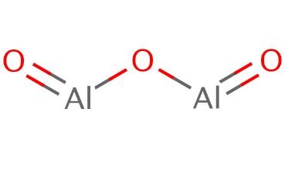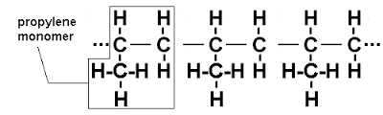

Aluminum oxide

*(*[*http://apps.echa.europa.eu/registered/data/dossiers/DISS-9eb4460f-9f3a-575c-e044-00144f67d031/AGGR-8ee589c5-a3b6-4d89-9d0c-e5895166b823\_DISS-9eb4460f-9f3a-575c-e044-00144f67d031.html*](http://apps.echa.europa.eu/registered/data/dossiers/DISS-9eb4460f-9f3a-575c-e044-00144f67d031/AGGR-8ee589c5-a3b6-4d89-9d0c-e5895166b823_DISS-9eb4460f-9f3a-575c-e044-00144f67d031.html) *)*

Polypropylene

*(*[*http://www.advancedpolymersolutions.com/polypropylene.html*](http://www.advancedpolymersolutions.com/polypropylene.html)*)*

The Al2O3 is actually not considered a true molecule, but due to its structure it has electrical dipoles and attracts water strongly via electrostatic attractions, making it hydrophilic. And as you can see in the right diagram, polypropylene is a polymer of propylene. The C-H arrangement around all carbon atoms is symmetrical, making the entire molecule nonpolar and thus hydrophobic.

Unfortunately, the atmospheric water collector illustrated in the Rohrig article and discussed above does not work as designed/built. It was a 2012 design project for a college course in Canada by student Thomas Row. He explains:

This is a project for environmental harmonious lifestyle course in which we were asked to biomimic the Namibian Desert Beetle that collects water from air using tiny bumps on its back with hydrophobic and hydrophilic extremes. I decided to design a water collecting device very portable and universal to common plastic bottle threads. Ideally this would be most useful in survival situations where drinkable water is scarce.

**Research & Testing**

The testing failed miserably. Even with a good weather and temperature, including using the cooling effects from low temperature night sky, only tiny droplets of water were collected. However, I'm confident that with better quality hydrophobic and hydrophilic surfaces, enough water should collect since my tests were only done with common household products.

(<https://www.behance.net/gallery/Atmospheric-Water-Collector/3949181>)

But even if this model doesn’t work—yet—there are other researchers jumping into the fray. **Kristof Retezár, a design engineer from Vienna, Austria has developed a prototype for a device called the Fontus bottle, named after the Roman god of wells and springs. This bottle is designed to be attached to a bicycle and, while the rider bikes across the countryside, the bottle will collect water from the air. It contains a very small solar-powered electric heat pump that cools incoming air and condenses the moisture contained therein. It traps that moisture and transfers it to a water bottle at the bottom of the unit.**

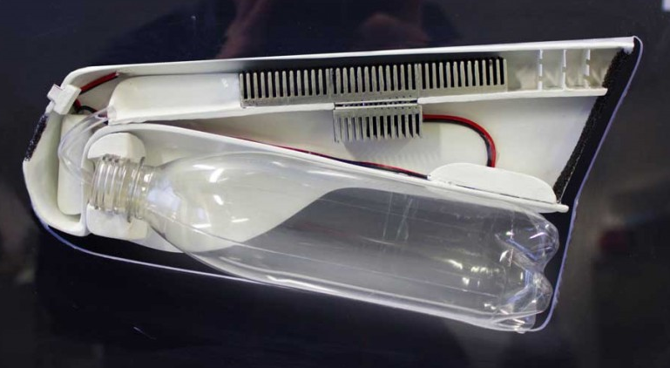

A cut-away view of the Fontus water bottle device

*(*[*http://delabuzz.com/wp-content/uploads/2014/11/fontusside1200800.jpg*](http://delabuzz.com/wp-content/uploads/2014/11/fontusside1200800.jpg)*)*

**The unit in the photo would be mounted on the bicycle frame, with the right of the unit pointing forward. Humid air enters unit from the right. The black vertical strip at right is the air filter. The top of the unit’s casing is the solar panel, and a storage battery can be seen at the far left. The long gray panel inside the device at the top that looks like a comb is the cooling unit, and the shorter gray panel below that is the heat sink that removes heat from the cooling unit.** As the humid air travels over the top cooling panel, its temperature decreases and the moisture it was holding condenses, forms drops, and rolls down the tube into the collecting bottle at the bottom. Excess heat is carried away by incoming air hitting that the heating unit and is expelled out the back of the unit.

As of this writing, the bottle is not yet available commercially, but this design and prototype was nominated for the James Dyson Award in engineering design. (<http://www.jamesdysonaward.org/projects/fontus-2/>) As you might imagine, the efficiency of this device varies greatly, depending on relative humidity, temperature and speed of the bicycle. On a warm, relatively low humidity day, productivity might be as low as 1 drop per minute (3 mL/hr), while at higher temperatures and humidities, the expected rate is 0.5 L/hr.

While this design does not make specific use of hydrophilic and hydrophobic surfaces on the cooling unit, it is very likely that the efficiency of the device could be enhanced greatly by incorporating this new chemical knowledge into the design.

But bottles mounted on bicycles to extract moisture from air aren’t the only designs being researched. This technology could be used in other settings to provide drinking water in third world countries. The image at right, another design from **Retezár,** shows the design for a more stationary version of the bike bottle above. This model uses fans to draw air into the device and expel air at the other end, minus its moisture. Electricity is required to turn the fans and, more significantly, to run the heat pump needed to transfer heat from the cooling unit to the heat sink. This electricity can be supplied by solar panels in tropical and sub-tropical areas. Here again, efficiency will be improved using hydrophobic/hydrophilic surfaces.

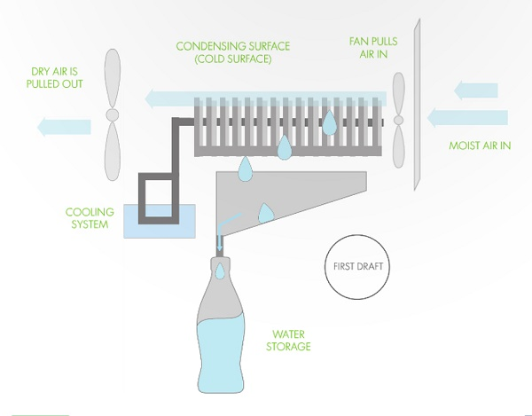

*(*[*http://mostepicstuff.com/wp-content/uploads/2014/11/self-filling-water-bottles-for-cyclists-2.jpg*](http://mostepicstuff.com/wp-content/uploads/2014/11/self-filling-water-bottles-for-cyclists-2.jpg)*)*

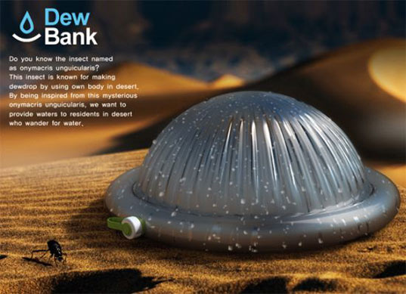Another attempt to copy the fogstand beetle is the Dew Bank, a small dome-shaped container that mimics the ridges and bumps of the beetle to collect water through channels that run vertically around the dome. The container is set out at night and left to stand overnight. As the air temperature cools down overnight, so does the Dew Bank. Its cool surface then becomes the surface on which morning humidity condenses. The condensed moisture runs down the ridges of the surface into the container at the bottom.

It is not truly analogous to the beetle because it is made of metal and primarily uses the cooler metal surface on which to condense morning mist/fog/dew, not hydrophilic/hydrophobic surfaces. It then channels this condensed water into the tubular tank that surrounds the bottom of the dome. (<http://inhabitat.com/beetle-inspired-bottle-harvests-drinking-water-from-thin-air/dew-bank-bottle1_gyqkq_2442/>) [Editor’s note: This seems to be only an idea at present (1/10/2016)—no such item could be found for sale, even at Amazon.com.]

And in an attempt to upscale the collection of water from air, NBD Nanotechnology, referenced in the Rohrig article, is in the process of gathering water from the air/fog, using technology similar to that of the Namib Desert beetle. This technology seeks to recover larger quantities of water from the moisture in fog—called “fog-catching”. In the San Francisco Bay Area, the company has installed mesh screens on the hillside to collect the famous San Francisco fog. The mesh in these screens is made of a polymer, typically polypropylene. But NBD Nano coats this mesh with a hydrophobic substance, and the results have shown that their nets catch five times as much water from fog as normal polymer nets.

Fognet pilot in coastal California

*(*[*http://www.nbdnano.com/fog-capture.html*](http://www.nbdnano.com/fog-capture.html)*)*



Lest anyone think that fog-catching is a new technology, the “Source Book of Alternative Technologies for Freshwater Augmentation in Latin America and the Caribbean” was published by the Organization of American States in Washington, DC, in 1997. It contains an entire section on “Fog Harvesting in Chile” that discusses the use of fog nets in the Andes Mountains, where the fog actually touches the land surface. A 3-ply polypropylene mesh net with a surface area of 144 m2 was used to collect an average of 2.5 L/m2/day in that mountainous area.

While the project was relatively successful, the report provides this suggestion for future development of the technology. “While the technology meets the need for small volumes of water, future development work should be directed toward increasing the yield from the harvesters for larger-scale applications.” (<http://www.oas.org/DSD/publications/Unit/oea59e/ch33.htm#5.2> and <http://www.oas.org/DSD/publications/Unit/oea59e/ch12.htm#TopOfPage>) The new technology developed from studying/mimicking the Namib Desert beetle will do just that.

On an entirely different note, scientists have copied the beetle’s surface to prevent frost from forming on airplane wing surfaces. The same technology, making a hydrophobic surface with very small bumps, attracts moisture and allows water to form small drops, but then the hydrophobic surface prevents the droplets from clinging and gathering together to form ice; they keep running down the surface, instead of collecting and freezing and, as a result, frost doesn’t form.

**More on the Lotus effect**

As the Rohrig article describes, there is a second example of surface-related biomimicry in the form of the lotus flower. Water rolls off its petals very easily, taking with it dirt and grime and making it a self-cleaning flower. As you can imagine, we might want to learn about the role of hydrophilic and hydrophobic properties in this case as we did in the last example.

The lotus plant grows in muddy waters but always appears immaculate. Water rolls of the leaves very easily because they are hydrophobic in the extreme (super-hydrophobic). The leaves are rough, not smooth as might be expected. They also have nanoparticle structures of a 3-dimensional waxy substance embedded in the leaves.

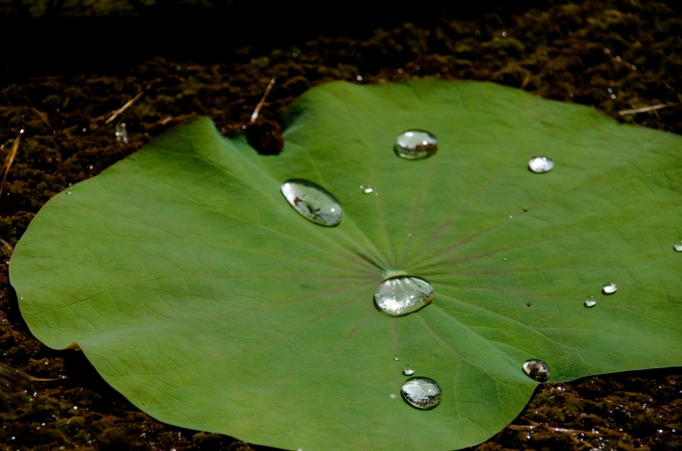

Water hitting a lotus leaf simply rolls off, leaving   
the leaf as pristine and dry as it was before.

*(*[*https://commons.wikimedia.org/wiki/File:Lotus\_leaf\_with\_waterdrops.jpg*](https://commons.wikimedia.org/wiki/File:Lotus_leaf_with_waterdrops.jpg)*)*

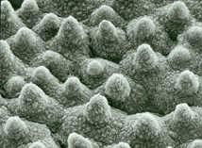

(At right) Electron microscope photograph of the surface of a lotus flower leaf. The combination of surface roughness and water-repellent wax crystals gives it superhydrophobic properties.

*(*[*http://www.nanowerk.com/spotlight/spotid=19644.php*](http://www.nanowerk.com/spotlight/spotid=19644.php)*)*

When combined with the waxes' water-repellent chemical properties, these structures make the lotus leaf extremely non-wettable, a state called ultrahydrophobia or super-hydrophobia, and they give it its self-cleaning properties. Dirt particles only sit on the tip of the wax crystals and as a result only a very small surface area comes into contact with the plant's surface. If water falls onto a leaf surface like this, the interplay of the surface tension and the low attraction force between the surfaces and the water produce a spherical water drop which only sits on the tips of the wax structures. If the leaf tips in the slightest, the water drop immediately rolls off, taking the dirt particles with it.

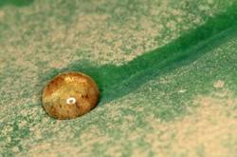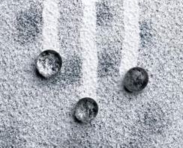

(<http://www.nanowerk.com/spotlight/spotid=19644.php#ixzz3xQpeKXaR>)

Right photo: Top: water and dirt rolling off a lotus leaf; Bottom: rain droplets and dirt (black) rolling off a self-cleaning Lotusan® (white) painted surface

*(The Joint Nature Conservation Committee, UK:* [*http://jncc.defra.gov.uk/page-5592*](http://jncc.defra.gov.uk/page-5592)*)*

What makes the lotus leaf self-cleaning is that, as the water droplets roll across the leaf, they carry the dirt particles along with them. Both water droplets and dirt particles are unable to exhibit large surface areas adjacent to the leaf surface, due to the bumps on the leaf surface. As a result, neither water nor dirt is able to adhere to the lotus leaf surface. Read more about self-cleaning systems in the article “Nanotechnology solutions for self-cleaning, dirt and water-repellent coatings” at the above nanowerk.com Web site.

The first commercial product employing the lotus effect, made in collaboration with industry, was a silicone resin paint which has since become widely used and in which silicon nanoparticles form micro-structured surface. Other "Lotus-Effect®"products include ceramic roof tiles, architectural glass and a spray for industrial use which makes surfaces temporarily non-wettable and self-cleaning. Advances are also being made in the development of engineered fabrics that are self-cleaning; indeed, nanofiber clothing that is “stain proof” is already on the market (but see below for a caveat).

Other future uses of the lotus effect might be in windows and walls of skyscrapers cleaning themselves (or entire cities, for that matter); self-deodorizing and disinfectant surfaces for hospitals and bathrooms; mirror surfaces that do not fog in the shower/bathroom.

One drawback to the actual lotus effect in plants is that it requires water to clean the leaf surface. Scientists attempting to mimic the lotus effect in an interior setting would meet with great difficulty. Also, the lotus effect usually requires a matte finish, so its use on glass would be limited, especially so on optical glass (e.g., eyeglasses). And the true lotus effect is temporarily annulled when soap and detergent are used on the surface, as they reduce the surface tension of the water, resulting in sheeting action that removes dirt, rather than water droplet formation that results in drops rolling off, taking dirt with them.

Many products on the market advertise their self-cleaning characteristics, including eyeglasses and clothing fabrics—and these work. The companies frequently tout their products’ “lotus effect”; however, most of these use nanoparticles to achieve the self-cleaning effect, not the properties of the lotus leaf.

**More on** **other examples of chemistry biomimicry**

Many major areas of research have led to development of items that utilize biomimicry. Here are some examples:

* “Growing” plastics, packaging material and building insulation from plants
* Building cities that work like ecosystems (e.g., sequestering carbon dioxide in concrete, emulating sea coral)
* Using systems-level bio-inspiration to show business people how to emulate systems in nature that waste want, want not.
* Mimicking shark skin to provide surfaces that prevent bacteria from growing on them (e.g., used in hospitals, restaurants, etc., where contamination is undesirable)
* The same sharkskin technology is being used on boats to prevent microorganisms from growing on the hull, and to reduce drag on ships and planes—and on the very successful U.S. 2008 Summer Olympics swimmers’ full-body swimsuits (now banned)
* Emulating insect swarms using “swarm logic” to manage energy networks and grids
* Emulating those swarms to mimic communication for use in information sciences (e.g., building a system that lets networks optimize performance by using idle servers during periods of peak demand)
* Mimicking termite mounds, which are “nature’s air conditioning systems”, to build a very energy-efficient 333,000 square-foot office complex in Zimbabwe
* The already mentioned mimicking of burrs in nature to create Velcro®
* Emulating the bumps at the front edge of a whale’s fins (which increase its efficiency by reducing drag by 32% and increasing lift by 8%) by designing them on turbine blades, increasing energy efficiency per turbine
* Mimicking the kingfisher (bird) to change the design of the nose of the Shinkansen Bullet Train, eliminating noises sounding like sonic booms as the train emerged from tunnels—and drastically reducing power use and enabling faster speeds
* Using the science behind nature’s biological membranes to produce a desalination process using Aquaporin, a membrane protein
* Of course, there’s the gecko and Geckoskin, adhesive developed at the University of Massachusetts, Amherst—so strong that a 3” x 5” strip can hold up to 700 pounds
* Glass glazed with a web-like pattern of UV-reflecting coating mimics the special UV-reflecting silk rope used by certain spiders to protect their webs from accidental bird collisions (birds frequently fly into glass windows and doors, usually killing them, and it is hoped this special coating will keep birds away)
* Using the tendency for fish to travel in schools, often creating vortices, scientists have created a new type of wind turbine, 30-ft tall vertical shafts about 3-feet in diameter which are situated very close to each other to take advantage of the air flow/wake vortices among the plot of turbines
* Mimicking tardigrades, members of the phylum *arthropoda*, animals that exhibit anhydrobiosis, meaning they can remain live specimens even when seemingly dried out and dead; Biomatrica, a San Diego company adapted this process to produce a chemical barrier that shrink-wraps vaccines that keep them viable until they’re reanimated with water (important because it eliminates the need to refrigerate vaccines, almost impossible in hot, arid third world countries, where vaccines are needed most)
* Skin grafts with patches of tiny needles made of material that swell up when exposed to water keeping the graft in place, were modeled after the parasitic spiny-headed worm, which pierces the intestine of its host with a sharp spine, then inflates it head inside the tissue to hold on
* The Mirasol color displays for some e-readers mimic butterfly wings’ ability to reflect light, rather than transmitting light from behind, as LCD monitors do
* Spider webs consisting of the alternating sticky segments (to catch prey) and non-sticky segments (so the spider can traverse the web) are being mimicked by scientists to produce a surgical tape that can be peeled off a wound without damaging the tissue beneath
* An electronic cane for the blind that vibrates as it approaches objects mimics the echolocation used by bats
* Mimicking the orange puffball sponge, which lives on the ocean floor, scientists have been able to mimic the way it creates its shell of calcium and silicon lattices from enzymes that extract calcium and silicon and then build them into precise shapes, in order to design electrodes that may be precursors to solar panels, microchips and batteries
* Horntail wasps that drill into trees to deposit their young are the model for a new type of drill being developed by astronomers for drilling on Mars and other astronomical bodies, like comets; this device requires little or no force, as it consists of two blades that actually work against one another, eliminating the need for great force
* Lobster eyes, which can see direct reflections of objects that are focused to a single point, are being mimicked in a new small, portable X-ray device(LEXID—Lobster Eye X-ray Imaging Device) to be used at airports and doctor’s offices

(sources for the above information:

* <http://www.popsci.com/science/article/2011-03/gallery-six-ways-biomimicry-reshaping-future?image=5>,
* <http://www.bloomberg.com/slideshow/2013-08-18/14-smart-inventions-inspired-by-nature-biomimicry.html#slide4>,
* <http://www.livescience.com/28873-cool-technologies-inspired-by-nature.html>) and
* <http://mentalfloss.com/article/22702/10-technologies-we-stole-animal-kingdom>)

The list of actual substances and processes based on natural design is growing by the month. A few examples include:

* Smart clothing, based on the behavior of pine cones. As temperature increases, the cones open and as the temperature decreases, the cones close up. Clothing has been designed by Julian Vincent using this principle. (<http://news.nationalgeographic.com/news/2004/10/1013_041013_smart_clothing.html>)
* Photonic crystals that behave like the wings of a colorful butterfly are being developed for optical application. (<http://europa.eu.int/comm/research/headlines/news/article_04_11_16_en.html>)
* Antimicrobial gases. Montana State University biologist Gary Strobel found that a fungus collected from a cinnamon tree in Honduras was able to emit a gas mixture that has antimicrobial properties. Says Strobel, “This little thing is a chemical factory," says Strobel. "When we put all the chemicals together in the same ratio, we can reproduce its effect against other microbes. You can grow it on one half of a plate and put almost any microbe on the other side and [the microbe] will grow for an hour and die." (<http://www.nsf.gov/discoveries/disc_summ.jsp?cntn_id=104473&org=NSF>)
* Nanoparticles in a surface coating for polyester fabric make awnings, sails and tents “self-cleaning” via the lotus effect

**More on other animals that scientists are attempting to mimic**

**The golden orb weaver spider**

Dragline silk from a golden orb weaver spider is five times stronger than steel (when compared gram for gram), and can absorb five times the impact force of Kevlar—the synthetic fiber of bullet-proof vests—without breaking. What’s more, it can stretch 40% longer than its original length. For the spider, the durability and strength of silk means food. And for humans, it could mean an amazingly useful fiber that can be made from safer and less hazardous chemistry. Science writer Steve Miller describes the properties of good web fiber in a February 2001 *ChemMatters* article: “It must be strong enough to bear the weight of a bungee-jumping spider, flexible enough to withstand the impact of a flying insect, and stable enough to last for days. … And it cannot require more raw material than the spider can replenish from ordinary food resources.” Even the U.S. military has taken notice. The U.S. Army has interest in a manufactured version of dragline silk for applications such as catching fighter jets as they land on aircraft carriers.

The golden orb weaver spider

*(*[*http://www.autoworldnews.com/articles/8679/20140820/study-city-lights-make-spiders-grow-bigger-reproduce-more.htm*](http://www.autoworldnews.com/articles/8679/20140820/study-city-lights-make-spiders-grow-bigger-reproduce-more.htm)*)*

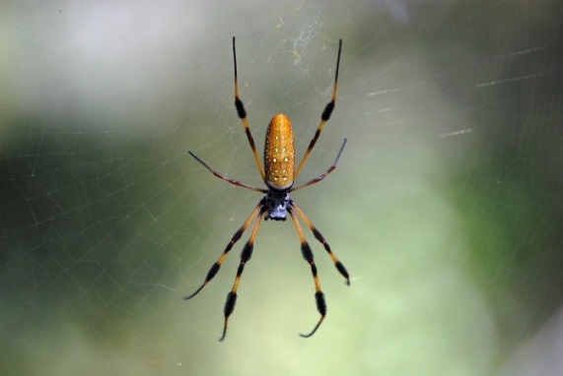

(Parent, K. and Young, J. Biomimicry—Where Chemistry Lessons Come Naturally. *ChemMatters*, *24* (2), pp 15–17)

The case of the golden orb weaver’s web may be a case of double biomimicry. In 1881, a physician, Dr. George Goodfellow, in Tombstone, Arizona noted that bullets fired even at close range could be trapped (and sometimes stopped) by as little as two thicknesses of handkerchief silk. The strength of silk strands has been a focus of research for decades for applications such as stronger ropes, parachutes, improved sutures and bandages, artificial tendons and ligaments, and supports for weakened blood vessels.

Chemists saw the strength of the dragline silk of the golden orb weaver spider (*Nephila clavipes)* as a second source of strong fibers. Golden orb weavers build large, strong, vertical orb webs. Geneticists believe that these spiders have been producing the silk in the same way for more than 125 million years. Harvesting spiders for silk production, however, is difficult because they tend not to live near one another. So a Canadian company has genetically engineered goats to produce spider milk. The dragline silk is then removed from the goat’s milk for use

Golden orb weaver spiders produce several types of silk in the form of water-soluble protein. The proteins are extremely long with thousands of amino acids in the chain. … [T]he silk is forced out through a spinneret where the folded silk proteins are stretched out to form the silk fibers.

(Teacher’s Guide to the following article in *ChemMatters*: Parent, K. and Young, J. Biomimicry—Where Chemistry Lessons Come Naturally. *ChemMatters*, *24* (2), pp 15–17)

**The Bombardier Beetle**

Beetles are at a bit of a disadvantage over other flying insects, like bees and butterflies in that they are unable to instantly fly away from predators, because they must first unfurl their wings from underneath their wing covers. The time this takes could mean they don’t survive. Many beetles have evolved means to help them escape. The bombardier beetle has a unique method of fending off its predators: it sprays them with a boiling-hot stream of toxic chemicals that are explosively ejected from glands on its abdominal tip.



**Reaction of bombardier beetle to the pinching of right foreleg (Note spray directed at forceps at right)**

(T. Eisner and D.J. Aneshansley, "Spray aiming in the bombardier beetle: Photographic evidence," PNAS USA 96, pp. 9705–9709.)  
([*http://www.pnas.org/content/96/17/9705.full.pdf?sid=97be217f-c80c-44f1-ba62-0420f0bcf95f*](http://www.pnas.org/content/96/17/9705.full.pdf?sid=97be217f-c80c-44f1-ba62-0420f0bcf95f))

Not only do the beetles eject this hot, toxic spray, but they can control the direction of the spray to match the direction from which the attack emanates. How do they do this?

The bombardier beetle has two separate chambers on its body, each containing a chemical. When attacked, the beetle releases the contents of those chambers, combines them, and uses them as a ·binary weapon. It shoots out a toxic spray that is also boiling hot at 100°C. The beetle can fire its weapon like an army rifle - in single shots, or in rapid-fire bursts. Moreover, the beetle has a highly accurate aim with the deadly spray, and can turn and whirl to scorch several predators.

(Downey, C. Insect Arsenals. ChemMatters, 1993, *11* (3), pp 8–10)

Research since that article was written seems to indicate that turning and whirling is not the way the bombardier beetle defends itself, but rather, it actually directs the abdominal tip, as seen in the above photograph. It also has deflectors in that same area of its body that can be deployed—or not—to direct the spray.

The chemistry of the bombardier beetle is well understood. The beetle stores the reactants that produce the spray in two separate glands, each having two compartments. One gland contains hydroquinone and hydrogen peroxide (each in its own compartment). The other gland contains special enzymes, catalases and peroxidases, which catalyze the reaction. When the reactants are mixed in a chamber in the second gland, the hydrogen peroxide oxidizes the hydroquinone to *p*-benzoquinone. Oxygen is also produced from the hydrogen peroxide and acts as a spray propellant. The reaction is exothermic (see equations below) and the temperature of the spray is about 100 oC. (Note that the mixture’s boiling point is not 100 oC, as it is not pure water, but a rather concentrated solution.)

We can use Hess’s Law to calculate the heat of reaction for the beetle’s spray. The overall reaction is:

H2O2 (aq) + C6H6O2 (aq) 🡪 C6H4O2 (aq) + 2 H2O (l) ΔH = ? kJ/mol

1. H2O (l) + ½ O2 (g) 🡪 H2O2 (aq) ΔH = +94.5 kJ/mol
2. C6H4O2 (aq) + H2 (g) 🡪 C6H6O2 (aq) ΔH = –177.4 kJ/mol

(1,4-benzoquinone) (Hydroquinone)

1. H2 (g) + ½ O2 (g) 🡪 H2O (g) ΔH = –241.8 kJ/mol
2. H2O (g) 🡪 H2O (l) ΔH = –43.8 kJ/mol

\_\_\_\_\_\_\_\_\_\_\_\_\_\_\_\_\_\_\_\_\_\_\_\_\_\_\_\_\_\_\_\_\_\_\_\_\_\_\_\_\_\_\_\_\_\_\_\_\_\_\_

H2O2 (aq) + C6H6O2 (aq) 🡪 C6H4O2 (aq) + 2 H2O (l) ΔH = –202.7 kJ/mol

To find the ΔH for the overall reaction, switch the first two equations (to get the reactants and products on the correct sides of the overall reaction), which changes the sign of their respective ΔHs. Then add all 4 equations to get the overall equation, and thus, add the 4 accompanying ΔHs to get the –202.7 kJ/mol.

Hydroquinone, C6H6O2, is used as a corrosion inhibitor, in photochemicals, in the manufacture of polystyrene, for printing and in latex production. It has a melting point of 172–175 oC, a boiling point of 285 oC. Its density is 1.33 g/cm3 and is moderately soluble in water. *P*-benzoquinone, C6H4O2, also referred to as 1,4-benzoquinone, has a melting point of 113–115 oC and a boiling point of about 180 oC.

One specific bombardier beetle, *Metrius contractus*, has some significantly different chemistry going on in its abdomen from that of all other beetles of its family. While all other bombardier beetle species eject their toxic brew at 100 oC, *Metrius contractus* ejects its mixture at only 55 oC. And the contents is very different also. One substance that is unique to this beetle is   
2-chlorobenzoquinone, a compound almost never found in nature and very difficult to produce. Also, Its primary quinone product is 1,4-benzoquinone, rather than the 2-methyl-1,4-benzoquinone primary quinone for all other of its close relatives. The result of the different chemical make-up of the spray is that it tends to form a cloud of toxic spray that hangs around.

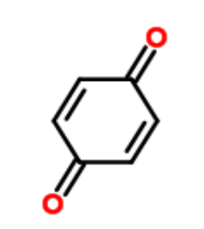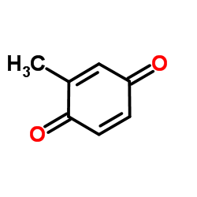

1,4-benzoquinone

*(*[*http://www.chemspider.com/Chemical-Structure.15470939.html*](http://www.chemspider.com/Chemical-Structure.15470939.html)*)*

2-methyl-1,4-benzoquinone

*(*[*http://www.chemspider.com/chemical-structure.10651.html*](http://www.chemspider.com/chemical-structure.10651.html)*)*

Another strange feature is that this spray also contains conjugated dienes, also hardly ever found in nature, and especially not expected to occur side by side with 1,4-benzoquinone, because they typically react together. The beetle has found a stereochemical way to keep these compounds from reacting with each other. This beetle, perhaps more than any other, seems to require more research into its chemistry than any other beetle.

Not only can we learn a great deal from its inner workings, but applications abound. Researchers have developed a micro-mist spray based on the beetle’s jet spray. Combustion engines, fire-fighting water delivery devices and aerosol containers all based on this beetle’s extraordinary defense mechanism are being researched and developed.

Another possible use is as a deterrent to would-be thieves stealing money from ATMs. A chemical reaction similar to the beetle’s concoction would use the peroxide reaction to build up pressure and eject a hot, concentrated solution, possibly containing a dye, to alarm the thief and mark him for easy detection and apprehension. Biomimicry is alive and well. (<https://bioweb.uwlax.edu/bio203/f2013/lyden_mega/index.htm>, “Ingenious Chemistry”)

# Connections to Chemistry Concepts

**(for correlation to course curriculum)**

1. **Green chemistry**—Although this may not be a specific concept in chemistry curricula, it is certainly a very serious topic in the chemical industry. And we can also apply it to our own classroom (e.g., using less toxic chemicals for experiments, properly disposing of waste materials from labs, etc.) Biomimicry and green chemistry both strive to use less toxic materials, and to avoid creation of waste altogether, rather than just disposing of or finding uses for waste that industrial reactions typically create.
2. **Conservation of matter**—Atom economy is integrally linked with conservation of matter, as % atom economy reflects the efficiency of the reaction at producing useful product without forming waste. A reaction that has 100% atom economy is one that produces all useful product; in other words, the mass of all reactants = the mass of useful product. In a reaction with less than 100% atom economy, the amount of useful product + the mass of waste will equal the mass of all reactants.
3. **Stoichiometry**—Green chemistry utilizes the idea of “atom economy” to ensure minimum amounts of reactants are used in producing new chemical products, all to minimize waste. Percent atom economy is another term that goes hand in hand with percent yield in establishing maximum product with minimum waste.
4. **Percent yield**--% atom economy is very closely related to percent yield; percent yield has always been the driving force behind industrial chemical reactions—to produce the most industrial product with the least amount of reactants, to maximize profit, while giving almost no thought to byproducts, which might be toxic. Green chemistry brought in percent atom economy, which focuses on essentially the same thing as percent yield, except that atom economy stresses the maximum product while creating the minimum of byproducts, striving for zero waste.
5. **Intermolecular attractive forces**—It is these forces that are responsible for adhesives’ stickiness.
6. **Polymers**—Polymers crosslinking (or just drying) are at the heart of most adhesives.
7. **Polar/non-polar**—The polar nature of the bumps on the Namib Desert beetle attract polar water, while the non-polar rest of the shell of the beetle does not attract water, allowing it to flow across the surface to the beetle’s mouth.
8. **Hydrophilic/hydrophobic**—These are the macroscopic properties that relate to polarity/non-polarity of materials. The bumps on the beetle above are hydrophilic because they are polar and attract polar water molecules, while the rest of the shell is hydrophobic or non-polar, allowing the water droplets to flow across the surface unaffected.
9. **Phase change**—Cooled water vapor in the air condenses to liquid, creating tiny droplets of fog, which then are attracted to the beetle bumps, forming droplets that drip into its mouth.

# Possible Student Misconceptions

**(to aid teacher in addressing misconceptions)**

1. **“Don’t industrial chemical reactions always take place at high temperatures and pressures and produce dangerous by-products?”** *Students may associate chemistry, at least on the industrial scale, with pollution and accidents, since much of the news about the chemical industry is focused in that direction. It is important to acknowledge to students that some of chemistry’s reputation is correct, but that efforts are being made to change the industry. This article and related resources provide you with an opportunity to paint a more realistic (and hopeful) picture for students.*
2. **“The reactions like those in blue mussel glue take place in the animal. Are these the same as the reactions we do in lab?”** *Students may have the idea that chemical reactions take place only on a lab table in their classroom or in a research lab. This article provides you with the chance to remind students that chemical reactions are an integral part of nature and that chemistry is essential to many areas of our lives.*

# Anticipating Student Questions

**(answers to questions students might ask in class)**

1. **“What is biomimicry?”** *See “More on biomimicry”, above.*
2. **“What is green chemistry?”** *See “More on green chemistry”, above.*
3. **“Why don’t present-day glues work underwater?”** *Objects underwater are covered with water molecules, so that the glue we try to apply, which would normally stick directly to the surface of the objects to be glued, now sticks to the water molecules instead. This results in a very weak bond between the glue and the object.*
4. **“Why is the contact angle so important for water drops?”** *The contact angle is an indication of how much of the surface of the water drop is actually in contact with the substrate’s surface. A small contact angle means that the water drop has spread out or flattened a lot, resulting in a large surface area in contact. This provides much space for the water drop to stick to. A large contact angle means the water drop is more spherical, giving it much less contact area exposed to the substrate surface. This results in less adhesion between the water drop and the substrate, allowing the water drop to roll easily.*

# In-Class Activities

**(lesson ideas, including labs & demonstrations)**

1. This site provides a 91-page digital flipbook of materials on teaching biomimicry, for all levels of students: <http://ben.biomimicry.net/curricula-and-resources/youth-curricula/>.
2. You can show your students the basic ideas of what biomimicry is by showing this video (21:47) from the Biomimicry Institute. It tells you what biomimicry is and provides lots of commercial working examples. It was produced through the Leonardo DiCaprio Foundation and is narrated by Jane Benyus, the initiator of and lead researcher in the field of biomimicry: <http://biomimicry.org/treemedia/#.VpfgoI-cG39>.
3. This document from the Royal Society of Chemistry is a 5-page worksheet for students. The topic is “Green chemistry, atom economy and sustainable development.” It presents students with an overview of the green chemistry philosophy re: atom economy and uses percent yield and stoichiometry to show students how to calculate % atom economy. (<http://www.rsc.org/Education/Teachers/Resources/Inspirational/resources/6.6.1.pdf>)
4. This site provides an 11-page student activity (high school and first year college) that has students use molecular models to represent the synthesis of a soap and calculate its % atom economy. The pdf includes an introduction to green chemistry and atom economy, a set of student instructions and accompanying questions, a student data table, and teacher notes that include sample data and answers to student questions. (<http://www.acs.org/content/dam/acsorg/greenchemistry/education/resources/cleaning-up-with-atom-economy.pdf>)
5. This series of PowerPoint slides could be used in your classroom to introduce students to the concepts of atom economy and green chemistry. After defining the terms, it provides several sample problems dealing with the calculation of % atom economy (with worked out answers in following slides) for different chemical reactions. (<http://www.educationscotland.gov.uk/Images/Atom_Economy_tcm4-670357.ppt>)
6. For AP or IB students, you might want to have them work on this student worksheet from the University of Scranton on atom economy and % atom economy calculations: <http://www.scranton.edu/faculty/cannm/green-chemistry/english/organicmodule.shtml>.
7. This is a 3-day lesson plan from Beyond Benign.org about intermolecular forces, “Green Chemistry Application to Intermolecular Forces: Biomimicry in Action”. It includes a lab on adhesives, a case study on a common glue, and a one-day matching game activity that asks students in groups to match natural adhesives to commercial adhesives, based on their described uses. The site mentions a PowerPoint to introduce intermolecular forces, but the editor can’t find it. (<https://view.officeapps.live.com/op/view.aspx?src=http%3A%2F%2Fwww.beyondbenign.org%2FK12education%2Fhsgc%2FGreen%2520Chemistry%2C%2520Biomimicry%2520and%2520intermolecular%2520forces.doc>.)
8. Molecular Workbench from the Concord Consortium site, provides this tutorial with its series of activities. “Intermolecular Attractions” offers a 10-screen tutorial with simulations allowing students to change variables to see effects on intermolecular forces of attraction: <http://concord.org/stem-resources/intermolecular-attractions>. The software downloads to your computer and uses Java.
9. This one-screen site simulates dipole-dipole vs. London dispersion forces of attraction using Flash: <http://chemsite.lsrhs.net/FlashMedia/html/dipoleVsLondon.html>.
10. NSTA Communities provides this lab activity on glues and adhesives: <http://nstacommunities.org/blog/wp-content/uploads/2011/02/LP-HS-Adhesives-Glues_Edited.doc>.
11. This is a similar lab activity from NBC Learn, “Chemistry Now: Intermolecular Forces and Adhesives”: <http://www.nbclearn.com/portal/site/learn/lesson/844f3869de97b310VgnVCM2000006fc3d240RCRD>.
12. This 64-slide set from the University of Illinois at Chicago covers the topic of intermolecular forces. Of the 64 slides, 30 – 40 of them can be used in a high school course; the rest of the slides are very mathematical. This set is probably best suited to be used by the teacher in the classroom, as the “show” will require your discussion with students because it is not always self-evident, but the illustrations of the various types of intermolecular interactions are very well done and would augment the typical chemistry lesson on intermolecular forces nicely. (<http://slideplayer.com/slide/2973382/>)
13. This 13-slide PowerPoint slide set discusses intermolecular forces. It could be used in class, or as a self-contained student lesson on the various types of intermolecular attractive forces. The set of slides is self-sufficient in that it contains text to cover the topic; little teacher input is necessary, although enhancement certainly can be done easily. It contains questions (with answers on successive slides) to assess student understanding. (<http://www.chalkbored.com/lessons/chemistry-12/intermolecular-forces.ppt>)
14. And here is yet another site for classroom use that presents a discussion of “Intermolecular Bonding—van der Waals Forces”. This one is probably ok for students to work on by themselves, or as part of the inverted classroom, requiring little of the teacher. (<http://www.chemguide.co.uk/atoms/bonding/vdw.html#top>)
15. And this site provides similar information specifically about hydrogen bonding: <http://www.chemguide.co.uk/atoms/bonding/hbond.html#top>.
16. You might want to ask students to compare the way the Namib Desert beetle or the self-filling water bottle collects water to the way a dehumidifier works; either way, it’s a useful lesson in phase changes.
17. This site from TeachEngineering, “Lesson: Superhydrophobicity—The Lotus Effect”, is a lesson for students on the lotus effect: <https://www.teachengineering.org/view_lesson.php?url=collection/duk_/lessons/duk_surfacetensionunit_lessons/duk_surfacetensionunit_less4.xml>.
18. You might want to use the bombardier beetle’s reaction with students in a study of heats of reaction, as in this question:

“The bombardier beetle stores two chemicals in two separate bladders. When attacked, the beetle mixes the chemicals. The chemicals react by means of the following exothermic reaction: C6H4(OH)2(aq) + H2O2(aq) 🡪 C6H4O2(aq) + 2 H2O(l)

The heat released by the reaction is sufficient to raise water to near its boiling point. The beetle then sprays the boiling hot mixture at the predator as a highly potent defensive mechanism. Using the following data and Hess's Law, calculate ∆H for the above reaction. C6H4(OH)2(aq) 🡪 C6H4O2(aq) + H2(g) ΔH = +177.4 kJ

H2(g) + O2(g) -> H2O2(aq) ΔH = -191.2 kJ

H2(g) + 1/2 O2(g) 🡪 H2O(l) ΔH = -285.6 KJ

(<http://gbschemphys.com/honchem/cabinet/u7/HeatOfFormation.pdf>)

# Out-of-Class Activities and Projects

**(student research, class projects)**

1. Some students, in a team or on their own, can research the Biomimicry Principles and other students can research Principles of Green Chemistry (both sets of principles are listed in this Teacher’s Guide). The object of this activity is to bring this research to class and compare, looking for how biomimicry is related to chemistry. With advanced arrangements with your librarian for library access, or for computer lab access, this could be a project for a substitute teacher in your absence.

# References

**(non-Web-based information sources)**

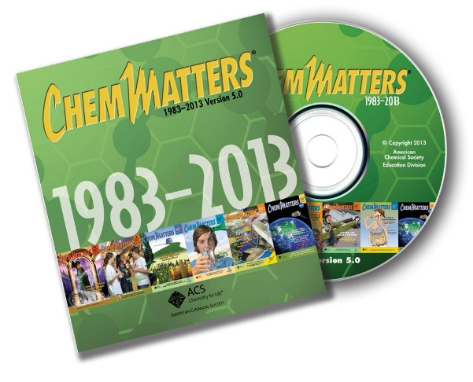

**30 Years of *ChemMatters***

Available Now!

**The references below can be found on the *ChemMatters* 30-year DVD (which includes all articles published during the years 1983 through April 2013 and all available Teacher’s Guides, beginning February 1990). The DVD is available from the American Chemical Society for $42 (or $135 for a site/school license) at this site:** [http://ww.acs.org/chemmatters](http://www.acs.org/chemmatters)**. Click on the “Archive” tab in the middle of the screen just under the *ChemMatters* logo. On this new page click on the “Get 30 Years of ChemMatters on DVD!” tab at the right for more information and to purchase the DVD.**

**Selected articles and the complete set of Teacher’s Guides for all issues from the past three years are available free online at the same Web site, above. Simply access the link and click on the aforementioned “Archive” tab.**

This article, “Benign by Design”, discusses three national awards for green chemistry, and the winning application for each: 1) a “green” polymer foam created for firefighting; 2) a “green” process that turns cellulosic waste into a feedstock for a wide variety of commercial chemicals; and 3) using CO2 as the blowing agent in making eco-friendly Styrofoam. (Ryan, M. Benign by Design, *ChemMatters*, 1999, *17* (4), pp 9–11)

This article describes the research behind finding a replacement refrigerant for chlorofluorocarbons (CFCs), to minimize the effect of greenhouse gases on the atmosphere. (Black, H. Green Refrigerants, *ChemMatters*, 2000**,** *18* (1), pp 11–13)

Author Rohrig looks at food packaging from a green chemistry standpoint: how to produce it with as little energy as possible, and without much waste. It also analyzes the bottle vs. can debate from these same criteria. (Rohrig, B. *Green Chemistry*: Food Packaging—Wrapping Up Freshness, *ChemMatters*,2000, *18* (3), pp 9–11)

The author discusses eco-friendly fire-fighting foams that biodegrade in the forest after the fire has been extinguished. (Zelaya-Quesada. Chemical Foams in the Line of Fire, *ChemMatters*, 2001**,** *19* (2), pp 8–9)

This article provides a brief background on the development of biomimicry and three specific chemistry-related examples: spider web silk, blue mussel adhesives and the bombardier beetle explosive secretions. (Parent, K and Young, J. Biomimicry—Where Chemistry Lessons Come Naturally, *ChemMatters*,2006, *24* (2), pp15–17)

This article discusses blue mussel’s adhesive, fish glue, animal glue, Gorilla glue, superglue, and geckos—and the chemistry behind why they all work. (Shiber, L. *ChemSumer*: Sticky Situations: The Wonders of Glue. *ChemMatters*, 2006**,** *24* (4), pp 8–9)

The Teacher’s Guide to the December 2006 *ChemMatters* article above includes an in-depth discussion (pp 31–35) of why water spreads out on glass and what makes glues sticky.

# Web Sites for Additional Information

**(Web-based information sources)**

**More sites on** **biomimicry**

The biomimicry web site Biomimicry 3.8, set up by Jane Benyus, has much more about the topic: <http://www.biomimicry.net/>.

This site, Asknature.org, was set up to be a clearinghouse for ways nature has solved problems. The developers envision that anyone who wants to solve a problem in the future can go to this Web site and search to see how nature has already solved the problem he/she faces. (<http://www.asknature.org/>)

View a video (21:47) from the Biomimicry Institute that tells you what biomimicry is and provides lots of working examples. It was produced through the Leonardo DiCaprio Foundation and is narrated by Jane Benyus, the initiator of and lead researcher in the field: <http://biomimicry.org/treemedia/#.VpfgoI-cG39>.

For a description of a Wiley reference book, titled *Bioinspiration and Biomimicry in Chemistry: Reverse Engineering Nature*,see <http://www.wiley.com/WileyCDA/WileyTitle/productCd-0470566671.html>.

National Academy Press has published a book called *Chemical Ecology*, which can be read online at <http://www.nap.edu/books/0309052815/html/index.html>. It contains examples of biodesign. Most entries are for more advanced students. (Use this article as a place for students to begin their research on biomimicry.)

The Eden Project in Cornwall, England is an educational charity that has constructed man-made sustainable ecosystems, and is using them for educational and community purposes. The project used biomimicry in its buildings and systems: <http://www.edenproject.com/>.

This 2-page article, “How Biomimicry is Inspiring Human Innovation”, from Smithsonian.com discusses highlights ideas emanating from the butterfly: <http://www.smithsonianmag.com/science-nature/how-biomimicry-is-inspiring-human-innovation-17924040/?all>.

Here is another site from Bloomberg.com describing discoveries/inventions made by mimicking life. It contains a page for each of 14 examples. (<http://www.bloomberg.com/slideshow/2013-08-18/14-smart-inventions-inspired-by-nature-biomimicry.html#slide16>)

**More sites on** **green chemistry**

Visit the American Chemical Society’s green Chemistry Institute web site at <http://www.chemistry.org/portal/a/c/s/1/acsdisplay.html?DOC=greenchemistryinstitute%5Cindex.html>.

For more on the Environmental Protection Agency’s Green Chemistry program see <http://www.epa.gov/greenchemistry/>.

You can read a *Chemical & Engineering News* article from 2001 that describes advances in Green Chemistry at <http://pubs.acs.org/cen/coverstory/7929/7929greenchemistry.html>.

The Green Chemistry site at the University of Oregon can be viewed here: <http://darkwing.uoregon.edu/~hutchlab/greenchem/index.html>.

Here from ausetute.com is an online tutorial/worksheet that introduces students to the concept of atom economy, provides them with a sample calculation, and then gives the one of their own to solve: <http://www.ausetute.com.au/atomeconomy.html>.

**More sites on examples of biomimicry**

For an online article on biomimicry that includes examples of biomaterials and bioengineering see <http://www.bioteach.ubc.ca/Bioengineering/Biomimetics/>.

(Use this article as a place for students to begin their research on biomimicry.)

Here is a 17:32 TED talk from Janine Benyus about the progress of our research into biomimicry: <https://www.ted.com/talks/janine_benyus_biomimicry_in_action?language=en>.

This site provides 7 examples of successful biomimicry: <http://www.mnn.com/earth-matters/wilderness-resources/photos/7-amazing-examples-of-biomimicry/sharkskin-swimsuit#top-desktop>.

This site from livescience.com also provides examples of biomimicry at work: <http://www.livescience.com/28873-cool-technologies-inspired-by-nature.html>.

And here is another site, livescience.com, which provides examples of biomimicry: <http://www.livescience.com/28873-cool-technologies-inspired-by-nature.html>

For a link to more than 30 articles on chemistry in animals from *Chemical & Engineering News*, see <http://pubs.acs.org/cen/critter/critterchemistry.html>. (Use this article as a place for students to begin any research on biomimicry.)

Engineers have been able to duplicate the air conditioning systems of termite mounds into their building construction. Here is a 1:51 YouTube video clip showing how termites are able to air condition their mounds: <https://www.youtube.com/watch?v=ic8IlHC1sZA>.

“14 Smart Inventions Inspired by Nature: Biomimicry” provides just that at <http://www.bloomberg.com/slideshow/2013-08-18/14-smart-inventions-inspired-by-nature-biomimicry.html>.

This 29-slide presentation on “Biomimetic Chemistry” by David Nagib highlights many chemical products that were made using biomimicry: <https://www.princeton.edu/chemistry/macmillan/group-meetings/DAN_biomimetic.pdf>. This is a very detailed set of slides, and probably needs annotation to make sense of it all.

**More sites on barnacles, mussels and adhesives**

This site, Darwin Online, recounts “Darwin’s Study of the Cirripedia”, his 8-year research project on barnacles: <http://darwin-online.org.uk/EditorialIntroductions/Richmond_cirripedia.html>.

This site by adhesivesandglue.com shows tabs on the left-hand side of the screen that provide a wealth of information about adhesives and glues, including theories of adhesion, advantages and disadvantages of adhesives, a lesson on intermolecular forces, polymers and uses of adhesives. (<http://www.adhesiveandglue.com/intermolecular-forces.html>)

This site from Discovery.com discusses the research being done to determine how barnacles and mussels create their glue. Several applications are mentioned, as well as one “anti-application”—using L-dopa, the sticky polymer in mussel glue, as a way to create a non-stick surface, a sort of “anti-glue”. (<http://discovermagazine.com/2003/feb/featchem>)

GizMag.com reports in its July 22, 2015 online magazine that scientists have produced a light-activated surgical glue using the compounds in mussel glue that can be used in place of sutures to close a wound. (<http://www.gizmag.com/mussel-surgical-glue/38573/?li_source=LI&li_medium=default-widget>)

**More sites on the Namib Desert beetle and extracting water from the atmosphere**

AskNature.org provides this set of seven images showing the Namib Desert beetle collecting water from the desert fog, along with a brief explanation of how it does it: <http://www.asknature.org/strategy/dc2127c6d0008a6c7748e4e4474e7aa1>.

This site from Wired.com shows a video clip of the desert beetle actually collecting water: <http://www.wired.com/2012/11/namib-beetle-bottle/>.

This site from futuristspeaker.com discusses a number of alternative methods of extracting water from the atmosphere: <http://www.futuristspeaker.com/2013/09/tapping-into-the-waterways-in-the-sky/>. Most, but not all, of these utilize biomimicry.

Here’s a 1:17 video clip of Namib Desert beetle: <https://www.youtube.com/watch?v=Lwfmz3SWB_Q>.

You can view here three very interesting short video clips (0:6, 0:48, 0:48) showing the selective hydrophilic/hydrophobic properties of the materials being developed by NDB Nano, as water travels specific paths along a material, even traveling uphill: <http://www.nbdnano.com/patterned-wettability.html>. The company calls the phenomenon “patterned wettability”.

This 1:52 YouTube video clip from a TV station highlights NBD Nano’s hydrophilic and hydrophobic coating materials and prospective uses, including the fog-catchers mentioned previously in this Teacher’s Guide: <http://www.wcvb.com/beetles-being-used-solve-waterloving-waterhating-issues/29715412>.

Another short (0:16) video clip from NDB Nano showcases their superhydrophobic and superoleophobic (fat-repelling) non-wetting material as chocolate sauce rolls off a sneaker coated with this nanomaterial: <http://www.nbdnano.com/non-wetting-coatings.html>.

Spider webs, too, can be used to collect water. Specific spider silk has nanofibrils with hydrophilic and hydrophobic properties that allow this silk to collect water from the air very efficiently. And scientists have designed artificial fibers that duplicate this ability. Read more in this Nature.com article, “Directional water collection on wetted spider silk”: <http://www.nature.com/nature/journal/v463/n7281/pdf/nature08729.pdf>

**More sites on the Lotus effect**

This site from Nanowerk.com, “Nanotechnology solutions for self-cleaning, dirt and water-repellent coatings”, provides detailed information about the lotus effect and commercial products available today that do and do not exhibit the lotus effect: <http://www.nanowerk.com/spotlight/spotid=19644.php>.

This site from the Nanoprobe Laboratory for Bio- & Nanotechnology and Biomimetics at Ohio State University is a very detailed 46-page coverage of the lotus effect, with lots of photographs, graphs and charts: <http://www.mecheng.osu.edu/nlbb/files/nlbb/Lotus_Effect.pdf>.

This is a 2:47 video clip from YouTube showing various experiments in the field with a lotus leaf: <https://www.youtube.com/watch?feature=player_embedded&v=LJtQ6dvcbOg>.

This site from the ICE program at the University of Wisconsin, “The Lotus Effect”, is a whole student lesson on surfaces, with multiple pages and screens. It includes a problem—how to mix oil and water—and research students can do (right on the site) to learn more about water, hydrophilicity, hydrophobicity, etc. (<http://ice.chem.wisc.edu/Oil/On_The_Surface,_Its_All_About_Nano/Lotus_Effect.html>)

This 4:44 YouTube video clip from Ultra Ever Dry shows off their product—a non-wetting surface spray that prevents wetting—ketchup, paint, mud, everything just rolls right off! (<https://www.youtube.com/watch?v=BvTkefJHfC0>)

**More sites on biomimicry in other animals**

This 1999 article, “Spray Aiming in the Bombardier Beetle: Photographic Evidence” from the *Proceedings of the National Academy of Science*, provides precisely that: a series of photos showing a beetle spraying accurately in various directions in response to specific stimuli: <http://www.pnas.org/content/96/17/9705.full.pdf?sid=97be217f-c80c-44f1-ba62-0420f0bcf95f>. Close-up photos show the beetle hitting its target every time, no matter the direction of attack.

Here’s a short (2:05) YouTube video clip showing a bit of the behavior of the bombardier beetle and several of its blasts at invading ants, one in slow motion: <https://www.youtube.com/watch?v=Pib9qT-pccI>.

This Web site provides detailed information about one specific bombardier beetle, *Metrius contractus*, mentioned in the “Bombardier Beetle” section above, which has some significantly different chemistry going on in its abdomen from that of other beetles of its family. (<https://bioweb.uwlax.edu/bio203/f2013/lyden_mega/index.htm>, “Ingenious Chemistry” tab)

This article, “Beetle’s Explosive Spray Mechanism Revealed by X-Ray Imaging”, from *C&E N* explains the mechanism behind the bombardier beetle’s chemical spray: <http://cen.acs.org/articles/93/i18/Beetles-Explosive-Spray-Mechanism-Revealed.html>.

For lists of additional articles about the silk of the golden orb weaver spider see <http://www.arachnology.be/pages/Silk.html> and <http://www.arachnology.org/Arachnology/Pages/Silk.html>.

For an article on spider silk fibers published in *Chemical & Engineering News* in 2003, see <http://pubs.acs.org/cen/science/8124/print/8124spidersilk.html>.

# More Web Sites on Teacher Information and Lesson Plans

**(sites geared specifically to teachers)**

Beyond Benign: Green Chemistry Education (<http://www.beyondbenign.org/>) is a Web site that contains a wealth of information about green chemistry and biomimicry that will be useful to high school chemistry teachers. The site includes

* curriculum mapping for teachers wishing to teach and incorporate green chemistry principles into their courses,
* complete lesson plans, including several inspired by the chemical industry examples and green chemistry standards (lessons are related to national teaching standards,
* student labs that teach biomimicry,
* student labs that reflect green chemistry principles, perhaps by substituting “greener” chemicals for those used in classic experiments,
* a student lab that teaches the 12 principles of green chemistry,
* professional development opportunities (e.g., teacher workshops and an online course for teachers),
* PowerPoints,
* posters,
* an education newsletter, “beyond benign bylines”, and
* other resources.

There’s also an 8-lesson series for biology teachers on biotechnology, and a series of green chemistry lessons for middle school teachers.

Another great resource for teachers wanting to teach about biomimicry is the Biomimicry Education Network, part of the Biomimicry Institute. This site provides educational materials for teaching biomimicry to all levels, K–16. It also contains materials for teachers specifically. The materials are grouped by school level, elementary, middle school, and high school. Some of the units of study are adapted for several school levels. One item, in particular, seems intriguing: “Biomimicry in Youth Education, A Resource Toolkit for K–12 Educators”. (<http://ben.biomimicry.net/curricula-and-resources/youth-curricula/resource-toolkit-for-k-12-educators/>) This 91-page digital flipbook provides ideas and materials for teaching about biomimicry at all levels.