logo_chemmatters[1]

**February/March 2016 Teacher's Guide for**

***Let’s Talk about E-Cigarettes***

**Table of Contents**

[About the Guide 2](#_Toc441571347)

[Student Questions 3](#_Toc441571348)

[Answers to Student Questions 4](#_Toc441571349)

[Anticipation Guide 6](#_Toc441571350)

[Reading Strategies 7](#_Toc441571351)

[Background Information 10](#_Toc441571352)

[Connections to Chemistry Concepts 34](#_Toc441571353)

[Possible Student Misconceptions 35](#_Toc441571354)

[Anticipating Student Questions 36](#_Toc441571355)

[In-Class Activities 37](#_Toc441571356)

[Out-of-Class Activities and Projects 37](#_Toc441571357)

[References 39](#_Toc441571358)

[Web Sites for Additional Information 40](#_Toc441571359)

[More Web Sites on Teacher Information and Lesson Plans 44](#_Toc441571360)

# About the Guide

Teacher’s Guide editors William Bleam, Regis Goode, Donald McKinney, Barbara Sitzman and Ronald Tempest created the Teacher’s Guide article material. E-mail: [bbleam@verizon.net](mailto:bbleam@verizon.net)

Susan Cooper prepared the anticipation and reading guides.

Patrice Pages, *ChemMatters* editor, coordinated production and prepared the Microsoft Word and PDF versions of the Teacher’s Guide. E-mail: [chemmatters@acs.org](mailto:chemmatters@acs.org)

Articles from past issues of *ChemMatters* can be accessed from a DVD that is available from the American Chemical Society for $42. The DVD contains the entire 30-year publication of *ChemMatters* issues, from February 1983 to April 2013.

The *ChemMatters* DVD also includes Article, Title and Keyword Indexes that covers all issues from February 1983 to April 2013.

The *ChemMatters* DVD can be purchased by calling 1-800-227-5558.

Purchase information can be found online at [www.acs.org/chemmatters](http://chemistry.org/chemmatters/cd3.html).

# Student Questions

**(taken from article)**

* + 1. Why is it easier in many states for teens to obtain e-cigarettes than regular cigarettes?
    2. What is the power source that vaporizes the liquid in e-cigarettes?
    3. Why may the presence of tobacco-specific nitrosamines in cigarette smoke be considered toxic?
    4. Of what value is nicotine to members of the nightshade plant family?
    5. How do neurons in the brain “talk” to each other?
    6. What is the importance of the structural similarity between nicotine and acetylcholine?
    7. How is chemical structure of acetylcholine (Figure 2) similar to the structure of nicotine?
    8. What happens when nicotine binds to acetylcholine brain receptors?
    9. How does the body regulate acetylcholine concentration?
    10. Over time, why do smokers want to smoke more cigarettes?
    11. What does research on mice tell us about the effects of nicotine exposure on the prefrontal cortex?
    12. What is the concern about student use of e-cigarettes before the ninth grade?

# Answers to Student Questions

**(taken from article)**

1. **Why is it easier in many states for teens to obtain e-cigarettes than regular cigarettes?**

*In many states it is easier for teens to obtain e-cigarettes than regular cigarettes because the purchase of e-cigarettes is legal under the age of 18 but people must be over 18 years to buy regular cigarettes.*

1. **What is the power source that vaporizes the liquid in e-cigarettes?**

*The power source that vaporizes the liquid in e-cigarettes is a battery-operated cartridge located inside the e-cigarette.*

1. **Why may the presence of tobacco-specific nitrosamines in cigarette smoke be considered toxic?**

*Tobacco-specific nitrosamines in cigarette smoke are considered toxic because they may cause DNA mutations.*

1. **Of what value is nicotine to members of the nightshade plant family?**

*Nicotine in the leaves of the members of the nightshade family such as tobacco plants helps prevent herbivores from eating them.*

1. **How do neurons in the brain “talk” to each other?**

*Neurons in the brain “talk” to each other through a flow of sodium ions inside the neuron, also causing the release of neurotransmitters and hormones affecting mood, memory and even appetite.*

1. **What is the importance of the structural similarity between nicotine and acetylcholine?**

*The importance of the structural similarity between nicotine and acetylcholine is that nicotine can bind to acetylcholine receptors in the brain.*

1. **How is chemical structure of acetylcholine (Figure 2) similar to the structure of nicotine?**

*The chemical structure of acetylcholine contains a positively charged trimethylammonium group that is similar to nicotine’s positively charged group that contains a nitrogen atom also bound to three groups: one methyl and two ─CH2.*

1. **What happens when nicotine binds to acetylcholine brain receptors?**

*When nicotine binds to acetylcholine brain receptors, the adrenal glands are stimulated to produce epinephrine which increases heart rate and blood pressure (and stimulates the production of dopamine).*

1. **How does the body regulate acetylcholine concentration?**

*The body regulates acetylcholine concentration by producing, storing and releasing it as needed. The body breaks down excess acetylcholine.*

1. **Over time, why do smokers want to smoke more cigarettes?**

*Over time, smokers want to smoke more cigarettes because nicotine inactivates the acetylcholine receptors causing a slower response, resulting in less perceived effect of the nicotine and the desire for increasing amounts of nicotine.*

1. **What does research on mice tell us about the effects of nicotine exposure on the prefrontal cortex?**

*Research on mice tells us that nicotine alters connections that develop between neurons in the prefrontal cortex, causing changes in the neural connections that are responsible for learning and impulse control.*

1. **What is the concern about student use of e-cigarettes before the ninth grade?**

*The concern about student use of e-cigarettes before the ninth grade comes from a National Institutes of Health funded study that found that these students were significantly more likely to smoke regular cigarettes within the next year than non-e-cigarette users.*

# Anticipation Guide

Anticipation guides help engage students by activating prior knowledge and stimulating student interest before reading. If class time permits, discuss students’ responses to each statement before reading each article. As they read, students should look for evidence supporting or refuting their initial responses.

**Directions: *Before reading***, in the first column, write “A” or “D,” indicating your agreement or disagreement with each statement. As you read, compare your opinions with information from the article. In the space under each statement, cite information from the article that supports or refutes your original ideas.

|  |  |  |
| --- | --- | --- |
| **Me** | **Text** | **Statement** |
|  |  | 1. E-cigarettes burn to produce carbon monoxide, hydrogen cyanide, and other toxic compounds. |
|  |  | 1. Nicotine comes from plants. |
|  |  | 1. Neurons are nerve cells that carry messages. |
|  |  | 1. Nicotine imitates acetylcholine, a neurotransmitter found in the body. |
|  |  | 1. Nicotine reduces production of adrenaline. |
|  |  | 1. Your body regulates nicotine production. |
|  |  | 1. Nicotine is addictive because it activates proteins in receptors. |
|  |  | 1. Nicotine can affect brain development in teenagers. |
|  |  | 1. Nicotine can lower blood pressure. |
|  |  | 1. Scientific studies agree that e-cigarettes can help people quit smoking. |

# Reading Strategies

These graphic organizers are provided to help students locate and analyze information from the articles. Student understanding will be enhanced when they explore and evaluate the information themselves, with input from the teacher if students are struggling. Encourage students to use their own words and avoid copying entire sentences from the articles. The use of bullets helps them do this. If you use these reading and writing strategies to evaluate student performance, you may want to develop a grading rubric such as the one below.

|  |  |  |
| --- | --- | --- |
| **Score** | **Description** | **Evidence** |
| 4 | Excellent | Complete; details provided; demonstrates deep understanding. |
| 3 | Good | Complete; few details provided; demonstrates some understanding. |
| 2 | Fair | Incomplete; few details provided; some misconceptions evident. |
| 1 | Poor | Very incomplete; no details provided; many misconceptions evident. |
| 0 | Not acceptable | So incomplete that no judgment can be made about student understanding |

***Teaching Strategies:***

1. Links to **Common Core Standards for Reading**:
   1. ELA-Literacy.RST.9-10.1:Cite specific textual evidence to support analysis of science and technical texts, attending to the precise details of explanations or descriptions.
   2. ELA-Literacy.RST.9-10.5: Analyze the structure of the relationships among concepts in a text, including relationships among key terms (e.g., force, friction, reaction force, energy).
   3. ELA-Literacy.RST.11-12.1:Cite specific textual evidence to support analysis of science and technical texts, attending to important distinctions the author makes and to any gaps or inconsistencies in the account.
   4. ELA-Literacy.RST.11-12.4: Determine the meaning of symbols, key terms, and other domain-specific words and phrases as they are used in a specific scientific or technical context relevant to grades 11-12 texts and topics.
2. Links to **Common Core Standards for Writing**:
   1. ELA-Literacy.WHST.9-10.2F: Provide a concluding statement or section that follows from and supports the information or explanation presented (e.g., articulating implications or the significance of the topic).
   2. ELA-Literacy.WHST.11-12.1E: Provide a concluding statement or section that follows from or supports the argument presented.
3. **Vocabulary** and **concepts** that are reinforced in this issue:
   1. Chemistry and Health
   2. Evaluating scientific claims
   3. Hydrophobic and hydrophilic substances
   4. Structural formulas
   5. Chemical engineering
   6. Intermolecular forces
4. **“Open for Discussion”** on page 4 of this issue provides excellent information about why different scientific studies might yield different results. You might consider relating this information to the articles in this issue about salt in food, kombucha, and e-cigarettes. Students can compare the different types of studies (randomized controlled trials and observational studies) to help them decide what information they need to make informed choices.
5. To help students engage with the text, ask students which article **engaged** them most and why, or what **questions** they still have about the articles. The Background Information in the *ChemMatters* Teachers Guide has suggestions for further research and activities.

**Directions**: As you read the article, complete the graphic organizer below to compare nicotine and acetylcholine.

|  |  |  |
| --- | --- | --- |
|  | **Nicotine** | **Acetylcholine** |
| What is it? |  |  |
| What elements are in the molecule? |  |  |
| How does it affect receptors in neurons? |  |  |
| What is the effect on the body? |  |  |
| How is it regulated by the body? |  |  |
| Write one interesting fact not covered by the questions above. |  |  |

* **Summary:** On the back of this paper, write a short text message to a friend describing important facts you learned from the article about the nicotine in e-cigarettes.

# Background Information

**(teacher information)**

**More on** **the** **history of tobacco use**

Tobacco was used in the Americas long before it was introduced in Europe. Although Mayan drawings showing tobacco use date back to between 600 and 900 A.D., Native Americans didn’t use tobacco on a regular basis like current smokers. It was usually smoked through ceremonial pipes to seal treaties or in religious ceremonies as a way to send prayers to the spirits through the smoke. Native shamans recognized that in high concentrations tobacco could be hallucinogenic.

Early explorers brought tobacco back to Europe from the Americas. It quickly gained popularity and created a commercial market for American settlers who grew tobacco as a primary cash crop. George Washington initially grew tobacco as a cash crop, but eventually decided that growing wheat was more financially sustainable. In the 1800s people did not smoke regularly. During this time, tobacco was chewed, smoked in pipes, or hand rolled into cigarettes or cigars.

Commercially made cigarettes were introduced in1865, providing easy access to tobacco smoking. Thereafter, sales increased rapidly—particularly to the armed services. During World War I and II soldiers were given free cigarettes every day. As women became more independent during the Second World War, companies began to shift marketing techniques and advertising to attract female smokers.

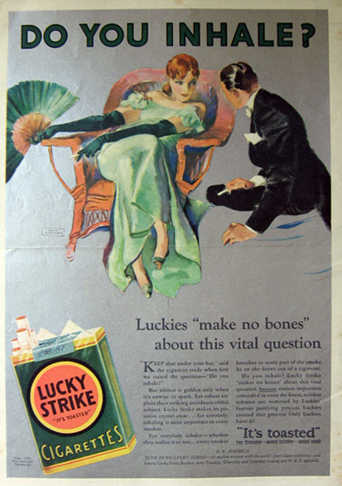

1932 Lucky Strike Cigarettes Ad ~ John Lagatta

*(*[*http://www.atticpaper.com/proddetail.php?prod=1932-lucky-strike-ad-no-bones*](http://www.atticpaper.com/proddetail.php?prod=1932-lucky-strike-ad-no-bones)*)*

In the 1950s medical studies began to connect smoking to lung cancer. In response, “filter tip cigarettes” were introduced as a safe solution to these hazards. Filters retain much of the tar and nicotine. So with each puff, the smoker receives more air and less tar and nicotine. The problem is that the nicotine-addicted smoker must continue to smoke additional filtered cigarettes until the body’s need for nicotine is satisfied. (<http://science.howstuffworks.com/innovation/science-questions/question650.htm>)

In 1964 the U.S. Surgeon General reported the dangers of tar and nicotine in cigarettes. The following year, the U.S. Congress passed the Cigarette Labeling and Advertising Act. This law required that a label stating, "Cigarettes may be hazardous to your health." be placed on every pack of cigarettes.

In the 1980s, as a response to this law, cigarette companies introduced formulas with reduced tar and they added filters to more of their products to reduce customer fear. The Comprehensive Smoking Education Act was passed by Congress in 1984. This required cigarette companies to change their warnings every three months by rotating these four different labels: Public Law 98-474, "Comprehensive Smoking Education Act, 1984".

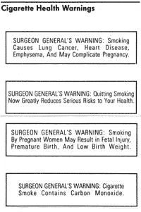

*(*[*http://healthliteracy.worlded.org/docs/tobacco/images/10b11a.gif*](http://healthliteracy.worlded.org/docs/tobacco/images/10b11a.gif)*)*

As it has become more difficult to sell cigarettes in the U.S., tobacco companies began looking for markets in South America, Asia and the Middle East. Where possible, they have moved their tobacco growing operations to the areas of greatest sales. (<http://healthliteracy.worlded.org/docs/tobacco/Unit1/2history_of.html>)

**More on** **tobacco production**

The main ingredient in cigarettes is dried tobacco leaves. After picking, the leaves are “cured” to prepare them for commercial use. Curing means drying the leaves slowly to produce “smooth aromatic” flavors. As the leaves are dried, the chlorophyll content is reduced so the green leaf color fades. Machines are then used to break the leaves into small pieces and artificial flavorings are added to make the cigarette smoke smooth and pleasurable. Potassium nitrate, an oxidizer, is added to both the tobacco and the rolling paper to ensure that the cigarette continues to burn even when someone is not actually smoking.

Cigarettes may contain many additives designed to increase their flavor and stability. The Ministry of Health in British Columbia claims that cigarettes may contain over 4,000 substances. Many of these are known carcinogens.

(<http://healthliteracy.worlded.org/docs/tobacco/Unit4/1whats_in.html>)

**More on toxics in cigarette smoke and e-cigarette vapor**

**Cigarette smoke**

The Harper E-cigarettes article lists several of the toxic compounds present in cigarette smoke and second-hand smoke. The possible effects on humans who are smoking or breathing second-hand smoke are located in the parentheses following each compound.

* carbon monoxide (headache, dizziness, weakness, upset stomach, vomiting, chest pain, confusion)
* hydrogen cyanide (headache, dizziness, weakness, nausea, vomiting)
* formaldehyde (watering of eyes, burning sensations of eyes, nose and throat, coughing, wheezing, nausea, skin irritation)
* benzene (leukemia)
* polyaromatic hydrocarbons or polycyclic aromatic hydrocarbons (malignant tumors in lungs and larynx)
* tobacco-specific nitrosamines or TSNAs (lung cancer)

Cigarette tar is a sticky, oily, viscous material that remains after the combustion of tobacco (or destructive distillation of wood). It accumulates in the lungs and is considered a carcinogen. (<http://healthliteracy.worlded.org/docs/tobacco/Unit4/1whats_in.html>)

Second hand smoke (SHS) refers to the smoke inhaled by people who are not actually smoking, but who are inhaling the smoke that comes directly from the cigarette or the vapor exhaled by smokers. The American Cancer Society says, “When non-smokers are exposed to SHS it’s called *involuntary smoking* or *passive smoking*.Non-smokers who breathe in SHS take in nicotine and toxic chemicals the same way smokers do.” (<http://www.cancer.org/cancer/cancercauses/tobaccocancer/secondhand-smoke>)

Recently, university research labs have drawn attention to the toxicity of third hand smoke (THS) or lingering smoke. This refers to the compounds left by prior smokers that permeate the air, dust and surfaces in an area occupied by cigarette smokers. Smelly evidence of smoking persists in the clothing, cigarette butts and carpeting of smokers. This residue is involuntarily inhaled by people visiting prior indoor smoking environments. (<http://ehp.niehs.nih.gov/1103500/>)

Unlike SHS which is composed of airborne particles, THS cannot be easily eliminated by opening doors and turning on fans. The residual nicotine and other toxics combine with ordinary air pollutants to form a toxic mix that permeates fabrics and settles on surfaces. This is especially harmful to young children. (<http://www.mayoclinic.org/healthy-lifestyle/adult-health/expert-answers/third-hand-smoke/faq-20057791>)

**E-cigarette vapor**

E-cigarette liquids called e-liquids or simply e-juices contain nicotine, flavorings, water, propylene glycol (C3H8O) and/or glycerol (C3H8O3). Nicotine is soluble in organic solvents such as propylene glycol (low viscosity) and glycerol (higher viscosity). The ratio of these two solvents is adjusted to create the correct amount of viscosity for easy e-liquid flow. Propylene glycol also keeps the vapor moist and well lubricated, while glycerol adds a sweet taste and enhances flavors.

(<http://cloudnine.hillarymilesproductions.com/electronic-cigarettes/pg-or-vg-how-propylene-glycol-and-vegetable-glycerin-affect-e-cigarette-vaping/>)

While e-cigarette liquids contain fewer ingredients than cigarette tobacco, toxics are formed during the high temperatures required for vaporizing. Under vaporizing (vaping) temperatures, both propylene glycol and glycerol decompose to formaldehyde and/or acetaldehyde. These compounds, found in e-cigarette vapor, are considered carcinogens. Below is a chemical list of the known toxics in e-cigarette vapor, with their effects on humans shown in parentheses. (<http://www.ncbi.nlm.nih.gov/pubmed/24832759>)

* nicotine (addictive)
* flavorings (safe to eat, unknown effects when vaporized)
* formaldehyde (carcinogen)
* acetaldehyde (carcinogen)
* acrolein (damages lungs, heart disease)
* heavy metals (various heavy metals can damage blood vessels; cause inflammation; and affect the central nervous system causing intelligence deficits, energy metabolism and protein synthesis disruption, and cell division irregularities)

(<http://www.webmd.com/smoking-cessation/news/20150218/e-cigarette-ingredients>)

In a letter published in the January 22, 2015 issue of the *New England Journal of Medicine*, researchers suggest that a "masked" form of formaldehyde is present in the condensed liquid from e-cigarette vapor. The concentration of this formaldehyde is much higher than in cigarette smoke. Scientists call it masked or hidden because it is a product formed when propylene glycol and glycerol are heated to high vaporizing temperatures in e-cigarettes. When the vapor is inhaled, formaldehyde from formaldehyde-releasing agents (FRAs) is deposited on lung tissue. Note that the graph below shows the difference between the quantities of formaldehyde intake from cigarettes as compared to that coming from e-cigarettes. The behavior of formaldehyde in the respiratory tract is currently unknown, but the irritating effects resemble those from cigarette smoke. (<http://www.nejm.org/doi/full/10.1056/NEJMc1413069>)

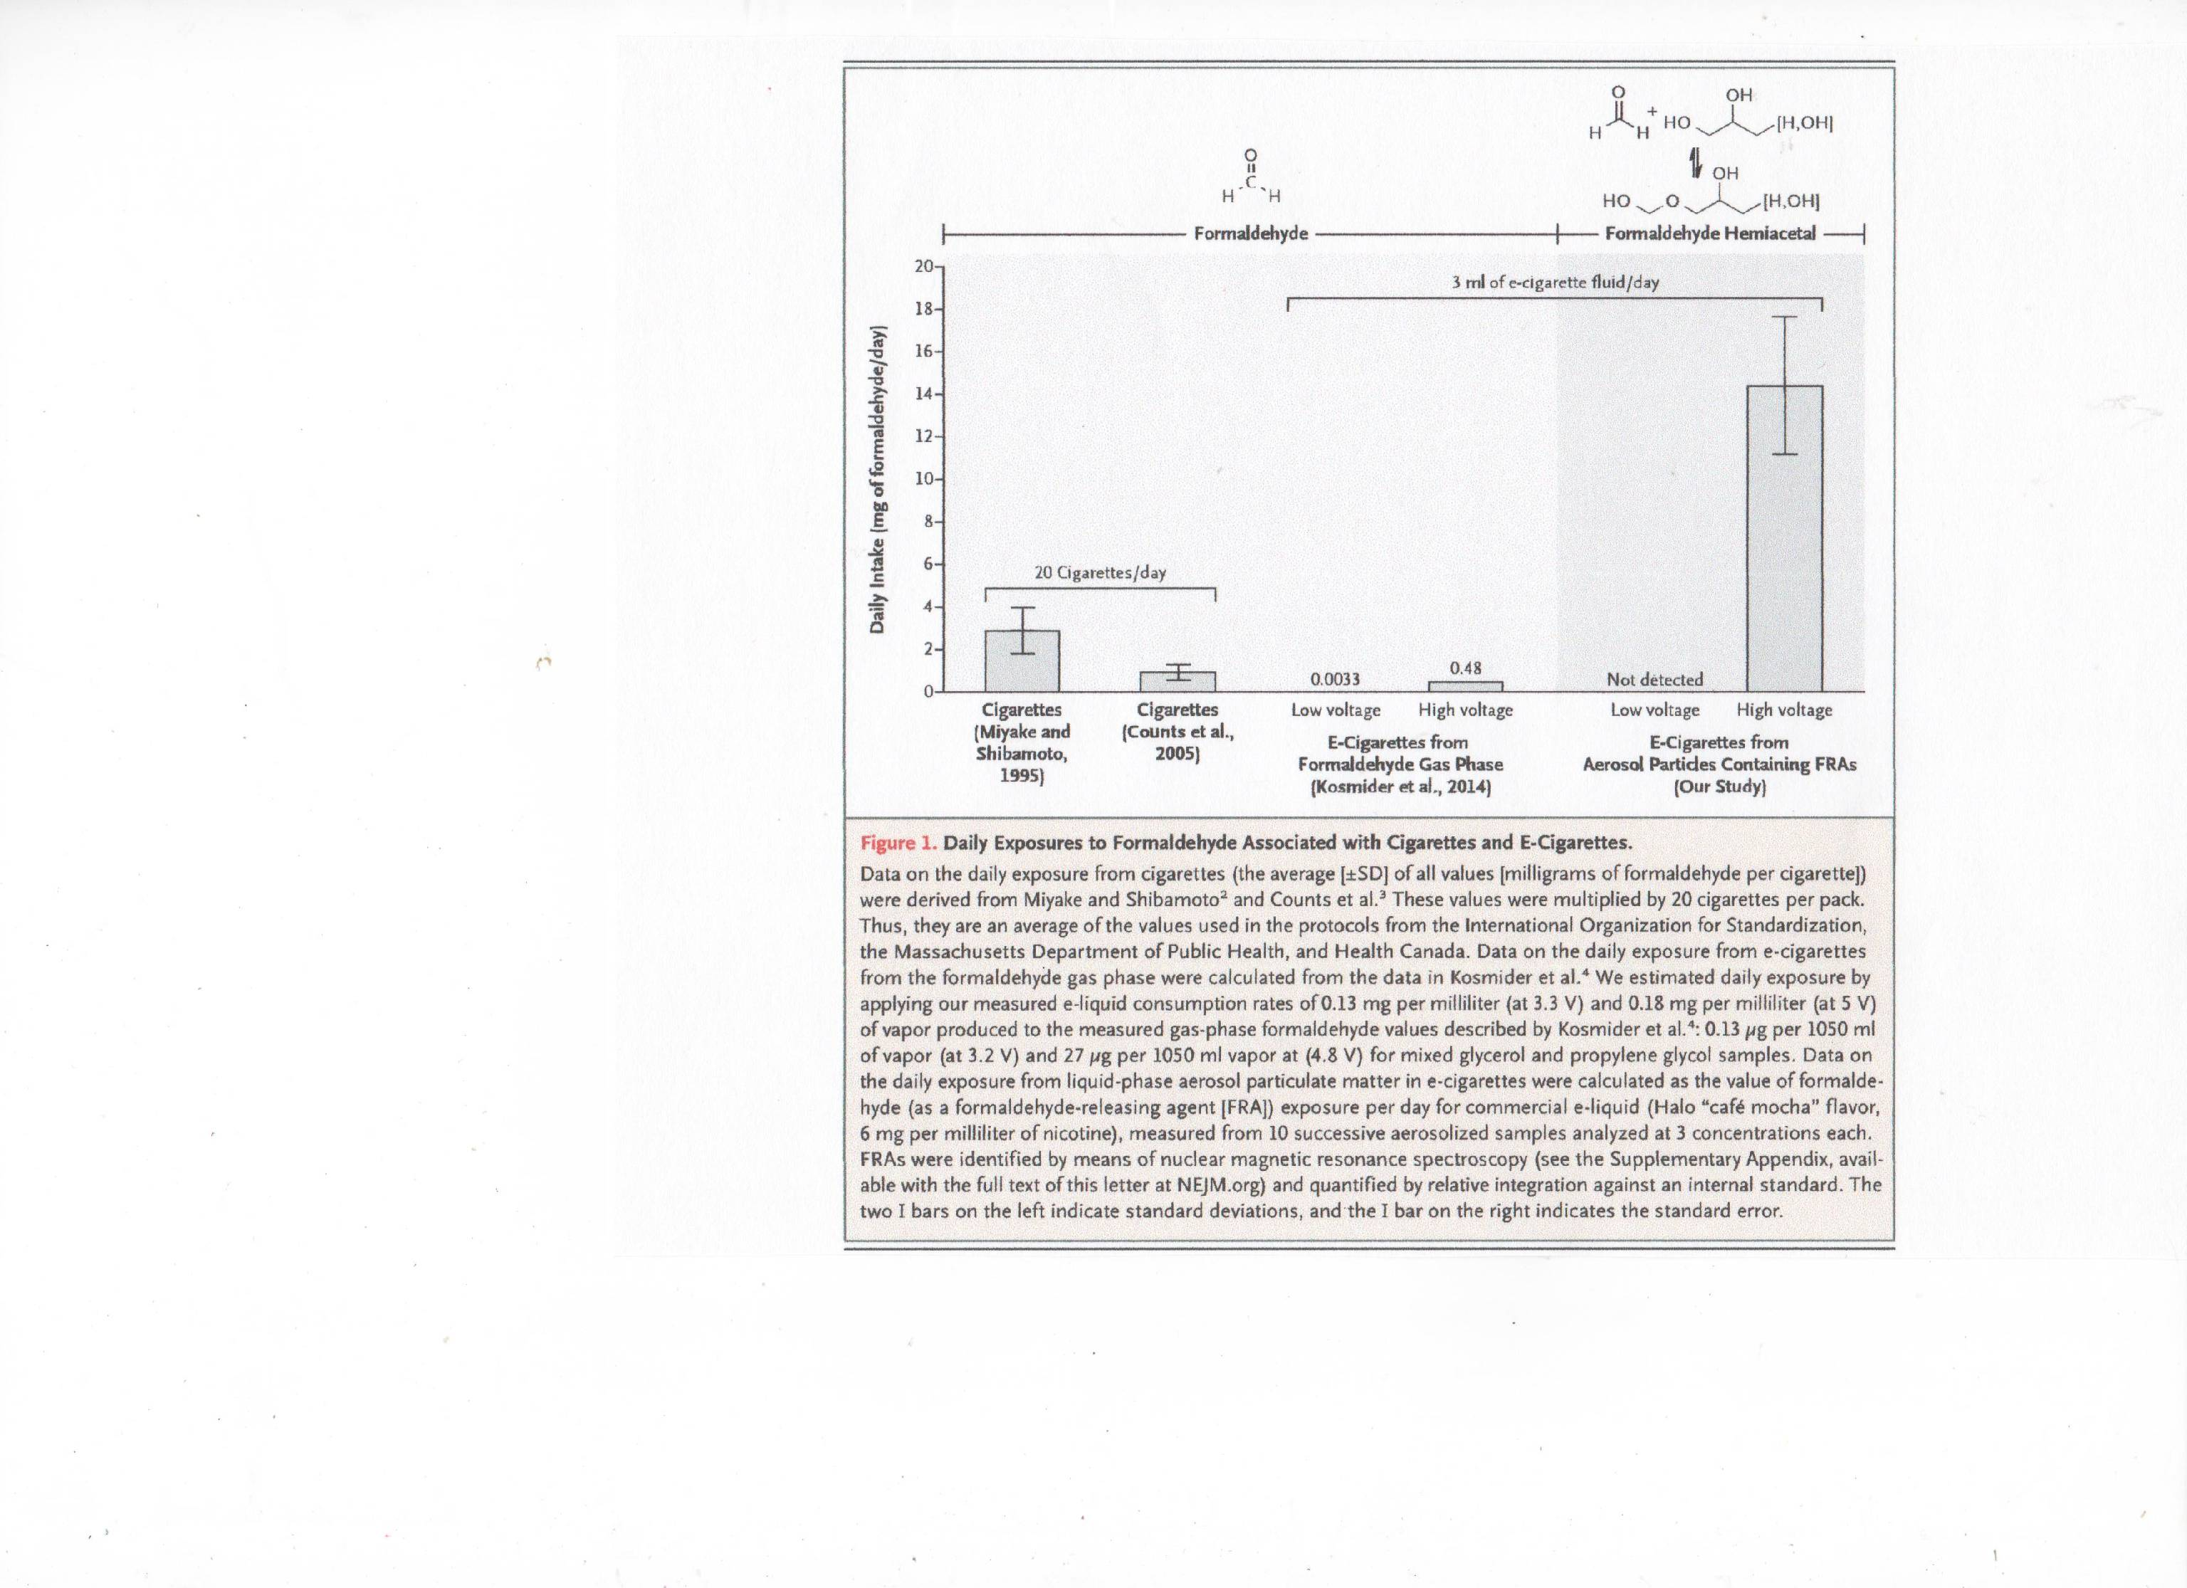

*(*[*http://www.nejm.org/doi/full/10.1056/NEJMc1413069*](http://www.nejm.org/doi/full/10.1056/NEJMc1413069)*)*

You might wonder about the source of heavy metals such as tin, chromium, nickel,

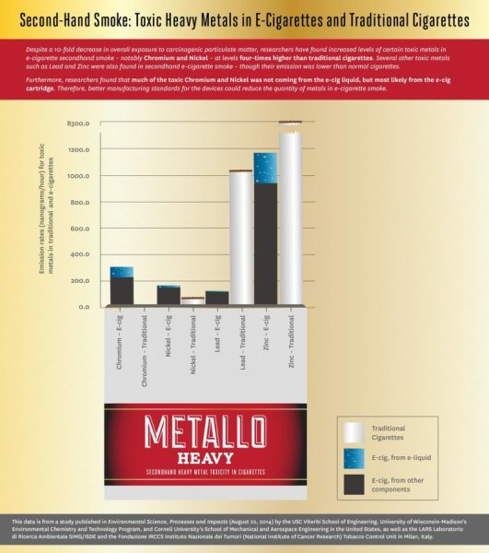mercury, or lead found in e-cigarette vapor. These metal particles flake off the metal coil, cartridge and solder during high vaping temperatures. E-cigarette vapor contains up to 100 times more nickel than regular cigarette smoke. The nano-sized flakes travel deep into lungs where they become embedded and create inflammation, damage blood vessels and affect the nervous system, as well as initiate cancer.

(<http://www.scientificamerican.com/article/smoke-screen-are-e-cigarettes-safe/>)

Despite a 10-fold decrease in overall exposure to carcinogenic particulate matter, researchers find increased levels of certain toxic metals in second-hand smoke from e-cigs. Credit: USC Viterbi

*(*[*http://www.sciencedaily.com/releases/2014/08/140828142809.htm*](http://www.sciencedaily.com/releases/2014/08/140828142809.htm)*)*

A comparison of toxics released in traditional cigarette smoke and in e-cigarette vapor is shown in the chart below:

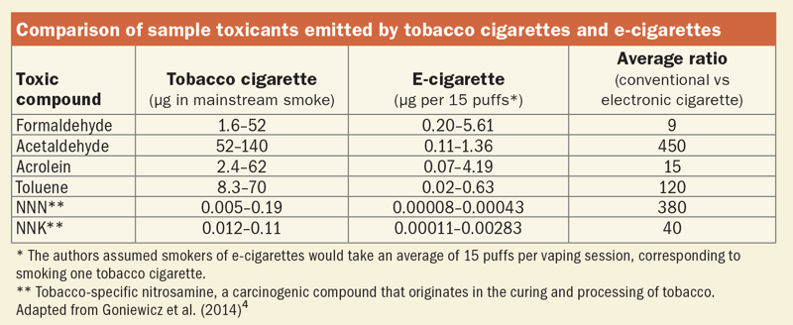

*(*[*http://ehp.niehs.nih.gov/122-a244/*](http://ehp.niehs.nih.gov/122-a244/)*)*

**More on** **the** **history of e-cigarettes**

Electronic cigarettes are basically battery-operated nicotine delivery systems that vaporize liquid. This vapor is inhaled instead of smoke from the burning of tobacco in regular cigarettes. Electronic cigarettes are designed to simulate the cigarette smoking experience. Many have added flavorings to additionally appeal to users.

Herbert A. Gilbert invented a “smokeless non-tobacco cigarette” in 1963 and received U.S. Patent number 3200819 for his invention on August 17, 1965. His design is used in current e-cigarettes. (<http://www.ecigarettedirect.co.uk/ashtray-blog/2013/10/interview-inventor-e-cigarette-herbert-a-gilbert.html>)

Although Gilbert was a heavy smoker, his original intent was to develop an easily hand-held device to be used as a warm respiratory inhalant of non-tobacco fluids. Quoting from his patent application:

The present invention relates to a smokeless nontobacco cigarette and has for an object to provide a safe and harmless means for and method of smoking by replacing burning tobacco and paper with heated, moist, flavored air; or by inhaling warm medication into the lungs in case of a respiratory ailment under direction of a physician. Another object of the invention is to provide an article of manufacture resembling a cigarette by which air may be drawn through a porous substance of a cartridge which has been moistened with a chemically harmless flavoring preparation, combining moisture and taste following which the moist and flavored air passes through a section of the device heated by a suitable heating element so that warm, moist and flavored air is drawn into the mouth and if desired into the lungs of the user.

A further object of the invention is to provide a smokeless non-tobacco cigarette in which provision is made for circulating the fluid around the heating element in a turbulent manner to suitably raise the temperature of the inhalant mixture, with the purpose that the temperature of the flavored air may approximate that of cigarette smoke.

(<http://www.google.com/patents/US3200819>)

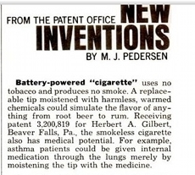

Although Gilbert’s invention was never successfully commercialized, it was advertised as shown at right.

*(*[*https://www.ecigarettedirect.co.uk/ashtray-blog/2012/05/history-electronic-cigarette.html*](https://www.ecigarettedirect.co.uk/ashtray-blog/2012/05/history-electronic-cigarette.html)*)*

The first electronic cigarette device used to replace the tobacco-smoking cigarette was patented in 2003 by Hon Lik, a pharmacist from Shenyang, China. Lik, a heavy smoker, developed the e-cigarette as an alternative to regular cigarettes. It was introduced to Chinese customers in 2004 and quickly spread internationally. E-cigarettes entered European and United States markets in 2006 and 2007.

**More on e-cigarette designs**

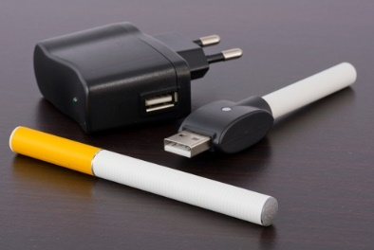

E-cigarettes can be purchased or custom made in many designs; some resemble regular cigarettes, cigars or pipes, while others look like the flash drive pictured at right or the vaping pens shown in the Harper e-cigarettes article, and below.

*(*[*http://women.smokefree.gov/ecigs.aspx*](http://women.smokefree.gov/ecigs.aspx)*)*

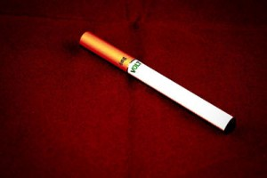

*(*[*http://vaperanks.com/what-is-a-cigalike/*](http://vaperanks.com/what-is-a-cigalike/)*)*

A “cigalike” is an e-cigarette that is designed to look and feel like a regular cigarette and taste somewhat like tobacco. It even has an ash-looking tip which is a light-emitting diode (LED), wired to light up when the e-cigarette is activated. People may have difficulty distinguishing a cigalike smoker from a person smoking a traditional cigarette. Since there are few regulations regarding e-cigarettes, people are usually not restricted from vaping (vaporizing the e-cigarette liquid) in a smoke free area. To keep e-cigarettes light weight and slim, their batteries are low capacity and require frequent recharging and their tiny canister holds little liquid so they must be refilled more often. Many are considered disposable.

Newer generations (called mods) come in various designs. Some resemble cigars and pipes or household items such as coke cans or flash drives. Others are made of various materials and displayed as luxury items. You can even design your own with help from the Internet. These have refillable canisters so one can choose a different flavor for each time you vape (“smoke” or vaporize the liquid).

(<http://motherboard.vice.com/read/e-cigarettes-dont-look-anything-like-you-think-they-do>)

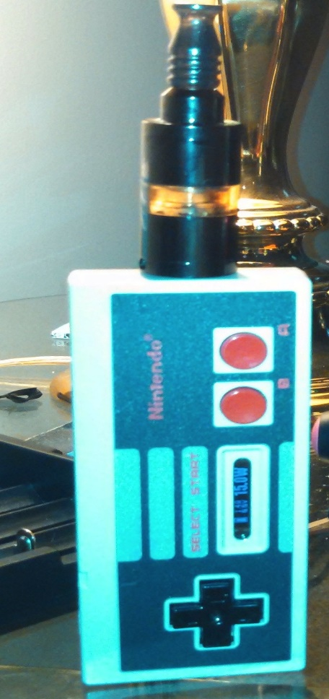

1. b.

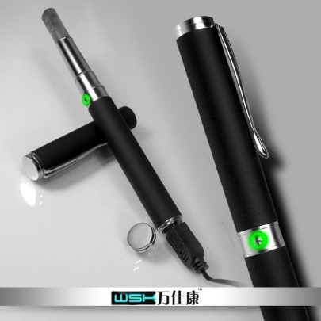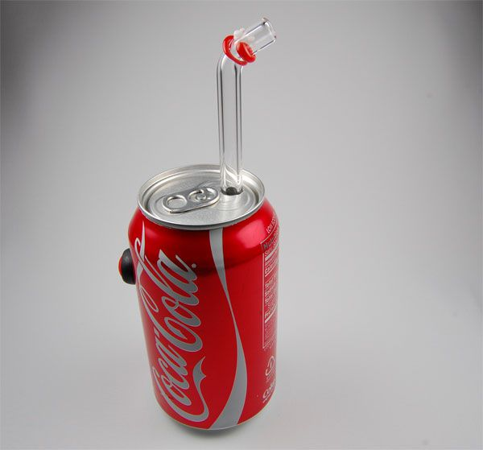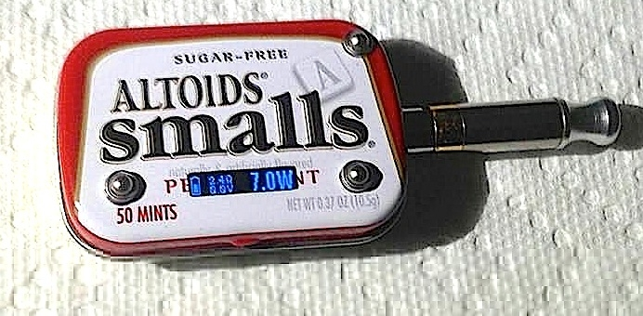

c. d.

Various types of mod e-cigarettes

* 1. *Coke Can e-cigarette:*

*(*[*http://cdn.shopify.com/s/files/1/0267/3447/files/coke-can-e-cig-mod.jpg?27331*](http://cdn.shopify.com/s/files/1/0267/3447/files/coke-can-e-cig-mod.jpg?27331)*)*

* 1. *Pen e-cigarette:*

*(*[*http://i01.i.aliimg.com/photo/v2/521410381/creative\_pen\_shape\_electronic\_cigarette.jpg*](http://i01.i.aliimg.com/photo/v2/521410381/creative_pen_shape_electronic_cigarette.jpg)*)*

* 1. *Altoids tin e-cigarette:*

*(*[*http://motherboard.vice.com/read/e-cigarettes-dont-look-anything-like-you-think-they-do*](http://motherboard.vice.com/read/e-cigarettes-dont-look-anything-like-you-think-they-do)*)*

* 1. *Nintendo controller e-cigarette:*

*(*[*http://motherboard.vice.com/read/e-cigarettes-dont-look-anything-like-you-think-they-do*](http://motherboard.vice.com/read/e-cigarettes-dont-look-anything-like-you-think-they-do)*)*

**More on** **how e-cigarettes work**

**Cigalikes**

They contain three parts as shown in the picture below:

* Cartridge: The container for the e-liquid has a cotton-like filling (similar to cotton swabs or coffee filters) to absorb the liquid, regulate its flow and avoid flooding or leaking. This part also works as the mouthpiece. (<http://vaperanks.com/what-is-filler-material/>)
* Atomizer: The battery powers the heating coil within the atomizer to vaporize the e-liquid.
* Battery: Homemade cigalikes may use two AA batteries as a power source. The LED activates when someone inhales. This light gives the cigalike the look of the burning tobacco seen during smoking a traditional cigarette.

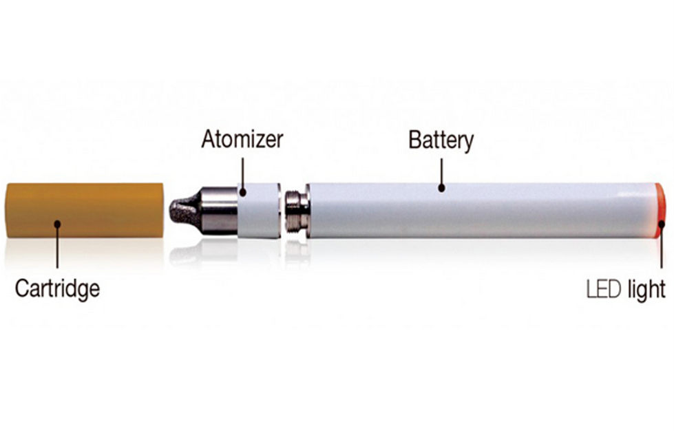

*(*[*http://e-cigpleasure.com/beginners-guide-all-about-electronic-cigarettes/*](http://e-cigpleasure.com/beginners-guide-all-about-electronic-cigarettes/)*)*

Newer models (see below) combine an advanced atomizer with the cartridge into a one piece cartomizer. This two-piece device, cartomizer and battery, is not designed to be refilled. Thus when you need liquid replacement, you also receive a new atomizer.

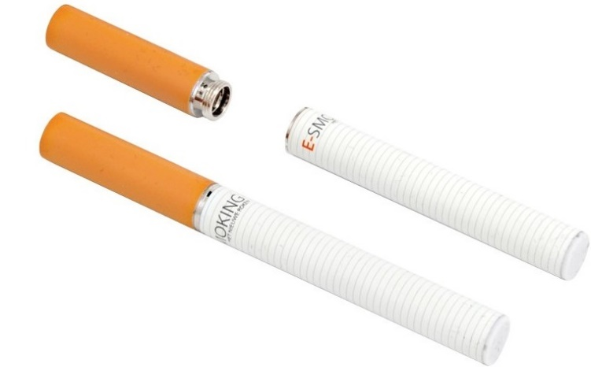

*(*[*http://artfulcrab.com/evolution-in-smoking-industry-e-cigarettes/*](http://artfulcrab.com/evolution-in-smoking-industry-e-cigarettes/)*)*

**Mods**

The newer, higher-end e-cigarettes called mods are not designed as disposables. They are larger and have more parts, controls, rechargeable batteries and refillable cartridges as shown in the picture below:

* LED: As in a cigalike, the light mimics the burning end of a regular cigarette.
* Battery: The lithium battery supplies current to the heating coil. In addition to being rechargeable, the battery voltage and wattage may be adjusted.
* Microprocessor/sensor: This is the control for the LED indicator light. The sensor notifies the processor when the user draws on the e-cigarette. This activates the LED light and turns on the heater.
* Heater or atomizer: The atomizer is activated when the user inhales pulling the liquid nicotine into the chamber where a customized coil heats and vaporizes the e-liquid, then passes the vapor on to the smoker.
* Cartridge or tank: The liquid nicotine is located inside another refillable chamber that looks like a cigarette filter. The smoker draws from this “filter” looking piece.
* Drip tip: This is where the user inhales to draw the nicotine vapor into the lungs. It can be made of various materials including glass and metal and take many shapes.

The picture below shows and describes the functions of each section:

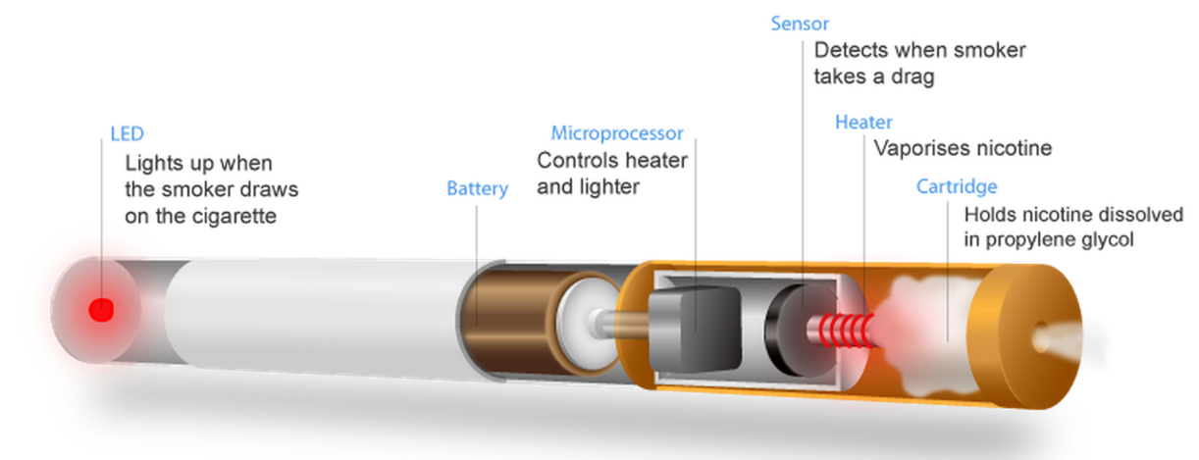

*(*[*http://motherboard.vice.com/read/e-cigarettes-dont-look-anything-like-you-think-they-do*](http://motherboard.vice.com/read/e-cigarettes-dont-look-anything-like-you-think-they-do)*)*

**More on plant nicotine**

Ian Baldwin, a plant ecologist at the Max Planck Institute for Chemical Ecology in Jena, Germany, has studied the role of nicotine in “tobacco plant fitness”. In his laboratory, genetic engineering is used to vary the nicotine concentration in plants. He has found that tobacco-chewing herbivores “prefer low nicotine diets”. (<http://journals.plos.org/plosbiology/article?id=10.1371/journal.pbio.0020250>)

Tobacco plants have solved a serious problem that arises during pollination. While plants can self-pollinate, to ensure reproductive strength they depend upon cross-fertilization between plants. When the plant releases benzyl acetone to attract moths, the moths lay eggs on the plant leaves; the eggs eventually become tobacco hornworm larvae. The hornworms are voracious herbivores that can quickly devour plant leaves.

Tobacco plants have developed a chemical mechanism to remedy this situation. The plants change the opening time of their flowers to daylight hours and release their chemical attractants to entice day time hummingbirds to become their primary pollinators thus avoiding the larvae produced by night time moths.



*(*[*http://blogs.discovermagazine.com/80beats/2008/08/29/tobacco-plants-control-pollinators-by-dosing-their-nectar-with-nicotine/*](http://blogs.discovermagazine.com/80beats/2008/08/29/tobacco-plants-control-pollinators-by-dosing-their-nectar-with-nicotine/)

The nectar of tobacco plants is a complex chemical mixture containing benzylacetone (4-phenyl-2-butanone), to lure some pollinators, and nicotine, to repel others. A high concentration of benzylacetone attracts hummingbirds. These plants can vary the concentration of nicotine in their nectar to discourage hummingbirds from spending too much time at one flower and encouraging them to flit from one plant to another. Thus, the nectar nicotine increases genetic diversity through cross-pollination. Robert Raguso, a Cornell University chemical ecologist says, “The plant is clearly manipulating its visitors in a way that optimizes its success.” (<http://www.the-scientist.com/?articles.view/articleNo/26715/title/Making-sense-of-floral-scents/>)

Benzylacetone—attractant

(<http://www.chemspider.com/Chemical-Structure.16422.html>)

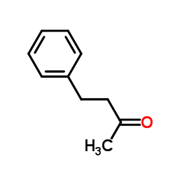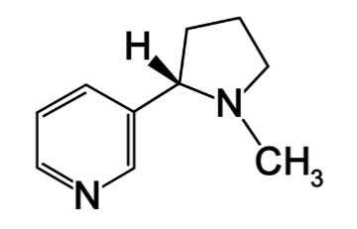

Nicotine—repellant

*(*[*http://www.apsnet.org/edcenter/intropp/topics/Pages/OverviewOfPlantDiseases.aspx*](http://www.apsnet.org/edcenter/intropp/topics/Pages/OverviewOfPlantDiseases.aspx)*)*

**Production and extraction**

Both regular cigarettes and e-cigarettes were developed to provide nicotine to the smoker. Nicotine is produced in tobacco plant roots, stored in plant leaf vacuoles and released as herbivores break the vacuoles during grazing. Nicotine, morphine, quinine and caffeine are classified as alkaloids. This is a large class or organic-ringed compounds that have physiological effects on humans. Poisons such as strychnine are also considered alkaloids.

When a tobacco plant is wounded—for example by an herbivore chewing its leaves, the plant produces jasmonic acid (JA). JA, a plant hormone, plays a major role in plant defense. This fatty acid molecule increases the plant’s resistance to herbivores by stimulating its production of nicotine. (<http://www.ncbi.nlm.nih.gov/pubmed/24242736>)

Jasmonic acid

*(*[*http://pubchem.ncbi.nlm.nih.gov/*](http://pubchem.ncbi.nlm.nih.gov/)*)*

(Enter jasmonic acid in search box.)

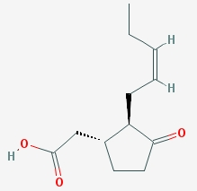

Nicotine citrate

*(*[*http://www.chemicalbook.com/ProductChemicalPropertiesCB9877676\_EN.htm*](http://www.chemicalbook.com/ProductChemicalPropertiesCB9877676_EN.htm)*)*

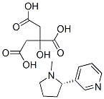

As tobacco plants mature, nicotine concentration increases. In a mature plants, approximately 64% of the nicotine is in the leaves, 18% in the stem, 13% in the root and 5% in the flowers. For stability, nicotine is stored in plants combined as a malate or citrate ([C16H22N2O7](http://pubchem.ncbi.nlm.nih.gov/search/#collection=compounds&query_type=mf&query=C16H22N2O7&sort=mw&sort_dir=asc)). (<https://en.wikipedia.org/wiki/Nicotiana_tabacum>)

On March 11, 2015, USA Liquid Nitrogen launched laboratories in the United States to extract nicotine. The company uses tobacco plant leaves grown in the central-eastern region of the United States, cures them and then uses a proprietary process to extract the pure liquid nicotine. (<http://usaliquidnicotine.com/contact-form-2/>)

**Nicotine chemistry**

Pale yellow nicotine is classified as an alkaloid, an organic molecule containing carbon, hydrogen, oxygen and nitrogen. As the name implies, alkaloids are basic (alkaline) substances. They are produced by plants, animals, fungi and bacteria. While many of these molecules are poisonous and addictive, they may play important roles in medicine due to their physiological effects. For example: atropine, a poisonous pesticide, is used to dilate pupils for eye examinations; and narcotics such as morphine and codeine are used to relieve pain following surgery. (<http://www.encyclopedia.com/topic/alkaloid.aspx>)

Alkaloids act quickly on the central nervous system (CNS), making them valuable as active ingredients in anesthetics, sedatives, stimulants, relaxants and tranquilizers. Since many are addictive, they must prescribed by a doctor and their use may be legally limited. (<http://science.howstuffworks.com/alkaloid-info.htm>)

Nicotine’s use in pesticides is extremely valuable. It has shown to be one of a few chemicals to which insects have not developed resistance. (<http://www.chemistryexplained.com/Ne-Nu/Nicotine.html>)

[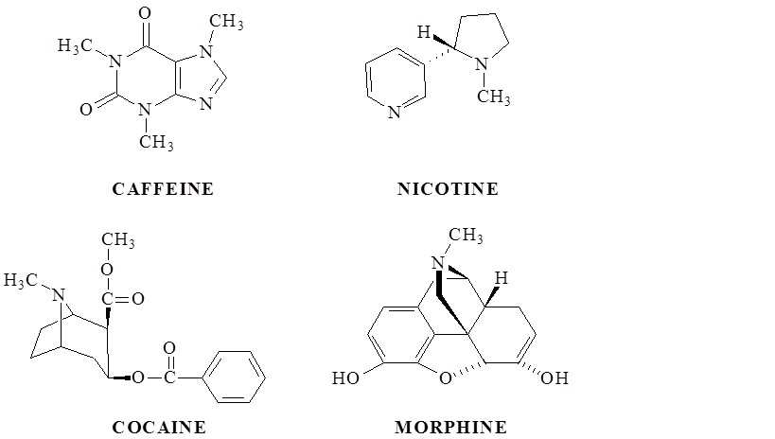](http://d1h8qm6whtl6z3.cloudfront.net/wp-content/uploads/2015/03/decodedscience1.jpg)

Representative alkaloids that are also addictive drugs

([Oné Pagán, PhD](http://www.decodedscience.org/author/orpaganyahoo-com): *(*[*http://www.decodedscience.org/drugs-nature-chemistry-addictive-alkaloids/53057*](http://www.decodedscience.org/drugs-nature-chemistry-addictive-alkaloids/53057)*)*

**More on the neurobiology of addiction**

As stated in the Harper e-cigarette article, it takes only 10 seconds for the nicotine in inhaled cigarette smoke to be absorbed through the mucous linings of the nose, mouth and lungs and enter the bloodstream which sends it directly to the brain.

The hypothalamus, located in the forebrain and shown in the pictures of the limbic system and the mesolimbic pathway, below, links the nervous system to the endocrine system via the pituitary gland. The major responsibility of this part of the brain is to maintain homeostasis of the automatic nervous system. When a stress is placed on the system, the hypothalamus is stimulated and reacts by stimulating the adrenal glands to produce hormones such as epinephrine (adrenaline), a neurotransmitter that constricts the blood vessels increasing the heart rate and blood pressure. In addition, the hypothalamus can stimulate the nucleus accumbens (the brain’s pleasure center) to release dopamine, a neurotransmitter that plays a role in regulating attention, cognition, movement, pleasure, and hormonal processes.

**Three Major Endocrine Glands**

Hormonal connections between the glands: corticotropin-releasing hormone (CRH), adrenocorticotropic hormone (ACTH), corticosterone hormone (CORT)

*(*[*https://commons.wikimedia.org/wiki/File:HPA\_Axis\_Diagram\_(Brian\_M\_Sweis\_2012).png*](https://commons.wikimedia.org/wiki/File:HPA_Axis_Diagram_(Brian_M_Sweis_2012).png)*)*

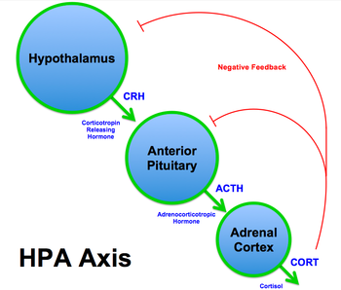

The hypothalamic-pituitary-adrenal axis (HPA axis) or limbic-hypothalamic-pituitary-adrenal axis (LHPA axis) directly influences and provides interactions among three endocrine glands pictured at right. (<https://en.wikipedia.org/wiki/Hypothalamic%E2%80%93pituitary%E2%80%93adrenal_axis>)

The picture below shows the primary structures of the brain’s limbic system. They are located on both sides of the thalamus, directly under the cerebrum. The hypothalamus is located below the thalamus. The mesolimbic dopamine pathway is located in this area. Note that the prefix “meso” refers to mid- or mid-brain area.

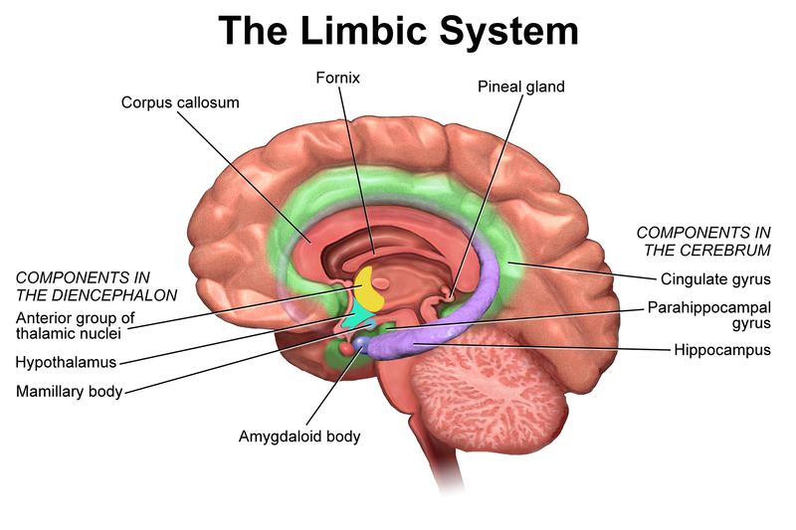*(*[*https://en.wikiversity.org/wiki/Wikiversity\_Journal\_of\_Medicine/Blausen\_gallery\_2014*](https://en.wikiversity.org/wiki/Wikiversity_Journal_of_Medicine/Blausen_gallery_2014)*)*

The mesolimbic pathway is central to the neurobiology of addiction. It is often referred to as the reward pathway or the path that dopamine follows in the brain. When nicotine and other addictive substances hijack or block the dopamine receptors as described in the Harper e-cigarette article, they follow the natural dopamine neural reward pathway. The pathway (see below) begins in the midbrain ventral tegmental area (VTA). Medium spiny neurons in the nucleus accumbens (NAc) receive messages from dopaminergic neurons in the VTA. The mesolimbic system is driven by the release of dopamine in the VTA. The pathway in the figure below is shown in blue running from the VTA to the NAc. (<http://www.nature.com/mp/journal/v8/n3/full/4001284a.html>)

[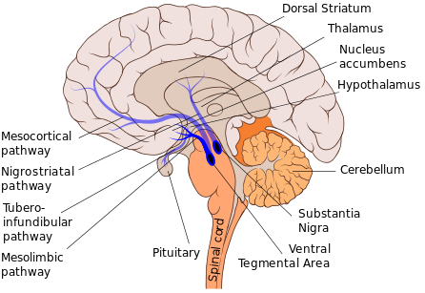](https://upload.wikimedia.org/wikipedia/commons/9/9d/Mesolimbic_pathway.svg)

Mesolimbic Pathway

*(Patrick J. Lynch:* [*https://en.wikipedia.org/wiki/Mesolimbic\_pathway*](https://en.wikipedia.org/wiki/Mesolimbic_pathway)*)*

In addition to the mesolimbic pathway (first on the list below), there are seven other dopaminergic pathways. These are the four major ones

|  |  |  |  |
| --- | --- | --- | --- |
| **Pathway name** | | **Description** | **Associated disorders** |
| Mesocorticolimbic projection | [mesolimbic pathway](https://en.wikipedia.org/wiki/Mesolimbic_pathway) | The mesolimbic pathway transmits dopamine from the [ventral tegmental area](https://en.wikipedia.org/wiki/Ventral_tegmental_area) (VTA) to the [limbic system](https://en.wikipedia.org/wiki/Limbic_system) via the [nucleus accumbens](https://en.wikipedia.org/wiki/Nucleus_accumbens). The VTA is located in the [midbrain](https://en.wikipedia.org/wiki/Midbrain), and the nucleus accumbens is in the [ventral striatum](https://en.wikipedia.org/wiki/Ventral_striatum). The "meso" [prefix](https://en.wikipedia.org/wiki/Prefix_(linguistics)) in the word "mesolimbic" refers to the midbrain, or "middle brain", since "meso" means "middle" in [Greek](https://en.wikipedia.org/wiki/Greek_language). This pathway is part of the mesocorticolimbic projection. | [schizophrenia](https://en.wikipedia.org/wiki/Schizophrenia), [ADHD](https://en.wikipedia.org/wiki/ADHD), [addiction](https://en.wikipedia.org/wiki/Addiction) |
| [mesocortical pathway](https://en.wikipedia.org/wiki/Mesocortical_pathway) | The mesocortical pathway transmits dopamine from the VTA to the [frontal cortex](https://en.wikipedia.org/wiki/Frontal_cortex). The "meso" prefix in "mesocortical" refers to the VTA, which is located in the midbrain, and "cortical" refers to the cortex. This pathway is part of the mesocorticolimbic projection. | [schizophrenia](https://en.wikipedia.org/wiki/Schizophrenia), [ADHD](https://en.wikipedia.org/wiki/ADHD), [addiction](https://en.wikipedia.org/wiki/Addiction) |
| [nigrostriatal pathway](https://en.wikipedia.org/wiki/Nigrostriatal_pathway) | | The nigrostriatal pathway transmits dopamine from the [substantia nigra pars compacta](https://en.wikipedia.org/wiki/Substantia_nigra_pars_compacta) (SNc) to the [dorsal striatum](https://en.wikipedia.org/wiki/Dorsal_striatum) (specifically, the [caudate nucleus](https://en.wikipedia.org/wiki/Caudate_nucleus) and [putamen](https://en.wikipedia.org/wiki/Putamen)). This pathway is associated with motor control. | [Parkinson's disease](https://en.wikipedia.org/wiki/Parkinson%27s_disease), [chorea](https://en.wikipedia.org/wiki/Chorea) |
| [tuberoinfundibular pathway](https://en.wikipedia.org/wiki/Tuberoinfundibular_pathway) | | The tuberoinfundibular pathway transmits dopamine from the [hypothalamus](https://en.wikipedia.org/wiki/Hypothalamus) ([arcuate nucleus](https://en.wikipedia.org/wiki/Arcuate_nucleus) aka "infundibular nucleus") to the [pituitary gland](https://en.wikipedia.org/wiki/Pituitary_gland). This pathway influences the secretion of certain [hormones](https://en.wikipedia.org/wiki/Hormone), including [prolactin](https://en.wikipedia.org/wiki/Prolactin). "Infundibular" in the word "tuberoinfundibular" refers to the cup or [*infundibulum*](https://en.wikipedia.org/wiki/Pituitary_stalk), out of which the pituitary gland develops. | [hyperprolactinaemia](https://en.wikipedia.org/wiki/Hyperprolactinaemia) |

*(*[*https://en.wikipedia.org/wiki/Dopaminergic\_pathways*](https://en.wikipedia.org/wiki/Dopaminergic_pathways)*)*

The mesolimbic (mesocorticolimbic) pathway is composed of nerve cells that have long axons that run the entire length of the pathway, conducting electrical impulses from the cell body that contains enzymes that synthesize dopamine throughout the pathway.

**Structure of a Typical Neuron**

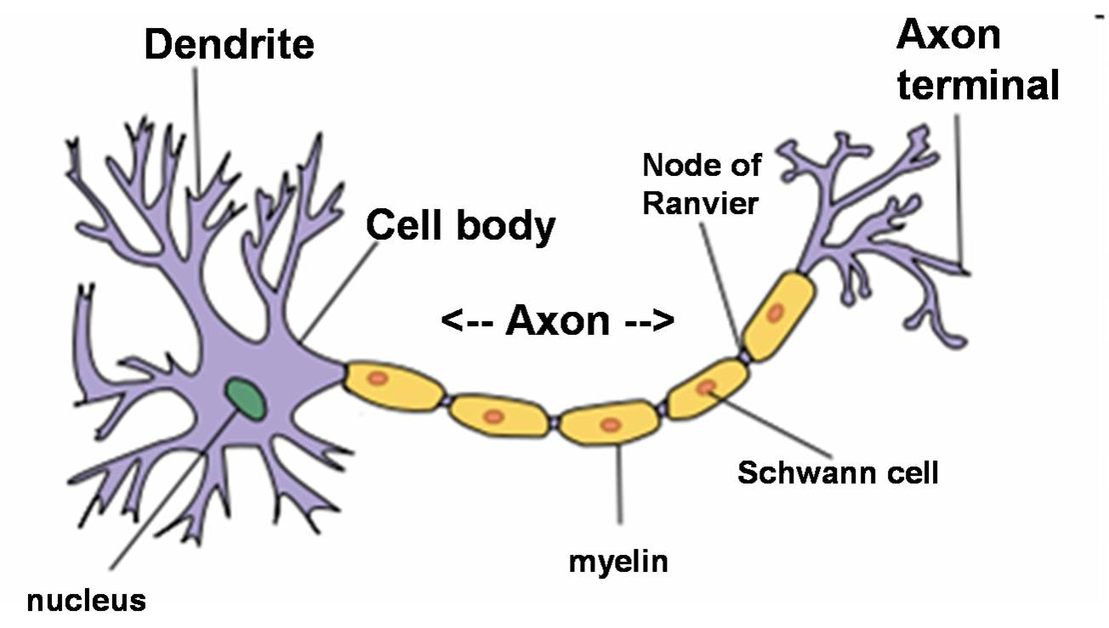

*(*[*https://basicbiochem.wordpress.com/tag/eukaryotic-and-prokaryotic-cells/*](https://basicbiochem.wordpress.com/tag/eukaryotic-and-prokaryotic-cells/)*)*

**More on nicotine addiction**

Harvard Medical School classifies addiction as a “chronic disease”, because it “hijacks the brain”, changing both its function and structure. As nicotine is absorbed, the brain undergoes changes. At first the person receives sensations of pleasure; soon the need for pleasure becomes a compulsion for more. Nicotine drives the nucleus accumbens to release increasing amounts of dopamine. An insufficient amount of nicotine in the brain signals the nucleus accumbens to produce less dopamine thus reducing the pleasure sensation. This drives the craving for increasing amounts of nicotine.

Harvard Medical School research suggests that addiction is a learning process because while dopamine provides pleasure, it also involves learning as well as remembering how to obtain this pleasure. Harvard finds that the brain’s reward circuit involves both motivation and memory along with pleasure. Therefore, when addictive substances such as nicotine overload the system, wanting something becomes a craving or addiction. (<http://www.helpguide.org/harvard/how-addiction-hijacks-the-brain.htm>)

The teen brain is still developing during adolescence. At puberty hormones trigger major changes. The prefrontal cortex (PFC) plays an important role in cognition involving memory, judgment and reasoning, as well as emotional and behavioral functioning. This is one of the last brain areas to develop. Thus, it is the focus of rat studies mentioned in the Harper article. As soon as nicotine binds to the acetylcholine receptors, signals are sent to activate the PFC. This disturbs working memory. When the PFC of an immature rodent is exposed to nicotine, synapses in the PFC are altered, leading to changes in gene expression at the molecular level.

This can lead to lasting effects on cognition.

The mesolimbic pathway, known as the reward pathway, carries dopamine from one area of the brain to another. Note the image in the “More on neurobiology of addiction” section of this guide. Dopamine controls the brain’s pleasure and reward centers. The pathway links the ventral tegmental area in the midbrain to the amygdala, nucleus accumbens, the medial prefrontal cortex and the hippocampus structures known as the limbic system. Emotional processing occurs in these structures.

During adolescence the emotional drive is strong and teens are motivated by rewards. During teenage years, the immature brain has reduced cognitive self-control and may lack the decision-making strategies of adults. The immature brain is more motivated by rewards and prone to mood swings, impulsivity, risk taking and influence from peers, especially in social interactions. For example, while an adult is more apt to recognize the risk, a teenager is more apt to believe that they can smoke for a few years and then quit.

Teens exposed to nicotine by smoking or vaping run the risk of developing psychiatric disorders and cognitive impairment, including reduced ability to remember or learn new things, pay attention, concentrate and make rational decisions that may affect their future.

(<http://www.ncbi.nlm.nih.gov/pmc/articles/PMC3543069/>)

In evidence based reviews, *Current Psychiatry* reports that children who are exposed to nicotine before the age of thirteen are extremely likely to suffer from attention deficit hyperactivity disorder (ADHD) which will last throughout their lives. Note that psychiatric comorbidity (below) refers to patients who have an addiction along with another psychiatric condition.

Psychiatric comorbidity is highly associated with cigarette smoking in adults and adolescents. In the United States:

* 44% of cigarettes smoked are sold to someone with a mental illness.
* Persons with mental illness are 2.7 times more likely to smoke than are those without mental illness.
* Most smokers start before age 18, and starting before age 13 is linked to psychopathology in later adolescence.

(<http://www.currentpsychiatry.com/the-publication/past-issue-single-view/how-to-help-nicotine-dependent-adolescents-quit-smoking/1ae29a758c4be54bfab7f7a75d1edf8f.html>)

**More on** **teen e-cigarette use**

The U.S. Department of Health and Human Services (HHS) reports a 4.7 percent increase in e-cigarette use by high school seniors in 2011. In 2014, this increase jumped to 17.2 percent. Teens are now using more e-cigarettes than traditional cigarettes.

The “Monitoring the Future Study” from the University of Michigan has been tracking 12th graders use of tobacco products since 1975. In 1991 surveys of students in grades eight and ten were added. From 1975 to 2014 they found declines in alcohol and cigarette use. The 2014 data also showed a drop in illicit drug use. In contrast the use of e-cigarettes has increased substantially.

The December 16, 2014 University of Michigan report that covered 377 public and private high schools and surveyed 41,551 students found a doubling of e-cigarette use by 8th and 10th grade students. This survey reported that “in the past 30 days” 9% of 8th grade students reported using e-cigarettes; 16% of 10th graders used e-cigarettes and 7% used regular cigarettes; and 17% of 12th graders used e-cigarettes and 14% smoked cigarettes. Based on this data, in May 2015 the U.S. HHS Office of Adolescent Health reported:

There is concern that e-cigarettes represent a gateway to the use of traditional cigarettes and other tobacco products. In 2013, one out of five middle school students who had tried an e-cigarette had not yet tried a conventional cigarette. Overall, approximately 263,000 middle- and high-school students used e-cigarettes that year, even though they had never smoked a conventional cigarette. Of these adolescents, just under half (43.9 percent) reported an intent to smoke conventional cigarettes in the next year. This is significantly higher than the number of youth who had never used an e-cigarette; of those, 21.5 percent reported an intent to smoke conventional cigarettes in the next year.

(<http://www.hhs.gov/ash/oah/adolescent-health-topics/substance-abuse/tobacco/trends.html>)

This study also showed that since the number of teenage smokers continues to decline, e-cigarettes rather than traditional tobacco appear to be the teen gateway to nicotine. This raises the concern that vaping will lead to nicotine addiction and lead to receiving a quicker satisfaction through smoking cigarettes. One of the researchers, R.A. Miech said, "Part of the reason for the popularity of e-cigarettes is the perception among teens that they do not harm health." (<http://ns.umich.edu/new/multimedia/videos/22575-e-cigarettes-surpass-tobacco-cigarettes-among-teens>)

In another study funded by the U.S. Food and Drug Administration (FDA) through the U.S. National Institutes of Health (NIH), the University of Southern California (USC) Keck School of Medicine found that vaping at an early age frequently leads to smoking regular cigarettes. Keck surveyed 2,530 14-year-olds at ten Los Angeles, California high schools who had never smoked tobacco by the beginning of the ninth grade. In the first study 222 of these students had used e-cigarettes. Six months later, 30.7 percent of the e-cigarette users had begun smoking cigarettes, cigars or hookahs. At the beginning of the tenth grade, the percentages were similar. A summary of their research was published on August 18, 2015 in *The Journal of the American Medical Association* (JAMA):

E-cigarettes may be drawing a new generation of teens into recreational nicotine use because they are high-tech, can be purchased somewhat easily, come in enticing flavors and have a perception that they’re not harmful,” said Adam Leventhal, Ph.D., associate professor and director of the USC Health, Emotion, & Addiction Laboratory (USC-HEAL) at the Keck School of Medicine. “Some e-cigarette devices appear to be very efficient at delivering nicotine to the lungs and brain. If you enjoy the experience of inhaling nicotine in e-cigarettes, it makes sense that you would be open to trying other nicotine products, like cigarettes, hookah, and cigars.

(<http://www.keck.usc.edu/news/teens-who-use-e-cigarettes-may-be-transitioning-to-tobacco-products-research-shows/>)

**More on** **e-cigarette regulation**

Unless marketed for therapeutic purposes, e-cigarettes are currently unregulated by the U.S. Food and Drug Administration (FDA).The only tobacco products regulated by the FDA are cigarettes, cigarette tobacco, roll-your-own tobacco and smokeless tobacco. However, there are proposals to extend regulation to include e-cigarettes because they meet the legal definition of a tobacco product. Some politicians and many in the tobacco industry oppose these proposals. (<http://www.fda.gov/NewsEvents/PublicHealthFocus/ucm172906.htm>)

This regulatory extension that would cover e-cigarettes is called the *Tobacco Products Deemed to Be Subject to the Food, Drug & Cosmetic Act (Deeming)*. Under Deeming e-cigarettes would be regulated by the FDA as well as cigars, pipe tobacco, certain dissolvable substances that are not “smokeless tobacco,” gels and water pipe tobacco. FDA regulation involves a scientific review of new products, age restrictions for purchase and an investigation of claims regarding the health, disease and death of users. (<http://www.fda.gov/TobaccoProducts/Labeling/RulesRegulationsGuidance/ucm388395.htm>)

Some states regulate or ban the sale of e-cigarettes to minors but they are still readily available for on-line purchase. State restrictions vary from none to certain age limits. Local laws may be more stringent than those imposed by the state.

Currently e-liquids are not regulated meaning there is no regulation of the purity and safety of the liquid nor of the amount of nicotine. Additionally, proposals pending for FDA regulation focus on what goes into the e-liquid, not what comes out in the vapor.

(<http://www.nytimes.com/2014/05/04/business/some-e-cigarettes-deliver-a-puff-of-carcinogens.html?_r=0>)

**More on** **e-liquid nicotine poisoning**

The U.S. FDA has approved five nicotine replacement products: patch, gum, nasal spray, inhalers and lozenges. These therapies are considered safer than e-cigarettes and e-cigarettes are considered safer than tobacco-burning cigarettes.

Nicotine is the addictive stimulant in both cigarettes and e-cigarettes. One regular cigarette contains 10 to 15 milligrams of nicotine, while a milliliter of e-liquid may contain anywhere from no nicotine to 72 milligrams. Short-term side effects from nicotine include increasing blood pressure and heart rate. In the long term, nicotine can interfere with fetal development. Although e-cigarettes do not contain tar, non-smokers may become addicted to nicotine by vaping. Frequently this addiction leads to smoking traditional cigarettes.

(<http://www.consumerreports.org/health/e-cigarette-facts-you-need-to-know>)

Not only do bubble gum and watermelon flavors attract teens to e-cigarettes, but they greatly increase the possibility that young children will be tempted by the devices. The U.S. Centers for Disease Control and Prevention (CDC) reports that more than half of the calls involving exposure to nicotine in e-cigarettes or e-liquid vials come from children aged five years and younger. The symptoms of nicotine poisoning include vomiting, nausea, and skin or eye irritation.

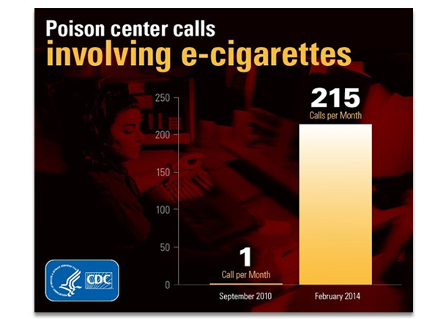 The CDC keeps statistics on the number of calls to their poison center hot-line. The graph at right shows an alarming monthly increase in calls between September 2010 and February 2014. During this period there were actually 2,405 calls: 69% involved ingestion; 17% were due to inhalation; 9% reported eye irritation; and 6% complained of skin irritation. (Note the total of 101% is due to rounding the values.)

*(*[*http://www.consumerreports.org/cro/news/2014/04/e-cigarette-poisonings-on-the-rise/index.htm*](http://www.consumerreports.org/cro/news/2014/04/e-cigarette-poisonings-on-the-rise/index.htm)*)*

(<http://www.consumerreports.org/cro/news/2014/04/e-cigarette-poisonings-on-the-rise/index.htm>)

The first death of a child from ingestion of e-liquid nicotine was reported in December 2014. This one-year-old ingested liquid nicotine at her New York home. (<http://abcnews.go.com/Health/childs-death-liquid-nicotine-reported-vaping-gains-popularity/story?id=27563788>)

Although nicotine concentration varies in e-liquid refills, it may be very high. Dr. Steven M. Marcus, medical director of the New Jersey Poison Information and Education System said, “Some are so high that if a child got a couple of drops it could put them into real serious trouble or death.” (<http://www.abc15.com/news/local-news/investigations/lawmakers-call-for-safety-caps-on-the-nicotine-refills-for-electronic-cigarettes>) The American Academy of Pediatrics says that one small 15 mL vial of e-liquid contains enough nicotine to kill four children. (<http://www.northjersey.com/news/n-j-issues-warning-on-liquid-nicotine-used-in-e-cigarettes-1.1287965>)

In response to the increased concern about poisoning of young children, a group of U.S. Senators lead by Bill Nelson (D-Florida), has introduced a bill that asks the Consumer Product Safety Commission to require safety caps on all e-cigarette liquid refills. Many of the refills are given child enticing flavors such as cotton candy and gummy bears.

(<http://www.abc15.com/news/local-news/investigations/lawmakers-call-for-safety-caps-on-the-nicotine-refills-for-electronic-cigarettes>)

**More on** **fires and explosions, and lawsuits**

The U.S. Fire Administration (USFA) posted a statement of “Key Points” regarding e-cigarette fires. Consumers complain that e-cigarette labels do not inform the public of the risk of fire. The last two bullets on the list below should be emphasized for all e-cigarette users.



*(*[*https://www.usfa.fema.gov/downloads/pdf/publications/electronic\_cigarettes.pdf*](https://www.usfa.fema.gov/downloads/pdf/publications/electronic_cigarettes.pdf)*)*

USFA is under the U.S. Department of Homeland Security and the U.S. Federal Emergency Management Agency (FEMA). USFA has compiled information about e-cigarette fires from media reports as seen in the graphs below. They caution that all incidents are not reported to the media.

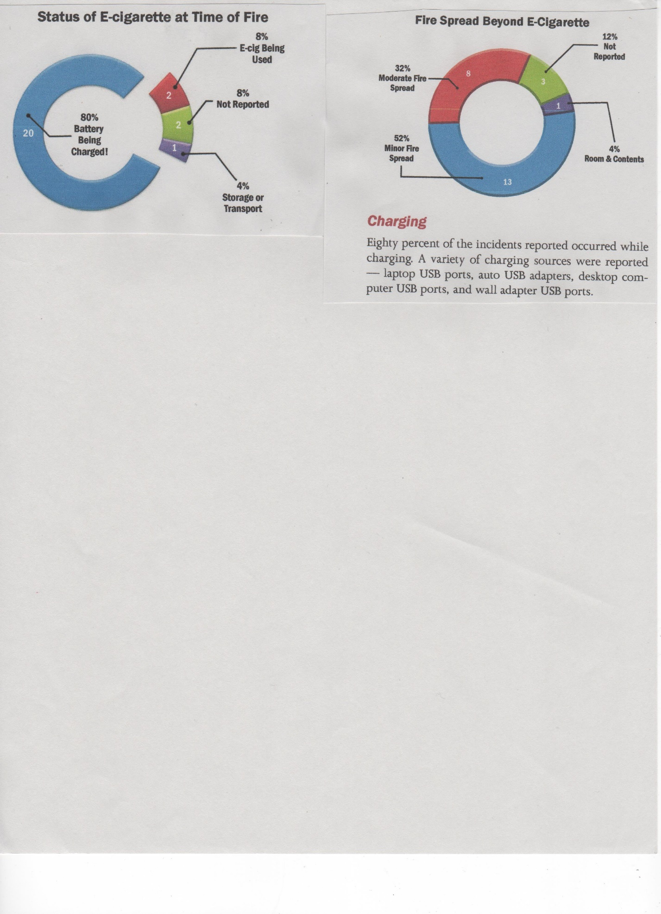

(<https://www.usfa.fema.gov/downloads/pdf/publications/electronic_cigarettes.pdf>)

A summary report with details about the incidents is located as Appendix 1 at this URL:

<https://www.usfa.fema.gov/downloads/pdf/publications/electronic_cigarettes.pdf>.

In January 2015 a lithium battery exploded and burned a suitcase in the Los Angeles International Airport storage area. This prompted a November 2015 U.S. Department of Transportation ban on e-cigarettes and other battery operated smoking devices in checked luggage. Passengers can still bring them on board in carry-on luggage, but they cannot be charged on the plane. (<http://www.cbsnews.com/news/government-bans-e-cigarettes-in-airline-passengers-checked-bags/>)

In March 2013, Jennifer Reis and her husband were driving to the airport when she decided to charge her e-cigarette battery. As soon as she plugged it into the car charger a liquid smelling like nail polish remover started dripping. As she tried to unscrew the battery, it suddenly exploded catching her dress and car seat on fire. She was severely burned. Cigalikes have low capacity batteries. A VapCigs e-cigarette battery can only hold a charge of less than 4.2 volts while a universal car cigarette lighter is approximately 5 volts.

In November 2015 she received $1.9 million against the distributor, manufacturer and the store that sold the device. Her product liability lawsuit claimed that these businesses were "involved in the distribution of a product that failed to conform to any kind of reasonable safety expectation—battery chargers should not explode—and failed to warn about known dangers."

(<http://www.latimes.com/local/crime/la-me-ecigarette-burns-verdict-20151001-story.html>)

**More on lithium batteries**

One of the major causes of lithium battery fires is failure to follow manufacturers’ advice to use the power adapter supplied with the e-cigarette device. Many e-cigarettes have USB ports for connecting to the adapter so people simply try to charge their e-cigs in their car or with their computer. The U.S. FEMA cautions that “all USB ports are not created equal”. The voltage and current may be too high for the e-cigarette battery.

Additionally to fit a lithium battery into a small cylindrical shaped e-cigarette requires winding the metallic anode and cathode material separated by a porous film, then enclosing it into a metal can that is sealed to prevent escape of the flammable liquid electrolyte. Failure occurs when the electrolyte is heated to boiling, increasing the internal pressure until it explodes.

The shape and construction of lithium batteries for e-cigarettes make them more likely to explode than other lithium-ion battery powered devices. In cell phones and computers, where space and shape are not such serious problems, safer construction involves flat shapes enclosed in rigid plastic pouches rather than metal cans.

(<https://www.usfa.fema.gov/downloads/pdf/publications/electronic_cigarettes.pdf>)

**More on e-cigarette language**

Vapers have their own jargon. Many Internet sites define the language of e-cigarette use. Students may be familiar with some of these basic terms. They may ask about others:

|  |  |
| --- | --- |
| **ADV** | All Day Vape |
| **Analog** | Traditional Tobacco Cigarette |
| **Atomizer (Atty)** | The heating element in the e-cigarette wrapped around a wick that produces vapor |
| **B&M** | Brick & Mortar – References a Vape Shop with a physical location you can visit |
| **Battery** | The power source for the atomizer in an electronic cigarette. May be replaceable, or integrated into the product |
| **Blend** | The Propylene Glycol to Vegetable Glycerin ratio in a bottle of e-liquid |
| **Box Mod** | A box shaped e-cigarette. May or may not have a replaceable battery |
| **Cartomizer (Carto)** | Cartridges with atomizers built into them, can be disposable or refillable |
| **Cartridge** | A plastic tube-like piece that is usually stuffed with some sort absorbent filler material that holds the juice |
| **Cigalike** | E-cig designed to look like a traditional cigarette |
| **Clearomizer (Clearo)** | Clear casings with atomizers built in that utilize a wick to transfer juice to the atomizer |
| **Cloudchaser** | Vapers who enjoy creating large clouds of vapor |
| **Clouds** | Exhaled Vapor |
| **Coil** | The heating element within the atomizer |
| **Condom** | Sanitary cover for the mouthpiece of an e-cigarette |
| **DIY** | Do it Yourself – References juice mixed by vaper not pre-mixed by distributor, and homemade e-cigarettes |
| **Drip Tip** | Mouthpiece of the e-cigarette. Generally replaceable |
| **Dripping** | The act of manually putting e-liquid onto the wick and heating element – no tank |
| **Dry Burn** | A method of cleaning atomizers to extend their life by burning the coil in short intervals without juice |
| **Dry Hit** | A puff from an e-cigarette when there is no juice being heated into vapor, resulting in an unpleasant burnt taste and harsh throat hit |
| **E-Cig** | Electronic Cigarette |
| **e-Liquid/Juice** | A liquid solution containing a mixture of Propylene Glycol (PG), Vegetable Glycerin (VG), flavoring and sometimes nicotine that is heated in the e-cigarette to create vapor |
| **eGo** | An e-cigarette battery style that offers two different threading types. Usually a pen appearance style e-cigarette. May also refer to the common “eGo” style threading |
| **Flavor Ghosting** | When you taste the previous flavor you were vaping after switching e-juice |
| **Flooding** | When too much juice is applied to the atomizer resulting in decreased vapor production, gurgling noises, and possible juice leaking into the drip tip |
| **Ghosting** | The act of using an electronic cigarette in such a way that it produces very little vapor. Usually by holding a hit until the exhale is not visible |
| **Lung Hit/Lung Rip** | Inhaling vapor directly from the atomizer into your lungs, as one would take a normal breath |
| **Mechanical Mod (Mech Mod)** | Modified e-cigarettes that have no regulatory electronic chip or safety features. Generally used by advanced users to accomplish “Cloud Chasing” |
| **Mod** | Used to describe modifications to a device or accessory, or a design variation of a commonly manufactured electronic cigarette |
| **Mouth Hit/Mouth Rip/Mouth-to-Lung** | Drawing vapor into the mouth before inhalation, similar to puffing a cigar. May or may not be followed by inhalation |
| **Nic** | Nicotine |
| **No-Nic** | 0mg Nicotine (No added Nicotine) |
| **Ohm** | A measure of electrical resistance. A lower number indicates lower resistance resulting in faster heating |
| **Passthrough** | E-cigarette battery style that allows use while charging |
| **PCC** | Personal or Portable Charging Case allows you to charge your e-cigarette without an outlet |
| **PG** | Propylene Glycol – A solution used as a base for e-juice |
| **PV** | Personal Vaporizer – Another term for e-cigarette |
| **Regulated Mod** | Modified e-cigarettes that still contain a regulating electronic chip and safety features |
| **Resistance** | Refers to the ability to electricity to travel through the heating element in the e-cigarette |
| **Stealth Vape** | An electronic cigarette that is inconspicuous, with a low profile that is easily concealed. May also refer to Ghosting |
| **Steeping** | An oxidation process that occurs between the flavoring, nicotine, and base (PG/VG) giving your juice time to become more flavorful |
| **Tank** | E-liquid reservoir |
| **Threading** | The radius and style of the attachment connector on an e-cigarette battery and the device being used to house your juice (atty, carto, clearo, etc.) |
| **Throat Hit** | The feeling you get in the back of your throat and in your lungs when you inhale vapor |
| **Unregulated/Non Regulated Mod** | Refers to a Mod that does not have a regulating chip. May refer to mechanical or semi-mechanical mods |
| **Vape/Vaping** | The act of using an e-cigarette |
| **Vaper** | An electronic cigarette user |
| **Vaper’s Tongue** | Also known as Vaper’s Fatigue refers to temporary olfactory fatigue resulting in a diminished or inability to taste the flavor of your juice |
| **VG** | Vegetable Glycerin – Used as a base in e-juice |
| **VV** | Variable Voltage – Allows you to change voltage of your e-cigarette |
| **VW** | Variable Wattage – Allows you to change the wattage of your e-cigarette |
| **Wick** | Absorbent material used to draw the e-liquid into the heating element |

*(*[*http://blog.mtbakervapor.com/understanding-vape-jargon/*](http://blog.mtbakervapor.com/understanding-vape-jargon/)*)*

# Connections to Chemistry Concepts

**(for correlation to course curriculum)**

1. **Phase change**—During the study of types of energy that are used to change physical states of matter, use the example of the liquid to vapor (gas) powered by a battery in e-cigarettes.
2. **Benzene ring structure and bonding**—When discussing the structure and sp2 bonding stability of benzene rings in aromatic compounds, show students the benzene ring in nicotine. Nicotine’s stability allows researchers to determine the concentration of nicotine in frozen blood.
3. **Classes of organic compounds**—This article provides the opportunity to discuss aldehydes, nitrosamines, and amino acids in the context of the components of cigarette smoke and their effect on the human body.
4. **Extraction processes**—Nicotine extraction from tobacco plant leaves presents the opportunity to introduce chemical engineering practices used to separate, purify and concentrate materials in the food, beverage and petroleum industries.
5. **Organic bonding**—Cation-π bonding between the negatively-charged, electron-rich benzene ring of an amino acid molecule and the nitrogen cation of the trimethylammonium group on the acetylcholine molecule can be used as an example of noncovalent molecular interaction. This interaction is pictured in Figure 3 of the Harper E-cigarettes article.
6. **Organic functional groups**—Addition of the amino, methyl and trimethylammonium groups to the study of organic functional groups can be used to show connections to real world examples of interactions between organic molecules.
7. **Cationic bonding**—In organic covalent bonding, positive and negative attractions between molecules can be illustrated between the nitrogen cation, present in both acetylcholine and nicotine molecules, serving as the positive center and the electron rich amino acid receptors that are attracted to it.
8. **Alkaloids**—This large group of organic compounds produced by plants usually contain carbon, hydrogen, nitrogen and usually oxygen. Many are alkaline and have physiological effects: some are addictive like nicotine; some like quinine are used in medicine; and others—for example, hemlock—are poisonous.
9. **Organic nomenclature**—Note that the names of nitrogen containing alkaloids end in “ine” such as nicot**ine** or caffe**ine** because their nitrogen atom is part of an amino group ─NH2.
10. **Biochemistry**—Nicotine can alter the synapses in the immature, developing brain of teenagers.

# Possible Student Misconceptions

**(to aid teacher in addressing misconceptions)**

1. **“E-cigarettes advertisements are intended to attract adults only.”** *If e-cigarettes were marketed for adults only, companies would not advertise odors and flavors that appeal to young people.*
2. **“I think that I’ll try vaping because I don’t want to become addicted to smoking regular cigarettes.”** *Studies have found as many as one-third of young e-cigarette users have never tried conventional cigarettes. However, there is evidence that vaping may lead non-smokers to nicotine addiction and they will turn to cigarette smoking as the body craves additional nicotine.*
3. **“I’ve heard that e-cigarettes are much better because the liquid in e-cigarettes is vaporized, so there won’t be any dangerous second hand smoke.”** *Since there are many different flavored e-cigarettes, the formula of the liquids varies as does the contents of the vapor. E-liquid contains nicotine and the vapor produces second-hand smoke containing carcinogens such as formaldehyde.*
4. **“I like the idea of trying e-cigarettes because there are so many flavors and I understand that many do not contain much nicotine.”** *Although the levels of nicotine vary in different e-cigarettes, they all contain some nicotine. Thus, people can become addicted and simply need to vape more of those containing a lower concentration of nicotine.*
5. **“Friends tell me that vaping e-cigarettes is a safe alternative to smoking regular cigarettes because there isn’t any smoke to inhale.”** *When you are vaping, you are still inhaling nicotine vapor and carcinogenic substances into your lungs*.
6. **“Since e-liquid contains only safe solvents, nicotine and flavoring, the vapor from e-cigarettes is pure.”** *Although e-liquid may sound pure, during the vaporization process at high temperatures, a mixture of gases including formaldehyde and heavy metal nanoparticles is produced.*
7. **“E-cigarettes do not present a problem for children.”** *In addition to the toxic chemicals produced, children find e-liquid packages attractive. The nicotine in e-liquids can be deadly for children.*
8. **“I understand that e-cigarettes are a safe, harmless nicotine delivery system without the carcinogenic byproducts that come from burning tobacco leaves.”** *Although tobacco leaves are not burned in e-cigarettes, harmful chemicals such as formaldehyde form during the vaporization of e-liquids.*

# Anticipating Student Questions

**(answers to questions students might ask in class)**

1. **“What is the difference between smoke and vapor?”** *Smoke is a mixture small; solid particles suspended in gases produced when something burns. Vapor is the gas formed when a liquid is evaporated or heated to its boiling point.*
2. **“Is it safe to inhale the vapor from flavorings?”** *This is still unknown due to many different commercial flavorings, plus concoctions that people invent. If and when the U.S. FDA regulates e-cigarettes, scientists will test the effects of commercial products on humans.*
3. **“What is the difference between smoking a hookah and vaping an e-cigarette?”** *Hookahs and e-cigarettes are different types of nicotine delivery devices. In a hookah tobacco is evaporated by hot coals, and then bubbled through water before the nicotine-laden smoke is inhaled. In e-cigarettes the nicotine liquid is vaporized before it is inhaled.*
4. **“I see vaping lounges advertised. What are they?”** *A vaping lounge is a place where people can legally smoke e-cigarettes even in areas where all tobacco and e-cigarette smoking is prohibited. Vaping lounges are usually located within retail e-cigarette shops.*
5. **“Is it true that e-cigarettes are an easy, pleasurable way to quit smoking?”** *Although people like the choice of e-cigarette flavors, there haven’t been any scientific studies that prove that e-cigarettes help people quit smoking. Rather than quitting, 2013 data shows that 76.8 percent of e-cigarette users also smoke regular cigarettes.*
6. **“I need to lose about 15 pounds. Can I do this by vaping?** *Although people who blog on vaping websites claim weight loss, there are better ways to reduce your weight without the multiple side effects of nicotine.*
7. **“Since I don’t plan to smoke e-cigarettes, will it be safe to spend some time in the vaping salon with my boyfriend?”** *This is not a good idea because you will inhale the toxic chemicals from the vapor present in the salon, and nano-sized particles of heavy metals that flake off the vaping device at high temperatures will enter your lungs.*
8. **“Since the FDA hasn’t published any warnings, does this mean that it must be alright to smoke e-cigarettes?”** *To date, the U.S. FDA has not evaluated any of the 7,700 e-cigarette flavors. So there are no warning labels listing the chemicals they contain or the products produced by vaporization. Yet, scientific data shows the dangers of nicotine addiction as well as the dangers of inhaling the by-products of e-liquid vaporization.*

## In-Class Activities

**(lesson ideas, including labs & demonstrations)**

1. The laboratory activity, *Distillation of Wood*, will amaze students. As wood splints are heated in a test tube, a tar-like residue remains in the test tube and the methane product is flammable. Students can see this process as similar to tobacco leaves producing tar as they are burned in a cigarette. For safety, you may consider doing this as a demonstration in a fume hood. Anyone close to the experiment must wear goggles. My students used to do this lab in the *Introductory Physical Science (IPS)* course. (<https://www.acs.org/content/dam/acsorg/pressroom/podcasts/distillation-of-wood-activity.pdf>)
2. A laboratory activity: “Comparing Cigarette Smoke”, Unit 7 Section C.7. Students create an apparatus to generate smoke from a cigarette and test its properties on Euglena. (Heikkinen, H., Ed. *ChemCom: Chemistry in the Community*, 1st ed. A project of the American Chemical Society; Kendall/Hunt Publishing Company: Dubuque, Iowa, 1988; unit 7, section C.7)
3. The U.S. Centers for Disease Control and Prevention published a 50-minute high school laboratory activity: “Where There’s Smoke: The Effects of Smoking on the Human Body”. Cigarette smoke is generated and then collected in a syringe for testing. (<http://www.cdc.gov/bam/teachers/documents/smoking.pdf>)
4. A viscosity lab: “Properties of Petroleum” asks students to study the rate of flow of several liquid hydrocarbons. The viscosity of e-liquid is regulated for optimal flow by adjusting the ratio of propylene glycol to glycerol. Powers, A., Ed. *ChemCom: Chemistry in the Community*, 6th ed. A project of the American Chemical Society; W.H. Freeman and Company/BFW: New York, New York, 2012; unit 3, section A.1.
5. Quick demonstration of viscosity: Compare the rate of flow of water and glycerol (or honey) by pouring each into a container.
6. A laboratory activity to extract caffeine from tea bags was developed by the *Tops Chemistry Program* at Occidental College, Eagle Rock, CA. Hexanes and isopropanol are used for the extraction. Caffeine crystals are collected by sublimation. (<https://oxytops.wordpress.com/2012/10/31/caffeine-extraction-from-tea-bags/>)
7. Demonstrate a simple extraction procedure using green leaves. This short YouTube video shows the addition of isopropanol to spinach leaves in a beaker. Place the mixture on a magnetic stirrer for an hour to extract the green pigment. Note that nicotine cannot be easily and safely removed from tobacco leaves in most high school laboratories. (<https://www.youtube.com/watch?v=6j4QIbC_1Nc>)
8. Separation, extraction and identification of mixtures can be shown by paper chromatography of black non-permanent markers, M&M candies, Skittles candies and/or food coloring. The candy and food coloring activity is Investigating Matter 7D.7 in the text: ACS. *Chemistry in the Community*, 6th ed. W.H. Freeman: NY, 2012. This site gives directions for paper chromatography of black jelly beans: (<http://www.stevespanglerscience.com/lab/experiments/candy-chromatography/>)

# Out-of-Class Activities and Projects

**(student research, class projects)**

1. Ask students to research and present the information they gather about the chemistry, health effects and government regulations of a toxic component present in cigarette smoke. Those listed in the Harper E-cigarettes article are: carbon monoxide**,** hydrogen cyanide, formaldehyde,benzene, polyaromatic hydrocarbons and tobacco-specific nitrosamine.
2. Assign a review of the literature on electronic nicotine delivery devices to students. The Department of Health Behavior of the University of North Carolina has published the abstracts of 10 research papers that they reviewed. For example, one paper cited is titled: “Electronic Cigarettes: Peering through the Smoke Screen”. (<http://tobaccocontrol.bmj.com/content/early/2013/11/20/tobaccocontrol-2013-051122>)
3. The site described in the second activity (above) describes the methods used by researchers and provides a good format for organizing their findings. Student teams could use the given format: Objective, Data Sources, Study Selection, Data Extraction, Data Synthesis and Conclusion to evaluate additional sites on teen e-cigarette use that they access through the Internet. (<http://tobaccocontrol.bmj.com/content/early/2013/11/20/tobaccocontrol-2013-051122>)
4. Accelerated students can view the Khan Academy video, “Types of neurotransmitter Receptors” as a homework enrichment assignment. This 6:35 minute YouTube video uses diagrams to explain the electrical nature of information flowing to neurons through the dendrites from a mix of excitatory and inhibiting synapses. (<https://www.youtube.com/watch?v=yg44T2HcA2o>)

# References

**(non-Web-based information sources)**



**30 Years of *ChemMatters***

Available Now!

**The references below can be found on the *ChemMatters* 30-year DVD (which includes all articles published during the years 1983 through April 2013 and all available Teacher’s Guides, beginning February 1990). The DVD is available from the American Chemical Society for $42 (or $135 for a site/school license) at this site:** [http://ww.acs.org/chemmatters](http://www.acs.org/chemmatters)**. Click on the “Archive” tab in the middle of the screen just under the *ChemMatters* logo. On this new page click on the “Get 30 Years of *ChemMatters* on DVD!” tab at the right for more information and to purchase the DVD.**

**Selected articles and the complete set of Teacher’s Guides for all issues from the past three years are available free online at the same Web site, above. Simply access the link and click on the aforementioned “Archive” tab.**

Holtzman, D. Smoking. *ChemMatters*, 1986, *4* (1), pp 4–6. Article discusses the effects of smoking on health including “the allure of nicotine”.

M. O. and D. R. Nicotine Patches. *ChemMatters*, 1992, *10* (3), p 15. This article explains how transdermal patches work and how they can be used to supply nicotine to those who want to stop smoking.

Wood, C. Plants Fight Back. *ChemMatters*, 1996**,** *14* (2), pp 9–11. Scientists developing insecticides studied how plants protect themselves with natural substances such as nicotine.

Herlocker, H. Transdermal Patch Driving Drugs Skin Deep. *ChemMatters*, 2004, *22* (4), pp 17–19. This article provides some good illustrations and further information about how transdermal patches work and notes that this is a method of supplying nicotine.

Brownlee, C. Percy Julian Rising Above Racism. *ChemMatters*, 2007, *25* (3), pp 13–15. While studying for his doctorate, Percy Julian worked with alkaloid (such as nicotine) producing plants.

\_\_\_\_\_\_\_\_\_\_\_\_\_\_\_\_\_\_\_\_\_

[Surleva](http://pubs.acs.org/action/doSearch?text1=Surleva+A+R&field1=Contrib), A. and [Drochioiu](http://pubs.acs.org/action/doSearch?text1=Drochioiu+G&field1=Contrib)[,](http://pubs.acs.org/doi/ipdf/10.1021/ed400280s#cor1) G. Visualizing Smoking Hazard: A Simple Spectrophotometric Determination of Hydrogen Cyanide in Cigarette Smoke and Filters. *J. Chem. Educ*., 2013, *90* (12), pp. 1654–1657. A lab procedure for the identification of hydrogen cyanide in cigarette smoke is described. The lab is designed for high school or the college introductory course. (Abstract only here, <http://pubs.acs.org/doi/ipdf/10.1021/ed400280s>. The article is available only to subscribers at this same URL.)

# Web Sites for Additional Information

**(Web-based information sources)**

**More sites on tobacco production**

This is one of the best resources I have found regarding cigarette tobacco additives. The article from the BBC News, “What’s in a Cigarette?” provides discussion by pro- and anti-tobacco lobbies and a scientist regarding the use of each of nine ingredients found in cigarette tobacco.

(<http://www.bbc.co.uk/worldservice/sci_tech/features/health/tobaccotrial/inacigarette.htm>)

Additional information about the process of treating tobacco leaves is presented in a paper from the University of Kentucky, Department of Agriculture. Various processes used to cure tobacco are described in the report, “Harvesting, Curing, and Preparing Dark Fire‑Cured Tobacco for Market”. (<http://www2.ca.uky.edu/agc/pubs/agr/agr152/agr152.pdf>)

**More sites on toxics in cigarette smoke**

A 2010 report by the Surgeon General, “How Tobacco Smoke Causes Disease: The Biology and Behavioral Basis for Smoking-Attributable Disease”, contains research details on the potential toxics in cigarette smoke. Some of these chemicals are in tobacco leaves; others are formed during the burning process. For example, polyaromatic hydrocarbons are the products of incomplete combustion of tobacco. This article is very complete and includes details on the research procedures. For information on new versions such as e-cigarettes click on the marginal link, “Cigarette-like Products”. (<http://www.ncbi.nlm.nih.gov/books/NBK53014/>)

The American Cancer Society provides comprehensive information on the dangers of smoke in the work place from benzene in cigarette smoke and second hand smoke. (<http://www.cancer.org/cancer/cancercauses/othercarcinogens/intheworkplace/benzene>)

**More sites on nicotine as a plant defense mechanism**

This research article, “Plant Signaling and Behavior” presents research on plant signals that regulate the synthesis of nicotine in tobacco plants. Nicotine production is a major mechanism that tobacco plants use to ward off attacks from leaf-eating herbivores. (<http://www.ncbi.nlm.nih.gov/pmc/articles/PMC2634150/>)

This article discusses procedures used by researchers to study the ability of tobacco plants to avoid attacks by herbivores while simultaneously encouraging pollinators. These plants have the ability to alter the composition of their nectar and to use nicotine to discourage pollinators from spending too much time at one flower. (<http://www.sciencedaily.com/releases/2010/01/100121135659.htm>)

**More sites on** **use of tobacco by early Native Americans**

Native South American shamans found the hallucinogenic properties of tobacco important for their ceremonies. Tobacco contains hallucinogenic harmala alkaloids, in addition to nicotine. Moreover, the native tobacco plant strains were more potent than today’s cigarette variety. This site contains interesting details of early Native American and later European use of tobacco. (<http://www.biopsychiatry.com/tobacco/>)

In chronological order, this site provides a history of tobacco use beginning with evidence of American Indian use in 1 B.C. to current use and legislation in the 1990s. (<http://academic.udayton.edu/health/syllabi/tobacco/history.htm>)

**More sites on the history of e-cigarettes**

This article in *The Guardian* provides a biographical sketch of Hon Lik, the Chinese pharmacist who invented the e-cigarette as a means to stop his heavy smoking habit. Smoking killed his father. His invention didn’t work for him as he continues to both smoke cigarettes and test-vape his e-cigarette flavors. (<http://www.theguardian.com/society/2015/jun/09/hon-lik-e-cigarette-inventor-quit-smoking-dual-user>)

**More sites on FDA consumer updates**

This FDA site is a consumer update page showing, “How to Recognize Tobacco in its Many Forms”. Pictures of tobacco in the forms of [cigarettes](http://www.fda.gov/ForConsumers/ConsumerUpdates/ucm392735.htm#cigarettes), cigars, little cigars, cigarillos, dissolvable products, e-cigarettes (also referred to as: vape pen, e-hookah and hookah pen), traditional smokeless tobacco products, and water pipes (also referred to as hookah, shisha, narghile and argileh) are shown and described. Warnings to parents about these products and the lack of current FDA regulations are included. (<http://www.fda.gov/ForConsumers/ConsumerUpdates/ucm392735.htm>)

**More sites on the chemistry of nicotine**

Pubchem provides much information including physical and chemical properties of nicotine, as well as the biochemistry, toxicity and biohazards and much more. Use this URL to reach the site: <https://pubchem.ncbi.nlm.nih.gov/>. Then enter nicotine in the search box.

Another site discusses how nicotine is metabolized in the body and the biomarkers that are used to detect the presence of metabolic products of nicotine in the blood, urine, saliva and nails of smokers. People exposed to second-hand cigarette smoke also test positive to for nicotine metabolic products long after exposure. (<http://www.ncbi.nlm.nih.gov/pmc/articles/PMC2953858/>)

**More sites on nicotine replacement**

The American Cancer Society discusses various FDA-approved replacement therapies to aid people who want to quit smoking, including how to use these products and possible side effects. This Web site stresses the importance of staying away from tobacco while receiving nicotine in a safer manner. (<http://www.cancer.org/healthy/stayawayfromtobacco/guidetoquittingsmoking/guide-to-quitting-smoking-types-of-nrt>)

**More sites on nicotine neural pathways**

The 2014 Blausen Medical Galleries of medical images include clear, excellent images of cardiology, circulatory, gastrointestinal and neurology systems, as well as many others. This is a free-access library of images. Images of the mesocorticolimbic dopamine system (the nicotine neural pathway) are shown here: <https://en.wikiversity.org/wiki/Wikiversity_Journal_of_Medicine/Blausen_gallery_2014#Neurology>).

**More sites on neurotransmitters**

The neurotransmitters: serotonin, dopamine, gamma-aminobutyric acid (GABA) and acetylcholine are important for our physical and emotional health. A description and the symptoms and conditions of an imbalance in each of these four key neural transmitters are provided at this site: <http://knowmental.com/neurotransmitters-serotonin-gaba-dopamine-acetylcholine/>.

**More sites on adrenaline**

Students may have heard of humans performing extraordinary feats of strength in emergency situations. This site includes scenarios of adrenaline-fueled people lifting cars and fighting bears, while it also discusses how adrenaline is produced. (<http://entertainment.howstuffworks.com/arts/circus-arts/adrenaline-strength.htm>)

**More sites on nicotine and health**

The 2014 U.S. Surgeon General Report, “The Health Consequences of Smoking—50 Years of Progress”, discusses the effects of smoking as well as the introduction of e-cigarettes. This URL takes you to the executive summary of the report; Chapter 11 addresses questions regarding the use of e-cigarettes. (<http://www.surgeongeneral.gov/library/reports/50-years-of-progress/exec-summary.pdf>)

The complete U.S. Surgeon General Report contains many tables and figures for the data discussed in the executive summary described above. (<http://www.surgeongeneral.gov/library/reports/50-years-of-progress/full-report.pdf>)

Researchers from Yale University, Massachusetts General Hospital and the University of California Irvine have created movies of neural activity changes during smoking using a linear parametric neurotransmitter Positron Emission Tomography (lp-ntPET) model that shows brain responses (dopamine release) over time to addictive substances such as nicotine. The process is shown in a video on this site: <http://www.jove.com/visualize/abstract/25327035/water-pipes-and-e-cigarettes-new-faces-of-an-ancient-enemy>.

**More sites on teens, nicotine and e-cigarettes**

This November 2015 National Institute on Drug Abuse (NIDA) article, “The Brain’s Response to Nicotine NIDA for Teens”, contains facts about the effects of nicotine on the developing brain of teens. (<https://teens.drugabuse.gov/educators/nida-teaching-guides/mind-over-matter-teaching-guide-and-series/tobacco-addiction/brains>)

Based on research that shows the adolescent brain is extremely sensitive to nicotine, Dr. Joseph DiFranza, of the University of Massachusetts Medical School, performed a four year study on sixth grade students. He found that students were very susceptible to nicotine addiction after only one or two days of inhaling cigarettes and that withdrawal symptoms occurred after inhaling only two cigarettes per day. His research design is described at this URL: <http://www.ncbi.nlm.nih.gov/pubmed/17606835>.

This 2013 publication based on studies of eighth and tenth grade smokers addresses how dependency develops in teen smokers. **(**<http://www.ncbi.nlm.nih.gov/pmc/articles/PMC3662047/>)

The University of Michigan survey data on e-cigarettes is shown in extensive table format showing numbers of smokers of tobacco and e-cigarettes in the 8th, 10th and 12th grade students. (<http://www.drugabuse.gov/trends-statistics/monitoring-future/monitoring-future-study-trends-in-prevalence-various-drugs>) Additional information about the study can be found on this URL: <https://www.icpsr.umich.edu/icpsrweb/ICPSR/series/35>.

**More sites on e-cigarette sales regulations**

The Public Health Law Center of the Mitchell Hamline School of Law in St. Paul, Minnesota provides a comprehensive list of e-cigarette regulations by state and the District of Columbia. These regulations were in effect as of May 22, 2015. A table by state provides data for the following items: “definition of ’tobacco product’, taxation, product packaging, youth access/other retail restrictions, and smoke-free air legislation. Note that local laws may also apply. (<http://publichealthlawcenter.org/resources/us-e-cigarette-regulations-50-state-review>)

**More sites on e-cigarettes, explosions and lawsuits**

This November 2015 article describes an e-cigarette explosion that left a Colorado man (shown in his hospital bed) seriously injured in an e-cigarette explosion. Other similar incidents are also described. (<http://www.cbsnews.com/news/man-seriously-injured-by-e-cigarette-explosion/>)

This reference describes several e-cigarette battery explosions attributed to charging the battery in the USB port of a computer or a car battery charger. (<https://www.smoketastic.com/exploding-e-cigs/3/>)

Three lawsuits over e-cigarette explosions are described in this *Los Angeles Times* article (November 20, 2015).The article includes photos of the physical damage to victims. (<http://www.latimes.com/local/lanow/la-me-e-cigarette-lawsuits-20151119-story.html>)

This article is a press release of the U.S. Senate bill to require safety caps on e-cigarette liquid vials. Data on the numbers of nicotine poisonings and concerns are expressed by the co-sponsors of this bill. A short video is located on this Web site. (<http://www.billnelson.senate.gov/newsroom/press-releases/lawmakers-want-safety-caps-on-liquid-nicotine-for-e-cigarettes>)

**More sites on e-cigarette language**

This site contains a comprehensive glossary of e-cigarette terms that you may find useful while discussing e-cigarette use with your students. (<http://best-e-cigarette-guide.com/e-cigarette-basics/the-language-of-vaping-a-glossary-of-popular-words/>)

In case definitions of some of the terms used by e-cigarette knowledgeable students would be helpful, this URL contains a glossary of e-cigarette language terms. (<http://www.e-savuke.com/en/ecig_vocabulary.htm>) And, this one contains a list of vaping vocabulary words. (<https://ecignvape.com/lingo/?age-verified=35a210d86c>

# More Web Sites on Teacher Information and Lesson Plans

**(sites geared specifically to teachers)**

The American Phytopathological Society has developed a comprehensive guide covering plant defenses including lesson plans and laboratory exercises titled: “An Overview of Plant Defenses against Pathogens and Herbivores” by Brian C. Freeman and Gwyn A. Beattie of Iowa State University. It is divided into the following sections: Introduction to Pathogen Groups, Plant Disease Lessons, Laboratory Exercises, Topics in Plant Pathology, Case Studies, Hungry Planet: Stories of Plant Diseases, APSnet Feature Articles and Resource Guide. Each section is listed on the left hand column so access is quick and easy. This material is listed as introductory level. (<http://www.apsnet.org/edcenter/intropp/topics/Pages/OverviewOfPlantDiseases.aspx>)