logo_chemmatters[1]

**February/March 2016 Teacher's Guide for**

***Shaking out the Facts about Salt***

**Table of Contents**

[About the Guide 2](#_Toc441570782)

[Student Questions 3](#_Toc441570783)

[Answers to Student Questions 4](#_Toc441570784)

[Anticipation Guide 6](#_Toc441570785)

[Reading Strategies 7](#_Toc441570786)

[Background Information 10](#_Toc441570787)

[Connections to Chemistry Concepts 27](#_Toc441570788)

[Possible Student Misconceptions 27](#_Toc441570789)

[Anticipating Student Questions 28](#_Toc441570790)

[In-Class Activities 28](#_Toc441570791)

[Out-of-Class Activities and Projects 31](#_Toc441570792)

[References 32](#_Toc441570793)

[Web Sites for Additional Information 33](#_Toc441570794)

# About the Guide

Teacher’s Guide editors William Bleam, Regis Goode, Donald McKinney, Barbara Sitzman and Ronald Tempest created the Teacher’s Guide article material. E-mail: [bbleam@verizon.net](mailto:bbleam@verizon.net)

Susan Cooper prepared the anticipation and reading guides.

Patrice Pages, *ChemMatters* editor, coordinated production and prepared the Microsoft Word and PDF versions of the Teacher’s Guide. E-mail: [chemmatters@acs.org](mailto:chemmatters@acs.org)

Articles from past issues of *ChemMatters* can be accessed from a DVD that is available from the American Chemical Society for $42. The DVD contains the entire 30-year publication of *ChemMatters* issues, from February 1983 to April 2013.

The *ChemMatters* DVD also includes Article, Title and Keyword Indexes that covers all issues from February 1983 to April 2013.

The *ChemMatters* DVD can be purchased by calling 1-800-227-5558.

Purchase information can be found online at [www.acs.org/chemmatters](http://chemistry.org/chemmatters/cd3.html).

# Student Questions

**(taken from the article)**

**Shaking out the Facts about Salt**

* 1. Besides adding “saltiness” to the taste food, what two other positive effects does salt have on the taste of food?
  2. OK, if salt makes food taste good, why is it bad for us?
  3. How effective is reducing sodium intake in alleviating the problem described in question 2, above?
  4. Current guidelines recommend a daily dietary intake of sodium from salt at 2300 mg. How’s that working out for us?
  5. What makes sodium so reactive?
  6. Do the facts from studies support the dietary guidelines recommendation to use less salt? Explain.
  7. Describe one potential medical problem associated with a low-sodium diet.
  8. What role do electrolytes like sodium play in the body?
  9. Describe osmolarity.
  10. Why does reduced sodium in the body contribute to dehydration?
  11. Why do we need to continually replenish our supply of salt in the body?
  12. Name the three major sources of sodium intake in U.S. citizens. Identify the largest source.
  13. Since there are scientific and medical advocates both for a low daily sodium intake (1500-2300 mg) and a high daily sodium intake (up to 6,000 mg), what path should the average person choose?

# Answers to Student Questions

**(taken from the article)**

**Shaking out the Facts about Salt**

* + 1. **Besides adding “saltiness” to the taste food, what two other positive effects does salt have on the taste of food?**

*In addition to adding “saltiness to food, salt also*

*enhances sweetness and*

*hides unpleasant metallic or chemical flavors*

* + 1. **OK, if salt makes food taste good, why is it bad for us?**

*Unfortunately, besides making food taste better, salt in our diet is associated with high blood pressure, which can damage the heart and blood vessels and increase the risk of heart attack and stroke.*

* + 1. **How effective is reducing sodium intake in alleviating the problem described in question 2, above?**

*Reducing sodium intake is not very effective. “According to the American Heart Association, a person who reduces salt intake from median levels (around 3,400 milligrams (mg)) to the federal recommended levels (no more than 2,300 mg) typically sees a drop in blood pressure, on average, of only 1% to 2%.”*

* + 1. **Current guidelines recommend a daily dietary intake of sodium from salt at 2300 mg, meaning a large reduction from our present 3,400 mg intake. How’s that working out for us?**

*The average citizen’s dietary intake of sodium has been relatively unaffected by the guidelines established in the 1970s recommending an upper limit of 2,300 mg of sodium per day, U.S. residents consumed on average 3,400 mg of sodium through the time span from 1957 to 2003.*

* + 1. **What makes sodium so reactive chemically?**

*Sodium is very reactive chemically because it has only one valence electron, which it tends to lose as it achieves a stable octet of electrons in its valence shell.*

* + 1. **Do the facts from studies support the dietary guidelines recommendation to use less salt? Explain.**

*Facts from a major study published in the* New England Journal of Medicine *do NOT support the lower dietary guidelines for sodium. In fact, in this study, people meeting the lower recommended limit for salt (2,300 mg daily) had more heart trouble than those consuming more salt.*

* + 1. **Describe one potential medical problem associated with a low-sodium diet.**

*A potential problem associated with a low-sodium diet is that low salt intake may stimulate the production of renin in the kidney. Renin helps regulate the body’s balance of water and blood pressure. “Too much renin may harm blood vessels, and a high-sodium diet would help lower the amount of renin produced.”*

* + 1. **What role do electrolytes like sodium play in the body?**

*Electrolytes are needed in the body to conduct electrical current throughout the body for communication between cells. This is necessary, for instance, in the functioning of nerves, the brain and muscles.*

* + 1. **Describe osmolarity.**

*Osmolarity is the total concentration of solutes in bodily fluids.*

* + 1. **Why does reduced sodium in the body contribute to dehydration?**

*Dehydration results from reduced sodium because cells with low sodium will lose water to the fluid in the blood. (In this case, the sodium concentration in the fluids in the blood is higher than that in cells, resulting in the flow of water from inside the cell (low sodium concentration) to the fluid in the blood outside the cells (higher sodium concentration.)*

* + 1. **Why do we need to continually replenish our supply of salt in the body?**

*Sodium is needed for communication between cells in the body. We ingest salt that contains the sodium ions in order to replenish the sodium lost through urine or sweat.*

* + 1. **Name the three major sources of U.S. citizens’ intake of sodium. Identify the largest source.**

*The three major sources of sodium, as noted in the sidebar on page 13 are*

1. *packaged and restaurant food,*
2. *foods that naturally contain sodium, and*
3. *adding salt to food while cooking or at the table.*

*The largest of these sources is from packaged and restaurant food (77%)*

* + 1. **Since there are scientific and medical advocates both for low daily sodium intake (1500–2300 mg) and high daily sodium intake (up to 6,000 mg), what path should the average person choose?**

*The author suggests that, “for most people, moderation is a good option.”*

# Anticipation Guide

Anticipation guides help engage students by activating prior knowledge and stimulating student interest before reading. If class time permits, discuss students’ responses to each statement before reading each article. As they read, students should look for evidence supporting or refuting their initial responses.

**Directions: *Before reading***, in the first column, write “A” or “D,” indicating your agreement or disagreement with each statement. As you read, compare your opinions with information from the article. In the space under each statement, cite information from the article that supports or refutes your original ideas.

|  |  |  |
| --- | --- | --- |
| **Me** | **Text** | **Statement** |
|  |  | 1. Salt can enhance sweetness and hide unpleasant flavors. |
|  |  | 1. Salt intake has no appreciable effect on blood pressure. |
|  |  | 1. Salt has little effect on other nutrients. |
|  |  | 1. Salt consumption has increased during the past half century because manufacturers add salt to commercial foods. |
|  |  | 1. Two tablespoons of Kraft Italian salad dressing has more salt than two Eggo waffles. |
|  |  | 1. Table salt is made of sodium chloride, an ionic compound. |
|  |  | 1. Electrolytes are compounds containing sodium and potassium ions. |
|  |  | 1. Sodium ions are needed by the nervous system for communication. |
|  |  | 1. In osmosis, water moves across a semipermeable membrane to equalize solute concentration. |
|  |  | 1. Too much sodium in our cells can lead to dehydration. |

# Reading Strategies

These graphic organizers are provided to help students locate and analyze information from the articles. Student understanding will be enhanced when they explore and evaluate the information themselves, with input from the teacher if students are struggling. Encourage students to use their own words and avoid copying entire sentences from the articles. The use of bullets helps them do this. If you use these reading and writing strategies to evaluate student performance, you may want to develop a grading rubric such as the one below.

|  |  |  |
| --- | --- | --- |
| **Score** | **Description** | **Evidence** |
| 4 | Excellent | Complete; details provided; demonstrates deep understanding. |
| 3 | Good | Complete; few details provided; demonstrates some understanding. |
| 2 | Fair | Incomplete; few details provided; some misconceptions evident. |
| 1 | Poor | Very incomplete; no details provided; many misconceptions evident. |
| 0 | Not acceptable | So incomplete that no judgment can be made about student understanding |

***Teaching Strategies:***

1. Links to **Common Core Standards for Reading**:
   1. ELA-Literacy.RST.9-10.1:Cite specific textual evidence to support analysis of science and technical texts, attending to the precise details of explanations or descriptions.
   2. ELA-Literacy.RST.9-10.5: Analyze the structure of the relationships among concepts in a text, including relationships among key terms (e.g., force, friction, reaction force, energy).
   3. ELA-Literacy.RST.11-12.1:Cite specific textual evidence to support analysis of science and technical texts, attending to important distinctions the author makes and to any gaps or inconsistencies in the account.
   4. ELA-Literacy.RST.11-12.4: Determine the meaning of symbols, key terms, and other domain-specific words and phrases as they are used in a specific scientific or technical context relevant to grades 11-12 texts and topics.
2. Links to **Common Core Standards for Writing**:
   1. ELA-Literacy.WHST.9-10.2F: Provide a concluding statement or section that follows from and supports the information or explanation presented (e.g., articulating implications or the significance of the topic).
   2. ELA-Literacy.WHST.11-12.1E: Provide a concluding statement or section that follows from or supports the argument presented.
3. **Vocabulary** and **concepts** that are reinforced in this issue:
   1. Chemistry and Health
   2. Evaluating scientific claims
   3. Hydrophobic and hydrophilic substances
   4. Structural formulas
   5. Chemical engineering
   6. Intermolecular forces
4. **“Open for Discussion”** on page 4 of this issue provides excellent information about why different scientific studies might yield different results. You might consider relating this information to the articles in this issue about salt in food, kombucha, and e-cigarettes. Students can compare the different types of studies (randomized controlled trials and observational studies) to help them decide what information they need to make informed choices.
5. To help students engage with the text, ask students which article **engaged** them most and why, or what **questions** they still have about the articles. The Background Information in the *ChemMatters* Teachers Guide has suggestions for further research and activities.

**Directions:** As you read the article, complete the graphic organizer below to describe information about salt in food.

|  |  |  |
| --- | --- | --- |
| 3 | **New things you learned about salt in your diet** |  |
| 2 | **Things to remember when adding salt to food** |  |
| 1 | **Question you have about salt in food** |  |
| ***Contact!*** | **What would you like to tell others about salt in our food?** |  |

**Summary:** On the back of this sheet, write a one-sentence summary (15 words or

less) of the article.

# Background Information

**(teacher information)**

**More on the history of salt**

Salt has a storied history. Salt has been used by man for millennia. It is believed that pre-historic man often hunted animals by following their trails to salt licks, natural outcroppings or shallow caverns of geological salt deposits, to which the animals were drawn by a biological need for the mineral. And man (also an animal) used the salt, also. Later, these trails became roads and settlements grew up along the roads. But salt wasn’t always easy to find. So man improvised. As early as 6000 B.C., salt was mined from a lake in China.

Salt was of great importance to ancient races and cultures of people. It played roles in the economies and religions of many cultures. Scarcity made it precious. It was valued highly, and in ancient times its production was legally controlled. Thus it was used historically as a medium of trade and currency. Often, prosperous towns arose along routes used to trade salt, or where salt deposits were discovered. Venice prospered primarily due to the salt it exchanged for spices from exotic lands. In desert areas, by the 6th century, salt routinely traded ounce for ounce for gold.

Towns that thrived due to the mining or trading of salt actually were named for the mineral. For instance, Salzburg, Austria, whose name means “City of salt”, was named because of its salt mines. Saltville, Virginia produced salt from brine from its salt marshes through our early history. Wars have been fought over salt. Saltville, VA was the site of several battles when the South tried to defend the town (and its valuable and necessary salt) from the Union Army. The overbearing tax on salt in France (the *gabelle*—up to 140 times salt’s production cost!) is said to have been a significant cause of the French Revolution. And salt also played a role in Gandhi’s passive resistance to British colonial rule of India. There is even a likelihood that salt played a role in the discovery of America, as salting was used as a means to preserve fish and meat that made such long voyages possible.

Some terms of historical significance relating to salt are still in use today. For example, “salary” comes from the payment of salt rations given to early Roman soldiers (*salarium argentum*); if he was “not worth his salt”, his pay could be cut; and “salt of the earth” from the Bible still means fundamental goodness, or a very worthy person. “Salvation” is a term related to using salt to seal covenants, from both Old and New Testaments of the Bible. And “a grain of salt” still leaves room for doubt.

Many other examples exist of the extreme importance of salt in man’s recorded history.

**More on the properties of salt**

Salt, sodium chloride, table salt, or halite, in its solid form is composed of a 3-dimensional crystalline matrix of sodium and chloride ions. This ionic compound contains these ions in a 1:1 ratio. The actual crystal lattice structure has six sodium ions (Na+) surrounding each chloride ion (Cl–), and vice versa (see below), as dictated by their electrostatic attractions. The ions in the solid are arranged in a face-centered cubic (fcc) lattice.

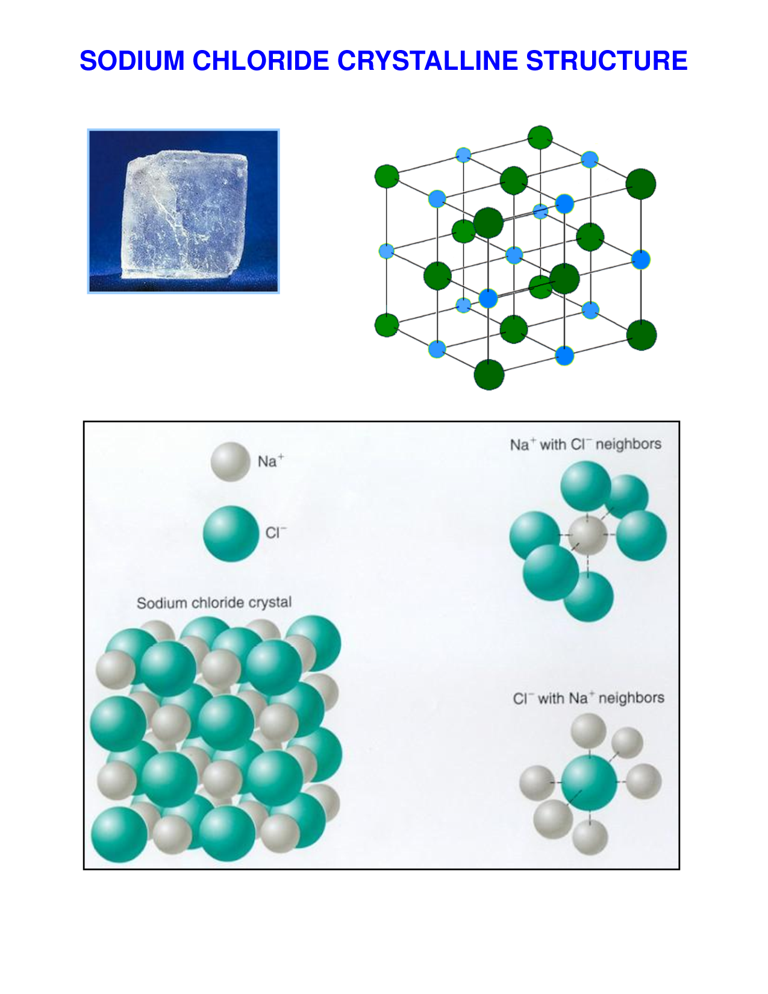

Large crystal of NaCl

Ball and stick model of NaCl

Space-filling model of NaCl

*(This came from a docstoc.com image, without some of these embellishments, but that Web site is no longer operating, as of 12/2015. The image was found in a Bing search accessed 1/10/2016 here:* [*http://www.bing.com/images/search?q=Sodium+Chloride+structure&view=detailv2&id=00EDB9B74BCB307F5B8432BBFD82D55FB3BBAD5B&selectedindex=61&ccid=Z7iZ8OPL&simid=608002194121883860&thid=OIP.M67b899f0e3cbae62644dd87fdbae9ff8o0&mode=overlay&first=1*](http://www.bing.com/images/search?q=Sodium+Chloride+structure&view=detailv2&id=00EDB9B74BCB307F5B8432BBFD82D55FB3BBAD5B&selectedindex=61&ccid=Z7iZ8OPL&simid=608002194121883860&thid=OIP.M67b899f0e3cbae62644dd87fdbae9ff8o0&mode=overlay&first=1)*)*

Na+

Cl–

In this close-packing arrangement, the chloride ions fill the cubic array, and the smaller sodium ions fill in the cubic gaps between the chloride ions. Each type of ion winds up in its own face-centered cubic lattice, with the two structures interpenetrating each other. Thus each chloride ion lines up at the corners of its lattice (which forms an octahedral), and each of the sodium ions lines up at the halfway point along the edges of the chloride fcc unit cell (and one sodium ion in the center). (See diagram at right.) In the sodium lattice, the sodium ions line up at the corners of the lattice and the chloride ions line up halfway between the vertices on the edges, with one chloride ion in the center of the polygon. Many other ionic compounds assume this same cubic structure, commonly known as the halite or rock salt crystal structure.

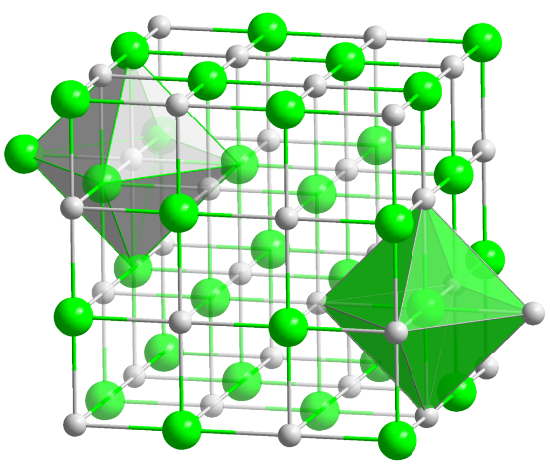

*(*[*https://commons.wikimedia.org/wiki/File:NaCl\_polyhedra.png#/media/File:NaCl\_polyhedra.png*](https://commons.wikimedia.org/wiki/File:NaCl_polyhedra.png#/media/File:NaCl_polyhedra.png)*)*

|  |  |
| --- | --- |
| **Properties** | |
| [Chemical formula](https://en.wikipedia.org/wiki/Chemical_formula) | NaCl |
| [Molar mass](https://en.wikipedia.org/wiki/Molar_mass) | 58.44 g mol−1 |
| Appearance | Colorless crystals |
| [Odor](https://en.wikipedia.org/wiki/Odor) | Odorless |
| [Density](https://en.wikipedia.org/wiki/Density) | 2.165 g/cm3 |
| [Melting point](https://en.wikipedia.org/wiki/Melting_point) | 801 °C (1,474 °F; 1,074 K) |
| [Boiling point](https://en.wikipedia.org/wiki/Boiling_point) | 1,413 °C (2,575 °F; 1,686 K) |
| [Solubility in water](https://en.wikipedia.org/wiki/Aqueous_solution) | 359 g/L |
| [Solubility](https://en.wikipedia.org/wiki/Solubility) in [ammonia](https://en.wikipedia.org/wiki/Ammonia) | 21.5 g/L |
| [Solubility](https://en.wikipedia.org/wiki/Solubility) in [methanol](https://en.wikipedia.org/wiki/Methanol) | 14.9 g/L |
| [Refractive index](https://en.wikipedia.org/wiki/Refractive_index) (*n*D) | 1.5442 (at 589 nm) |

Selected properties of sodium chloride are shown at right. Because of the strong ionic bonds between the ions in solid sodium chloride, only highly polar solvents are able to dissolve salt. Salt’s solubility in water, seen at right, is almost 360 g/L, while its solubility in methanol, a less polar molecule, is only approximately 15 g/L. When salt dissolves in water, the sodium ions and chloride ions are surrounded by water molecules, keeping them apart in solution. The solvated sodium ions are surrounded by 8 water molecules, while the chloride ions are surrounded by 6 water molecules, both forming complexes that travel through the solution with their water layer intact.

*(*[*https://en.wikipedia.org/wiki/Sodium\_chloride*](https://en.wikipedia.org/wiki/Sodium_chloride)*)*

Here is the Safety Data Sheet for sodium chloride from Flinn Scientific: <http://www.flinnsci.com/Documents/SDS/S/SodiumChloride.pdf>.

**More on daily salt intake and our need for salt**

Salt is the most abundant electrolyte in the human body, almost 85% of which is located in the blood and lymph. Salt is needed to maintain volume of extracellular fluid (in the blood and lymphatic system). Salt is also a major contributor to determining the membrane potential of cells and the active transport of molecules across cell membranes. Intracellular salt concentrations are typically less than 10% of the extracellular concentration, requiring an energy-dependent and active process to maintain this concentration gradient.

Almost 100% of ingested salt is absorbed in the small intestine. The majority of that absorbed salt is excreted in the urine, unless sweating is excessive. Providing a person is maintaining a sodium and fluid balance, sodium excreted in urine roughly equals that ingested. This is due to the function of the kidneys, which can filter about 25 moles of sodium per day and reabsorb 99% or more of that filtered material. The absorbed sodium resides in extracellular fluid, including plasma, interstitial fluid, and plasma fluids, as well as intracellular fluids in tissues such as muscle.

Although other sources of sodium exist in our diet (e.g., sodium bicarbonate, and a variety of sources in processed foods, such as monosodium glutamate, sodium phosphate, sodium carbonate and sodium benzoate), sodium from sodium chloride accounts for approximately 90% of our total sodium intake.

One of the sources of information for the 2,300 mg maximum daily intake of salt mentioned in the article (and everywhere else) is the National Academy of Science’s Institute of Medicine 2004 report, “Dietary Reference Intakes for Water, Potassium, Sodium, Chloride and Sulfate”. (<http://fnic.nal.usda.gov/dietary-guidance/dri-nutrient-reports/water-potassium-sodium-chloride-and-sulfate>)

Some confusion can develop over the actual number for the maximum recommended daily intake—is it 2,300 mg or 6,000 mg of sodium? In this quote, the number seems to be 2,300 mg, but here’s a quote from the December 1992 *ChemMatters* article, “Salt”: “Because doctors can't predict which of us will develop problems from eating too much salt, the National Research Council of the National Academy of Sciences recommends a limit of **6 grams a day**.” [Editor’s emphasis] This makes it sound like the academy then was recommending a limit almost three times as great as the present recommendation, 6,000 mg vs. 2,300 mg.

However, the 2,300 mg recommendation is for sodium, while the academy’s recommendation is to limit your intake to 6,000 mg of **salt**, not 6,000 mg of **sodium**. If you do the math, you can see that the recommendations are almost identical.

$$2,300 mg Na x \frac{1 g Na}{1,000 mg Na} x \frac{58.44 g NaCl}{22.99 g Na} x \frac{1,000 mg NaCl}{1 g NaCl} = 5,847 \sim 6,000 mg NaCl$$

Thus, 2,300 mg of sodium is approximately equivalent to 6,000 mg of salt, sodium chloride, about a level teaspoonful.

So, how did scientists get to the recommendation of a maximum of 2,300 mg of salt per day? This amount is known as the tolerable upper intake level (UL). The reference above cites three different research studies, all dose-response trials (one of which was the DASH study), that documented reduced blood pressure related to decreased salt intake. The results of these studies established a lowest-observed-adverse-effect level (LOAEL) for dietary sodium at 2.3 g/day. The LOAEL is a point on a continuous relationship between sodium intake and blood pressure. This point corresponds to the next level above the adequate intake (AI) that was tested in these trials.

The UL is defined as the maximum level of intake consumed on a daily basis at which no increased risk of serious adverse effects are likely to happen. Given that there is some uncertainty in the results of the studies, the UL was calculated to be the same as the LOAEL. (See *Dietary Reference Intakes for Water, Potassium, Sodium, Chloride, and Sulfate* “Dose-Response Assessment, Adults”, pp 373–381 for more information; <http://www.nap.edu/read/10925/chapter/8>.)

It is interesting to note that, although the Department of Health and Human Services and the Department of Agriculture have been publishing their “Dietary Guidelines for Americans” every five years since 1980, the first time it mentioned an actual number for sodium intake was 1995, and then it recommended 2,400 mg of sodium. Also interesting: in 1980 the document was a 20-page brochure (half pages); in 2005 it was a 70-page document; today (2015) the guidelines online have more than 140 printable pages of text, plus 14 multi-paged appendices!

OK, we’ve been told we have too much salt in our diet (maybe, depending on the study one uses—see “More on daily salt intake and our need for salt”, above). So where does all this sodium (maybe too much?) in our diet come from?

The diagram at right, from the “Dietary Guidelines 2015-2020” publication, shows the sources of sodium in our diet. Despite the salty taste of snacks like potato chips and popcorn, only a small portion of our daily intake of salt comes from this source (8%). And who would think that vegetables would contain so much salt (11%)? (Celery has 80 mg per cup.) Meats, of course, contain sodium, since animals typically seek salt in their diets and then we eat them; likewise, dairy is expected to contain some sodium. But by far, the largest percentage (44%) of our daily salt intake comes from processed foods, foods like hamburgers and other sandwiches (21%).

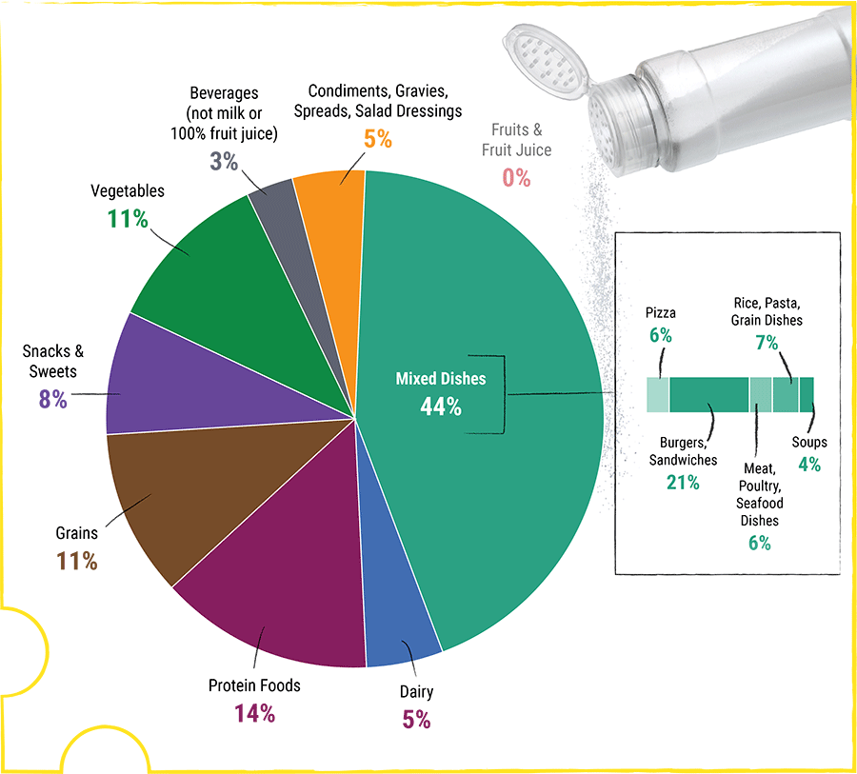

Food Category Sources of Sodium in the U.S. Population

Ages 2 Years and Older

*(*[*http://health.gov/dietaryguidelines/2015/guidelines/chapter-2/a-closer-look-at-current-intakes-and-recommended-shifts/#figure-2-14-food-category-sources-of-sodium-in-the-us-population*](http://health.gov/dietaryguidelines/2015/guidelines/chapter-2/a-closer-look-at-current-intakes-and-recommended-shifts/#figure-2-14-food-category-sources-of-sodium-in-the-us-population)*)*

The controversy about too much or too little salt arises from medical research studies that seem to be contradictory. The graph below shows the results of varying amounts of salt intake and its effect on elevated risk of cardio-vascular disease. The Cook study published in the American Heart Association (AHA) journals study seems to show that ingesting more than 3.4 g of salt results in a significant increase in the risk of heart problems, while the O’Donnell study published in the *New England Journal of Medicine* (NEJM) indicates that the increased risk of heart problems is of little consequence with amounts even up to almost 6 g of salt, with only slight increased risk beyond that level.

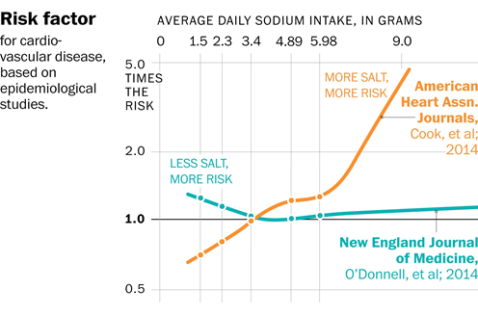

*(*[*http://apps.washingtonpost.com/g/page/national/salt-how-much-is-too-much-or-too-little/1656/*](http://apps.washingtonpost.com/g/page/national/salt-how-much-is-too-much-or-too-little/1656/)*)*

The AHA study also shows a significant *decrease* in risk for cardio-vascular disease at reduced levels of salt intake, while the NEJM study shows a significant *increase* in risk at those same lower levels (below 3.4 grams of salt). Thus it is not difficult to see why there is so much disagreement and concern about who to believe.

The chart below shows the intake habits of people in the U.S. by age group, by sex. It looks like young men have the largest excesses (too much watching sports on TV, maybe?)—and the most work to do to bring their levels down to the UL.

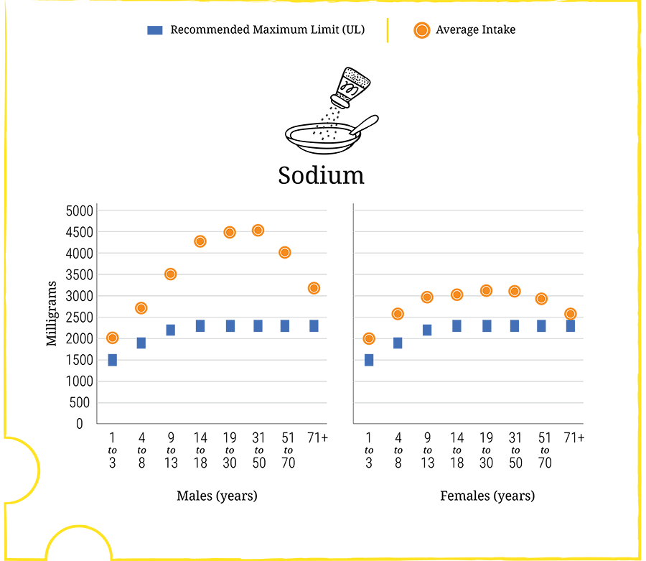

**Average Intake of Sodium in Milligrams per Day by Age-Sex Groups,   
Compared to Tolerable Upper Intake Levels (UL)**

*(*[*http://health.gov/dietaryguidelines/2015/guidelines/chapter-2/a-closer-look-at-current-intakes-and-recommended-shifts/#figure-2-13-average-intake-of-sodium-in-milligrams-per-day-by-ag*](http://health.gov/dietaryguidelines/2015/guidelines/chapter-2/a-closer-look-at-current-intakes-and-recommended-shifts/#figure-2-13-average-intake-of-sodium-in-milligrams-per-day-by-ag)*)*

While the article mentions (and many studies seem to show) that U.S. residents have not changed their habits over decades (1957 to 2003) with respect to the actual amount of sodium we ingest daily (the 3.4 grams), the graph here shows others around the globe do not share that magical number. Many hypotheses have been offered to explain these differences, but none has been able to explain all the disparities.

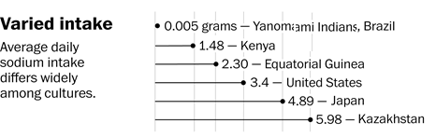

*(*[*http://apps.washingtonpost.com/g/page/national/salt-how-much-is-too-much-or-too-little/1656/*](http://apps.washingtonpost.com/g/page/national/salt-how-much-is-too-much-or-too-little/1656/)*)*

Here is a chart showing how the guidelines have changed over the decades since the Department of Health and Human Services and the Department of Agriculture (and other organizations) began providing their joint recommendation for the upper level of the amount of salt U.S. citizens should be consuming.

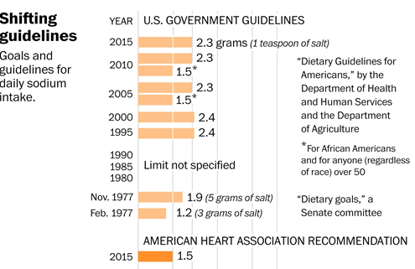

*(*[*http://apps.washingtonpost.com/g/page/national/salt-how-much-is-too-much-or-too-little/1656/*](http://apps.washingtonpost.com/g/page/national/salt-how-much-is-too-much-or-too-little/1656/)*)*

As you can see from the chart above, the essential upper level recommendation has not changed appreciably since its inception in 1995, except for the addition of the lower UL for African Americans and anyone over 50.

The following are the recommendations to reduce sodium intake made by the U.S. Department of Health and Human Services and the U.S. Department of Agriculture “Dietary Guidelines 2015–20120” document:

Shift **food choices to reduce sodium intake:** Because sodium is found in so many foods, careful choices are needed in all food groups to reduce intake. Strategies to lower sodium intake include using the Nutrition Facts label to compare sodium content of foods and choosing the product with less sodium and buying low-sodium, reduced sodium, or no-salt-added versions of products when available. Choose fresh, frozen (no sauce or seasoning), or no-salt-added canned vegetables, and fresh poultry, seafood, pork, and lean meat, rather than processed meat and poultry. Additional strategies include eating at home more often; cooking foods from scratch to control the sodium content of dishes; limiting sauces, mixes, and “instant” products, including flavored rice, instant noodles, and ready-made pasta; and flavoring foods with herbs and spices instead of salt.

(<http://health.gov/dietaryguidelines/2015/guidelines/chapter-2/a-closer-look-at-current-intakes-and-recommended-shifts/>)

These recommendations, ways to reduce sodium, also have changed very little since they were first instituted into the U.S. dietary guidelines document in 1980.

Another suggestion has been made for a way to reduce our daily salt intake. Because Americans and Canadians get the majority of their salt—77 percent, according to one study—from prepared and processed foods, research should be done to help food processors develop alternative technologies that can reduce the amount of salt added during processing without impairing taste, shelf-life, or product qualities at an affordable cost.

**More on the need for salt in other animals**

Humans are not the only creatures who feel the need for salt. The following sections highlight just a few of the situations in which animals also seek salt.

It has long been known that animals in the wild sill seek salt. As mentioned previously, it is believed that early man discovered that animals left trails to salt sources, sometimes over very long distances, as the animals sought salt for their diets. By tracing these trails to the salt source, he was able to trap those animals for food.

In present times, ranchers put out large cakes of solid salt, called salt licks, to feed their livestock. The bonus to this process is that ranchers know their cattle will stay close to the salt licks, making rounding up the herds easier for the rancher. People in more rural areas who enjoy watching wildlife also put out salt licks to attract deer and other animals.

[](http://www.dhsmall.net/TXNABA/MX_Lep/Satyr_Moths_Monterrey_Mx_10-04.JPG)And a *ChemMatters* article from 1996 highlights strange behavior in moths—large numbers of male Gluphisia moths collect together and spend a large portion of their short lives in rain puddles. There they drink in enormous amounts of water from the puddles and expel it from behind, in a process called, appropriately enough, puddling. They store the salt from the large quantities of water and pass it on to the females when they court them. The females then pass it on to their offspring. Apparently, this species of moth needs the sodium from the puddles to augment their sodium intake because the aspen tree, their main food source, contains much less salt than most trees.

Puddling Satyr Moths

*(*[*http://www.dhsmall.net/NABA\_Mexico.htm*](http://www.dhsmall.net/NABA_Mexico.htm)*)*

Scientists from Cornell University tried duplicating the phenomenon, under more controlled conditions, in the lab. The volume of water (with its electrolytes) that the moths drank, and the time spent puddling varied with concentration.

Moths that drank the dilute 0.01 mM solution guzzled an average of 28 mL over 2 hours and 15 minutes, whereas those that drank the stronger 0.1 mM solution consumed 8 mL and finished in 40 minutes; moths that got the strongest solution (1 mM) imbibed 5 mL in just 25 minutes. (Real puddles, in the Pennsylvania woods, averaged 0.07 mM, or 0.00007 mole Na+ per liter of puddle water).

(Angier, N. Puddling Moths. ChemMatters, 1996, *14* (2), pp 6–8)

As mentioned previously, many, if not all, animals seem to crave salt in their diets.

Dramatic though the puddler’s methods may be, other animals have equivalent passions for salt. As Derek Denton described in his classic text, *The Hunger for Salt*, many big-game animals migrate long distances in search of mineral fields, which are natural salt licks. Elephants, for example, dislodge clay with their toenails and hoist it up to their mouths with their trunks to lick the salt within. Monkeys dip their potatoes in saltwater before eating. Other animals frequent termite mounds for their salt, because the upturned earth in the mound brings salty deposits to the surface.

Hunters hoping to attract deer often put up salt licks. By urinating outside their homes (say, on a porch post), people may inadvertently attract animal visitors to their homes. Porcupines have been known to chew the impregnated posts apart to get at the residues of salt, Denton writes. In fact, anthropologists suspect that the reindeer, one of the first animals to be domesticated, was initially drawn and bound to human encampments by an ever-replenished supply of human urine. …

Because so many animals have an instinctive craving for salt, scientists have posed the question, “Do they crave the sodium ion or the chloride ion?” In 1953, D. S. Stockstad tested the ion preferences of wild animals by offering them a choice of chemicals, all known nutrients. He set up wilderness “cafeterias” containing separate pots of 22 chemicals. What did the deer, elk, and rodents prefer? The most popular compounds were NaI, NaCl, and NaHCO3. The animals totally ignored MgI2, KHCO3, and HCl.

Conclusion: There is a strong cross-species passion for sodium. This is not surprising because sodium ions, in concert with potassium ions, provide the electrical conductivity that makes nerves work. If your sodium level is too low, your neurons—-including those in your brain—-stop working. Animals as different as mammals and reptiles have remarkably similar plasma concentrations of Na+. The kangaroo rat has 149 mM of Na+, compared with 145 mM in the blue-tongued lizard (your blood serum is about 143 mM). To some experts, these data suggest that the different animals all had ancestors that drank from, or swam in, the same ancient ocean.

(Angier, N. Puddling Moths. *ChemMatters*, 1996, *14* (2), pp 6–8)

[](http://2.bp.blogspot.com/_3qz9pvfALAM/TFBCWOUD90I/AAAAAAAAAJI/dWxrJ-5jdpA/s1600/SANY0099.jpg)Another example of elephants seeking out salt-bearing rock in underground caves can be seen at the link below. They use their tusks to grind the rock, releasing salt chips/chunks that they then eat to maintain their salt balance.

(<http://www.bornfree.org.uk/animals/african-elephants/projects/mt-elgon/elgon-elephants/>)

Elephants foraging for salt and minerals

*(*[*http://gvithailandenvironmental.blogspot.com/2010/07/elephants-foraging-for-important.html*](http://gvithailandenvironmental.blogspot.com/2010/07/elephants-foraging-for-important.html)*)*

**More on salty taste**

Scientists have long known that the taste of salt is due to the sodium ion.

The salt taste [on the tongue] is the result of the presence of NaCl. Other alkali halides also produce saltiness, but only NaCl and LiCl produce a salty taste above concentrations of about 0.10 M. Specifically, it is Na+ ions that elicit the taste. You can note to students that, within the alkali metal family, saltiness of the ions decreases as atomic number increases. It is believed that the salty taste evolved as a way to find salt-containing foods in order to maintain the body’s electrolyte balance

(December 2008 Teacher’s Guide accompanying this article: Pages, P. Tasteful Chemistry, 2008, *26* (4), pp 4–6)

The ability to taste salt derives from receptors found in cells in the taste buds on the tongue.

To understand how a taste cell works, say, you eat a saltine cracker. After the cracker is broken down in the mouth, sodium ions (Na+) from the salt (Na+, Cl-) first reach salt taste cells and then cross ion channels on their surface.

Once inside, these ions cause calcium ions (Ca2+) to enter the cell and potassium ions (K+) to leave it (Fig. 1a). This ion movement in and out of the cell directs the cell to release chemicals called neurotransmitters to nerve cells on the tongue. Then these nerve cells convey a signal to the brain telling it that the cracker tastes salty.

(Pages, P. Tasteful Chemistry. *ChemMatters*, 2008, *26* (4), pp 4–6)

**More on electrolytes**

The need for salt is due to its role as an electrolyte in cells. The following quote comes from the Teacher’s Guide for a 2012 *ChemMatters* article.

Perhaps by this time in your course, students will already have learned about electrolytes. If not, a quick review: Electrolytes are aqueous solutions in which the solute is present, either totally or in part, in the form of ions. That means that the solute has dissociated or ionized when it dissolved. If the solute is present entirely as ions, the solution is considered a strong electrolyte. If the solute only partially ionized or dissociated, the solution is called a weak electrolyte. Pure water is a non-electrolyte.

One of the most important characteristics of electrolytes is their ability to conduct an electric current. The ions in solution carry charge through the solution. A majority of the human body is water, but not pure water. Minerals like sodium chloride and other sodium or potassium salts in the diet become solutes that produce ions when dissolved. So we can say that most of the human body is an electrolyte. This is very important when it comes to neurons and other cells transmitting electric current that carry nerve impulses. Neurons maintain different concentrations of potassium and sodium ions inside the cell versus outside the cell. Cell walls are impermeable to these ions, but cells have the ability to transport ions selectively across the cell walls or to change the cell wall permeability to these cations. Anions cannot pass through the cell walls.

By one or both of these mechanisms, cells are able to move ions in or out of the cell and thus create an electrical potential difference within the cell. In this way the cell creates a small voltage that transmits electric charge along the neuron. … The normal function of the nervous system, then, depends on ions present in the electrolyte. As mentioned earlier, the most important ions for proper functioning of the nervous and muscle systems are sodium ions (Na+), potassium ions (K+) and chloride ions (Cl–). Sodium and chloride ions are found in higher concentrations outside cells, while potassium ions are in higher concentrations inside cells.

It is primarily the migration of sodium ions across neuron cell walls that creates the action potential, or voltage, that drives nerve impulses through individual neurons. Sodium ions play an important role in maintaining the balance of body fluids. They stimulate the absorption of water and sucrose during exercise as well as triggering the thirst mechanism. An extremely low sodium level is called hyponatremia and is characterized by nausea and vomiting, muscle fatigue, confusion and, in acute cases, seizures. Potassium ions help to control muscle contractions, including heartbeat. Chloride ions help maintain body fluid balance and acid-base balance in the body. Other ions important for normal body functioning are calcium (Ca2+), magnesium (Mg2+), bicarbonate (HCO31-), phosphate (PO43-) and sulfate (SO42-).

(Rohrig, B. Tasers. ChemMatters, 2012, *30* (2), pp 18–19)

The above quote is from an article on tasers. It is interesting to note that tasers wouldn’t work on us if our bodies weren’t full of electrolytes to carry the current.

**More on dehydration and rehydration**

Two groups of healthy people who are most likely to experience dehydration are blue-collar workers undergoing hard labor and athletes, both of which groups experience unusually heavy activity levels that result in excessive sweating. Sweating, of course, is the body’s mechanism for lowering core body temperature (increased by extensive muscle activity). Sweating is an endothermic process that absorbs body heat to vaporize liquid water off the body’s surface into its gaseous form.

The result of excessive sweating is twofold: first, large amounts of water are lost from the bloodstream, which results secondarily in the loss of water from cells through osmosis. The second result is a small loss of salt and other electrolytes as extracellular fluid from the bloodstream is brought to the skin surface to accomplish sweating. These electrolytes do not evaporate with the water and are left on the skin. (This is evidenced by the salty taste of the skin after a hard workout.)

People experiencing excessive sweating quickly become dehydrated and tend to feel a greater thirst, so it is natural for them to drink more water to make up for the lost bodily fluids. Unfortunately, drinking just water (or soft drinks or juices, for that matter) can actually make the problem worse. As mentioned above, water isn’t the only loss the body suffers with sweating. Electrolytes are also lost, and these are not replenished by drinking any of the above-mentioned fluids. Drinking only water to replenish lost body fluids results in a decreased concentration of sodium in the blood, resulting in a condition known as hyponatremia—too little sodium in the blood. Symptoms include muscle cramps, nausea, disorientation, slurred speech and confusion.

To prevent hyponatremia, those lost electrolytes must also be replenished; drinking water alone doesn’t help. In fact, drinking water alone can result, at the extreme, in seizures, coma or death. Replacing electrolytes requires salt. In days past, workers and athletes would take salt pills to replace the lost ions. But these can cause gastric distress and possibly worsen the condition.

Enter sports drinks, like Gatorade® and Powerade®. These were originally developed by college officials trying to treat and prevent dehydration in their athletes (see “More on sports drinks” below). Sports drinks contain salt and other electrolytes in roughly the same concentrations as those in the body. These electrolytes can replace those lost by the body through sweating. Athletes and very active workers should be sure they are replacing amounts of electrolytes roughly equal to those they are losing by sweating. They might also minimize the amounts of dehydration by increasing salt intake several days prior to competition (if not hypertensive).

Here’s another explanation of attempting to rehydrate by drinking water. Rehydrating can be a tricky matter. If one rehydrates too quickly, drinking copious amounts of water, kidneys can’t flush this water out of the body fast enough, resulting in hyponatremia. The actual numbers for the normal amounts of sodium in blood range from 135 to 145 millimoles of sodium per liter. Amounts below this range are considered hyponatremic and can possibly lead to water intoxication. Symptoms of this condition include nausea and vomiting, headaches, fatigue, frequent urination, and mental disorientation.

Cells experiencing hyponatremia will absorb large amounts of water from the bloodstream by osmosis, swelling significantly as a result. Most cells exist within flexible tissues, such as fat and muscle, and these cells are able to expand to accommodate the extra water.

While this swelling might be ok (still not desirable) for most cells in the body, brain cells are rather tightly packed inside the skull, sharing the space with blood and cerebrospinal fluid, with practically zero room for swelling or expansion. “Thus, brain edema, or swelling, can be disastrous. ‘Rapid and severe hyponatremia causes entry of water into brain cells leading to brain swelling, which manifests as seizures, coma, respiratory arrest, brain stem herniation and death,’ explains M. Amin Arnaout, chief of nephrology at Massachusetts General Hospital and Harvard Medical School.” (<http://www.scientificamerican.com/article/strange-but-true-drinking-too-much-water-can-kill/>)

**More on sports drinks**

Athletes experience dehydration at the cellular level, due to sweating that removes water from bodily fluids. Excessive sweating can result in headaches, fatigue, muscle cramps and spasms, lightheadedness, and possibly fainting.

Preventing dehydration from happening in the first place would be preferable to rehydration, and that's just what scientists at the University of Florida did in 1965 when they invented Gatorade Thirst Quencher. Their goal was to prevent the football team from experiencing dehydration in Florida's muggy weather. The Florida Gators spawned the new sports drink named after them. Not surprisingly, it contains sugar and the salts potassium and sodium citrate in an aqueous solution. The lower sugar content (less than half that found in Kool-Aid and Hawaiian Punch) results in a less sweet taste and, with the added electrolytes, the solution is very similar in concentration to fluids in the human body.

*(Plummer, C.M. Deadly Cholera. ChemMatters, 1995, 13 (1), p 13)*

**More on cholera and its treatment**

Cholera is an extreme example of dehydration of body fluids. Much success has been achieved in treating cholera by the simple use of oral rehydration salts (ORS) that contain both water and electrolytes. The World Health Organization (WHO) has issued this “WHO position paper on Oral Rehydration Salts to reduce mortality from cholera”:

Cholera is characterized by a sudden onset of acute watery diarrhoea that can rapidly lead to death by severe dehydration. The disease is acquired by ingestion of water or food contaminated by *Vibrio cholerae* and has a short incubation period of two hours to five days. Cholera is an extremely virulent disease that affects both children and adults. Unlike other diarrhoeal diseases, it can kill healthy adults within hours. Individuals with lower immunity, such as malnourished children or people living with AIDS, are at greater risk of death if infected by cholera. Among people developing symptoms, 80% present with mild to moderate acute watery diarrhoea, while the other 20% develop rapidly severe dehydration leading to deaths. Key message: cholera can rapidly lead to severe dehydration and death if left untreated.



A packet of Oral Rehydration Salts

*(Plummer, C.M. Deadly Cholera. ChemMatters, 1995, 13 (1), p 13)*

Effective and timely case management contributes to reducing mortality to less than 1%. It consists of prompt rehydration of patients. Mild and moderate cases can be successfully treated with oral rehydration salts (ORS) only. The remaining 20% of severe cases will need rehydration with intravenous fluids. Antibiotics are not paramount to successfully treat patients, but they can reduce the duration of disease, diminish the volume of rehydration fluids needed, as well as shorten duration of shedding of the germ. Key message: ORS can successfully treat 80% of cholera patients, both adults and children.

ORS can dramatically reduce the number of death, particularly during an epidemic and when given early when symptoms arise. ORS cannot influence the infectious process, but corrects dehydration and thus saves lives. Numerous experiences with ORS have shown convincing evidence that ORS could be given by non-medical personnel, volunteers and family members, reducing death rates dramatically. Delays in rehydrating patients contribute to higher mortality and thus call for early ORS therapy already at home, while waiting to get access to proper medical treatment at cholera treatment centres or health care facilities. Key message: ORS has to be given early at home to avert delays in rehydration and death.

ORS is a sodium and glucose solution which is prepared by diluting 1 sachet of ORS in 1 litre of safe water. It is important to administer the solution in small amounts at regular intervals on a continuous basis. In case ORS packets are not available, caregivers at home may use homemade solutions consisting of half a teaspoon of salt and six level teaspoons of sugar dissolved in one litre of safe water. Alternatively, lightly salted rice water or even plain water may be given. To avoid dehydration, increased fluids should be given as soon as possible. All oral fluids, including ORS solution, should be prepared with the best available drinking water and stored safely. Continuous provision of nutritious food is essential and breastfeeding of infants and young children should continue. Key message: In the absence of ORS packets, homemade solutions can be administered.

Prevention of cholera mainly consists in providing clean water and proper sanitation to the communities, while individuals need to adhere to adequate food safety as well as to basic hygiene practices.

*Conclusion*:

**Many lives can be saved if ORS is being used early at home, while waiting to get access to proper health care. WHO does not see any contradiction in making ORS packages available to households and non-medical personnel outside health care facilities. In the opposite, making ORS available at household and community levels can avert unnecessary deaths and contributes to diminishing case fatality rates, particularly in resource-poor settings.**

(<http://www.who.int/cholera/technical/ORSRecommendationsForUseAtHomeDec2008.pdf>)

The disease cholera causes gastric distress and possibly death, both due to cellular dehydration. Scientists have discovered inexpensive ways to rehydrate patients suffering from cholera, based primarily on replenishing electrolytes in the body. This rehydration therapy can mean the difference between life and death for patients suffering from the disease.

Interestingly, people who are lactose intolerant who drink milk or eat milk products often suffer from similar symptoms to cholera—stomach irritation, bloating, pain, diarrhea—and for similar reasons, namely, dehydration. Lactose-intolerant people cannot digest lactose, so this sugar proceeds directly into the small intestine, where it draws water through osmosis from surrounding tissue into the intestine. This probably causes these intestinal contents to flow quickly into the large intestine, causing diarrhea.

**More on osmolarity**

The information below provides more detail about osmolarity and tonicity

All human cells are enclosed by semipermeable membranes. *Semi*permeable means that the cell membranes allow some particles to pass through them, while others are restricted. Water flows freely through the cell membranes, so if the membrane separates two solutions with different concentrations of dissolved particles, water flows from the solution of lower concentration to the solution of higher concentration until equilibrium is achieved and the concentrations are equal. This process is referred to as *osmosis*, and the “concentration” of dissolved particles in a solution is expressed in terms of something called its *osmolarity*.

The osmolarity (osM) of a solution is conceptually similar to the molarity of the solution, but it takes into account the entire concentration of all particles produced in the solution regardless of their identity.

Consequently one must take into consideration whether the dissolved substance breaks apart into ions when it dissolves. For example, a 0.30 M solution of a nonelectrolyte like glucose (C6H12O6) would also have an osM of 0.30, but a 0.30 M of an electrolyte like sodium chloride, NaCl, which dissociates into two ions (Na+ and Cl-) would have an osM of 0.60, and a 0.30 M solution of magnesium chloride, MgCl2 would be a 0.90 osM solution.

In somewhat simplified terms, if a semipermeable membrane separates two solutions with equal osmolarities, the solutions are said to be *isotonic*, and one would not expect any net flow of water across the membrane. In reality things are somewhat more complicated. For example, some molecules, like urea, can easily cross a cell membrane. Consequently, while they do contribute to the osmolarity of the solution, they basically do not contribute to the tonicity. Nonideal behaviors must also be taken into consideration.

Plasma has an osmolarity of about 0.30 osM, so a 0.15 osM solution of NaCl is essentially isotonic with plasma, assuming that neither sodium nor chloride ions can cross a cell membrane, which is nearly true. But while a 0.30 osM solution of urea would be isoosmotic with plasma, it would not be isotonic, since urea can cross a cell membrane.

(October 2002 *ChemMatters* Teacher’s Guide for the article, Tapping Saltwater for a Thirsty World)

**More on osmosis and mummies**

In ancient times in Egypt, the process of mummification relied on the drying out of body tissues via osmosis (although they didn’t know the term at the time). If the tissue is sufficiently dried, it provides an environment that is hostile to the growth of decay bacteria and fungi, and thus preserves the specimen.

The initial treatment of the body involved washing it with palm wine to kill bacteria and rinsing with water. After this, blood was drained and organs were removed through an incision in the stomach area.

Corpses were then treated for a month with natron, a naturally occurring mixture of four salts: sodium carbonate decahydrate [Na2(CO3)•10(H2O)]; sodium bicarbonate, or baking soda (NaHCO3); and small amounts of sodium chloride, or table salt (NaCl) and sodium sulfate (Na2SO4). The mixture takes its name from the Natron Valley, where ancient Egyptians mined the lake salts.

Natron preserves tissue by drawing out moisture through osmosis. Osmosis describes a process that occurs when two solutions of different concentrations are on either side of a semipermeable membrane—a membrane that allows only water molecules to pass freely back and forth. Water molecules move to the side with the greater concentration until both sides have the same concentration.

Cell membranes in the body are semipermeable, so when a dead body is treated with natron, the water in the cells crosses the cell membranes to dilute the concentrated salt solution outside the cells until nearly all of the water leaves the cells, which dries up the body.

(Washam, C. Unwrapping the Mystery of Mummies. *ChemMatters*, 2012, 30 (1), p 17)

**More on uses for salt**

The following is a partial list of the uses for salt, sodium chloride.

**Food**

Food preservative

pickles

sauerkraut

meat

cheese

condiments

Leavening agent for breads and cakes

Seasoning

Flavor enhancer

**Health & Medical**

Saline solutions

IVs

catheter flush

wound irrigation

eyewashes

eye drops

contact lens cleaners

nasal washes (e.g., Neti pot)

nasal sprays

Salt tablets for rehydrating

Rehydration therapy

Cleansing agent

Exfoliating scrub

Prevents goiter (ok, it’s the KI, but it’s still in table salt)

**Feedstock for producing other chemicals**

NaOH for making soap, paper, drain cleaner

Cl2 for bleach, plastics (e.g., PVC), water treatment

Na2CO3 for making glass, germicide, water softener

Na for sodium vapor lamps, producing other metals from their compounds, heat transfer in fast nuclear reactors

**Industrial processes**

Tanning leather

Textiles

Fixing color in dyed cloth

Making dyes

Fire extinguishers for type D metal fires

Lubricants and greases

Fracking solutions

**Water softening**

**Melting ice**

De-icing roadways

Making homemade ice cream

**Storage**

Salt mines used to store petroleum and natural gas

**More on the role of salt in cheese-making**

Manufacturers of cheddar cheese use salt to improve both the taste and the texture of the cheese. The original milk solution that will become the chees is heated and treated with a bacterial culture to acidify the milk by changing lactose into lactic acid, resulting in the unfolding of protein particles. Then the enzyme rennin is added to produce curds that collect into a gel. The whey, the fluid leftover is trapped inside the curds, so it must be removed. After being cut into smaller pieces, the curd pieces begin shrinking, releasing whey. They are then heated to increase the release of whey. The curds fuse into a larger mass and are cut into large slabs that are stacked on top of each other and then turned and restacked, a process called cheddaring.

Then, the slabs of cheddar are milled into small pieces and salted. Salt also helps to remove whey from the curds. The presence of salt at the surface of the cheese pieces causes the moisture within the cheese to be drawn out by osmosis. Osmosis is the process that occurs when two solutions of different concentrations are on either side of a semipermeable membrane—a membrane that allows only water molecules to pass freely back and forth. Water molecules move to the side with the greater concentration until both sides have the same concentration. …

In this case, water flows from areas of low salt concentration inside the cheese to areas of high-salt concentration on the surface of the cheese. At the same time, some of the salt is drawn into the cheese through the process of diffusion (Fig. 3), in which molecules tend to move toward areas where they are less concentrated until their concentration becomes uniform throughout.

(Antonis, K. Who Put Cheddar in the Cheese? *ChemMatters*, 2012, 30 (1), pp 12–13)

So the net result of salting cheddar cheese is a saltier taste, but also a harder, more compact cheese that resists mold growth, since the salty surface will cause cells in mold or other bacteria to undergo osmosis, dehydrating them.

# Connections to Chemistry Concepts

**(for correlation to course curriculum)**

1. **Electrolytes**—These ion-containing aqueous solutions—especially salt—are necessary to carry on normal life functions based on electrical signals. The salty taste is an important factor in humans (and other animals) ingesting foods that maintain the body’s electrolyte balance.
2. **Concentration**—Osmolarity, the concentration of electrolytes inside and outside cells, determines whether water flows into or out of those cells.
3. **Osmosis**—Passage of water through semipermeable cell membranes equilibrates osmolarity within the organism, maintaining salt concentrations.
4. **Molecular motion**—Water molecules must be in motion in order for cells to experience osmosis, which maintains electrolyte balance within the body.
5. **Ions**—These are responsible for transmission of all electrical impulses within the body.
6. **Concentration of Solutions**—The bigger the difference in solute/solvent concentrations between intra- and extracellular solutions, the greater the osmotic pressure. More advanced courses may approach this concept in a quantitative way, such as calculating the osmotic pressure that would theoretically be exerted by a solution of given concentration.

# Possible Student Misconceptions

**(to aid teacher in addressing misconceptions)**

1. **“Eating too much salt is REALLY bad for me.”** *While there are extremes that are to be avoided, health studies have failed to show a definite or consistent correlation between salt intake and adverse health effects. In fact, higher intake (the true average of 3,400 mg instead of the 2300 mg recommended) seems to result in healthier test subjects, and some scientists are recommending even higher daily amounts (up to 6000 mg per day).*
2. **“Americans need to cut back on the amount of salt they take in on a daily basis.”** *The article seems to say that no clear evidence exists to support this claim or, at least, the evidence is mixed (see number 1, above).*
3. **“The dietary recommendation for daily salt intake is based on solid scientific evidence.”** *Actually, as mentioned in the article, “The U.S. dietary guidelines were established in the 1970s when relatively little information was available about dietary salt and health. The guidelines were the* ***best guess*** *[editor’s emphasis], given the information available at the time.” Even now, with the release of the new January 2016 “Dietary Guidelines for Americans”, 2015–2020, 8th ed., from the Department of Health and Human Services and the U.S. Department of Agriculture, the recommendation for daily salt intake remains essentially unchanged (at 2,300 mg) from the 1970 2300 mg recommendation.*

# Anticipating Student Questions

**(answers to questions students might ask in class)**

1. **“Do sports drinks like Gatorade and Powerade contain sodium?”** *Indeed, salt is an ingredient in these sports drinks, to replace sodium ions lost by sweating, but since sodium isn’t the only ion in body fluids lost to sweating, these drinks also contain other electrolytes. Powerade, for example, contains salt, mono****potassium*** *phosphate,* ***magnesium*** *chloride and* ***calcium*** *chloride, to rebuild all electrolyte concentrations, while Gatorade contains salt,* ***sodium*** *citrate and mono****potassium*** *phosphate, but no calcium or magnesium ions.*
2. **“Should I take salt tablets after a hard workout (and lots of sweating) to replenish my electrolytes?”** *Salt tablets used to be the answer to dehydration, in both sports and manual laborers. But today, sports drinks have gained popularity and salt tablets are recommended far less frequently, if at all. There are several problems with salt tablets: they are often difficult to digest, and may cause irritation to the gastroenterological system; if taken without water, the salt pills are only slowly dissolved and absorption of the salt in the stomach is often delayed, resulting in further dehydration until the salt reaches cells. Sports drinks, on the other hand, are more easily and quickly absorbed by the body. Also, salt tablets can cause the body to draw water from surrounding body tissue, like muscles, into the stomach to dilute the salt. This can result in stomach cramps, nausea or vomiting. And salt alone isn’t sufficient to replace all electrolytes lost (e.g., potassium and calcium) through sweating. Here again, sports drinks are preferred because they contain other electrolytes.*
3. **“Aren’t there specific areas of the tongue for each taste, like ‘salty’ and ‘sweet’? I think I did an experiment in elementary school that showed this.”** This age-old idea has been shown to be a myth. For an online article from 2006 explaining the new concept of taste see <http://www.livescience.com/health/060829_bad_tongue.html>.
4. **Where does salt come from and/or how is salt produced?** *Salt occurs naturally as the mineral halite in underground deposits. Major salt deposits in the U.S. are located in Texas, Michigan, Kansas and New York. Most halite is mined by blasting out cavernous spaces in the salt deposit, leaving as much as 30% of the salt forming thick pillars that support the dome of the blasted space. The salt is then crushed and screened prior to sale. Or salt can be obtained from ocean salts that have evaporated on coastal areas in temporal climates. It is simply scraped off the beaches. This salt is typically not as pure as that mined underground. This salt is often the basis for “sea salt”.*

# In-Class Activities

**(lesson ideas, including labs & demonstrations)**

1. Here’s a 42:33 video about salt from the Discovery Channel’s “How Stuff Works” that you could use to introduce your classes to the properties, sources, and uses of salt: <https://www.youtube.com/watch?v=gI5qV-kvLeg>. It shows how and why prosciutto ham is preserved, how cucumbers are changed to pickles by salting them, and the various sources of salt and how it is processed to be useful to man. The video includes discussion of sodium chloride as a source of chemical products, like bleach (sodium hypochlorite), caustic soda (sodium hydroxide), and the elements hydrogen, sodium and chlorine. It also discusses dehydration that occurs from drinking ocean water, and the process of desalination by reverse osmosis. You might want to use this video as a lesson plan for a substitute teacher. If so, you could ask students to find errors/misconceptions in the film. Here are three:
2. @ 26:39, the narrator says, “Transition of water from liquid to solid is a ‘kind of chemical reaction.’”
3. @ 27:40, Illustration of oxygen with 6 “outermost shell” electrons in pairs and revolving around the atom,
4. @ 33:42, Illustration of chlorine atoms, supposedly having 7 valence electrons, but in reality only the top one has 7; the other chlorine atoms have many more than 7 (I counted 12 each).
5. You can have students experiment with conductivity of electricity by ionic compounds dissolved in water (electrolytes) vs. non-conductivity of non-polar substances dissolved in water (non-electrolytes).
6. This pdf document provides background information, student procedure, and data table to test conductivity of various solutions: <http://mhvpschool.com/science1/web_documents/conductivitylab.pdf>.
7. For a 12-page conductivity experiment with a very detailed introduction that explains types of materials and their conductivity or lack thereof and procedure for the experiment, complete with a very complete student data table and teacher demonstration for more concentrated solutions, see <http://www.ccchemistry.us/ch%20111%20experiment%2010%20sp%20'11.pdf>.
8. Vernier Software offers a downloadable inquiry lab exercise, using their conductivity probes, which deals with conductivity of sports drinks. View the draft copy of this experiment here: <http://www.vernier.com/innovate/thirst-quenchers-inquiry-experiment/>.
9. This experiment from the Holt chemistry lab manual describes how to determine the bond type from a substance’s conductivity behavior. This would be useful to explain electrolytes vs. non-electrolytes. The site contains both student and teacher versions of the experiment.  
   (<http://bcpshelpdeskhighschoolscience.weebly.com/uploads/6/3/4/6/6346142/lab_-_conductivityasanindicatorofbondtype.pdf>)
10. This lab, “Differences between Ionic and Covalent Compounds”, has students test for solubility and conductivity of various solids to determine the bond type and whether or not the substance is an electrolyte: <http://www.mtlsd.org/teachers/smeer/stuff/lab%20differences%20between%20ionic%20and%20covalent%20compounds.pdf>.
11. You could also show conductivity of solutions as a demonstration, if you prefer, to reinforce the concept that cell behavior is dependent on the presence of electrolytes. See <https://youtu.be/UHYWIM8AbPE> for a suggested procedure. NOTE: If you plan to do this demonstration for your classes, It would be **much** better; i.e., safer, to use a battery-powered conductivity tester, instead of the plug-in type described in this demonstration. And if you prefer, you can simply show the above-mentioned 4:13 video clip.
12. You could use this animation from Professor Tom Greenbowe to show students NaCl dissolving in water, focusing on the role water molecules play in that process: <http://www.chem.iastate.edu/group/Greenbowe/sections/projectfolder/flashfiles/thermochem/solutionSalt.html>
13. You can show students what effect osmosis has on cells that are exposed to salt solution in this video clip (1:19) of red onion cells exposed to varying concentrations of salt: <https://youtu.be/Mp_CJBqRI5A>.
14. You can show this 2:03 video: <http://www.brainstuffshow.com/blog/how-twitching-frog-legs-work-a-little-gross-yes-but-fascinating/>, which demonstrates the effect that salt has on the action potential of frog leg muscles. The notes that accompany the video explain that adding salt to fresh frog legs creates sodium ions around the muscles cells which, in turn, produces the action potential needed to cause the legs to twitch.
15. You can demonstrate the idea of osmotic pressure using a thistle tube with a dialysis membrane covering the top part of the tube. The top part is filled with a concentrated solution of sugar or corn syrup, then inverted in a beaker of distilled water. Over time, osmotic pressure will cause the movement of water from the beaker through the semipermeable membrane into the thistle tube. This results in a rise of fluid in the stem of the tube until an equilibrium is reached. Here’s a source for the procedure, with little else: <http://faculty.southwest.tn.edu/jiwilliams/osmosis_experiment.htm>
16. One of the most common ways to demonstrate osmosis occurring through a cell wall is the classic demo using a de-shelled egg placed first in distilled water and then in solutions of various substances such as salt or Karo or corn syrup. If you are interested in doing this as a demonstration or as a class activity, there are various Web sites offering different variations of this activity, from the very simple to more complex, that involve the use of a graphing calculator or actually constructing an osmometer from an egg. Web sites of interest include:
17. This is a middle school student lab showing the effects of osmosis on a raw egg: <http://edtech2.boisestate.edu/pattymcginnis/592/Files/506%20Lesson%202%20Egg%20Osmosis%20Lab.pdf>.
18. Here is a second example: <http://utahscience.oremjr.alpine.k12.ut.us/sciber00/7th/cells/sciber/osmosis1.htm>
19. If you’d rather demonstrate the phenomenon than experiment with eggs, here is a short video (5:47) from “The Sci Guys” that shows the old tried-and-true egg-in-vinegar-and-corn syrup demonstration that shows a raw egg growing and shrinking due to osmosis. The video also explains the phenomena. (<https://www.youtube.com/watch?v=SrON0nEEWmo>)
20. This site offers a set of 3 experiments to show osmosis and selective diffusion. It is extensive, containing student pages and teacher pages, complete with collected student data. (<http://schools.birdvilleschools.net/cms/lib2/TX01000797/Centricity/Domain/852/The%20gate%20keepers.pdf>)
21. You can show in class a short video (7:45) from bozemanscience.com of the difference between diffusion and osmosis, and examples of each and a description of an AP lab using potatoes and KI. (<https://www.youtube.com/watch?v=LeS2-6zHn6M>)
22. Then you can have students test osmotic effects using potato cores in an experiment similar to the second lab described in the video above, to test mass differences with time. Punch out equal length potato cores using a cork borer. Students mass the cores, then place individual cores in various saline solutions—distilled water, 0.1, 0.5, 1.0, 2.0, 3.0, and 5.0 % salt. Remove cores, pat dry with paper towel and re-mass. Have students explain the change in mass of the cores in the different salt solutions based on osmotic principles. See the following for more specific details: <http://www.utsouthwestern.edu/media/other-activities/251270osmodemo.pdf>.
23. An excellent short video with good diagrammatic illustrations on osmosis is found at <http://www.youtube.com/watch?v=MUcP_sZ1eCk>.
24. If you’re talking mummies desiccated via osmosis, you might want to show students the approximate feel of mummy tissue by showing them some meat jerky.
25. To show students osmotic pressure when water comes in contact with a polymer (analogous to osmotic pressure in cells), use superabsorbing polymer, sodium polyacrylate. See the December 1992 *ChemMatters* Teacher’s Guide “Superabsorbent Polymer Lab”, on page 3, available on the *ChemMatters* 30-year DVD. Here’s a later version: Super-Soakers: Just How Super Are They? *ChemMatters*, 1999, *17* (3), p 6. This student lab tests the claim that sodium polyacrylate can absorb 800 times its weight in water. Further experimenting is suggested.
26. To simulate kidney dialysis via a semi-permeable membrane, use starch and iodine and a Zip-loc® bag. (See Experiment! Kidney dialysis—A working model you can make. *ChemMatters*, 2001, *19* (2), p 12—available on the 30-year DVD) Or try this version of the same lab, but inquiry-based, with background information for students: <http://kaffee.50webs.com/Science/labs/Chem/Lab-Dialysis.html>.
27. This site from Texas Instruments provides a calculator-based (TI-NSpire models) simulation and accompanying student and teacher note sheets to show students at the molecular level what happens when there is a difference in solvent concentration between left and right sides of a semi-permeable membrane: <https://education.ti.com/en/us/activity/detail?id=17A663407AA24D11B4FA14A5FC820849&ref=/en/us/activity/search/advanced>.
28. You can choose from a series of neuroscience PowerPoints on this site from Harvard University: <http://outreach.mcb.harvard.edu/lessonplans_S05.htm>. Lesson topics include basic nervous system mechanisms and neuron structure and function.
29. This activity relates the concentration of ions to muscle contraction in the heart: <http://www.teachengineering.org/view_lesson.php?url=collection/uva_/lessons/uva_pump_bme0607_less/uva_pump_bme0607_less.xml>.
30. Students can do experiments involving freezing point depression using salt.
31. this one at the AP level from Oklahoma State University: <http://intro.chem.okstate.edu/HTML/SEXP10.HTM>)
32. or this one from California Polytechnic Institute: <http://chemweb.calpoly.edu/chem/125/125LabExp/FPDepression/>

# Out-of-Class Activities and Projects

**(student research, class projects)**

1. So often, in our departmentalized high school curricula there is minimal chance for the sciences and humanities to meet. It might be interesting to have a student or a group of students present a “science” report in an English Literature class where they discussed exactly why the Ancient Mariner could not drink the ocean water and the efforts being made today to desalinate seawater and then give a presentation in a science class about the poem itself and its literary significance? Some ideas for projects related to the poem are offered at http://www.shunsley.eril.net/armoore/poetry/mariner.htm
2. Students attracted to the more mathematical and theoretical sides of chemistry might enjoy learning about and reporting on what osmotic pressure really is and how it is determined experimentally and calculated theoretically. An individual or group might try to teach these concepts to their classmates. Students attempting to do something like this often leave with a much higher respect for the difficulties involved in teaching and occasionally there will be a student for whom the attempt will either uncover or spark an interest in teaching as a career.
3. You could have students research the pros and cons of ingesting amounts of salt exceeding today’s recommended amount, based on the latest health studies. This fact sheet is a possible starting point, with links to several of the studies: <http://www.saltinstitute.org/wp-content/uploads/2013/08/si_health_fact_sheet.pdf>. Students should note that this fact sheet is published by the Salt Institute, and they should consider the ramifications of that information.

# References

**(non-Web-based information sources)**

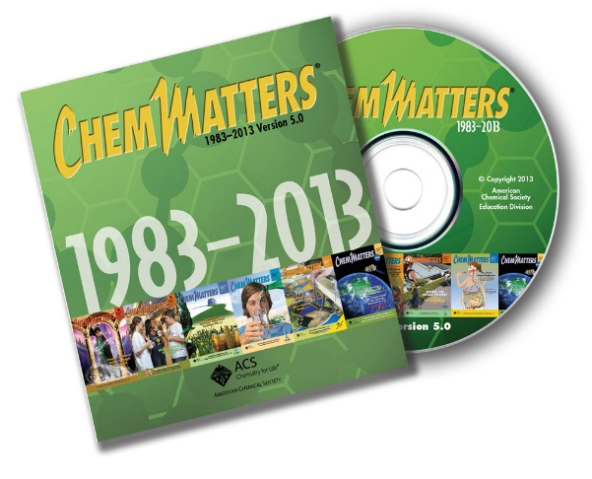

**30 Years of *ChemMatters***

Available Now!

**The references below can be found on the *ChemMatters* 30-year DVD (which includes all articles published during the years 1983 through April 2013 and all available Teacher’s Guides, beginning February 1990). The DVD is available from the American Chemical Society for $42 (or $135 for a site/school license) at this site:** [http://ww.acs.org/chemmatters](http://www.acs.org/chemmatters)**. Click on the “Archive” tab in the middle of the screen just under the *ChemMatters* logo. On this new page click on the “Get 30 Years of ChemMatters on DVD!” tab at the right for more information and to purchase the DVD.**

**Selected articles and the complete set of Teacher’s Guides for all issues from the past three years are available free online at the same Web site, above. Simply access the link and click on the aforementioned “Archive” tab.**

This article discusses the different types of solid salt—crystal, hopper, flake, and the differences in their taste and other properties. It also talks about the chemistry of salt substitutes. (Smith, T. Salt. *ChemMatters,* 1992, *10* (4), pp 4–6)

This article explains what cholera is, how it works, and how oral rehydration salts (ORS) were developed and are being used to prevent it. (Plummer, C.M. Deadly Cholera *ChemMatters,* 1995, *13* (1), pp 12–13)

Author Touchette discusses how mummies are made, featuring the role natron (a mixture of these sodium compounds: carbonate, bicarbonate, chloride and sulfate) in dehydrating a corpse through osmosis (and hydration of anhydrous salts). (Touchette, N. Mumab—Making of Mummy. *ChemMatters,* 1996, *14* (1), pp 4–7)

This article describes the strange behavior of Gluphisia moths and their need for salt. (Angier, N. Puddling Moths. ChemMatters, 1996, *14* (2), pp 6–8)

In this article, author Graham discusses the role sports drinks play in rehydrating an athlete dehydrated by excessive sweating. He focuses on the need to replenish both carbohydrates and electrolytes depleted through exercise. (Graham, T. Sports Drinks: Don’t Sweat the Small Stuff. *ChemMatters,* 1999, *17* (1), pp 11–13)

This article provides a discussion of another use of salt: wintertime de-icing of roads. (Kimbrough, D. Salting Roads: The Solution for Winter Driving. *ChemMatters,* 2006, *24* (1), pp 14–16)

The February 2006 Teacher’s Guide for this article provides more information about salt used to de-ice roads, including student experiments and background information for teachers.

This article describes the scientific techniques used to discover how mummies were prepared. The role that osmosis plays in the making of mummies is specifically discussed in this article. (Washam, C. Unwrapping the Mystery of Mummies. *ChemMatters,* 2012, *30* (1), pp 17–19)

# Web Sites for Additional Information

**(Web-based information sources)**

**More sites on the history of salt**

At this site, several links are listed that discuss a) the history of salt and b) the human need for salt: <http://chriskresser.com/shaking-up-the-salt-myth-healthy-salt-recommendations/>.

This 2:17 video clip, “Salt: A Brief Big History”, from H2 (not H2) that describes briefly the history and uses of salt: <https://www.youtube.com/watch?v=G24Yc8DijLM>.

This site provides information about the history of salt involving a) salt production in the U.S., b) religion, c) economics, and d) warfare: <http://www.saltworks.us/salt_info/si_HistoryOfSalt.asp>.

**More sites on salt**

This site provides a 42:33 full video about salt from the Discovery Channel’s “How Stuff Works” series: <https://youtu.be/gI5qV-kvLeg>. It includes clips of the sources of salt—dry salt extraction (“room and pillar” mining) from a salt mine, evaporative extraction from ocean water by solar energy in equatorial areas, salt flats like the Bonneville Salt Flats in Utah, and solution mining; the pros (de-ices roads, keeps us alive) and the cons (rusts cars and bridges); the history of salt; and the uses of salt—eating it to provide electrolytes for cells, preserving meats (prosciutto), using it to de-ice roads. It also shows that salt is used to prepare other chemicals, including caustic soda, bleach and sodium, chlorine, and hydrogen for fuel. And it discusses reverse osmosis as a way to desalinate sea water to make it drinkable. Finally, it presents a way (controversial concerning its chemistry) to use salt to produce energy via radio frequency stimulation of salt water.

**More sites on salt in our diet**

This site from the National Academies Press (NAP) provides this 224-page book, *Sodium Intake in Populations: Assessment of Evidence*, which discusses in depth and at great length the studies that have been done worldwide on sodium intake: <http://www.nap.edu/catalog/18311/sodium-intake-in-populations-assessment-of-evidence>. The book can be read online for free, or downloaded, it you’ve registered with NAP

This infographic from the American Heart Association, “75% of Americans Want Less Sodium in Processed and Restaurant Foods”, shows survey responses about salt in the American diet, and where the salt comes from in our diet: <http://www.heart.org/HEARTORG/GettingHealthy/NutritionCenter/HealthyEating/75-of-Americans-Want-Less-Sodium-in-Processed-and-Restaurant-Foods-Infographic_UCM_467291_SubHomePage.jsp>

And this “Salty Six” infographic from the American Heart Association shows what our worst problem foods are: <http://www.heart.org/HEARTORG/GettingHealthy/NutritionCenter/HealthyEating/The-Salty-Six-Infographic_UCM_446591_SubHomePage.jsp>.

**More sites on the DASH diet**

This January 9, 2001 article in the *New York Times, “With Dietary Salt, What “Everyone Knows’ Is in Dispute,* discusses the (then) latest research on salt and diet—the DASH diet. It quotes doctors on both sides of the argument, ones saying we aren’t getting enough salt in our diets, and ones saying we have way too much in our diets. (<http://www.nytimes.com/2001/01/09/health/09SALT.html?ex=1194321600&amp;amp;amp;amp;amp;amp;en=260217115494b8a0&amp;amp;amp;ei=5070&pagewanted=1>)

**More sites on sports drinks**

This site provides the contents of Gatorade sports drinks: <http://www.pepsicobeveragefacts.com/Home/Search?productName=Gatorade&submit>=.

And this one gives you Powerade’s contents: <http://www.us.powerade.com/>. Click on the “Products” tab at the top, choose a product, and then click on the “Product Info” tab at the bottom.

**More sites on effects of osmosis**

The article “What Determines Human Sodium Intake: Policy or Physiology?” from the September 2014 issue of *Advances in Nutrition: An International Review Journal,* discusses the physiological basis for our normal sodium intake (3.4 g or higher): <http://advances.nutrition.org/content/5/5/578.full#sec-6>.

This 7:47 video clip shows photographs of what happens when salt is added to elodea. Microscopic images are shown of before and after the salt solution is added, and then the teacher provides a nice analogy to explain what is really happening as the elodea cells shrink. (<https://youtu.be/OtPaPbVBMbM>) You can highlight just the sections showing the photos, if you prefer.

The McGraw-Hill Web site offers this quick 1:35 animation, “How Osmosis Works”, which is accompanied by text and voiceover explanation of the process. (<http://highered.mcgraw-hill.com/sites/0072495855/student_view0/chapter2/animation__how_osmosis_works.html>)

**More sites on dietary guidelines**

This is the overall site for the **2015** dietary guidelines from the Department of Health and Human Services and the Department of Agriculture published in January 2016: <http://health.gov/dietaryguidelines/2015/guidelines/>. This site includes all concerns about diet, not just salt.

In case you wanted to make comparisons, these are the overall sites for the **2005** and **2010** dietary guidelines from the Department of Health and Human Services and the Department of Agriculture:

2010: <http://health.gov/dietaryguidelines/2010/>,

2005: <http://health.gov/dietaryguidelines/dga2005/document/>.

The 2010 link above also offers links for the other 5-year guidelines back to 1980.

Many of the present-day recommendations for reducing salt in our diet were already incorporated into this 2003 document from the Department of Health and Human Services, “Your Guide to Lowering Blood Pressure”: <http://www.nhlbi.nih.gov/files/docs/public/heart/hbp_low.pdf>.