February/March 2016 Teacher's Guide for

Stuck on You

Table of Contents

About the Guide 2
Student Questions 3
Answers to Student Questions 4
Anticipation Guide 5
Reading Strategies 6
Background Information 9
Connections to Chemistry Concepts 18
Possible Student Misconceptions 19
Anticipating Student Questions 19
In-Class Activities 20
Out-of-Class Activities and Projects 20
References 21
Web Sites for Additional Information 21

About the Guide

Teacher’s Guide editors William Bleam, Regis Goode, Donald McKinney, Barbara Sitzman and Ronald Tempest created the Teacher’s Guide article material. E-mail: bbleam@verizon.net

Susan Cooper prepared the anticipation and reading guides.

Patrice Pages, ChemMatters editor, coordinated production and prepared the Microsoft Word and PDF versions of the Teacher’s Guide. E-mail: chemmatters@acs.org

Articles from past issues of ChemMatters can be accessed from a DVD that is available from the American Chemical Society for $42. The DVD contains the entire 30-year publication of ChemMatters issues, from February 1983 to April 2013.

The ChemMatters DVD also includes Article, Title and Keyword Indexes that covers all issues from February 1983 to April 2013.

The ChemMatters DVD can be purchased by calling 1-800-227-5558.

Purchase information can be found online at www.acs.org/chemmatters.

Student Questions
  - Lucy reports that cooks take off the beard of the mussel. Why do they do that and what is the purpose of the beard?
  - Why is something like Elmer’s glue ineffective in suturing organs and tissues together?
  - What amino acid is found in the mussel proteins?
  - What is the composition of the catechol group?
  - List the three types of forces that are involved in binding of the catechol group to a surface, and state what type of surface each intermolecular force would bind.
  - What structure binds the mussel to hard surfaces?
  - How does this article define molecular weight?
  - List three properties of a substance that are effected by the molecular weight.
  - State the function of each of the following:
a. Low-molecular-weight proteins
b. Middle-molecular weight proteins
c. High-molecular-weight proteins
  - What two types of forces are exerted by the wheels of a train and the track?
  - What was Lucy’s gift to Alex?

Answers to Student Questions

    - Lucy reports that cooks take off the beard of the mussel. Why do they do that and what is the purpose of the beard?
The cooks remove the beard so that the mussels look better. The beard is used by the mussel to stick to materials.
    - Why is something like Elmer’s glue ineffective in suturing organs and tissues together?
Elmer’s glue do not work in wet environments.
    - What amino acid is found in the mussel proteins?
The amino acid is 3,4-dihydroxyphenylalanine, also referred to as DOPA.
    - What is the composition of the catechol group?
The catechol group contains a benzene ring with two hydroxyl (–OH) functional groups.
    - List the three types of forces that are involved in binding the catechol group to a surface, and state what type of surface each intermolecular force would bind.
The type of intermolecular forces include:
      - Hydrogen bonding—used to bind the catechols to hydrophilic surfaces.
      - London dispersion-force attractions—used to bind the catechols to hydrophobic surfaces.
      - Covalent bonding—used when the catechol group bonds with surface material containing metal ions.
    - What structure binds the mussel to hard surfaces?
The structure is called a byssus and consists of a byssal thread and a cuff-like root.
    - How does this article define molecular weight?
Molecular weight is the sum of the masses of each atom in a molecule.
    - List three properties of a substance that are effected by the molecular weight.
Three properties effected by molecular weight are:
a. strength
b. stiffness
c. toughness
    - State the function of each of the following:
a. Low-molecular-weight proteins
b. Middle-molecular-weight proteins
c. High-molecular-weight proteins.
The functions of each are:
a. Low-molecular-weight proteins make the bond between the surface and the plaque.
b. Middle-molecular-weight proteins make up the main body of the plaque.
c. The high-molecular-weight proteins coat the outside of the plaque.
    - What two types of forces are exerted by the wheels of a train and the track?
The two forces exerted by the wheels of a train are adhesion and friction.
    - What was Lucy’s gift to Alex?
Lucy promises not to talk about science for the rest of the evening.

Anticipation Guide
Anticipation guides help engage students by activating prior knowledge and stimulating student interest before reading. If class time permits, discuss students’ responses to each statement before reading each article. As they read, students should look for evidence supporting or refuting their initial responses.

Directions: Before reading, in the first column, write “A” or “D,” indicating your agreement or disagreement with each statement. As you read, compare your opinions with information from the article. In the space under each statement, cite information from the article that supports or refutes your original ideas.

Me | Text | Statement
 |  | - Glue would be superior to sutures used in operations on people.
 |  | - Mussels use their beards to stick to rocks.
 |  | - Mussels make glue from proteins so they can stick to rocks.
 |  | - Railroad wheels should not adhere to the track as the train moves forward.
 |  | - The shape of train wheels must be slightly different from the shape of the rail tracks to produce force for the train to move forward.
 |  | - Intermolecular forces include hydrogen bonds and London dispersion forces.
 |  | - Hydrophilic surfaces may be linked by hydrogen bonds.
 |  | - Proteins can form covalent bonds with metal ions.
 |  | - The benzene ring of a catechol molecule is involved in bonding to hydrophilic surfaces.
 |  | - The adhesive deposited by mussels has different proteins with the same molecular weights.

Reading Strategies
These graphic organizers are provided to help students locate and analyze information from the articles. Student understanding will be enhanced when they explore and evaluate the information themselves, with input from the teacher if students are struggling. Encourage students to use their own words and avoid copying entire sentences from the articles. The use of bullets helps them do this. If you use these reading and writing strategies to evaluate student performance, you may want to develop a grading rubric such as the one below.

Score | Description | Evidence
4 | Excellent | Complete; details provided; demonstrates deep understanding.
3 | Good | Complete; few details provided; demonstrates some understanding.
2 | Fair | Incomplete; few details provided; some misconceptions evident.
1 | Poor | Very incomplete; no details provided; many misconceptions evident.
0 | Not acceptable | So incomplete that no judgment can be made about student understanding

Teaching Strategies:

- Links to Common Core Standards for Reading:
  - ELA-Literacy.RST.9-10.1: Cite specific textual evidence to support analysis of science and technical texts, attending to the precise details of explanations or descriptions.
  - ELA-Literacy.RST.9-10.5: Analyze the structure of the relationships among concepts in a text, including relationships among key terms (e.g., force, friction, reaction force, energy).
  - ELA-Literacy.RST.11-12.1: Cite specific textual evidence to support analysis of science and technical texts, attending to important distinctions the author makes and to any gaps or inconsistencies in the account.
  - ELA-Literacy.RST.11-12.4: Determine the meaning of symbols, key terms, and other domain-specific words and phrases as they are used in a specific scientific or technical context relevant to grades 11-12 texts and topics.

- Links to Common Core Standards for Writing:
  - ELA-Literacy.WHST.9-10.2F: Provide a concluding statement or section that follows from and supports the information or explanation presented (e.g., articulating implications or the significance of the topic).
  - ELA-Literacy.WHST.11-12.1E: Provide a concluding statement or section that follows from or supports the argument presented.

- Vocabulary and concepts that are reinforced in this issue:

  - Chemistry and Health
  - Evaluating scientific claims
  - Hydrophobic and hydrophilic substances
  - Structural formulas
  - Chemical engineering
  - Intermolecular forces

- “Open for Discussion” on page 4 of this issue provides excellent information about why different scientific studies might yield different results. You might consider relating this information to the articles in this issue about salt in food, kombucha, and e-cigarettes. Students can compare the different types of studies (randomized controlled trials and observational studies) to help them decide what information they need to make informed choices.

- To help students engage with the text, ask students which article engaged them most and why, or what questions they still have about the articles. The Background Information in the ChemMatters Teachers Guide has suggestions for further research and activities.
Directions: As you read the article, complete the graphic organizer below to explain the significance of each topic below as it relates to the glue described in the article.

Topic | Significance
Blue mussels
Catechol molecule
Byssus structure
Forces

Summary: On the bottom or back of this paper, write a short email message to a friend explaining how the mussel glue works, and why it is important.

Background Information
(teacher information)
More on adhesion, cohesion and intermolecular forces

Cohesive and adhesive forces are involved in the effectiveness of glues. The suffix
–hesion means to stick together.

Cohesion

Cohesion is the mutual attraction between like molecules that causes them to stick together. The cohesive forces are intermolecular forces, such as hydrogen bonding and van der Waals forces. These forces cause the substance to resist separation. As an example, rain falls in droplets due to the cohesion that pulls the molecules together. Otherwise, rain would always fall in a fine mist. The atoms in metal are strongly held together in a rigid crystal structure called a lattice. As a result, the cohesive forces are so strong it is difficult to separate a piece of metal like iron.

Adhesion

Adhesion is the attraction between unlike molecules that causes them to cling to one another. Adhesion is caused by forces acting between two different substances, such as mechanical forces (sticking together) and electrostatic forces (attraction due to opposing charges). There are many theories used to explain adhesion. The explanation generally depends on the two materials involved in adhesion. The most common theories are mechanical and chemical adhesion theories, but there are many others. Let’s look as some of these theories.

Mechanical adhesion is the simpler and more common form of adhesion. In mechanical adhesion, the attraction is formed between the two substances by the adhesive material filling in the voids or pores of the surfaces and holding the surfaces together by interlocking. This process is like using millions of microscopic screws and bolts driven between the two substances. Velcro is an example of mechanical adhesion.

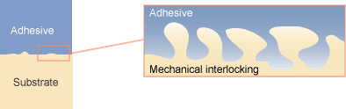

Mechanical adhesion

(http://ffden-2.phys.uaf.edu/webproj/212_spring_2014/Connor_Mattson/connor_mattson/physics.html)

Chemical adhesion occurs when the surface atoms from the two different substances form either ionic, covalent or hydrogen bonds. The strongest adhesions occurs when ionic or covalent bonds are formed. If the surface molecules can form bonds, then the surfaces will be attached together by a network of bonds. These bonds are effective over very small distances—distances less than a nanometer. This means that to form the bonds the two surfaces need to be in close contact. The mussel adhesive protein is a form of chemical adhesion.

Dispersive adhesion, also referred to as adsorptive adhesion, occurs when the force of attraction between the two substances is a result of intermolecular forces. The intermolecular forces involved include van der Waal forces and dipole-dipole attractions. The strength of dispersive adhesion depends on the chemical composition of the two substances, the extent to which they wet each other, and the degree of roughness of the surfaces. Wetting is the ability of a liquid to maintain contact with a solid surface and is the result of intermolecular interactions when the two substances are brought together.

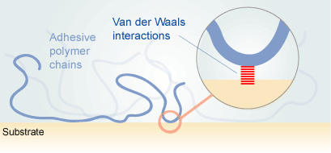
Dispersive adhesion

(http://ffden-2.phys.uaf.edu/webproj/212_spring_2014/Connor_Mattson/connor_mattson/physics.html)

Diffusive adhesion occurs when two materials intermingle or dissolve into each other. This occurs when the two substance’s molecules are mobile and soluble in each other. This is how polymers tend to bond to each other.

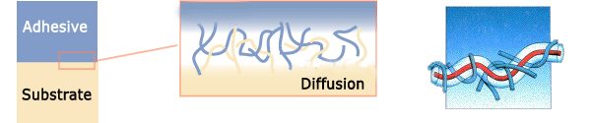
Diffusive adhesion

(http://www.adhesiveandglue.com/adhesion-theories.html)

Intermolecular forces

Since both adhesive and cohesive forces involve intermolecular forces, it is important to understand these attractions. The following text is adapted from the Teacher’s Guide accompanying the April 2015 ChemMatters article: Gmurczyk, M. Parabens: A Source of Concern? ChemMatters, 2015, 33 (2) pp 8–9.

Intermolecular forces are the forces between molecules, especially the attractive forces. The type of the intermolecular force will have an effect on the strength of both cohesion and adhesion. Several types of intermolecular attractions exist, but they all depend on the attraction between positive and negative charges—the electrostatic attraction. The three basic types of intermolecular attractions mentioned in the discussion of adhesion and cohesion are dipole-dipole attractions, hydrogen bonding, and London dispersion forces.

Dipole-Dipole attractions occur between polar molecules, which are the result of the uneven distribution of electrons within a molecule caused by polar bonds and an asymmetric molecule. When there is a difference in electronegativity—the ability to attract shared electrons within a covalent bond—the electrons shift to create a partial negative end and a partial positive end of the molecule. This creates a dipole moment. Molecules with dipole moments can attract each other electrostatically by the positive end of one molecule lining up next to the negative end of an adjacent molecule, creating the dipole-dipole attraction. Dipole-dipole attractions are only about 1% as strong as ionic or covalent bonds.

Example of dipole-dipole attractions:
(http://upload.wikimedia.org/wikipedia/commons/5/59/Dipole-dipole-interaction-in-HCl-2D.png)

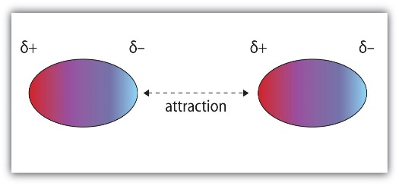

(http://images.flatworldknowledge.com/ball/ball-fig10_002.jpg)

Hydrogen-bonding is really a special case of dipole-dipole attraction. Particularly strong dipole-dipole forces occur when hydrogen is bonded to a small, highly electronegative atom. The three highly electronegative atoms are fluorine, oxygen and nitrogen. The partially positive hydrogen atom is attracted to the partial negative charge of nitrogen, oxygen or fluorine atoms of another molecule. The large polarity and the small size cause the hydrogen bonding to be much stronger (4–30 kJ/mole) than any other dipole-dipole attractions (less than 4 kJ/mole).

Examples of hydrogen bonding follow. The hydrogen bond is represented by the dashed lines.
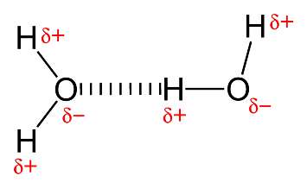
(http://upload.wikimedia.org/wikipedia/commons/thumb/b/b5/Hydrogen-bonding-in-water-2D.png/1024px-Hydrogen-bonding-in-water-2D.png)

H H H
| | |
δ+
δ-
δ+
δ-
H—N - - - - - H—N - - - - - H—N
| | |
H H H

London dispersion forces occur in nonpolar molecules. In these molecules, the electrons are considered evenly distributed throughout the molecule; however, electrons are in constant random motion, and a temporary dipole can be created by the shifting of the electrons. These temporary dipoles can repel or attract the electrons in a neighboring nonpolar molecule. This instantaneous dipole that occurs accidentally in a given atom or molecule can then induce a similar dipole in a neighboring molecule. Although this dipole may only exist for a fraction of a second, it does create a short-lived attraction between molecules. The strength of this attraction, although weak, depends on how easily the electron clouds can be distorted. Larger atoms or molecules with larger numbers of electrons far from the nucleus are more easily distorted and therefore form stronger attractions. This explains why nonpolar molecules like those in vegetable oil are liquid at room temperature.
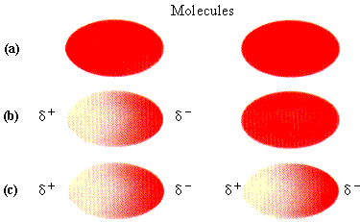
Example of London dispersion forces:

  - Electrons are evenly distributed in a nonpolar molecule;

  - Electrons are temporarily distorted creating an instantaneous dipole;

  - The instantaneous dipole on the left induces a dipole in the on the right.

(https://encryptedtbn3.gstatic.com/images?q=tbn:ANd9GcRmkI4GIZfx98Ij8kBWxD-XljtRokOk0hRx2BADKhcdTPM_2b56)

More on the history of adhesives

An adhesive is a non-metallic material which is able to join two substances (substrates) together. There is evidence of man using adhesives for thousands of years. Archaeologists studying burial sites dating to 4000 B.C. discovered foodstuffs buried in broken pottery vessels that had been repaired with sticky resins from tree sap. Cavemen used bitumen, a tarry substance, to attach flint arrowheads to the top of wooden spears.

From 1500–1000 B.C. the Egyptians used a variety of adhesives. They produced adhesives from connective tissue of animals and used it in building coffins for their pharaohs. A casket from King Tutankhamun’s tomb used such glue. Egyptian paintings depict the wood gluing process. Bonding and laminating using the animal glue was used to produce bows as well as furniture. The animal glue for the laminating and bonding was a casein (milk protein) glue. Egyptians also developed a starch based paste for bonding papyrus to clothing.

From about 1–500 A.D. the Romans and Greeks refined the production of animal glues. These glues were used in their art of wood veneering. They developed glues from a variety of sources, such as blood, bone, hide, milk, cheese, vegetables, and grains.

During the dark ages, from 500 A.D. until around 1500 A.D. glue was not used in most of Europe. It was not until the famous furniture and cabinet makers, such as Chippendale and Duncan Phyfe, began to use adhesives to hold their products together. The first glue-producing factory opened in 1690 in Holland, making glue from animal hides. In the mid-1700s, the first glue patent was issued in Britain. After that, many patents were issued for adhesives that used natural rubber, animal bones, starch and milk.

The advent of plastics revolutionized the adhesive industry. The first plastic, bakelite, produced in 1910, was a phenolic resin. Within a year, adhesives using this resin were on the market. Since that time, new adhesives have continued to become available. Even though adhesives have been known for thousands of years, most of the technology of adhesives has developed in the last 100 years.

More on how adhesives work

A good adhesive must exhibit excellent properties of both adhesion and cohesion. If you want to stick two substrates together, say A and B, with adhesive C, there need to be adhesive forces between A and C, as well as between B and C. Strong cohesive forces are needed to hold C together too. As explained by the article “Adhesives” by Explain That Stuff:

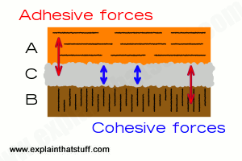
The first two [forces] are pretty obvious: the glue has to stick to each of the materials you want to hold together. But the glue also has to stick to itself! If that's not obvious, think about sticking a training shoe to the ceiling. The glue clearly has to stick both to the training shoe and to the ceiling. But if the glue itself is weak, it doesn't matter how well it sticks to the shoe or the ceiling because it will simply break apart in the middle, leaving a layer of glue behind on both surfaces. That's a failure caused when the adhesive forces are greater than the cohesive ones and the cohesive forces aren't big enough to overcome the pull of gravity.
(http://www.explainthatstuff.com/adhesives.html)

So adhesion and cohesion are both important for an adhesive to be effective. If you pull apart two things that have been glued together and the glue comes off either substrate, then the adhesive force failed. If the glue itself splits apart, leaving glue on each of the substrates then the cohesive force failed.

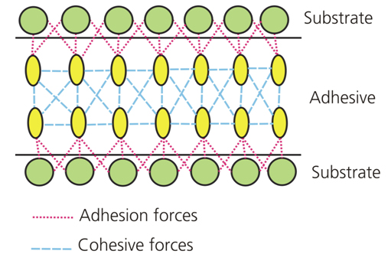
(http://www.adhesives.org/adhesives-sealants/science-of-adhesion/adhesion-cohesion)

More on types of adhesives

There are many types of adhesives and the following will describe three different ones.

Chemical reactive adhesives are supplied in a low molecular mass and then polymerized after the application. The polymerization can occur in a variety of ways. Multi-component adhesives harden by mixing the components that react chemically, forming polymers. Epoxy adhesives based on epichlorhydrin bisphenol are an example of a multi-component adhesive.

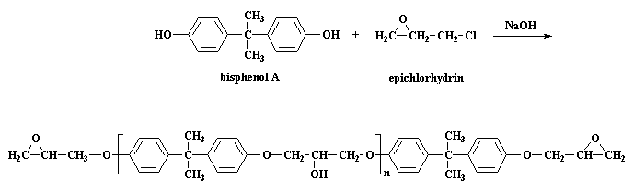

Reaction of an epoxy

(http://pslc.ws/welcome/tour/macrog/eposyn.htm)

Moisture curing adhesives rely on the moisture either on the surface of the substrate or in the atmosphere to cause the polymerization. Examples of this type of adhesive includes cyanoacrylates and polyurethane.

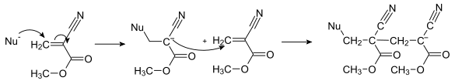

Polymerization of methyl-2-cyanoacrylate

(https://en.wikipedia.org/wiki/Cyanoacrylate)

Heat curing adhesives utilize heat to polymerize the adhesive components. When heat is applied, the components react and cross-link, which is the process of joining two or more molecules with a covalent bond. Urethane, below, is an example of a heat curing adhesive.
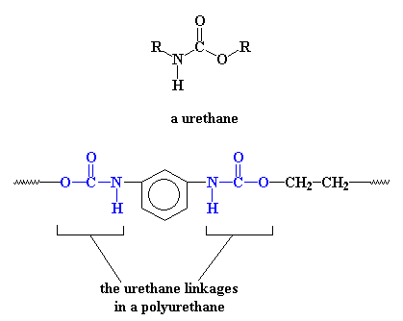

Heat curing adhesive

(http://pslc.ws/macrog/urethane.htm)

Thermoplastic adhesives are a second type of adhesives. These adhesives, when heated to a sufficient temperature (in the range 65–189 ºC), will flow and wet the substrates and then set and develop their strength on cooling. (Wetting is the ability of a liquid to maintain contact with a solid substrate and is necessary for the adhesive to be effective.) Thermoplastic adhesives form strong bonds between a wide ranges of substrates. Thermoplastic adhesives based on ethylene-vinyl acetate are easy to use. A glue gun is the commonly used method for applying these adhesives.

Evaporation or diffusion adhesives are a third type. These adhesives have the polymers in essentially their final form but the polymer is dissolved in a solvent so it will be able to wet the substrate. As the solvent evaporates the polymer hardens and adheres to the substrate. White glue and rubber cements are examples of evaporation adhesives.

The following table provides information on a wide range of adhesives.

Types of adhesives and their uses

Type | Example | How it bonds | Uses | Strong points | Weak points
PVA – White/  Yellow glues | Elmer's, Titebond | Physically interlocks materials | Porous materials; e.g., wood, paper | Water-based, easy cleanup, long open time  Heat/moisture to reverse bond | Needs clamping while setting. Slow setting
Epoxy |  | Physically interlocks and chemically bonds materials | Bonds most | Very strong and tough, various cure times available | Needs clamping while setting. Not reversible
Solvent Cements | Tenax, Plastruct, Testors, Acetone, Methyl ethyl ketone (MEK) | Dissolves plastics, which then re-harden, similar to welding | Polystyrene and acrylic plastics – Each kind of plastic will require a different solvent | Very strong bond, quick set and cure time | Will dissolve or distort thin materials.  Generally not reversible
Cyano-acrylate | Zap, Cyanopoxy | Binds to water and hydroxyl groups on substrate surface | Bonds just about all non-porous materials | Very strong bond | Brittle, low shear strength,  Gap-filling cement somewhat better
Contact adhesive | Goo, Barge cement | Viscosity of adhesive holds materials together | Bonding dissimilar materials, like wood and plastic, metal and plastic | Sticks almost anything | Creep, joint failure.  Solvent may affect plastics
Poly-urethane | Gorilla Glue | Interlocks and binds to water/hydroxyl | Bonds many substrates | Water-proof, expands to fill gaps while setting | Expands while setting, so must be clamped while setting

(http://www.starr-mrc.org/Workshop/Glues1.pdf)

More on mussels and mussel adhesives

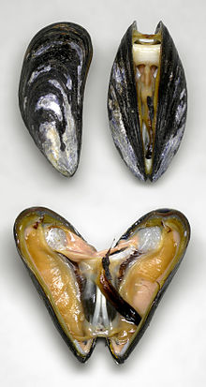
Mussels are twin-shelled mollusks that live in either saltwater or fresh water. They have a shell that is elongated and asymmetric. Their shells are generally brown, dark blue or black. The two shells or valves are joined on the outside by a ligament. The shells are opened and closed by strong internal muscles. The shells provide support for soft tissues, protection from predators and protection from drying out. Like most bivalves, mussels have an organ called a foot. In freshwater mussels the foot is large, while in saltwater ones it is smaller and tongue-like. Mussels feed by filtering water through their chambers, extracting plankton, other microscopic sea creatures and minerals.
(https://en.wikipedia.org/wiki/Mussel)

Mussels adhesives

Mussels spend their lives attached to a rock or other hard surface. The adhesives they use to attach themselves to hard surfaces is something that scientists have studied for years and still do not fully understand. Mussels produce a sticky thread called a byssus that behaves like a bungee cord to attach the mussel to the surface. They anchor their shell by creating a cable of several hundred of these threads. The threads are produced in a process similar to injection-molded plastics. They squeeze a series of adhesive protein secretions into a groove in the foot.

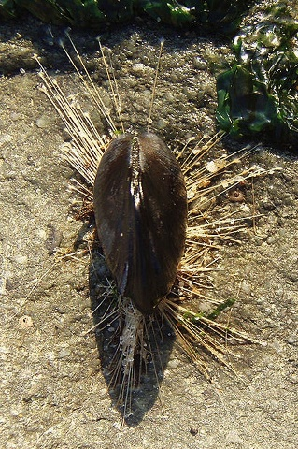
Herbert Waite, a marine biochemist at the University of California at Santa Barbara, who has studied mussel adhesives for years, found that the overall mechanics of these proteins is similar to that of two-part epoxy glues. The mussel’s glue gland is comprised of two compartments. One compartment produces resin-like proteins and the other produces a chemical that behaves like hardeners. When these proteins enter the water they mix and cure by crosslinking. The hardening takes seconds. In the picture at right you can see the byssus.

"Mytilus with byssus" by Brocken Inaglory. Licensed under CC BY-SA 3.0 via Wikimedia Commons
(https://commons.wikimedia.org/wiki/File:Mytilus_with_byssus.jpg#/media/File:Mytilus_with_byssus.jpg)

There are at least 9 different mussel adhesive proteins (MAP) produced by the foot. All contain L-Dopa, 3,4 dihroxy-L-phenylalanine, which is responsible for their ability to stick.
L-Dopa forms adhesive and cohesive bonds through its reduced and oxidized states, respectively. In the figure below, the left side demonstrates L-Dopa’s adhesive properties. The reduced L-Dopa leads to the strongest surface bonds. The oxidized L-Dopa can only lead to cohesive bonding, shown on the right side of the figure. Cohesive bonds are vital to the development of the bulk material for the thread and plaque.

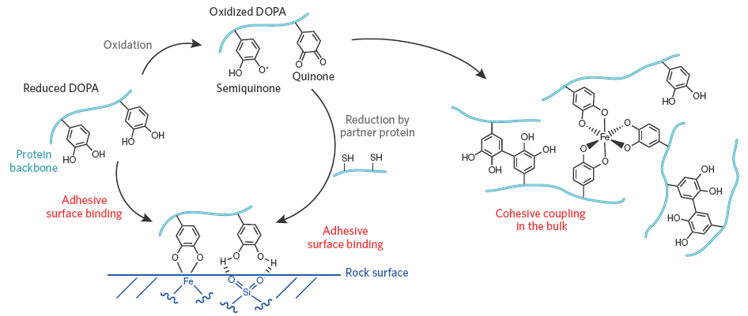

(http://www.nature.com/nchembio/journal/v7/n9/fig_tab/nchembio.639_F1.html)

More on potential uses for mussel adhesive proteins (MAPs)

The fact that mussel adhesive proteins are strong, adhere to a variety of materials, and work in water make their potential for use in the human world extensive.

In the field of medicine, mussel adhesive proteins, MAPs, could be used in a variety of applications. They could be used to replace suture in operations, especially when operating on newborn babies. Their fetal membranes are so delicate that it is difficult to suture them. Using the mussel inspired glues that work when wet and do not trigger immune responses would make these operations easier. Dental surgery requires a glue that can be applied while soft, bonds quickly in a wet environment and strongly adheres to teeth and bone. MAPs would fill this need.

The treatment of the buildup of plaque in arteries is frequently treated by inserting balloon angioplasties or stents into the blood vessels to widen them. They are covered in anti-inflammatory drugs and unfortunately 95% of these drugs get washed away in the bloodstream. Using MAPs to stick the drugs to the stent could drastically reduce the waste and prolong the stent’s lifespan. The MAPs could potentially prove useful anywhere tissues need to meet and stay together; for example connecting tendons and ligaments.

The mussel-like glue could be used in rustproof coatings for outdoor exteriors of buildings and cars. Coating the materials with mussel glue would result in a natural rustproofing compound, better than any of the polymers on the market today.

Mussels, barnacles and other encrusting organisms are a major problem for the maritime industry. The attachment of the animals to the bottom of ships is known as biofouling and it creates drag and increases the cost of fuel by forty percent. It is estimated that the U.S. Navy spends an additional $500 million per year in fuel and maintenance costs due to biofouling, as ships are dry-docked to scrape off the barnacles.

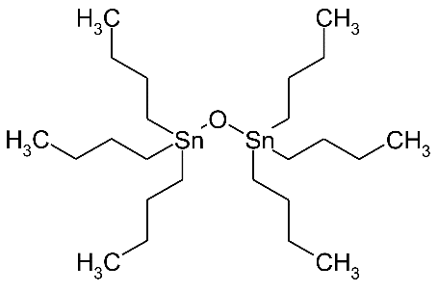
In the 1980s and 1990s ships were coated with a tributyltin oxide that served as a biocide and anti-fouling agent. It was effective but has since been banned, since it caused major ecological problems as it entered the water. It was discovered that it was making oysters infertile. Copper-based paints are often used on the bottom of ships to kill barnacles; however, the copper leaches into the water and, as a result, copper levels in many harbors are high, creating environmental hazards. Research into using the waterproof mussel-like glues to attach the anti-fouling agents firmly to ship bottoms is receiving much attention. This could prevent any more environmental damage.
Tributyltin oxide

(https://upload.wikimedia.org/wikipedia/commons/thumb/0/03/Tributyltin_oxide_structure.svg/2000px-Tributyltin_oxide_structure.svg.png)

Connections to Chemistry Concepts
(for correlation to course curriculum)
- Intermolecular forces—Hydrogen bonding and London dispersion forces are two of the forces which bind the mussel to a surface material.
- Adhesion—This is the result of intermolecular forces that bond the different substrates.
- Covalent bonds—Covalent bonds are formed between the mussel and the surface material when metal ions are present.
- Organic chemistry—The mussel proteins contain the amino acid 3,4-dihyhydroxyphenylalamine that bind mussels to materials. The structure of the catechol group is described as having a benzene ring with hydroxyl functional groups.
- Molecular weight—Molecular weight is used to describe the functions of the various proteins in the mussel adhesive.

Possible Student Misconceptions
(to aid teacher in addressing misconceptions)
- “Glues form chemical bonds with substances.” Most adhesives bind to a substance by some type of intermolecular force, not by chemical bonds; however, chemical bonds are formed in the curing (cross-linking) process of some adhesives, like super glue, when cyanoacrylate monomers react to form polymers.
- “Most glues are made from horses.” Animal glues have been used since ancient times. The necessary ingredient to make these glues is collagen, which is found in connective tissues such as cartilage, tendons and ligaments, and hides and bones. These are boiled down to make the glue. A hundred years ago these parts of horses and other animals were used to make glue. (Horses that got too old or sick to work were “sent to the glue factory.”) Today only a small amount of animal glue is produced and most of that is made from cattle. Most glues today are synthetic. Note: Gorilla Glue is NOT made from gorillas!
- “Adhesives are forever; once glued, two items will stay together.” Many glues are designed with this in mind, “forever” glues. But some adhesives are meant to be separable; think painter’s tape or Post-it Notes®. These are meant to be removable, so that they can be reused. See item 2 below for more information.

Anticipating Student Questions
(answers to questions students might ask in class)
- “Why doesn’t glue stick in the tube?” They are designed to work that way and achieve this in a variety of ways. Many are dissolved in solvents that keep them from reacting and becoming sticky. When the adhesive material comes out of its container the solvents evaporate and they are absorbed by the surface and do their job. Other adhesives, such as epoxy, come in two separate containers and do not react until they are mixed together. A good video (2:22) explaining this can be found at: https://www.youtube.com/watch?v=kzqA7NfX0r0.
- “How do Post-it Notes® work?” The adhesive on the Post-it Notes® is a unique low-tack pressure sensitive adhesive. The adhesive is not a continuous film but a series of many microcapsules. They are about 10–100 times bigger and much weaker than glue particles found on sticky tape. When pressure is applied to the Post-it Note® some of the large sticky capsules bind to the surface with enough adhesive force to hold the weight of the paper in the note. Because of the many microcapsules of varying sizes a Post-it-Note® can be used over and over again.
- “How can I unstick my fingers if I superglue them together?” According to the official Super Glue Web site:
Super Glue is incredibly strong, it has one weakness: acetone. Acetone is often found in household nail polish remover, and a small amount on the end of a Q-tip or cotton swab applied directly to the glue should dissolve the bond without damaging the skin. Be very cautious in gently peeling the skin apart as in removing a bandage from the skin; pulling the skin apart may rip the skin! Read the label to make sure that the remover actually contains acetone, as more and more manufacturers are turning away from the chemical because of the growing popularity of acrylic nails (which are loosened by acetone). (http://www.supergluecorp.com/?q=removingsuperglue.html)

In-Class Activities
(lesson ideas, including labs & demonstrations)
- There are many activities that involve the making and testing of a glue. Many involve the production of casein glue, which is a milk based glue.
- At this site is an excellent experiment for the production of glue as well as an experiment for testing it: http://www.rsc.org/learn-chemistry/resource/res00000459/developing-a-glue?cmpid=CMP00005014.
- Another similar experiment provides directions for the production of glue and then a procedure for comparing the student made glue with commercial glue: http://www.education.com/science-fair/article/power-of-homemade-casein-glue/.
- You could have students perform the “Stick-O-Meter” lab activity. This activity tests the adhesive properties of a number of substances. It is designed for middle school students, but could be adapted for high school students by adding variables such as roughening the surfaces and using different substrates. (http://pbskids.org/zoom/activities/sci/stickometer.html)
- Students can determine the strength of adhesives. Instructions can be found at this site: http://agpa.uakron.edu/p16/lesson.php?id=adhesive_strength&pg=abstract.
- Teachers can perform a series of demonstrations dealing with intermolecular forces. A wonderful set of these demonstrations is explained in a short video (5:04) produced by Flinn Scientific. A pdf file explaining the demonstrations and the video can be found at this site: http://www.flinnsci.com/teacher-resources/teacher-resource-videos/best-practices-for-teaching-chemistry/teaching-strategies/intermolecular-forces-magic-trick/.

Out-of-Class Activities and Projects
(student research, class projects)
- Students could design a series of safe experiments that investigate the adhesive properties of glue. Suggestions for this project are given at this site: http://www.sciencebuddies.org/science-fair-projects/project_ideas/CE_p021.shtml.
They could report the results of their experiments to the class.
- Students could choose or be assigned a particular adhesive and research its chemical composition, how it cures, the type of adhesion forces, common uses and some historical information. A final report could be written or orally given.
- Students could investigate and prepare a report on unexpected uses for adhesives. Some unexpected uses might include bonding of automobile structural components, surgical sutures, food, forensic science, pest control and space flight.

References
(non-Web-based information sources)
30 Years of ChemMatters

Available Now!

The references below can be found on the ChemMatters 30-year DVD (which includes all articles published during the years 1983 through April 2013 and all available Teacher’s Guides, beginning February 1990). The DVD is available from the American Chemical Society for $42 (or $135 for a site/school license) at this site: http://ww.acs.org/chemmatters. Click on the “Archive” tab in the middle of the screen just under the ChemMatters logo. On this new page click on the “Get 30 Years of ChemMatters on DVD!” tab at the right for more information and to purchase the DVD.

Selected articles and the complete set of Teacher’s Guides for all issues from the past three years are available free online at the same Web site, above. Simply access the link and click on the aforementioned “Archive” tab.

Plummer, C. The Story of Post-it Notes. ChemMatters, 1993, 11 (4), pp 13–15. This article describes the glue on Post-it Notes.

The December 1993 ChemMatters Teacher’s Guide for the above article provides another casein glue experiment, including notes for the teacher.

Parent, K. and Young, J. Biomimicry—Where Chemistry Lessons Come Naturally. ChemMatters, 2006, 24 (2), pp 15–17. This article includes a brief discussion of mussel glue.

The April 2006 ChemMatters Teacher’s Guide for the above article provides a small amount of additional information on blue mussels.

Shiber, L. Sticky Situation: The Wonder of Glue. ChemMatters, 2006, 24 (4), pp 8–10. In this article, a variety of glues, including mussel glue are described.

The December 2006 ChemMatters Teacher’s Guide on the above article includes extensive information about varying aspects of adhesives.

Web Sites for Additional Information
(Web-based information sources)
More sites on adhesion, cohesion and intermolecular forces

Cohesive and adhesive forces are explained at this ChemWiki site. In addition an explanation of the meniscus is explained. (http://chemwiki.ucdavis.edu/Physical_Chemistry/Physical_Properties_of_Matter/Bulk_Properties/Cohesive_And_Adhesive_Forces)

At this site cohesion and adhesion is explained in terms of water. There are nice molecular drawings included in this article. (https://www.khanacademy.org/science/biology/water-acids-and-bases/cohesion-and-adhesion/a/cohesion-and-adhesion-in-water)

A concise explanation of cohesion and adhesion is provided at http://www.softschools.com/difference/adhesion_vs_cohesion/38/.

This is a fun video (10:44) that describes adhesion and cohesion of water. It includes good graphics and specific examples of adhesion and cohesion. (https://www.youtube.com/watch?v=5rEVU7YxHr8)

This article compares cohesion to adhesion and discusses capillary action: http://www.diffen.com/difference/Adhesion_vs_Cohesion.

An overview of intermolecular forces is provided at this site. It includes excellent diagrams in the explanations. (http://chemwiki.ucdavis.edu/Physical_Chemistry/Physical_Properties_of_Matter/Atomic_and_Molecular_Properties/Intermolecular_Forces/Overview_of_Intermolecular_Forces)

More sites on adhesives

An introduction to glue, its history and how it is manufactured is given at http://www.madehow.com/Volume-5/Glue.html.

At this site a graphic history of adhesives is given: http://www.arwarchitect.com/infographics/history-of-adhesive.

A history of adhesives and a description of some of the more common types of adhesives and their uses are provided at this site: http://www.bsahome.org/archive/html/escreports/historyofadhesives.pdf.

A history of adhesives written for children is provided at this Kids Discovery site: http://www.kidsdiscover.com/teacherresources/history-of-glue/.

This Explain That Stuff site provides a variety of information on adhesives. It includes a little history and explains the adhesive and cohesive forces in glue and how each works. It also explains how Post-it Notes and geckos stick. (http://www.explainthatstuff.com/adhesives.html)

A brief explanation of how adhesives work can be found at this site. The molecular models used in the explanation are nicely done. (http://www.adhesiveandglue.com/adhesive-definition.html)

A more extensive discussion of the forces working in adhesives can be found at: http://engineering.mit.edu/ask/what-are-basic-forces-behind-tape-and-glue.

The James May’s video (6:10) provides a good explanation of adhesives. (https://www.youtube.com/watch?v=hzFQ6LefGCo)

Several theories of adhesives are explained at this site: http://nzic.org.nz/ChemProcesses/polymers/10H.pdf.

This site also provides explanations of adhesives theories, with nice graphics included: http://www.adhesiveandglue.com/adhesion-theories.html.

Mechanical bonding and chemical bonding are briefly described here: http://www.permabond.com/blog/2008/07/28/in-english-doc-how-do-adhesives-work/.

Several types of adhesives can be found at this site: http://www.adhesives.org/adhesives-sealants/science-of-adhesion/design-of-adhesives-bonds/types-of-adhesives.

More sites on mussels and mussel adhesives

This Web site discusses the advantages of mussel adhesive: http://news.mit.edu/2014/new-adhesives-stick-in-water-0921.

A glimpse of the science dealing with how the mussel adhesive works as described by the biochemist Herbert Waite can be found at http://discovermagazine.com/2003/feb/featchem.

A description of the research with mussel adhesives and some of its potential uses are described in this article: http://www.purdue.edu/uns/html4ever/2004/040112.Wilker.mussels.html.

This is an extensive review article dealing with mussel adhesives and the mussel adhesion mechanism. The article includes good graphics. (www.usbr.gov/research/projects/download_product.cfm?id=830)

A detailed article about mussel adhesives and their uses can be found at http://www.mdpi.com/1660-3397/13/11/6792/htm.

This article briefly describes mussel adhesives as well as cites many of its potential uses: http://sciencenordic.com/synthetic-mussel-adhesive-sticks-anything.

The potential medical uses of mussel adhesives is discussed in this article: http://phys.org/news/2015-07-mussel-inspired-surgical-protein-wounds-medical.html.

These two articles describe the problems of biofouling:
http://www.whoi.edu/oceanus/feature/barnacles-and-biofilms and
http://gizmodo.com/the-navys-huge-hidden-problem-barnacles-on-ships-1572231175.

