April/May 2017 Teacher's Guide

Background Information

for

Don’t Let Cortisol Stress You Out!

Table of Contents

About the Guide 2
Background Information 3
References 22
Web Sites for Additional Information 22

About the Guide

Teacher’s Guide team leader William Bleam and editors Pamela Diaz, Regis Goode, Diane Krone, Steve Long and Barbara Sitzman created the Teacher’s Guide article material.
E-mail: bbleam@verizon.net

Susan Cooper prepared the anticipation and reading guides.

Patrice Pages, ChemMatters editor, coordinated production and prepared the Microsoft Word and PDF versions of the Teacher’s Guide.
E-mail: chemmatters@acs.org

Articles from past issues of ChemMatters and related Teacher’s Guides can be accessed from a DVD that is available from the American Chemical Society for $42. The DVD contains the entire 30-year publication of ChemMatters issues, from February 1983 to April 2013, along with all the related Teacher’s Guides since they were first created with the February 1990 issue of ChemMatters.

The DVD also includes Article, Title, and Keyword Indexes that cover all issues from February 1983 to April 2013. A search function (similar to a Google search of keywords) is also available on the DVD.

The ChemMatters DVD can be purchased by calling 1-800-227-5558. Purchase information can also be found online at http://tinyurl.com/o37s9x2.

Background Information
(teacher information)
The endocrine system

The endocrine system consists of all of the glands in the body and their hormones. The major glands of the endocrine system include the hypothalamus, pituitary gland, pineal gland, thyroid gland, parathyroid gland, adrenal glands, pancreas, ovaries (in females), and testicles (in males). The location and major functions of each gland are outlined in the table below.

Gland | Location | Major Function(s)
Hypothalamus | In the brain, above the pituitary gland | It works with the pituitary gland to control the entire endocrine system. It is considered a connector between the endocrine and nervous systems and regulates body temperature, thirst, appetite, emotions, sleep, blood pressure, sex drive, childbirth, and production of digestive juices.
Pituitary | At the base of the brain and near the hypothalamus | After the hypothalamus prompts it, the pituitary gland secretes hormones that regulate the functions of other endocrine glands. For this reason, the pituitary gland is called the “master gland.”
Pineal | At the deep center of the brain | It produces melatonin which helps regulate sleep-wake patterns and it regulates reproductive hormones.
Thyroid | In the front of the neck | It releases hormones that regulate body metabolism. Breathing, heart rate, body weight, body temperature and cholesterol levels are some of the vital body functions controlled by this gland.
Parathyroid | In the neck, behind the thyroid gland | The four tiny parathyroid glands control the body’s calcium levels.
Adrenal | On top of each kidney | These glands help regulate blood pressure, electrolyte balance, metabolism, and immune system suppression. They also help the body respond to stress.
Pancreas | Across the back of the abdomen behind the stomach | It controls blood sugar levels in the body.
Ovaries | In the lower abdomen | They produce hormones that promote the development of female sex characteristics and fertility.
Testicles | Behind the penis in the scrotum | These glands are responsible for the development of male sex characteristics, bone density, and muscle strength.

The diagram below shows the anatomy and location of each of the major endocrine glands.

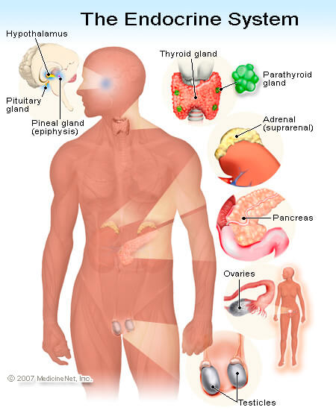

Human anatomy and location of glands of the endocrine system

(http://www.emedicinehealth.com/anatomy_of_the_endocrine_system/article_em.htm)

Some of the body’s processes that are regulated by the endocrine system include: emotions, growth and development, metabolism, blood pressure and heart rate, production of digestive juices, sexual function and reproduction, and stress. By regulating these body processes, the endocrine system helps maintain homeostasis, or a normal balanced state of being, within the body. Homeostasis is happening constantly and allows the body to maintain a stable, relatively constant condition of properties. Regulating glucose levels in the blood is one example of how the endocrine system maintains homeostasis. When glucose amounts in the blood rise above the normal glucose level, the pancreas secretes the hormone insulin. This allows the cells in muscles, fat, and the liver to absorb the glucose, where it is used to make energy or is converted to fat. When blood sugar amounts are below the normal glucose range, the pancreas secretes the hormone glucagon. This signals the liver to break down glycogen into glucose, which is then released into the blood stream. So, homeostasis can be thought of as a dynamic equilibrium where feedback mechanisms are constantly being made so that levels are staying at or near the normal ranges.

The endocrine glands are controlled by stimulation from the nervous system, by chemical receptors in the blood, and by hormones produced by other glands.

Hormones

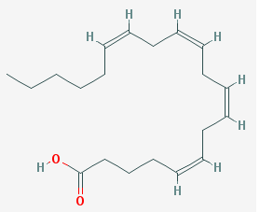
Hormones are produced by endocrine glands and regulate body functions such as metabolism, respiration, heart rate, blood pressure, growth and development, reproduction, and mood, by signaling different parts of the body to communicate with one another. Hormones are classified according to their chemical structure and can be grouped into three classes: eicosanoids, steroids, and amino acid derivatives.
Arachidonic acid

(https://pubchem.ncbi.nlm.nih.gov/compound/444899)

Eicosanoid hormones

Eicosanoids are synthesized as the body needs them. They are produced by the oxidation of arachidonic acid, a polyunsaturated fatty acid containing four double bonds. This carboxylic acid contains the carboxyl group (–COOH) on its first carbon atom. The molecular structure of the 20-carbon organic acid is shown at right.

Eicosanoids are referred to as “local hormones” because they target cells close to their site of formation and they are rapidly degraded, so they don’t get a chance to travel too far away from their site of synthesis. Their biosynthesis is activated by physical injury caused by mechanical trauma, ischemia (a restriction in blood supply to tissues that causes a deficiency of oxygen and glucose to tissue cells), or an attack by pathogens. Examples of eicosanoids are prostaglandins, prostacyclins, thromboxanes, leukotrienes, and epoxyeicosatrienoic acids.

The table below summarizes the functions of these eicosanoids.

Eicosanoid | Function
Prostaglandins | They are produced by almost all nucleated cells and aid in contraction and relaxation of smooth muscle, the dilation and constriction of blood vessels, control of blood pressure, and modulation of inflammation.
Prostacyclins | They are synthesized in endothelial cells, the cells that line the blood vessels, and aid in inhibition of platelet activation and formation of blood clots and in the dilation of blood vessels to decrease blood pressure.
Thromboxanes | They are made by platelets and aid in blood clotting and blood vessel constriction.
Leukotrienes | They are produced in leukocytes, a type of white blood cell, and regulate immune responses.
Epoxyeicosatrienoic acids | They are synthesized by various types of cells and can lower blood pressure, prevent heart attacks and strokes, and inhibit blood clotting.

Prostaglandin structure

Every prostaglandin contains 20 carbon atoms, including a 5-carbon ring. Numbering of the carbon atoms begins with the carboxyl end (–COOH). All prostaglandins contain a hydroxyl group on carbon-15 and a cis double bond between carbon atoms 13 and 14. The cis-double bond allows formation of a 3-dimensional orientation of atoms for the five ring structure.

A cis-double bond results in a type of stereoisomer where the functional groups are on the same side of the carbon chain, as opposed to a trans-isomer, where the functional groups are on opposite sides of the double bond. The simple images below illustrate the difference between two isomers. While the molecules have the same molecular formulas, they differ in the three dimensional orientation of their atoms in space.

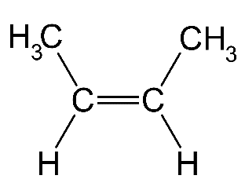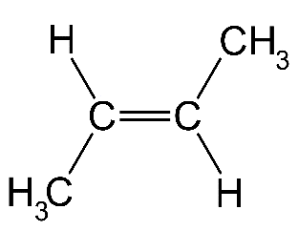

2-butene
Cis-sterioisomer Trans-sterioisomer

(http://chemistry-reference.com/isomerism/default.asp?language=fr)

When naming, individual prostaglandins begin with the prefix “PG” followed by a letter, which relates to ring modifications. For example, in the diagram below, PGA to PGE and PGJ have a keto group (RCOR’, with R and R’ representing functional groups) at some position on the ring, while PGK has two keto groups. Other ring modifications may be double bonds, hydroxyl groups, or oxygen bridges. The image below shows keto groups on PGA through PGE, and PGJ and PGK. PGD through PGF and PGI all contain hydroxyl groups on their rings. PGG, PGH, and PGI contain oxygen bridges between carbon atoms within the ring(s).

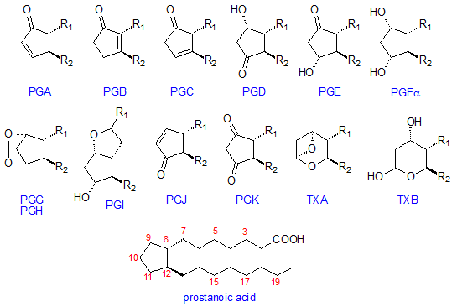

Nomenclature and structure of prostanoids

(http://lipidlibrary.aocs.org/Primer/content.cfm?ItemNumber=39316)

Continuing with the naming system, a numerical subscript between one and three follows the letter. This number indicates the number of double bonds within the two alkyl groups that are attached to the pentane ring.

The discussion and images above can be used as a guide for naming, for example, prostaglandin D₂, shown below. The pentane ring is type D, because the ring contains a hydroxyl group on carbon-9 and a keto group on carbon-11. The subscript 2 identifies the two double bonds within the two alkyl groups. (Remember that all prostaglandins contain a hydroxyl group bonded to carbon-15.)
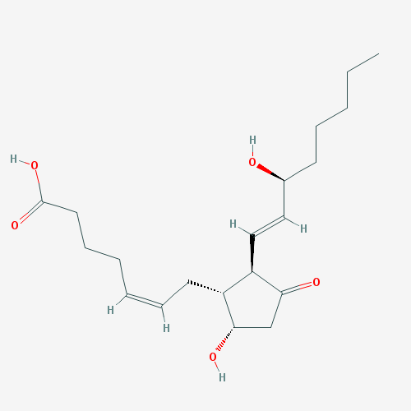
Prostaglandin D₂ (PGD₂)

(https://pubchem.ncbi.nlm.nih.gov/compound/prostaglandin_D2)

The structural differences of prostaglandins give them different biological activities or effects on the body. Interestingly, the same prostaglandin that stimulates a reaction in one tissue can inhibit the same reaction in another, because the reaction that occurs is determined by the type of prostaglandin binding receptor within the tissue. (Binding receptors are discussed in the “Hormone signaling” section of this Teacher’s Guide.)

Prostacyclin structure

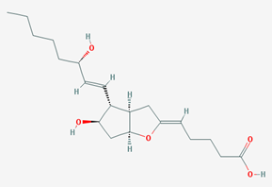
Prostacyclin is a type of prostaglandin because each molecule contains 20 carbon atoms, a 5-carbon ring, a hydroxyl group on carbon atom 15, and a double bond between carbons 13 and 14. Characteristic of a prostacyclin molecule is an oxygen bridge between carbon 6 and carbon 9 (see diagram at right), and a second hydroxyl group on carbon atom 11. The molecular structure of prostacyclin is provided at right.

Prostacyclin (PGI₂)

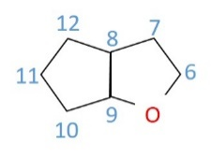
(https://pubchem.ncbi.nlm.nih.gov/compound/5282411)

The image to the right will help identify the numbering of the
carbon atoms in the double ring portion of the molecule.

Thromboxane structure

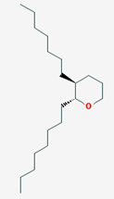
Thromboxanes are similar in structure to prostaglandins. Characteristic to this type of eicosanoid is a six-membered, ether-containing ring, which can be seen in the diagram at right.

Thromboxane

(https://pubchem.ncbi.nlm.nih.gov/compound/114873)

Leukotriene structure

Leukotrienes are also 20 carbon structures. Characteristic of these molecules is the absence of a ring structure.
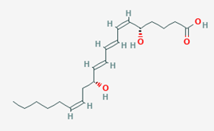

Leukotriene B4
(https://pubchem.ncbi.nlm.nih.gov/compound/5280492)

Epoxyeicosatrienoic acids

Epoxyeicosatrienoic acids are 20-carbon, straight chain structures.

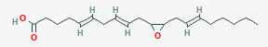

11,12-epoxyeicosatrienoic acid

(https://pubchem.ncbi.nlm.nih.gov/compound/5353269)

Steroid hormones

Steroid hormones get their name because they are synthesized from cholesterol, which is a steroid. All steroids contain a 17-carbon skeleton arranged in four rings which are labeled A, B, C, and D. Rings A, B, and C are cyclohexanes (6 carbon rings), while ring D is a cyclopentane (5 carbon ring). In most steroids, methyl groups (–CH₃) are present at positions C-10 and C-13, and an alkyl group may be present at C-17. Alkyl groups have the general formula C_{n}H_{2n+1}. The typical functional groups –OH, –CHO, and –COOH may be attached to the ring or to the alkyl group. The image below identifies the four rings in the steroid skeleton. The steroid ring numbering shows that the carbon in the methyl group attached to C-13 is numbered C-18 and the carbon in the methyl group attached to C-10 is numbered as C-19. The first carbon in the alkyl group attached to C-17 is then numbered C-20.

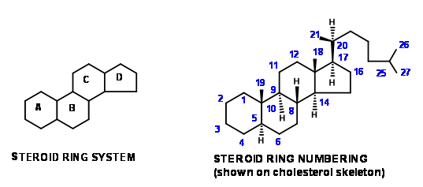

Numbering system for steroid hormones

(http://ictwiki.iitk.ernet.in/wiki/index.php/Strategies_in_STEROIDS_Synthesis)

Variations in the ring structure and or the atoms or functional groups attached to the ring structure result in differences in the physiological effects of the steroid hormones. Notice in the table below that the two adrenal hormones aldosterone and cortisol only differ in structure by the functional group attached to C-13. Aldosterone contains an aldehyde (–CHO) attached to C-13, while cortisol contains a methyl group (–CH₃) attached to C-13. This slight structural difference results in very different functions for these hormones. Aldosterone regulates electrolyte and water balance in the body, while cortisol regulates carbohydrate metabolism. We can see, also, that slight structural differences between the sex hormones estradiol and testosterone result in whether the hormone functions to stimulate female or male characteristics.

Hormone | Effect
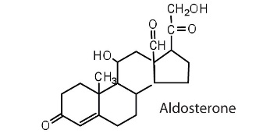  (https://pblnotes.wordpress.com/2011/08/25/steroid-hormones/) | Regulates salt metabolism; stimulates kidneys to retain sodium and excrete potassium
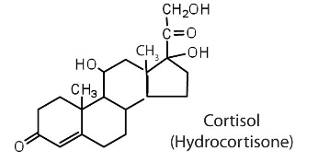  (https://pblnotes.wordpress.com/2011/08/25/steroid-hormones/) | Stimulates the conversion of proteins to carbohydrates
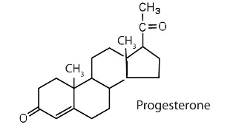  (https://pblnotes.wordpress.com/2011/08/25/steroid-hormones/) | Regulates the menstrual cycle; maintains pregnancy
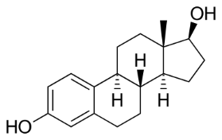  Estradiol  (https://en.wikipedia.org/wiki/Estradiol) | Stimulates female sex characteristics; regulates changes during the menstrual cycle
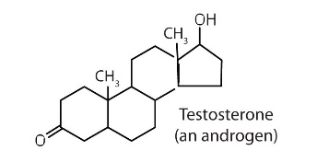  (https://pblnotes.wordpress.com/2011/08/25/steroid-hormones/) | Stimulates and maintains male sex characteristics

Representative steroid hormones and their physiological effects

Amino acid-derived hormones

Amino acid-derived hormones are derived from the amino acids tyrosine and tryptophan and are relatively small, water soluble molecules. Amino acid-derived hormones can be identified by their “in” and “ine” endings. Examples of the amino acid-derived hormones and their functions are listed in the table below.

Hormone | Derived from  (amino acid) | Function(s) | Where manufactured
Dopamine | Tyrosine | Affects sleep, mood, learning and memory | Brain
Norepinephrine | Tyrosine | Increases in O₂ to brain, heart rate, glucose release, and breathing rate | Adrenal Gland
Epinephrine | Tyrosine | Increases in heart rate, muscle strength, blood pressure, sugar metabolism | Adrenal Gland
Thyroxine | Tyrosine | Regulates metabolic rate | Thyroid Gland
Melatonin | Tryptophan | Regulates sleep and wakefulness | Pineal Gland
Seratonin | Tryptophan | Stabilizes mood and regulates sleeping, eating, and digesting | Brain & Intestine

Examples of the amino acid-derived hormones and their functions

Many of these hormones can also act as neurotransmitters that allow a nerve to communicate with other nerves, muscles, or glands. Neurotransmitters control the heart, lungs, and digestion, as well as mood, sleep, and concentration. Stress, alcohol consumption, and caffeine can cause neurotransmitter hormones to be out of balance, resulting in adverse symptoms such as anxiety and high blood pressure.

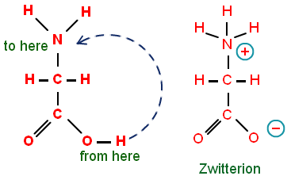
In nature all amino acids exist as zwitterions. The term zwitterion comes from the German word zwitter which means hybrid ion. A zwitterion is a dipolar molecule that contains separate positively and negatively charged ends but has no net charge itself. The separately charged ends result because amino acids undergo intramolecular acid-base reactions where the proton (H⁺) from the carboxyl group (–COOH) is transferred to the amine group (–NH₂). The diagram at right shows this proton transfer.
Transfer of a proton from the
carboxyl group to the amino group
within an amino acid molecule

(http://chemistry.tutorvista.com/biochemistry/essential-amino-acids.html)

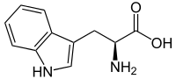
Amino acids are organic compounds containing amine (–NH₂) and carboxyl (–COOH) functional groups, along with a side chain specific to the amino acid. For adults, there are eight amino acids that the body cannot synthesize; these are found in the proteins that we eat. These amino acids are called essential amino acids. Tryptophan, a precursor to the hormones melatonin, serotonin, and thyroxine, is a non-polar, essential amino acid, where the amine and carboxyl groups are separated by one carbon atom (α-carbon) and contains the indole side chain. Its structural formula is shown in the image at left.
The essential amino acid tryptophan

(https://en.wikipedia.org/wiki/Tryptophan)

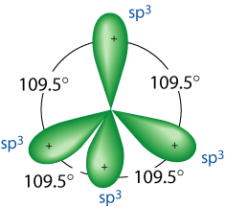
In tryptophan, the central carbon atom (α-C) contains four sp³ hybrid orbitals that are oriented in space in the same directions as the corners of a tetrahedron, resulting in bond angles of 109.5°. The image at right is a representation of the 3-D arrangement of the orbitals.
Orientation in space of
the four sp³ orbitals in a tetrahedral carbon atom.

(http://www.grandinetti.org/orbital-hybridization)

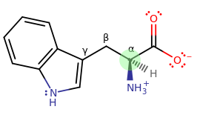
Tryptophan and all other amino acids except glycine have the central carbon atom bonded to four different functional groups or atoms. The structure of tryptophan at left shows the central carbon atom (α-C, highlighted in green) bonded to a carboxylate ion
(–COO–), an amino ion
(–NH₃⁺), a hydrogen atom, and the indole side chain.
The α-carbon in tryptophan forms four separate bonds

(https://socratic.org/questions/how-would-you-draw-tryptophan-and-select-the-chiral-carbon)

Because of these four separate bonds around the central carbon atom, tryptophan can occur in two isomeric forms, L-tryptophan and D-tryptophan. These molecules are mirror images of one another, where L is designated as a left handed configuration and D is designated as the right hand configuration. The designation “L” comes from the Latin word laevis which means on the left and “D” comes from the Latin word dexter, meaning on the right. Because the L and D configurations contain the same molecular formulas and sequence of bonding, but different spatial, or 3-D orientation of the atoms, they are referred to as stereoisomers.

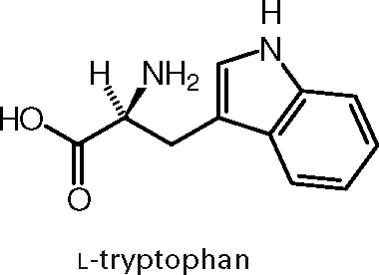
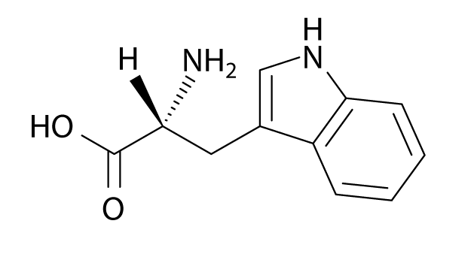
The images below show the difference in the spatial orientation of the amino group and hydrogen, (in circles) bonded to the central carbon atom for the two molecules. Think of most of the molecule as being planar, where the sticks represent bonds that are in the plane of the paper. The wedges represent bonds coming out of the paper toward you and the dashed lines represent bonds going away from you, behind the paper. In the D-tryptophan molecule, the amino group is oriented behind the paper, while in the L-tryptophan molecule, the amino group is oriented in front of the paper. Thus, the two molecules are mirror images of one another. Only L amino acids are produced by cells.
L-tryptophan

(https://jtw441.wordpress.com/2014/02/17/reflection-03-amino-acids-and-proteins/)
D-tryptophan

(http://www.chemeddl.org/alfresco/service/chemeddl/molecules/search.html?guest=true&pubchem=9060)

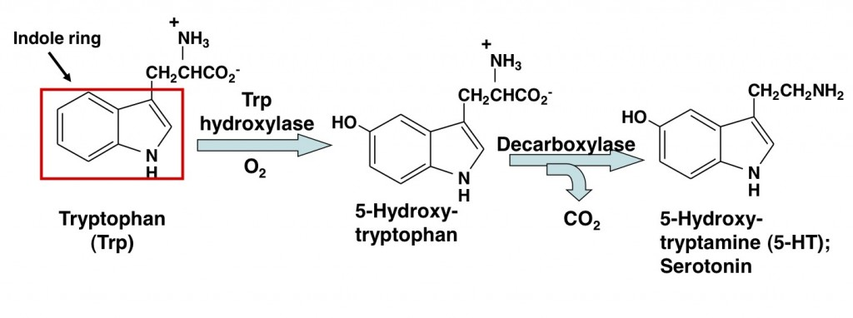
The hormone serotonin is synthesized from L-tryptophan. Through a reaction with O₂ and the enzyme tryptophan hydroxylase, a hydroxyl group is added to tryptophan to produce 5-hydroxytryptophan. A decarboxylation reaction converts 5-hydroxytryptophan to serotonin. Serotonin is synthesized in the brain and intestines. The series of chemical reactions that synthesize serotonin from tryptophan are outlined in the reactions below.
The synthesis of serotonin from tryptophan

(http://bigtone.zone/neurotransmitters/neurotransmitter-serotonin/)

At nighttime, the reduction of light striking the eyes causes the pineal gland to convert serotonin to melatonin, which regulates our sleep cycle. Acetylation of serotonin (the addition of CH₃CO–) produces N-acetylserotonin. This reaction is followed by the methylation (the addition of –CH₃) of N-acetylserotonin to produce melatonin. These reactions are summarized in the image below.
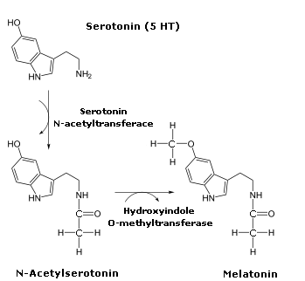

The synthesis of melatonin from serotonin

(http://www.ebay.com/itm/5-HTP-L-dopa-Vit-B6-Diet-Weight-Loss-Slimming-Fat-Pill-/250881670134)

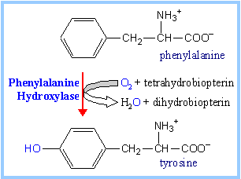
The amino acid tyrosine is the precursor to the hormones dopamine, norepinephrine, epinephrine, and thyroxine. Because our bodies can produce it, tyrosine, is a non-essential amino acid; it is synthesized from the essential amino acid phenylalanine. The synthesis of tyrosine involves a reaction between phenylalanine, the enzyme phenylalanine hydroxylase, the co-factor, or helper molecule, called tetrahydrobiopterin, and an oxygen molecule (see diagram at right). With the aid of the enzyme, tetrahydrobiopterin is oxidized, as one of the oxygen atoms of the oxygen molecule is reduced to water. The other oxygen atom from the oxygen molecule is incorporated into the tyrosine molecule as phenylalanine is hydroxylated (gains a hydroxyl group) to tyrosine.
Hydroxylation of phenylalanine to tyrosine

(https://www.rpi.edu/dept/bcbp/molbiochem/MBWeb/mb2/part1/aacarbon.htm)

Because of this hydroxyl group on the side chain of tyrosine, tyrosine is a polar molecule and can hydrogen-bond to water molecules. Thus, tyrosine is very water soluble.

The series of reactions in the diagram on the next page summarize the biosyntheses of the hormones dopamine, norepinephrine, and epinephrine. The synthesis of tyrosine from phenylalanine has been described in the previous paragraph.

The enzyme tyrosine oxidase reacts with tyrosine in an oxidation-reduction reaction to produce the amino acid L-dopa (levodopa). L-dopa differs from tyrosine by one hydroxyl group. A decarboxylase enzyme removes the carboxyl group from L-dopa to produce the hormone dopamine. Β-hydroxylase aids in the incorporation of a hydroxyl group on the second carbon atom to produce norepinephrine. A methyl-transferase adds a methyl group (–CH₃) to the amine group and produces epinephrine. So, the hormones dopamine, norepinephrine, and epinephrine are similar in structure and differ by one or two functional groups. These differences in structure result in differences in function.
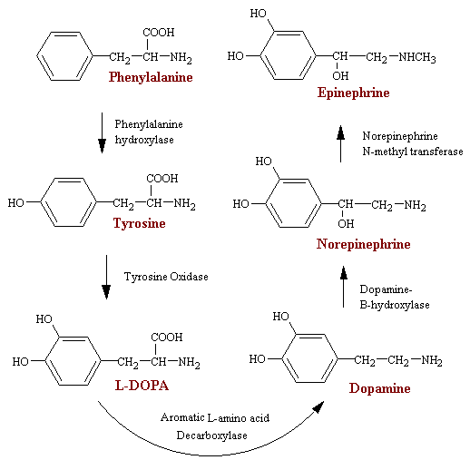

The biosynthesis of the hormones dopamine,
norepinephrine, and epinephrine from tyrosine

(http://faculty.weber.edu/ewalker/Medicinal_Chemistry/topics/Adrenergic/adrenerg.htm)

Thyroxine is a hormone produced by the thyroid gland. Molecular iodine from our diet is stored here and is oxidized to iodide ions (I–). These ions react with tyrosine to produce diiodotyrosine. Thyroxine is synthesized from a condensation reaction between two diiodotyrosine molecules by the removal of an alanine (CH₃CH(NH₂)COOH) molecule and is shown in the diagram below.
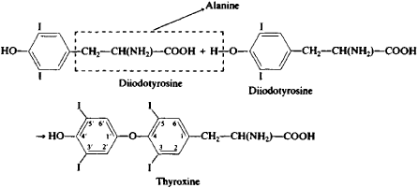

The condensation reaction between two diiodotyrosine molecules

(http://encyclopedia2.thefreedictionary.com/thyroxine)

Because thyroxine is not very water soluble, carrier proteins that are water soluble bind to thyroxine to transport it through the blood. To ensure optimal levels of thyroxine in the blood, a dynamic equilibrium exists between protein-bonded thyroxine and free thyroxine.

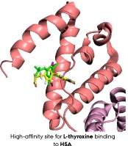
The image at right shows thyroxine bonded to the carrier protein called human serum albumin (HAS). The non-polar, or hydrophobic thyroxine molecule is embedded in the folds of the carrier protein. The carrier protein contains hydrophilic (having an affinity to water molecules) amino acids located on the outer portions of the globular protein, allowing for hydrogen bonding with water molecules.
High-affinity site for L-thyroxine binding to HSA

(http://www.sciencedirect.com/science/article/pii/S0304416516000027)

Peptide Hormones

Peptide hormones are relatively large molecules, compared to monoamine acid hormones and steroid hormones. These hormones are water soluble and insoluble in lipids. A large portion of hormones are peptide hormones, and a representative group is included in the table below.

Hormone | Produced by | Function
Glucagon | Pancreas | Increase blood glucose levels
Growth hormone | Pituitary Gland | Regulates growth and reproduction of cells
Insulin | Pancreas | Regulates glucose intake by cells
Thyroid stimulating hormone (TSH) | Pituitary Gland | Stimulates the thyroid to produce thyroxine
Vasopressin | Hypothalamus | Regulates body’s retention of water

A representative grouping of peptide hormones

Hormone signaling

Hormones can act on the same cells that produce them, on neighboring cells, or they can be secreted into the blood and transported to distant target cells. A target cell responds to a hormone because it has receptors for the hormone. Receptors are large, flexible protein molecules. The hormone-receptor mechanism can be compared to a lock and key mechanism where the receptor acts as the lock and the hormone acts as the key.

Water-soluble hormones cannot pass through the lipid layer of cell membranes and therefore affect target cells by binding to cell surface receptors. The diagram below shows the cascade of reactions that begins with the binding of a hormone to its specific receptor, which activates an enzyme within the cell membrane. This enzyme catalyzes the formation of cyclic adenosine monophosphate (cAMP). This molecule activates the enzyme protein kinase A. This enzyme phosphorylates (adds phosphates to) other proteins within the cell. Many of these proteins are enzymes that are either activated or supressed. These protein structural changes alter intracellular functions, such as changes in membrane permeability, changes in cellular metabolism, or stimulation of cellular secretions.

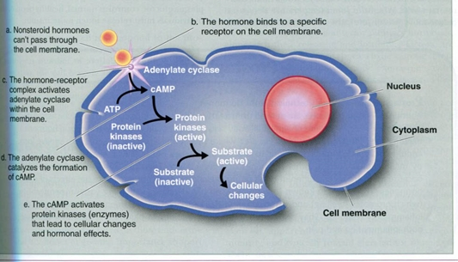

The mechanism of action for a water-soluble hormone

(http://completesoccertraining.blogspot.com/2012/05/hormones-in-human-body-general-info.html)

Steroid hormones and thyroxine are lipid-soluble and can pass through the cell membrane. The diagram below outlines the mechanism of lipid soluble hormones. The hormone-receptor binding occurs in the cytoplasm. The complex then passes into the nucleus and binds to part of the DNA. This results in certain genes being activated, which results in mRNA being produced. The mRNA then enters the cytoplasm where protein synthesis occurs. These new proteins may be enzymes or structural proteins.
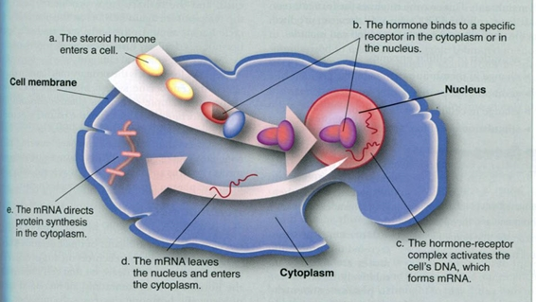

The mechanism of action for a lipid-soluble hormone

(http://completesoccertraining.blogspot.com/2012/05/hormones-in-human-body-general-info.html)

The endocrine system helps maintain a condition of balance or stability within the body. The body maintains this “dynamic equilibrium” (homeostasis) through a negative feedback mechanism, where a system acts to reverse a direction of change. The process of how the body maintains normal glucose levels in the blood will be used here to describe how this negative feedback mechanism works.

After we eat, there is a rise in blood glucose levels. This triggers the pancreas to produce more insulin, which is released into the blood. When the insulin reaches target cells, it binds with receptors within those cells to trigger glucose uptake, thus lowering glucose levels in the blood. The blood glucose levels then return to normal and this, in turn, decreases the secretion of insulin into the blood.

Stress and hormones

Stress is defined as any situation which tends to disturb the body’s dynamic equilibrium. Through its endocrine system, the body reacts to stress, whether it be physical or emotional, by adjusting levels of hormones to help the body adapt to new circumstances. This healthy response takes priority over all other metabolic functions and is not designed to last very long. Short term stress provides the stimulus to activate the hypothalamus at the base of the brain to send hormonal signals to other glands in the body to produce a “fight or flight” response. The adrenal glands respond by releasing epinephrine, norepinephrine and cortisol. Epinephrine increases heart rate, elevates blood pressure, dilates the bronchioles, increases blood flow to the skeletal muscles, and provides the body with extra energy by causing the breakdown of glycogen to glucose in the liver cells. Norepinephrine makes us more awake and more focused. By constricting the arteries in the skin, norepinephrine directs blood away from that tissue so that more blood is available to the other tissues of the body that need the additional blood flow. Cortisol increases glucose levels in the blood and decreases the production of insulin. This results in added energy for muscle cells. Cortisol also increases blood flow throughout the body by narrowing arteries and plays a role in tissue repair. But cortisol also suppresses immune system responses and the digestive system, and alters the growth process. Stress is meant to be short term and once the perceived threat has disappeared, hormone levels return to normal via a negative feedback system.

It is chronic stress that results in consistently high levels of the stress hormones that wreaks havoc on our bodies. Chronically elevated levels of cortisol result in lowered immune responses, fatigue, obesity, hypoglycemia, high blood pressure, heart disease, insomnia, mood swings, memory loss, concentration problems, and digestive problems.

During short-term stress, hormones are released that help the body fight off infection and respond quickly to injuries. Chronic stimulation of the immune system causes it to become suppressed, making it less effective in fighting off infections. The immune system also releases chemicals called cytokines that also help the body fight infection. Cytokine production is inhibited by the stress hormones. This is why highly stressed people are more prone to infections and colds. Chronic stress may also be responsible for autoimmune diseases, such as rheumatoid arthritis, lupus, and multiple sclerosis.

Stomachaches and diarrhea are also common symptoms of stress. The stress hormones slow the release of stomach acid and the emptying of the stomach, and they stimulate the colon, causing pain or diarrhea. Individuals under constant stress are more likely to develop Crohn’s disease, a constant inflammation of the large intestines.

Because cortisol is known to increase appetite and may encourage cravings for sugary or fatty foods, some individuals with chronically high levels of this stress hormone may become obese or develop diabetes. Chronic stress can also have the reverse effect—loss of appetite and weight loss, due to a strain on the adrenal glands that causes low levels of cortisol production.

The relationship between chronic stress hormones and heart disease is complicated. Stress hormones can cause high blood pressure, heart palpitations, sustained high levels of cholesterol, and heart attack. Along with an increase in stress hormones, chronic stress causes some people to cope by overeating, smoking, and consuming excess alcohol, all of which exasperate the conditions causes by chromic stress hormones.

The chart below summarizes the effects of chronic stress hormones on the body.

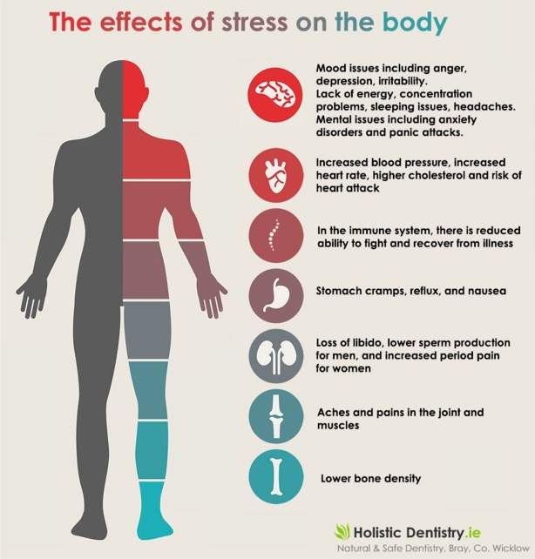

(http://www.agemanagementoptimalwellness.com/health-effects-stress-may-differ-men-women/)

The good news is that we can reduce the adverse effects produced by chronically high levels of stress hormones by using stress reduction techniques, keeping a strong social network, choosing sugar free, non-processed nutrient rich foods, exercising regularly, avoiding alcohol and caffeine, and getting proper rest.

“It’s not stress that kills us, it is our reaction to it.”
– Hans Selye, noted expert on stress

References
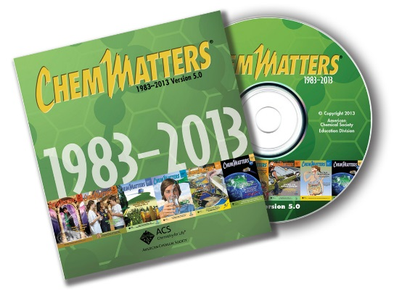
(non-Web-based information sources)
The references below can be found on the ChemMatters 30-year DVD, which includes all articles
published from the magazine’s inception in October 1983 through April 2013; all available Teacher’s Guides, beginning February 1990; and 12 ChemMatters videos. The DVD is available from the American Chemical Society for $42 (or $135 for a site/school license) at this site: http://ww.acs.org/chemmatters. Click on the “Teacher’s Guide” tab to the left, directly under the “ChemMatters Online" logo and, on the new page, click on “Get the past 30 Years of ChemMatters on DVD!” (the icon on the right of the screen).

Selected articles and the complete set of
Teacher’s Guides for all issues from the past three
years are available free online at the same Web site, above. Click on the “Issues” tab just below the logo, “ChemMatters Online”.
30 Years of ChemMatters !
Available Now!

This article discusses various hormones of the endocrine system. In particular, it discusses the sex hormone and relates form to function. (Tinnesand, M. Your Body Under Construction. ChemMatters, 2011, 29 (4), pp 14–16)

The Teacher’s Guide for the December 2011 article above provides additional information on the endocrine system and hormones, in particular the sex hormones, and their receptors.

This 2014 article discusses performance enhancement drugs such as anabolic steroids, which mimic the hormone testosterone. (Wendel, J. Performance Enhancement Drugs. Is Winning Everything? ChemMatters, 2014, 32 (3), pp 9–11)

There is useful information in this article about chiral molecules. The article defines chiral molecules, explains enantiomers, and discusses how chirality affects how these molecules function. (Warmflash, D. Left Life? Right Life? Chirality in Action. ChemMatters, 2015, 33 (2), pp 5–7)

Web Sites for Additional Information
(Web-based information sources)
Hormones

“Healthline” provides this site that describes the hypothalamus and the hormones produced by this gland. (http://www.healthline.com/human-body-maps/hypothalamus)

This site describes the hypothalamus, homeostasis, and the feedback mechanisms that maintain homeostasis. (http://www.braintheinsidestory.co.uk/hypothalamus-section/)

This concept review of amino acids, the precursors of hormones, describes their isomeric forms and polarity. (http://www.phschool.com/science/biology_place/biocoach/bioprop/landd.html)

This Web site describes the synthesis, transport, and endocrinology of thyroid hormones: http://people.upei.ca/bate/html/notesonthyroidfunction.html.

Receptors

This site includes information about hormone receptors: http://e.hormone.tulane.edu/learning/docking-receptor-binding.html.

Stress

This site discusses the role of CRH in chronic stress: https://breakingmuscle.com/learn/what-you-dont-know-about-crh-can-kill-you.

