

**December 2016/January 2017 Teacher's Guide**

**Background Information**

**for**

***No Smartphones, No TV, No Computers:***

***Life without Rare-Earth Metals***

**Table of Contents**

About the Guide 2

Background Information 3

References 19

Web Sites for Additional Information 20

# About the Guide

Teacher’s Guide team leader William Bleam and editors Pamela Diaz, Regis Goode, Diane Krone, Steve Long and Barbara Sitzman created the Teacher’s Guide article material.   
E-mail: [bbleam@verizon.net](mailto:bbleam@verizon.net)

Susan Cooper prepared the anticipation and reading guides.

Patrice Pages, *ChemMatters* editor, coordinated production and prepared the Microsoft Word and PDF versions of the Teacher’s Guide.

E-mail: [chemmatters@acs.org](mailto:chemmatters@acs.org)

Articles from past issues of *ChemMatters* and related Teacher’s Guides can be accessed from a DVD that is available from the American Chemical Society for $42. The DVD contains the entire 30-year publication of *ChemMatters* issues, from February 1983 to April 2013, along with all the related Teacher’s Guides since they were first created with the February 1990 issue of *ChemMatters*.

The DVD also includes Article, Title, and Keyword Indexes that cover all issues from February 1983 to April 2013. A search function (similar to a Google search of keywords) is also available on the DVD.

The *ChemMatters* DVD can be purchased by calling 1-800-227-5558. Purchase information can also be found online at <http://tinyurl.com/o37s9x2>.

# Background Information

**(teacher information)**

**The discovery of the rare-earth metals**

The story of rare-earth elements begins in 1787 with Lieutenant Karl Arrhenius picking up a black rock near Stockholm, Sweden from a quarry in the village of Ytterby. This mineral rock was named ytterbite (later called gadolinite), and from this mineral the first rare-earth element was isolated.

The first element discovered that is now identified as a rare-earth element was yttrium. It was isolated by Johan Gadolin in 1794 from a dense, black mineral called ytterbite (which was named for the nearby Swedish village of Ytterby). The second rare-earth element to be discovered was cerium in 1803 from the mineral cerite. Its discovery was almost a three-way tie between Jons Jacob Berzelius and Wilhelm Hisinger in Sweden and Martin Klaproth in Germany. This nearly simultaneous announcement of the discovery of a new element was the first of many disputes over credit for discovery of rare-earth and other elements. The process of chemically separating the rare-earth minerals into the individual elements was extremely difficult. However, between 1794 and 1901 all but two of the rare-earth metals had been identified. Both better technology and the development of the periodic table were pieces in the discovery of the rare-earth elements.

*(*[*https://www.acs.org/content/acs/en/education/whatischemistry/landmarks/earthelements/jcr:content/articleContent/columnsbootstrap/column1/image.scale.medium.jpg/1383682183871.jpg*](https://www.acs.org/content/acs/en/education/whatischemistry/landmarks/earthelements/jcr:content/articleContent/columnsbootstrap/column1/image.scale.medium.jpg/1383682183871.jpg)*)*

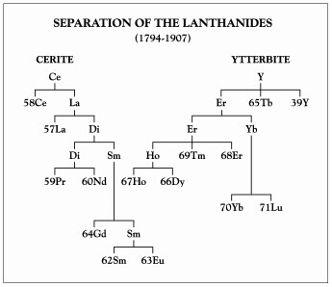

Several factors made their [rare-earth elements’] identification difficult: The chemical and physical properties of the different elements are quite similar; the elements were isolated as "earths" or oxides of the elements; and the methods of separation and purification depended on laborious fractional precipitation and crystallization techniques. Compounding the difficulties of separation were a lack of good methods for identification and assessment of purity and a lack of knowledge of the number of rare earth elements that existed.

The invention of the spectroscope by Kirchhoff and Bunsen in 1859 and the development of spectral analysis, along with the development of the periodic table by Mendeleev and Meyer in 1869, provided valuable tools for the study of rare earths. The impact of these advances is clear. In the 60 or so years before their introduction, only six rare earths had been identified, one of them erroneously. In the following 50 years, the number jumped to 15. However, problems remained. The rare earths severely challenged Mendeleev's periodic system, because he did not know where to place them in the table.

(<http://www.acs.org/content/acs/en/education/whatischemistry/landmarks/earthelements.html>)

[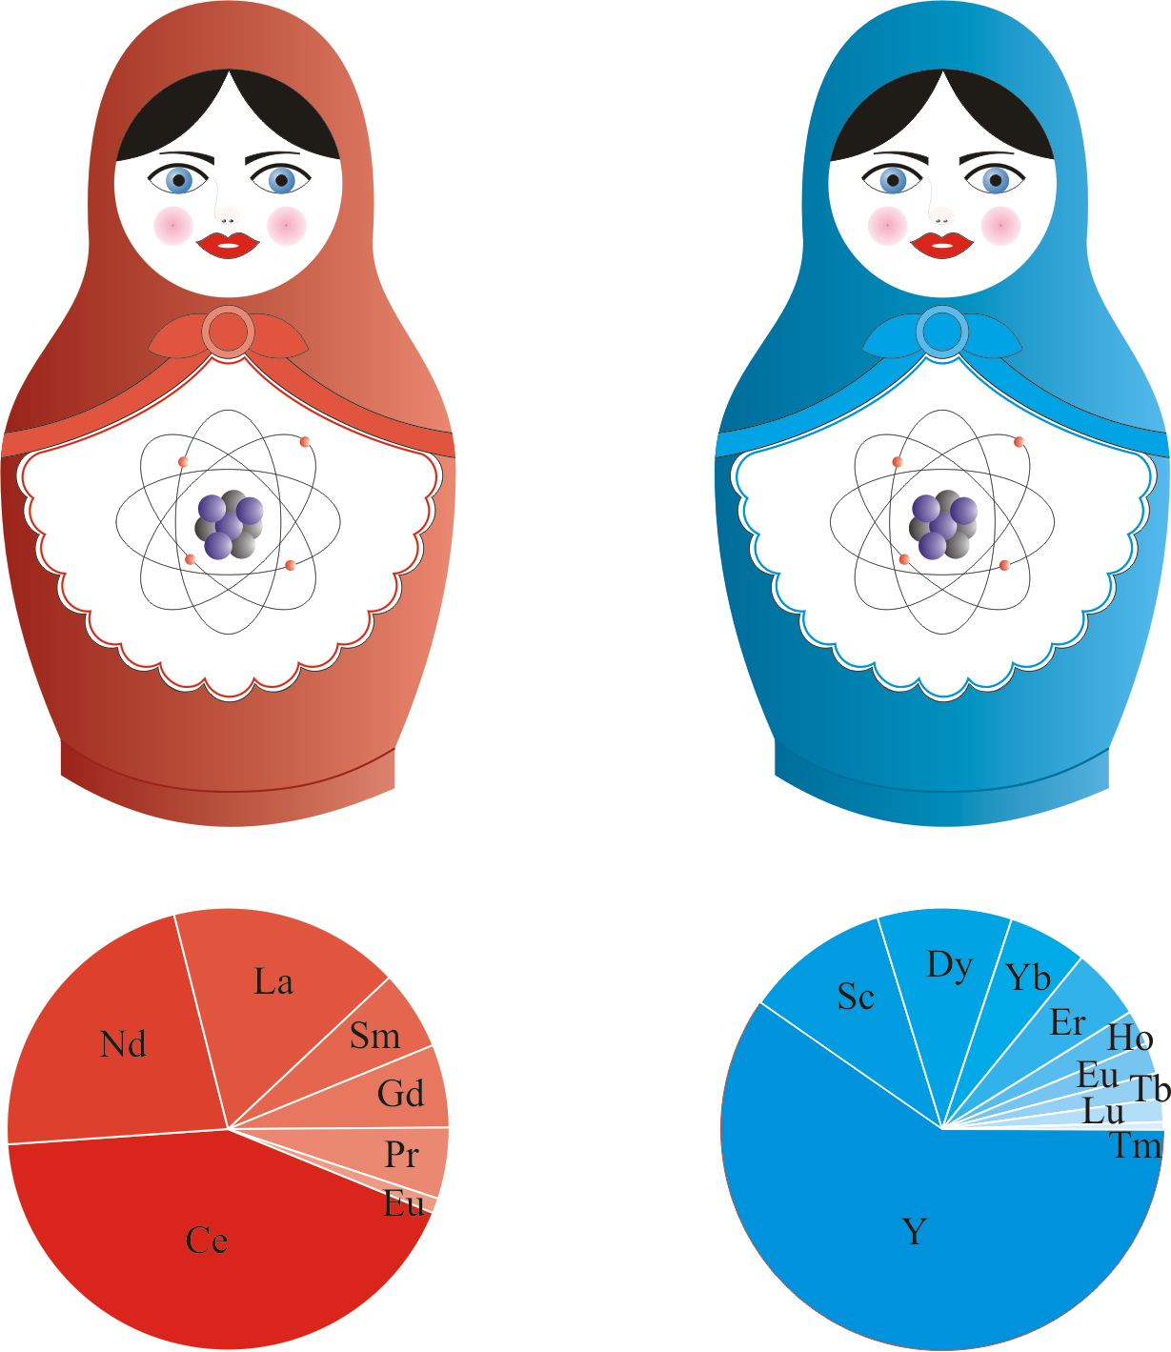](http://www.periodni.com/gallery/rare_earths_matryoshka.png)

*Rare-earth elements as a Russian nesting dolls (matryoshka or babushka dolls):   
red is 'ceria matryoshka' and blue is 'ittria matryoshka'.*

*Ceria is cerium oxide and yttria is yttrium oxide. Each of these compounds is found in ore that contains other rare-earth elements, which is what made it so difficult historically to separate and identify them.*

*(*[*http://www.periodni.com/history_of_rare_earth_elements.html*](http://www.periodni.com/history_of_rare_earth_elements.html)*)*

The work of Henry Moseley in 1912, with his understanding of the relationship between X-ray spectra and atomic number, and Mendeleev's periodic table published in 1869 were critical in determining the exact number of lanthanide elements and their eventual discovery.

The publication of the periodic law of the chemical elements by Mendeleev in 1869, although not of immediate help, pointed the way for the atomic theory of the "aufbau" of the elements spearheaded by Niels Bohr and other quantum theorists in the early 1910s. The prime contribution, however, was the experimental work of H.G.J. Moseley in 1912 on the relationship of the X-ray spectra to atomic number which finally showed exactly how many rare-earth elements should exist. Furthermore, the anomaly that 14 elements with properties similar to lanthanum existed proved to be an extremely important clue in developing our present theory of atomic structure.

(<https://www.ameslab.gov/sites/default/files/TwoHundredYearsRE_0.pdf>)

The last of the rare-earth elements to be discovered, promethium, was authenticated in 1947 using the new ion-exchange technology that had been developed during World War II for work on the atomic bomb. So, it required over 150 years to discover all of the rare-earth elements, due in part to their scarcity and similar properties.

**The origin of the names of the rare-earth elements**

The individual who is confirmed to be the discoverer of a new element has the right to name that element (with some guidelines and approvals). The sources for the element names can be interesting and curious. There are disputes, at times, over the source or reason for the name given to an element. Currently, the International Union of Pure and Applied Chemistry (IUPAC) has oversight on approval of names for newly discovered elements. (See “*Web Sites for Additional Information”* below for specific information on naming new elements.) Below are the commonly accepted origins behind the 17 silvery-colored, rare-earth element names.

* *Scandium (Sc):* named after Scandia, the Latin name for Scandinavia.
* *Yttrium (Y):* named after Ytterby, the village where this first rare-earth element was discovered.
* *Lanthanum (La):* named for the Greek word "lanthanein" which means "hidden".
* *Cerium (Ce):* named for the Roman goddess of agriculture, Ceres, and it is a dwarf planet or asteroid.
* *Praseodymium (Pr):* named from Greek "prasios" for "green" and "didymos" meaning "twin".
* *Neodymium (Nd):* named from Greek "neos" meaning "new" and "didymos" meaning "twin"
* *Promethium (Pm):* named after the Greek deity, Prometheus, who was a Titan and gave fire to men.
* *Samarium (Sm):* named for a mine official, Vasili Samarsky-Bykhovets, and from the mineral, samarskite.
* *Europium (Eu):* named for the continent of Europe.
* *Gadolinium (Gd):* named in honor of Johan Gadolin who identified the first rare-earth element
* *Terbium (Tb):* named after Ytterby, Sweden.
* *Dysprosium (Dy):* named from Greek "dysprositos" meaning "hard to get".
* *Holmium (Ho):* named after the Latin name for Stockholm, Holmia.
* *Erbium (Er):* another element named after the village of Ytterby, Sweden.
* *Thulium (Tm):* named for the mythological land of the north, Thule, which some believe may be Norway or the whole of Scandinavia.
* *Ytterbium (Yb):* another element named after Ytterby, Sweden.
* *Lutetium (Lu):* named for the Gallo-Roman city of Lutetia, which became Paris, France.

(<http://www.rsc.org/periodic-table/history>)

**How elements are formed**

The majority of the mass of the universe is composed of the elements hydrogen and helium. The hydrogen, composing most stars, begins to spin under the influence of gravity. The spinning and forces of gravity collapse the hydrogen into dense clumps of matter. When the temperature is high enough (15 million degrees Celsius) and the density is great enough, the mass of gas begins to glow. Ultimately, fusion occurs, with the hydrogen gas in the star becoming helium. This is the process occurring in our sun. As the resulting helium forms and compacts and the star collapses under gravity and spinning, the helium fuses into carbon. (<http://aether.lbl.gov/www/tour/elements/stellar/stellar_a.html>).

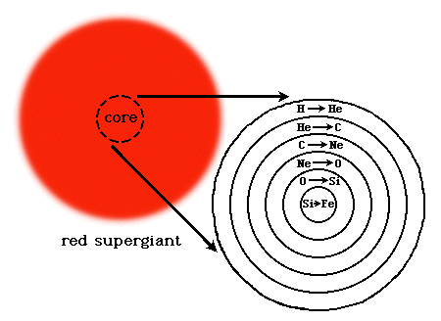

*Elements forming via stellar fusion*

*(*[*http://aether.lbl.gov/www/tour/elements/stellar/stellar_a.html*](http://aether.lbl.gov/www/tour/elements/stellar/stellar_a.html)*)*

With sufficient mass, gravity, and temperature, the carbon fuses into neon, neon into oxygen, oxygen to silicon, and silicon finally into iron. (This is a very involved process and greatly simplified here. See “Web Sites for Additional Information” for more detail.) When the iron in the core of the star concentrates sufficiently, the core contracts, the temperature increases, and the iron undergoes nuclear reactions different than those that formed the lighter elements. These tremendous forces give the iron nuclei extreme kinetic energies and the iron nuclei break apart, releasing high concentrations of neutrons (neutron flux). These neutrons can be captured by surrounding nuclei and undergo decay, releasing a proton, an electron, and an antineutrino (see diagram at right). Each time a nucleus acquires a decaying neutron, its atomic number increases by one making a new, heavier element.

*(*[*http://aether.lbl.gov/www/tour/elements/stellar/stellar_a.html*](http://aether.lbl.gov/www/tour/elements/stellar/stellar_a.html)*)*

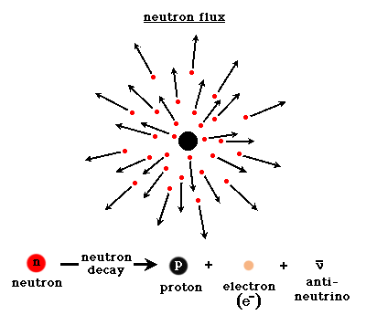

The elements with a mass higher than iron (all of the rare-earth elements except scandium) are created in this fashion and released into the universe as supernova explode. So, all elements, including the rare-earth elements, are the result of stellar fusion of the starting raw materials of hydrogen and helium. See

**What ARE rare-earth elements?**

The Haines article calls the rare-earth elements "chemical vitamins". The Japanese have been known to call them the "seeds of technology". The U.S. Department of Energy calls them "technology metals". So what are these silvery, strange-named elements? They consist of 17 metals, which include the 15 lanthanide elements plus scandium and yttrium. Scandium and yttrium are included as rare-earth elements because, although they are much lighter, they often occur in the same mineral deposits with the lanthanide elements, they have similar properties, and they are used in similar applications.

*Periodic Table—Rare-earth elements are those within red boxes.*

*(*[*http://www.rareelementresources.com/rare-earth-elements#.V-rYJWIVB3C*](http://www.rareelementresources.com/rare-earth-elements%23.V-rYJWIVB3C)*)*

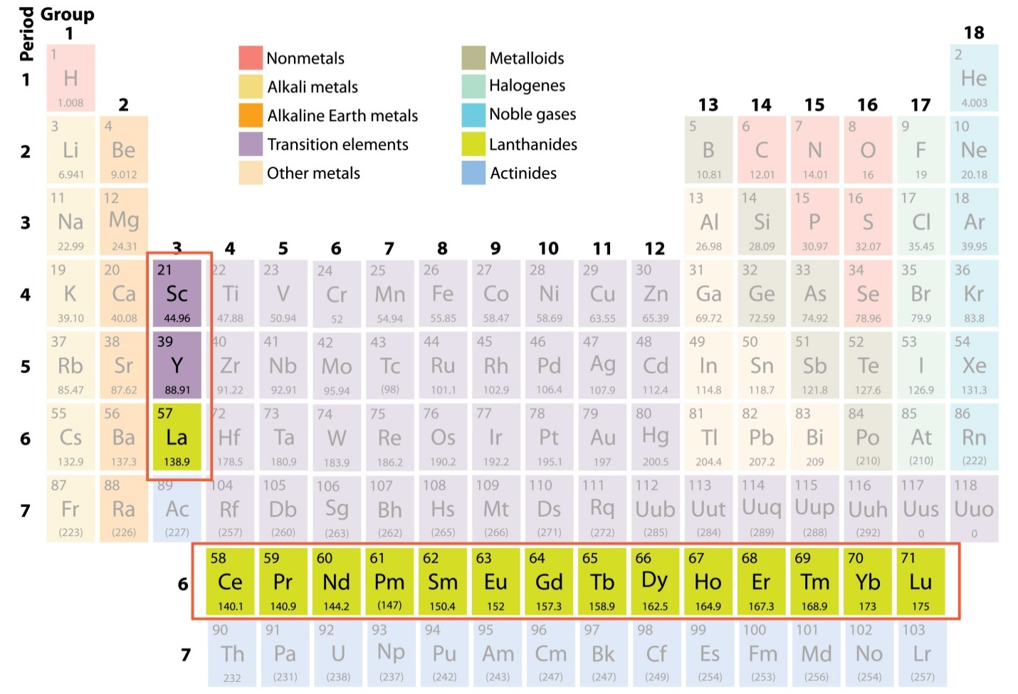

The rare-earth elements are sometimes grouped into the two categories of the light rare-earth elements (cerium, praseodymium, neodymium, promethium, and samarium) and the heavy rare-earth elements (yttrium, europium, gadolinium, terbium, dysprosium, holmium, erbium, thulium, ytterbium, and lutetium). Scandium and yttrium are classified by some sources as heavy rare-earth elements even though they are lighter than lanthanum because their use is similar to the heavier rare-earth elements. The heavy rare-earth elements are more scarce and, therefore, more expensive.

The rare-earth elements are used for a variety of products in the U.S. The rapid growth in popularity of cell phones and smartphones in the past 10–20 years has produced a huge demand for rare-earth elements for computer chips, rechargeable batteries, magnets, and phone vibrators. In addition, these rare-earth elements are being used in alternative energy products such as wind-turbine generators and hybrid cars, typically for the strong permanent magnets that these devices require.

**Alloys**

Alloys are mixtures of two or more metals (e.g., copper and tin = bronze) or a metal with another element (e.g., iron and carbon = carbon steel). There are two common types of alloys: substitutional (solution) and interstitial. Of course, there can also be combinations of these types. In a substitutional alloy, the atomic radii of the two metals must be similar in size, varying no more than about 10–15%. In addition, the materials must have similar chemical bonding properties. An analogy of a substitutional alloy might be replacing a few ping pong balls in a box with a similar number of golf balls. Common examples of substitutional alloys include gold-silver alloys forming colored or crown gold, and copper-zinc alloys forming brass. The transition metals (*d*-block) are similar in size and chemistry and can form a variety of alloys with each other. These types of alloys are homogeneous and can also referred to as substitutional (solution) alloys.

*Diagrams of different types of alloys*

*(*[*https://upload.wikimedia.org/wikipedia/commons/thumb/5/5a/Alloy_atomic_arrangements_showing_the_different_types.jpg/1024px-Alloy_atomic_arrangements_showing_the_different_types.jpg*](https://upload.wikimedia.org/wikipedia/commons/thumb/5/5a/Alloy_atomic_arrangements_showing_the_different_types.jpg/1024px-Alloy_atomic_arrangements_showing_the_different_types.jpg)*)*

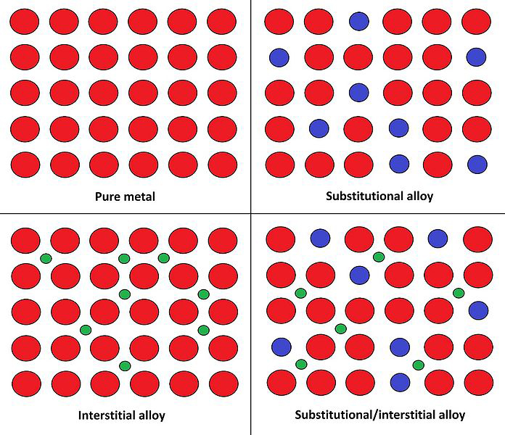

Interstitial (between the spaces) alloys are formed by elements with atoms of different sizes, so that atoms of one element take up the open spaces between the atoms of the second element. Analogies to interstitial alloys would be grains of sand stuck between ball bearings causing the ball bearings to lock up, or marbles filling the spaces between oranges in a box. An example of an interstitial alloy is carbon steel where the much smaller carbon atoms fill the spaces between the iron atoms giving the iron more strength. There are many different alloy compositions for steel, depending on the desired use for the steel. Some types are alloyed for strength and others may be alloyed to reduce oxidation (rusting).

Rare-earth elements are often used to alloy with other metals to produce desired properties. One example is didymium. "Didymium is a mixture of the [rare-earth elements praseodymium](http://chemistry.about.com/od/periodictableelements/ig/Element-Photo-Gallery.--98/Praseodymium.htm) and neodymium and sometimes other rare-earths. The term comes from the Greek word didymus, meaning twin, with the -ium ending. The word sounds [like an element name](http://chemistry.about.com/od/elementfaqs/f/elementnamed.htm) because at one time didymium was considered to be an element. In fact, it appears [on Mendeleev's original periodic table](http://chemistry.about.com/od/imagesclipartstructures/ig/Science-Pictures/Mendeleev-s-Periodic-Table.-0EA.htm)."

(<http://chemistry.about.com/od/metalsalloys/fl/Didymium-Facts-and-Uses.htm>)



*Glassblowers’ safety glasses tinted with didymium*

*(*[*http://sundanceglass.com/didymium-green-ACE-IR-92-lampworker-glassblowing-safety-glasses-aura-phillips/Titanium-202-Lg.jpg*](http://sundanceglass.com/didymium-green-ACE-IR-92-lampworker-glassblowing-safety-glasses-aura-phillips/Titanium-202-Lg.jpg)*)*

Carl Mosander discovered didymium in 1843, believing it to be a new element. The great difficulty in chemically separating didymium into its component elements, and the similar properties of praseodymium and neodymium both further compounded the difficulty in misidentifying didymium as an element and its ultimate separation into two new elements. Didymium is used in safety glass for glassblowers and blacksmiths to filter out the yellow light emitted by the sodium atoms found in common glass and also found in iron as a contaminant. Didymium is also used as a camera filter to reduce yellow/orange colors in photographs.

Another rare-earth alloy is mischmetal (from German meaning mixed metal), which is composed of about 50% cerium, 25% lanthanum, 15% neodymium and/or praseodymium, and 10% other metals including iron for hardness. Mischmetal with iron is the flint (sparker) used in many cigarette lighters, Bunsen burner lighters, etc. It is also the material found in survivor kits used to start fires in the wilderness.

One of the most common alloys that people use is steel. Iron is mixed with a variety of other elements, and in varying concentrations of these added elements, to produce an array of unique alloys. When iron is alloyed with the rare-earth element cerium, it forms an alloy that is used in flint (sparker) lighters. The ferrocerium alloy produces a bright, hot spark when it is rubbed against a harder substance than itself, like carbon steel—another alloy of iron. Another form of flint lighter sparkers uses iron and lanthanum. However, people will be most familiar with iron in its alloy forms of low-carbon steel, high-carbon steel, cast iron, stainless steel, spring steel, weathering steel, chromoly steel, and Damascus steel.

The table below shows various elements that are alloyed with iron to make different types of steel. It also shows the effects of alloying these elements with iron.

*Elements used in alloys of steel to change its properties*

*(*[*https://www.learner.org/courses/chemistry/images/text_img/SteelAlloyingAgents.jpg*](https://www.learner.org/courses/chemistry/images/text_img/SteelAlloyingAgents.jpg)*)*

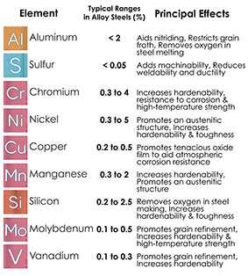

An aluminum-cerium alloy shows promise of better automobile engines and improved fuel economy. Currently, cerium makes up about 50% of all of the rare-earth ores that are mined, and there is too much cerium produced for the need. By combining a small portion of cerium with aluminum, the alloy has better high-temperature stability and improved casting properties "The aluminum industry is huge,” Rios [Orlando Rios, Oak Ridge National Laboratory scientist] explained. “A lot of aluminum is used in the auto industry, so even a very small implementation into that market would use an enormous amount of cerium.” A 1 percent penetration into the market for aluminum alloys would translate to 3,000 tons of cerium, he added." (<https://www.ornl.gov/news/new-alloy-promises-boost-rare-earth-production-while-improving-energy-efficiency-engines>).

*Aluminum-cerium alloyed engine part*

*(*[*https://www.ornl.gov/sites/default/files/styles/node_slideshow/public/Cerium%20alloy%20-%20engine%20head.jpg?itok=Md66dDiM*](https://www.ornl.gov/sites/default/files/styles/node_slideshow/public/Cerium%20alloy%20-%20engine%20head.jpg?itok=Md66dDiM)*)*

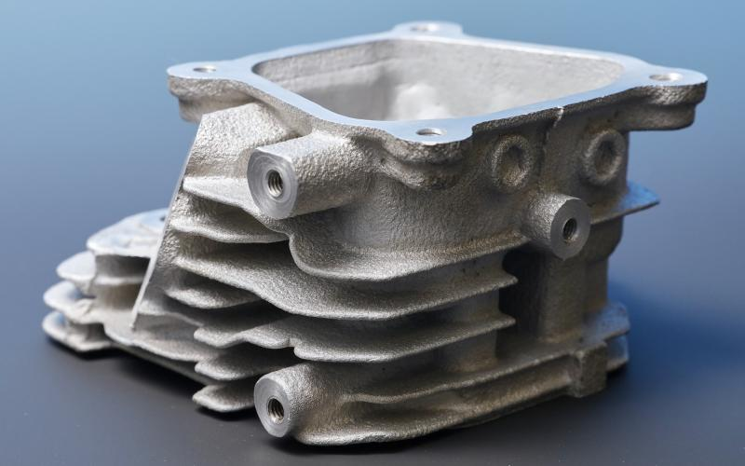

Other aluminum alloys involve the addition of erbium which creates an alloy with finer grain structure, greater hardness, and unchanged plasticity. Similar results can be achieved with lanthanum, cerium, neodymium, yttrium, gadolinium, and scandium.

One of the most common alloys with rare-earth elements involves super magnets. The addition of neodymium to iron and boron forms one of the strongest, affordable permanent magnets. The chemical formula for a common form of this magnet is Nd2Fe14B. This magnet is sometimes referred to as the NdFeB, NIB, or Neo magnet. This formulation was discovered in 1982 by General Motors and Sumitomo Special Metals as an alternate to the more expensive and weaker samarium-cobalt permanent magnets.

All of the lanthanide elements are ferromagnetic; however, their Curie temperatures are very low. The Curie temperature (point) is the temperature at which a material loses its permanent magnetic properties, and they are replaced by induced magnetic properties. The addition of neodymium or other lanthanide elements to iron, cobalt, or nickel can form permanent magnets with Curie points at temperatures above room conditions. Another feature of the rare-earth elements is that they magnetize easily in one direction, but do not magnetize easily in the other direction. These very strong magnets are used in electric motors in cordless tools, computer hard disk drives, jewelry clasps, and alternative energy applications.

Rare-earth magnets can be dangerous, especially for small children. If the magnets are swallowed, the small magnets can pinch parts of the intestine or stomach together, resulting in severe bowel problems.

Recent anecdotal reports have shown that magnet ingestions have led to dozens of surgeries, bowel perforations or fistulas, endoscopies, bowel resections, and other serious gastrointestinal injuries as a result of young children swallowing magnets and adolescents unintentionally swallowing them after using magnets as a fake tongue piercing. Ingested magnets can stick together and trap and compress portions of the bowel wall between them, potentially leading to perforation, ischemia, sepsis, and bowel obstructions. Because of the severe health consequences of ingesting these dangerous products it is necessary to educate children, adolescents, and their parents about the imperative to keep small magnets out of hands and mouths.

(<https://www.aap.org/en-us/advocacy-and-policy/federal-advocacy/Pages/AAP-Alerts-Pediatricians-to-Dangers-of-Magnet-Ingestions.aspx?nfstatus=401&nftoken=00000000-0000-0000-0000-000000000000&nfstatusdescription=ERROR:+No+local+token>)

*A lattice of rare-earth magnets*

*(*[*https://www.aap.org/en-us/advocacy-and-policy/federal-advocacy/Pages/AAP-Alerts-Pediatricians-to-Dangers-of-Magnet-Ingestions.aspx?nfstatus=401&nftoken=00000000-0000-0000-0000-000000000000&nfstatusdescription=ERROR:+No+local+token*](https://www.aap.org/en-us/advocacy-and-policy/federal-advocacy/Pages/AAP-Alerts-Pediatricians-to-Dangers-of-Magnet-Ingestions.aspx?nfstatus=401&nftoken=00000000-0000-0000-0000-000000000000&nfstatusdescription=ERROR:+No+local+token)*)*

If body parts like fingers or ears become pinched between two magnets or a magnet and a magnetic surface, they can injure children. Or, if the powerful magnets are allowed to get too close together they can attract and smash together with enough force to splinter and break apart sending sharp metallic pieces flying. (<https://en.wikipedia.org/wiki/Rare-earth_magnet>)

**Mining rare-earth elements**

While rare-earth elements are distributed around the world, most are mined in China, due to favorable environmental laws and wages. China produces more than 95% of all rare-earth metals used in the world. In addition, China has the greatest ability to process these rare-earth materials, so product manufacturers often locate manufacturing plants in China to better utilize the rare-earth metals in their products. China can control companies and countries by limiting supplies of rare-earth metals to them or controlling exports. In particular, China produces 99% of the dysprosium and 95% of the neodymium used in the world. The electric motors in a Toyota Prius each use about three pounds of neodymium. ([http://www.forbes.com/sites/larrybell/2012/04/15/chinas-rare-earth-metals-monopoly-neednt-put-an-electronics-stranglehold-on-america/#44bdf2ac161b](http://www.forbes.com/sites/larrybell/2012/04/15/chinas-rare-earth-metals-monopoly-neednt-put-an-electronics-stranglehold-on-america/%2344bdf2ac161b))

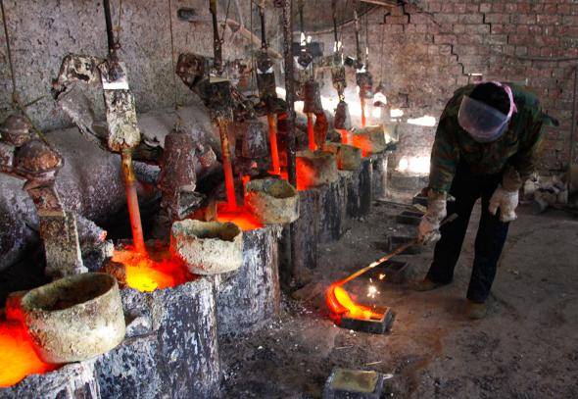

*Chinese rare-earth mine operation*

*(*[*http://www.hcn.org/issues/47.11/why-rare-earth-mining-in-the-west-is-a-bust*](http://www.hcn.org/issues/47.11/why-rare-earth-mining-in-the-west-is-a-bust)*)*

*Pouring lanthanum into a mold near  
Damao in Inner Mongolia*

*(*[*https://www.theguardian.com/sustainable-business/rare-earth-mining-china-social-environmental-costs*](https://www.theguardian.com/sustainable-business/rare-earth-mining-china-social-environmental-costs)*)*

The only commercial U.S. rare-earth metals mine, Molycorp's Mountain Pass, near the California-Nevada border is not operating. While the western half of the U.S. has deposits of the rare-earth metals, it is not economical to mine ore, extract the metals from the ore, and sell at a profit. The Mountain Pass site was discovered in 1949 while exploring the area for uranium.

Geologists sent a curious rock to the U.S. Geological Survey for analysis and the sample contained low concentrations of both uranium and thorium. However, it was extremely rich in rare-earth metals. A small part of the site had ore concentrations up to 40%, and a larger ore site that was easily accessible had a concentration of rare-earth metals of about 8%. By comparison, copper is economically mined at concentrations of only 0.6%. But, there were no demands for rare-earth metals in 1949. In the 1960s, color televisions became popular and the element europium was used to produce the bright red colors. For the next 40 years, Mountain Pass mine was busy producing europium and other rare-earth metals that were slowly finding uses in lasers, fluorescent lights, and microchips. But in the early 1990s, problems from wastewater spills caused environmental contamination in the Mojave National Preserve where the mine was located, and both federal and state agencies started lawsuits against Molycorp.

At about the same time as Molycorp was struggling with its environmental problems, China began its national movement to develop and produce its vast rare-earth resources. Mountain Pass mine was a problem, both environmentally and economically. So, in 1998, Molycorp shut down the Mountain Pass processing facility due to the costs of environmental cleanup and the competition from cheaper metals now coming from China. However, the excavation and mining operation continued until it, too, shut down in 2002. But with surging demands, rising prices, and political posturing between China and Japan, Mountain Pass mine reopened to process ore in 2010, with the input of Japanese capital to upgrade the facility. In 2014 the mine produced 4,700 tons of rare-earth metals. Sadly, Mountain Pass mine could not compete with the Australian Mount Weld mine and China's higher volume and lower cost of rare-earth metals from its numerous mines. Mountain Pass mine is not operational today.

[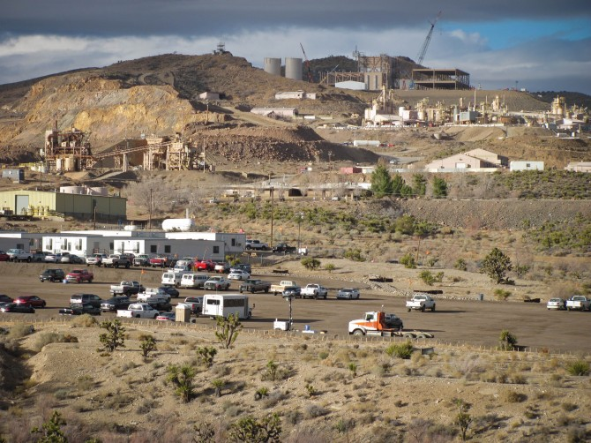](http://ifixit.org/files/2012/01/IMG_0553.jpg)

*Mountain Pass mine in California*

*(*[*http://www.theatlantic.com/technology/archive/2012/02/a-visit-to-the-only-american-mine-for-rare-earth-metals/253372/*](http://www.theatlantic.com/technology/archive/2012/02/a-visit-to-the-only-american-mine-for-rare-earth-metals/253372/))

Some of the problems with rare-earth mining are the waste tailings (some radioactive), water pollution (both surface and ground), and air pollution from all of the dust. The environmental hazards are expensive to mitigate when done correctly. This is one reason that China has such an economic advantage on rare-earth ore extraction and metal processing. Many of the mines there are open pit mines which can be environmentally damaging because of the huge quantities of ore that must be dug, hauled, processed, and the enormous volume of tailings that are dumped. The process of extracting the metals from their ore requires large amounts of electricity, water, and some hazardous chemicals (fluorine gas, sulfur dioxide, hydrochloric acid, sulfuric acid, sodium hydroxide, nitric acid, ammonium hydroxide, and a variety of organic compounds) are used or released in the processing.

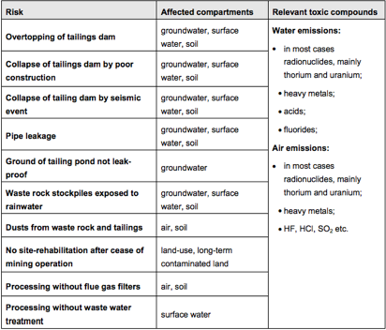

*Chart of common risks from general mining and refining*

*(*[*http://web.mit.edu/12.000/www/m2016/finalwebsite/problems/mining.html*](http://web.mit.edu/12.000/www/m2016/finalwebsite/problems/mining.html)*)*

There are approximately 60 rare-earth deposits (mines) around the world in development or production. The demand for rare-earth metals world-wide is about 150,000 tons annually. China supplies about 95,000 tons, and Chinese wildcatters (black-market miners) supply about 40,000 tons, so the 4,700 tons that Mountain Pass produced at its peak is small in comparison. (<http://www.hcn.org/issues/47.11/why-rare-earth-mining-in-the-west-is-a-bust>)

There are potential sites across the U.S., especially in the western half, where rare-earth metals could be mined if the prices of these metals increases, and if effective, economical methods of controlling the environmental wastes can be found. Clicking on the link below the map, below, allows you to enlarge the map view to see more detail.

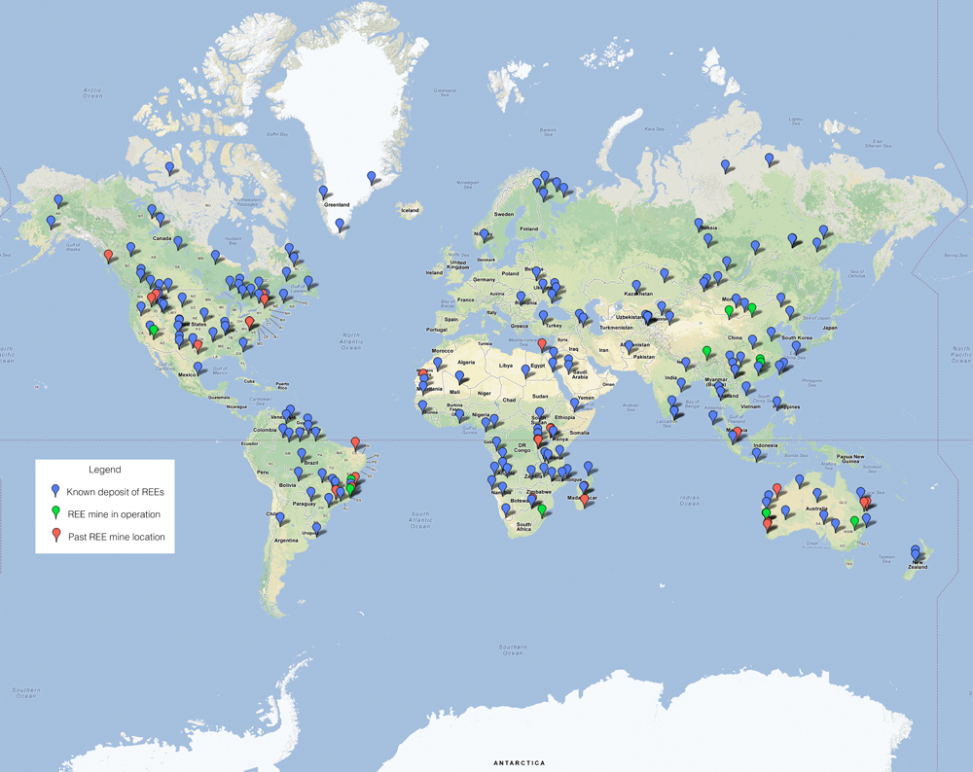

*World map showing locations of rare-earth elements   
(REE) deposits, and past and present mining operations (ca 2002)*

*(*[*http://web.mit.edu/12.000/www/m2016/finalwebsite/solutions/assets/deposits-1.jpg*](http://web.mit.edu/12.000/www/m2016/finalwebsite/solutions/assets/deposits-1.jpg)*)*

The map that follows is more recent (2011), showing sites that are being mined, or are under development, around the world. The mines are ranked by number according to the amount of production. As you can see from the map, three of the five top-producing mines are located in China.

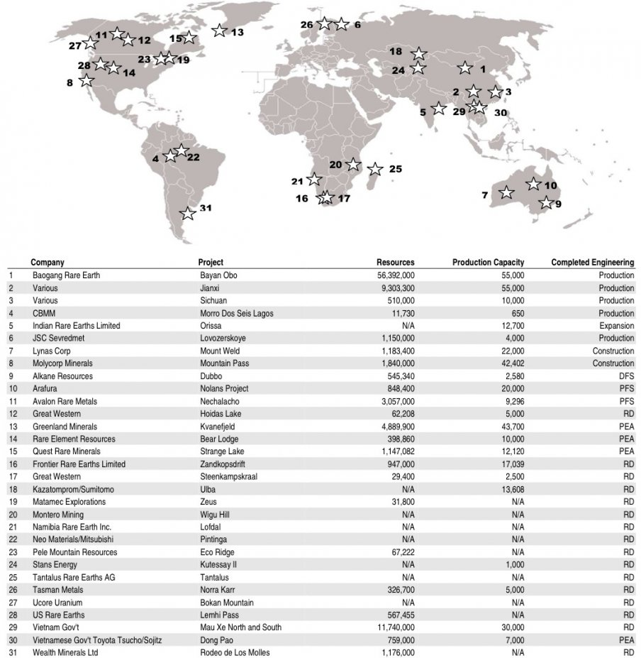

*(*[*http://www.businessinsider.com/map-of-the-day-rare-earths-projects-2011-3*](http://www.businessinsider.com/map-of-the-day-rare-earths-projects-2011-3)*)*

**Luminescence and color theory**

"**Luminescence** is the generic term for the emission of light which is not an effect of high temperature. So luminescence can be determined as an appearance of cold body radiation. This radiation can either be part of a chemical reaction or a cause of subatomic motions or stress on a crystal." (<http://www.leica-microsystems.com/science-lab/basic-principles-of-luminescence/>)

In the context of the Haines article, the luminescence occurs when ground state electrons in the rare-earth compounds have been excited (thereby moving to higher orbitals) by electricity, and then move from those higher orbitals back to lower orbitals with the release of energy as visible light. This phenomenon is also known as an atomic emission. This luminescence (atomic emission) is the general mechanism of producing the colors on a television, smartphone, or other display screen. The color of light emitted is directly related to the size of the orbital energy change. The warm colors (red end of the spectrum) are produced from smaller energy changes, and the cool colors (blue end of the spectrum) are produced from larger energy changes. The image for the hydrogen emission is shown below, as an example of the colors that can be produced by smaller or larger energy changes.

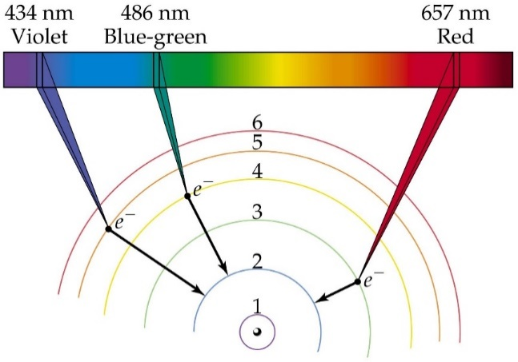

*Light emission (luminescence) from hydrogen atom electron energy-level jumps*

*(*[*https://bradleystockwell.files.wordpress.com/2015/02/fg09_12.jpg*](https://bradleystockwell.files.wordpress.com/2015/02/fg09_12.jpg)

In order to produce the thousands of colors that appear on display screens, the primary colors of red, green, and blue are added together to produce secondary colors, and white is produced by the use of phosphors or dyes.

The latest high-brightness (HB) white LEDs are made possible by the discovery of semiconductor materials that produce blue or ultraviolet photons. In addition to the diode, an HB package contains “yellow” phosphors on the inside of its lens. Some “blue” photons escape, but others excite the phosphors, which then give off “yellow” photons. The result can be tuned in manufacturing to produce “white” light.

(<http://electronicdesign.com/components/understanding-led-application-theory-and-practice>)

 This additive color theory allows wavelengths of the primary colors of red, blue, and green to be added together to form the wavelength (color) of the desired light. The intensity of each primary color, plus the actual primary colors that are added, create the vast array of colors displayed on television screens, smartphones, and other display devices. The process is complex and involves the use of polarizing filters, liquid crystals, fluorescent or LED backlights (more modern TVs use LEDs), and pixels. The pixels are tiny blocks which contain the primary red, green, and blue light which can be rapidly be switched on or off in various combinations.

For more details see “Web Sites for Additional Information” sites on LEDs, luminescence, and light.

*Additive color theory   
to form secondary colors   
from red, green, and blue light*

*(*[*https://upload.wikimedia.org/wikipedia/commons/thumb/c/c2/AdditiveColor.svg/400px-AdditiveColor.svg.png*](https://upload.wikimedia.org/wikipedia/commons/thumb/c/c2/AdditiveColor.svg/400px-AdditiveColor.svg.png)*)*

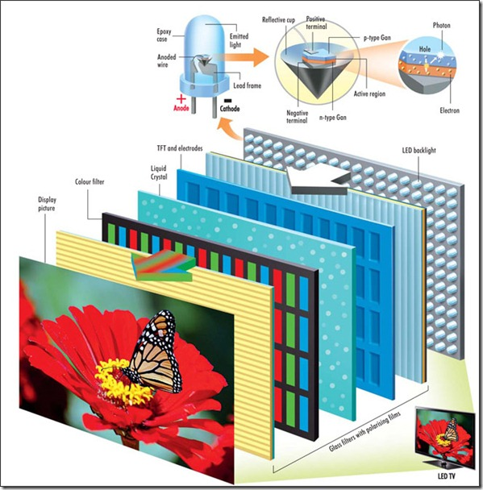

*Image of how LED TV works*

*(*[*http://www.guidingtech.com/assets/postimages/2014/02/how-led-tv-works.jpg*](http://www.guidingtech.com/assets/postimages/2014/02/how-led-tv-works.jpg)*)*

**Uses of rare-earth elements**

The Haines article identifies many uses for rare-earth elements and compounds. Rare-earth materials are used in LED and fluorescent lighting devices, glass grinding and polishing compounds, colorants for glass and ceramics, chemical catalysts, batteries, pollution control, lasers, fiber-optic data amplifiers, metal alloys, powerful magnets, display screens, cancer treatment drugs, electric motors, nuclear reactor shields, fuel cells, hard disk drives, superconductors, petroleum refining, microphones, TV screens, genetic tests, MRIs, CAT scans, PET imaging, X-rays, portable X-rays, cochlear implants, ear buds and in-ear headphones, sonar, guided missile systems, mole and tattoo removal, and cell phone camera lenses. Many of the technological devices that make lives richer and easier are dependent upon these rare-earth compounds.



*Photograph of a hard drive from a personal computer showing   
(A) a spindle motor and (B) a voice coil that contain rare-earth magnets*

*(*[*http://pubs.usgs.gov/of/2013/1072/OFR2013-1072.pdf*](http://pubs.usgs.gov/of/2013/1072/OFR2013-1072.pdf)*)*

Many people fail to realize the importance of the rare-earth metals. People may have heard about rare-earths, but they do not understand the extent of their use in so many everyday products.

Rare-earth elements [REE] are necessary components of more than 200 products across a wide range of applications, especially high-tech consumer products, such as cellular telephones, computer hard drives, electric and hybrid vehicles, and flat-screen monitors and televisions. Significant defense applications include electronic displays, guidance systems, lasers, and radar and sonar systems.

*(*[*http://geology.com/articles/rare-earth-elements/*](http://geology.com/articles/rare-earth-elements/)*)*

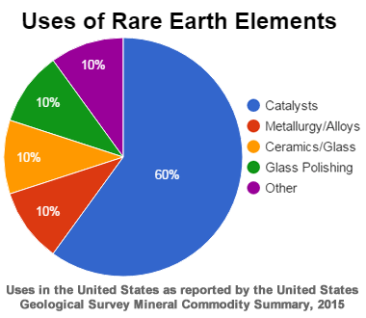

Although the amount of REE used in a product may not be a significant part of that product by weight, value, or volume, the REE can be necessary for the device to function. For example, magnets made of REE often represent only a small fraction of the total weight, but without them, the spindle motors and voice coils of desktops and laptops would not be possible.

(<https://www2.usgs.gov/blogs/features/usgs_top_story/going-critical-being-strategic-with-our-mineral-resources/>)

The largest use (by quantity) for rare-earth compounds is for catalysts. These rare-earth metals can be found in small quantities in automotive catalytic converters where they protect some of the more expensive metal catalysts like platinum and palladium. From the 1950s until about 2000, large quantities of cerium oxide was used in glass and lapidary polishes; however, the cerium oxide is being replaced today with other polishes due to increasing costs and other uses for cerium oxide.

One of the largest uses of lanthanum is in nickel-metal hybrid battery. The popular Toyota Prius contains 33 pounds of lanthanum and two pounds of neodymium in the engine and batteries. Supplies of lanthanum may ultimately limit the availability of hybrid and electric cars, so many automotive companies are trying to secure supplies of lanthanum or investigating other battery types such as lithium-ion (<http://www.mining.com/rare-earth-metals-and-hybrid-cars/>).

Most of the samarium that is mined is used to alloy with aluminum in aerospace applications. However, it is also widely used in aluminum sports equipment such as baseball bats, lacrosse sticks, bicycle frames, and some revolver parts.

One source (<http://geology.com/articles/rare-earth-elements/>) states that the majority of scandium used in the U.S. is for making aluminum-scandium alloys for baseball bats. The addition of as little as 0.2–0.6% by weight of scandium to aluminum produces dramatic strengthening effects. This strength is largely due to small and consistent grain size produced by the alloy. This inhibits metal fatigue and cracking, and improves welded joints. (<http://www.dunand.northwestern.edu/refs/files/JOM-0302-35.pdf>)

While there are many alloys used for baseball bats ([http://www.aluminumbats.com/whatsinanaluminumbatanyway.aspx#.WBVOj2IzV3A](http://www.aluminumbats.com/whatsinanaluminumbatanyway.aspx%23.WBVOj2IzV3A)), the aluminum-scandium alloy is the most popular.



*Aluminum-scandium alloy baseball bat*

*(*[*http://geology.com/articles/rare-earth-elements/*](http://geology.com/articles/rare-earth-elements/)*)*

Various aluminum alloy bats were also introduced in the 1990s. The most successful of these was the scandium-aluminum bat. Scandium is a mineral that, when alloyed with aluminum, greatly increases the strength and resilience of the aluminum without adding to the weight. Scandium occurs in minute quantities in more than 800 minerals, and is usually obtained as a byproduct of refining uranium. Today, most high-quality metal bats are made from scandium-aluminum alloy.

(<http://minerals.usgs.gov/minerals/pubs/general_interest/sport_mins/baseball.pdf>)

The U.S. Defense Department depends on rare-earth metals for many strategic uses. These special elements give the military an important advantage in peace and combat over other countries and groups. On occasion, a different material can (or must) be substituted for a rare-earth element, but the results are often inferior. The table below summarizes some of the military application of the rare-earth elements.

|  |  |
| --- | --- |
| **Defense Uses of Rare Earth Elements** | |
| Lanthanum | night-vision goggles |
| Neodymium | laser range-finders, guidance systems, communications |
| Europium | fluorescents and phosphors in lamps and monitors |
| Erbium | amplifiers in fiber-optic data transmission |
| Samarium | permanent magnets that are stable at high temperatures |
| Samarium | precision-guided weapons |
| Samarium | "white noise" production in stealth technology |

*(*[*http://geology.com/articles/rare-earth-elements/*](http://geology.com/articles/rare-earth-elements/)*)*

A table of more uses for rare-earth elements listed by element is available at <http://pubs.usgs.gov/of/2013/1072/OFR2013-1072.pdf>.

**China and rare-earth metals**

The United States is a major consumer of rare-earth materials and products. Currently, the U.S. has no commercial mining operations to supply the rare-earth materials needed for consumer and military uses. Therefore, the U.S. must import vast quantities of rare-earth materials. Currently, China supplies approximately 95% of the rare-earth compounds or products used in the U.S. This quantity is declining as other countries open mines or increase production from existing mines. China's plan to restrict exports of rare-earth materials has caused countries and large companies to find solutions to China's monopoly. The U.S. military believes that it is in good shape, other than for yttrium, and the U.S. has some natural reserves of this element. Japan is maintaining stockpiles of several rare-earth metals. South Korea is also stockpiling rare-earth metals. Sweden and Germany are investigating avenues for access to the rare-earth elements they need. ([http://www.forbes.com/sites/larrybell/2012/04/15/chinas-rare-earth-metals-monopoly-neednt-put-an-electronics-stranglehold-on-america/#ca1212a161b0](http://www.forbes.com/sites/larrybell/2012/04/15/chinas-rare-earth-metals-monopoly-neednt-put-an-electronics-stranglehold-on-america/%23ca1212a161b0))

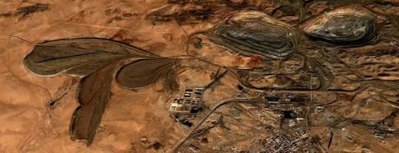

*Satellite view of China's Baotou rare-earths complex. Mines are at top right; waste lakes are at left.*

*(*[*http://www.mnn.com/earth-matters/translating-uncle-sam/stories/what-are-rare-earth-metals*](http://www.mnn.com/earth-matters/translating-uncle-sam/stories/what-are-rare-earth-metals)*)*

Toyota Corporation has negotiated tie-ins with Viet Nam and is operating a small mine in India to insure access to critical materials. Other American companies are negotiating private opportunities for the rare-earth materials they need. While China is currently the biggest player in the rare-earth metals market, some analysts believe that they may not always control the market. Unfortunately, it may take from seven to fifteen years for U.S. mines or other world-wide resources to be identified and put in full production.

A 2010 [U.S. Geological Survey Report](http://pubs.usgs.gov/sir/2010/5220/)estimates that known reserves of rare oxides are about 1.5 million tons, and total domestic resources might be 13 million tons. At peak 10,200 2007 U.S. consumption levels, supplies from known reserves would last nearly 150 years, and possibly more than one thousand years if other resources are explored and exploited. In addition, other friendly, stable countries like Australia and Canada have substantial rare earth deposits as well. The Australian mining company Lynas Corporation aims to annually produce 11,000 tons of rare earth oxides from its new Mount Weld mine.

([http://www.forbes.com/sites/larrybell/2012/04/15/chinas-rare-earth-metals-monopoly-neednt-put-an-electronics-stranglehold-on-america/#ca1212a161b0](http://www.forbes.com/sites/larrybell/2012/04/15/chinas-rare-earth-metals-monopoly-neednt-put-an-electronics-stranglehold-on-america/%23ca1212a161b0))

Other ways for countries and companies to decrease their reliance on rare-earth materials from China is to develop substitutes for the required rare-earth metals or to decrease the quantities needed in their products. Also, improving the manufacturing processes may cut wastes formed or allow the use of these wastes to be recycled into new products. One critical area for research is the use of dysprosium and neodymium in rare-earth magnets.

Because rare earths make such excellent magnets, researchers have put little effort since the early 1980s into improving them or developing other materials that could do the job. Few scientists and engineers outside China work on rare-earth metals and magnet alternatives. Inventing substitutes and getting them into motors will take years, first to develop the scientific expertise and then to build a manufacturing infrastructure. The United States “lost expertise” when its mines closed and magnet manufacturing relocated to Asia to be near operating mines and less expensive labor, says George Hadjipanayis, chair of physics and astronomy at the University of Delaware. As a result, there were few incentives for researchers or companies to work on magnets. Now, he says, “there is not much funding and no industry around.”

Few experts express optimism that there will be enough rare-earth materials to sustain significant growth of clean energy technologies like electric cars and wind power, which need every possible cost and efficiency advantage to compete. “The writing is already on the wall,” says Patrick Taylor, director of the Kroll Institute for Extractive Metallurgy at the Colorado School of Mines. “You want to develop this big new energy economy, but there’s a limited supply and an ever-increasing demand.” Asked how China gained its edge over the rest of the world, Taylor points out that most of the necessary expertise and industry began moving to that country nearly two decades ago. Back then, he adds, no one was even paying attention.

(<https://www.technologyreview.com/s/423730/the-rare-earth-crisis/>)

The huge environmental impact that rare-earth mining and processing produces is another factor in China's dominance in rare-earth metals. While other countries (including the U.S.) have rare-earth deposits and potential mining sites, the toxic wastes, mine tailings, and ground damage are suppressing rare-earth production in other countries.

While China produces 90% of the global market’s neodymium, only 30% of the world’s deposits are located there. Arguably, what makes it, and cerium, scarce enough to be profitable are the hugely hazardous and toxic process needed to extract them from ore and to refine them into usable products. For example, cerium is extracted by crushing mineral mixtures and dissolving them in sulphuric and nitric acid, and this has to be done on a huge industrial scale, resulting in a vast amount of poisonous waste as a byproduct. It could be argued that China’s dominance of the rare earth market is less about geology and far more about the country’s willingness to take an environmental hit that other nations shy away from.

(<http://www.bbc.com/future/story/20150402-the-worst-place-on-earth>)

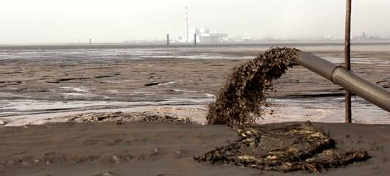

*Image of Ground-level view of wastewater being pumped   
into a rare-earth lake at Baotou in China.*

*(*[*http://www.mnn.com/earth-matters/translating-uncle-sam/stories/what-are-rare-earth-metals*](http://www.mnn.com/earth-matters/translating-uncle-sam/stories/what-are-rare-earth-metals)*)*

China appears to be attempting to take control of its environmental pollution created by years of rare-earth metal mining and processing. In about 2006, China changed export quotas and taxes. These changes were stated to be necessary to protect the environment and their workers. Some experts believe that it was a slight-of-hand maneuver to limit exports and create increased demand and prices.

China, the world’s dominant producer of rare earth metals, quietly and unilaterally imposed taxes and annual tonnage limits on its rare earth exports seven years ago. It then gradually raised the taxes and lowered the tonnage limits in subsequent years, slowly throttling supplies to overseas manufacturers.

China contends that these export restrictions are needed to protect its environment. The United States, the European Union and Japan have challenged China’s taxes and quotas at the World Trade Organization [W.T.O.]. They note that China has done little to limit rare earth consumption within its borders.

The rare earth case “will be a landmark case in terms of both export restrictions and the environment,” said James Bacchus, the former two-term chairman of the W.T.O. appeals tribunal in Geneva.

China has made ample supplies available to manufacturers within China that produce crucial components for a host of products like laptop computers, compact fluorescent bulbs, wind turbines and electric cars. Some Western and Japanese companies have moved factories to China to make sure that they have access to rare earths.

But the case before the World Trade Organization appears to have made a difference already by prompting a broad environmental cleanup. In a white paper issued in June last year, China’s cabinet described at length the environmental harm caused by the rare earth industry, an admission that although embarrassing for Beijing may have buttressed its case at the W.T.O. that the rare earth industry is a dirty business for which export restrictions are justified. “Excessive rare earth mining has resulted in landslides, clogged rivers, environmental pollution emergencies and even major accidents and disasters, causing great damage to people’s safety and health and the ecological environment,” [the white paper said](http://www.nytimes.com/2012/06/21/business/global/china-vows-tighter-controls-over-rare-earth-mining.html).

(http://www.nytimes.com/2013/10/23/business/international/china-tries-to-clean-up-toxic-legacy-of-its-rare-earth-riches.html?_r=0

It is expected that China will continue to dominate the markets as the largest exporter of rare-earth metals and rare-earth products for the foreseeable future. Their more lax environmental restrictions and the vast number and size of currently operating mines virtually assures China's continued dominance. While large corporations such as Toyota, and many countries, including the U.S., seek alternate sources of these critical rare-earth elements, it will be many years before sufficient mine exploration and development can begin to compete with China's rare-earth industry. The map below shows the countries from which the United States imports the rare-earth elements upon which we depend.

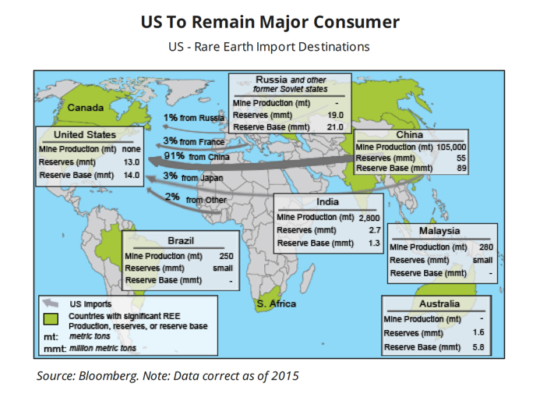

*US dependence on foreign rare-earth supplies and how much we receive from them.*

*(*[*http://www.mining.com/us-remains-almost-entirely-dependent-china-rare-earths/*](http://www.mining.com/us-remains-almost-entirely-dependent-china-rare-earths/)*)*

# References

**(non-Web-based information sources)**

**The references below can be found on the *ChemMatters* 30-year DVD, which includes all articles   
published from the magazine’s inception in October 1983 through April 2013; all available Teacher’s Guides, beginning February 1990; and 12 *ChemMatters* videos. The DVD is available from the American Chemical Society for $42 (or $135 for a site/school license) at this site:** [**http://ww.acs.org/chemmatters**](http://www.acs.org/chemmatters)**. Click on the “Teacher’s Guide” tab to the left, directly under the “*ChemMatters Online"* logo and, on the new page, click on “Get the past 30 Years of *ChemMatters* on DVD!” (the icon on the right of the screen).**

**Selected articles and the complete set of   
Teacher’s Guides for all issues from the past three   
years are available free online at the same Web site, above. Click on the “Issues” tab just below the logo, *“ChemMatters Online”*.**

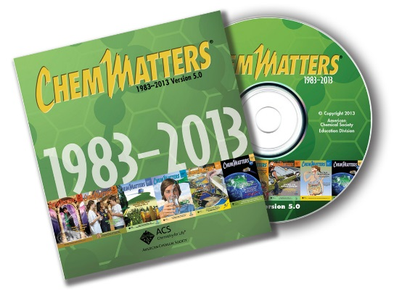

***30* Years of *ChemMatters !***

Available Now!

One of the earliest issues in *ChemMatters* included an article on stars. Students may enjoy a look back at this article on the origin of the elements. (Finkbeiner, A. Star Born: The Origin of the Elements. *ChemMatters*, 1984, *2* (3), pp 6–9)

This article on nitinol, a nickel-titanium alloy, includes its history, crystal structure and uses, and it shows how this unique alloy behaves under different temperatures. (Kauffman G.; Mayo, I. Memory Metal. *ChemMatters*, 1993, *11* (3), pp 4–7)

Another *ChemMatters* author addresses the origin of the elements and their origin in the stars. (Thielk, D. The Birth of the Elements. *ChemMatters*, 2000, *18* (3), pp 4–5)

Students will gain a better understanding of display screens, especially liquid crystal designs, along with information on pixels, polarization, and color theory in this 2005 article. While the photos of flip phones and other older devices date the article, the information and visuals are excellent. (Fruen, L. Liquid Crystal Displays. *ChemMatters*, 2005, *23* (3), pp 6–9)

Many scholars believe that the Japanese samurai sword is a milestone in metallurgy and weaponry. This article describes the history, alloy composition, and the process of making the samurai sword. The discussion of the structure of the carbon steel alloy in the sword ties in nicely with the Haines article. (Graham, T. Secrets of the Samurai Sword Revealed. *ChemMatters*, 2005, *23* (5), pp 9–12)

The alloys used in metal coins and a description of alloys is featured in this article. (Rohrig, B. The Captivating Chemistry of Coins. *ChemMatters*, 2007, *25* (2), pp 14–17)

This article includes diagrams and a description of the atomic emission spectra of elements as it relates to fireworks, but the information may help readers understand the science behind luminescence. (Copes, J. Science at Hogwarts: Chemistry in Harry Potter's World. *ChemMatters*, 2009, *27* (1), pp 4–6)

This is an excellent explanation of the origin of elements from stars. Included in a sidebar is a section on identifying elements by their emission spectra. (Ruth, C. Where Do Chemical Elements Come From? *ChemMatters*, 2009, *27* (3), pp 6–8)

The accompanying Teacher's Guide for the October 2009 *ChemMatters* article above, Where Do Elements Come From, is a rich source of information and resources on the formation of elements, nucleosynthesis, and the life cycle of stars. Included are a student activity comparing the life cycle human to a star, additional Web sites, and video links.

A brief piece in the "Did You Know? ..." feature includes information on rare-earth metals. (Pages, P. Rare-earth Metals: Not Well-Known but Critical for High Technology. *ChemMatters*. 2010, *28* (2), p 4)

This is another look at the atomic emission spectra of elements as it applies to colored fireworks. Luminescence and spectra are explained and a chart of typical fireworks color sources is provided. (De Antonis, K. Fireworks. *ChemMatters*, 2010, *28* (3), pp 8–10)

The impurities in the metal rivets and chemistry of the alloy carbon-steel plates likely contributed to the sinking of the Titanic. This article discussed the metallic properties of the rivets and the steel alloy. (Rohrig, B. Titanic: Was It Doomed by Chemistry? *ChemMatters*, 2011, *22* (4), pp 17–19)

This is an infographic on the elements (many of them rare-earth metals) that are found in a typical smartphone. Your Smart Phone Contains Valuable Chemicals. *ChemMatters*, 2014, *32* (1), p 4)

The importance of recycling old cell phones and a life-cycle diagram of a cell phone is found in this short article. (Rohrig, B. Be Smart—Recycle that Old Cell Phone! *ChemMatters*, 2015, *33* (2), p 4)

This is an excellent resource to accompany the Haines article. Information on rare-earth metals used in the smartphones is highlighted throughout the article. Also, a discussion of Gorilla Glass (which is strengthened by the addition of potassium ions) is analogous to the formation of substitutional alloys. (Rohrig, B. Smartphones, Smart Chemistry. *ChemMatters*, 2015, *33* (2), pp 10–12)

____________________

An interesting historical view of the rare-earth elements and their discovery is found in this 1932 article. The article provides details on the rare-earth elements and the discovery of each. It also includes photographs of people and places associated with the rare-earth elements. (Weeks, M. The Discovery of the Elements. XVI. The Rare-earth Elements. *J. Chem. Educ.*, 1932, *9* (10), pp 1751–1773; <http://pubs.acs.org/doi/pdf/10.1021/ed009p1751>; note that this link is a brief abstract only, the full article is only available to American Chemical Society members or subscribers to the journal)

While this article is designed as a laboratory experiment for high school students, the publication date of 1963 should be considered, especially with respect to safety, equipment, and whether it is currently appropriate. However, it is filled with lab procedures for, the chemistry of, and details pertaining to the lighter lanthanides. (Kauffman, G.; Takahashi, L.; Vickery, R. The Lighter Lanthanides: A Laboratory Experiment in Rare-earth Chemistry. *J. Chem. Educ.*, 1963, *40* (8), pp 433–437; <http://pubs.acs.org/doi/pdf/10.1021/ed040p433>; note that this link is a brief abstract only, the full article is only available to American Chemical Society members or subscribers to the journal)

A scholarly article from *The Journal of Chemical Education* explains luminescence in greater detail with accompanying diagrams. The article specifically refers to phosphors used in cathode ray television tubes, fluorescent lamps, and x-ray detectors. (DeLuca, J. An Introduction to Luminescence in Inorganic Solids. *J. Chem. Educ.*, 1980, *57* (8), pp 541–545; <http://pubs.acs.org/doi/pdf/10.1021/ed057p541>; note that this link is a brief abstract only, the full article is only available to American Chemical Society members or subscribers to the journal)

This article is from 1990, but the information on how the elements are formed in the stars, nucleosynthesis, is explained in detail, with diagrams, and chemical equations to help readers understand this complex process. (Viola, V. Formation of the Chemical Elements and the Evolution of Our Universe. *J. Chem. Educ.*, 1990, *67* (9), pp 723–730; <http://pubs.acs.org/doi/pdf/10.1021/ed067p723>; note that this link is a brief abstract only, the full article is only available to American Chemical Society members or subscribers to the journal)

Emphasize properties of metals by using five guided inquiry experiments with metals to develop students' understanding of chemistry concepts, including intensive and extensive properties, limiting reagents, spectator ions, reactivity series, and strengths of oxidizing and reducing agents. (Lamba, R.; Sharma, S.; Lloyd, B. Constructing Chemical Concepts through a Study of Metals and Metal Ions. *J. Chem. Educ.*, 1997, *74* (9), pp 1095–1099; <http://pubs.acs.org/doi/pdf/10.1021/ed074p1095>; note that this link is a brief abstract only, the full article is only available to American Chemical Society members or subscribers to the journal)

Take an historical look at atomic emission spectroscopy with its contributions to science and technology as well as the changes and revisions it has undergone. The components (sources, dispersion systems, and detectors) are analyzed and compared to other elemental analysis methods. (Hieftje, G. Atomic Emission Spectroscopy—It Lasts and Lasts and Lasts. *J. Chem. Educ.*, 2000, *77* (5), pp 577–583; <http://pubs.acs.org/doi/pdf/10.1021/ed077p577>; note that this link is a brief abstract only, the full article is only available to American Chemical Society members or subscribers to the journal)

Forensic cases are popular on television and in teaching science. A chemical mystery using the popular characters of Sherlock Holmes and Dr. Watson is used to solve a case based upon knowledge of simple physical and chemical properties of metals. (Rybolt, T.; Waddell, T. The Chemical Adventures of Sherlock Holmes: The Case of Three. *J. Chem. Educ.*, 2002, *79* (4), pp 448–453; <http://pubs.acs.org/doi/pdf/10.1021/ed079p448>; note that this link is a brief abstract only, the full article is only available to American Chemical Society members or subscribers to the journal)

This thorough article on luminescence is aimed at high school students. It explains the types of luminescence (triboluminescence, fluorescence, chemiluminescence, phosphorescence, and bioluminescence) and contrasts luminescence with incandescence. For readers with paid access to *JCE Online*, there are five supplemental experiments available to accompany the article. (O'Hara, P.; Engelson, C.; St. Peter, W. Turning on the Light: Lessons from Luminescence. *J. Chem. Educ.*, 2005, *82* (1), pp 49–52; <http://pubs.acs.org/doi/pdf/10.1021/ed082p49>; note that this link is a brief abstract only, the full article is only available to American Chemical Society members or subscribers to the journal)

# Web Sites for Additional Information

**(Web-based information sources)**

**Rare-earth elements**

A *ChemMatters* Teachers Guide for the article, Smartphones, Smart Chemistry has a wealth of additional information, charts, and graphics on the history, chemical and physical properties, supply and demand, and substitutes for rare-earth elements. Select the April 2015 Teacher's Guide at: <https://www.acs.org/content/acs/en/education/resources/highschool/chemmatters/teachers-guide.html>. [Note: this Teacher’s Guide will only be available free online until summer, 2018.]

For a scholarly article on the rare-earth elements go to <http://www.fieldexexploration.com/images/property/1_RareEarths_FLX_02.pdf>.

Information on the only commercial U.S. rare-earth mine, Mountain Pass, in California can be located at <http://www.theatlantic.com/technology/archive/2012/02/a-visit-to-the-only-american-mine-for-rare-earth-metals/253372/>.

The U.S. Geological Survey (USGS) has a vast array of articles, charts, reports, and other information on its Web site. Rare-earth statistics and information for each year starting with 1996 can be found at <http://minerals.usgs.gov/minerals/pubs/commodity/rare_earths/>.

The *Rare Element Resources* Web site includes links for “Rare Earth Elements”, “Critical Rare Earth Elements”, “Rare Earths at Bear Lodge” [a northeast Wyoming mine], and “Industry Related Reports”. All of these can be accessed at [http://www.rareelementresources.com/rare-earth-elements#.V_b1leArJhG](http://www.rareelementresources.com/rare-earth-elements%23.V_b1leArJhG).

The *Rare Earth Technology Alliance* Web site lists the 17 rare-earth metals and gives a short paragraph about each. (<http://www.rareearthtechalliance.com/What-are-Rare-Earths>)

Maps of potential U.S. rare-earth production sites, rare-earth ores types, processing rare-earth minerals and a chart of rare-earth mineral deposits in the world are available at <http://geology.com/usgs/ree-geology/>.

An interactive world map identifying mineral deposits containing rare-earth elements with quality (grade) of ore, tonnage, and their mineralogy is found at <http://mrdata.usgs.gov/mineral-resources/ree.html>.

Maps of rare-earth deposits in the world as well as for other strategic minerals (platinum group, uranium, phosphorous, and lithium) along with short summaries by groups are located at <http://web.mit.edu/12.000/www/m2016/finalwebsite/solutions/deposits.html>.

A 2010 report from *The Economist* addresses the cost, supply, and importance of rare-earth elements can be found here: <http://www.economist.com/blogs/babbage/2010/09/rare-earth_metals>.

The *American Geosciences Institute* has a Web page listing the ways we use rare-earth elements. (<http://www.americangeosciences.org/critical-issues/faq/how-do-we-use-rare-earth-elements>)

*National Geographic* provides the article “Rare-Earth Elements” discussing supply, China's domination of the market, uses, and opinions regarding the instability of the rare-earth metals market. (<http://ngm.nationalgeographic.com/2011/06/rare-earth-elements/folger-text>)

*National Geographic* has 14 pictures with captions regarding China's rare-earth mining at <http://news.nationalgeographic.com/news/energy/2012/04/pictures/120403-china-rare-earth-mining-pictures/>.

The U.S.G.S. has a four-page, colorful publication describing the rare-earth elements and explaining why they are vital to our technology and lifestyles. (<http://pubs.usgs.gov/fs/2014/3078/pdf/fs2014-3078.pdf>)

A short profile of an EPA female scientist who works with rare-earth minerals is located at <https://www.epa.gov/sciencematters/meet-epa-scientist-diana-bless>.

A scholarly article, “Effects of Samarium Addition on Microstructure and Mechanical Properties of As-Cast AL-Si-Cu Alloy” is available at <http://www.ysxbcn.com/down/2013/11_en/10-p3228.pdf>.

Another scholarly article, “A Historical Geography of Rare Earth Elements: From Discovery to the Atomic Age”, is located at <https://www.bu.edu/pardeeschool/files/2015/08/Klinger-2015-Extractive-Industries-and-Society.pdf>.

For a look at why recycling rare-earth metals is rare and difficult see <http://ensia.com/features/why-rare-earth-recycling-is-rare-and-what-we-can-do-about-it/>.

**Rare-earth mining pollution**

Environmental damages associated with mining (not just rare-earth mining) identified by the type of mining, specific contaminants, and additional environmental problems are listed in this Web site. In addition, some case studies are briefly described. (<http://web.mit.edu/12.000/www/m2016/finalwebsite/problems/mining.html>)

The pollution from mines in Mongolia is described, along with pictures, at <http://www.bbc.com/future/story/20150402-the-worst-place-on-earth>.

Mining risks from toxic pollution to produce rare-earth materials is discussed in a 2013 report at <http://e360.yale.edu/feature/boom_in_mining_rare_earths_poses_mounting_toxic_risks/2614/>.

The *New York Times* reports on rare-earth mining toxic wastes and pollution at <http://www.nytimes.com/2013/10/23/business/international/china-tries-to-clean-up-toxic-legacy-of-its-rare-earth-riches.html?_r=0>.

Concern regarding possible rare-earth mining and the associated pollution in Arizona and other places is found at <http://tucson.com/business/local/big-pollution-risk-seen-in-rare-earth-mining/article_c604dd80-7a8d-5ab5-8342-0f9b8dbb35fb.html>.

The huge social and ecological impact of rare-earth mining in China is discussed in an article at <https://www.theguardian.com/sustainable-business/rare-earth-mining-china-social-environmental-costs>.

**Naming elements**

The International Union of Pure and Applied Chemistry (<https://iupac.org/> ) coordinates and affirms the naming of new elements. For additional information on the entire procedure, see <https://www.degruyter.com/view/j/ci.2016.38.issue-2/ci-2016-0205/ci-2016-0205.xml>.

The recent announcement of the temporary names and symbols of newest elements 113, 115, 117, 118 has stimulated interest in the nomenclature procedure for new elements. For an announcement on these new elements and their proposed names, see <http://cen.acs.org/articles/94/i24/Proposed-names-new-periodic-table.html>.

**LEDs, LCDs, luminescence, and light**

This site provides an in-depth explanation of LED theory and practice. Information includes color rendering index, controlling LEDs in building and street lamps, LED arrays, luminous efficacy, and electroluminescence at semiconductor junctions. (<http://electronicdesign.com/components/understanding-led-application-theory-and-practice>)

For a review of the basics of light, including light as energy, absorption and emission of light, and the wave/particle nature of light see <http://www.pha.jhu.edu/~wpb/spectroscopy/basics.html>.

“ Theory of Operation” explains both the CRT (TV picture tube) and the LED types of televisions at <http://wavuti.webs.com/teleprinciples/Television%20Theory%20of%20Operation.pdf>.

A detailed explanation of how a television screen makes its picture using LCDs (liquid-crystal displays), using polarizing filters can be found here: <http://www.explainthatstuff.com/lcdtv.html>.

An excellent Web site with the history and properties of liquid crystals (which are used in color TVs) is located at <http://www.nobelprize.org/educational/physics/liquid_crystals/history/index.html>.

**Sites on metals**

NOVA has an interesting Web page, “Metal Fundamentals”, explaining basic properties of metals, defects (alloys), metal failures, and sword making. (<http://www.pbs.org/wgbh/nova/tech/metal-fundamentals.html>)

For many students, Samurai swords are of interest. NOVA provides a slideshow at <http://www.pbs.org/wgbh/nova/tech/crafting-samurai-sword.html> to show the steps involved in making this classic sword.

**Sites on element formation**

Additional information on how elements are formed in stars is located at <http://aether.lbl.gov/www/tour/elements/stellar/stellar_a.html>.

The formation of elements (nucleosynthesis) is included in a discussion of the timeline, processes, empirical evidence, and a list of additional references at <https://en.wikipedia.org/wiki/Nucleosynthesis>.

This site gives a brief overview of nucleosynthesis and it has links to more detailed explanations of the formation of elements, including the s-process and the r-process. (<http://curious.astro.cornell.edu/about-us/84-the-universe/stars-and-star-clusters/nuclear-burning/402-how-are-light-and-heavy-elements-formed-advanced>)