How to Login to the ACS Learning Center

- Go to https://learning.acs.org/
  - In the upper right corner click on “Log In”
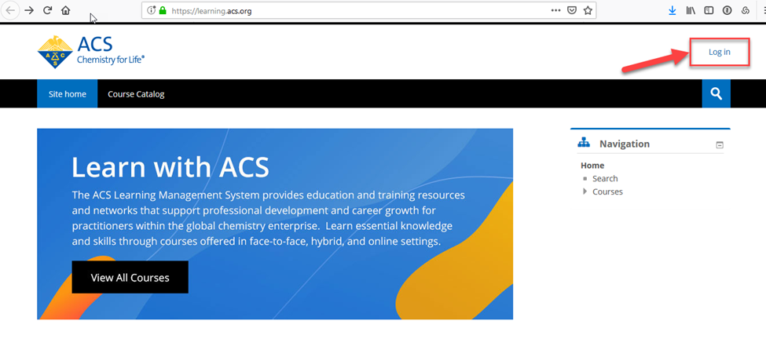
  - Enter your ACD and Password and click “Log In”
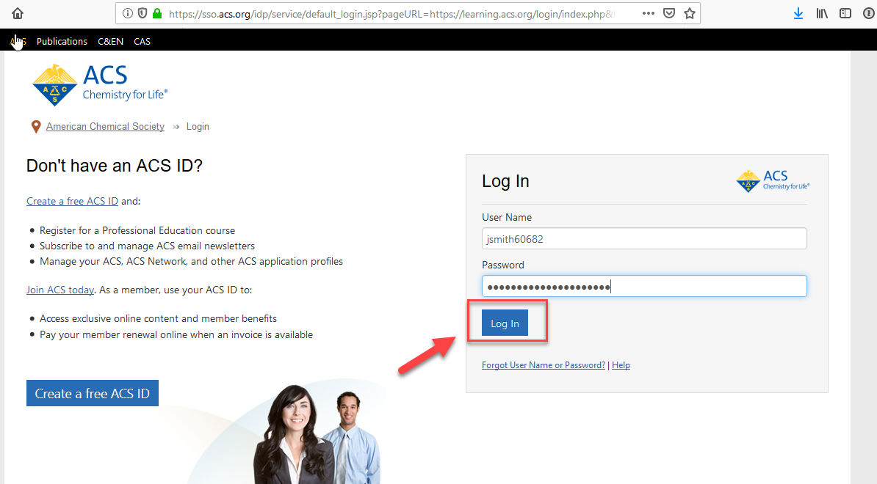

- If you do not have an ACS ID
  - Click on the “Create a free ACS ID” button
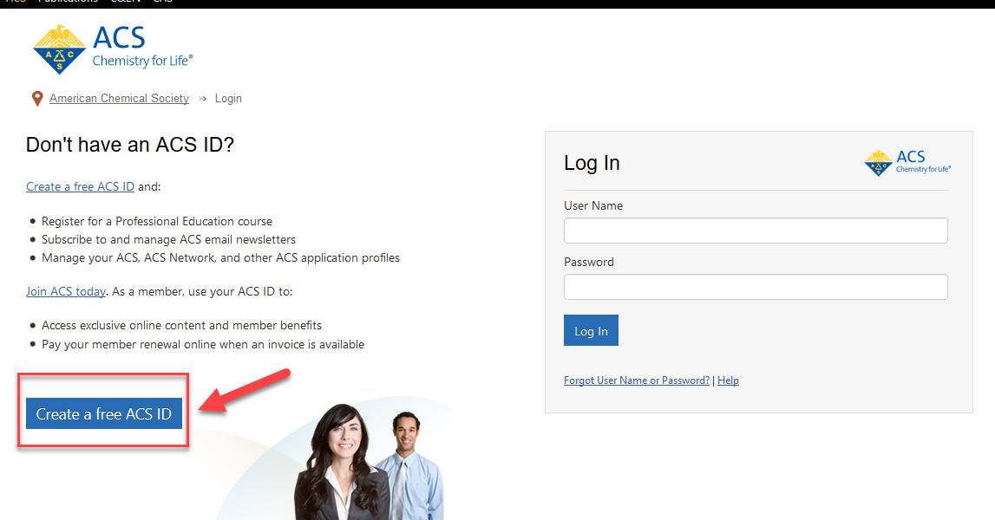

  - Complete the required fields marked with *
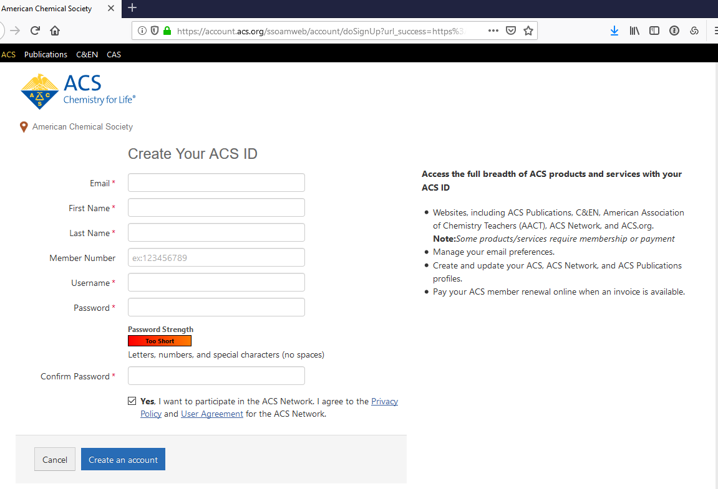

  - Click the “Create an account” button
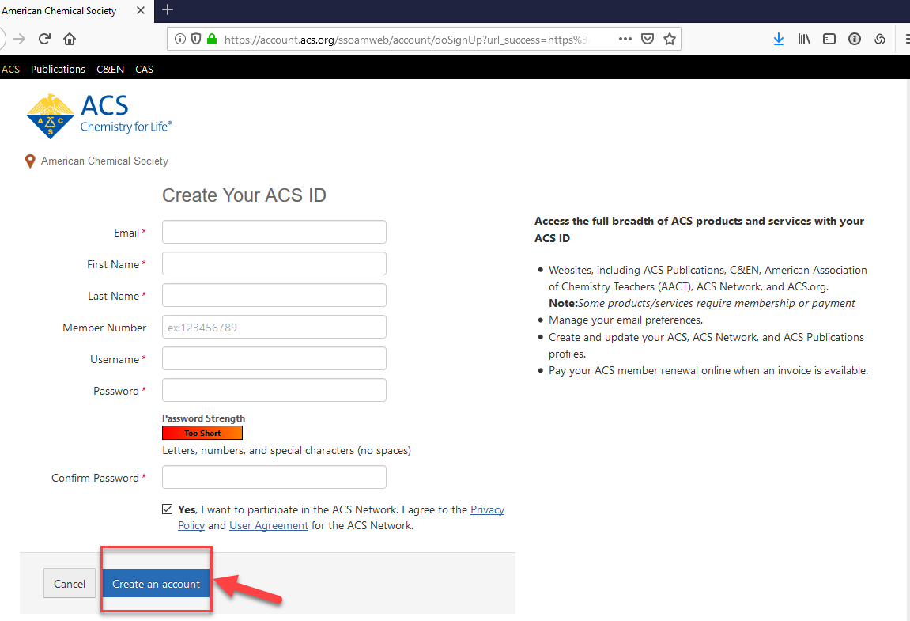

After your ACS ID account is created click on the “LMS” button
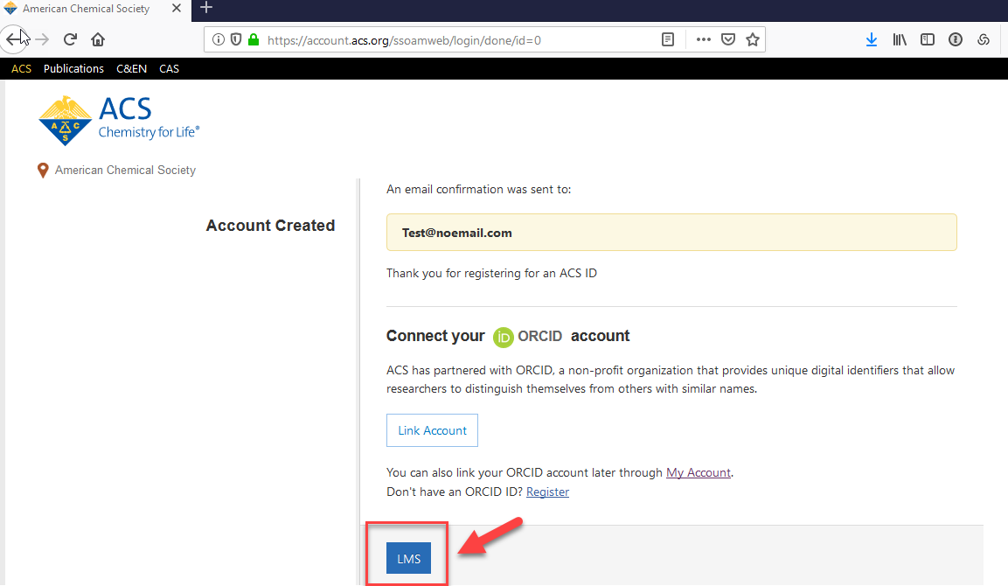
- You are now logged in to the ACS Learning Center
