ACS Inclusivity Style Guide practice exercise 1: Description of an award

Instructions: Part 1
Start by reading the original text. Use the ACS Inclusivity Style Guide to try to identify where more inclusive language could be used. Then scroll to the annotated version and read the comments in the margins to see where the text does not use inclusive language. Last, scroll to the final version to see text that follows guidelines from the ACS Inclusivity Style Guide.

Original text
The ACS Science Award is intended to recognize a young, diverse chemistry student’s research.
Before nominating a student, ensure that he/she meets the following criteria:
- A chemistry student from one of the following groups:
  - Undergraduate student, 20–22 years of age
  - Master’s or doctoral student
- Part of one of the following minorities:
  - African-American
  - Hispanic
  - Alaska Native or American Indian
- Fluent in English
- Available to stand on stage at the ACS spring meeting in Washington, DC, for the award ceremony on March 15
- Willing to commit to a pre- and postconference virtual event related to the ACS spring meeting

Instructions: Part 2
Read the comments to understand what parts of the text are not inclusive.

Annotated version
The ACS Science Award is intended to recognize a young, diverse chemistry student’s research.
Before nominating a student, ensure that he/she meets the following criteria:
- A chemistry student from one of the following groups:
  - Undergraduate student, 20–22 years of age
  - Master’s or doctoral student
- Part of one of the following minorities:
  - African-American
  - Hispanic
  - Alaska Native or American Indian
- Fluent in English
- Available to stand on stage at the ACS spring meeting in Washington, DC, for the award ceremony on March 15
- Willing to commit to a pre- and postconference virtual event related to the ACS spring meeting

Instructions: Part 3
Review a version that follows guidelines from the ACS Inclusivity Style Guide. Find the full guide at www.acs.org/inclusivityguide. Email ISG@acs.org with questions.

Final version
The ACS Science Award is intended to recognize the research of a chemistry student with a race or ethnicity underrepresented in the sciences.
Before nominating a student, ensure that your nominee meets the following criteria:
- Is a chemistry student from one of the following groups:
  - Third- or fourth-year undergraduate student
  - Master’s or doctoral student
- Has a race or ethnicity underrepresented in the sciences.* Examples include:
  - African American or Black
  - Alaska Native or American Indian
  - Hispanic or Latin American
- Has at least one research publication in English
- Is willing to commit to a pre- and postconference virtual event related to the ACS spring meeting

*We define “underrepresented races and ethnicities” as those that have a lower percentage among US science students than in the US population as a whole.

ACS Inclusivity Style Guide practice exercise 2: Email to a project team

Instructions: Part 1
Start by reading the original text. Use the ACS Inclusivity Style Guide to try to identify where more inclusive language could be used. Then scroll to the recommended changes and read the comments in the margins to see where the text does not use inclusive language. Last, scroll to the final version to see text that follows guidelines from the ACS Inclusivity Style Guide.

Original text
Hi guys,
Thanks for meeting yesterday to review the status of the project. To recap:
- We decided that we need to add a diverse team member to help us make sure our content reaches a BIPOC audience. He or she should come on board by next month.
- Sherry is in charge of finding a millennial to join our team—we need someone who can help us optimize our reach on social media.
- Ava volunteered to man the phone line while Bob is out.
- Unresolved question: Is the website set up to be accessible to the disabled? We need to resolve this before we next meet.
As a reminder, our next meeting will be in person. To celebrate, we will order lunch. Any requests? I’d personally like something ethnic, but I’m open to other suggestions.
Last but not least: Thank you to Kenji for the reminder that Ava prefers the pronoun “they” because she’s gender nonbinary. Let’s all please respect that preference.
Thanks,
Team Leader

Instructions: Part 2
Read the comments to understand what parts of the text are not inclusive.

Annotated version
Hi guys,
Thanks for meeting yesterday to review the status of the project. To recap:
- We decided that we need to add a diverse team member to help us make sure our content reaches a BIPOC audience. He or she should come on board by next month.
- Sherry is in charge of finding a millennial to join our team—we need someone who can help us optimize our reach on social media.
- Ava volunteered to man the phone line while Bob is out.
- Unresolved question: Is the website set up to be accessible to the disabled? We need to resolve this before we next meet.
As a reminder, our next meeting will be in person. To celebrate, we will order lunch. Any requests? I’d personally like something ethnic, but I’m open to other suggestions.
Last but not least: Thank you to Kenji for the reminder that Ava prefers the pronoun “they” because she’s gender nonbinary. Let’s all please respect that preference.
Thanks,
Team Leader

Instructions: Part 3
Review a version that follows guidelines from the ACS Inclusivity Style Guide. Find the full guide at www.acs.org/inclusivityguide. Email ISG@acs.org with questions.

Final version
Hi all,
Thanks for meeting yesterday to review the status of the project. To recap:
- We decided that we need to diversify our team so that we get a broader range of perspectives and make sure our content reaches a wide audience. Let’s aim for three more people to come on board by next month. When we work on this project next year, we’ll ensure we recruit a diverse team from the start.
- Sherry is in charge of finding someone who can help us optimize our reach on social media.
- Ava volunteered to staff the phone line while Bob is out.
- Unresolved question: Is the website set up to be accessible to people with disabilities? We need to resolve this before we next meet.
As a reminder, our next meeting will be in person. To celebrate, we will order lunch. Any requests? I’d personally like something Indian or Thai, but I’m open to other suggestions.
Last but not least: Thank you to Kenji for the reminder that Ava’s pronoun is “they.” Let’s all please respect Ava and use the correct pronoun.
Thanks,
Team Leader

ACS Inclusivity Style Guide practice exercise 3: Image on toxic workplaces

Instructions
The next page shows two images that a project team is considering for a story on toxic workplace cultures. First, use the ACS Inclusivity Style Guide to identify which image is more appropriate. Then scroll down to read why the good image works and why the bad image does not work. Find the full guide at www.acs.org/inclusivityguide. Email ISG@acs.org with questions.

Image 1
Credit: Mr.Good/Shutterstock/C&EN
Image 2
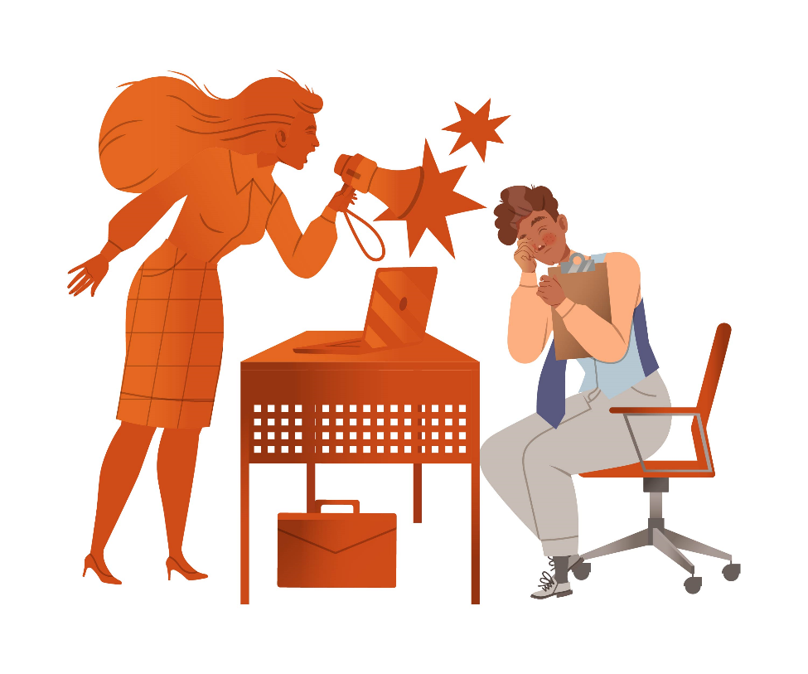
Credit: HappyPictures/Shutterstock

Why the first image doesn’t work:
The first image showcases a Black woman yelling at an employee, which perpetuates the racial stereotype of “the angry Black woman,” a racist trope in American society that portrays Black women as sassy, ill mannered, and ill tempered by nature. See “Stereotypes in images” for more information.

Additionally, a reverse search of the graphic shows that in the original, the woman was not Black. Changing the skin tone without considering the implications is an example of trying to do a quick fix instead of approaching diversity and inclusion holistically and thoughtfully. See "Performative diversity in images" for more information. 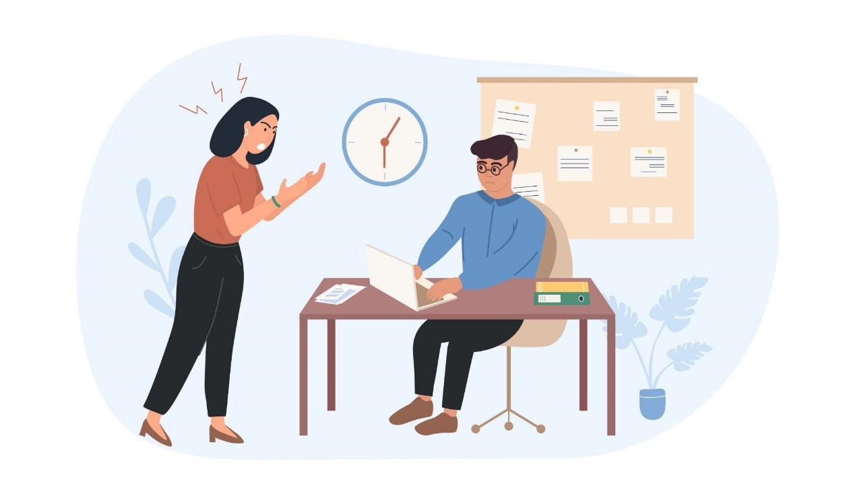
Credit: Mr.Good/Shutterstock

Why the second image works:
The second image disrupts of the norm of White men being bosses but does not perpetuate harmful stereotypes. 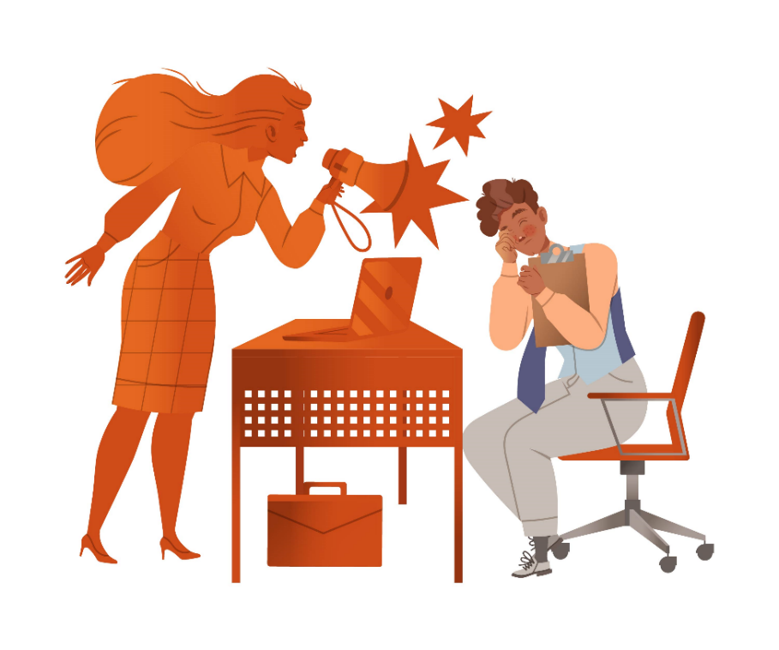

ACS Inclusivity Style Guide practice exercise 4: Image on returning to work

Instructions
The next page shows two images that a project team is considering using to accompany information on returning to work. First, use the ACS Inclusivity Style Guide to identify which image is more appropriate. Then scroll down to read why the good image works and why the bad image does not work. Find the full guide at www.acs.org/inclusivityguide. Email ISG@acs.org with questions.

Image 1
Credit: GoodStudio/Shutterstock
Image 2
Credit: GoodStudio/Shutterstock/C&EN

Why the first image doesn’t work:
The entire staff is White, including the character who seems to represent the boss.

Why the second image works:
Incorporating other races and skin tones into the illustration shows a more diverse workplace. See “How to choose images” for more information.

ACS Inclusivity Style Guide practice exercise 5: Image on inclusive hiring practices

Instructions
The next page shows two images that a project team is considering for a campaign on inclusive hiring practices. First, use the ACS Inclusivity Style Guide to identify which image is the better choice. Then scroll down to read which image was chosen and why. Find the full guide at www.acs.org/inclusivityguide. Email ISG@acs.org with questions.

Image 1

Image 2
Credit: Andrey_Popov/Shutterstock (both)

Why the first image is better:
Technically, there is nothing wrong with the second image. But inclusivity doesn’t mean just race; it can also mean gender, religion, sexuality, disability, and more.
The first image does a better job of showing an inclusive work environment that would appeal to diverse audiences, including job seekers with disabilities and underrepresented racial groups in the sciences. See “How to choose images” for more information.

ACS Inclusivity Style Guide practice exercise 6: Image on job opportunities

Instructions
The next page shows two images that a project team is considering for a campaign on job opportunities. First, use the ACS Inclusivity Style Guide to identify which image is the better choice. Then scroll down to read which image was chosen and why. Find the full guide at www.acs.org/inclusivityguide. Email ISG@acs.org with questions.

Image 1

Image 2
Credit: fizkes/Shutterstock (both)

Why the second image is better:
The second image is more gender inclusive. The first image appears to be led by a man, and the only other visible people appear to be men. See “How to choose images” and “Editing photos” for more information.

