Test Bank - Chapter 1
The questions in the test bank cover the concepts from the lessons in Chapter 1. Select questions from any of the categories that match the content you covered with students. The types of questions include multiple choice, true/false, fill-in-the-blank, and short answer.

Multiple Choice
For questions 1-10, circle only one answer.

- Any sample of matter has mass and takes up space. The main reason for this is because:
  - All matter is heavy
  - Matter can be a gas
  - Matter is made up of tiny particles that have mass and take up space
  - The Earth is made of matter

- Water drops stay together on wax paper and don’t break apart easily. This is mainly because:
  - Water molecules are small
  - Water molecules are in motion
  - Water molecules are attracted to each other
  - Water molecules are wet

- When you bring two drops of water near each other and allow them to touch, they combine immediately and become one drop.
This is mainly because:
  - Water molecules are made of atoms
  - Water molecules are attracted to each other
  - Water molecules are magnetic
  - Water is a liquid

- If you put food coloring in room temperature water, the coloring spreads throughout the water. The water causes the color to spread mainly because:
  - Water molecules are warm
  - Water molecules are in motion
  - Water is more dense than food coloring
  - Food coloring molecules are small

- Food coloring spreads out faster in hot water than in cold water. This is mainly because:
  - The water molecules in hot water move more quickly
  - The molecules in hot water are larger
  - The food coloring molecules are small
  - Hot water is less dense
- When a thermometer is heated, the red liquid inside the thermometer moves up. This is mainly because:
  - The red liquid is thin
  - The molecules of the liquid move faster and get a little further apart
  - Hot liquid is lighter
  - The glass of the thermometer gets hot

- When a thermometer is cooled, the red liquid inside the thermometer moves down. This is mainly because:
  - Cold liquids sink
  - The glass of the thermometer gets cold
  - The molecules of the liquid move slower and get a little closer together
  - The red liquid is thick

- When you heat a sample of a solid, the particles that make up the solid:
  - Get bigger
  - Loose mass
  - Move faster
  - Slow down

- When you heat a sample of a solid, the sample gets a little bigger. This is mainly because:
  - The particles move faster and get a little further apart
  - Heat helps the particles grow
  - Heating the sample makes it lighter
  - Heating helps the particles slide past each other

- When you heat a sample of gas, what happens to the particles that make up the gas?
  - The particles move faster
  - The particles break apart
  - The particles get smaller
  - The particles become more dense

For questions 11-13, circle all the correct answers.

- To describe a liquid, you could say:
  - The particles of a liquid are attracted to one another
  - The particles of a liquid are in motion
  - The particles of a liquid are able to move past one another
  - A liquid has mass and takes up space

- To describe a solid, you could say:
  - The particles of a solid are attracted to each other
  - The particles of a solid can move past one another
  - The particles of a solid vibrate but do not move past one another
  - A solid has mass and takes up space

- To describe a gas, you could say:
  - The particles are very attracted to each other
  - The particles are not very attracted to each other
  - The particles are close together like a liquid
  - The particles of a gas are further apart than the particles in a liquid or solid

Chapter 1
Multiple Choice Answers

- c  - c  - b  - b  - a  - b  - c | - c  - a  - a  - a, b, c, d  - a, c, d  - b, d

True/False and Fill-in-the-blank

The three common states of matter are ____, _, and . solid, liquid, gas

True or False?
The particles of a liquid are attracted to one another, but can’t move past each other. False

is the study of matter. Chemistry

True or False?
An increase in temperature increases molecular motion and increases the distance between atoms and molecules in solids, liquids, and gases. True

A in the speed of the molecules allows the attractions between molecules to bring them a little closer together. decrease

True or False?
Even when measuring the same temperature, the liquids in different thermometers can move to different heights depending on the liquid inside of them. True

The molecules of the liquid inside the thermometer increase in speed when the thermometer is _______ . heated

True or False?
The atoms of a solid are very far apart and vibrate in fixed positions. False
Cooling a solid the motion of the atoms. decreases
True or False?
Heating a gas stops all of its molecular motion. False

True or False?
Air has mass. True

True or False?
The molecules of a gas are not very attracted to each other. True

Short Answer

If the particles of a liquid are always moving, why don’t they all come apart from each other and become a gas?
Even though the particles of a liquid are moving, they are attracted to each other, so they don’t just spread far apart to become a gas. But some do when they evaporate.

Water beads up on the surface of a freshly waxed car. If you use your finger to drag one drop very close to another and let them touch, the two drops quickly join to become one bigger drop. What can you infer about water molecules based on this observation?
Water molecules are very attracted to one another.

Even though water in a clear glass appears still, a drop of food coloring placed at the surface will slowly move throughout the water. Eventually, without stirring or shaking, the water will become evenly colored. What can you infer about water molecules based on these observations?
Water molecules are in motion.
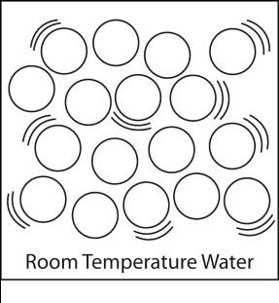

What do the circles and lines tell you about the arrangement, spacing, and speed of water molecules in room temperature water?
Water molecules are randomly arranged, close together, and move at a moderate speed.

In a little more than a tablespoon of water, there are about 600 billion trillion water molecules. If you could count 1 million water molecules every second, it would take about 200 million centuries (20 billion years) to count all the molecules in that tablespoon of water! What does this amazing fact tell you about the size of water molecules?
Water molecules are extremely small.

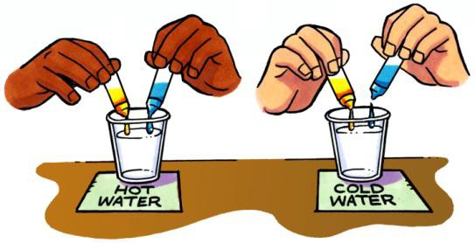
What differences would you expect if, at the same time, you place yellow and blue food coloring in both hot and cold water?
The food coloring would move and mix in the hot water more quickly than it would in the cold water.

Compare the speed of molecules in hot water compared to molecules in cold water?
Water molecules move faster in hot water and slower in cold water.

Draw circles and motion lines in each box to show differences in the movement and arrangement of water molecules in cold, room temperature, and hot water.
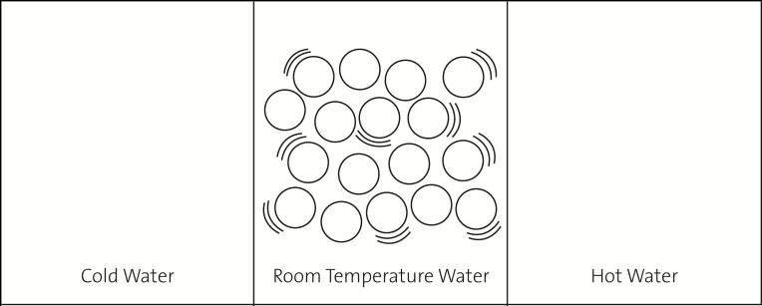
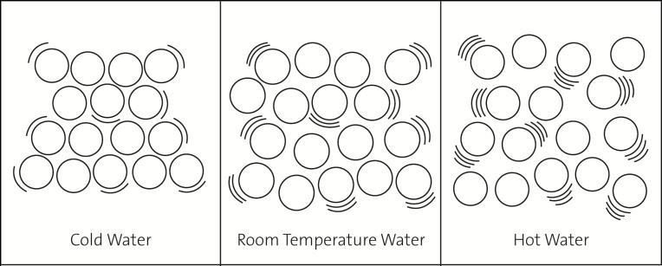

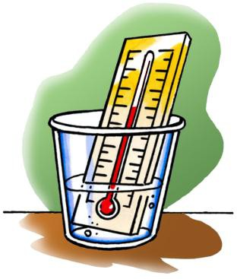
Thermometers have a very thin tube inside that stretches up from a round bulb at the bottom, which holds most of the liquid.

- Why does the red liquid move up the tube when a thermometer is heated?
When heated, the molecules in the liquid inside the thermometer get a little further apart. Because the liquid takes up more space, the red line moves up in the tube.

- Why does the red liquid move down the tube when a thermometer is cooled?
When cooled, the molecules in the liquid inside the thermometer get a little closer together. Because the liquid takes up less space, the red line moves down in the tube.

If two thermometers have different liquids in them, the liquids can move to different heights in the thermometers even if they are measuring the same temperature. Why does that happen?
Different liquids are made up of different molecules with different attractions for one another. If they are heated, the molecules will increase their speed but the amount that they separate from each other and move up the tube will be different.

Show the difference between the speed and spacing of the molecules in hot water and cold water. Draw circles in each straw below to represent water molecules. Use motion lines to represent the speed of the molecules.
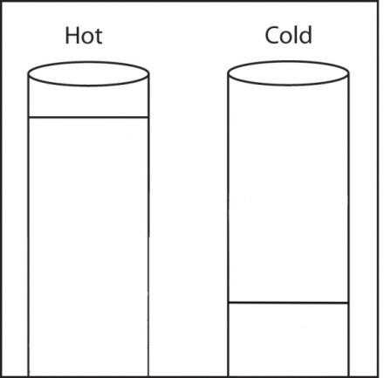
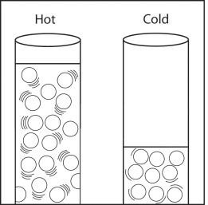

Do you think that the particles of a solid or liquid are more attracted to each other? Why?
The particles of a solid are more attracted to each other because they can’t slide past one another the way the particles of a liquid can.

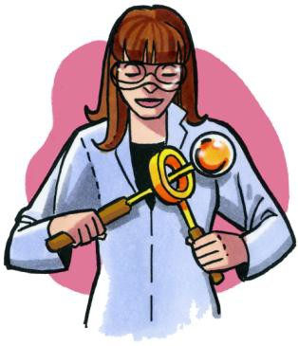
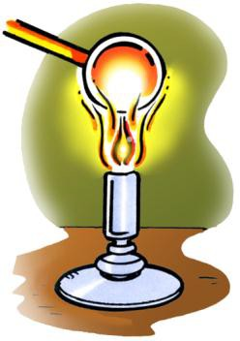
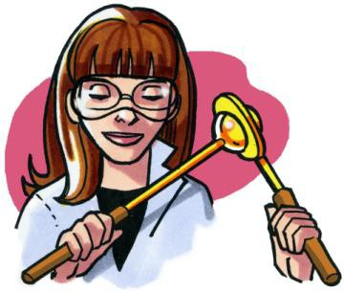
There is a metal ball and ring set that is specially made so that at room temperature the ball fits through the ring. However, when the ball is heated, it gets stuck and cannot fit through anymore. When heated, the ball actually gets a little bigger! Explain how the motion and attractions of the atoms in the metal ball cause it to get slightly larger when heated.

When heated, the atoms in the ball and ring vibrate faster. This increased motion competes with the attractions the atoms have for one another, so they move a little further apart. As the atoms move slightly further apart, the metal ball gets a little bigger.

Describe what happens on the molecular level when a solid is heated.
When a solid is heated, the atoms or molecules it is made of move faster. This movement competes with the attraction between the molecules and they spread out a little.

In the demonstration with the metal ball and ring, why didn’t the ball fit through the ring after the ball was heated with a Bunsen burner?
The ball didn’t fit through the ring because when the ball was heated, the atoms moved faster and got a little further apart. They spread out enough that the ball could not fit through the ring.

If the metal ring was cooled a lot, and the metal ball was at room temperature, would the ball still fit through the ring?
If the ring was cooled a lot, the atoms would slow down enough that their attractions would bring them closer together. This could cause the ring to get a little smaller so the ball might not be able to fit through.

Sometimes on especially hot days, a wooden door, that opens and closes just fine during cooler months, will be hard to open and close. Why is the door hard to open and close on hot days?
Hint: Think about the difference in the spacing of molecules in solids that are heated and cooled.
On hot days, the molecules that make up the door are slightly further apart. This makes the door just a little bigger than normal, so it gets stuck.

Is gas matter? How do you know?
Gas is matter because it is made up of atoms or molecules. Atoms and molecules have mass and take up space so they are matter.

The bottle in each picture is “empty” and has a thin film of bubble solution over the top. When placed in a cup with hot water, a bubble forms at the top. When placed in cold water, the bubble shrinks and turns inside out in the bottle. Answer the questions below by describing what each illustration is trying to show.
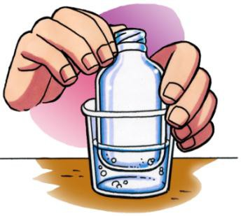
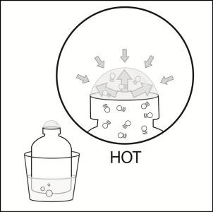
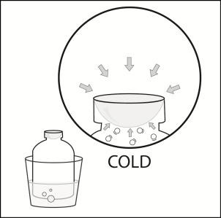

Why does a bubble form on the top of the bottle placed in hot water?
The molecules of air inside the bottle move faster and push the inside of the bubble film harder than they did before. When the push from the air inside the bubble is stronger than the push from the air outside of the bubble, a bubble forms.

Why does the bubble shrink when the bottle is placed in cold water?
The molecules of air inside the bottle move slower and do not push the inside of the bubble film as hard as they did before. When the push from the air outside is stronger, the bubble is pushed down.

