Chapter 1, Lesson 3: The Ups and Downs of Thermometers
Key Concepts
- The way a thermometer works is an example of heating and cooling a liquid.
- When heated, the molecules of the liquid in the thermometer move faster, causing them to get a little farther apart. This results in movement up the thermometer.
- When cooled, the molecules of the liquid in the thermometer move slower, causing them to get a little closer together. This results in movement down the thermometer.
Summary
Students will look closely at the parts of a thermometer. After placing a thermometer in hot and cold water, students will look at molecular model animations of the liquid in a thermometer. Students will then draw a model of the molecules of a thermometer after it has been placed in hot and then cold water.
Objective
Students will be able to describe, on the molecular level, why the liquid in a thermometer goes up when it is heated and down when it is cooled.
Evaluation
The activity sheet will serve as the “Evaluate” component of each 5-E lesson plan. The activity sheets are formative assessments of student progress and understanding. A more formal summative assessment is included at the end of each chapter.
Safety
- Be sure you and the students wear properly fitting goggles.
- Students should use care when handling hot tap water.
- When using isopropyl alcohol, read and follow all warnings on the label. Isopropyl alcohol is flammable. Keep it away from any flames or spark sources.
Materials for Each Group
- Student thermometer
- Magnifier
- Cold water
- Hot water (about 50 °C)

ENGAGE

Find out what students know about thermometers.
Hold up an alcohol thermometer and ask students:

Why do you think the liquid in a thermometer moves up and down when it is heated and cooled?
Students should realize that the movement of the liquid in a thermometer is related to the motion of the molecules of the liquid when they are heated and cooled. Remind students that molecules move faster and a little further apart when they are heated. Molecules also move slower and a little closer together when they are cooled.
Tell students that they will apply their understanding of what happens when liquids are heated and cooled to explain how a thermometer works.

Give each student an activity sheet.
Students will record their observations and answer questions about the activity on the activity sheet. The Explain It with Atoms & Molecules and Take It Further sections of the activity sheet will either be completed as a class, in groups, or individually depending on your instructions. Look at the teacher version of the activity sheet to find the questions and answers.

EXPLORE

Do an activity to investigate what makes the liquid in a thermometer go up and down.
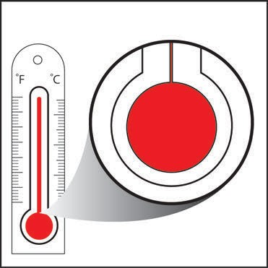
Question to investigate
What makes the liquid in a thermometer go up and down?

Materials for each group
  - Student thermometer
  - Magnifier
  - Cold water
  - Hot water (about 50 °C)

Procedure
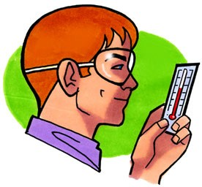
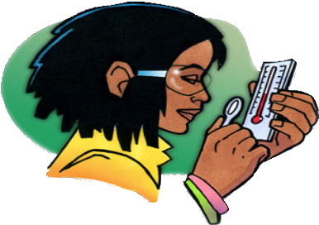
- Look closely at the parts of a thermometer.
  - Look closely at your thermometer. The liquid inside is probably a type of alcohol that’s been dyed red.
  - Practice reading the temperature in °C by having your eye at the same level as the top of the red
liquid. What is the temperature?
  - Use a magnifier to look closely at the thermometer from the front and from the side. Look at the bulb and the thin tube that contains the red liquid.
  - Put your thumb or finger on the bulb and see if the red liquid moves in the thin tube.
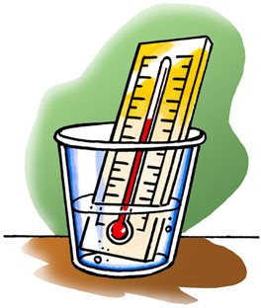
- Observe the red liquid in the thermometer when it is heated and cooled.
- Place the thermometer in hot water and watch the red liquid. Keep it in the hot water until the liquid stops moving. Record the temperature in °C.
- Now put the thermometer in cold water. Keep it in the cold water until the liquid stops moving. Record the temperature in °C.

Expected results
The red liquid goes up in hot water and down in cold water. Students will have an opportunity to relate these observations to an explanation, on the molecular level, of why the liquid moves the way it does.

If you have time, you can have students pick a temperature somewhere
between the temperature of cold water and hot water and then attempt to
combine an amount of hot and cold water to achieve that temperature in one
try. They can see how close they can get.

Record and discuss student observations.
Give students time after the activity to record their observations by answering the following questions on their activity sheet. Once they have answered the questions, discuss their observations as a whole group.

- Based on what you know about the way molecules move in hot liquids, explain why the liquid in the thermometer goes up when heated.
- Based on what you know about the way molecules move in cold liquids, explain why the liquid in the thermometer goes down when cooled.
- Why do you think the tube that contains the red liquid is so thin?
- What do you think is the purpose of the larger outer tube?

When heated, the molecules of the red liquid inside the thermometer move faster. This movement competes with the attractions the molecules have for each other and causes the molecules to spread a little further apart. They have nowhere to go other than up the tube. When the thermometer is placed in cold water, the molecules slow down, and their attractions bring them a little closer together bringing them down the tube. The red liquid is contained in a very thin tube so that a small difference in the volume of the liquid will be noticeable. The large outer tube has two purposes—to protect the fragile inner tube and act as a magnifier to help you better see the red liquid.

EXPLAIN

Show an animation of the molecules of liquid in a thermometer as they are heated and cooled.
Note: Alcohol molecules are composed of different atoms, but in the model shown in the animation the molecules are represented as simple red spheres.
Show the molecular model animation Heating and Cooling a Thermometer. www.acs.org/middleschoolchemistry/simulations/chapter1/lesson3.html
Point out that when the thermometer is heated, the molecules move faster, get slightly further apart, and move up the tube. When the thermometer is cooled, the molecules move more slowly, get closer together, and move down the tube. Help students realize that the attractions the molecules in the thermometer have for each other remain the same whether the thermometer is heated or cooled. The difference is that when heated, the molecules are moving so fast that the movement competes with the attractions, causing the molecules to move further apart and up the tube. When cooled, the movement of the molecules is slower and does not compete as much with the attractions the molecules have for one another. This is why the molecules in the thermometer move closer together and down the tube.
Ask students:

The animation shows that the molecules spread out slightly when heated. Do you think the thermometer would work as well if the tube of red liquid were wider?
The molecules spread out in all directions when heated. If the tube were wide, the molecules would be free to spread out sideways as well as up. In the thin tube, the molecules can’t move very far sideways, so they go up. This causes a greater difference in the height of the liquid, which is easier to see.

Have students draw a molecular model to represent the molecules of the liquid in a thermometer.
Project the image Molecules in a Thermometer.
www.acs.org/middleschoolchemistry/simulations/chapter1/lesson3.html
In the drawing, lines have been added to indicate the level of the liquid in each tube. In reality, there is no line. The “line” is made up of molecules. Students should draw circles representing molecules all the way up to the line drawn in each tube.
Have students use the projected illustration as a guide as they draw a model of the molecules in a hot and cold thermometer on their activity sheet.

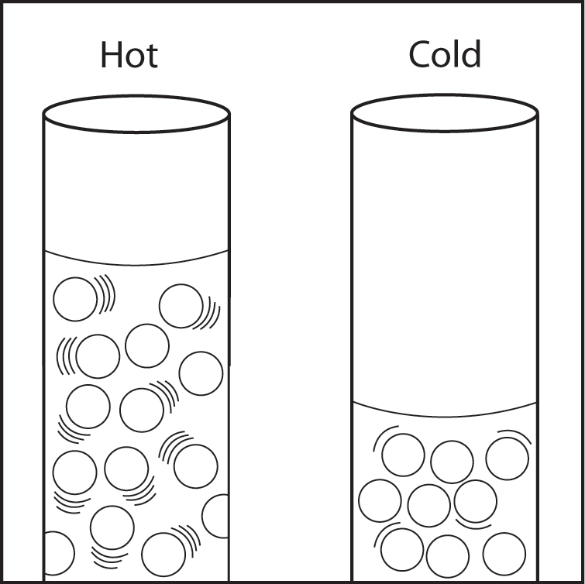
The Hot Thermometer illustration should show random circles with more motion lines. The circles should be a little further apart than in the cold thermometer.

The Cold Thermometer should show random circles with fewer motion lines. The circles should be a little closer together than the circles in the hot thermometer.

EXTEND

Discuss with students why thermometers with different liquids in them rise to different heights even at the same temperature.
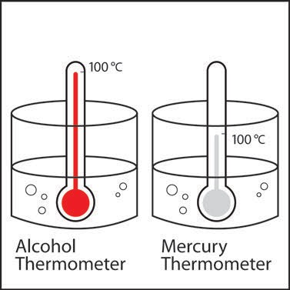
Project the image Different Thermometers Same Temperature. www.acs.org/middleschoolchemistry/simulations/chapter1/lesson3.html
Tell students that this picture shows two thermometers that are identical in every way, except one has alcohol and the other has mercury inside. Point out that both thermometers are placed in hot water that is 100 °C. The levels of the alcohol and mercury are shown.

Ask students:

How can the liquids in the thermometers be at different levels even though they are in water that is the same temperature?
Hint: Alcohol and mercury are both liquids but are made of different atoms and molecules. Use what you know about the motion and attractions the particles in a liquid have for one another to explain why the levels of alcohol and mercury in the thermometers are different.
The main reason why the level of liquid in each thermometer is different is that they are different substances with different properties. The molecules that make up the alcohol have different attractions for each other than the atoms that make up the mercury. Therefore, heating and cooling them are going to make them move different distances up or down the tube.
After the class discussion, have students write their own response to the question about the two different thermometers on the activity sheet.

