Test Bank - Chapter 2
The questions in the test bank cover the concepts from the lessons in Chapter 2. Select questions from any of the categories that match the content you covered with students. The types of questions include multiple choice, true/false, fill-in-the-blank, and short answer.

Multiple Choice

- In the process of conduction
  - Energy is transferred from a substance at a lower temperature to a substance at a higher temperature
  - Energy is transferred from a substance at a higher temperature to a substance at a lower temperature
  - The amount of energy is increased
  - Both substances get hotter

- In the process of conduction
  - Fast-moving particles get larger
  - Slow-moving particles get smaller
  - Fast-moving particles transfer energy to slower-moving particles
  - Slow-moving particles transfer energy to faster-moving particles

- A water molecule is made up of
  - One oxygen atom and two hydrogen atoms
  - One hydrogen atom and two oxygen atoms
  - Many different molecules of oxygen
  - Two hydrogen atoms and two oxygen atoms

- Water molecules attract each other because there is an attraction between
  - The oxygen atoms from different water molecules
  - The oxygen of one water molecule and the hydrogen of another
  - The hydrogen atoms from different water molecules
  - The nucleus of two water molecules

- When water evaporates
  - Water molecules separate into one oxygen atom and two individual hydrogen atoms
  - The motion of water molecules causes them to stay in the liquid
  - The motion of water molecules causes them to leave the liquid and become a gas
  - The water increases in mass

- Hot water evaporates faster than room-temperature water because:
  - Molecules of hot water are lighter
  - More water molecules move fast enough to break away from other water molecules
  - Room temperature water has more mass
  - The molecules in room temperature water are moving faster

- When water vapor condenses
  - Water vapor changes from a liquid to a gas
  - One oxygen and two hydrogen atoms join to form a water molecule
  - Water vapor changes from a gas to a liquid
  - The water molecules spread further apart

- Cooling water vapor makes it condense faster because
  - Cooling the vapor causes the molecules to get further apart
  - The molecules slow down and their attractions bring them closer together
  - Colder temperatures speeds up the molecules
  - Water vapor is less dense than liquid water

- When water freezes, liquid water turns to solid ice mainly because
  - The water molecules get harder
  - The molecules move slowly enough that their attractions keep them in fixed positions
  - All liquid water eventually becomes ice
  - Ice can float on water

- Different liquids have different freezing points mainly because
  - Freezers are at different temperatures
  - Some winters are colder than others
  - The less liquid you use, the faster it freezes
  - Molecules of different liquids have a different amount of attraction for each other

- Ice melts to become liquid water mainly because
  - The water molecules move fast enough to break out of their fixed positions
  - Water molecules slow down so much that they melt
  - Water molecules react with oxygen to produce melting
  - Ice is less dense than water

- If you compare ice and liquid water on the molecular level, you could say that
  - The molecules in liquid water are closer together
  - The molecules in ice are closer together
  - The molecules in ice slide past each other
  - The molecules in liquid water are smaller

Chapter 2
Multiple Choice Answers

- b  - c  - a  - b  - c  - b | - c  - b  - b  - d  - a  - a

True/False and Fill-in-the-blank

True or false?
When fast-moving atoms or molecules hit slower-moving atoms or molecules and cause them to move faster, energy is transferred. The energy that is transferred is called heat. True

Energy can be added or removed from a substance through a process called
. conduction

True or false?
Adding energy has no effect on the rate of evaporation. False

To conduct a valid experiment, variables need to be identified and . controlled, or kept the same

True or false?
Condensation is the process in which molecules of a gas spread very far apart. False

True or false?
Making water vapor colder increases the rate of condensation. True

is the process that causes a substance to change from a liquid to a solid. Freezing

True or false?
The molecules in liquid water are closer together than they are in ice. True

True or false?
Dry ice can change directly from a solid to a gas. True

True or false?
The process of changing to a gas from a solid is called sublimation. True

If you placed a piece of hot metal in cold water, the temperature of the metal will while the temperature of the water will . decrease, increase

Short Answer

Briefly explain how the process of conduction works.
Conduction happens when a hot thing touches a colder thing. The faster moving particles of the hot thing bump into the particles of the colder thing which makes them move faster which makes the cold thing warmer and the hot thing cooler.

Imagine that you place a room temperature metal spoon in a cup of hot soup. Draw motion lines for the spoon and the soup in both pictures to show how the motion or the molecules changes when a room temperature spoon is placed in a cup of hot soup.
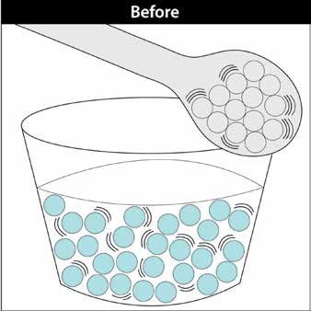
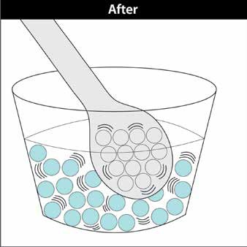

What happens to the motion of the atoms in the spoon after it is placed in hot soup? They move faster.

After placing the spoon in the hot soup, do the molecules in the soup move faster, slower, or move at about the same speed? They move slower.

How is the temperature of a substance related to the speed of its atoms or molecules?
A substance with a higher temperature has faster-moving molecules. A substance with a lower temperature has slower-moving molecules.

Describe how heat is transferred when you touch a piece of ice with your finger?
Heat moves from your finger into the ice, making your finger a little cooler and the ice a little warmer.
Or
When you touch ice, the faster molecules from your finger strike the molecules in the ice making them move faster. The molecules in your skin slow down.

How can room temperature water evaporate?
Even though the water is at room temperature, some molecules are moving pretty fast and some are moving pretty slowly. Some of the fast-moving molecules are moving fast enough to break away from other molecules and evaporate.

What does it mean to “control a variable” in an experiment? Give an example.
“Controlling a variable” means that you try to keep everything about the experiment the same except for the one thing you are trying to find out about. If you are trying to see if temperature affects the rate of evaporation, you would keep the amount of water and the surface you put the water on the same. These are variables that you would control by keeping them the same. The only thing you would change would be the amount of heat you apply to the water.

Why is it important to control variables when conducting an experiment?
By controlling variables, you can tell if the thing you are testing actually was the cause of the result. If you didn’t control the variables, other things could cause the result you see and you couldn’t be sure if it was the thing you were testing or something else.

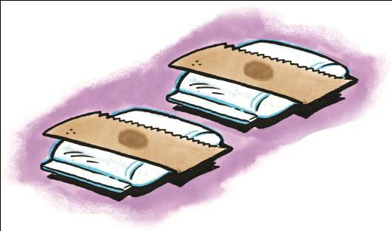
Imagine that you place a drop of water on each of two paper towels. Then you place one on a bag of hot water and the other on a bag of room temperature water. Which drop will evaporate first? Why?
The drop on the bag of warm water will evaporate first because more of the molecules have enough energy to break away from the other water molecules.

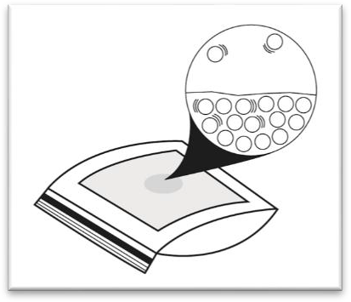
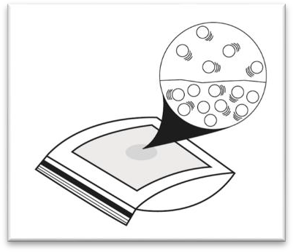
Write a caption beneath the illustration to describe how differences in molecular motion cause one of the drops to evaporate first. Label each illustration to show which is an example of the drop that has been warmed and which has been cooled.
Room-temp
Hot

Adding energy speeds molecules up. Evaporation happens faster because more of these faster- moving molecules have enough energy to break away from the other molecules and go into the air.

Briefly explain why cooling water vapor increases the rate of condensation.
Cooling water vapor causes the water molecules to slow down. Water molecules are very attracted to one another so slowing them down allows their attractions to bring them closer together and causes them to change from a gas to a liquid.

On days when the air is humid, tiny droplets of water appear on the outside of a glass of cold water. Use the ideas of motion and attractions between water molecules to explain how this liquid forms.
Water molecules in the air around the cold cup slow down. Because they aren’t moving as fast, the attractions water molecules have for each other pull them close together, forming liquid water.

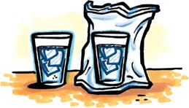
In this experiment, one cup of cold water is placed in a plastic bag. The bag is sealed while as much air as possible is removed from it. How does this experimental design test whether the moisture that appears on the outside of a cold cup, comes from the air or not?
The cup in the bag has less air and therefore fewer water molecules around it. If water from the air causes moisture to appear on the outside of a cold cup, the cup with less air around it should have less moisture on it.

Is this a description of water molecules during evaporation or condensation?

- When water molecules in the air slow down so much that their attractions overcome their speed, they join together forming liquid water.
, condensation

- When water molecules speed up so much that their speed overcomes their attractions, they break away from other water molecules and become water vapor.
, evaporation

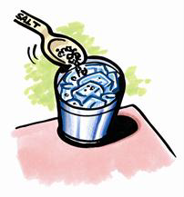
If you place ice and salt in a metal can, the can will become so cold that frost may form on the outside of the can if the air is humid enough. Use the ideas of motion and attractions between water molecules to explain how this frost forms.
Water molecules in the air around the cold can slow down. Because they are moving more slowly, the attractions water molecules have for each other pull them together to form ice.

Why does water expand when it freezes?
Water expands when it freezes because the water molecules arrange themselves according the attractions between the oxygen atom of one water molecule with the hydrogen atom of another. These attractions and the shape of the water molecule cause the water molecules to be further apart in their fixed positions in ice than they were in liquid water.

Different liquids have different freezing points. Why?
The molecules that make up different liquids have their own attractions for one another. When different liquids are cooled, the molecules slow down and their different attractions cause the liquids to freeze at different temperatures.

What is the difference between the way regular ice and dry ice change when heated?
Regular ice made out of water melts and becomes a liquid. But dry ice, made out of carbon dioxide, doesn’t melt to form a liquid. Instead it changes from a solid directly to a gas.

Write labels beneath each of the illustrations below to show which one represents water and which one represents ice.

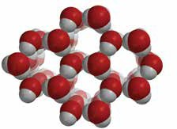
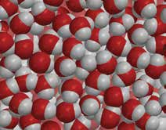
Water
Ice

If you are going to place a bottle of water in the freezer, you should not fill the bottle completely. Instead, you should leave some space at the top and then tighten the cap. Explain why it is best to leave some space at the top.
Water takes up more space when it is frozen than when it is a liquid. Leaving some space at the top of the bottle gives the ice room to expand. If you fill the bottle all the way and seal it tightly, the bottle might burst.

Different substances have different freezing points. For example, water freezes
at 0 °C and carbon dioxide freezes at -78.5 °C.
Are the attractions water molecules have for each other stronger or weaker than the attractions between molecules of carbon dioxide?
The attractions between water molecules are stronger than the attractions molecules of carbon dioxide have for each other.

In your experiment to see if you could figure out a way to make ice melt faster, you were required to use two pieces of ice. Why?
One piece of ice was the control. This way we could tell if your method made a difference in the rate the ice melted or not.

Write the words evaporation, condensation, freezing, or melting near each red or blue arrow to correctly name the processes as water changes state from one form to another.
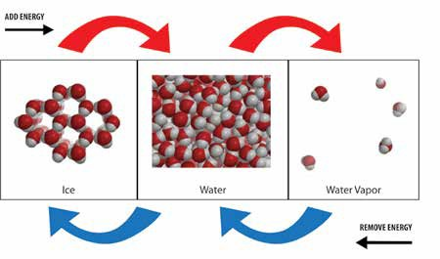
melting
evaporation
condensation
freezing

Use the chart to compare the movement, arrangement, and space between water molecules in the different states.

Compare water molecules in different states
 | Ice | Water | Water vapor
Speed of molecules | slower | medium | faster
Amount of movement | Vibrate | slide past each other | can bounce off each other
Arrangement of molecules | orderly | random | random
Distance between molecules | slightly further apart than water | close together | very far apart

Describe how the motion and arrangement of water molecules change as ice is warmed and begins to melt.
As ice is warmed, water molecules begin to vibrate faster. Some of them have enough energy to slide past each other. As they do, the very orderly arrangement of water molecules in ice becomes more random.

Why does dry ice sublimate faster in hot water than in cold water?
Hot water gives more energy to the molecules of carbon dioxide gas so more of them move faster and can move away from each other to become a gas.

