Activity Sheet Answers
Chapter 2, Lesson 5
Changing State—Melting

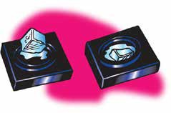
DEMONSTRATION

- You watched a piece of ice melt. Where do you think the energy came from to melt the ice?
The energy that melted the ice is in the black metal and foam squares which are both at room temperature. The metal is a better conductor than the foam so energy is transferred from the metal to the ice faster than from the foam to the ice.

- What do you think happened to the speed of the molecules in the ice when it was heated?
When the ice is heated, the water molecules in the ice move faster.

ACTIVITY

3. Write down the steps in your procedure under “Procedure” below. Check with your teacher before conducting your experiment.
Experiments will vary. Some groups may put ice in water, some might hold ice in their hand or use some other heat source.

4. Does your method make ice melt faster? How do you know?
Student answers will vary depending on the experiment they conducted and the observations they made.

EXPLAIN IT WITH ATOMS AND MOLECULES

5. Write a caption underneath each picture to explain how the motion and arrangement of the water molecules changes as ice melts.
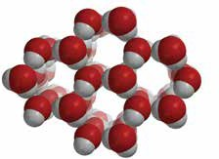
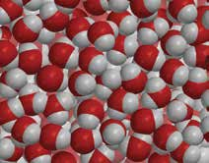

Ice: Energy causes the molecules to move faster. Eventually their motion overcomes the attraction keeping them in fixed positions and the crystal structure of the ice collapses.

Liquid Water: As liquid water, the molecules are closer together and able to slide past each other.

6. Look at the diagram below representing the motion and arrangement of the molecules of a substance (not water) when it is a solid, a liquid, and a gas. Write the name of the state change that takes place on each curved arrow.

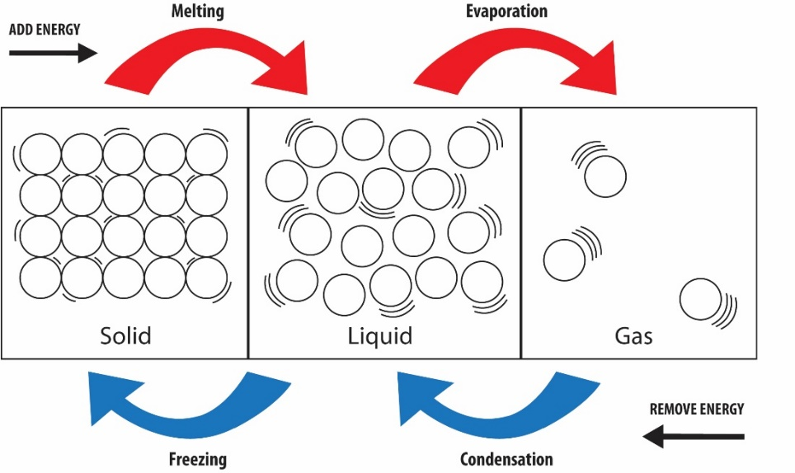

7. The following diagram uses the space-filling model of water to represent the arrangement of water molecules when it is a solid, liquid, and a gas.
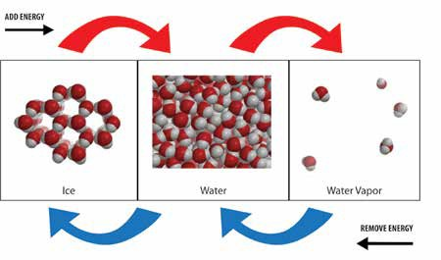

a. How are the state changes of water similar to the state changes in most other substances?
The state change from solid to liquid in water is similar to most other substances in some ways but different in others. When energy is added, molecules of the solid change from being in fixed positions to being able to move past one another. This is true for water and other substances.

b. How are state changes of water different from the state changes in most other substances?
But water is different than most other substances because the molecules in liquid water are closer together than in solid ice. In most other substances, the molecules of the liquid are a little further apart than the molecules of the solid. The state change from liquid to gas is similar in water as most other substances.

TAKE IT FURTHER

8. Do regular ice and dry ice melt in the same way? How do you know?
Regular ice made from water changes from a solid to a liquid by melting. But dry ice made from carbon dioxide does not change from a solid to a liquid. It changes from a solid directly to a gas. This is called sublimation. You can tell because it doesn’t leave any wet spot on a paper towel.
9. You saw that the dry ice sublimates very quickly in water. Why does it sublimate even faster in hot water?
Dry ice changes from a solid to a gas (sublimates) when energy is transferred to it. More energy is transferred to dry ice in hot water than in room temperature water, so it changes to a gas faster.

