Activity Sheet Name
Chapter 3, Lesson 2
Finding Volume—The Water Displacement Method Date

DEMONSTRATION
Think about the longest, middle-sized, and shortest rods your teacher showed you. All these samples have the same mass, but their volumes are different.

- Predict the densities of each sample by writing an answer from beneath the box on the line next to each sample.

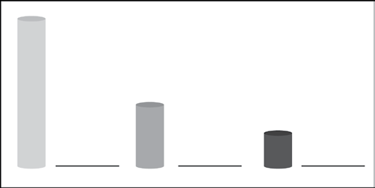
Most dense Medium dense Least dense

- Explain why you think each rod is either the most, medium, or least dense.

- The animation showed you how to find the volume of a sample using the water displacement method.

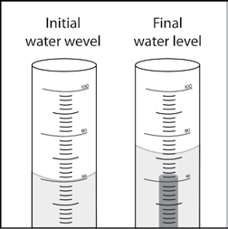
Look at the illustrations showing the water level in a graduated cylinder before and after a sample is submerged in water. What does this difference in water level tell you about the sample?

How much would the water level rise if you submerged a cube with a volume of 1 cm³ in a graduated cylinder filled with 40 mL of water?

- What is the density of the sample described below? Be sure to write the units in g/cm³.

  - Water level rose from 60 mL to 85 mL
  - Mass = 50 g

ACTIVITY

Your group will work with five rods each with the same mass but made of a different material. Carefully measure the volume of each sample and calculate the density. Then use density to correctly identify each of the five samples.
Hint: the volume of the smallest rod is between 1.5–2.0 cm3.

Question to investigate
Can you use density to identify all five rods?

Materials for each group
- Set of five different rods that all have the same mass
- Graduated cylinder, 100 mL
- Water in a cup
- Calculator

Procedure

Volume
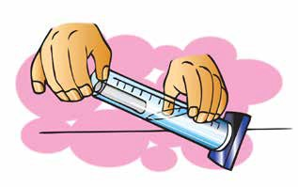
- Pour enough water from your cup into the graduated cylinder to reach a height that will cover the sample. Read and record the volume.
- Slightly tilt the graduated cylinder and carefully place the sample into the water.
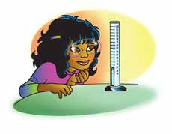
- Place the gradated cylinder upright on the table and look at the level of the water. If the sample floats, use a pencil to gently push the top of the sample just under the surface of the water. Record the number of milliliters for this final water level.
- Find the amount of water displaced by subtracting the initial level of the water from the final level. This volume equals the volume of the cylinder in cm³.
- Record this volume in the chart on the activity sheet.
- Remove the sample by pouring the water back into your cup and taking the sample out of your graduated cylinder.

Density
- Calculate the density using the formula D = m/v. Record the density in (g/cm³).
- Trade samples with other groups until you have measured the volume and calculated the density of all five samples.

Sample | Initial water level (mL) | Final water level (mL) | Volume of the rods (cm³) | Mass (g) | Density (g/cm³)
A |  |  |  | 15.0
B |  |  |  | 15.0
C |  |  |  | 15.0
D |  |  |  | 15.0
E |  |  |  | 15.0

Identify the samples
- Compare the values for density you calculated to the values in the chart. Then write the letter name for each sample in the chart.

Material | Approximate density (g/cm³) | Sample (Letters A–E)
Brass | 8.8
Aluminum | 2.7
PVC | 1.4
Nylon | 1.2
Polyethylene | 0.94

- On the first page of this activity sheet, you made a prediction about the density of a small, medium, and long rod. Based on your calculations for density in your chart, were your predictions correct? If a short rod and a long rod have the same mass, explain why the short one will be more dense than the long one.

EXPLAIN IT WITH ATOMS & MOLECULES

The difference in density between the small, medium, and large rods can be explained based on the atoms and molecules they are made from. Refer to the chart of atomic size and mass to answer the following question about each substance.

- Polyethylene is made of carbon and hydrogen atoms. Polyvinyl chloride is also made of carbon and hydrogen atoms, but also has chlorine atoms.

Look at the size and mass of these atoms in the chart to explain why polyvinyl chloride is more dense than polyethylene.

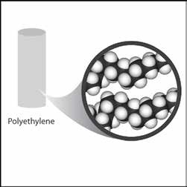
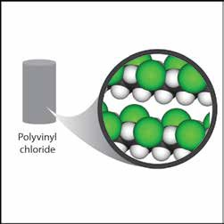

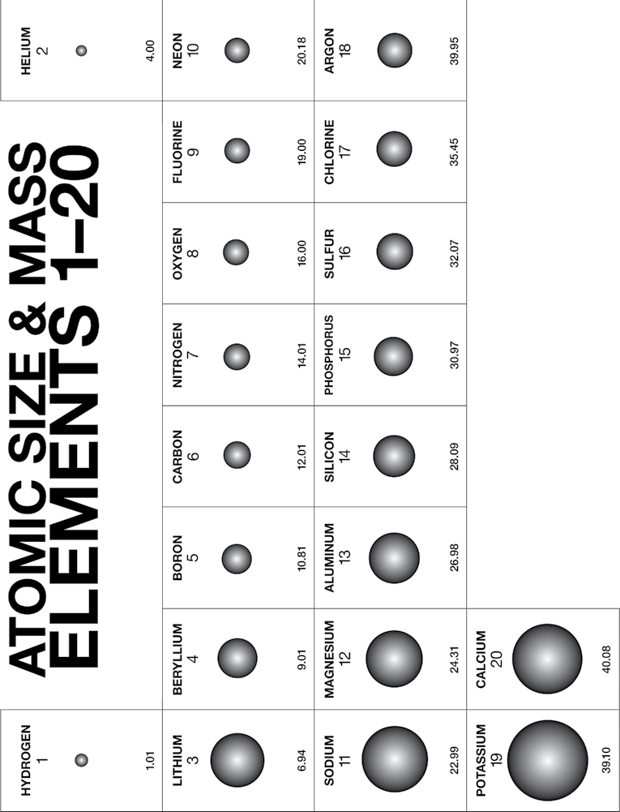

- Brass is made of copper and zinc atoms. These atoms are pretty heavy for their size, but they are also packed together differently than the molecules of the plastics. How does the way these atoms pack together help make the brass more dense than the plastics?

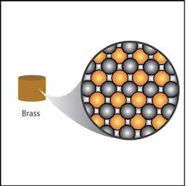

TAKE IT FURTHER
- Based on the Atomic Size and Mass chart, a calcium atom is both bigger
and heavier than a sulfur atom. But a piece of solid sulfur is more dense than a solid piece of calcium. In fact, sulfur is about 2 g/cm³, and calcium is about 1.5 g/cm³.

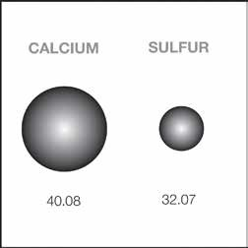

Based on what you know about the size, mass, and arrangement of atoms, explain why a sample of sulfur is more dense than a sample of calcium.

