Activity Sheet Name Chapter 4, Lesson 1
Protons, Neutrons, and Electrons Date

INTRODUCTION

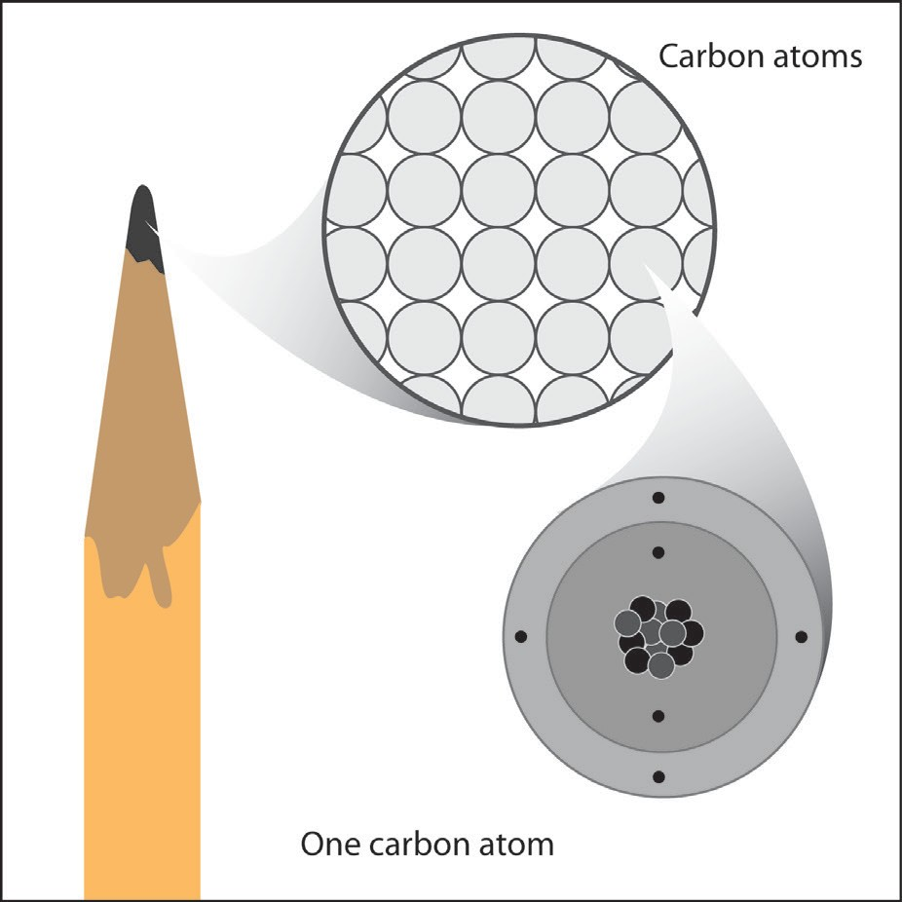
If you look closely at the tip of a sharpened pencil, you will see that it is made of graphite. Going deeper, graphite is made of carbon atoms. Deeper still, each carbon atom is made of protons, neutrons, and electrons. In this lesson, you will explore these subatomic particles and their charges.

- Label the nucleus (protons, neutrons) and electrons in the drawing of the carbon atom.
- Draw a line between the subatomic particle and its charge.

proton no charge
electron positive charge
neutron negative charge

- Would the following subatomic particles attract each other or repel one another?
Two protons ___
Two electrons ___
A proton and an electron ___

ACTIVITY

Question to investigate
What makes objects attract or repel each other?

Materials for each group
- Plastic grocery bag
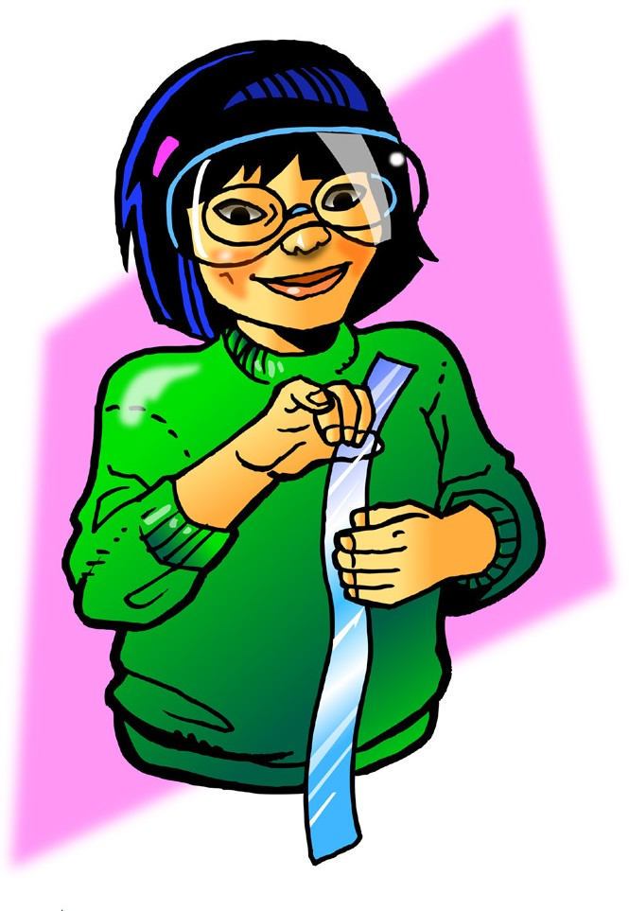
- Scissors

Procedure, part 1
Charged plastic and charged skin
  - Cut 2 strips from a plastic grocery bag so that each is about 2–4 cm wide and about 20 cm long.
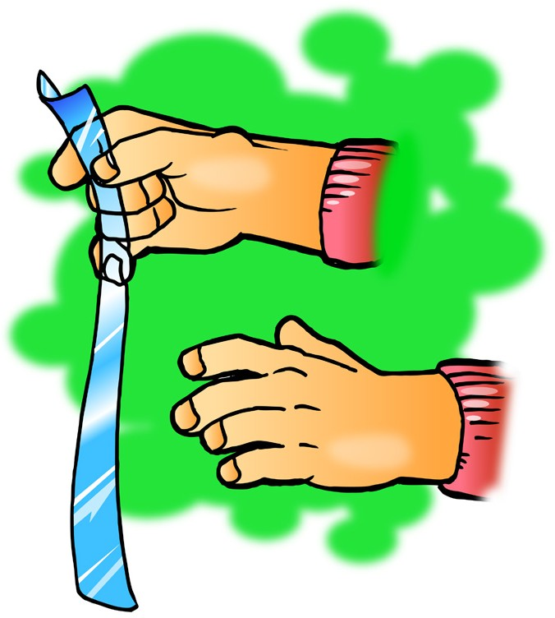
  - Hold the plastic strip firmly at one end. Then grasp the plastic strip between the thumb and fingers of your other hand as shown.
  - Quickly pull your top hand up so that the plastic strip runs through your fingers. Do this three or four times.
  - Allow the strip to hang down. Then bring your other hand near it.
  - Write “attract” or “repel” in the chart on the next page and explain why this happened.
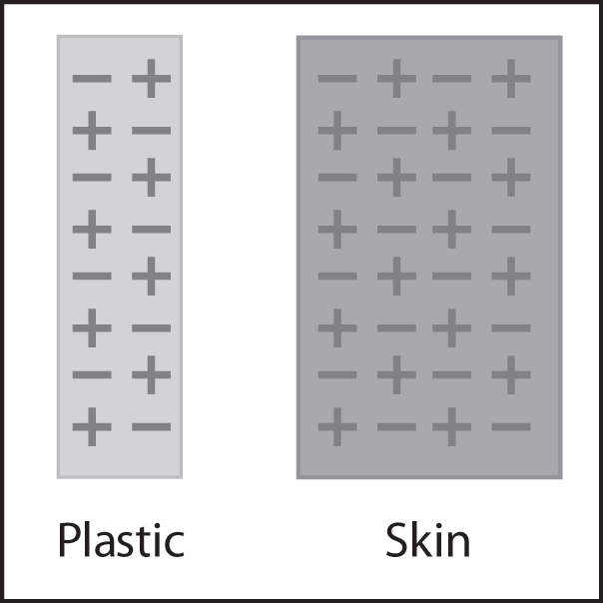
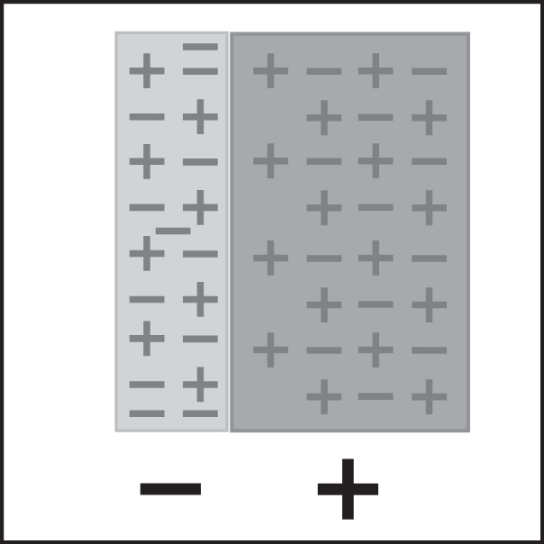
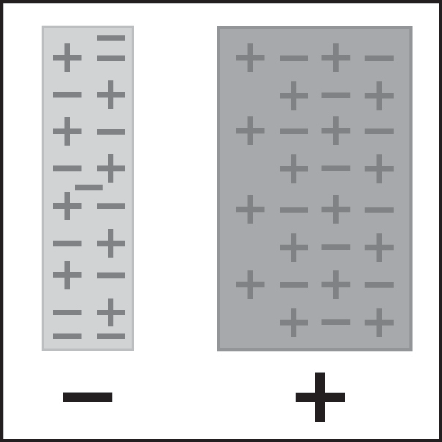
Protons and electrons before rubbing
Protons and electrons after rubbing

Opposites attract

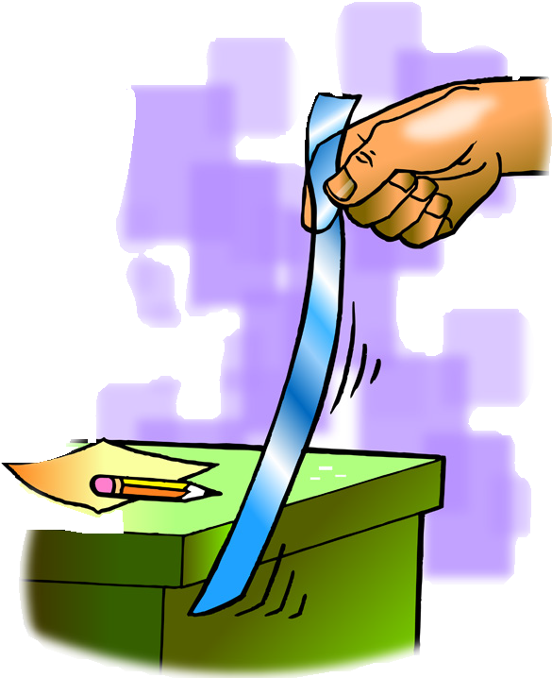
Procedure, part 2
Charged plastic and neutral desk
- Charge one strip of plastic the same way you did previously.
- This time, bring the plastic strip toward your desk or chair.
- Write “attract” or “repel” in the chart on the next page and explain why this happened.
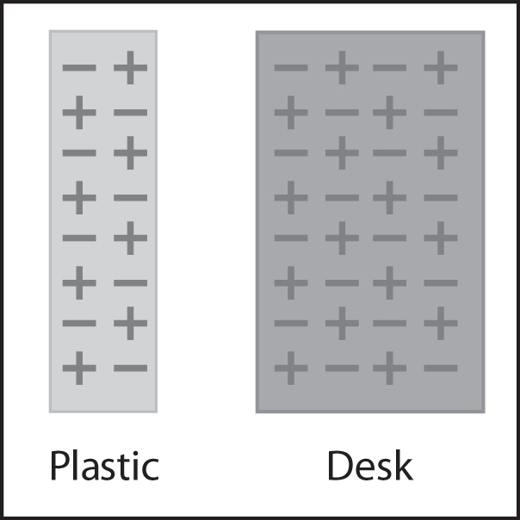
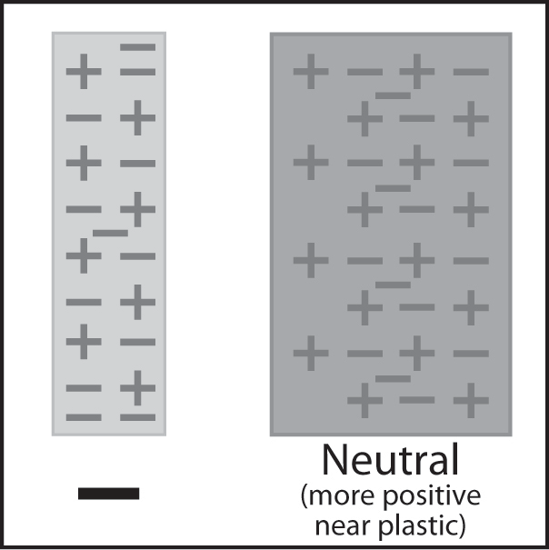
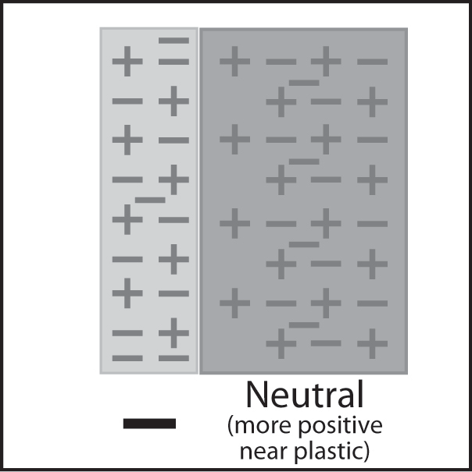
Protons and electrons before rubbing
Protons and electrons after rubbing

Procedure, part 3
2 pieces of charged plastic
- Charge two strips of plastic the way you did previously.
- Slowly bring the two strips of plastic near each other.
- Write “attract” or “repel” in the chart and explain why this happened.
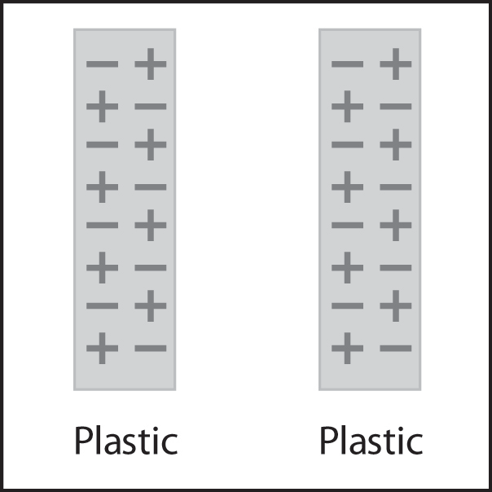
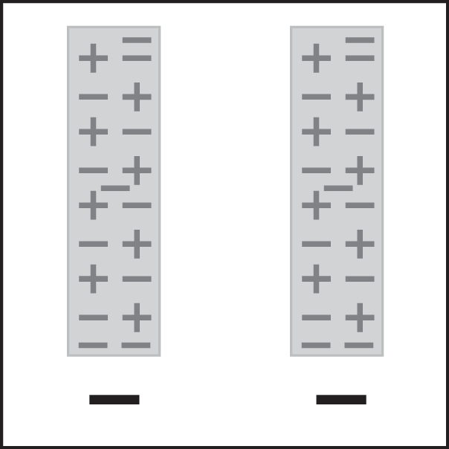
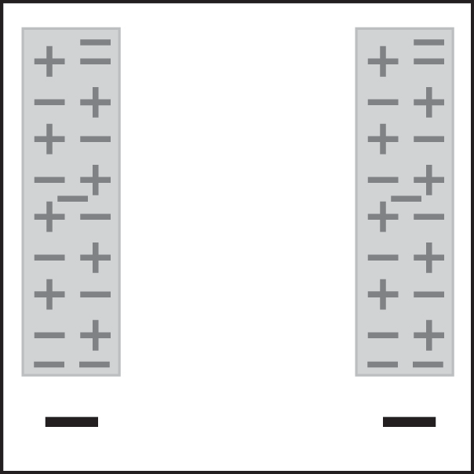
Protons and electrons before rubbing
Protons and electrons after rubbing

EXPLAIN IT WITH ATOMS & MOLECULES
- Describe what happened with the electrons and charges to explain your observations in the last box in the chart.
What happened when you brought the following materials near each other?
Materials | Attract or Repel | Use what you know about electrons, protons, and charges to explain your observations
charged plastic + charged skin
charged plastic + neutral desk
charged plastic + charged plastic

TAKE IT FURTHER

Materials for each group
  - Inflated balloon
  - Small pieces of paper, confetti-size

Procedure
  - Rub a balloon on your hair or clothes.
  - Bring the balloon slowly toward small pieces of paper.

- Write captions beneath each picture explaining what happened between the balloon and your hair and the balloon and the paper in the activity.

