Activity Sheet Name Chapter 4, Lesson 2
The Periodic Table Date

Your group will receive a set of cards with information that describes a particular atom. Your job is to figure out which atom the card describes and to place it in the area in your classroom for that atom.

You will use the Periodic Table, Elements 1–20 chart to help you determine what atom your card describes. The diagram and information below will help you match your cards to the correct atoms.
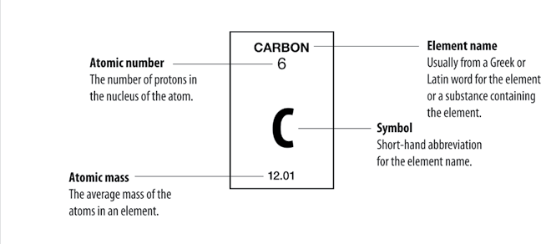

Parts of an Atom
Proton
Positively charged particle in the nucleus of the atom.
The number of protons in an atom’s nucleus is the atom’s atomic number.

Electron
Negatively charged particle surrounding the nucleus of the atom.
The number of electrons surrounding the nucleus of an atom is equal to the number of protons in the atom’s nucleus.

Neutron
Particle in the nucleus that has about the same mass as a proton but has no charge. For the atoms of the first 20 elements, the number of neutrons is either equal to or slightly greater than the number of protons.

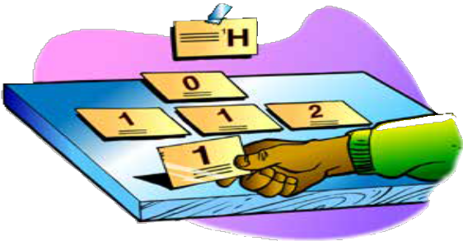
Placing your cards

Once you know what the information in each box on your periodic table stands for and you know the parts of the atom, you will be able to correctly place most of your cards with the atoms they describe. You will need to know the following additional information in order to answer any question having to do with neutrons.

To match the number of neutrons listed on your card to the correct element, look for an element on the periodic table so that if you add
the number of neutrons on your card to the protons of the element, you will get close to the atomic mass for that element.

For example, you may have a card that says, “The atom you are looking for has 5 neutrons.” Look at the periodic table to find an atom that you could add 5 to its number of protons that would give you a sum close to the atomic mass given for that element. The answer is beryllium (Be), which has 4 protons and an atomic mass of 9.01.

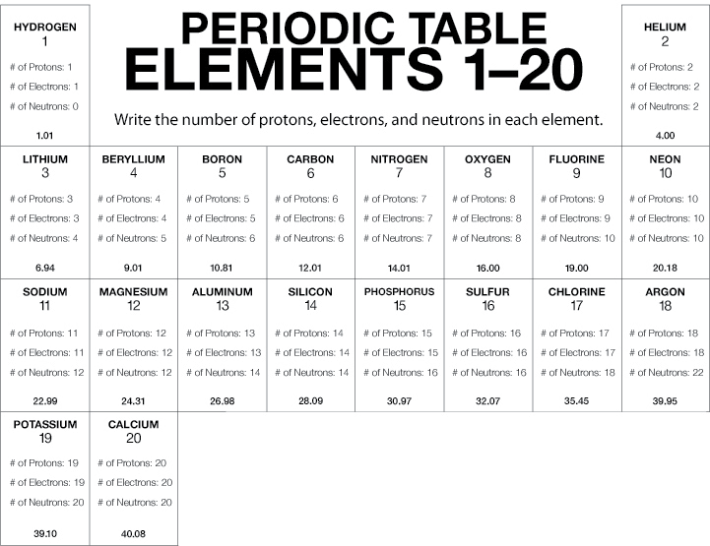

Note: Remember that the number of neutrons is not the same for every atom of an element. The number of neutrons you write in this chart will be a number, that when added to the number of protons, gives a sum as close as possible to the atomic mass.

