Activity Sheet Name Chapter 4, Lesson 4
Energy Levels, Electrons, and Covalent Bonding Date

EXPLAIN IT WITH ATOMS & MOLECULES
- Write a short caption under each picture to describe the process of covalent bonding.
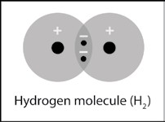
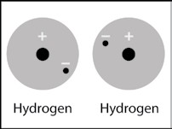
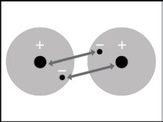
Two hydrogen atoms are near each other.

- What are two conditions atoms must have to form covalent bonds with one another?

- Why is a hydrogen molecule (H₂) more stable than two individual hydrogen atoms?

- Why can’t a third hydrogen atom join the H₂ molecule to make H₃
- Write a short caption beside each picture to describe the process of covalent bonding.

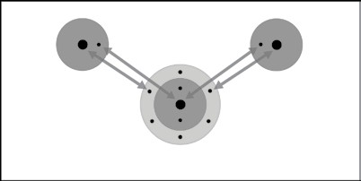
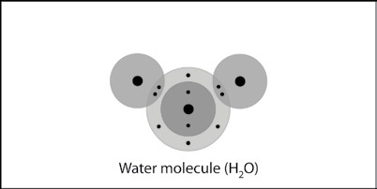
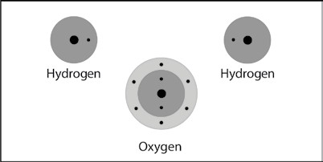
Two hydrogen atoms and one oxygen atom are near each other.

- Why can’t a third hydrogen atom join the water molecule (H₂0) to make H₃O?

ACTIVITY

Question to investigate
What is produced when electricity is put into water?

Materials for each group
  - 9-volt battery
  - 2 wires with alligator clips on both ends
  - 2 pencils sharpened at both ends
  - Water
  - Epsom salt (magnesium sulfate)
  - Clear plastic cup
  - Tape

Procedure
- Place a battery between 2 pencils. Be sure that the battery is more than half-way up.
- With the help of a partner, wrap tape around the pencils and battery as shown.
- Add water to a clear plastic cup until it is about ½-full.
- Add about a ½ teaspoon of Epsom salt to the water and stir until the salt dissolves.
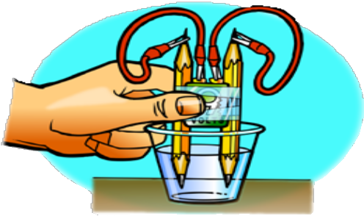
- Connect one alligator clip to one terminal of the battery.
- Using the other wire, connect one alligator clip to the other terminal of the battery.
- Connect one end of the pencil lead to the alligator clip at the end of one of the wires.
- Using the other wire, connect one end of the other pencil lead to the alligator clip at the end of the wire.
- Place the ends of the pencil into the water as shown.

- What were the bubbles made out of in this activity?
- Why was there more hydrogen gas produced than oxygen gas?
HINT: Look back at the drawings showing the number of hydrogen and oxygen atoms that bond to form a water molecule.

TAKE IT FURTHER

- Briefly describe the process of covalent bonding between two oxygen atoms to make an oxygen molecule. Be sure to mention attractions between electrons and protons and the number of electrons in the outer energy level for the atoms in the final molecule.
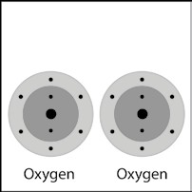
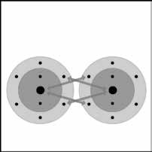
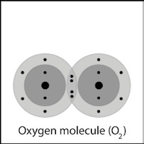
Each oxygen atom has 6 electrons in its outer energy level.

- Briefly describe the process of covalent bonding between the carbon and the four hydrogen atoms to make a methane molecule. Be sure to mention attractions between electrons and protons and the number of electrons in the outer energy level for the atoms in the final molecule.

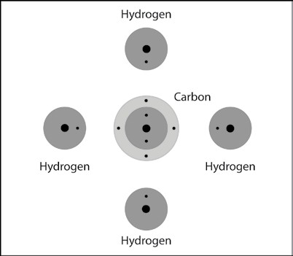
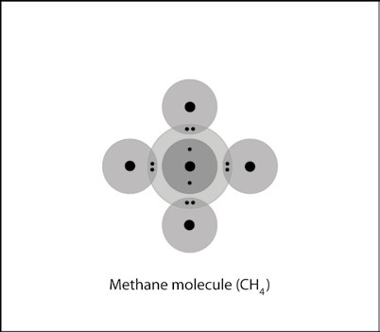

- Briefly describe the process of covalent bonding between the carbon and the two oxygen atoms to make a carbon dioxide molecule. This molecule has two double bonds. Be sure to mention attractions between electrons and protons and the number of electrons in the outer energy level for the atoms in the final molecule.
