Chapter 4, Lesson 4: Energy Levels, Electrons, and Covalent Bonding
Key Concepts
- The electrons on the outermost energy level of the atom are called valence electrons.
- The valence electrons are involved in bonding one atom to another.
- The attraction of each atom’s nucleus for the valence electrons of the other atom pulls the atoms together.
- As the attractions bring the atoms together, electrons from each atom are attracted to the nucleus of both atoms, which “share” the electrons.
- The sharing of electrons between atoms is called a covalent bond, which holds the atoms together as a molecule.
- A covalent bond happens if the attractions are strong enough in both atoms and if each atom has room for an electron in its outer energy level.
- Atoms will covalently bond until their outer energy level is full.
- Atoms covalently bonded as a molecule are more stable than they were as separate atoms.
Summary
Students will look at animations and refer to the energy level models they have been using to make drawings of the process of covalent bonding. Students will consider why atoms bond to form molecules like H₂ (hydrogen), H₂O (water), O₂ (oxygen), CH₄ (methane), and CO₂ (carbon dioxide).
Objective
Students will be able to explain that attraction between the protons and electrons of two atoms cause them to bond. Students will be able to draw a model of the covalent bonds between the atoms in H₂ (hydrogen), H₂O (water), O₂ (oxygen), CH₄ (methane), and CO₂ (carbon dioxide).
Evaluation
The activity sheet will serve as the “Evaluate” component of each 5-E lesson plan. The activity sheets are formative assessments of student progress and understanding.
Safety
Be sure you and the students wear properly fitting goggles.

About this Lesson
This lesson will probably take more than one class period.

Materials for Each Group
- 9-volt battery
- 2 wires with alligator clips on both ends
- 2 pencils sharpened at both ends
- Water
- Clear plastic cup
- Epsom Salt (magnesium sulfate)
- Tape

ENGAGE

Show an animation to introduce the process of covalent bonding.
Introduce the question students will investigate in this lesson:
  - If atoms have an equal number of protons and electrons, why do atoms bond to other atoms? Why don’t they just stay separate?
Begin to answer this question by using hydrogen as an example.

Project the animation Covalent bond in hydrogen.
www.acs.org/middleschoolchemistry/simulations/chapter4/lesson4.html

Make sure students see that each hydrogen atom has 1 proton and 1 electron. Remind students that the electron and its own proton are attracted to each other. Explain that if the atoms get close enough to each other, the electron from each hydrogen atom feels the attraction from the proton of the other hydrogen atom (shown by the double-headed arrow).
Read more about bonding in Teacher Background.

Point out to students that the attractions are not strong enough to pull the electron completely away from its own proton. But the attractions are strong enough to pull the two atoms close enough together so that the electrons feel the attraction from both protons and are shared by both atoms.

At the end of the animation, explain that the individual hydrogen atoms have now bonded to become the molecule H₂. This type of bond is called a covalent bond. In a covalent bond, electrons from each atom are attracted or “shared” by both atoms.

EXPLAIN

Discuss the conditions needed for covalent bonding and the stable molecule that is formed.
Project the image Covalent bond in hydrogen.
www.acs.org/middleschoolchemistry/simulations/chapter4/lesson4.html

Note: This model of covalent bonding for the hydrogen molecule (H₂) starts with 2 individual hydrogen atoms. In reality, hydrogen atoms are never separate to start with. They are always bonded with something else. To simplify the process, this model does not show the hydrogen atoms breaking their bonds from other atoms. It only focuses on the process of forming covalent bonds between two hydrogen atoms.

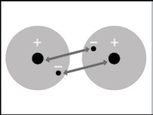
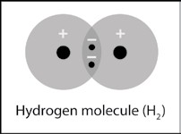
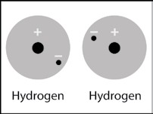
Two hydrogen atoms are near each other.

When two hydrogen atoms get close enough to each other, their electrons are attracted to the protons in the other atom.

Because there is both a strong enough attraction between atoms and room in the outer energy level of both atoms, the atoms share electrons. This is a covalent bond.

Tell students that there are two main reasons why two hydrogen atoms bond together to make one hydrogen molecule:
- There needs to be a strong enough attraction between the electrons of each atom for the protons of the other atom.
- There needs to be room in the outer energy level of both atoms.

Once bonded, the hydrogen molecule is more stable than the individual hydrogen atoms. Explain to students that by being part of a covalent bond, the electron from each hydrogen atom gets to be near two protons instead of only the one proton it started with. Since the electrons are closer to more protons, the molecule of two bonded hydrogen atoms is more stable than the two individual unbonded hydrogen atoms.

This is why it is very rare to find a hydrogen atom that is not bonded to other atoms. Hydrogen atoms bond with other hydrogen atoms to make hydrogen gas (H₂). Or they can bond with other atoms like oxygen to make water (H₂O) or carbon to make methane (CH₄) or many other atoms.

3. Show students that when two hydrogen atoms bond together, the outer energy level becomes full.
Have students look at their Periodic table of energy levels for elements 1–20 distributed in lesson 3.
Explain that the two electrons in the hydrogen molecule (H₂) can be thought of as
“belonging” to each atom. This means that each hydrogen atom now has two electrons in its first energy level. The first energy level in the outer energy level for hydrogen and can only accommodate or “hold” two electrons. Atoms will continue to covalently bond until their outer energy levels are full. At this point, additional atoms will not covalently bond to the atoms in the H₂ molecule.

4. Have students describe covalent bonding in a hydrogen molecule on their activity sheet and then review their answers.
Give each student an activity sheet.
Have students write a short caption under each picture to describe the process of covalent bonding and answer the first three questions. The rest of the activity sheet will either be completed as a class, in groups, or individually, depending on your instructions.
Ask students:
  - What did you write for the second and third pictures of covalent bonding?
Center drawing: When two hydrogen atoms come close enough, their electrons are attracted to the proton of the other atom.
Last drawing: This brings the atoms close enough together that they share electrons.

What are two conditions atoms must have in order to form covalent bonds with one another?
There is a strong enough attraction between atoms and there is room for electrons in the outer energy level of both atoms.

Why is a hydrogen molecule (H₂) more stable than two individual hydrogen atoms?
In the hydrogen molecule, the electrons from each atom are able to be near two protons instead of only the one proton it started with. Whenever negative electrons are near additional positive protons, the arrangement is more stable.

Why doesn’t a third hydrogen atom join the H₂ molecule to make H₃?
When two hydrogen atoms share their electrons with each other, their outer energy levels are full.
You could explain to students that when the outer energy levels are full, sharing electrons with another atom would not happen for two main reasons:
- An electron from a new atom would have to join an atom in the H₂ molecule on the next energy level, further from the nucleus where it would not feel a strong enough attraction.
- An electron from an atom already in the H₂ molecule and close to the nucleus would need to move further away to share with the new atom.

Both possibilities would make the molecule less stable and therefore would not happen.

Discuss the process of covalent bonding in a water molecule.
Project the animation Covalent bond in water.
www.acs.org/middleschoolchemistry/simulations/chapter4/lesson4.html
Before hitting the “play” button, point out the oxygen atom and the two hydrogen atoms. Ask students:

Is there anything that might attract these atoms to one another?
Students should suggest that the electrons from each atom are attracted to the pro- tons of the other atoms.
Play the animation to show the attraction between the protons of oxygen for the electron from each of the hydrogen atoms, the attraction of the proton from the hydrogen atoms for the electrons of oxygen, and the atoms coming together.
Explain that the electrons are shared by the oxygen and hydrogen atoms forming a covalent bond. These bonds hold the oxygen and hydrogen atoms together and form the H₂O molecule. The reason why the atoms are able to bond is that the attractions are strong enough in both directions and there is room for the electrons on the outer energy level of the atoms.
The electron from each hydrogen atom and the electrons from the oxygen atom get to be near more protons when the atoms are bonded together as a molecule than when they are separated as individual atoms. This makes the molecule of bonded oxygen and hydrogen atoms more stable than the individual separated atoms.
Explain to students that the two electrons in the bond between the hydrogen atom and the oxygen atom can be thought of as “belonging” to each atom. This gives each hydrogen atom two electrons in its outer energy level, which is full. It also gives oxygen 8 electrons in its out- er energy level, which is also full.
Project the image Covalent bond in water.
www.acs.org/middleschoolchemistry/simulations/chapter4/lesson4.html
Review with students the process of covalent bonding covered in the animation.

Have students describe covalent bonding in a water molecule on their activity sheet.
Have students write a short caption beside each picture to describe the process of covalent bonding in the water molecule.
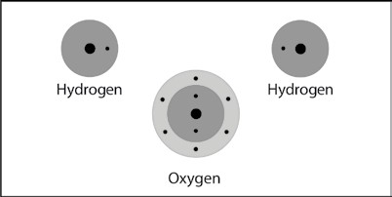
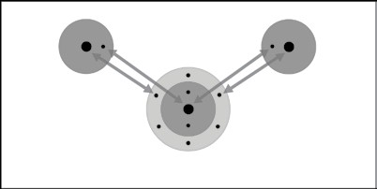
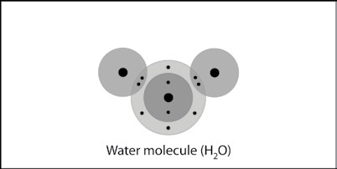
Two hydrogen atoms and one oxygen atom are near each other.
Because there is both a strong enough attraction between atoms and room for electrons in the outer level of the atoms, they share electrons. This forms a covalent bond.
When two hydrogen atoms come close enough to an oxygen atom, their electrons are attracted to the proton of the other atom.

Note: This model of covalent bonding for a water molecule starts with 2 individual hydrogen atoms and 1 oxygen atom. In reality, these atoms are never separate to start with. They are always bonded with something else. To simplify the process, this model does not show the hydrogen and oxygen atoms breaking their bonds from other atoms. It only focuses on the process of forming covalent bonds to make water.

Ask students:
- Why can’t a third hydrogen atom join the water molecule (H₂O) to make H₃O?
Once the outer energy levels are full, sharing electrons with another atom would not happen for two main reasons: An electron from a new atom would have to join an atom in the H₂O molecule on the next energy level, further from the nucleus where it would not feel a strong enough attraction. An electron from an atom already in the H₂O molecule and close to the nucleus would need to move further away to share with the new atom. Both of these possibilities would make the molecule less stable and would not happen.

EXPLORE

Have students use electricity to form oxygen and hydrogen gas from water.
Tell students that electrical energy causes electrons and atoms from water molecules to rearrange and produce hydrogen atoms and oxygen atoms. Two hydrogen atoms bond to form hydrogen gas (H₂) and two oxygen atoms bond to form oxygen gas (O₂).
Note: It is true that in the electrolysis of water, oxygen and hydrogen atoms from water molecules (H₂O) eventually become hydrogen gas (H₂) and oxygen gas (O₂). But this is a multi-step process and not a simple breaking of the covalent bonds in water and immediately reforming new bonds to make the gases. There are several intermediate steps.
You may choose to do this activity as a demonstration or show the video Electrolysis.
www.acs.org/middleschoolchemistry/simulations/chapter4/lesson4.html

Question to investigate
What is produced when electricity is put into water?

Materials for each group
- 9-volt battery
- 2 wires with alligator clips on both ends
- 2 pencils sharpened at both ends
- Water
- Epsom salt (magnesium sulfate)
- Clear plastic cup
- Tape

Procedure
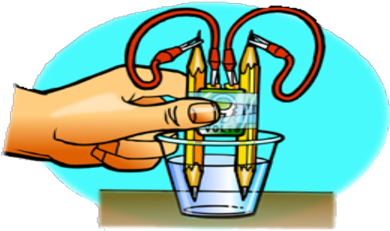
- Place a battery between 2 pencils. Be sure that the battery is more than half-way up.
- With the help of a partner, wrap tape around the pencils and battery as shown.
- Add water to a clear plastic cup until it is about ½-full.
- Add about ½ teaspoon of Epsom salt to the water and stir until the salt dissolves.
- Connect one alligator clip to one terminal of the battery.
- Using the other wire, connect one alligator clip to the other terminal of the battery.
- Connect one end of the pencil lead to the alligator clip at the end of one of the wires.
- Using the other wire, connect one end of the other pencil lead to the alligator clip at the end of the wire.
- Place the ends of the pencil into the water as shown.

Expected results
Bubbles will form and rise initially from one pencil lead. Soon, bubbles will form and rise from the other. Students should be able to see that there is more of one gas than the other. The gas that forms the small bubbles that comes off first is hydrogen. The other gas that forms the larger bubbles and lags behind a bit is oxygen.

Note: There will be bubbling when hydrogen and oxygen gas form on the pencil leads. Be sure students do not get the misconception that the bubbles they see mean that the water is boiling. In boiling, the bonds holding the atoms together in water molecules do not come apart. In the process of electrolysis, the bonds holding the atoms together do come apart.

Discuss student observations.
Ask students:

What are the bubbles made out of in the activity?
Hydrogen gas (H₂) and oxygen gas (O₂)

Why was there more hydrogen gas produced than oxygen gas?
Each water molecule breaks into 2 hydrogen atoms and 1 oxygen atom. Two hydrogen atoms then bond to form hydrogen gas (H₂) and 2 oxygen atoms bond to form oxygen gas (O₂).

Each water molecule has all the atoms needed to make 1 molecule of hydrogen gas. But with only 1 oxygen atom, a water molecule only has half of what is needed to make 1 molecule of oxygen gas. So, 2 water molecules will produce 2 molecules of hydrogen gas but only 1 molecule of oxygen gas.

EXTEND

Help students understand how atoms combine to form the molecules of oxygen, methane, and carbon dioxide.
Remind students that in this lesson they looked at the covalent bonds in hydrogen molecules and in water molecules. Tell them that they will look at the covalent bonds in three other common substances.
Project the animation Oxygen’s double bond.
www.acs.org/middleschoolchemistry/simulations/chapter4/lesson4.html
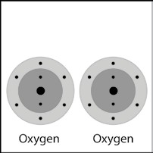
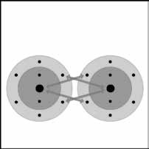
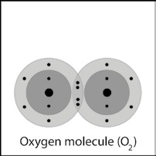
Each oxygen atom has 6 valence electrons in its outer energy level.
When two oxygen atoms get close to each other, the attractions from the nucleus of both atoms attract the outer electrons.

In this case, two electrons from each atoms are shared. This is called a double bond.

Explain to students that the oxygen molecules that are present in our air are made up of 2 oxygen atoms. This animation will show what the covalent bond between 2 oxygen atoms is like.
Narrate the animation by pointing out that:
- Each oxygen atom has 6 valence electrons in its outer energy level.
- When the oxygen atoms get close together, the attractions from the nucleus of both atoms attract the outer electrons from the other atom.
- In this case, 2 electrons from each atom are shared. This is called a double covalent bond.

Project the image Oxygen’s double bond II.
www.acs.org/middleschoolchemistry/simulations/chapter4/lesson4.html
Review with students the process of covalent bonding covered in the animation.

Project the before and after pictures Covalent bonding of methane. www.acs.org/middleschoolchemistry/simulations/chapter4/lesson4.html

Ask students:

Briefly describe the process of covalent bonding between the carbon and the four hydrogen atoms to make a methane molecule. Be sure to mention attractions between electrons and protons and the number of electrons in the outer energy level for the atoms in the final molecule.
Be sure students realize that the protons of each atom attracts the other atoms electrons, which brings the atoms together. Atoms continue to bond with other atoms until their outer energy levels are full.
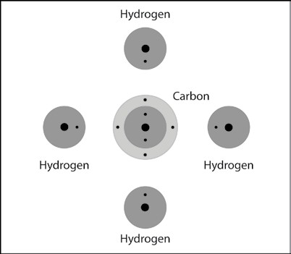
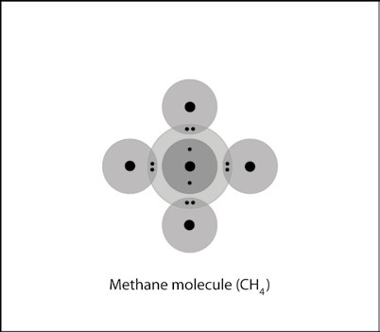

Project the before and after pictures Covalent bonding of carbon dioxide gas.
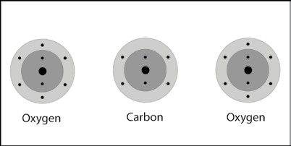
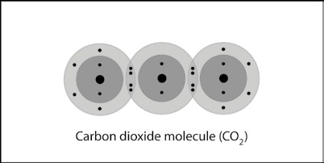
www.acs.org/middleschoolchemistry/simulations/chapter4/lesson4.html

Ask students:

Briefly describe the process of covalent bonding between the carbon and the two oxygen atoms to make a carbon dioxide molecule. Be sure to mention attractions between electrons and protons and the number of electrons in the outer energy level for the atoms in the final molecule.

Be sure students realize that the protons of each atom attracts the other atom’s electrons, which brings the atoms together. Atoms continue to bond with other atoms until their outer energy levels are full.

