Activity Sheet Name Chapter 5, Lesson 2
Surface Tension Date
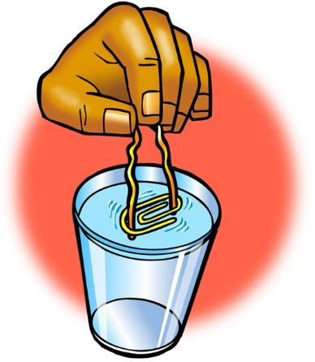

EXPLAIN IT WITH ATOMS & MOLECULES
- You saw a demonstration of a paper clip floating at the surface of water. Paper clips are more dense than water and usually sink. Why do you think the paperclip was able to stay on the surface of the water?

ACTIVITY

Question to Investigate
How much water can you add to a full test tube?

Materials for Each Group
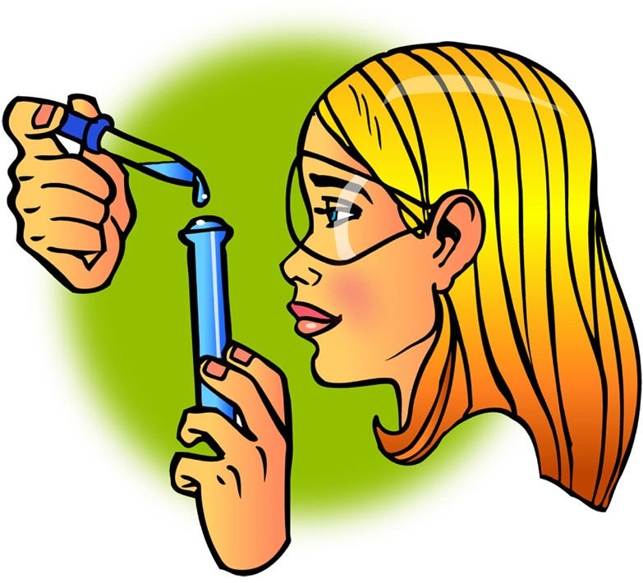
  - Water
  - Dropper
  - Test tube
  - Penny
  - 2 paper towels

Procedure
- Pour water into a test tube so that the water is very near the top of the test tube.
- Hold the test tube up to eye level and use a
dropper to carefully add drops of water, one at a time to the test tube.
- Watch the water at the top of the test tube while you add the drops. Continue adding drops until the water spills.
- Place a penny on a paper towel.
- While watching from the side, add single drops of water to the penny. Continue adding drops until the water spills.

- What did the water look like as you added it to the top of the test tube and the penny?

- Use the illustration to explain why water has a strong surface tension.
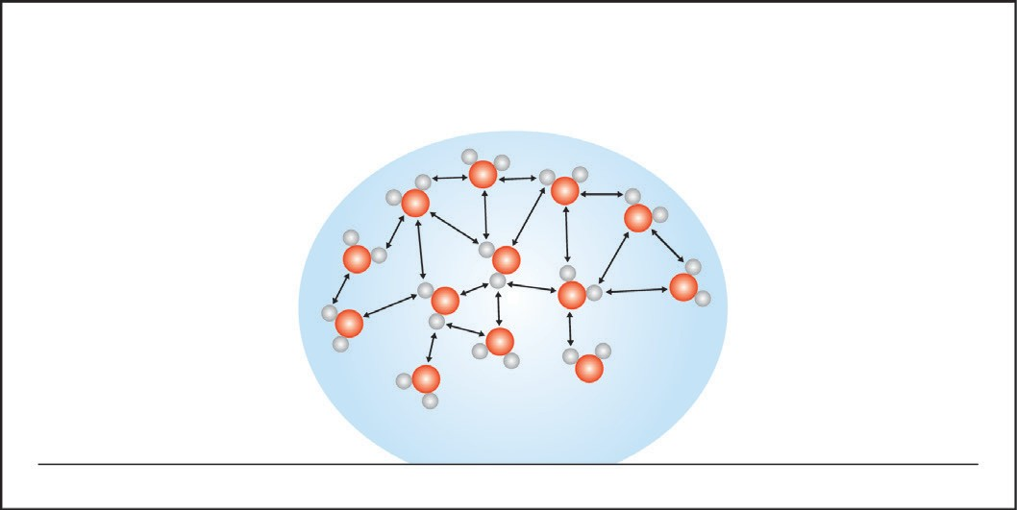

ACTIVITY

Question to Investigate
Which has a greater surface tension, water or alcohol?

Materials for Each Group
  - 2 pennies
  - 2 droppers
  - Water
  - Isopropyl alcohol (70% or higher)
  - Paper towel

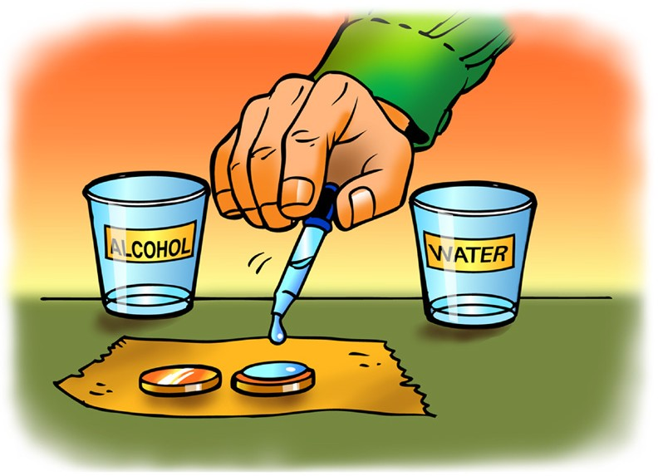
Procedure
- Place two pennies on a paper towel.
- Use a dropper to add drops of water to the
surface of a penny. Count the drops until the water overflows.
- Use a dropper to add drops of alcohol to the surface of the other penny. Count the drops until the alcohol overflows.

- How many drops of each liquid were you able to get on a penny?

Alcohol Water

- Does alcohol or water have a greater surface tension?

How do you know?

- How does the polarity of alcohol and water molecules affect the surface tension of each liquid?
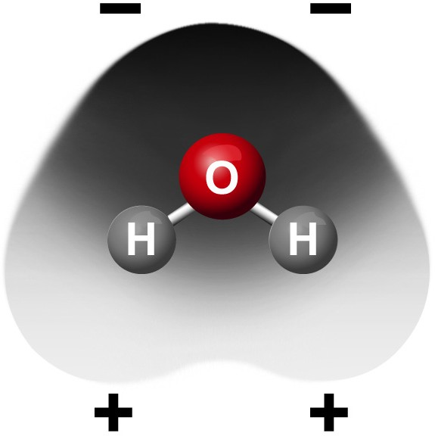
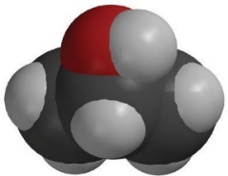
–
+

ACTIVITY

Question to Investigate
How does detergent affect water’s surface tension?

Materials
  - Dish detergent in cup
  - 2 pennies
  - Dropper
  - 2 toothpicks
  - Paper towel

Procedure
- Place 2 clean, dry pennies on a flat surface like a table or desk.
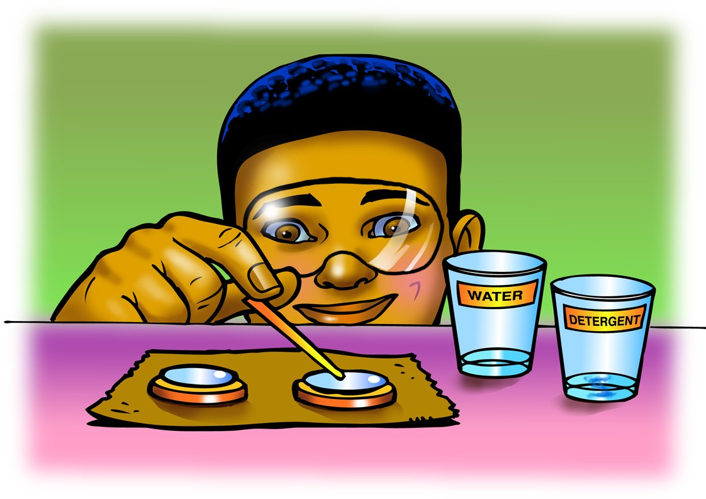
- Use a dropper to add water to both pennies. Add the same number of drops to each penny so that the water stacks up in a dome shape about the same height on both.
- Gently touch the water on one penny with a toothpick. Watch the surface of the water as you touch it.
- Dip the toothpick in liquid detergent and then touch the water on the other penny with the toothpick.

- What happens when you add a small amount of detergent to a large drop of water?

- Use the illustration to explain how detergent interferes with water’s surface tension.
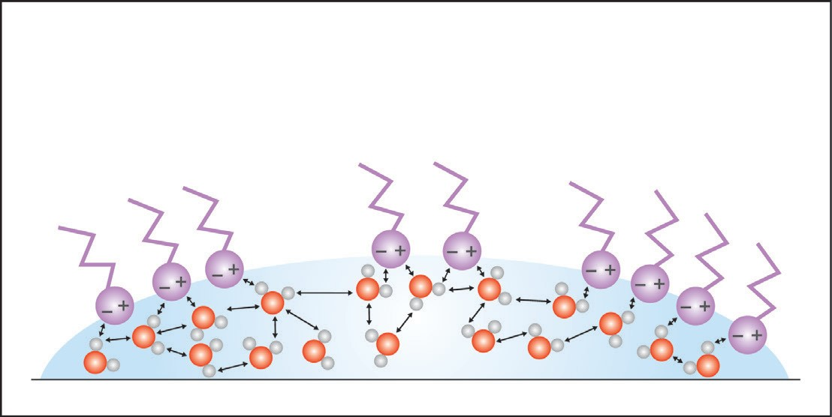

TAKE IT FURTHER

- If water absorbs into a paper towel but does not absorb into wax paper, what does that say about the polarity of paper and the polarity of wax paper?

