Activity Sheet Name Chapter 5, Lesson 7
Can Liquids Dissolve in Water? Date

DEMONSTRATION

- Your teacher placed some food coloring in water. Did the food coloring dissolve in the water?

How do you know when a solute, like food coloring, has dissolved in a solvent, like water?

ACTIVITY

Question to Investigate
Do isopropyl alcohol, mineral oil, and corn syrup dissolve in water?

Materials for Each Group
  - Water
  - Isopropyl alcohol (70% or higher) in small, labeled cup
  - Mineral oil in small, labeled cup
  - Corn syrup in small, labeled cup
  - 3 clear plastic cups
  - Permanent marker or masking tape and a pen for labeling cups
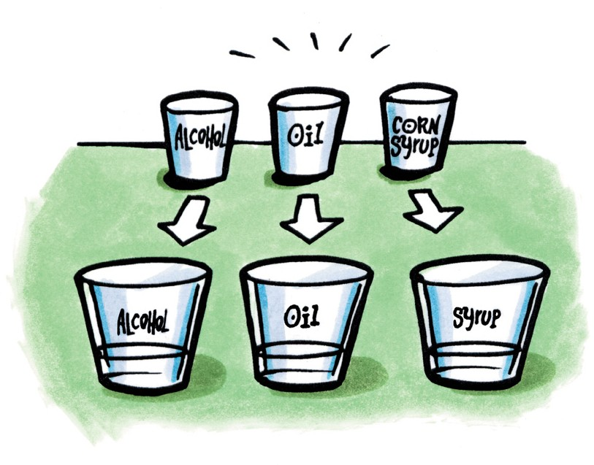
  - 3 straws or popsicle sticks for stirring

Procedure
- Label 3 clear plastic cups Alcohol, Oil, and Syrup.
- Pour water into all three labeled cups until each is about half-full.
- While looking at the water from the side, slowly pour the alcohol into its labeled cup.

- Without stirring, watch to see if the alcohol dissolves in the water on its own. Record your observations in the chart.
- After waiting about 10 seconds, stir to see if the alcohol dissolves. Record your observations.
- Repeat Steps 2–5 for oil and corn syrup.

Do alcohol, oil, and syrup dissolve in water?
Liquid | What does this liquid do when you first place it in water? | Does this liquid dissolve in water after you stir? | How do you know whether this liquid dissolves or does not dissolve in water?
Isopropyl alcohol
Mineral oil
Corn syrup
- Based on your observations of the way isopropyl alcohol, mineral oil, and corn syrup dissolve in water, would you say that solubility is a characteristic property of a liquid? Why?

EXPLAIN IT WITH ATOMS & MOLECULES
Isopropyl alcohol
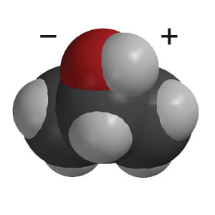
Mineral oil

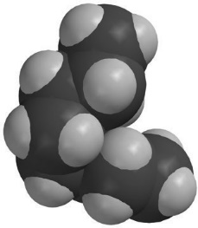

Glucose in corn syrup
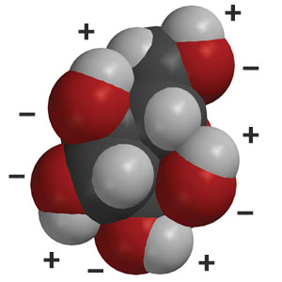

Look at the structure of the molecules in isopropyl alcohol, corn syrup, and mineral oil. Explain why either dissolves or does not dissolve in water.

3. In some salad dressings a layer of oil floats on top of a layer of vinegar, which is mostly water. If you shake the bottle of salad dressing, the liquids will temporarily combine. The oil and vinegar do not dissolve in one another because eventually the two liquids separate out again.

Knowing what you do about molecules and dissolving, why doesn’t the oil in these salad dressings dissolve in vinegar?

4. Some people with diabetes may accidentally let their sugar level get too low. There are glucose tablets to help them with this problem. When a person eats one, do you think it will act quickly to increase his/her blood sugar level? Why or why not?

TAKE IT FURTHER

Question to Investigate
What happens as drops of water and alcohol combine?

Materials for Each Group
  - Water (colored blue)
  - Isopropyl alcohol (70% or higher and colored yellow)
  - Laminated index card or card covered with wax paper
  - 2 droppers
  - Toothpick or popsicle stick

Procedure
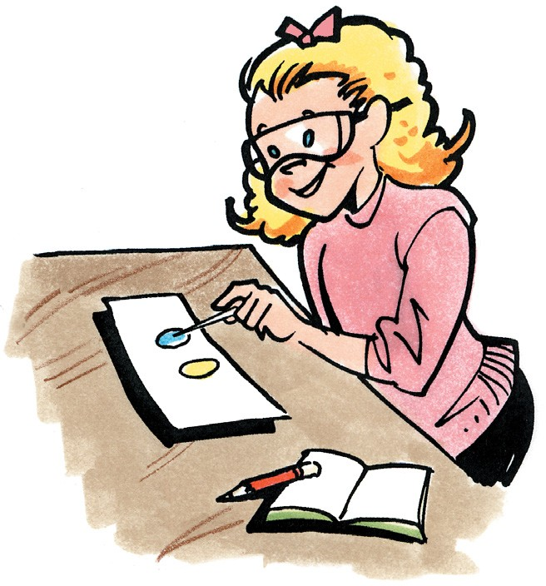
- Use a dropper to place about 5 drops of blue water together to make 1 large drop on your index card.
- Use another dropper to make a similar large drop of yellow alcohol close to, but not touching, the blue drop.
- Use a toothpick to drag the blue water toward the yellow alcohol until they touch. As soon as the drops touch, lift the toothpick away and do not stir.
- Watch closely as the alcohol and water mix.

- What do you observe when the drop of alcohol and drop of water combine?
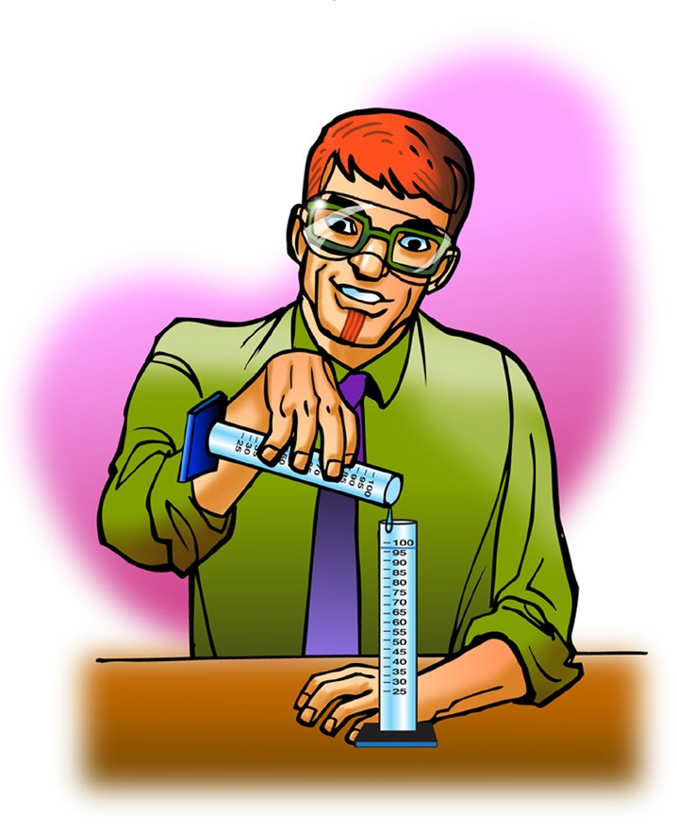

- Your teacher combined 50 mL of isopropyl alcohol and 50 mL of water. What is surprising about the result?

