Chapter 5, Lesson 7—Can Liquids Dissolve in Water?
Key Concepts
- Liquids have characteristic properties based on the molecules they are made of.
- The properties of liquids depend on the attractions the molecules of the liquid have for each other and for other substances.
- Liquids can dissolve certain other liquids, depending on the attractions between the molecules of both liquids.
- Polar liquids, like water, dissolve other liquids which are polar or somewhat polar.
- Polar liquids, like water, do not dissolve nonpolar liquids like oil.

Summary
Students will place isopropyl alcohol, mineral oil, and corn syrup in water to see if any of these liquids dissolve in water. Students will extend their understanding and definition of “dissolving” and see that certain, but not all, liquids can dissolve in water.

Objective
Students will identify and control variables to help design a solubility test for different liquids in water. Students will be able to explain, on the molecular level, why certain liquids, but not all, will dissolve in water. They will also be able to explain that the solubility of a liquid is a characteristic property of that liquid.

Evaluation
The activity sheet will serve as the “Evaluate” component of each 5-E lesson plan. The activity sheets are formative assessments of student progress and understanding. A more formal summative assessment is included at the end of each chapter.

Safety
Be sure you and the students wear properly fitting goggles. Isopropyl alcohol is flammable. Keep it away from flames or spark sources. Read and follow all warnings on the label. Isopropyl alcohol and mineral oil should be disposed of according to local regulations. Have students wash hands after the activity.

Materials for the Demonstrations
  - Clear plastic cup
  - Water
  - Food coloring
  - Straw or popsicle stick
  - Isopropyl alcohol (70% or higher)
  - 2 identical 100-mL graduated cylinders

Materials for Each Group
  - Water
  - Mineral oil
  - Isopropyl alcohol (70% or higher)
  - Corn syrup
  - 3 clear plastic cups
  - 5 small cups
  - Permanent marker or masking tape and a pen for labeling cups
  - 3 straws or popsicle sticks (for stirring)
  - Laminated index card or card covered with wax paper
  - Blue water
  - Yellow isopropyl alcohol (70% or higher)
  - 2 droppers
  - Toothpick or popsicle stick

ENGAGE

Do a demonstration to introduce the idea that solids aren’t the only substances that can dissolve—liquids can also dissolve in liquids.
Ask students to make a prediction:

Solids, like salt or sugar, can dissolve in water. Do you think that liquids can dissolve in water?

Question to Investigate
Does liquid food coloring dissolve in water?

Materials for the Demonstration
- Clear plastic cup
- Water
- Food coloring
- Straw or popsicle stick

Note: A similar demonstration was conducted back in Chapter 1 as evidence that molecules are in motion. Here, the demonstration is used to show the attraction between water molecules and the liquid coloring molecules that allows the color to dissolve in the water.

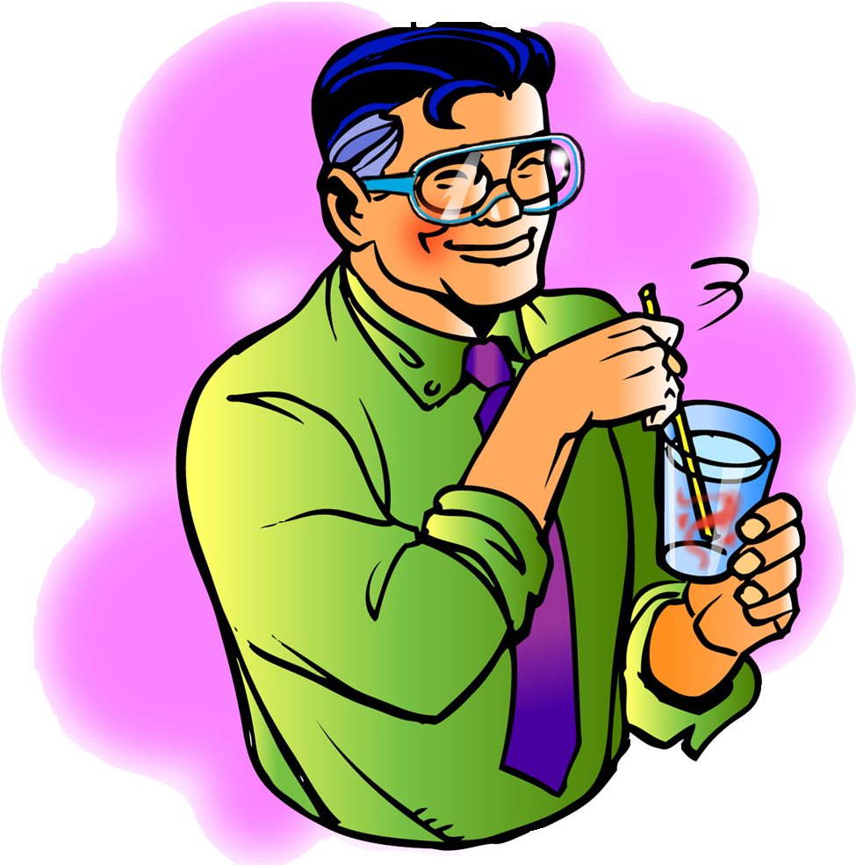
Procedure
- Hold up a clear plastic cup or other clear container of room temperature water. Add 1 or 2 drops of food coloring and allow the coloring to drift and spread in the water a bit.
- Stir with a straw or popsicle stick.

Expected results
The food coloring will drift and slowly mix throughout the water. When stirred, the water will be evenly colored throughout.

Ask students:

Does food coloring dissolve in water?
Yes.

How do you know when a solute, like food coloring, has dissolved in a solvent, like water?
As part of the answer to this question, review the definition of dissolving using the food coloring and water as an example. The solute (food coloring) is dissolved in the solvent (water) when the molecules of the solute are so thoroughly intermixed within the molecules of the solvent that they do not settle out or separate.

This demonstration showed that food coloring can dissolve in water. Describe an experiment you could do to compare how isopropyl alcohol, mineral oil, and corn syrup dissolve in water.
Students should agree that they will need three cups filled with the same amount of water. They should also realize that it’s important that the same temperature water is used in each cup and that the temperature of each of the three liquids being tested is the same, too.

Give each student an activity sheet.
Students will describe their experimental design, record their observations, and answer questions about the activity on the activity sheet. The Explain It with Atoms & Molecules and Take It Further sections of the activity sheet will either be completed as a class, in groups, or individually depending on your
instructions. Look at the teacher version of the activity sheet to find the questions and answers.

EXPLORE

Have students conduct an activity to see how well isopropyl alcohol, mineral oil, and corn syrup dissolve in water.
Question to Investigate
Do isopropyl alcohol, mineral oil, and corn syrup dissolve in water?

Teacher Preparation for Each Group
  - Label 3 small cups Alcohol, Oil, and Syrup for each group.
  - Pour about 1 tablespoon of isopropyl alcohol, mineral oil, and corn syrup into their labeled cups.

Materials for Each Group
  - Water
  - Isopropyl alcohol (70% or higher) in small, labeled cup
  - Mineral oil in small, labeled cup
  - Corn syrup in small, labeled cup
  - 3 clear plastic cups
  - Permanent marker or masking tape and a pen for labeling cups
  - 3 straws or popsicle sticks for stirring

Procedure
- Label 3 clear plastic cups Alcohol, Oil, and Syrup.
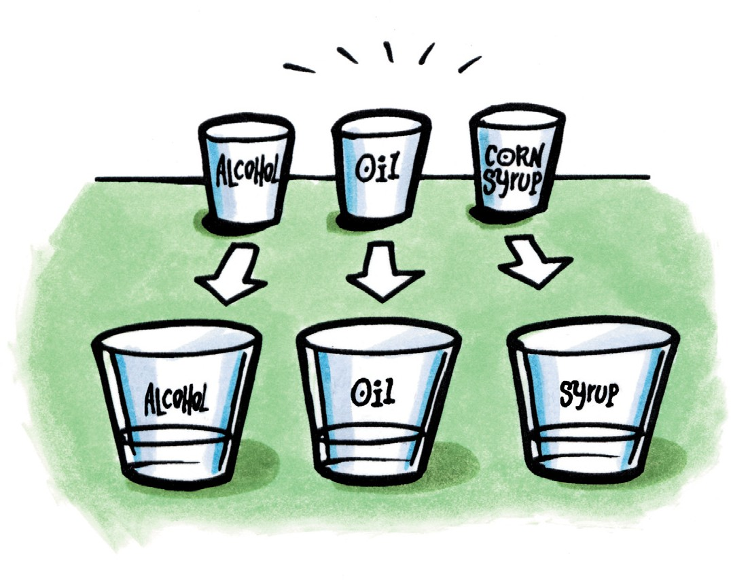
- Pour water into all three labeled cups until each is about half-full.
- While looking at the water from the side, slowly pour the alcohol into its labeled cup.
- Without stirring, watch to see if the alcohol dissolves in the water on its own. Record your observations in the chart.
- After waiting about 10 seconds, stir to see if the alcohol dissolves. Record your observations.
- Repeat Steps 2–5 for oil and corn syrup.

Expected Results
- The alcohol looks kind of gray and swirly as it goes into the water. The alcohol tends to stay on the surface of the water because it is less dense than water. It does not seem to dissolve immediately but dissolves when stirred.
- The oil stays on the surface of the water because it is less dense than water, but it does not appear to mix much at all with the water. When stirred, the oil breaks apart a bit and then forms a layer again on the surface of the water. The oil does not dissolve.
- The corn syrup sinks in the water because it is more dense than water. It seems to stay there without much initial dissolving. After stirring, the corn syrup dissolves into the water and the solution turns clear.

Discuss student observations.
Have students describe what the alcohol, oil, and corn syrup looked like in the water and whether or not they dissolved.

Ask students:

Can a liquid dissolve another liquid?
Students should realize that some liquids, but not all, can dissolve in water.

Based on your observations of the way isopropyl alcohol, mineral oil, and corn syrup dissolve in water, would you say that solubility is a characteristic property of a liquid? Why?
Yes. Solubility is a characteristic property because each liquid interacted with the water differently.

EXPLAIN

Discuss how the molecular structure of isopropyl alcohol, mineral oil, and glucose (in corn syrup) determines whether or not each liquid will dissolve in water.
Project the image Isopropyl Alcohol.
www.acs.org/middleschoolchemistry/simulations/chapter5/lesson7.html
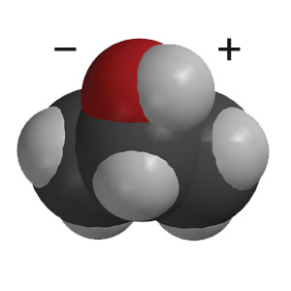
Point out the bond between oxygen and hydrogen in one area of the alcohol molecule.

Ask students:

What do you already know about the O–H bond?
It is polar. The oxygen has a slight negative charge, and the hydrogen has a slight positive charge.

How do you think this polar part of the molecule affects the solubility of alcohol?
Even though alcohol has one polar area (O–H bond) and a larger nonpolar area (C–H bonds), polar water molecules and the polar area on alcohol molecules are attracted to each other, causing alcohol to dissolve in water.

Project the image Mineral Oil.
www.acs.org/middleschoolchemistry/simulations/chapter5/lesson7.html
Remind students that the carbon (darker gray) and hydrogen atoms share electrons rather evenly. This means that the bonds in mineral oil are nonpolar, so water molecules and mineral oil molecules are not attracted to each other.
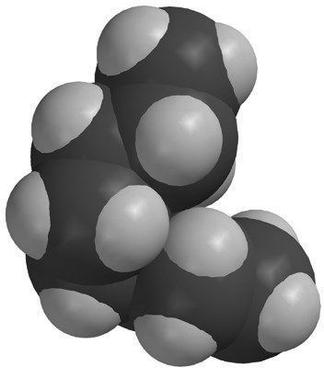

Why do you think the oil does not dissolve in water?
The mineral oil molecule is made of carbon atoms bonded to hydrogen atoms. The bond between these atoms creates very little polarity. Water is not very attracted to the oil and so does not dissolve it.

In some salad dressings a layer of oil, like canola or olive oil, floats on top of a layer of vinegar, which is mostly water. If you shake a bottle of this kind of salad dressing, the liquids will temporarily combine. But the oil and vinegar do not dissolve in one another because eventually the two liquids will separate out again. Knowing what you do about molecules and dissolving, why doesn’t the oil in these salad dressings dissolve in vinegar?
Oil is nonpolar and is not attracted to the water in vinegar, so it will not dissolve.

Note: Students should understand that polar molecules, like water, attract other polar molecules but they do not attract nonpolar molecules, like oil. At the middle school level, this understanding is sufficient but could lead to the impression that nonpolar molecules have no attractions at all. This is not true.

Read more about the attractions between nonpolar molecules in the additional teacher background section at the end of this lesson.

Project the image Glucose.
www.acs.org/middleschoolchemistry/simulations/chapter5/lesson7.html
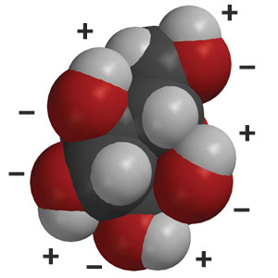
Explain to students that corn syrup is mostly glucose but also
contains a similar sugar, fructose. Show students the glucose
molecule and point out the bonds between oxygen and
hydrogen.

Note: Students may have heard of “high fructose corn syrup” used in carbonated beverages and some prepared foods. This type of corn syrup contains a higher percentage of fructose than the corn syrup commonly sold in the baking aisle at grocery stores.

Ask students:

Why do you think glucose molecules dissolve well in water?
Glucose has many areas where oxygen is bonded to hydrogen. These O–H bonds are polar. Polar water molecules and the polar areas of glucose molecules are attracted to each other, causing the corn syrup to dissolve.

Some people with diabetes may accidentally let their sugar level get too low. There are glucose tablets to help them with this problem. When a person eats one, do you think it will act quickly to increase his/her blood sugar level? Why or why not?
Yes. The tablet will act quickly because the water in a person’s saliva and stomach will easily dissolve the glucose.

EXTEND

Look more closely at the way water and alcohol mix.
Water and alcohol do some pretty interesting things when they mix. Tell students that you colored water blue and isopropyl alcohol yellow so that they can see the mixing better.

Materials for Each Group
- Water (colored blue)
- Isopropyl alcohol (70% or higher and colored yellow)
- Laminated index card or card covered with wax paper
- 2 droppers
- Toothpick or popsicle stick

Procedure
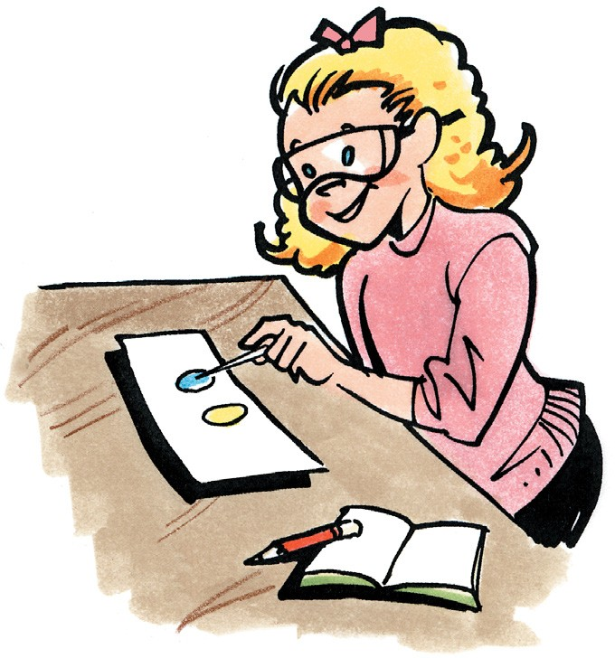
- Use a dropper to place about 5 drops of blue water together to make 1 large drop on your index card.
- Use another dropper to make a similar large drop of yellow alcohol close to, but not touching, the blue drop.
- Use a toothpick to drag the blue water toward the yellow alcohol until they touch. As soon as the drops touch, lift the toothpick away and do not stir.
- Watch closely as the alcohol and water mix.

Expected Results
The alcohol and water will kind of “shake” or “jiggle” right at the area where they are mixing.

Discuss student observations.
Ask students:
  - What do you observe when the drop of alcohol and drop of water combine?
Students will notice that the alcohol and water seem to shake at the area where they are mixing. As the liquids mix, the yellow and blue colors combine to make green.

Tell students that the mixing of alcohol and water is not completely understood on the molecular level. One reason for the shaky appearance might be that alcohol is less dense than water so as it mixes with water, the density of the overall liquid changes. Alcohol (which alone floats on water) sinks as it mixes. Maybe lots of little “sinkings” make the mixing look shaky. It could be that the changing density causes light to refract differently to cause the shaky look. Maybe the alcohol interferes with water’s surface tension and causes a shaky look on the surface. It is also true that when water and alcohol are mixed, the solution gets warmer. Maybe the heat increases molecular motion at the surface, which somehow contributes to the shaky look.

Do a demonstration to show that when water and alcohol combine, the volume of the resulting solution is less than expected.
Tell students that the characteristic way water and alcohol interact with each other causes another interesting phenomenon.

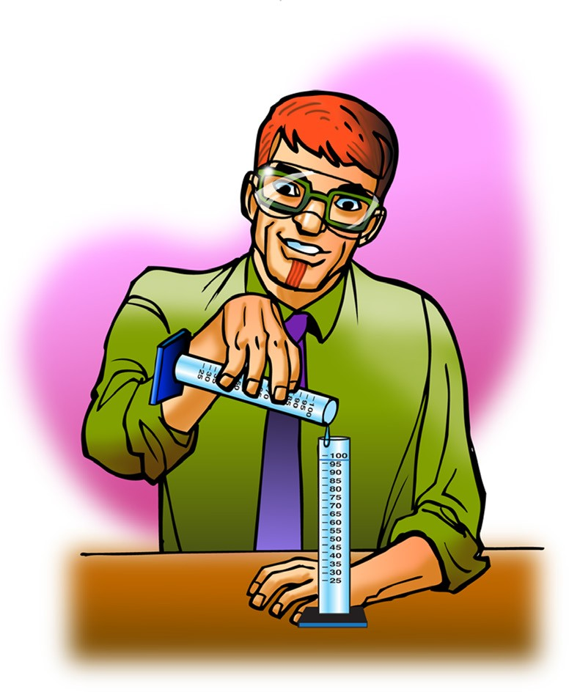
Materials for the Demonstration
- Isopropyl alcohol (90% or higher)
- Water
- 2 identical 100-mL graduated cylinders

Procedure
- Measure 50 mL of isopropyl alcohol and pour it into a 100-mL graduated cylinder.
- Measure 50 mL of water and add it to the alcohol in the 100-mL graduated cylinder.

Expected Results
The total volume of the liquid will be about 97 or 98 mL. This is surprising because 50 mL of water + 50 mL of water equals 100 mL.

Explain to students that when the water and alcohol molecules interact, they rearrange and actually take up less room than if you add up their individual volumes.

Note: You may have heard the explanation that the water molecules are in the spaces between the alcohol molecules, or the alcohol molecules are in the spaces between the water molecules. This is too passive an explanation. It’s not like marbles falling in the spaces between golf balls. There is an active rearranging of molecules that are attracted to one another that results in the final volume. In fact, adding any two liquids that can dissolve in one another will result in a volume that’s different from the sum of the separate liquid volumes. Alcohol and water are often used as an example of this phenomenon because they are easy to get and show a particularly big difference.





