**Chapter 6—Student Reading**

## What is a chemical reaction?

There are many common examples of chemical reactions. For instance, chemical reactions happen when baking cookies, and also in your digestive system when you eat the cookies. Rusting iron and burning gasoline in a car engine are chemical reactions. Adding baking soda to vinegar also causes a chemical reaction. In a chemical reaction, the molecules in the reactants interact to form new substances. A chemical reaction causes a *chemical* change. Other processes, like dissolving or a change of state, cause a *physical* change in which no new substance is formed.

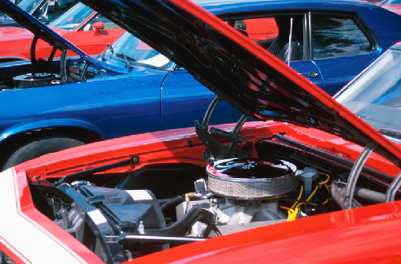

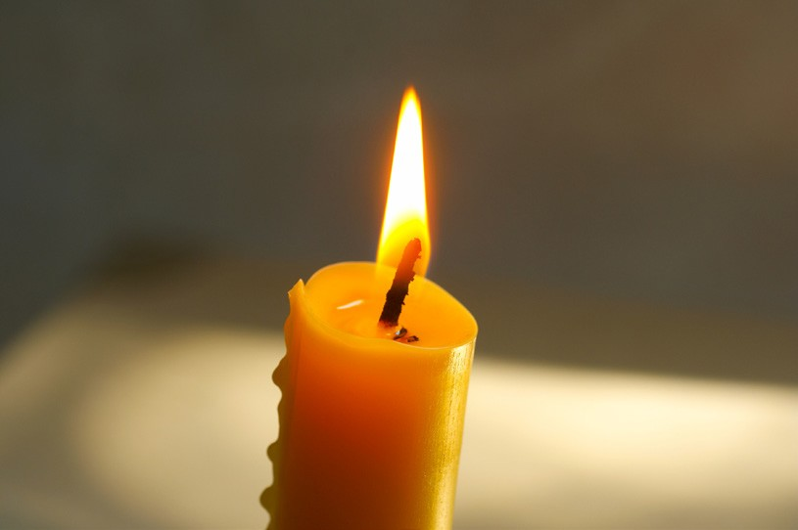Another chemical reaction that you have seen many times is a burning candle.

When a candle burns, molecules in the wax react with oxygen in the air. This reaction, called **combustion**, releases energy in the form of the heat and light of the flame. The reaction also produces something else which is not as obvious – carbon dioxide and water vapor.

## **A closer look at a burning candle**

The wax in the candle is made of long molecules called **paraffin**. These paraffin molecules are made up of only carbon atoms and hydrogen atoms bonded together like in the model of a molecule shown here.

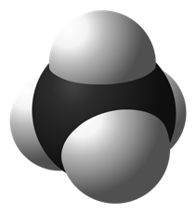

Molecules made of only carbon and hydrogen are called *hydrocarbons*. The simplest hydrocarbon (methane) can be used as a model to show how the wax or any other hydrocarbon burns.

The chemical formula for methane is CH4. This means that methane is made up of one carbon atom and 4 hydrogen atoms.

This is the chemical equation for the reaction of methane and oxygen.

**CH4**

methane

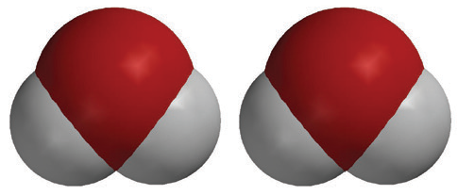

**2O2**

oxygen

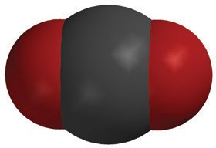

**CO2**

carbon dioxide

**2H2O**

water

+

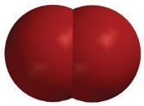

+



## **The reactants**

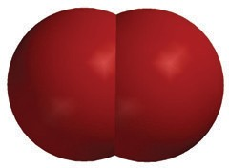

The methane and oxygen on the left side of the equation are called the **reactants**. Each molecule of oxygen gas is made up of two oxygen atoms bonded together.

It can be confusing that oxygen the *atom*, and oxygen the *molecule*, are both called “oxygen”. When we talk about the oxygen in the air, it is always the molecule of oxygen which is two oxygen atoms bonded together, or O2. In the equation, there is a “2” in front of the O2 to show that there are two molecules of O2 reacting with one molecule of methane.

## **The products**

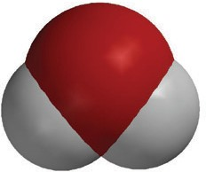

The carbon dioxide and water on the right side of the equation are called the products. The chemical formula for carbon dioxide is CO2. This means that carbon dioxide is made up of one carbon atom and 2 oxygen atoms.

Each molecule of water is made up of two hydrogen atoms bonded to one oxygen atom or H2O. The reason why there is a “2” in front of the H2O in the equation shows that there are two molecules of H2O.

## **Where do the products come from?**

The atoms in the products come from the atoms in the reactants. In a chemical reaction, the reactants interact with each other, bonds between atoms in the reactants are broken, and the atoms rearrange and form new bonds to make the products.

## **Counting the atoms in the reactants and products**

To understand a chemical reaction, you need to check that that the equation for the reaction is *balanced*. This means that the same type and number of atoms are in the reactants as are in the products. To do this, you need to be able to count the atoms on both sides of the equation.

**CH4**

methane



**2O2**

oxygen



**CO2**

carbon dioxide

**2H2O**

water

+



+



Look again at the equation for methane reacting with oxygen. You see a big number called a **coefficient** in front of some of the molecules and a little number called a **subscript** after an atom in some of the molecules. The coefficient tells how many of a particular type of *molecule* there are. The subscript tells how many of a certain type of *atom* are in a molecule. So if there is a coefficient in front of the molecule and a subscript after an atom, you need to multiply the coefficient times the subscript to get the number of atoms.

Example: In the products of the reaction there are 2H2O. The coefficient means that there are two molecules of water. The subscript means that each water molecule has 2 hydrogen atoms. Since each water molecule has 2 hydrogen atoms and there are 2 water molecules, there must be (2×2) or 4 hydrogen atoms.

If you look closely at the equation, you can see that there is 1 carbon atom in the reactants and 1 carbon atom in the products. There are 4 hydrogen atoms in the reactants and 4 hydrogen atoms in the products. There are 4 oxygen atoms in the reactants and 4 oxygen atoms in the products. Since there are the same number of each type of atom in the reactants and the products, the equation is balanced.

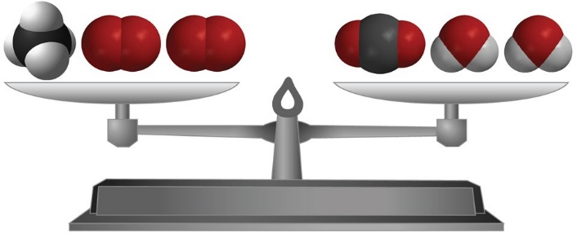

Another way of saying that an equation is balanced is that “mass is conserved”. This means that the atoms in the reactants end up in the products and that no new atoms are created and no atoms are destroyed.

## **Changing the amount of products**

If you want to change the amount of products formed in a chemical reaction, you need to change the amount of reactants. This makes sense because atoms from the reactants need to interact to form the products.

An example is the popular reaction between vinegar (acetic acid) and baking soda (sodium bicarbonate).

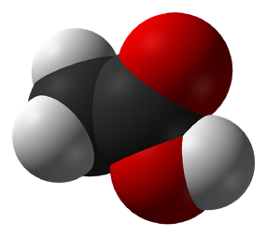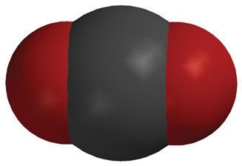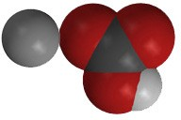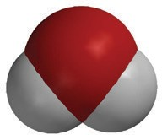

+

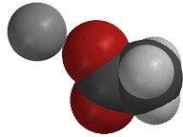

+

+

**C2H4O2**

acetic acid

**NaHCO3**

sodium bicarbonate

**NaC2H3O2**

sodium acetate

**H2O**

water

**CO2**

carbon dioxide

When you conduct this reaction, one of the most noticeable products, which you see on the right side of the equation, is carbon dioxide gas (CO2). If you wanted to produce more CO2, you could use more baking soda because there would be more baking soda to react with the vinegar to produce more carbon dioxide. In general, using more of one or more reactants will result in more of one or more products as long as there is enough of the other reactant to react with. Using less of one or more reactants will result in less of one or more products.

If you wanted to make a lot of carbon dioxide, you couldn’t just keep adding more and more baking soda to the same amount of vinegar. This might work for a while, as long as there was enough vinegar, but eventually there would be no atoms of vinegar left for the extra baking soda to react with so no more carbon dioxide would be produced.

# EVIDENCE OF A CHEMICAL REACTION

## **Production of a gas**

The gas produced from mixing vinegar with baking soda is evidence that a chemical reaction has taken place. Since the gas was produced from mixing a solid (baking soda) and a liquid (vinegar), the gas is a new substance formed by the reaction.

## **Formation of a precipitate**

Another clue that a chemical reaction has taken place is a solid is formed when two solutions are mixed. When this happens, the solid is called a precipitate. The precipitate does not dissolve in the solutions. One example of solutions that form a precipitate are calcium chloride solution and sodium bicarbonate solution.

When these solutions are combined, a precipitate called calcium carbonate is produced. Calcium carbonate is the main ingredient in chalk and seashells, and does not easily dissolve.

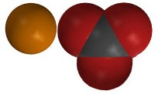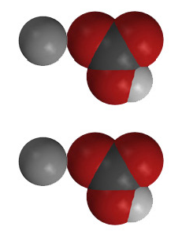

+

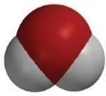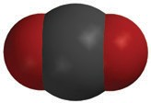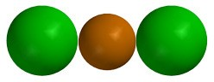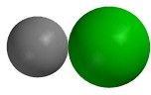

+

+

+

**CaCl2**

calcium chloride

**2NaHCO3**

sodium bicarbonate

**CaCO3**

calcium carbonate

**2NaCl**

sodium chloride

**H2O**

water

**CO2**

carbon dioxide

## **Color change**

When two substances are mixed and a color change results, this color change can also be evidence that a chemical reaction has taken place. The atoms that make up a molecule and the structure of the molecules determine how light interacts with them to give them their color. A color change can mean that new molecules have been formed in a chemical reaction with different structures that produce different colors.

## **Temperature change**

Another clue that a chemical reaction has occurred is a change in temperature of the reaction mixture. You can read more about the change in temperature in a chemical reaction under “Chemical reactions and energy” below.

# RATE OF A CHEMICAL REACTION

## **Increasing the temperature increases the rate of the reaction**

The rate of a chemical reaction is a measure of how fast the reactants are changed into products. This can be increased by increasing the temperature of the reactants.

For reactant molecules to react, they need to contact other reactant molecules with enough energy for atoms or groups of atoms to come apart and recombine to make the products. If they do not have enough energy, most reactant molecules just bounce off and do not react.

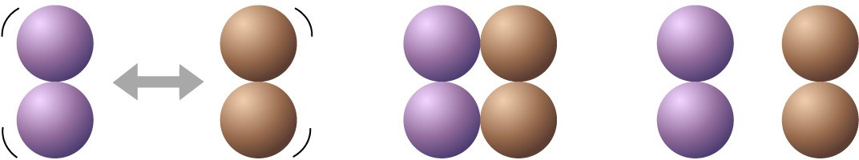

**Molecules contact each other but do not react.**

But if the reactants are heated, the average kinetic energy of the molecules increases. This means that more molecules are moving faster and hitting each other with more energy. If more molecules hit each other with enough energy to react, then the rate of the reaction increases.

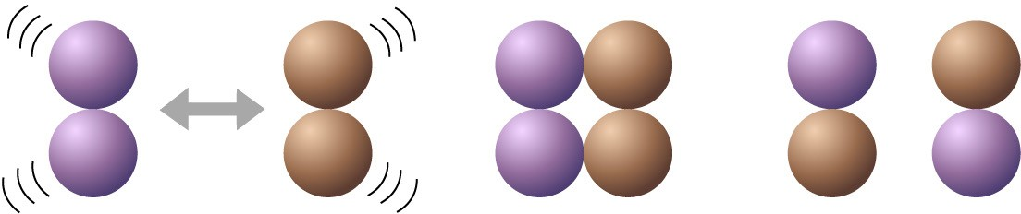

**Molecules contact each and react to form new products.**

## **A catalyst can increase the rate of the reaction**

Another way to increase the rate of the reaction is by adding a substance that helps bring the reactants together so they can react. A substance which helps speed up a chemical reaction in this way but does not become a product of the reaction is called a **catalyst**.

A common catalyst in the cells of living organisms is called *catalase*. During normal cell processes, living things produce hydrogen peroxide in their cells. But hydrogen peroxide is a poison, so the cells need a way to break it down very quickly. Catalase helps break down hydrogen peroxide at a very fast rate. Catalase and many other catalysts in living things, are large complex molecules. Reactants attach to specific parts of the catalyst which helps the reactants to come apart or bond together. A single molecule of catalase can catalyze the breakdown of millions of hydrogen peroxide molecules every second.

***Substances react chemically in characteristic ways***

If you tested different substances with a particular liquid to see how the substances react, each would react in its own characteristic way. And each substance that reacted would react the same way each time it was tested with the same liquid. Substances react in characteristic ways because every substance is different. Each one is made up of certain atoms bonded in a particular way that makes it different from any other substance. When it reacts with another substance, certain atoms or groups of atoms unbond, rearrange, and rebond in their own way.

## **Chemical reactions and energy**

Chemical reactions involve breaking bonds in the reactants and making new bonds in the products. It takes energy to break bonds in the reactants. Energy is released when new bonds are formed in the products. The using and releasing of energy in a chemical reaction can help explain why the temperature of some reactions goes up (*exothermic*) and the temperature of other reactions goes down (*endothermic*).

## **Exothermic**

If a reaction is exothermic, that means that it takes less energy to break the bonds of the reactants than is released when the bonds in the products are formed. Overall, the temperature *increases*.

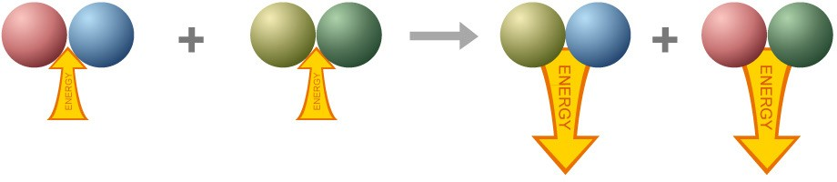**Endothermic**

If a reaction is endothermic, it takes more energy to break the bonds in the reactants than is released when the products are formed. Overall, the temperature *decreases*.

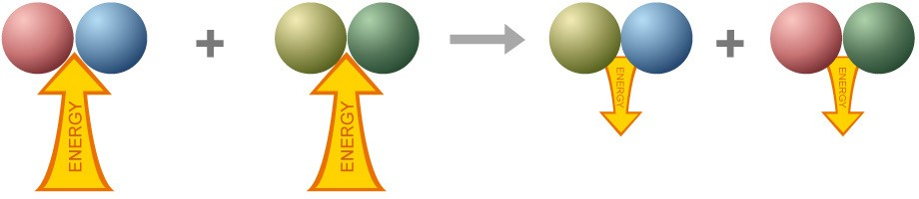

## **Acids, bases, and pH**

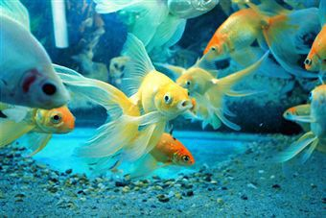You may have heard of the term “pH” when talking about the water in a pool or fish tank. You may have seen people take a sample of water and compare it to colors on a chart to test the pH of the water. The pH scale is a way to measure whether the water is acidic or basic.

Normally we think of water as good ol’ H2O, but in fact some water molecules react with each other and become something different. When two water molecules bump into each other and react, a proton from a hydrogen atom in one of the water molecules gets transferred to the other water molecule. This proton leaves its electron behind in the water molecule it came from.

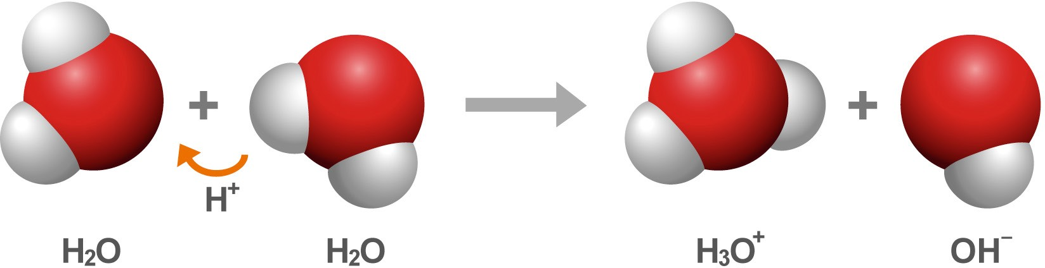

When a proton is transferred from one water molecule to another, it’s as if the molecule gaining the proton is actually gaining another hydrogen atom (but without the electron). So in the reaction between the two water molecules, the one that gained the extra proton has one more proton than electron and changes from H2O to become the ion H3O+.

It works the other way around for the water molecule that lost the proton. It’s as if the water molecule lost a hydrogen atom (but held on to the electron). So the water molecule that lost the proton has one more electron than proton and changes from H2O to become the ion OH–.

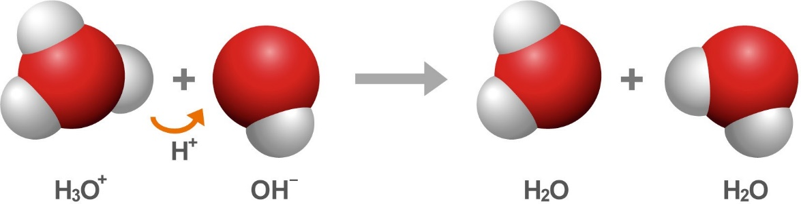

But the H3O+ ions and the OH– ions also react with one another. In this reaction, the extra proton on the H3O+ can be transferred back to the OH– to form two water molecules again.

In pure water, these reactions balance one another and result in a small but equal concentration of H3O+ and OH–.

The concentration of H3O+ in water determines how acidic or basic a solution is. The pH scale is a measure of the concentration of H3O+ in water. Pure water is neutral and measures 7 on the pH scale.

## **How do acids and bases make water acidic or basic?**

If a solution has a higher concentration of H3O+ than OH–, it is considered an acid. An acid measures less than 7 on the pH scale. If the solution has a lower concentration of H3O+ than OH–, it is considered a base. A base measures greater than 7 on the pH scale.

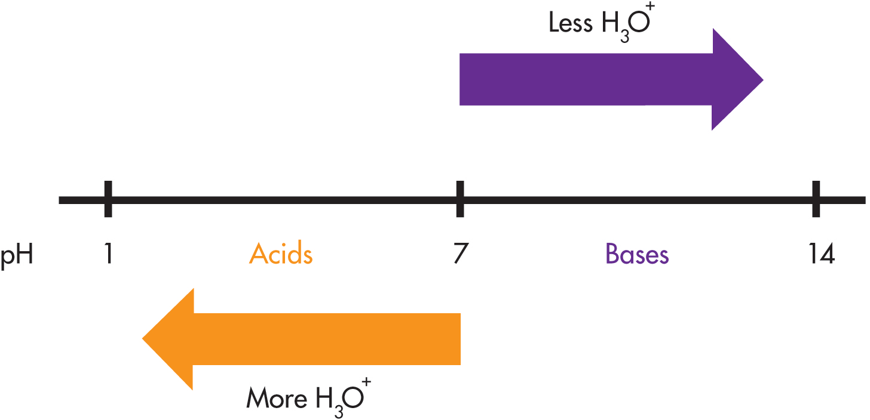

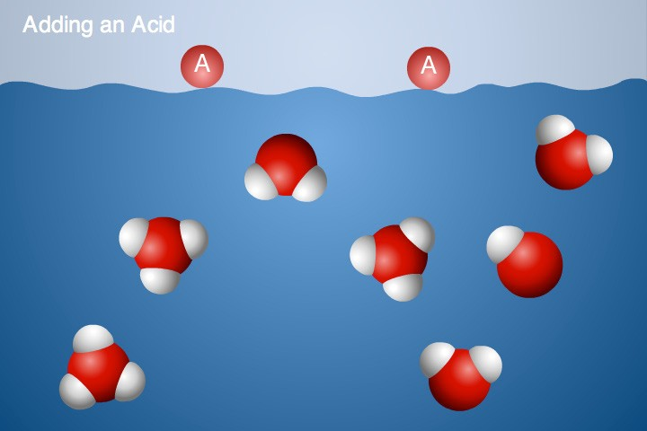***Adding an acid***

Acids are sometimes called “proton donors”. This means that when an acid is added to water, the acid molecule transfers a proton to water molecules forming more H3O+. Since the solution has a higher concentration of H3O+ than OH–, it is an acid.

***Adding a base***

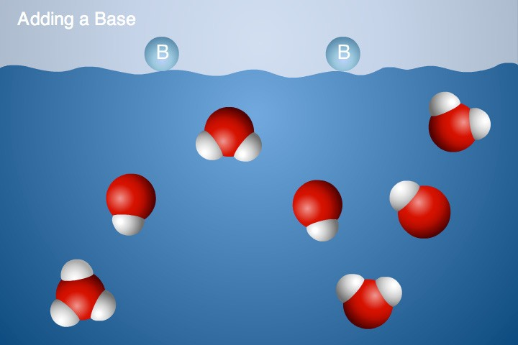Talking about bases is a little trickier because you have to look at two steps to see how a base affects the pH. Bases are sometimes called “proton acceptors”. This means that when a base is added to water, the base molecule accepts a proton from water forming more OH–. When there is extra OH– in the water, the H3O+ ions transfer protons to the OH– ions forming water. Since the solution has a lower concentration of H3O+ than neutral, it is a base.

## **Acids and bases are like chemical opposites**

An acid can neutralize a base and base can neutralize an acid. This makes sense because if an acid is a proton donor and a base is a proton acceptor, they have the opposite effect on water and can cancel each other.

The acid donates protons and increases the concentration of H3O+. The base accepts protons from water molecules making more OH–. The H3O+ transfers a proton to the OH– and causes the concentration of H3O+ to decrease and become closer to neutral again.

# STRENGTH AND CONCENTRATION IN ACIDS AND BASES

The effect that an acid or base has in a chemical reaction is determined by its *strength* and *concentration*. It is easy to confuse these two terms.

## **Strength**

There are different kinds of acids. There are strong acids, weak acids, and acids in-between. Some acids are so strong that they can make a hole in a piece of metal. Other acids, like citric acid or ascorbic acid (Vitamin C), are weaker and are even safe to eat.

The factor that determines the strength of an acid is its ability to donate a proton, increasing the amount of H3O+ in water. A strong acid produces a lot of H3O+ in water, while the same amount of a weak acid produces a smaller amount of H3O+.

## **Concentration**

Concentration is different from strength. Concentration has to do with the amount of acid added to a certain amount of water.

It is the combination of the concentration and the strength of an acid that determines the amount of H3O+ in the solution. And the amount of H3O+ is a measure of the acidity of the solution.

## Acids and the environment

There’s been a lot of news lately about too much carbon dioxide (CO2) gas going into the atmosphere and contributing to global warming. This is a big problem but CO2 also does something else which is not in the news as much. Carbon dioxide gas goes into the ocean and reacts with water to form a weak acid called carbonic acid.

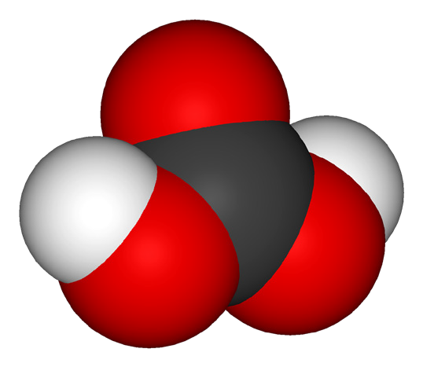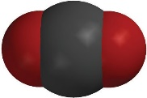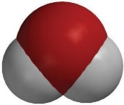

+

**CO2**

carbon dioxide

**H2O**

water

**H2CO3**

Carbonic acid

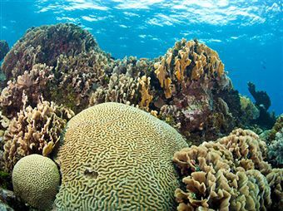

This extra carbonic acid affects the pH of the ocean. The ocean is actually slightly basic. The extra acid makes the ocean less basic or more acidic than it would normally be. The change in ocean pH has an effect on organisms in the ocean, particularly ones that build shells like corals.

These organisms need calcium ions and carbonate ions to make the material for their shell which is calcium carbonate. The extra H3O+ from the acid interacts with the carbonate ion and changes it so that it can’t be used for making shells. Reducing the amount of CO2 that gets into the ocean is the first step to helping to solve this problem.