Activity Sheet Answers
Chapter 6, Lesson 1
What is a Chemical Reaction?

DEMONSTRATION

- Your teacher lit a candle and told you that this was a chemical reaction. What are the reactants in this chemical reaction?
In the chemical reaction that causes a candle to burn, the reactants are molecules in the wax and oxygen in the air.

- What are the products in this chemical reaction?
When a candle burns, the products of the reaction are carbon dioxide and water vapor.

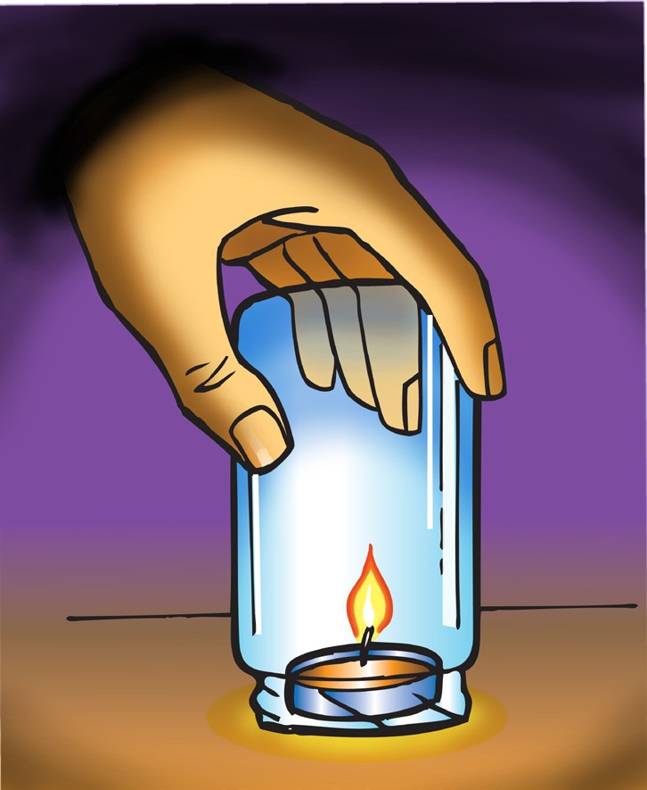
- Why did the flame go out when your teacher put a jar over the candle?
Oxygen from the air is one of the reactants in the chemical reaction that makes the flame. When a jar is placed over the candle the flame goes out because the oxygen under the jar gets used up and no more can get to the candle. Without one of the reactants, the reaction stops and the flame goes out.

- Where do the atoms come from that make the carbon dioxide and the water on the right side of the equation?
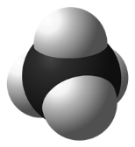
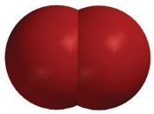
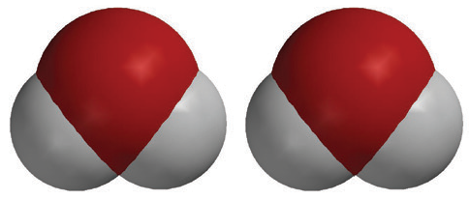
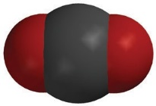
+
+
CH₄
methane

CO₂
carbon dioxide
2O₂
oxygen

2H₂O
water

The atoms that make up the carbon dioxide and the water on the right side of the equation come from the reactants which are methane and oxygen on the left side of the equation.

EXPLAIN IT WITH ATOMS & MOLECULES

- Count the number of atoms on each side of the equation below and write this in the chart.

CH₄ + 2O₂ CO₂ + 2H₂O
Atom | Reactant side | Product side
Carbon | 1 | 1
Hydrogen | 4 | 4
Oxygen | 4 | 4

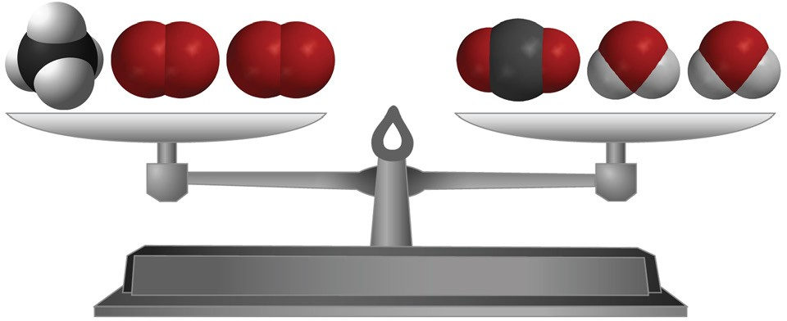
- Are atoms created or destroyed in a chemical reaction? How do you know?
In a chemical reaction, atoms are not created or destroyed. You can tell by looking at a chemical equation. There is exactly the same number of each type of atom in the products as there are in the reactants.

- In a physical change, like changing state from a solid to a liquid, the sub- stance itself doesn’t really change. How is a chemical change different from a physical change?
A chemical change is different than a physical change because in a chemical change the identity of the substance actually changes. Like when methane reacts with oxygen, the products, which are carbon dioxide and water, are completely different substances from the reactants.

TAKE IT FURTHER
Molecules made up of only carbon and hydrogen are called hydrocarbons. The candle and the hydrocarbons listed below react with oxygen in a chemical reaction called combustion.

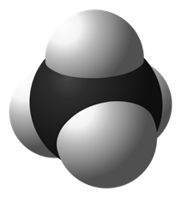
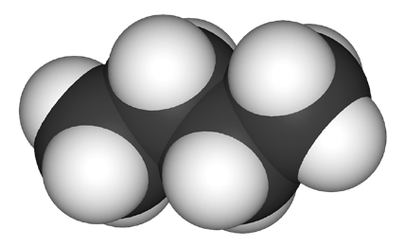
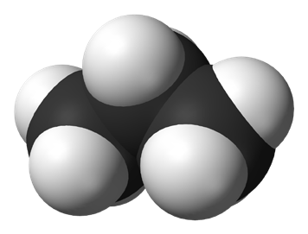
CH₄
Methane
C₃H₈
Propane
C₄H₁₀
Butane
Fuel in gas stoves in many home kitchens
Fuel in outdoor gas grills

Fuel in disposable lighters

- Count the number of carbon, hydrogen, and oxygen atoms in the reactants and products of each equation to see if the equation is balanced. Record the number of each type of atom in each chart.

Combustion of Propane C₃H₈ + O₂ 3CO₂ + 4H₂0

C₃H₈ + 5O₂ |  | 3CO₂ + 4H₂O
Atom | Reactant side | Product side
Carbon | 3 | 3
Hydrogen | 8 | 8
Oxygen | 10 | 10

Combustion of Butane
2C₄H₁₀ + 13O₂ 8CO₂ + 10H₂O

2C₄H₁₀ + 13O₂ |  | 8CO₂ + 10H₂O
Atom | Reactant side | Product side
Carbon | 8 | 8
Hydrogen | 20 | 20
Oxygen | 26 | 26

