**Chapter 6, Lesson 1: What is a Chemical Reaction?**

***Key Concepts:***

* A physical change, such as a state change or dissolving, does not create a new substance, but a chemical change does.
* A chemical change is the result of a chemical reaction.
* In a chemical reaction, the atoms and molecules that interact with each other are called *reactants*.
* In a chemical reaction, the atoms and molecules produced by the reaction are called *products*.
* In a chemical reaction, only the atoms present in the reactants can end up in the products. No new atoms are created, and no atoms are destroyed.
* In a chemical reaction, reactants contact each other, bonds between atoms in the reactants are broken, and atoms rearrange and form new bonds to make the products.

***Summary***

The teacher will use a small candle flame to demonstrate a chemical reaction between the candle wax and oxygen in the air. Students will see a molecular animation of the combustion of methane and oxygen as a model of a similar reaction. Students will use atom model cut-outs to model the reaction and see that all the atoms in the reactants show up in the products.

***Objective***

Students will be able to explain that for a chemical reaction to take place, the bonds between atoms in the reactants are broken, the atoms rearrange, and new bonds between the atoms are formed to make the products. Students will also be able to explain that in a chemical reaction, no atoms are created or destroyed.

***Evaluation***

The activity sheet will serve as the “Evaluate” component of each 5-E lesson plan. The activity sheets are formative assessments of student progress and understanding. A more formal summative assessment is included at the end of each chapter.

***Safety***

Be sure you and the students wear properly fitting goggles. Be careful when lighting the candle. Be sure that the match and candle are completely extinguished when you are finished with the demonstration.

***Materials for the Demonstration***

* Tea light candle or other small stable candle
* Matches
* Glass jar, large enough to be placed over the candle

***Materials for Each Student***

* Atom cut-outs from the activity sheet
* Sheet of colored paper or construction paper
* Colored pencils
* Scissors
* Glue or tape

# ENGAGE

## Review what happens during a physical change and introduce the idea of chemical change.

Tell students that in previous chapters they have studied different aspects of physical change. When atoms and molecules speed up or slow down, that is a physical change. When they change state from liquid to solid or from gas to liquid, that is a physical change. When a substance is dissolved by water or some other solvent, a new substance has not really been formed. The ions or molecules can still come back together to form the original substance.

Let students know that in this chapter they will explore what happens during a *chemical* change. In a chemical change, the atoms in the reactants rearrange themselves and bond together differently to form one or more new products with different characteristics than the reactants. When a new substance is formed, the change is called a *chemical change*.

1. **As a demonstration, light a candle and explain what is happening using the terms *reactants*, *products*, and *chemical reaction*.**

Explain that in most chemical reactions, two or more substances, called *reactants,* interact to create different substances called *products*. Tell students that burning a candle is an example of a chemical reaction.

## Procedure

1. Carefully light a tea light candle or other small candle.
2. Keep the candle burning as you ask students the questions below. You will put the candle out in the second part of the demonstration.

## Expected Results

The wick will catch on fire and the flame will be sustained by the chemical reaction.

The following question is not easy, and students are not expected to know the answer at this point. However, thinking about a candle burning in terms of a chemical reaction is a good place to start developing what it means when substances react chemically.

Ask students:

## What do you think are the reactants in this chemical reaction?

Wax and oxygen from the air are the reactants.

Students often say that the string or wick is burning. It is true that the string of the wick does burn but it’s the wax on the string and not so much the string itself that burns and keeps the candle flame burning. Explain that the molecules that make up the wax combine with oxygen from the air to make the products carbon dioxide and water vapor.

Point out to students that this is one of the major characteristics of a chemical reaction:

**In a chemical reaction, atoms in the reactants combine in new and different ways to form the molecules of the products.**

Students may be surprised that water can be produced from combustion. Since we use water to extinguish a fire, it may seem strange that water is actually produced by combustion. You may want to let students know that when they metabolize or “burn” food in their bodies, they also produce carbon dioxide and water.

## Place a jar over the candle to help students realize that oxygen is a reactant in the burning of a candle.

Remind students that air is a mixture of gases. Explain that when something burns, it reacts with the oxygen in the air.

Ask students to make a prediction:

## Will the candle still burn if one of the reactants (wax or oxygen) is no longer available?

Students may guess that the candle will not burn because both

reactants are required for the chemical reaction to continue.

## Procedure

## Carefully place a glass jar over the lit candle.

## Expected Results

The flame goes out.

Ask students:

## Why do you think the flame goes out when we put a jar over the candle?

Placing a jar over the candle limits the amount of oxygen in the air around the candle. Without enough oxygen to react with the wax, the chemical reaction cannot take place and the candle cannot burn.

* **When a candle burns for a while, it eventually gets smaller and smaller. Where does the candle wax go?**

When a candle burns, the candle wax seems to “disappear.” It doesn’t really disappear: It reacts chemically, and the new products go into the air.

***Note****: Some curious students may ask what the flame is made of. This is a great question and not trivial to answer. The flame is burning wax vapor. The light of the flame is caused by a process called chemiluminescence. Energy released in the chemical reaction makes electrons from different molecules move to a higher energy state. When the electrons come back down, energy is released in the form of light.*

# EXPLAIN

## Introduce the chemical equation for the combustion of methane and explain that atoms rearrange to become different molecules.

Explain to students that wax is made of long molecules called *paraffin* and that paraffin is made up of only carbon atoms and hydrogen atoms bonded together. Molecules made of only carbon and hydrogen are called *hydrocarbons*. Tell students that you will use the simplest hydrocarbon (methane) as a model to show how the wax, or any other hydrocarbon, burns.

**Project the image *Methane and Oxygen React*.**

[www.acs.org/middleschoolchemistry/simulations/chapter6/lesson1.html](http://www.acs.org/middleschoolchemistry/simulations/chapter6/lesson1.html)

**CH4**

methane

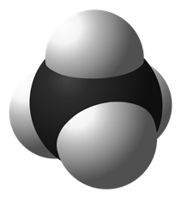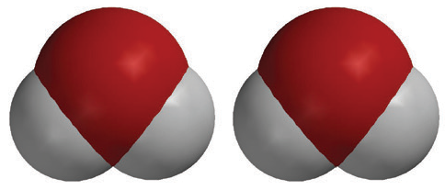

**2O2**

oxygen

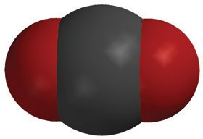

**CO2**

carbon dioxide

**2H2O**

water

+

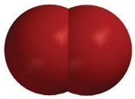

+



Show students that there is methane and oxygen on the left side of the chemical equation and carbon dioxide and water on the right side. Explain that the molecules on the left side are the *reactants* and the ones on the right side are the *products*. When the candle was burning, the paraffin reacted with oxygen in the air to produce carbon dioxide and water, similar to the chemical reaction between methane and oxygen.

Explain to students that the chemical formula for methane is CH4. This means that methane is made up of one carbon atom and four hydrogen atoms.

Show students that the other reactant is two molecules of oxygen gas. Point out that each molecule of oxygen gas is made up of two oxygen atoms bonded together. It can be confusing for students that oxygen the atom, and oxygen the molecule, are both called *oxygen*. Let students know that when we talk about the oxygen in the air, it is always the molecule of oxygen, which is two oxygen atoms bonded together, or O2.

Ask students:

## Where do the atoms come from that make the carbon dioxide and the water on the right side of the equation?

The atoms in the products come from the atoms in the reactants. In a chemical reaction, bonds between atoms in the reactants are broken and the atoms rearrange and form new bonds to make the products.

***Note****: Leave this equation projected throughout the activity in the Explore section of this lesson. Students will need to refer to it as they model the chemical reaction.*

## Give Each Student an Activity Sheet.

Students will record their observations and answer questions about the activity on the activity sheet. The *Explain It with Atoms and Molecules* and *Take It Further* sections of the activity sheet will either be completed as a class, in groups, or individually, depending on your instructions. Look at the teacher version of the activity sheet to find the questions and answers.

# EXPLORE

## Have students make a model to show that in a chemical reaction the atoms of the reactants rearrange to form the products.

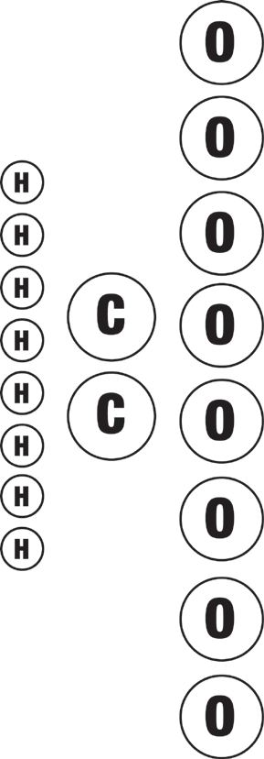**Question to Investigate**

Where do the atoms in the products of a chemical reaction come from?

## Materials for Each Student

* Atom model cut-outs (carbon, oxygen, and hydrogen)
* Sheet of colored paper or construction paper
* Colored pencils
* Scissors
* Glue or tape

## Procedure

### Prepare the Atoms

1. Color the carbon atoms black, the oxygen atoms red, and leave the hydrogen atoms white.
2. 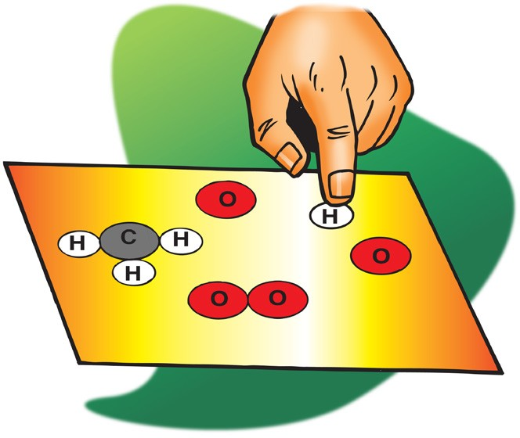Use scissors to carefully cut out the atoms.

### Build the Reactants

1. On a sheet of paper, place the atoms together to make the molecules of the reactants on the left side of the chemical equation for the combustion of methane.
2. Write the chemical formula under each molecule of the reactants. Also draw a “+” sign between the reactants.

After you are sure that students have made and written the formula for the reactant molecules, tell students that they will rearrange the atoms in the reactants to form the products.

### Build the Products

1. Draw an arrow after the second oxygen molecule to show that a chemical reaction is taking place.
2. Rearrange the atoms in the reactants to make the molecules in the products on the right side of the arrow.
3. Write the chemical formula under each molecule of the products. Also draw a “+” sign between the products.

Tell students that in a chemical reaction, the atoms in the reactants come apart, rearrange, and make new bonds to form the products.

### Represent the Chemical Equation

1. Have students use their remaining atoms to make the reactants again to represent the chemical reaction as a complete chemical equation.
2. Glue or tape the atoms to the paper to make a more permanent chemical equation of the combustion of methane.

# EXPLAIN

## Help students count the number of atoms on each side of the equation.

**Project the animation *Combustion of Methane*.**

[www.acs.org/middleschoolchemistry/simulations/chapter6/lesson1.html](http://www.acs.org/middleschoolchemistry/simulations/chapter6/lesson1.html)

Show students that the atoms in methane and oxygen need to come apart like in their models. Also point out that the atoms arrange themselves differently and rebond to form new products. This is also like their model. Be sure that students realize that the atoms in the products only come from the reactants. There are no other atoms available. No new atoms are created, and no atoms are destroyed.

***Note:*** *Explain to students that chemical reactions are more complicated than the simplified model shown in the animation. The animation shows that bonds between atoms in the reactants are broken, and that atoms rearrange and form new bonds to make the products.*

*In reality, the reactants need to collide and interact with each other in order for their bonds to break and rearrange. Also, the animation shows all of the atoms in the reactants coming apart and rearranging to form the products. But in many chemical reactions, only some bonds are broken, and groups of atoms stay together as the reactants form the products.*

Read more about the combustion of methane in *Teacher Background.*

Guide students as you answer the following question together:

## How many carbon, hydrogen, and oxygen atoms are in the reactants compared to the number of carbon, hydrogen, and oxygen atoms in the products?

Show students how to use the big number (coefficient) in front of the molecule and the little number after an atom of the molecule (subscript) to count the atoms on both sides of the equation. Explain to students that the subscript tells how many of a certain type of atom are in a molecule. The coefficient tells how many of a particular type of molecule there are. So if there is a coefficient in front of the molecule and a subscript after an atom, you need to multiply the coefficient times the subscript to get the number of atoms.

For example, in the products of the chemical reaction there are 2H2O. The coefficient means that there are two molecules of water. The subscript means that each water molecule has two hydrogen atoms. Since each water molecule has two hydrogen atoms and there are two water molecules, there must be 2 x 2 = 4 hydrogen atoms.

|  |  |  |
| --- | --- | --- |
| **Atoms** | **Reactant side** | **Product side** |
| Carbon | 1 | 1 |
| Hydrogen | 4 | 4 |
| Oxygen | 4 | 4 |

***Note****: The coefficients indicate the ratios of the numbers of molecules in a chemical reaction. It is not the actual number as in two molecules of oxygen and one molecule of methane since there are usually billions of trillions of molecules reacting. The coefficient shows that there are twice as many oxygen molecules as methane molecules reacting. It would be correct to say that in this reaction there are two oxygen molecules for every methane molecule.*

## Explain that mass is conserved in a chemical reaction.

Ask students:

## Are atoms created or destroyed in a chemical reaction?

No.

## How do you know?

There are the same number of each type of atom on both the reactant side and the product side of the chemical equation we explored.

## In a physical change, like changing state from a solid to a liquid, the substance itself doesn’t really change. How is a chemical change different from a physical change?

In a chemical change, the molecules in the reactants interact to form new substances. In a physical change, like a state change or dissolving, no new substance is formed.

Explain that another way to say that no atoms are created or destroyed in a chemical reaction is to say, “Mass is conserved.”

**Project the image *Balanced Equation*.** [www.acs.org/middleschoolchemistry/simulations/chapter6/lesson1.html](http://www.acs.org/middleschoolchemistry/simulations/chapter6/lesson1.html)

Explain that the balance shows the mass of methane and oxygen on one side exactly equals the mass of carbon dioxide and water on the other. When an equation of a chemical reaction is written, it is “balanced” and shows that the atoms in the reactants end up in the products and that no new atoms are created, and no atoms are destroyed.

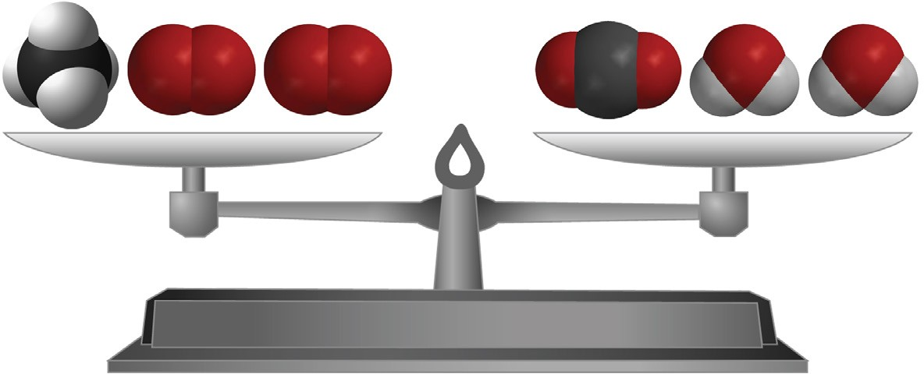

+

**CH4**

oxygen

methane

**2O2**

**CO2**

carbon dioxide

**2H2O**



+

water

# EXTEND

## Introduce two other combustion reactions and have students check to see whether or not they are balanced.

Tell students that, in addition to the wax and methane, some other common hydrocarbons are propane (the fuel in outdoor gas grills), and butane (the fuel in disposable lighters). Have students count the number of carbon, hydrogen, and oxygen atoms in the reactants and products of each equation to see if the equation is balanced. They should record the number of each type of atom in the chart on their activity sheet.

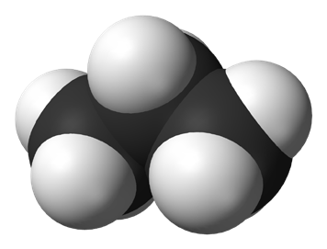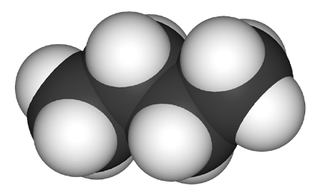

**CH4**

methane

**C3H8**

propane

**C4H10**

butane

## Lighting an outdoor gas grill—Combustion of propane

C3H8 + 5O2 → 3CO2 + 4H20

## Using a disposable lighter—Combustion of butane

2C4H10 + 13O2 → 8CO2 + 10H2O

After students have counted each type of atom, review their answers to make sure they know how to interpret subscripts and coefficients.