Activity Sheet Answers
Chapter 6, Lesson 2
Controlling the Amount of Products in a Chemical Reaction

DEMONSTRATION
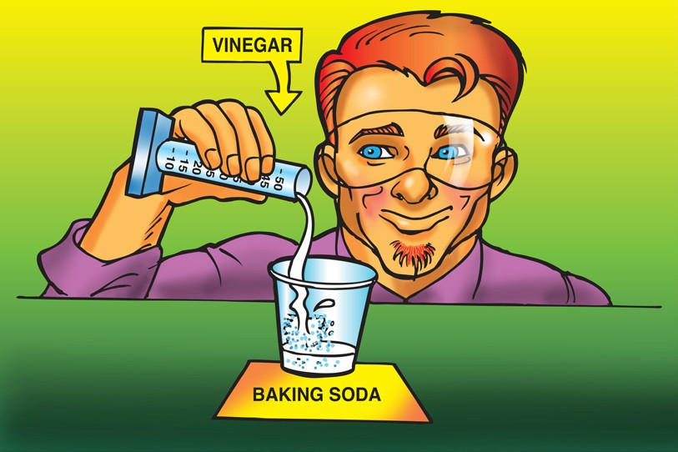
- Your teacher combined a liquid (vinegar) and a solid (baking soda). You observed bubbling, which is made from gas. Do you think a chemical reaction occurred?
Why?
When vinegar is added to baking soda, gas is produced. This is evidence of a chemical change because the gas is a new substance.

- Look at the chemical equation for the reaction between vinegar and baking soda to answer the following questions.
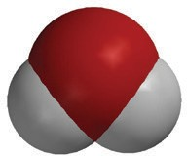
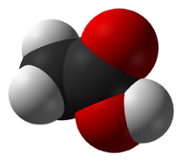
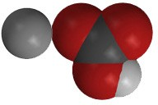
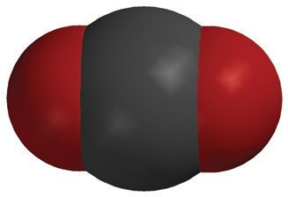
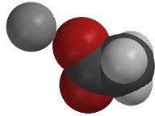
H₂O
water
CO₂
carbon dioxide
NaHCO₃
sodium bicarbonate
NaC₂H₃O₂
sodium acetate
+
+
+

C₂H₄O₂
acetic acid
What are the reactants in this chemical reaction?
In the reaction between vinegar and baking soda, the reactants are vinegar (acetic acid) and baking soda (sodium bicarbonate).

What are the products in this chemical reaction?
The products are sodium acetate, water, and carbon dioxide gas.

- How many of each type of atom appears on each side of the chemical equation?

C₂H₄O₂ + NaHCO₃ NaC₂H₃O₂ + H₂O + CO₂
Atom | Reactant side | Product side
Carbon | 3 | 3
Hydrogen | 5 | 5
Oxygen | 5 | 5
Sodium | 1 | 1
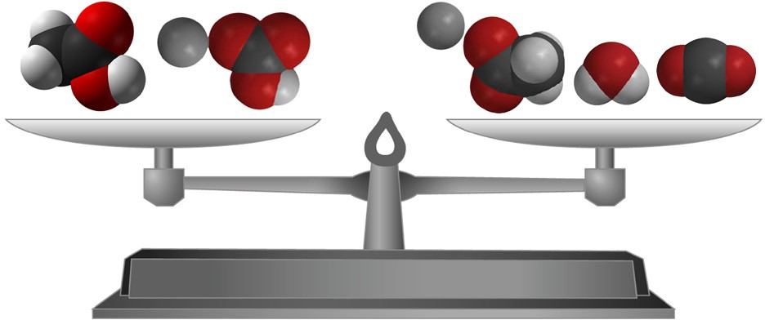
- What does the statement “Mass is conserved during a chemical reaction” mean?
The statement “Mass is conserved in a chemical reaction” means that the same type and number of atoms are in the products of the reaction as are in the reactants. No atoms are created or destroyed.

EXPLAIN IT WITH ATOMS & MOLECULES
- Why, on the molecular level, does changing the amount of baking soda or vinegar affect the amount of carbon dioxide gas produced?
Reducing the amount of vinegar will reduce the amount of carbon dioxide produced because there will be fewer molecules of acetic acid to react with the baking soda and produce the carbon dioxide. Reducing the amount of baking soda will reduce the amount of carbon dioxide gas produced because there will be fewer molecules of sodium bicarbonate to react with the acetic acid and produce the carbon dioxide gas.

- What would you do if you wanted to make more carbon dioxide?
To make more carbon dioxide, you could add either more acetic acid or more sodium bicarbonate or more of both.

- Could you just keep adding more and more baking soda to the same amount of vinegar to get more carbon dioxide? Why or why not?
To produce more carbon dioxide you could add more baking soda but there is a limit. Eventually, all the acetic acid molecules will have already reacted and no more carbon dioxide will be produced.

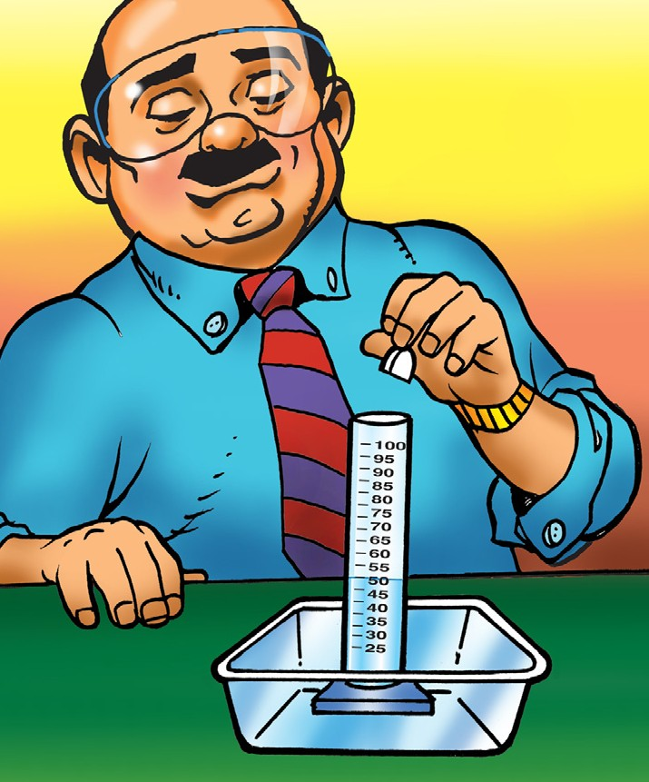
TAKE IT FURTHER
- An Alka-Seltzer tablet contains aspirin, sodium bicarbonate, and citric acid. Your teacher placed an Alka-Seltzer tablet in water with a drop of detergent. Do you think placing an Alka-Seltzer in water causes a chemical reaction? Why?
Placing an Alka-Seltzer tablet in water causes a chemical reaction because a gas is produced. The sodium bicarbonate reacts with the citric acid instead of acetic acid (vinegar) and produces carbon dioxide gas.

