Activity Sheet Answers
Chapter 6, Lesson 4

Temperature and the Rate of a Chemical Reaction
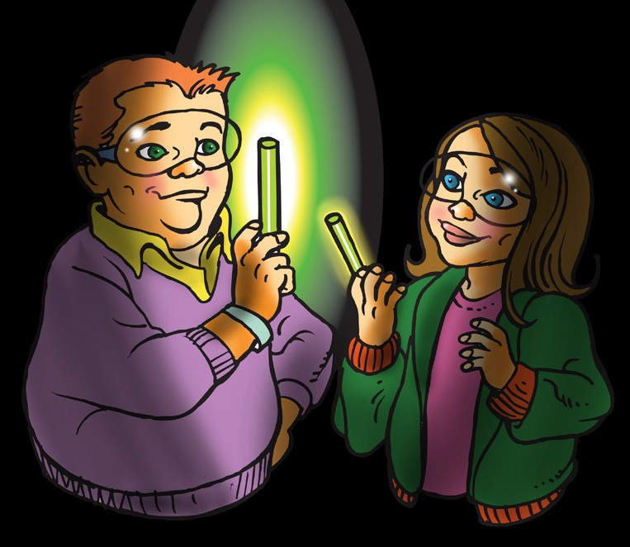

DEMONSTRATION
- Your teacher warmed one glow stick and cooled another. Once the light sticks were started, there was a noticeable difference in their brightness.

- How can you tell whether the chemical reaction is happening faster or slower in each glow stick?
The chemical reaction is happening faster in the glow stick that was in hot water. The production of more light is evidence that the reaction is happening faster.

- Some people place glow sticks in the freezer to make them last longer. Why do you think this works?
If warming the reactants makes the reaction happen faster, cooling the reactants makes the reaction happen more slowly so the glow sticks last longer.
- Do you think that starting with warmer reactants in other reactions increases the rate of those chemical reactions? Why or why not?
Warming the reactants increases the rate of other chemical reactions. If the reactant molecules are moving faster there are more molecules that hit hard enough to react.

EXPLAIN IT WITH ATOMS & MOLECULES
- Does the temperature of the reactants affect the rate of the chemical reaction? How do you know?
In the reaction between baking soda solution and calcium chloride solution, the temperature of the solution does affect the rate of the reaction. The reactants that were warmed bubbled much faster than the reactants that were cooled.

- On the molecular level, why do you think the warm solutions react faster than the cold solutions?
The warm solutions react faster than the cold solutions because in the warm solutions more reactant molecules are moving fast enough so that when they collide they can react.

TAKE IT FURTHER
- You saw a video showing the ammonium dichromate volcano. Heat from a burning wick starts the reaction, but why does the reaction continue?
When the reactants were mixed they just sat there and nothing happened. But then a little wick that was stuck into the mixture and lit. The heat from the flame gave the reactants enough energy to react. The reaction itself gave off enough heat to keep the reaction going.

