Activity Sheet Name Chapter 6, Lesson 8
pH and Color Change Date

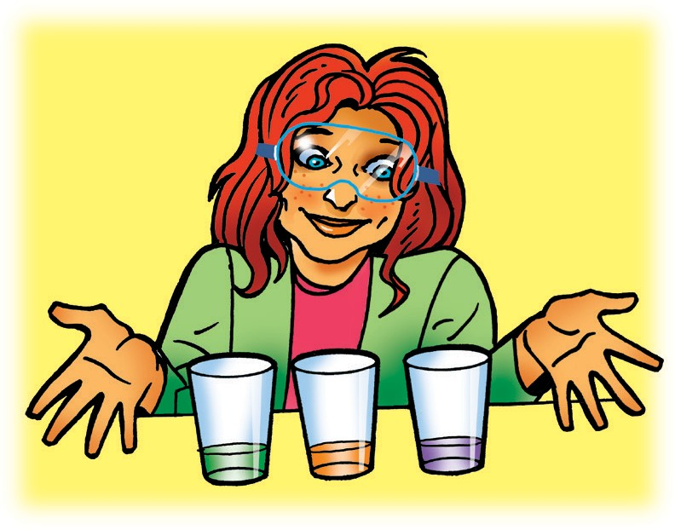
DEMONSTRATION
- Your teacher poured green universal indicator into each of two cups. What does the change in color of the indicator solution tell you about the substance your teacher placed in each cup?

PREPARE FOR THE ACTIVITY

Materials for Each Group
  - 2 clear plastic cups
  - 3 droppers
  - Masking tape and pen or permanent marker
  - Universal indicator in cup
  - Water
  - Graduated cylinder
  - Sodium carbonate
  - Citric acid
  - 2 flat toothpicks
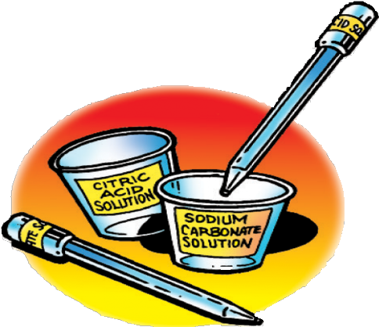

Procedure

Label your equipment
- Use masking tape and a pen to label one cup citric acid solution and another cup sodium carbonate solution.
- Use a small piece of masking tape and a pen to label one dropper citric acid solution and the other dropper sodium carbonate solution.

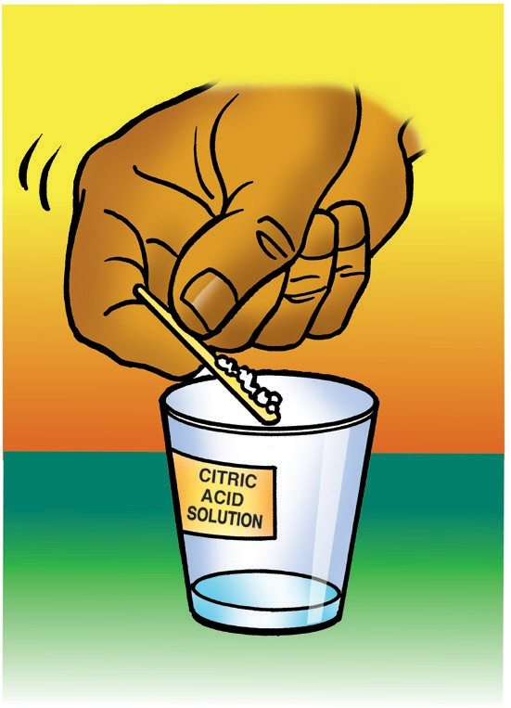
Make a citric acid solution
- Use your graduated cylinder to add 5 mL of water to the cup labeled citric acid.
- Use a flat toothpick to pick up as much citric acid as you can on the end of the toothpick as shown.
- Add this citric acid to the water in the citric acid cup. Gently swirl until the citric acid dissolves.

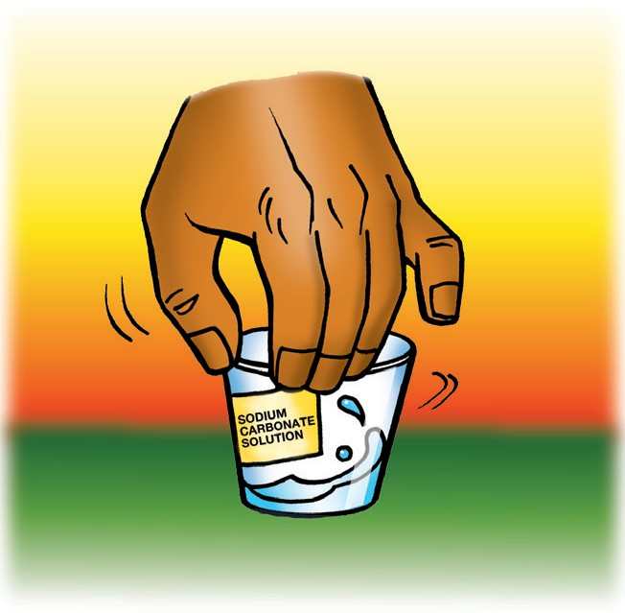
Make a sodium carbonate solution
- Use your graduated cylinder to add 5 mL of water to the cup labeled sodium carbonate.
- Use a flat toothpick to pick up as much sodium carbonate as you can on the end of a toothpick.
- Add this sodium carbonate to the water in the sodium carbonate cup. Gently swirl until the sodium carbonate dissolves.

ACTIVITY

Question to Investigate
How does the concentration of citric acid affect the color of universal indicator solution?

Materials for Each Group
  - Universal indicator solution
  - pH color chart
  - Citric acid solution
  - At least 6 toothpicks
  - Spot plate
  - 2 droppers

Procedure

Test your citric acid solution
- Use one of your droppers to nearly fill 6 small wells in your first spot plate with the universal indicator solution. Place the Universal Indicator pH Color Chart in front of the spot plate.

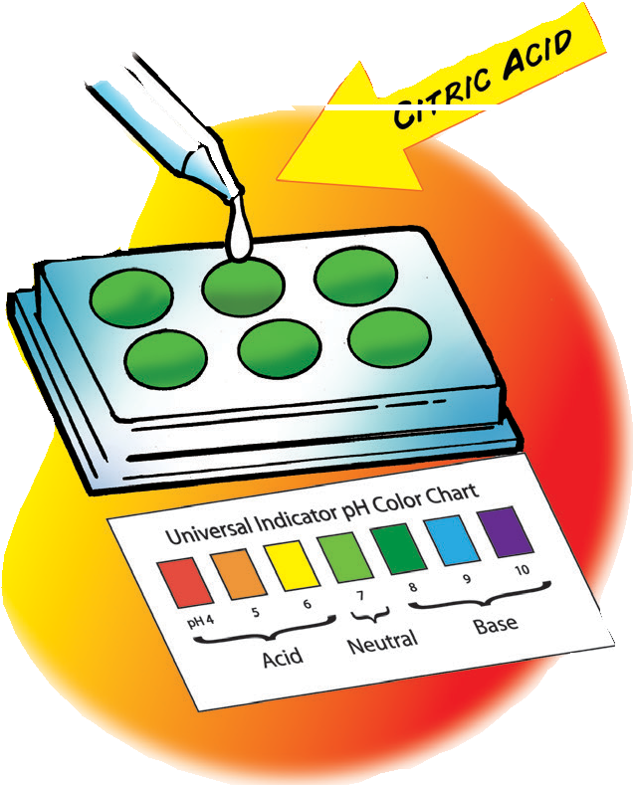
- Use your dropper to add 1 drop of citric acid solution to the second well. Gently mix the liquid with a clean toothpick.
- Compare the color of the liquid to the control and to the Universal Indicator pH Color Chart. Record the color of the indicator, the number of toothpicks of citric acid, and the pH number in the chart for well 2.

Test a more concentrated citric acid solution
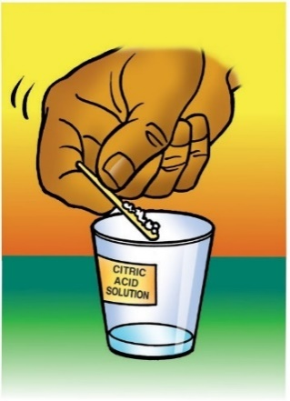
- Add another toothpick scoop of citric acid to the citric acid cup. Gently swirl until the citric acid dis- solves.
- Add 1 drop of this more concentrated citric acid solution to the third well. Gently mix the solution with a clean toothpick.
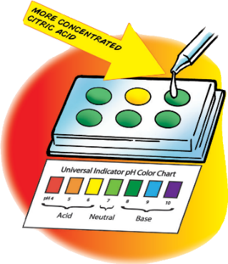
- Compare the color of the solution to the control and to the Universal Indicator pH Color Chart. Record the color of the indicator, the number of toothpick scoops of citric acid added, and the pH number in the chart for well 3.
- Continue adding toothpicks of citric acid and testing the solution in the last three wells to see how many different colors you can get.

The color and pH of different concentrations of citric acid
Well number | Number of tiny scoops of citric acid used in 5 mL of water | Color | pH
1 | 0 |  | 7
2 | 1
3 | 2
4 | 3
5 | 4
6 | 5

- How does the color of the indicator solution change as the citric acid solution becomes more concentrated?

- How does the number on the pH scale change as the concentration of citric acid solution increases?

Question to Investigate
How does the concentration of sodium carbonate affect the color of universal indicator solution?

Materials for Each Group
  - Universal indicator solution
  - pH color chart
  - Sodium carbonate solution
  - At least 6 toothpicks
  - Spot plate
  - 2 droppers
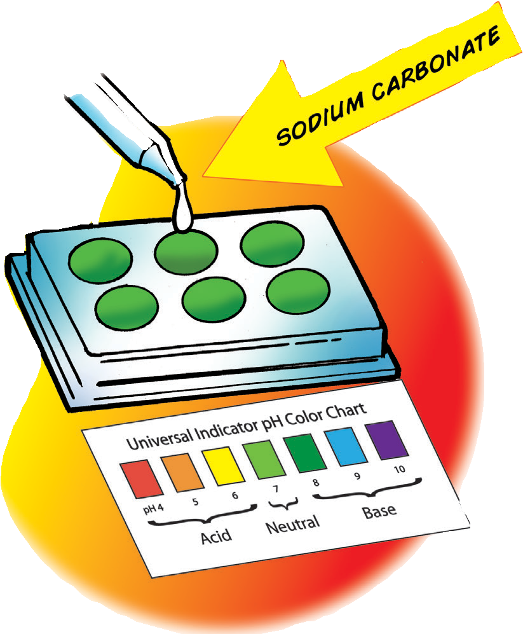

Procedure

Test your sodium carbonate solution
- Use a dropper to nearly fill the 6 wells in your other spot plate with universal indicator solution. You will not add anything else to the first well.
- Add 1 drop of sodium carbonate solution to the second well. Gently mix the solution with a clean toothpick.
- Compare the color of the solution to the control and to the Universal Indicator pH Color Chart. Record the color of the indicator, the number of toothpicks of sodium carbonate used to make the solution, and the pH number in the chart for well 2.
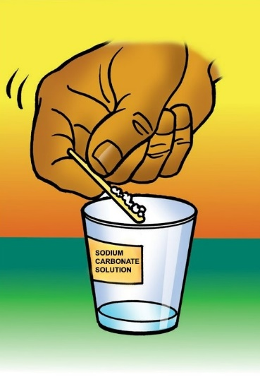

Test a more concentrated sodium carbonate solution
- Add another toothpick of sodium carbonate to the sodium carbonate cup. Gently swirl until the sodium carbonate dissolves.
- Add 1 drop of sodium carbonate solution to the next well. Gently mix the liquid with a clean toothpick.
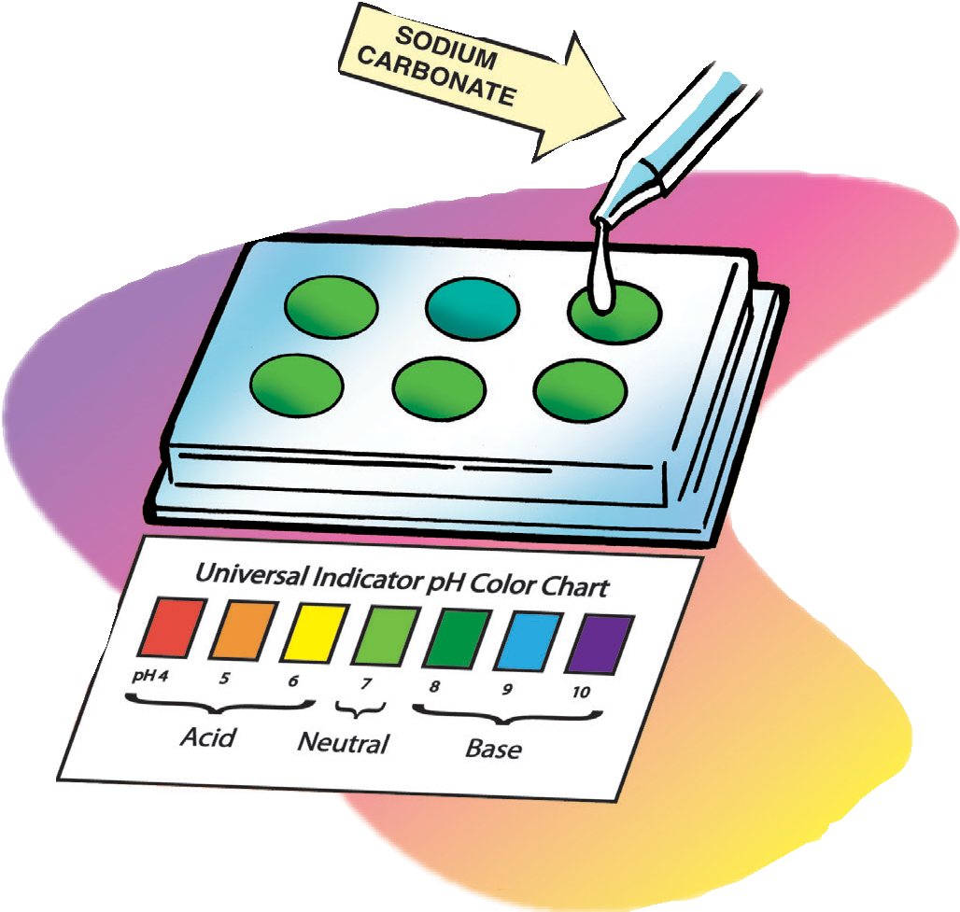
- Compare the color of the liquid to the control and to the Universal Indicator pH Color Chart. Record the color of the indicator, the number of toothpicks of sodium carbonate used, and the pH number in the chart for well 3.
- Continue adding toothpicks of sodium carbonate and testing the solution in the last three wells to see how many different colors or shades you can make.

The color and pH of different concentrations of sodium carbonate
Well number | Number of tiny scoops of sodium carbonate used in 5 mL of water | Color | pH
1 | 0 |  | 7
2 | 1
3 | 2
4 | 3
5 | 4
6 | 5

- How does the color of the indicator solution change as the sodium carbonate solution becomes more concentrated?

- How does the number on the pH scale change as the concentration of base increases?

- In this activity, you did not add any citric acid solution or sodium carbonate solution to the first well in each spot plate. What is the purpose of leaving the first well green?

EXPLAIN IT WITH ATOMS AND MOLECULES

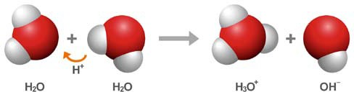
- The chemical formula for water is H₂O. Sometimes two water molecules can bump into each other and form the ions H₃O⁺ and OH⁻.
a. What is happening in the chemical equation above?

b. Why is one ion positive and the other ion negative?

- The pH scale is a measure of the concentration of H₃O⁺ ions in a solution. In the chart, use the words increases, decreases, or stays the same to describe how the concentration of H₃O⁺ ions changes as different substances are added to water.
How does the concentration of H₃O⁺ ions change as each substance is added to water?
Type of substance | Concentration of H₃O⁺ ions
Acid
Base
Neutral

TAKE IT FURTHER

Question to Investigate
How will the color change as you slowly pour your acid and base solutions into the indicator?

Materials for Each Group
  - Universal indicator solution
  - pH color chart
  - Citric acid solution
  - Sodium carbonate solution

Procedure
- Pour a small amount of either your citric acid solution or sodium carbonate solution into your indicator solution. Swirl and compare the color to your Universal Indicator pH Color Chart.
- Pour a small amount of the other solution into your indicator solution. Swirl and compare the color to your color chart.
- Continue to pour small amounts of the acid and base solutions into your indicator until the solutions are used up.
- What did you observe as you slowly poured your acid and base solutions into the indicator solution?

