Activity Sheet Name Chapter 6, Lesson 9
Neutralizing Acids and Bases Date

DEMONSTRATION
- Your teacher added drops of an acid to a universal indicator solution and then neutralized the solution by adding drops of a base.

How did you know when the solution became close to neutral?

PREPARE FOR THE ACTIVITY

Materials for Each Group
  - Sodium carbonate in cup
  - Citric acid in cup
  - Universal indicator in cup
  - Water
  - 3 clear plastic cups
  - Graduated cylinder
  - Flat toothpicks
  - 2 droppers
  - Masking tape and pen or permanent marker
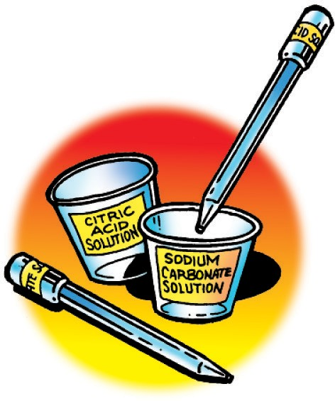

Procedure

Label your equipment
- Use masking tape and a pen to label one cup citric acid solution and another cup sodium carbonate solution.
- Use a small piece of masking tape and a pen to label one dropper citric acid solution and the other dropper sodium carbonate solution.

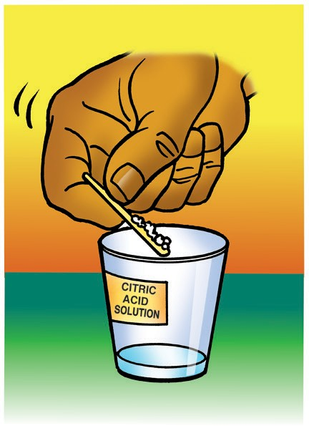
Make a citric acid solution
3. Use your graduated cylinder to add 5 mL of water to the cup labeled citric acid.
4. Use a flat toothpick to pick up as much citric acid as you can on the end of the toothpick as shown.
5. Add this citric acid to the water in the citric acid cup. Gently swirl until the citric acid dissolves.

Make a sodium carbonate solution
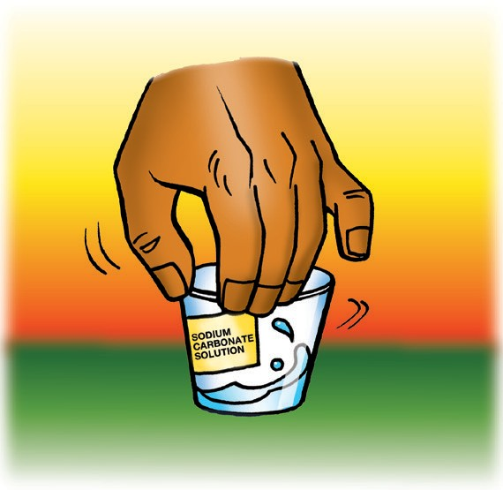
6. Use your graduated cylinder to add 5 mL of water to the cup labeled sodium carbonate.
7. Use a flat toothpick to pick up as much sodium carbonate as you can on the end of a toothpick.
8. Add this sodium carbonate to the water in the sodium carbonate cup. Gently swirl until the sodium carbonate dissolves.

ACTIVITY

Question to Investigate
How many drops of sodium carbonate solution will it take to neutralize your citric acid solution?

Materials for Each Group
  - Universal indicator solution
  - Citric acid solution
  - Sodium carbonate solution
  - At least 6 flat toothpicks
  - Spot plate
  - 3 droppers

Procedure
- Use a dropper to nearly fill two small wells in your spot plate with universal indicator solution. Do not add anything else to the first well. This will be your control.
- Add 3 drops of citric acid solution to the indicator in one of the wells. Use a clean toothpick to mix the solution. If it is not reddish, add more drops, but be sure to count the total number of drops added.

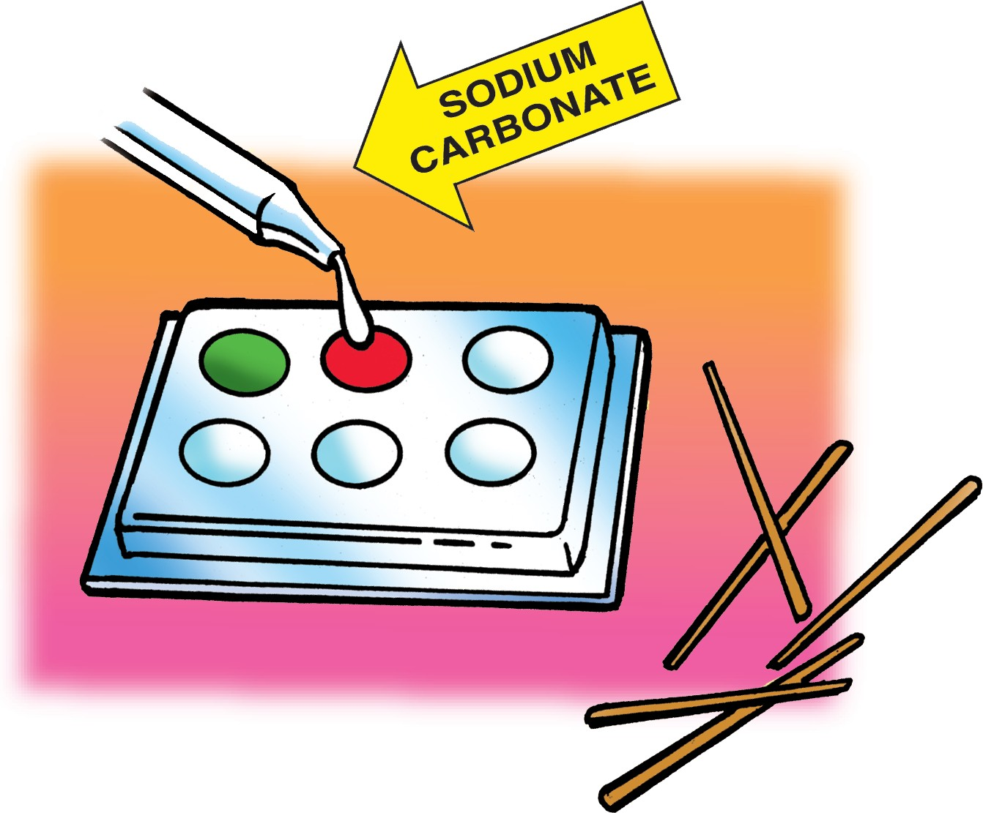
- Add single drops of sodium carbonate to the same well in which you added the acid. Be sure to count the drops you use and stir with a toothpick after adding each drop.

How many drops of sodium carbonate does it take to neutralize your citric acid solution?
Acidic solution | Number of drops of citric acid solution added to the indicator | Number of drops of sodium carbonate solution needed to neutralize the citric acid solution
First citric acid solution | 3 drops
More concentrated citric acid solution

2. Does the solution become more acidic or less acidic as each drop of sodium carbonate is added to the indicator?

EXPLAIN IT WITH ATOMS & MOLECULES
3. What happens to the protons from the H₃O⁺ ions when a base is used to neutralize an acid?

4. What do you know about the concentration of H₃O⁺ ions and OH⁻ ions when a solution is neutralized?

ACTIVITY

Question to Investigate
How many more drops of sodium carbonate solution will it take to neutralize a more concentrated citric acid solution?

Materials for Each Group
  - Citric acid
  - Citric acid solution
  - Sodium carbonate solution
  - Universal indicator solution
  - 2 flat toothpicks
  - 3 droppers
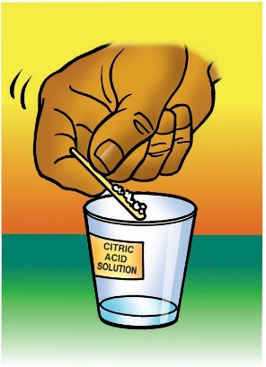
  - Spot plate

Procedure
- Use a flat toothpick to add two scoops of citric acid to your citric acid solution to make it even more acidic. Gently swirl until the citric acid dissolves.
- Add universal indicator solution to a clean well in the spot plate.
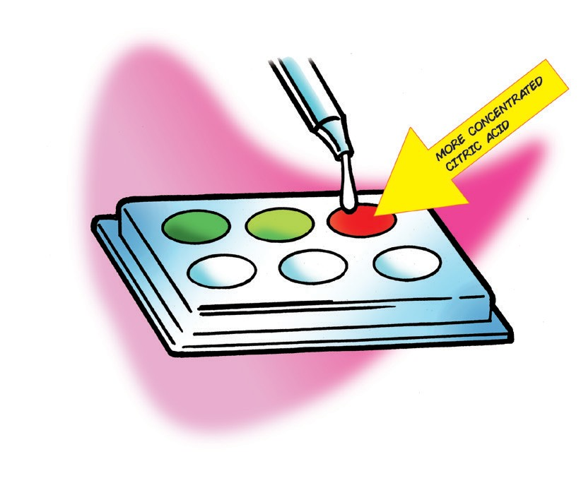
- Add 3 drops of the more concentrated citric acid solution to the indicator and stir with a clean toothpick.
- Add single drops of sodium carbonate to the same well in which you added the acid. Be sure to count the drops you use and stir with a toothpick after adding each drop. Record this number in the chart.

5. Did it take more, less, or the same amount of sodium carbonate solution to neutralize this more concentrated citric acid solution?

6. Thinking about the animation, why did you need more drops of sodium carbonate solution?

TAKE IT FURTHER

Question to Investigate
Is Solution A or Solution B a more concentrated basic solution?

Materials for Each Group
  - Universal indicator solution
  - Citric acid solution
  - Solution A
  - Solution B
  - At least 6 toothpicks
  - Spot plate
  - 3 droppers

Procedure
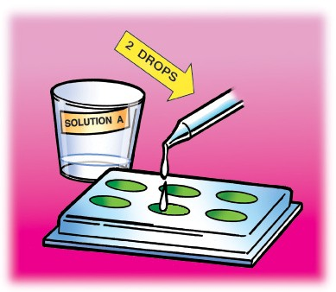
- Add universal indicator solution to three wells in a clean spot plate.
- Leave the first well alone so that it can be used as a control. Add 2 drops of Solution A to the second well.
- Add 2 drops of Solution B to the third well.
- Neutralize Solution A. Record the number of drops used in the chart.
Which solution is the most concentrated?
Solution | Number of drops of solution added to the indicator | Number of drops of citric acid solution needed to neutralize the sodium carbonate solution
Solution A | 2 drops
Solution B | 2 drops
- Neutralize Solution B. Record the number of drops used in the chart.

7. Which solution is the most concentrated? How do you know?

8. Antacids are medicines people take when the acid in their stomach is causing them discomfort. One advertisement says that the medicine provides relief for acid indigestion and “sour” stomach. What type of chemical do you think is in the medicine?

