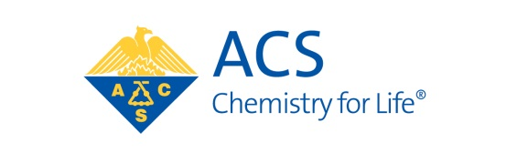
COUNCIL POLICY COMMITTEE
2019 Committee Roster
Members of the Council Policy Committee can be contacted via email at: cpc@acs.org

VOTING

ABRAHAMSON, Harmon B.
BOOKSH, Karl S.
CHARPENTIER, Bonnie A., Chair
CONNELLY Jr., Thomas M., Ex Officio
DAVIS, Ella L.
DORHOUT, Peter K.
DULANY, Lissa
ECHEGOYEN, Luis A.
FRISHBERG, Mark D.
HOUSTON, Lisa, Vice-Chair
LYNCH, Will E.
MORALES MARTINEZ, Zaida C.
PETERS, Sally B.
RUDD, Martin D.
TWISS-BROOKS, Andrea B.
WATKINS, Linette M.

NONVOTING (Ex Officio)
ADAMS, V. Dean NIELSON, Jennifer B.
EDGAR, Kevin J. RIBES, Carolyn
HEPPERT, Joseph A. RITCHIE, Jason E.
HINKLE, Amber S. ROMANO, Frank
MATHES, Brian M. TAKACS, James M.

LEWIS, Flint H., Secretary and Staff Liaison

