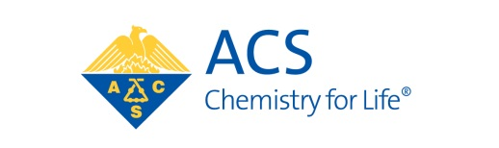

Suggestions for 2017 Elected Committees of Council

Mr. D. Richard Cobb, Chair, Nominations and Elections
nomelect@acs.org

Dear Mr. Cobb:

I propose the following Councilors for consideration by the Committee on Nominations and Elections and the Council Policy Committee:
(Please Type, or Print Clearly)

COMMITTEE ON COMMITTEES (Councilors only)

Councilor Name______________________________________________________________________

Local Section or Division Affiliation______________________________________________________

Councilor Name______________________________________________________________________

Local Section or Division Affiliation______________________________________________________

COUNCIL POLICY COMMITTEE (Councilors only)

Councilor Name______________________________________________________________________

Local Section or Division Affiliation______________________________________________________

Councilor Name______________________________________________________________________

Local Section or Division Affiliation______________________________________________________

COMMITTEE ON NOMINATIONS AND ELECTIONS (Councilors only)

Councilor Name______________________________________________________________________

Local Section or Division Affiliation______________________________________________________

Councilor Name______________________________________________________________________

Local Section or Division Affiliation______________________________________________________

Sincerely,

(name)

(Local Section or Division affiliation)

This form must be received by Mr. Cobb at nomelect@acs.org no later than October 31, 2015

