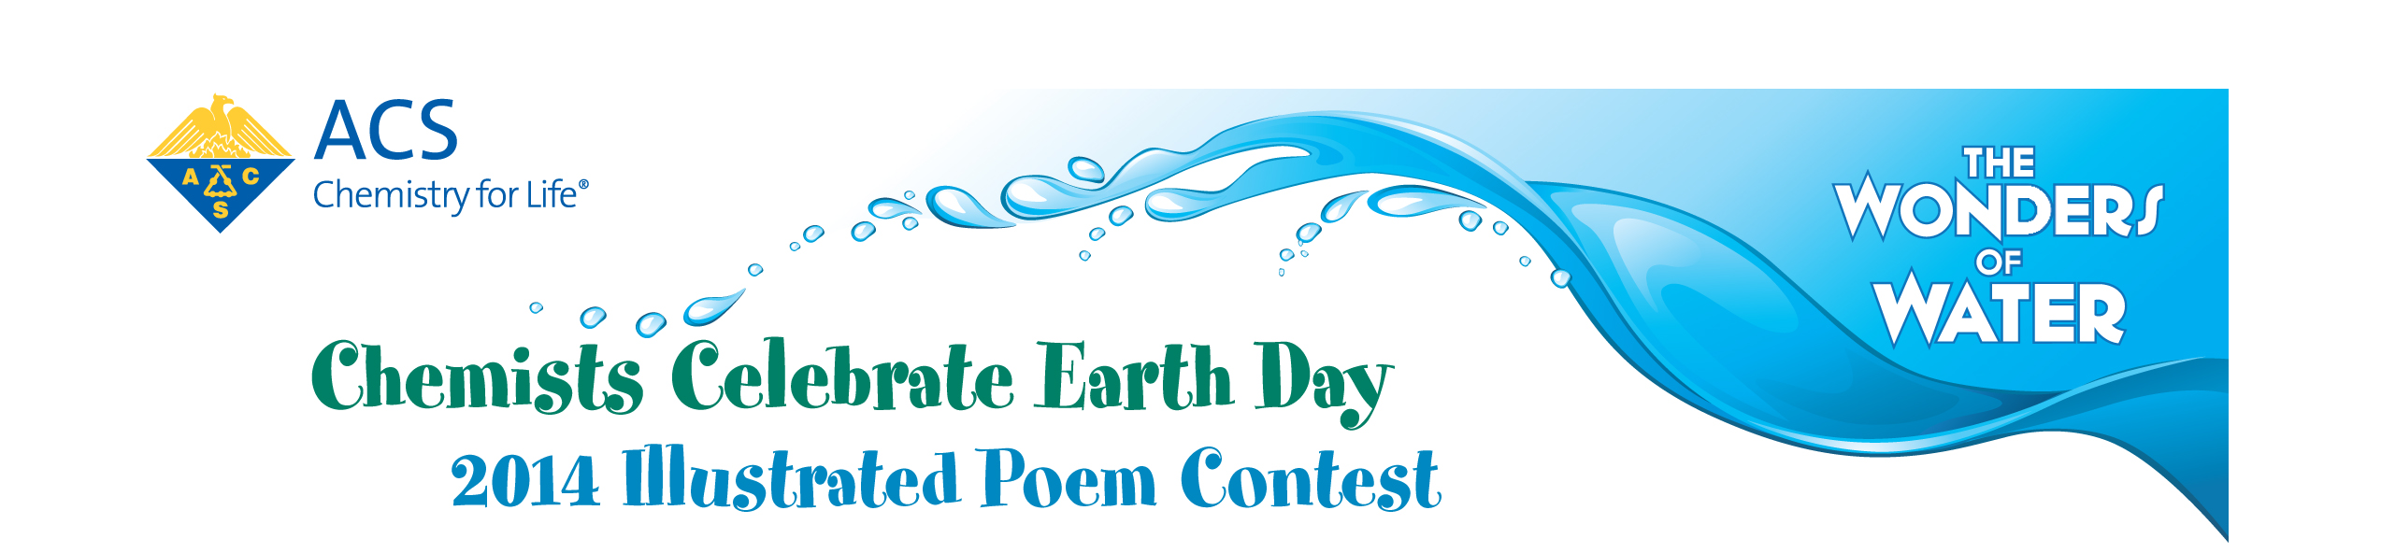
The [Section Name] Section of the American Chemical Society (ACS) is sponsoring an illustrated
poem contest for students in Kindergarten - 12th grade.

Contest Deadline: [Enter Deadline]

Prizes: [Enter Prize Information]
Contact: [Enter contact and address information for submission]
Winners of the [Section Name] illustrated poem contest will advance to the ACS National Illustrated Poem Contest!


